Table of Contents

UNITED STATES

SECURITIES AND EXCHANGE COMMISSION
Washington, D.C. 20549

SCHEDULE 14A

Proxy Statement Pursuant to Section 14(a) of the

Securities Exchange Act of 1934

Filed by the Registrant ☒ Filed by a Party other than the Registrant ☐

Check the appropriate box:

- Preliminary Proxy Statement

- Confidential, for Use of the Commission Only (as permitted by Rule 14a-6(e)(2))

- Definitive Proxy Statement

- Definitive Additional Materials

- Soliciting Material under § 240.14a-12

EXXON MOBIL CORPORATION

(Name of Registrant as Specified In Its Charter)

NOT APPLICABLE

(Name of Person(s) Filing Proxy Statement, if other than the Registrant)

Payment of Filing Fee (Check all boxes that apply):

- No fee required

- Fee paid previously with preliminary materials

- Fee computed on table in exhibit required by Item 25(b) per Exchange Act Rules 14a-6(i)(1) and 0-11.

Table of Contents

Notice of 2023 Annual Meeting


and Proxy Statement

April 13, 2023

Dear Shareholder:

We invite you to attend the annual meeting of shareholders on Wednesday, May 31, 2023, beginning promptly at

9:30 a.m. Central Time. The annual meeting of shareholders will be a virtual meeting. This format will help provide for a safe experience for our shareholders, employees, and other members of the community, and provide broader access and participation in the meeting versus an in-person meeting. Shareholders will be able to attend, vote, and submit questions during the annual meeting from any remote location that has Internet connectivity. We believe this approach provides for equitable participation and enhances accessibility to the meeting. Online access will be available approximately 15 minutes prior to the annual meeting start time at www.virtualshareholdermeeting.com/XOM2023. Please see page 5 for detailed instructions for attending and participating in the annual meeting.

At the meeting, you will hear a report on our business and vote on the following items:

- Election of directors;

- Ratification of PricewaterhouseCoopers LLP as independent auditors;

- Advisory votes to approve executive compensation and future voting frequency;

- Thirteen shareholder proposals contained in this proxy statement; and

- Other matters if properly raised.

Only shareholders of record on April 5, 2023, or their valid proxy holders may vote at the meeting. We are first mailing these proxy materials to shareholders of record on or about April 13, 2023.

This booklet includes the formal notice of the meeting and proxy statement. The proxy statement tells you about the agenda, procedures, and rules of conduct for the meeting. It also describes how the Board operates, gives information about our director candidates, and provides information about the other items of business to be conducted at the meeting.

Financial information is provided separately in the 2022 Annual Report that accompanies or precedes the proxy materials or is made available online to all shareholders.

Your vote is important. Even if you own only a few shares, we want your voice to be represented at the meeting. You can vote your shares by Internet, toll-free telephone call, or proxy card. A preliminary summary of 2023 Proxy Voting Results will be available at exxonmobil.com after the annual meeting of shareholders and will be filed on a Form 8-K within four business days of the meeting.

Sincerely,



Craig S. Morford

Secretary

Darren W. Woods

Chairman of the Board

Table of Contents
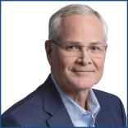

Darren W. Woods

Chairman of the Board,
Chief Executive Officer,

Exxon Mobil Corporation

Dear Fellow Shareholders:

I would like to invite you to join the 2023 Exxon Mobil Corporation virtual annual shareholder meeting on May 31, 2023, beginning at 9:30 a.m. Central Time.

In 2022, the hard work and commitment of our people drove exceptional results. While our results benefited from a favorable market, our work to meet demand began years ago, well before the pandemic. We chose to invest counter-cyclically, leaning in when others leaned out. As a result, we made strong progress against our strategic priorities, including delivering industry-leading earnings, cash flows, and shareholder returns.

Our progress also included building and improving our advantaged portfolio, as we increased production to meet demand when people needed it the most, increased our refining throughput to record levels, and positioned the Company to bring the largest refining capacity expansion in North America on line in more than a decade.

At this year’s meeting, we’ll highlight this progress and share how we’re working to be a valued partner of choice as we continue to innovate and provide solutions that meet the growing needs of society reliably and affordably. This includes our landmark agreement that is expected to capture, transport, and store up to 2 million metric tons of CO2 per year on behalf of a large fertilizer manufacturer in Louisiana, and the start-up of one of North America’s largest advanced recycling facilities in Baytown, Texas. It also includes our plans to increase value-accretive investments in lower-emission initiatives to approximately $17 billion from 2022 through 2027 (a $2 billion increase over our prior plan), as we work to achieve our previously announced 2030 greenhouse gas emission-reduction plans, and advance our net-zero by 2050 ambition.

We are working to solve the “and” equation: delivering the energy and products society needs and lead industry in reducing greenhouse gas emissions.

On behalf of the ExxonMobil leadership team and Board of Directors, we would like to thank our employees who work tirelessly so that we can meet the world’s evolving needs and progress our plans to play a leading role in a thoughtful energy transition.

We look forward to sharing more with you at our annual shareholder meeting.

Thank you for investing in ExxonMobil.

Table of Contents


Joseph L. Hooley

Board of Directors,
Lead Director,

Exxon Mobil Corporation

Dear Fellow Shareholders:

As Independent Lead Director, I’m focused on ensuring that ExxonMobil’s Board delivers cohesive management oversight and that shareholders benefit from the full range of relevant skill sets and contributions of each Board member.

Our Board is composed of proven leaders who bring diverse experience in critically important areas, including energy, new technologies, climate science, business transformation, safety, risk management, investment stewardship, and capital allocation. In my first full year as Lead Director, it has been a privilege to work with such a diverse and talented group.

In 2022, ExxonMobil generated industry-leading total shareholder returns and met all of its annual strategic goals.

The Company took the necessary steps to help meet society’s need for energy and products, while also delivering on its commitment to lower emissions. Its Low Carbon Solutions business is making exciting progress that will help the Company reduce its own emissions and grow opportunities to help others do the same. ExxonMobil entered 2023 with positive momentum, significant financial flexibility, and an even stronger platform for continued value-focused growth, performance, and innovation.

A key responsibility of the Board is to consider a wide range of scenarios and risks to ensure the Company is well-positioned to overcome challenges and capture opportunities to help achieve a lower-emissions future. This is the focus of the Board’s oversight in the development of the Company’s five-year plan. The plan continues to call for investments in high-return, low cost of supply, advantaged assets in the Upstream and the new Product Solutions business. It also includes a nearly 15 percent increase in investments aimed at emission reductions and accretive lower-emission initiatives. The Low Carbon Solutions business has tripled its organization size in the past year, leveraging the Company’s unique capabilities to advance an increasing number of opportunities with competitive returns in carbon capture and storage, hydrogen, and biofuels.

ExxonMobil’s balanced and disciplined strategy is working. Today, ExxonMobil leads its peers in earnings, cash flow, and returns, all while expanding lower-emission investments. Your Board is committed to building on this momentum while continuing direct interactions with investors in the year ahead.

It is a tremendous honor to serve on ExxonMobil’s Board, and I thank you for the trust you’ve placed in us and in ExxonMobil.


Table of Contents

 |  |  |  |  |  |  |  |  |  |  |  |  |  | TABLE OF CONTENTS
 |  |  |  |  |  |  |  |  |  |  |  |  |  |  |  |  |  |  |  |  |  |  |  |  |  |  | Page
PROXY SUMMARY |  |  |  |  |  |  |  |  |  |  |  |  |  |  |  |  |  |  |  |  |  |  |  |  |  |  | 1
GENERAL INFORMATION |  |  |  |  |  |  |  |  |  |  |  |  |  |  |  |  |  |  |  |  |  |  |  |  |  |  | 4
BOARD OF DIRECTORS |  |  |  |  |  |  |  |  |  |  |  |  |  |  |  |  |  |  |  |  |  |  |  |  |  |  | 8
 | Item 1 – Election of Directors |  |  |  |  |  |  |  |  |  |  |  |  |  |  |  |  |  |  |  |  |  |  |  |  |  | 8
CORPORATE GOVERNANCE |  |  |  |  |  |  |  |  |  |  |  |  |  |  |  |  |  |  |  |  |  |  |  |  |  |  | 20
DIRECTOR COMPENSATION |  |  |  |  |  |  |  |  |  |  |  |  |  |  |  |  |  |  |  |  |  |  |  |  |  |  | 37
CERTAIN BENEFICIAL OWNERS |  |  |  |  |  |  |  |  |  |  |  |  |  |  |  |  |  |  |  |  |  |  |  |  |  |  | 39
DIRECTOR AND EXECUTIVE OFFICER STOCK OWNERSHIP |  |  |  |  |  |  |  |  |  |  |  |  |  |  |  |  |  |  |  |  |  |  |  |  |  |  | 39
AUDIT COMMITTEE REPORT |  |  |  |  |  |  |  |  |  |  |  |  |  |  |  |  |  |  |  |  |  |  |  |  |  |  | 41
 | Item 2 – Ratification of Independent Auditors |  |  |  |  |  |  |  |  |  |  |  |  |  |  |  |  |  |  |  |  |  |  |  |  |  | 43
COMPENSATION COMMITTEE REPORT |  |  |  |  |  |  |  |  |  |  |  |  |  |  |  |  |  |  |  |  |  |  |  |  |  |  | 44
 | Item 3 – Advisory Vote to Approve Executive Compensation |  |  |  |  |  |  |  |  |  |  |  |  |  |  |  |  |  |  |  |  |  |  |  |  |  | 44
 | Item 4 – Frequency of Advisory Vote on Executive Compensation |  |  |  |  |  |  |  |  |  |  |  |  |  |  |  |  |  |  |  |  |  |  |  |  |  | 44
EXECUTIVE COMPENSATION |  |  |  |  |  |  |  |  |  |  |  |  |  |  |  |  |  |  |  |  |  |  |  |  |  |  | 45
 | Compensation Discussion and Analysis |  |  |  |  |  |  |  |  |  |  |  |  |  |  |  |  |  |  |  |  |  |  |  |  |  | 45
 | Executive Compensation Tables |  |  |  |  |  |  |  |  |  |  |  |  |  |  |  |  |  |  |  |  |  |  |  |  |  | 68
SHAREHOLDER PROPOSALS |  |  |  |  |  |  |  |  |  |  |  |  |  |  |  |  |  |  |  |  |  |  |  |  |  |  | 77
 | Item 5 – Establish a New Board Committee on Decarbonization Risk |  |  |  |  |  |  |  |  |  |  |  |  |  |  |  |  |  |  |  |  |  |  |  |  |  | 78
 | Item 6 – Reduce Executive Stock Holding Period |  |  |  |  |  |  |  |  |  |  |  |  |  |  |  |  |  |  |  |  |  |  |  |  |  | 79
 | Item 7 – Additional Carbon Capture and Storage and Emissions Report |  |  |  |  |  |  |  |  |  |  |  |  |  |  |  |  |  |  |  |  |  |  |  |  |  | 81
 | Item 8 – Additional Direct Methane Measurement |  |  |  |  |  |  |  |  |  |  |  |  |  |  |  |  |  |  |  |  |  |  |  |  |  | 82
 | Item 9 – Establish a Scope 3 Target and Reduce Hydrocarbon Sales |  |  |  |  |  |  |  |  |  |  |  |  |  |  |  |  |  |  |  |  |  |  |  |  |  | 85
 | Item 10 – Additional Report on Worst-case Spill and Response Plans |  |  |  |  |  |  |  |  |  |  |  |  |  |  |  |  |  |  |  |  |  |  |  |  |  | 87
 | Item 11 – GHG Reporting on Adjusted Basis |  |  |  |  |  |  |  |  |  |  |  |  |  |  |  |  |  |  |  |  |  |  |  |  |  | 89
 | Item 12 – Report on Asset Retirement Obligations Under IEA NZE Scenario |  |  |  |  |  |  |  |  |  |  |  |  |  |  |  |  |  |  |  |  |  |  |  |  |  | 91
 | Item 13 – Report on Plastics Under SCS Scenario |  |  |  |  |  |  |  |  |  |  |  |  |  |  |  |  |  |  |  |  |  |  |  |  |  | 93
 | Item 14 – Litigation Disclosure Beyond Legal and Accounting Requirements |  |  |  |  |  |  |  |  |  |  |  |  |  |  |  |  |  |  |  |  |  |  |  |  |  | 96
 | Item 15 – Tax Reporting Beyond Legal Requirements |  |  |  |  |  |  |  |  |  |  |  |  |  |  |  |  |  |  |  |  |  |  |  |  |  | 98
 | Item 16 – Energy Transition Social Impact Report |  |  |  |  |  |  |  |  |  |  |  |  |  |  |  |  |  |  |  |  |  |  |  |  |  | 100
 | Item 17 – Report on Commitment Against AMAP Work |  |  |  |  |  |  |  |  |  |  |  |  |  |  |  |  |  |  |  |  |  |  |  |  |  | 101
PAY VERSUS PERFORMANCE |  |  |  |  |  |  |  |  |  |  |  |  |  |  |  |  |  |  |  |  |  |  |  |  |  |  | 104
PAY RATIO |  |  |  |  |  |  |  |  |  |  |  |  |  |  |  |  |  |  |  |  |  |  |  |  |  |  | 106
ADDITIONAL INFORMATION |  |  |  |  |  |  |  |  |  |  |  |  |  |  |  |  |  |  |  |  |  |  |  |  |  |  | 107
EXHIBIT A |  |  |  |  |  |  |  |  |  |  |  |  |  |  |  |  |  |  |  |  |  |  |  |  |  |  | 109

Table of Contents

PROXY SUMMARY


ITEM 1: Election of Directors

The Board recommends you vote FOR each of the nominees.

The Board of Directors has nominated the director candidates in this proxy statement, all of whom currently serve as ExxonMobil directors. All director nominees have stated they are willing to serve, if elected.

Personal information about each nominee and their extensive qualifications begins on Page 8.

ExxonMobil Board of Director Nominees
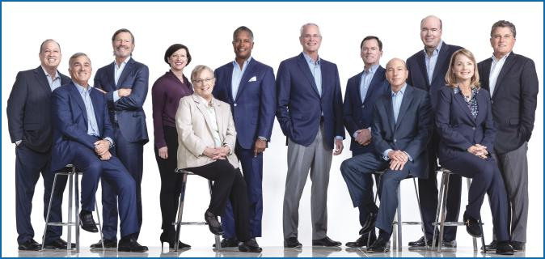

ExxonMobil works each day to meet society’s needs for energy and the products essential to modern life, while planning to play a leading role in a thoughtful energy transition. The Company’s strategy is built on a unique combination of global scale, deep technology, innovation expertise, functional excellence, and world-class people. This strategy has built globally competitive businesses that lead the industry in absolute earnings and cash flow. The Board believes this strategy well-positions the Company for a range of future scenarios and reflects our intention to maximize long-term shareholder value throughout the energy transition.

The Board of Directors oversees the Company’s strategy and planning process, with each director bringing a range of skills and experiences that serve to strengthen Board deliberations and decision-making. Considering a variety of potential scenarios, the Board’s goal is to ensure the Company is well-positioned to execute its long-term strategy, which is designed to deliver profitable growth and significant shareholder returns.

In support of its governance, the Board reviews assumptions and sensitivities in testing projects and investments for resiliency. For example, the Board oversees the development of the Company’s plans through 2027. This five-year plan continues to call for high-return, low cost of supply, advantaged assets in the Upstream and the new Product Solutions business; it also includes significantly increasing investments in lower-emission initiatives to approximately $17 billion, including progressing advanced recycling, hydrogen, biofuels, and carbon capture and storage projects. The Board is actively involved in discussions on technology development and deployment. These discussions help guide the Company’s efforts to further reduce greenhouse gas emissions from its operated assets, and progress its plans to help others reduce their emissions from the manufacturing, power generation, and commercial transportation sectors.

The Board refreshment process is led by the Nominating and Governance Committee, which incorporates the perspectives of shareholders and external experts. This Committee seeks highly qualified Board candidates with diverse, relevant backgrounds. Important director competencies include experience in capital-intensive and cyclical industries, the energy transition, climate science, and technological research and development. In 2023, the Company added two new independent directors with proven experience in leading value-creation at industries likewise going through transitions.

The Board unanimously recommends you vote FOR

each of the ExxonMobil director candidates.

2023 Proxy Statement | 1

Table of Contents

Board Tenure

ExxonMobil added eight new independent directors since 2020 — more than

60 percent of the total current Board as of the date of this proxy statement. Average tenure for current non-employee directors is 3.5 years.

Strategy delivers industry-leading results in 2022

Earnings |  | Dividend |  | Cash flow from
 |  |  |  | operations
increased to |  | annual growth for |  | increased to
$56 billion |  | 40 consecutive years |  | $77 billion

62%

of current directors have

joined the Board since 2020

Director Diversity

The Board believes diversity of thought, experience, and background is critical to good governance. Unique perspectives and experiences add value in working together as a collective body to represent the interests of all shareholders.
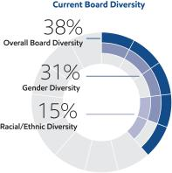

Broad Range of Business & Industry Experience

Directors bring a wide range of business experience, including climate expertise, industrial operations experience, investor perspectives, and experience in the oil and gas industry.

23%

of current directors have experience in large-scale energy / commodity businesses

Additional information:

Director leadership & oversight...Page 20

Director qualifications & competencies...Page 22

Director tenure...Page 29

2 2023 Proxy Statement

Progress on greenhouse gas emission reductions1

ExxonMobil cut global operated methane emissions in half since 2016 and eliminated routine flaring in the Permian Basin operated assets in line with the World Bank’s Zero Routine Flaring Initiative.²

>50% | >10%
Reduction in corporate-wide | Reduction in corporate-wide
methane intensity from operated | greenhouse gas (GHG)
assets | emissions intensity

2030 GHG emission-reduction plans³ -
applies to Scope 1 and Scope 2 GHG emissions
from operated assets, versus 2016 levels:

20-30% | 40-50%
Reduction in corporate-wide | Reduction in Upstream
GHG emissions intensity | GHG emissions intensity
70-80% | 60-70%
Reduction in corporate-wide | Reduction in corporate-wide
methane intensity | hydrocarbon flaring intensity

2050 Net-zero Ambition for Operated Assets

With advances in technology and the support of clear and consistent government policies, we aim to achieve our Scope 1 and Scope 2 net-zero ambition Corporate-wide by 2050. To this end, we have taken a comprehensive approach to create emission-reduction roadmaps⁴ for our major operated assets. The roadmaps build on our 2030 emission-reduction plans and include reaching net-zero emissions in our unconventional Permian Basin operated assets by 2030.

Investing in Lower-Emission Opportunities

ExxonMobil plans to invest approximately $17 billion in value accretive, lower-emission initiatives from 2022 through 2027. Approximately

40 percent will be directed toward building the Company’s Low Carbon Solutions business to help customers reduce their GHG emissions through large-scale carbon capture and storage, hydrogen, and biofuels. These lower-emissions technologies are recognized as necessary solutions to help address climate change and closely align with ExxonMobil’s existing competitive advantages and core capabilities. The Company’s robust research and development process, continued evaluation of emerging technologies, and global collaborations will be key to identifying lower-emission opportunities and growing the Low Carbon Solutions business.

~$17 Billion

Allocated toward lower-emissions investments from 2022 through 2027

Table of Contents

ITEM 2: Ratification of Independent Auditors

The Board recommends you vote FOR this proposal.

The ExxonMobil Audit Committee has appointed PricewaterhouseCoopers LLP (PwC) to audit ExxonMobil’s financial statements for 2023.

You are asked to ratify that appointment.


Page 41

Additional information about the Audit Committee’s appointment of PwC
and PwC’s fees for
2021 and 2022

ITEM 3: Advisory Vote to Approve Executive Compensation

ITEM 4: Frequency of Advisory Vote on Executive Compensation

The Board recommends you vote FOR on Item 3 and FOR One-Year Frequency on Item 4.

ExxonMobil asks you to vote on non-binding resolutions to approve the Page 44

compensation of the Named Executive Officers and on the future voting frequency Additional information
of that advisory vote. about ExxonMobil’s
compensation

program

ITEMS 5 through 17: Shareholder Proposals

The Board recommends you vote AGAINST each of these proposals.

You will have the opportunity to vote on shareholder proposals submitted to Page 77

ExxonMobil. The text of these
proposals, the
proponents’ statements
in support, and
ExxonMobil’s responses

- Based on Scope 1 and 2 emissions of ExxonMobil operated assets through 2022 (versus 2016). ExxonMobil’s reported emissions, reductions, and avoidance performance data are based on a combination of measured and estimated emissions data using reasonable efforts and collection methods. Calculations are based on industry standards and best practices, including guidance from the American Petroleum Institute (API) and Ipieca. There is uncertainty associated with the emissions, reductions, and avoidance performance data due to variation in the processes and operations, the availability of sufficient data, quality of those data and methodology used for measurement and estimation. Performance data may include rounding. Changes to the performance data may be reported as part of the company’s annual publications as new or updated data and/or emission methodologies become available. We are working to continuously improve our performance and methods to detect, measure and address greenhouse gas emissions. ExxonMobil works with industry, including API and Ipieca, to improve emission factors and

methodologies, including measurements and estimates.

- References to routine flaring herein are consistent with the World Bank’s Zero Routine Flaring Initiative/Global Gas Flaring Reduction Partnership’s (GGFRP) principle of routine flaring, and excludes safety and non-routine flaring.
- ExxonMobil’s 2030 GHG emission reduction plans, corporate.exxonmobil.com/News/Newsroom/News-releases /2021/1201_ExxonMobil-announces-plans-to-2027-doubling-earnings-and-cash-flow-potential-reducing-emissions.
- ExxonMobil’s Scope 1 and Scope 2 net-zero ambition is backed by a comprehensive approach centered on detailed emission-reduction roadmaps for our major operated assets. Roadmaps may be updated as needed to reflect technology, policy and other necessary developments, including the development and acquisition of major operated assets.

2023 Proxy Statement | 3

Table of Contents

GENERAL INFORMATION

Who May Vote

Shareholders of ExxonMobil, as recorded in our stock register on April 5, 2023, may vote at the meeting according to the instructions below.

How to Vote

Your vote is important. We recommend you vote by proxy even if you plan to participate in the virtual meeting.

You may vote at the annual meeting according to the instructions below or by proxy.

If your shares are held in your name, you can vote by proxy in one of three convenient ways:

Online | Telephone | Mail
Follow the instructions at | Call toll-free | Complete, sign, date, and return your
investorvote.com/exxonmobil. | 1-800-652-8683 or | proxy card in the enclosed
You will need to have your | 1-781-575-2300 (outside the | envelope. If you receive a Notice and
proxy card or Notice of Internet | United States, Canada, and | would like to vote by mail, please
Availability (Notice) in hand. | Puerto Rico), | follow the instructions in the Notice
 | and follow the instructions. | to obtain paper proxy materials.
 | You will need to have your
 | proxy card or Notice in hand.




How Proxies Work

ExxonMobil’s Board of Directors is asking for your proxy. Giving us your proxy means you authorize us to vote your shares at the meeting in the manner you direct on the proxy card from the Board of Directors.

If you give us your signed proxy but do not specify how to vote, we will vote your shares as follows:

- For the election of all director candidates nominated by the ExxonMobil Board;

- For ratification of the appointment of independent auditors;

- For approval of the compensation of the Named Executive Officers;

- For one year as the frequency of future advisory votes on executive compensation; and

- As recommended by the Board with respect to shareholder proposals.

If you hold shares through someone else, such as a brokerage firm, bank, or intermediary, you will receive materials from that firm asking how you want to vote. Check the voting form used by that firm as most offer online or telephone voting in addition to mail.

Attendance at the Annual Meeting

You have received this proxy statement because you are a shareholder as of the record date. Attendance at the

annual meeting through the website www.virtualshareholdermeeting.com/XOM2023 or any adjournment or postponement thereof will be limited to shareholders of the Company as of the close of business on the record date and to guests. You will not be able to attend the annual meeting in person at a physical location. Separate instructions for how to attend the annual meeting as a shareholder and have the ability to vote and/or submit a comment or question during the annual meeting are provided below for Registered Shareholders (those who hold shares through our transfer agent, Computershare, or participate in the Savings Plan) and Beneficial Shareholders (generally, those who hold shares through a bank or brokerage account).

4 2023 Proxy Statement

Table of Contents

Registered Shareholders must pre-register by 4:00 p.m. Central Time on May 24, 2023.

For Registered Shareholders who hold shares through our transfer agent, Computershare, or participate in the Savings Plan, you must request a 16-digit virtual meeting access (VMA) control number no later than 4:00 p.m. Central Time on Wednesday, May 24, 2023.

To request a VMA control number, please email Computershare at legalproxy@computershare.com with “VMA Request” in the subject line. Include your full name exactly as it appears on your account, and include a copy of your proxy card or Notice. Alternatively, if you received your voting instructions via email, you may forward or attach that email. The 15-digit voter control number on your proxy card, Notice, or email allows you to vote your shares prior to and during the meeting but does not provide access to the virtual meeting as a shareholder. You will receive an email response from Computershare within seven days of your request. The email response will include your VMA control number and instructions to attend the virtual meeting. Please check that you have received a response in advance of the meeting, as it may be possible that the email may be in your spam or junk folder.

As a reminder, requests for VMA control numbers must be received at legalproxy@computershare.com no later than 4:00 p.m. Central Time on May 24, 2023.

Beneficial Shareholders

For Beneficial Shareholders who hold their shares through an intermediary, such as a bank or brokerage firm, the 16-digit control number can be found on the Notice of Internet Availability (Notice), voting instruction form, or other instructions you receive from your bank, brokerage firm, or other intermediary. Beneficial Shareholders can use their 16-digit control number to log in to attend the meeting, submit questions, and vote during the meeting. Beneficial Shareholders who did not receive a 16-digit control number from their bank or brokerage firm who wish to attend the meeting should follow the instructions from their bank or brokerage firm, including any requirement to obtain a legal proxy. Most brokerage firms or banks allow a shareholder to obtain a legal proxy either online or by mail.

Attending as a Guest

Shareholders who do not pre-register for the virtual annual meeting (as specified above) or who do not have their 16-digit control number may still attend the meeting virtually as a guest by accessing the annual meeting website, www.virtualshareholdermeeting.com/XOM2023, beginning 15-minutes prior to the annual meeting’s scheduled start time and following the instructions provided to attend as a guest.

Guests at the virtual annual meeting will be able to listen to the meeting but will not be able to vote nor submit a comment or question during the annual meeting.

Submitting Questions and Voting at the Annual Meeting

Other than shareholders who attend as guests, all shareholders may submit questions and vote at the annual meeting by following the instructions that will be available on the annual meeting website. Even if you plan to attend the annual meeting, the Company recommends that you vote your shares in advance, so that your vote will be counted if you later decide not to attend the annual meeting. Please note the additional information below for Registered Shareholders on voting during the annual meeting.

Registered Shareholders can continue to vote their shares during the annual meeting by following the instructions that will be available on the annual meeting website and using the 15-digit voter control number displayed on your proxy card, Notice, or meeting materials email for the annual meeting. The 15-digit voter control number will not provide you access to the virtual annual meeting. For instructions on attending the annual meeting, please reference the section above titled “Attendance at the Annual Meeting.”

Submitting a Question Prior to the Annual Meeting

Shareholders may submit a comment or question prior to the annual meeting, beginning on May 1, 2023, by visiting exxonmobil.com/investor and following the instructions on the website.

Questions received prior to or during the annual meeting will be answered as allotted time permits. In order to address as many topics as time permits, similar questions may be combined. In light of the number of business items on this year’s agenda and the need to conclude the annual meeting within a reasonable period of time, we cannot ensure that every shareholder who wishes to have a question or comment addressed during the annual meeting will be able to do so.

2023 Proxy Statement | 5

Table of Contents

Virtual Meeting Technical Assistance

If you encounter technical difficulties accessing the virtual annual meeting, the meeting login page will include technical support line contact information. Technical support will be available beginning at 9:15 a.m. Central Time on May 31, 2023, and will remain available until the annual meeting has ended.

Important Notice Regarding the Availability of Proxy Materials for the Shareholders Meeting to be held on

May 31, 2023:

The 2023 Proxy Statement and 2022 Annual Report are available at www.edocumentview.com/xom.

Notice and Access

We distribute proxy materials to many shareholders via the Internet under the Securities and Exchange Commission’s (SEC) “Notice and Access” rules, thereby capturing cost and environmental benefits. On or about April 13, 2023, we mailed a Notice of Internet Availability of Proxy Materials (Notice) that contains information about our 2023 annual meeting of shareholders and instructions on how to view all proxy materials on the Internet. Also included are instructions on how to vote and how to request a paper or e-mail copy of the proxy materials.

Electronic Delivery of Proxy Statement and Annual Report Documents

For shareholders receiving proxy materials by mail, you can elect to receive an e-mail in the future that will provide electronic links to these documents. Opting to receive your proxy materials online will save the Company the cost of producing and mailing documents to you, and will also give you an electronic link to vote your proxy.

- Registered Shareholders: You may enroll in the electronic proxy delivery service at any time by going to computershare.com/exxonmobil. You may also revoke an electronic delivery election at this site at any time.

- Beneficial Shareholders: If you hold your shares in a brokerage firm or bank account, you may also have the opportunity to receive copies of the proxy materials electronically. Please check the information provided in the proxy materials mailed to you by your bank, brokerage firm, or intermediary regarding the availability of this service.

Voting Shares in the ExxonMobil Savings Plan

The Trustee of the ExxonMobil Savings Plan will vote Plan shares as participants direct. If participants do not give instructions, the Trustee will vote shares as it thinks best. The proxy card serves to give voting instructions to the Trustee.

Revoking a Proxy for Registered Shareholders

You may revoke your proxy before it is voted at the meeting by:

- Submitting a new proxy with a later date via a proxy card, online, by telephone, or by mail;

- Notifying ExxonMobil’s Secretary in writing before the meeting; or

- Voting during the meeting.

Confidential Voting

Independent inspectors count the votes. Your individual vote is kept confidential from us unless otherwise required by law or special circumstances exist. For example, a copy of your proxy card is sent to us if you write comments on the card.

Quorum

In order to carry on the business of the meeting, we must have a quorum. This means at least a majority of the outstanding shares eligible to vote must be represented at the meeting, either by proxy or in person. Treasury shares, which are shares owned by ExxonMobil itself, are not voted and do not count for this purpose.

Votes Required

- Election of Directors Proposal: Under ExxonMobil’s by-laws, in a non-contested election, a director nominee must receive a majority of votes cast in order to be elected to the Board of Directors. In a contested election (in which the number of nominees exceeds the number of directors to be elected), the plurality vote standard under New Jersey law applies. Under plurality voting, the director nominee with the most votes for a particular seat is elected for that seat. Abstentions and broker non-votes are not counted for purposes of the election of directors.

6 2023 Proxy Statement

Table of Contents

A broker non-vote occurs when a bank, broker, or other holder of record that is holding shares for a beneficial owner does not vote on a particular proposal because the record holder does not have discretionary voting power and has not received instructions from the beneficial owner. If you own shares through a brokerage firm, bank, or intermediary, you must give the brokerage firm, bank, or intermediary instructions to vote your shares in the election of directors. You provide those instructions to your brokerage firm, bank, or intermediary by voting according to the directions on your proxy card or Notice by mail, online, or telephone. If you do not give your brokerage firm, bank, or intermediary instructions on voting your shares, then your shares will not be voted for this proposal.

Our Corporate Governance Guidelines, which can be found in the Corporate Governance section of our website at exxonmobil.com/governance, state that all directors will stand for election at the annual meeting of shareholders. In a non-contested election of directors, any director nominee who receives a greater number of votes AGAINST his or her election than votes FOR such election shall tender his or her resignation. Within 90 days after certification of the election results, the Board of Directors will decide, through a process managed by the Nominating and Governance Committee and excluding the nominee in question, whether to accept the resignation. Absent a compelling reason for the director to remain on the Board, the Board shall accept the resignation. The Board will promptly disclose its decision and, if applicable, the reasons for rejecting the tendered resignation on Form 8-K filed with the Securities and Exchange Commission.

- Other Proposals: Approval of the ratification of the appointment of independent auditors, the advisory vote to approve executive compensation, and the shareholder proposals require the favorable vote of a majority of votes cast. Only votes FOR or AGAINST these proposals count.

Approval of the frequency of the advisory vote on executive compensation requires the favorable vote of a majority of votes cast unless none of the frequency choices receives a majority, in which case the choice that receives the plurality of votes cast will be considered approved.

Abstentions count for quorum purposes, but not for voting. Broker non-votes count as votes FOR the ratification of the appointment of independent auditors but do not count for voting on any of the other proposals.

Conduct of the Meeting

The Chairman has broad responsibility and legal authority to conduct the annual meeting in an orderly and timely manner. This authority includes establishing rules for shareholders who wish to address the virtual meeting. Only shareholders or their valid proxy holders may address the meeting. A copy of these rules will be available at the virtual meeting. The Chairman may also exercise discretion in recognizing shareholders’ comments or questions and in determining the extent of discussion on each item of business. In light of the number of business items on this year’s agenda and the need to conclude the meeting within a reasonable period of time, we cannot ensure that every shareholder who wishes to have a question or comment addressed during the meeting will be able to do so.

Dialogue can also be facilitated with interested parties outside the meeting and, for this purpose, we have provided a method on our website at exxonmobil.com/directors for raising issues and contacting the non-employee directors in writing either by mail or electronically. The Chairman may also rely on applicable law regarding disruptions or disorderly conduct to ensure that the meeting is conducted in a manner that is fair to all shareholders. Shareholders who wish to make comments during the meeting should do so in writing. Shareholders may send their comments prior to the meeting in writing to the Secretary as set forth below.


Contact Information

If you have questions or need more information about the annual meeting, write to Mr. Craig S. Morford, Secretary, Exxon Mobil Corporation, 22777 Springwoods Village Parkway, Spring, TX 77389. Alternatively, send an email to shareholderrelations@exxonmobil.com.

For information about shares registered in your name or your Computershare Investment Plan account, call ExxonMobil Shareholder Services at 1-800-252-1800 or 1-781-575-2058 (outside the United States, Canada, and Puerto Rico), or access your account via the website at computershare.com/exxonmobil. We also invite you to visit ExxonMobil’s website, where investor information can be found at exxonmobil.com/investor. Shareholders may submit a comment or question in advance of the annual meeting beginning on May 1, 2023, by following the instructions on the website. Website materials are not part of this proxy solicitation.

2023 Proxy Statement | 7

Table of Contents

BOARD OF DIRECTORS

Item 1 – Election of Directors

Our Board of Directors has general oversight responsibility for ExxonMobil’s affairs pursuant to New Jersey’s General Corporation Law and ExxonMobil’s Restated Certificate of Incorporation and by-laws. In exercising its fiduciary duties, the Board represents and acts on behalf of ExxonMobil’s shareholders and is committed to strong corporate governance, as reflected through its policies and practices. The Board of Directors has nominated the director candidates named on the following pages. All of our nominees currently serve as ExxonMobil directors.

All director nominees have stated they are willing to serve if elected and have consented to be named in this proxy statement. If a nominee becomes unavailable before the election, your proxy authorizes the people named as proxies to vote for a replacement nominee if the Board names one. In any event, the Board size at the time of the meeting will equal the number of nominees nominated by the Board, and there will be no vacancy at the time of the meeting.

The Board unanimously recommends you vote FOR each of the following candidates:
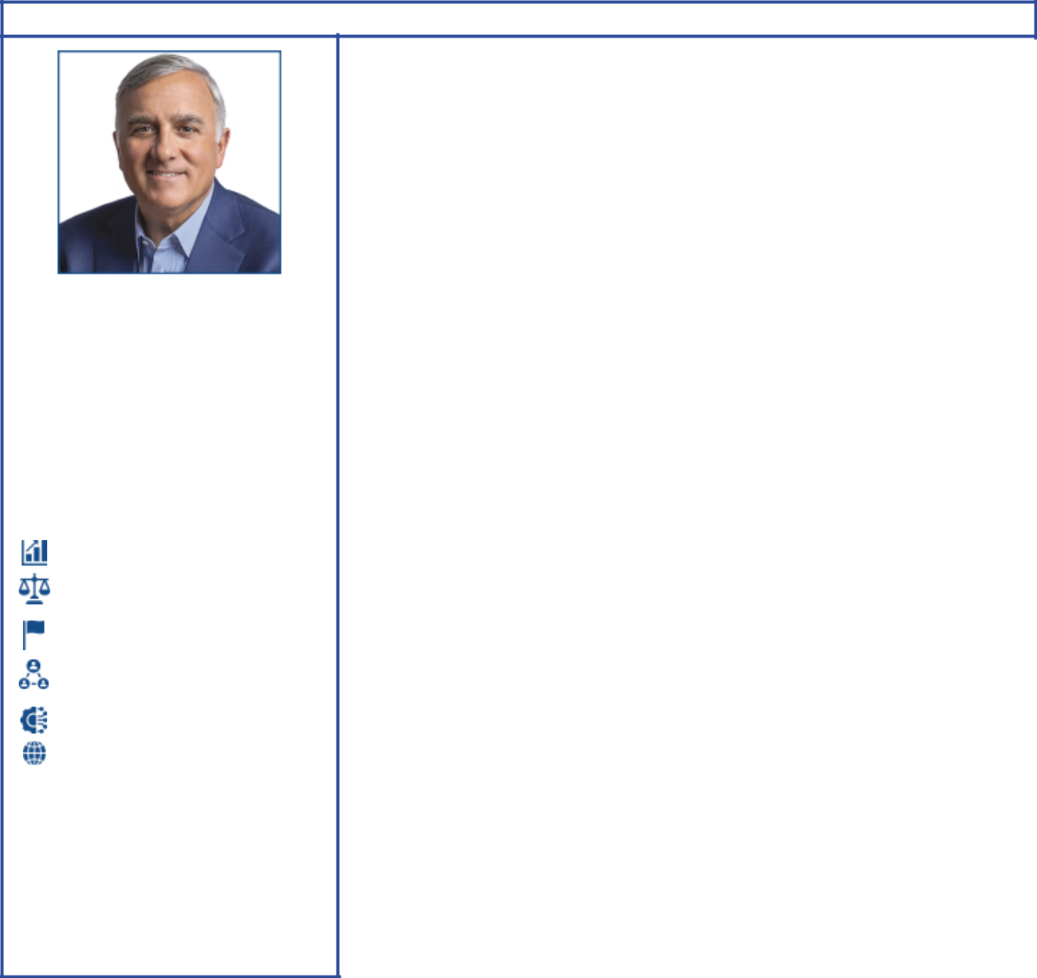

Michael J. Angelakis

Independent director

Director since 2021
Age 58

Committees:

Audit; Executive; Finance (Chair)

Attributes and Skills:

Financial expertise and portfolio management

Public policy / regulatory experience

Risk management / investment stewardship experience

Public company board governance experience

Operation experience in capital-intensive industry

Global business experience

Expertise provided to the Board:

Mr. Angelakis’ financial experience, highlighted by his executive leadership position (CFO) transforming Comcast while navigating the financial crisis of 2008, helps the Board to better understand financial risk and opportunities facing ExxonMobil. In addition to his extensive business career, Mr. Angelakis’ experience as Chairman of the Federal Reserve Bank of Philadelphia provides a vital perspective to the challenges ExxonMobil faces related to policy risk.

Qualifications:

Atairos Group

• Chair & CEO (2015 to present)

Comcast Corporation

• Vice Chairman & CFO (2011 to 2015)

• Executive Vice President & CFO (2007 to 2011)

Providence Equity Partners

• Managing Director and member of the Management and Investment Committees (1999 to 2007)

Current public company directorships:

Bowlero Corporation (December 2021 to present; Chair of the Nominating and Corporate Governance Committee)

Clarivate Plc (December 2021 to present)

TriNet Group, Inc. (February 2017 to present; member of the Nominating and Corporate Governance and Compensation committees)

Previous public company directorships in last five years:

Groupon, Inc. (April 2016 to May 2021)

Hewlett Packard Enterprise Company (November 2015 to April 2020)

Other board experience:

Chairman of The Federal Reserve Bank of Philadelphia (2016 to 2018) and Deputy Chairman and board member (2012 to 2016)

8 2023 Proxy Statement

Table of Contents


Susan K. Avery

Independent director

Director since 2017
Age 73

Committees:

Environment, Safety and Public Policy (Chair); Nominating and Governance

Attributes and Skills:

Public policy / regulatory experience

Relevant scientific / technology experience

Low carbon solutions technology and safety experience

Expertise provided to the Board:

Dr. Avery brings extensive experience as an atmospheric scientist and engineer. Her work at the University of Colorado-Boulder and Woods Hole Oceanographic Institution puts her at the leading edge of climate research, including the evolving field of earth system science. This unique perspective helps the Board better understand the technological opportunities available in low carbon solutions as well as providing effective oversight to the climate-related risks facing ExxonMobil.

Qualifications:

Woods Hole Oceanographic Institution • President & Director (2008 to 2015) University of Colorado-Boulder

• Interim dean of the graduate school and vice chancellor for research, interim provost, and executive vice chancellor for academic affairs (2004 to 2008)

Current public company directorships:

None

Previous public company directorships in last five years:

None

Government / scientific research experience:

Past member of the United Nations Scientific Advisory Board and the National Research Council Global Change Research Program Advisory Committee

Science, engineering, and research:

Advisory committee memberships held or recently held include the American Institute of Physics Board (Treasurer); NASA; NOAA; National Science Foundation; Lawrence Berkeley National Laboratory; National Park System; Independent Advisory Committee on Applied Climate Risk; Center for Southern Hemisphere Ocean Research; and Japan Agency for Marine-Earth Science and Technology

Scientific and environment affiliations:

University Corporation for Atmospheric Research (Chair); American Geophysical Union; American Meteorological Society (fellow); American Association for the Advancement of Science (fellow); and IEEE (fellow)

2023 Proxy Statement | 9

Table of Contents


Angela F. Braly

Independent director

Director since 2016
Age 61

Committees:

Compensation (Chair); Environment, Safety and Public Policy

Attributes and Skills:

Public policy / regulatory experience

Public company board governance experience

Current / former CEO of large public company

Financial expertise and portfolio management

Risk management / investment stewardship experience

Expertise provided to the Board:

Ms. Braly’s experience successfully leading WellPoint through the regulatory changes stemming from the Affordable Care Act helps the Board to better understand the risks and opportunities in industries that are challenged by government-led transformation. Her continued work in public policy and governance experience on the Board of Procter & Gamble, a 100,000+ employee company, further helps the Board navigate public policy issues that arise at a global public company.

Qualifications:

WellPoint, Inc. (formerly known as Anthem, Inc. and now known as Elevance Health, Inc.)

• Chair (2010 to 2012)

• President, CEO (2007 to 2012)

• Executive Vice President, General Counsel, and Chief Public Affairs Officer (2005 to 2007)

Blue Cross Blue Shield of Missouri • CEO (2003 to 2005)

Current public company directorships:

Brookfield Asset Management Inc. (now Brookfield Corporation) (May 2015 to present; Audit Committee member)

The Procter & Gamble Company (December 2009 to present; Chair of the Governance & Public Responsibility Committee and Audit Committee member)

Previous public company directorships in last five years:

Lowe’s Companies, Inc. (November 2013 to July 2021)

Business and public policy affiliations:

Blue Cross Blue Shield Association (former Director); Business Council (former member); Business Roundtable (former member); Harvard Advisory Council on Health Care Policy (former member); Indiana Economic Development Corporation (former Director); and The Policy Circle (Co-Founder, Director, and Secretary)

10 2023 Proxy Statement

Table of Contents


Gregory J. Goff

Independent director

Director since 2021
Age 66

Committees:

Audit; Executive; Finance

Attributes and Skills:

Leadership experience in large-scale energy / commodity business

Public company board governance experience

Current / former CEO of large public company

Global business experience

Public policy / regulatory experience

Low carbon solutions technology and safety experience

Financial expertise and portfolio management

Operation experience in capital-intensive industry

Risk management / investment stewardship experience

Expertise provided to the Board:

Mr. Goff brings significant industry experience in the areas of exploration and production, marketing and logistics, refining, trading, and lower carbon solutions, including renewable fuels, from his leadership roles at ConocoPhillips and Andeavor. This deep understanding of operational processes at scale helps the Board refine its long-term strategies while providing effective oversight of management. Mr. Goff’s extensive transaction experience, in addition to his unique understanding of the regulatory risks related to the industry, provides a vital perspective to the ExxonMobil Board.

Qualifications:

Marathon Petroleum Corporation • Executive Vice Chairman (2018 to 2019)

Andeavor

• Chair (2014 to 2018)

• President & CEO (2010 to 2018)

ConocoPhillips

• Over his 30-year career at ConocoPhillips, Mr. Goff held multiple roles in the

areas of Exploration and Production, Downstream, and served as Senior Vice President of Commercial from 2008 to 2010.

Current public company directorships:

Avient Corporation (October 2011 to present; Chair of the Environmental, Health and Safety Committee, Governance Committee member)

Previous public company directorships in last five years:

Andeavor (May 2010 to October 2018)

Andeavor Logistics LP (April 2011 to October 2018)

Marathon Petroleum Corporation (October 2018 to December 2019)

MPLX LP (October 2018 to December 2019)

Enbridge Inc. (February 2020 to June 2021)

Other board experience:

American Fuel & Petrochemical Manufacturers (Chair 2015 to 2017)

2023 Proxy Statement | 11

Table of Contents
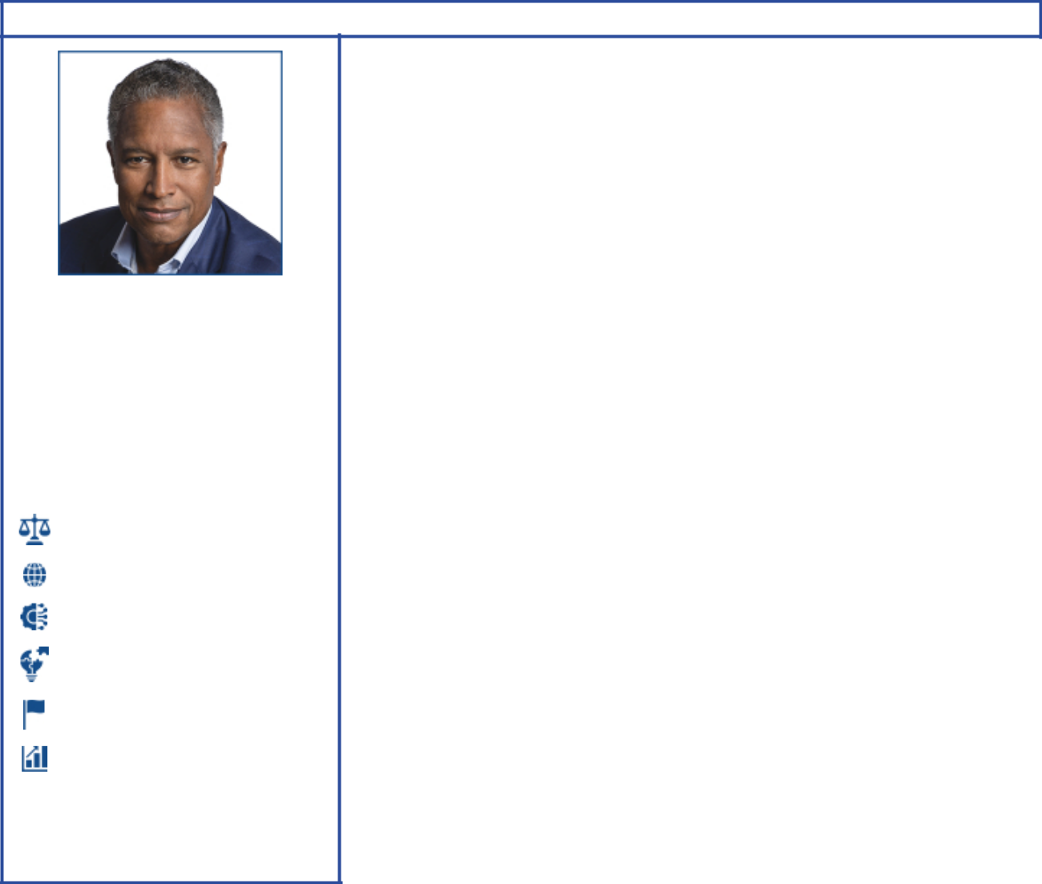

John D. Harris II

Independent director

Director since 2023
Age 61

Committees:

Audit; Compensation

Attributes and Skills:

Public policy / regulatory experience

Global business experience

Operation experience in capital-intensive industry

Relevant scientific / technology experience

Risk management / investment stewardship experience

Financial expertise and portfolio management

Expertise provided to the Board:

Mr. Harris brings to the Board a global perspective, as well as strategic, functional, and operational skills with a focus on customer success. He is a committed innovator and leader with a deep understanding of business transformation. Mr. Harris’ CEO and functional experience includes competencies in talent management, culture development, and strategic planning.

Qualifications:

Raytheon Technologies Corporation (1983 to 2020) • CEO, Raytheon International, Inc. (2013 to 2020)

• Mr. Harris held various leadership positions, including serving as General Manager of Raytheon’s Intelligence, Information and Services business, President of Raytheon Technical Services Company, Vice President of Operations and Contracts for Raytheon’s Electronic Systems business, Vice President of Contracts for Raytheon’s government and defense businesses, Vice President of Contracts and Supply Chain for Raytheon Company, and Vice President of Business Development for Raytheon Company.

Current public company directorships:

Flex Ltd. (November 2020 to present; Compensation & People Committee member)

Cisco Systems, Inc. (June 2021 to present; member of Audit and Compensation & Management Development Committees)

Kyndryl Holdings, Inc. (September 2021 to present; Nominating & Corporate Governance Committee member)

Previous public company directorships in last five years:

None

Other affiliations:

Redwood Library and Athenaeum (Board member); McLaren Racing (Advisory Team member)

12 2023 Proxy Statement

Table of Contents


Kaisa H. Hietala

Independent director

Director since 2021
Age 52

Committees:

Audit; Finance

Attributes and Skills:

Global business experience

Relevant scientific / technology experience

Risk management / investment stewardship experience

Low carbon solutions technology and safety experience

Operation experience in capital-intensive industry
Leadership experience in large-scale energy / commodity business

Financial expertise and portfolio management

Public company board governance experience

Expertise provided to the Board:

Ms. Hietala brings a breadth of industry experience, having led the transformation of an oil and gas company into one of the world’s largest producers of renewable diesel. In addition to her vast industry experience, Ms. Hietala’s academic background in geophysics helps the Board to better understand both the risks and opportunities ExxonMobil faces in its low carbon solutions technologies.

Qualifications:

Neste Corporation

• Executive Vice President of Renewable Products and member of the Executive Committee (2014 to 2019)

• Over her 20-year career at Neste Corporation, Ms. Hietala served in various roles, from exploration and production and crude trading to leading the strategic review that resulted in the Renewable Products segment.

Current public company directorships: Rio Tinto Group (March 2023 to present)

Smurfit Kappa Group Plc (October 2020 to present; Senior Independent Director as of 2022; member of the Audit and Sustainability Committees)

Previous public company directorships in last five years:

Kemira Oyj (March 2016 to March 2021)

Other board experience:

Chair of Tracegrow Oy (2019 to present)

Sustainability and academic affiliations:

New Sustainability Oy (partner); Supervisory Board of Oulu University (member); Susformation Oy (Founder); and Sustainability Hub Advisory Board of Aalto University (former member)

2023 Proxy Statement | 13

Table of Contents
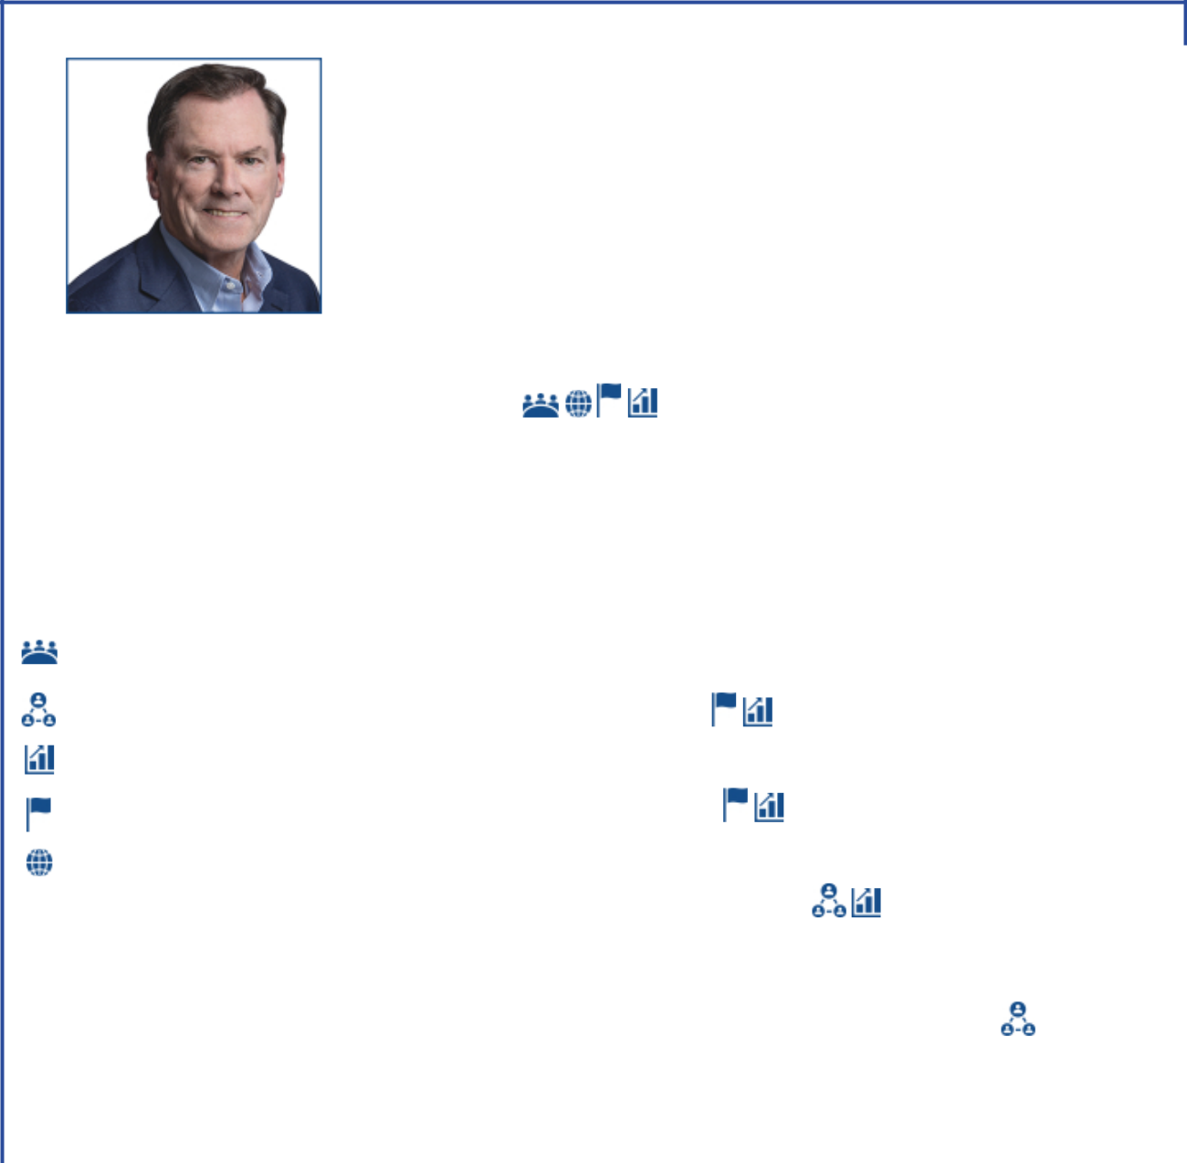

Joseph L. Hooley

 |  |  | Expertise provided to the Board:
 |  |  | Mr. Hooley has extensive experience with institutional investors having overseen
 |  |  | the servicing of over $35 trillion of assets as well as the stewardship of over $4
 |  |  | trillion in capital as Chair and CEO at State Street. Mr. Hooley successfully
 |  |  | transformed State Street in multiple ways, including driving a technological
 |  |  | transformation, globalization of the business and investment portfolio, and
 |  |  | navigating the post-financial crisis of 2008. Mr. Hooley’s unique background
 |  |  | helps the Board better understand investors’ perspectives on risk and ensures
 |  |  | those perspectives are incorporated into Board discussions with management on
 |  |  | important strategic decisions.
Lead Independent director |  |  | Qualifications:
Director since 2020
Age 66 |  |  | State Street
Committees: |  |  | • Chair (2011 to 2019)
Compensation; Executive;
Nominating and Governance |  |  | • CEO (2010 to 2018)
(Chair) |  |  | • President & COO (2008 to 2014)
 |  |  | • Executive Vice President and Head of Investor Services Division (2002 to
Attributes and Skills: |  | 2008)
 |  |  | • Vice Chairman and Global Business Experience Head of Investment
 | Current / former CEO of large public
 | company |  | Servicing and Investment Research and Trading (2006)
 | Public company board governance
 | experience |  | Boston Financial Data Services
 | Financial expertise and portfolio |  | • President & CEO (1990 to 2000)
 | management
 | Risk management / investment |  | National Financial Data Services
 | stewardship experience
 | Global business experience |  | • President & CEO (1988 to 1990)
 |  |  | Current public company directorships:
 |  |  | Aptiv PLC (January 2020 to present; Chair of the Compensation and Human
 |  |  | Resources Committee; Audit Committee member)
 |  |  | Previous public company directorships in last five years:
 |  |  | State Street Corporation (October 2009 to December 2019)
 |  |  | Other board experience:
 |  |  | Liberty Mutual Insurance (2019 to present)
14 | 2023 Proxy Statement

Table of Contents
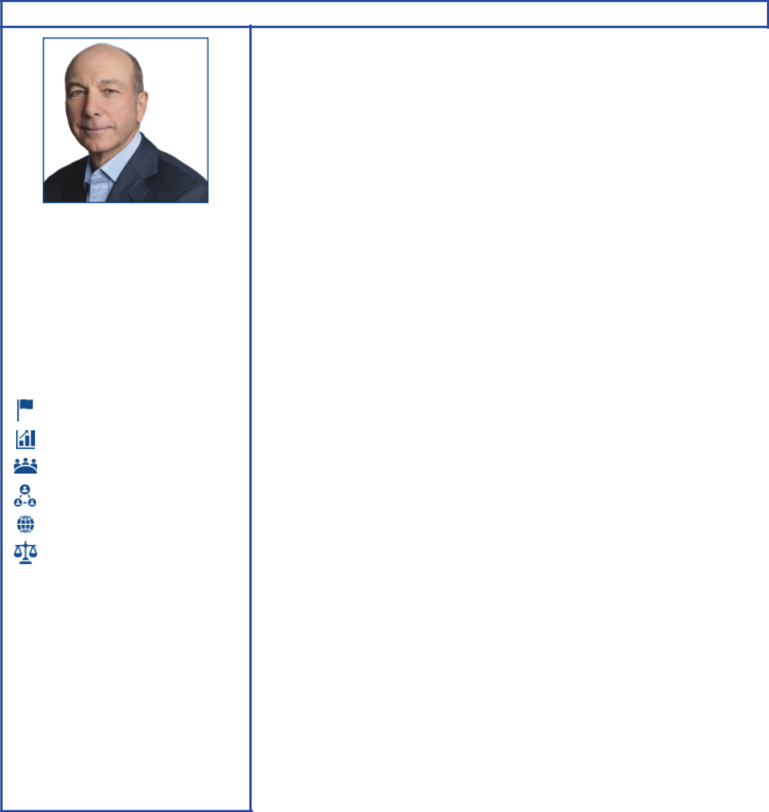

Steven A. Kandarian

Independent director

Director since 2018
Age 71

Committees:

Compensation; Nominating and Governance

Attributes and Skills:

Risk management / investment stewardship experience

Financial expertise and portfolio management

Current / former CEO of large public company
Public company board governance experience

Global business experience

Public policy / regulatory experience

Expertise provided to the Board:

Mr. Kandarian’s 14 years of senior executive leadership experience at MetLife, where he led a significant transformation following the implementation of Dodd-Frank, brings a viewpoint vital to the Board when developing the long-term strategic plan and overseeing capital allocation across the portfolio. His former positions as CEO and CIO of a global large-cap insurance business, in addition to his previous work as a Federal regulator, provide the Board with critical insights related to geopolitical risks, government engagement, and risk management.

Qualifications:

MetLife, Inc.

• President & CEO (2011 to 2019)

• Chair (2012 to 2019)

• Chief Investment Officer (2005 to 2011)

Pension Benefit Guaranty Corporation • Executive Director (2001 to 2004)

Current public company directorships:

Jackson Financial Inc. (February 2021 to present; Non-executive Chair; Chair of the Nominating & Governance Committee, Compensation Committee member)

Previous public company directorships in last five years:

AECOM (March 2019 to February 2021; Lead Independent Director; Chair of the Compensation Committee; member of the Audit Committee)

MetLife (May 2011 to April 2019)

Other board experience:

Director of Neuberger Berman (2015 to present)

Business and cultural affiliations:

The University of California, Berkeley, School of Law and Ceres ESG certification (recipient); Business Council (member); Business Roundtable (former member); Financial Services Forum (former member); Partnership for New York City (former Director); Institute of International Finance (former Director and Chair, Insurance Regulatory Committee); and the Lincoln Center for the Performing Arts (former Director)

Scientific and research affiliations:

Damon Runyon Cancer Research Foundation (Director)

2023 Proxy Statement | 15

Table of Contents


Alexander A. Karsner

Independent director

Director since 2021
Age 56

Committees:

Environment, Safety and Public Policy; Nominating and Governance

Attributes and Skills:

Risk management / investment stewardship experience

Public policy / regulatory experience

Relevant scientific / technology experience

Low carbon solutions technology and safety experience

Financial expertise and portfolio management

Global business experience

Expertise provided to the Board:

Mr. Karsner’s energy policy and diplomacy experience, in addition to his background in commercializing breakthrough energy technologies, provides the Board with important perspectives on geopolitical risks and investment opportunities for profitably managing the energy transition. Mr. Karsner’s public service as U.S. Assistant Secretary of Energy, a senior regulatory official, and a principal U.S. negotiator to the UN Framework Convention on Climate Change, contributes an in-depth understanding of U.S. and international energy policy. His energy sector experience, including energy infrastructure development in emerging markets, helps the Board better understand public- and private-sector considerations when executing strategy.

Qualifications:

X (formerly Google X) Alphabet’s Moonshot Factory • Senior Strategist (2013 to present)

Emerson Collective

• Managing Partner (2016 to 2019)

Hudson Private Equity

• Senior Advisor (2009 to 2014)

Vantage Point Venture Capital

• Senior Advisor, Venture Partner (2009 to 2014)

Department of Energy

• U.S. Assistant Secretary (2006 to 2008)

Current public company directorships:

Applied Materials, Inc. (September 2008 to present; member of the Corporate Governance & Nominating and Human Resources & Compensation Committees)

Previous public company directorships in last five years:

Broadscale Acquisition Corp. (February 2021 to January 2023)

Business and public policy experience:

Council on Foreign Relations Working Group on Energy Transition (co-chair), and U.S.-India and U.S.-China Track II diplomatic climate bi-laterals; National Petroleum Council (former member); Energy Futures Initiative; Trilateral Commission (member); Gas Technology Institute (former Director); Argonne National Laboratory (former Director)

Sustainability, scientific and academic affiliations:

Rice University Institute for Material Science (Director); Conservation International (Director); Elemental Labs (Founder, Chairman); National Marine Sanctuary Foundation (Trustee Emeritus); Aspen Institute Clean Energy Forum (Founder); American Academy of Arts & Sciences Accelerating Climate Action Commission (member); Stanford University Precourt Institute for Energy (member, Board of Advisors); Hoover Institution Shultz-Stephenson Energy Task Force (member); Stanford Natural Capital Project (Advisory Board); MIT Media Lab (Advisory Board)

16 2023 Proxy Statement

Table of Contents
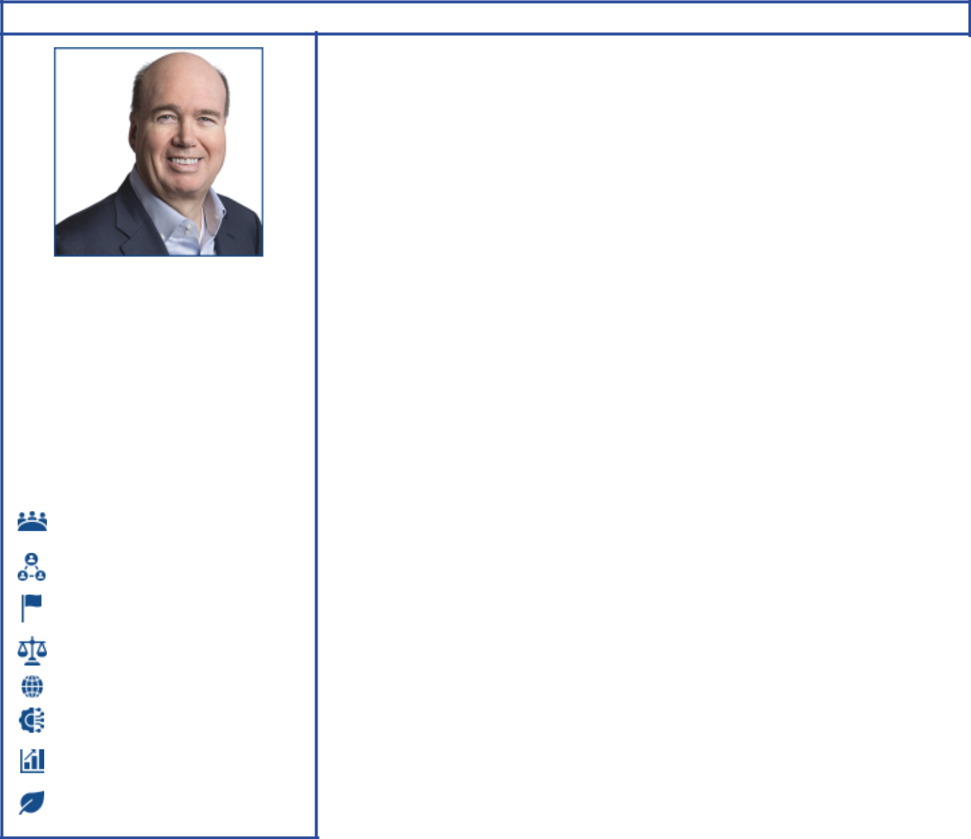

Lawrence W. Kellner

Independent director

Director since 2023
Age 64

Committees:

Environment, Safety and
Public Policy; Nominating

and Governance

Attributes and Skills:

Current / former CEO of large public company

Public company board governance experience

Risk management / investment stewardship experience

Public policy / regulatory experience

Global business experience

Operation experience in capital-intensive industry

Financial expertise and portfolio management

Low carbon solutions technology and safety experience

Expertise provided to the Board:

Mr. Kellner brings extensive experience in a highly regulated and capital-intensive industry, having served as CEO, COO, and Chair of Continental Airlines. Mr. Kellner’s deep operational understanding and executive leadership help the Board understand how best to develop a long-term strategy for a capital-intensive industry.

Qualifications:

Emerald Creek Group, LLC

• President (2010 to present)

Continental Airlines, Inc. • Chairman & CEO (2004 to 2009) • President & COO (2003 to 2004) • President (2001 to 2003)

Current public company directorships:

The Boeing Company (October 2011 to present; Independent Chair December 2019 to present; member of the Aerospace Safety and Governance & Public Policy Committees)

Previous public company directorships in last five years:

Marriott International, Inc. (July 2002 to May 2022; Lead Independent Director from 2013 to 2022)
Sabre Corporation (August 2013 to April 2020; Chair of the Board from August 2013 to January 2020)

2023 Proxy Statement | 17

Table of Contents


Jeffrey W. Ubben

Independent director

Director since 2021
Age 61

Committees:

Environment, Safety and
Public Policy; Finance

Attributes and Skills:

Financial expertise and portfolio management

Risk management / investment stewardship experience

Relevant scientific / technology experience

Low carbon solutions technology and safety experience

Public company board governance experience

Expertise provided to the Board:

Having served on over 20 public company boards, Mr. Ubben brings a long history of successfully challenging and working alongside boards and management teams to grow value for shareholders. His expertise in return-driven, environmental and socially active investing, including his unique knowledge and experience investing in the energy transition, helps the Board make better strategic and investing decisions around low carbon solutions, including carbon capture and hydrogen technologies.

Qualifications:

Inclusive Capital Partners, L.P.

• Founder, Portfolio Manager and Managing Partner (2020 to present)

• Inclusive Capital Partners is focused on increasing shareholder value and promoting sound environmental, social, and governance practices

ValueAct Capital Management, L.P. • Founder & CEO (2000 to 2020) • CIO (2000 to 2017)

Blum Capital Partners, L.P.

• Managing Partner (1995 to 2000)

Fidelity Investments

• Served in various positions including Portfolio Manager and Research Analyst (1987 to 1995)

Current public company directorships:

Vistry Group Plc (March 2023 to present)

Enviva Inc. (June 2020 to present)

Previous public company directorships in last five years:

Fertiglobe Plc (November 2021 to March 2023)

AppHarvest, Inc. (May 2019 to March 2022)

Nikola Corporation (September 2019 to February 2022; Chair of the Nominating and Corporate Governance Committee)

The AES Corporation (January 2018 to March 2021)

Twenty-First Century Fox, Inc. (November 2015 to April 2018)

Other affiliations:

World Wildlife Fund (Board member); E.O. Wilson Biodiversity Foundation (Board member); The Redford Center (Board member); and Duke University (Board member)

18 2023 Proxy Statement

Table of Contents
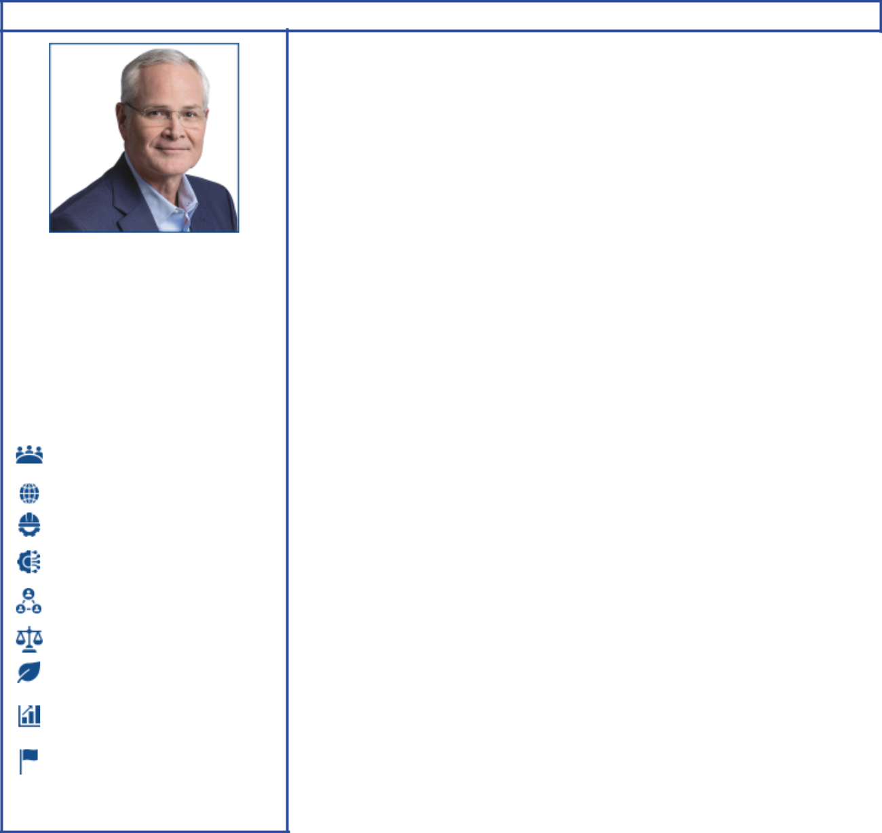

Darren W. Woods

Chairman of the Board,

Chief Executive Officer
Director since 2016

Age 58

Committees:

Executive (Chair); Finance

Attributes and Skills:

Current / former CEO of large public company

Global business experience

Leadership experience in large-scale energy / commodity business

Operation experience in capital-intensive industry

Public company board governance experience

Public policy / regulatory experience

Low carbon solutions technology and safety experience

Financial expertise and portfolio management

Risk management / investment stewardship experience

Expertise provided to the Board:

Mr. Woods brings more than 30 years of global industry experience managing highly sophisticated, safety-critical operations and has held a number of senior leadership roles in multiple international business units prior to being promoted to CEO. His in-depth understanding of Company operations, knowledge of global business, markets, and strategy, and experience leading transformational change, helps the Board to better understand and navigate the complex issues associated with transforming a multi-dimensional, capital intensive, commodity business through a thoughtful, long-term energy transition.

Qualifications:

ExxonMobil (1992 to present) • Chair & CEO (2017 to present) • President (2016 to present)
• Vice President, and President, ExxonMobil Refining & Supply Company (2012 to 2014)

Current public company directorships:

None

Previous public company directorships in last five years:

None

Business affiliations:

Business Roundtable (member); American Petroleum Institute (former Chair); Business Council (member); Center for Strategic and International Studies (Trustee); Oil and Gas Climate Initiative; and National Petroleum Council (Chair)

2023 Proxy Statement | 19

Table of Contents

CORPORATE GOVERNANCE

Overview

The Board of Directors and its committees perform a number of functions for ExxonMobil and its shareholders, including:

- Overseeing the management of the Company on your behalf, including oversight of risk management;

- Reviewing ExxonMobil’s long-term strategic plans;

- Exercising direct decision-making authority in key areas, such as declaring dividends;

- Selecting the Chief Executive Officer (CEO) and reviewing the CEO’s performance;

- Reviewing development and succession plans for ExxonMobil’s top executives; and

- Gathering insights and sharing perspectives from shareholders during engagements and other communications.

The Board has adopted Corporate Governance Guidelines that govern the structure and functioning of the Board and set out the Board’s position on a number of governance issues. A copy of our current Corporate Governance Guidelines is posted on our website at exxonmobil.com/governanceguidelines.

Risk Oversight

The full Board of Directors provides oversight of key risks to ExxonMobil’s business. The Board throughout the year participates in reviews with management on the Company’s business, including identified risk factors. As a whole, the Board reviews litigation and other legal matters; political contributions, budget, and policy; lobbying costs; developments in climate science and policy; the Outlook for Energy, which projects world energy supply and demand to 2050; the Advancing Climate Solutions report; stewardship of business performance; and long-term strategic plans. The Board receives updates and reviews from both internal ExxonMobil and external experts on issues of importance to the Company.

The Board, including the Environment, Safety and Public Policy Committee, periodically visits an ExxonMobil operations site. These visits enable the directors to observe and provide input on safety, operating practices, environmental performance, technology, products, industry and corporate standards, and community engagement.

The Board oversees a broad spectrum of interrelated risks with assistance from its committees. This integrated risk management approach facilitates recognition and oversight of important risk interdependencies.

Audit Committee oversees risks associated with financial and accounting matters, including compliance with legal and regulatory requirements and the Company’s financial reporting and internal control systems. At least annually, the Audit Committee also reviews ExxonMobil’s overall risk management approach and structure, including cybersecurity risks and preparedness.

Nominating and Governance Committee oversees Board structure and matters of corporate governance, including Board evaluation and director refreshment. It also coordinates identification of external experts to address the Board and sets the criteria for shareholder engagement with directors.

Compensation Committee reviews executive compensation, which is designed to promote accountability to maximize shareholder value over the long term while effectively managing longer-term risks, including those related to the energy transition. The Committee also assesses each element of the compensation program to ensure that these do not create any material adverse risks to the Company and do not encourage executives to take risks that may not be aligned with shareholders’ long-term interests.

Environment, Safety and Public Policy Committee oversees operational risks such as those relating to employee and community safety, health, environmental performance, including actions taken to address climate-related risks, and security matters. The Committee also reviews and provides advice on objectives, policies, and programs related to lobbying activities and political and other contributions.

20 2023 Proxy Statement

Table of Contents

Finance Committee reviews the Company’s capital structure/capital allocation, and its financial policies, practices, and strategies.

Each Board committee has the authority in its sole discretion to retain and oversee the work of such outside advisors as it deems appropriate and to approve the fees and expenses of such advisors. The Board receives regular updates from the committees and believes this structure is best suited for overseeing risk.

Board Leadership Structure

The Board believes that the decision as to who should serve as Chairman and/or CEO is the proper responsibility of the Board. The Board retains authority to amend the by-laws to separate the positions of Chairman and CEO at any time and regularly considers the pros and cons of such separation or combination. At the present time, the Board believes the interests of all shareholders are best served through a leadership model with a combined Chairman/CEO position and an independent Lead Director selected by and from the independent directors.

The current CEO possesses an in-depth knowledge of the Company; its integrated, multinational operations; the evolving energy industry supply and demand fundamentals; and the array of challenges and opportunities presented by the energy transition. This knowledge was gained through more than 30 years of successful experience in progressively more senior positions, including domestic and international responsibilities.

The Board believes that these experiences and other insights put the CEO in the best position to provide broad leadership for the Board as it considers strategy and exercises its fiduciary responsibilities to shareholders. Further, the Board has demonstrated its commitment and ability to provide independent oversight of management.

The Board is comprised solely of independent directors other than the CEO, and 100 percent of the Audit, Compensation, Nominating and Governance, and Environment, Safety and Public Policy Committee members are independent. Each independent director has access to the CEO and other Company executives and employees, and is empowered to call meetings of the independent directors and request agenda topics to be added or addressed in more detail at meetings of the full Board or an appropriate Board committee.

The Board believes the Lead Director provides effective independent Board leadership. Joseph L. Hooley serves as Lead Director and is expected to remain in the position through the annual meeting of shareholders.

The Lead Director’s authority, under the

Corporate Governance Guidelines, includes:

• Calling, chairing, and setting the agenda for executive sessions of the non-employee directors;

• Providing feedback to the Chairman;

• Chairing meetings of the Board in the absence of the Chairman;

• Reviewing and approving the schedule and agenda for all Board meetings and reviewing associated materials distributed to the directors, in consultation with the Chairman;

• Advising the Chairman on the quality, quantity, and timeliness of information flow;

• Reviewing committee meeting schedules;

• Engaging with shareholders, as appropriate; and

• Leading the annual performance evaluation of the Board.

The Lead Director also serves as Chair of the Nominating and Governance Committee with authority that includes:

• Establishing the criteria for director engagement with shareholders;
• Providing comments and suggestions to the Board on Board committee structure, operations, member qualification, and member appointment;

• Overseeing independent director succession planning, remuneration, requests for additions to board memberships, and resignations;

• Establishing and maintaining procedures for interested parties to communicate with non-employee directors;

• Considering Board governance practices and procedures, including any changes to governance guidelines; and

• Providing oversight of the performance and effectiveness of the evaluation process for the Board and its committees.

In addition, the Lead Director, working together with the Compensation Committee, oversees the annual evaluation of the CEO, the communication of resulting feedback to the CEO, and the review of CEO succession plans.

2023 Proxy Statement | 21

Table of Contents

Board and Committee Self-Evaluations

Each year, the Board and each of the Board committees conduct a comprehensive evaluation of their performance and effectiveness and solicit feedback for enhancement and improvement. The Lead Director, as Chair of the Nominating and Governance Committee, oversees the Board evaluation process and will periodically engage outside counsel to bring a third-party perspective to the process.

As part of the Board’s robust assessment, the Lead Director or outside counsel, as applicable, will ask each director for suggestions to improve Board and Board committee effectiveness and feedback on a range of issues, including Board leadership, culture, purpose, and strategy; Board composition and structure; individual director performance; quality of deliberations and communication with management; and oversight of risk management. The Board reviews and discusses the feedback during an evaluation session facilitated by the Lead Director, providing an opportunity for Directors to identify areas for improvement.

Director feedback emphasized the need for continued focus on strategic oversight, including the development and deployment of solutions to support a lower-emissions future while helping meet society’s need for energy and products, as well as the development of the Company’s next generation of leaders.

Director Qualifications

ExxonMobil’s Corporate Governance Guidelines outline the qualifications sought when considering non-employee director candidates. The Corporate Governance Guidelines state in part:

“ExxonMobil recognizes the strength and effectiveness of the Board reflects the balance, experience, and diversity of the individual directors; their commitment; and importantly, the ability of directors to work effectively as a group in carrying out their responsibilities. ExxonMobil seeks candidates with diverse backgrounds who possess knowledge and skills in areas of importance to the Corporation.”

Within the scope of the Corporate Governance Guidelines, we seek director candidates with a diversity of experiences and backgrounds, including gender and race/ethnic diversity, with a focus on the key director competencies described in more detail in the “Competencies and Relevance” matrix below.

Additional considerations for director candidates include: a substantial majority of the Board must meet independence standards as described in the Corporate Governance Guidelines; all candidates must be free from any relationship with management or the Corporation that would interfere with the exercise of independent judgment; candidates should be committed to representing the interests of all shareholders and not any particular constituency; and the Board must include members who satisfy legal and stock exchange requirements for certain Board committees.

All directors are expected to adhere to the Company’s policies and procedures, including the Conflict of Interest Policy and Ethics Policy. See the Code of Ethics and Business Conduct section below for additional information.

22 2023 Proxy Statement

Table of Contents

The Board is comprised of directors with an effective mix of backgrounds, knowledge, and skills that the Board considers relevant and beneficial in fulfilling its oversight role. The chart below provides a summary of the competencies of the current ExxonMobil Board and explains why these are important.

ExxonMobil Board competencies and Director qualifications


Current / former CEO of large public company

An understanding of the complexities inherent in running a large public company provides a unique perspective that helps the Board independently oversee the Company’s management, long-term strategic planning, shareholder value creation, human capital management, risk oversight, governance, and shareholder engagement.

Global business experience

Leadership experience in a multinational business that operates across diverse and evolving political conditions, economic systems, and cultures provides valuable perspectives for oversight of the risks and opportunities within the Company’s extensive global business and operations.

Operation experience in capital-intensive industry

Leadership experience in a business with capital-intensive industrial operations, involving complex engineering and long-lived assets, provides critical insight for assessing the risks and opportunities that face the Company in its long-term capital deployment decisions and for overseeing its financial and operational performance.

Leadership experience in large-scale energy / commodity business

Understanding the unique challenges of large-scale energy or other cyclical or commodity businesses provides critical insight for assessing Company strategies, challenges, and opportunities in operations, risks, and business transitions.

Financial expertise and portfolio management

Expertise in finance, accounting, financial reporting, and portfolio management is essential to the Board’s oversight of the Company’s capital allocation, risk management strategies, and internal financial controls and procedures.

Risk management / investment stewardship experience

Experience managing a broad array of enterprise risks and stewarding investor capital through varied and challenging market conditions, business cycles, and business transitions provides critical expertise to better develop and oversee execution of the Company’s long-term strategies.

Public policy / regulatory experience

Deep understanding of public policy and regulatory matters relevant to the Company’s businesses and global reach assists the Board in developing its long-term strategies by incorporating current and potential changes in public policy and regulation.

Public company board governance experience

Current or prior service as a Chair, Lead Director, Committee Chair, or other significant leadership position on the board of other public companies provides governance experience essential to ensure that the Board continues to maintain the right balance of skills and attributes needed to address the Company’s current and evolving risks and opportunities and to ensure that the Board is focusing on appropriate matters and functioning as an effective and cohesive independent oversight body.

Relevant scientific / technology experience

Experience applying science and technology, including climate science, to large-scale challenges and investments in new and emerging technologies relevant to the Company’s businesses and scale provides sound guidance as the Company navigates the complex challenges of helping society meet the world’s energy needs and reduce carbon emissions.

Low carbon solutions technology and safety experience

Experience in environmental and safety operations, including lower carbon technologies, strengthens the Board’s oversight of the Company’s current and future business operations and promotes long-term sustainability.

2023 Proxy Statement | 23

Table of Contents
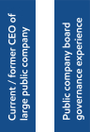
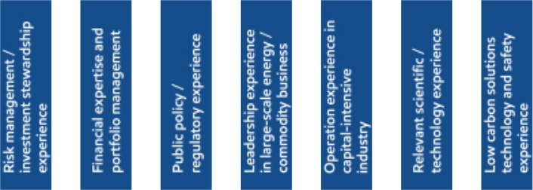

Director & key

qualifications
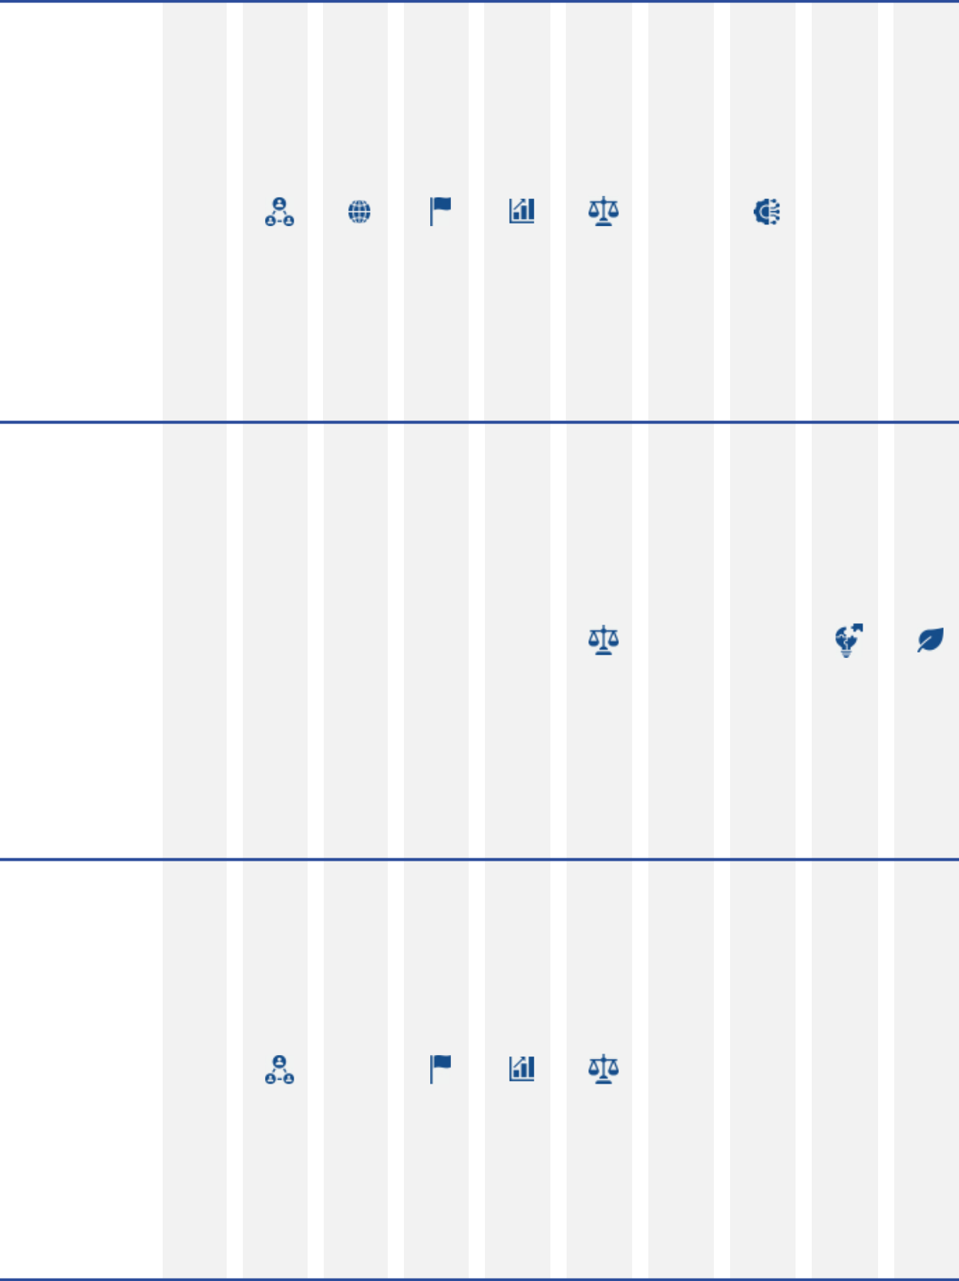

Michael J. Angelakis
Mr. Angelakis’ financial
experience, highlighted
by his executive
leadership position
(CFO) transforming
Comcast while
navigating the financial
crisis of 2008, helps
the Board to better
understand financial
risk and opportunities
facing ExxonMobil. In
addition to his
extensive business
career, Mr. Angelakis’
experience as
Chairman of the
Federal Reserve Bank
of Philadelphia
provides a vital
perspective to the
challenges ExxonMobil
faces related to policy
risk.

Susan K. Avery
Dr. Avery brings
extensive experience
as an atmospheric
scientist and engineer.
Her work at the
University of Colorado-
Boulder and Woods
Hole Oceanographic
Institution puts her at
the leading edge of
climate research,
including the evolving
field of earth system
science. This unique
perspective helps the
Board better
understand the
technological
opportunities available
in low carbon solutions
as well as providing
effective oversight to
the climate-related
risks facing
ExxonMobil.

Angela F. Braly
Ms. Braly’s experience
successfully leading
WellPoint through the
regulatory changes
stemming from the
Affordable Care Act
helps the Board to
better understand the
risks and opportunities
in industries that are
challenged by
government-led
transformation. Her
continued work in
public policy and
governance
experience on the
Board of Procter &
Gamble, a 100,000+
employee company,
further helps the Board
navigate public policy
issues that arise at a
global public company.

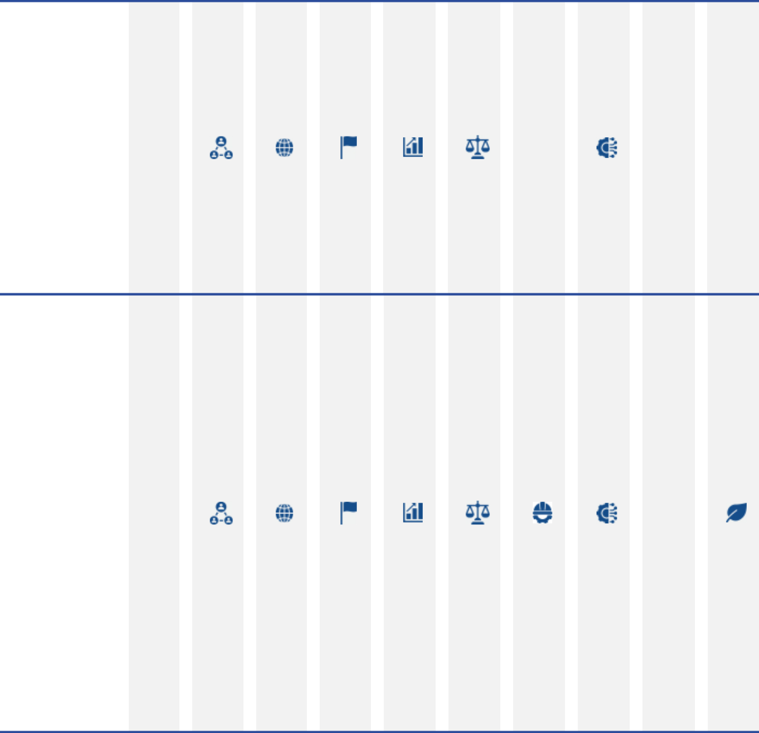
Ursula M. Burns (not
standing for
re-election)
Ms. Burns has deep
expertise running a
large, complex global
corporation. As CEO of
Xerox, Ms. Burns
successfully led its
transformation from a
printing business to a
tech-forward document
management
business. This, along
with her extensive
engineering and
operational
background, provides
a critical perspective to
the Board when
developing its long-

term strategy.

Gregory J. Goff Mr. Goff brings significant industry experience in the areas of exploration and production, marketing and logistics, refining, trading, and lower carbon solutions, including renewable fuels, from his leadership roles at ConocoPhillips and Andeavor. This deep understanding of operational processes at scale helps the Board refine its long-term strategies while providing effective oversight of management.
Mr. Goff’s extensive
transaction
experience, in addition
to his unique
understanding of the
regulatory risks related
to the industry,
provides a vital
perspective to the
ExxonMobil Board.

24 2023 Proxy Statement

Table of Contents

Director & key

qualifications
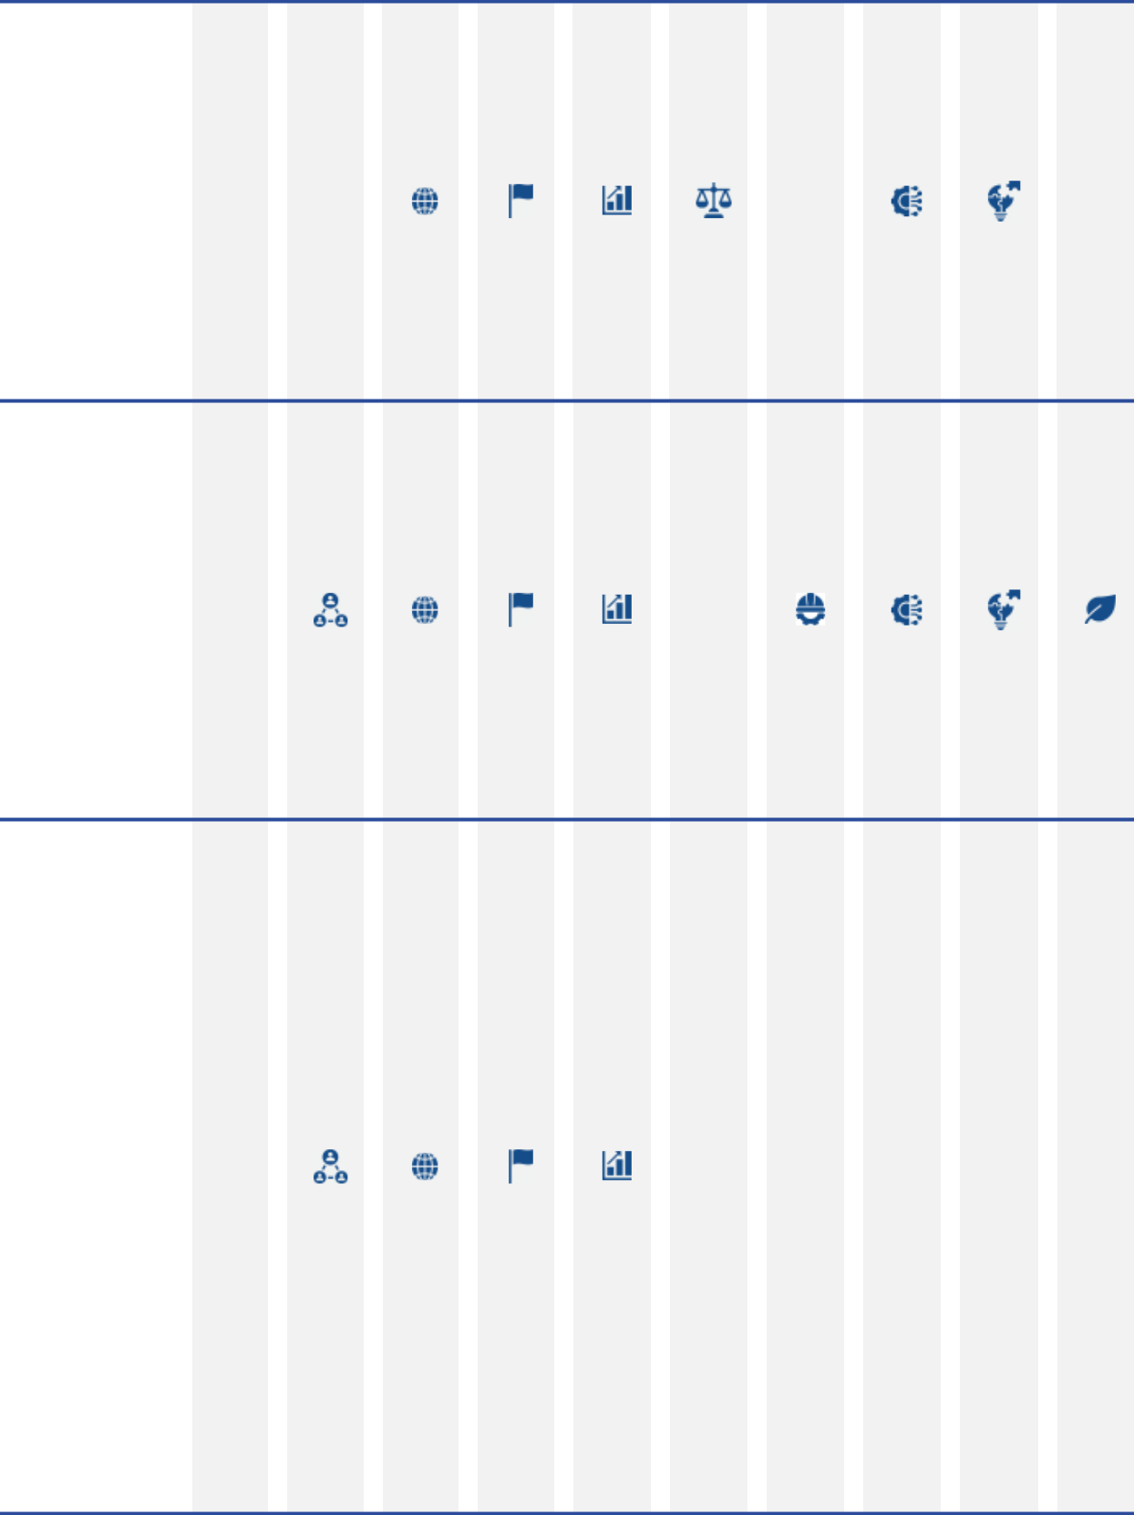

John D. Harris II
Mr. Harris brings to the
Board a global
perspective, as well as
strategic, functional,
and operational skills
with a focus on
customer success. He
is a committed
innovator and leader
with a deep
understanding of
business
transformation. Mr.
Harris’ CEO and
functional experience
includes competencies
in talent management,
culture development,
and strategic planning.

Kaisa H. Hietala
Ms. Hietala brings a
breadth of industry
experience, having led
the transformation of
an oil and gas
company into one of
the world’s largest
producers of
renewable diesel. In
addition to her vast
industry experience,
Ms. Hietala’s academic
background in
geophysics helps the
Board to better
understand both the
risks and opportunities
ExxonMobil faces in its
low carbon solutions
technologies.

Joseph L. Hooley
Mr. Hooley has
extensive experience
with institutional
investors having
overseen the servicing
of over $35 trillion of
assets as well as the
stewardship of over $4
trillion in capital as
Chair and CEO at
State Street. Mr.
Hooley successfully
transformed State
Street in multiple ways,
including driving a
technological
transformation,
globalization of the
business and
investment portfolio,
and navigating the
post-financial crisis of
2008. Mr. Hooley’s
unique background
helps the Board better
understand investors’
perspectives on risk
and ensures those
perspectives are
incorporated into
Board discussions with
management on
important strategic
decisions.


Steven A. Kandarian
Mr. Kandarian’s 14
years of senior
executive leadership
experience at MetLife,
where he led a
significant
transformation
following the
implementation of
Dodd-Frank, brings a
viewpoint vital to the
Board when
developing the long-
term strategic plan and
overseeing capital
allocation across the
portfolio. His former
positions as CEO and
CIO of a global large-
cap insurance
business, in addition to
his previous work as a
Federal regulator,
provide the Board with
critical insights related
to geopolitical risks,
government
engagement, and risk
management.

2023 Proxy Statement | 25

Table of Contents
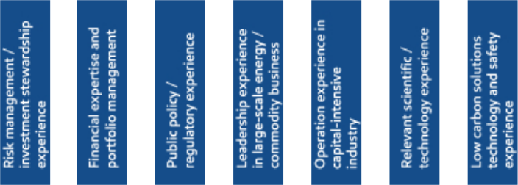

Director & key

qualifications
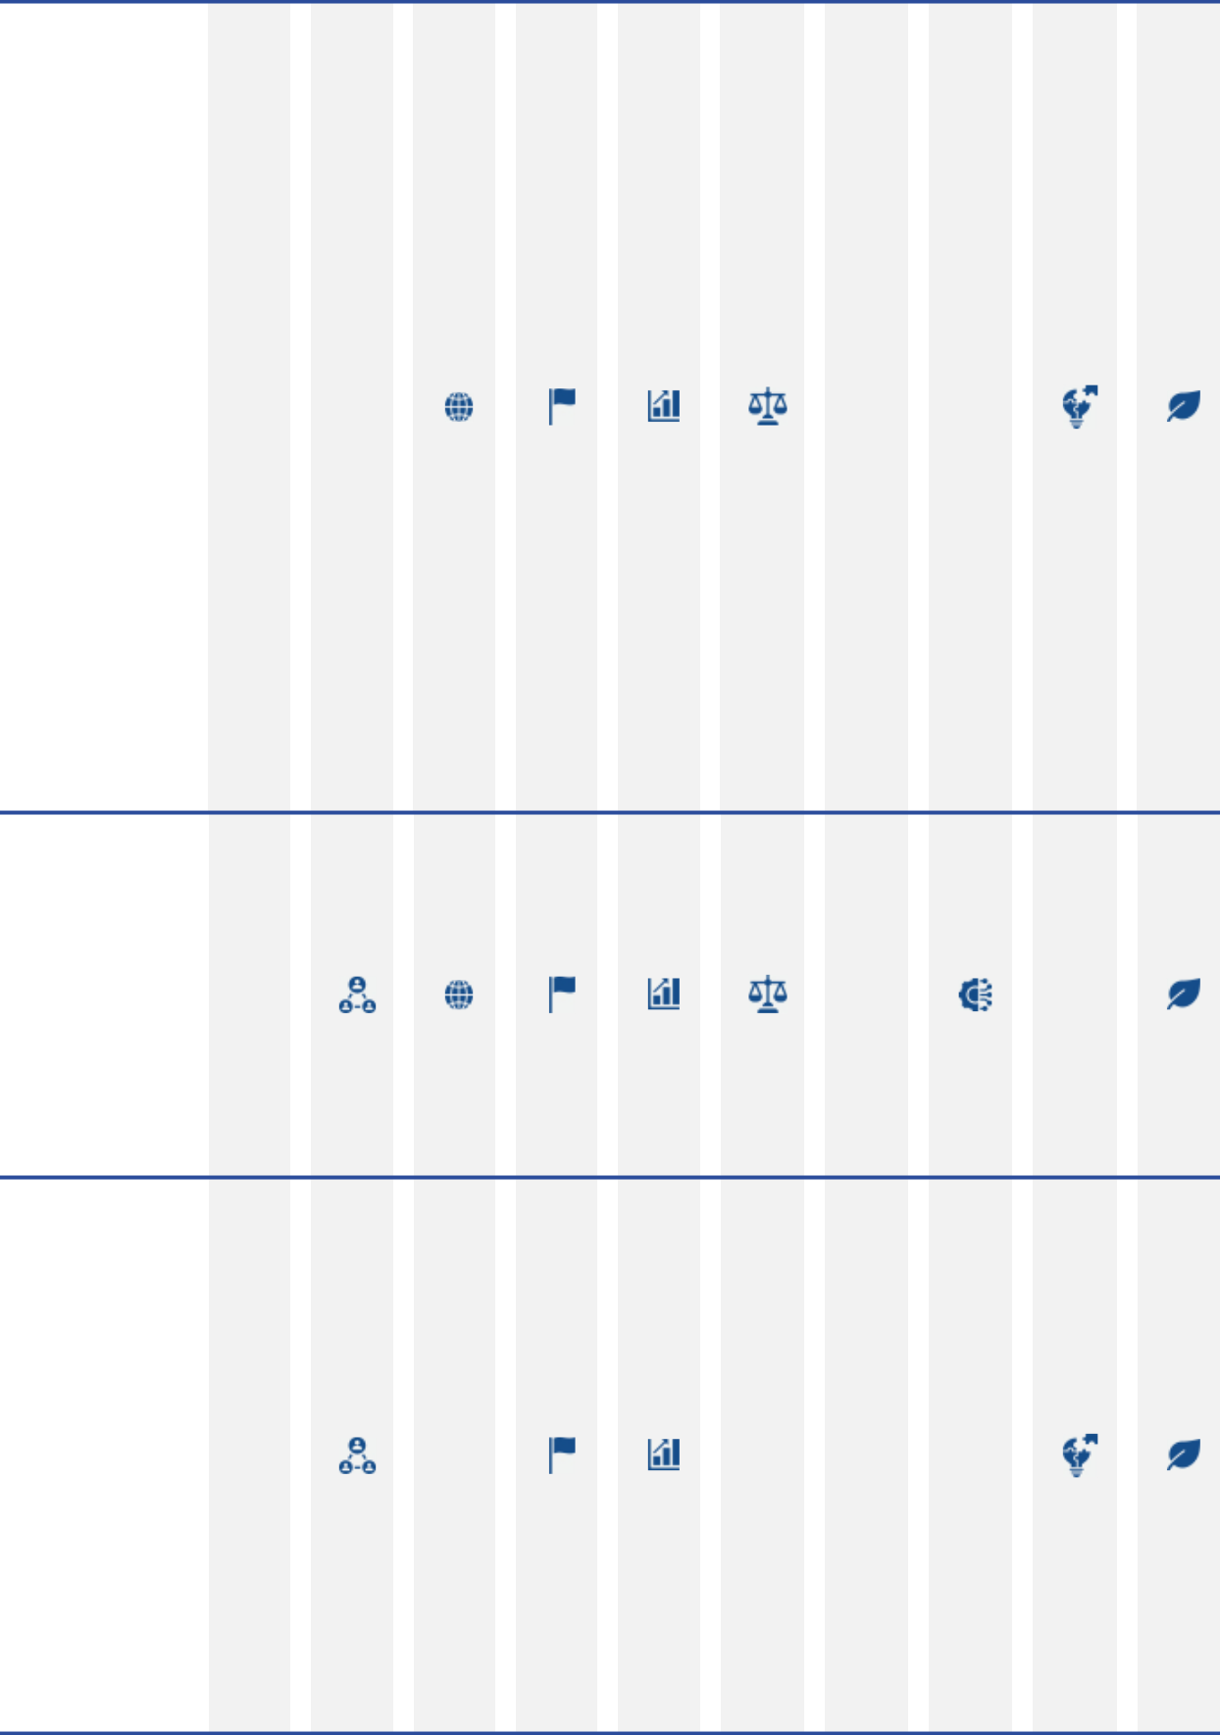

Alexander A. Karsner
Mr. Karsner’s energy
policy and diplomacy
experience, in addition
to his background in
commercializing
breakthrough energy
technologies, provides
the Board with
important perspectives
on geopolitical risks
and investment
opportunities for
profitably managing the
energy transition. Mr.
Karsner’s public
service as U.S.
Assistant Secretary of
Energy, a senior
regulatory official, and
a principal U.S.
negotiator to the UN
Framework Convention
on Climate Change,
contributes an in-depth
understanding of U.S.
and international
energy policy. His
energy sector
experience, including
energy infrastructure
development in
emerging markets,
helps the Board better
understand public- and
private-sector
considerations when
executing its strategy.

Lawrence W. Kellner
Mr. Kellner brings
extensive experience
in a highly regulated
and capital-intensive
industry, having served
as CEO, COO, and
Chair of Continental
Airlines. Mr. Kellner’s
deep operational
understanding and
executive leadership
helps the Board
understand how best to
develop a long-term
strategy for a capital-

intensive industry.

Jeffrey W. Ubben
Having served on over
20 public company
boards, Mr. Ubben
brings a long history of
successfully
challenging and
working alongside
boards and
management teams to
grow value for
shareholders. His
expertise in return-
driven, environmental
and socially active
investing, including his
unique knowledge and
experience investing in
the energy transition,
helps the Board make
better strategic and
investing decisions
around low carbon
solutions, including
carbon capture and
hydrogen technologies.

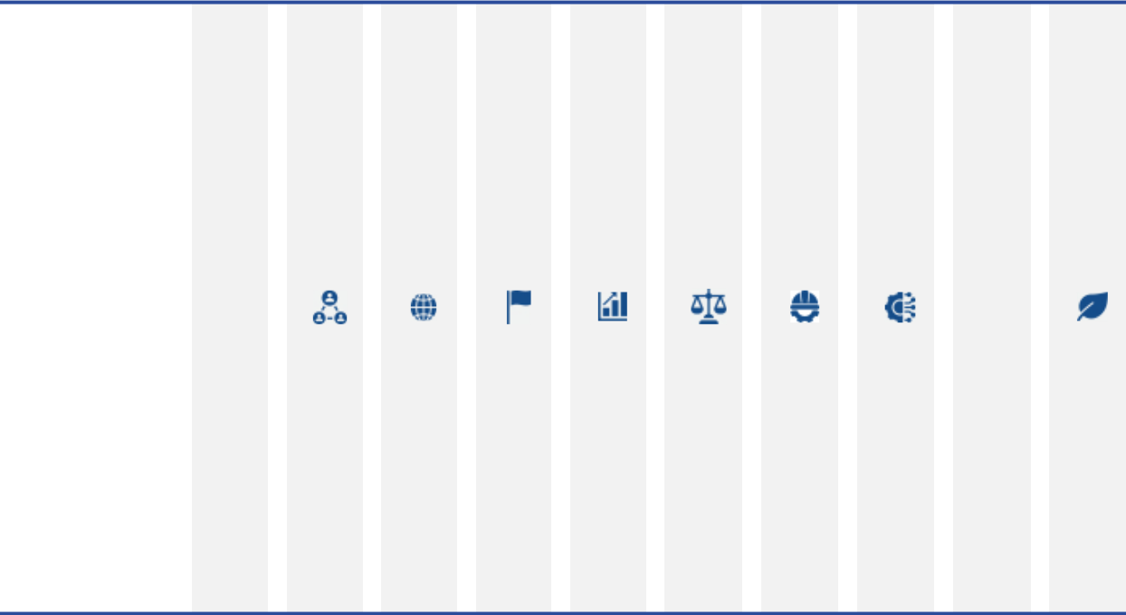
Darren W. Woods

Mr. Woods brings more than 30 years of global industry experience managing highly sophisticated, safety-critical operations and has held a number of senior leadership roles in multiple international business units prior to being promoted to CEO. His in-depth understanding of Company operations, knowledge of global business, markets and strategy, and experience leading transformational change, helps the Board to better understand and navigate the complex issues associated with transforming a multi-dimensional, capital intensive, commodity business through a thoughtful, long-term energy transition.

26 2023 Proxy Statement

Table of Contents

Diversity of experiences and backgrounds, including gender and race/ethnicity, is also an important consideration for Board members. The charts below reflect the diversity of the current Board.

Strong Board Gender and Racial/Ethnic Diversity
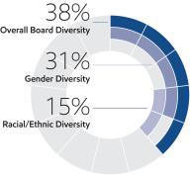
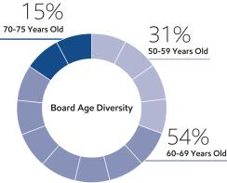

Director Independence

ExxonMobil’s Corporate Governance Guidelines require that a substantial majority of the Board consists of independent directors. In general, these Guidelines require that an independent director must have no material relationship with ExxonMobil, directly or indirectly, except as a director. The Board determines independence on the basis of the standards specified by the New York Stock Exchange (NYSE), the additional standards referenced in our
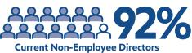
Corporate Governance Guidelines, and other facts and circumstances the Board considers relevant.

Under ExxonMobil’s Corporate Governance Guidelines, a director will not be independent if a reportable “related person transaction” exists with respect to that director or a member of the director’s family for the current or most recently completed fiscal year. See the Guidelines for Review of Related Person Transactions posted on the Corporate Governance section of our website and described in more detail under Related Person Transactions and Procedures below.

The Board has reviewed relevant relationships between ExxonMobil and each non-employee director and director nominee to determine compliance with the NYSE standards and ExxonMobil’s additional standards. The Board has evaluated whether there are any other facts or circumstances that might impair a director’s independence. Based on that review, the Board has determined that all ExxonMobil non-employee directors are independent. The Board has also determined that each member of the Audit, Nominating and Governance, Compensation, and Environment, Safety and Public Policy Committees (see table on page 34) is independent based on both applicable NYSE standards and the Company’s independence standards for each of these committees. The Company’s standards for each committee are included in their respective charters and posted on our website at exxonmobil.com/governance.

In recommending that each director and nominee be found independent, the Nominating and Governance Committee identified no transactions, relationships, or arrangements that required consideration under the NYSE and ExxonMobil independence standards described above.

Director Nomination Process and Board Succession

As noted in the committee information that follows, the Nominating and Governance Committee is responsible for identifying and evaluating director candidates. The description below sets forth the process through which the Committee identifies potential nominees to the Board and evaluates their qualifications.

Candidate Recommendations

The Nominating and Governance Committee seeks new candidates in several ways:

- Engagement of an executive search firm. The firm brings forward potential director candidates for the Committee to consider and helps research candidates identified by the Committee.

2023 Proxy Statement | 27

Table of Contents

- Recommendations made by the non-employee directors. These recommendations are developed based on the directors’ own knowledge and experience in a variety of fields and on the research conducted by ExxonMobil staff at the Committee’s direction.

- Recommendations made by employee directors, shareholders, and others.

All recommendations, regardless of the source, are evaluated on the same basis against the criteria contained in the Corporate Governance Guidelines. The Committee has also instructed its executive search firm to include diversity as part of the candidate search criteria.

Shareholders may send recommendations for director candidates to the Corporate Secretary at the address given under

Contact Information on page 7. A submission recommending a candidate should include:

- Sufficient biographical information to enable the Committee to evaluate the candidate in light of provisions of the Corporate Governance Guidelines on non-employee director qualifications;

- Information concerning any relationship between the candidate and the recommending shareholder; and

- Material indicating the willingness of the candidate to serve if nominated and elected.

The procedures by which shareholders may recommend nominees have not changed materially since last year’s proxy statement.

Assessment and Nomination

Once potential nominees are identified, the Nominating and Governance Committee assesses each candidate’s overall qualifications for nomination to the Board relative to an assessment of the Company’s future direction. In evaluating prospective directors, the Committee considers various factors including:

- ExxonMobil’s Corporate Governance Guidelines, including provisions on non-employee director qualifications;

- ExxonMobil’s strategy, risk profile, and current Board composition;

- Independence, perspectives, objectivity, reasoning, and judgment of the candidate; and

- Board diversity.

ExxonMobil seeks to have a diverse Board representing a range of backgrounds, knowledge, and skills relevant to the Company’s business and the needs of the Board, and as part of the search process, considers highly qualified candidates, including women and minorities. The Committee does not use quotas, but considers diversity along with the other requirements of the Corporate Governance Guidelines provisions on non-employee director qualifications when evaluating potential new directors. The resulting diversity of experience, skills, gender, and race/ethnicity on the ExxonMobil Board serves as a testament to this robust process.

If the Nominating and Governance Committee determines to advance a candidate in the nomination process, the Committee puts the candidate forward for consideration by the full Board.

Since our last annual meeting of shareholders, the Committee continued its director succession planning, using the process described above and taking into account, among other factors, shareholders’ interest in board refreshment and specifically in adding directors with oil and natural gas industry, energy and business transition, capital allocation, and finance expertise. Mr. Harris and Mr. Kellner were recommended by our executive search firm and joined the Board in January 2023.

Director Re-Nomination

The Nominating and Governance Committee also oversees the re-nomination process. In considering whether to re-nominate a director for re-election at our annual meeting, the Committee reviews each director, considering such factors as:

- Attendance and participation at Board and committee meetings;

28 2023 Proxy Statement

Table of Contents

- Skills, experience, and personal attributes;

- Continued contribution to the Board’s effectiveness;

- Results from the annual Board and committee self-assessments;

- Shareholder feedback, including the support received at our annual meeting of shareholders; and

- Independence.

Board Tenure

The Board does not impose tenure limits on its directors, other than a mandatory retirement age of 75 and the requirement to stand for election annually. Given the complexity and breadth of our business and its long-term investment horizons, the Board considers longevity of service and experience of great value. The Board also believes that its director compensation approach, which limits the vesting of restricted shares until retirement, closely aligns directors with the interests of long-term shareholders.

All ExxonMobil directors stand for election at the annual meeting. Non-employee directors cannot stand for election after they have reached age 75, unless the Board makes an exception on a case-by-case basis.

Restricted shares received by non-employee directors are subject to forfeiture if the non-employee director leaves the Board early, i.e., before the retirement age of 75. Employee directors resign from the Board when they are no longer employed by ExxonMobil.

As of April 1, 2023, the average tenure of ExxonMobil’s non-employee directors is 3.5 years, below the average of Standard & Poor’s (S&P) 500 companies of 7.8 years (per 2022 Spencer Stuart Board Index). More than sixty percent of current ExxonMobil directors have joined the Board since 2020.
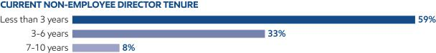

2022 Shareholder Vote Response

At last year’s annual shareholder meeting, our shareholders voted to receive more information about our resiliency modeling under the International Energy Agency’s Net Zero Emissions by 2050 (IEA NZE) scenario, through a majority vote in favor of shareholder proposal Item 8 – Report on Scenario Analysis. That shareholder proposal sought an audited report assessing how applying the assumptions of the IEA NZE pathway would affect the assumptions, costs, estimates, and valuations underlying our financial statements, including those related to long-term commodity and carbon prices, remaining asset lives, future asset retirement obligations, capital expenditures, and impairments.

In January 2022, we published a resiliency analysis in our Advancing Climate Solutions 2022 Progress Report, using the IEA NZE scenario assumptions, showing how our business could change under this aggressive decarbonization pathway. In the second half of 2022, Board members, senior management, and subject matter experts engaged with our shareholders to better understand their request for additional information on this scenario analysis. We also had additional engagement with the proponent, including participation by members of the Board.

Although there is a range of perspectives across our over 3 million shareholders, interest coalesced around certain key items. With input and oversight from our Board, in December 2022, we responded by updating our Advancing Climate Solutions 2023 Progress Report (ACS) with enhanced content and expanded disclosures reflecting the proposal and shareholder input. Since publishing the 2023 ACS, we have hosted several investor webcasts and engaged directly with investors on the expanded content, with positive feedback. The proponent attended one of these calls in February 2023.

Below is a summary of the investor input we received regarding our IEA NZE scenario analysis and the enhancements we provided in our most recent ACS report.

2023 Proxy Statement | 29

Table of Contents

Key items heard from
shareholders |  |  | How we responded in our 2023 ACS disclosure
We should provide more |  |  | • We explicitly detailed the IEA NZE assumptions that we used to inform demand
information on assumptions
 |  |  | and pricing in our IEA NZE modeling and analysis.
used in our 2022 ACS IEA |  |  | and pricing in our IEA NZE modeling and analysis.
 |  |  | • See ACS Page 30.
NZE modeling. |  |  | • See ACS Page 30.
We should provide more
context around the effects |  |  | • Our IEA NZE-modeled operating cash flow disclosures in our ACS have been
the IEA NZE assumptions
 |  |  | designed to show more scale and the potential growth or contraction over time for
could have on our 2022
 |  |  | key elements of our portfolio under this scenario.
ACS IEA NZE modeling of |  |  | key elements of our portfolio under this scenario.
 |  |  | • Similarly, modeled effects on capital expenditures were enhanced to provide
financial statement
financial statement |  |  | greater transparency by business to 2050.
estimates of operating cash |  |  | greater transparency by business to 2050.
 |  |  | • See ACS Page 31.
flow and capital |  |  | • See ACS Page 31.
expenditures.
 |  |  | • The ACS includes a discussion of why we believe our disclosure of future cash
 |  |  | flow and capital expenditures under the IEA NZE scenario is a valuable, industry-
 |  |  | leading disclosure. It also provides a clearer view of the resiliency and enterprise
 |  |  | value of our portfolio, expertise, and the opportunities we could have under such
 |  |  | an aggressive scenario. We believe this disclosure is more useful to investors
 |  |  | versus narrowly focusing on remaining asset lives and hypothetical noncash
 |  |  | accounting measures such as AROs that are dependent on asset-specific
 |  |  | assumptions and technology and policy developments not provided by the IEA
 |  |  | NZE scenario.
 |  |  | • We did, however, expand our disclosure to discuss why we believe our existing
 |  |  | assets are generally resilient in the energy transition, and in the IEA NZE
 |  |  | scenario.
We should provide greater |  |  | ¡ Due to superior performance attributes and generally lower greenhouse gas
 |  |  | intensity versus alternatives, the demand for chemicals is robust, even in the
detail on the potential |  |  | IEA NZE scenario.
impact of the IEA NZE |  |  | ¡ Business resiliency of our refineries was exemplified with our disclosure
scenario on remaining asset |  |  | describing that more than 75 percent of our refining capacity is co-located with
lives, asset retirement |  |  | chemical manufacturing capacity in large, integrated sites that have the
obligations (AROs), and |  |  | flexibility to shift toward biofuels and chemical feedstocks as demand for
asset-use optionality. |  |  | conventional road transport fuels declines, thereby extending their useful lives.
 |  |  | In addition to repurposing select assets, consistent with our strategy, less
 |  |  | advantaged, non-integrated refineries could be converted to terminals (again
 |  |  | extending their useful lives) or sold.
 |  |  | ¡ Additionally, we note that a substantial majority of our proved reserves are
 |  |  | expected to have been produced by 2050. For proved reserves projected to be
 |  |  | produced beyond 2050, the majority of development costs will have been
 |  |  | incurred before 2050.
 |  |  | • Providing further asset-specific public disclosure regarding remaining useful lives,
 |  |  | retirement costs, and potential proved reserves in an IEA NZE scenario could
 |  |  | imply a higher degree of certainty than exists. It also could provide competitively
 |  |  | sensitive information on how we might make adjustments to our portfolio.
 |  |  | • See ACS Pages 18 and 30-37.
 |  |  | • Details of the audit performed by Wood Mackenzie are disclosed in the ACS,
We should provide more |  |  | including that the IEA NZE assumptions are accurately reflected in our modeling
 |  |  | and that the output of the model is a reasonable representation of the portfolio
detail about the |  |  | mix as defined by the model inputs.
independent third-party |  |  | • The independent audit statement issued by Wood Mackenzie is now disclosed as
audit of our IEA NZE |  |  | part of our ACS publication.
modeling in the ACS. |  |  | • See ACS Page 33 for a link to the quality assurance audit statement from Wood
 |  |  | Mackenzie.
30 | 2023 Proxy Statement

Table of Contents

Key items heard from
shareholders |  | How we responded in our 2023 ACS disclosure
 |  | • We now disclose, for both advanced and emerging economies, our assumed
 |  | greenhouse gas emissions pricing used where we operate and invest through
 |  | 2050. This is done in context with similar carbon pricing from World Bank and
We should provide long- |  | IEA WEO STEPS.
We should provide long- |  | • We now disclose the carbon pricing assumptions included in the published IEA
term carbon pricing and
term carbon pricing and |  | NZE scenario which were used to inform our IEA NZE resiliency analysis.
commodity pricing
commodity pricing |  | • Further, we now publish commodity pricing projections for Brent oil and
assumptions for both the
assumptions for both the |  | Henry Hub natural gas under the IEA NZE and a range of third-party analyses,
IEA NZE scenario and for
our assumed greenhouse |  | including FACTS Global Energy Group, Wood Mackenzie, IHS Markit, Rystad
gas pricing in places where |  | Energy, and S&P Global Commodity Insights. Additionally, we state that, for the
we operate and invest. |  | mid- to longer-term, our prices, which are based on the fundamentals projected in
 |  | our Outlook for Energy, are in the range of these third-party projections published
 |  | by reputable organizations with significant industry expertise.
 |  | • See ACS Pages 30, 37, and 41.

The full ACS is available at corporate.exxonmobil.com/climate-solutions/advancing-climate-solutions-progress-report.

Also included in the ACS, in response to shareholder feedback, is greater detail regarding our methane emissions measurement and reduction efforts. Through 2022, we have achieved more than 50 percent reduction of methane emissions intensity from operated assets, and reduced operated absolute methane emissions by 50 percent, since 2016. Our methane reporting framework has enabled the development of consistent and comparable data, which along with growing field observations, has guided our mitigation efforts. Our ACS also describes how we continue to expand the volume of natural gas production that is independently certified for methane emissions management by the non-profit organization, MiQ.

Our ongoing response to shareholder perspectives is an important aspect of the continuous improvement of our governance. With the oversight and participation of our Board, we will continue an active outreach program to gather feedback that helps shape the information we publicly share.

ExxonMobil’s consistent responsiveness to shareholder perspectives
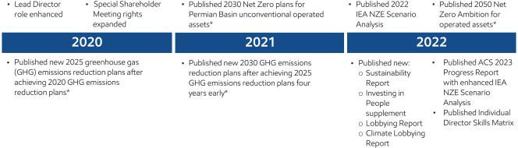

- See exxonmobil.com/news/newsroom/news-releases for May 23, 2018 release of 2020 emissions reduction plans; December 14, 2020 release of 2025 emissions reduction plans; December 1, 2021 release of 2030 emissions reduction plans; December 6, 2021 release of net zero by 2030 emissions plan for Permian Basin unconventional operations; and January 18, 2022 release of Scope 1 and Scope 2 net zero ambition for operated assets by 2050.

2023 Proxy Statement | 31

Table of Contents

Shareholder Engagement in 2022

The Board and management believe ongoing engagement with our shareholders is vitally important and understand the importance of understanding shareholders’ perspectives, keeping shareholders informed about the business, and addressing shareholders’ areas of interest. The Board and management welcome and value input from all shareholders.

Engaged with: |  |  | Engaged through: |  |  |  |  | Engagements include:
• | Institutional Investors |  | • Individual and Group Investor |  |  |  |  | • | Non-employee Directors
• | Retail Shareholders |  |  | Meetings |  |  |  | • Chairman / CEO /
• | Pension Funds |  | • | Investor Day |  |  |  |  | Management Committee
• | Religious Organizations |  | • | Quarterly Earnings Calls |  |  |  | • | Senior Management
• | Nongovernmental |  | • | Investor Conferences |  |  |  | • | Subject Matter Experts
 | Organizations |  | • | Spotlight Events |  |  |  | • | Other Employees
• | Proxy Advisory Firms |  | • | Annual Shareholder Meeting
• | Environmental, Social, and |  | • | Shareholder Webcasts |  |  |  | ESG Engagements:
 | Governance (ESG) Rating |  | • | Stakeholder Outreach |  |  |  |  | 88% Increase
 | Firms |  |  |  |  |  |  |  | 88% Increase
• | Industry Thought Leaders |  |  |  |  |  |  |  | since 2017
Engaged with shareholders representing: |  |  |  |  | Information shared through:
 | ~ 1.7 billion shares |  |  |  | • | SEC Filings |  | • | Advancing Climate Solutions
~ 42% of total outstanding shares |  |  |  |  | • | Press Releases |  |  | report
 |  |  |  |  | • | Annual Report |  | • | Sustainability Report
 | and |  |  |  | • | Company Website |  | • | Perspectives Blog
~ 69% of institutional shareholdings |  |  |  |  | • | Energy Factor Website |  | • | Lobbying Report
 |  |  |  |  | • | Investing in People |  | • | Climate Lobbying Report
 |  |  |  |  |  | supplement

Insights into the Boardroom

ExxonMobil’s diverse, highly qualified Board represents a range of backgrounds, knowledge, and skills relevant to the Company’s business and the Board’s needs. The Company added eight new non-employee directors since 2020 – more than 60 percent of the total current Board. Average tenure for current non-employee directors is 3.5 years. Almost 40 percent of the current Board is female and/or racially/ethnically diverse.

The Board expanded from 11 to 13 directors in 2023 by adding two new independent directors. The new directors provide deep experience as executives of large public, complex, capital-intensive global companies that successfully navigated significant industry transitions. Each new director participates in comprehensive onboarding sessions with senior leaders designed to accelerate the learning curve, with reviews covering a wide range of topics, including overviews of the Company’s major business lines, practices, risk framework, energy outlook, technology, and capital allocation, as well as applicable legal and regulatory requirements, and ethics and other policies.

The ExxonMobil Board is actively engaged and committed to overseeing the Company’s efforts to grow long -term shareholder value by executing its strategy and plans to play a leading role in a thoughtful energy transition. The Board provides oversight for the Company’s key risks and opportunities and regularly reviews a variety of important issues through a process that involves briefings with subject matter experts from inside and outside the Company. Topics include climate change, technology, operating strategies, business and corporate planning, current events, research and development, shareholder engagements, and Company performance.

32 2023 Proxy Statement

Table of Contents

The Board provides oversight and guidance on the Company’s five-year plan. This plan is expected to double earnings and cash flow potential by 2027 versus 2019 and supports investments in high-return, low cost of supply opportunities in the Upstream and Product Solutions businesses; in 2023, ExxonMobil expects to invest $ 23-$25 billion to help increase supply to meet global demand while also delivering $ 9 billion in structural cost savings by year end versus 2019. See Exhibit A for information on future earnings and cash flow potential and structural cost savings. The plan allocates approximately $17 billion from 2022 through 2027 to reduce the Company’s own greenhouse gas emissions and grow its Low Carbon Solutions business, which is focused on accretive third-party, lower-emissions opportunities in carbon capture and storage, hydrogen, and biofuels. The plan also expands the share-repurchase program to up to $50 billion through 2024, including $15 billion of repurchases made in 2022.

Each year, the Board reviews and approves the corporate goals and objectives which form the framework for the organization to deliver on its commitments. Progress is discussed throughout the year in various Board and Committee reviews. Assessment of accomplishments versus these plan goals and objectives forms the basis for pay deliberations. In addition, the CEO reviews with the Board progress on executive development and succession planning for senior-level positions, and organizational health. The Board also reviews the Company’s efforts to support the health and safety of its workforce, as well as the Company’s efforts in investing in globally diverse talent.


The Nominating and Governance Committee has established and oversees procedures for shareholders and other interested persons to send written or electronic communications to individual directors, including the Lead Director, Board committees, or the non-employee directors as a group.

• Written Communications: Written correspondence should be addressed to the director or directors at the address given under Contact Information on page 7.

• Electronic Communications: You may send a message to individual non-employee directors, Board committees, or the non-employee directors as a group by using the form provided for that purpose on our website at exxonmobil.com/directors.

All communications are recorded by an ExxonMobil Assistant Secretary or designated staff member and forwarded to the appropriate director or directors or otherwise handled as the Committee has directed.

Code of Ethics and Business Conduct

The Board maintains policies and procedures (referred to in this proxy statement as the Code) that represent both the code of ethics for the principal executive officer, principal financial officer, and principal accounting officer under SEC rules, and the code of business conduct and ethics for directors, officers, and employees under NYSE listing standards. The Code applies to all directors, officers, and employees and is at the core of the Company’s foundational policies. The Code includes a Conflicts of Interest Policy under which directors, officers, and employees are expected to avoid any actual or apparent conflict between their own personal interests and the interests of the Corporation. The Code also includes an Ethics Policy under which directors, officers, and employees are expected to observe the highest ethical standards of integrity in the conduct of the Company’s business. Each year, directors, officers, and employees are required to certify that they have read the Code and remain in compliance with its requirements. The Code is posted on the ExxonMobil website at exxonmobil.com/code. The Code is also included as an exhibit to our Annual Report on Form 10-K. Any amendment of the Code will be posted promptly on ExxonMobil’s website.

The Corporation maintains procedures for administering and reviewing potential issues under the Code, including procedures that allow employees to make complaints without identifying themselves unless otherwise required by law. The Corporation also conducts periodic mandatory business practice training sessions.

The Nominating and Governance Committee will initially review any suspected violation of the Code involving an executive officer or director and will report its findings to the Board. The Board does not envision that any waiver of the Code will be granted. Should such a waiver occur, it will be promptly disclosed on ExxonMobil’s website.

2023 Proxy Statement | 33

Table of Contents

Board Meetings and Annual Meeting Attendance

The Board met nine times in 2022. ExxonMobil’s incumbent directors, on average, attended approximately 98 percent of Board and committee meetings during 2022. No director attended fewer than 75 percent of such meetings. ExxonMobil’s non-employee directors held seven executive sessions in 2022, chaired by the independent Lead Director. As specified in our Corporate Governance Guidelines, it is ExxonMobil’s policy that directors should make every effort to attend the annual meeting of shareholders. All directors attended the 2022 annual meeting of shareholders on May 25, 2022.

Board Committees

The Board appoints committees to help carry out its duties. Board committees work on key issues in greater detail than would be possible at full Board meetings. Only non-employee directors may serve on the Audit, Compensation, Nominating and Governance, and Environment, Safety and Public Policy Committees. Each committee has a written charter. The charters are posted on the Corporate Governance section of our website at exxonmobil.com/governance.

The tables below show the current membership and the number of meetings each committee held in 2022.


 |  |  | Nominating and |  | Environment, Safety
Director | Audit | Compensation | Governance | Finance | and Public Policy | Executive⁽¹⁾

M.J. Angelakis | · |  |  | ·
S.K. Avery |  |  | ·
A.F. Braly |  |  |  | ·
U.M. Burns |  |  | · | ·
G.J. Goff | · |  | · | ·
J.D. Harris II | · | ·
K.H. Hietala | · |  | ·
J.L. Hooley |  | · |  | ·
S.A. Kandarian |  | · | ·
A.A. Karsner |  |  | · | ·
L.W. Kellner |  |  | · | ·
J.W. Ubben |  |  | · | ·
D.W. Woods |  |  | ·
= Chair · = Member |  | (1) Other directors serve as alternate members on a rotational basis

Meetings in 2022:
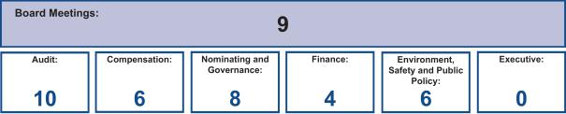

Nominating and Governance Committee

The Nominating and Governance Committee, chaired by the independent Lead Director, serves as ExxonMobil’s nominating and corporate governance committee. Its responsibilities include:

- Recommendations on director candidates and reviewing requests for participation on other boards;

- Maintaining procedures for director engagement with shareholders;

34 2023 Proxy Statement

Table of Contents

- Providing comments and suggestions to the Board on committee structure and committee assignments;

- Reviewing corporate governance practices, including the Corporate Governance Guidelines;

- Reviewing any issue involving an executive officer or director under the Code; and

- Administering ExxonMobil’s Related Person Transaction Guidelines.

The Committee also administers provisions of the Corporate Governance Guidelines that require a director to tender a resignation when there is a substantial change in the director’s circumstances. The Committee reviews the relevant facts to determine whether the director’s continued service would be appropriate and makes a recommendation to the Board.

Another responsibility of the Committee is to review and make recommendations to the Board regarding the compensation of the non-employee directors. The Committee uses an independent consultant, Pearl Meyer & Partners, LLC (Pearl Meyer), to provide information on current developments and practices in director compensation. Pearl Meyer is the same consultant retained by the Compensation Committee to advise on executive compensation, but performs no other work for ExxonMobil.

The Corporate Governance Guidelines describe the qualifications the Committee looks for in director candidates. These Corporate Governance Guidelines, as well as the Committee’s charter, are posted on the Corporate Governance section of our website.

Audit Committee

The Audit Committee oversees accounting and internal control matters. Its responsibilities include oversight of:

- Management’s conduct of the Corporation’s financial reporting process;

- The integrity of the financial statements and other financial information provided by the Corporation to the SEC and the public;

- The Corporation’s system of internal accounting and financial controls;

- The Corporation’s compliance with legal and regulatory requirements;

- The performance of the Corporation’s internal audit function;

- The independent auditors’ qualifications, performance, and independence; and

- The annual independent audit of the Corporation’s financial statements.

The Committee has direct authority and responsibility to appoint (subject to shareholder ratification), compensate, retain, and oversee the independent auditors.

The Committee also prepares the report that SEC rules require be included in the Corporation’s annual proxy statement.

The report begins on page 41.

The Audit Committee has adopted specific policies and procedures for pre-approving fees paid to the independent auditors. Under the Audit Committee’s approach, an annual program of work is approved each October for the following categories of services: Audit, Audit-Related, and Tax. Additional engagements may be brought forward from time to time for pre-approval by the Audit Committee. Pre-approvals apply to engagements within a category of service, and cannot be transferred between categories. If fees might otherwise exceed pre-approved amounts for any category of permissible services, the incremental amounts must be reviewed and pre-approved prior to commitment. The complete text of the Audit Committee’s pre-approval policies and procedures, as well as the Committee’s charter, is posted on the Corporate Governance section of ExxonMobil’s website.

The Board has determined that all members of the Committee are financially literate within the meaning of the NYSE standards, and a majority are “audit committee financial experts” as defined in the SEC rules, including Ms. Burns as the Audit Committee Chair.

Compensation Committee

The Compensation Committee is comprised exclusively of non-employee, independent directors, and oversees compensation for ExxonMobil’s senior executives (including salary, bonus, and performance share awards), as well as succession planning for key executive positions. The Committee’s charter is available on the Corporate Governance section of our website.

2023 Proxy Statement | 35

Table of Contents

The Committee took the following actions:

- Reviewed with the Board and approved the corporate goals and objectives;

- Reviewed the Corporation’s business results and progress toward strategic objectives during the year with ExxonMobil’s CEO and other senior executives;

- Reviewed the individual performance and contributions of the CEO and other senior executives;

- Discussed the Company’s executive compensation program design with its independent consultant;

- Considered feedback from shareholder engagements and the results of the 2022 advisory vote on executive compensation;

- Deliberated pay decisions based on an assessment of progress toward strategic objectives, business results, individual performance, and the results of annual benchmarking, taking into account experience in position;

- Established the aggregate annual ceiling for the 2022 long-term incentive award program and bonus program;

- Assessed each element of the Company’s compensation program and practices, and confirmed that these do not create any material adverse risks for the Company. The key design features of the compensation program that discourage executives from taking inappropriate risk are described in detail in this proxy statement (see pages 47, 64, and 65);

- Reviewed with the Board progress on executive development and succession planning for senior-level positions and organizational health with input from the CEO; and

- Reviewed with the Board the Company’s efforts in investing in globally diverse talent.

The Committee does not delegate its responsibilities with respect to ExxonMobil’s executive officers and other senior executives. For other employees, the Committee delegates authority to determine individual salaries and incentive awards to a committee consisting of the Chairman and Management Committee. That committee’s actions are subject to a salary budget and aggregate annual ceilings on incentive awards established by the Compensation Committee.

For more information on the compensation decisions made by the Committee for 2022, refer to the Compensation Discussion and Analysis beginning on page 45.

The Compensation Committee’s report is available on page 44.

The Compensation Committee utilizes the expertise of an external independent consultant, Pearl Meyer. At the direction of the Committee, Pearl Meyer:

- Attends Committee meetings;

- Informs the Committee regarding general trends in executive compensation across industries;

- Prepares the analysis of comparator company compensation used by the Committee; and

- Participates in the Committee’s deliberations regarding compensation for Named Executive Officers.

In addition, at the direction of the Chair of the Nominating and Governance Committee, Pearl Meyer provides an annual survey of non-employee director compensation for use by that Committee.

The Compensation Committee is solely and directly responsible for the appointment, compensation, and oversight of the consultant. The Committee considers factors that could affect Pearl Meyer’s independence, including that the consultant provides no services for ExxonMobil other than its engagement by the Committee and the Nominating and Governance Committee as described above. Based on this review, the Committee has determined the consultant’s work for the Committee to be free from conflicts of interest.

Finance Committee

The Finance Committee reviews ExxonMobil’s capital structure/capital allocation, and its financial policies, practices, and strategies which may include the following: the Corporation’s financial outlook and capital plan, including

36 2023 Proxy Statement

Table of Contents

significant capital appropriations, shareholder distribution policies and practices, insurance and pension programs, and significant acquisitions and divestitures. The Committee also authorizes the issuance and early retirement of corporate debt subject to limits set by the Board. The Committee’s charter is available on the Corporate Governance section of our website.

Environment, Safety and Public Policy Committee

The Environment, Safety and Public Policy Committee assists the Board in overseeing the Corporation’s positions and practices regarding safety, security, health, and the environment (including but not limited to climate, emissions, and sustainability) and other public policy issues relevant to the Corporation. The Committee hears reports on safety and environmental activities, and along with the full Board periodically visits operating sites to observe and comment on current operating practices. In addition, the Committee provides oversight on the Corporation’s overall contributions strategies, objectives, and policies through an annual review of contributions, including the Corporation’s contributions to the ExxonMobil Foundation. The Foundation and the Corporation engage in a range of philanthropic activities that advance education, with a focus on math and science in the United States; promote women as catalysts for economic development; combat malaria; and support other cultural and public service initiatives. The Committee’s charter is available on the Corporate Governance section of our website.

Executive Committee

The Executive Committee has broad power to act on behalf of the Board. In practice, the Committee meets only when it is impractical to call a meeting of the full Board.

DIRECTOR COMPENSATION

Director compensation elements are designed to:

- Ensure alignment with long-term shareholder interests;

- Ensure the Company can attract and retain outstanding director candidates who meet the selection criteria outlined in the Corporate Governance Guidelines, which can be found on the Corporate Governance section of our website;

- Recognize the substantial time commitment necessary to oversee the affairs of the Corporation; and

- Support the independence of thought and action expected of directors.

Non-employee director compensation levels are reviewed by the Nominating and Governance Committee each year, and resulting recommendations are presented to the full Board for approval. The Committee uses an independent consultant, Pearl Meyer, to provide information on current developments and practices in director compensation. Pearl Meyer is the same consultant retained by the Compensation Committee to advise on executive compensation, but performs no other work for ExxonMobil.

ExxonMobil employees receive no additional pay for serving as directors.

Non-employee directors receive compensation consisting of cash and equity in the form of restricted stock. Non-employee directors are also reimbursed for reasonable expenses incurred to attend Board meetings or other functions relating to their responsibilities as a director of Exxon Mobil Corporation.

The annual cash retainer for non-employee directors is $ 110,000 per year. The Chairs of the Audit and Compensation Committees receive an additional $10,000 per year. The Lead Director receives an additional $50,000 per year.

A significant portion of director compensation is granted in the form of restricted stock; this aligns director interests with the interests of our long-term shareholders. The annual restricted stock award grant for incumbent non-employee directors is 2,500 shares. A new non-employee director receives a one-time grant of 8,000 shares of restricted stock upon first being elected to the Board.

While on the Board, the non-employee director receives the same cash dividends on restricted shares as a holder of regular common stock, but the shares remain unvested and, thus, cannot be sold or pledged. The restricted shares are subject to forfeiture if the non-employee director leaves the Board early, i.e., before the retirement age of 75, as specified for non-employee directors.

2023 Proxy Statement | 37

Table of Contents

Current and former non-employee directors of Exxon Mobil Corporation are eligible to participate in the ExxonMobil Foundation’s Educational Matching Gift Programs under the same terms as the Corporation’s U.S. employees.

Non-Employee Director Compensation for 2022

 |  |  |  |  | Change in
 |  |  |  |  | Pension Value
 | Fees |  |  |  | and Nonqualified
 | Earned |  |  | Non-Equity | Deferred
 | or Paid | Stock | Option | Incentive Plan | Compensation | Other
 | in Cash | Awards | Awards | Compensation | Earnings | Compensation | Total
Name | ($) | ($)(a) | ($) | ($) | ($) | ($)(b) | ($)
M.J. Angelakis | 110,000 | 156,006 | 0 | 0 | 0 | 254 | 266,260
S.K. Avery | 110,000 | 156,006 | 0 | 0 | 0 | 254 | 266,260
A.F. Braly | 120,000 | 156,006 | 0 | 0 | 0 | 254 | 276,260
U.M. Burns | 120,000 | 156,006 | 0 | 0 | 0 | 254 | 276,260
K.C. Frazier^{(c)} | 64,176 | 156,006 | 0 | 0 | 0 | 105 | 220,287
G.J. Goff | 110,000 | 156,006 | 0 | 0 | 0 | 254 | 266,260
K.H. Hietala | 110,000 | 156,006 | 0 | 0 | 0 | 254 | 266,260
J.L. Hooley | 139,945 | 156,006 | 0 | 0 | 0 | 254 | 296,205
S.A. Kandarian | 110,000 | 156,006 | 0 | 0 | 0 | 254 | 266,260
A.A. Karsner | 110,000 | 156,006 | 0 | 0 | 0 | 254 | 266,260
J.W. Ubben | 110,000 | 156,006 | 0 | 0 | 0 | 254 | 266,260

- In accordance with SEC rules, the valuation of stock awards in this table represents fair value on the date of grant. Dividends on stock awards are not shown in the table because those amounts are factored into the grant date fair value.

Each director in office at that time received an annual grant of 2,500 restricted shares in January 2022. The valuation of these awards is based on a market price of $62.40 on the date of grant.

At year-end 2022, the aggregate number of restricted shares held by each director was as follows:

Name | Restricted Shares (#)
M.J. Angelakis | 10,500
S.K. Avery | 20,500
A.F. Braly | 23,000
U.M. Burns | 33,000
G.J. Goff | 10,500
K.H. Hietala | 10,500
J.L. Hooley | 13,000
S.A. Kandarian | 18,000
A.A. Karsner | 10,500
J.W. Ubben | 10,500

- The amount shown for each director is the cost of travel accident insurance covering death, dismemberment, or loss of sight, speech, or hearing under a policy purchased by the Corporation with a maximum benefit of $500,000 per individual.

- Mr. Frazier left the Board on May 25, 2022.

The non-employee directors do not receive any additional payments or benefits as a result of leaving the Board or death except as described above. The non-employee directors are not entitled to any payments or benefits resulting from a change in control of the Corporation.

38 2023 Proxy Statement

Table of Contents

CERTAIN BENEFICIAL OWNERS

Based on our review of ownership reports filed with the SEC, the firms listed below are the only beneficial owners of more than 5 percent of ExxonMobil’s outstanding common stock as of December 31, 2022.

Name and Address | Aggregate Beneficial | Percent of
of Beneficial Owner | Ownership in Shares⁽¹⁾ | Outstanding Shares⁽¹⁾
The Vanguard Group⁽²⁾ | 368,671,214 | 9.0%
100 Vanguard Blvd.
Malvern, PA 19355
BlackRock, Inc.⁽³⁾ | 292,132,859 | 7.1%
55 East 52nd Street
New York, NY 10055
State Street Corporation⁽⁴⁾ | 223,630,483 | 5.4%
One Lincoln Street
Boston, MA 02111

- The Company is permitted to rely on the information set forth in these filings and has no reason to believe that the information is incomplete or inaccurate or that the beneficial owner should have filed an amended report and did not.

- Based solely on a Schedule 13G/A filed with the Securities and Exchange Commission on February 9, 2023, The Vanguard Group reported it had shared voting power with respect to 5,540,016 shares, sole dispositive power with respect to 351,790,054 shares, and shared dispositive power with respect to 16,881,160 shares as of December 31, 2022.

- Based solely on a Schedule 13G/A filed with the Securities and Exchange Commission on January 31, 2023, BlackRock, Inc. reported that it had sole voting power with respect to 271,623,684 shares, and sole dispositive power with respect to 292,132,859 shares as of December 31, 2022.

- Based solely on a Schedule 13G/A filed with the Securities and Exchange Commission on February 6, 2023, State Street Corporation reported that it had shared voting power with respect to 212,600,158 shares, and shared dispositive power with respect to 223,237,162 shares as of December 31, 2022.

DIRECTOR AND EXECUTIVE OFFICER STOCK OWNERSHIP

These tables show the number of ExxonMobil common shares each executive named in the Summary Compensation Table on page 68 and each non-employee director or director nominee owned on February 28, 2023. In these tables, ownership means the right to direct the voting or the sale of shares, even if those rights are shared with someone else. None of these individuals owns more than 0.03 percent of the outstanding shares.

 |  | Shares Covered by
Named Executive Officer | Shares Owned⁽¹⁾ | Exercisable Options
D.W. Woods | 210,173⁽²⁾ | 0
K.A. Mikells | 10,050⁽³⁾ | 0
N.A. Chapman | 151,536⁽⁴⁾ | 0
J.P. Williams, Jr. | 151,384 | 0
K.T. McKee | 79,447⁽⁵⁾ | 0

- Does not include unvested restricted stock units, which do not carry voting rights prior to the issuance of shares on settlement of the awards.

- Includes 757 shares held by spouse.

- Includes 8,350 shares owned together with spouse through family trusts and related entities.

- Includes 61,728 shares jointly owned with spouse.

- Includes 8,030 shares held by spouse.

2023 Proxy Statement | 39

Table of Contents

Non-Employee Director | Shares Owned
M.J. Angelakis | 53,792⁽¹⁾
S.K. Avery | 23,000
A.F. Braly | 27,575⁽²⁾
U.M. Burns | 35,706
G.J. Goff | 23,462⁽³⁾
J.D. Harris II | 8,250⁽⁴⁾
K.H. Hietala | 13,000
J.L. Hooley | 15,500
S.A. Kandarian | 20,500
A.A. Karsner | 30,000
L.W. Kellner | 8,000⁽⁵⁾
J.W. Ubben | 1,190,000⁽⁶⁾

- Includes 20,000 shares jointly owned with spouse. Also includes 20,792 shares in a charitable family trust for which Mr. Angelakis serves as co-trustee.

- Includes 1,175 shares owned by spouse and 900 shares held in trusts for family members for which Ms. Braly serves as co-trustee.
- Includes 10,041 shares jointly owned with spouse. Also includes 421 shares held in trusts for family members for which Mr. Goff serves as co-trustee.
- Mr. Harris joined the Board in January 2023 and received a one-time grant of 8,000 shares on that date; includes 250 shares jointly owned with spouse.
- Mr. Kellner joined the Board in January 2023, and received a one-time grant of 8,000 shares on that date.

- Includes shares held by certain funds managed by Inclusive Capital Partners, L.P. Mr. Ubben is Founder, Portfolio Manager, and Managing Partner of Inclusive Capital Partners, L.P. Mr. Ubben disclaims beneficial ownership of the reported securities except to the extent of his pecuniary interest therein.

On February 28, 2023, ExxonMobil’s incumbent directors and executive officers (23 people) together owned 2,276,298 shares of ExxonMobil stock and zero shares covered by exercisable options, representing less than 0.06 percent of the outstanding shares.

Related Person Transactions and Procedures

In accordance with SEC rules, ExxonMobil maintains Guidelines for Review of Related Person Transactions (Related Person Transaction Guidelines). These guidelines are available on the Corporate Governance section of our website.

All executive officers, directors, and director nominees are required to identify, to the best of their knowledge after reasonable inquiry, business and financial affiliations involving themselves or their immediate family members that could reasonably be expected to give rise to a reportable related person transaction. Covered persons must also advise the Secretary of the Corporation promptly of any change in the information provided, and will be asked periodically to review and reaffirm their information.

Based on this information, the Company’s own records are reviewed and follow-up inquiries are made as may be necessary to identify potentially reportable transactions. A report summarizing such transactions is then provided to the Nominating and Governance Committee. The Committee oversees the Related Person Transaction Guidelines and reviews specific items to assess materiality and make a recommendation to the Board as to whether an identified transaction is required to be reported and/or should be ratified or approved. The Board shall only approve or ratify a transaction that is deemed to be in the best interests of the Corporation. A director will abstain from the decision on any transactions involving that director or his or her immediate family members.

Under SEC rules, certain transactions are deemed not to involve a material interest (including interests solely as a non-employee director). In addition, based on a consideration of ExxonMobil’s facts and circumstances, the Committee will presume that the following transactions do not involve a material interest and do not require further ratification or approval:

- Transactions in the ordinary course of business with an entity for which a related person serves as an executive officer, provided: (1) the affected person did not participate in the decision on the part of ExxonMobil to enter into such transactions; and (2) the amount involved in any related transactions in a year is less than 2 percent of the entity’s gross revenues;

40 2023 Proxy Statement

Table of Contents

- Grants or membership payments in the ordinary course of business to nonprofit organizations, provided: (1) the affected person did not participate in the decision on the part of ExxonMobil to make such payments; and (2) the amount of grants in a year is less than 2 percent of the recipient’s gross revenues;

- Payments under ExxonMobil plans and arrangements that are available generally to U.S. salaried employees; and

- Employment by ExxonMobil of a family member of an executive officer, provided the executive officer does not participate in decisions regarding the hiring, performance evaluation, or compensation of the family member.

Transactions or relationships not covered by the above standards will be assessed by the Nominating and Governance Committee on the basis of the specific facts and circumstances.

Unless otherwise noted, the following disclosures are made as of February 21, 2023, which is the date of the most recent Nominating and Governance Committee review of potential related person transactions.

ExxonMobil and its affiliates have more than 62,000 employees around the world, and employees related by birth or marriage may be found at all levels of the organization. ExxonMobil employees do not receive preferential treatment by reason of being related to an executive officer, and executive officers do not participate in hiring, performance evaluation, or compensation decisions for family members.

Several current ExxonMobil executive officers and retirees who served as executive officers in 2022 have family members who are employed by the Corporation or its affiliates and whose current annualized compensation (including benefits) exceeds the SEC disclosure threshold of $120,000: L.D. DuCharme (President – ExxonMobil Technology and Engineering Company) has a spouse employed by ExxonMobil Upstream Company; L.M. Mallon (President – ExxonMobil Upstream Company) has a son employed by ExxonMobil Upstream Company; K.T. McKee (President – ExxonMobil Product Solutions Company) has a spouse employed by ExxonMobil Product Solutions Company; and D.L. Talley (Vice President

– Corporate Strategic Planning) has a brother employed by ExxonMobil Global Projects Company. Each employee mentioned above received total cash compensation in 2022 between $120,000 and $785,000. Pay earned was comparable to that of employees in similar positions. Employees are eligible to participate in benefit programs on the same basis as other eligible employees. Consistent with ExxonMobil’s guidelines described above, these relationships are not considered to be material within the related person transaction rules.

The Nominating and Governance Committee identified no transactions, relationships, or arrangements involving ExxonMobil’s non-employee directors or their immediate family members that could reasonably be expected to give rise to a reportable related person transaction under the SEC rules or ExxonMobil standards described above. See Director Independence on page 27.

The Committee also determined that no related person transactions occurred during the year involving any of the investors who have reported ownership of more than 5 percent of ExxonMobil’s outstanding common stock. See Certain Beneficial Owners on page 39.

ExxonMobil is not aware of any related person transactions required to be reported under applicable SEC rules since the beginning of the last fiscal year where our policies and procedures did not require review, or where such policies and procedures were not followed.

AUDIT COMMITTEE REPORT

The primary function of the Audit Committee is oversight of the Corporation’s financial reporting process, public financial reports, internal accounting and financial controls, and the independent audit of the annual consolidated financial statements. The Committee acts under a charter which can be found on the ExxonMobil website at exxonmobil.com/auditcommitteecharter. The adequacy of the charter is reviewed at least annually. All members of the Audit Committee are independent directors, and the Committee met 10 times in 2022. In these meetings, as discussed in more detail below, it had extensive reports and discussions with the independent auditors, internal auditors, and members of management.

2023 Proxy Statement | 41

Table of Contents

In performing its oversight function, the Committee reviewed and discussed the consolidated financial statements with management and PricewaterhouseCoopers LLP (PwC), the independent auditors. Management and PwC indicated that the Corporation’s consolidated financial statements were fairly stated in accordance with generally accepted accounting principles. The Committee discussed significant accounting policies applied by the Corporation in its financial statements, as well as alternative treatments. It also discussed with PwC matters covered by Public Company Accounting Oversight Board (PCAOB) standards and the Commission, including PCAOB AS 1301 Communication with Audit Committees. In addition, the Committee reviewed and discussed management’s report on internal control over financial reporting and the related audits performed by PwC, which confirmed the effectiveness of the Corporation’s internal control over financial reporting.

The Audit Committee also reviewed the written disclosure and the letter from PwC required by the PCAOB rules regarding PwC’s communications with the Audit Committee concerning independence, and has discussed with PwC its independence from the Corporation and management. The Committee considered the non-audit services provided by PwC to the Corporation, and concluded that the auditors’ independence has been maintained.

The Committee discussed with the Corporation’s internal auditors and PwC the overall scope and plans for their respective audits; furthermore, it met regularly with the internal auditors and PwC, both with and without management present. Discussions included the results of their examinations, their evaluations of the Corporation’s internal controls, and the overall quality of the Corporation’s financial reporting.

The Audit Committee met with the Corporation’s management to discuss the comprehensive, long-standing risk management and compliance processes of the Corporation, and reviewed several topics of interest. The Committee also reviewed the Company’s cybersecurity assurance program including mitigations for evolving risk areas and external maturity assessment results.

Based on the reviews and discussions referred to above, in reliance on management and PwC, and subject to the limitations of its role described below, the Audit Committee recommended to the Board, and the Board approved, the inclusion of the audited financial statements in the Corporation’s Annual Report on Form 10-K for the year ended December 31, 2022, for filing with the SEC.

In carrying out its responsibilities, the Audit Committee looks to management and the independent auditors. Management is responsible for the preparation and fair presentation of the Corporation’s financial statements and for maintaining effective internal control. Management is also responsible for assessing and maintaining the effectiveness of internal control over the financial reporting process in compliance with Sarbanes-Oxley Section 404 requirements. The independent auditors are responsible for auditing the Corporation’s annual financial statements, and expressing an opinion as to whether the statements are fairly stated in conformity with generally accepted accounting principles. In addition, the independent auditors are responsible for auditing the Corporation’s internal control over financial reporting and for expressing an opinion on the effectiveness of internal control over financial reporting. The independent auditors perform their responsibilities in accordance with the standards of the PCAOB. Audit Committee members are not professionally engaged in the practice of accounting or auditing, and are not experts under the Securities Act of 1933 in either of those fields or in auditor independence.

The Audit Committee has also appointed PwC to audit the Corporation’s financial statements for 2023, subject to shareholder ratification of that appointment. The Committee, along with the other members of the Board, management, the Controller, and the General Auditor, annually evaluates PwC’s qualifications, performance and independence, including the performance of the lead audit partner, in deciding whether to retain PwC. That evaluation includes consideration of:

- PwC’s quality control, including any material issues identified by that quality control or a governmental/professional authority along with PwC’s plan to deal with any such issues;

- All relationships between PwC and ExxonMobil covered by the PCAOB;

- PwC’s expertise in the global oil and gas industry; and

- The quality of PwC’s audit plans.

The Committee believes that PwC’s tenure as ExxonMobil’s independent registered public accounting firm is a benefit to audit quality given PwC’s experience with ExxonMobil and knowledge of the business, as well as the effectiveness of their audit plans, which build on that established knowledge.

42 2023 Proxy Statement

Table of Contents

Based on its annual evaluation of PwC’s qualifications, performance, and independence, as well as frequent private meetings with the lead partner, the Audit Committee believes that the continued retention of PwC as ExxonMobil’s independent registered public accounting firm is in the best interest of the Corporation and its stockholders.

Ursula M. Burns, Chair

Michael J. Angelakis
Gregory J. Goff

John D. Harris II

Kaisa H. Hietala

Item 2 – Ratification of Independent Auditors

The Audit Committee has appointed PricewaterhouseCoopers LLP to audit ExxonMobil’s financial statements for 2023.

We are asking you to ratify that appointment.

Total Fees

The total fees for PwC professional services rendered to ExxonMobil for the year ended December 31, 2022, were $41.9 million, an increase of $1.0 million from 2021. The Audit Committee reviewed and pre-approved all services in accordance with the service pre-approval policies and procedures, which can be found on the ExxonMobil website at exxonmobil.com/pre-approval. The Audit Committee did not use the “de minimis” exception to pre-approval that is available under SEC rules. The following table summarizes the fees, which are described in more detail below.

 | 2022 |  |  | 2021
 |  |  | (millions of dollars)
Audit Fees | 35.4 |  |  | 34.1
Audit-Related
Fees | 5.8 |  |  | 5.8
Tax Fees | 0.7 |  |  | 1.0
All Other Fees |  |  | — |  | —
Total | 41.9 |  |  | 40.9

Audit Fees

The aggregate fees for PwC professional services rendered for the annual audits of ExxonMobil’s financial statements for the year ended December 31, 2022, and for the reviews of the financial statements included in our quarterly reports on Form 10-Q for that year, were $35.4 million (versus $34.1 million for 2021).

Audit-Related Fees

The aggregate fees for PwC Audit-Related services rendered to ExxonMobil for the year ended December 31, 2022, were $5.8 million (versus $5.8 million for 2021). Audit-related services were mainly related to benefit plan audits and other attestation procedures.

Tax Fees

The aggregate fees for PwC Tax services rendered to ExxonMobil for the year ended December 31, 2022, were

$0.7 million (versus $1.0 million for 2021). These services were mainly related to assisting various ExxonMobil affiliates with the preparation of local tax filings and related services.

All Other Fees

The aggregate fees for PwC services rendered to ExxonMobil, other than the services described above under “Audit Fees,” “Audit-Related Fees,” and “Tax Fees,” for the year ended December 31, 2022, were zero (also zero for 2021).

We believe PwC is well qualified to perform this work. A PwC representative will be at the annual meeting to answer appropriate questions and to make a statement if desired.

The Audit Committee recommends you vote FOR this proposal.

2023 Proxy Statement | 43

Table of Contents

COMPENSATION COMMITTEE REPORT

The Compensation Committee of the Board of Directors has reviewed and discussed the Compensation Discussion and Analysis with management of the Corporation. Based on that review and discussion, we recommended to the Board that the Compensation Discussion and Analysis be included in the Corporation’s proxy statement for the 2023 annual meeting of shareholders, and also incorporated by reference in the Corporation’s Annual Report on Form 10-K for the year ended December 31, 2022.

Angela F. Braly, Chair

John D. Harris II

Joseph L. Hooley

Steven A. Kandarian

Item 3 – Advisory Vote to Approve Executive Compensation

At the meeting, shareholders will be asked to vote on a non-binding resolution to approve the compensation of the Named Executive Officers (NEOs) listed in the Summary Compensation Table.

When casting your vote, we encourage you to consider the detailed information in the Compensation Discussion and Analysis beginning on page 45.

The Board supports the overall design of the compensation program, on the basis that the program:

- Is aligned with the Company’s business model and shareholder returns over the long term;

- Delivers pay that is highly performance based and tied to company and individual performance; and

- Enables the Compensation Committee to leverage its experience and judgment to deliver market competitive pay.

We continue to listen and respond to the feedback we receive from shareholders during our shareholder engagement process. In response, this disclosure builds on the enhancements introduced last year, focused on better illustrating the tie between business and individual performance and pay decisions. Furthermore, operating metrics have been updated to reflect the Company’s ongoing commitment to reducing emissions intensity.

The Board recommends an advisory vote FOR the following resolution:

RESOLVED: That shareholders approve the compensation of the Named Executive Officers as disclosed pursuant to Item 402 of SEC Regulation S-K, including the Compensation Discussion and Analysis, compensation tables, accompanying narrative, and additional compensation disclosures included in this proxy statement.

Item 4 – Frequency of Advisory Vote on Executive Compensation

At the meeting, shareholders will be asked to vote on a non-binding resolution as to whether future advisory votes on executive compensation, similar to the preceding resolution, should be held every one, two, or three years.

The Board remains committed to ensuring the Company’s executive compensation program aligns with its business model and shareholders’ interests. We have a long-standing philosophy that executive compensation should be based on long-term performance, aligned with the investment lead times and risk profile of the business.

Consistent with our commitment to excellence in governance and responsiveness to shareholders, the Board recommends that future advisory votes on executive compensation be held every year but will follow the frequency that receives the plurality of votes cast by shareholders on this non-binding resolution.

Shareholders may vote for any of the three choices provided on the form of proxy (1, 2, or 3 years) or abstain from voting.

The vote on this item is not a vote for or against the Board’s recommendation.

The Board recommends a vote FOR One-Year Frequency on this proposal.

44 2023 Proxy Statement

Table of Contents
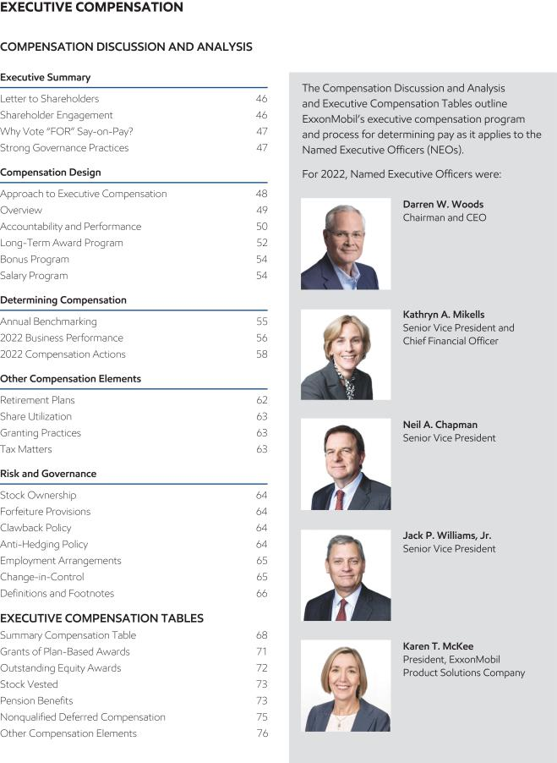

2023 Proxy Statement | 45

Table of Contents
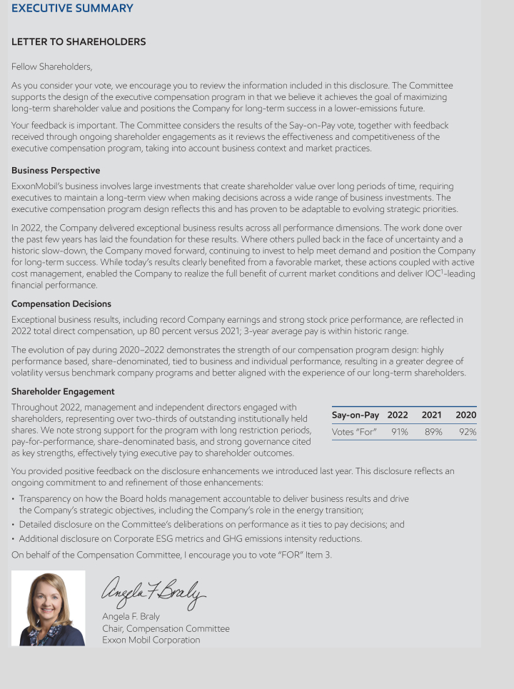

46 2023 Proxy Statement

Table of Contents
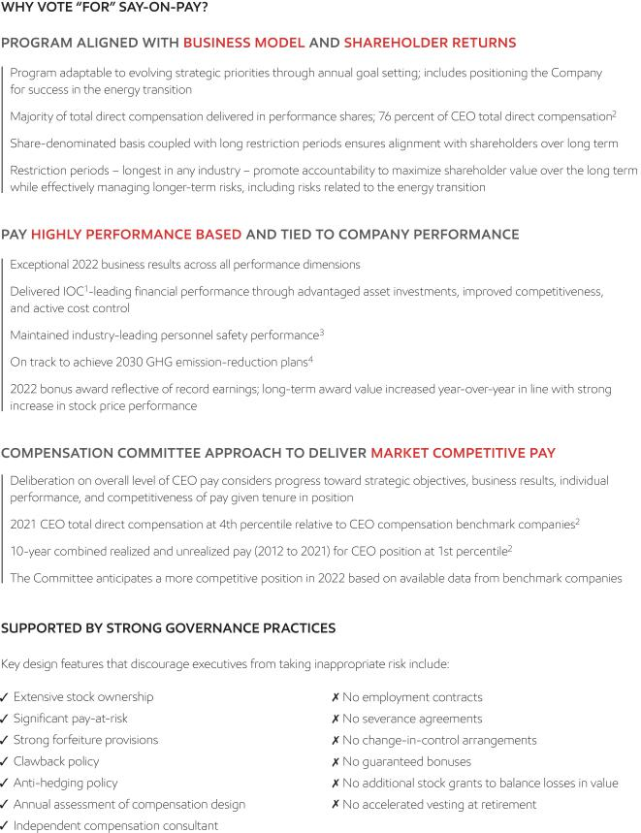

2023 Proxy Statement | 47

Table of Contents
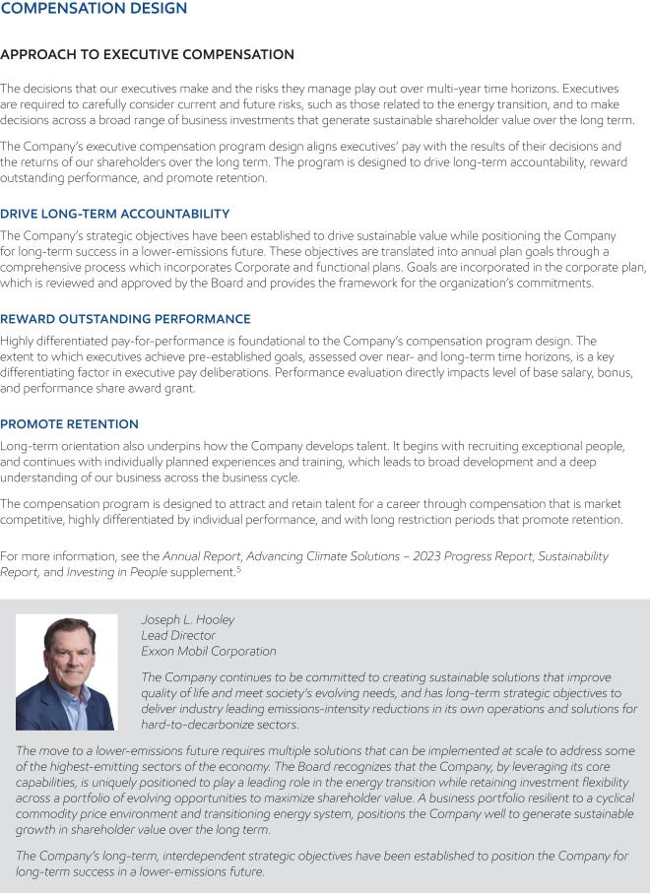

48 2023 Proxy Statement

Table of Contents

2023 Proxy Statement | 49

Table of Contents
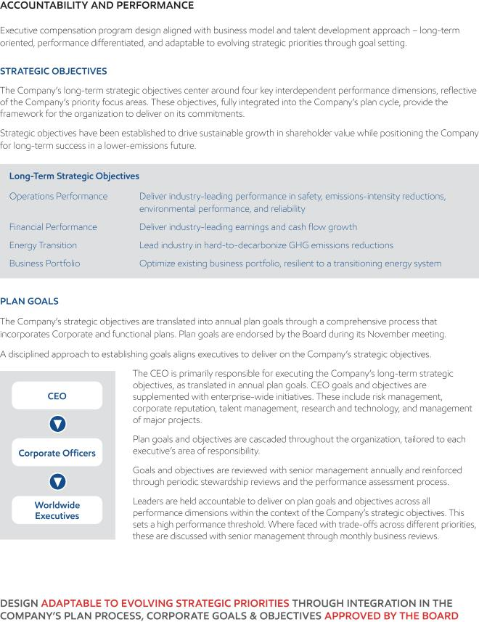

50 2023 Proxy Statement

Table of Contents
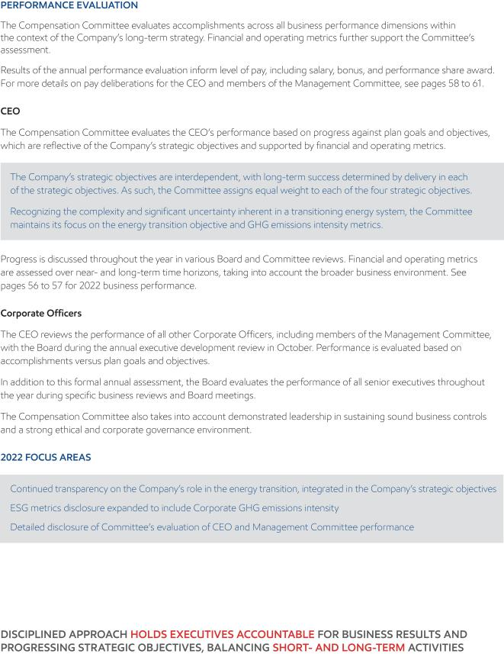

2023 Proxy Statement | 51

Table of Contents
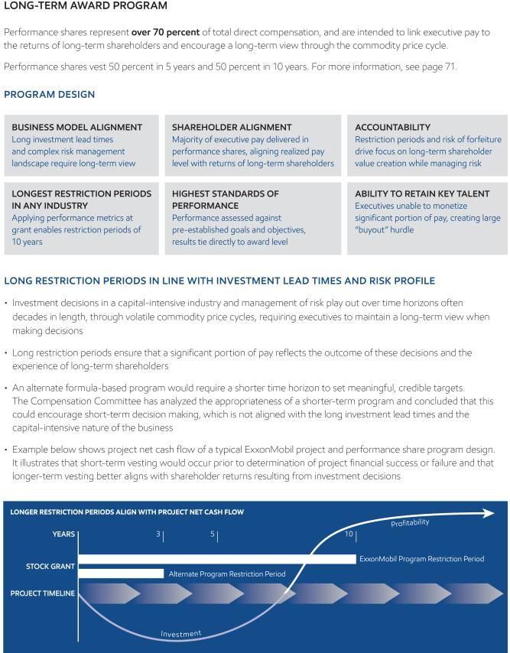

52 2023 Proxy Statement

Table of Contents
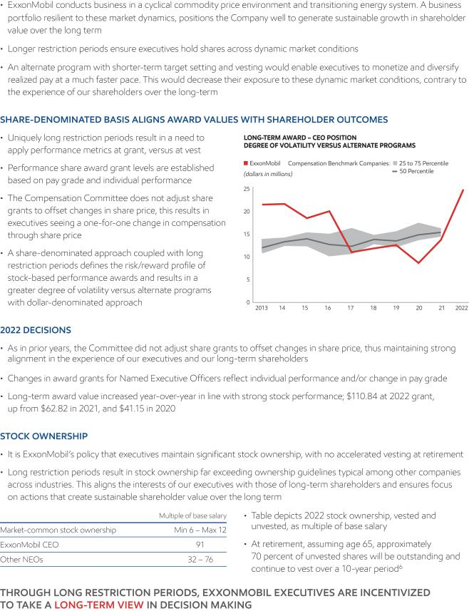

2023 Proxy Statement | 53

Table of Contents
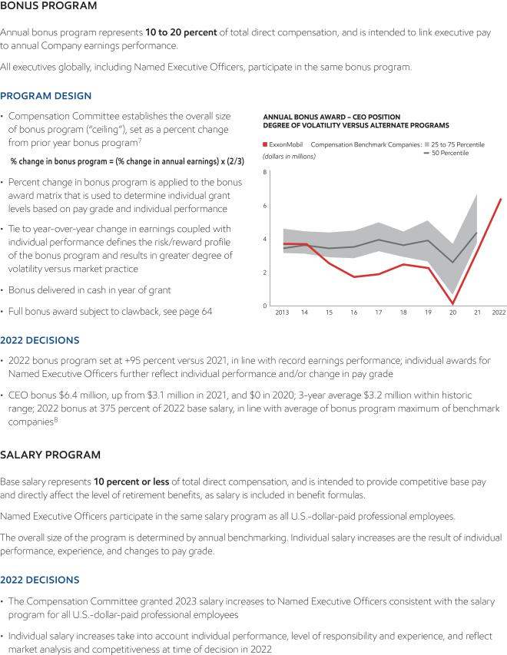

54 2023 Proxy Statement

Table of Contents
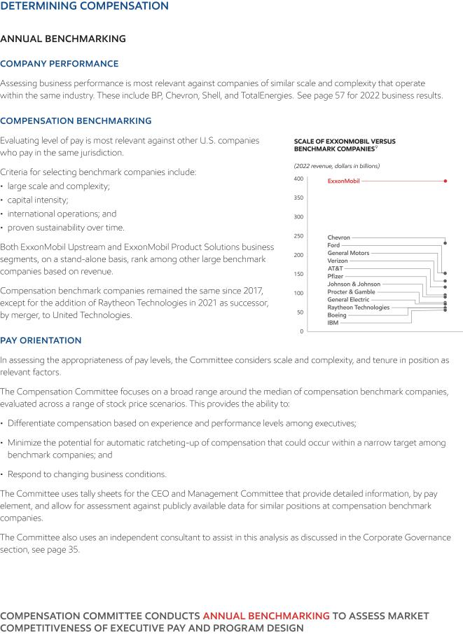

2023 Proxy Statement | 55

Table of Contents
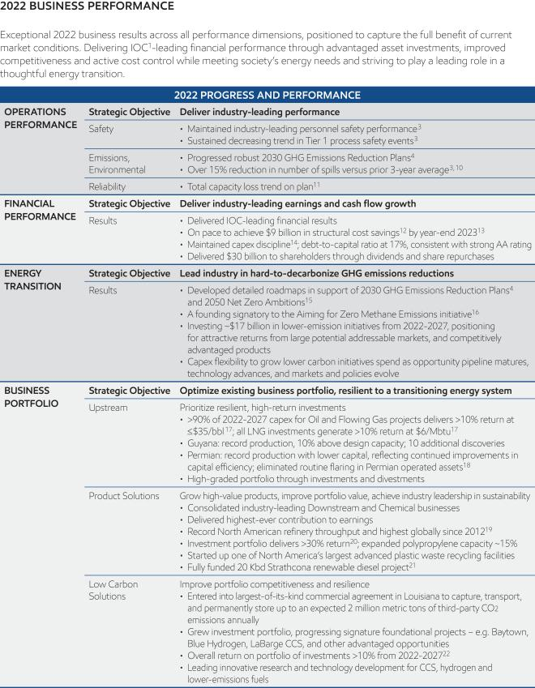

56 2023 Proxy Statement

Table of Contents
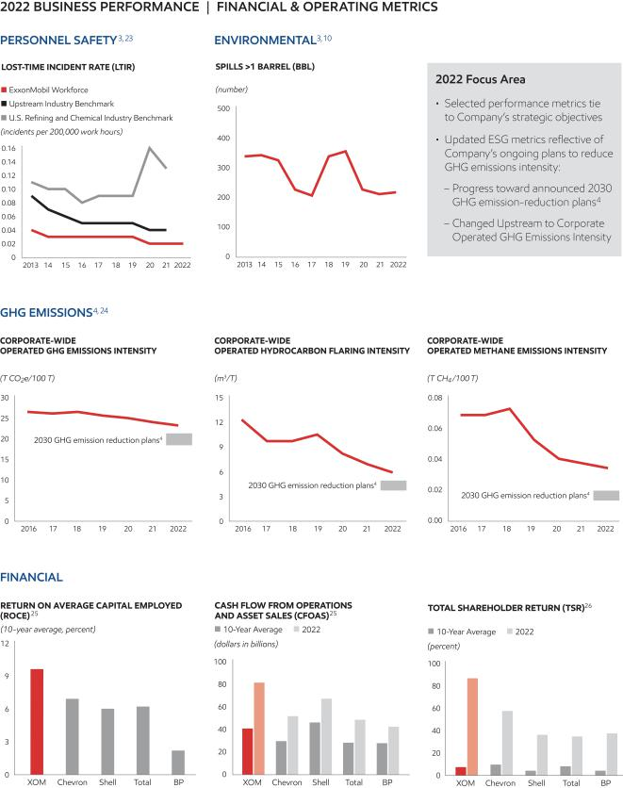

2023 Proxy Statement | 57

Table of Contents
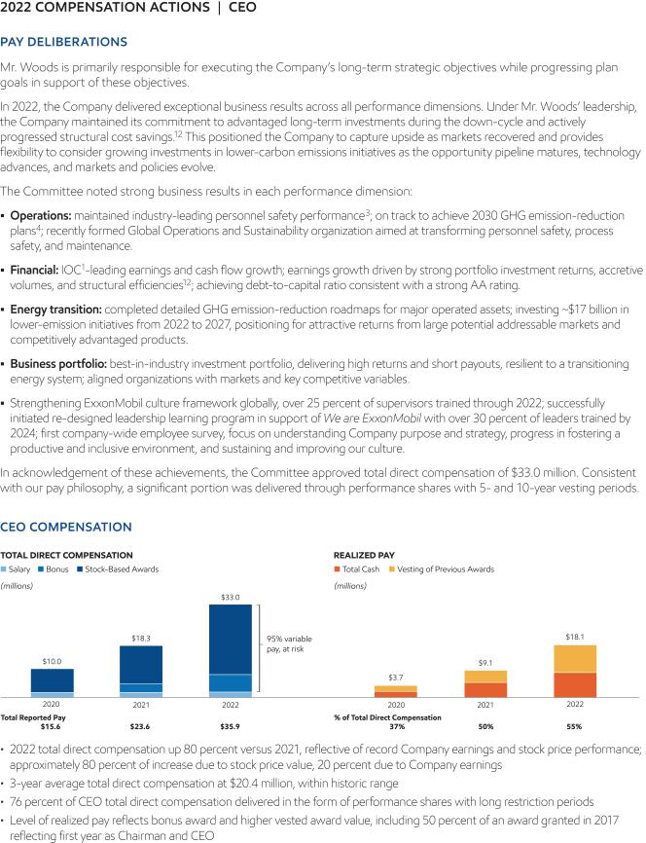

58 2023 Proxy Statement

Table of Contents
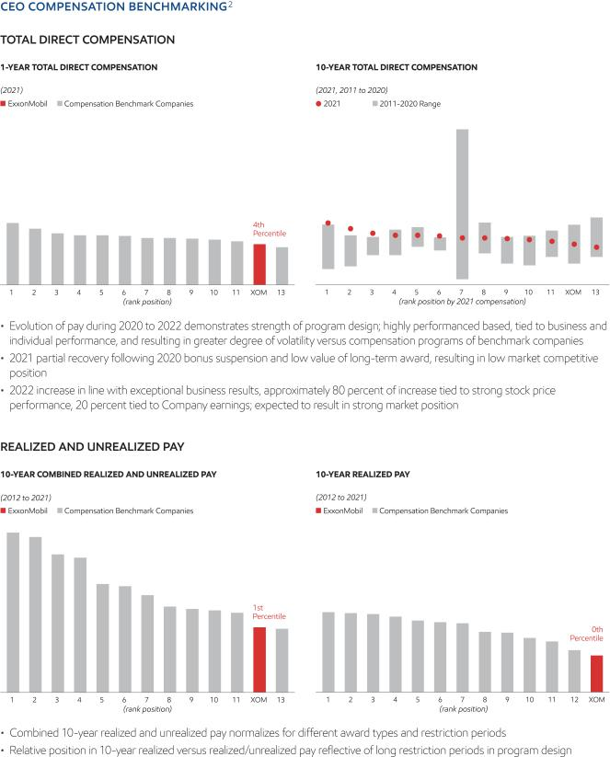

2023 Proxy Statement | 59

Table of Contents
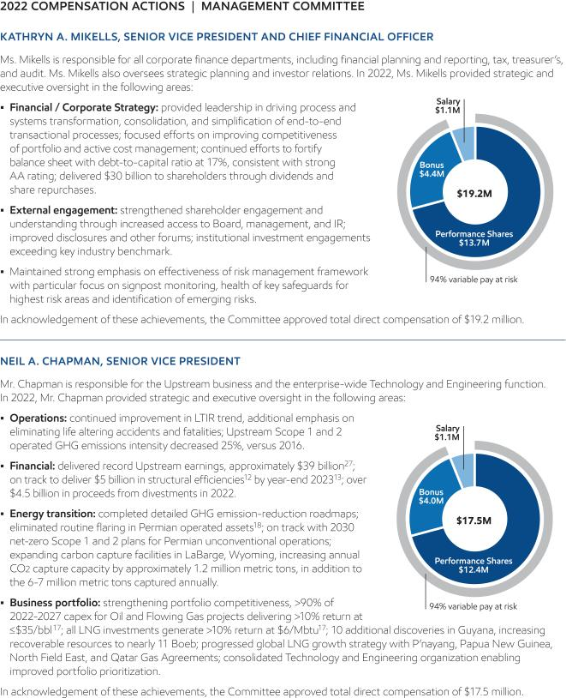

60 2023 Proxy Statement

Table of Contents
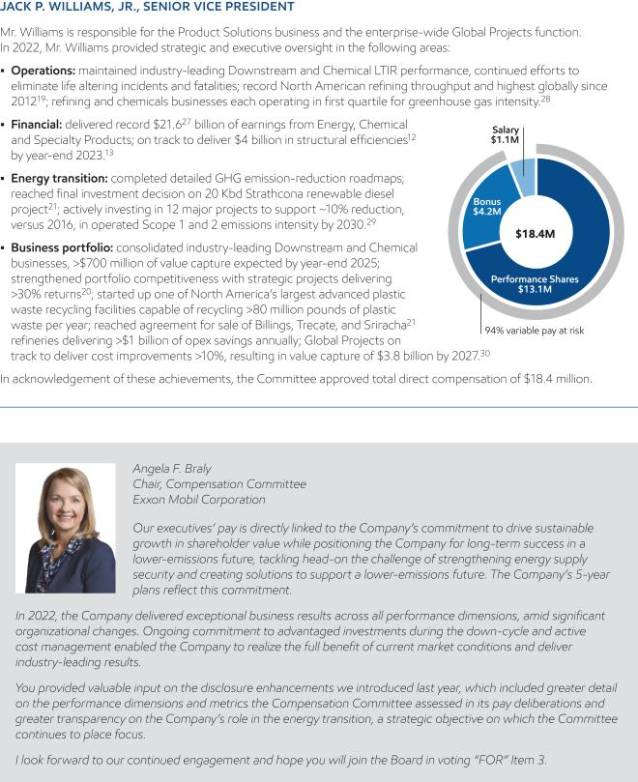

2023 Proxy Statement | 61

Table of Contents
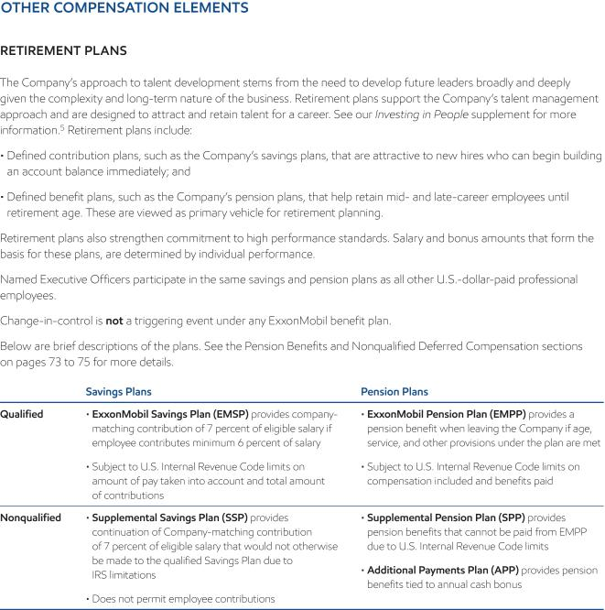

62 2023 Proxy Statement

Table of Contents
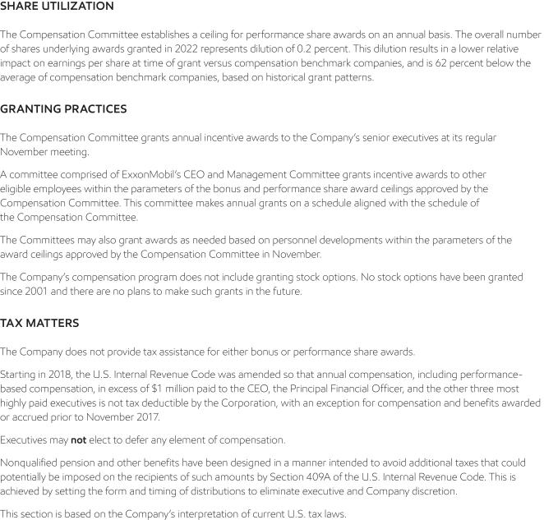

2023 Proxy Statement | 63

Table of Contents
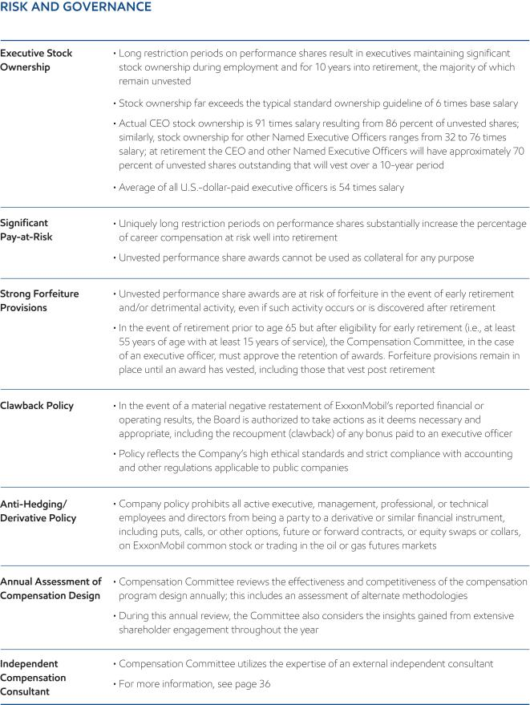

64 2023 Proxy Statement

Table of Contents
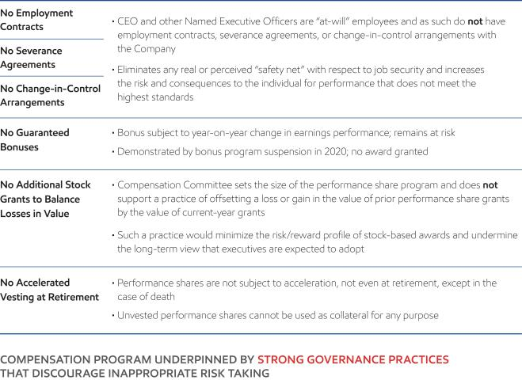

2023 Proxy Statement | 65

Table of Contents
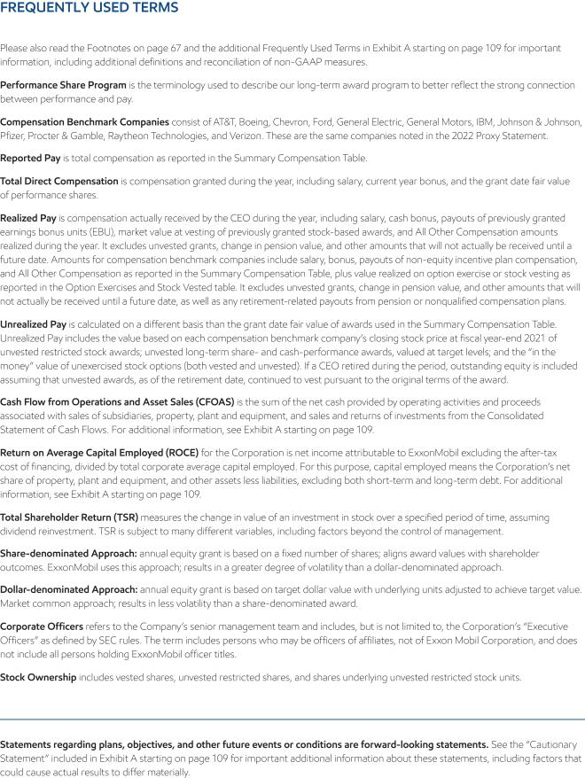

66 2023 Proxy Statement

Table of Contents
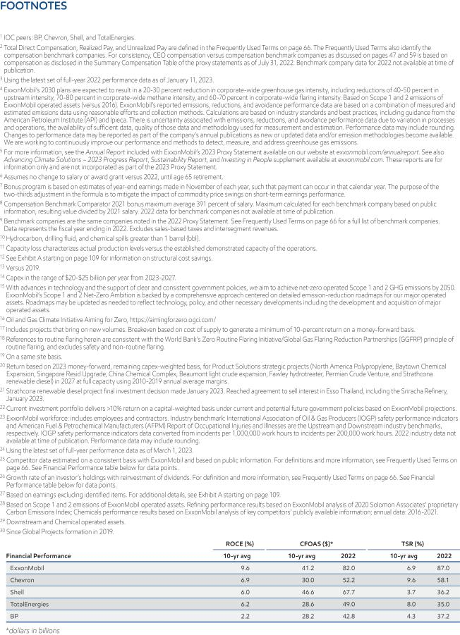

2023 Proxy Statement | 67

Table of Contents
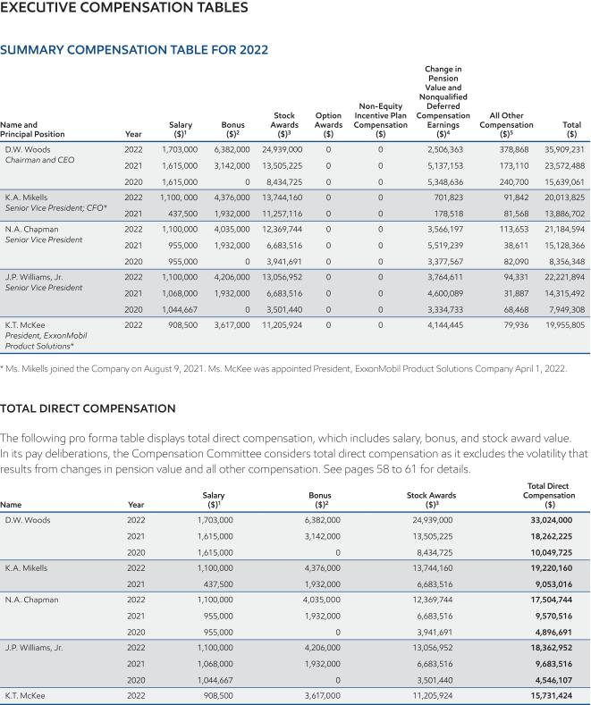

68 2023 Proxy Statement

Table of Contents
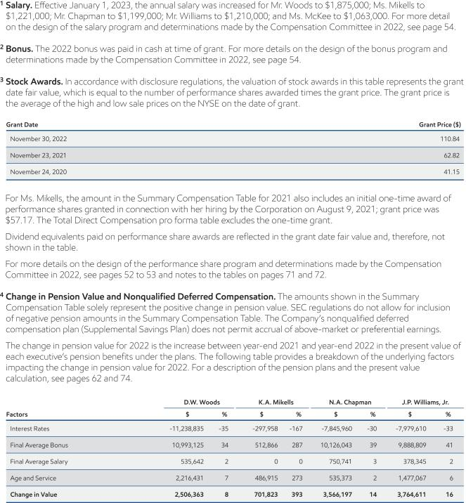

2023 Proxy Statement | 69

Table of Contents
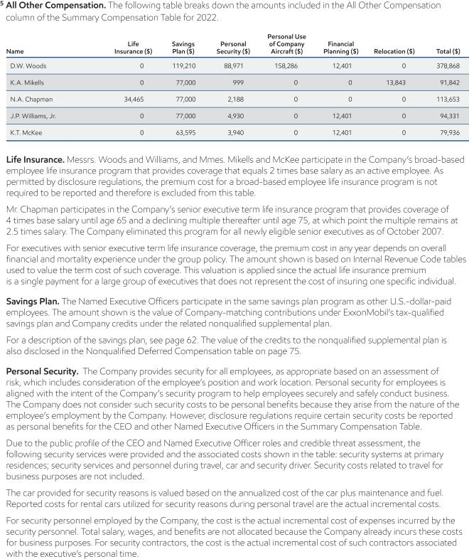

70 2023 Proxy Statement

Table of Contents
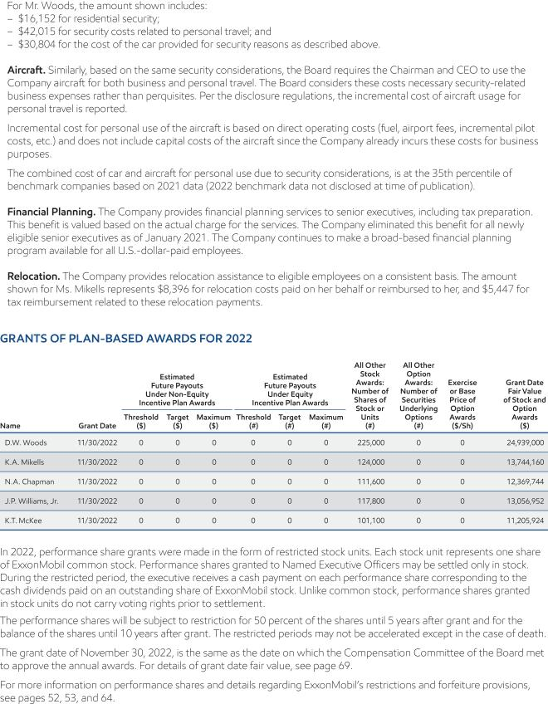

2023 Proxy Statement | 71

Table of Contents
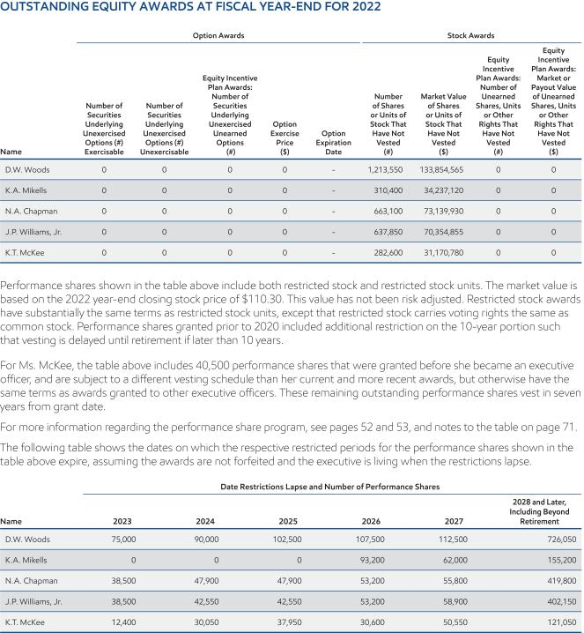

72 2023 Proxy Statement

Table of Contents
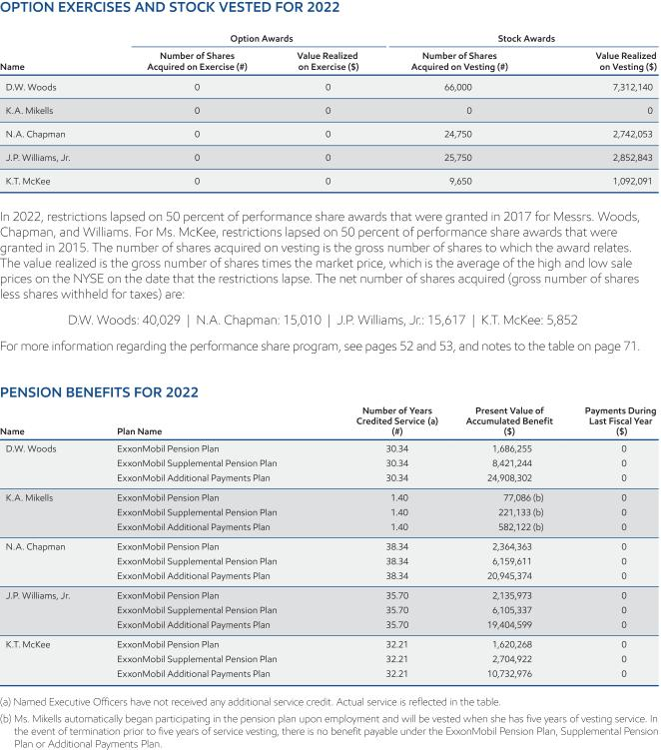

2023 Proxy Statement | 73

Table of Contents
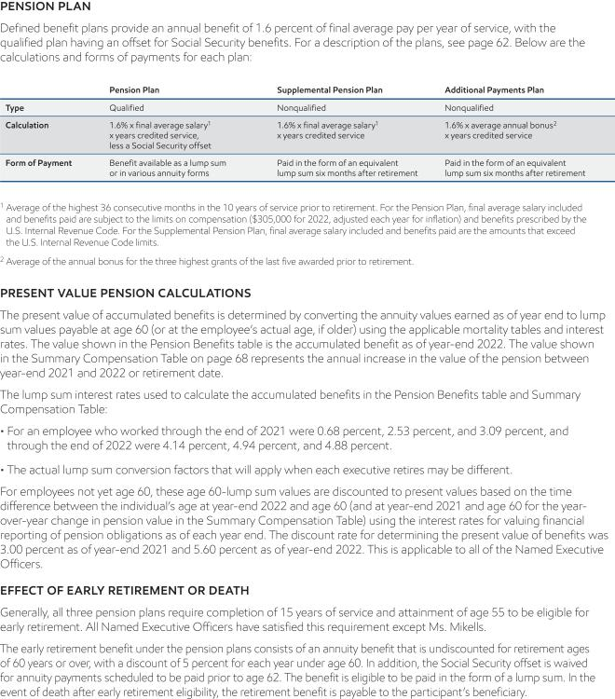

74 2023 Proxy Statement

Table of Contents
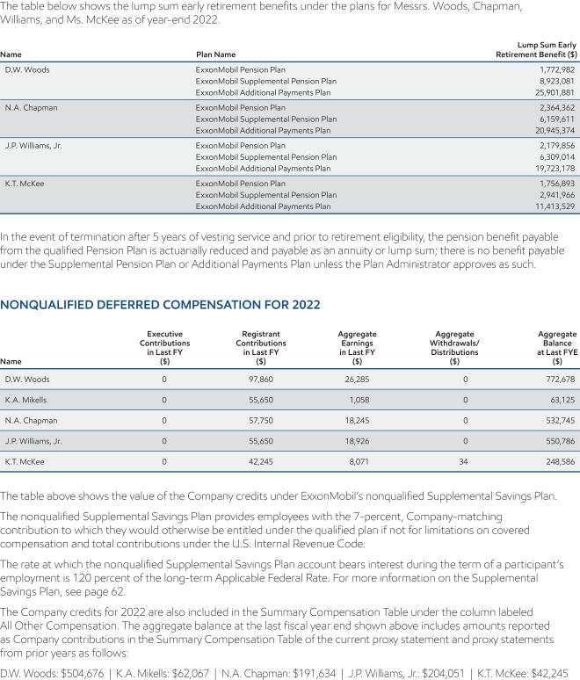

2023 Proxy Statement | 75

Table of Contents
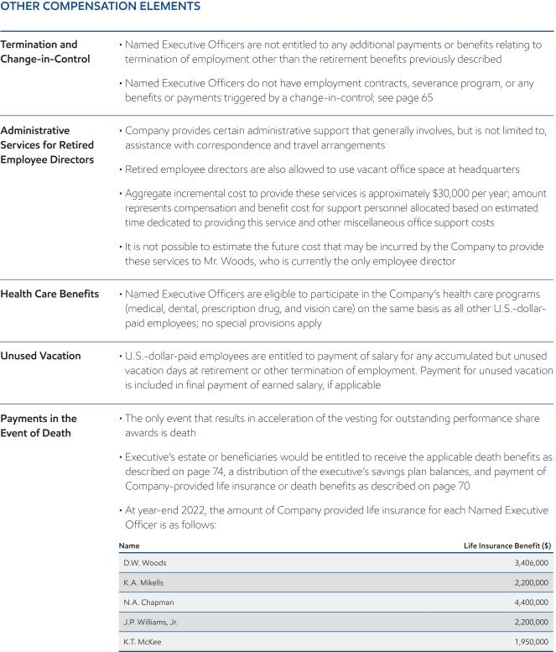

76 2023 Proxy Statement

Table of Contents

SHAREHOLDER PROPOSALS

We expect Items 5 through 17 to be presented by shareholders at the annual meeting. Following SEC rules, other than minor formatting changes, we are reprinting the proposals and supporting statements as they were submitted to us. We take no responsibility for them. Upon oral or written request to the Secretary at the address listed under Contact Information on page 7, we will provide information about the sponsors’ shareholdings, as well as the names, addresses, and shareholdings of any co-sponsors.

The SEC’s shareholder proposal rules were designed to give shareholders access to directors, management, and fellow shareholders so their voices can be heard. We fully support shareholder engagement and advocacy. We consistently work to engage with all proponents each year. In addition, we have significantly expanded our efforts in shareholder engagement over the past several years. We also respect that our shareholders may have viewpoints and perspectives that differ from management and the Board, and we always consider their feedback.

Each year, the Board and management team spend a significant amount of time considering each shareholder proposal. We annually form a taskforce including subject matter experts; members of our Investor Relations, Public and Government Affairs, and Law functions; external advisors; and outside legal counsel to deliberate on each proposal to fully understand each request and determine whether the proposal would generate shareholder value and is in the best interest of the Company. We then spend time developing and reviewing potential responses to each of the proposals. Our CEO and Chief Financial Officer (CFO), individually, spend numerous hours evaluating and participating in those discussions and reviews. This taskforce and management make recommendations to the Board, which also carefully reviews and discusses each proposal. The Board’s and Company’s view is that the shareholder proposals below (10 of which call for additional reports beyond the Company’s already lengthy disclosures and fail to provide decision-useful disclosures) are not in the best interest of the Company and do not enhance shareholder value. To the contrary, the countless hours that the Board, CEO, CFO, management committee, and taskforce members spend discussing and deliberating each proposal detract from time that would have been better spent on other activities in support of the Company’s strategy to further generate shareholder value.

Unfortunately, there are some anti-oil and natural gas activists who use the SEC’s shareholder proposal process to further their own interests, which are often in conflict with the interests of many of the Company’s other shareholders.

These activist firms, by their own admission, prefer not to own fossil fuels stocks yet acquire a minimal ownership stake in the Company with the sole purpose of targeting campaigns and pressuring investors to support resolutions ultimately designed to eliminate oil and gas investments necessary to meet society’s needs. These campaigns can create a burden on our long-term shareholders, and undermine the advancement of constructive Environment, Social, and Governance (ESG) objectives. For instance, the founder of Follow This has previously stated, “We buy shares in order to work on our mission to stop climate change, not to make a financial profit.”¹ He has also stated that his Scope 3 proposals are a “Trojan horse,”² designed to eliminate fossil fuel investments and production. Of the 13 proposals below, several are put forth by anti-oil and gas activists.

We believe their activity is inconsistent with investors’ and fiduciaries’ goal of enhancing the economic value of their investments and advancing constructive ESG objectives. Forcing our company to stop oil and natural gas development would do nothing to reduce global demand. In fact, it would encourage less carbon-efficient, non-public, or less experienced operators, including those without our commitment to reducing greenhouse gas emissions, to step in to fill the supply void. Alternatively, reducing our production would cause reduced global supply before there are viable alternatives at scale. This would significantly drive up prices and hurt the global economy and broader society in ways that are not accounted for by anti-oil and gas activists. We are working to solve the “and” equation: delivering the energy and products society needs and lead industry in reducing greenhouse gas emissions.

Additionally, 10 of the shareholder proposals below seek some form of report. Several of these proposals for reports require us to assume a potential decarbonization pathway that virtually all observers agree society is not currently on. Significantly, even the authors at the International Energy Agency (IEA) have said society is not currently on the IEA Net Zero Emissions by 2050 pathway. The IEA states that “huge leaps in clean energy innovation” are required to reach net zero by 2050, and almost half of the reductions in 2050 would come from technologies that are currently at the demonstration or prototype phase. In heavy industry and long-distance transport, the share of emissions reductions from technologies that are still under development today is even higher.³

2023 Proxy Statement | 77

Table of Contents

ExxonMobil already publishes numerous reports that consider a range of future scenarios from respected third parties and our internal experts. These reports are responsive to shareholder interests and require considerable resources and time to produce on an annual basis, including reviews by subject matter experts, senior management, Board committees, and in several cases, the full Board. They include the Advancing Climate Solutions Progress Report, Sustainability Report, Outlook for Energy, Lobbying Report, Climate Lobbying Report, Political Action Committee Contributions Report, Investing in People supplement, and numerous other SEC filings, investor presentations, and public disclosures. Creating additional, and in many cases, duplicative reports, including reports based on a particular scenario that has little chance at this point of being realized, is a waste of Company resources and serves only to distract the Board, management, and employees from their important work.

We believe it is in the best interest of our shareholders to speak plainly about these proponents, their stated motives, and how their proposals can undermine constructive ESG objectives, which we lay out in our responses.

- See https://www.follow-this.org/how-it-works/
- See https://www.follow-this.org/how-to-get-big-oil-to-end-the-climate-crisis-mark-van-baal-tedxeindhoven/

- See https://iea.blob.core.windows.net/assets/7ebafc81-74ed-412b-9c60-5cc32c8396e4/NetZeroby2050-ARoadmapfortheGlobalEnergySector-SummaryforPolicyMakers_CORR.pdf

The Board recommends you vote AGAINST Items 5 through 17 for the reasons we give after each one.

Item 5 – Establish a New Board Committee on Decarbonization Risk

This proposal was submitted by the Bahnsen Family Trust, 520 Newport Center Drive, Suite 300, Newport Beach, California, 92660, the beneficial owner of 1,310 shares for at least one year.

“Be It Resolved: Shareholders request the Board of Directors charter a new Board Committee on Decarbonization Risk to evaluate ExxonMobil’s strategic vision and responses to calls for ExxonMobil decarbonization on activist-established timelines. The charter should require the committee to engage in formal review and oversight of corporate strategy, above and beyond matters of legal compliance, to assess the company’s responses to demands for such decarbonization schedules, including the potential impacts on the Company from flaws in activists’ climate models, the possibility that the U.S. will not force decarbonization according to such schedules, thus obviating ‘stranded asset’ calculations, the possibility that other countries will not adopt similar targets, thus making Company efforts meaningless, concerns about technological or economic infeasibility, and other relevant considerations.

Supporting Statement:

ExxonMobil has repeatedly stated its commitment to achieving net-zero carbon emissions by 2050. It does not appear from publicly available information, however, that ExxonMobil has fully considered the risk that decarbonization on activist schedules might entail. Claims about the need for decarbonization at all, but especially by some activist-generated date certain, are based on a long series of assumptions that are either counterfactual or insufficiently examined. For decades, for instance, claims have been made that action must be taken before some date, or it will be too late.¹ If those claims were right, it’s too late for decarbonization to matter now, so we should be building up economic resources to deal with climate change. If they are wrong, then the odds are high that current claims are also wrong. ExxonMobil’s decarbonization will be meaningless if other countries do not follow the same decarbonization schedules, and there is abundant evidence that they will not.² The United States government has never mandated net-zero by statute or authorized regulatory action³, and is unlikely ever to do so; this contravenes the assumptions of ‘stranded asset’ analysis. If decarbonization is neither required nor technologically feasible, ExxonMobil will lose significant markets and revenues to private equity firms and (less clean-producing) state actors, thus harming shareholders while also harming the environment. These and all relevant considerations should be fully and objectively examined.

- https://nypost.com/2021/11/12/50-years-of-predictions-that-the-climate-apocalypse-is-nigh/
²https://www.theepochtimes.com/across-the-world-coal-power-is-back_4671888.html; https://www.realclearenergy.org/ articles/2022/06/03/india_and_china_coal_production_surging_by_700m_tons_per_year_thats_greater_than_all_us_coal _output_835483.html https://www.breitbart.com/environment/2022/04/21/worlds-worst-polluter-china-increases-coal-production-by-three-hundred-million-tons/ https://mishtalk.com/economics/global-net-zero-climate-change-targets-are-pie-in-the-sky

³https://www.npr.org/2022/06/30/1103595898/supreme-court-epa-climate-change”

78 2023 Proxy Statement

Table of Contents

The Board carefully considered this proposal and recommends you vote AGAINST it for the following reasons:

The Board and several of its committees actively oversee the development of the Company’s strategy, including all matters related to our decarbonization efforts. Forming a new committee solely for the narrow purpose of reviewing what the full Board and several of its committees already spend significant time and effort engaged in is unnecessary and redundant.

The Board stays well informed of risks and opportunities relevant to strategic decisions through regular briefings on supply-and-demand metrics, impact of geopolitical events, scientific and technical research updates, public policy positions and analyses, signposts for the pace of the transition to lower-emission energy sources, and the progress of our initiatives and actions. The Board also assesses our management of, and response to, other external risk factors, including regulation, climate change, and the energy transition. The Environment, Safety and Public Policy Committee (ESPP) oversees operational and other risks that result from technology, policy, and regulatory changes, and regularly engages with senior management on climate matters and our environmental approach and performance.

The full Board and its various committees, in line with their oversight responsibilities, also review and approve ExxonMobil’s strategy and our annual and medium-term operating plan. Importantly, our strategy leverages the same competitive advantages and core competencies to address both our heritage businesses and our new Low Carbon Solutions business. This approach allows us to allocate our resources in line with market demands and policy developments, and pace our investments in lower-emissions initiatives with value-accretive opportunities as those develop. The full Board carefully considered the concerns raised by the proponent with their endorsement of our strategy that is robust to a range of scenarios, from “business as usual” to “full decarbonization” and at any point in between.

Further, after discussion and dialogue with ExxonMobil management, the Board exercised its oversight in endorsing our five-year plans through 2027, which prioritize high-return, low cost of supply assets, and support efforts to reduce emissions in our own operations and to help others reduce theirs. Our capital plan allocates $17 billion for investments in lower-emission investments, including in our Low Carbon Solutions business, which is expected to generate competitive returns for shareholders.

In speaking with the proponent, we understand the primary concern is disclosure of risks we could face if we over-invest in energy-transition opportunities, either without policy or ahead of it. The Board recognizes that there is risk in pursuing or foregoing investment opportunities – whether in the base business or in new areas; thus, investment decisions are informed by a whole host of considerations to test for resiliency. The “decarbonization risk” outlined by the proponent is one of many risks already incorporated into the rigorous risk oversight framework and processes overseen by the Board and the relevant Committees, and also well disclosed in Company materials. Therefore, the Board recommends a vote against this proposal.

Item 6 – Reduce Executive Stock Holding Period

This proposal was submitted by Kenneth Steiner, 14 Stoner Avenue, 2M, Great Neck, New York 11021, the beneficial owner of at least 500 shares for at least three years.

“Proposal 6 – Executives to Retain Significant Stock


Shareholders urge that our executive pay committee adopt a policy requiring senior executives to retain 50% of stock acquired through equity pay programs until reaching normal retirement age and to report to shareholders regarding the policy in our Company’s next annual meeting proxy. For the purpose of this policy, normal retirement age would be an age of at least 60 and be determined by our executive pay committee.

This single unified policy shall prohibit hedging transactions for shares subject to this policy which are not sales but reduce the risk of loss to the executive. Otherwise our directors might be able to avoid the impact of this proposal.

2023 Proxy Statement | 79

Table of Contents

This policy shall supplement any other share ownership requirements that have been established for senior executives, and should be implemented without violating current company contractual obligations or the terms of any current pay or benefit plan. The Board is encouraged to obtain waivers of any current pay or benefit plan for senior executives that might delay implementation of this proposal.

Requiring senior executives to hold a significant portion of stock obtained through executive pay plans would focus our executives on our company’s long-term success. A Conference Board Task Force report stated that hold-to-retirement requirements give executives ‘an ever-growing incentive to focus on long-term stock price performance.’

Please vote yes:

Executives to Retain Significant Stock – Proposal 6”

The Board carefully considered this proposal and recommends you vote AGAINST it for the following reasons:

The Board fully recognizes the importance of tying executive compensation to the Company’s long-term success. However, this proposal is unnecessary as ExxonMobil’s executive compensation program is already designed with that clear goal in mind. Through its design, stock ownership for senior executives far exceeds the requirements of this proposal. We attempted to engage the proponent and explain that this proposal would result in a reduction of stock ownership into retirement, but he declined to speak with us.

ExxonMobil’s long-term incentive program represents more than 70 percent of total direct compensation for senior executives and takes the form of performance shares subject to some of the longest restriction periods in the Fortune 100. Half of the performance shares vest five years from grant date, while the remaining half vest 10 years from grant date. Vesting is not accelerated at retirement; rather, vesting continues up to 10 years after a senior executive retires and awards remain at risk of forfeiture while unvested.

Of Executive Officers who retired from ExxonMobil January 1, 2020, through January 1, 2023, the average age of appointment in position was 52 and average age of retirement was 62. The chart below shows vesting of awards granted over this timeframe. The grey bar represents each year that an award is granted. The light and dark blue bars reflect the 50 percent of awards that vest in five and 10 years, respectively, from grant date.

As demonstrated in the chart, upon retirement at age 62, 26 percent of awards granted over this timeframe have vested, whereas 74 percent remains unvested and will vest over the next 10 years. This stock holding far exceeds the requirements stated in the shareholder proposal.

In addition, retaining 50 percent of awards only until retirement, as stated in this proposal, would in fact result in accelerated vesting — thus undermining the intent of the program and misaligning the interests of our senior executives with those of our long-term investors. Our senior executives have a significant percentage of their wealth represented in shares, and their interests are well aligned with that of shareholders well into retirement.
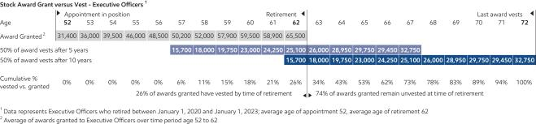

Furthermore, our policies already prohibit hedging awards granted under the program.

The Board believes this proposal is unnecessary. Strong forfeiture and hedging policies are already in place. Adopting the proposed vesting schedule would result in a shortening of senior executive award retention, which would be detrimental to the intent of the program and shareholder interests. As such, the Board recommends a vote against this proposal.

80 2023 Proxy Statement

Table of Contents

Item 7 – Additional Carbon Capture and Storage and Emissions Report

This proposal was submitted by Steve Milloy, 12309 Briarbush Lane, Potomac, Maryland 20854, the beneficial owner of 100 shares for at least three years.

“Carbon Capture and Storage Report Card

Resolved:

Shareholders request that, beginning in 2023, ExxonMobil report annually to shareholders, omitting any confidential business information, the net amount of carbon dioxide (CO2) stored underground as a result of the company’s enhanced oil recovery (EOR) activities, including:

- The total amount (in tons) of captured CO2 stored underground during EOR for the year;

- The total amount of oil (in barrels) produced through CO2-based EOR for the year; and

- The difference (in tons) between the CO2 stored underground during EOR and the expected CO2 emissions produced by the burning of the oil produced by EOR, as calculated using EPA greenhouse gas equivalencies (i.e., 0.43 tons of CO2 per barrel of oil, https://www.epa.gov/energy/greenhouse-gases-equivalencies-calculator -calculations-and-references) or other reasonable means.

Supporting Statement:

ExxonMobil stated on November 6, 2022: ‘ExxonMobil is counting on its long track record in carbon capture for use in enhanced oil recovery to underpin its ambitions for permanent geologic sequestration of greenhouse gases... It’s a well-proven technology that we’ve been doing for many years. We actually account for 40% globally of man-made carbon dioxide that’s being captured.’ https://www.upstreamonline.com/energy-transition/exxonmobil-sees -enhanced-oil-recovery-expertise-as-learning-path-for-climate-action/2-1-1274460

But it’s not at all clear that CO2 capture for EOR results in a net storage of CO2. After all, the produced oil will be burned by consumers and the amount of CO2 emitted thereby may in fact be greater than the amount of CO2 stored. See, e.g., https://junkscience.com/2016/03/no-co2-used-to-produce-oil-does-not-store-co2/

In the event that more CO2 is emitted as a result of EOR than is stored, it would be false and misleading to imply that EOR reduces CO2 in the atmosphere.

Such false and misleading information could make the company subject to government enforcement actions, other lawsuits and reputational harm that would adversely affect shareholder value.

Shareholders have the right to know whether the company is making claims about carbon capture that are not supported by the facts.”

The Board carefully considered this proposal and recommends you vote AGAINST it for the following reasons:

This is one of 10 new reports requested by proponents at this annual shareholder meeting.

The proposal appears to be based on an incomplete understanding of our widespread and well-funded efforts to advance carbon capture and storage technology, and the effectiveness of these initiatives. It also does not recognize that we currently provide extensive information on our annual carbon capture and storage metrics in our Advancing Climate Solutions Progress Report and other communications.

ExxonMobil has more than 30 years of experience capturing and storing CO2, and has cumulatively captured more anthropogenic CO2 than any other company. As mentioned to this proponent, we have an equity share of about one-fifth of the world’s carbon capture capacity at about 9 million metric tons per year, which is equivalent to approximately

2 million gasoline-powered passenger vehicles per year.¹ Since formally launching our Low Carbon Solutions business in early 2021, we have significantly grown our pipeline of emission-reduction opportunities, including opportunities in carbon capture and storage.

2023 Proxy Statement | 81

Table of Contents

For example, our LaBarge facility has the capacity to capture up to 7 million metric tons of CO2 a year, the largest of any industrial facility in the world; furthermore, we have plans underway to expand this facility by up to 1.2 million more metric tons per year beginning in 2025. In addition, we continue to evaluate and progress potential future projects around the world. The carbon capture and storage component of our announced blue hydrogen facility at Baytown has the potential to transport and store up to 10 million metric tons of CO2 per year, more than doubling ExxonMobil’s current carbon capture capacity. It would be our initial contribution to a broad, cross-industry effort to establish a Houston carbon capture and storage hub with an initial goal of about 50 million metric tons of CO2 per year by 2030 and 100 million metric tons by 2040.

To reduce global emissions, existing oil and gas demand needs to be addressed with production techniques that enable the lowest greenhouse gas (GHG) emission intensity. The proponent is implying that there is no emissions benefit associated with the use of CO2 injection for enhanced oil recovery (EOR) production, citing an article from 2016 that does not account for full life cycle analysis. Contrary to that view, CO2-EOR is broadly recognized for its economic and GHG benefits through the use of a closed loop CO2 injection system. On a life cycle basis, which includes global oil market impacts, 63 percent of all CO2 stored through EOR is a net reduction in CO2 emissions. Compared to conventional oil, every barrel of CO2-EOR oil emits 37 percent less CO2.² The United States government also recognizes the importance of carbon capture and storage for EOR application and recently implemented the Inflation Reduction Act that provides an expansion of the Internal Revenue Code Section 45Q CCS-EOR tax incentives. It is anticipated that these incentives will be critical to the United States achieving its near-term GHG emission reduction plans, in support of its net-zero ambition.

We plan to invest approximately $17 billion from 2022 through 2027 on initiatives to lower GHG emissions. These include investments to reduce the emissions intensity of our operated assets and investments that will help others reduce their emissions. We are open to investing even more should additional commercially viable opportunities materialize. Our commitment to help society reduce emissions includes: 1) measuring, monitoring, and managing reductions of our emissions; 2) providing lower emission-intensive products that help customers increasingly reduce their own emissions; and 3) advancing commercialization of emission-reduction and emission-storage technologies.

The additional disclosures requested by the proponent are unwarranted as CO2-EOR is broadly recognized for its greenhouse gas benefits and the disclosures requested would provide no meaningful insight into our efforts to reduce our emissions intensity and assist customers in doing the same. As shareholders already have access to extensive and rigorous reporting on the effectiveness of our decarbonization efforts, the Board recommends a vote against this proposal.

- Nine million metric tons of CO2 emissions is equivalent to approximately 2 million gasoline-powered passenger vehicles driven for one year, according to the U.S. EPA greenhouse gas equivalencies calculator. Passenger vehicles are defined as two-axle, four-

tire vehicles, including passenger cars, vans, pickup trucks, and sport/utility vehicles.

https://www.epa.gov/energy/greenhouse-gas-equivalencies-calculator.

- “CO2 EOR represents a win-win strategy for beneficial use of industrially-sourced CO2. From an economic standpoint, CO2 EOR is a highly effective tool for re-invigorating oil production from mature fields that might otherwise be abandoned. From an environmental standpoint, it represents a practical way to recycle and utilize CO2 while reducing overall atmospheric

CO2 emissions.” https://cdn.catf.us/wp-content/uploads/2019/06/21093723/CATF_EOR_LCA_Factsheet_2019.pdf https://netl.doe.gov/research/coal/energy-systems/gasification/gasifipedia/eor

See also https://iea.blob.core.windows.net/assets/bf99f0f1-f4e2-43d8-b123-

309c1af66555/Storing_CO2_through_Enhanced_Oil_Recovery.pdf; Global CCS capacity: Global CCS Institute, Global Status of

CCS 2021, p. 14. ExxonMobil CCS capacity: ExxonMobil estimates.

Item 8 – Additional Direct Methane Measurement

This proposal was submitted by Sisters of St. Francis Charitable Trust, 3390 Windsor Avenue, Dubuque, Iowa 52001, the beneficial owner of shares with a market value exceeding $2,000 for at least three years, and lead proponent of a filing group.

“Direct Methane Measurement

Whereas, methane is at least 80 times more potent as a greenhouse gas than carbon dioxide over a 20-year period. The Environmental Protection Agency (EPA) reports that 32% of U.S. methane emissions from human activities comes from natural gas and petroleum systems.¹ According to the United Nations Environment Programme (UNEP), cutting methane is the strongest lever we have to slow climate change over the next 25 years.²
82 2023 Proxy Statement

Table of Contents

The EPA methodology used to estimate methane emissions underestimates and fails to capture many major leaks, which waste a valuable product worth over $2 billion per year. Studies have found actual emissions to be 50 to 100% higher than reported emissions.³ In certain basins, emissions are more than 10 times industry-disclosed figures.² Therefore, oil and gas industry Scope 1 emissions may be significantly higher than currently reported. Methane emissions estimates improve when direct measurement methodologies are used, when emissions are identified by source type and at a site or facility level, and then reconciled, as shown by the Oil and Gas Methane Partnership 2.0 (OGMP).⁴

The U.S. joined the Global Methane Pledge in 2021, committing to use best available inventory methodologies to quantify methane emissions. The same year, investors managing more than $6 trillion supported strong federal methane regulations. Companies responsible for approximately 30% of global natural gas production, including bp, Shell, TotalEnergies, Occidental, and ConocoPhillips, have joined the OGMP, a multi-stakeholder initiative launched by UNEP committed to improving methane data quality and consistency.⁵ Companies that do not adequately manage methane emissions risk their reputation and license to operate.

ExxonMobil has committed to reduce methane emissions in alignment with the Global Methane Pledge by deploying best practices and advanced technologies, including satellite, aerial, and ground-sensor networks.⁶ The Company supports strong measurement, reporting and verification standards. It participates in various international methane coalitions and contributes to research to improve methane quantification.⁷ However, it has not taken the critical step to reduce investor concerns by reporting on its methane emission measurements.

Resolved, shareholders request that ExxonMobil issue a report analyzing the reliability of its methane emission disclosures. The report should:

- Be made public, omit proprietary information, and be prepared expeditiously at reasonable cost; and

- Summarize the outcome of efforts to directly measure methane emissions, using recognized frameworks such as OGMP; and whether those outcomes suggest a need to alter the Company’s actions to achieve its climate targets.

Supporting Statement:

At management’s discretion, we recommend that the report:

- Describe the types of source- and site-level measurements used;

- Describe any material difference between its own or third-party direct measurement results and Company’s reported methane emissions;

- Describe plans to validate emissions estimates and disclosure through third-party audit or evaluation; and

- Describe plans to improve emission estimates over time, consistent with frameworks such as OGMP.

- https://www.epa.gov/ghgemissions/overview-greenhouse-gases
- https://www.ccacoalition.org/sites/default/files/press/GMA%20Press%20Release%20FINAL.pdf
- https://www.seas.harvard.edu/news/2021/03/oil-and-natural-gas-production-emit-more-methane-previously-thought,

https://www.nature.com/articles/s41467-021-25017-4
- https://business.edf.org/files/Investors-Guide-to-the-OGMP_09.17.21_FINAL.pdf
- http://ogmpartnership.com/partners
- https://corporate.exxonmobil.com/climate-solutions/advancing-climate-solutions#:~:text=Net%2Dzero%20ambition,Scope%202%20greenhouse%20gas%20emissions”

The Board carefully considered this proposal and recommends you vote AGAINST it for the following reasons:

This is one of 10 new reports requested by proponents at this annual shareholder meeting.

ExxonMobil agrees that reducing methane emissions is one of the most effective ways to help reduce the risks associated with climate change in the near term, and we have made significant progress, both to reduce methane emissions and to improve the robust disclosures already provided. However, the proposal neglects to acknowledge the important work we are doing on these fronts and suggests initiatives that are duplicative to what we are already doing, which would be unnecessary. The Board therefore recommends that shareholders vote against this proposal.

2023 Proxy Statement | 83

Table of Contents

ExxonMobil is a leader in advocating for strong measurement, reporting, and verification standards, and we have publicly reported methane emissions on an annual basis since 2014. This data is based on internationally recognized methodologies and compiled every year by determining emissions by source at each operated asset across the Company. As discussed with the proponent, since receiving this proposal, we published our Advancing Climate Solutions 2023 Progress Report, which includes our methane emissions data and describes efforts to continuously improve the reliability of our methane reporting as part of broader efforts to reduce greenhouse gas emissions in support of a lower emissions future.

Our reporting framework has enabled the development of consistent and comparable data, which, along with growing field observations, has guided our mitigation efforts. We are focused on emissions mitigation and the transition to observation-based emission quantification of potential non-routine sources. This is why we continue to develop and deploy enhanced technologies to ensure rapid detection, mitigation, and quantification of these non-routine sources at our operated assets.

Since 2019, we have voluntarily used airplane-based surveys as enhanced leak detection in the Permian Basin. Additionally, we are installing state-of-the-art technology across our 1.8 million-acre Permian position to continuously monitor and detect methane leaks by integrating data from ground sensors, aerial flyovers, and satellite images. We have already begun 24/7 monitoring of certain ground sources in the field, and we expect the entire system to be fully operational by 2025.

Lloyd’s Register Quality Assurance has provided their independent limited level of assurance that the 2021 ExxonMobil greenhouse gas emissions inventory meets ISO 14064-3 expectations. The assurance engagement covered ExxonMobil’s GHG Inventory for CY2021 and Oil & Gas Climate Initiative (OGCI) Metrics for CY2021, including absolute and intensity metrics for greenhouse gas emissions, methane emissions, and flaring emissions for operated assets based on IPCC AR6.

Furthermore, we aim to continually improve emission estimates over time by applying the best available technology and protocols, and support utilizing frameworks similar to the Oil and Gas Methane Partnership 2.0 (OGMP 2.0).

However, significant challenges remain with us joining, and using the framework established by, OGMP 2.0. Quantification technologies are still emerging and do not currently provide consistent, repeatable results at the site/point-source level. In many countries where we have operations, there are significant access and security issues, as well as a limited number of providers to support measurement and quantification technologies. In addition, the framework requires the execution of a memorandum of understanding that we believe poses onerous legal obligations, including a requirement for us to indemnify the United Nations. We are continuing to collaborate with the United Nations Environment Programme (UNEP) and OGMP 2.0 leadership and to improve the quality of methane emissions reporting.

We are in regular contact with third-party groups who monitor methane emissions. We are not aware of any third-party direct measurement results that are materially different than our reported methane emissions. If any material methane source from our operations is identified in the future, we would take steps to confirm the data and address the issue.

As described in the Advancing Climate Solutions 2023 Progress Report, we have long participated in industry and academic consortiums to advance the scientific understanding and quality of methane measurement, calculation, and models. To that end, we recently joined the Gas Technology Institute-led Project Veritas with 30 other leading organizations to develop and implement a standardized, science-based, technology-neutral, measurement-informed approach to reporting methane emissions.

Additionally, we are actively progressing the elimination of many sources of methane emissions as part of our commitment to OGCI’s Aiming for Zero Methane Emissions Initiative. We are working to eliminate all natural gas driven pneumatic devices by 2025 in our key U.S. unconventional operated assets and to accelerate the phase-out of these devices across all of our global operated assets where technically feasible. Also, we eliminated routine flaring in our Permian Basin operated assets at year-end 2022 and plan to eliminate routine flaring across our global operated upstream assets by 2030 in line with the World Bank Zero Routine Flaring Initiative.

In summary, given the significant progress we are making to reduce methane emissions and the robust disclosures already provided, the Board believes that this proposal is duplicative and, therefore, unnecessary. As such, the Board recommends that shareholders vote against this proposal.

84 2023 Proxy Statement

Table of Contents

For more information, visit our website: corporate.exxonmobil.com/Climate-Solutions/Methane.

Item 9 – Establish a Scope 3 Target and Reduce Hydrocarbon Sales

This proposal was submitted by Follow This, Anthony Fokkerweg 61, 1059 CP Amsterdam, Netherlands, the beneficial owner of 37 shares for at least three years, and lead proponent of a filing group.

“Shareholder proposal at the 2023 AGM of ExxonMobil Corporation (‘the Company’)

Filed by Follow This

WHEREAS: The world has declared to drive down greenhouse gas (GHG) emissions this decade, the energy transition presents great opportunities for an integrated energy multinational.

RESOLVED: Shareholders request the Company to set a medium-term reduction target covering the greenhouse gas (GHG) emissions of the use of its energy products (Scope 3) consistent with the goal of the Paris Climate Agreement: to limit global warming to well below 2°C above pre-industrial levels and to pursue efforts to limit the temperature increase to 1.5°C.

The strategy for how to achieve this target is entirely up to the board.

You have our support.

SUPPORTING STATEMENT:

We believe that ExxonMobil could lead and thrive in the energy transition by meeting the increasing demand for energy services while reducing GHG emissions to levels consistent with the global intergovernmental consensus specified by the Paris Accord.

Setting a Paris-aligned medium-term target covering Scope 3 is paramount, because the medium-term is decisive for the Company and the Paris Accord and because Scope 3 accounts for around 90% of total Scope 1, 2 and 3 emissions.^{1,2}

ExxonMobil is one of the few oil majors that has not set Scope 3 targets (at the time of filing this proposal).

Therefore, this proposal supports ExxonMobil to set a Paris-aligned medium-term target covering Scope 3.

We, the shareholders, understand this support to be our fiduciary duty to secure the long-term interest of the Company and to protect all our assets in the global economy from devastating climate change; limiting global warming is essential to risk management and responsible stewardship of the economy.

Backing from investors determined to achieve Paris remains strong; in 2022, 28% of shareholders in ExxonMobil and up to 39% of shareholders in other oil majors voted in favour of Follow This climate resolutions requesting Paris-aligned targets.³

The current energy crisis and the climate crisis can be addressed simultaneously by investing the windfall profits from high oil and gas prices in other energy sources.⁴ Diversification of the energy supply would foster energy security by reducing dependency on oil and gas fields tied up in geo-political conflict and reduce emissions to address the climate crisis simultaneously.

Changes in demand are as critical as changes in supply, but customers can only change sufficiently when key system players like ExxonMobil offer alternative energy sources at scale.⁵ By investing in alternatives, a global integrated energy company like ExxonMobil could decrease emissions without ultimately shrinking business.

It is in the Company’s and its shareholders’ best interest to pursue the opportunities the energy transition presents; this will also pre-empt risks of losing access to capital markets, policy interventions, litigation, liability for the costs of climate change, disruptive innovation, and stranded assets.⁶

You have our support.

Sources: www.follow-this.org/ExxonMobil-resolution-2023-sources/”

2023 Proxy Statement | 85

Table of Contents

The Board carefully considered this proposal and recommends you vote AGAINST it for the following reasons:

The Board takes an active role in overseeing ExxonMobil’s approach to climate change and agrees with the proponent that we can be, and are in fact working to be, a leader in the energy transition. As described in our Advancing Climate Solutions 2023 Progress Report, we have increased investments by nearly 15 percent to approximately $17 billion from 2022 through 2027 to advance a number of initiatives to reduce greenhouse gas emissions in our own operations and help others reduce their emissions. We believe setting Scope 3 targets can have significant unintended consequences for society, and therefore we recommend a vote against this proposal.

In making this recommendation against the proposal, we note the following:

- The proposal does not acknowledge our significant work and commitment to reduce our emissions and aid our customers in doing the same, including those emissions arising from energy-intensive industries.

- The proponent is an anti-oil and gas activist group using environmental, social, and governance objectives to diminish the important role ExxonMobil plays in the energy industry.

The group’s founder openly admitted in a TED Talk, which is available on its website, that its shareholder proposals use alignment with the Paris Climate Agreement 1.5°C as a “Trojan horse”¹ to force companies to eliminate oil and natural gas investments. Forcing investment decisions based on this scenario, before the technology and policies exist, would have clear consequences for energy security, consumer pricing, and standards of living for people in the U.S. and around the world by creating supply shortages that drive prices up and harm vulnerable populations. The proposal does nothing to further shareholder interests.

- This “Trojan horse” proposal speaks to a Scope 3 emissions framework that, when applied at a company level, has flaws, not just in its calculations but in the misguided insights those calculations offer (e.g., double counting of emissions). We believe applying Scope 3 targets to companies will have significant, unintended consequences for society.

As we discussed with the proponent, calculating Scope 3 emissions at a macro level can provide useful insights into sources of emissions and opportunities for an economy to improve. However, applying Scope 3 targets to an oil and gas company incentivizes asset divestments or reduced production of products that society needs. In the first case, the greenhouse gas emissions still occur but are no longer attributable to the original asset owner. This does not reduce global emissions and may, depending on the capabilities and commitments of the new owner, increase overall emissions. In the second case, where operations are discontinued, the need for that energy remains. Consumers are forced to make do with less energy, pay significantly more for their energy, or, depending on availability, turn to alternative, higher-emitting sources like coal.

Another flaw of company-specific Scope 3 targets is that it disincentivizes companies from providing products that help society reduce emissions by displacing higher-emitting alternatives. For example, the natural gas we produce can reduce global emissions by about 60 percent on a life-cycle intensity basis when it displaces coal. However, in producing more natural gas for society to burn less coal, our Company’s calculated Scope 3 emissions go up. This is a clear disincentive for helping society reduce emissions.

Likewise, Scope 3 does not allow for a net number when arriving at its calculations. As a consequence, no emissions benefit is given to a company like ours that is engaged in the critical work of helping customers remove and safely store carbon emissions that would otherwise wind up in the atmosphere.

Make no mistake, we are committed to reducing greenhouse gas emissions, which is why we’re taking a full life-cycle approach that uses intensity metrics and allows for a more meaningful view of our progress and contributions to society across products and industries. To demonstrate this approach, we have modeled and disclosed our expected lifecycle emission reductions by 2030 (a 6 percent reduction in intensity and an 18 percent reduction in absolute emissions versus 2016).

In our view, this proposal reflects the proponent’s underlying objective to reduce the supply of oil and natural gas at a time in the energy transition when there is no viable alternative at scale. It is overly prescriptive and incorrectly applies a metric that is intended to measure society’s progress in reducing emissions to an individual company. Scope 3 targets are the wrong basis for evaluating a company’s progress in supporting the goals of the Paris Agreement and

86 2023 Proxy Statement

Table of Contents

meeting the needs of society. For these reasons, the Board supports the Company’s life-cycle approach toward reducing greenhouse gas emissions and rejects using Scope 3 targets as put forth by the proponent. We recommend a vote against this proposal.

- https://www.follow-this.org/how-to-get-big-oil-to-end-the-climate-crisis-mark-van-baal-tedxeindhoven/

Item 10 – Additional Report on Worst-case Spill and Response Plans

This proposal was submitted by Mercy Investment Services, Inc., 2039 North Geyer Road, St. Louis, Missouri 63131, the beneficial owner of shares with a market value exceeding $2,000 for at least three years, and lead proponent of a filing group.

“WHEREAS:

ExxonMobil operates one of the largest oil plays discovered in the past decade, offshore of the South American country Guyana. After discovering oil in 2015, development proceeded rapidly. Production began in 2019,¹ with capacity expected to exceed one million bpd by 2030.²
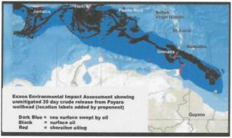

CEO Darren Woods admitted ExxonMobil is exceeding design capacity for production in two offshore projects in Guyana.³ Production in one project has reached 150,000 bpd, clearly above its listed peak production safety threshold of 120,000 bpd⁴, raising concerns among observers.⁵ A former director of Guyana’s environmental protection agency called this ‘unheard of’ and stated ExxonMobil is ‘without a conscience and ruthlessly taking advantage of an abysmal EPA and weak Government’ in Guyana.⁶ Other safety concerns include gas compressor failures resulting in fines exceeding US$10 million.⁷

Caribbean countries rely on tourism and fishing industries to support their economies,⁸ yet ExxonMobil’s Environmental Impact Assessment (EIA) characterizes residual risk to employment as minor and assumes that a large oil spill is unlikely.⁹

The BP Macondo oil spill released millions of barrels of oil into the Gulf of Mexico over 87 days and created a 57,500 square mile oil slick, exemplifying the risks of deep-water drilling.¹⁰ BP stock plummeted 52% over two months.¹¹ Robert Bea, an expert on the Macondo spill, warns ExxonMobil shows ‘ignorance of risk management fundamentals’ in its Guyana operations and mirrors overconfidence preceding the Macondo disaster.¹² The most severe spill scenario in ExxonMobil’s EIA accounts for only a 30-day spill.¹³

President of Esso Exploration and Guyana Limited, Alistair Routledge, has stated ‘there is no limit’ to what ExxonMobil would do in response to an oil spill.¹⁴ ExxonMobil’s responsibility and potential liability are of concern to investors.

RESOLVED:

Shareholders request that the Company issue a report evaluating the economic, human, and environmental impacts of a worst-case oil spill from its operations offshore of Guyana. The report should be prepared at reasonable expense, omit proprietary or privileged information, and clarify the extent of the Company’s cleanup response commitments given the potential for severe impact on Caribbean economies.

2023 Proxy Statement | 87

Table of Contents

Supporting Statement:

A ‘worst-case’ should use adverse assumptions such as an extended duration of an uncontrolled release similar to the BP spill, severe weather conditions, increased flow including risks from operating beyond the production thresholds in the EIA, and potential harm to marine ecosystems and public health.

- https://corporate.exxonmobil.com/news/newsroom/news-releases/2022/0211_exxonmobil-starts-production-at- guyanas-second-offshore-development.
- https://newsroom.gy/2022/10/26/with-new-discoveries-oil-production-to-exceed-1-million-barrels-per-day-by-2030/;
- https://www.fool.com/earnings/call-transcripts/2022/10/28/exxonmobil-xom-q3-2022-earnings-call-transcript/
- Liza Phase I EIA, p. 38
- https://www.kaieteurnewsonline.com/2022/11/01/exxonmobil-ruthlessly-taking-advantage-of-slack-govt-abysmal-epa-by-violating-safe-production-limits-dr-adams/
- https://www.kaieteurnewsonline.com/2022/11/01/exxonmobil-ruthlessly-taking-advantage-of-slack-
govt-abysmal-epa-by-violating-safe-production-limits-dr-adams/

- https://demerarawaves.com/2022/07/26/exxonmobil-racks-up-us10-million-flaring-fine-installs-new-flash-gas-compressor-increases-liza-destinys-daily-output/
- https://www.fao.org/3/ax904e/ax904e.pdf
- Payara EIA, Volume I, p. 1,002.
- https://www.britannica.com/event/Deepwater-Horizon-oil-spill; See also, https://www.epa.gov/enforcement/ deepwater-horizon-bp-gulf-mexico-oil-spill#:~:text=4%20million%20barrels%20of%20oil,be%20responsible%20for% 20the%20spill.

- https://money.cnn.com/2010/06/24/news/companies/BP_stock_price/index.htm
- https://www.theguardian.com/environment/2021/aug/17/exxon-oil-drilling-guyana-disaster-risk
- Payara EIA Volume I, p. 839
- Newsroom Interview, https://www.facebook.com/watch/?v=1758505224495143”

The Board carefully considered this proposal and recommends you vote AGAINST it for the following reasons:

This is one of 10 new reports requested by proponents at this annual shareholder meeting.

The information requested by the proposal is already publicly available in published reports prepared by the Company and credible third-party experts, as mentioned to this proponent during our engagement. This includes multiple Environmental Impact Assessments (EIAs), the Oil Spill Response Plan for Guyana Operations (OSRP), and other publications and filings that are available on our website and the website of the Guyana Environmental Protection Agency (EPA) as part of the legally required permitting process. This proposal is therefore redundant and unnecessary.

ExxonMobil is determined to be a good corporate citizen wherever it operates worldwide. Before any exploration activities were carried out in Guyana, we developed detailed emergency preparedness and response plans, including the OSRP. The plans indicate that we are prepared and able to handle possible oil spills in the region. These plans are continuously updated as our project scope in Guyana expands, and they include detailed models showing a wide variety of potential scenarios, including our response plan under those scenarios.

These scenarios include releases of different types of hydrocarbons, with several being applicable for spills at the shorebase(s) and on vessels in the Demerara River estuary (e.g., from a supply vessel) or in the Atlantic Ocean (e.g., from a well, drillship, supply vessel, tanker, or floating production, storage, and offloading vessel). Each ExxonMobil facility and business unit has access to readily available trained responders, including regional response teams, to provide rapid tactical support. These scenarios also consider the latest technology advancements. Since the Macondo incident, the oil and gas industry and their partners have developed a world-wide network of equipment that was not available in 2010, most notably the capping stacks. Through its multiple subscriptions to oil spill response companies, in the case of an incident, ExxonMobil Guyana would activate the resources needed to bring a capping stack into Guyana, and mobilize it and related resources to the well site in record time.

We also want to clear up any misunderstanding of engineering terminology. When we indicate an asset is producing “above design capacity,” we simply mean that the volume is above the investment basis, meaning its performance is exceeding expectations. The actual volume that is safe to produce is well above the design capacity. It in no way indicates that the asset is producing at an unsafe level. After production begins, we regularly look for opportunities to increase production beyond initial EIA estimates while remaining within safe operational limits. We take safety very seriously at all our sites. Last, we safely replaced a gas compressor, working closely with the Government of Guyana, and agreed in advance to pay an associated fee. The proponent mischaracterizes this fee as a fine.

88 2023 Proxy Statement

Table of Contents

Given the comprehensive materials that are publicly available on our website, including our preparedness plan and the EIAs related to our Guyana operations, creating an additional report as requested by this proposal would place an unnecessary administrative burden on ExxonMobil, be wasteful of the Company’s time and resources, and therefore is not in the best interests of shareholders. For the reasons stated above, the Board recommends a vote against this proposal.

Item 11 – GHG Reporting on Adjusted Basis

This proposal was submitted by Andrew Behar, 2020 Milvia St., Suite 500, Berkeley, California 94704, the beneficial owner 40 shares for at least three years, and lead proponent of a filing group.

“WHEREAS: The economic risks associated with climate change exist in the real world rather than on company balance sheets. Transferring emissions from one company to another may reduce balance sheet emissions but does not mitigate company or stakeholder exposure to climate risk or contribute to the goal of limiting global temperature rise to 1.5 degrees Celsius. In the aggregate, upstream oil and gas assets are moving from operators with stronger climate commitments to operators with weaker climate targets and disclosures.¹

The Glasgow Financial Alliance for Net Zero states that ‘divestment of carbon-intensive assets can be ineffective and even lead to real-world increases in emissions.’² As such, these divestments should not be counted as emissions reductions.

To accurately account for greenhouse gas (GHG) emissions reductions, the Greenhouse Gas Protocol provides that companies should recalculate base year emissions in the event of a ‘transfer of ownership or control of emissions-generating activities.’³ Oil and gas industry association IPIECA similarly recommends ‘adjustments to the base year emissions’ to account for asset divestiture, to avoid giving the appearance of ‘increases or decreases in emissions, when in fact. . . emissions would merely be transferred from one company to another.’⁴

Since 2016, ExxonMobil reports absolute Scope 1 and 2 emissions reductions of roughly 10% on both equity and operated bases.⁵ However, between 2017 and 2021, ExxonMobil sold more assets than any other American oil and gas company except Chevron, ranking fourth globally among sellers.⁶ It is unclear how ExxonMobil accounts for these divestitures in its emissions reporting. Therefore, shareholders cannot determine whether ExxonMobil’s reported GHG reductions are the result of operational improvements or of transferring emissions off its books.

In contrast, peer company Devon Energy recalculates its baseline when asset divestitures or investments result in ‘a change to its emissions baseline of 5% or higher’ to ensure accuracy and comparability of emissions reporting.⁷ Devon notes that this ‘recalculation methodology affirms our commitment to structurally drive down emissions, rather than divesting assets as a means to achieve our ambitious emissions reduction targets.’⁸ Investors deserve the same transparency from ExxonMobil.

RESOLVED: Shareholders request that ExxonMobil, at reasonable cost and omitting proprietary information, disclose a recalculated emissions baseline that excludes the aggregated GHG emissions from material asset divestitures occurring since 2016, the year ExxonMobil uses to baseline its emissions.

SUPPORTING STATEMENT: Proponents recommend disclosing, at management’s discretion:

- The emissions associated with ExxonMobil’s material asset divestments since 2016;

- What portion, if any, of ExxonMobil’s current emissions reduction targets relies on accounting for asset transfers as emissions reductions;

- A base year emissions recalculation policy establishing a threshold for future recalculations related to divestitures.

- https://business.edf.org/files/Transferred-Emissions-How-Oil-Gas-MA-Hamper-Energy-Transition.pdf p. 4
- https://assets.bbhub.io/company/sites/63/2021/11/GFANZ-Progress-Report.pdf p. 52
- https://ghgprotocol.org/sites/default/files/standards/ghg-protocol-revised.pdf p. 35
- https://www.ipieca.org/resources/good-practice/petroleum-industry-guidelines-for-reporting-greenhouse-gas- emissions-2nd-edition/ p. 39

2023 Proxy Statement | 89

Table of Contents

- https://corporate.exxonmobil.com/-/media/global/files/advancing-climate-solutions-progress-report/2022-july-update/exxonmobil-advancing-climate-solutions-2022-progress-report.pdf?la=en&hash= 3A2B299463CE50DCDD6A9595E49AC3030CFF4350
- https://business.edf.org/files/Transferred-Emissions-How-Oil-Gas-MA-Hamper-Energy-Transition.pdf p. 22
- https://dvnweb.azureedge.net/assets/documents/Sustainability/DVN_2022_SustainabilityReport.pdf p. 20
⁸Ibid.”

The Board carefully considered this proposal and recommends you vote AGAINST it for the following reasons:

This is one of 10 new reports requested by proponents at this annual shareholder meeting.

The Board agrees with the proponent that greenhouse gas metrics and calculation methods should incentivize actions to address emissions. We also acknowledge that the proponent is aligned with our long-held position that divesting assets to manipulate company-specific absolute emissions is not a constructive way to reduce global emissions. We make divestment decisions to maximize value and improve competitiveness, not to manage emissions.

Divesting assets to reduce emissions and meet an emissions target does not reduce global emissions and could result in potentially higher emissions depending on the capabilities of the acquiring company. Similarly, an individual company reducing oil and natural gas investments required to meet global demand does not reduce emissions; rather, it shifts the investments needed to meet demand and resulting emissions to other, potentially less capable, companies. That is why we commit to reducing emissions intensity. We believe that society’s demand for oil and natural gas should be met by producers with the lowest-emissions intensity for the resource types required to meet that demand.

Further, we believe that a company’s size, reflected in absolute emissions, should not be used to evaluate a company’s commitment to improving global emissions. To offset reduced industry capacity and meet growing demand, we are planning to increase oil and natural gas production and refining throughput while reducing the emissions of our operations, resulting in a lower emissions intensity. Focusing exclusively on absolute emissions would discourage this and lead to further supply shortages and higher prices – disproportionately increasing the burden on low-income families.

We advocate for economy-wide, comprehensive emissions measurement using a life-cycle approach and emissions intensity.

The proponent correctly states that we do not adjust for divestments. As we have discussed with the proponent, we also do not adjust for acquisitions or added capacity. This is consistent with a majority of the industry, and aligns with the U.S. EPA Greenhouse Gas Reporting Program (GHGRP) regulations. The proponent’s request to recalculate the baseline to remove divested assets would be inconsistent with the GHGRP regulatory requirements and reporting practices for reserves and financial data.

Consistent with regulatory requirements, through 2022 and using a baseline year of 2016 for Scope 1 and Scope 2 emissions from operated assets, we have disclosed that the Company has achieved a greater than 10 percent reduction in its greenhouse gas emissions intensity and approximately a 15 percent reduction in absolute emissions. For the same period, methane emissions intensity from operated assets is down more than 50 percent and by 50 percent on an absolute basis. Informed by detailed emission-reduction roadmaps for major operated assets, the Company is making significant progress toward its greenhouse gas emission-reduction plans, including meeting our 2025 emission intensity reduction goals four years early.¹ The Company also has announced that, with advances in technology and clear and consistent government policies, it aims to achieve net-zero operated Scope 1 and 2 greenhouse gas emissions by 2050.

In addition, we notified the SEC of our view that this proposal, together with the proposal from Anna Marie Lyles (Item 14 below), misuses the shareholder proposal process by violating the clear intent of the SEC’s one-proposal limitation given that both proposals originate with persons directly affiliated with As You Sow. This proponent is the CEO of As You Sow, and Ms. Lyles serves as board member and treasurer of As You Sow. As You Sow is an organization with a history of activism against the oil and natural gas industry. This includes working with 350.org and EarthJustice to promote “keep it in the ground” efforts.^{2,3}

For these reasons, the Board recommends a vote against this proposal, as it narrowly focuses on divestments and doesn’t address the broader measurement issue associated with continuing to responsibly meet society’s needs while

90 2023 Proxy Statement

Table of Contents

reducing emissions. In addition, it would lead to a reporting basis that is inconsistent with the majority of industry. It also fails to recognize the Company’s disclosures and clear actions to achieve its emission-reduction plans, and the progress that is being made to achieve them.

- corporate.exxonmobil.com/news/newsroom/news-releases/2021/1201_exxonmobil-announces-plans-to-2027-doubling-earnings-and-cash-flow-potential-reducing-emissions; exxonmobil.com/advancingclimatesolutions, page 88.

- As You Sow is listed under the heading “Allies” on 350.org’s website. 350.org describes itself as, “an international movement of ordinary people working to end the age of fossil fuels and build a world of community-led renewable energy for all.” 350.org’s aims include, “No new fossil fuel projects anywhere,” “Stop[ping] and ban[ning] all oil, coal and gas projects from being built…” and, “Cut[ting] off the social license and financing for fossil fuel companies – divest, desponsor and defund.” (Sources:

https://350.org/allies/ and https://350.org/about/).

- As You Sow has previously worked with EarthJustice in filing complaints with the SEC against energy companies. (Source: https://www.upi.com/Energy-News/2014/05/07/Maryland-LNG-terminal-draws-fire/4981399470232/). EarthJustice describes the aims of its work to include: “End the extraction and burning of fossil fuels…blocking new fossil fuel infrastructure, and more.” (Source: https://earthjustice.org/our_work). Its strategies include, “…work[ing] to halt investments in massive new gas plants…and we compel utilities to consider clean energy and energy efficiency alternatives.” (Source: https://earthjustice.org/our_work/oil-coal-gas).

EarthJustice has also engaged in several legal campaigns that involved Exxon. (Source: https://earthjustice.org/blog/2017-may/taking-exxon-to-court-to-protect-clean-air-and-winning-big).

Item 12 – Report on Asset Retirement Obligations Under IEA NZE Scenario

This proposal was submitted by Legal & General Investment Management America, Inc., 71 S. Wacker Drive, Suite 800, Chicago Illinois 60606, the beneficial owner of 1,082,666 shares for at least one year, and lead proponent of a filing group.

“Report on the Impact of the Energy Transition on Asset Retirement Obligations

Last year 51% of ExxonMobil shareholders supported a proposal asking for an audited report on how the International Energy Agency Net Zero by 2050 pathway (IEA NZE) would affect the assumptions, costs, estimates, and valuations underlying its financial statements, including Asset Retirement Obligations (AROs). Despite the majority vote, investors continue to lack the requisite transparency to assess the financial impact associated with the energy transition and the potential for accelerated remediation and closure obligations.

Oil and gas companies are legally required to decommission long-lived tangible assets at the end of their useful lives. However, given uncertainty around lives of assets in midstream and downstream segments (e.g., refineries, pipelines, and wells), most oil and gas companies have only recognized upstream AROs (presented on a discounted basis). For example, ExxonMobil has generally not recognized the relevant liabilities or disclosed estimated costs for downstream and chemical facilities, maintaining that ‘these sites have indeterminate lives based on plans for continued operations and as such, the fair value of the conditional legal obligations cannot be measured, since it is impossible to estimate the future settlement dates of such obligations.’¹

As companies are not disclosing estimated undiscounted costs or discount rates used and/or the payment schedule of those obligations, investors also have limited insight into the estimates and assumptions that underpin reported AROs, making it difficult for them to analyze the impact of the energy transition on these obligations and to formulate their own risk-adjusted values. However, peers such as bp² have disclosed the estimated undiscounted ARO [‘decommissioning’] amounts and estimated timing thereof. Shell³ has also noted that some previously unrecognized AROs [‘decommissioning and restoration’ provisions] would have to be recognized, given the energy transition. Ideally, corporate disclosures would include discount rates, asset types, the range of potential settlement dates and probabilities associated with those dates given potential accelerated timing of the energy transition.

Resolved: Shareholders request that the Board provide an audited report estimating the quantitative impacts of the IEA NZE scenario on all asset retirement obligations. The report should disclose, as the Board deems appropriate, the estimated undiscounted costs to settle, in aggregate, related upstream and downstream AROs, and separately, identify both recognized and unrecognized amounts, as applicable. The Board should publish the report by February 2024 at reasonable cost and omitting proprietary information. Alternately this information could be disclosed in the 2023 consolidated financial statements.

Supporting statement: The Proponent recommends the report be supported with reasonable assurance from an independent auditor. In the Board and management’s discretion we recommend such report also disclose

2023 Proxy Statement | 91

Table of Contents

quantitative key assumptions used to estimate the AROs and whether, based on known information, it is reasonably possible that assumptions and estimates will change in the near term.

- Exxon Mobil Corporation Form 10-K for the fiscal year ended December 31, 2021, p. 86. https://www.sec.gov/Archives/edgar/data/34088/000003408822000011/xom-20211231.htm

- bp Annual Report and Form 20-F 2021, p. 191. https://www.sec.gov/Archives/edgar/data/0000313807/000031380722000012/bp-20211231.htm
- Shell plc Form 20-F, 2021, p. 222, 245 and 256. https://www.sec.gov/Archives/edgar/data/1306965/000130696522000012/shel-20211231.htm”

The Board carefully considered this proposal and recommends you vote AGAINST it for the following reasons:

This is one of 10 new reports requested by proponents at this annual shareholder meeting.

ExxonMobil’s Advancing Climate Solutions 2023 Progress Report, discussed with this proponent, contains a detailed account of our most recent resiliency modeling and expands disclosures on this topic in direct response to previous requests from shareholders. As a result, the proponent’s request for this narrow, prescriptive additional disclosure is unnecessary.

It is not reasonable to require us to arbitrarily establish asset retirement obligations for assets with indeterminate lives, contrary to our International Energy Agency Net Zero Emissions by 2050 (IEA NZE) scenario analysis. The proposal seeks to replace our thoughtful, data-based approach to the analysis with the proponent’s expectations for the energy transition or with strategies that peers are pursuing to shrink or exit businesses. We believe this is inappropriate, is not reflective of how we expect to manage our assets as the energy transition progresses, and would result in misleading disclosure. This would not serve the interests of our shareholders.

For background, our most recent resiliency modeling, which was subject to a quality-assurance audit by an independent third-party, describes our approach to scenario analysis and the robustness of our business and assets through an aggressive energy transition scenario. As requested by the prior proposal, it was conducted using the assumptions provided by the IEA NZE scenario. It is important to note that the IEA acknowledges that society is not on an IEA NZE pathway, and that the IEA NZE scenario assumes unprecedented energy efficiency gains, innovation and technology transfer, lower-emission investments, and globally coordinated greenhouse gas reduction policy by governments. Further, under that scenario, oil and natural gas remain an important part of the supply mix at least through 2050.

The Advancing Climate Solutions 2023 Progress Report makes clear that assets with a low cost of supply, like those in our portfolio, will be needed to meet society’s needs. In particular, assets with shorter production cycles, such as unconventional developments in the Permian Basin, and a lower cost of supply, like deepwater production in Guyana, would continue to attract capital and generate competitive returns under a multitude of different scenarios, including the IEA NZE scenario. The future value and flexibility of individual assets in our portfolio vary based on their type, location, and other characteristics that respond differently to global and regional economic signals, technology evolution, commodity prices, government policies, and many other variables. As a result, the life span of many of our refineries and chemical plants is indeterminate. Market conditions as described in the IEA NZE scenario do not necessarily make an individual asset obsolete.

As with any business, we incur retirement obligations for certain assets, and to the extent the timing of these can be reasonably estimated, we record on our balance sheet the fair value of those obligations on a discounted basis. Asset retirement obligations for other types of assets, such as refineries and chemical plants, cannot be reasonably estimated because they have indeterminate life spans, based on plans for continued operations. Those assets, by design, provide greater optionality and lend themselves to the possibility of other use.

More than 75 percent of our refining and chemical manufacturing capacity is co-located in large, integrated sites that have the flexibility to shift product yield to best meet society’s evolving needs. As demand for conventional road transport fuels declines, select assets can be repurposed to manufacture high-value products including chemicals, lubricants, and lower-emission fuels. Less-advantaged, non-integrated refineries could be converted to terminals or sold. Under the IEA NZE scenario, the market for chemical products continues to grow, in part supported by their greenhouse gas benefits and lower cost compared to alternatives. Further, we are investing in technologies and

92 2023 Proxy Statement

Table of Contents

capabilities to change our product mix as market demand changes. We continue to improve our portfolio, focusing investments on those major assets in advantaged locations, including locations with low cost of supply and with sound, comprehensive carbon policy.

Our investments in North America, China, and Singapore will help meet demand for products with lower life-cycle emissions, and the flexibility of our sites will allow us to change as society’s needs evolve. This is consistent with our strategy and the flexibility we have to repurpose assets in a changing market environment. It would therefore be premature and inappropriate to assume specific asset-life limitations even under the IEA NZE scenario.

To be clear, our recently updated resiliency disclosures, which were made in response to shareholder feedback, describe the flexibility we have to change the product mix in our integrated, petrochemical assets to extend their useful lives as the energy transition evolves.

The Board recommends that shareholders vote against this proposal.

Item 13 – Report on Plastics Under SCS Scenario

This proposal was submitted by Meyer Memorial Trust (S), 2020 Milvia St., Suite 500, Berkeley, California 94704, the beneficial owner of 11,225 shares for at least one year.

“WHEREAS: Plastics, with a lifecycle social cost at least ten times higher than its market price, actively threatens the world’s oceans, wildlife, and public health.¹ Concern about the growing scale and impact of global plastic pollution has elevated the issue to crisis levels.² Of particular concern are single-use plastics (SUPs)³ which make up the largest component of the 11 million metric tons of plastic ending up in waterways annually.⁴ Without drastic action, this amount could triple by 2040.⁵

In response to the plastic pollution crisis, countries and major packaging brands are beginning to drive reductions in virgin plastic use.^{6,7}

Several studies demonstrate that a significant absolute reduction in virgin plastic demand is critical to curbing the flow of plastic into oceans.⁸ One of the most robust reduction pathways is presented in the widely-respected report, Breaking the Plastic Wave, which found that plastic leakage into the ocean can be feasibly reduced by 80% under its System Change Scenario (SCS), which is based on a significant absolute reduction of virgin SUPs.^{9,10}

BP has recognized the potential disruption that global SUP reductions could have on the oil industry in its 2019 Outlook, where it found a global SUP ban by 2040 would reduce oil demand growth by 60%.¹¹

The future under the SCS – one built on recycled plastics and circular business models – looks drastically different than today’s linear take-make-waste production model. Several implications of the SCS, including a one-third absolute demand reduction (mostly of virgin SUPs) and immediate reduction of new investment in virgin production, are at odds with Exxon’s planned investments.¹²

Exxon was recently identified as the largest global producer of SUP-bound polymers (5.9 million metric tons in 2019, an estimated 50% of its total polymer production) and exposed for lobbying against plastic pollution laws.^{13,14} While Exxon states it is acting to ‘address plastic waste,’ it fails to meaningfully address the potential for regulatory restrictions and/or significant disruption in demand for virgin plastic, both of which could result in stranded assets.^{15,16}

RESOLVED: Shareholders request the Board issue an audited report addressing, at reasonable cost and omitting proprietary information, whether and how a significant reduction in virgin plastic demand, as set forth in Breaking the Plastic Wave’s System Change Scenario for reducing ocean plastic pollution, would affect the Company’s financial position and assumptions underlying its financial statements.

SUPPORTING STATEMENT: Proponents recommend that, at Board discretion, the report include:

- Quantification (in tons and/or as a percentage of the total) of the Company’s polymer production for SUP markets;

- A summary or list of the Company’s existing and planned investments that may be materially impacted by the SCS;

2023 Proxy Statement | 93

Table of Contents

- Plans or goals to shift Exxon’s business model from virgin to recycled plastics and use of recycling technologies that are cost-effective, process and energy efficient, and environmentally sound.

- https://wwfint.awsassets.panda.org/downloads/wwf_pctsee_report_english.pdf
- https://www.unep.org/resources/pollution-solution-global-assessment-marine-litter-and-plastic-pollution
- https://eur-lex.europa.eu/legal-content/EN/TXT/PDF/?uri=CELEX:32019L0904&from=EN#page=8
- https://www.minderoo.org/plastic-waste-makers-index/findings/executive-summary/
- https://www.nationalgeographic.com/science/article/plastic-trash-in-seas-will-nearly-triple-by-2040-if-nothing-done
- https://www.pbs.org/newshour/science/bold-single-use-plastic-ban-kicks-europes-plastic-purge-into-high-gear
- https://www.unilever.com/news/press-releases/2019/unilever-announces-ambitious-new-commitments-for-a-waste-free-world.html
- https://www.theguardian.com/environment/2021/jul/01/call-for-global-treaty-to-end-production-of-virgin-plastic-by-2040
⁹https://www.pewtrusts.org/-/media/assets/2020/07/breakingtheplasticwave_report.pdf
¹⁰ https://www.science.org/doi/full/10.1126/science.aba9475
¹¹ https://www.bp.com/content/dam/bp/business-sites/en/global/corporate/pdfs/energy-economics/energy-outlook/ bp-energy-outlook-2019.pdf#page=18
¹² https://www.bloomberg.com/news/articles/2019-06-13/exxon-sabic-greenlight-new-texas-plant-to-process-shale-output? sref=TtrRgti9
¹³ https://www.minderoo.org/plastic-waste-makers-index/data/flows/#/sankey/global/10
¹⁴ https://gizmodo.com/we-now-know-how-exxon-secretly-fights-crackdowns-on-pla-1847220288
¹⁵ https://corporate.exxonmobil.com/Sustainability/Sustainability-Report/Environment/Plastic-waste-management#Addressingplasticwaste
¹⁶ https://www.forbes.com/sites/scottcarpenter/2020/09/05/why-the-oil-industrys-400-billion-bet-on-plastics-could- backfire/? sh=6e099bd843fe”

The Board carefully considered this proposal and recommends you vote AGAINST it for the following reasons:

This is one of 10 new reports requested by proponents at this annual shareholder meeting.

We are concerned about plastic waste in the environment and are actively working to address this issue as detailed in our Sustainability Report, Advancing Climate Solutions Progress Report, and other communications. As mentioned in the introductory paragraphs of the Shareholder Proposal section of this proxy statement, creating another report with a focus on a single remote scenario does not provide decision-useful information to our shareholders. This is why we recommend a vote against this proposal.

As conveyed to this proponent, solutions to all types of municipal solid waste, including plastic waste, require significant enhancements in waste management infrastructure, particularly in rapidly growing economies. These solutions can and should be implemented without depriving society of the countless benefits plastics provide. The proponent has wrongly concluded that developing solutions to the plastic waste challenge requires the elimination or reduced use of plastics, thereby using a flawed scenario to support a flawed conclusion.

ExxonMobil agrees with many statements in the “Breaking the Plastic Wave” report, for example, that waste collection infrastructure should be developed and that plastic waste recycling rates should be increased worldwide. However, the report incorrectly developed two key assumptions, which result in plastic demand growth conclusions well below projections from industry and the International Energy Agency Net Zero Emissions by 2050 scenario. The report’s System Change Scenario substitutes plastics with paper-based or compostable materials without sufficient assessment of the scalability of these alternatives and of potential unintended consequences of such substitution, including driving higher greenhouse gas emissions. Additionally, the scenario understates the potential of recycling, particularly advanced recycling. The report’s failure to properly ground its assumptions undermine the utility of the report in developing solutions to address the plastic waste challenge.

As described in our publications, plastics play an important role in both facilitating modern life and supporting decarbonization efforts. As a result, our efforts are focused on enabling these significant societal benefits and addressing plastic waste. We have a comprehensive approach including: developing plastic products that society can more easily recycle; expanding our advanced recycling capability that broadens the range of plastics that can be recycled; and supporting improvements in plastic waste recovery. Our efforts include:

- Responsible Manufacturing. We have established systems to responsibly manage the manufacture of plastics, including a global standard across all of our resin-handling operations with the objective of zero pellet loss to the environment. As a result, we have had zero reportable plastic pellet losses to the environment from our resin-handling facilities since 2018.¹
94 2023 Proxy Statement

Table of Contents

- Advanced Recycling Solutions. Our advanced recycling solutions convert a broad range of plastic waste into raw materials that can be used to make new, virgin-quality plastics and other valuable products. To date, we have processed nearly 14 million pounds of plastic waste with our ExxtendTM technology for advanced recycling in Baytown, Texas, and we recently expanded the facility’s capacity to approximately 80 million pounds of plastic waste per year, making it one of North America’s largest advanced recycling facilities. We are evaluating the use of this technology at our facilities in other U.S. locations, Belgium, Canada, and the Netherlands. We are also collaborating with third parties on advanced recycling projects in France, Malaysia, Indonesia, and Singapore. By year-end 2026, we hope to build about 1 billion pounds of annual advanced recycling capacity.

To make advanced recycling even more effective, in 2020, we formed Cyclyx International, a joint venture with Agilyx Corporation. Together, we are developing innovative solutions for aggregating and pre-processing large volumes of plastic waste that can be recycled into valuable products. We are investing in Cyclyx’s first-of-its-kind $100 million plastic waste processing facility in Houston, Texas, which, upon startup in 2024, will provide feed for plastics recyclers, including ExxonMobil.

- Collaborations to Increase Plastic Recycling. At the same time, we collaborate with others across the value chain to increase plastic waste collection and meet growing customer demand for certified circular products. Cyclyx and ExxonMobil are founding members of the Houston Recycling Collaboration, which brings together industry and government to increase access to plastic recycling. In addition, we are a founding member of the Alliance to End Plastic Waste, a global collaboration effort focused on increasing collection and sorting of plastic waste. In California, we are collaborating with TenCate Grass and Cyclyx to recycle artificial turf used in football fields – a material that might have otherwise gone to landfill. ExxonMobil has made initial sales of certified circular plastics to customers across multiple regions for use in food-safe plastic packaging, such as Sealed Air and Ahold Delhaize, Berry Global, and Amcor.

The Board considered the proponent’s views as well as the vital role both durable and non-durable, or single-use, plastics play in modern life in reducing greenhouse gas emissions and in the energy transition. All of these factors influence our investment decisions as a Company and why we believe context to the discussion is necessary:

- Plastics help make modern life possible with their superior performance, affordability, and life-cycle sustainability benefits versus alternative materials as a group.² In any hospital, kitchen, daycare center, science lab, airplane, or automobile, there are abundant examples of essential plastic products.

- Plastics play an important role in the energy transition as they are used in many lower-emission technologies. For example, they are used in solar panels, wind turbine blades, energy-saving building insulation, and lightweight, fuel-efficient vehicles, both traditional and electric vehicles.

- Single-use plastics are often seen to have many recognized benefits in their use, for example in medical applications or in packaging. According to an independent study by Franklin Associates, plastic packaging has 54 percent lower life-cycle greenhouse gas emissions versus alternative materials as a group, including aluminum, glass, and paper.² Similarly, a recent report from McKinsey & Company showed that in 13 of the 14 applications studied, plastics had greenhouse gas savings ranging between 10- and 90-percent compared to next-best alternatives.³ A 2016 TruCost study found that replacing plastics in consumer products and packaging with alternatives that perform the same function would have nearly four times the negative environmental cost on a full life-cycle basis.⁴

- Plastics are instrumental to achieving many of the United Nations’ (UN) Sustainable Development Goals, including good health, food preservation, and clean drinking water. Even in the International Energy Agency’s Net Zero Emissions by 2050 Scenario, global demand for primary chemicals is 30 percent higher than 2020; and plastics make up about half of that total volume.

As mentioned above, we publicly provide our guidelines, measures, and practices to assess and mitigate risk factors related to plastics, and we include detailed information about plastic waste solutions in our Sustainability Report and Advancing Climate Solutions 2023 Progress Report, available on our website. We also publicly disclose our lobbying efforts, including those related to plastics, in a detailed Lobbying Report available on our website. Further, ExxonMobil, along with the American Chemistry Council and America’s plastic makers, looks forward to working with Congress on comprehensive solutions to address plastic waste in the environment while driving new economic growth in the United States through recycling – an important “win-win” that is achievable with the right policies, support, and dedication.

2023 Proxy Statement | 95

Table of Contents

Acknowledging the importance of plastics in helping society achieve its lower-emission ambitions, and the UN’s Sustainable Development goals, and in light of our strong commitment to responsible operations, our support of expanding advanced recycling efforts, our well-established risk management processes and procedures, and our existing detailed, publicly available disclosures, the Board recommends a vote against this unnecessary proposal.

- Based on reporting under our global standard for resin-handling facilities.
- Per April 2018 report of Franklin Associates; US; Max Decomp.; Figure 4-1; Impacts as defined in Chapter 4.7: Global Warming

Potential (GWP) results, and Indexed to the alternatives as a group (including steel; aluminum; glass; paper- based packaging; fiber-based textiles; and wood). Source: https://www.americanchemistry.com /content/download /7885/file/Life-Cycle-Impacts-of-Plastic-Packaging-Compared-to-Substitutes-in-the-United-States-and-Canada.pdf
- Climate Impact of Plastics, McKinsey, July 2022, p.12
- Plastics and Sustainability, A Valuation of Environmental Benefits, Costs and Opportunities for Continuous Improvement, TruCost, July 2016, p.7.

Item 14 – Litigation Disclosure Beyond Legal and Accounting Requirements

This proposal was submitted by Anna Marie Lyles, 253 Jefferson Road, Princeton, New Jersey 08540, the beneficial owner of 60 shares for at least three years.

“PROPOSAL

RESOLVED: Shareholders request an actuarial assessment, omitting confidential information and prepared at a reasonable cost, of the potential cumulative risk to Exxon Mobil Corporation (‘ExxonMobil’ or the ‘Company’) from current environment-related litigation against the Company and its affiliates.

SUPPORTING STATEMENT

Environment-related litigation poses an increasing risk to oil and gas investments. For instance, BP paid more than $60bn in criminal and civil penalties and remediation costs following the Macondo blowout, and Shell has been ordered by a Dutch court to reduce its CO2 emissions by 45% by 2030.

In addition, we have observed a recent trend of courts cancelling energy production permits (e.g. in Australia, South Africa, Brazil), which poses a particular risk for investments in new production. These cancellations allegedly result from non-compliance with environmental laws and the incompatibility of new production with climate goals. Notably, we believe that courts may now use as a point of reference the International Energy Agency’s assessment in its 2021 report Net Zero by 2050 that no new oil, gas, or thermal coal projects can be approved by relevant licensing authorities in order to meet Paris Agreement emissions goals.

These environment-related lawsuits are often lengthy and we believe that the direct and indirect risks posed to the business and shareholder value in case of losing some of these lawsuits appear substantial, and shareholders deserve proper disclosure of these risks.

Media reports indicate that ExxonMobil also faces environment-related lawsuits with potentially material impacts on the business. For example:

- Multiple climate lawsuits brought by states and attorneys general alleging failures to adequately address climate risks, an obligation to pay damages for climate harms, and misleading consumers and investors regarding greenhouse gas emissions.¹ Individually and cumulatively, losing these cases could have a direct financial and/or reputational impact on ExxonMobil.

- Multiple lawsuits alleging non-compliance with legal requirements by ExxonMobil’s major investment in Guyana. A court has cut two of ExxonMobil’s Guyana subsidiary’s environmental permits from over 20 years to 5 years.

- Ongoing lawsuits seek cancellation of more permits, enforcement regarding safety conditions amid reports of spills, and unlimited parent company indemnities to cover the risk of a major spill that could impact many Caribbean countries. Constitutional litigation demands that Guyana’s government halt oil and gas production entirely due to its alleged impact on the environment.

96 2023 Proxy Statement

Table of Contents

Clearly, ExxonMobil is not immune to risks of environment-related litigation. However, it discloses what we believe is insufficient information on these risks, leaving shareholders with an inadequate means to assess the future value of their investments. Therefore, the shareholders believe the board of directors of the Company should take the steps necessary to direct the Company to provide additional disclosure regarding these risks so that the shareholders are able to properly evaluate potential impact such risks may have on the shareholder value.

- See e.g., City and County of Honolulu v. ExxonMobil et al. 1CCV-20-0000380; Matthew Platkin Attorney-General of New Jersey v. ExxonMobil Corporation et al. MER-L-001797-22; Commonwealth of Massachusetts v. ExxonMobil Corporation No.

19-12430-WGY.”

The Board carefully considered this proposal and recommends you vote AGAINST it for the following reasons:

This is one of 10 new reports requested by proponents at this annual shareholder meeting.

ExxonMobil is committed to providing transparency to shareholders. In accordance with U.S. Securities and Exchange Commission (SEC) regulations and U.S. Generally Accepted Accounting Principles (GAAP), we disclose material litigation risks, and where appropriate, financial contingencies related to litigation.

SEC regulations also require public companies to disclose proceedings arising under environmental laws where a governmental authority is a party and the potential monetary sanctions exceed certain financial thresholds. These SEC and GAAP accounting rules strike a careful balance of providing information to investors while recognizing that the public disclosure of proprietary and/or confidential information, including protected attorney-client and work product communications, can impair a public company’s ability to defend itself in litigation while providing publicity and advantage to those attacking the company.

Despite our multiple invitations to the proponent to discuss the proposal, the proponent has declined to speak with us without her legal counsel present. Not only would the presence of counsel be inconsistent with the Company’s longstanding shareholder engagement practices, this particular proponent is affiliated with As You Sow, which has a history of adversarial conduct toward the Company in a litigation context; As You Sow’s President and Chief Counsel, Danielle Fugere, was named as a witness against the Company by the New York Attorney General (NYAG) and deposed in the lead up to the 2019 trial, in which the court ultimately ruled in favor of the Company on all claims brought by the NYAG. We believe this proposal is an extension of As You Sow’s continued advocacy against the Company and antithetical to the interests of its shareholders.

Demanding information beyond what is required by legal and accounting disclosure rules unnecessarily risks public disclosure of information that could jeopardize our operations or limit our ability to effectively defend the Company in current and future litigation. We believe that the proceedings referred to in the proposal do not meet the materiality standard for disclosure under applicable accounting rules and regulations. Moreover, we believe those proceedings lack merit, and we intend to vigorously defend against them.

As for the proposal’s reference to media reports regarding environmental proceedings in Guyana, ExxonMobil’s local affiliate works cooperatively with the Guyana Environmental Protection Agency to ensure environmental permitting relating to exploration, development, and production activity fully complies with Guyana law. To date, permit challenges have been found to be meritless by both trial and appellate courts. Similarly, activist litigation to halt oil and gas production has failed in the courts, and pending litigation against the Government of Guyana (in which ExxonMobil’s local affiliate has intervened) also is expected to fail.

In addition, we notified the SEC of our view that this proposal, combined with the proposal from Andrew Behar (Item 11 above), misuses the shareholder proposal process by violating the clear intent of the SEC’s one-proposal limitation given that both proposals originate with persons directly affiliated with As You Sow. The proponent serves as board member and treasurer of As You Sow, and Mr. Behar is the CEO of As You Sow. As we’ve pointed out, As You Sow has a history of activism against the oil and natural gas industry, including working with “keep it in the ground” activists like EarthJustice.¹

Given these facts, we believe this proposal was written with the explicit intent to utilize the shareholder proposal process for the benefit of plaintiffs’ lawyers and could harm the Company and our shareholders. Therefore, we strongly recommend a vote against it.

- As You Sow has previously worked with EarthJustice in filing complaints with the SEC against energy companies. (Source: https://www.upi.com/Energy-News/2014/05/07/Maryland-LNG-terminal-draws-fire/4981399470232/). EarthJustice describes the aims of its work to include: “End the extraction and burning of fossil fuels…blocking new fossil fuel infrastructure, and more.” (Source: https://earthjustice.org/our_work). Its strategies include, “…work[ing] to halt investments in massive new gas plants…and we compel utilities to consider clean energy and energy efficiency alternatives.” (Source: https://earthjustice.org/our_work/oil-coal-gas). EarthJustice has also engaged in several legal campaigns that involved Exxon. (Source: https://earthjustice.org/blog/2017-may/taking-exxon-to-court-to-protect-clean-air-and-winning-big)

2023 Proxy Statement | 97

Table of Contents

Item 15 – Tax Reporting Beyond Legal Requirements

This proposal was submitted by Oxfam America, 226 Causeway Street, 5th Floor, Boston, Massachusetts 02114, the beneficial owner of shares with a market value greater than $2,000 for at least three years, and lead proponent of a filing group.

“RESOLVED: Shareholders request that the Board of Directors issue a tax transparency report to shareholders, at reasonable expense and excluding confidential information, prepared in consideration of the indicators and guidelines set forth in the Global Reporting Initiative’s (GRI) Tax Standard.

Supporting Statement

The GRI Standards are the world’s most utilized corporate reporting standard.¹ The GRI Tax Standard – GRI 207 – is the first comprehensive, global standard for public tax disclosure. It includes four components. GRI 207-1, 207-2, and 207-3 require companies to disclose their approach to tax; their tax governance, control, and risk management; and their stakeholder engagement and management of concerns related to tax, respectively. 207-4 requires public country-by-country reporting (CbCR) of certain company financial information, including revenues, profits and losses, and tax payments within each jurisdiction.² GRI 207 also recommends disclosing ‘industry-related and other taxes or payments to governments.’ Given the significance of other project-specific payments to governments in the oil and gas sector, GRI identifies disclosures of all significant project-level payments to governments as relevant for that sector in reporting under the Tax Standard.³

Tax transparency is increasingly important to investors. The PRI, representing investors with $89 trillion assets under management, states that tax avoidance is a key driver of inequality.⁴ Economic challenges have increased government concern about corporate tax avoidance, and 96% of US companies expect more tax disputes as governments become more rigorous in tax examinations.⁵

In October 2021, 136 countries agreed to a global tax reform framework.⁶ The proposed Disclosure of Tax Havens and Offshoring Act, passed by the House of Representatives in 2021, would require public CbCR of financial (including tax) data by SEC-registered companies.⁷ Further, in November 2021, the European Union approved a directive to implement public CbCR for large multinationals operating there.⁸

ExxonMobil does not disclose revenues or profits in non-US markets, nor foreign tax payments, with adequately disaggregated data, challenging investors’ ability to evaluate the risks of taxation reforms, or whether ExxonMobil engages in responsible tax practices that ensure long term value creation. Tax authorities across the globe have repeatedly challenged ExxonMobil’s taxation approach, producing significant costs for the company.⁹ In a recent case involving ExxonMobil’s dealings in Qatar and Malaysia, a US federal court denied ExxonMobil a $1 billion refund request and the IRS initially assessed a $200 million penalty to ExxonMobil for claiming an excessive refund.¹⁰

A GRI-aligned tax transparency report would bring ExxonMobil in line with peer companies – including many in the oil, gas, and mining industries¹¹ – who report using GRI 207.¹² ExxonMobil already reports CbCR information to OECD tax authorities privately, so any increased burden is negligible.

- https://assets.kpmg/content/dam/kpmg/xx/pdf/2020/11/the-time-has-come.pdf
- https://www.globalreporting.org/standards/media/2482/gri-207-tax-2019.pdf
- https://www.globalreporting.org/standards/standards-development/sector-standard-for-oil-and-gas/
- https://www.globalreporting.org/about-gri/news-center/backing-for-gri-s-tax-standard/
- https://www2.deloitte.com/content/dam/Deloitte/global/Documents/Tax/gx-beps-global-survey-summary-results-2022.pdf
- https://www.oecd.org/tax/international-community-strikes-a-ground-breaking-tax-deal-for-the-digital-age.htm
- https://www.congress.gov/bill/117th-congress/house-bill/3007;
- https://www.internationaltaxreview.com/article/b1vf7yc65qpzcd/this-week-in-tax-eu-on-track-for-public-cbcr-by-2023
⁹https://www.theguardian.com/business/2018/jul/03/exxonmobil-spent-10m-fighting-australian-tax-office; https://www.bloomberg.com/news/articles/2018-08-09/exxon-loses-fight-for-337-million-tax-refund-from-u-s; https://www.france24.com/en/20170914-exxonmobil-russia-settle-tax-row

¹⁰ https://www.taxnotes.com/research/federal/court-documents/court-opinions-and-orders/fifth-circuit-affirms-mineral-lease%252C-fuel-credit%252C-penalty-holdings/7dvfy

98 2023 Proxy Statement

Table of Contents

- https://www.hess.com/sustainability/how-we-operate/tax-practices; https://reports.shell.com/tax-contribution-report/2020/our-tax-data.html; https://s24.q4cdn.com/382246808/files/doc_downloads/2022/sustainability/newmont-2021-tax-report.pdf; https://www.bp.com/en/global/corporate/sustainability/our-approach-to-sustainability/tax- transparency.html; https://reports.shell.com/tax-contribution-report/2020/; https://www.eni.com/assets/documents/eng/reports/2020/Country-by-Country-2020_ENG.pdf; https://totalenergies.com/sites/g/files/nytnzq121/files/documents/2022-03/Tax_transparency_report_2019_2020.pdf

- https://www.globalreporting.org/news/news-center/momentum-gathering-behind-public-country-by-country-tax- reporting/”

The Board carefully considered this proposal and recommends you vote AGAINST it for the following reasons:

This is one of 10 new reports requested by proponents at this annual shareholder meeting.

ExxonMobil is a global leader in supporting transparency initiatives that improve governance and accountability. As we conveyed to this proponent during our engagement, we take care to ensure the information we provide is meaningful and not competitively sensitive in the context of what our peers, competitors, and others in the industry provide. The tax rates that ExxonMobil is subject to are an important element of negotiations with resource owners and a commercially and competitively sensitive factor in our investment analysis and decisions.

Notwithstanding, ExxonMobil complies with the requirements of applicable laws everywhere we conduct business, including applicable tax laws. ExxonMobil conducts business in more than 100 countries and is subject to some of the highest tax rates in the world. Energy demand and the location of natural resources dictate where we conduct business, not tax rates. Many countries impose higher tax rates on petroleum operations than on other industries, and those rates can rise as high as 85 percent. For tax years 2019 to 2021, ExxonMobil’s effective income tax rate, excluding equity companies, was third highest of Fortune 10 companies, according to Bloomberg. ExxonMobil’s worldwide effective income tax rate, including equity companies, was 31 percent for 2021, and increased to 33 percent for 2022.

Several important new reporting requirements for our industry, intended to enhance tax transparency, take effect in the immediate future. For example, we will be complying for our 2023 financial year with the newly implemented rules for reporting of payments to governments, including taxes, for extractive activities on a country or project basis, as applicable, under Section 1504 of the Dodd-Frank Wall Street Reform and Consumer Protection Act (“Dodd-Frank”). Section 1504 of Dodd-Frank is only applicable to public companies in the extractive sectors, and will provide shareholders, policymakers, civil society, and the public an unprecedented level and amount of country-by-country tax payment information that no other industries are required to disclose publicly.

Additionally, beginning no later than for our 2025 financial year, ExxonMobil will be disclosing country-by-country data in the European Union as applicable under rules to be adopted by each jurisdiction.

We believe it is prudent that shareholders assess the utility, benefits, and trade-offs of the new, legally mandated disclosures before requesting still further and potentially duplicative and competitively sensitive disclosures.

This proposal requests the adoption of a disclosure framework on financial reporting and related metrics that is unevenly applied and not widely adopted with our U.S. peers; in our view, this creates regulatory, financial, and reputational risks without providing stakeholders with consistent, comparable data. Given the relatively novel and untested nature of the disclosure requested, there is also significant risk that information could be misunderstood. As such, implementing new disclosures, including onerous project-level payment disclosures, to report information beyond what is both currently and soon to be required by law, and beyond the practices of similarly situated U.S.-based companies with extensive international operations, risks putting ExxonMobil at a competitive disadvantage to our shareholders’ potential detriment.

The proposal mentions the risk of potential tax penalty payments as a rationale for seeking additional disclosures. The penalty assessed by the Internal Revenue Service, mentioned by the proponent, was dismissed by the Fifth Circuit Court of Appeals.

We believe our record demonstrates responsible tax practices. For these reasons, the Board recommends a vote against this proposal.

2023 Proxy Statement | 99

Table of Contents

Item 16 – Energy Transition Social Impact Report

This proposal was submitted by United Steelworkers, 60 Boulevard of the Allies, Pittsburgh, Pennsylvania 15222, the beneficial owner of 116 shares for at least three years.

“RESOLVED: The shareholders of Exxon Mobil Corporation (the ‘Company’), hereby request that the Board of Directors create a report regarding the social impact on workers and communities from closure or energy transition of the Company’s facilities, and alternatives that can be developed to help mitigate the social impact of such closures or energy transitions. The report should be prepared at reasonable cost, omitting proprietary information, and be available on the Company’s website by the 2024 Annual Meeting of Shareholders.

SUPPORTING STATEMENT

As the nation and our Company prepare for and participate in a transitioning energy economy, our Company should play a role to in helping provide security for impacted workers and communities where our Company operates.

Our Company’s Chairman and CEO Darren W. Woods has personally signed the Business Roundtable’s Statement on the Purpose of a Corporation which affirmed our Company’s commitment to serve all stakeholders, including ‘investing in our employees’ and supporting the communities in which we work.’ (https://opportunity.businessroundtable.org/ourcommitment/)

UN PRI’s Statement of Investor Commitment to Support a Just Transition on Climate Change states that ‘the responsible management of workforce and community dimensions of climate change are increasingly material drivers for value creation.’ (https://www.unpri.org/download?ac=10382)

In the International Labour Organization’s (ILO) 2015 Guidelines for a Just Transition towards Environmentally Sustainable Economies and Societies for All, ILO emphasizes that the transition to environmentally sustainable economies and societies involves ‘the pivotal role of employers’ and ‘anticipating impacts on employment, adequate and sustainable social protection for job losses and displacement, skills development and social dialogue, including the effective exercise of the right to organize and bargain collectively.’ (https://www.ilo.org/wcmsp5/groups/public/@ed_emp/@emp_ent/documents/publication/wcms_432859.pdf)

In its Advancing Climate Solutions 2022 Progress Report, the Company stated that it plans to invest more than $15 billion over the next six years under the International Energy Agency’s (IEA) Net Zero Emissions by 2050 (NZE) scenario to reduce emissions through carbon capture and storage, hydrogen and biofuels. The report discussed the Company’s process to address socioeconomic risks before pursuing a new development, but the report did not discuss the implications for workers and communities when a refining, petrochemical or production facility is transitioning or closed. (https://corporate.exxonmobil.com/climate-solutions/advancing-climate-solutions-progress-report)

For these reasons, it is imperative that the Board creates the proposed report as a first step towards understanding and mitigating the impact of future plant closings and transition on workers and communities where the Company operates.

We urge shareholders to vote ‘FOR’ this proposal.”

The Board carefully considered this proposal and recommends you vote AGAINST it for the following reasons:

This is one of 10 new reports requested by proponents at this annual shareholder meeting.

ExxonMobil has a proven, long-term commitment to developing employees, facilitating local economic growth, and engaging with and supporting communities where we operate. As relayed to the proponent, our approach to employees and the community, including considerations associated with lower-emission projects at existing sites, is already communicated in our publications, including the Sustainability Report. The report requested in this proposal is therefore unnecessary and wasteful of Company resources.

Our strategy for the energy transition is to create flexibility for ExxonMobil’s existing facilities. Over time, we have the flexibility to change our refinery product mix, increasing production of biofuels, high-value lubricants, and chemical basestocks when demand for traditional fuels declines. Given the numerous benefits of plastics versus alternatives,

100 2023 Proxy Statement

Table of Contents

including 54 percent lower greenhouse gas life-cycle emissions,¹ we expect the demand for our chemical products to continue to grow. We invest in both catalyst and other technology to upgrade our products to meet the changing needs of our customers at the lowest possible cost. We expect this will result in direct, ongoing employment opportunities, community investment programs, and indirect economic growth within the communities in which we operate.

ExxonMobil’s approach to new initiatives and investments is holistic. Our annual Advancing Climate Solutions Progress Report, along with our Sustainability Report, lay out the range of ways in which the issues raised by the proponent are acknowledged and addressed. Specifically, our environmental and socioeconomic management approach, which serves as a framework for identifying and managing positive and negative impacts to local communities, is described in these reports.

Our management framework also includes developing our workforce where we operate throughout the life cycle of an asset. We periodically update our environmental and socioeconomic assessments to reflect any material changes to our operation or socioeconomic sensitivities, and we amend management plans where needed. We share details of this process on exxonmobil.com under “Managing Socioeconomic Impacts” in the Sustainability Report, and in the “Environmental Aspects Guide.”

Further, as outlined in our Investing in People supplement, people are ExxonMobil’s biggest competitive advantage. We invest in and support employees for long-term careers. The capabilities and skills of today’s workforce are the same critical skills required to thoughtfully lead an energy transition while continuing to meet the world’s energy needs. For example, our teams operating and supporting the Strathcona refinery today will also be responsible for operating a new biofuels unit, and our research teams who developed catalyst technology for refining operations are developing catalysts for biofuels production. Many of our geoscientists are working on new carbon capture and sequestration initiatives, while our project engineers are working on the infrastructure investments needed to support third-party emission reduction efforts, like the project announced in Louisiana, that will transport and store 2 million tons of carbon annually.

As we deliver on our strategic objectives, the Company strives to:

- Create value for ExxonMobil’s customers, business partners, and communities;

- Provide employees unrivaled opportunities for personal and professional growth with impactful work;

- Consider potential environmental and socioeconomic impacts of projects and operations throughout the asset life cycle; and

- Engage with stakeholders, including employees and communities.

For the reasons above, the Board views the proposal as unnecessary and wasteful of Company resources, and recommends voting against the proposal.

- April 2018 report of Franklin Associates on Life Cycle Impacts of Plastic Packaging Compared to Substitutes (April 2018 Franklin Associates Report); U.S. packaging market; alternatives include steel, aluminum, glass, paper-based packaging, fiber-based textiles, and wood (Table 4-14). Source: https://www.americanchemistry.com/content/download/7885/file/ Life-Cycle-Impacts-of-Plastic-Packaging-Compared-to-Substitutes-in-the-United-States-and-Canada.pdf.

Item 17 – Report on Commitment Against AMAP Work

This proposal was submitted by Green Century Capital Management, 114 State St. Suite 200, Boston, Massachusetts 02109, the beneficial owner of shares with a market value greater than $2,000 for at least three years.

“Whereas: Petroleum development in ecologically sensitive and biologically rich protected areas poses material financial, climate, and reputational risks.

The Arctic National Wildlife Refuge is home to over 200 bird species, 42 species of fish, and 45 species of mammals, including four threatened species protected under the Endangered Species Act. It is also experiencing rapid warming, estimated to be nearly four times faster than the rest of the world.

2023 Proxy Statement | 101

Table of Contents

Pursuit of drilling and related activities in the Arctic Refuge and broader AMAP area could expose ExxonMobil to considerable material financial risk, including:

- Regulatory: The political landscape creates uncertainty for developing the Refuge; any developments could become stranded assets. The Interior Department has suspended current oil and gas leases in the Refuge, and the House of Representatives has passed legislation including provisions for the repeal of the Arctic Refuge Oil and Gas Leasing Program.

- Liability: In its 2020 10-K, Exxon states that ‘substantial liabilities and other adverse impacts could result if we do not timely [sic] identify and mitigate applicable risks, or if our management systems and controls do not function as intended.’ The Trans-Alaska Pipeline will transport oil from the Arctic Refuge. Oil spills have occurred along the pipeline and around Prudhoe Bay, the pipeline’s northern terminus, including a three-week-long spill in 2020.

- Price Risk: Oil spills negatively affect stock prices. Chevron’s share price declined 8.5% in the weeks after a public announcement of an 800,000 gallon spill at a Chevron oil well. BP’s stock dropped 54% as a result of the Deepwater Horizon oil spill.

- Constrained access to capital: All major US banks are now unwilling to finance drilling in the Arctic Refuge, including Goldman Sachs, Morgan Stanley, JPMorgan Chase, Wells Fargo, CitiBank, and Bank of America.

- Reputational: Reputationally damaging events have financial consequences. BP lost 38% of its American clients after the 2010 oil spill. 67% of Americans oppose drilling in the Arctic Refuge. In 2020, 259 organizations, representing more than 27 million members, launched a campaign against drilling in the Arctic Refuge.

While ExxonMobil pulled out of some joint ventures in the Arctic in 2018 and terminated their leases in the Arctic Refuge, competitors Chevron and Hilcorp have no remaining stake in the Refuge and stopped pursuing any exploration projects in the region in 2021.

Drilling in the Arctic, and particularly in the Arctic Refuge, poses unnecessary risks to the company and fragile Arctic ecosystems as climate-related risks grow in concern for investors.

Resolved: Shareholders request that the Board of Directors issue a public report, within a reasonable time, assessing the benefits and drawbacks of committing to not engage in oil and gas exploration and production in the AMAP area, particularly in the Arctic Refuge, as well as the financial and reputational risks to the company associated with such development.”

The Board carefully considered this proposal and recommends you vote AGAINST it for the following reasons:

This is one of 10 new reports requested by proponents at this annual shareholder meeting.

To meet society’s growing need for our energy and products, we must often work in remote and challenging environments all over the world, and in some cases in ecologically sensitive and/or biologically rich areas. This is something we have done for decades. Using a rigorous and comprehensive assessment process, we consider the full range of potential environmental, socioeconomic, security, and health risks associated with our operations before we begin a new development. This enables us to establish a comprehensive understanding of the potential impacts and develop specific measures to avoid or significantly reduce the potential risks, or to remedy the impacts with the higher-risk exposures requiring more extensive mitigation. This proven assessment approach is worked jointly with the communities in which we operate and in cooperation with the governments and regulatory agencies that provide oversight for permit application and approval processes and ongoing regulatory oversight.

Our Operations Integrity Management System (OIMS) has proven effective at ensuring readiness and resiliency, including design, operating procedures, and emergency preparedness. Our operations and facilities are designed, constructed, and operated consistent with industry standards to withstand a variety of environmental conditions. We monitor and manage ongoing facility integrity, and maintain disaster preparedness, response, and business continuity plans.

With regard to this proposal:

- ExxonMobil does not hold any active leases and is not pursuing any active developments within the Arctic National Wildlife Refuge (ANWR).

102 2023 Proxy Statement

Table of Contents

- Our current investment plans do not include exploration activity within the Arctic Monitoring and Assessment Program (AMAP) region, and we plan relatively limited investment to sustain our existing interests in the region, which include our equity in the long-standing facilities in Norman Wells, Prudhoe Bay, Point Thompson, Kuparuk and associated infrastructure in Alaska. For example, Alaska North Slope oil from Prudhoe Bay is transported through one of the world’s largest pipeline systems, the Trans Alaska Pipeline System, in which ExxonMobil owns a minority interest; the Norman Wells facilities include both producing wells and a central processing facility, which also generates electricity for the town of Norman Wells. Sustainment of production from these assets in the AMAP region, and outside of the ANWR, plays an important role in providing reliable and affordable energy to North America and beyond.

- The significant measures ExxonMobil takes to ensure the safety of, and manage risk for, all of our operations and investments are already described in our Advancing Climate Solutions 2023 Progress Report. This report includes information about our enterprise risk framework, which provides a structured, comprehensive approach to identifying, prioritizing, and managing risks across the Company. As detailed, we are committed to the ongoing assessment and mitigation of potential physical impacts to the environments in which we operate and use data and advanced computer modeling to assess the full range of potential environmental, socioeconomic, security, and health risks associated with potential construction and operations before pursuing a new development. In addition, the risks associated with all of our operations are included in our financial filings, including our Form 10-K.

- We believe the proponent has been disingenuous in its motives for this proposal on behalf of shareholders. The proponent openly acknowledges on its website that its funds do not invest in the fossil fuel and other industries.¹ In the About Us section of its website, Green Century also claims to be “one of the first fossil free, diversified and environmentally responsible mutual funds,” yet is the beneficial owner of ExxonMobil shares with a market value greater than $2,000.

In summary, and as mentioned to this proponent during our engagement, given ExxonMobil’s comprehensive assessment and risk mitigation to all of our developments and operations, and more specifically our limited operations in the AMAP region (with none at all in the Arctic National Wildlife Refuge), combined with the safety and risk-related disclosures we already provide, we believe a separate report for this region is unnecessary. The Board therefore encourages shareholders to vote against this proposal.

- See https://www.greencentury.com/about-us/

2023 Proxy Statement | 103

Table of Contents

PAY VERSUS PERFORMANCE

Please refer to the Compensation and Discussion Analysis on pages 45 to 67 for a detailed description of the Company’s Executive Compensation program design and 2022 pay decisions, including how the Company links executive compensation to performance. This section is provided solely to comply with recently adopted SEC rules under the Dodd-Frank Act.

Pay Versus Performance Table
 |  |  |  |  | Value of Initial Fixed $100
 |  |  |  |  | Investment Based On:
 | Summary |  | Average Summary | Average
 | Compensation | Compensation | Compensation | Compensation | Total | Peer Group
 | Table Total for | Actually Paid to | Table Total for | Actually Paid to | Shareholder | Total Shareholder | Net Income | CFOAS⁵
 | PEO¹ | PEO^{1,4} | Non-PEO NEOs² | Non-PEO NEOs^{2,4} | Return | Return³ | (in millions) | (in millions)
Year | $ | $ | $ | $ | $ | $ | $ | $
(a) | (b) | (c) | (d) | (e) | (f) | (g) | (h) | (i)
2022 | 35,909,231 | 89,747,677 | 20,844,030 | 37,954,580 | 188 | 136 | 55,740 | 82,044
2021 | 23,572,488 | 40,080,212 | 11,277,117 | 18,671,104 | 101 | 94 | 23,040 | 51,305
2020 | 15,639,061 | -7,691,707 | 8,331,316 | -8,714,670 | 64 | 69 | -22,440 | 15,667

See footnote text on page 105 for the Summary Compensation Table (SCT) to Compensation Actually Paid (CAP) calculation.

Following table and information are provided to supplement the Pay versus Performance table.

 |  |  | Average
 | Total Direct |  | Total Direct | Average Realized
 | Compensation | Realized Pay | Compensation for | Pay for Non-PEO
 | PEO^{1,6} | PEO^{1,6} | Non-PEO NEOs^{2,6} | NEOs^{2,6}
Year | $ | $ | $ | $
(a) | (j) | (k) | (l) | (m)
2022 | 33,024,000 | 18,116,008 | 17,704,820 | 7,649,062
2021 | 18,262,225 | 9,068,366 | 7,594,806 | 4,188,130
2020 | 10,049,725 | 3,748,895 | 4,785,620 | 2,744,862
3-year | 20,445,317 | 10,311,090 | 10,028,415 | 4,860,685
average

Columns (b) and (d) represent Total Reported Pay for PEO and other NEOs as disclosed in the Summary Compensation Table on page 68. In its pay deliberations, the Compensation Committee considers Total Direct Compensation, columns
- and (l), as it excludes the volatility that results from changes in pension value and all other compensation. See pages
58 to 61.

“Compensation Actually Paid” in columns (c) and (e) includes pension service cost and year-over-year change in value of unvested awards. We believe Realized Pay, shown in columns (k) and (m), is a more accurate representation of pay actually realized during the year. See pages 58 to 59 for details specific to PEO Realized Pay.

The main factor in year-over-year changes in “Compensation Actually Paid” is the change in value of unvested equity awards. Performance shares with uniquely long vesting periods represent over 70 percent of Total Direct Compensation, aligning the interests of our executives with the returns of long-term shareholders.

PEO “Compensation Actually Paid” |  | Actual |  | Year-over-Year
2022 versus 2021 ($ in millions) |  | 2022 | 2021 | Change | % of Change
Cash: Salary, Bonus, All Other Compensation |  | 8.5 | 4.9 | 3.5 | 7%
Stock Awards granted in current year, YE value |  | 24.8 | 13.2 | 11.7 | 23%
Outstanding equity, year-over-year change in value |  | 48.5 | 16.8 | 31.8 | 64%
Vested awards, vested value minus prior YE value |  | 3.3 | 1.3 | 2.0 | 4%
Dividends paid prior to vesting of underlying awards |  | 3.7 | 3.2 | 0.6 | 1%
Pension Service Cost |  | 0.9 | 0.7 | 0.2 | 0%
Total |  | 89.7 | 40.1 | 49.7 | 100%
104 | 2023 Proxy Statement

As a result, close to 90 percent of the year-over-year change of PEO “Compensation Actually Paid” reflects unvested equity, its value influenced by the Company’s stock performance.

Year-end stock price of $ 110.30 in 2022, from $61.19 in 2021 and $41.22 in 2020, resulted in significant year-over-year change.

Table of Contents

While the charts below suggest correlation, it is important to note that in its pay deliberations, the Compensation Committee evaluates the CEO’s performance based on progress against a broad range of plan goals and objectives and performance measures. See pages 49 to 51.
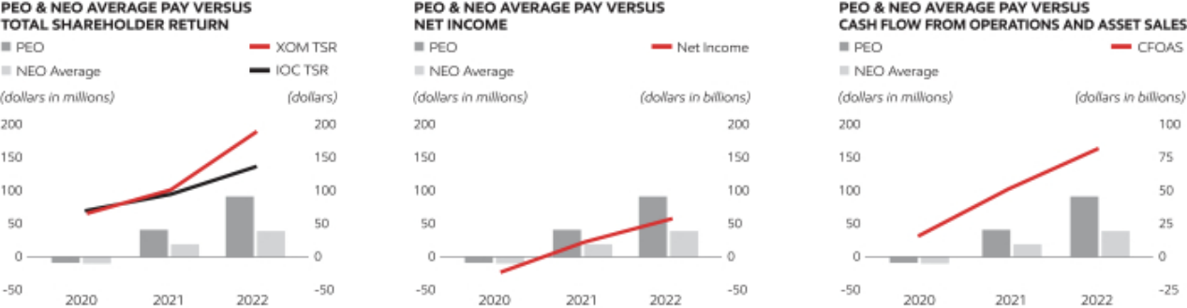

The table below indicates certain performance measures used by the Compensation Committee to link compensation to performance. ExxonMobil operates in a capital intensive industry where decisions and management of risk play out over time horizons decades in length through cyclical commodity price environments. As a result, and particularly in a down-cycle, near-term financial performance may not be reflective of strong business and operational performance. For this reason, performance is assessed across a broad range of financial and operating metrics, over near- and long-term time horizons and taking into account the broader business environment. See pages 49 to 51.


Supporting Financial & Operating Metrics

∎ TSR

∎ Earnings

∎ Cash Flow from Operations and Asset Sales

∎ Return on Capital Employed

∎ Safety Performance

∎ Environmental Performance

∎ Corporate-wide operated asset GHG emissions intensity

Information on performance measures as well as a description of Executive Compensation Program, including information on Compensation Design, Determining Compensation, other Compensation Elements, Risk and Governance can be found in the Compensation and Discussion Analysis on pages 45 to 67.

FOOTNOTES

- Principle Executive Officer (PEO): 2020-2022 D.W. Woods
- Named Executive Officer (NEO): In 2022, K.A. Mikells, N.A. Chapman, J.P. Williams, Jr., and K.T. McKee; in 2021, K.A. Mikells, A.P. Swiger, N.A. Chapman, J.P. Williams, Jr., and L.M. Mallon; in 2020, A.P. Swiger, N.A. Chapman, J.P. Williams, Jr., and N.W. Duffin
- CD&A Performance Peer group: BP, Chevron, Shell, and TotalEnergies
- Adjustments to determine “Compensation Actually Paid”:

 |  |  | PEO¹ |  | Average Non-PEO NEOs²
 | +/- | 2022 | 2021 | 2020 | 2022 | 2021 | 2020
SCT grant value of current year long-term awards | – | 24,939,000 | 13,505,225 | 8,434,725 | 12,594,195 | 5,892,181 | 3,594,016
Year-end value of current long-term awards | + | 24,817,500 | 13,155,850 | 8,450,100 | 12,532,838 | 5,827,736 | 3,600,567
Year-over-year change in “fair value” of unvested awards | + | 48,547,691 | 16,765,814 | -20,079,108 | 17,672,847 | 7,865,983 | -15,015,063
Value of vested awards received | + | 3,273,600 | 1,314,686 | -1,274,817 | 751,602 | 486,992 | -1,009,384
SCT change in pension value | – | 2,506,363 | 5,137,153 | 5,348,636 | 3,044,269 | 2,710,176 | 3,442,800
Pension Service cost | + | 901,365 | 744,658 | 751,812 | 460,833 | 326,056 | 462,472
Dividends | + | 3,743,653 | 3,169,095 | 2,604,606 | 1,330,895 | 1,489,577 | 1,952,237

- Additional information on CFOAS is included in Exhibit A starting on page 109.
- Definitions of “Total Direct Compensation” and “Realized Pay” are included on page 66.

2023 Proxy Statement | 105

Table of Contents

PAY RATIO

Annual total CEO compensation for 2022 was $35,950,331. The median annual total compensation of all employees of the Corporation, except the CEO, for 2022 was $171,582. The ratio of annual total CEO compensation to the median annual total compensation of all employees was 210:1.

The median employee was identified as of October 15, 2022, based on total taxable wages for the most recently completed prior fiscal year as shown in the Corporation’s records. No estimates or sampling methodologies were used for this purpose. No cost-of-living adjustments were made and the taxable wages of employees employed for less than the full fiscal year were not annualized. “Employees” were defined based on applicable employment and tax laws.

For purposes of this disclosure, as permitted by SEC rules, the value of non-discriminatory benefits is included in annual total compensation of both the median employee and the CEO. These non-discriminatory benefits are long-term disability plan, basic life insurance and accidental death and dismemberment plan, medical plan, and dental plan.

Including these benefits provides a more accurate pay ratio. Since SEC rules do not require inclusion of these generally available benefits in the Summary Compensation Table, annual total CEO compensation shown above is slightly higher than the Total CEO Compensation shown in that table.

ExxonMobil is a global company with employees in many countries around the world. As permitted by the de minimis exemption under the SEC rules, for purposes of identifying the median employee in 2022, we excluded employees from 34 countries, which represent in aggregate less than 5 percent of the Corporation’s total employees. As required, where any employees from a jurisdiction were excluded, all employees from that jurisdiction were excluded. In total, as detailed in the table below, 1,307 employees out of a total number of 64,062 worldwide employees (as of October 15, 2022) were excluded under the de minimis exemption.


Countries Excluded / Number of Employees

1. | Equatorial Guinea | 224 | 10. | Taiwan | 51 | 19. | N. Mariana Islands | 17 | 28. | Cameroon | 3
2. | Qatar | 136 | 11. | Mozambique | 35 | 20. | South Korea | 17 | 29. | Luxembourg | 3
3. | Norway | 115 | 12. | Guam | 33 | 21. | Saudi Arabia | 13 | 30. | Peru | 3
4. | Turkey | 105 | 13. | Kazakhstan | 33 | 22. | Greece | 12 | 31. | South Africa | 3
5. | New Zealand | 80 | 14. | Cyprus | 28 | 23. | Vietnam | 10 | 32. | Micronesia | 2
6. | Finland | 78 | 15. | Fiji | 25 | 24. | Spain | 8 | 33. | Namibia | 2
7. | Japan | 67 | 16. | New Caledonia | 24 | 25. | Denmark | 5 | 34. | Bahamas | 1
8. | Sweden | 65 | 17. | Colombia | 23 | 26. | Ukraine | 4
9. | Utd. Arab Emir. | 56 | 18. | Poland | 23 | 27. | Azerbaijan | 3
 |  |  |  |  |  |  |  | Total number of employees excluded: |  |  | 1,307
106 |  | 2023 Proxy Statement

Table of Contents

ADDITIONAL INFORMATION

Other Business

We are not currently aware of any other business to be acted on at the annual meeting. Under the laws of New Jersey, where ExxonMobil is incorporated, no business other than procedural matters may be raised at the meeting unless proper notice has been given to the shareholders. If other business is properly raised, your proxies have authority to vote as they think best, including to adjourn the meeting.

Outstanding Shares

Holders of record of our common stock at the close of business on April 5, 2023 are entitled to vote at the 2023 annual meeting of shareholders. On February 28, 2023, there were 4,059,294,340 shares of common stock outstanding and entitled to vote. Each common share entitles the holder to one vote.

How We Solicit Proxies

We bear the cost of solicitation of proxies by the Company. In addition to this mailing, ExxonMobil directors, officers, and employees in the ordinary course of their employment, without special compensation other than reimbursement of expenses, may solicit proxies personally, electronically, by telephone, or with additional mailings. We are paying Innisfree a fee of $40,000 plus expenses to help with the solicitation. We also reimburse brokerage firms, banks, and other intermediaries for their expenses in sending these materials to you and getting your voting instructions.

Shareholder Proposals and Director Nominations for Next Year

Any shareholder proposal for the annual meeting in 2024 must be sent to the Secretary at the address of ExxonMobil’s principal executive office or email address listed under Contact Information on page 7. The deadline for receipt of a proposal to be considered for inclusion in the 2024 proxy statement is 5:00 p.m. Central Time, on December 15, 2023. The deadline for notice of a proposal for which a shareholder will conduct his or her own solicitation is February 28, 2024. Upon request, the Secretary will provide instructions for submitting proposals.

Submissions of nominees for director under the proxy access provisions of our by-laws for the 2024 annual meeting must be submitted in compliance with those by-laws no later than December 15, 2023, and no earlier than November 15,
2023. Notice of a director nomination other than under proxy access must be submitted in compliance with the advance notice provisions of our by-laws no later than February 1, 2024, and no earlier than January 2, 2024.

For the 2023 annual meeting of shareholders, the ExxonMobil proxy card will be White. ExxonMobil intends to use the White proxy card for its annual meeting next year and for all future shareholder meetings.

Duplicate Annual Reports

Registered Shareholders with multiple accounts may authorize ExxonMobil to discontinue mailing annual reports for an account by calling ExxonMobil Shareholder Services at the toll-free telephone number listed on page 7 at any time during the year. Beneficial holders should contact their banks, brokerage firms, or other holders of record to discontinue duplicate mailings. At least one account must continue to receive an annual report. Eliminating these duplicate mailings will not affect receipt of future proxy statements and proxy cards.

Shareholders With the Same Address

If you share an address with one or more ExxonMobil shareholders, you may elect to “household” your proxy mailing. This means you will receive only one set of proxy materials at that address unless one or more shareholders at that address specifically elects to receive separate mailings. Shareholders who participate in householding will continue to receive separate proxy cards. Householding will not affect dividend check mailings. We will promptly send separate proxy materials to a shareholder at a shared address on request. Shareholders with a shared address may also request us to send separate proxy materials in the future, or to send a single copy in the future, if we are currently sending multiple copies to the same address.

2023 Proxy Statement | 107

Table of Contents

Requests related to householding should be made by calling ExxonMobil Shareholder Services at the telephone number listed on page 7. Beneficial shareholders should request information about householding from their banks, brokers, or other holders of record.

SEC Form 10-K

Shareholders may obtain a copy of the Corporation’s Annual Report on Form 10-K to the Securities and Exchange Commission without charge by writing to the Secretary at the address listed under Contact Information on page 7, or by visiting ExxonMobil’s website at exxonmobil.com/secfilings.

108 2023 Proxy Statement

Table of Contents

EXHIBIT A: Forward-Looking Statements and Frequently Used Terms

Set forth below is important information concerning forward-looking statements, as well as definitions and additional information for certain key business and financial performance measures, made or referenced in this proxy statement.

Statements regarding potential future earnings and cash flow assume a Brent crude price of $60/bbl and a Henry Hub gas price of $ 3/mmbtu, in each case adjusted for inflation after 2022; Energy, Chemical, and Specialty Products margins at historical averages for the 10-year period 2010-2019, and before-tax Corporate and Financing expenses between $2.3 and $2.5 billion annually. These price assumptions are not intended to reflect management’s forecasts for future prices or prices we use for internal planning purposes. The 2019 baseline excludes identified items.

Statements of future events or conditions, including outlooks, projections, ambitions, plans and objectives are forward-looking statements. Actual future results, including financial and operating performance; total capital expenditures and mix, including allocations of capital to low carbon solutions; cost reductions and efficiency gains; ambitions to achieve net-zero operated Scope 1 and Scope 2 emissions by 2050, to reach net-zero operated Scope 1 and 2 emissions in our unconventional Permian Basin operated assets by 2030, to eliminate routine flaring in-line with World Bank Zero Routine Flaring, and to reach near-zero methane emissions from operated assets, within evolving growth, start-up, divestment, and technological efforts; timing and outcome of projects to capture and store CO2, produce hydrogen or biofuels, and increase plastics recycling; cash flow, dividends and shareholder returns, including the timing and amounts of share repurchases; future debt levels; and other business and project plans, timing, costs, capacities and returns could differ materially due to a number of factors. These include global or regional changes in the supply and demand for oil, natural gas, petrochemicals, and feedstocks and other market factors, economic conditions or seasonal fluctuations that impact prices and differentials for our products; laws and government policies supporting lower carbon investment opportunities or limiting the attractiveness of future investments; actions of competitors and commercial counterparties; the outcome of commercial negotiations, including final agreed terms and conditions and satisfaction of conditions precedent; the ability to access debt markets; the impacts of COVID-19 or other public health crises, including the effects of government responses on people and economies; reservoir performance; the level and outcome of, and allocation of capital to, exploration projects; timely completion of development and other construction projects; final management approval of future projects and any changes in the scope, terms, or costs of such projects as approved; changes in law, taxes, or regulation including environmental regulations, trade sanctions, and timely granting of governmental permits, as well as expropriations or seizures; war, civil unrest, and other political or security disturbances; capacity, insurance or shipping limitations; the capture of efficiencies within and between business lines and the ability to maintain near-term cost reductions as ongoing efficiencies; unforeseen technical or operating difficulties and unplanned maintenance; the development and competitiveness of, and market demand for, alternative energy and low-carbon technologies; the results of research programs and the ability to bring new technologies to commercial scale on a cost-competitive basis; and other factors discussed under Item 1A. Risk Factors in ExxonMobil’s 2022 Annual Report on Form 10-K.

Historical, current, and forward-looking environmental, social and sustainability-related statements may be based on standards for measuring progress that are still developing, internal controls and processes that continue to evolve, and assumptions that are subject to change in the future, including future rule-making. The reference to any scenario in this report, including any potential net-zero scenarios, does not imply ExxonMobil views any particular scenario as likely to occur. In addition, energy demand scenarios require assumptions on a variety of parameters. As such, the outcome of any given scenario using an energy demand model comes with a high degree of uncertainty. Third-party scenarios discussed in this report reflect the modeling assumptions and outputs of their respective authors, not ExxonMobil, and their use by ExxonMobil is not an endorsement by ExxonMobil of their underlying assumptions, likelihood or probability.

2023 Proxy Statement | 109

Table of Contents

Cash Flow From Operations and Asset Sales (Non-GAAP)

Cash flow from operations and asset sales is the sum of the net cash provided by operating activities and proceeds associated with sales of subsidiaries, property, plant and equipment, and sales and returns of investments from the Consolidated Statement of Cash Flows. This cash flow reflects the total sources of cash both from operating the Corporation’s assets and from the divesting of assets. The Corporation employs a long-standing and regular disciplined review process to ensure that assets are contributing to the Corporation’s strategic objectives. Assets are divested when they are no longer meeting these objectives or are worth considerably more to others. Because of the regular nature of this activity, we believe it is useful for investors to consider proceeds associated with asset sales together with cash provided by operating activities when evaluating cash available for investment in the business and financing activities, including shareholder distributions.

Cash Flow From Operations and Asset Sales | 2022 | 2021 | 2020
(millions of dollars) | 2022 | 2021 | 2020
Net cash provided by operating activities | 76,797 | 48,129 | 14,668
Proceeds associated with sales of subsidiaries, property, plant and equipment, and sales and returns of
investments | 5,247 | 3,176 | 999
Cash flow from operations and asset sales (Non-GAAP) | 82,044 | 51,305 | 15,667

Capital Employed (Non-GAAP)

Capital employed is a measure of net investment. When viewed from the perspective of how the capital is used by the businesses, it includes ExxonMobil’s net share of property, plant and equipment and other assets less liabilities, excluding both short-term and long-term debt. When viewed from the perspective of the sources of capital employed in total for the Corporation, it includes ExxonMobil’s share of total debt and equity. Both of these views include ExxonMobil’s share of amounts applicable to equity companies, which the Corporation believes should be included to provide a more comprehensive measure of capital employed.

Capital Employed |  | 2022 |  | 2021 | 2020
(millions of dollars) |  | 2022 |  | 2021 | 2020
Business uses: asset and liability perspective
Total assets |  | 369,067 |  | 338,923 | 332,750
Less liabilities and noncontrolling interests share of assets and liabilities
Total current liabilities excluding notes and loans payable |  | (68,411) |  | (52,367) | (35,905)
Total long-term liabilities excluding long-term debt |  | (56,990) |  | (63,169) | (65,075)
Noncontrolling interests share of assets and liabilities |  | (9,205) |  | (8,746) | (8,773)
Add ExxonMobil share of debt-financed equity company net assets |  | 3,705 |  | 4,001 | 4,140
Total capital employed (Non-GAAP) |  | 238,166 |  | 218,642 | 227,137
Total corporate sources: debt and equity perspective
Notes and loans payable |  | 634 |  | 4,276 | 20,458
Long-term debt |  | 40,559 |  | 43,428 | 47,182
ExxonMobil share of equity |  | 195,049 |  | 168,577 | 157,150
Less noncontrolling interests share of total debt |  | (1,781) |  | (1,640) | (1,793)
Add ExxonMobil share of equity company debt |  | 3,705 |  | 4,001 | 4,140
Total capital employed (Non-GAAP) |  | 238,166 |  | 218,642 | 227,137
110 | 2023 Proxy Statement

Table of Contents

Return on Average Capital Employed (Non-GAAP)

Return on average capital employed (ROCE) is a performance measure ratio. From the perspective of the business segments, ROCE is annual business segment earnings divided by average business segment capital employed (average of beginning and end-of-year amounts). These segment earnings include ExxonMobil’s share of segment earnings of equity companies, consistent with our capital employed definition, and exclude the cost of financing. The Corporation’s total ROCE is net income attributable to ExxonMobil excluding the after-tax cost of financing, divided by total corporate average capital employed. The Corporation has consistently applied its ROCE definition for many years and views it as one of the best measures of historical capital productivity in our capital-intensive, long-term industry. Additional measures, which are more cash flow based, are used to make investment decisions.

Return on Average Capital Employed | 2022 |  | 2021 | 2020
(millions of dollars) | 2022 |  | 2021 | 2020
Net income (loss) attributable to ExxonMobil | 55,740 |  | 23,040 | (22,440)
Financing costs (after-tax)
Gross third-party debt | (1,213) |  | (1,196) | (1,272)
ExxonMobil share of equity companies | (198) |  | (170) | (182)
All other financing costs – net | 276 |  | 11 | 666
Total financing costs | (1,135) |  | (1,355) | (788)
Earnings (loss) excluding financing costs | 56,875 |  | 24,395 | (21,652)
Average capital employed | 228,404 |  | 222,890 | 234,031
Return on average capital employed – corporate total (Non-GAAP) | 24.9% |  | 10.9% | (9.3)%

Structural Cost Savings

Structural cost savings describe decreases certain expenses as a result of operational efficiencies, workforce reductions, and other cost saving measures that are expected to be sustainable compared to 2019 levels. Relative to 2019, estimated cumulative annual structural cost savings totaled $7 billion. The total change between periods in expenses below will reflect both structural cost savings and other changes in spend, including market factors, such as inflation and foreign exchange impacts, as well as changes in activity levels and costs associated with new operations. Estimates of cumulative annual structural savings may be revised depending on whether cost reductions realized in prior periods are determined to be sustainable compared to 2019 levels. Structural cost savings are stewarded internally to support management’s oversight of spending over time. This measure is useful for investors to understand the Corporation’s efforts to optimize spending through disciplined expense management.

CALCULATION OF STRUCTURAL COST SAVINGS | 2019 |  | 2022
(Dollars in billions) | 2019 |  | 2022
Components of operating costs
From ExxonMobil’s Consolidated Statement of Income
(U.S. GAAP)
Production and manufacturing expenses | 36.8 |  | 42.6
Selling, general and administrative expenses | 11.4 |  | 10.1
Depreciation and depletion (includes impairments) | 19.0 |  | 24.0
Exploration expenses, including dry holes | 1.3 |  | 1.0
Non-service pension and postretirement benefit expense | 1.2 |  | 0.5
Subtotal | 69.7 |  | 78.2
ExxonMobil’s share of equity company expenses | 9.1 |  | 13.0
Total operating costs (non-GAAP) | 78.8 |  | 91.2


Less:
Depreciation and depletion (includes impairments) | 19.0
Non-service pension and postretirement benefit expense | 1.2
Other adjustments (includes equity company depreciation
and depletion) | 3.6
Total cash operating expenses (cash opex) (non-GAAP) | 55.0

24.0

0.5

3.5

63.2


Energy and production taxes | 11.0 |  | 23.8

 |  |  | Activity / | Structural
Total cash operating expenses (cash opex) excluding energy and production taxes |  | Market | Other | Savings
(non-GAAP) | 44.0 | +3 | -1 | -7 |  | 39.4
 | 2023 Proxy Statement |  |  |  | 111

Table of Contents

Earnings (Loss) excluding Identified Items (Non-GAAP)

Earnings (loss) excluding Identified Items, are earnings (loss) excluding individually significant non-operational events with an absolute corporate total earnings impact of at least $250 million in a given quarter. The earnings (loss) impact of an Identified Item for an individual segment in a given quarter may be less than $250 million when the item impacts several segments or several periods. Management uses these figures to improve comparability of the underlying business across multiple periods by isolating and removing significant non-operational events from business results. The Corporation believes this view provides investors increased transparency into business results and trends, and provides investors with a view of the business as seen through the eyes of management. Earnings (loss) excluding Identified Items is not meant to be viewed in isolation or as a substitute for net income (loss) attributable to ExxonMobil as prepared in accordance with U.S. GAAP.

Upstream |  |  |  | 2022 |  |  |  |  | 2021 |  |  | 2020
(millions of dollars) |  | U.S. |  |  | Non-U.S. |  | Total | U.S. | Non-U.S. | Total | U.S. | Non-U.S. | Total
Earnings (loss) (U.S. GAAP) | 11,728 |  |  | 24,751 |  |  | 36,479 | 3,663 | 12,112 | 15,775 | (19,385) | (645) | (20,030)
Impairments |  | — |  | (3,790) |  |  | (3,790) | (263) | (489) | (752) | (17,092) | (2,244) | (19,336)
Gain/(loss) on sale of assets |  | 299 |  | 587 |  |  | 886 | — | 459 | 459 | — | — | —
Inventory valuation – lower of cost or
market |  | — |  |  | — |  | — | — | — | — | — | (61) | (61)
Tax-related items |  | — |  | (1,415) |  |  | (1,415) | — | — | — | — | (297) | (297)
Contractual provisions |  | — |  |  | — |  | — | — | (250) | (250) | — | — | —
Other |  | — |  |  | 1,380 |  | 1,380 | — | — | — | — | — | —
Identified Items |  | 299 |  |  | (3,238) |  | (2,939) | (263) | (280) | (543) | (17,092) | (2,602) | (19,694)
Earnings (loss) excluding Identified Items |  | 11,429 |  |  | 27,989 |  | 39,418 | 3,926 | 12,392 | 16,318 | (2,293) | 1,957 | (336)
(Non-GAAP) |  | 11,429 |  |  | 27,989

Energy Products |  |  |  | 2022 |  |  | 2021 |  |  | 2020
(millions of dollars) |  | U.S. |  | Non-U.S. | Total | U.S. | Non-U.S. | Total | U.S. | Non-U.S. | Total
Earnings (loss) (U.S. GAAP) | 8,340 |  |  | 6,626 | 14,966 | 668 | (1,014) | (347) | (1,342) | (1,230) | (2,572)
Impairments |  | (58) |  | (216) | (274) | — | — | — | (4) | (374) | (378)
Tax-related items |  | — |  | (410) | (410) | — | — | — | — | (262) | (262)
Identified Items |  | (58) |  | (626) | (684) | — | — | — | (4) | (636) | (640)
Earnings (loss) excluding Identified Items |  | 8,398 |  | 7,252 | 15,650 | 668 | (1,014) | (347) | (1,338) | (594) | (1,932)
(Non-GAAP) |  | 8,398

Chemical Products |  |  |  | 2022 |  |  | 2021 |  |  | 2020
(millions of dollars) |  | U.S. |  | Non-U.S. | Total | U.S. | Non-U.S. | Total | U.S. | Non-U.S. | Total
Earnings (loss) (U.S. GAAP) | 2,328 |  |  | 1,215 | 3,543 | 3,697 | 3,292 | 6,989 | 1,196 | 1,061 | 2,257
Impairments |  | — |  | — | — | — | — | — | (90) | (2) | (92)
Tax-related items |  | — |  | — | — | — | — | — | — | (13) | (13)
Identified Items |  | — |  | — | — | — | — | — | (90) | (15) | (105)
Earnings (loss) excluding Identified |  | 2,328 |  | 1,215 | 3,543 | 3,697 | 3,292 | 6,989 | 1,286 | 1,076 | 2,362
Items (Non-GAAP) |  | 2,328

Specialty Products |  |  |  |  | 2022 |  |  |  | 2021 |  |  | 2020
(millions of dollars) |  |  | U.S. |  |  | Non-U.S. | Total | U.S. | Non-U.S. | Total | U.S. | Non-U.S. | Total
Earnings (loss) (U.S. GAAP) |  | 1,190 |  |  | 1,225 |  | 2,415 | 1,452 | 1,807 | 3,259 | 571 | 630 | 1,201
Impairments |  |  | — |  | (40) |  | (40) | — | — | — | — | (219) | (219)
Gain/(loss) on sale of assets |  |  | — |  |  | — | — | 498 | 136 | 634 | — | — | —
Tax-related items |  |  | — |  |  | — | — | — | — | — | — | (9) | (9)
Identified Items |  |  | — |  |  | (40) | (40) | 498 | 136 | 634 | — | (228) | (228)
Earnings (loss) excluding Identified |  |  | 1,190 |  |  | 1,265 | 2,455 | 954 | 1,672 | 2,625 | 571 | 858 | 1,429
Items (Non-GAAP) |  |  | 1,190
112 | 2023 Proxy Statement

Table of Contents

Corporate and Financing | 2022 |  | 2021 | 2020
(millions of dollars) | 2022 |  | 2021 | 2020
Earnings (loss) (U.S. GAAP) | (1,663) |  | (2,636) | (3,296)
Impairments | (98) |  | — | (35)
Gain/(loss) on sale of assets | — |  | (12) | —
Tax-related items | 324 |  | — | —
Severance charges | — |  | (52) | (326)
Other | 76 |  | — | —
Identified Items | 302 |  | (64) | (361)
Earnings (loss) excluding Identified Items (Non-GAAP) | (1,965) |  | (2,572) | (2,935)
Corporate Total | 2022 |  | 2021 | 2020
(millions of dollars) | 2022 |  | 2021 | 2020
Net income (loss) attributable to ExxonMobil (U.S. GAAP) | 55,740 |  | 23,040 | (22,440)
Impairments | (4,202) |  | (752) | (20,060)
Gain/(loss) on sale of assets | 886 |  | 1,081 | —
Inventory valuation – lower of cost or market | — |  | — | (61)
Tax-related items | (1,501) |  | — | (581)
Severance charges | — |  | (52) | (326)
Contractual provisions | — |  | (250) | —
Other | 1,456 |  | — | —
Identified Items | (3,361) |  | 27 | (21,028)
Earnings (loss) excluding Identified Items (Non-GAAP) | 59,101 |  | 23,013 | (1,412)

References in this discussion to Corporate earnings (loss) mean net income (loss) attributable to ExxonMobil (U.S. GAAP) from the Consolidated Statement of Income. Unless otherwise indicated, references to earnings (loss), Upstream, Energy Products, Chemical Products, Specialty Products, and Corporate and Financing segment earnings (loss), and earnings (loss) per share are ExxonMobil’s share after excluding amounts attributable to noncontrolling interests.

Due to rounding, numbers presented may not add up precisely to the totals indicated.

2023 Proxy Statement | 113

Table of Contents

Printed entirely on recycled paper 002CSND8F5

Table of Contents
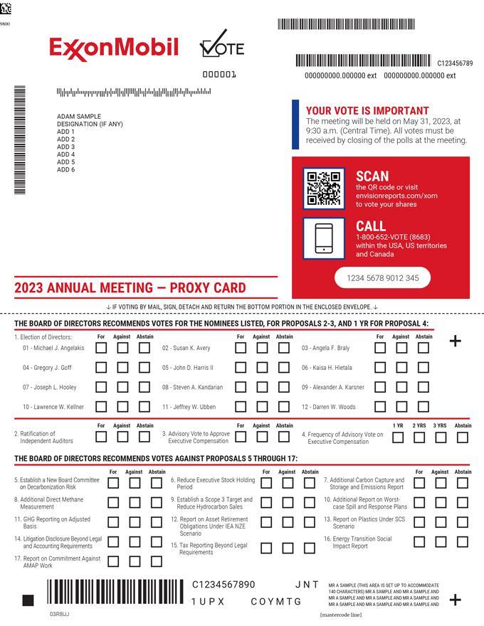

Table of Contents


