UNITED STATES

SECURITIES AND EXCHANGE COMMISSION

Washington, D.C. 20549

SCHEDULE 14A

Proxy Statement Pursuant to Section 14(a) of the Securities

Exchange Act of 1934 (Amendment No. )

Filed by the Registrant ☑

Filed by a Party other than the Registrant o

Check the appropriate box:

- Preliminary Proxy Statement

- Confidential, for Use of the Commission Only (as permitted by Rule 14a-6(e)(2))

- Definitive Proxy Statement

- Definitive Additional Materials

- Soliciting Material Pursuant to §240.14a-12

Exxon Mobil Corporation

(Name of Registrant as Specified In Its Charter)

(Name of Person(s) Filing Proxy Statement, if other than the Registrant)

Payment of Filing Fee (Check the appropriate box):

- No fee required.

- Fee computed on table below per Exchange Act Rules 14a-6(i)(1) and 0-11.

  - Title of each class of securities to which transaction applies:

  - Aggregate number of securities to which transaction applies:

  - Per unit price or other underlying value of transaction computed pursuant to Exchange Act Rule 0-11 (set forth the amount on which the filing fee is calculated and state how it was determined):

  - Proposed maximum aggregate value of transaction:

  - Total fee paid:

- Fee paid previously with preliminary materials.

- Check box if any part of the fee is offset as provided by Exchange Act Rule 0-11(a)(2) and identify the filing for which the offsetting fee was paid previously. Identify the previous filing by registration statement number, or the Form or Schedule and the date of its filing.

  - Amount Previously Paid:

  - Form, Schedule or Registration Statement No.:

  - Filing Party:

  - Date Filed:

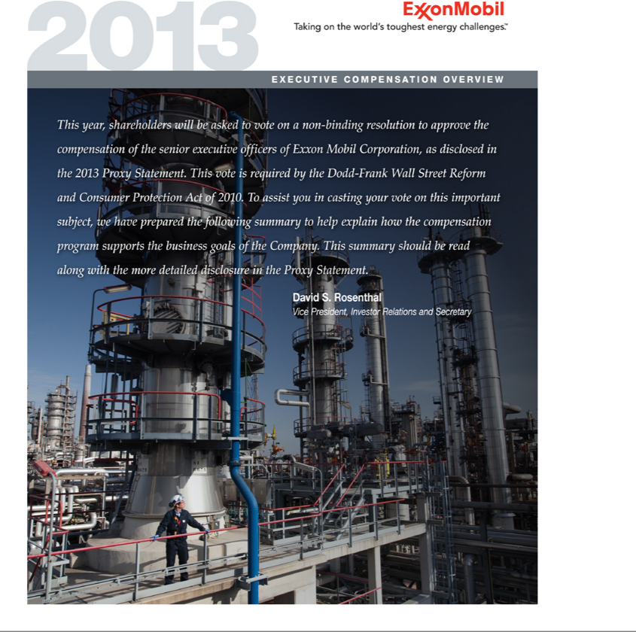

2 | E X X O N M O B I L 2 0 1 3 E X E C U T I V E C O M P E N S A T I O N O V E R V I E W


Before you cast your vote on Management Resolution Item 3 – Advisory Vote to Approve Executive Compensation, please review this summary, as well as the more detailed information included in the Compensation Discussion and Analysis, compensation tables, and narrative in ExxonMobil’s 2013 Proxy Statement.

2012 SHAREHOLDER ENGAGEMENT

Preceding the 2012 advisory vote to approve executive compensation, ExxonMobil management held a series of meetings with institutional shareholders and conducted a webcast available to all shareholders to explain the Company’s executive compensation programs and answer questions, which typically took the form of requests for additional information or clarification. The following summarizes shareholder feedback and describes steps taken in this disclosure to address their requests for additional information.

Positive shareholder feedback was received on the following:

- More than half of total compensation in equity.

- Very long stock holding periods that extend through retirement.

- Delayed payout of 50 percent of the annual bonus.

- Disclosure of six years of realized pay history (full tenure of CEO).

- Strong executive development, retention, and succession planning.

- Absence of employment contracts and change-in-control arrangements.

- All U.S. executives (more than 1,000), including the CEO, participate in common programs (the same salary, incentive, and retirement programs).

- Improved overall disclosure of the compensation program.

Shareholders requested additional information on the following:

- More explanation of the performance basis for determining the annual bonus award program.

In response to this request, the Compensation Committee is providing additional detail concerning the formula basis used to determine the annual bonus program. See page 5.

- More explanation of the Committee’s determination that restricted stock grants with long vesting periods and risk of forfeiture provide better alignment with ExxonMobil’s business model than a short-term, formula-based method for structuring stock grants.

In response to this request, the charts and explanation on pages 6 and 7 are provided to illustrate why we believe our current stock program aligns more closely with ExxonMobil’s business model and the long-term interests of our shareholders.

FINANCIAL AND OPERATING PERFORMANCE

The financial and operating results outlined below provide additional perspective on ExxonMobil’s performance:

- Earnings of $45 billion in 2012, a 9-percent increase versus 2011. Five-year annual average of $36 billion in earnings.

- Distributed more than $30 billion in dividends and share purchases to shareholders in 2012, for a distribution yield of 7.5 percent. Distributed $292 billion in dividends and share purchases since the beginning of 2000. Dividends per share increased for the 30th consecutive year.

- Industry-leading return on average capital employed (ROCE) of 25.4 percent, with a five-year average of 24.4 percent.

- Improved safety and operations performance supported by effective risk management.

STRATEGIC BUSINESS RESULTS

In addition to financial and operating performance, a key factor underlying the compensation decisions made by the Compensation Committee in 2012 was the progress achieved on strategic priorities. The accomplishments outlined below are expected to have a positive impact on ExxonMobil’s performance for decades.

- ExxonMobil progressed the Strategic Cooperation Agreement with Rosneft to jointly participate in oil and natural gas exploration and development activities in Russia, the United States, and Canada, and to share technology and expertise. In 2012, we completed seismic data acquisition in the Black Sea and Kara Sea. We also agreed to jointly develop tight oil reserves in West Siberia and establish a joint Arctic Research Center for offshore developments.

- Significant exploration discoveries in Romania, Tanzania, Nigeria, Australia, and Papua New Guinea added to the resource base. In addition, ExxonMobil was awarded the Skifska block in the Ukrainian sector of the Black Sea.

- Strong progress on major projects, including first oil for three projects in Africa with a gross capacity of 350 thousand barrels per day. We also completed construction and began commissioning activities for the Kearl Oil Sands project in Canada and the Singapore Chemical Expansion project in Asia Pacific. The Papua New Guinea Liquefied Natural Gas project was also advanced.

- Unconventional acreage positions in the United States were expanded in the liquids-rich Bakken and Woodford Ardmore plays, and an agreement was signed to acquire acreage in the Montney and Duvernay unconventional plays in western Canada.

- ExxonMobil finalized plans to build a new world-scale specialty elastomers facility with joint venture partner Saudi Basic Industries Corporation (SABIC).

- Downstream and Chemical holdings in Japan were restructured and reduced to further improve efficiencies and optimize returns.

For definitions and additional information concerning ROCE, see page 5 of the 2012 Financial Statements and Supplemental Information included with the 2013 Proxy Statement.

The term “project” as used in this brochure does not necessarily have the same meaning as under SEC Rule 13q-1 relating to government payment reporting. For example, a single project for purposes of the rule may encompass numerous properties, agreements, investments, developments, phases, work efforts, activities, and components, each of which we may also informally describe as a “project.”

3

LONG-TERM BUSINESS PERFORMANCE AND BASIS FOR COMPENSATION DECISIONS

The following charts illustrate the effectiveness of ExxonMobil’s compensation program in delivering superior results for shareholders over the long term. These results, in addition to individual performance, experience, and level of responsibility, helped form the basis for compensation decisions made by the Compensation Committee in 2012.

Chart 1: Safety • Safety is a core value for ExxonMobil, and nothing receives more attention from management. We also believe that safety performance is a leading indicator of business performance. We achieved improved safety performance in 2012.

Chart 2: Profitability • ExxonMobil continues to lead the industry in return on average capital employed (ROCE), a standard performance metric in our industry.

Chart 3: Shareholder Returns • ExxonMobil’s total shareholder return (TSR) is compared to other integrated oil companies in the chart below. The compensation program is designed to support the business model, which is focused on long-term sustainable growth in shareholder value.

Chart 4: Shareholder Returns Compared to Others • The most relevant metric for comparing shareholder returns is the TSR of companies with similar size and scale in the same industry. However, given the relatively small number of U.S.-based oil and gas companies that are comparable in size and scale to ExxonMobil, and to provide a reasonable point of reference, we evaluate the compensation levels of other large U.S.-based companies as well. The criteria used to select these benchmark companies are outlined beginning on page 42 of the Compensation Discussion and Analysis (CD&A). For illustration, this chart compares ExxonMobil’s TSR to the 12 companies used for benchmarking compensation.

1 | Lost-Time Injuries and Illnesses | 2 | Return on Average Capital Employed
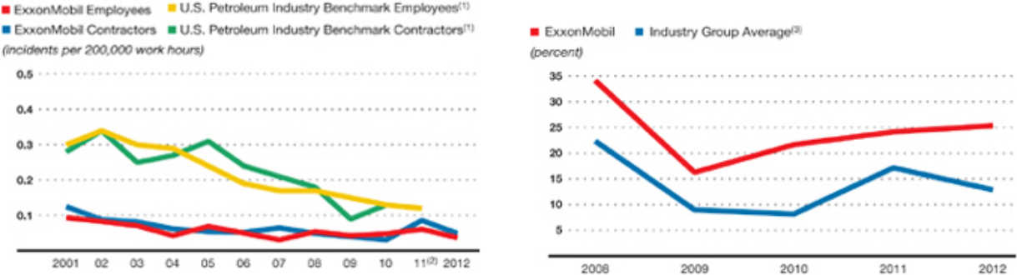

3 | Industry Group Total Shareholder Returns(4) | 4 | Compensation Benchmark Companies Total Shareholder Returns(4)
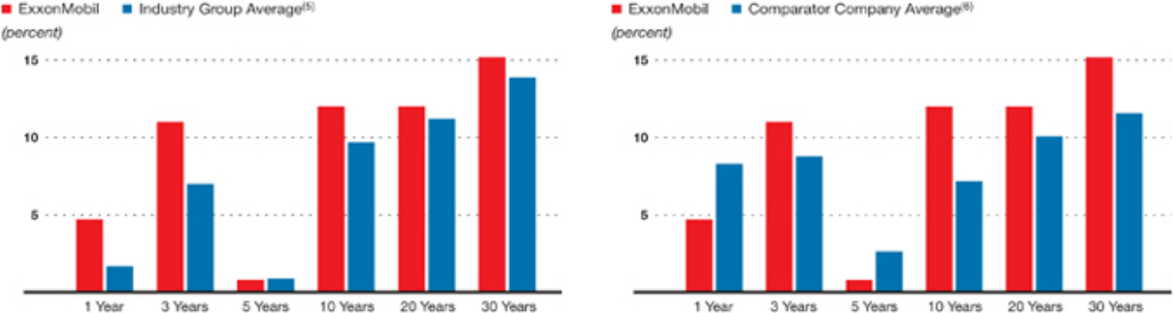

An analysis of historical TSR shows that one- and three-year TSR bears little correlation to prospective long-term TSR performance.

For a more detailed analysis of the relationship between short- and long-term TSR, refer to page 48 of the CD&A.

- Employee and contractor safety data from participating American Petroleum Institute companies (2012 industry data not available at time of publication). (2) XTO Energy Inc. data included beginning 2011. (3) Royal Dutch Shell, BP, and Chevron values are on a consistent basis with ExxonMobil, based on public information. For definitions and additional information concerning the calculation of ROCE, see page 5 of the 2012 Financial Statements and Supplemental Information included with the 2013 Proxy Statement.
- TSR represents annualized returns assuming dividends are reinvested when paid. (5) Royal Dutch Shell, BP, and Chevron values are on a consistent basis with ExxonMobil, based on public information. (6) AT&T, Boeing, Chevron, Ford, General Electric, Hewlett-Packard, IBM, Johnson & Johnson, Pfizer, Procter & Gamble, United Technologies, and Verizon values are on a consistent basis with ExxonMobil, based on public information.

4 |  | E X X O N M O B I L 2 0 1 3 E X E C U T I V E C O M P E N S A T I O N O V E R V I E W
 | As discussed on page 48 of the CD&A, short-term TSR |  | 5 | Average Annual Total Distribution Yield (2008–2012)(1)

comparisons can be misleading, particularly when measured across different industries. For example, when oil and gas industry TSR performance is measured against the S&P 500 for the period from 2008 to 2012, the starting point of the performance measurement period significantly affects the results due to the historically high crude prices in the second half of 2007, which elevated year-end equity prices for the oil and gas industry far greater than the general market.
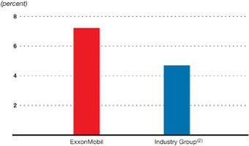

Chart 5: Annual Distribution Yield • This chart compares ExxonMobil to the industry group on the basis of combined dividend and share repurchase distribution yield. Over the most recent five-year period, ExxonMobil had an average yield of 7.2 percent, more than 50 percent higher than the industry group average of 4.7 percent. This metric further demonstrates the financial strength of ExxonMobil and its ability to provide industry-leading total distributions to shareholders.

CEO COMPENSATION

A substantial portion of the compensation granted by the Compensation Committee to the CEO and reported in the Summary Compensation Table represents an incentive for future performance, not current cash compensation. The Summary Compensation Table is on page 49 of the 2013 Proxy Statement. This long-term incentive pay will not actually be received by the CEO for many years in the future and remains at risk of forfeiture.

Chart 6: CEO Reported Pay vs. Realized Pay • This chart demonstrates the long-term orientation of the compensation program by comparing the difference between the pay shown in the Summary Compensation Table and the actual pay realized by the CEO since his appointment in 2006.

Stock Options Granted 10 Years Prior

The column titled “Realized Pay” in Chart 6 includes the value realized from the exercise of stock options that were granted in 2001 and in prior years. Specifically, 39 percent of 2011 realized pay resulted from the exercise of the last options granted to the CEO, which would have expired if they had not been exercised in 2011; the execution of those options in 2011 reflects the impact of ExxonMobil stock appreciation since 2001. ExxonMobil has not granted any stock options to the CEO or any other employee since 2001.

Alignment of CEO Reported Compensation

Chart 7: CEO Reported Pay vs. TSR • This chart illustrates how the percent change in reported pay has tracked ExxonMobil’s total shareholder return (TSR) during the current CEO’s tenure.

 | 6 | CEO Reported Pay vs. Realized Pay |  |  |  |  |  |  | 7 | CEO Reported Pay vs. TSR
Year of |  |  |  |  |  |  | Realized Pay as
 |  |  |  |  |  | Realized Pay vs. a Percentage of
Compensation Reported Pay⁽³⁾ |  |  |  | Realized Pay⁽⁴⁾ |  | Reported Pay | Reported Pay
 | 2012 |  | $ 40,266,501 | $ | 15,561,163 | – $ 24,705,338 | 39%
 | 2011 |  | $ 34,920,506 | $ | 24,637,196 | – $ 10,283,310 | 71%
2010 |  |  | $ 28,952,558 | $ | 14,229,609 | – $ 14,722,949 | 49%
 | 2009 |  | $ 27,168,317 | $ | 8,530,165 | – $ 18,638,152 | 31%
2008 |  |  | $ 32,211,079 | $ | 10,212,091 | – $ 21,998,988 | 32%
 | 2007 |  | $ 27,172,280 | $ | 12,884,308 | – $ 14,287,972 | 47%
2006 |  |  | $ 22,440,807 | $ | 6,712,435 | – $ 15,728,372 | 30%
 |  |  |  |  |  | Average | 43%
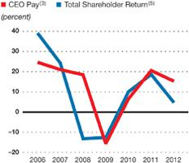

- Dividends and share repurchases as a percentage of beginning-of-year 2008 market capitalization. (2) Royal Dutch Shell, BP, and Chevron values are on a consistent basis with ExxonMobil, based on public information. (3) Reported Pay is Total Compensation based on the current reporting rules for the Summary Compensation Table. Reported Pay for 2006-2008 includes the grant date value of restricted stock to put all years of compensation on the same basis (rather than the annual expense value that was reported in the Summary Compensation Table for each of these years). (4) Realized Pay is compensation actually received by the CEO during the year, including salary, current bonus, payouts of previously-granted Earnings Bonus Units (EBU), net spread on stock option exercises, market value at vesting of previously-granted restricted stock, and All Other Compensation amounts realized during the year. Excludes the value of new/unvested EBU and restricted stock grants, change in pension value, and other amounts that will not actually be received until a future date. (5) TSR represents annualized returns assuming dividends are reinvested when paid.

ANNUAL BONUS PROGRAM

The annual bonus for the CEO increased 5 percent in 2012, compared to a 9-percent increase in corporate earnings to $45 billion. Since 2002, the annual bonus program for more than 1,600 executives worldwide, including the CEO, has been based on the annual percentage change in projected net income according to the following formula:
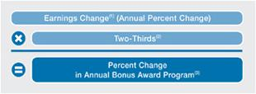

Chart 8: Percent Change in Earnings vs. Percent Change in Bonus Award Program • This chart shows the consistent
application of the bonus formula in each of the last
11 years, including years in which earnings declined. We also benchmark the bonus program, along with all other compensation, to ensure alignment with the market, as described in more detail beginning on page 42 in the CD&A.

The bonus award program provides for differentiated awards based on pay grade and individual performance assessment. For this reason, the annual change in an executive’s bonus may not always track the percentage change in the bonus program.

In 2012, the CEO’s bonus was aligned with the formula. The Compensation Committee assessed the CEO’s performance as strong; the determination was heavily influenced by the financial and operating results and the progress on strategic priorities summarized on page 2.

Delayed Bonus Feature

Once the amount of the annual bonus is determined based on the formula described above, payout of
50 percent of the annual bonus amount is delayed until ExxonMobil’s cumulative earnings per share (EPS) reach a specified level ($6.25 for the 2012 grant versus $6.00 for 2011). The earnings-per-share threshold has been raised steadily over the years. For example, it was $3.00 per unit in 2001. This delayed bonus feature further aligns the interests of senior executives with sustainable growth in shareholder value.

Annual Bonus as a Percentage of Total Pay

The bonus is intentionally a small portion of the CEO’s total compensation (about 12 percent in 2012) to reflect the Committee’s continuing emphasis on long-term compensation. As a point of comparison, long-term, stock-based compensation represents 49 percent of the CEO’s 2012 total compensation, and 72 percent of total compensation when the pension accrual is excluded.

Recoupment

The annual bonus is also subject to recoupment in the case of a material negative restatement of ExxonMobil’s financial or operating results.

5

- Percent Change in Earnings vs.

Percent Change in Bonus Award Program

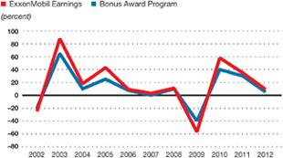

Summary of Three Performance Factors

that Determine Annual Bonus

- Award program varies based on annual earnings, as described.

- Award program differentiates bonus based on individual performance assessment.

- Fifty percent of bonus is delayed until cumulative earnings per share reach a specified level.

RESTRICTED STOCK PROGRAM

Risk Management and Investments

The compensation program recognizes the operating and investment risk inherent in the industry; long stock holding periods and risk of forfeiture encourage executives to focus on sustainable operations and results over the long term. This is a critical success factor given the scale, operational risk, and long lead times of ExxonMobil’s investments.

To provide additional perspective on the scale of

ExxonMobil’s investments, our capital and
exploration expenditures in 2012 were more than
$39 billion, which exceeds the market capitalization
of most U.S.-based oil and gas companies. Over the
next five years, we expect to invest an additional
$190 billion in the business.

This level of spend requires a disciplined, selective investment strategy and long-term focus. It also requires strong project execution and risk management. The restricted stock program reinforces these priorities.

- Since bonuses are granted in late November of each year, the formula relies on a projection of calendar year earnings just prior to the grant. (2) The purpose of the two-thirds adjustment is to mitigate the impact of commodity price swings on short-term earnings performance. (3) The earnings projection for 2012 versus the projection for 2011 was +7 percent (7% x 2/3 = 5% change in annual bonus award program).

6 | E X X O N M O B I L 2 0 1 3 E X E C U T I V E C O M P E N S A T I O N O V E R V I E W

9 | Typical ExxonMobil Project Net Cash Flow | 10 | Shares Vested by Year
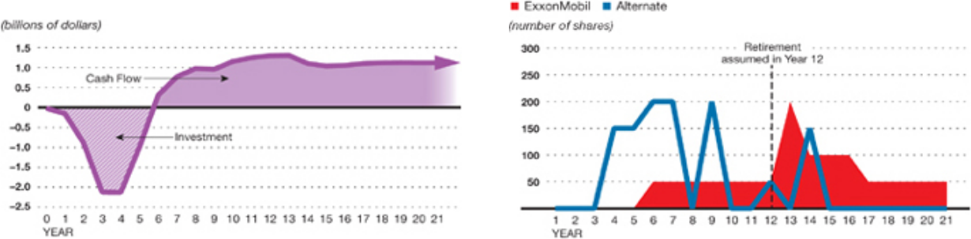

Restricted Stock Grant

Half of the CEO’s reported compensation is in restricted stock with vesting periods far longer than most companies across all industries. The 2012 restricted stock grant to the CEO was awarded at the same share level as the last four years, with the vesting provisions described below. The grant was based on a performance assessment of the CEO by the Compensation Committee. The performance assessment was heavily influenced by the financial and operating results and the progress on strategic priorities summarized on page 2 and discussed in more detail beginning on page 43 of the CD&A.

Linkage to the Business Model

Chart 9: Project Cash Flow • ExxonMobil’s stock program is unique in how it effectively links executive pay to our business model and the interests of long-term shareholders. Our business model is characterized by significant capital intensity, operational risk, and very long investment lead times that can span multiple decades. As mentioned on page 5, ExxonMobil expects to invest $190 billion over the next five years. Chart 9 is an example of the annual investment required and the cash flow generated by a typical ExxonMobil project.

Long-Term Program Design

The stock program aligns with long investment lead times by granting restricted stock with 50 percent of the shares not vesting until five years after grant and the remaining 50 percent not vesting until 10 years after grant or retirement, whichever is later. This formula results in senior executives holding individual stock grants for well over 10 years in many cases. For example, half of the shares granted to the CEO in 2002 will not vest until January 2018, or 15 years later. Vesting is not accelerated for any reason other than death. The size of individual grants is based on a rigorous annual performance assessment of individual executives including an assessment of progress on strategic priorities, as outlined on page 2.

Comparison to Formula-Based Pay

Chart 10: Shares Vested by Year • Some shareholders have suggested that ExxonMobil consider using a formula-based measure of relative performance to increase the variability of our restricted

stock award payouts, or vesting, based on three-year TSR versus the industry. While this approach may be appropriate for the business model of other companies, Chart 10 helps illustrate why the Compensation Committee does not believe such a formula-based plan would deliver the desired results for ExxonMobil’s business model.

In Chart 10, the ExxonMobil case represents an annual grant of restricted stock vesting 50 percent in five years and 50 percent in 10 years or retirement, whichever is later, consistent with ExxonMobil’s current program. The alternate case represents an annual grant of the same target number of shares vesting on the third anniversary of the grant date, according to a formula. Specifically, on each vesting date the percentage of target shares vesting would depend on ExxonMobil’s relative three-year TSR rank versus our primary competitors – Royal Dutch Shell, BP, and Chevron. The following payout factors are applied to the initial grants based on the ranking outcome: Rank 1

- 200 percent; Rank 2 = 150 percent; Rank 3 = 50 percent; and Rank 4 = 0 percent.

Notwithstanding ExxonMobil’s demonstrated record of superior performance versus peers over 10- and 20-year periods, for purposes of the alternate case we have assumed that the Company’s relative TSR ranking over short periods of time will vary. In Chart 10, TSR ranking has been determined by a Monte Carlo simulation that applies equal probability to each rank position. The Monte Carlo simulation method is consistent with U.S. GAAP accounting principles for valuing performance stock awards.

A key observation from Chart 10 is the potential for an alternate program with a short-term focus to result in unintended consequences, including:

- Rewarding short-term performance that bears little correlation to long-term sustainable growth in shareholder value (see page 48 of the CD&A).

- Diminished focus on long-term operations integrity.

- Incentive to underinvest in the business to achieve short-term TSR results.

- Incentive to take excessive risks.

- Integration of Project Net Cash Flow and Compensation Program Design
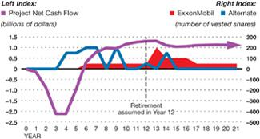

Integration of Project Net Cash Flow

and Compensation Program Design

Chart 11: Integration of Project Net Cash Flow and

Compensation Program Design • This chart combines Charts 9 and 10 to illustrate the relationship between the investment profile of a typical ExxonMobil project and the vesting profiles of the ExxonMobil stock program and the alternate method. Chart 11 illustrates how the ExxonMobil design of granting and vesting stock better aligns with the lead times and risks of our business. As shown, the high degree of variability of the alternate method (blue line) and earlier payout are misaligned with the investment profile of a typical ExxonMobil project and could result in an overemphasis on short-term business performance at the expense of sustainable risk management and long-term business results. Sustainable growth in shareholder value relies on strong alignment between the design of compensation and the ExxonMobil investment profile shown in Chart 11.

Better Alignment with Long-Term Shareholders

ExxonMobil’s compensation strategy puts the value of an executive’s compensation at risk in a way that is similar to the risk assumed by long-term shareholders, and it helps ensure that business decisions made by executives are consistent with the priorities of long-term shareholders and the business model. This compensation strategy also

7

ensures that the majority of compensation granted over multiple years and the shareholding net worth of senior executives are linked to the performance of ExxonMobil stock and resulting shareholder value.

Hold Through Retirement and Risk of Forfeiture

As illustrated in Chart 9, management decisions on large, capital-intensive projects affect financial and operating results for decades into the future. Thus, the holding periods and the risk of forfeiture of these stock-based awards extend beyond retirement.

Under the ExxonMobil program, approximately

70 percent of a senior executive’s cumulative shares granted over the illustrated time period will be unvested and at risk during employment, versus approximately 30 percent for the alternate case. After retirement, the ExxonMobil executive will continue to have shares unvested and at risk of forfeiture for 10 years.

SCALE AND SCOPE OF EXXONMOBIL

AND COMPENSATION IMPACT

The Compensation Committee believes that performance should be the primary basis on which compensation decisions are made, particularly annual changes in compensation.

At the same time, the Committee believes that the compensation program should recognize that ExxonMobil’s senior executives are responsible for managing a larger investment on behalf of shareholders relative to that of most other large, publicly traded companies. The geographic scope involves conducting business in more than 120 countries and territories.

Chart 12: Scale of ExxonMobil vs. Compensation Benchmark Companies • The table below puts into perspective the
scale, scope, and complexity of ExxonMobil versus our compensation benchmark companies.

The Committee does not suggest that compensation should be directly proportional to the relative size of the Company. Rather, the Committee places the most emphasis on individual performance and business results. At the same time, the Committee takes into consideration the size and complexity of ExxonMobil as one of several factors in determining compensation levels.

- Scale of ExxonMobil vs. Compensation Benchmark Companies(1)

($ in billions) | Revenue⁽²⁾ | Market Capitalization | Assets⁽³⁾ | Net Income⁽⁴⁾
Comparator Companies
Median ($) | 110 | 185 | 140 | 10.7
75th Percentile ($) | 129 | 198 | 208 | 13.9
90th Percentile ($) | 144 | 216 | 233 | 16.4
ExxonMobil ($) | 421 | 390 | 334 | 44.9
ExxonMobil Rank (percentile) | 100 | 100 | 100 | 100
ExxonMobil – Multiple of Median | 3.8x | 2.1x | 2.4x | 4.2x

To further illustrate the size and scale challenge, the following demonstrates the ratio of financial values managed for each dollar of compensation paid to the CEO of ExxonMobil relative to the CEOs of comparator companies:⁽⁵⁾

ExxonMobil – Multiple of Median | 2.9x | 1.6x | 1.5x | 3.2x

- Comparator companies consist of: AT&T, Boeing, Chevron, Ford, General Electric, Hewlett-Packard, IBM, Johnson & Johnson, Pfizer, Procter & Gamble, United Technologies, and Verizon. These comparator companies have been selected based on their alignment with ExxonMobil’s current business circumstances, as described in more detail beginning on page 42 of the CD&A. Financial data estimated based on publicly available information. Market capitalization is as of December 31, 2012. (2) Trailing twelve months (TTM); excludes excise taxes and other sales-based taxes, if applicable. (3) Excludes General Electric due to lack of comparability resulting from how assets are quantified and reported for its financial business. (4) Trailing twelve months (TTM). (5) For consistency, CEO compensation is based on most recent one-year total compensation as disclosed in the Summary Compensation Table of the proxy statements filed as of January 1, 2013.

8 | E X X O N M O B I L 2 0 1 3 E X E C U T I V E C O M P E N S A T I O N O V E R V I E W


Corporate Headquarters

5959 Las Colinas Blvd.

Irving, Texas 75039-2298

exxonmobil.com


PRIOR SAY-ON-PAY VOTE AND SHAREHOLDER ENGAGEMENT

The Compensation Committee has carefully considered the results of the 2012 advisory vote on executive compensation, in which more than 77 percent of votes cast were “For” the compensation of the Named Executive Officers, as described in the 2012 Proxy Statement. The Committee also discussed ExxonMobil’s executive compensation program with its independent consultant, as described in more detail in the 2013 Proxy Statement.

As described earlier in this brochure, the Committee considered shareholder feedback on executive compensation received through a wide-ranging dialogue between management and numerous shareholders, including ExxonMobil’s largest shareholders, many of whom have held our stock for over a decade. This provided an excellent opportunity to discuss the alignment between pay and performance, including the Company’s long-standing philosophy that executive compensation should be based on long-term performance.


From this dialogue with shareholders, and the analysis outlined on pages 6 and 7 of this brochure, we concluded that a formula-based approach that relies heavily on one-or three-year total shareholder return could encourage inappropriate risk taking and have a lasting and negative impact on ExxonMobil’s business by encouraging a focus on more immediate results at the expense of our long-term business model. In contrast, the compensation program described herein is designed to ensure that executives maintain an unwavering focus on the long-term performance of the business. We expect this ongoing focus will continue to generate strong operating and financial results for the benefit of our long-term shareholders.

The Committee respects all shareholder votes, both “For” and “Against” our compensation program. The Committee is committed to continued engagement between shareholders and the Company to fully understand diverse viewpoints and discuss the important connections between ExxonMobil’s compensation program, business strategy, and long-term financial and operating performance.

RECYCLE

INFO

002CSN8217

