Table of Contents

UNITED STATES

SECURITIES AND EXCHANGE COMMISSION
Washington, D.C. 20549

SCHEDULE 14A

Proxy Statement Pursuant to Section 14(a) of the

Securities Exchange Act of 1934

Filed by the Registrant ☒ Filed by a Party other than the Registrant ☐

Check the appropriate box:

- Preliminary Proxy Statement

- Confidential, for Use of the Commission Only (as permitted by Rule 14a-6(e)(2))

- Definitive Proxy Statement

- Definitive Additional Materials

- Soliciting Material under § 240.14a-12

EXXON MOBIL CORPORATION

(Name of Registrant as Specified In Its Charter)

NOT APPLICABLE

(Name of Person(s) Filing Proxy Statement, if other than the Registrant)

Payment of Filing Fee (Check all boxes that apply):

- No fee required

- Fee paid previously with preliminary materials

- Fee computed on table in exhibit required by Item 25(b) per Exchange Act Rules 14a-6(i)(1) and 0-11.

Table of Contents


Table of Contents

Notice of 2026 Annual Meeting


and Proxy Statement

April 8, 2026

Dear Shareholder:

We invite you to attend the annual meeting of shareholders on Wednesday, May 27, 2026, beginning promptly at

9:30 a.m. Central Time. The annual meeting of shareholders will be a virtual meeting. This format will help provide for a convenient, cost-effective, and safe experience for our shareholders, employees, and other members of the community, and provide open access and equitable participation. Shareholders are encouraged to participate, vote, and submit questions during the annual meeting from any remote location that has internet connectivity. Online access will be available approximately 15 minutes prior to the annual meeting start time at www.virtualshareholdermeeting.com/XOM2026. Please see the “General Information” section below for detailed instructions.

At the meeting, you will hear a report on our business and vote on the following items:

- Election of directors;

- Ratification of PricewaterhouseCoopers LLP as independent auditors;

- Advisory vote to approve executive compensation;

- Approval of the redomiciliation of ExxonMobil from New Jersey to Texas (the “Texas Redomiciliation”) to be effected through the plan of merger;

- Shareholder proposals; and

- Other matters, if properly raised.

Only shareholders of record on April 1, 2026, or their valid proxy holders, may vote at the meeting. We are first mailing these proxy materials to shareholders of record on or about April 8, 2026.

This booklet includes the formal notice of the meeting and proxy statement. The proxy statement tells you about the agenda, procedures, and rules of conduct for the meeting. It also describes how the Board operates, gives information about our director candidates, and provides information about the other items of business to be conducted at the meeting.

Financial information is provided separately in the 2025 Annual Report that accompanies or precedes the proxy materials or is made available online to all shareholders.

Your vote is important. Even if you own only a few shares, we want your voice to be represented at the meeting. You can vote your shares by internet, toll-free telephone call, or proxy card. A preliminary summary of 2026 Proxy Voting Results will be available at exxonmobil.com after the annual meeting of shareholders and will be filed on a Form 8-K within four business days of the meeting.

Sincerely,
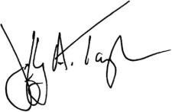
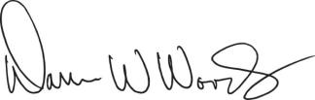

Jeffrey A. Taylor

Secretary

Darren W. Woods

Chairman of the Board

Table of Contents


Darren W. Woods

Chairman of the Board,
Chief Executive Officer,
Exxon Mobil Corporation

Dear Fellow Shareholders,

I am pleased to invite you to the 2026 Exxon Mobil Corporation annual shareholder meeting, which will be held virtually on May 27, 2026.

In 2025, ExxonMobil again demonstrated the strength and durability of our strategy. The transformation we have driven over the past several years has made our portfolio more advantaged, strengthened our earnings power, and further reinforced our unique role in the world. As a result of the quality of our assets and the consistency of our execution, we are leading all IOCs with five-year total annualized shareholder returns of 29%.¹ Our strategy is working and is continuing to create long-term value for you, our shareholders.

Our competitive position is defined by advantages in scale, integration, technology, and operations that few companies in any industry can match. Each of these is underpinned by one constant: the uniquely talented and committed men and women of ExxonMobil. Our structural advantages compound over time and reinforce sustained performance through market cycles. As a result, we have proven our ability to strengthen our long-term earnings power through improvements in portfolio mix, cost structure, reliability, and capital productivity.

In the Upstream, our advantaged production in the Permian Basin, Guyana, and LNG continues to represent a larger share of total output. This production has lower cost of supply, lower emissions intensity, and higher unit earnings – strengthening margins and enhancing cash-flow across a wide range of price scenarios.

In Product Solutions, we’re strengthening the portfolio with select divestments and advantaged project start-ups that drive meaningful earnings growth at constant margins through 2030.

At the same time, we are building new growth platforms that draw on the same world-class capabilities that underpin our core businesses. The ProxximaTM resin systems and carbon materials businesses are emerging as attractive offerings in large, high-value markets with meaningful long-term opportunities. In our Low Carbon Solutions business, we continue to advance the world’s first large-scale, end-to-end carbon capture and storage network to help industrial customers reduce emissions.² We are engaging in these opportunities with disciplined pacing, guided by commercial milestones and return criteria to ensure they strengthen our long-term earnings power.

The world continues to rely on our industry to provide affordable, reliable energy and essential products that support economic growth, while also seeking solutions that help lower greenhouse gas emissions. Our strategy is underpinned by a disciplined capital framework that supports both priorities and positions ExxonMobil for long-term success.

I am grateful to our employees around the world for their commitment, professionalism, and teamwork. Their dedication to safe operations, operational excellence, and customer and community service is what makes our achievements possible. On behalf of the Board and our entire Company, thank you for your continued confidence and investment in ExxonMobil. I look forward to sharing more with you at our annual shareholder meeting.

Table of Contents


Joseph L. Hooley

Board of Directors,
Lead Director,
Exxon Mobil Corporation

Dear Fellow Shareholders,

In 2025, ExxonMobil continued to strengthen its structural earnings power, cash-flow resilience, and long-term capacity to create value for shareholders. The Company’s disciplined strategy – supported by an advantaged portfolio, improving mix, and technology-enabled execution – is widening its competitive advantages and reinforcing performance across cycles.

This progress is reflected in attractive long-term total shareholder returns, reinforcing our commitment to our strategy and delivering durable value. The Board of Directors is focused on ensuring that these gains are sustained and grow consistent with your long-term interests.

A key responsibility of the Board is to provide oversight of the Company’s long-term strategy and performance, ensuring ExxonMobil remains well positioned to deliver sustainable value across changing market conditions. We draw on the Board’s diverse experience and perspectives to review strategic priorities, assess risks and opportunities, and support management as they execute plans designed to strengthen the Company’s competitive position and long-term earnings capacity.

Board composition and governance are important enablers of this work. Over the past year, we further strengthened the Board through thoughtful refreshment that added additional experience in large-scale industrial operations, capital allocation, and energy sector leadership. This added to and complemented our strong mix of expertise across finance, global operations, technology, strategy, risk management, and public policy. We also value the perspectives provided through our engagement with shareholders, which help inform our oversight priorities and the Company’s approach to transparency and disclosure.

It is a privilege to serve as Lead Director and to work alongside a Board, leadership team, and workforce whose discipline, execution, and commitment to excellence continue to strengthen the Company’s competitive position. On behalf of my fellow directors, thank you for your confidence in us and for your continued investment in ExxonMobil.

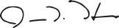

Table of Contents

- See Exhibit B for definitions of IOCs, total shareholder returns, and earnings growth at constant margins. 5-year total shareholder returns for period ending December 31, 2025. Total shareholder return compares to each IOC as of December 31, 2025. Sourced

from FactSet.

- “End-to-end CCS network” entails CO2 capture as well as transportation and storage of CO2. Based on contracts starting in 2025, subject to additional investment by ExxonMobil and receipt of government permitting for carbon capture and storage projects.

Table of Contents

 |  |  |  |  |  |  |  |  |  |  |  |  |  |  |  |  | TABLE OF CONTENTS
 |  |  |  |  |  |  |  |  |  |  |  |  |  |  |  |  |  |  |  |  |  |  |  |  |  |  |  | Page
PROXY SUMMARY |  |  |  |  |  |  |  |  |  |  |  |  |  |  |  |  |  |  |  |  |  |  |  |  |  |  |  | 1
GENERAL INFORMATION |  |  |  |  |  |  |  |  |  |  |  |  |  |  |  |  |  |  |  |  |  |  |  |  |  |  |  | 4
BOARD OF DIRECTORS |  |  |  |  |  |  |  |  |  |  |  |  |  |  |  |  |  |  |  |  |  |  |  |  |  |  |  | 8
 | Item 1 – Election of Directors |  |  |  |  |  |  |  |  |  |  |  |  |  |  |  |  |  |  |  |  |  |  |  |  |  |  | 8
CORPORATE GOVERNANCE |  |  |  |  |  |  |  |  |  |  |  |  |  |  |  |  |  |  |  |  |  |  |  |  |  |  |  | 21
 | Shareholder Vote Response and Engagement |  |  |  |  |  |  |  |  |  |  |  |  |  |  |  |  |  |  |  |  |  |  |  |  |  |  | 28
VOLUNTARY RETAIL VOTING PROGRAM |  |  |  |  |  |  |  |  |  |  |  |  |  |  |  |  |  |  |  |  |  |  |  |  |  |  |  | 34
DIRECTOR COMPENSATION |  |  |  |  |  |  |  |  |  |  |  |  |  |  |  |  |  |  |  |  |  |  |  |  |  |  |  | 36
CERTAIN BENEFICIAL OWNERS |  |  |  |  |  |  |  |  |  |  |  |  |  |  |  |  |  |  |  |  |  |  |  |  |  |  |  | 37
DIRECTOR AND EXECUTIVE OFFICER STOCK OWNERSHIP |  |  |  |  |  |  |  |  |  |  |  |  |  |  |  |  |  |  |  |  |  |  |  |  |  |  |  | 38
AUDIT COMMITTEE REPORT |  |  |  |  |  |  |  |  |  |  |  |  |  |  |  |  |  |  |  |  |  |  |  |  |  |  |  | 41
 | Item 2 – Ratification of Independent Auditors |  |  |  |  |  |  |  |  |  |  |  |  |  |  |  |  |  |  |  |  |  |  |  |  |  |  | 43
COMPENSATION COMMITTEE REPORT |  |  |  |  |  |  |  |  |  |  |  |  |  |  |  |  |  |  |  |  |  |  |  |  |  |  |  | 44
 | Item 3 – Advisory Vote to Approve Executive Compensation |  |  |  |  |  |  |  |  |  |  |  |  |  |  |  |  |  |  |  |  |  |  |  |  |  |  | 44
EXECUTIVE COMPENSATION |  |  |  |  |  |  |  |  |  |  |  |  |  |  |  |  |  |  |  |  |  |  |  |  |  |  |  | 45
 | Compensation Discussion and Analysis |  |  |  |  |  |  |  |  |  |  |  |  |  |  |  |  |  |  |  |  |  |  |  |  |  |  | 45
 | Executive Compensation Tables |  |  |  |  |  |  |  |  |  |  |  |  |  |  |  |  |  |  |  |  |  |  |  |  |  |  | 65
EXXONMOBIL CORPORATE DOMICILE |  |  |  |  |  |  |  |  |  |  |  |  |  |  |  |  |  |  |  |  |  |  |  |  |  |  |  | 76
 | Item 4 – Texas Redomiciliation |  |  |  |  |  |  |  |  |  |  |  |  |  |  |  |  |  |  |  |  |  |  |  |  |  |  | 76
SHAREHOLDER PROPOSALS |  |  |  |  |  |  |  |  |  |  |  |  |  |  |  |  |  |  |  |  |  |  |  |  |  |  |  | 115
 | Item 5 – Independent Chair, a proposal overwhelmingly defeated on 16 separate occasions since 2000 |  |  |  |  |  |  |  |  |  |  |  |  |  |  |  |  |  |  |  |  |  |  |  |  |  |  | 116
 | Item 6 – Proposal requesting Company to modify its Voluntary Retail Voting Program to provide multiple |  |  |  |  |  |  |  |  |  |  |  |  |  |  |  |  |  |  |  |  |  |  |  |  |  |  | 119
 | options not aligned with the Board’s recommendations |  |  |  |  |  |  |  |  |  |  |  |  |  |  |  |  |  |  |  |  |  |  |  |  |  |  | 119
PAY VERSUS PERFORMANCE |  |  |  |  |  |  |  |  |  |  |  |  |  |  |  |  |  |  |  |  |  |  |  |  |  |  |  | 124
PAY RATIO |  |  |  |  |  |  |  |  |  |  |  |  |  |  |  |  |  |  |  |  |  |  |  |  |  |  |  | 126
ADDITIONAL INFORMATION |  |  |  |  |  |  |  |  |  |  |  |  |  |  |  |  |  |  |  |  |  |  |  |  |  |  |  | 127
EXHIBIT A |  |  |  |  |  |  |  |  |  |  |  |  |  |  |  |  |  |  |  |  |  |  |  |  |  |  |  | 129
 | Annex A: Agreement and Plan of Merger |  |  |  |  |  |  |  |  |  |  |  |  |  |  |  |  |  |  |  |  |  |  |  |  |  |  | 129
 | Annex B: Amended and Restated Certificate of Formation of ExxonMobil Holdings Corporation |  |  |  |  |  |  |  |  |  |  |  |  |  |  |  |  |  |  |  |  |  |  |  |  |  |  | 135
 | Annex C: ExxonMobil Holdings Corporation By-Laws |  |  |  |  |  |  |  |  |  |  |  |  |  |  |  |  |  |  |  |  |  |  |  |  |  |  | 139
 | Annex D: Restated Certificate of Incorporation of Exxon Mobil Corporation |  |  |  |  |  |  |  |  |  |  |  |  |  |  |  |  |  |  |  |  |  |  |  |  |  |  | 163
 | Annex E: Exxon Mobil Corporation By-Laws |  |  |  |  |  |  |  |  |  |  |  |  |  |  |  |  |  |  |  |  |  |  |  |  |  |  | 190
EXHIBIT B |  |  |  |  |  |  |  |  |  |  |  |  |  |  |  |  |  |  |  |  |  |  |  |  |  |  |  | 213

Table of Contents


Your vote makes a difference.

To express appreciation for your participation,

ExxonMobil will make a $1 charitable donation to

Khan Academy®

for every retail shareholder account that votes before or during the

Annual Shareholder Meeting on May 27, 2026.

See page 4 for more information.

Table of Contents

PROXY SUMMARY


ITEM 1 – Election of Directors

The Board recommends you vote FOR each of the nominees described in the following pages.

The Board of Directors has nominated the director candidates in this proxy statement, all of whom currently serve as ExxonMobil directors. All director nominees have stated they are willing to serve, if elected.

Personal information about each nominee and their extensive qualifications begins on Page 9.

ExxonMobil Board of Directors Nominees


ExxonMobil’s Board of Directors is responsible for overseeing the Company’s long-term strategy, governance framework, and capital discipline to support durable shareholder value creation through market cycles. The Board’s approach emphasizes independent judgment, accountability, and flexibility in leadership and governance structures, recognizing that effective oversight must adapt to the Company’s scale, complexity, and operating environment. Central to this approach is maintaining alignment between strategy and execution, protecting shareholder rights, and supporting timely, well-reasoned decision-making in the long-term interests of our shareholders.

Board composition and governance support its stewardship responsibilities. The Board brings deep experience across capital-intensive industries, large-scale operations, finance, technology, and strategy, with ongoing refreshment aligned to long-term priorities and informed by shareholder engagement.

This framework guides the Board’s evaluation of the proposals presented for shareholder consideration at the 2026 Annual Meeting of Shareholders, including the Board’s reasons and beliefs regarding their recommendations, all of which are summarized in this 2026 proxy statement.

The Board unanimously recommends you vote FOR each of the ExxonMobil director

candidates.

2026 Proxy Statement | ¹

Table of Contents

Driving Value and Extending Our Lead in 2025
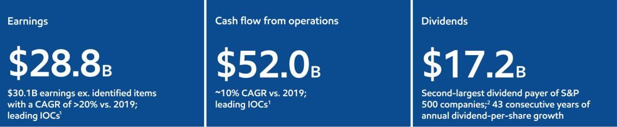

An Independent, Engaged Board Focused on Long-Term

Value Current Board Composition

- Board Independence

¡ 12 of 13 directors are independent

¡ 100% of Audit, Compensation, Nominating and Governance, and Environment, Safety and Public Policy committee members are independent directors
¡ Strong Lead Independent Director with defined authorities

- Board Refreshment and Experience

¡ Nearly 70% of our directors have joined the Board since 2021

¡ Average independent director tenure of 4.6 years, balancing continuity and fresh perspective
¡ Broad mix of critical skills, including global operations, financial, regulatory, and geopolitical expertise
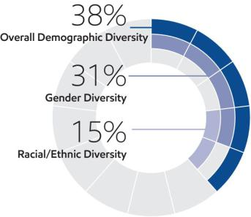

Broad Expertise, Experience, and Thought Leadership
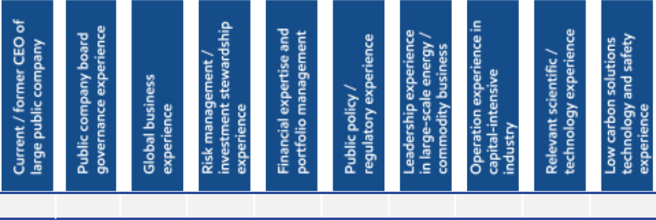

✓ ✓ ✓ ✓ ✓ ✓ ✓ ✓ ✓ ✓

¹ ExxonMobil had leading earnings ex. identified items compound annual growth rate (“CAGR”) versus each of the other IOCs comparing 2025 to 2019, as well as leading cash flow from operations CAGR. See footnote reference on page 222 of this proxy statement for reconciliation of ExxonMobil 2025 and 2019 earnings ex. identified items CAGR. Historic data was collected from public filings and from FactSet.
² ExxonMobil’s $17.2 billion of dividends paid in 2025 is the second largest of all S&P
500 companies per Bloomberg data.

- 2026 Proxy Statement

Oversight that Supports Execution

- Capital discipline

- Portfolio optimization

- Risk management and safety
- Long-cycle investment stewardship
- Shareholder engagement

Governance that is Adaptive,

Not Prescriptive

Effective governance is not one-size-fits-all. ExxonMobil’s Board evaluates leadership structure, shareholder engagement, and governance practices annually – informed by experience, performance, and evolving conditions – with a singular focus on long-term shareholder value.

Table of Contents

ITEM 2 – Ratification of Independent Auditors

The Board recommends you vote FOR this proposal. Page 43

The ExxonMobil Audit Committee has appointed PricewaterhouseCoopers LLP (PwC) to audit ExxonMobil’s financial statements for 2026.

You are asked to ratify that appointment.

ITEM 3 – Advisory Vote to Approve Executive Compensation

The Board recommends you vote FOR this proposal. Page 44

ExxonMobil asks you to vote on a non-binding resolution to approve the compensation of the Named Executive Officers.

ITEM 4 – Texas Redomiciliation

The Board recommends you vote FOR this proposal. Page 76

Consistent with its responsibility to provide a stable and efficient governance framework, the Board supports redomiciling ExxonMobil to Texas, which is the Company’s home state and location of its global headquarters. The Board concluded that shareholder rights remain largely comparable, while Texas law provides protections against abusive litigation, clearer standards, and legal predictability that support sound decision-making and long-term value creation. The Company is not adopting any elective provisions of the Texas corporate statute that weaken shareholder rights as compared to New Jersey law in connection with the Texas Redomiciliation.

ITEMS 5 and 6 – Shareholder Proposals

The Board recommends you vote AGAINST these proposals Page 115

Proposal 5 – Independent Chair, a proposal overwhelmingly defeated on 16 separate occasions since 2000

The Board believes effective governance requires discretion and flexibility to determine the leadership structure best suited to the Company’s strategy and complexity. ExxonMobil’s combined CEO and Chair structure, balanced by a strong Lead Independent Director and an overwhelmingly independent Board, supports clear accountability, strategic alignment, and effective oversight. Mandating separation would constrain Board judgment without any evidence of improved governance or shareholder returns. In fact, there are multiple examples in our industry in which separate CEOs and Chairs lost sight of the fundamentals and destroyed shareholder value. For these reasons, this proposal has been rejected time after time and should be rejected once again.

Proposal 6 – Proposal requesting Company to modify its Voluntary Retail Voting Program to provide multiple options not aligned with the Board’s recommendations

This proposal asks ExxonMobil to offer its retail investors additional voting options such as the option to vote against the Board’s recommendations. Our view is that, in submitting this proposal, on behalf of the New York City Police Pension Fund, the New York City Comptroller’s Office has not done the work to confirm the viability of their proposal. The changes proposed go far beyond the SEC no-action letter, violate proxy rules, and are inconsistent with both state law and the Board’s fiduciary duties, making the proposal unworkable and illegal.

2026 Proxy Statement | ³

Table of Contents

GENERAL INFORMATION

Who May Vote

Shareholders of Exxon Mobil Corporation (“ExxonMobil”, the “Company”, or the “Corporation”) as recorded in our stock register on April 1, 2026, may vote at the meeting according to the instructions below.

How to Vote

Your vote is important. We recommend you vote by proxy even if you plan to participate in the virtual meeting.

You may vote at the annual meeting according to the instructions below or by proxy.

In Appreciation for Your Vote

ExxonMobil will make a $1 charitable donation to Khan Academy® in appreciation of every retail shareholder account that votes prior to or at the meeting.

Khan Academy, Inc. is a nonprofit organization working to provide a free, world-class education for anyone, anywhere. Khan Academy offers practice exercises, instructional videos, and a personalized learning dashboard that empowers learners of all ages to study at their own pace in and outside of the classroom. Their offerings help students succeed in math, science, computing, economics, and more, including test preparation (SAT, LSAT, and more). All Khan Academy content is available for free at www.khanacademy.org. Khan Academy also empowers teachers by providing classroom insights and detailed student profiles that help identify gaps in student learning and provide tailored instruction. Millions of students from all over the world, each with their own unique story, learn at their own pace on Khan Academy every single day.

How Proxies Work

ExxonMobil’s Board of Directors is asking for your proxy. Giving us your proxy means you authorize us to vote your shares at the meeting in the manner you direct on the proxy card from the Board of Directors.

If your shares are held in your name, you can vote by proxy in one of three convenient ways:

Online | Telephone | Mail
Follow the instructions at | Call toll-free | Complete, sign, date, and return your
www.envisionreports.com/xom. | 1-800-652-8683 or | proxy card in the enclosed
You will need to have your | 1-781-575-2300 (outside the | envelope. If you receive a Notice and
proxy card or Notice of Internet | United States, Canada, and | would like to vote by mail, please
Availability (Notice) in hand. | Puerto Rico), | follow the instructions in the Notice
 | and follow the instructions. | to obtain paper proxy materials.
 | You will need to have your
 | proxy card or Notice in hand.




If you give us your signed proxy but do not specify how to vote, we will vote your shares as follows:

- For the election of all director candidates nominated by the ExxonMobil Board;

- For ratification of the appointment of independent auditors;

- For approval of the compensation of the Named Executive Officers;

- For approval of the redomiciliation of ExxonMobil from New Jersey to Texas; and

- As recommended by the Board with respect to shareholder proposals.

If you hold shares through someone else, such as a brokerage firm, bank, or intermediary, you will receive materials from that firm asking how you want to vote. Check the voting form used by that firm as most offer online or telephone voting in addition to mail.

- 2026 Proxy Statement

Table of Contents

Attendance at the Annual Meeting

You have received this proxy statement because you are a shareholder as of the record date. Attendance at the annual meeting through the website www.virtualshareholdermeeting.com/XOM2026 or any adjournment or postponement thereof will be limited to shareholders of the Company as of the close of business on the record date and to guests. You will not be able to attend the annual meeting in person at a physical location. Separate instructions for how to attend the annual meeting as a shareholder and have the ability to vote and/or submit a comment or question during the annual meeting are provided below for Registered Shareholders (those who hold shares through our transfer agent, Computershare, or participate in the Savings Plan) and Beneficial Shareholders (generally, those who hold shares through a bank or brokerage account).

Registered Shareholders must pre-register by 4:00 p.m. Central Time on May 20, 2026

For Registered Shareholders who hold shares through our transfer agent, Computershare, or participate in the Savings Plan, you must request a 16-digit virtual meeting access (VMA) control number no later than 4:00 p.m. Central Time on Wednesday, May 20, 2026.

To request a VMA control number, please email Computershare at legalproxy@computershare.com with “VMA Request” in the subject line. Include your full name exactly as it appears on your account and include a copy of your proxy card or Notice of Internet Availability (Notice). Alternatively, if you received your voting instructions via email, you may forward or attach that email. The 15-digit voter control number on your proxy card, Notice, or email allows you to vote your shares prior to and during the meeting but does not provide access to the virtual meeting as a shareholder. You will receive an email response from Computershare within seven days of your request. The email response will include your VMA control number and instructions to attend the virtual meeting. Please check that you have received a response in advance of the meeting, as it may be possible that the email may be in your email spam or junk folder.

Beneficial Shareholders

For Beneficial Shareholders who hold their shares through an intermediary, such as a bank or brokerage firm, the 16-digit control number can be found on the Notice, voting instruction form, or other instructions you receive from your bank, brokerage firm, or other intermediary. Beneficial Shareholders can use their 16-digit control number to log in to attend the meeting, submit questions, and vote during the meeting. Beneficial Shareholders who did not receive a 16-digit control number from their bank or brokerage firm who wish to attend the meeting should follow the instructions from their bank or brokerage firm, including any requirement to obtain a legal proxy. Most brokerage firms or banks allow a shareholder to obtain a legal proxy either online or by mail.

Attending as a Guest

Shareholders who do not pre-register for the virtual annual meeting (as specified above) or who do not have their 16-digit control number may still attend the meeting virtually as a guest by accessing the annual meeting website, www.virtualshareholdermeeting.com/XOM2026, beginning 15 minutes prior to the annual meeting’s scheduled start time and following the instructions provided to attend as a guest.

Guests at the virtual annual meeting will be able to listen to the meeting but will not be able to vote nor submit a comment or question during the annual meeting.

Submitting Questions and Voting at the Annual Meeting

All shareholders, other than shareholders who attend as guests (see “Attending as a Guest” above), may submit questions and vote at the annual meeting by following the instructions that will be available on the annual meeting website. Even if you plan to attend the annual meeting, the Company recommends that you vote your shares in advance, so that your vote will be counted if you later decide not to attend the annual meeting. Please note the additional information below for Registered Shareholders on voting during the annual meeting. Shareholders may also be able to submit questions prior to the meeting when voting.

Questions received prior to or during the annual meeting will be answered as allotted time permits. To address as many topics as time permits, similar questions may be combined. Considering the need to conclude the annual meeting within a reasonable period of time, we cannot ensure that every shareholder who wishes to have a question or comment addressed during the annual meeting will be able to do so.

Registered Shareholders can continue to vote their shares during the annual meeting by following the instructions that will be available on the annual meeting website and using the 15-digit voter control number displayed on your

2026 Proxy Statement | ⁵

Table of Contents

proxy card, Notice, or meeting materials email for the annual meeting. The 15-digit voter control number will not provide you access to the virtual annual meeting. For instructions on attending the annual meeting, please reference the section above titled “Attendance at the Annual Meeting.”

Virtual Meeting Technical Assistance

If you encounter technical difficulties accessing the virtual annual meeting, the meeting login page will include technical support line contact information. Technical support will be available beginning at 9:15 a.m. Central Time on May 27, 2026, and will remain available until the annual meeting has ended.

Important Notice Regarding the Availability of Proxy Materials for the Shareholders Meeting to Be Held on

May 27, 2026:

The 2026 Proxy Statement and 2025 Annual Report are available at www.edocumentview.com/xom.

Notice and Access

We distribute proxy materials to many shareholders via the internet under the Securities and Exchange Commission’s (SEC) “Notice and Access” rules, thereby capturing cost and environmental benefits. On or about April 8, 2026, we mailed a Notice of Internet Availability of Proxy Materials (Notice) that contains information about our 2026 annual meeting of shareholders and instructions on how to view all proxy materials on the internet. Also included are instructions on how to vote and how to request a paper or email copy of the proxy materials.

Electronic Delivery of Proxy Statement and Annual Report Documents

For shareholders receiving proxy materials by mail, you can elect to receive an email in the future that will provide electronic links to these documents. Opting to receive your proxy materials online will save the Company the cost of producing and mailing documents to you and will also give you an electronic link to vote your proxy. You may revoke electronic delivery election at any time.

Beneficial Shareholders (16-digit | Registered Shareholders (15-digit
control number) may enroll in | control number) may enroll in
electronic proxy delivery with their bank, | electronic proxy delivery at any time
brokerage, or other intermediary firm. | at www.computershare.com/
You may also be able to use the | exxonmobil. You may also enroll
electronic delivery request service at | while voting at
www.investordelivery.com. | www.envisionreports.com/xom.



Beneficial Shareholders who did not receive a 16-digit control number from their bank or brokerage firm who wish to enroll in electronic delivery should contact their bank or brokerage firm.

ExxonMobil Voluntary Retail Voting Program (see page 34 for more information)

Approximately 38% of ExxonMobil’s shares are held by individual investors, yet historically only about a quarter of those investors regularly vote at ExxonMobil shareholder meetings. Our individual investors have told us that they want to participate more actively but often find traditional voting processes cumbersome.

To promote shareholder engagement and streamline the proxy voting process in response to this feedback, ExxonMobil created a new Voluntary Retail Voting Program. This makes it easier for shareholders to engage while preserving full voting rights, flexibility, and control.

Shareholders who enroll in the Voluntary Retail Voting Program can provide a standing instruction that authorizes voting of their shares consistent with the Board’s voting recommendations.

Shareholders who enroll will continue to receive proxy materials to vote at each meeting of shareholders with details on the proposals for that meeting. The Board’s rationale for each recommendation will be included in these proxy materials consistent with the prior solicitation made to invite shareholders to join the program.

- 2026 Proxy Statement

Table of Contents

Shareholders who enroll in the Voluntary Retail Voting Program may opt-out at any time and will receive annual reminders that they are enrolled in the program, how their shares were voted at the last meeting and how to opt-out of the program if they choose to do so. Participants can also opt-out at any time by following the instructions on our website at investor.exxonmobil.com/individual-shareholders. Participation is voluntary and changes can be made at any time at no cost.

If the shareholder opts out on or after the date that ExxonMobil has filed a definitive proxy statement with the SEC for an upcoming meeting, then their decision to opt-out will apply only to all subsequent meetings. If the shareholder would like to change their vote for that particular upcoming meeting, then the shareholder may vote using the instructions in their proxy materials, which will override the standing instruction with respect to the specified proposals at that upcoming meeting. If you are a shareholder who currently participates in the Voluntary Retail Voting Program and would like to change your vote for this Annual Meeting, please cast your vote in a timely manner by completing and submitting your proxy materials.

More information on the program can be found at the Company’s Investor Relations website at investor.exxonmobil.com/individual-shareholders/vote, which includes instructions on how to sign up for the program.

Voting Shares in the ExxonMobil Savings Plan

The Trustee of the ExxonMobil Savings Plan will vote Plan shares as participants direct. If participants do not give instructions, the Trustee will vote shares as it thinks best. The proxy card serves to give voting instructions to the Trustee.

Revoking a Proxy for Registered Shareholders

You may revoke your proxy before it is voted at the meeting by:

- Submitting a new proxy with a later date via a proxy card, online, by telephone, or by mail;

- Notifying ExxonMobil’s Secretary in writing before the meeting; or

- Voting during the meeting.

Confidential Voting

Independent inspectors count the votes. Your individual vote is kept confidential from us unless otherwise required by law or special circumstances exist. For example, a copy of your proxy card is sent to us if you write comments on the card.

Quorum

In order to carry on the business of the meeting, we must have a quorum. This means at least a majority of the outstanding shares eligible to vote must be represented at the meeting, either by proxy or in person. Treasury shares, which are shares owned by ExxonMobil itself, are not voted and do not count for this purpose.

Votes Required

- Election of Directors Proposal: Under ExxonMobil’s by-laws, in a non-contested election, a director nominee must receive a majority of votes cast in order to be elected to the Board of Directors. In a contested election (in which the number of nominees exceeds the number of directors to be elected), the plurality vote standard under New Jersey law applies. Under plurality voting, the director nominee with the most votes for a particular seat is elected for that seat. Abstentions and broker non-votes are not counted for purposes of the election of directors. A broker non-vote occurs when a bank, broker, or other holder of record that is holding shares for a beneficial owner does not vote on a particular proposal because the record holder does not have discretionary voting power and has not received instructions from the beneficial owner but exercises discretionary voting authority to vote on at least one other proposal. If you own shares through a brokerage firm, bank, or intermediary, and have not enrolled in ExxonMobil’s Voluntary Retail Voting Program or a similar program offered by a brokerage firm, bank, or intermediary, you must give the brokerage firm, bank, or intermediary instructions to vote your shares in the election of directors. You provide those instructions to your brokerage firm, bank, or intermediary by voting according to the directions on your proxy card, voting instruction form or Notice by mail, online, or telephone. If you do not give your brokerage firm, bank, or intermediary instructions on voting your shares, then your shares will not be voted for this proposal.
2026 Proxy Statement | ⁷

Table of Contents

Our Corporate Governance Guidelines, which can be found in the Corporate Governance section of our website at exxonmobil.com/governanceguidelines, state that all directors will stand for election at the annual meeting of shareholders. In a non-contested election of directors, any director nominee who receives a greater number of votes AGAINST his or her election than votes FOR such election shall tender his or her resignation. Within 90 days after certification of the election results, the Board of Directors will decide, through a process managed by the Nominating and Governance Committee and excluding the nominee in question, whether to accept the resignation. Absent a compelling reason for the director to remain on the Board, the Board shall accept the resignation. The Board will promptly disclose its decision and, if applicable, the reasons for rejecting the tendered resignation on Form 8-K filed with the SEC.

- Other Proposals: Approval of the ratification of the appointment of independent auditors, the advisory vote to approve executive compensation, the approval of the plan of merger effecting the redomiciliation of ExxonMobil from New Jersey to Texas, and the shareholder proposals require the favorable vote of a majority of votes cast. Only votes FOR or AGAINST these proposals count. Abstentions count for quorum purposes but not for voting. Broker non-votes count as shares present for quorum purposes but do not count as votes cast on other proposals.

Conduct of the Meeting

The Chairman has broad responsibility and legal authority to conduct the annual meeting in an orderly and timely manner. This authority includes establishing rules for shareholders who wish to address the virtual meeting. Only shareholders or their valid proxy holders may address the meeting. A copy of these rules will be available at the virtual meeting. The Chairman may also exercise discretion in recognizing shareholders’ comments or questions and in determining the extent of discussion on each item of business. In light of the need to conclude the meeting within a reasonable period of time, we cannot ensure that every shareholder question or comment will be addressed during the meeting.

Dialogue can also be facilitated with interested parties outside the meeting, and for this purpose, we have provided a method on our website at exxonmobil.com/directors for raising issues and contacting the non-employee directors in writing either by mail or electronically. The Chairman may also rely on applicable law regarding disruptions or disorderly conduct to ensure that the meeting is conducted in a manner that is fair to all shareholders. Shareholders who wish to make comments during the meeting should do so in writing.


Contact Information

If you have questions or need more information about the annual meeting, write to Mr. Jeffrey A. Taylor, Secretary, Exxon Mobil Corporation, 22777 Springwoods Village Parkway, Spring, TX 77389. Alternatively, send an email to shareholderrelations@exxonmobil.com.

For information about shares registered in your name or your Computershare Investment Plan account, call ExxonMobil Shareholder Services at 1-800-252-1800 or 1-781-575-2058 (outside the United States, Canada, and Puerto Rico), or access your account at computershare.com/exxonmobil. We also invite you to visit ExxonMobil’s website, where investor information can be found at exxonmobil.com/investor. Website materials are not part of this proxy solicitation.

BOARD OF DIRECTORS

Item 1 – Election of Directors

Our Board of Directors has general oversight responsibility for ExxonMobil’s affairs pursuant to New Jersey’s General Corporation Law and ExxonMobil’s Restated Certificate of Incorporation and by-laws. In exercising its fiduciary duties, the Board represents and acts on behalf of ExxonMobil’s shareholders and is committed to strong corporate governance, as reflected through its policies and practices. The Board of Directors has nominated the director candidates named on the following pages. All of our nominees currently serve as ExxonMobil directors.

Each director nominee was elected by shareholders at the 2025 annual meeting of shareholders aside from Mr. Garland, who was appointed to the Board in November, 2025. All director nominees have stated they are willing to serve if elected and have consented to be named in this proxy statement. If a nominee becomes unavailable before the election, your proxy authorizes the people named as proxies to vote for a replacement nominee if the Board names one. In any event, the Board size at the time of the meeting will equal the number of nominees nominated by the Board, and there will be no vacancy at the time of the meeting.

- 2026 Proxy Statement

Table of Contents

The Board unanimously recommends you vote FOR each of the following candidates:


Michael J. Angelakis

Independent director

Director since 2021
Age 61

Committees:

Audit; Executive; Finance
(Chair)

Attributes and Skills:

Financial expertise and portfolio management

Public policy / regulatory experience

Risk management / investment stewardship experience

Public company board governance experience

Operation experience in capital-intensive industry

Global business experience

Expertise provided to the Board:

Mr. Angelakis’ financial experience, highlighted by his executive leadership position (CFO) transforming Comcast while navigating the financial crisis of 2008, helps the Board to better understand financial risk and opportunities facing ExxonMobil. In addition to his extensive business career, Mr. Angelakis’ experience as Chairman of the Federal Reserve Bank of Philadelphia and Chairman and CEO of Atairos Group provides vital perspectives to the challenges ExxonMobil faces related to policy and financial risk.

Qualifications:

Atairos Group

- Chairman & CEO (2015 to present)

Comcast Corporation

- Vice Chairman & CFO (2011 to 2015)

- Executive Vice President & CFO (2007 to 2011)

Providence Equity Partners

- Managing Director and member of the Management and Investment Committees (1999 to 2007)

Current public company directorships:

American Express Company (March 2025 to present; Nominating and Governance and Audit Committees)

Lucky Strike Entertainment Corporation (formerly Bowlero Corporation) (December 2021 to present; Chair of the Nominating and Corporate Governance Committee)

TriNet Group, Inc. (February 2017 to present; member of the Nominating and Corporate Governance and Compensation Committees)

Previous public company directorships in last five years:

Clarivate Plc (December 2021 to May 2025)

Groupon, Inc. (April 2016 to May 2021)

Hewlett Packard Enterprise Company (November 2015 to April 2020)

Other board experience:

Duke Energy Corporation (2015 to 2017)

Chairman of the Federal Reserve Bank of Philadelphia (2016 to 2018) and Deputy Chairman and board member (2012 to 2016)

Mr. Angelakis’ perspectives on ExxonMobil:

We work to ensure management’s strategic plans are evaluated through a long-term lens and supported by sound risk management and governance practices. Oversight of financial discipline and performance is essential to sustaining value across cycles. Our goal is to help ensure decisions made today strengthen the Company’s position for the future.

2026 Proxy Statement | ⁹

Table of Contents


Angela F. Braly

Independent director

Director since 2016
Age 64

Committees:

Compensation (Chair);
Environment, Safety and
Public Policy

Attributes and Skills:

Public policy / regulatory experience

Public company board governance experience

Current / former CEO of large public company

Financial expertise and portfolio management

Risk management / investment stewardship experience

Expertise provided to the Board:

Ms. Braly’s experience successfully leading WellPoint through the regulatory changes stemming from the Affordable Care Act helps the Board to better understand the risks and opportunities in industries that are challenged by government-led transformation. Her previous work in public policy and governance experience on the board of Procter & Gamble, a 100,000+ employee company, further helps the Board navigate public policy issues that arise at a global public company.

Qualifications:

WellPoint, Inc. (formerly known as Anthem, Inc. and now known as Elevance Health, Inc.)

- Chair (2010 to 2012)

- President, CEO (2007 to 2012)

- Executive Vice President, General Counsel, and Chief Public Affairs Officer (2005 to 2007)

Blue Cross Blue Shield of Missouri

- CEO (2003 to 2005)

Current public company directorships:

Brookfield Asset Management Ltd. (March 2025 to present)

Previous public company directorships in last five years:

Brookfield Corporation (May 2015 to March 2025)

The Procter & Gamble Company (December 2009 to June 2024)

Lowe’s Companies, Inc. (November 2013 to July 2021)

Business and public policy affiliations:

Blue Cross Blue Shield Association (former Director); Business Council (former member); Business Roundtable (former member); Harvard Advisory Council on Health Care Policy (former member); Indiana Economic Development Corporation (former Director); and The Policy Circle (Co-Founder, Director, and Secretary)

Ms. Braly’s perspectives on ExxonMobil:

ExxonMobil’s scale and technology capabilities provide important competitive strengths. The Board works to ensure governance and oversight frameworks support management’s efforts to translate those strengths into sustainable performance. Maintaining operational discipline remains critical to long-term success.

- 2026 Proxy Statement

Table of Contents


Maria S. Dreyfus

Independent director

Director since 2024
Age 46

Committees:

Audit (Chair); Compensation

Attributes and Skills:

Low carbon solutions technology and safety experience

Public policy / regulatory experience

Financial expertise and portfolio management

Risk management / investment stewardship experience

Expertise provided to the Board:

Ms. Dreyfus’ investment and financial experience and her work in the energy transition, highlighted by her executive leadership (CEO and Founder) positions at Ardinall Investment Management, help the Board to better understand capital allocation and opportunities to grow shareholder value through sustainable investments critical to managing the energy transition. Ms. Dreyfus’ experience as a portfolio manager and Managing Director at Goldman Sachs provides vital perspectives on energy, industrials, transportation, and infrastructure investments across the capital structure.

Qualifications:

Ardinall Investment Management

- Chief Executive Officer (2017 to present)

Goldman Sachs Asset Management, L.P.

- Managing Director, GS Investment Strategies, LLC (2002 to 2017)

Current public company directorships: Cadiz Inc. (June 2023 to present)

Previous public company directorships in last five years:

Pioneer Natural Resources Company (September 2021 to May 2024)

Nabors Energy Transition Corporation (June 2021 to November 2023)

Macquarie Infrastructure Corporation (September 2018 to September 2022)

Business and public policy affiliations:

I-Pulse; Alsym (advisory board); 100 Women in Finance (Board member); Girls Inc. of New York City; Global Carbon Management Foundation; Columbia University’s Center on Global Energy Policy (advisory board); MIT Corporation Development Committee; and MIT Economics Department Visiting Committee

Ms. Dreyfus’ perspectives on ExxonMobil:

As directors, we focus on ensuring management’s plans position the Company to adapt and succeed in evolving markets. Oversight includes careful consideration of risk, innovation, and long-term competitiveness. These elements help support sustainable value creation.

2026 Proxy Statement | ¹¹

Table of Contents


Gregory C. Garland

Independent director

Director since 2025
Age 68

Committees:

Audit; Finance

Attributes and Skills:

Current / former CEO of large public company

Public company board governance experience

Global business experience

Risk management / investment stewardship experience

Financial expertise and portfolio management

Leadership experience in large-scale energy / commodity business

Operation experience in capital-intensive industry

Low carbon solutions technology and safety experience

Public policy / regulatory experience

Expertise provided to the Board:

Mr. Garland has over 40 years of energy industry experience and a distinguished record of leadership, including a decade as Executive Chairman and CEO of Phillips 66. He brings to the Board deep expertise in upstream and downstream operations, global energy markets, risk management, and corporate governance. His leadership roles at Amgen Inc. and various philanthropic organizations include investment stewardship and portfolio management.

Mr. Garland’s experience provides the Board with critical insight into navigating complex challenges and driving long-term shareholder value.

Qualifications:

Phillips 66 (1986 to 2024)

- Executive Chair (2022 to 2024)

- Chair and CEO (2012 to 2022)

- President (2012 to 2014) ConocoPhillips

- Senior Vice President, Exploration and Production, Americas (2010 to 2012) Chevron Phillips Chemical Company

- President and CEO (2008 to 2010)

- Senior Vice President, Planning and Specialty Chemicals (2001 to 2008)

- Senior Vice President, Planning and Strategic Transactions (2000 to 2001)

Current public company directorships:

Amgen Inc. (October 2013 to present; Governance and Nominating Committee Chair; Compensation and Management Development Committee member, Executive Committee member)

Previous public company directorships in last five years: Phillips 66 (May 2012 to May 2024; Executive Chair) Other affiliations:

Barbara Bush Literacy Foundation (Board Vice Chair); Memorial Hermann Foundation (Director); M.D. Anderson Cancer Center (President’s Advisory Council member)

- 2026 Proxy Statement

Table of Contents


John D. Harris II

Independent director

Director since 2023
Age 64

Committees:

Audit; Compensation

Attributes and Skills:

Public policy / regulatory experience

Global business experience

Operation experience in capital-intensive industry

Relevant scientific / technology experience

Risk management / investment stewardship experience

Financial expertise and portfolio management

Expertise provided to the Board:

Mr. Harris brings to the Board a global perspective, as well as strategic, functional, and operational skills with a focus on customer success. He is a committed innovator and leader with a deep understanding of business transformation. Mr. Harris’ CEO and functional experience includes competencies in talent management, culture development, and strategic planning.

Qualifications:

Raytheon Technologies Corporation (1983 to 2020)

- CEO, Raytheon International, Inc. (2013 to 2020)

- Mr. Harris held various leadership positions, including serving as General Manager of Raytheon’s Intelligence, Information and Services business; President of Raytheon Technical Services Company; Vice President of Operations and Contracts for Raytheon’s Electronic Systems business; Vice President of Contracts for Raytheon’s government and defense businesses; Vice President of Contracts and Supply Chain for Raytheon Company; and Vice President of Business Development for Raytheon Company.

Current public company directorships:

Flex Ltd. (November 2020 to present; Audit Committee member)

Cisco Systems, Inc. (June 2021 to present; member of Audit and Compensation & Management Development Committees)

Kyndryl Holdings, Inc. (September 2021 to present; Nominating & Corporate Governance Committee member)

Previous public company directorships in last five years:

None

Other affiliations:

Redwood Library and Athenaeum (Board member); McLaren Racing (Advisory Team member)

2026 Proxy Statement | 13

Table of Contents


Kaisa H. Hietala

Independent director

Director since 2021
Age 55

Committees:

Audit; Finance

Attributes and Skills:

Global business experience

Relevant scientific / technology experience

Risk management / investment stewardship experience

Low carbon solutions technology and safety experience

Operation experience in capital-intensive industry

Leadership experience in large-scale energy / commodity business

Financial expertise and portfolio management

Public company board governance experience

Expertise provided to the Board:

Ms. Hietala brings a breadth of industry experience, having led the transformation of an oil and gas company into one of the world’s largest producers of renewable diesel. In addition to her vast industry experience, Ms. Hietala’s academic background in geophysics helps the Board to better understand both the risks and opportunities ExxonMobil faces in its low carbon solutions technologies.

Qualifications:

Neste Corporation

- Executive Vice President of Renewable Products and member of the Executive Committee (2014 to 2019)

- Over her 20-year career at Neste Corporation, Ms. Hietala served in various roles, from exploration and production and crude trading to leading the strategic review that resulted in the Renewable Products segment.

Current public company directorships:

SmurfitWestrock Plc (July 2024 to present; Senior Independent Director; Chair of the Sustainability Committee; member of the Nomination Committee)

Previous public company directorships in last five years:

Rio Tinto Group (March 2023 to May 2025)

Kemira Oyj (March 2016 to March 2021)

Smurfit Kappa Group Plc (October 2020 to July 2024; Senior Independent Director from 2022 to 2024; member of the Nomination Committee and Chair of the Sustainability Committee)

Other board experience:

Chair of Greencode Ventures Oy (2023 to present)

Chair of Tracegrow Oy (2019 to 2024)

Sustainability and academic affiliations:

New Sustainability Oy (partner); Supervisory Board of Oulu University (member); Susformation Oy (Founder); and Sustainability Hub Advisory Board of Aalto University (former member)

- 2026 Proxy Statement

Table of Contents


Joseph L. Hooley

Lead Independent Director

Director since 2020
Age 69

Committees:

Compensation; Executive;
Nominating and Governance
(Chair)

Attributes and Skills:

Current / former CEO of large public company

Public company board governance experience

Financial expertise and portfolio management

Risk management / investment stewardship experience

Global business experience

Expertise provided to the Board:

Mr. Hooley has extensive experience with institutional investors, having overseen the servicing of over $35 trillion of assets as well as the stewardship of over $4 trillion in capital as Chair and CEO at State Street. Mr. Hooley successfully transformed State Street in multiple ways, including driving a technological transformation, globalization of the business and investment portfolio, and navigating the post financial crisis of 2008. Mr. Hooley’s unique background helps the Board better understand investors’ perspectives on risk and ensures those perspectives are incorporated into Board discussions with management on important strategic decisions.

Qualifications:

State Street

- Chair (2011 to 2019)

- CEO (2010 to 2018)

- President & COO (2008 to 2014)

- Executive Vice President and Head of Investor Services Division (2002 to 2008)

- Vice Chairman and Global Business Experience Head of Investment Servicing and Investment Research and Trading (2006)

Boston Financial Data Services

- President & CEO (1990 to 2000)

National Financial Data Services

- President & CEO (1988 to 1990)

Current public company directorships:

Aptiv PLC (January 2020 to present; Chair of the Compensation and Human Resources Committee; Audit Committee member)

Idexx (July 2025 to present; Audit Committee member; Governance and Corporate Responsibility Committee member)

Previous public company directorships in last five years:

None

Other board experience:

State Street Corporation (October 2009 to December 2019)

Liberty Mutual Insurance (April 2019 to present)

OnCorps, Inc. (January 2022 to present)

Mr. Hooley’s perspectives on ExxonMobil:

ExxonMobil’s progress reflects years of disciplined planning and execution. As directors, we work to ensure governance and oversight frameworks help sustain that progress while supporting transparency and accountability. Our aim is to help position the Company for continued success.

2026 Proxy Statement | ¹⁵

Table of Contents


Steven A. Kandarian

 |  | Expertise provided to the Board:
 |  | Mr. Kandarian’s 14 years of senior executive leadership experience at MetLife,
 |  | where he led a significant transformation following the implementation of Dodd-
 |  | Frank, brings a viewpoint vital to the Board when developing the long-term
 |  | strategic plan and overseeing capital allocation across the portfolio. His former
 |  | positions as CEO and CIO of a global large-cap insurance business, in addition
 |  | to his previous work as a federal regulator, provide the Board with critical
 |  | insights related to geopolitical risks, government engagement, and risk
 |  | management.
Independent director |  | Qualifications:
Director since 2018 |  | MetLife, Inc.
Age 74
Committees: |  | • President & CEO (2011 to 2019)
Compensation; Executive; |  | • Chair (2012 to 2019)
Nominating and Governance |  | • Chief Investment Officer (2005 to 2011)
Attributes and Skills: |  | Pension Benefit Guaranty Corporation
Risk management / investment |  | • Executive Director (2001 to 2004)
stewardship experience
Financial expertise and portfolio
management |  | Current public company directorships:
Current / former CEO of large public
Current / former CEO of large public |  | Jackson Financial Inc. (February 2021 to present; Non-executive Chair; Chair of
company
Public company board governance |  | the Nominating & Governance Committee; Compensation Committee member)
experience
Global business experience |  | Previous public company directorships in last five years |  |  |  |  |  |  | :
Public policy / regulatory experience |  | AECOM (March 2019 to February 2021; Lead Independent Director; Chair of the
 |  | Compensation Committee; member of the Audit Committee)
 |  | Other board experience:
 |  | Director of Neuberger Berman (2015 to present)
 |  | Business and cultural affiliations:
 |  | The University of California, Berkeley, School of Law and Ceres ESG
 |  | certification (recipient); Business Council (member); Business Roundtable
 |  | (former member); Financial Services Forum (former member); Partnership for
 |  | New York City (former Director); Institute of International Finance (former
 |  | Director and Chair, Insurance Regulatory Committee); and the Lincoln Center for
 |  | the Performing Arts (former Director)
 |  | Scientific and research affiliations:
 |  | Damon Runyon Cancer Research Foundation (Director)

- 2026 Proxy Statement

Table of Contents


Alexander A. Karsner

Independent director

Director since 2021
Age 59

Committees:

Environment, Safety and
Policy; Nominating
and Governance

Attributes and Skills:

Risk management / investment stewardship experience

Public policy / regulatory experience

Relevant scientific / technology experience

Low carbon solutions technology and safety experience

Financial expertise and portfolio management

Global business experience

Expertise provided to the Board:

Mr. Karsner’s energy policy and diplomacy experience, in addition to his background in commercializing breakthrough energy technologies, provides the Board with important perspectives on geopolitical risks and investment opportunities for profitably managing the energy transition. Mr. Karsner’s public service as U.S. Assistant Secretary of Energy, a senior regulatory official, and a principal U.S. negotiator to the UN Framework Convention on Climate Change, contributes an in-depth understanding of U.S. and international energy policy. His energy sector experience, including energy infrastructure development in emerging markets, helps the Board better understand public- and private-sector considerations when executing strategy.

Qualifications:

X (formerly Google X) Alphabet’s Moonshot Factory

- Senior Strategist (2013 to present)

Emerson Collective

- Managing Partner (2016 to 2019)

Vantage Point Venture Capital

- Venture Partner (2009 to 2014)

Hudson Private Equity

- Senior Advisor (2009 to 2014)

Department of Energy

- U.S. Assistant Secretary (2006 to 2008)

Current public company directorships:

Applied Materials, Inc. (September 2008 to present; member of the Corporate Governance & Nominating and Human Resources & Compensation Committees)

Previous public company directorships in last five years:

Broadscale Acquisition Corp. (February 2021 to January 2023)

Business and public policy experience:

Council on Foreign Relations Working Group on Energy Transition (co-chair), and U.S.-India and U.S.-China Track II diplomatic climate bi-laterals; National Petroleum Council (former member); Energy Futures Initiative; Trilateral Commission (member); Gas Technology Institute (former Director); and Argonne National Laboratory (former Director)

Sustainability, scientific, and academic affiliations:

Conservation International (Director); Elemental Labs (Founder, Chairman); MIT Energy Initiative (MITei) (Advisory Board); MIT Media Lab (Advisory Board); National Marine Sanctuary Foundation (Trustee Emeritus); Aspen Institute Clean Energy Forum (Founder); American Academy of Arts & Sciences Accelerating Climate Action Commission (member); Stanford University Precourt Institute for Energy (member, Board of Advisors); Hoover Institution Shultz-Stephenson Energy Task Force (member); Stanford Natural Capital Project (Advisory Board); and University of Chicago Booth School, Polsky Center for Entrepreneurship (Advisory Board)

2026 Proxy Statement 17

Table of Contents


Lawrence W. Kellner

Independent director

Director since 2023
Age 67

Committees:

Environment, Safety and Public Policy (Chair); Executive; Nominating and Governance

Attributes and Skills:

Current / former CEO of large public company

Public company board governance experience

Risk management / investment stewardship experience

Public policy / regulatory experience

Global business experience

Operation experience in capital-intensive industry

Financial expertise and portfolio management

Low carbon solutions technology and safety experience

Expertise provided to the Board:

Mr. Kellner brings extensive experience in a highly regulated and capital-intensive industry, having served as CEO, COO, and Chair of Continental Airlines. Mr. Kellner’s deep operational understanding and executive leadership help the Board understand how best to develop a long-term strategy for a capital-intensive industry.

Qualifications:

Emerald Creek Group, LLC

- President (2010 to present)

Continental Airlines, Inc.

- Chairman & CEO (2004 to 2009)

- President & COO (2003 to 2004)

- President (2001 to 2003)

Current public company directorships:

None

Previous public company directorships in last five years:

The Boeing Company (October 2011 to May 2024; Independent Chair from December 2019 to March 2024)

Marriott International, Inc. (July 2002 to May 2022; Lead Independent Director from August 2013 to May 2022)

Sabre Corporation (August 2013 to April 2020; Chair of the Board from August 2013 to January 2020)

Mr. Kellner’s perspectives on ExxonMobil:

In capital intensive industries, long-term success requires clarity of strategy and disciplined execution over many years. The Board evaluates decisions with a focus on resilience, capital productivity, and performance through cycles. ExxonMobil’s transformation reflects a deep understanding of long-cycle investments and structural cost discipline. These changes strengthen the Company’s competitive position. Consistent execution of the strategy is essential to delivering durable shareholder value.

- 2026 Proxy Statement

Table of Contents


Dina Powell McCormick

Independent director

Director since 2024
Age 52

Committees:

Environment, Safety and
Public Policy; Nominating
and Governance

Attributes and Skills:

Risk management / investment stewardship experience

Public policy / regulatory experience Global business experience

Financial expertise and portfolio management

Low carbon solutions technology and safety experience

Expertise provided to the Board:

Ms. Powell McCormick brings a rare level of geopolitical, national security, and economic expertise. Her knowledge in these areas and experience leading Goldman Sachs’ sustainability efforts help the Board provide oversight of the Company’s global strategy and plans. Her investment experience, service in diplomatic and national security roles, and proven ability to navigate cultural and societal challenges, provides a vital understanding of an ever-changing global marketplace.

Qualifications:

Meta

- President and Vice Chair (January 2026 to present)

BDT & MSD Partners

- Advisory Board member (January 2026 to present)

- Vice Chair, President, and Head of Global Client Services (2023 to 2026)

The Goldman Sachs Group Inc. (2007 to 2023)

- Global Head of Sustainability and Inclusive Growth (2018 to 2023)

- President, Goldman Sachs Foundation and Global Head of Corporate Engagement (2010 to 2017)

- Managing Director (2007 to 2010)

Executive Office of the President (2003 to 2005; 2017 to 2018)

- Deputy National Security Advisor and Assistant to the President (2017 to 2018)

- Assistant to the President, Presidential Personnel (2003 to 2005)

- Deputy Assistant to the President, Presidential Personnel (2001 to 2003)

Current public company directorships:

None

Previous public company directorships in last five years:

Meta (May 2025 to December 2025)

Other affiliations:

Robin Hood Foundation (Chair); National Geographic Society Board (Trustee); Lincoln Center for the Performing Arts (Trustee); Mount Sinai Health System (Trustee); Atlantic Council (Board member); U.S. Department of State (Assistant Secretary of State, Educational and Cultural Affairs); Republican National Committee (Director, Congressional Affairs); and U.S. House of Representatives (Staff Member)

2026 Proxy Statement | ¹⁹

Table of Contents


Darren W. Woods

Chairman of the Board,

Chief Executive Officer
Director since 2016
Age 61

Committees:

Executive (Chair); Finance

Attributes and Skills:

Current / former CEO of large public company

Global business experience

Leadership experience in large-scale energy / commodity business

Operation experience in capital-intensive industry

Public company board governance experience

Public policy / regulatory experience

Low carbon solutions technology and safety experience

Financial expertise and portfolio management

Risk management / investment stewardship experience

Expertise provided to the Board:

Mr. Woods brings more than 30 years of global industry experience managing highly sophisticated, safety-critical operations and has held a number of senior leadership roles in multiple international business units prior to being promoted to CEO. His in-depth understanding of Company operations; knowledge of global business, markets, and strategy; and experience leading transformational change, help the Board to better understand and navigate the complex issues associated with transforming a multi-dimensional, capital-intensive commodity business through a thoughtful, long-term energy transition.

Qualifications:

ExxonMobil (1992 to present)

- Chairman & CEO (2017 to present)

- President (2016 to present)

- Senior Vice President (2014 to 2015)

- Vice President, and President, ExxonMobil Refining & Supply Company (2012 to 2014)

Current public company directorships:

None

Previous public company directorships in last five years:

None

Business affiliations:

Business Roundtable (member); American Petroleum Institute (former Chair); Business Council (member); Center for Strategic and International Studies (Trustee); Oil and Gas Climate Initiative; and National Petroleum Council (former Chair)

Mr. Woods’ perspectives on ExxonMobil:

ExxonMobil’s strategy is grounded in our competitive advantages and disciplined capital allocation. The transformation we have driven is strengthening our portfolio, improving structural performance, and enhancing resilience across cycles. These improvements are delivering results today while positioning the Company for long-term value creation. We are focused on investing where we have clear advantages and where returns justify the capital. That disciplined approach underpins our ability to deliver durable value for our shareholders over time.

- 2026 Proxy Statement

Table of Contents

CORPORATE GOVERNANCE

Overview

The Board of Directors and its committees perform a number of functions for ExxonMobil and its shareholders, including:

- Overseeing the management of the Company on your behalf, including oversight of risk management;

- Reviewing ExxonMobil’s long-term strategic plans;

- Exercising direct decision-making authority in key areas, such as declaring dividends;

- Selecting the Chief Executive Officer (CEO) and reviewing the CEO’s performance;

- Reviewing development and succession plans for ExxonMobil’s top executives; and

- Gathering insights and sharing perspectives from shareholders during engagements and other communications.

The Board has adopted Corporate Governance Guidelines that govern the structure and functioning of the Board and set out the Board’s position on a number of governance issues. Our current Corporate Governance Guidelines are posted on our website at exxonmobil.com/governanceguidelines.

Risk Oversight

The full Board of Directors provides oversight of key risks to ExxonMobil’s business. The Board throughout the year participates in reviews with management on the Company’s business, including identified risk factors. As a whole, the Board reviews litigation and other legal matters; political contributions, budget, and policy; lobbying costs; developments in climate science and policy; the Global Outlook, which projects world energy supply and demand to 2050; the Advancing Climate Solutions report; stewardship of business performance; and long-term strategic plans. The Board receives updates and reviews from both internal ExxonMobil and external experts on issues of importance to the Company.

The Board, including the Environment, Safety and Public Policy Committee, periodically visits an ExxonMobil operations site. These visits enable the directors to observe and provide input on safety, operating practices, environmental performance, technology, products, industry and corporate standards, and community engagement.

The Board oversees a broad spectrum of interrelated risks with assistance from its committees. This integrated risk management approach facilitates recognition and oversight of important risk interdependencies. Details related to the responsibilities of each committee can be found in the “Board Committees” section.

Each Board committee has the authority in its sole discretion to retain and oversee the work of such outside advisors as it deems appropriate and to approve the fees and expenses of such advisors. The Board receives regular updates from the committees and believes this structure is best suited for overseeing risk.

Board Leadership Structure

The Board believes that the decision as to who should serve as Chairman and/or CEO is the proper responsibility of the Board. The Board retains authority to amend the by-laws to separate the positions of Chairman and CEO at any time and regularly considers the pros and cons of such separation or combination. At the present time, the Board believes the interests of all shareholders are best served through a leadership model with a combined Chairman/CEO position and an independent Lead Director selected by and from the independent directors.

The current CEO possesses an in-depth knowledge of the Company; its integrated, multinational operations; the evolving energy industry supply and demand fundamentals; and the array of challenges and opportunities presented by an energy transition. This knowledge was gained through more than 30 years of successful experience in progressively more senior positions, including domestic and international responsibilities.

The Board believes that this in-depth knowledge and broad strategy leadership by the CEO best meets the Board’s fiduciary responsibilities to shareholders. Further, the Board has demonstrated its commitment and ability to provide independent oversight of management. The Board is comprised solely of independent directors other than the CEO, and 100% of the Audit, Compensation, Nominating and Governance, and Environment, Safety and Public Policy Committee members are independent. Each independent director has access to the CEO and other Company

2026 Proxy Statement | ²¹

Table of Contents

executives and employees, and is empowered to call meetings of the independent directors and request agenda topics to be added or addressed in more detail at meetings of the full Board or an appropriate Board committee.

The Board believes the Lead Director provides effective independent Board leadership. Joseph L. Hooley serves as Lead Director and is expected to remain in the position through the annual meeting of shareholders.

The Lead Director’s authority, under the Corporate Governance Guidelines, includes:

• Calling, chairing, and setting the agenda for executive sessions of the non-employee directors;

• Providing feedback to the Chairman;

• Chairing meetings of the Board in the absence of the Chairman;
• Reviewing and approving the schedule and agenda for all Board meetings and reviewing associated materials distributed to the
directors, in consultation with the Chairman;

• Advising the Chairman on the quality, quantity, and timeliness of information flow;
• Reviewing committee meeting schedules;

• Engaging with shareholders, as appropriate; and

• Leading the annual performance evaluation of the Board.

The Lead Director also serves as Chair of the Nominating and Governance Committee with authority that includes:

• Establishing the criteria for director engagement with shareholders;

• Providing comments and suggestions to the Board on Board committee structure, operations, member qualification, and member appointment;

• Overseeing independent director succession planning, remuneration, requests for additions to board memberships, and resignations;

• Establishing and maintaining procedures for interested parties to communicate with non-employee directors;
• Considering Board governance practices and procedures, including any changes to governance guidelines; and

• Providing oversight of the performance and effectiveness of the evaluation process for the Board and its committees.

In addition, the Lead Director, working together with the Compensation Committee, oversees the annual evaluation of the CEO, the communication of resulting feedback to the CEO, and the review of CEO succession plans.

Board and Committee Self-Evaluations

Each year, the Board and each of the Board committees conduct a comprehensive evaluation of their performance and effectiveness and solicit feedback for enhancement and improvement. The Lead Director, as Chair of the Nominating and Governance Committee, oversees the Board evaluation process and will periodically engage outside counsel to bring a third-party perspective to the process.

As part of the Board’s robust assessment, the Lead Director or outside counsel, as applicable, will ask each director for suggestions to improve Board and Board committee effectiveness and feedback on a range of issues, including Board leadership, culture, purpose, and strategy; Board composition and structure; individual director performance; quality of deliberations and communication with management; and oversight of risk management. The Board reviews and discusses the feedback during an evaluation session facilitated by the Lead Director, providing an opportunity for directors to identify areas for improvement.

Director Time Commitments

Service on the ExxonMobil Board requires a substantial time commitment. It is expected that our directors will serve on the boards of other companies only to the extent that, in the judgment of the ExxonMobil Board, such services do not detract from the director’s ability to devote the necessary time and attention to ExxonMobil. The Nominating and Governance Committee reviews all directors’ service on the boards of other companies at least annually. To avoid potential conflicts of interest, directors may not accept a seat on any additional company board without first reviewing the matter with the Nominating and Governance Committee.

- 2026 Proxy Statement

Table of Contents

Director Qualifications

ExxonMobil’s Corporate Governance Guidelines outline the qualifications sought when considering non-employee director candidates. The Corporate Governance Guidelines state in part:

“ExxonMobil recognizes the strength and effectiveness of the Board reflects the balance, experience, and diversity of the individual directors; their commitment; and importantly, the ability of directors to work effectively as a group in carrying out their responsibilities. ExxonMobil seeks candidates with diverse backgrounds who possess knowledge and skills in areas of importance to the Corporation.”

Within the scope of the Corporate Governance Guidelines, we seek director candidates with a diversity of experiences and backgrounds, including gender and race/ethnic diversity, with a focus on the key director competencies described in more detail in the “Competencies” matrix below.

Additional considerations for director candidates include: a substantial majority of the Board must meet independence standards as described in the Corporate Governance Guidelines; all candidates must be free from any relationship with management or the Corporation that would interfere with the exercise of independent judgment; candidates should be committed to representing the interests of all shareholders and not any particular constituency; and the Board must include members who satisfy legal and stock exchange requirements for certain Board committees.

All directors are expected to adhere to the Company’s policies and procedures, including the Conflicts of Interest Policy and Ethics Policy. See the “Code of Ethics and Business Conduct” section below for additional information.

Board Oversight

The Board is actively engaged in and committed to overseeing the Company’s processes.

Each new director participates in comprehensive onboarding sessions with senior leaders designed to accelerate the learning curve. These sessions span about 20 hours and cover a wide range of topics, including the Company’s values, strategies, objectives for major business lines and functional organizations, practices and policies, ethics, risk framework, the Global Outlook, technology, and capital allocation, as well as applicable legal and regulatory requirements. Additionally, the Board regularly visits ExxonMobil sites to meet with employees and experience our facilities and operations up close.

The Board is comprised of directors with an effective mix of backgrounds, knowledge, and skills that the Board considers relevant and beneficial in fulfilling its oversight role. The chart below provides a summary of the competencies of the current ExxonMobil Board and explains why these are important.

2026 Proxy Statement | 23

Table of Contents

ExxonMobil Board Competencies and Director Qualifications


Current / former CEO of large public company

An understanding of the complexities inherent in running a large public company provides a unique perspective that helps the Board independently oversee the Company’s management, long-term strategic planning, shareholder value creation, human capital management, risk oversight, governance, and shareholder engagement.

Public company board governance experience

Current or prior service as a Chair, Lead Director, Committee Chair, or other significant leadership position on the board of other public companies provides governance experience essential to ensure that the Board continues to maintain the right balance of skills and attributes needed to address the Company’s current and evolving risks and opportunities and to ensure that the Board is focusing on appropriate matters and functioning as an effective and cohesive independent oversight body.

Global business experience

Leadership experience in a multinational business that operates across diverse and evolving political conditions, economic systems, and cultures provides valuable perspectives for oversight of the risks and opportunities within the Company’s extensive global business and operations.

Risk management / investment stewardship experience

Experience managing a broad array of enterprise risks and stewarding investor capital through varied and challenging market conditions, business cycles, and business transitions provides critical expertise to better develop and oversee execution of the Company’s long-term strategies.

Financial expertise and portfolio management

Expertise in finance, accounting, financial reporting, and portfolio management is essential to the Board’s oversight of the Company’s capital allocation, risk management strategies, and internal financial controls and procedures.

Public policy / regulatory experience

Deep understanding of public policy and regulatory matters relevant to the Company’s businesses and global reach assists the Board in developing its long-term strategies by incorporating current and potential changes in public policy and regulation.

Leadership experience in large-scale energy / commodity business

Understanding the unique challenges of large-scale energy or other cyclical or commodity businesses provides critical insight for assessing Company strategies, challenges, and opportunities in operations, risks, and business transitions.

Operation experience in capital-intensive industry

Leadership experience in a business with capital-intensive industrial operations, involving complex engineering and long-lived assets, provides critical insight for assessing the risks and opportunities that face the Company in its long-term capital deployment decisions and for overseeing its financial and operational performance.

Relevant scientific / technology experience

Experience applying science and technology, including climate science, to large-scale challenges and investments in new and emerging technologies relevant to the Company’s businesses and scale provides sound guidance as the Company navigates the complex challenges of helping society meet the world’s energy needs and reduce carbon emissions.

Low carbon solutions technology and safety experience

Experience in environmental and safety operations, including lower carbon technologies, strengthens the Board’s oversight of the Company’s current and future business operations and promotes long-term sustainability.

- 2026 Proxy Statement

Table of Contents


Director & key qualifications


Michael J. Angelakis

Angela F. Braly

Maria S. Dreyfus

Gregory C. Garland

John D. Harris II

Kaisa H. Hietala

Joseph L. Hooley

Steven A. Kandarian

Alexander A. Karsner

Lawrence W. Kellner

Dina Powell McCormick

Jeffrey W. Ubben (not standing for re-election)

Darren W. Woods

2026 Proxy Statement | ²⁵

Table of Contents

Diversity of experiences and backgrounds is also an important consideration for Board members. The charts below reflect the diversity of the current Board.

Current Board Composition
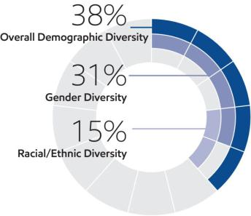
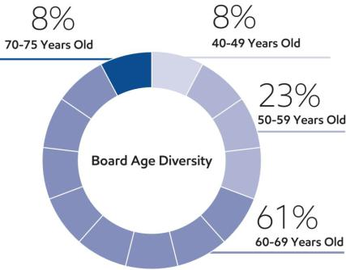

Director Independence

ExxonMobil’s Corporate Governance Guidelines require that a substantial majority of the Board consists of independent directors. In general, these guidelines require that an independent director must have no material relationship with ExxonMobil, directly or indirectly, except as a director. The Board determines independence based on the standards specified by the New York Stock Exchange (NYSE), the additional standards referenced in our Corporate Governance Guidelines, and other facts and circumstances the Board considers relevant.

Under ExxonMobil’s Corporate Governance Guidelines, a director will not be independent if a reportable “related person transaction” exists with respect to that director or a member of the director’s family for the current or most recently completed fiscal year. See the Guidelines for Review of Related Person Transactions posted on the Corporate Governance section of our website and described in more detail under “Related Person Transactions and Procedures” below.

The Board has reviewed relevant relationships between ExxonMobil and each non-employee director and director nominee to determine compliance with the NYSE standards and ExxonMobil’s additional standards. The Board evaluated whether there are any other facts or circumstances that might impair a director’s independence. Based on that review, the Board determined that all ExxonMobil non-employee directors are independent. The Board also determined that each member of the Audit, Nominating and Governance, Compensation, and Environment, Safety and Public Policy Committees (see table on page 31) is independent based on both applicable NYSE standards and the Company’s independence standards for each of these committees. The Company’s standards for each committee are included in their respective charters and posted on our website at exxonmobil.com/governance.

In recommending that each director and nominee be found independent, the Nominating and Governance Committee identified no transactions, relationships, or arrangements that required consideration under the NYSE and ExxonMobil independence standards described above.

Director Nomination Process and Board Succession

As noted in the committee information that follows, the Nominating and Governance Committee is responsible for identifying and evaluating director candidates. The description below sets forth the process through which the Committee identifies potential nominees to the Board and evaluates their qualifications.

Candidate Recommendations

The Nominating and Governance Committee seeks new candidates in several ways:

- Engagement of an executive search firm. The firm brings forward potential director candidates for the Committee to consider and helps research candidates identified by the Committee.

- Recommendations made by the non-employee directors. These recommendations are developed based on the directors’ own knowledge and experience in a variety of fields and on the research conducted by ExxonMobil staff at the Committee’s direction.

- Recommendations made by employee directors, shareholders, and others.

- 2026 Proxy Statement

Table of Contents

All recommendations, regardless of the source, are evaluated on the same basis against the criteria contained in the Corporate Governance Guidelines. The Committee has also instructed its executive search firm to include diversity as part of the candidate search criteria.

Shareholders may send recommendations for director candidates to the Secretary at the address given under Contact Information on page 8. A submission recommending a candidate should include:

- Sufficient biographical information to enable the Committee to evaluate the candidate in light of provisions of the Corporate Governance Guidelines on non-employee director qualifications;

- Information concerning any relationship between the candidate and the recommending shareholder; and

- Material indicating the willingness of the candidate to serve if nominated and elected.

The procedures by which shareholders may recommend nominees have not changed materially since last year’s proxy statement.

Assessment and Nomination

Once potential nominees are identified, the Nominating and Governance Committee assesses each candidate’s overall qualifications for nomination to the Board relative to an assessment of the Company’s future direction. In evaluating prospective directors, the Committee considers various factors including:

- ExxonMobil’s Corporate Governance Guidelines, including provisions on non-employee director qualifications;

- ExxonMobil’s strategy, risk profile, and current Board composition;

- Independence, perspectives, objectivity, reasoning, and judgment of the candidate; and

- Board diversity.

ExxonMobil seeks to have a diverse Board representing a range of backgrounds, knowledge, and skills relevant to the Company’s business and the needs of the Board, and as part of the search process, considers highly qualified candidates. The Committee does not use quotas but considers diversity along with the other requirements of the Corporate Governance Guidelines provisions on non-employee director qualifications when evaluating potential new directors. The resulting diversity of experience, skills, gender, and race/ethnicity on the ExxonMobil Board serves as a testament to this robust process.

If the Nominating and Governance Committee determines to advance a candidate in the nomination process, the Committee puts the candidate forward for consideration by the full Board.

Since our last annual meeting of shareholders, the Committee continued its director succession planning, using the process described above and taking into account, among other factors, shareholders’ interest in Board refreshment and specifically in adding directors with oil and natural gas industry, energy and business transition, capital allocation, and finance expertise. Mr. Garland was recommended by our executive search firm and joined the Board in November 2025.

Director Re-Nomination

The Nominating and Governance Committee also oversees the re-nomination process. In considering whether to re-nominate a director for re-election, the Committee reviews each director, considering such factors as:

- Attendance and participation at Board and committee meetings;

- Skills, experience, and personal attributes;

- Continued contribution to the Board’s effectiveness;

- Results from the annual Board and committee self-assessments;

- Shareholder feedback, including the support received at our annual meeting of shareholders; and

- Independence.

Board Tenure

The Board does not impose tenure limits on its directors, other than a mandatory retirement age of 75 and the requirement to stand for election annually. Given the complexity and breadth of our business and its long-term
2026 Proxy Statement | ²⁷

Table of Contents

investment horizons, the Board considers longevity of service and experience of great value. The Board also believes that its director compensation approach, which limits the vesting of restricted shares until retirement, closely aligns directors with the interests of long-term investors.

All ExxonMobil directors stand for election at the annual meeting. Non-employee directors cannot stand for election after they have reached age 75, unless the Board makes an exception on a case-by-case basis.

Restricted shares received by non-employee directors are subject to forfeiture if the non-employee director leaves the Board early, i.e., before the retirement age of 75. Employee directors resign from the Board when they are no longer employed by ExxonMobil.
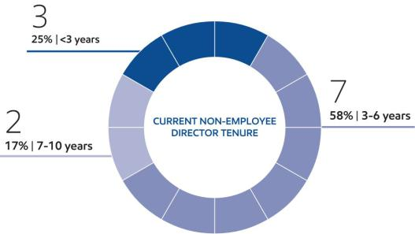

As of April 1, 2026, the average tenure of ExxonMobil’s non-employee directors is 4.6 years, below the average of Standard & Poor’s (S&P) 500 companies of 7.8 years (per 2025 Spencer Stuart Board Index). Nearly 70% of current ExxonMobil directors have joined the Board since January 2021.

2025 Shareholder Vote Response and Engagement

At last year’s annual shareholder meeting, our shareholders voted with the Board’s recommendations on all items. Throughout the following year, Board members, senior management, and subject-matter experts continued to engage with a wide range of our shareholders to understand their perspectives and how ExxonMobil can better provide decision-useful information on key issues.

There is a wide range of perspectives across our more than 6 million shareholders. However, as a group, they provided positive feedback and general satisfaction related to our disclosures. With input and oversight from our Board, we update these materials each year, including modifications to respond to investor requests for additional clarity in certain areas, extension of disclosure in other areas, and new decision-useful information.

The following reports provide our shareholders with information on key topics:

- Advancing Climate Solutions (ACS) is available at exxonmobil.com/acsprogressreport.

- Sustainability Report is available at exxonmobil.com/sustainabilityreport.

- Investing in People is available at corporate.exxonmobil.com/community/investing-in-people.

- Global Outlook is available at corporate.exxonmobil.com/sustainability-and-reports/global-outlook.

- Worldwide Giving is available at corporate.exxonmobil.com/community/worldwide-giving/worldwide-giving-report.

- Lobbying and Political Contributions are available at corporate.exxonmobil.com/who-we-are/policy/lobbying.

- Our Approach to Tax is available at corporate.exxonmobil.com/-/media/global/files/sustainability-and-reports/tax-disclosure.pdf.

- 2026 Proxy Statement

Table of Contents

The Board and management recognize how important it is to understand shareholders’ perspectives, keep shareholders informed about the business, and address investors’ areas of interest. The Board and management welcome and value input from all shareholders and have significantly expanded engagements over the past five years.

Engaged with: | Engaged through: |  | Engagements include:
• Institutional Investors | • Individual and Group |  | • Independent Directors
• Retail Shareholders |  | Investor Meetings | • Chairman / CEO /
• Pension Funds | • Corporate Plan Update |  |  | Management Committee
• Religious Organizations | • Quarterly Earnings Calls |  | • Senior Management
• Non-governmental Organizations | • Investor Conferences |  | • Subject-Matter Experts
• Proxy Advisory Firms | • Spotlight Events |  | • Other Employees
• Environmental, Social, and Governance | • Annual Shareholder
• Environmental, Social, and Governance |  |  | Sustainability engagements:
(ESG) Rating Firms |  | Meeting
• Industry Thought Leaders | • Shareholder Webcasts |  |  | >90% increase
• Shareholder proposal proponents | • Stakeholder Outreach |  |  | >90% increase
 |  |  |  | since 2020
Engaged with Shareholders representing: | Information shared through:
2.0 billion shares | • | SEC Filings | • | Advancing Climate
~ 46% of total outstanding shares | • | Press Releases |  | Solutions report
~ 46% of total outstanding shares | • | Annual Report | • | Sustainability Report
and | • | Company Website | • | Advocacy Report
~ 76% of institutional shareholdings | • Investing in People report |  | • | Earnings Calls
 | • | Global Outlook

Our engagement program is designed to foster an open, constructive dialogue with shareholders – providing insight into our strategy, performance, and governance while ensuring we listen carefully to investor perspectives. We interact with investors across multiple levels of the Company, including our Board, Management Committee, senior management, and subject-matter experts. Our comprehensive publications serve as another channel for communication and have been improved over time leveraging investor feedback. We also host special events like our Corporate Plan Update and Global Outlook Roadshow to broadly communicate our plans and the fundamentals that support them. In total, we participate in hundreds of conversations each year.

Amidst a backdrop of changes to investor filing requirements, the shareholder proposal process, and regulations, institutional investors have told us they appreciate our principled approach, continued focus on broad access and engagement, and the consistency in our strategy and publications.

In 2025 and 2026, we took significant steps to expand outreach to our individual retail investors, who have told us that they want to participate more actively but often find traditional voting processes cumbersome. We launched a Voluntary Retail Voting Program and a dedicated retail shareholder internet landing page: investor.exxonmobil.com/individual-shareholders.

The Voluntary Retail Voting Program makes it easier for retail shareholders to engage while preserving full voting rights, flexibility, and control – reinforcing the principle that effective governance depends first and foremost on accessibility in voting. Beyond our ongoing engagement with institutional investors, proxy advisors, and other stakeholders, this initiative strengthens the shareholder voice. We have been encouraged by the enthusiastic response from our retail shareholders to this program.

Across all engagements, investors continue to emphasize the importance of disciplined capital allocation, long-term value creation, and governance structures that support accountability and performance. We believe our evolving engagement approach – including expanded access for retail shareholders – reflects those priorities and supports a governance framework that is responsive, balanced, and focused on delivering durable shareholder value.

2026 Proxy Statement | ²⁹

Table of Contents


The Nominating and Governance Committee has established and oversees procedures for shareholders and other interested persons to send written or electronic communications to individual directors, including the Lead Director, Board committees, or the non-employee directors as a group.

- Written Communications: Written correspondence should be addressed to the director or directors at the address given under Contact Information on page 8.

- Electronic Communications: You may send a message to individual non-employee directors, Board committees, or the non-employee directors as a group by using the form provided for that purpose on our website at exxonmobil.com/directors.

All communications are recorded by an ExxonMobil Assistant Secretary or designated staff member and forwarded to the appropriate director or directors or otherwise handled as the Committee has directed.

Code of Ethics and Business Conduct

The Board maintains policies and procedures (referred to in this proxy statement as the Code) that represent both the code of ethics for the principal executive officer, principal financial officer, and principal accounting officer under SEC rules, and the code of business conduct and ethics for directors, officers, and employees under NYSE listing standards. The Code applies to all directors, officers, and employees and is at the core of the Company’s foundational policies. The Code includes a Conflicts of Interest Policy under which directors, officers, and employees are expected to avoid any actual or apparent conflict between their own personal interests and the interests of the Corporation. The Code also includes an Ethics Policy under which directors, officers, and employees are expected to observe the highest ethical standards of integrity in the conduct of the Company’s business. Each year, directors, officers, and employees are required to certify that they have read the Code and remain in compliance with its requirements. The Code is posted on the ExxonMobil website at exxonmobil.com/code. The Code is also included as an exhibit to our Annual Report on Form 10-K. Any amendment of the Code will be posted promptly on ExxonMobil’s website.

The Corporation maintains procedures for administering and reviewing potential issues under the Code, including procedures that allow employees to make complaints without identifying themselves unless otherwise required by law. The Corporation also conducts periodic mandatory business practice training sessions.

The Nominating and Governance Committee will initially review any suspected violation of the Code involving an executive officer or director and will report its findings to the Board. The Board does not envision that any waiver of the Code will be granted. Should such a waiver occur, it will be promptly disclosed on ExxonMobil’s website.

Consistent with our focus on ethical standards and compliance with the law, in addition to the Code, the Company’s Insider Trading Policy requires that all directors, officers, and employees of ExxonMobil and its subsidiaries avoid securities transactions based on material non-public information learned through their positions with the Company. The Insider Trading Policy and related procedures are included as an exhibit to our Annual Report on Form 10-K.

Board Meetings and Annual Meeting Attendance

The Board met 10 times in 2025. ExxonMobil’s incumbent directors, on average, attended approximately 97% of Board and committee meetings during 2025. No director attended fewer than 75% of such meetings. ExxonMobil’s non-employee directors held seven independent sessions in 2025, chaired by the independent Lead Director. As specified in our Corporate Governance Guidelines, it is ExxonMobil’s policy that directors should make every effort to attend the annual meeting of shareholders. All directors attended the 2025 annual meeting of shareholders on May 28, 2025.

Board Committees

The Board appoints committees to help carry out its duties. Board committees work on key issues in greater detail than would be possible at full Board meetings. Only non-employee directors may serve on the Audit, Compensation, Nominating and Governance, and Environment, Safety and Public Policy Committees. Each committee has a written charter. The charters are posted on the Corporate Governance section of our website at exxonmobil.com/governance.

- 2026 Proxy Statement

Table of Contents

The tables below show the current membership and the number of meetings each committee held in 2025.

 |  |  | Nominating and |  | Environment, Safety | Executive
Director | Audit | Compensation | Governance | Finance | and Public Policy | Committee⁽¹⁾
M.J. | • |  |  |  |  | •
Angelakis | • |  |  |  |  | •
A.F. |  |  |  |  | •
Braly |  |  |  |  | •
M.S. |  | •
Dreyfus |  | •
G.C. | • |  |  | •
Garland | • |  |  | •
J.D. | • | •
Harris II | • | •
K.H. | • |  |  | •
Hietala | • |  |  | •
J.L. |  | • |  |  |  | •
Hooley |  | • |  |  |  | •
S.A. |  | • | • |  |  | •
Kandarian |  | • | • |  |  | •
A.A. |  |  | • |  | •
Karsner |  |  | • |  | •
L.W. |  |  | • |  |  | •
Kellner |  |  | • |  |  | •
D. |  |  | • |  | •
Powell |  |  | • |  | •
McCormick
J.W. |  |  |  | • | •
Ubben |  |  |  | • | •
D.W. |  |  |  | •
Woods |  |  |  | •

= Chair • = Member (1) Other directors serve as alternate members on a rotational basis

Meetings in 2025:
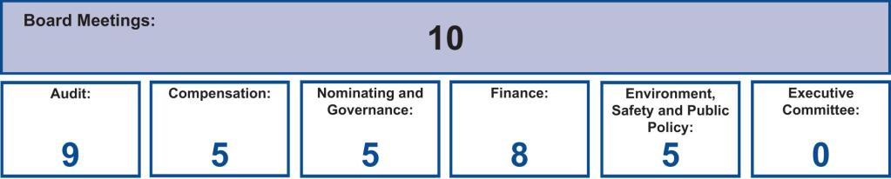

Nominating and Governance Committee

The Nominating and Governance Committee, chaired by the independent Lead Director, serves as ExxonMobil’s nominating and corporate governance committee. Its responsibilities include:

- Recommendations on director candidates and reviewing requests for participation on other boards;

- Maintaining procedures for director engagement with shareholders;

- Providing comments and suggestions to the Board on committee structure and committee assignments;

- Reviewing corporate governance practices, including the Corporate Governance Guidelines;

- Reviewing any issue involving an executive officer or director under the Code; and

- Administering ExxonMobil’s Related Person Transaction Guidelines.

The Committee also administers provisions of the Corporate Governance Guidelines that require a director to tender a resignation when there is a substantial change in the director’s circumstances. The Committee reviews the relevant facts to determine whether the director’s continued service would be appropriate and makes a recommendation to the Board.

Another responsibility of the Committee is to review and make recommendations to the Board regarding the compensation of the non-employee directors. The Committee uses an independent consultant, Pearl Meyer &
2026 Proxy Statement | ³¹

Table of Contents

Partners, LLC (Pearl Meyer), to provide information on current developments and practices in director compensation. Pearl Meyer is the same consultant retained by the Compensation Committee to advise on executive compensation but performs no other work for ExxonMobil.

The Corporate Governance Guidelines describe the qualifications the Committee looks for in director candidates. These Corporate Governance Guidelines, as well as the Committee’s charter, are posted on the Corporate Governance section of our website.

Audit Committee

The Audit Committee oversees accounting and internal control matters. Its responsibilities include oversight of:

- Management’s conduct of the Corporation’s financial reporting process;

- The integrity of the financial statements and other financial information provided by the Corporation to the SEC and the public;

- The Corporation’s system of internal accounting and financial controls;

- The Corporation’s compliance with legal and regulatory requirements;

- The performance of the Corporation’s internal audit function;

- The independent auditors’ qualifications, performance, and independence;

- The annual independent audit of the Corporation’s financial statements;

- The Corporation’s overall risk management approach and structure; and

- The Corporation’s cybersecurity program and preparedness (see our Annual Report on Form 10-K for more details).

The Committee has direct authority and responsibility to appoint (subject to shareholder ratification), compensate, retain, and oversee the independent auditors.

The Committee also prepares the report that SEC rules require be included in the Corporation’s annual proxy statement.

The report is below in the “Audit Committee Report” section.

The Audit Committee has adopted specific policies and procedures for pre-approving fees paid to the independent auditors. Under the Audit Committee’s approach, an annual program of work is approved each July for the following categories of services: Audit, Audit-Related, and Tax. Additional engagements may be brought forward from time to time for pre-approval by the Audit Committee. Pre -approvals apply to engagements within a category of service and cannot be transferred between categories. If fees might otherwise exceed pre-approved amounts for any category of permissible services, the incremental amounts must be reviewed and pre-approved prior to commitment. The complete text of the Audit Committee’s pre-approval policies and procedures, as well as the Committee’s charter, is posted on the Corporate Governance section of ExxonMobil’s website.

The Board has determined that all members of the Committee are financially literate within the meaning of the NYSE standards, and a majority are “audit committee financial experts” as defined in the SEC rules, including Ms. Dreyfus as the Audit Committee Chair.

Compensation Committee

The Compensation Committee is comprised exclusively of non-employee, independent directors, and oversees compensation, based on individual performance, for ExxonMobil’s senior executives (including salary, bonus, and performance share awards), as well as succession planning for key executive positions. The Committee’s charter is available on the Corporate Governance section of our website.

The Committee took the following actions:

- Reviewed with the Board and approved the corporate goals and objectives;

- Reviewed the Corporation’s business results and progress toward strategic objectives during the year with ExxonMobil’s CEO and other senior executives;

- 2026 Proxy Statement

Table of Contents

- Reviewed the individual performance and contributions of the CEO and other senior executives;

- Discussed the Company’s executive compensation program design with its independent consultant;

- Considered feedback from shareholder engagements and the results of the 2025 advisory vote on executive compensation;

- Deliberated pay decisions based on an assessment of progress toward strategic objectives, business results, individual performance, and the results of annual benchmarking, taking into account experience in position;

- Established the aggregate annual ceiling for the 2025 long-term incentive award program and bonus program;

- Assessed each element of the Company’s compensation program and practices, and confirmed that these do not create any material adverse risks for the Company. The key design features of the compensation program that discourage executives from taking inappropriate risk are described in detail in this proxy statement (see discussion in Compensation Discussion and Analysis below);

- Reviewed with the Board progress on executive development and succession planning for senior-level positions and organizational health with input from the CEO; and

- Reviewed with the Board the Company’s efforts in investing in globally diverse talent.

The Committee does not delegate its responsibilities with respect to ExxonMobil’s executive officers and other senior executives. For other employees, the Committee delegates authority to determine individual salaries and incentive awards to a committee consisting of the Chairman and Management Committee. That committee’s actions are subject to a salary budget and aggregate annual ceilings on incentive awards established by the Compensation Committee.

For more information on the compensation decisions made by the Committee for 2025, refer to the Compensation Discussion and Analysis below.

The Compensation Committee utilizes the expertise of an external independent consultant, Pearl Meyer. At the direction of the Committee, Pearl Meyer:

- Attends Committee meetings;

- Informs the Committee regarding general trends in executive compensation across industries;

- Prepares the analysis of comparator company compensation used by the Committee; and

- Participates in the Committee’s deliberations regarding compensation for Named Executive Officers.

In addition, at the direction of the Chair of the Nominating and Governance Committee, Pearl Meyer provides an annual survey of non-employee director compensation for use by that Committee.

The Compensation Committee is solely and directly responsible for the appointment, compensation, and oversight of the consultant. The Committee considers factors that could affect Pearl Meyer’s independence, including that the consultant provides no services for ExxonMobil other than its engagement by the Committee and the Nominating and Governance Committee as described above. Based on this review, the Committee has determined the consultant’s work for the Committee to be free from conflicts of interest.

Finance Committee

The Finance Committee reviews ExxonMobil’s financial policies, practices, and strategies, including issues related to its financial outlook, capital allocation plan, and capital structure; shareholder distribution policies and practices; insurance and pension investment programs; and significant investments, acquisitions, and divestitures. The Committee’s charter is available on the Corporate Governance section of our website.

Environment, Safety and Public Policy Committee

The Environment, Safety and Public Policy Committee assists the Board in overseeing the Corporation’s positions and practices regarding safety, security, health, and the environment (including but not limited to climate, emissions, and sustainability) and other public policy issues relevant to the Corporation. This includes workplace health and safety –
2026 Proxy Statement | ³³

Table of Contents

see our Investing in People report for more information. The Committee hears reports on safety and environmental activities and along with the full Board periodically visits operating sites to observe and comment on current operating practices. In addition, the Committee provides oversight on the Corporation’s overall contributions strategies, objectives, and policies through an annual review of contributions, including the Corporation’s contributions to the ExxonMobil Foundation. The Foundation and the Corporation engage in a range of philanthropic activities that advance education, with a focus on math and science in the United States; promote women as catalysts for economic development; combat malaria; and support other cultural and public service initiatives. The Committee’s charter is available on the Corporate Governance section of our website.

Executive Committee

The Executive Committee has broad power to act on behalf of the Board. In practice, the Committee meets only when it is impractical to call a meeting of the full Board.

VOLUNTARY RETAIL VOTING PROGRAM

The Company adopted a voluntary program to enhance retail shareholder participation and facilitate voting at shareholder meetings (the “Voluntary Retail Voting Program”). The Voluntary Retail Voting Program gives participating Registered Shareholders and Beneficial Shareholders (each, a “Participant”) the ability to give the Company a standing instruction to vote the Participant’s shares in line with the Board’s recommendations.

The Voluntary Retail Voting Program involves no cost for Participants.

Participants’ Opt-In Choices under the Voluntary Retail Voting Program

In signing up for the Voluntary Retail Voting Program, Participants can have their standing voting instruction apply to:

- all matters, or (2) all matters except any contested director election and any acquisition, merger or divestiture transaction that, under applicable state law or stock exchange rules, requires approval of the Company’s shareholders. Participants remain in the Voluntary Retail Voting Program until they opt-out, which is described below.

Retail investors who opt-in to the Voluntary Retail Voting Program on or after April 8, 2026, the date of filing the definitive proxy statement for this Annual Meeting, have opted in for future shareholder meetings, not this Annual Meeting.

If you are a shareholder who does not currently participate in the Voluntary Retail Voting Program or who opted in on or after April 8, please cast your vote in a timely manner by completing and submitting proxy materials.

Proposal 4 involves a merger transaction that, under applicable state law, requires approval of the Company’s shareholders. For retail investors who opted in to the Voluntary Retail Voting Program and elected to have their standing instructions applied to all matters except any contested director election and any acquisition, merger or divestiture transaction that, under applicable state law or stock exchange rules, requires approval of the Company’s shareholders, their shares will not be voted on Proposal 4 under the Retail Voting Program. If you are a shareholder who elected to have your standing voting instruction apply to all matters except any contested director election and any acquisition, merger or divestiture transaction that, under applicable state law or stock exchange rules, requires approval of the Company’s shareholders, please cast your vote on Proposal 4 in a timely manner by completing and submitting proxy materials.

Implementing the Standing Voting Instructions by the Company

The Company votes all of the Participants’ shares for a particular shareholder meeting in accordance with the Board’s recommendations on or about the day that the proxy statement for that meeting is filed by the Company. For this Annual Meeting, the Company has cast all of the votes from Participants’ shares on April 8, 2026.

Distribution of Proxy Materials by the Company

The Voluntary Retail Voting Program does not affect the distribution of proxy materials, and Participants will still receive proxy materials for all shareholder meetings if they are holders of record for that meeting. The Voluntary Retail Voting Program is designed to minimize any impact on our retail holders’ voting experience. If a Participant votes at this Annual Meeting, the vote at this Annual Meeting will be determinative, even if the Participant is part of the Voluntary Retail Voting Program.

- 2026 Proxy Statement

Table of Contents

Participants’ Choice to Vote at any Shareholder Meeting (overriding the Voluntary Retail Voting Program for just this Annual Meeting)

The Voluntary Retail Voting Program does not limit the ability of Participants to vote at shareholder meetings. Using their proxy materials, a Participant can vote at any shareholder meeting in favor of, against or abstain from, any matters at the meeting. If a Participant’s vote cast at the meeting is different than the Board’s recommendation, then the Participant’s vote overrides any votes that have been cast on behalf of the Participant. The Participant’s overriding vote is the vote that counts at the meeting.

If you are a Participant in the Voluntary Retail Voting Program and would like to change your vote for this Annual Meeting, please cast your vote in a timely manner by completing and submitting your proxy materials.

Voting at this Meeting and Overriding the Votes Cast by the Voluntary Retail Voting Program Does Not Opt-Out of the Voluntary Retail Voting Program for Future Meetings

For those Participants already enrolled in the Voluntary Retail Voting Program, casting a vote on a particular matter at this Annual Meeting does not cause a Participant to opt-out of the standing voting instruction under the Voluntary Retail Voting Program or change the Participant’s standing voting instruction with respect to other matters.

Opting out of the Voluntary Retail Voting Program for Future Meetings

A Participant will receive annual reminders that they are enrolled in the program and can opt-out of the Voluntary Retail Voting Program at any time. Participants can opt-out at any time by following the instructions on our website at investor.exxonmobil.com/individual-shareholders.

A Participant who opts out of the Voluntary Retail Voting Program on or after April 8, 2026, the date of filing this proxy statement, has opted out for future shareholder meetings, not this Annual Meeting.

Reminder After the Annual Meeting and Special Circumstances

The Company will send Participants a reminder of their enrollment status, including instructions on how to opt-out of the Voluntary Retail Voting Program, as well as how the shares were voted at this Annual Meeting. Participants who have selected to have their standing voting instruction apply to all matters will also receive an additional reminder prior to any shareholder meeting involving a proxy contest or merger and acquisition matters that require approval of shareholders under applicable state law or stock exchange rules. Both of these reminders will provide an option to adjust the Participant’s program selection or to opt-out of the program entirely.

Since its initiation, the Voluntary Retail Voting Program has received broad acceptance from individual shareholders. As of March 1, 2026, more than a hundred thousand shareholders have availed themselves of the opportunity to participate in the program. Total shares participating in the program represent more than 3.0% of ExxonMobil’s outstanding shares. As of March 1, 2026, this includes 119 million shares that have opted in for all matters and 31 million shares that have opted in for certain matters.

2026 Proxy Statement | ³⁵

Table of Contents

DIRECTOR COMPENSATION

Director compensation elements are designed to:

- Ensure alignment with long-term investor interests;

- Ensure the Company can attract and retain outstanding director candidates who meet the selection criteria outlined in the Corporate Governance Guidelines, which can be found on the Corporate Governance section of our website;

- Recognize the substantial time commitment necessary to oversee the affairs of the Corporation; and

- Support the independence of thought and action expected of directors.

Non-employee director compensation levels are reviewed by the Nominating and Governance Committee each year, and resulting recommendations are presented to the full Board for approval. The Committee uses an independent consultant, Pearl Meyer, to provide information on current developments and practices in director compensation. Pearl Meyer is the same consultant retained by the Compensation Committee to advise on executive compensation but performs no other work for ExxonMobil.

ExxonMobil employees receive no additional pay for serving as directors.

Non-employee directors receive compensation consisting of cash and equity in the form of restricted stock. Non-employee directors are also reimbursed for reasonable expenses incurred to attend Board meetings or other functions relating to their responsibilities as a director of Exxon Mobil Corporation.

The annual cash retainer for non-employee directors is $110,000 per year. The Chairs of the Audit, Compensation, Environment, Safety and Public Policy, and Finance Committees receive an additional $20,000 per year. The Lead Director receives an additional $50,000 per year.

A significant portion of director compensation is granted in the form of restricted stock that is not adjusted to offset changes in share price, resulting in directors seeing a one-for-one change in compensation through share price; this aligns director interests with the interests of our long-term investors. The annual restricted stock award grant for incumbent non-employee directors is 2,500 shares. A new non-employee director receives a one-time grant of 8,000 shares of restricted stock upon first being elected to the Board.

While on the Board, the non-employee director receives the same cash dividends on restricted shares as a holder of regular common stock, but the shares, including those received when first elected to the Board, remain unvested and, thus, cannot be sold or pledged. All restricted shares are subject to forfeiture if the non-employee director leaves the Board early (i.e., before the retirement age of 75), as specified for non-employee directors.

Non-Employee Director Compensation in 2025

 |  |  |  |  | Change in
 |  |  |  |  | Pension Value
 | Fees |  |  |  | and Nonqualified
 | Earned |  |  | Non-Equity | Deferred
 | or Paid | Stock | Option | Incentive Plan | Compensation | Other
 | in Cash | Awards | Awards | Compensation | Earnings | Compensation | Total
Name | ($) | ($)(a) | ($) | ($) | ($) | ($)(b) | ($)
M.J. Angelakis | 130,000 | 269,850 | 0 | 0 | 0 | 109 | 399,959
A.F. Braly | 130,000 | 269,850 | 0 | 0 | 0 | 109 | 399,959
M.S. Dreyfus | 130,000 | 269,850 | 0 | 0 | 0 | 109 | 399,959
G.C. Garland^{(a)} | 17,636 | 914,520 | 0 | 0 | 0 | 18 | 932,174
J.D. Harris II | 110,000 | 269,850 | 0 | 0 | 0 | 109 | 379,959
K.H. Hietala | 110,000 | 269,850 | 0 | 0 | 0 | 109 | 379,959
J.L. Hooley | 160,000 | 269,850 | 0 | 0 | 0 | 109 | 429,959
S.A. Kandarian | 110,000 | 269,850 | 0 | 0 | 0 | 109 | 379,959
A.A. Karsner | 110,000 | 269,850 | 0 | 0 | 0 | 109 | 379,959
L.W. Kellner | 130,000 | 269,850 | 0 | 0 | 0 | 109 | 399,959
D. Powell McCormick | 110,000 | 269,850 | 0 | 0 | 0 | 109 | 379,959
J.W. Ubben | 110,000 | 269,850 | 0 | 0 | 0 | 109 | 379,959

- 2026 Proxy Statement

Table of Contents

- In accordance with SEC rules, the valuation of stock awards in this table represents fair value on the date of grant. Dividends on stock awards are not shown in the table because those amounts are factored into the grant date fair value.

Each director continuing in office in January 2025 received an annual grant of 2,500 restricted shares at that time. The award date market price for January awards was $107.94.

Mr. Garland received a one-time grant of 8,000 restricted shares upon joining the Board in November 2025 with an award date market price of $114.315.

At year-end 2025, the aggregate number of restricted shares held by each director was as follows:

Name | Restricted Shares
M.J. Angelakis | 18,000
A.F. Braly | 30,500
M.S. Dreyfus | 10,500
G.C. Garland | 8,000
J.D. Harris II | 13,000
K.H. Hietala | 18,000
J.L. Hooley | 20,500
S.A. Kandarian | 25,500
A.A. Karsner | 18,000
L.W. Kellner | 13,000
D. Powell McCormick | 10,500
J.W. Ubben | 18,000

- The amount shown for each director is the cost of travel accident insurance covering death, dismemberment, or loss of sight, speech, or hearing, under a policy purchased by the Corporation with a maximum benefit of $500,000 per individual.

The non-employee directors do not receive any additional payments or benefits as a result of leaving the Board or death except as described above. The non-employee directors are not entitled to any payments or benefits resulting from a change in control of the Corporation.

CERTAIN BENEFICIAL OWNERS

The following table provides information, as of March 10, 2026, about the beneficial owners known to the Company that own more than 5% of our outstanding common stock. Based on our review of ownership reports filed with the SEC as of March 10, 2026, the firms listed below are the only beneficial owners of more than 5% of ExxonMobil’s outstanding common stock as of the date specified.


Name and Address | Aggregate Beneficial |  |  | Percent of
of Beneficial Owner | Ownership in Shares⁽¹⁾ |  |  | Outstanding Shares⁽¹⁾

The Vanguard Group⁽²⁾ | 436,662,435 |  |  | 10.4%
100 Vanguard Blvd.
Malvern, PA 19355
BlackRock, Inc.⁽³⁾ | 272,498,849 |  |  | 6.5%
50 Hudson Yards
New York, NY 10001
State Street Corporation⁽⁴⁾ | 214,815,389 |  |  | 5.1%
1 Congress Street, Suite 1
Boston, MA 02114

- The Company is permitted to rely on the information set forth in these filings and, except as set forth below, has no reason to believe that the information is incomplete or inaccurate or that the beneficial owner should have filed an amended report and did not. Ownership percentage is based on shares outstanding on December 31, 2025, of 4,179,747,572.
- Based solely on a Schedule 13G/A filed with the SEC on March 6, 2025, The Vanguard Group reported it had shared voting power with respect to 5,177,385 shares, sole dispositive power with respect to 416,190,394 shares, and shared dispositive power with respect to 20,472,041 shares as of February 28, 2025. The Vanguard Group subsequently reported on March 26, 2026 that due to an internal realignment it no longer has, or is deemed to have, beneficial ownership over Company securities beneficially owned by various Vanguard subsidiaries and/or business divisions. The Vanguard Group also reported that certain subsidiaries or business divisions that formerly had, or were deemed to have, beneficial ownership with The Vanguard Group, will report beneficial ownership separately (on a disaggregated basis). Such separate reports have not yet been filed.

2026 Proxy Statement | ³⁷

Table of Contents

- Based solely on a Schedule 13G/A filed with the SEC on January 26, 2024, BlackRock, Inc. reported that it had sole voting power with respect to 254,681,764 shares, and sole dispositive power with respect to 272,498,849 shares as of December 31, 2023. No subsequent amended report was filed.
- Based solely on a Schedule 13G filed with the SEC on May 13, 2025, State Street Corporation reported that it had shared voting power with respect to 149,138,613 shares, and shared dispositive power with respect to 214,786,681 shares as of March 31, 2025. No subsequent amended report was filed.

DIRECTOR AND EXECUTIVE OFFICER STOCK OWNERSHIP

These tables show the number of ExxonMobil common shares each executive named in the Summary Compensation Table below and each non-employee director or director nominee owned on February 28, 2026. In these tables, ownership means the right to direct the voting or the sale of shares, even if those rights are shared with someone else. None of these individuals owns more than 0.01% of the outstanding shares.

 |  |  | Shares Covered by
Named Executive Officer | Shares Owned⁽¹⁾ |  | Exercisable Options
D.W. Woods | 374,437⁽²⁾ |  | 0
K.A. Mikells | 10,050⁽³⁾ |  | 0
N.A. Chapman | 232,905⁽⁴⁾ |  | 0
J.P. Williams, Jr. | 201,787 |  | 0
J.M. Gibbs | 44,199 |  | 0

- Does not include unvested restricted stock units, which do not carry voting rights prior to the issuance of shares on settlement of the awards.
- Includes 757 shares held by spouse.

- Holdings as of last day subject to Section 16 as ExxonMobil Insider (January 31, 2026). Includes 8,350 shares owned together with spouse through family trusts and related entities.
- Includes 137,061 shares jointly owned with spouse.

Non-Employee Director | Shares Owned
M.J. Angelakis | 61,292⁽¹⁾
A.F. Braly | 35,075⁽²⁾
M.S. Dreyfus | 40,757
G.C. Garland | 10,839⁽³⁾
J.D. Harris II | 15,750⁽⁴⁾
K.H. Hietala | 20,500
J.L. Hooley | 23,218⁽⁵⁾
S.A. Kandarian | 28,000
A.A. Karsner | 37,500
L.W. Kellner | 15,500
D. Powell McCormick | 13,000
J.W. Ubben | 20,500

- Includes 3,000 shares jointly owned with spouse. Also includes 37,792 shares in a charitable family trust for which Mr. Angelakis serves as co-trustee.
- Includes 1,175 shares held jointly with spouse in joint revocable trust and 900 shares held in trusts for family members for which Ms. Braly serves as co-trustee.
- Mr. Garland joined the Board in November 2025 and received a one-time grant of 8,000 shares on that date.

- Includes 250 shares jointly owned with spouse.

- Includes 218 shares held in a trust for which Mr. Hooley serves as co-trustee.

On February 28, 2026, ExxonMobil’s incumbent directors and executive officers (24 people) together owned 1,315,797 shares of ExxonMobil stock and zero shares covered by exercisable options, representing approximately 0.03% of the outstanding shares.

- 2026 Proxy Statement

Table of Contents

Delinquent Section 16(a) Reports

Section 16(a) of the Securities and Exchange Act of 1934 requires our executive officers and directors to file reports of their ownership and changes in ownership of ExxonMobil stock on Forms 3, 4, and 5 with the SEC. In 2025, due to administrative processing delays during the preliminary stages required to obtain filing credentials, a Form 3 related to his initial holdings was not filed timely for M.R. Crocker.

Related Person Transactions and Procedures

In accordance with SEC rules, ExxonMobil maintains Guidelines for Review of Related Person Transactions (Related Person Transaction Guidelines). These guidelines are available on the Corporate Governance section of our website.

All executive officers, directors, and director nominees are required to identify, to the best of their knowledge after reasonable inquiry, business and financial affiliations involving themselves or their immediate family members that could reasonably be expected to give rise to a reportable related person transaction. Covered persons must also advise the Secretary of the Corporation promptly of any change in the information provided and will be asked periodically to review their information.

Based on this information, the Company’s own records are reviewed, and follow-up inquiries are made as may be necessary to identify potentially reportable transactions. A report summarizing such transactions is then provided to the Nominating and Governance Committee. The Committee oversees the Related Person Transaction Guidelines and reviews specific items to assess materiality and make a recommendation to the Board as to whether an identified transaction is required to be reported and/or should be ratified or approved. The Board shall only approve or ratify a transaction that is deemed to be in the best interests of the Corporation. A director will abstain from the decision on any transactions involving that director or his or her immediate family members.

Under SEC rules, certain transactions are deemed not to involve a material interest (including interests solely as a non-employee director). In addition, based on a consideration of ExxonMobil’s facts and circumstances, the Committee will presume that the following transactions do not involve a material interest and do not require further ratification or approval:

- Transactions in the ordinary course of business with an entity for which a related person serves as an executive officer, provided: (1) the affected person did not participate in the decision on the part of ExxonMobil to enter into such transactions; and (2) the amount involved in any related transactions in a year is less than 2% of the entity’s gross revenues.

- Grants or membership payments in the ordinary course of business to nonprofit organizations, provided: (1) the affected person did not participate in the decision on the part of ExxonMobil to make such payments; and (2) the amount of grants in a year is less than 2% of the recipient’s gross revenues.

- Payments under ExxonMobil plans and arrangements that are available generally to U.S. salaried employees.

- Employment by ExxonMobil of a family member of an executive officer, provided the executive officer does not participate in decisions regarding the hiring, performance evaluation, or compensation of the family member.

Transactions or relationships not covered by the above standards will be assessed by the Nominating and Governance Committee on the basis of the specific facts and circumstances.

Unless otherwise noted, the following disclosures are made as of February 18, 2026, which is the date of the most recent Nominating and Governance Committee review of potential related person transactions.

ExxonMobil and its affiliates have approximately 58,000 employees around the world, and employees related by birth or marriage may be found at all levels of the organization. ExxonMobil employees do not receive preferential treatment by reason of being related to an executive officer, and executive officers do not participate in hiring, performance evaluation, or compensation decisions for family members.

2026 Proxy Statement | ³⁹

Table of Contents

Several current ExxonMobil executive officers and retirees who served as executive officers in 2025 have family members who are employed by the Corporation or its affiliates and whose current annualized compensation (including benefits) exceeds the SEC disclosure threshold of $120,000: M.R. Crocker (President – ExxonMobil Product Solutions Company) has a spouse employed by Exxon Mobil Corporation – Management Support Services Company; L.M. Mallon (President – ExxonMobil Upstream Company – retired from position effective February 1, 2025) has a son employed by ExxonMobil Upstream Company; K.T. McKee (President – ExxonMobil Product Solutions Company – retired from position effective May 1, 2025) has a spouse who was employed by ExxonMobil Product Solutions Company (retired from position effective May 1, 2025); and D.L. Talley (Vice President – Corporate Strategic Planning) has a brother employed by ExxonMobil Global Projects Company. Each family-member employee mentioned above received total cash compensation in 2025 between $120,000 and $500,000. Pay earned was comparable to that of employees in similar positions. Employees are eligible to participate in benefit programs on the same basis as other eligible employees. Consistent with ExxonMobil’s guidelines described above, these relationships are not considered to be material within the related person transaction rules.

The Nominating and Governance Committee identified no transactions, relationships, or arrangements involving ExxonMobil’s non-employee directors or their immediate family members that could reasonably be expected to give rise to a reportable related person transaction under the SEC rules or ExxonMobil standards described above. See “Director Independence” above.

The Committee also determined that no related person transactions occurred during the year involving any of the investors who have reported ownership of more than 5% of ExxonMobil’s outstanding common stock. See “Certain Beneficial Owners” above.

ExxonMobil is not aware of any related person transactions required to be reported under applicable SEC rules since the beginning of the last fiscal year where our policies and procedures did not require review, or where such policies and procedures were not followed.

- 2026 Proxy Statement

Table of Contents

AUDIT COMMITTEE REPORT

The primary function of the Audit Committee is oversight of the Corporation’s financial reporting process, public financial reports, internal accounting and financial controls, cybersecurity, and the independent audit of the annual consolidated financial statements. The Committee acts under a charter which can be found on the ExxonMobil website at exxonmobil.com/auditcommitteecharter. The adequacy of the charter is reviewed at least annually. All members of the Audit Committee are independent directors, and the Committee met 9 times in 2025. In these meetings, as discussed in more detail below, it had extensive reports and discussions with the independent auditors, internal auditors, and members of management.

In performing its oversight function, the Committee reviewed and discussed the consolidated financial statements with management and PricewaterhouseCoopers LLP (PwC), the independent auditors. Management and PwC indicated that the Corporation’s consolidated financial statements were fairly stated in accordance with generally accepted accounting principles. The Committee discussed significant accounting policies applied by the Corporation in its financial statements, as well as alternative treatments. It also discussed with PwC matters covered by Public Company Accounting Oversight Board (PCAOB) standards and the SEC, including PCAOB AS 1301 Communication with Audit Committees. In addition, the Committee reviewed and discussed management’s report on internal control over financial reporting and the related audits performed by PwC, which confirmed the effectiveness of the Corporation’s internal control over financial reporting.

The Audit Committee also reviewed the written disclosure and the letter from PwC required by the PCAOB rules regarding PwC’s communications with the Audit Committee concerning independence and has discussed with PwC its independence from the Corporation and management. The Committee considered the non-audit services provided by PwC to the Corporation and concluded that the auditors’ independence has been maintained.

The Committee discussed with the Corporation’s internal auditors and PwC the overall scope and plans for their respective audits; furthermore, it met regularly with the internal auditors and PwC, both with and without management present. Discussions included the results of their examinations, their evaluations of the Corporation’s internal controls, and the overall quality of the Corporation’s financial reporting.

The Audit Committee met with the Corporation’s management to discuss the comprehensive, long-standing risk management and compliance processes of the Corporation, and reviewed several topics of interest. The Committee also reviewed the Corporation’s cybersecurity assurance program including strategy and the evolving threat landscape.

Based on the reviews and discussions referred to above, in reliance on management and PwC, and subject to the limitations of its role described below, the Audit Committee recommended to the Board, and the Board approved, the inclusion of the audited financial statements in the Corporation’s Annual Report on Form 10-K for the year ended December 31, 2025, for filing with the SEC.

In carrying out its responsibilities, the Audit Committee looks to management and the independent auditors. Management is responsible for the preparation and fair presentation of the Corporation’s financial statements and for maintaining effective internal control. Management is also responsible for assessing and maintaining the effectiveness of internal control over the financial reporting process in compliance with Sarbanes-Oxley Section 404 requirements. The independent auditors are responsible for auditing the Corporation’s annual financial statements, and expressing an opinion as to whether the statements are fairly stated in conformity with generally accepted accounting principles. In addition, the independent auditors are responsible for auditing the Corporation’s internal control over financial reporting and for expressing an opinion on the effectiveness of internal control over financial reporting. The independent auditors perform their responsibilities in accordance with the standards of the PCAOB. Audit Committee members are not professionally engaged in the practice of accounting or auditing and are not experts under the Securities Act of 1933 in either of those fields or in auditor independence.

The Audit Committee has also appointed PwC to audit the Corporation’s financial statements for 2026, subject to shareholder ratification of that appointment. The Committee, along with the other members of the Board, management, the Controller, and the General Auditor, annually evaluates PwC’s qualifications, performance and independence, including the performance of the lead audit partner, in deciding whether to retain PwC. That evaluation includes consideration of:

- PwC’s quality control, including any material issues identified by that quality control or a governmental/professional authority along with PwC’s plan to deal with any such issues;

2026 Proxy Statement | ⁴¹

Table of Contents

- All relationships between PwC and ExxonMobil covered by the PCAOB;

- PwC’s expertise in the global oil and gas industry; and

- The quality of PwC’s audit team and audit plans.

The Committee believes that PwC’s tenure as ExxonMobil’s independent registered public accounting firm is a benefit to audit quality given PwC’s experience with ExxonMobil and knowledge of the business, as well as the effectiveness of their audit plans, which build on that established knowledge.

Based on its annual evaluation of PwC’s qualifications, performance, and independence, as well as frequent private meetings with the lead partner, the Audit Committee believes that the continued retention of PwC as ExxonMobil’s independent registered public accounting firm is in the best interest of the Corporation and its stockholders.

Maria S. Dreyfus, Chair

Michael J. Angelakis
Gregory C. Garland

John D. Harris II

Kaisa H. Hietala

- 2026 Proxy Statement

Table of Contents

Item 2 – Ratification of Independent Auditors

The Audit Committee has appointed PricewaterhouseCoopers LLP to audit ExxonMobil’s financial statements for 2026.

We are asking you to ratify that appointment.

Total Fees

The total fees for PwC professional services rendered to ExxonMobil for the year ended December 31, 2025, were $37.6 million, down from $39.7 million in 2024. The Audit Committee reviewed and pre-approved all services in accordance with the service pre-approval policies and procedures, which can be found on the ExxonMobil website at exxonmobil.com/pre-approval. The Audit Committee did not use the de minimis exception to pre-approval that is available under SEC rules. The following table summarizes the fees, which are described in more detail below.

 |  | 2025 | 2024
 |  | (millions of dollars)
Audit Fees | 32.0 |  | 34.8
Audit-Related Fees | 5.2 |  | 4.6
Tax Fees | 0.4 |  | 0.3
All Other Fees |  | — |  | —
Total | 37.6 |  | 39.7

Audit Fees

The aggregate fees for PwC professional services rendered for the annual audits of ExxonMobil’s financial statements for the year ended December 31, 2025, and for the reviews of the financial statements included in our quarterly reports on Form 10-Q for that year, were $32.0 million (versus $34.8 million for 2024).

Audit-Related Fees

The aggregate fees for PwC Audit-Related services rendered to ExxonMobil for the year ended December 31, 2025, were $5.2 million (versus $4.6 million for 2024). Audit-related services were mainly related to benefit plan audits and other attestation procedures.

Tax Fees

The aggregate fees for PwC Tax services rendered to ExxonMobil for the year ended December 31, 2025, were

$0.4 million (versus $0.3 million for 2024). These services were mainly related to assisting various ExxonMobil affiliates with the preparation of local tax filings and related services.

All Other Fees

The aggregate fees for PwC services rendered to ExxonMobil, other than the services described above under “Audit Fees,” “Audit-Related Fees,” and “Tax Fees,” for the year ended December 31, 2025, were zero (also zero for 2024).

We believe PwC is well qualified to perform this work. A PwC representative will be at the annual meeting to answer appropriate questions and to make a statement if desired.

The Audit Committee recommends you vote FOR this proposal.

2026 Proxy Statement | ⁴³

Table of Contents

COMPENSATION COMMITTEE REPORT

The Compensation Committee of the Board of Directors reviewed and discussed the Compensation Discussion and Analysis with management of the Corporation. Based on that review and discussion, we recommended to the Board that the Compensation Discussion and Analysis be included in the Corporation’s proxy statement for the 2026 annual meeting of shareholders and also incorporated by reference in the Corporation’s Annual Report on Form 10-K for the year ended December 31, 2025.

Angela F. Braly, Chair

Maria S. Dreyfus
John D. Harris II

Joseph L. Hooley

Steven A. Kandarian

Item 3 – Advisory Vote to Approve Executive Compensation

At the meeting, shareholders will be asked to vote on a non-binding resolution to approve the compensation of the Named Executive Officers (NEOs) listed in the Summary Compensation Table.

When casting your vote, we encourage you to consider the detailed information in the Compensation Discussion and Analysis section.

The Board supports the overall design of the compensation program, on the basis that the program:

- Is aligned with the Company’s business model and shareholder returns over the long term;

- Delivers pay that is highly performance based and tied to Company and individual performance; and

- Enables the Compensation Committee to leverage its experience and judgment to deliver market competitive pay.

We continue to listen and respond to the feedback we receive from shareholders during our shareholder engagement process. In response, this disclosure builds on the enhancements introduced last year, focused on better illustrating how award determination is directly tied to individual performance.

The Board recommends an advisory vote FOR the following resolution:

RESOLVED: That shareholders approve the compensation of the Named Executive Officers as disclosed pursuant to Item 402 of SEC Regulation S-K, including the Compensation Discussion and Analysis, compensation tables, accompanying narrative, and additional compensation disclosures included in this proxy statement.

- 2026 Proxy Statement

Table of Contents

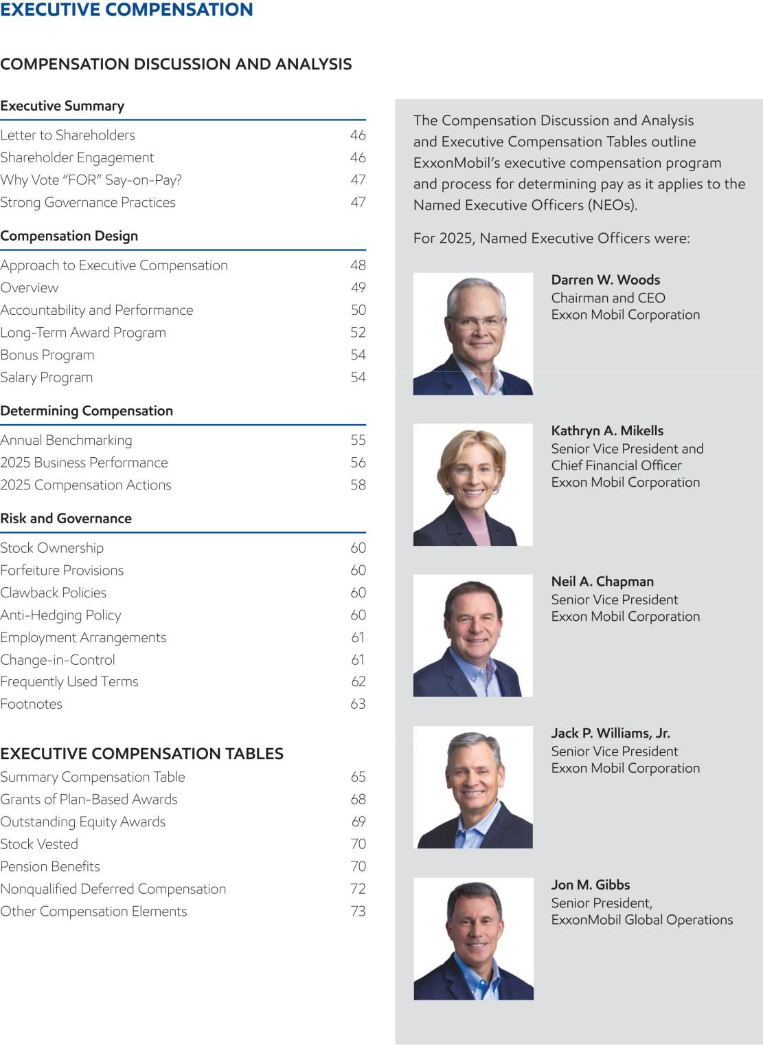

2026 Proxy Statement | ⁴⁵

Table of Contents
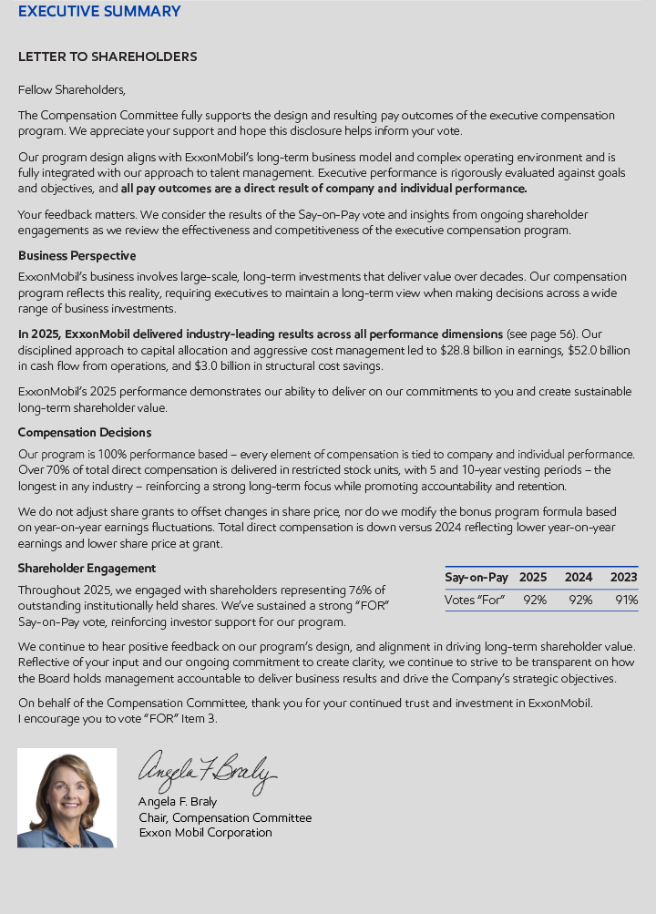

- 2026 Proxy Statement

Table of Contents
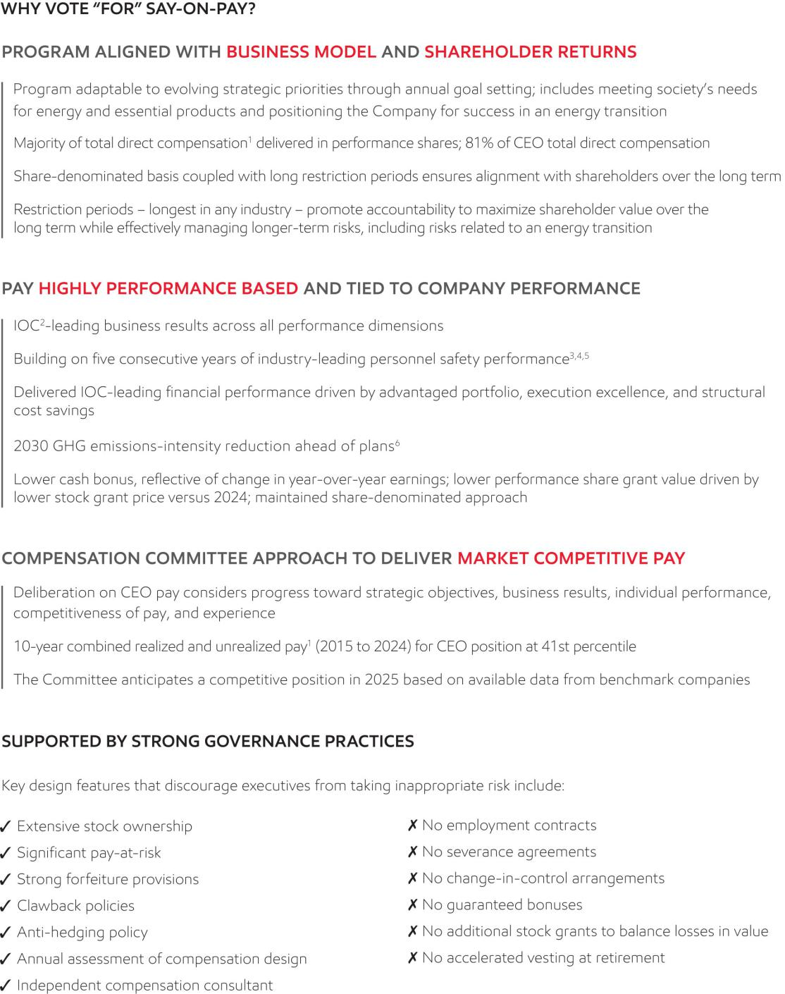

2026 Proxy Statement | 47

Table of Contents
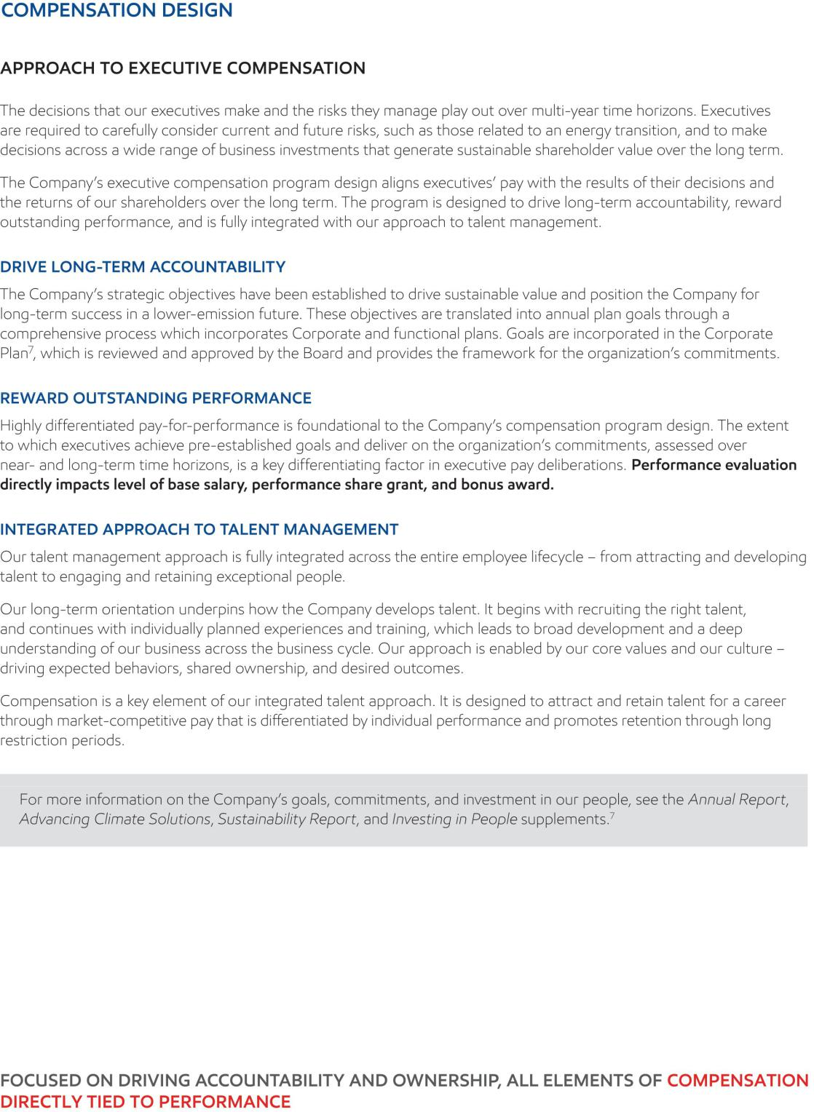

- 2026 Proxy Statement

Table of Contents
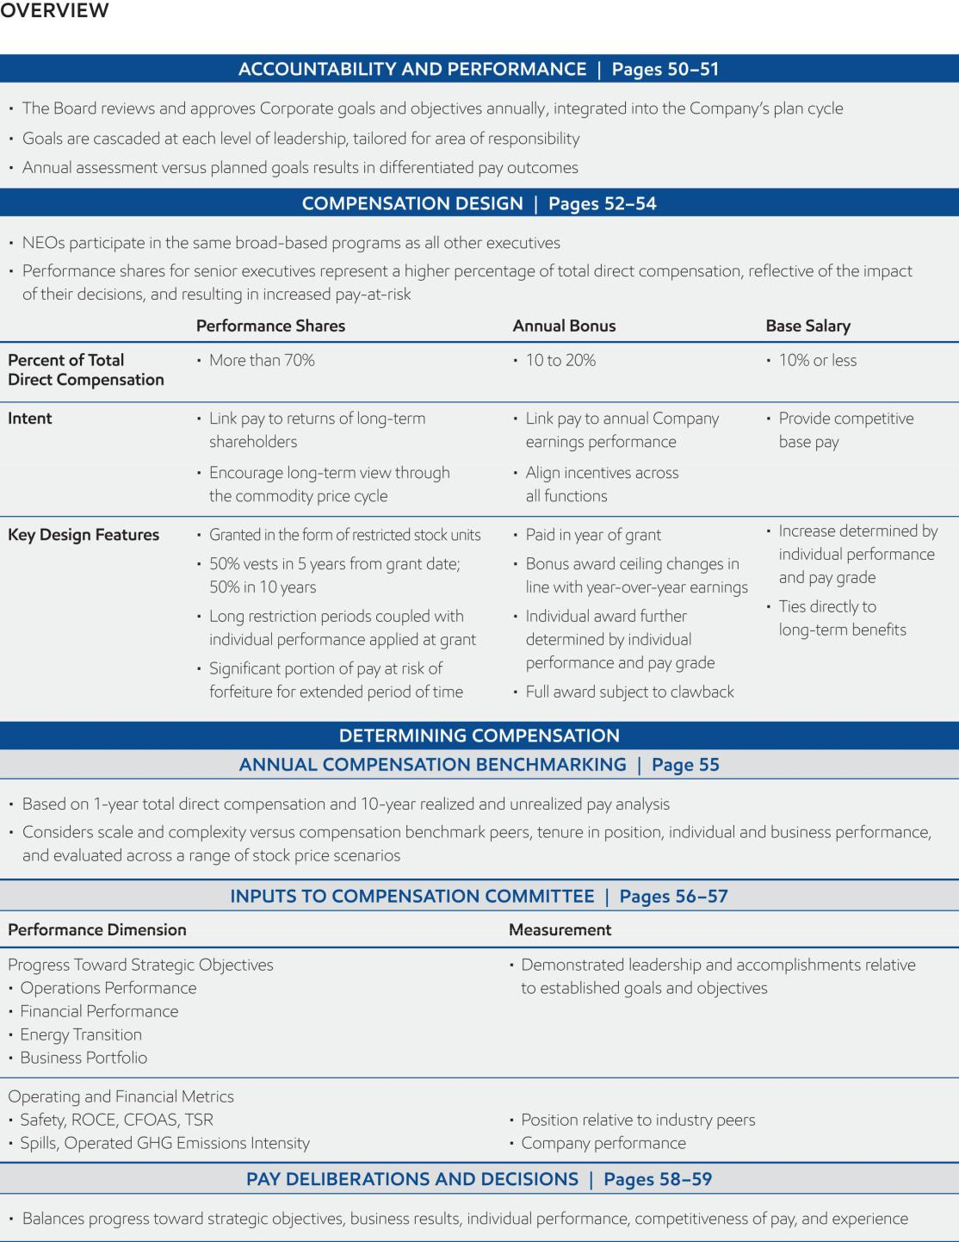

2026 Proxy Statement | 49

Table of Contents
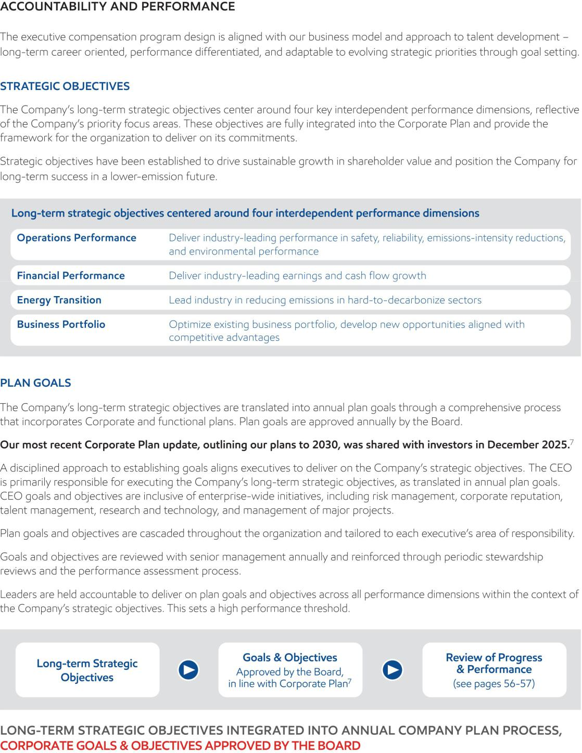

- 2026 Proxy Statement

Table of Contents
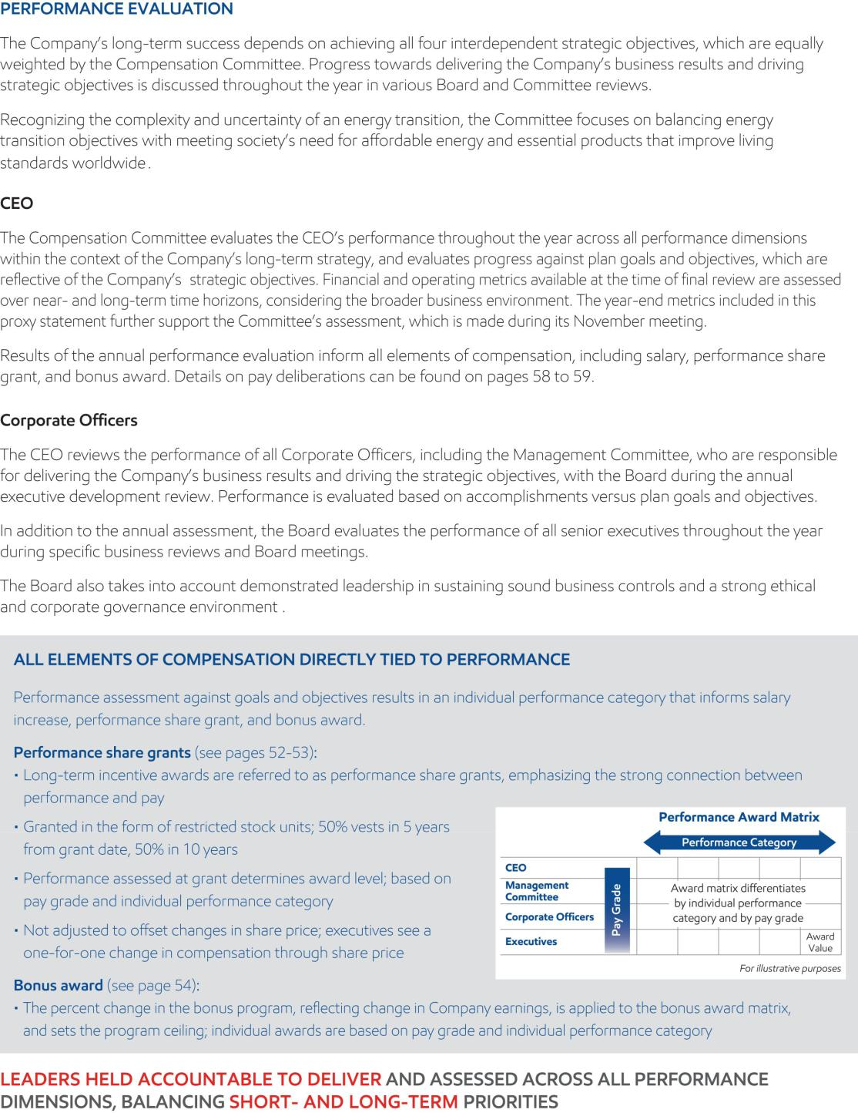

2026 Proxy Statement | ⁵¹

Table of Contents
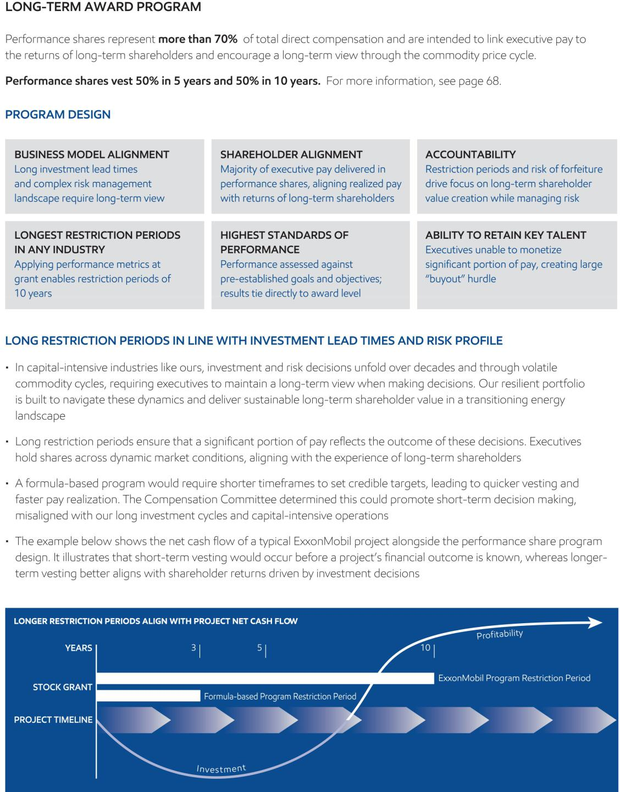

- 2026 Proxy Statement

Table of Contents
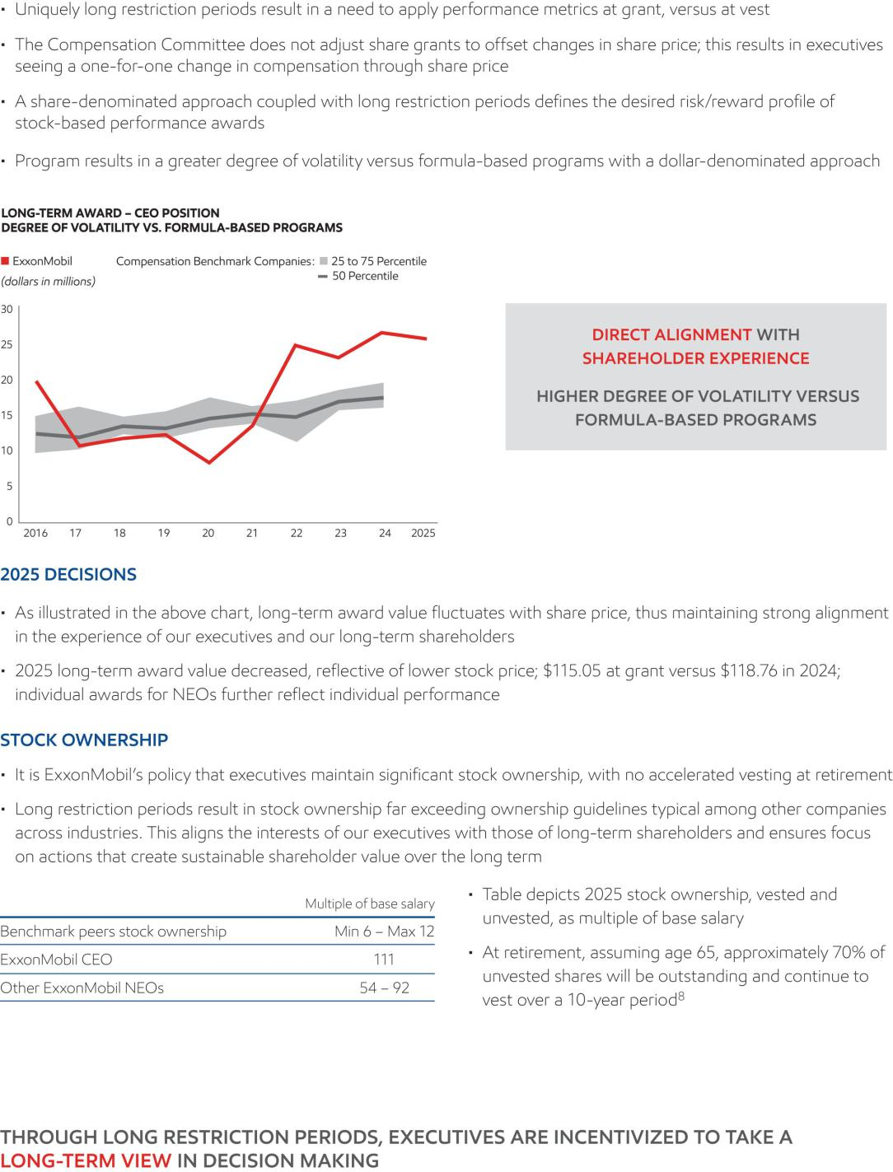

2026 Proxy Statement | ⁵³

Table of Contents
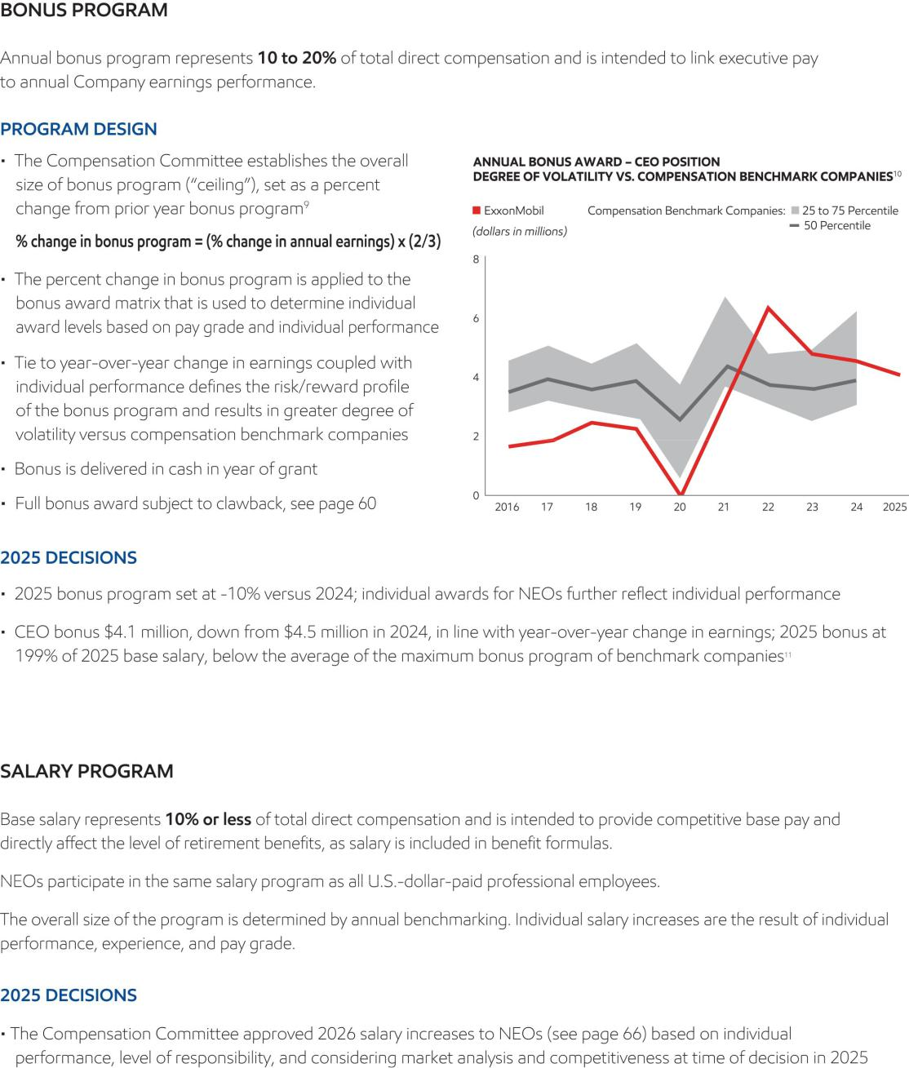

- 2026 Proxy Statement

Table of Contents
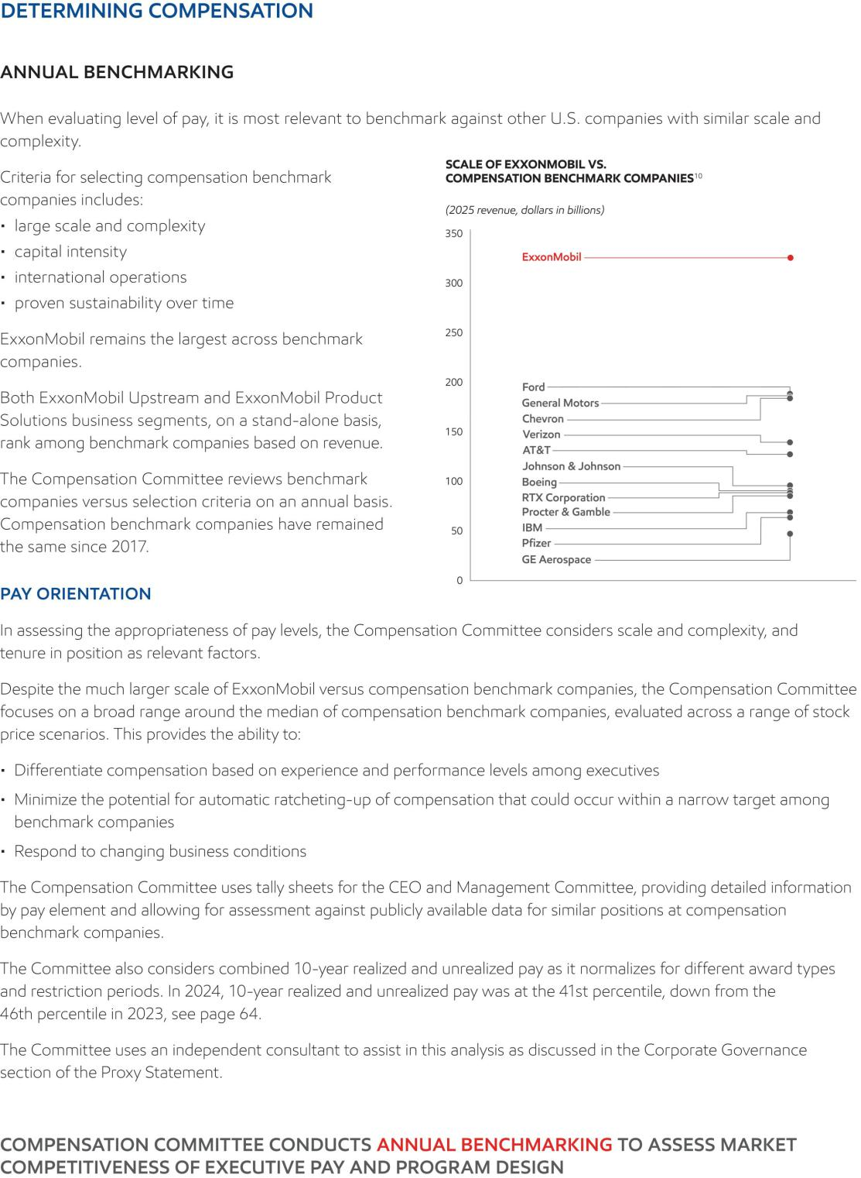

2026 Proxy Statement | ⁵⁵

Table of Contents
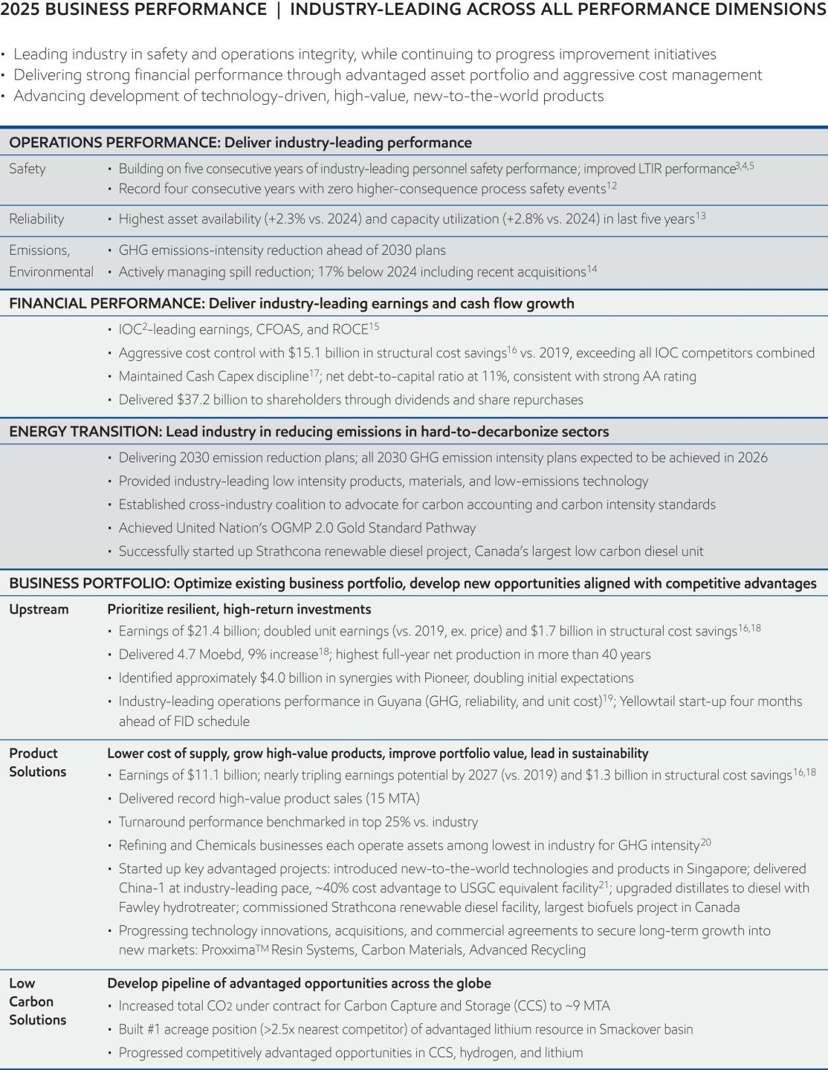

- 2026 Proxy Statement

Table of Contents
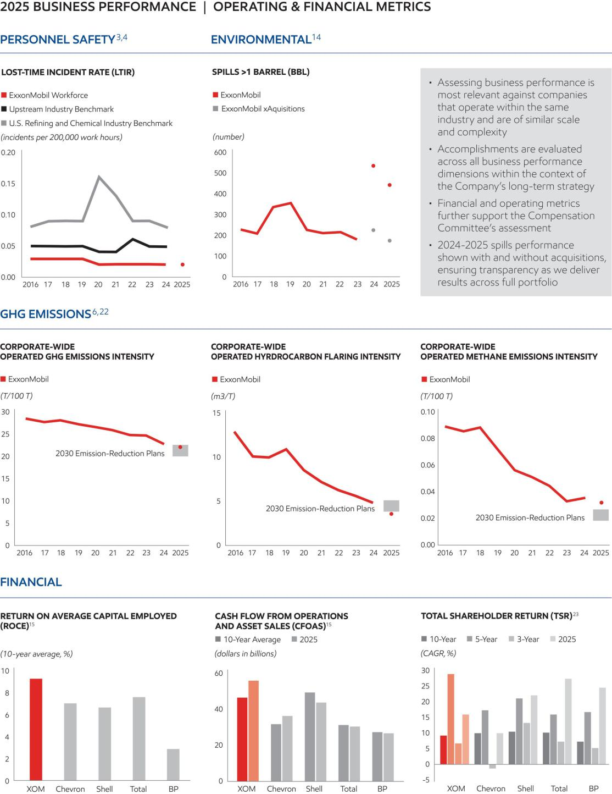

2026 Proxy Statement | ⁵⁷

Table of Contents
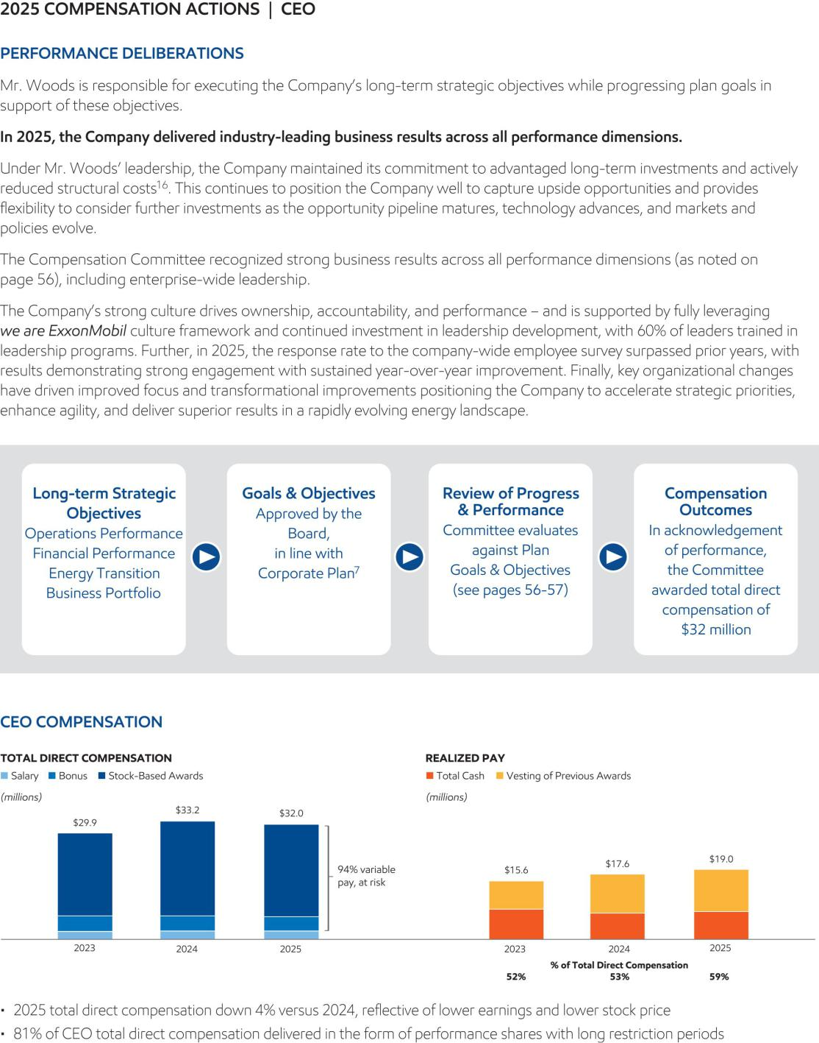

- 2026 Proxy Statement

Table of Contents


2026 Proxy Statement | 59

Table of Contents
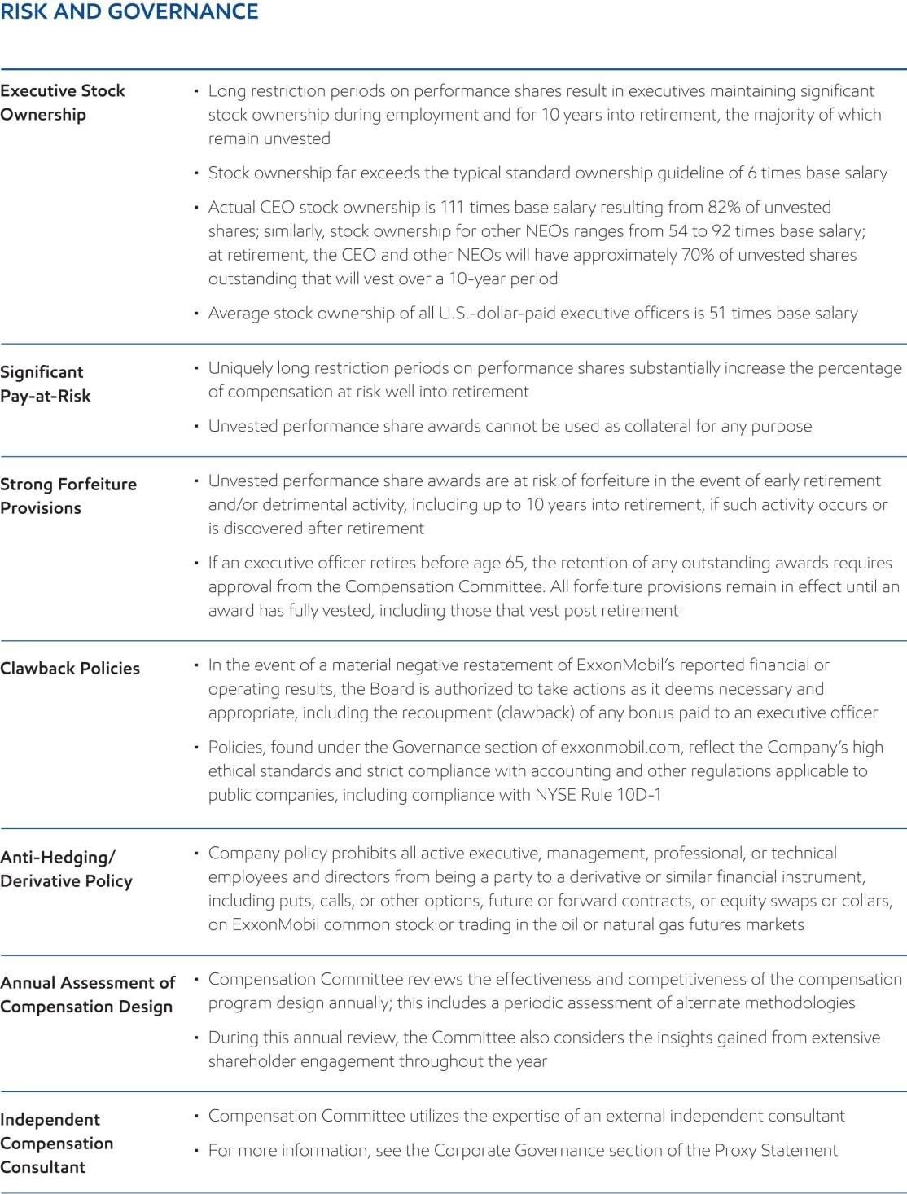

- 2026 Proxy Statement

Table of Contents
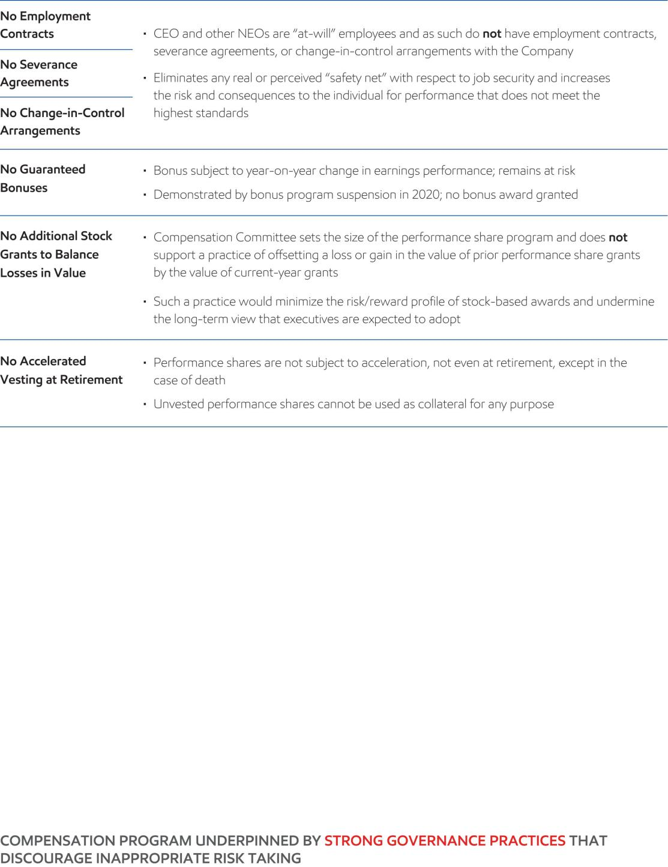

2026 Proxy Statement | ⁶¹

Table of Contents
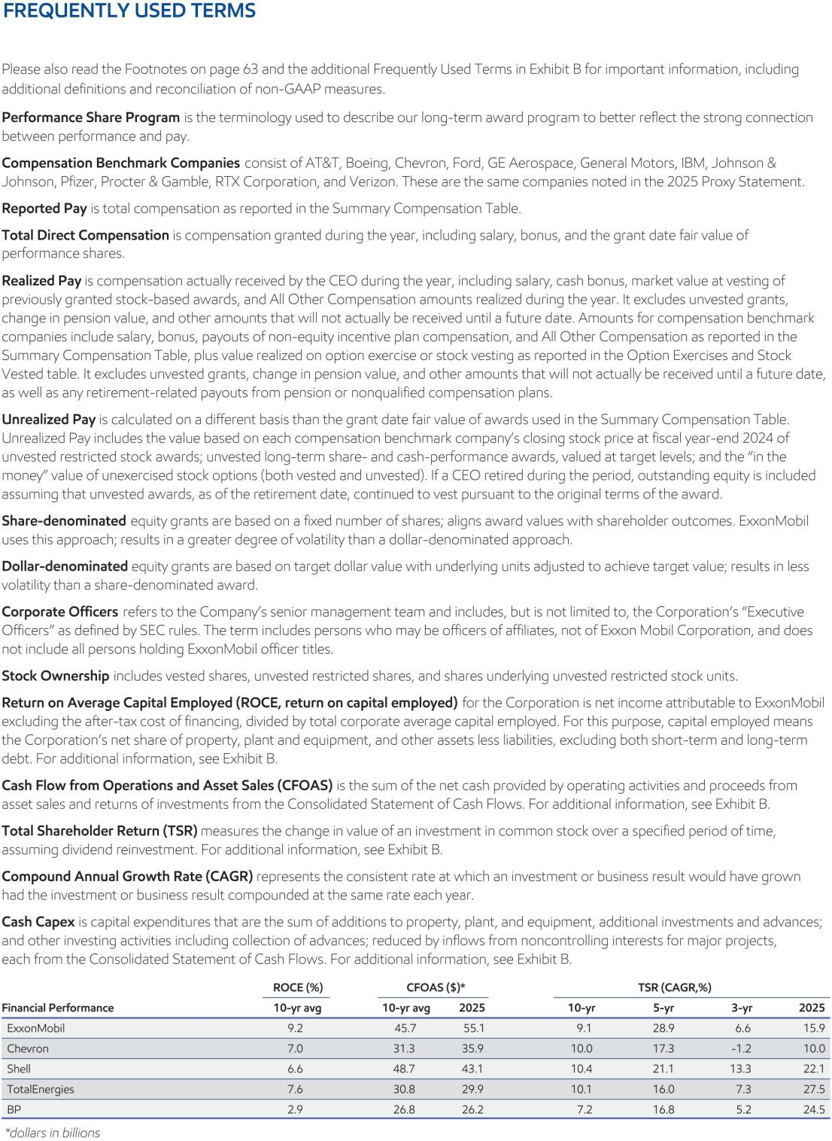

- 2026 Proxy Statement

Table of Contents
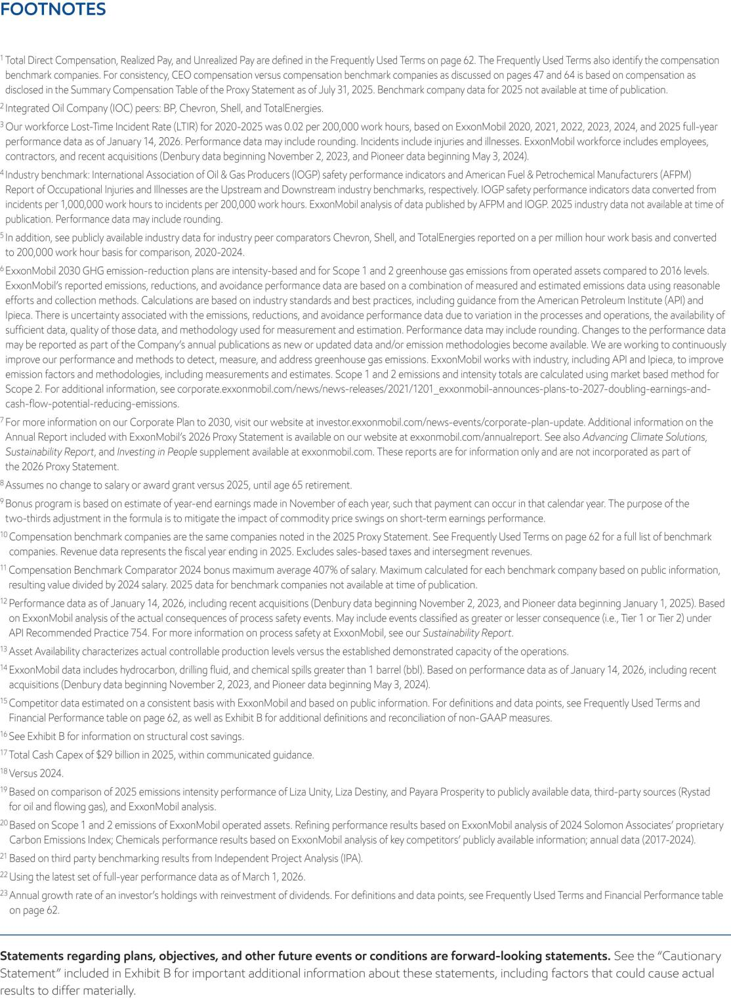

2026 Proxy Statement | ⁶³

Table of Contents
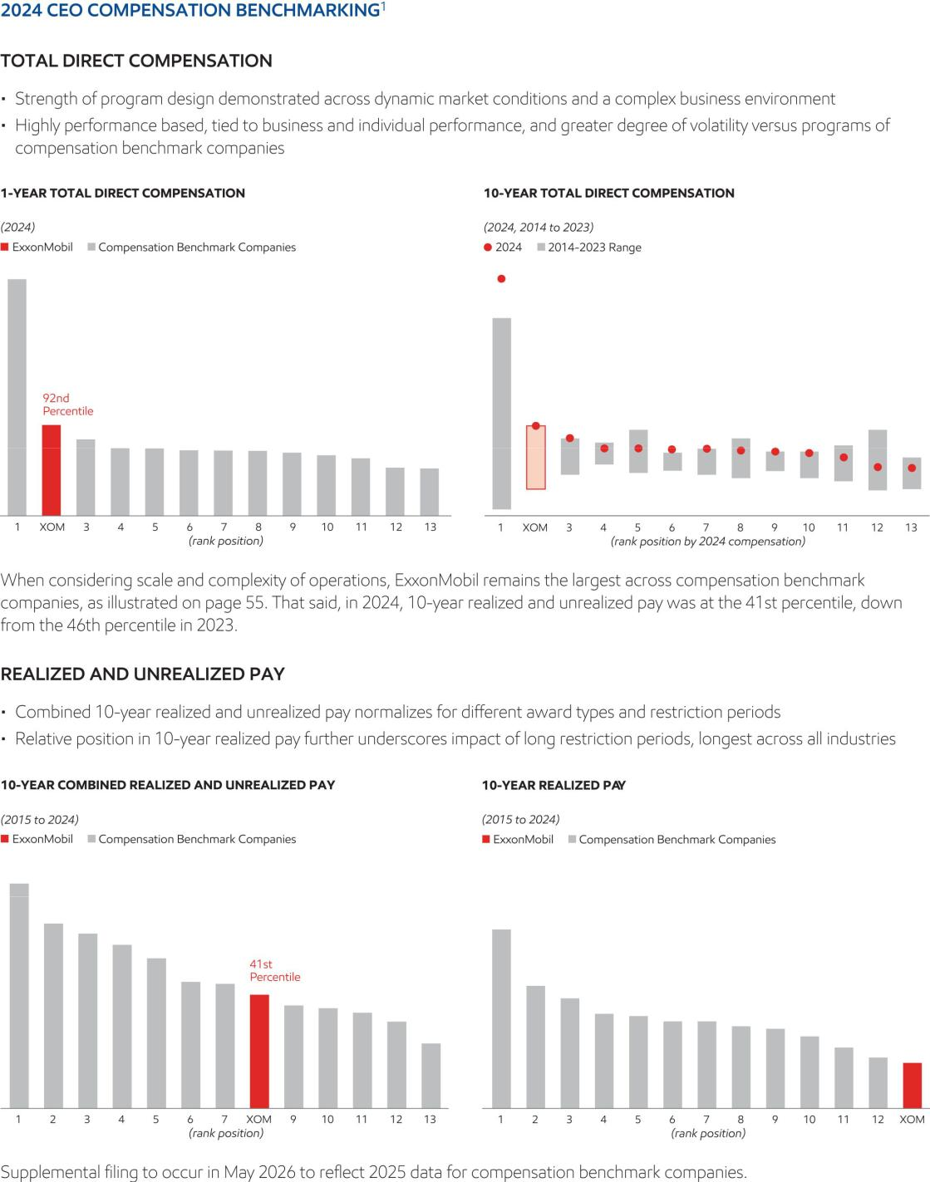

- 2026 Proxy Statement

Table of Contents
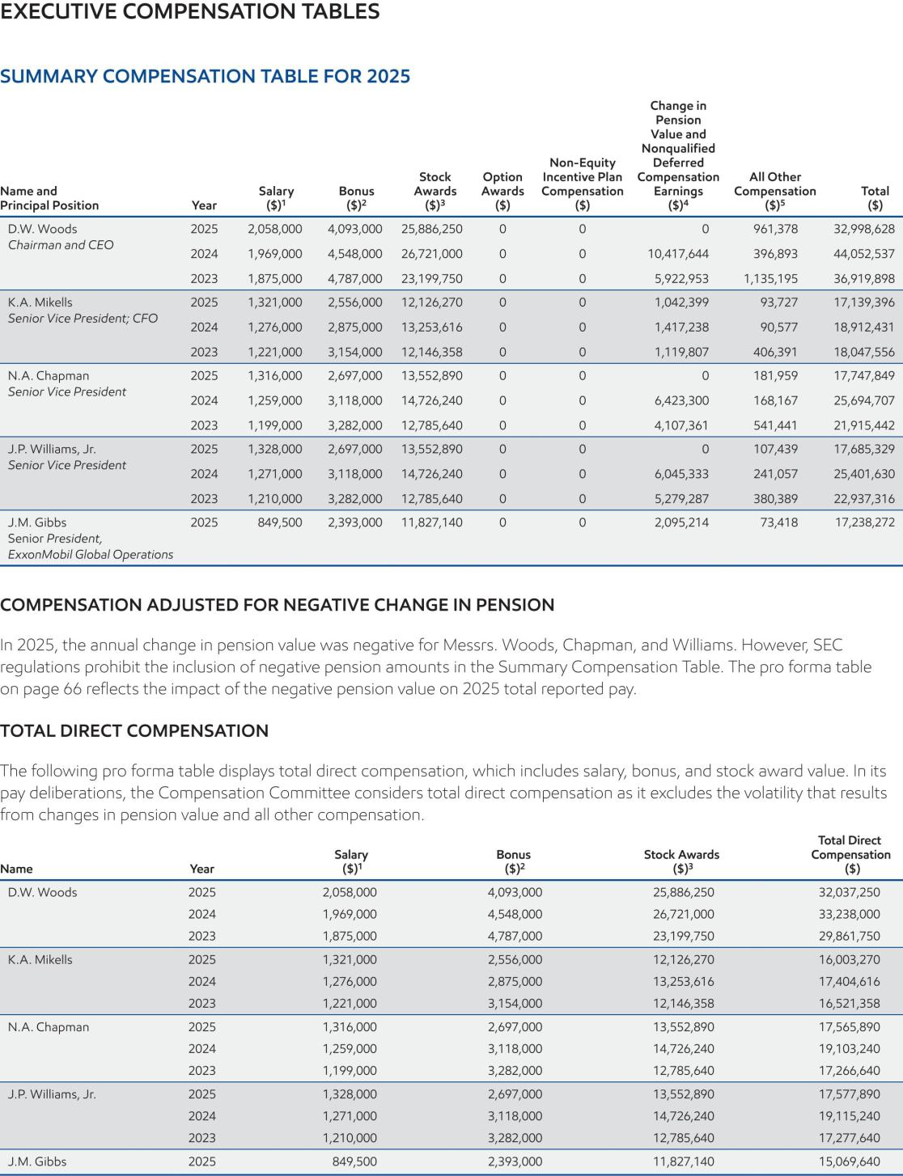

2026 Proxy Statement | ⁶⁵

Table of Contents
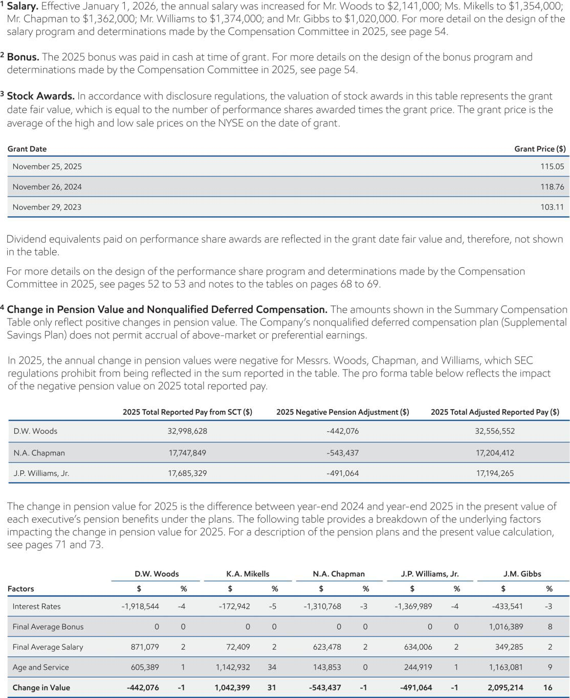

- 2026 Proxy Statement

Table of Contents
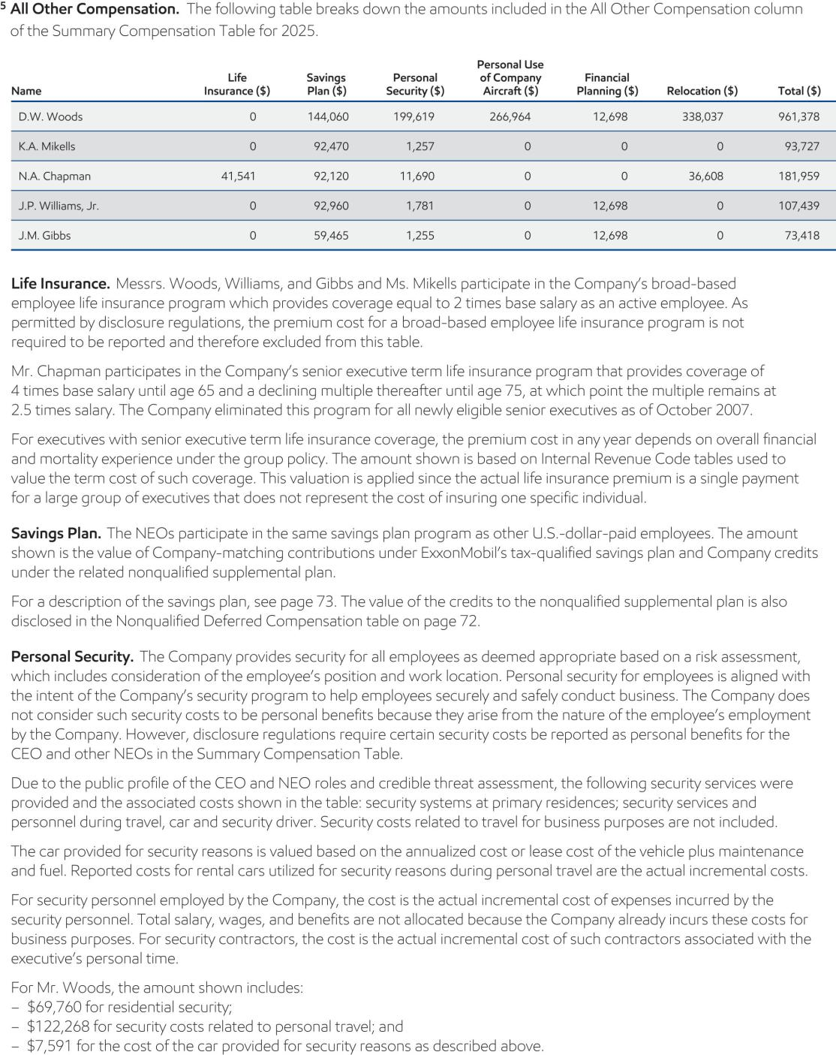

2026 Proxy Statement | ⁶⁷

Table of Contents
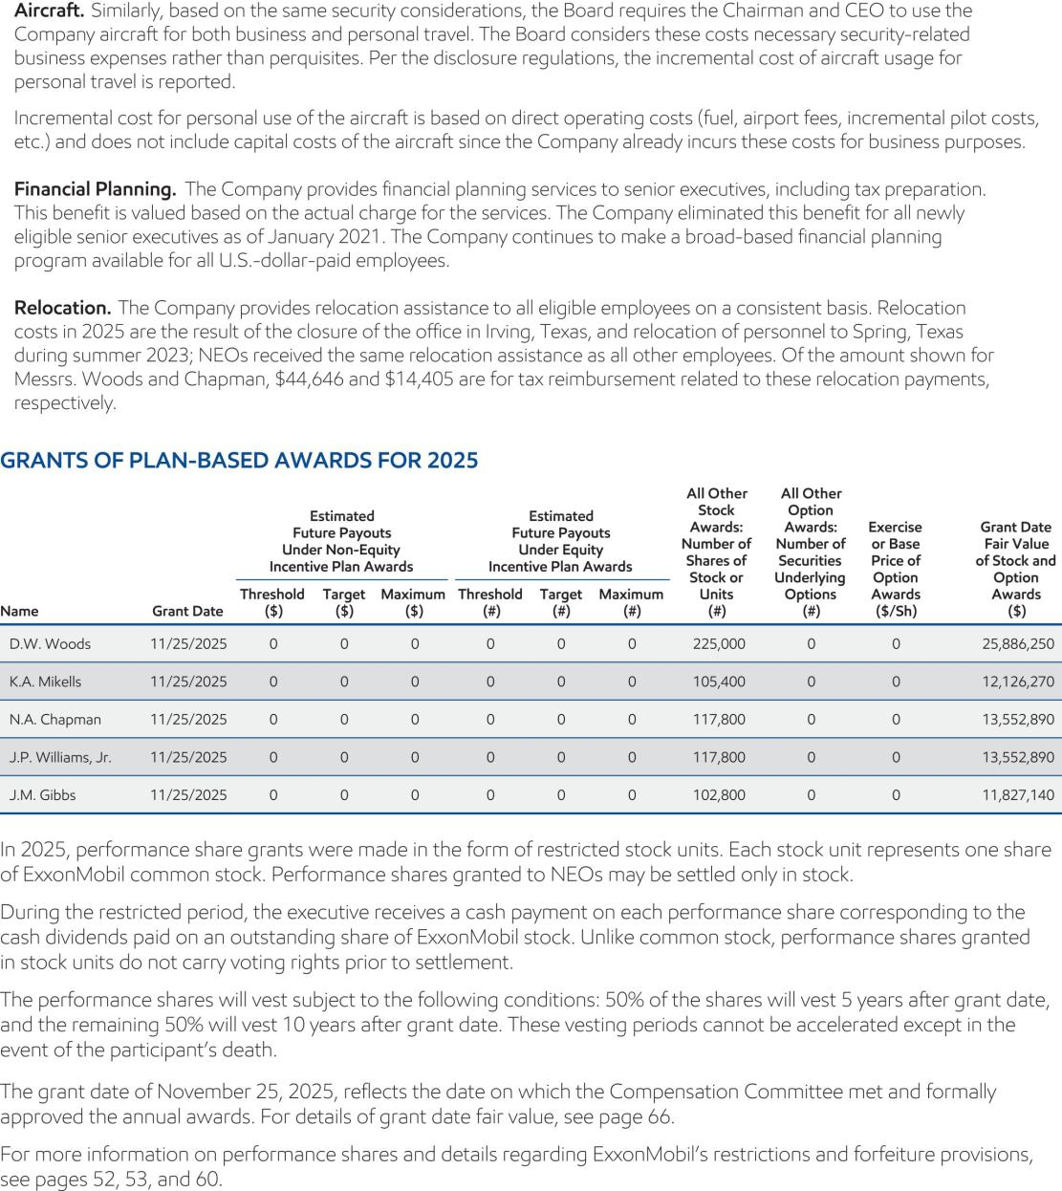

- 2026 Proxy Statement

Table of Contents
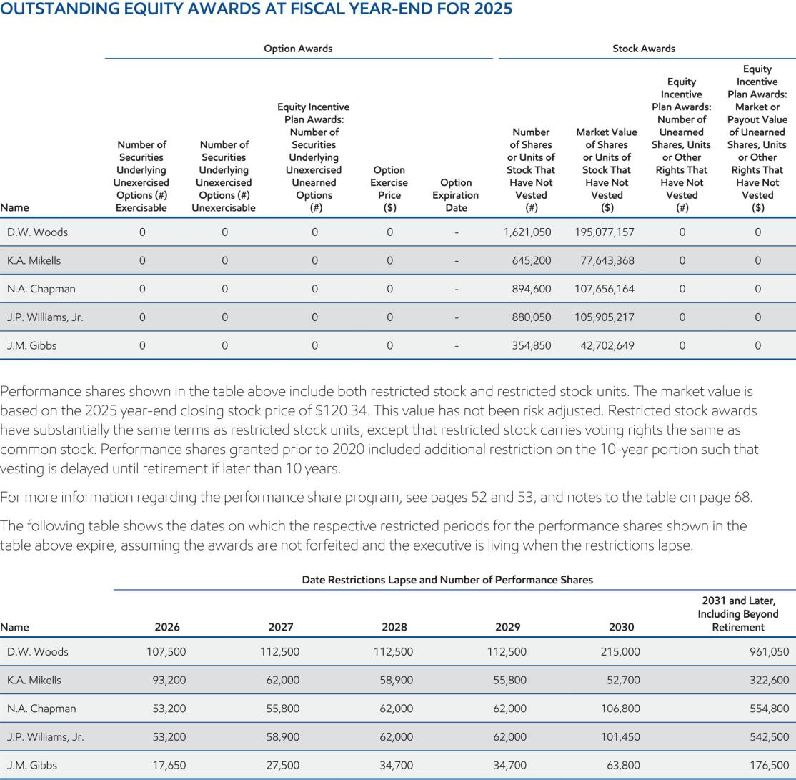

2026 Proxy Statement | ⁶⁹

Table of Contents
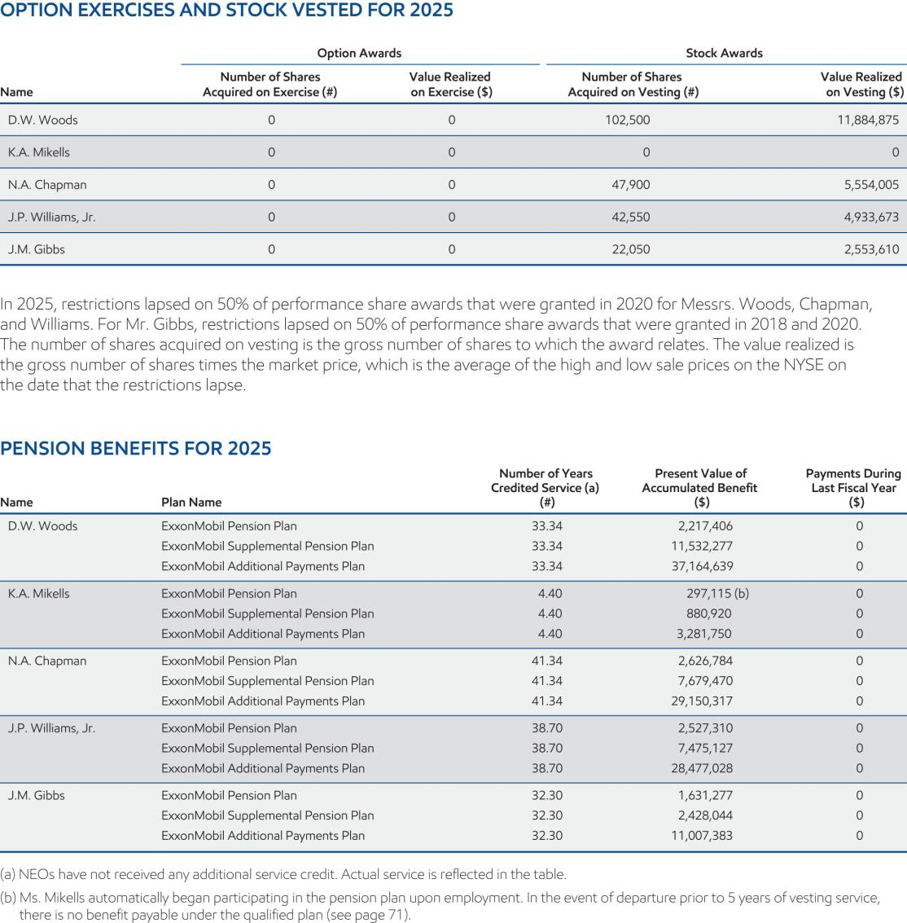

- 2026 Proxy Statement

Table of Contents
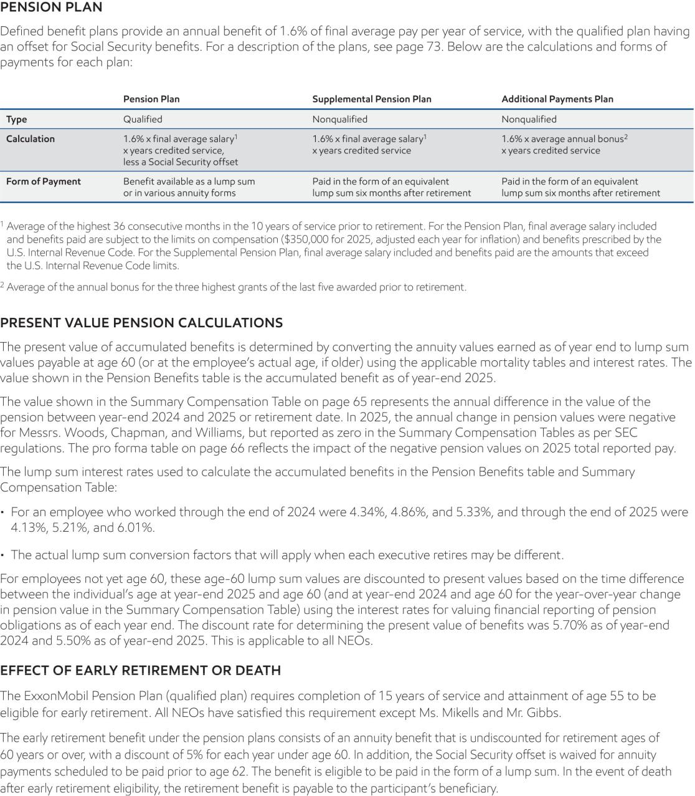

2026 Proxy Statement | ⁷¹

Table of Contents
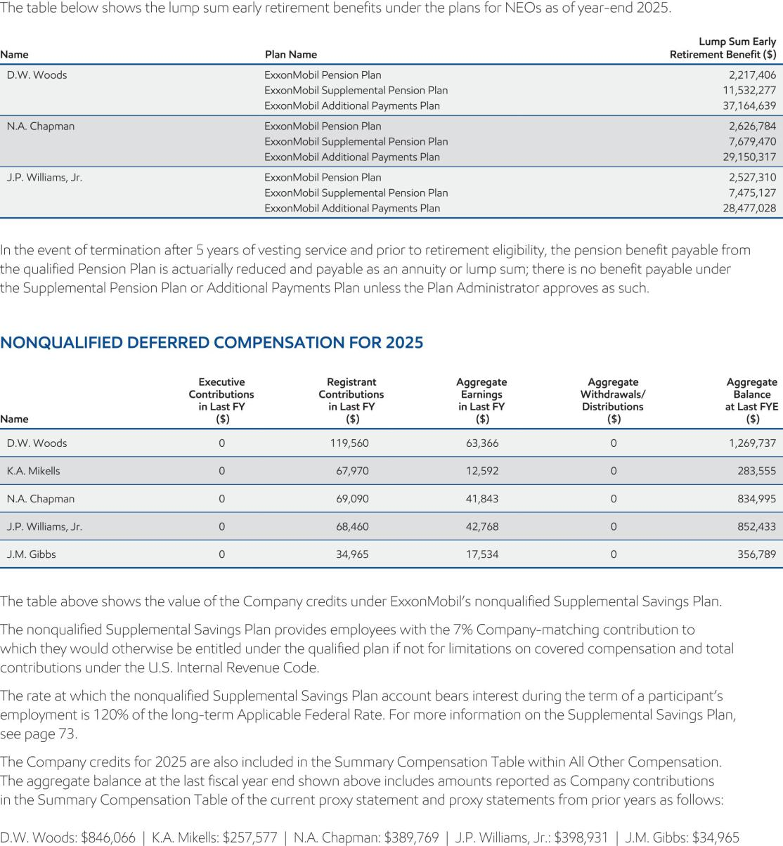

- 2026 Proxy Statement

Table of Contents
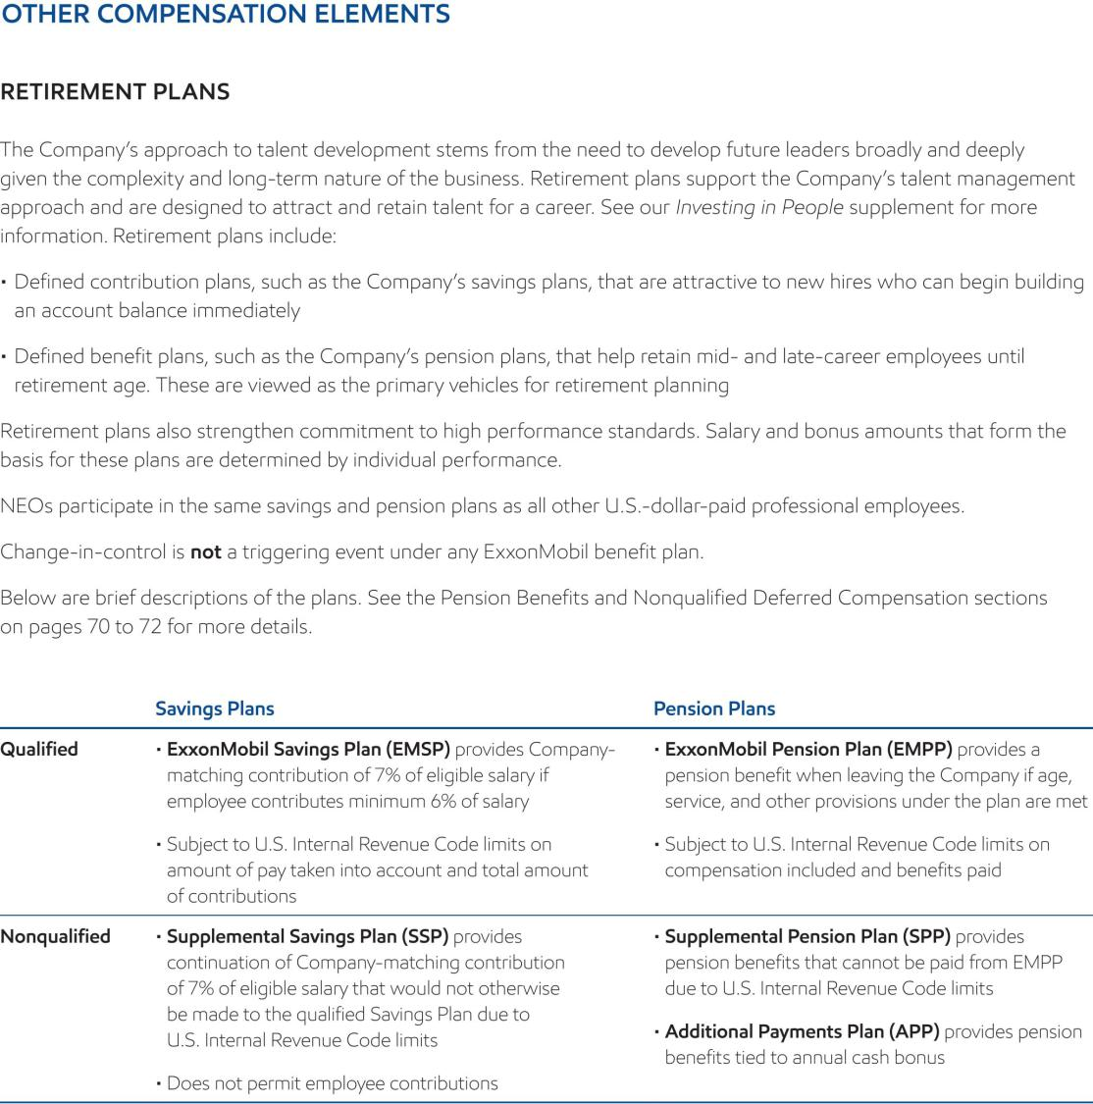

2026 Proxy Statement | 73

Table of Contents


- 2026 Proxy Statement

Table of Contents
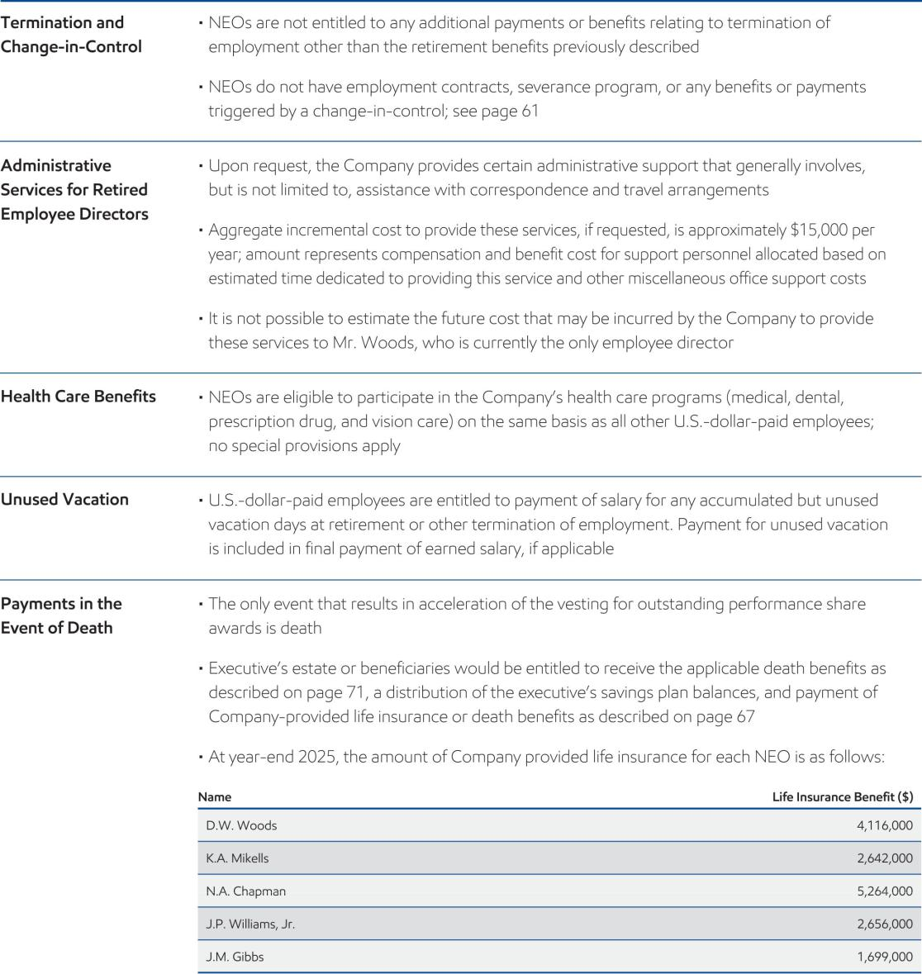

2026 Proxy Statement | 75

Table of Contents

EXXONMOBIL CORPORATE DOMICILE

Item 4 – Texas Redomiciliation

Why you should vote FOR this proposal


- ExxonMobil is a Texas corporation in all but name, with most senior corporate executives and all corporate functions based in the state for the last 35 years.

- Texas’ executive, legislative, and judicial officers are familiar with the benefits ExxonMobil brings to the state.

- Texas has become one of the largest economies in the world, in part, because it has been deliberate in passing legislation and regulation designed to support innovation, job creation and economic growth strengthing shareholder value.

- Texas courts take a predictable, statute-oriented approach to corporate affairs.

- The Texas Redomiciliation is consistent with shareholder rights. It would change our state of incorporation, but it would not alter our commitment to protecting shareholder rights. The Company is not adopting any elective provisions of the Texas corporate statute that could be viewed as weakening shareholder rights as compared to New Jersey law in connection with the Texas Redomiciliation.

The Board unanimously recommends that our shareholders approve the redomiciliation of ExxonMobil from New Jersey to Texas to be effected through the Agreement and Plan of Merger (the “plan of merger”) included as Annex A to this proxy statement, as more fully described in this Item 4. The Board has determined that the Merger (as defined below) and resulting Texas Redomiciliation are in the best interests of the Company and its shareholders.¹

Background of the Texas Redomiciliation

Texas is – and has been for a long time – ExxonMobil’s Home

In 1989, ExxonMobil moved its headquarters from New York City to Texas and since then our most senior executives and all corporate functions and businesses have been located in the state. Approximately 30% of our global employees are based in Texas, with the vast remainder located in other countries versus other U.S. states. Our U.S.-based research facilities are in Texas; the vast majority of our U.S.-facing non-profit giving is focused on Texas communities and the primary focus of our professional-level employee recruiting is directed toward Texas’ leading undergraduate and graduate institutions.

Operationally and practically, Texas has been our home for more than three decades. Our only material association with New Jersey is that Standard Oil executives in 1882 incorporated their business in the state. Aside from this historical footnote, New Jersey and ExxonMobil have no substantive business relationship and have not for many, many years. As an example, the ExxonMobil Board has not met in New Jersey in nearly four decades.

When a corporation calls a given state its home, it does so not just because of its roots in that state but because it believes the public policy of that state, generally speaking, is consistent with the company’s values, strategy, and ambition. That is the case with ExxonMobil and Texas. The goal of redomiciling to Texas is to cement this connection by making it a matter of law and, as a result, afford shareholders all the benefits that come with that change.

The Shareholder Benefits Derived from Redomiciling in Texas

The Board believes Texas legislators, judges, and juries who might make decisions that impact ExxonMobil are generally more familiar with our business and operations. Our business is complex and that kind of familiarity means

- For purposes of this Item 4, references to the “Board” refer to the Board of the New Jersey Corporation prior to the Texas Redomiciliation Effective Time and to the Board of the Texas Corporation following the Texas Redomiciliation Effective Time.

- 2026 Proxy Statement

Table of Contents

we are more likely to get reasonable, productive decisions from Texas officials and citizens. They are also more likely to be aware of and recognize the benefits our industry affords Texas and its citizens in the form of reliable, affordable energy products, jobs, tax revenue, and deep, century-old community engagement. In this regard, Texans have a stake in the health of our industry, and ExxonMobil specifically, meaning shareholders’ interests are in the hands of people who have potentially aligned goals. This, of course, does not guarantee the legal or public policy results sought by the Company. It only makes it more likely that Texas public policy and legal decision makers appreciate the tangible consequences of their decisions, including those that are relevant to our business.

ExxonMobil is not unique in seeking this shareholder benefit. Other companies have pursued redomiciliation to better align their legal and physical homes, such as Microsoft, which redomiciled to Washington from Delaware. At the time, the company said Washington was “the location of the [c]ompany’s world headquarters and the location of its primary research and development efforts.”

More broadly, Texas is one of the largest economies in the world, and the Board believes Texas is deliberate in offering businesses a common-sense regulatory environment that fosters innovation, job creation, and economic growth. As noted, our view is that the Texas legislature and courts are aware of and value ExxonMobil’s significant and long-standing contributions to the economy and generally have a vested interest in ensuring our Company and industry continue playing a vital role in supporting global economic growth. The Board’s view is that the State of Texas has made an effort to listen to the business community and has shaped a policy and regulatory environment that takes into account many of the ways corporations seek to maximize shareholder value.

Texas Preserves Shareholder Rights and Provides Certainty

The Texas Redomiciliation will allow ExxonMobil to benefit from this supportive business environment via the state’s business statutes and the Texas Business Court. Among other factors, the Board considered Texas’ statute-oriented approach to corporate law, which provides a degree of legal and regulatory certainty in corporate decision-making that can benefit long-term shareholder value. For example, the 2025 amendments to the Texas Business Organizations Code provide even greater certainty about the standard of conduct to which directors and officers are held through a clear and consistent legal framework for reviewing corporate decisions that does not exist in the same form under New Jersey law. Having a clear statement of fiduciary duty is in the best interests of shareholders because legal predictability is fundamental to sound, timely business decisions. The Board and management also considered the establishment of the Texas Business Court, a court system specifically designed to address and expeditiously resolve corporate law matters. In both cases, Texas has created a regulatory and legal construct supportive of a company’s ability to build shareholder value. The Board believes Texas’ approach to corporate law will provide a stable, predictable, and efficient platform for ExxonMobil’s operations that will enhance our ability to act in the best interests of our shareholders.

The Board also compared shareholders’ rights under New Jersey and Texas law and believes the economic and voting rights of shareholders are comparable and stronger in some areas. The Texas Redomiciliation would change our state of incorporation, but it would not alter our commitment to protecting shareholder rights. The Company is not adopting any elective provisions of the Texas corporate statute that could be viewed as weakening shareholder rights as compared to New Jersey law in connection with the Texas Redomiciliation. Moreover, in connection with the Texas Redomiciliation, the Board has determined to maintain the majority of the terms of the New Jersey Charter and New Jersey By-laws in the Texas Charter and the Texas By-laws (each as defined below), subject to provisions where the Texas Business Organizations Code currently differs from the New Jersey Business Corporation Act. Our focus is, and will remain, on growing and protecting shareholder value and we are committed to maintaining transparency, accountability, and direct engagement with our investors.

We continue to strengthen engagement across our shareholder base and value constructive, transparent dialogue. Shareholder perspectives help strengthen our governance practices, inform strategic decisions, and promote alignment with shareholder expectations. We also remain committed to clear, transparent disclosures that support informed decision-making, including continued publication of our Advancing Climate Solutions, Sustainability, and Global Outlook reports, along with regular updates through SEC filings and other investor communications.

The Board of Directors’ Evaluation, Recommendation, and Approval of the Texas Redomiciliation

Throughout 2025, in response to the Company’s long-standing and deep connections to Texas and legislative developments discussed above, the Board and management began discussions about changing the Company’s state
2026 Proxy Statement | ⁷⁷

Table of Contents

of incorporation. The Board ultimately determined the Texas Redomiciliation is advisable and in the best interests of our shareholders. The Board also determined a holding company structure would provide more organizational flexibility, including allowing certain assets and contracts to remain with Exxon Mobil Corporation (the “New Jersey Corporation”). As described in detail above, the Board believes there are several important reasons why the Texas Redomiciliation is in the best interests of the Company and its shareholders.

At meetings held on October 28, 2025, and November 25, 2025, the Board discussed the Texas Redomiciliation with management. As part of those discussions, management outlined reasons for considering a redomiciliation from New Jersey to Texas, including (i) the benefits of consolidating the Company’s legal home with its physical home, (ii) a more favorable business environment, including that the Texas legislature and courts are likely to recognize the Company’s contributions to the economy and creation of long-term value for our shareholders, and (iii) increased certainty for corporate decisionmakers. For additional detail on each of the above points considered by the Board, see “Background of the Texas Redomiciliation” above.

At those meetings, management also outlined certain considerations associated with a redomiciliation from New Jersey to Texas, including a relative lack of case law in the Texas Business Court, and potential criticism or litigation that could result from the Texas Redomiciliation.

On January 27, 2026, the Board again met and discussed and evaluated the Texas Redomiciliation with management, including further discussion of the factors described above.

At a meeting of the Board held on February 18, 2026, at which all Directors were present, following its (i) evaluation of the proposed Texas Redomiciliation, including the plan of merger effecting the Texas Redomiciliation, management’s recommendation and the factors considered by management and management’s rationale in recommending the Texas Redomiciliation, the review and consideration of various factors deemed relevant by the Board, including those described under “Background of the Texas Redomiciliation” above, and the investigation and consideration of the benefits and risks of the Texas Redomiciliation, and (ii) receipt of, and the opportunity to review and consider, the draft proxy statement to be distributed to the Company’s shareholders, the Texas Charter, the Texas By-laws, and the plan of merger, and to ask questions of management and to seek advice of counsel, the Board determined that adoption of the plan of merger effecting the Texas Redomiciliation is advisable and in the best interest of the Company and its shareholders and unanimously approved the Texas Redomiciliation.

Principal Terms of the Texas Redomiciliation

The Texas Redomiciliation will be effected through a merger (the “Merger”) pursuant to Title 14A, Chapter 10 of the New Jersey Business Corporation Act, as amended, and Title 1, Chapter 1, Subchapter A of the Texas Business Organizations Code, as amended, as set forth in the plan of merger, included as Annex A to this proxy statement. The New Jersey Corporation has caused the creation of ExxonMobil Holdings Corporation, a Texas corporation (the “Texas Corporation”) and Ensign LLC, a Texas limited liability company (“Merger Sub”). The New Jersey Corporation is the sole shareholder of the Texas Corporation and the sole member of Merger Sub. At the Texas Redomiciliation Effective Time (as defined below), the New Jersey Corporation will transfer all of the shares of Merger Sub to the Texas Corporation. Both the Texas Corporation and Merger Sub will have no operations prior to the effectiveness of the Texas Redomiciliation.

At the Texas Redomiciliation Effective Time:

- Merger Sub will merge with and into the New Jersey Corporation, with the New Jersey Corporation surviving as a wholly owned subsidiary of the Texas Corporation.

- The Texas Corporation will be the parent company of the New Jersey Corporation, and the directors of the New Jersey Corporation elected at the annual meeting of shareholders and the executive officers of the New Jersey Corporation will become the directors and executive officers of the Texas Corporation.

- Each outstanding share of common stock, without par value, of the New Jersey Corporation will be automatically exchanged for one outstanding share of common stock, par value $0.001 per share, of the Texas Corporation, resulting in the current shareholders of the New Jersey Corporation becoming shareholders of the Texas Corporation.

- Each outstanding share of common stock of the Texas Corporation held by the New Jersey Corporation will be cancelled.

- 2026 Proxy Statement

Table of Contents

- The internal affairs of and your rights as a shareholder of the Texas Corporation will be governed by Texas law. See “Effects of the Texas Redomiciliation—Comparison of Shareholder Rights under New Jersey and Texas Law” below.

- The Texas Corporation will not be governed by the New Jersey Restated Certificate of Incorporation (the “New Jersey Charter”) and the New Jersey By-laws (the “New Jersey By-laws”) and will instead be governed by the provisions of the Amended and Restated Certificate of Formation of ExxonMobil Holdings Corporation (the “Texas Charter”) and the By-laws, as amended of ExxonMobil Holdings Corporation (the “Texas By-laws”), copies of which are included in as Annex B and Annex C, respectively, to this proxy statement. Please read “Effects of the Texas Redomiciliation— Comparison of the New Jersey Charter and By-laws and the Texas Charter and By-laws” below.

- The Texas Redomiciliation will not result in any change in our headquarters, business, jobs, management, properties, facilities, number of employees, obligations, assets, liabilities, or net worth (other than as a result of the transaction costs related to the Texas Redomiciliation).

- All U.S. federal income tax filing obligations and U.S. federal income tax attributes of the New Jersey Corporation will carry over to the Texas Corporation.

- Shareholders of the New Jersey Corporation will not be required to exchange their existing share certificates for new share certificates.

- Each equity compensation plan of the New Jersey Corporation will be assumed by the Texas Corporation and each warrant, stock option, restricted stock unit, performance stock unit, equity or equity-based award or other right to acquire any, or any instrument to convert into or exchange for, or based on the value of common stock (an “Equity Award”), of the New Jersey Corporation (each an “ExxonMobil Equity Award”) that is outstanding immediately prior to the Texas Redomiciliation Effective Time will be converted into an Equity Award of the Texas Corporation on the same terms and conditions as were applicable to the corresponding ExxonMobil Equity Award.

- We intend to apply to have the common stock of the Texas Corporation listed on the NYSE under the current symbol “XOM.” The Texas Redomiciliation is not expected to cause any interruption in the trading of such common stock.

Texas Redomiciliation Effective Time: Conditions

The Texas Redomiciliation is subject to the satisfaction of the following conditions:

- Approval of the Merger by the shareholders of the New Jersey Corporation;

- The shares of common stock to be issued by the Texas Corporation in connection with the Merger have been approved for listing, subject to official notice of issuance, by the NYSE;

- All regulatory authorizations and approvals of the Merger deemed necessary or advisable by the Board have been obtained;

- All third-party consents or waivers deemed necessary or advisable by the Board in connection with the Merger have been obtained; and

- The New Jersey Corporation and the Texas Corporation each have received an opinion of Gibson, Dunn & Crutcher LLP to the effect that the Texas Redomiciliation will qualify as a “reorganization” within the meaning of Section 368(a) of the Internal Revenue Code or, alternatively, as an exchange described in Section 351 of the Internal Revenue Code.

Following satisfaction of these conditions, certificates of merger, prepared and executed in accordance with the relevant provisions of the New Jersey Business Corporation Act and the Texas Business Organizations Code, with respect to the Merger (the “New Jersey Certificate of Merger” and the “Texas Certificate of Merger”) shall be filed with the New Jersey Division of Revenue and Enterprise Services and the Secretary of State of the State of Texas, respectively. The Merger shall become effective at the time of the acceptance of the filing of the Texas Certificate of Merger by the Secretary of State of the State of Texas after the New Jersey Certificate of Merger is filed with the New Jersey Division of Revenue and Enterprise Services or, if a later effective time was provided in the Texas Certificate of Merger, such later time (the “Texas Redomiciliation Effective Time”). The Texas Redomiciliation will be complete upon the effectiveness of the Merger.

2026 Proxy Statement | ⁷⁹

Table of Contents

If the conditions to the Texas Redomiciliation are satisfied, we anticipate that the Board will cause the Texas Redomiciliation Effective Time to occur on or after June 1, 2026. However, the Texas Redomiciliation may be delayed or accelerated by the Board, or the plan of merger may be terminated and abandoned by action of the Board, at any time prior to the Texas Redomiciliation Effective Time, whether before or after the approval by our shareholders, if the Board determines for any reason that such change in timing or abandonment would be in the best interests of the New Jersey Corporation and its shareholders. In addition, the New Jersey Corporation or the resulting Texas Corporation may face legal challenges to the Texas Redomiciliation, including shareholder challenges under New Jersey law ultimately seeking to delay or prevent the Texas Redomiciliation.

Certain Risks Associated with Texas Redomiciliation

Although the Board believes that the Texas Redomiciliation is in the best interests of ExxonMobil and its shareholders, there can be no assurance that the Texas Redomiciliation will result in all or any of the benefits described in this proxy statement, including the benefits of or resulting from incorporation in Texas or the application of Texas law to the internal affairs of ExxonMobil. Nevertheless, the Board, as guided by outside counsel and experts, believes a sufficient number of benefits will inure to the Company such that Texas Redomiciliation is advisable.

Certain Differences Between New Jersey and Texas Law

Although the Board has determined the rights of shareholders under the New Jersey Business Corporation Act and the Texas Business Organizations Code are largely comparable, the New Jersey Business Corporation Act and New Jersey case law, collectively, are different in certain respects than the Texas Business Organizations Code and Texas case law in ways that may affect the rights of our shareholders. See the Company’s summary of certain differences in the section titled “Effects of the Texas Redomiciliation—Comparison of Shareholder Rights under New Jersey and Texas Law.”

Transaction Costs and Potential Litigation

We have incurred and will incur certain non-recurring costs in connection with the Texas Redomiciliation, including certain filing fees and legal and other transaction costs. We believe a majority of these costs have already been incurred or will be incurred in connection with the delivery of this proxy statement to shareholders regardless of whether the Texas Redomiciliation is ultimately completed, except for any litigation-related expenses that may arise, which we cannot predict. The Texas Redomiciliation may also, if completed, result in certain state sales and transfer taxes and other transfer taxes. Many of the expenses that will be incurred and other potential transaction costs are difficult to accurately estimate at the present time, and additional unanticipated costs may be incurred in connection with the Texas Redomiciliation.

It is also possible that the Texas Redomiciliation results in additional litigation, regardless of merit, with additional expense, distraction, and time of ExxonMobil and management to address such litigation. Further, if a court determines that any such litigation has merit, we may be required to pay substantial expenses, monetary damages, or attorneys’ fees.

Effects of the Texas Redomiciliation

The Texas Redomiciliation will effect a change in the legal domicile of ExxonMobil. Following the Texas Redomiciliation, the Texas Corporation as the new ExxonMobil parent company, and the rights of its shareholders will be governed by the Texas Business Organizations Code instead of the New Jersey Business Corporation Act, and will be governed by the Texas Charter and Texas By-laws. In approving the Texas Redomiciliation, the Board recognized there are differences in the rights and powers of boards of directors and shareholders under Texas and New Jersey corporate laws. For example, as discussed below, voting standards for approval of certain corporate actions and the default standard for shareholder action by written consent vary under the Texas Business Organizations Code and the New Jersey Business Corporation Act. The Board’s objective with the Texas Redomiciliation was to maintain the majority of the terms in the Texas Charter and the Texas By-laws that had applied under the New Jersey Charter and the New Jersey By-laws, subject to provisions where the Texas Business Organizations Code currently differs from the New Jersey Business Corporation Act. The discussions and tables below summarize a comparison of the New Jersey Business Corporation Act, New Jersey Charter, and New Jersey By-laws, and the Texas Business Organizations Code, Texas Charter, and Texas By-laws.

- 2026 Proxy Statement

Table of Contents

Texas Protection Against Frivolous, Wasteful Litigation

The Texas Redomiciliation may reduce the risk of future frivolous litigation against the Texas Corporation and its directors and officers. Texas corporate law generally provides for deference to board actions, much like New Jersey corporate law. The Texas Business Organizations Code has certain limitations for bringing a civil lawsuit initiated by a shareholder on behalf of a corporation (commonly referred to as a “derivative proceeding”) against a Texas corporation, including requiring shareholders to make a formal written demand on the corporation prior to bringing a derivative claim. Similar to New Jersey corporate law, to exercise inspection rights of corporate books and records under Texas law, a shareholder must hold at least 5% of the outstanding shares of a Texas corporation or have been a record holder of shares for at least six months. A publicly traded Texas corporation may also deny inspection demands from shareholders with ongoing or expected litigation involving the corporation or derivative proceedings involving the shareholders or its affiliates, and instead the shareholders are entitled to use proper discovery procedures in such litigation processes. In addition, the Texas Business Organizations Code provides that the resolution of a derivative proceeding that results only in additional or amended disclosures being made to shareholders, regardless of materiality, is not an appropriate basis for awarding plaintiff attorney’s fees. As a result of these provisions in the Texas Business Organizations Code, the Texas Corporation may be able to avoid opportunistic or frivolous inspection demands to a greater degree than the New Jersey Corporation, thereby benefitting ExxonMobil and its shareholders to the extent management is not spending time on, and ExxonMobil is not incurring costs in connection with, frivolous and opportunistic litigation or threats of litigation.

Additional Corporate Governance Considerations

The Texas Business Organizations Code, as with the New Jersey Business Corporation Act and corporate laws of Delaware and other states, includes certain permissive provisions that corporations may, but are not required to, opt into. The Board has elected not to opt into or incorporate certain of these corporate governance provisions permitted under the Texas Business Organizations Code in connection with the Texas Redomiciliation. For example, in the context of shareholders’ ability to submit proposals for consideration at annual meetings of shareholders, the Board determined to defer to the existing provisions established under Exchange Act Rule 14a-8, which allows, but places certain limits on, shareholders’ ability to include proposals that are appropriate under state corporate law in the Company’s proxy materials. The Board therefore determined that it is not appropriate for the Texas Corporation to adopt the provisions of the Texas Business Organizations Code that place heightened ownership and procedural conditions on shareholders’ ability to introduce appropriate proposals at a meeting of shareholders. Although the Texas Business Organizations Code allows the Texas Corporation to opt into this provision in the future, that is the case under many provisions of the New Jersey Business Corporation Act (as well as the corporate law of many states). Notably, no provision of the New Jersey Business Corporation Act limits a corporation’s ability to adopt eligibility and procedural restrictions on shareholder proposals. Accordingly, the Board believes that the existence of a provision under the Texas Business Organizations Code authorizing, but not mandating, such restrictions does not represent a meaningful distinction between New Jersey and Texas corporate law. Similarly, the Board has determined not to establish an ownership threshold that would apply to any shareholder seeking to institute a derivative proceeding in the right of the corporation, even though the Texas Business Organizations Code permits a corporation to establish a required ownership threshold of up to 3% of the outstanding shares of the corporation in its certificate of formation or by-laws.

New Jersey and Texas Corporate Law Comparisons

The summaries below do not purport to be complete and are subject to, and qualified in their entirety by reference to, the Texas Business Organizations Code, the Texas Charter, the Texas By-laws, the New Jersey Business Corporation Act, the New Jersey Charter, and the New Jersey By-laws, which you should carefully read, together with this entire document and the other referenced documents for a more complete understanding of the differences between being a shareholder of the New Jersey Corporation before the Texas Redomiciliation and being a shareholder of the Texas Corporation following the completion of the Texas Redomiciliation. Copies of the Texas Charter, the Texas By-laws, the New Jersey Charter, and the New Jersey By-laws are included as Annex B, Annex C, Annex D, and Annex E, respectively, to this proxy statement.

2026 Proxy Statement | ⁸¹

Table of Contents

Comparison of the New Jersey Charter and New Jersey By-laws and the Texas Charter and Texas By-laws

Issue New Jersey Texas

With Respect to the
Board of Directors

Director Vacancies Any vacancy occurring on the ExxonMobil Board, however caused, may be filled by the affirmative vote of a majority of the remaining directors even though less than a quorum, or by a sole remaining director.

Under New Jersey law, if there are no directors in office, any shareholder or the executor or administrator of a deceased shareholder may call a special meeting of shareholders for the election of directors and, over his own signature, will give notice of said meeting in accordance with the New Jersey Business Corporation Act and as described below under “—Notice to Shareholders.”

Any vacancy occurring on the ExxonMobil Board, however caused, may be filled by the affirmative vote of a majority of the remaining directors even though less than a quorum, or by a sole remaining director, except that Texas law provides that, between two successive annual meetings of shareholders, the board of directors may not fill more than two vacancies created by an increase in the number of directors.

Under Texas law, a vacancy occurring in the board of directors after the issuance of shares may be filled by election at an annual or special meeting of shareholders called for that purpose or by the affirmative vote of the majority of the remaining directors, even if the remaining directors constitute less than a quorum of the board of directors.

Director Removal New Jersey law allows shareholders to remove directors for cause or, unless the certificate of incorporation provides otherwise, without cause, in each case by the affirmative vote of the majority of votes cast by the holders of shares entitled to vote, for the election of directors. Because the New Jersey Charter includes no additional provisions in this regard, ExxonMobil shareholders may remove directors with or without cause. In addition, the New Jersey Charter allows the removal of a director for cause by a majority of the directors then in office if, in the judgment of such majority, the director’s continuation in office would be harmful to the corporation and the ExxonMobil Board may suspend a director or directors for a reasonable period pending a final determination that cause for removal exists.

Texas law allows shareholders to remove directors with or without cause or, unless the certificate of incorporation or by-laws provide otherwise. In each case, directors may be removed by the affirmative vote of the majority of the holders of shares entitled to vote at an election of directors. Because the Texas Charter includes no additional provisions in this regard, ExxonMobil shareholders may remove directors with or without cause.

To the extent permitted by Texas law, the Texas By-laws allow for the removal of a director by a majority of the directors then in office if, in the judgment of such majority, the director’s continuation in office would be harmful to the corporation. To the extent permitted by Texas law, the ExxonMobil Board may suspend a director pending a final determination that cause for removal exists. Currently, Texas law does not permit the removal of a director by the other directors or suspension of a director by the other directors.

Texas law does not currently permit the removal of a director by the other directors or suspension of a director by the other directors.

- 2026 Proxy Statement

Table of Contents

Issue New Jersey Texas

Board of Director Under the New Jersey By-laws, no committee
Committees may (a) make, alter or repeal any by-laws of
the company, (b) elect any director, or remove
any officer or director, (c) submit to
shareholders any action that requires
shareholders’ approval; (d) amend or repeal
any resolution adopted by the board which by
its terms is amendable or repealable only by
the board.

With Respect to

Shareholders

Under the Texas By-laws, no committee may

- amend, alter or repeal any by-laws of the corporation or adopt new by-laws of the corporation, (b) submit to shareholders any action that requires shareholders’ approval,
- alter or repeal a resolution of the board which states that it may not be amended or repealed by a committee of the board,
- amend the certificate of formation, except to

(1) establish a series of shares, (2) increase or decrease the number of shares in a series, or

(3) eliminate a series of shares as authorized by law, (e) propose a reduction in stated capital as authorized by law, (f) approve a plan of merger, share exchange or conversion of the corporation, (g) recommend to shareholders the sale, lease, or exchange of all or substantially all of the property and assets of the corporation not made in the usual and regular course of its business, (h) recommend to the shareholders a voluntary winding up and termination or a revocation of a voluntary winding up and termination, (i) fill vacancies on the board of directors, (j) fill vacancies on or designate alternate members of a committee of the board of directors, (k) fill a vacancy to be filled because of an increase in the number of directors, (l) elect or remove officers of the corporation or members or alternate members of a committee of the board of directors, or

- set the compensation of the members or alternate members of a committee of the board of directors.

Shareholder Vote for New Jersey law provides that in the case of a

Fundamental or corporation organized prior to January 1, 1969,
Extraordinary a sale, lease, exchange, or other disposition of
Corporate all or substantially all of a corporation’s assets
Transactions not in the usual and regular course of its
business, a merger or consolidation of a
corporation with another corporation, or a
dissolution of a corporation generally requires
the affirmative vote of the corporation’s board
of directors and the affirmative vote
of two-thirds of the votes cast by shareholders
entitled to vote thereon, unless the corporation
adopts by the affirmative vote of two-thirds of
the votes cast by the holders of shares entitled

to vote thereon a majority voting requirement.

Texas law provides that certain fundamental actions, including: (1) an amendment to the certificate of formation, (2) a voluntary wind up of the corporation, (3) a revocation of a voluntary decision to wind up the corporation,

- a cancellation of an event requiring winding up of the corporation, (5) a reinstatement, (6) a merger and (7) a sale of all or substantially all of the assets of the company, generally require the affirmative vote of at least two-thirds of the outstanding shares entitled to vote on the fundamental action, unless the certificate of formation provides that the affirmative vote of the holders of a specified portion, but not less than the majority, of the shares entitled to vote on that matter is required for shareholder action on that matter.

2026 Proxy Statement | ⁸³

Table of Contents

Issue New Jersey Texas

ExxonMobil shareholders have previously adopted a majority voting requirement by the requisite shareholder approval, and the New Jersey Charter provides that the following shareholder actions may be taken by the affirmative vote of a majority of the votes cast by the holders of shares of the corporation entitled to vote: (i) the adoption by shareholders of a proposed amendment of the certificate of incorporation; (ii) the adoption by shareholders of a proposed plan of merger or consolidation; (iii) the approval by shareholders of a sale, lease, exchange, or other disposition of all, or substantially all, of the assets of the corporation otherwise than in the usual and regular course of business as conducted by the corporation; and (iv) dissolution of the corporation.

Shareholder Vote The New Jersey Business Corporation Act Standard for Election provides that directors are elected by a plurality
of Directors vote, unless the certificate of incorporation or by-laws provide otherwise.

The New Jersey By-laws provide that a nominee will be elected to the Board of Directors if the number of votes cast “for” such nominee’s election exceed the number of votes cast “against” such nominee’s election, excluding abstentions; provided that directors are elected by a plurality of the votes cast if the number of nominees exceeds the number of directors to be elected at such meeting.

- 2026 Proxy Statement

The Texas Charter provides that the following shareholder actions may be taken by the affirmative vote of a majority of shares of the corporation entitled to vote, provided that, if permitted by law, instead of the foregoing voting standard, the following actions may be taken by the affirmative vote of a majority of the votes cast by the holders of shares of the corporation entitled to vote thereon: (i) the adoption by shareholders of a proposed amendment of the certificate of incorporation;
- the adoption by shareholders of a proposed plan of merger or consolidation; (iii) the approval by shareholders of a sale, lease, exchange, or other disposition of all, or substantially all, of the assets of the corporation otherwise than in the usual and regular course of business as conducted by the corporation; and (iv) the winding up or dissolution of the corporation.

Texas law does not permit a majority of votes cast standard for such actions.

The Texas Charter does not address the vote necessary to revoke a voluntary decision to wind up the corporation or cancel an event requiring winding up of the corporation or reinstatement. Therefore, those actions will require the affirmative vote of two-thirds of the shareholders entitled to vote on such fundamental actions.

The Texas Business Organizations Code provides that directors are elected by a plurality vote, unless one of the vote standards provided for under the Code is provided for by a corporation’s certificate or by-laws.

The Texas By-laws provide that a nominee will be elected to the Board of Directors if the number of votes cast “for” such nominee’s election exceed the number of votes cast “against” such nominee’s election, excluding abstentions; provided that directors are elected by a plurality of the votes cast if the number of nominees exceeds the number of directors to be elected at such meeting.

Table of Contents

Issue New Jersey Texas

Shareholder Vote The New Jersey Business Corporation Act
Standard for Other provides that whenever any action, other than
Matters the election of directors, is to be taken by vote of the shareholders, it will be authorized by a majority of the votes cast at a meeting of shareholders by the holders of shares entitled to vote thereon, unless a greater plurality is required by a corporation’s certificate of incorporation or another section of the Act.

The New Jersey Charter does not provide

otherwise, so the default voting standard for
the New Jersey Company is the affirmative
vote of a majority of the votes cast at the
meeting.

The Texas Business Organizations Code provides that, on any matter other than the election of directors or a matter for which a different standard is required by the Code, the affirmative vote of the holders of the majority of the shares entitled to vote on, and who voted for, against, or expressly abstained with respect to, the matter at a shareholders’ meeting is the act of the shareholders, unless one of the alternative vote standards provided for under the Code is provided for by a corporation’s certificate or by-laws.

The Texas Charter and Texas By-laws do not provide otherwise, so the default voting standard for the Texas Company is the affirmative vote of a majority of the shares voted for, against, or that expressly abstained with respect to the matter.

Action by Written New Jersey law provides that, except as

Consent otherwise stated in the certificate of
incorporation, shareholders who would have been entitled to cast the minimum number of votes that would be necessary to authorize a permitted or required action at a meeting at which all shareholders entitled to vote were present and voting may act by written consent without a meeting, except in regard to the annual election of directors, which may be by written consent only if unanimous. The New Jersey Charter does not provide otherwise.

New Jersey law also provides that such shareholder action may not take effect unless the corporation gives all non-consenting shareholders advance notice of the action consented to, the proposed effective date of the action, and any conditions precedent to such action. Also, under New Jersey law, if the action gives rise to dissenters’ rights, the board of directors must fix a date for the tabulation of consents.

Calling of Special The New Jersey Business Corporation Act

Meetings of provides that a special meeting of the
Shareholders shareholders may be called by the president or

the board, or by such other officers, directors, or shareholders as may be provided in a corporation’s by-laws, except that notwithstanding any such provision, upon the application of the holder or

Texas law provides that any action required or permitted to be taken at a meeting of shareholders may be taken without a meeting, without prior notice and without a vote if (1) all holders of outstanding shares of stock, or (2) if authorized in the certificate of formation, the holders of outstanding shares of stock having at least the minimum number of votes that would be necessary to authorize or take the action at a meeting of shareholders, consent to the action in writing. Texas law requires a corporation to give prompt notice of the taking of corporate action without a meeting by less than unanimous written consent to those shareholders who did not consent in writing.

The Texas Charter does not address action by written consent, so the default Texas rule allowing for unanimous written consent by shareholders applies.

The Texas Business Organizations Code provides that a special meeting of the shareholders may be called by the president, the board of directors, or any other person so authorized by the corporation’s certificate of formation or by-laws, or by the holders of the percentage of shares specified in the certificate of formation, not

2026 Proxy Statement | ⁸⁵

Table of Contents

Issue New Jersey Texas

holders of not less than 10% of all the shares entitled to vote at a meeting, the New Jersey Superior Court, in an action in which the court may proceed in a summary manner, for good cause shown, may order a special meeting of the shareholders to be called.

The New Jersey By-laws provide that special

meetings of the shareholders may be called by
the board of directors, the chairman of the
board, the president, or if properly requested
by shareholders pursuant to Article I,

Section 3(b) of the New Jersey By-laws, by the
secretary of the corporation and may not be
called by any other person.

The New Jersey By-laws further provide that a special meeting of shareholders will be called by the secretary of ExxonMobil at the written request or requests (“Special Meeting Request”) of holders of record of at least 15% of the voting power of the outstanding capital stock of the corporation, entitled to vote on the matter or matters to be brought before the proposed special meeting, provided that the requesting shareholders’ ownership of such shares must meet the requirements for being “Net Long Shares,” as described in the New Jersey By-laws and must otherwise comply with the applicable requirements of the New Jersey By-laws.

Except as may otherwise be permitted by the New Jersey Business Corporation Act, a Special Meeting Request must be delivered by hand or by registered U.S. mail, postage prepaid, return receipt requested, or courier service, postage prepaid, to the attention of the secretary of ExxonMobil at its principal executive offices. A Special Meeting Request to the secretary will be signed and dated by each shareholder of record and each beneficial owner, if any, on whose behalf the Special Meeting Request is being made (or a duly authorized agent of such shareholder or owner) requesting the special meeting.

A special meeting requested by shareholders in accordance with the New Jersey By-laws will be held on such date and at such time as may be fixed by the board of directors in accordance with

to exceed 50% of the shares entitled to vote or, if no percentage is specified, at least 10% of all of the shares entitled to vote at the proposed special meeting.

The Texas Charter provides that, subject to the procedures set forth in the Texas By-laws, the percentage of shares required to be owned by shareholders requesting that the corporation call a special meeting of shareholders shall be 15% of the voting power of the outstanding capital stock of the corporation entitled to vote on the matter or matters to be brought before the proposed special meeting. The Texas By-laws further provide that a special meeting of shareholders will be called by the Secretary of ExxonMobil at the written request or requests (“Special Meeting Request”) of holders of record of at least 15% of the voting power of the outstanding capital stock of the corporation, entitled to vote on the matter or matters to be brought before the proposed special meeting. For this purpose, and unless otherwise required under the laws of the State of Texas, a shareholder or beneficial owner will be deemed to own only those shares meeting the requirements for being “Net Long Shares,” as described in the Texas By-laws.

Except as may otherwise be permitted by the Texas Business Organizations Code, a Special Meeting Request must be delivered by hand or by registered U.S. mail, postage prepaid, return receipt requested, or courier service, postage prepaid, to the attention of the secretary of ExxonMobil at its principal executive offices. A Special Meeting Request to the secretary will be signed and dated by each shareholder of record and each beneficial owner, if any, on whose behalf the Special Meeting Request is being made (or a duly authorized agent of such shareholder or owner) requesting the special meeting and must otherwise comply with the applicable requirements of the Texas By-laws.

A special meeting requested by shareholders in accordance with the Texas By-laws will be held on such date and at such time as may be fixed by the board of directors in accordance with the by-laws; provided, however, that the date of any such special meeting will not be more than

- 2026 Proxy Statement

Table of Contents

Issue New Jersey Texas

the by-laws; provided, however, that the date of any such special meeting will not be more than 120 days after a Special Meeting Request that satisfies the requirements of Section 3 of Article I of the New Jersey By-laws is received by the secretary.

Proxies Under New Jersey law, no proxy will be valid

for more than 11 months, unless a longer time is expressly provided for in the proxy.

120 days after a Special Meeting Request that satisfies the requirements of Section 3 of Article I of the Texas By-Laws is received by the secretary.

Under Texas law, no proxy will be valid for more than 11 months, unless a longer time is expressly provided for in the proxy.

Indemnification of The New Jersey By-laws provide for (i) the Directors and Officers indemnification of its current or former directors and Advancement of and officers to the fullest extent permitted by

Expenses law, and (ii) the advancement of expenses (including attorneys’ fees) upon receipt of an undertaking to repay such amounts if it is ultimately determined that the director or officer or former director or officer is not entitled to indemnification.

New Jersey law provides that a domestic corporation may indemnify a corporate agent (generally defined as any person who is or was a director, officer, employee, or agent of the corporation or of any constituent corporation absorbed by the corporation in a consolidation or merger and any person who is or was a director, officer, trustee, employee, or agent of any other enterprise, serving as such at the request of the corporation, or any such constituent corporation, or the legal representative of any such director, officer, trustee, employee, or agent) against such person’s expenses and liabilities in connection with any proceeding involving the corporate agent by reason of being or having been such a corporate agent (other than a proceeding by or in the right of the corporation) if the corporate agent (i) acted in good faith and in a manner the agent reasonably believed to be in or not opposed to the best interests of the corporation; and (ii) with respect to any criminal proceeding, had no reasonable cause to believe the conduct at issue was unlawful.

New Jersey law also permits indemnification of a corporate agent against expenses incurred in connection with a derivative action which involves the corporate agent, if the corporate agent acted in good faith and in a manner the corporate agent reasonably believed to be in or not opposed to the best interests of the corporation. However, in such proceeding, no indemnification will be

The Texas By-laws provide for (i) the indemnification of its current or former directors and officers to the fullest extent permitted by law, and (ii) the advancement of expenses (including attorneys’ fees) upon receipt of an undertaking to repay such amounts if it is ultimately determined that the director or officer or former director or officer is not entitled to indemnification.

Texas law provides that a corporation is required to indemnify a director, former director or delegate against reasonable expenses actually incurred by the person in connection with a proceeding in which the person is a respondent because the person is or was a director or delegate if the person is wholly successful, on the merits or otherwise, in the defense of the proceeding.

The Texas Business Organizations Code provides that a corporation is required to indemnify an officer to the same extent as directors. Under Texas law, a court may order a corporation to indemnify a director, former director, or delegate to the extent the court determines that the person is fairly and reasonably entitled to indemnification in view of all the relevant circumstances.

Under Texas law, a corporation is permitted to indemnify a director, former director, or delegate who was, is, or is threatened to be made a respondent in a proceeding, against judgments and against expenses (other than a judgment) reasonably and actually incurred by the person in connection with a proceeding if the person (i) acted in good faith;

- reasonably believed, in the case of conduct in the person’s official capacity, that

2026 Proxy Statement | ⁸⁷

Table of Contents

Issue New Jersey Texas

provided in respect of any claim, issue or matter as to which the corporate agent is adjudged to be liable to the corporation, unless and only to the extent that the Superior Court of the State of New Jersey (or the court in which the proceeding was brought) determines upon application that, despite the adjudication of liability, but in view of all circumstances of the case, the corporate agent is fairly and reasonably entitled to indemnity for such expenses as the court deems proper.

New Jersey law requires a corporation to indemnify a corporate agent for such corporate agent’s expenses to the extent that such corporate agent has been successful on the merits or otherwise in any proceeding referred to above, or in defense of any claim, issue, or matter therein. Except as required by the previous sentence, no indemnification may be made or expenses advanced, and none may be ordered by a court, if such indemnification or advancement would be inconsistent with

- a provision of the corporation’s certificate of incorporation, (ii) its by-laws, (iii) a resolution of the board of directors or of the corporation’s shareholders, or (iv) an agreement or other proper corporate action in effect at the time of the accrual of the alleged cause of action asserted in the proceeding, which prohibits, limits or otherwise conditions the exercise of indemnification powers by the corporation or the rights of indemnification to which a corporate agent may be entitled.

The indemnification and advancement of expenses permitted by New Jersey law do not exclude any other rights to which the corporate agent may be entitled under the corporation’s certificate of incorporation, its by-laws, an agreement, vote of shareholders, or otherwise; provided that no indemnification is permitted if a judgment or other final adjudication adverse to the corporate agent establishes that the corporate agent’s acts or omissions (i) were in breach of the duty of loyalty to the corporation or its shareholders,

- were not in good faith or involved a knowing violation of law, or (iii) resulted in receipt by the corporate agent of an improper personal benefit.

- 2026 Proxy Statement

the person’s conduct was in the corporation’s best interests, and in any other case, that the person’s conduct was not opposed to the corporation’s best interests; and (iii) in the case of a criminal proceeding, did not have a reasonable cause to believe the person’s conduct was unlawful.

If, however, the person is found liable to the corporation, or is found liable on the basis that he or she received an improper personal benefit, then indemnification under Texas law is limited to the reimbursement of reasonable expenses actually incurred in connection with the proceeding, and which excludes a judgment, a penalty, a fine, and an excise or similar tax, including an excise tax assessed against the person with respect to an employee benefit plan. Furthermore, no indemnification will be available if the person is found liable for:

- willful or intentional misconduct in the performance of the person’s duty to the corporation; (ii) breach of the person’s duty of loyalty owed to the corporation; or (iii) an act or omission not committed in good faith that constitutes a breach of a duty owed by the person to the corporation.

A corporation may indemnify or advance expenses to a person who is not a director, including an officer, employee or agent, as provided by (a) the corporation’s governing documents; (b) general or specific action of the corporation’s board of directors; (c) resolution of the shareholders; (d) contract; or (e) common law.

Table of Contents

Issue New Jersey Texas

Under New Jersey law, expenses incurred by a

corporate agent in connection with a
proceeding may be paid by the corporation in
advance of the final disposition of such
proceeding as authorized by the board of
directors upon receipt of an undertaking by or
on behalf of the corporate agent to repay such
amount if it is ultimately determined that the
corporate agent is not entitled to be so
indemnified.

Notice to The New Jersey By-laws provide that, except

Shareholders as otherwise provided by statute, written notice
of every meeting of shareholders must be given not less than 10 nor more than 60 days before the date of the meeting.

New Jersey law requires that the written notice of any shareholder meeting specify the time, place, and purpose or purposes of the meeting. Under the New Jersey By-laws, business conducted at shareholder meetings is limited to the business specified in the meeting notice.

Exclusive Forum Under New Jersey law, a corporation may

provide in its by-laws that the federal and state
courts in New Jersey will be the sole and
exclusive forum for (i) any derivative action or
proceeding brought on behalf of the
corporation, (ii) any action by one or more
shareholders asserting a claim of a breach of
fiduciary duty owed by a director or officer, or
former director or officer, to the corporation or
its shareholders, or a breach of the certificate
of incorporation or by-laws, (iii) any action
brought by one or more shareholders asserting
a claim against the corporation or its directors
or officers, or former directors or officers,
arising under the certificate of incorporation or
the New Jersey Business Corporation Act,
- any other state law claim, including a class action asserting a breach of a duty to disclose, or a similar claim, brought by one or more shareholders against the corporation, its directors or officers, or its former directors or officers or (v) any other claim brought by one or more shareholders which is governed by the internal affairs or an analogous doctrine.

There is no exclusive forum provision in the

New Jersey By-laws.

The Texas By-laws provide that, except as otherwise provided by statute, written notice of every meeting of shareholders must be given not less than 10 nor more than 60 days before the date of the meeting.

Texas law requires that the written notice of any shareholder meeting specify the purpose or purposes of the meeting. Under the Texas By-laws, business conducted at shareholder meetings is limited to the business specified in the meeting notice.

Texas law provides that the certificate of formation or by-laws of a Texas corporation, consistent with state and federal jurisdictional requirements, may provide that any “internal entity claim” (generally defined as a claim of any nature, including a derivative claim in the right of the corporation that is based on, arises from, or relates to the internal affairs of the corporation) must be brought only in a court in Texas and that one or more courts in Texas having jurisdiction must serve as the exclusive forum and venue for any internal entity claims. The Texas Business Organizations Code does not address exclusive forum provisions in the certificate of formation or by-laws that are applicable to claims other than internal entity claims.

The Texas By-laws provide that, unless the corporation consents in writing to the selection of an alternative forum, the sole and exclusive forum for (i) derivative actions, (ii) claims based on or asserting a breach of fiduciary duties by directors and officers, (iii) claims arising under the organizational documents, (iv) actions governed by the internal affairs doctrine, or

- actions asserting an “internal entity claim” (as that

2026 Proxy Statement | ⁸⁹

Table of Contents

Issue New Jersey Texas
term is defined by Texas Business
Organizations Code), will be the United States
District Court for the Southern District of Texas,
Houston Division (the “Federal Court”),
provided that if the Federal Court lacks subject
matter jurisdiction, the Texas Business Court,
provided that if the Texas Business Court lacks
jurisdiction, the state district court of
Montgomery County, Texas.

Jury Trial Waiver Neither the New Jersey Charter nor the New Jersey By-laws include a mandatory waiver of the right to a jury trial.

Neither the Texas Charter nor the Texas By-laws include a mandatory waiver of the right to a jury trial.

Comparison of Shareholder Rights under New Jersey and Texas Law

The rights of our shareholders are currently governed by the New Jersey Business Corporation Act, New Jersey case law, the New Jersey Charter, and the New Jersey By-laws. Following completion of the Texas Redomiciliation, the rights of ExxonMobil’s shareholders will be governed by the Texas Business Organizations Code, Texas case law, the Texas Charter, and the Texas By-laws. The statutory corporate laws of Texas, as governed by the Texas Business Organizations Code, are similar in many respects to those of New Jersey, as governed by the New Jersey Business Corporation Act. However, there are certain differences that may affect your rights as a shareholder of the Texas Corporation, as well as the corporate governance of the Texas Corporation.

The following are brief summaries of material similarities and differences between the current rights of shareholders of the New Jersey Corporation under the New Jersey Business Corporation Act and the rights of shareholders of the Texas Corporation following completion of the Texas Redomiciliation under the Texas Business Organizations Code. This summary is qualified in its entirety by reference to the New Jersey Business Corporation Act, Texas Business Organizations Code, the body of case law in both jurisdictions, the New Jersey Charter and New Jersey By-laws, and the Texas Charter and Texas By-laws. Specifically, as noted above in “Effects of the Texas Redomiciliation—Comparison of the New Jersey Charter and New Jersey By-laws and the Texas Charter and Texas By-laws,” many of the key differences between New Jersey corporate law and Texas corporate law will not apply to ExxonMobil because the Texas Charter and Texas By-laws are consistent with the New Jersey Charter and New Jersey By-laws, except to the extent Texas corporate law requires certain differences. This section does not provide a complete description of all similarities and differences among such rights, nor does it include a complete description of such rights.

Issue New Jersey Texas

Increasing and Under the New Jersey Business Corporation
Decreasing Act, unless otherwise provided in the certificate
Authorized Capital of incorporation, authority granted to the board
Stock to determine the number of shares of any class

or series is also deemed to include the power to increase the number of shares of such class or series and to decrease the number of shares to a number not less than that of the shares then outstanding.

Except as otherwise provided in the certificate of incorporation, a share dividend division or combination may be effected by action of the board alone, except that any division which adversely affects the shares of another class must be made by amendment. The board, in effecting a share dividend combination or division, may amend the certificate of incorporation to

Under the Texas Business Organizations Code, once stock has been issued, the board cannot unilaterally increase or decrease the amount of authorized capital stock without shareholder approval, except as provided below.

The Texas Business Organizations Code allows forward or reverse stock splits, including a proportionate increase or decrease in the number of outstanding capital stock, without the need for shareholder approval, so long as

- the corporation only has one class of stock outstanding and such class is not divided into series, and (ii) the primary purpose of such forward or reverse split is to maintain listing eligibility on a national securities exchange.

- 2026 Proxy Statement

Table of Contents

Issue New Jersey Texas

increase or decrease the par value of shares, increase or decrease the number of authorized shares, and to make any other change necessary or appropriate to assure that the rights or preferences of the holders of outstanding shares of any class or series will not be adversely affected by such combination or division.

Notwithstanding the above, the board will not have the authority to amend the certificate of incorporation, and shareholder approval is required in accordance with the Business Corporation Act, if as a result of the amendment (1) the rights or preferences of the holders of outstanding shares of any class or series will be adversely affected; or (2) the percentage of authorized shares that remains unissued after the share dividend division or combination will exceed the percentage of authorized shares that was unissued before the share dividend division or combination.

Classified Board of The New Jersey Business Corporation Act

Directors allows a corporation in its certificate of incorporation to classify its board of directors, however, no class of directors may hold office for a term shorter than one year or longer than five years, and the term of office of at least one class must expire each year. No classification of directors will be effective prior to the first annual meeting of shareholders.

With respect to a series of shares of preferred stock established by the board of directors if authorized by the corporation’s certificate of formation (and subject thereto), unless the certificate of formation expressly restricts the board of directors from increasing or decreasing the number of unissued shares of a series to be established by the board of directors, the board of directors may increase or decrease the number of shares in each series to be established, except that the board of directors may not decrease the number of shares in a particular series to a number that is less than the number of shares in that series that are issued at the time of the decrease.

The Texas Business Organizations Code permits any Texas corporation to classify its board of directors into two or three classes, with each group containing the same or a similar number of directors as each other class and staggered terms of office.

Cumulative Voting Under the New Jersey Business Corporation Act, a corporation’s certificate of incorporation may provide for cumulative voting.

The Texas Business Organizations Code permits any Texas corporation to provide in its certificate of formation the right to cumulative voting in the election of directors if certain procedures are followed.

Vacancies Under the New Jersey Business Corporation

Act, unless otherwise provided in the certificate of incorporation or the by-laws, any directorship not filled at the annual meeting, any vacancy occurring in the board, or newly created directorships resulting from an increase in the authorized number of directors may be filled by the affirmative vote of a majority of the remaining directors even though less than a quorum of the board or by a sole remaining director. The term of a director so elected by the board lasts until the next succeeding annual meeting of shareholders and until their successor is elected and qualified.

Under the Texas Business Organizations Code, except as provided below with respect to class voting, vacancies may be filled by the affirmative vote of the majority of the remaining directors, even if less than a quorum, or by the election at an annual or special meeting of shareholders called for that purpose. The term of a director elected to fill a vacancy occurring in the board of directors is the unexpired term of the director’s predecessor in office.

Except as provided below with respect to class voting, a directorship to be filled because of an increase in the number of directors may be filled by the shareholders

2026 Proxy Statement | ⁹¹

Table of Contents

Issue New Jersey Texas

Unless otherwise provided in the certificate of incorporation or by-laws, when one or more directors resign from the board, a majority of the directors then in office, including those who have resigned, may fill such vacancy or vacancies. Each director chosen will hold office until the next succeeding annual meeting of shareholders and until their successor is elected and qualified.

Any directorship not filled by the board may be filled by the shareholders at an annual meeting or at a special meeting of shareholders called for that purpose.

If for any reason a corporation has no directors in office, any shareholder or the executor or administrator of a deceased shareholder may call a special meeting of shareholders for the election of directors and give notice of the meeting in accordance with the New Jersey Business Corporation Act.

Removal of Directors The New Jersey Business Corporation Act provides that a director may be removed for cause or, unless otherwise provided in the certificate of incorporation, without cause by the shareholders by the affirmative vote of the majority of the votes cast by the holders of shares entitled to vote for the election of directors.

Unless otherwise provided in the certificate of incorporation, the removal of directors, with or without cause by vote of the shareholders, is subject to the following qualifications: (1) where cumulative voting is authorized, if less than the total number of directors then serving on the board is to be removed by the shareholders, none of the directors can be removed if the votes cast against their removal would be sufficient to elect them if voted cumulatively at an election of the entire board or, if classes of directors, at an election of the class of directors of which they are a part; (2) if elected by class vote, a director may be removed only by a class vote of the holders of shares entitled to vote for their election; (3) if the certificate of incorporation requires a greater vote than a plurality of the votes cast for the election of directors, no director

or by the board of directors for a term of office continuing only until the next election of one or more directors by the shareholders. The board of directors may not fill more than two such directorships during the period between any two successive annual meetings of shareholders.

Unless otherwise authorized by a Texas corporation’s certificate of formation, vacancies on the board of directors, including those resulting from any increase in the authorized number of directors, that the certificate of formation entitles the holders of a class or series of shares or group of classes or series of shares to elect may be filled only (1) by the affirmative vote of the majority of the directors then in office elected by the class, series, or group; (2) by the sole remaining director elected in that manner; or (3) by the affirmative vote of the holders of the outstanding shares of the class, series, or group. Any director so appointed will hold office for the remainder of the term of the director no longer on the board.

The Texas Business Organizations Code provides that in the absence of a provision for removal in the certificate of formation or by-laws, a director may be removed from office, with or without cause, by the shareholders entitled to elect, designate, or appoint the director. If the director was elected to office, removal requires an affirmative vote equal to the majority of shareholders entitled to vote at an election of the director or directors.

- 2026 Proxy Statement

Table of Contents

Issue New Jersey Texas

may be removed except by the greater vote required to elect them; and (4) shareholders of a corporation whose board of directors is classified cannot remove directors without cause.

The certificate of incorporation or the by-laws adopted by the shareholders may provide that the board will have the power to remove directors for cause and to suspend directors pending a final determination that cause exists for removal.

Fiduciary Duties The New Jersey Business Corporation Act provides that directors must discharge their duties in good faith and with that degree of diligence, care, and skill which ordinarily prudent people would exercise under similar circumstances in similar positions. In New Jersey, the New Jersey Business Corporation Act and case law determine fiduciary duties. Directors owe fiduciary duties of care and loyalty to both the corporation and the shareholders.

Directors and committee members may rely, if acting in good faith, upon the opinion of counsel for the corporation, written reports setting forth financial data concerning the corporation and prepared by an independent public accountant or certified public accountant or firm of such accountants, financial statements, books of account or reports of the corporation represented to them to be correct by the president, the officer of the corporation having charge of its books of account, or the person presiding at a meeting of the board or written reports of committees of the board.

Business Judgment The business judgment rule is not codified in

Rule the New Jersey Business Corporation Act. The business judgment rule is a product of New Jersey case law, which establishes a presumption that any business decisions made by the directors of a New Jersey corporation are proper and in the best interests of the corporation where the directors acted on an informed basis, in good faith, and in the belief that the action was taken in the corporation’s best interests. In the absence of a conflict of interest, this presumption will not be overcome unless a plaintiff is able to show

Texas law requires that directors and officers of Texas corporations exercise their powers in good faith and with a view to the interests of the corporation. In Texas, fiduciary duties are generally developed by case law. Directors and officers owe fiduciary duties of loyalty, care, and obedience (i.e., duty to follow the law) to the corporation.

A director may rely (unless the director knows reliance is unwarranted) in good faith and with ordinary care on information, opinions, and reports, including financial statements and other financial data, concerning a domestic entity or another person prepared or presented by officers, employees, legal counsel, certified public accountants, investment bankers, a person reasonably believed to have professional expertise in the matter, and board members of a committee of which the director is not a member.

Texas has codified the Business Judgment Rule, providing a statutory presumption that directors and officers of publicly traded corporations took or declined to take actions consistent with their duty of care and duty of loyalty. The statute imposes pleading requirements on those seeking to challenge actions taken by such corporation’s directors and officers and mandates that no cause of action may be brought against such directors or officers based on any alleged act or omission unless the claimant proves that the act or omission constituted a breach of the person’s

2026 Proxy Statement | ⁹³

Table of Contents

Issue New Jersey Texas

the decision was made in an uninformed manner; that no one could reasonably believe that the decision was in the best interests of the corporation; or that the decision was otherwise made in bad faith.

fiduciary duties involving fraud, intentional misconduct, an ultra vires act, or a knowing violation of law. It further requires that the claimant plead with particularity the circumstances constituting the fraud, intentional misconduct, ultra vires act, or knowing violation of law. In addition, all directors and officers are entitled to a presumption that their actions or omissions on behalf of the corporation were made in good faith, on an informed basis, in furtherance of the interests of the corporation, and in obedience to the law and the corporation’s governing documents.

Jurisdiction of The New Jersey Business Corporation Act

Disputes provides that the by-laws may provide that the
federal and state courts in New Jersey will be the sole and exclusive forum for (1) any derivative action or proceeding brought on behalf of the corporation; (2) any action by one or more shareholders asserting a claim of a breach of fiduciary duty by a director, officer, former director, or former officer to the corporation or its shareholders, or a breach of the certificate of incorporation or by-laws; (3) any action brought by one or more shareholders asserting a claim against the corporation or its directors, officers, former directors, or former officers arising under the certificate of incorporation or the New Jersey Business Corporation Act; (4) any other state law claim, including a class action asserting a breach of a duty to disclose, or a similar claim, brought by one or more shareholders against the corporation, its directors, officers, former directors, or former officers; or (5) any other claim brought by one or more shareholders which is governed by the internal affairs or an analogous doctrine.

If the by-laws contain an exclusive forum provision, the directors, officers, former directors, and former officers are deemed to have consented to the personal jurisdiction of that forum. If the provision was not contained in the original by-laws but was adopted by an amendment, the provisions and the personal jurisdiction over directors, officers, former directors, and former officers apply only to actions brought by one or more shareholders after the date of the amendment of the by-laws and which assert claims arising after the date of the amendment.

- 2026 Proxy Statement

The Texas Business Organizations Code provides that the certificate of formation or by-laws of a Texas corporation, consistent with state and federal jurisdictional requirements, may provide that any “internal entity claim” (generally defined as a claim of any nature, including a derivative claim in the right of the corporation, that is based on, arises from, or relates to the internal affairs of the corporation) must be brought only in a court in Texas and that one or more courts in Texas having jurisdiction must serve as the exclusive forum and venue for any internal entity claims. The Texas Business Organizations Code does not address exclusive forum provisions in the certificate of formation or by-laws that are applicable to claims other than internal entity claims.

Table of Contents

Issue New Jersey Texas

Flexibility for New Jersey provides directors with discretion
Decisions, Including in making corporate decisions, including
Takeovers decisions made in takeover situations. New
Jersey law emphasizes that directors must discharge their duties in good faith and with the degree of diligence, care and skill which ordinarily prudent people would exercise under similar circumstances in like positions. Directors, in the discharge of their duties, may take into consideration the effect of the action on shareholders and other constituencies.

Texas provides directors with discretion in making corporate decisions, including decisions made in takeover situations. Texas law emphasizes that directors must act in good faith, with due care and in the best interests of the corporation and its shareholders. The duty to maximize shareholder value in change of control situations is not among the fiduciary duties expressly required under Texas case law.

Considerations by Under the New Jersey Business Corporation Directors Permitted by Act, in addition to considering the effects of any
Statute action on shareholders, a director may consider any of the following while discharging their duties and determining what they reasonably believe to be in the best interest of the corporation (1) the effects of the action on the corporation’s employees, suppliers, creditors, and customers; (2) the effects of the action on the community in which the corporation operates; and (3) the long term as well as the short-term interests of the corporation and its shareholders, including the possibility that these interests may be served by the continued independence of the corporation.

Limitations on Under the New Jersey Business Corporation

Personal Liability of Act, the certificate of incorporation may provide
Directors and Officers that a director or officer will not be personally
liable, or will be liable only to the extent
provided in the certificate of incorporation, to
the corporation or its shareholders for
damages for breach of any duty owed to the
corporation or its shareholders. However, such
provision cannot relieve a director or officer
from liability for any breach of duty based upon
an act or omission (1) in breach of such
person’s duty of loyalty to the corporation or its
shareholders, (2) not in good faith or involving
a knowing violation of law, or (3) resulting in

receipt by such person of an improper personal

benefit.

Under the Texas Business Organizations Code, in discharging the duties of a director and in considering the best interests of the corporation, a director is entitled to consider the long-term and short-term interests of the corporation and the shareholders of the corporation, including the possibility that those interests may be best served by the continued independence of the corporation.

In discharging the duties of a director or officer under the Texas Business Organizations Code or otherwise, a director or officer of a corporation is entitled to consider any social purpose specified in the corporation’s certificate of formation. In addition, the Texas Business Organizations Code provides that nothing prohibits or limits a director or officer of a corporation that does not have a social purpose specified as a purpose in the corporation’s certificate of formation from considering, approving, or taking an action that promotes or has the effect of promoting a social purpose.

Under the Texas Business Organizations Code, a corporation is permitted to provide that a director or officer is not liable, or is liable only to the extent provided by the certificate of formation, to the corporation or its shareholders for monetary damages for an act or omission by the person in the person’s capacity as a director or officer, respectively.

The Texas Business Organizations Code does not, however, permit any limitation of the liability of a director or officer for (i) a breach of the duty of loyalty to the corporation or its shareholders; (ii) an act or omission not in good faith that constitutes a breach of duty of the person to the corporation or involves intentional

2026 Proxy Statement | ⁹⁵

Table of Contents

Issue New Jersey Texas

For purposes of limiting liability, an act or omission in breach of a person’s duty of loyalty means an act or omission which that person knows or believes to be contrary to the best interests of the corporation or its shareholders in connection with a matter in which he or she has a material conflict of interest.

Indemnification Under the New Jersey Business Corporation

Act, a corporation may indemnify a corporate agent against their expenses and liabilities in connection with any proceeding involving the corporate agent by reason of their being or having been such a corporate agent, other than a proceeding by or in the right of the corporation, if (1) such corporate agent acted in good faith and in a manner they reasonably believed to be in or not opposed to the best interests of the corporation, and (2) with respect to any criminal proceeding, such corporate agent had no reasonable cause to believe their conduct was unlawful.

A corporation may indemnify a corporate agent against their expenses in connection with any proceeding by or in the right of the corporation to procure a judgment in its favor which involves the corporate agent by reason of their being for having been such corporate agent, if they acted in good faith and in a manner they reasonably believed to be in or not opposed to the best interests of the corporation. However, in such proceeding, no indemnification will be provided in respect of any claim, issue, or matter as to which such corporate agent is adjudged to be liable to the corporation, unless and only to the extent that the Superior Court of the court in which such proceeding was brought determines upon

misconduct or a knowing violation of law; (iii) a transaction from which the director or officer obtains an improper benefit, regardless of whether the benefit resulted from an action taken within the scope of the person’s duties; or (iv) an act or omission for which the liability of a director or officer is expressly provided by an applicable statute (such as wrongful distributions).

The Texas Business Organizations Code also provides that corporations with securities listed on a national securities exchange and their shareholders would not have a cause of action against a director or officer of the corporation as a result of any act or failure to act, unless

- the presumption of the business judgment rule is rebutted; (ii) the director’s or officer’s act or failure to act constituted a breach of a fiduciary duty; and (iii) such breach involved fraud, intentional misconduct, an ultra vires act, or a knowing violation of law.

Under the Texas Business Organizations Code, a corporation is required to indemnify a director, former director, or delegate against reasonable expenses actually incurred by the person in connection with a proceeding in which the person is a respondent because the person is or was a director or delegate if the person is wholly successful, on the merits or otherwise, in the defense of the proceeding. The Texas Business Organizations Code provides that a corporation is required to indemnify an officer to the same extent as directors. Under the Texas Business Organizations Code, a court may order a corporation to indemnify a director, former director or delegate to the extent the court determines that the person is fairly and reasonably entitled to indemnification in view of all the relevant circumstances.

Under the Texas Business Organizations Code, a corporation is permitted to indemnify a director, former director, or delegate who was, is, or is threatened to be made a respondent in a proceeding, against judgments and against expenses (other than a judgment) reasonably and actually incurred by the person in connection with a proceeding if the person

- acted in good faith; (ii) reasonably believed, in the case of conduct in the person’s official capacity, that the person’s conduct was in the

- 2026 Proxy Statement

Table of Contents

Issue New Jersey Texas

application that despite the adjudication of liability, but in view of all circumstances of the case, such corporate agent is fairly and reasonably entitled to indemnity for such expenses as the Superior Court or other such court deems proper.

Under the New Jersey Business Corporation Act, a corporation must indemnify a corporate agent against expenses to the extent that such corporate agent is successful on the merits or otherwise in any proceeding referred to above or in defense of any claim, issue, or matter therein.

Any indemnification listed above, unless ordered by a court, may be made by the corporation only as authorized in a specific case upon a determination that indemnification is proper in the circumstances because the corporate agent met the applicable standard of care set forth in the New Jersey Business Corporation Act. Unless otherwise provided in the certificate of incorporation or by-laws, such determination will be made (1) by the board of directors or a committee thereof, acting by a majority vote of a quorum consisting of directors who were not parties to or otherwise involved in the proceeding; or (2) if such quorum is not obtainable, or, even if obtainable and such quorum of the board of directors or committee by a majority vote of the disinterested directors so directs, by independent legal counsel, in a written opinion, such counsel to be designated by the board of directors; or (3) by the shareholders if the certificate of incorporation or by-laws or a resolution of the board of directors or of the shareholders so directs.

Except when indemnification is required due to a corporate agent being successful on the merits or otherwise in any proceeding referred to above or in defense of any claim, issue, or matter therein, no indemnification will be made or expenses advanced by a corporation under this section, and none will be ordered by a court, if such action would be inconsistent with a provision of the certificate of incorporation, a by-law, a resolution of the board of directors or of the shareholders, an agreement or other proper corporate action, in effect at the time of the accrual of the alleged cause of action

corporation’s best interests, and in any other case, that the person’s conduct was not opposed to the corporation’s best interests; and (iii) in the case of a criminal proceeding, did not have a reasonable cause to believe the person’s conduct was unlawful.

If, however, the person is found liable to the corporation, or is found liable on the basis that he or she received an improper personal benefit, then indemnification under the Texas Business Organizations Code is limited to the reimbursement of reasonable expenses actually incurred in connection with the proceeding, and which excludes a judgment, a penalty, a fine, and an excise or similar tax, including an excise tax assessed against the person with respect to an employee benefit plan. Furthermore, no indemnification will be available if the person is found liable for

- willful or intentional misconduct in the performance of the person’s duty to the corporation; (ii) breach of the person’s duty of loyalty owed to the corporation; or (iii) an act or omission not committed in good faith that constitutes a breach of a duty owed by the person to the corporation.

A corporation may indemnify or advance expenses to a person who is not a director, including an officer, employee or agent, as provided by (a) the corporation’s governing documents; (b) general or specific action of the corporation’s board of directors; (c) resolution of the shareholders; (d) contract; or (e) common law.

2026 Proxy Statement | 97

Table of Contents

Issue New Jersey Texas

asserted in the proceeding, which prohibits, limits, or otherwise conditions the exercise of indemnification powers by the corporation or the rights of indemnification to which a corporate agent may be entitled.

A “corporate agent” means any person who is or was a director, officer, employee, or agent of the indemnifying corporation or of any constituent corporation absorbed by the indemnifying corporation in a consolidation or merger and any person who is or was a director, officer, trustee, employee, or agent of any other enterprise, serving as such at the request of the indemnifying corporation, or of any such constituent corporation, or the legal representative of any such director, officer, trustee, employee, or agent.

Advancement of Under the New Jersey Business Corporation

Expenses Act, expenses incurred by a corporate agent in connection with a proceeding may be paid by the corporation in advance of the final disposition of the proceeding upon receipt of an undertaking by or on behalf of the corporate agent to repay such amount if it will ultimately be determined that they are not entitled to be indemnified.

Director Under the New Jersey Business Corporation

Compensation Act, the board of directors, by the affirmative
vote of a majority of directors in office and irrespective of any personal interest of any of them, has the authority to establish reasonable compensation for directors for services to the corporation as directors, officers or otherwise.

Under the Texas Business Organizations Code, a corporation may pay or reimburse reasonable expenses incurred by a present director or delegate who was, is, or is threatened to be made a respondent in a proceeding in advance of the final disposition of the proceeding without making the determinations required for permissive indemnification after the corporation receives

- a written affirmation by the person of the person’s good faith belief that the person has met the standard of conduct necessary for indemnification; and (ii) a written undertaking by or on behalf of the person to repay the amount paid or reimbursed if the final determination is that the person has not met that standard or that indemnification is prohibited by the Texas Business Organizations Code.

Such advancement of expenses is discretionary unless the certificate of formation, the by-laws or an agreement made by the corporation requires the corporation to pay such expenses upon receipt of such an undertaking.

The Texas Business Organizations Code allows compensation to directors in a reasonable amount to the director for the services provided.

- 2026 Proxy Statement

Table of Contents

Issue New Jersey Texas

Action by Written Under the New Jersey Business Corporation Consent of Directors Act, unless otherwise provided by the
certificate of incorporation or by-laws, any action required or permitted to be taken pursuant to authorization voted at a meeting of the board or any committee of the board, may be taken without a meeting if, prior or subsequent to the action, all members of the board or of such committee consent to the action in writing or by electronic transmission and the written consents or electronic transmissions are filed with the minutes of the proceedings of the board or committee. Such consent or electronic transmission will have the same effect as a unanimous vote of the board or committee for all purposes and may be stated as a unanimous vote in any certificate or other document filed with the Secretary of State.

The Texas Business Organizations Code provides that, unless the certificate of formation or the by-laws provide otherwise, any action required or permitted to be taken at a meeting of the board or a committee of the board may be taken without a meeting if all members of the board or committee, as the case may be, consent to the action in writing.

Actions by Written Under the New Jersey Business Corporation

Consent of Act, any action required or permitted to be
Shareholders taken at a meeting of shareholders may be
taken without a meeting if all the shareholders entitled to vote consent in writing, except that in the case of any action to be taken concerning a merger, consolidation, or sale of substantially all corporate assets, such action may be taken without a meeting only if all shareholders consent in writing or if all shareholders entitled to vote consent in writing and the corporation provides to all other shareholders advance notification pursuant to the New Jersey Business Corporation Act.

Except as otherwise provided in the certificate of incorporation and subject to the New Jersey Business Corporation Act, any action required or permitted to be taken at a meeting of shareholders, other than the annual election of directors, may be taken without a meeting, without prior notice and without a vote, upon the written consent of shareholders who would have been entitled to cast the minimum number of votes which would be necessary to authorize such action at a meeting at which all shareholders entitled to vote thereon were present and voting. With respect to the election of directors, action by written consent must be unanimous.

Under the Texas Business Organizations Code, any action required or permitted to be taken at a meeting of shareholders may be taken without a meeting, without prior notice and without a vote, if (1) all holders of outstanding shares of stock, or (2) if authorized in the certificate of formation, the holders of outstanding shares of stock having at least the minimum number of votes that would be necessary to authorize or take the action at a meeting of shareholders, consent to the action in writing. The Texas Business Organizations Code requires a corporation to give prompt notice of the taking of corporate action without a meeting by less than unanimous written consent to those shareholders who did not consent in writing.

The Texas Business Organizations Code requires that shareholders have the right to act by unanimous written consent. The Texas Charter and By-laws do not modify this right.

2026 Proxy Statement | ⁹⁹

Table of Contents

Issue New Jersey Texas
If action is taken by non-unanimous consent,
the corporation must furnish the
non-consenting shareholders with notice of the
action consented to and the proposed effective

date.

Dividends and Under the New Jersey Business Corporation

Distributions Act, a distribution is defined as a direct or
indirect transfer of money or other property (except the corporation’s own shares) or incurrence of indebtedness by a corporation to or for the benefit of its shareholders in respect of any of its shares. A distribution may be in the form of a dividend, a purchase, redemption, or other acquisition of its shares, or otherwise.

Subject to the certificate of incorporation and the New Jersey Business Corporation Act, a corporation may, from time to time, pay dividends on its shares in cash, in its own shares, in its bonds, or in other property, including the shares or bonds of other corporations. Unless the certificate of incorporation otherwise provides, a dividend may be paid in shares having a preference in the assets of the corporation upon liquidation, whether or not the net assets at the time of the share dividend are less than the aggregate amount of such prior and newly created preferences.

A corporation may not make a distribution if,

after giving effect to the distribution, either
- the corporation would be unable to pay its debts as they become due in the usual course of business or (2) the corporation’s total assets would be less than its total liabilities.

The New Jersey Business Corporation Act provides that a director’s determination that a distribution is lawful will be presumed proper if they came to such conclusion using the standard of conduct encapsulating the duty of care. Directors who vote for or concur in the declaration of any dividend or other distribution of assets to the shareholders contrary to the provisions of the New Jersey Business Corporation Act or any restrictions in the certificate of incorporation are jointly and severally liable to the corporation for the benefit of its creditors or shareholders, to the extent of any injury suffered by

- 2026 Proxy Statement

Under the Texas Business Organizations Code, a distribution is defined as a transfer of cash or other property (except a corporation’s own shares or rights to acquire its shares or a split-up or division of the issued shares of a class of a corporation into a larger number of shares within the same class that does not increase the stated capital of the corporation), or an issuance of debt, by a corporation to its shareholders in the form of (1) a dividend on any class or series of a corporation’s outstanding shares; (2) a purchase or redemption, directly or indirectly, of its shares; or (3) a payment in liquidation of all or a portion of its assets.

The Board may authorize a share dividend subject to the certificate of formation and the Texas Business Organizations Code.

A corporation may not make a distribution if

- such distribution violates its certificate of formation, (2) if the corporation’s surplus is less than the amount of the corporation’s stated capital or, (3) unless a corporation is in receivership or the distribution is made in connection with the winding up and termination of the corporation, if it either renders the corporation unable to pay its debts as they become due in the course of its business or affairs, or exceeds, depending on the type of distribution, either the net assets or the surplus of the corporation, or (4) subject to certain exceptions, if the distribution will be made to shareholders of another class or series.

The Texas Business Organizations Code provides that directors consenting to a prohibited distribution are jointly and severally liable only for the amount of the distribution exceeding the permitted amount.

Table of Contents

Issue New Jersey Texas
creditors or shareholders of the corporation as
a result of such action.

Stock Redemption Under the New Jersey Business Corporation

and Repurchase Act, the purchase, redemption, or other acquisition by a corporation of its shares constitutes a distribution. Accordingly, the discussion relating to distributions is applicable to share redemptions and repurchases.

When shares of a corporation are reacquired by purchase, by redemption, or by their conversion into other shares of the corporation, the reacquisition will effect their cancellation, unless the board determines that the shares will be treasury shares or the by-laws so provide.

Under the Texas Business Organizations Code, the purchase or redemption by a corporation of its shares constitutes a distribution. Accordingly, the discussion relating to distributions is applicable to stock redemptions and repurchases.

Restrictions on Notwithstanding anything to the contrary

Business contained in the New Jersey Shareholders’
Combinations Protection Act (except section 6 of the act),
New Jersey corporations may not engage in any business combination with any Interested shareholder (as defined below) of the corporation for a period of five years following such Interested shareholder’s stock acquisition date unless (a) the business combination is approved by the board of directors prior to such Interested shareholder’s stock acquisition date; or (b) the transaction or series of related transactions which caused the person to become an Interested shareholder was approved by the board of directors prior to the Interested shareholder’s stock acquisition date and any subsequent business combinations with such Interested shareholder are approved by the board of directors, provided that any such subsequent business combination is approved by (1) the board of directors, or a committee of that board, consisting solely of persons who are not employees, officers, directors, shareholders, affiliates or associates of such interested shareholder, and (2) the affirmative vote of the holders of a majority of the voting stock not beneficially owned by such Interested shareholder at a meeting called for such purpose.

“Interested shareholder,” when used in reference to a New Jersey corporation, means any person (other than the corporation or any subsidiary of the

Under the Texas Business Organizations Code, a Texas “issuing public corporation” is generally prohibited from, directly or indirectly, entering into (1) mergers, share exchanges, or conversions with an affiliated shareholder or other entity that after such transaction would be an affiliate or associate of an affiliated shareholder, and certain other entities;

- sales, leases, exchanges, mortgages, pledges, transfers or other dispositions of assets having an aggregate market value of 10% or more of (a) the aggregate market value of the consolidated assets of such corporation,

(b) the aggregate market value of the outstanding voting stock of such corporation or

(c) the earning power or net income of such corporation on a consolidated basis; (3) certain transactions that would result in the issuance or transfer of shares of such corporation to an affiliated shareholder or an affiliate or associate; (4) liquidation or dissolution plans or proposals with an affiliated shareholder or an associate or an affiliate of an associate of an affiliated shareholder; (5) certain transactions, including reclassifications of securities or other share distributions or recapitalizations, that have the effect, directly or indirectly, of increasing the proportionate ownership percentage of the outstanding shares of a class or series of voting shares or securities convertible into voting shares of the issuing public corporation that is beneficially owned by the affiliated shareholder or an affiliate or associate of the affiliated shareholder,

2026 Proxy Statement | 101

Table of Contents

Issue New Jersey Texas

corporation) that (1) is the beneficial owner, directly or indirectly, of 10% or more of the voting power of the outstanding voting stock of the corporation; or (2) is an affiliate or associate of the corporation and at any time within the five-year period immediately prior to the date in question was the beneficial owner, directly or indirectly, of 10% or more of the voting power of the then outstanding stock of the corporation.

Unless the certificate of incorporation provides otherwise, the provisions of the New Jersey Shareholders’ Protection Act will not apply to any business combination of a corporation with an Interested shareholder (1) if the corporation did not have a class voting stock registered on a national securities exchange or registered with the SEC on the Interested shareholder’s stock acquisition date; (2) who was an Interested shareholder prior to the effective date of the act unless subsequent thereto the Interested shareholder increased their or its Interested shareholder’s proportion of the voting power of the corporation’s outstanding voting stock to a proportion in excess of the proportion of voting power that Interested shareholder held prior to the effective date of the act; (3) which became an Interested shareholder inadvertently, if such Interested shareholder (a) as soon as practicable divests itself of a sufficient amount of the voting stock of the corporation so that they no longer are the beneficial owner, directly or indirectly, of 10% or more of the voting power of the outstanding voting stock of the corporation, or a subsidiary of the corporation, and (b) would not at any time within the five-year period preceding the announcement date with respect to that business combination have been an interested shareholder but for that inadvertent acquisition: (4) which, prior to August 5, 1986 became the beneficial owner of more than 50% of the voting power of the outstanding voting stock of the corporation by reason of a purchase of voting stock directly from the corporation in a transaction approved by the board of directors, provided that, at the time of the approval, none of the directors of the corporation was an employee, officer, director, shareholder, affiliate, or associate

except as a result of immaterial changes due to fractional share adjustments; or (6) loans, advances, guarantees, pledges, or other financial assistance or a tax credit or other tax advantages the recipient of which is an affiliated shareholder or an affiliate or associate of an affiliated shareholder, in each case, with an “affiliated shareholder” or any affiliate or associate of the “affiliated shareholder” for a period of three years after the date the shareholder obtained “affiliated shareholder” status.

“Affiliated shareholder” is generally broadly defined as a person who beneficially owns (or has owned within the preceding three-year period) 20% or more of the outstanding voting stock of an issuing public corporation.

“Issuing public corporation” means a Texas corporation that has (1) 100 or more shareholders of record as shown by the share transfer records of the corporation; (2) a class or series of the corporation’s voting shares registered under the Exchange Act, as amended; or (3) a class or series of the corporation’s voting shares qualified for trading on a national securities exchange.

The Texas Business Organizations Code provides an exception to this prohibition if
- the board of directors of the corporation approves the transaction or the acquisition of shares by the affiliated shareholder prior to the affiliated shareholder becoming an affiliated shareholder; or (2) the holders of at least two-thirds of the outstanding voting shares not beneficially owned by the affiliated shareholder or an affiliate or associate of the affiliated shareholder approve the transaction at a meeting held no earlier than six months after the shareholder acquires such ownership. The Texas Business Organizations Code expressly provides that the foregoing shareholder approval may not be by written consent.

A corporation may expressly elect in its certificate of formation to not be governed by this statute. The Texas Corporation will not make this election.

- 2026 Proxy Statement

Table of Contents

Issue New Jersey Texas
of the interested shareholder; or (5) which
became an interested shareholder on or after
August 5, 1986, and before January 1, 1987.

Shareholder Vote for Under the New Jersey Business Corporation

Mergers, Asset Sales Act, the board, upon approving a plan of
and Other Corporate merger or plan of consolidation, will submit the
Reorganizations plan to a vote at a meeting of shareholders. Such plan will be approved upon receiving the affirmative vote of a majority of the votes cast by the holders of shares of the corporation entitled to vote, and, in addition, if any class or series is entitled to vote as a class, the affirmative vote of a majority of the votes cast in each class vote, except that, in the case of a corporation organized prior to January 1, 1969, the plan of the merger or consolidation will be approved upon receiving the affirmative vote of two-thirds of the votes so cast, unless a corporation organized prior to January 1, 1969, adopts the majority voting requirements by an amendment of its certificate of incorporation adopted by the affirmative vote of two-thirds of the votes cast by the holders of shares entitled to vote on such amendment.

Any class or series of shares of any corporation will be entitled to vote as a class if the plan of merger or consolidation contains any provision which, if contained in a proposed amendment to the certificate of incorporation, would entitle such class or series of shares to vote as a class unless such provision is one which could be adopted by the board without shareholder approval.

Voting requirements are subject to such

greater requirements as may be provided in
the certificate of incorporation.

Notwithstanding the above, the approval of the shareholders of a surviving corporation is not required to authorize a merger, unless the certificate of incorporation otherwise provides, if (1) the plan of merger does not make an amendment of the certificate of incorporation of the surviving corporation which is required to be approved by the shareholders; (2) each shareholder of the surviving corporation whose shares were outstanding immediately before the

Under Texas law, unless otherwise provided for in the Texas Business Organizations Code or the certificate of formation, shareholders holding at least two-thirds of the outstanding shares of a class entitled to vote on the matter must typically approve fundamental business transactions such as (1) a merger; (2) an interest exchange; (3) a conversion; or (4) a sale of all or substantially all of the corporation’s assets that is not made in the usual and regular course of the corporation’s business.

The certificate of formation can provide for a different threshold of approval, but not less than a majority of the outstanding shares entitled to vote on the transaction. The Texas Charter provides that shareholders holding at least a majority of the outstanding shares of a class entitled to vote on the matter must typically approve certain fundamental business transactions such as (1) amendment to the Texas Charter; (2) merger or consolidation;

- a sale, lease, exchange, or other disposition of all or substantially all of the assets of the corporation; and (4) winding up or dissolution of the corporation.

The Texas Business Organizations Code defines “a sale of all of substantially all of the assets” as the sale, lease, exchange, or other disposition, other than a pledge, mortgage, deed of trust, or trust indenture, unless otherwise provided by the certificate of formation, of all or substantially all of the property and assets of a domestic corporation that is not made in the usual and regular course of the corporation’s business without regard to whether the disposition is made with the goodwill of the business, subject to certain exceptions, including a transaction that results in the corporation directly or indirectly continuing to engage in one or more activities or applying a portion of the consideration received in connection with the transaction to the conduct of an activity that the corporation engages in after the transaction.

2026 Proxy Statement | 103

Table of Contents

Issue New Jersey Texas

effective date of the merger will hold the same number of shares, with identical designations, preferences, limitations, and rights, immediately after; (3) the number of voting shares outstanding immediately after the merger, plus the number of voting shares issuable on conversion of other securities or on exercise of rights and warrants issued pursuant to the merger, will not exceed by more than 40% the total number of voting shares of the surviving corporation outstanding immediately before the merger; and (4) the number of participating shares outstanding immediately after the merger, plus the number of participating shares issuable on conversion of other securities or on exercise of rights and warrants issued pursuant to the merger, will not exceed by more than 40% the total number of participating shares of the surviving corporation outstanding immediately before the merger.

Any plan of merger or consolidation may contain a provision allowing the board to amend the plan of merger or consolidation at any time prior to the time that the merger or consolidation contemplated by the plan of merger or consolidation becomes effective, provided that an amendment made subsequent to the adoption of the agreement by the shareholders of any corporation will not, without further shareholder approval, (1) alter or change the amount or kind of shares, securities, cash, property, or rights to be received in exchange for, or on conversion of, all or any of the shares of any class or series of such corporation; (2) alter or change any term of the certificate of incorporation of the surviving corporation to be effected by the merger or consolidation; or (3) unless the plan of merger or consolidation expressly provides otherwise, alter or change any of the terms and conditions of the plan, if that alteration or change would materially and adversely affect the shareholders of either corporation who are or were entitled to vote on the plan. In the event the plan of merger or consolidation is amended after the filing of a certificate of merger or consolidation with the Secretary of State but prior to the time the merger or consolidation has become effective, a

Except as otherwise provided by the Texas Business Organizations Code, if a class or series of shares is entitled to vote as a class or series on a fundamental business transaction, the affirmative vote of the holders of at least two-thirds of the outstanding shares in each such class or series of shares entitled to vote on the transaction as a class or series is also required to approve the fundamental business transaction, unless a different threshold, not less than a majority, is specified in the certificate of formation. Shares entitled to vote as a class or series are only entitled to vote as a class or series on the fundamental business transaction unless that class or series is otherwise entitled to vote on each matter submitted to the shareholders generally or is otherwise entitled to vote under the certificate of formation.

The Texas Business Organizations Code allows a corporation to provide in its certificate of formation that all shares vote as a single class for the purpose of approving any matter, even in transactions that would otherwise require approval by separate class vote.

Unless required by the corporation’s certificate of formation, a merger is not required to be approved by the shareholders of a corporation if (1) the corporation is the sole surviving corporation in the merger, (2) the certificate of formation of the corporation following the merger will not differ from the corporation’s certificate of formation before the merger,

- immediately after the effective date of the merger, each shareholder whose shares were outstanding immediately before the effective date of the merger will hold the same number of shares, with identical rights, (4) the sum of the voting power of the number of voting shares outstanding immediately after the merger and the voting power of securities that may be acquired on the conversion or exercise of securities issued under the merger does not exceed by more than 20% the voting power of the total number of voting shares of the corporation are outstanding immediately prior to the merger, and (5) the sum of the number of participating shares that are

- 2026 Proxy Statement

Table of Contents

Issue New Jersey Texas

certificate of amendment of merger or

consolidation will be filed.

outstanding immediately after the merger and the number of participating shares that may be acquired on the conversion or exercise of securities issued under the merger does not exceed by more than 20% the total number of participating shares of the corporation that are outstanding immediately before the merger.

Appraisal and Under the New Jersey Business Corporation

Dissenter’s Rights Act, shareholders have the right to dissent from
any plan of merger or consolidation to which the corporation is a party, provided that, unless the certificate of incorporation otherwise provides, (1) a shareholder does not have the right to dissent from any plan of merger or consolidation with respect to shares; (a) of a class or series which is listed on a national securities exchange or is held of record by not less than 1,000 holders on the record date fixed to determine the shareholders entitled to vote upon the plan of merger or consolidation; or (b) for which, pursuant to the plan of merger or consolidation, they will receive (i) cash, (ii) shares, obligations or other securities which, upon consummation of the merger or consolidation, will either be listed on a national securities exchange or held of record by not less than 1,000 holders, or (iii) cash and such securities; (2) a shareholder of a surviving corporation will not have the right to dissent from a plan of merger, if the merger did not require for its approval the vote of such shareholders; (3) a shareholder of a corporation will not have the right to dissent from a plan of merger, if the merger did not require, for its approval, the vote of the shareholders.

Under the New Jersey Business Corporation Act, a shareholder has the right to dissent to any sale, lease, exchange or other disposition of all or substantially all of the assets of a corporation not in the usual or regular course of business as conducted by such corporation, other than a transfer by a parent corporation to a wholly owned subsidiary, provided that, unless the certificate of incorporation otherwise provides, the shareholder will not have the right to dissent (1) with respect to shares of a class or series which, at the record date fixed to determine the shareholders entitled to vote upon such transaction, is listed on a

Under the Texas Business Organizations Code, except for the limited classes of mergers, consolidations, sales and asset dispositions for which no shareholder approval is required under Texas law, shareholders of Texas corporations with voting rights have dissenters’ rights in the event of a merger, consolidation, interest exchange, conversion, sale, lease, exchange or other disposition of all, or substantially all, the property and assets of the corporation. However, a shareholder of a Texas corporation has no dissenters’ rights with respect to any plan of merger or conversion in which there is a single surviving or new domestic or foreign corporation, or with respect to any plan of exchange, if (1) the ownership interest, or a depository receipt in respect of the ownership interest, held by the owner is part of a class or series of ownership interests, or depository receipts in respect of ownership interests, that are, on the record date set for purposes of determining which owners are entitled to vote on the plan of merger, conversion, or exchange, as appropriate

- listed on a national securities exchange, or
- held of record by at least 2,000 owners,
(2) the owner is not required by the terms of the plan of merger, conversion, or exchange, as appropriate, to accept for the owner’s ownership interest any consideration that is different from the consideration to be provided to any other holder of an ownership interest of the same class or series as the ownership interest held by the owner, other than cash instead of fractional shares or interests the owner would otherwise be entitled to receive, and (3) the owner is not required by the terms of the plan of merger, conversion, or exchange, as appropriate, to accept for the owner’s ownership interest any consideration other than: (a) ownership interests, or depository receipts in respect of ownership interests, of another entity of the same general

2026 Proxy Statement | 105

Table of Contents

Issue New Jersey Texas

national securities exchange or is held of
record by not less than 1,000 holders; or
- from a transaction pursuant to a plan of dissolution of the corporation which provides for distribution of substantially all of its net assets to shareholders in accordance with their respective interests within one year after the date of such transaction, where such transaction is wholly for (a) cash, (b) shares, obligations or other securities which, upon consummation of the plan of dissolution will either be listed on a national securities exchange or held of record by not less than 1,000 holders, or (c) cash and such securities; or (3) from a sale pursuant to an order of a court having jurisdiction.

Under the New Jersey Business Corporation Act, a shareholder may not dissent as to less than all of the shares owned beneficially by him or her and with respect to which a right of dissent exists. A nominee or fiduciary may not dissent on behalf of any beneficial owner as to less than all of the shares of such owner with respect to which the right of dissent exists.

A corporation may provide in its certificate of incorporation that holders of all its shares, or of a particular class or series thereof, will have the right to dissent from specified corporate actions in addition to those enumerated in the New Jersey Business Corporation Act, in which case the exercise of such right of dissent will be governed by the provisions of the New Jersey Business Corporation Act.

Under the New Jersey Business Corporation Act, a shareholder entitled to dissent from a corporate action as listed above or as specified pursuant to the corporation’s certificate of incorporation will not have the right to challenge a corporate action from which a shareholder has a right to dissent, regardless of whether the shareholder actually exercised the right to dissent as to that action, except that a shareholder may challenge a corporate action that was (1) not effectuated in accordance with the applicable provisions of the New Jersey Business Corporation Act or the corporation’s certificate of incorporation, or

- procured as a result of fraud, material misrepresentation, or other deceptive means.

organizational type that, immediately after the effective date of the merger, conversion, or exchange, as appropriate, will be part of a class or series of ownership interests, or depository receipts in respect of ownership interests, that are (i) listed on a national securities exchange or authorized for listing on the exchange on official notice of issuance, or
- held of record by at least 2,000 owners,
- cash instead of fractional ownership interests the owner would otherwise be entitled to receive, or (c) any combination of the ownership interests and cash above.

- 2026 Proxy Statement

Table of Contents

Issue New Jersey Texas

Special Meetings of Under the New Jersey Business Corporation
Shareholders Act, special meetings of the shareholders may
be called by the president or the board, or by
such other officers, directors or shareholders
as may be provided in the by-laws.
Notwithstanding any such provision, upon the
application of the holder or holders of not less
than 10% of all shares entitled to vote at a
meeting, the Superior Court, in an action in
which the court may proceed in a summary
manner, for good cause shown, may order a
special meeting of the shareholders to be
called and held at such time and place, upon
such notice and for the transaction of such

business as may be designated in such order.

At any special meeting ordered to be called, the shareholders present in person or by proxy and having voting powers will constitute a quorum for the transaction of the business designated in such order.

The Texas Business Organizations Code permits special meetings of shareholders to be called by the president, the board of directors or any other person authorized to call special meetings by the certificate of formation or by-laws of the corporation. In addition, the holders of the percentage of shares specified in the certificate of formation, not to exceed 50% of the shares entitled to vote or, if no percentage is specified, at least 10% of all of the shares of the corporation entitled to vote at the proposed special meeting may call a special meeting of shareholders.

Under the Texas Business Organizations Code, a corporation cannot prohibit its shareholders from having the ability to call a special meeting of shareholders.

Meetings Pursuant to Under the New Jersey Business Corporation

Petition of Act, if there is a failure to hold an annual
Shareholders meeting for a period of 30 days after the date
designated, or if no date has been designated for a period of 13 months after the organization of the corporation or after its last annual meeting, the Superior Court may, upon the application of any shareholder, order the meeting or the election, or both, to be held at such time and place, upon such notice and for the transaction of such business as may be designated in such order. At any meeting ordered to be called pursuant to this section, the shareholders present in person or by proxy and having voting powers will constitute a quorum for the transaction of the business designated in such order.

Under the Texas Business Organizations Code, a shareholder who has previously submitted a written request to the corporation that an annual meeting be held may apply to the court in the county in which the principal executive office of the corporation is located, which court may order a meeting to be held if the annual meeting is not held or written consent instead of the annual meeting is not executed within any 13-month period.

Adjournment of Under the New Jersey Business Corporation

Shareholder Meetings Act, the shareholders present in person or by
proxy at a duly organized meeting may
continue to do business until adjournment,
notwithstanding the withdrawal of enough
shareholders to leave less than a quorum.

Less than a quorum may adjourn.

When a meeting is adjourned to another time or place, it is not necessary, unless the by-laws otherwise provide, to give notice of the adjourned meeting if the time and place

Under the Texas Business Organizations Code, unless the certificate of formation or by-laws provide otherwise, a meeting of shareholders may be adjourned due to lack of quorum until the time and to the place as may be determined by a vote of the holders of the majority of the shares who are present or represented by proxy at the meeting.

The Texas Business Organizations Code does not have a specific provision on the notice for an adjourned meeting or the

2026 Proxy Statement | 107

Table of Contents

Issue New Jersey Texas

to which the meeting is adjourned are announced at the meeting at which the adjournment is taken and at the adjourned meeting only such business is transacted as might have been transacted at the original meeting. However, if after the adjournment the board fixes a new record date for the adjourned meeting, a notice of the adjourned meeting will be given to each shareholder of record on the new record date entitled to notice under the New Jersey Business Corporation Act.

Duration of Proxies Under the New Jersey Business Corporation Act, no proxy is valid for more than 11 months, unless a longer time is expressly provided therein.

business that may be transacted at an adjourned meeting.

Under the Texas Business Organizations Code, the only business that may be conducted at a special meeting of the shareholders is business that is within the purpose or purposes described in the notice.

Under the Texas Business Organizations Code, a proxy is effective only for a period of 11 months, unless otherwise provided in the proxy.

Quorum and Voting Under the New Jersey Business Corporation Act, unless otherwise provided in the certificate of incorporation or the New Jersey Business Corporation Act, the holders of shares entitled to cast a majority of the votes at a meeting constitute a quorum at such meeting. Unless otherwise provided in the certificate of incorporation, whenever the holders of any class or series of shares are entitled to vote separately on a specified item of business, the holders of such class or series of shares entitled to cast a majority of the votes of such class or shares constitutes a quorum of such class or series for the transaction of such specified item of business.

Under the New Jersey Business Corporation Act, each outstanding share is entitled to one vote on each matter submitted to a vote at a meeting of shareholders, unless otherwise provided in the certificate of incorporation.

Whenever any action, other than the election of directors, is to be taken by vote of the shareholders, such action will be authorized by a majority of the votes cast at a meeting of shareholders by the holders of shares entitled to vote thereon, unless a greater plurality is required by the certificate of incorporation or the New Jersey Business Corporation Act.

Except as otherwise provided by the certificate of incorporation or by-laws, directors will be elected by a plurality of the votes cast at an election.

Under the Texas Business Organizations Code, the holders of the majority of the shares entitled to vote at a meeting of the shareholders of a Texas corporation that are present or represented by proxy at the meeting constitute a quorum for the consideration of a matter to be presented at that meeting.

However, the certificate of formation of a corporation may provide that a quorum is present only if: (1) the holders of a specified portion of the shares that is greater than the majority of the shares entitled to vote are represented at the meeting in person or by proxy; or (2) the holders of a specified portion of the shares that is less than the majority but not less than one-third of the shares entitled to vote are represented at the meeting in person or by proxy.

The certificate of formation or by-laws of a corporation may provide that a director of a corporation will be elected only if the director receives (1) the vote of the holders of a specified portion, but not less than the majority, of the shares entitled to vote in the election of directors; (2) the vote of the holders of a specified portion, but not less than the majority, of the shares entitled to vote in the election of directors and represented in person or by proxy at a meeting of shareholders at which a quorum is present; or (3) the vote of the holders of a specified portion, but not less than the majority, of the votes cast by the holders of shares entitled to vote in the election of directors at a meeting of shareholders at which a quorum is present. If no standard is

- 2026 Proxy Statement

Table of Contents

Issue New Jersey Texas

The certificate of incorporation may provide that any class or classes of shares, or any series thereof, may vote as a class to authorize any action, including amendments to the certificate of incorporation. Such voting as a class may be in addition to any other vote required by the New Jersey Business Corporation Act. Where voting as a class or series is provided in the certificate of incorporation, it will be by the proportionate vote provided in the certificate or, if no proportionate vote is so provided, then for any action other than the election of directors, by a majority of the votes cast at such meeting by the holders of shares of such class or series entitled to vote thereon or a such higher percentage as may be required by the certificate of incorporation.

specified, directors of a corporation will be elected by a plurality of the votes cast.

Subject to the following sentence, with respect to a matter other than the election of directors or a matter for which the affirmative vote of the holders of a specified portion of the shares entitled to vote is required by the Texas Business Organizations Code, the affirmative vote of the holders of the majority of the shares entitled to vote on, and who voted for, against, or expressly abstained with respect to, the matter at a shareholders’ meeting of a corporation at which a quorum is present is the act of the shareholders.

With respect to a matter other than the election of directors or a matter for which the affirmative vote of the holders of a specified portion of the shares entitled to vote is required by the Texas Business Organizations Code, the certificate of formation or by-laws of a corporation may provide that the act of the shareholders of the corporation is (1) the affirmative vote of the holders of a specified portion, but not less than the majority, of the shares entitled to vote on that matter; (2) the affirmative vote of the holders of a specified portion, but not less than the majority, of the shares entitled to vote on that matter and represented in person or by proxy at a shareholders’ meeting at which a quorum is present; (3) the affirmative vote of the holders of a specified portion, but not less than the majority, of the shares entitled to vote on, and who voted for or against, the matter at a shareholders’ meeting at which a quorum is present; or (4) the affirmative vote of the holders of a specified portion, but not less than the majority, of the shares entitled to vote on, and who voted for, against, or expressly abstained with respect to, the matter at a shareholders’ meeting at which a quorum is present.

Under the Texas By-laws, the holders of shares entitled to cast a majority of votes at a meeting, present either in person or by proxy, will constitute a quorum.

Nominees for director will be elected to the Board of Directors if the number of votes cast “for” such nominee’s election exceed

2026 Proxy Statement | 109

Table of Contents

Issue New Jersey Texas

Access to Books and Under New Jersey law, any person who has

Records been a shareholder of record of a corporation for at least six months immediately preceding his demand, or any person holding, or so authorized in writing by the holders of, at least 5% of the outstanding shares of any class or series, upon at least five days’ written demand will have the right for any proper purpose to examine in person or by agent or attorney, during usual business hours, its minutes of the proceedings of its shareholders and record of shareholders and to make extracts therefrom, at the places where the records are kept. If the records are kept on an electronic network, the corporation will convert any such records into a clearly legible form upon the request of any person entitled to the records.

A court, upon proof by a shareholder of proper purpose, irrespective of the period of time during which the shareholder has been a shareholder of record, and irrespective of the number of shares held by him, may compel the production for examination by such shareholder of the books and records of account, minutes, and record of shareholders of a corporation. The court may, in its discretion, prescribe any limitations or conditions with reference to the inspection or award any other or further relief as the court may deem just and proper. The court may order books, documents and records, pertinent extracts therefrom, or duly authenticated copies thereof, to be brought within this State and kept in this State upon whatever terms and conditions as the order may prescribe. In any action for inspection the court may

the number of votes cast “against” such nominee’s election, excluding abstentions; provided, that directors will be elected by a plurality of the votes cast if the number of nominees exceeds the number of directors to be elected at such meeting.

With respect to a matter other than the election of directors, the affirmative vote of the holders of the majority of the shares entitled to vote on, and who voted for, against, or expressly abstained with respect to, the matter at a shareholders’ meeting at which a quorum is present is the act of the shareholders.

Under Texas law, upon a written demand stating a proper purpose, a holder of shares of a corporation for at least six months immediately preceding the holder’s demand, or a holder of at least 5% of all of the outstanding shares of a corporation, is entitled to examine and copy, at a reasonable time at the corporation’s principal place of business or other location approved by the corporation and the holder, the corporation’s books, records of account, minutes, share transfer records, and other records, whether in written or other tangible form, if the records are reasonably related to and appropriate to examine and copy for that proper purpose. The records of the corporation will not include e-mails, text messages, or similar electronic communications, or information from social media accounts unless the particular e-mail, communication, or social media information effectuates an action by the corporation.

The examination and copying may be conducted by the holder of shares or through an agent, accountant, or attorney. An agent, accountant, or attorney who conducts an examination and copying under this section is subject to any obligations of the shareholder with respect to the records made available for examination and copying.

A written demand will not be for a proper purpose if the corporation reasonably determines that the demand is in connection with (1) an active or pending derivative proceeding in the right of the corporation that is or is expected to be instituted or maintained by the holder or the

- 2026 Proxy Statement

Table of Contents

Issue New Jersey Texas

proceed summarily. A corporation may impose reasonable limitations or conditions on the use or distribution of requested materials provided to a demanding shareholder.

holder’s affiliate; or (2) an active or pending civil lawsuit to which the corporation, or its affiliate, and the holder, or the holder’s affiliate, are or are expected to be adversarial named parties. The limitation contained in the preceding sentence does not impair any rights of (1) the holder or the holder’s affiliate to obtain discovery of records from the corporation in (A) a civil lawsuit; or (B) a derivative proceeding; or (2) the holder to obtain a court order to compel production of records of the corporation for examination by the holder.

A court, on the presentation of proof of proper purpose by a beneficial or record holder of shares, may compel the production for examination by the holder, at the holder’s cost, of the books and records of account, minutes, share transfer records, and other records, whether in written or other tangible form, of a corporation, regardless of the period during which the holder was a beneficial holder or record holder and regardless of the number of shares held by the person.

What Does not Change after the Texas Redomiciliation

Following completion of the Texas Redomiciliation, you will be a shareholder of the Texas Corporation and your rights as shareholders will be governed by the Texas Charter, Texas By-laws, and the Texas Business Organizations Code. By virtue of the Texas Redomiciliation, the New Jersey Corporation will become a wholly owned subsidiary of the Texas Corporation. All property, real, personal, and mixed, and all debts due to the New Jersey Corporation, as well as all other things and causes of action belonging to the New Jersey Corporation, will remain with the New Jersey Corporation. In addition, all debts, liabilities, and duties of the New Jersey Corporation will remain with the New Jersey Corporation.

No Change in Business, Jobs of Physical Location

The Texas Redomiciliation will not result in any change in business, jobs, management, properties, location of any of our offices or facilities, number of employees, obligations, assets, or liabilities (other than as a result of the costs related to the Texas Redomiciliation). We intend to maintain our corporate headquarters at its current location in Spring, Texas.

Our management, including all directors and officers, will remain the same following the Texas Redomiciliation and will have identical positions with the Texas Corporation. To the extent that the Texas Redomiciliation will require the consent or waiver of a third party, we will use commercially reasonable effects to obtain such consent or waiver before completing the Texas Redomiciliation. ExxonMobil does not expect that any such required consent will impede its ability to redomicile to Texas.

Exchange Listing and Exchange Act Consequences

The Texas Corporation will be a publicly held company following completion of the Texas Redomiciliation, and we intend to apply to have the common stock of the Texas Corporation listed on the NYSE under the current symbol “XOM.” The Texas Corporation will become the successor registrant upon consummation of the Texas Redomiciliation and will file required periodic reports and other documents with the SEC. There is not expected to be any interruption in the trading of the ExxonMobil common stock as a result of the Texas Redomiciliation. The Texas

2026 Proxy Statement | 111

Table of Contents

Corporation and its shareholders will be in the same respective positions under the federal securities laws after the Texas Redomiciliation as the New Jersey Corporation and its shareholders were prior to the Texas Redomiciliation.

No Exchange of Stock Certificates Required

Shareholders will not have to exchange their existing stock certificates for new stock certificates. At the Texas Redomiciliation Effective Time, each outstanding share of New Jersey Corporation common stock will automatically be exchanged for one share of Texas Corporation common stock, and your stock certificates will represent the same number of shares of the Texas Corporation as they represented of the New Jersey Corporation. If you hold physical stock certificates, you do not have to exchange your existing stock certificates of the New Jersey Corporation for stock certificates of the Texas Corporation; however, after the Texas Redomiciliation, any shareholder desiring a new stock certificate may submit the existing stock certificate to Computershare, ExxonMobil’s transfer agent, for cancellation and obtain a new certificate by contacting Computershare at computershare.com/exxonmobil.

All of the New Jersey Corporation’s obligations under the New Jersey Corporation’s equity compensation plans will be assumed by the Texas Corporation. Each outstanding option to purchase shares of New Jersey Corporation common stock under these plans will be converted into an option to purchase an equal number of shares of the Texas Corporation common stock on the same terms and conditions as in effect immediately prior to the Texas Redomiciliation. Each other stock award will be converted to an equivalent award with the same terms issued by the Texas Corporation.

No Material Accounting Implications

Effecting the Texas Redomiciliation is not expected to have any material accounting implications for the New Jersey Corporation or the Texas Corporation.

Material U.S. Federal Income Tax Considerations

The following is a discussion of material U.S. federal income tax considerations of the Texas Redomiciliation. This discussion is based on the Internal Revenue Code of 1986, as amended (the “Tax Code”), the U.S. Treasury Regulations promulgated thereunder, rulings, and other administrative pronouncements issued by the Internal Revenue Service (“IRS”), and judicial decisions, in each case as in effect on the date of this proxy statement, and all of which are subject to differing interpretations and may change at any time, possibly with retroactive effect. Any such change could affect the accuracy of the statements and conclusions set forth in this proxy statement.

This discussion applies only to U.S. Holders (as defined below) of shares of the New Jersey Corporation’s capital stock who hold such shares as capital assets within the meaning of Section 1221 of the Tax Code (meaning generally, property held for investment). This discussion is based on the assumption that the Texas Redomiciliation will be completed in accordance with the plan of merger and as described in this proxy statement. This discussion does not address all aspects of U.S. federal income taxation that may be relevant to particular U.S. Holders of the New Jersey Corporation’s capital stock in light of those holders’ particular circumstances (such as, for example, real estate investment trusts; insurance companies; tax-exempt organizations or governmental organizations; financial institutions; S corporations and other passthrough entities; regulated investment companies; certain former U.S. citizens or former U.S. residents; broker-dealers; traders in securities who elect a mark-to-market method of accounting; holders who directly, indirectly, or constructively own 5% or more (by vote or by value) of the New Jersey Corporation’s capital stock; holders who hold their stock as part of a hedge, straddle, conversion, synthetic security, integrated investment, or constructive sale transaction; holders who acquired capital stock of the New Jersey Corporation upon the exercise of employee stock options or otherwise as compensation for services; or U.S. Holders whose functional currency is not the U.S. dollar). This discussion also does not address any tax considerations arising under the alternative minimum tax or the Medicare tax on net investment. In addition, no information is provided with respect to any tax considerations under any state, local, or non-U.S. laws or U.S. federal laws other than those pertaining to U.S. federal income tax (such as the estate tax).

If a partnership (or any other entity or arrangement that is treated as a partnership for U.S. federal income tax purposes) holds shares of New Jersey Corporation stock, the tax treatment of a partner in such partnership will generally depend on the status of the partner, the activities of the partnership, and certain determinations made at the partnership level. Holders of New Jersey Corporation stock that are partnerships and the partners in such partnerships should consult their tax advisors as to the tax considerations of the Texas Redomiciliation.

- 2026 Proxy Statement

Table of Contents

For purposes of this discussion, a “U.S. Holder” is a beneficial owner of New Jersey Corporation common stock prior to the Texas Redomiciliation Effective Time who is, for U.S. federal income tax purposes, any of the following:

- an individual who is a citizen or a resident of the United States;

- a corporation (or other entity treated as a corporation for U.S. federal income tax purposes) created or organized in or under the laws of the United States, any state thereof, or the District of Columbia;

- an estate the income of which is subject to U.S. federal income tax regardless of its source; or

- a trust, if (i) the administration of the trust is subject to the primary supervision of a U.S. court and one or more “U.S. persons” (within the meaning of Section 7701(a)(30) of the Tax Code) have the authority to control all of the substantial decisions of such trust, or (ii) the trust has a valid election in effect under applicable Treasury Regulations to be treated as a U.S. person.

THE FOLLOWING DISCUSSION IS A SUMMARY OF MATERIAL U.S. FEDERAL INCOME TAX CONSIDERATIONS OF THE TEXAS REDOMICILIATION UNDER CURRENT LAW AND IS FOR GENERAL INFORMATION ONLY. MOREOVER, THE DISCUSSION DOES NOT ADDRESS ANY STATE TAX, LOCAL TAX, NON-INCOME TAX, OR NON-U.S. TAX CONSIDERATIONS OR REPORTING REQUIREMENTS. ACCORDINGLY, EACH HOLDER OF NEW JERSEY CORPORATION STOCK IS URGED TO CONSULT WITH ITS TAX ADVISOR REGARDING THE TAX CONSIDERATIONS OF THE TEXAS REDOMICILIATION TO SUCH HOLDER’S PARTICULAR SITUATION, INCLUDING THE APPLICATION AND EFFECT OF U.S. FEDERAL, STATE, LOCAL, NON-U.S., AND OTHER TAX LAWS.

It is a condition to each party’s obligation to complete the Texas Redomiciliation that the New Jersey Corporation and the Texas Corporation each receive an opinion of Gibson, Dunn & Crutcher LLP to the effect that the Texas Redomiciliation will qualify as a “reorganization” within the meaning of Section 368(a) of the Tax Code or, alternatively, as an exchange described in Section 351 of the Tax Code.

The opinion of counsel represents the judgment of counsel and is not binding on the IRS or on any court. The IRS or a court may disagree with the conclusions in the opinion of counsel. Further, the New Jersey Corporation and the Texas Corporation have not sought and do not intend to seek any ruling from the IRS regarding the qualification of the Texas Redomiciliation as a “reorganization” within the meaning of Section 368(a) of the Tax Code or, alternatively, as an exchange described in Section 351 of the Tax Code. Accordingly, notwithstanding receipt by the New Jersey Corporation and the Texas Corporation of the aforementioned opinion of counsel, there can be no assurance that the IRS will not assert that the Texas Redomiciliation fails to qualify as a “reorganization” within the meaning of Section 368(a) of the Tax Code or, alternatively, that the Texas Redomiciliation fails to qualify as an exchange described in Section 351 of the Tax Code, nor can there be any assurance that a court would not sustain such assertions by the IRS.

The opinion of counsel will be based upon and rely on, among other things, various facts and assumptions, as well as certain representations, statements, and undertakings of the New Jersey Corporation and the Texas Corporation. If any of these representations, statements, and undertakings is, or becomes, inaccurate or incomplete, or if any of the representations or covenants contained in any of the transaction-related agreements and documents or in any documents relating to the opinions of counsel are inaccurate or not complied with by the New Jersey Corporation or the Texas Corporation, such opinion of counsel may be invalid, and the conclusions reached therein could be jeopardized.

Section 368(a) Reorganization or Section 351 Treatment

The discussion below is based upon Gibson, Dunn & Crutcher LLP’s opinion that the Texas Redomiciliation will qualify as a “reorganization” within the meaning of Section 368(a) of the Tax Code or, alternatively, as an exchange described of Section 351 of the Tax Code.

The material U.S. federal income tax considerations of the Texas Redomiciliation to U.S. Holders will be as follows:

Exchange of Shares of New Jersey Corporation Stock for Shares of Texas Corporation Stock

- U.S. Holders who exchange their shares of New Jersey Corporation stock for shares of Texas Corporation stock will not recognize any gain or loss for U.S. federal income tax purposes.

2026 Proxy Statement | 113

Table of Contents

- Each U.S. Holder’s aggregate tax basis in its shares of Texas Corporation stock received in the Texas Redomiciliation will equal such U.S. Holder’s aggregate adjusted tax basis in the shares of New Jersey Corporation stock exchanged pursuant to the Texas Redomiciliation.

- The holding period of the shares of Texas Corporation stock received by a U.S. Holder in the Texas Redomiciliation will include such U.S. Holder’s holding period for the shares of New Jersey Corporation stock exchanged pursuant to the Texas Redomiciliation.

- If a U.S. Holder holds different blocks of shares of New Jersey Corporation stock (such as shares that were acquired at different times or at different prices), such U.S. Holder should consult its tax advisor with respect to the determination of the tax basis and holding period for the particular shares of Texas Corporation stock received in the Texas Redomiciliation.

ADDITIONAL INFORMATION

Interests of Certain Persons

There are currently no known pending claims or lawsuits against any of the New Jersey Corporation’s directors or officers related to their service as directors, officers, or shareholders of the New Jersey Corporation that would be affected by the Texas Redomiciliation. Nonetheless, as part of its process, the Board considered if the Texas Redomiciliation would convey any non-ratable benefits on any of the New Jersey Corporation or the Texas Corporation’s directors or officers as shareholders and did not identify any such non-ratable benefits. However, others may allege, and a court could determine, that the New Jersey Corporation and the Texas Corporation’s directors and officers may be considered to have interests in the Texas Redomiciliation that are different from, or in addition to, the interests of ExxonMobil’s shareholders generally to the extent that it might afford them greater statutory protections or limitations on liability under Texas law for acts in their capacities as directors, officers, or shareholders occurring after the Texas Redomiciliation.

Regulatory Matters

In connection with the Texas Redomiciliation, ExxonMobil intends to make filings with the Secretary of State of the State of Texas and the New Jersey Division of Revenue and Enterprise Services and does not anticipate making any other filings to effect the Texas Redomiciliation.

Legal Proceedings

From time to time, the New Jersey Corporation or the Texas Corporation may become subject to various legal proceedings and claims that arise in the ordinary course of its business activities. As of the date of this proxy statement, the New Jersey Corporation and the Texas Corporation are not currently a party to any claim or litigation, the outcome of which, if determined adversely to it, would individually or in the aggregate be reasonably expected to have a material adverse effect on its business. Regardless of the outcome, litigation can have an adverse impact on the New Jersey Corporation and the Texas Corporation because of defense and settlement costs, diversion of management resources, and other factors.

Anti-Takeover Implications of the Texas Redomiciliation

The Texas Redomiciliation is not being effected to prevent a change in control of the New Jersey Corporation, nor is it in response to any present attempt known to the Board to acquire control of the New Jersey Corporation or obtain representation on the Board. Nevertheless, certain effects of the Texas Redomiciliation may be considered to have anti-takeover implications by virtue of our being subject to Texas law following the Texas Redomiciliation Effective Time.

Appraisal Rights

Under the New Jersey Business Corporation Act, holders of our common stock are not entitled to appraisal rights with respect to the Texas Redomiciliation described in this proposal. We have no holders of preferred stock.

The Board unanimously recommends you vote FOR this proposal.

- 2026 Proxy Statement

Table of Contents

SHAREHOLDER PROPOSALS

We expect Items 5 and 6 to be presented by their sponsors at the annual meeting. Following SEC rules, other than minor

formatting changes, we are reprinting the proposals and supporting statements as they were submitted to us. We take no
responsibility for them, and we encourage readers to undertake their own investigations into their assertions and demands

– many of which are inaccurate and misleading.

Our Approach to Shareholder Proposals

We value constructive engagement with shareholders and recognize that investors may hold a range of views about our business, governance, and strategy. Our Board and management team devote significant time to understanding investor perspectives through proactive outreach and dialogue. These discussions have helped inform our disclosures, strategy, and governance practices in ways that we believe best support sustainable, long-term shareholder value.

The SEC’s shareholder proposal process is intended to provide a mechanism for investors to communicate their views to companies and fellow shareholders. We see value in this process when it is used with honest intent and respects the ability to have constructive and transparent engagement between companies and those who submit proposals. In recent years, however, we have continued to observe proposals that are largely ideologically-driven, repetitive, or prescriptive in nature, and do not reflect the perspectives or priorities expressed by the vast majority of our long-term investors. These proposals frequently advance narrow objectives, seek to impose rigid mandates, or attempt to use the proxy process as a platform for political or advocacy campaigns – rather than to enhance shareholder value.

Our Board takes every proposal seriously and undertakes a thorough, good-faith evaluation of each one. This review includes consideration of:

- the proposal’s relevance to our business and industry context;

- its consistency with applicable laws and regulatory requirements, including the risks that implementing the proposal would pose;

- whether it would strengthen or impair the Board’s ability to exercise informed judgment or be consistent with its fiduciary duties; and

- whether it would advance the long-term economic interests of our shareholders.

In the current regulatory environment in which the SEC has largely deferred to companies in evaluating which proposals were appropriate to include on the ballot, we chose to use a straight-forward approach based on our historical experience with SEC no-action letters on excluded proposals. The merits or legitimacy of proposals were not considered.

Under this framework, the proposals on the ballot this year do not improve shareholder returns or strengthen the Company’s governance or performance. They misunderstand the role of the Board and our governance framework. They would limit the Board’s ability to apply its experience and fiduciary judgment by requiring specific structural or procedural outcomes that cannot be adapted as circumstances, leadership needs, market conditions, or even the law allows. The New York City Comptroller’s Office has submitted a proposal on behalf of the New York City Police Pension Fund related to our Voluntary Retail Voting Program, and in particular, asks ExxonMobil to implement additional voting options to vote against some or all of the Board’s recommendations. The changes proposed go beyond the SEC no-action letter and are inconsistent with state law and the Board’s fiduciary duties, making the proposal unworkable and illegal. It is clear to us in submitting the proposal on behalf of the New York City Police Pension Fund, the New York City Comptroller’s Office has not done the work to confirm the viability of their proposal.

We would note that this year each of the entities that submitted shareholder proposals failed to respect the solicitation process and privacy norms for disclosure and discussions regarding proposal contents prior to the publication of the full proxy. Specially, the New York City Comptroller’s Office gave a public speech at an investor conference to solicit votes for their proposal in a way that was clearly inconsistent with their stated goal in the speech of “defending the very integrity of the proxy process itself,” including referencing not just their own position but also their interpretation of the Company’s position, learned through non-public communications. In the case of NLPC, when we privately sent them a draft response statement to their proposal they responded by using that information to publicly advocate for their position before the proposal and our response were available in the proxy statement and filed with the SEC.

Unfortunately, all shareholders bear the cost of addressing and responding to these proposals – including the significant time and attention required of the Board, management, and subject-matter experts. This is particularly onerous when the proposals are submitted by proponents with extremely limited economic interests in the Company or with objectives at odds with long-term value creation.

2026 Proxy Statement | 115

Table of Contents

After careful review, the Board has determined that the shareholder proposals included in this proxy statement do not serve the best interests of shareholders and would not improve our governance, performance, or ability to deliver long-term value.¹ The Board’s detailed analyses and voting recommendations follow each proposal, and we encourage shareholders to read them carefully.

The Board unanimously recommends you vote AGAINST Items 5 and 6 for the reasons we give after each one.

- We may determine, with the advice of counsel, that we have a reasonable basis to exclude a shareholder proposal from the proxy statement because it fails to meet and is contrary to the requirements under Rule 14a-8. Even then, we may nonetheless include the proposal in the proxy statement to be voted on by shareholders. As a result, the inclusion of a shareholder proposal in our proxy statement should not be taken as an indication that we believe the proposal meets Rule 14a-8 or that we would not otherwise exclude the same or a similar proposal in the future. For example, we have included one proposal in the proxy this year to address the criticisms of the Voluntary Retail Voting Program that we have heard repeated to our investors from serial proponents and their backers, not because our analysis showed that it complied with Rule 14a-8.

Item 5 – Independent Chair, a proposal overwhelmingly defeated on 16 separate occasions since 2000

This proposal was submitted by the National Legal and Policy Center, 107 Park Washington Court, Falls Church, Virginia, 22046, the beneficial owner of 106 shares for at least 3 years.

“Request for Board of Directors to Adopt Policy for an Independent Chair

RESOLVED:

Shareholders request the Board of Directors (‘Board’) of Exxon Mobil Corporation (‘ExxonMobil’ or ‘Company’) adopt as policy, and amend the governing documents as necessary, to require hereafter that that two separate people hold the office of Chairman of the Board (‘Chair’) and the office of the Chief Executive Officer (‘CEO’) as follows:

Selection of the Chair: The Board requires the separation of the offices of the Chair and the CEO.

Whenever possible, the Chair shall be an Independent Director.

The Board may select a temporary Chair who is not an Independent Director to serve while the Board seeks an Independent Chair.

The Chair should not be a former CEO of the company.

Selection of the Chair shall be consistent with applicable law and existing contracts.

SUPPORTING STATEMENT:

The CEO of ExxonMobil is also Board Chair. These roles – each with separate, different responsibilities that are critical to the health of a successful corporation – are greatly diminished when held by a singular company official, weakening its governance structure.

Expert perspectives substantiate our position:

- According to the 2024 Spencer Stuart Board Index survey, 60 percent of S&P 500 companies had separate CEOs and Board Chairs as of 2024, up from 47 percent in 2014. Meanwhile, 39% of companies had an independent chair as of 2024, up from 28% in 2014.¹
- Proxy adviser Institutional Shareholder Services contends that ‘the chair of the board should ideally be an independent director,’ and generally encourages investors to vote for ‘shareholder proposals requiring that the board chair position be filled by an independent director.’²

- Proxy adviser Glass Lewis wrote in 2024, ‘it can become difficult for a board to fulfill its role of overseer and policy setter when a CEO/chair controls the agenda and the boardroom discussion. Such control can allow a CEO to have an entrenched position, leading to longer-than-optimal terms, fewer checks on management, less scrutiny of the business operation, and limitations on independent, shareholder-focused goal-setting by the board.’³
- 2026 Proxy Statement

Table of Contents

- According to the CFA Institute Research and Policy Center, ‘Combining [Chair and CEO] positions may give undue influence to executive board members and impair the ability and willingness of board members to exercise their independent judgment … Many jurisdictions consider the separation of the chair and CEO positions a best practice because it ensures that the board agenda is set by an independent voice uninfluenced by the CEO.’⁴
- Search firm Calibre One argues that ‘governance best practices increasingly recommend separating the roles of CEO from the Chair of the Board, especially in times of leadership transition or strategic inflection ... When one executive holds both titles, it can lead to ambiguity in oversight responsibilities. By contrast, separating the roles introduces a clearer distinction.’⁵
- https://www.spencerstuart.com/-/media/2024/09/ssbi2024/2024_us_spencer_stuart_board_index.pdf
- https://www.issgovernance.com/file/policy/active/americas/US-Voting-Guidelines.pdf
- https://resources.glasslewis.com/hubfs/2024%20Guidelines/2024%20US%20 Benchmark%20Policy%20Guidelines.pdf
- https://rpc.cfainstitute.org/-/media/documents/article/position-paper/corporate-governance-of-listed-companies-3rd-edition.pdf
⁵https://www.calibreone.com/a-thoughtful-look-at-ceo-chair-separation-what-boards-should-consider-in-2025/”

The Board carefully considered this proposal and recommends you vote AGAINST it.
Why you should vote AGAINST this proposal


- Restricting the Board’s ability to use its experience and judgment is not in the best interest of shareholders. The Company’s long-standing approach gives the Board full flexibility to implement what it believes to be the best leadership structure to drive long-term shareholder value. Precluding that degree of flexibility simply because others have chosen to do so does not pass the common-sense test.

- Good governance is measured by results, and independent chairs have a poor track record in our industry. There is no credible evidence that separating the CEO and Chair roles improves governance or shareholder returns. Over the past decade, there are multiple examples in our industry in which separate CEOs and Chairs lost sight of their business fundamentals and fiduciary responsibility, including due to pressure from activists and other short-term distractions. Our consistent industry-leading results demonstrate the effectiveness of our current Board governance structure.

- Combined leadership works at ExxonMobil. This proposal assumes our Company has a problem where it does not. The Board’s annual evaluation supports maintaining a combined CEO and Chair as it aligns strategy and execution, leveraging a deep and comprehensive understanding of the Company and industry.

- A strong Lead Independent Director role, combined with the fact that 12 of our 13 directors are fully independent, provides effective oversight. The Lead Independent Director role has specific authority and broad oversight responsibilities, including approving board agendas and chairing our Board Nominating and Governance Committee, that other companies give to a separate Chair.

- Shareholders considered and voted down this proposal multiple times. Submission on this occasion appears to only provide a serial proponent with a platform at our annual meeting. This proposal has been withdrawn or excluded five times¹ and voted down 16 times since 2000. It is an example of a zombie proposal that is brought forward by serial proponents who disregard the clear and repeated voice of our shareholders. It is a waste of Company and shareholder time and resources to respond to it. Sixteen attempts should be more than enough to conclude that the will of the shareholder is clearly not aligned with the activist proponent. We recommend you reject this proposal, once again.

We share the proponent’s view that effective representation of shareholder interests requires a strong, independent Board and a Lead Independent Director empowered to oversee management, including the CEO. However, as communicated during our engagement with the proponent, a rigid, one-size-fits-all governance mandate requiring permanent separation of the CEO and Chair roles is neither in the best interest of our shareholders nor does it improve corporate governance.
2026 Proxy Statement | 117

Table of Contents

Restricting the Board’s ability to use its experience and judgment is not in the best interest of shareholders.

The Board must retain flexibility and discretion to implement the Board governance structure best suited to serve the Company’s evolving needs and the long-term interests of our shareholders. Mandating separation constrains the Board’s ability to respond to industry dynamics, talent availability, and strategic complexity. Calibre One, whom the proponent cited, supports this argument in saying “there’s no one-size-fits-all answer” and “ultimately, governance is not static. It must adapt to organizational maturity, market expectations, and strategic demands. This noted, the decision to separate roles should reflect thoughtful consideration, rather than being driven by compliance or other pressures.”² The decision to have a combined CEO and Chair role reflects the Board’s current judgment and independent research indicating that unified leadership is advantageous ”under conditions of resource scarcity or high complexity.”³

In fact, multiple reference points reflect that roughly two-thirds of large U.S. public companies have either a combined CEO and Chair or, in the case where they are separate, the chairs are not independent.⁴ Clearly, the broad use of this structure indicates that it is effective for large companies like ours.

Good governance is measured by results, and independent chairs have a poor track record in our industry.

As we look at our industry, we believe a clear pattern has emerged on this issue. Companies with a separate chair pursued poorly conceived businesses or non-financial goals that damaged shareholder returns. Notably, these decisions included reducing production, a position that is generally unsupportive to the strategy and goals of a thriving oil and gas company.⁵ We believe our combined CEO and Chair structure has provided superior leadership to navigate the challenges of a complex and ever-evolving industry, consistently creating value and achieving real progress against our strategy. Specifically, our approach has delivered 43 consecutive years of annual per-share dividend increases, and over the past five years, the highest TSR of the IOCs.⁶

Combined leadership works at ExxonMobil.

For a large, complex, long-cycle business like ours, a combined CEO and Chair leadership structure delivers:

- Unified leadership: Having a single person in both roles ensures a unified vision and strategy for the company, which streamlines decision-making and maintains clear lines of command.

- Strategic clarity: The CEO leverages a comprehensive understanding of the Company, its competitive advantages, and industry to develop a strategic plan that is approved by the Board and then implemented by the CEO and the broader management team thereby closely aligning strategy development and execution.

- External representation: In an organization that regularly meets with heads of state, national oil companies, and NGOs, the combination of the CEO and Chair title provides singular accountability and stature.

- Clear communication: Combining the roles improves the flow of information between the Board and management, reducing potential conflicts and inconsistencies.

Our top three publicly traded shareholders⁷ publicly stated they prefer a governance structure that combines the CEO and Chair positions for their own businesses, and ISS favored this approach in its 2023 recommendations to retain combined roles at two major competitors in our industry.

The proponent cited Glass Lewis’ benchmark voting policy, but during an October 2025 engagement Glass Lewis readily admitted they do not evaluate the merits of this topic on a case-by-case basis. They also willingly offered that there is no empirical evidence supporting the benefit of separating the CEO and Chair roles. Additionally, by not being present in the boardroom, Glass Lewis acknowledged they lack full insight into boardroom dynamics that might support or contradict their voting policy. Finally, they also offered their recommendation to separate the roles should not be interpreted as a reflection on CEO performance.

A strong Lead Independent Director role, combined with the fact that 12 of our 13 directors are fully independent, provides effective oversight.

Our Board is composed entirely of independent directors, with the sole exception of the CEO. The Audit, Compensation, Nominating and Governance, and Environment, Safety and Public Policy Committees are 100% independent. The Lead Independent Director is selected by and from the independent directors and holds broad responsibilities, including shareholder engagement, CEO succession planning, agenda approval, and oversight of

- 2026 Proxy Statement

Table of Contents

executive sessions. The current Lead Independent Director also chairs the Nominating and Governance Committee as described in our Corporate Governance Guidelines. The CFA Institute Research and Policy Center, which the proponent cited, recognizes the nuances in evaluating board independence. In particular, they advise investors to consider whether “independent board members have a lead member if the board chair is not independent” that can “set or influence the board agenda.”⁸ Our Board meets these criteria with a strong Lead Independent Director who, in consultation with the Chairman, reviews and approves the agenda for all Board meetings, and regularly engages with shareholders to ensure their views are heard in the boardroom.

Shareholders considered and voted down this proposal multiple times. Submission on this occasion appears to only provide a serial proponent with a platform at our annual meeting.

This proposal fails the most basic test – it does not demonstrate improved governance or result in enhanced shareholder returns. Instead, it promotes a formulaic approach that would restrict the Board’s ability to exercise informed judgment. The Board believes its current governance structure – anchored by a strong Lead Independent Director – best serves the Company and its shareholders. Shareholders on 16 separate occasions made their voices clear on this issue. This proposal appears to only provide the proponent a platform at our meeting and perhaps a chance for publicity and fundraising. It does nothing to enhance value for our shareholders.

Voting results among S&P 500 companies further illustrate how shareholders view this topic. Similar proposals appeared nearly 200 times over the past 5 years – passing only once, and even then by a narrow margin.⁹ So after nearly a quarter-century of advocacy and lobbying, the overwhelming majority of shareholders still reject the practice of forced CEO and Chair separation. They do so for good reason – the directors of the Company know the Company best.

For the 17th time, the Board recommends a vote AGAINST this proposal.
- Withdrawn in 2022 (failure to meet resubmission threshold); also withdrawn in 2014 and excluded in 2002, 2005 and 2010.
- https://www.calibreone.com/a-thoughtful-look-at-ceo-chair-separation-what-boards-should-consider-in-2025
- Bryce C. Tingle, Hard Lessons in Corporate Governance, p. 47.
- See NYSE United States companies by market cap as of September 29, 2025; companies with combined Chair and CEO in the Top 20: Berkshire Hathaway Inc., JPMorgan Chase, Eli Lilly and Company, Exxon Mobil Corporation, Johnson & Johnson, Home Depot Inc., AbbVie Inc., Bank of America Corporation, Procter & Gamble Company, Chevron Corporation, UnitedHealth Group, Coca-Cola Company, and IBM. (65% of the top 20 U.S. public companies by market capitalization listed on the NYSE maintain a combined CEO and Chair); A&O Shearman, “Annual Corporate Governance Executive,” pg. 69, https://www.aoshearman.com/en/insights/ao-shearman-releases-its-first-annual-corporate-governance-executive (55 of the top 100 U.S. public companies listed on the NYSE and Nasdaq have a combined CEO and Chair. Of the 45 companies with

separated roles, 13 chairs are not independent); Proxy Analytics LLC data as of September 29, 2025 (approximately 60% of S&P 500 energy companies with a market capitalization over $50 billion maintain a combined CEO and Chair).
- https://www.telegraph.co.uk/business/2024/07/09/oil-giants-shell-bp-green-energy/; https://www.reuters.com/sustainability/boards-policy-regulation/bp-appoints-meg-oneill-ceo-2025-12-17/
- 5-year total shareholder returns for period ending December 31, 2025. Sourced from FactSet.
- BlackRock, 2025 Proxy Statement, pg. 28; JP Morgan Chase 2025 Proxy, pg. 86; State Street, 2025 Proxy, pg. 11.
⁸https://rpc.cfainstitute.org/-/media/documents/article/position-paper/corporate-governance-of-listed-companies-3rd-edition.pdf
- Proxy Analytics LLC data as of September 29, 2025, passed proposal: NortonLifeLock Inc. 52% vote

Item 6 – Proposal requesting Company to modify its Voluntary Retail Voting Program to provide multiple options not aligned with the Board’s recommendations

This proposal was submitted by New York City Comptroller’s Office, One Centre Street, 8th Floor North, New York, New York 10007-2341, on behalf of the New York City Police Pension Fund, which is the beneficial owner of 927,471 shares for at least one year. The proposal and all correspondence has come on the letterhead of the New York City Comptroller’s Office. All of our engagements and communications have been with employees of the New York City Comptroller’s Office. We have not identified any separate personnel or representatives of the New York City Police Pension Fund participating in the submission of this proposal.

“Board-Aligned Automatic Voting

Resolved: Shareholders request that the Board of Directors adopt and disclose policies to ensure that Exxon Mobil Corporation’s (‘Exxon’) retail shareholder voting program provides multiple independent options to shareholders so
2026 Proxy Statement | 119

Table of Contents

that the retail voting program does not inordinately advantage the Board’s own voting recommendations. The offerings to retail investors may include a range of possible voting options, such as: independent voting options based on standing instructions; a general ‘against management’ policy; and/or customized policies.

Supporting Statement:

Exxon is implementing a new retail voting program (the ‘Program’) that is intended to increase retail investor participation - a goal we support. The current Program, however, raises significant governance concerns, as Exxon has effectively created a process for robo-voting in line with board recommendations.

Notably, the Program is also inconsistent with Exxon’s own stated position. In connection with the SEC’s 2019 Roundtable on the U.S. Proxy Process, Exxon argued that ‘the current practice of automatic voting of shares with predetermined voting policies immediately following issuance of a proxy advisor’s voting recommendations should be prohibited.’¹

Yet Exxon now proposes its own predetermined policy-not an investor-developed voting policy, but a board-created predetermined policy. Moreover, the ‘predetermined voting policies,’ which Exxon criticized, are what is generally known as ‘custom policies.’ These custom policies are developed independently by investors after analyzing relevant topics and are based on their own voting guidelines. Custom policies may also be reviewed and revised by investors as issues and markets evolve. Exxon’s Program, by contrast, only offers investors the board’s self-interested option that may make board entrenchment more likely. Retail investors will be asked to sign onto this Program before a proxy statement is even published.

This is particularly troubling because Exxon has a history of being unresponsive to shareholders and has even attempted to limit their right to advance shareholder proposals. Prior to 2017, Exxon’s independent board members had a practice of not engaging with shareholders (even large asset managers such as BlackRock.²) In 2021, Exxon lost a proxy contest to Engine No. 1, who nominated directors that shareholders preferred over those designated.³ In 2024, Exxon took the unprecedented step of suing its own investors who submitted shareholder proposals for ‘abuse’ of the shareholder proposal process - continuing the litigation even after the proposal was withdrawn.⁴

In providing multiple, independent options for retail investors, Exxon could build a more impactful retail voting platform. Although historically, many retail investors may have voted in line with board recommendations, Broadridge has noted that in 2025, support for environmental and social shareholder proposals was higher for retail investors than institutional investors.⁵ Exxon’s Program presupposes that retail investors who opt in to the Program agree with board’s recommendation on every ballot item.

The New York City Comptroller’s Office requests that you vote FOR this proposal to ensure retail investors have options other than robo-voting in line with board recommendations.

- https://www.sec.gov/comments/4-725/4725-5879063-188728.pdf
- https://www.ft.com/content/5fb43100-e438-11e7-97e2-916d4fbac0da
- Why ExxonMobil’s Proxy Contest Loss is a Wakeup Call for all Boards
- Exxon’s Suit Against Its Own Shareholders Threatens Valuable Bargaining - ProMarket
⁵https://www.broadridge.com/_assets/pdf/2025proxypulse-updated.pdf”

- 2026 Proxy Statement

Table of Contents
The Board carefully considered this proposal and recommends you vote AGAINST it.
Why you should vote AGAINST this proposal


- The proposal asks ExxonMobil to implement additional voting options beyond those approved in our SEC no-action letter and which we believe violate proxy rules. For example, the proposal specifically suggests an “against management” option that would be inconsistent with state law and the Board’s fiduciary duties, making the proposal unworkable and illegal. By issuing a no-action letter, the SEC acknowledged ExxonMobil’s Voluntary Retail Voting Program respects the rights of shareholders to make their own decisions. It was also clear that our program, unlike passthrough voting by investors, represents a direct solicitation by ExxonMobil. The proposal ignores all this and wants ExxonMobil to make solicitations directly against the Board’s recommendations.

- We view this proposal as part of a long-standing political campaign by a serial submitter of proposals with a history of seeking headlines and taking actions that attempt to constrain our business and ExxonMobil shareholder value. The Comptroller’s Office advertises that, on behalf of the various New York City Retirement Systems, it has submitted 27 proposals to companies in fiscal year 2025, it has been an outspoken opponent of fossil fuels, and has used the shareholder proposal process to seek to advance its agenda.

- The proposal misleads investors by comparing our program to robo-voting, when it is clearly not. The proposal misquotes and takes out of context our 2019 letter to the SEC on this matter. Robo-voting is when institutions agree to vote on behalf of beneficial shareholders but outsource that vote to a third party with no fiduciary duty. Program participants in our case, who are the beneficial owners of the shares, simply opt-in to vote their shares consistent with ExxonMobil’s Board, who has fiduciary duty to ExxonMobil shareholders. This program is directly analogous to a beneficial owner asking a large institutional investor, through which it owns shares, to vote on their behalf.

- The proposal fails to recognize ExxonMobil’s successful efforts to empower retail shareholders through a more modern, streamlined, and entirely voluntary program that makes voting participation easier. The proposal ignores the fact that retail shareholders enthusiastically embraced this program, as evidenced by their participation. The guidance provided in the SEC no-action letter is applicable to all parties, and the New York City Comptroller’s Office, or any other party, is free to implement its own retail voting program. This is a much more reasonable answer than demanding ExxonMobil’s Voluntary Retail Voting Program be modified to be inconsistent with the SEC no-action letter, state law, or the Board’s fiduciary duties.

The proposal asks ExxonMobil to implement additional voting options beyond those approved in our SEC no-action letter and which we believe violate proxy rules. For example, the proposal specifically suggests an “against management” option that would be inconsistent with state law and the Board’s fiduciary duties, making the proposal unworkable and illegal.

An SEC no-action letter¹ makes clear that invitations to join the Voluntary Retail Voting Program represent solicitations, which makes it unique and different than passthrough voting and other institutional investor programs. As a company solicitation, the design of the program also must be consistent with state law and the Board’s fiduciary duties. We believe the proposal fails in meeting these requirements.²

Changing the Voluntary Retail Voting Program to compel the Board to include language or options in its solicitations that are against the Board’s recommendations, whether directly, through independent voting instructions, or a customized voting policy managed by a proxy advisor, is inconsistent with state law and the Board’s fiduciary duties. The same applies to an abstain option, which the New York City Comptroller’s Office raised in our engagement despite this making no sense for a Voluntary Retail Voting Program where the retail shareholder can simply abstain by not joining the program and by not voting their proxy. Filing any proxy statement against their own recommendations, including a solicitation to abstain, would be inconsistent with the Board’s fiduciary duties.

We engaged with the New York City Comptroller’s Office and raised questions about how their proposal complied with the SEC no-action letter, which was widely covered by law firm publications,³ or with the proxy rules. Based on the lack of responses we received to our questions during that engagement, we believe that they did not consider the proxy rules, state laws, or the Board’s fiduciary duties in drafting their proposal. Despite our clear explanation on how their suggested scenarios would be illegal, they have not withdrawn it.

We view this proposal as part of a long-standing political campaign by a serial submitter of proposals with a history of seeking headlines and taking actions that attempt to constrain our business and ExxonMobil shareholder value.

2026 Proxy Statement | 121

Table of Contents

This is the twelfth proposal that the New York City Comptroller’s Office has submitted to ExxonMobil on behalf of various New York City Retirement Systems since the mid-2000’s and they advertise that they submitted 27 proposals to companies in their portfolio in fiscal year 2025.⁴ In fact, over the last 10 years, the New York City Comptroller’s Office, acting on behalf of various New York City Retirement Systems, has submitted over 200 proposals across multiple companies and industries.⁵ Also, various New York City Retirement Systems have initiated litigation this year, for the fifth time, against a public company for excluding a proposal submitted by the New York City Comptroller’s Office on behalf of these funds.⁶ Clearly, this is a serial submitter of proposals that is interested in using the shareholder proposal process to draw attention to their political causes.

It is noteworthy that Brad Lander, the elected New York City Comptroller at the time this proposal was submitted, announced his congressional bid less than 48 hours after the proposal was received by ExxonMobil.⁷

This campaign has continued regardless of who leads the New York City Comptroller’s Office. A prior New York City Comptroller, Scott M. Stinger, also publicized the “successful divestment” of ExxonMobil stock in 2021, stating that “divesting fossil fuels is proof-positive that environmental and fiscal responsibility go hand in hand.”⁸

Using the shareholder proposal process for political causes is a waste of Company and shareholders’ time. Despite our misgivings regarding the appropriateness of this proposal, we have included the proposal in the proxy this year since there is no SEC no-action precedent addressing retail voting programs.

The proposal misleads investors by comparing our program to robo-voting, when it is clearly not.

The proposal attempts to mislead shareholders by misquoting and taking out of context our 2019 letter to the SEC on this matter by alleging that the Voluntary Retail Voting Program is robo-voting.

Robo-voting is a process in which large institutional investors, who are assumed to vote shares on behalf of their beneficial holders, instead outsource that voting function to an unrelated third party, such as ISS or Glass Lewis.⁹ This is what ExxonMobil’s 2019 letter objected to and what the New York City Comptroller’s Office has taken out of context in their proposal.

Retail voters are the beneficial owners of their shares. If they decide to ask ExxonMobil to vote those shares consistent with the Board’s recommendations (such as through the Voluntary Retail Voting Program), then this is directly analogous to a beneficial owner asking a large institutional investor, through which it owns shares, to vote on their behalf. Neither of these scenarios is robo-voting and both are entirely consistent with fulfilling a retail shareholder’s desire to more easily vote their shares as they see fit. The New York City Comptroller’s Office’s attempt to redefine robo-voting would mean that all large institutional investors are engaged in robo-voting regardless of the time and effort they spend in seeking to fulfill their fiduciary duties to their clients.

Lastly, the proposal references and implicitly endorses “custom voting policies,” which are most closely associated with the major proxy advisors. The proposal’s implicit advocacy for those companies creates a potential conflict of interest for proxy advisors as independent advisors in recommending a vote on this proposal.

The proposal fails to recognize ExxonMobil’s successful efforts to empower retail shareholders through a more modern, streamlined, and entirely voluntary program that makes voting participation easier. The proposal ignores the fact that retail shareholders enthusiastically embraced this program, as evidenced by their participation.

In promoting this proposal, the New York City Comptroller’s Office and the New York City Police Pension Fund accuse ExxonMobil of being unresponsive to shareholders. However, ExxonMobil and its senior leadership invest extensive time and effort to engage with shareholders and is widely recognized for the quality and impact of this effort.¹⁰ In fact, this program is a result of these engagements.

The promoters of this proposal are turning a blind eye to the enthusiastic reception by retail shareholders to this program. Over the last several years, retail shareholders have told us they want to participate more actively in Company decisions but find the traditional process cumbersome. Our innovative program directly addresses this burden by streamlining the voting process while retaining all of the voting rights retail shareholders have historically enjoyed. Retail shareholders are clearly embracing this program, with beneficial and registered holders of 150 M shares having already signed up in the six months since its launch.¹¹ Notably, this is roughly 160 times greater than the shares evidenced as being held by the New York City Police Pension Fund at the time of this proposal’s submission. We believe the number of retail shareholders participating in this voluntary program will only climb as awareness of the program increases.

- 2026 Proxy Statement

Table of Contents

The proposals argument seems to us to come down to this: retail shareholders who have entered our voting program can’t be trusted to make their own decisions about whether to allow their shares to be voted by the Company or, when they disagree with management, opt-out as easily as they opted in. Our view is equally clear: Our program empowers retail shareholders, as shown by their embrace of the program. We are proud to be the first, but certainly not the last, public company to do so.

The limitations of our program do not stop the New York City Comptroller’s Office or the New York City Police Pension Fund from engagement with retail investors. The SEC no-action letter is applicable to all parties. The New York City Comptroller’s Office or any other party is free to implement its own retail voting program offering if they think it is valid, consistent with its own fiduciary or contractual duties. We believe this is a much more reasonable approach as opposed to demanding the Voluntary Retail Voting Program be modified beyond the SEC no-action letter or inconsistent with the Board’s fiduciary duties.

The Board recommends all shareholders send a clear message regarding the importance of retail shareholder participation by voting AGAINST this proposal.

- https://www.sec.gov/rules-regulations/no-action-interpretive-exemptive-letters/division-corporation-finance-no-action/exxon-mobile-091525. The SEC no-action letter directly contemplates that the program materials would be filed pursuant to Rule 14a-12 and thereby comply with the requirements for solicitation materials.

- Under New Jersey law the Board of Directors has no obligation to facilitate positions it believes are contrary to the best interests of the corporation. See N.J.S.A. § 14A-6-1(3) for an example of this principle in the mergers & acquisitions context. The submitter of proposal demand goes even further beyond this principle. Its proposal would require, not merely facilitate, making and filing solicitations that include material directly contrary to its view of what is in the best interests of the corporation. This also seems inconsistent with how Delaware views these fiduciary issues. See CA, Inc. v. AFSCME Employees Pension Plan, 953 A.2d 227 (Del. Sup. Ct. July 17, 2008). In this case, the Delaware Supreme Court held that a bylaw mandating reimbursement of a dissident shareholder’s proxy solicitation expenses violated Delaware law because the bylaw would “require” the board to act in a fashion that would limit the exercise of its fiduciary duties. While the court acknowledged there may be a scenario where the board determines reimbursement is appropriate, compelling the board to offer reimbursement in a scenario that is inconsistent with its fiduciary duties is not. Similarly, the proposal would compel the board to fund and promote positions it has determined are not in

the corporation’s best interests.

- Following publication of the SEC no-action letter, several law firms stated that the SEC Staff requested that companies speak with the SEC prior to proceeding with any program differing from ExxonMobil’s offering. There is a general recognition in the market that the uniqueness of the program means that any deviation should be considered carefully and evaluated thoroughly for

compliance with SEC and state laws. See Skadden client alert: SEC Grants No-Action Relief for Retail Voting Program | Insights |

Skadden, Arps, Slate, Meagher & Flom LLP at

https://www.skadden.com/insights/publications/2025/09/sec-grants-no-action-relief-for-retail-voting-program
- https://comptroller.nyc.gov/wp-content/uploads/documents/2025-Postseason-Report.pdf
- Data provided by Proxy Analytics LLC as of January 22, 2026
- See each of (1) N.Y. Cty. Employees’ Ret. Sys. v. Dole Food Co., 969 F.2d 1430; (2) N.Y. Employees’ Retirement Sys. v. TransDigm Grp., Inc., No. 1:18-cv-11344 (SDNY); (3) N.Y. Employees’ Retirement Sys. v. Brunswick Corp., 789 F.Supp. 144; (4) New York City Employees’ Ret. Sys. v. Am. Brands, Inc., 634 F. Supp. 1382; and (5) N.Y. City Employees’ Retirement Sys., et al.

v. AT&T, Inc., Case 1:26-cv-01310 (S.D.N.Y. February 17, 2026).

- https://www.msn.com/en-us/news/politics/new-york-city-comptroller-brad-lander-launches-congressional-bid/ar-AA1S5t6s? ocid=BingNewsSerp
- https://comptroller.nyc.gov/newsroom/comptroller-stringer-and-trustees-announce-successful-3-billion-divestment-from-fossil-
fuels/#:~:text=In%20January%202018%2C%20the%20trustees,with%20approximately%20$1%20billion% 20remaining
- https://www.sec.gov/comments/4-725/4725-5879063-188728.pdf
- For example, ExxonMobil was awarded the most-honored integrated oil company by Institutional Investor magazine for both 2024 and 2025, based on sell- and buy-side investor voting. https://www.extelinsights.com/news/latest-news/ab4157n2u00sahur277px

- Data provided by Broadridge as of March 1, 2026

2026 Proxy Statement | 123

Table of Contents

PAY VERSUS PERFORMANCE

Please refer to the Compensation Discussion and Analysis on pages 45 to 64 for a detailed description of the Company’s executive compensation program design and 2025 pay decisions, including how executive compensation is directly tied to performance. This section is provided solely to comply with SEC rules under the Dodd-Frank Act.

Pay Versus Performance Table
 |  |  |  |  |  | Value of Initial Fixed $100
 |  |  |  |  |  | Investment Based On:
 |  | Summary |  | Average Summary | Average
 |  | Compensation | Compensation | Compensation | Compensation | Total | Peer Group
 |  | Table Total for | Actually Paid to | Table Total for | Actually Paid to | Shareholder | Total Shareholder | Net Income | CFOAS⁵
 |  | PEO¹ | PEO^{1,4} | Non-PEO NEOs² | Non-PEO NEOs^{2,4} | Return³ | Return³ | (in millions) | (in millions)
 | Year | $ | $ | $ | $ | $ | $ | $ | $
 | (a) | (b) | (c) | (d) | (e) | (f) | (g) | (h) | (i)
2025 |  | 32,998,628 | 60,042,706 | 17,452,712 | 28,022,826 | 356 | 228 | 28,844 | 55,128
2024 |  | 44,052,537 | 48,838,037 | 23,370,696 | 24,234,121 | 307 | 192 | 33,680 | 60,009
2023 |  | 36,919,898 | 23,567,917 | 20,748,653 | 13,866,194 | 276 | 201 | 36,010 | 59,447
2022 |  | 35,909,231 | 89,747,677 | 20,844,030 | 37,954,580 | 294 | 196 | 55,740 | 82,044
2021 |  | 23,572,488 | 40,080,212 | 11,277,117 | 18,671,104 | 157 | 136 | 23,040 | 51,305

See footnote on next page for the calculation to determine Compensation Actually Paid.

The following table and information are provided to supplement the Pay Versus Performance Table.

 |  |  |  | Average
 |  | Total Direct |  | Total Direct | Average Realized
 |  | Compensation | Realized Pay | Compensation for | Pay for Non-PEO
 |  | _{PEO}1,6 | _{PEO}1,6 | Non-PEO NEOs^{2,6} | NEOs^{2,6}
 | Year | $ | $ | $ | $
 | (a) | (j) | (k) | (l) | (m)
2025 |  | 32,037,250 | 18,997,253 | 16,554,173 | 7,163,833
2024 |  | 33,238,000 | 17,602,293 | 17,901,706 | 7,895,275
2023 |  | 29,861,750 | 15,627,195 | 16,381,837 | 6,985,831
2022 |  | 33,024,000 | 18,116,008 | 17,704,820 | 7,649,062
2021 |  | 18,262,225 | 9,068,366 | 7,594,806 | 4,188,130
5-year average |  | 29,284,645 | 15,882,223 | 15,227,468 | 6,776,426

Columns (b) and (d) represent Total Reported Pay for PEO and other NEOs as disclosed in the Summary Compensation Table on page

- In its pay deliberations, the Compensation Committee considers Total Direct Compensation, columns (j) and (l), as it excludes the volatility that results from changes in pension value and all other compensation. See pages 58 and 65.

“Compensation Actually Paid” in columns (c) and (e) includes pension service cost and year-over-year change in value of unvested awards. We believe Realized Pay, shown in columns (k) and (m), is a more accurate representation of pay actually realized during the year. See pages 58 and 64 for details specific to PEO Realized Pay.

The main factor in year-over-year changes in “Compensation Actually Paid” is the change in value of unvested equity awards. Performance shares with uniquely long vesting periods represent over 70% of Total Direct Compensation, aligning the interests of our executives with the returns of long-term shareholders. See page 49.

PEO “Compensation Actually Paid” | Actual |  | Year-over-Year
2025 versus 2024 ($ in millions) | 2025 | 2024 | Change | % of Change
Cash: Salary, Bonus, All Other Compensation | 7.11 | 6.91 | 0.20 | 2%
Stock Awards granted in current year, YE value | 27.08 | 24.20 | 2.88 | 22%
Outstanding equity, year-over-year change in value | 17.83 | 9.67 | 8.16 | 64%
Vested awards, vested value minus prior YE value | 0.86 | 1.69 | -0.83 | 6%
Dividends paid prior to vesting of underlying awards | 5.99 | 5.24 | 0.75 | 6%
Pension Service Cost | 1.17 | 1.13 | 0.04 | 0%
Total | 60.04 | 48.84 | 11.20 | 100%

As a result, 86% of the year-over-year change of PEO “Compensation Actually Paid” reflects unvested equity, its value influenced by the Company’s stock price, $120.34 at the end of 2025.

Year-end stock price was $107.57 in 2024, $99.98 in 2023, $110.30 in 2022, and $61.19 in 2021, resulting in significant year-over-year change.

- 2026 Proxy Statement

Table of Contents

While the charts below suggest correlation, it is important to note that in its pay deliberations, the Compensation Committee evaluates the PEO’s performance based on progress against a broad range of plan goals and objectives and performance measures. See pages 49 to 51.
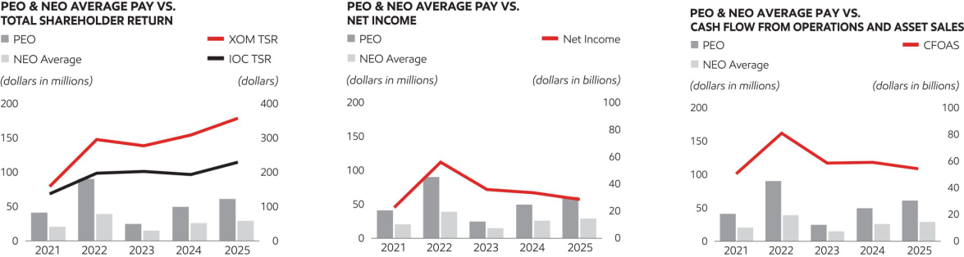

The table below indicates certain performance measures used by the Compensation Committee to assess PEO and NEOs performance, which is directly tied to their compensation. ExxonMobil operates in capital intensive industries where decisions and management of risk play out over time horizons decades in length, through cyclical commodity price environments. As a result, and particularly in a down-cycle, near-term financial performance may not be reflective of strong business and operational performance. For this reason, performance is assessed across a broad range of financial and operating metrics, over near- and long-term time horizons and taking into account the broader business environment. See pages 49 to 51.


Supporting Financial & Operating Metrics
∎ Safety Performance
∎ TSR
∎ Environmental Performance
∎ Earnings
∎ Corporate-wide operated asset GHG emissions intensity
∎ Cash Flow from Operations and Asset Sales

∎ Return on Capital Employed

Information on performance measures as well as a description of executive compensation program, including information on Compensation Design, Determining Compensation, other Compensation Elements, Risk and Governance can be found in the Compensation Discussion and Analysis on pages 45 to 64.

FOOTNOTES

- Principal Executive Officer (PEO): 2021-2025 D.W. Woods.
- Named Executive Officers (NEOs): In 2025, K.A. Mikells, N.A. Chapman, J.P. Williams, Jr., and J.M. Gibbs; in 2022-2024, K.A. Mikells, N.A. Chapman, J.P. Williams, Jr., and K.T. McKee; in 2021, K.A. Mikells, A.P. Swiger, N.A. Chapman, J.P. Williams, Jr., and L.M. Mallon.
- Reflects TSR indexed to $100 per share on December 31, 2020, for the Company and IOC Peers: BP, Chevron, Shell, and TotalEnergies.
- Adjustments to determine “Compensation Actually Paid”:

 |  |  |  | PEO¹ |  |  |  | Average Non-PEO NEOs²
 | +/- | 2025 | 2024 | 2023 | 2022 | 2021 | 2025 | 2024 | 2023 | 2022 | 2021
SCT grant value of long-
term awards granted in the
year | – | 25,886,250 | 26,721,000 | 23,199,750 | 24,939,000 | 13,505,225 | 12,764,798 | 13,728,656 | 12,079,337 | 12,594,195 | 5,892,181
Year-end value of long-term
awards granted in the year | + | 27,076,500 | 24,203,250 | 22,495,500 | 24,817,500 | 13,155,850 | 13,351,723 | 12,435,092 | 11,712,657 | 12,532,838 | 5,827,736
Year-over-year change in
“fair value” of unvested
awards | + | 17,827,559 | 9,666,245 | -11,749,836 | 48,547,691 | 16,765,814 | 7,441,398 | 4,084,653 | -4,655,739 | 17,672,847 | 7,865,983
Value of vested awards
received | + | 858,950 | 1,690,200 | -442,500 | 3,273,600 | 1,314,686 | 234,916 | 562,570 | -135,756 | 751,602 | 486,992
SCT change in pension
value | – | 0 | 10,417,644 | 5,922,953 | 2,506,363 | 5,137,153 | 784,403 | 5,321,232 | 4,012,935 | 3,044,269 | 2,710,176
Pension Service cost | + | 1,173,119 | 1,128,418 | 1,001,694 | 901,365 | 744,658 | 647,878 | 648,773 | 546,216 | 460,833 | 326,056
Dividends | + | 5,994,200 | 5,236,032 | 4,465,864 | 3,743,653 | 3,169,095 | 2,443,400 | 2,182,224 | 1,742,434 | 1,330,895 | 1,489,577

- Additional information on CFOAS is included in Exhibit B.
- Definitions of “Total Direct Compensation” and “Realized Pay” are included on page 62.

2026 Proxy Statement | 125

Table of Contents
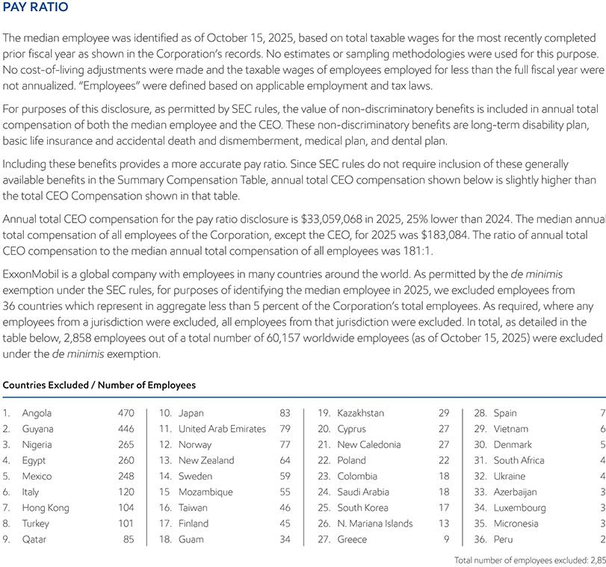

- 2026 Proxy Statement

Table of Contents

ADDITIONAL INFORMATION

Other Business

We are not currently aware of any other business to be acted on at the annual meeting. Under the laws of New Jersey, where ExxonMobil is incorporated, no business other than procedural matters may be raised at the meeting unless proper notice has been given to the shareholders. If other business is properly raised, your proxies have authority to vote as they think best, including to adjourn the meeting.

Outstanding Shares

Holders of record of our common stock at the close of business on April 1, 2026, are entitled to vote at the 2026 annual meeting of shareholders. On February 28, 2026, there were 4,156,559,415 shares of common stock outstanding and entitled to vote. Each common share entitles the holder to one vote.

How We Solicit Proxies

We bear the cost of solicitation of proxies by the Company. In addition to this mailing, ExxonMobil directors, officers, and employees in the ordinary course of their employment, without special compensation other than reimbursement of expenses, may solicit proxies personally, electronically, by telephone, or with additional mailings. We are paying Innisfree a fee of $40,000 plus expenses to help with the solicitation. We also reimburse brokerage firms, banks, and other intermediaries for their expenses in sending these materials to you and getting your voting instructions.

Shareholder Proposals and Director Nominations for Next Year

Any shareholder proposal for the annual meeting in 2027 must be sent to the email address or to the Secretary at the address of ExxonMobil’s principal executive office listed in the Contact Information above. The deadline for receipt of a proposal to be considered for inclusion in the 2027 proxy statement is 12:00 p.m. Central Time, on December 9, 2026. Upon request, the Secretary will provide instructions for submitting proposals.

Submissions of nominees for director under the proxy access provisions of our by-laws for the 2027 annual meeting must be submitted in compliance with those by-laws no later than December 9, 2026, and no earlier than November 9, 2026. Notice of a director nomination, or a shareholder proposal, other than under proxy access, or for which a shareholder will conduct his or her own solicitation must be submitted in compliance with the advance notice provisions of our by-laws no later than January 27, 2027, and no earlier than December 28, 2026. In all cases, material fully compliant with the requirements of our by-laws must be received by 12:00 p.m. Central Time on the relevant date.

For the 2026 annual meeting of shareholders, the ExxonMobil proxy card will be White. ExxonMobil intends to use the White proxy card for its annual meeting next year and for all future shareholder meetings.

Duplicate Annual Reports

Registered Shareholders with multiple accounts may authorize ExxonMobil to discontinue mailing annual reports for an account by calling ExxonMobil Shareholder Services at the toll-free telephone number listed in the Contact Information above at any time during the year. Beneficial holders should contact their banks, brokerage firms, or other holders of record to discontinue duplicate mailings. At least one account must continue to receive an annual report. Eliminating these duplicate mailings will not affect receipt of future proxy statements and proxy cards.

Shareholders With the Same Address

If you share an address with one or more ExxonMobil shareholders, you may elect to “household” your proxy mailing. This means you will receive only one set of proxy materials at that address unless one or more shareholders at that address specifically elects to receive separate mailings. Shareholders who participate in householding will continue to receive separate proxy cards. Householding will not affect dividend check mailings. We will promptly send separate proxy materials to a shareholder at a shared address on request. Shareholders with a shared address may also request us to send separate proxy materials in the future, or to send a single copy in the future, if we are currently sending multiple copies to the same address.

2026 Proxy Statement | 127

Table of Contents

Requests related to householding should be made by calling ExxonMobil Shareholder Services at the telephone number listed in the Contact Information above or by sending the request to the Secretary at the address listed in the Contact Information above. Beneficial shareholders should request information about householding from their banks, brokers, or other holders of record.

SEC Form 10-K

Shareholders may obtain a copy of the Corporation’s Annual Report on Form 10-K, including the financial statements and the financial statement schedules thereto, without charge by writing to the Secretary at the address listed in the Contact Information above, or by visiting ExxonMobil’s website at investor.exxonmobil.com/sec-filings.

- 2026 Proxy Statement

Table of Contents

EXHIBIT A

Annex A: Agreement and Plan of Merger

AGREEMENT AND PLAN OF MERGER

THIS AGREEMENT AND PLAN OF MERGER (“Agreement”) is made as of April 8, 2026, by and among Exxon Mobil Corporation, a New Jersey corporation (“ExxonMobil”), ExxonMobil Holdings Corporation, a Texas corporation and a direct, wholly owned subsidiary of ExxonMobil (“Texas HoldCorp”) and Ensign LLC, a Texas limited liability company and a direct, wholly owned subsidiary of ExxonMobil (“Merger Sub”).

WHEREAS, ExxonMobil has authorized capital consisting of (i) 9,000,000,000 shares of common stock, without par value (“ExxonMobil Common Stock”), of which 4,156,559,415 shares were issued and outstanding as of February 28, 2026 and 3,862,865,019 shares were held as treasury stock; and (ii) 200,000,000 shares of preferred stock, without par value (“ExxonMobil Preferred Stock”), of which no shares are issued and outstanding;

WHEREAS, Texas HoldCorp has authorized capital consisting of 9,000,000,000 shares of common stock, par value $ 0.001 per share (“Texas HoldCorp Common Stock”), of which 100 shares are issued and outstanding and are owned beneficially and of record by ExxonMobil, and 200,000,000 shares of preferred stock, par value $0.001 per share (“Texas HoldCorp Preferred Stock”), of which no shares are issued and outstanding;

WHEREAS, the Board of Directors of ExxonMobil has determined that it would be advisable and in the best interests of ExxonMobil and its shareholders to undergo a corporate reorganization under which simultaneously (i) Merger Sub would merge with and into ExxonMobil, with ExxonMobil continuing as the surviving corporation (the “Merger”), and ExxonMobil would become a direct, wholly owned subsidiary of Texas HoldCorp, and (ii) ExxonMobil shareholders would become shareholders of Texas HoldCorp as a result of the exchange of each outstanding share of ExxonMobil Common Stock for one share of Texas HoldCorp Common Stock in accordance with the terms of this Agreement;

WHEREAS, the Board of Directors of ExxonMobil has (i) determined that this Agreement and the Merger are advisable and in the best interests of ExxonMobil and its shareholders, (ii) approved and adopted this Agreement and the Merger, (iii) resolved to submit this Agreement and the Merger to ExxonMobil shareholders for their approval, and

- resolved to recommend to ExxonMobil’s shareholders that they vote in favor of the adoption and approval of this Agreement and the Merger;

WHEREAS, the Board of Directors of Texas HoldCorp has (i) determined that this Agreement and the Merger are advisable and in the best interests of Texas HoldCorp and its shareholder and (ii) approved and adopted this Agreement and Merger;

WHEREAS, the sole member of Merger Sub has (i) determined that this Agreement and the Merger are advisable and in the best interests of Merger Sub and its member and (ii) approved and adopted this Agreement and Merger;

WHEREAS, to facilitate such corporate reorganization, prior to the execution of this Agreement, ExxonMobil has caused the creation of (i) Texas HoldCorp and (ii) Merger Sub;

WHEREAS, ExxonMobil is the sole member of Merger Sub and holds all outstanding shares of Merger Sub (“Merger Sub Shares”);

WHEREAS, Merger Sub is a disregarded entity for U.S. federal income tax purposes and was formed solely for the purpose of effectuating the corporate reorganization, and owns no assets and has no liabilities;

WHEREAS, ExxonMobil, Texas HoldCorp and Merger Sub desire to make certain covenants and agreements in connection with the Merger and to prescribe various conditions to the Merger;

WHEREAS, the parties to this Agreement intend that the Merger qualify, for U.S. federal income tax purposes, as (i) a “reorganization” within the meaning of Section 368(a) of the Internal Revenue Code of 1986, as

2026 Proxy Statement | 129

Table of Contents

amended (the “Code”), with ExxonMobil and Texas HoldCorp each a “party to the reorganization” within the meaning of Section 368(b) of the Code, or, alternatively, as (ii) an exchange described in Section 351 of the Code; and

WHEREAS, the parties to this Agreement also intend this Agreement to be, and hereby adopt this Agreement as, a “plan of reorganization” within the meaning of Treasury Regulations Section 1.368-2(g); and

NOW, THEREFORE, in consideration of the foregoing and the covenants and agreements contained herein, the parties agree as follows:

Article 1

THE MERGER

1.1 The Merger; Effective Time of the Merger. Upon the terms and subject to the conditions of this Agreement, at the Effective Time, Merger Sub shall be merged with and into ExxonMobil in accordance with the New Jersey Business Corporation Act (the “NJBCA”) and the Texas Business Organizations Act (the “TBOC”). As soon as practicable at or after the closing of the Merger (the “Closing”), certificates of merger, prepared and executed in accordance with the relevant provisions of the NJBCA and the TBOC, with respect to the Merger (respectively, the “New Jersey Certificate of Merger” and the “Texas Certificate of Merger”) shall be filed with the New Jersey Division of Revenue and Enterprise Services and the Secretary of State of the State of Texas, respectively. The Merger shall become effective at the time of the acceptance of the filing of the Texas Certificate of Merger by the Secretary of State of the State of Texas after the New Jersey Certificate of Merger is filed with the New Jersey Division of Revenue and Enterprise Services or, if a later effective time was provided in the Texas Certificate of Merger, such later time (the “Effective Time”). In addition, at the Effective Time, all Merger Sub Shares shall be transferred from ExxonMobil to Texas HoldCorp.

1.2 Effects of the Merger.

(a) At the Effective Time: (i) Merger Sub shall be merged with and into ExxonMobil, the separate existence of Merger Sub shall cease and ExxonMobil shall continue as the surviving corporation (ExxonMobil is sometimes referred to herein as the “Surviving Corporation”); (ii) the Restated Certificate of Incorporation of ExxonMobil as in effect immediately prior to the Effective Time shall be the Certificate of Incorporation of the Surviving Corporation; and (iii) the By-laws of ExxonMobil as in effect immediately prior to the Effective Time shall be the By-laws of the Surviving Corporation.

(b) The directors set forth in Section 5.3 and the officers of ExxonMobil at the Effective Time shall, from and after the Effective Time, be the directors and officers of the Surviving Corporation and shall serve until their successors have been duly elected or appointed and qualified or until their earlier death, resignation or removal in accordance with the Surviving Corporation’s Certificate of Incorporation and By-laws.

(c) The Merger shall have the effects set forth in this Section 1.2 and the applicable provisions of the NJBCA and the TBOC.

Article 2

EFFECT OF THE MERGER ON THE CAPITAL STOCK OF EXXONMOBIL AND TEXAS HOLDCORP AND ON THE MEMBERSHIP INTERESTS IN MERGER SUB; TREATMENT OF EQUITY AWARDS; EXCHANGE OF CERTIFICATES

2.1 Effect of Merger on Capital Stock and Membership Interests. At the Effective Time, by virtue of the Merger and without any action on the part of the holder of any shares of capital stock of ExxonMobil or Texas HoldCorp or of any Merger Sub Shares:

(a) Exchange of Merger Sub Shares. All Merger Sub Shares issued and outstanding immediately prior to the Effective Time shall be automatically exchanged for one share of common stock, without par value, of the Surviving Corporation all of which shall be owned by Texas HoldCorp.

(b) Exchange of ExxonMobil Common Stock. Each share of ExxonMobil Common Stock issued and outstanding immediately prior to the Effective Time shall be automatically exchanged for one share of Texas HoldCorp Common Stock. All shares of ExxonMobil Common Stock, when so exchanged, shall no longer be outstanding and shall automatically be canceled and retired and shall cease to exist, and each holder of a certificate

- 2026 Proxy Statement

Table of Contents

representing any such shares shall cease to have any rights with respect to stock of the Surviving Corporation, and their sole rights shall be with respect to the Texas HoldCorp Common Stock into and for which their shares of ExxonMobil Common Stock shall have been exchanged in the Merger.

(c) Treatment of ExxonMobil Equity Awards. As of the Effective Time, by virtue of the Merger and without any action on the part of the holders thereof, each warrant, stock option, restricted stock unit, performance stock unit, equity or equity-based award or other right to acquire any, or any instrument to convert into or exchange for, or based on the value of, ExxonMobil Common Stock (each an “ExxonMobil Equity Award”) that is outstanding immediately prior to the Effective Time shall cease to relate to or represent any right to receive shares of ExxonMobil Common Stock and shall be exchanged, at the Effective Time, into a warrant, stock option, restricted stock unit, performance stock unit, equity or equity-based award or other right to acquire any, or any instrument to convert into or exchange for, or based on the value of, Texas HoldCorp Common Stock relating to a number of shares of Texas HoldCorp Common Stock equal to the number of shares of ExxonMobil Common Stock subject or otherwise relating to the corresponding ExxonMobil Equity Award as of immediately prior to the Effective Time, on the same terms and conditions as were applicable to the corresponding ExxonMobil Equity Awards, including with respect to, as applicable, exercisability, vesting and forfeiture (including performance vesting criteria), form of settlement (i.e., cash or equity-based) and dividend equivalent rights, except as adjusted by this Agreement.

(d) ExxonMobil Treasury Stock. Each share of ExxonMobil Common Stock held by ExxonMobil in its treasury immediately prior to the Effective Time, if any, shall be canceled.

2.2 Cancellation of ExxonMobil Holdings Corporation Common Stock. At the Effective Time, each share of Texas HoldCorp Common Stock issued and outstanding immediately prior to the Effective Time shall be deemed to be surrendered by ExxonMobil to Texas HoldCorp for cancellation and retirement without payment or consideration therefor.

2.3 Exchange of ExxonMobil Common Stock Certificates. Following the Effective Time, each outstanding certificate which, prior to the Effective Time, represented ExxonMobil Common Stock shall be deemed and treated for all purposes to represent the ownership of the same number of shares of Texas HoldCorp Common Stock as though a surrender or transfer and exchange had taken place. Each holder of an outstanding certificate or certificates which, prior to the Effective Time, represented shares of ExxonMobil Common Stock may, but shall not be required to, surrender the same to Texas HoldCorp for cancellation or transfer, and each such holder or transferee will be entitled to receive certificates representing the same number of shares of Texas HoldCorp Common Stock as the shares of ExxonMobil Common Stock previously represented by the stock certificates surrendered. The stock transfer books for the ExxonMobil Common Stock shall be deemed to be closed at the Effective Time and no transfer of outstanding shares of ExxonMobil Common Stock shall thereafter be made on such books, but when certificates that formerly represented shares of ExxonMobil Common Stock are duly presented to Texas HoldCorp or its transfer agent for exchange or transfer, Texas HoldCorp will cause to be issued in respect thereof certificates representing an equal number of shares of Texas HoldCorp Common Stock.

Article 3

CONDITIONS TO THE MERGER

Completion of the Merger is subject to the satisfaction of the following conditions:

3.1 Shareholder Approval. This Agreement and the transactions provided for herein shall have been approved by holders of common stock of ExxonMobil and by the sole member of Merger Sub as and to the extent required by their respective Certificate of Incorporation, Certificate of Formation, the NJBCA and the TBOC.

3.2 Texas HoldCorp Common Stock Listed. The Texas HoldCorp Common Stock to be issued and to be reserved for issuance pursuant to the Merger shall have been approved for listing, upon official notice of issuance, by the New York Stock Exchange.

3.3 Regulatory Approvals. All authorizations by and approvals of any governmental or public authority or agency deemed necessary or advisable by the Board of Directors of ExxonMobil in connection with the Merger and other related transactions shall have been obtained, shall be in full force and effect, shall not have been revoked and shall be legally sufficient to authorize the transactions contemplated by this Agreement.

2026 Proxy Statement | 131

Table of Contents

3.4 Other Approvals or Waivers. All third party consents or waivers deemed necessary or advisable by the Board of Directors of ExxonMobil in connection with the Merger and other related transactions shall have been obtained.

3.5 Tax Opinion. Each of ExxonMobil and Texas HoldCorp shall have received a written opinion of Gibson, Dunn & Crutcher LLP, dated as of the closing date of the Merger, to the effect that, on the basis of the facts, representations, and assumptions set forth or referred to in such opinion, upon which facts, representations, and assumptions the opinion will be permitted to rely, the Merger will qualify, for U.S. federal income tax purposes, as a “reorganization” within the meaning of Section 368(a) of the Code or, alternatively, as an exchange described in Section 351 of the Code.

Article 4

AMENDMENT AND TERMINATION

4.1 Amendment. ExxonMobil and Texas HoldCorp, by mutual consent of their respective Boards of Directors may amend, modify or supplement this Agreement in such manner as may be agreed upon by them in writing at any time before or after approval of this Agreement by the holders of ExxonMobil Common Stock (as provided in Section 3.1 above).

4.2 Termination. This Agreement may be terminated and the Merger and other transactions provided for by this Agreement may be abandoned at any time, whether before or after approval of this Agreement by the holders of ExxonMobil Common Stock, by action of the Board of Directors of ExxonMobil if such Board of Directors determines for any reason that the completion of the transactions provided for herein would for any reason be inadvisable or not in the best interests of ExxonMobil or its shareholders.

Article 5

ADDITIONAL AGREEMENTS

5.1 Assumption of Plans.

(a) Stock Based Employee Benefit Plans. As of the Effective Time, Texas HoldCorp shall assume the Exxon Mobil Corporation 2003 Incentive Program, the 2004 Non-Employee Director Restricted Stock Plan, the Pioneer Natural Resources Company Second Amended and Restated 2006 Long Term Incentive Plan and any other plan, program or arrangement under which an outstanding ExxonMobil Equity Award was granted (each, an “Incentive Plan”), each of which shall continue to govern the applicable ExxonMobil Equity Awards as assumed pursuant to this Section 5.1(a) and for the purpose of making future grants relating to shares of ExxonMobil Holdings Corporation Common Stock to applicable employees and other service providers of ExxonMobil Holdings Corporation and its Subsidiaries, which Incentive Plans shall be amended and adjusted as reasonably necessary to give effect to the transactions contemplated by this Agreement. Texas HoldCorp will reserve, for purposes of the Incentive Plans, a number of shares of Texas HoldCorp Common Stock equivalent to the number of shares of ExxonMobil Common Stock reserved by ExxonMobil for such purposes immediately prior to the Effective Time.

(b) Other Benefit Plans. At the Effective Time, responsibility for all other benefit- and employment-related plans, programs, contracts and agreements maintained by ExxonMobil as in effect immediately prior to the Effective Time shall remain with ExxonMobil.

5.2 Indebtedness. As of the Effective Time, all debts and liabilities of ExxonMobil will remain with ExxonMobil.

- 2026 Proxy Statement

Table of Contents

5.3 Election of Directors. Effective immediately, upon the approval of the Merger by the shareholders of ExxonMobil, ExxonMobil, in its capacity as the sole shareholder of Texas HoldCorp, will elect each of the following persons as a director of Texas HoldCorp (and to be the only directors of Texas HoldCorp), each of whom shall serve until the annual meeting of shareholders of Texas HoldCorp at which his or her term expires and until his or her successor shall have been elected and qualified:

Darren W. Woods

Michael J. Angelakis

Angela F. Braly

Maria S. Dreyfus

Gregory C. Garland

John D. Harris II

Kaisa H. Hietala

Joseph L. Hooley

Steven A. Kandarian

Alexander A. Karsner

Lawrence W. Kellner

Dina Powell McCormick

5.4 Appointment of Officers. Effective immediately, upon the approval of the Merger by the shareholders of ExxonMobil, the Board of Directors of Texas HoldCorp will appoint each person who is then an officer of ExxonMobil as an officer of Texas HoldCorp, and each officer so appointed shall hold the same position at Texas HoldCorp as such officer holds at ExxonMobil immediately prior to the Effective Time.

5.5 Listing of Texas HoldCorp Common Stock. Texas HoldCorp will use its best efforts to obtain, at or before the Effective Time, authorization to list, upon official notice of issuance, on the New York Stock Exchange the Texas HoldCorp Common Stock issuable pursuant to the Merger.

5.6 Approval of Sole Member of Merger Sub. ExxonMobil, as the sole member of Merger Sub, hereby votes all Merger Sub Shares owned by ExxonMobil to approve this Agreement.

2026 Proxy Statement | 133

Table of Contents

ARTICLE 6

MISCELLANEOUS

6.1 Governing Law. This Agreement shall be governed by and construed in accordance with the laws of the State of Texas.

IN WITNESS WHEREOF, ExxonMobil, Texas HoldCorp and Merger Sub have each caused this Agreement and Plan of Merger to be executed by their respective officers or managing members thereunto authorized, all as of the date first written above.

Exxon Mobil Corporation,

a New Jersey corporation

By: /s/ Darren W. Woods
Name: Darren W. Woods
Title: Chief Executive Officer

Ensign LLC,

a Texas limited liability company

By: ExxonMobil Holdings Corporation, as sole member

By: /s/ Jeffrey A. Taylor
Name: Jeffrey A. Taylor
Title: Sole Director

ExxonMobil Holdings Corporation, a Texas corporation

By: /s/ Jeffrey A. Taylor
Name: Jeffrey A. Taylor
Title: Sole Director

- 2026 Proxy Statement

Table of Contents

Annex B: Amended and Restated Certificate of Formation of ExxonMobil Holdings Corporation

AMENDED AND RESTATED CERTIFICATE OF FORMATION

of

EXXONMOBIL HOLDINGS CORPORATION

(As Amended Effective [•])

ExxonMobil Holdings Corporation, a corporation organized and existing under the laws of the State of Texas, amends and restates its Certificate of Formation in accordance with the following:

A. This Amended and Restated Certificate of Formation accurately copies the provisions of the existing Certificate of Formation of ExxonMobil Holdings Corporation, as further amended by this Amended and Restated Certificate of Formation as hereinafter set forth, and contains no other change in any provisions thereof.

B. The amendments have been made in accordance with the Texas Business Organizations Code, and this Amended and Restated Certificate of Formation and the amendments effected hereby have been approved in the manner required under the Texas Business Organizations Code and the governing documents of ExxonMobil Holdings Corporation.

C. The existing Certificate of Formation is hereby superseded by the following Amended and Restated Certificate of Formation, which accurately copies the entire text thereof, as amended hereby:

FIRST. The name of the corporation is:

EXXONMOBIL HOLDINGS CORPORATION

SECOND. The address of the corporation’s registered office is 211 East 7th Street, Suite 620, Austin, TX 78701-3218. The name of the corporation’s registered agent at such address, upon whom process against the corporation may be served, is Corporation Service Company.

THIRD. The purposes for which the corporation is organized are to engage in any or all activities within the purposes for which corporations now or at any time hereafter may be organized under the Texas Business Organizations Code and under all amendments and supplements thereto, or any revision thereof or any statute enacted to take the place thereof (the “TBOC”), including but not limited to the following:

(1) To do all kinds of mining, manufacturing and trading business; transporting goods and merchandise by land or water in any manner; to buy, sell, lease and improve lands; to build houses, structures, vessels, cars, wharves, docks and piers; to lay and operate pipelines; to erect and operate telegraph and telephone lines and lines for conducting electricity; to enter into and carry out contracts of every kind pertaining to its business; to acquire, use, sell and grant licenses under patent rights; to purchase or otherwise acquire, hold, sell, assign and transfer shares of capital stock and bonds or other evidences of indebtedness of corporations, and to exercise all the privileges of ownership including voting upon the securities so held; to carry on its business and have offices and agencies therefor in all parts of the world; and to hold, purchase, mortgage and convey real estate and personal property within or without the State of Texas;

(2) To engage in any activities encompassed within this Article Third directly or through a subsidiary or subsidiaries and to take any and all acts deemed appropriate to promote the interests of such subsidiary or subsidiaries, including, without limiting the foregoing, the following: making contracts and incurring liabilities for the benefit of such subsidiary or subsidiaries; transferring or causing to be transferred to any such subsidiary or subsidiaries assets of this corporation; guaranteeing dividends on any shares of the capital stock of any such subsidiary; guaranteeing the principal and interest or either of the bonds, debentures, notes or other evidences of indebtedness issued or obligations incurred by any such subsidiary or subsidiaries; securing said bonds, debentures,

2026 Proxy Statement | 135

Table of Contents

notes or other evidences of indebtedness so guaranteed by mortgage of or security interest in the property of this corporation; and contracting that said bonds, debentures, notes or other evidences of indebtedness so guaranteed, whether secured or not, may be convertible into shares of this corporation upon such terms and conditions as may be approved by the board of directors;

(3) To guarantee the bonds, debentures, notes or other evidences of indebtedness issued, or obligations incurred, by any corporation, partnership, limited partnership, joint venture or other association in which this corporation at the time such guarantee is made has a substantial interest or where such guarantee is otherwise in furtherance of the interests of this corporation; and

(4) To exercise as a purpose or purposes each power granted to corporations by the TBOC or by any amendment or supplement thereto or by any statute enacted to take the place thereof, insofar as such powers authorize or may hereafter authorize corporations to engage in activities.

FOURTH. The aggregate number of shares which the corporation shall have authority to issue is nine billion two hundred million (9,200,000,000) shares, divided into two hundred million (200,000,000) shares of preferred stock, par value $0.001 per share, and nine billion (9,000,000,000) shares of common stock, par value $0.001 per share.

(1) The board of directors of the corporation is authorized at any time or from time to time pursuant to a resolution or resolutions (i) to issue the shares of preferred stock in one or more classes or series within any class or classes of preferred stock; (ii) to determine for any such class or series its designation, relative rights, preferences and limitations; (iii) to determine the number of shares in any such class or series (including a determination that such class or series shall consist of a single share); (iv) to increase the number of shares of any such class or series previously determined by it and to decrease such previously determined number of shares to a number not less than that of the shares of such class or series then outstanding; (v) to change the designation or number of shares, or the relative rights, preferences and limitations of the shares, of any theretofore established class or series no shares of which have been issued; and (vi) to cause to be executed and filed without further approval of the shareholders such amendment or amendments to the Amended and Restated Certificate of Formation or other instruments as may be required in order to accomplish any of the foregoing. In particular, but without limiting the generality of the foregoing, the board of directors is authorized to determine with respect to the shares of any class or series of preferred stock:

(a) whether the holders thereof shall be entitled to cumulative, non-cumulative or partially cumulative dividends or to no dividends and, with respect to shares entitled to dividends, the dividend rate or rates (which may be fixed or variable and may be made dependent upon facts ascertainable outside of the Amended and Restated Certificate of Formation) and any other terms and conditions relating to such dividends;

(b) whether the holders thereof shall be entitled to receive dividends payable on a parity with or subordinate or in preference to the dividends payable on any other class or series of shares of the corporation;

(c) whether, and if so to what extent and upon what terms and conditions, the holders thereof shall be entitled to preferential rights upon the liquidation of, or upon any distribution of the assets of, the corporation;

(d) whether, and if so upon what terms and conditions, such shares shall be convertible into other

securities;

(e) whether, and if so upon what terms and conditions, such shares shall be redeemable;

(f) the terms and amount of any sinking fund provided for the purchase or redemption of such shares;

and

(g) the voting rights, if any, to be enjoyed by such shares and the terms and conditions for the exercise

thereof.

(2) Each holder of shares of common stock shall be entitled to one vote for each share of common stock held of record by such holder on all matters on which holders of shares of common stock are entitled to vote.

- 2026 Proxy Statement

Table of Contents

(3) No holder of any shares of common or preferred stock of the corporation shall have any right as such holder (other than such right, if any, as the board of directors in its discretion may determine) to purchase, subscribe for or otherwise acquire any unissued or treasury shares, or any option rights, or securities having conversion or option rights, of the corporation now or hereafter authorized.

FIFTH. For the historic record, this company has its origins in the Standard Oil Company of New Jersey, which was incorporated in 1882. The following is a list of the names and residences of the original shareholders of the historic Standard Oil Company of New Jersey, and of the number of shares held by each:

H.M. Flagler | of New York City, | One share.
Paul Babcock, Jr. | of Jersey City, | One share.
James McGee | of Plainfield, New Jersey, | One share.
Thos. C. Bushnell | of Morristown, New Jersey, | One share.
John D. Rockefeller | of Cleveland, Ohio, | }
Wm. Rockefeller | of New York City, | }
J.A. Bostwick | of New York City, | }
John D. Archbold | of New York City, | }
O.H. Payne | of Cleveland, Ohio, | }
Wm. G. Warden | of Philadelphia, Pa., | }
Benj. Brewster | of New York City, | }
Chas. Pratt | of Brooklyn, N.Y., | }
and H.M. Flagler | of New York City. | }

Trustees of Standard Oil Trust, twenty-nine thousand nine hundred and ninety-six shares (29,996), of which twenty-one thousand seven hundred and twenty-four shares (21,724) were issued for property purchased and necessary for the business of this historic Standard Oil Company of New Jersey. The shareholders listed above are not the original shareholders of this company but are listed in this Certificate of Formation in recognition of their contributions to the historic Standard Oil Company of New Jersey.

SIXTH. The number of directors at any time may be increased or diminished by vote of the board of directors, and in case of any such increase the board of directors shall, to the extent permitted by the TBOC, have power to elect each such additional director to hold office until the next succeeding annual meeting of shareholders and until his successor shall have been elected and qualified.

The board of directors from time to time shall determine whether and to what extent, and at what times and places, and under what conditions and regulations, the accounts and books of the corporation, or any of them, shall be open to the inspection of the shareholders; and no shareholder shall have any right of inspecting any account or book or document of the corporation, except as conferred by statute or authorized by the board of directors, or by a resolution of the shareholders.

SEVENTH. The following actions may be taken by the affirmative vote of a majority of the shares of the corporation entitled to vote thereon, provided, that, if permitted by the TBOC, instead of the foregoing voting standard, the following actions may be taken by the affirmative vote of a majority of the votes cast by the holders of shares of the corporation entitled to vote thereon:

(1) The adoption by the shareholders of a proposed amendment of the Amended and Restated Certificate of Formation of the corporation;

(2) The adoption by the shareholders of a proposed plan of merger or consolidation involving the corporation;

(3) The approval by the shareholders of a sale, lease, exchange, or other disposition of all, or substantially all, the assets of the corporation otherwise than in the usual and regular course of business as conducted by the corporation; and

(4) Winding up or dissolution.

2026 Proxy Statement | 137

Table of Contents

EIGHTH. Subject to the procedures set forth in the by-laws of the corporation, the percentage of shares required to be owned by shareholders requesting that the corporation, call a special meeting of shareholders shall be fifteen percent (15%) of the voting power of the outstanding capital stock of the corporation entitled to vote on the matter or matters to be brought before the special meeting.

NINTH. Except as otherwise provided by statute or by this Amended and Restated Certificate of Formation or the by-laws of the corporation, as in each case the same may be amended from time to time, all corporate powers may be exercised by the board of directors. Without limiting the foregoing, the board of directors shall have power, without shareholder action:

(1) To authorize the corporation to purchase, acquire, hold, lease, mortgage, pledge, sell and convey such property, real, personal and mixed, without as well as within the State of Texas, as the board of directors may from time to time determine, and in payment for any property to issue, or cause to be issued, shares of the corporation, or bonds, debentures, notes or other obligations or evidence of indebtedness thereof secured by pledge, security interest or mortgage, or unsecured; and

(2) To authorize the borrowing of money, the issuance of bonds, debentures, notes and other obligations or evidences of indebtedness of the corporation, secured or unsecured, and the inclusion of provisions as to redeemability and convertibility into shares of stock of the corporation or otherwise, and, as security for money borrowed or bonds, debentures, notes and other obligations or evidences of indebtedness issued by the corporation, the mortgaging or pledging of any property, real, personal, or mixed, then owned or thereafter acquired by the corporation.

TENTH. To the full extent from time to time permitted by law, no director or officer of the corporation shall be personally liable to the corporation or its shareholders for damages for breach of any duty owed to the corporation or its shareholders. Neither the amendment or repeal of this Article, nor the adoption of any provision of this Amended and Restated Certificate of Formation inconsistent with this Article, shall eliminate or reduce the protection afforded by this Article to a director or officer of the corporation with respect to any matter which occurred, or any cause of action, suit or claim which but for this Article would have accrued or arisen, prior to such amendment, repeal or adoption.

IN WITNESS WHEREOF, ExxonMobil Holdings Corporation, has caused this Amended and Restated Certificate of Formation to be signed by its duly authorized officer on [•], 2026.

By:
Name: Jeffrey A. Taylor
Title: Authorized Signatory

- 2026 Proxy Statement

Table of Contents

Annex C: ExxonMobil Holdings Corporation By-Laws

EXXONMOBIL HOLDINGS CORPORATION

INCORPORATED IN TEXAS

January 23, 2026

BY-LAWS

(As revised [•])

ARTICLE I

Meetings of Shareholders

- Meetings of shareholders may be held on such date and at such time and place, within or without the State of Texas, as may be fixed by the board of directors and stated in the notice of meeting.

- The date for each annual meeting of shareholders, fixed as provided in Section 1 of this Article I, shall be a date not more than thirteen months after the date on which the last annual meeting of shareholders was held. The directors shall be elected at the annual meeting of shareholders or any special meeting of shareholders in accordance with these by-laws.

3. (a) Special meetings of the shareholders may be called by the board of directors, the chairman of the board or the president, or pursuant to Article I, Section 3(b), and may not be called by any other person.

- A special meeting of shareholders shall be called by the secretary of the corporation at the written request or requests (each, a “Special Meeting Request” and, collectively, the “Special Meeting Requests”) of holders of record owning at least 15% of the voting power of the outstanding capital stock of the corporation, entitled to vote on the matter or matters to be brought before the proposed special meeting (the “Requisite Percentage”). To satisfy the Requisite Percentage, each such holder must comply with the requirements of these by-laws including Section 9 of this Article I.

- For purposes of this Article I, Section 3(b), and unless otherwise required under the laws of the State of Texas, a shareholder or beneficial owner shall be deemed to own only those shares meeting the requirements for being “Net Long Shares,” as described in this paragraph. Net Long Shares shall be limited to the number of shares beneficially owned, directly or indirectly, by any shareholder or beneficial owner that constitute such person’s net long position as defined in Rule 14e-4 under the Securities Exchange Act of 1934, as amended (the “Exchange Act”) provided that (i) for purposes of such definition, in determining each person’s “short position,” the reference in Rule 14e-4 to “the date the tender offer is first publicly announced” shall instead be the date for determining and/or documenting a shareholder’s or beneficial owner’s Net Long Shares and the reference to the “highest tender offer price or stated amount of the consideration offered for the subject security” shall refer to the market price on such date, and, to the extent not covered by such definition, reduced by any shares as to which such person does not have the right to vote or direct the vote at the special meeting or as to which such person has entered into a derivative or other agreement, arrangement or understanding that hedges or transfers, in whole or in part, directly or indirectly, any of the economic consequences of ownership of such shares. In addition, to the extent any affiliates of the shareholder or beneficial owner are acting in concert with the shareholder or beneficial owner with respect to the calling of the special meeting, the determination of Net Long Shares may include the effect of aggregating the Net Long Shares (including any negative number) of such affiliate or affiliates. Whether share ownership meets the requirements for being “Net Long Shares,” shall be decided by the board in its reasonable determination.

- Except as may otherwise be permitted by the Texas Business Organizations Code (the “TBOC”), a Special Meeting Request must be delivered by hand or by registered U.S. mail, postage prepaid, return receipt requested, or courier service, postage prepaid, to the attention of the secretary of the corporation at the principal executive offices of the corporation. A Special Meeting Request to the secretary shall be signed and dated by each shareholder of record and each beneficial owner, if any, on whose behalf the Special Meeting Request is being made (or a duly authorized agent of such shareholder or owner) requesting the special meeting (each, a “Requesting Shareholder”), shall comply with this Section 3 of Article I, and shall include

2026 Proxy Statement | 139

Table of Contents

- a statement of the specific purpose or purposes of the special meeting, a brief description of the business desired to be brought before the meeting, the text of the proposal or business (including the text of any resolutions proposed for consideration and in the event that such business includes a proposal to amend these by-laws, the text of the proposed amendment), the reasons for conducting such business and any material interest in such business of such shareholder and the beneficial owner, if any, on whose behalf the proposal is made,

- as to the “Requesting Shareholders” and the beneficial owners, if any, on whose behalf the Special Meeting Request(s) are being made, the information required by Section 9(a)(iii)(B) of Article I (as if Section 9(a)(iii) applies to a special meeting and any nomination of directors or other business brought before a special meeting),

- such other information, if applicable, required to be set forth in a shareholder’s notice required by Section 9(a)(iii)(A) of Article I (as if Section 9(a)(iii) applies to a special meeting and any nomination of directors or other business brought before a special meeting),

- an acknowledgement by the Requesting Shareholders and the beneficial owners, if any, on whose behalf the Special Meeting Request(s) are being made that any reduction in the number of Net Long Shares with respect to which a Special Meeting Request relates following the delivery of such Special Meeting Request to the secretary shall constitute a revocation of such Special Meeting Request to the extent of such reduction, and an agreement to notify the corporation if there has been any such reduction, and

- documentary evidence that the Requesting Shareholders own the Requisite Percentage as of the date of such written request to the secretary; provided, that if the Requesting Shareholders are not the beneficial owners of the shares representing the Requisite Percentage, then to be valid, the Special Meeting Request(s) must also include documentary evidence (or, if not simultaneously provided with the Special Meeting Request(s), such documentary evidence must be delivered to the secretary within 10 business days after the date on which the Special Meeting Request(s) are delivered to the secretary) that the beneficial owners on whose behalf the Special Meeting Request(s) are made beneficially own the Requisite Percentage as of the date on which such Special Meeting Request(s) are delivered to the secretary. In addition, the Requesting Shareholders and the beneficial owners, if any, on whose behalf the Special Meeting Request(s) are being made shall promptly provide any other information reasonably requested by the corporation.

  - The information required under clauses (b)(ii), (iii), (iv) and (v) of this Section 3 of Article I shall be supplemented by each Requesting Shareholder and any beneficial owner on whose behalf the Special Meeting Request(s) are made not later than 10 days after the record date for the special meeting to disclose such information as of the record date (and with respect to the information required under clause (b)(v) of this Section 3 of Article I, as of a date not more than 5 business days before the scheduled date of the special meeting to which the Special Meeting Request relates).

- A special meeting requested by shareholders in accordance with these by-laws shall be held on such date and at such time as may be fixed by the board of directors in accordance with these by-laws; provided, however, that the date of any such special meeting shall not be more than 120 days after a Special Meeting Request that satisfies the requirements of this Section 3 of Article I is received by the secretary.

- Notwithstanding the foregoing provisions of this Section 3 of Article I, a special meeting requested by shareholders shall not be held if

- the Special Meeting Request does not comply with this Section 3 of Article I,

- the Special Meeting Request relates to an item of business that is not a proper subject for shareholder action under applicable law,

- the Special Meeting Request is delivered during the period commencing 90 days prior to the first anniversary of the date of the notice of annual meeting for the immediately preceding annual meeting and ending on the earlier of (x) the date of the next annual meeting and (y) 30 calendar days after the first anniversary of the date of the immediately preceding annual meeting,

- 2026 Proxy Statement

Table of Contents

- an identical or substantially similar matter (as determined in good faith by the board of directors, a “Similar Matter”) was included on the agenda of any annual or special meeting of shareholders held within 120 days before the Special Meeting Request is delivered or will be included on the agenda at an annual or special meeting to be held within 90 days after the Special Meeting Request is delivered (and for purposes of this clause (iv), the nomination, election or removal of directors, changing the size of the Board of Directors or filling of vacancies and/or newly created directorships resulting from any increase in the authorized number of directors shall be considered an identical or substantially similar matter with respect to all matters involving nomination, election or removal of directors, changing the size of the Board of Directors or filling of vacancies and/or newly created directorships resulting from any increase in the authorized number of directors),

- a Similar Matter is included in the corporation’s notice as an item of business to be brought before a stockholder meeting that has been called or will be called within 30 days after the Special Meeting Request is delivered, or

- the applicable requirements of Section 9 of this Article I are not complied with.

- For purposes of this section, the date of delivery of the Special Meeting Request shall be the first date on which valid Special Meeting Requests constituting the Requisite Percentage have been delivered to the corporation.

- In determining whether a special meeting of shareholders has been requested by shareholders who own shares that are Net Long Shares representing in the aggregate at least the Requisite Percentage, multiple Special Meeting Requests delivered to the secretary will be considered together only if

  - each Special Meeting Request identifies substantially the same purpose or purposes of the special meeting and substantially the same matters proposed to be acted on at the special meeting (in each case as determined in good faith by the board of directors) and

  - such Special Meeting Requests have been dated and delivered to the secretary within 60 days of the earliest dated Special Meeting Request.

- A Requesting Shareholder may revoke a Special Meeting Request at any time by written revocation delivered to the secretary. If at any point the unrevoked (after giving effect to specific written revocation by the shareholder or Section 3(b)(iv) of Article I) valid Special Meeting Requests from Requesting Shareholders represent in the aggregate less than the Requisite Percentage, the board of directors may, in its discretion, cancel the special meeting. If none of the Requesting Shareholders appears or sends a duly authorized representative to present the business to be presented for consideration that was specified in the Special Meeting Request, the corporation need not present such business for a vote at such special meeting.

  - Nothing contained herein shall prohibit the board of directors from submitting matters to the shareholders at any special meeting requested by shareholders, and only such business shall be conducted at a special meeting of shareholders as shall have been brought before the meeting pursuant to the corporation’s notice of meeting in accordance with Section 4 of Article I.

  - Nothing in Section 3(b) of Article I or Section 9 of Article I shall limit or impair the right of a shareholder or shareholders under applicable state law to make an application to a court of competent jurisdiction to call a special meeting of shareholders.

- Except as otherwise provided by statute, written notice of the date, time, place and purpose or purposes of every meeting of shareholders shall be given not less than ten nor more than sixty days before the date of the meeting, either personally or by mail, to each shareholder of record entitled to vote at the meeting. The business transacted at meetings shall be confined to the purposes specified in the notice.

- Unless otherwise provided by statute, the holders of shares entitled to cast a majority of votes at a meeting, present either in person or by proxy, shall constitute a quorum at such meeting. Less than a quorum may adjourn.

At a meeting of shareholders at which directors are to be elected and a quorum is present, a nominee for director shall be elected to the Board of Directors if the number of votes cast “for” such nominee’s election

2026 Proxy Statement | 141

Table of Contents

exceed the number of votes cast “against” such nominee’s election, excluding abstentions; provided, that directors shall be elected by a plurality of the votes cast if the number of nominees exceeds the number of directors to be elected at such meeting.

- For the purpose of determining the shareholders entitled to notice of or to vote at any meeting of shareholders or any adjournment thereof, or for the purpose of determining shareholders entitled to receive payment of any dividend or allotment of any right, or for the purpose of any other action, the board of directors may fix in advance a date as the record date for any such determination of shareholders. Such date shall not be more than sixty nor less than ten days before the date of such meeting, nor more than sixty days prior to any other action.

- The board of directors may, in advance of any shareholders’ meeting, appoint one or more inspectors to act at the meeting or any adjournment thereof. If inspectors are not so appointed by the board or shall fail to qualify, the person presiding at a shareholders’ meeting may, and at the request of any shareholder entitled to vote thereat, shall, make such appointment. In case any person appointed as inspector fails to appear or act, the vacancy may be filled by appointment made by the board in advance of the meeting or at the meeting by the person presiding at the meeting. Each inspector, before entering upon the discharge of the duties of inspector, shall take and sign an oath faithfully to execute such duties at such meeting with strict impartiality and according to the best of the inspector’s ability.

- The inspectors shall determine the number of shares outstanding and the voting power of each, the shares represented at the meeting, the existence of a quorum, the validity and effect of proxies, and shall receive votes or consents, hear and determine all challenges and questions arising in connection with the right to vote, count and tabulate all votes or consents, determine the result, and do such acts as are proper to conduct the election or vote with fairness to all shareholders. If there are three or more inspectors, the act of a majority shall govern. On request of the person presiding at the meeting or any shareholder entitled to vote thereat, the inspectors shall make a report in writing of any challenge, question or matter determined by them. Any report made by them shall be prima facie evidence of the facts therein stated, and such report shall be filed with the minutes of the meeting.

8. (a) Inclusion of Shareholder Nominees in corporation’s Proxy Statement.

- Subject to the provisions of this Section 8 of Article I (the “Proxy Access By-Law”), if expressly requested in the relevant Nomination Notice (as defined below), the corporation shall include in its proxy statement for any annual meeting of shareholders:

  - the names of any person or persons nominated for election (each, a “Shareholder Nominee”), who shall also be included on the corporation’s form of proxy and ballot, by any Eligible Shareholder (as defined below) or group of up to 20 Eligible Shareholders that, as determined by the board of directors, has (individually and collectively, in the case of a group) satisfied all applicable conditions and complied with all applicable procedures and requirements set forth in this Section 8 of Article I (such Eligible Shareholder or group of Eligible Shareholders being a “Nominating Shareholder”);

  - disclosure about each Shareholder Nominee and the Nominating Shareholder required under the rules of the Securities and Exchange Commission or other applicable law to be included in the proxy statement;

  - any statement included by the Nominating Shareholder in the Nomination Notice for inclusion in the proxy statement in support of each Shareholder Nominee’s election to the board of directors (subject, without limitation, to Section 8(e)(ii) of Article I, and provided that such statement does not exceed 500 words and fully complies with Section 14 of the Exchange Act), including Rule 14a-9 thereunder (the “Supporting Statement”)); and

  - any other information that the corporation or the board of directors determines, in their discretion, to include in the proxy statement relating to the nomination of each Shareholder Nominee, including, without limitation, any statement in opposition to the nomination, any of the information provided pursuant to this Section 8 of Article I and any solicitation materials or related information with respect to a Shareholder Nominee.

- For purposes of this Section 8 of Article I, any determination to be made by the board of directors may be made by the board of directors, a committee of the board of directors or any officer of the

- 2026 Proxy Statement

Table of Contents

corporation designated by the board of directors or a committee of the board of directors, and any such determination shall be final and binding on the corporation, any Eligible Shareholder, any Nominating Shareholder, any Shareholder Nominee and any other person so long as made in good faith (without any further requirements). The chairman of any annual meeting of shareholders, in addition to making any other determinations that may be appropriate to the conduct of the meeting, shall have the power and duty to determine whether a Shareholder Nominee has been nominated in accordance with the requirements of this Section 8 of Article I and, if not so nominated, shall direct and declare at the meeting that such Shareholder Nominee shall not be considered.

- Maximum Number of Shareholder Nominees.

  - The corporation shall not be required to include in the proxy statement for an annual meeting of shareholders more Shareholder Nominees than that number of directors constituting the greater of two or 20% of the total number of directors of the corporation then serving on the last day on which a Nomination Notice may be submitted pursuant to this Section 8 of Article I (rounded down to the nearest whole number) (the “Maximum Number”).

  - The Maximum Number for a particular annual meeting shall be reduced by:

    - each Shareholder Nominee whose nomination is withdrawn by the Nominating Shareholder or who becomes unwilling to serve on the board of directors;

    - each Shareholder Nominee who ceases to satisfy, or each Shareholder Nominee of a Nominating Shareholder that ceases to satisfy, the eligibility requirements in this Section 8 of Article I, as determined by the board of directors;

    - each Shareholder Nominee who the board of directors itself decides to nominate for election at such annual meeting; and

    - the number of incumbent directors who had been Shareholder Nominees at any of the preceding two annual meetings of shareholders and whose reelection at the upcoming annual meeting of shareholders is being recommended by the board of directors.

- In the event that one or more vacancies for any reason occurs on the board of directors after the deadline for submitting a Nomination Notice as set forth in Section 8(d) of Article I but before the date of the annual meeting of shareholders and the board of directors resolves to reduce the size of the board of directors in connection therewith, the Maximum Number shall be calculated based on the number of directors then serving in office as so reduced.

- If the number of Shareholder Nominees pursuant to this Section 8 of Article I for any annual meeting of shareholders exceeds the Maximum Number then, promptly upon notice from the corporation, each Nominating Shareholder will select one Shareholder Nominee for inclusion in the proxy statement until the Maximum Number is reached, going in order of the amount (largest to smallest) of shares of the corporation’s common stock that each Nominating Shareholder disclosed as owned in its Nomination Notice, with the process repeated if the Maximum Number is not reached after each Nominating Shareholder has selected one Shareholder Nominee. If, after the deadline for submitting a Nomination Notice as set forth in Section 8(d) of Article I, a Nominating Shareholder or a Shareholder Nominee ceases to satisfy the eligibility requirements in this Section 8 of Article I, as determined by the board of directors, a Nominating Shareholder withdraws its nomination or a Shareholder Nominee becomes unwilling to serve on the board of directors, whether before or after the mailing or other distribution of the definitive proxy statement, then the corporation:

  - shall not be required to include in its proxy statement or on any ballot or form of proxy the Shareholder Nominee or any successor or replacement Shareholder Nominee proposed by the Nominating Shareholder or by any other Nominating Shareholder and

  - may otherwise communicate to its shareholders, including without limitation by amending or supplementing its proxy statement or ballot or form of proxy, that the Shareholder Nominee will
2026 Proxy Statement | 143

Table of Contents

not be included as a Shareholder Nominee in the proxy statement or on any ballot or form of proxy and will not be voted on at the annual meeting of shareholders.

- Eligibility of Nominating Shareholder.

  - An “Eligible Shareholder” is a person who has either

    - been a record holder of the shares of common stock of the corporation used to satisfy the eligibility requirements in this Section 8(c) of Article I continuously for the three-year period specified in subsection (c)(ii) of this Section 8 or

    - provides to the secretary, within the time period referred to in Section 8(d) of Article I, evidence of continuous ownership of such shares for such three-year period from one or more securities intermediaries in a form that the board of directors determines acceptable.

  - An Eligible Shareholder or group of up to 20 Eligible Shareholders may submit a nomination in accordance with this Section 8 of Article I only if the person or group (in the aggregate) has continuously owned at least the Minimum Number (as defined below) (as adjusted for any stock splits, reverse stock splits, stock dividends or similar events) of shares of the corporation’s common stock throughout the three-year period preceding and including the date of submission of the Nomination Notice, and continues to own at least the Minimum Number of shares through the date of the annual meeting of shareholders. The following shall be treated as one Eligible Shareholder if such Eligible Shareholder shall provide together with the Nomination Notice documentation satisfactory to the board of directors that the Eligible Shareholder consists only of two or more funds that are:

    - under common management and investment control;

    - under common management and funded primarily by the same employer; or

    - a “group of investment companies” (as defined in the Investment Company Act of 1940, as amended).

- In the event of a nomination by a Nominating Shareholder that includes more than one Eligible Shareholder, any and all requirements and obligations for a given Eligible Shareholder shall apply to each member of such group; provided, however, that the Minimum Number shall apply to the aggregate ownership of the group of Eligible Shareholders constituting the Nominating Shareholder. Should any Eligible Shareholder cease to satisfy the eligibility requirements in this Section 8 of Article I, as determined by the board of directors, or withdraw from a group of Eligible Shareholders constituting a Nominating Shareholder at any time prior to the annual meeting of shareholders, the Nominating Shareholder shall be deemed to own only the shares held by the remaining Eligible Shareholders. As used in this Section 8 of Article I, any reference to a “group” or “group of Eligible Shareholders” refers to any Nominating Shareholder that consists of more than one Eligible Shareholder and to all the Eligible Shareholders that make up such Nominating Shareholder.

- The “Minimum Number” of shares of the corporation’s common stock means 3% of the number of outstanding shares of common stock of the corporation as of the most recent date for which such amount is given in any filing by the corporation with the Securities and Exchange Commission prior to the submission of the Nomination Notice.

- For purposes of this Section 8 of Article I, and unless otherwise required under the laws of the State of Texas, an Eligible Shareholder “owns” only those outstanding shares of the corporation’s common stock as to which such Eligible Shareholder possesses both:

  - the full voting and investment rights pertaining to such shares and

  - the full economic interest in (including the opportunity for profit from and the risk of loss on) such shares; provided that the number of shares calculated in accordance with clauses (A) and (B) of this Section (c)(iv) shall not include any shares: (w) purchased or sold by such Eligible Shareholder or

- 2026 Proxy Statement

Table of Contents

any of its affiliates in any transaction that has not been settled or closed, (x) that were entered into short positions or otherwise sold short by such Eligible Shareholder, (y) borrowed by such Eligible Shareholder or any of its affiliates for any purpose or purchased by such Eligible Shareholder or any of its affiliates pursuant to an agreement to resell or subject to any other obligation to resell to another person, or (z) subject to any option, warrant, forward contract, swap, contract of sale, other derivative or similar agreement entered into by such Eligible Shareholder or any of its affiliates, whether any such instrument or agreement is to be settled with shares or with cash based on the notional amount or value of outstanding capital stock of the corporation, in any such case which instrument or agreement has, or is intended to have, or if exercised would have, the purpose or effect of:

    - reducing in any manner, to any extent or at any time in the future, such Eligible Shareholder’s or any of its affiliates’ full right to vote or direct the voting of any such shares and/or

    - hedging, offsetting or altering to any degree any gain or loss arising from the full economic ownership of such shares by such Eligible Shareholder or any of its affiliates.

- An Eligible Shareholder “owns” shares held in the name of a nominee or other intermediary so long as the Eligible Shareholder retains the right to instruct how the shares are voted with respect to the election of directors and possesses the full economic interest in the shares. An Eligible Shareholder’s ownership of shares shall be deemed to continue during any period in which the Eligible Shareholder has delegated any voting power by means of a proxy, power of attorney or other similar instrument or arrangement that is revocable at any time by the Eligible Shareholder. An Eligible Shareholder’s ownership of shares shall be deemed to continue during any period in which the Eligible Shareholder has loaned such shares; provided that

  - the Eligible Shareholder both has the power to recall such loaned shares on five business days’ notice and recalls the loaned shares promptly upon being notified that its Shareholder Nominee will be included in the corporation’s proxy materials for the relevant annual meeting and

  - the Eligible Shareholder holds the recalled shares through the annual meeting.

- The terms “owned,” “owning” and other variations of the word “own” shall have correlative meanings. Whether outstanding shares of the corporation are “owned” for these purposes shall be determined by the board of directors. For purposes of this Section 8(c)(iv) of Article I, the term “affiliate” or “affiliates” shall have the meaning ascribed thereto under the General Rules and Regulations under the Exchange Act.

  - No Eligible Shareholder shall be permitted to be in more than one group constituting a Nominating Shareholder, and if any Eligible Shareholder appears as a member of more than one group, such Eligible Shareholder shall be deemed to be a member of only the group that has the largest ownership position as reflected in the Nomination Notice.

- Nomination Notice.

To nominate a Shareholder Nominee pursuant to this Section 8 of Article I, the Nominating Shareholder (including, for the avoidance of doubt, each group member in the case of a Nominating Shareholder consisting of a group of Eligible Shareholders) must deliver to the secretary at the principal offices of the corporation all of the following information and documents in a form that the board of directors determines acceptable (collectively, the “Nomination Notice”), not less than 120 days nor more than 150 days prior to the anniversary of the date that the corporation mailed its proxy statement for the prior year’s annual meeting of shareholders; provided, however, that if (and only if) the annual meeting of shareholders is not scheduled to be held within a period that commences 30 days before and concludes 30 days after the first anniversary date of the preceding year’s annual meeting of shareholders (an annual meeting date outside such period being referred to herein as an (“Other Meeting Date”)), the Nomination Notice shall be given in the manner provided herein by the later of the close of business on the date that is 180 days prior to such Other Meeting Date or the tenth day following the date such Other Meeting Date is first publicly announced or disclosed (in no event shall the adjournment or postponement of an annual meeting, or the public

2026 Proxy Statement | 145

Table of Contents

announcement thereof, commence a new time period (or extend any time period) for the giving of the

Nomination Notice):

- one or more written statements from the record holder of the shares (and from each intermediary through which the shares are or have been held during the requisite three-year holding period) verifying that, as of a date within seven (7) calendar days prior to the date of the Nomination Notice, the Nominating Shareholder owns, and has continuously owned for the preceding three (3) years, the Minimum Number of shares, and the Nominating Shareholder’s agreement to provide, within five (5) business days after the record date for the annual meeting, written statements from the record holder and intermediaries verifying the Nominating Shareholder’s continuous ownership of the Minimum Number of shares through the record date;

- an agreement to hold the Minimum Number of shares through the annual meeting and to provide immediate notice if the Nominating Shareholder ceases to own the Minimum Number of shares at any time prior to the date of the annual meeting;

- a Schedule 14N (or any successor form) relating to each Shareholder Nominee, completed and filed with the Securities and Exchange Commission by the Nominating Shareholder, as applicable, in accordance with Securities and Exchange Commission rules;

- the written consent of each Shareholder Nominee to being named in any proxy statement, form of proxy and ballot for the applicable meeting as a Shareholder Nominee and to serving as a director if elected;

- a written notice, in a form deemed satisfactory by the board of directors, of the nomination of each Shareholder Nominee that includes the following additional information, agreements, representations and warranties by the Nominating Shareholder:

  - the information that would be required to be set forth in a shareholder’s notice of nomination pursuant to Section 9 (a)(iii) of Article I;

  - a representation and warranty that the Nominating Shareholder acquired the securities of the corporation in the ordinary course of business and did not acquire, and is not holding, securities of the corporation for the purpose or with the intent of changing or influencing control of the corporation;

  - a representation and warranty that the Nominating Shareholder has not nominated and will not nominate for election to the board of directors at the annual meeting any person other than such Nominating Shareholder’s Shareholder Nominee(s);

  - a representation and warranty that the Nominating Shareholder has not engaged in and will not engage in a “solicitation” within the meaning of Rule 14a-1(l) under the Exchange Act (without reference to the exception in Section 14a-1(l)(2)(iv)) with respect to the annual meeting, other than with respect to such Nominating Shareholder’s Shareholder Nominee(s) or any nominee of the board of directors;

  - a representation and warranty that the Nominating Shareholder will not use any proxy card other than the corporation’s proxy card in soliciting shareholders in connection with the election of a Shareholder Nominee at the annual meeting;

  - a representation and warranty that each Shareholder Nominee’s candidacy or, if elected, membership on the board of directors would not violate the corporation’s certificate of incorporation, these by-laws, applicable state or federal law or the rules of any stock exchange on which the corporation’s securities are traded;

  - a representation and warranty that each Shareholder Nominee:

- does not have any direct or indirect relationship with the corporation that would cause the Shareholder Nominee to be deemed not independent pursuant to the corporation’s standards

- 2026 Proxy Statement

Table of Contents

in its Corporate Governance Guidelines and otherwise qualifies as independent under any other standards established by the corporation and the rules of the primary stock exchange on which the corporation’s shares of common stock are traded;

    - meets the audit committee and compensation committee independence requirements under the rules of the primary stock exchange on which the corporation’s shares of common stock are traded;

    - is a “non-employee director” for the purposes of Rule 16b-3 under the Exchange Act (or any successor rule);

    - is an “outside director” for the purposes of Section 162(m) of the Internal Revenue Code (or any successor provision);

    - is not and has not been subject to any event specified in Rule 506(d)(1) of Regulation D (or any successor rule) under the Securities Act of 1933 or Item 401(f) of Regulation S-K (or any successor rule) under the Exchange Act, without reference to whether the event is material to an evaluation of the ability or integrity of such Shareholder Nominee; and

    - meets the director qualifications set forth in the corporation’s Corporate Governance Guidelines and any other standards established by the Board and corporation;

  - a representation and warranty that the Nominating Shareholder satisfies the eligibility requirements set forth in Section 8(c) of Article I;

  - a representation and warranty that the Nominating Shareholder intends to continue to satisfy the eligibility requirements described in Section 8(c) of Article I through the date of the annual meeting;

  - details of any position of a Shareholder Nominee as an officer or director of any competitor (that is, any entity that produces products or provides services that compete with or are alternatives to the principal products produced or services provided by the corporation or its affiliates) of the corporation, and of any other relationship with or financial interest in any competitor, within the three years preceding the submission of the Nomination Notice;

  - if desired, a Supporting Statement; and

  - in the case of a nomination by a Nominating Shareholder comprised of a group, the designation by all Eligible Shareholders in such group of one Eligible Shareholder that is authorized to act on behalf of the Nominating Shareholder with respect to matters relating to the nomination, including withdrawal of the nomination;

- an executed agreement, in a form deemed satisfactory by the board of directors, pursuant to which the Nominating Shareholder (including in the case of a group, each Eligible Shareholder in that group that comprises the Nominating Shareholder) agrees:

  - to comply with all applicable laws, rules and regulations in connection with the nomination, solicitation and election;

  - to file any written solicitation or other communication with the corporation’s shareholders relating to one or more of the corporation’s directors or director nominees or any Shareholder Nominee with the Securities and Exchange Commission, regardless of whether any such filing is required under any rule or regulation or whether any exemption from filing is available for such materials under any rule or regulation;

  - to assume all liability stemming from an action, suit or proceeding concerning any actual or alleged legal or regulatory violation arising out of any communication by the Nominating Shareholder or any of its Shareholder Nominees with the corporation, its shareholders or any other person in connection with the nomination or election of directors, including, without limitation, the Nomination Notice;

2026 Proxy Statement | 147

Table of Contents

  - to indemnify and hold harmless (jointly and severally with all other Eligible Shareholders, in the case of a group of Eligible Shareholders that comprise the Nominating Shareholder) the corporation and each of its directors, officers and employees individually against any liability, loss, damages, expenses or other costs (including attorneys’ fees) incurred in connection with any threatened or pending action, suit or proceeding, whether legal, administrative or investigative, against the corporation or any of its directors, officers or employees arising out of or relating to a failure or alleged failure of the Nominating Shareholder or any of its Shareholder Nominees to comply with, or any breach or alleged breach of, its or their obligations, agreements or representations under this Section 8 of Article I;

  - in the event that any information included in the Nomination Notice or any other communication by the Nominating Shareholder (including with respect to any Eligible Shareholder included in a group) with the corporation, its shareholders or any other person in connection with the nomination or election ceases to be true and accurate in any material respect (or omits a material fact necessary to make the statements made not misleading), to promptly (and in any event within 48 hours of discovering such misstatement or omission) notify the corporation and any other recipient of such communication of the misstatement or omission in such previously provided information and of the information that is required to correct the misstatement or omission; and

  - in the event that the Nominating Shareholder (including any Eligible Shareholder in a group) has failed to continue to satisfy the eligibility requirements described in Section 8(c) of Article I, to promptly notify the corporation; and

- an executed agreement, in a form deemed satisfactory by the board of directors, by each Shareholder Nominee:

  - to provide to the corporation such other information and certifications, including completion of the corporation’s director nominee questionnaire, as the corporation may reasonably request;

  - at the reasonable request of the board of directors, any committee or any person employed by the corporation, to meet with the board of directors, any committee or any person employed by the corporation to discuss matters relating to the nomination of such Shareholder Nominee to the board of directors, including the information provided by such Shareholder Nominee to the corporation in connection with his or her nomination and such Shareholder Nominee’s eligibility to serve as a member of the board of directors;

  - that such Shareholder Nominee has read and agrees, if elected, to comply with all of the corporation’s corporate governance, conflict of interest, confidentiality, and stock ownership and trading policies and guidelines, and any other corporation policies and guidelines applicable to directors, and understands that any material breach of these by a director may constitute cause for removal from the board of directors, without limiting any other causes for removal under the corporation’s certificate of incorporation, these by-laws or otherwise under law; and

  - that such Shareholder Nominee is not and will not become a party to:

    - any agreement, arrangement or understanding with any person with respect to any direct or indirect compensation, reimbursement or indemnification in connection with being a Shareholder Nominee that has not been fully disclosed to the corporation prior to or concurrently with the Nominating Shareholder’s submission of the Nomination Notice;

    - any agreement, arrangement, or understanding with any person other than the corporation with respect to any direct or indirect compensation, reimbursement, or indemnification in connection with service or action as a director of the corporation;

    - any agreement, arrangement or understanding with any person or entity as to how such Shareholder Nominee, if elected, will vote or act on any issue (a “Voting Commitment”) except such as is already existing and has been fully disclosed to the corporation prior to or concurrently with the Nominating Shareholder’s submission of the Nomination Notice; or

- 2026 Proxy Statement

Table of Contents

    - any Voting Commitment that could limit or interfere with such Shareholder Nominee’s ability to comply, if elected, with his or her fiduciary duties under applicable law. A material breach by a director of any of the foregoing may constitute cause for removal of such director by the board of directors.

- The information and documents required by this Section 8(d) of Article I to be provided by the Nominating Shareholder shall be:

  - provided with respect to and executed by each Eligible Shareholder in the group in the case of a Nominating Shareholder comprised of a group of Eligible Shareholders and

  - provided with respect to the persons specified in Instructions 1 and 2 to Items 6(c) and (d) of Schedule 14N (or any successor item) (x) in the case of a Nominating Shareholder that is an entity and (y) in the case of a Nominating Shareholder that is a group that includes one or more Eligible Shareholders that are entities.

The Nomination Notice shall be deemed submitted on the date on which all of the information and documents referred to in this Section 8(d) of Article I (other than such information and documents contemplated to be provided after the date the Nomination Notice is provided) have been delivered to and received by the secretary.

- Exceptions.

  - Notwithstanding anything to the contrary contained in this Section 8 of Article I, the corporation may omit from its proxy statement any Shareholder Nominee and any information concerning such Shareholder Nominee (including a Nominating Shareholder’s Supporting Statement) and no vote on such Shareholder Nominee will occur (notwithstanding that proxies in respect of such vote may have been received by the corporation), and the Nominating Shareholder may not, after the last day on which a Nomination Notice would be timely, cure in any way any defect preventing the nomination of such Shareholder Nominee, if:

    - the corporation receives a notice pursuant to the Advance Notice By-Law (as defined below) that a shareholder intends to nominate a candidate for director at the annual meeting, whether or not such notice is subsequently withdrawn or made the subject of a settlement with the corporation;

    - the Nominating Shareholder (or, in the case of a Nominating Shareholder consisting of a group of Eligible Shareholders, the Eligible Shareholder that is authorized to act on behalf of the Nominating Shareholder), or any qualified representative thereof, does not appear at the annual meeting to present the nomination submitted pursuant to this Section 8 of Article I, the Nominating Shareholder withdraws its nomination or the chairman of the annual meeting declares that such nomination was not made in accordance with the procedures prescribed by this Section 8 of Article I and shall therefore be disregarded;

    - the board of directors determines that such Shareholder Nominee’s nomination or election to the board of directors would result in the corporation violating or failing to be in compliance with these by-laws or the certificate of incorporation or any applicable law, rule or regulation to which the corporation is subject, including any rules or regulations of any stock exchange on which the corporation’s securities are traded;

    - such Shareholder Nominee was nominated for election to the board of directors pursuant to this Section 8 of Article I at one of the corporation’s two preceding annual meetings of shareholders and either withdrew from or became ineligible or unavailable for election at such annual meeting or received a vote of less than 25% of the shares of common stock entitled to vote for such Shareholder Nominee;

    - such Shareholder Nominee has been, within the past three years, an officer or director of a competitor, as defined for purposes of Section 8 of the Clayton Antitrust Act of 1914, as amended;
2026 Proxy Statement | 149

Table of Contents

    - the corporation has previously removed the Shareholder Nominee, when elected as a director, for cause pursuant to these by-laws, the certificate of incorporation or otherwise under law; or

    - the corporation is notified, or the board of directors determines, that the Nominating Shareholder or such Shareholder Nominee has failed to continue to satisfy the eligibility requirements described in Section 8(c) of Article I, any of the representations and warranties made in the Nomination Notice ceases to be true and accurate in all material respects (or omits a material fact necessary to make the statements made not misleading), such Shareholder Nominee becomes unwilling or unable to serve on the board of directors or any material violation or breach occurs of any of the obligations, agreements, representations or warranties of the Nominating Shareholder or such Shareholder Nominee under this Section 8 of Article I.

  - Notwithstanding anything to the contrary contained in this Section 8 of Article I, the corporation may omit from its proxy statement, or may supplement or correct, any information, including all or any portion of the Supporting Statement or any other statement in support of a Shareholder Nominee included in the Nomination Notice, if the board of directors determines that:

    - such information is not true in all material respects or omits a material statement necessary to make the statements made not misleading;

    - such information directly or indirectly impugns the character, integrity or personal reputation of, or directly or indirectly makes charges concerning improper, illegal or immoral conduct or associations, without factual foundation, with respect to, any individual, corporation, partnership, association or other entity, organization or governmental authority;

    - the inclusion of such information in the proxy statement would otherwise violate the Securities and Exchange Commission proxy rules or any other applicable law, rule or regulation; or

    - the inclusion of such information in the proxy statement would impose a material risk of liability upon the corporation.

- The corporation may solicit against, and include in the proxy statement its own statement relating to, any Shareholder Nominee.

9. (a) Nomination of Directors or Submission of Other Business at Annual Meetings of Shareholders

- Nominations of persons for election to the board of directors and the proposal of other business to be considered by shareholders (other than matters properly brought under Rule 14a-8 promulgated under the Exchange Act) at an annual meeting of shareholders may be made only:

  - pursuant to the corporation’s notice of meeting (or any supplement thereto),

  - by or at the direction of the board of directors,

  - by any shareholder of the corporation who is a shareholder of record at the time of giving of notice provided for in paragraph (ii) of this Section 9(a) of Article I and at the time of the annual meeting, who shall be entitled to vote at the meeting and who complies with the procedures and information requirements set forth in Section 9 (a) and (c) of Article I (the “Advance Notice By-Law”), including without limitation providing timely updates and supplements to the information contained therein, or

  - solely with respect to nominations of persons for election to the board of directors, in accordance with the requirements of the Proxy Access By-Law;

and except as otherwise required by law, any failure to comply with these procedures shall result in the nullification of such nomination or proposal of other business.

- For nominations or proposals of other business to be properly brought before an annual meeting of shareholders by a shareholder pursuant to clause (C) of Section 9(a)(i) of Article I, the shareholder must

- 2026 Proxy Statement

Table of Contents

have given timely notice thereof in writing to the secretary. To be timely, a shareholder of record’s notice shall be delivered by registered mail, and received by, the secretary at the principal offices of the corporation not later than the close of business on the date that is 120 days nor earlier than close of business on the date that is 150 days prior to the anniversary date of the prior year’s annual meeting of shareholders; provided, however, that if (and only if) the annual meeting of shareholders is scheduled for an Other Meeting Date, then to be timely, such notice must be received by the corporation by the later of the close of business on the date that is 180 days prior to such Other Meeting Date or the close of business on the date that is the tenth day following the date such Other Meeting Date is first publicly announced or disclosed. In no event shall the recess, adjournment or postponement of any meeting, or the public announcement thereof, commence a new time period (or extend any time period) for the giving of a shareholder’s notice as described above, and a shareholder shall not be entitled to make additional or substitute nominations following the expiration of the time periods set forth in these by-laws.

The number of nominees a shareholder may nominate for election at an annual meeting (or in the case of a shareholder giving the notice on behalf of a beneficial owner, the number of nominees a shareholder may nominate for election at an annual meeting on behalf of such beneficial owner) shall not exceed the number of directors to be elected at such annual meeting.

- In accordance with the applicable time periods prescribed for delivery of notice under Section 9(a)(ii) of Article I, a shareholder’s notice to the secretary shall set forth:

  - as to each person whom the shareholder proposes to nominate for election or reelection as a director:

    - all information relating to such person that is required to be disclosed in solicitations of proxies for election of directors, or is otherwise required, in each case pursuant to Regulation 14A under the Exchange Act including such person’s written consent to being named in the proxy statement as a nominee and to serving as a director for the full term if elected;

    - a description of all direct and indirect compensation and other agreements, arrangements and understandings, between or among the shareholder, any Shareholder Associated Person or any Substantial Participant (as each such term is defined below), on the one hand, and each such nominee, and his or her respective affiliates and associates on the other hand, relating to or in connection with the nomination or proposal or any related solicitation or campaign, including, without limitation, (i) a representation as to whether such person is a principal, employee or affiliate of the shareholder, any Shareholder Associated Person or any Substantial Participant, and (ii) all information that would be required to be disclosed pursuant to Item 404 promulgated under Regulation S-K under the Exchange Act if the shareholder making the nomination or proposal, any Shareholder Associated Person or any Substantial Participant were the “registrant” for purposes of such rule and the nominee were a director or executive officer of such registrant; and

    - completed and signed questionnaire(s), representation(s) and agreement(s) required by Section 9(c)(i) of Article I;

  - as to the shareholder giving the notice and each beneficial owner, if any, on whose behalf the proposed nomination or proposal of other business is made:

    - the name and address of such shareholder (as they appear on the corporation’s books) and of any Shareholder Associated Person and Substantial Participant;

    - the number of shares of capital stock of the corporation that are held of record or are beneficially owned by such shareholder, by any Shareholder Associated Person or by any Substantial Participant, including any class or series of the corporation of which such shareholder, any Shareholder Associated Person or any Substantial Participant have the right to acquire beneficial ownership;

2026 Proxy Statement | 151

Table of Contents

  - a description of any agreement, arrangement or understanding between or among such shareholder, any Shareholder Associated Person or any Substantial Participant, any of their respective affiliates or associates, and any other person or persons (including their names) in connection with or relating to the proposal of such nomination or other business, any related solicitation or campaign, the funding of such campaign or the voting of shares of the corporation;

  - a description of any agreement, arrangement or understanding (including, regardless of the form of settlement, any derivative, long or short positions, profit interests, forwards, futures, swaps, options, warrants, convertible securities, stock appreciation or similar rights, hedging transactions and borrowed or loaned shares) that has been entered into by or on behalf of, or any other agreement, arrangement or understanding that has been made, the effect or intent of which is to create or mitigate loss to, manage risk or benefit of share price changes for, or increase or decrease the voting power of, such shareholder, any Shareholder Associated Person, any Substantial Participant or any director nominee with respect to the corporation’s securities;

  - any direct or indirect interest of such shareholder, any Shareholder Associated Person or any Substantial Participant in any contract with the corporation or any affiliate of the corporation (including, in any such case, any employment agreement, collective bargaining agreement or consulting agreement);

  - a representation as to whether such shareholder, any Shareholder Associated Person or any Substantial Participant intends to propose any other business in addition to the such shareholder’s nomination of directors at the annual meeting;

  - with respect to any proposals of business other than the nomination of directors brought before the annual meeting by such shareholder, if any, (i) the information required by Section 3(b)(i) of Article I (as if Section 3(b)(i) applies to an annual meeting and other business brought before an annual meeting) and (ii) a brief description of any material interest in such business of the shareholder, any Shareholder Associated Person or any Substantial Participant;

  - any other information relating to such shareholder, or any Shareholder Associated Person, or director nominee that would be required to be disclosed in a proxy statement or other filing required to be made in connection with the solicitation of proxies in support of such nominee pursuant to Section 14 of the Exchange Act; and

  - such other information relating to the proposed nomination or other business as the corporation may reasonably require to determine whether such proposed nomination or other business is a proper matter for shareholder action; and

- as to the shareholder giving the notice and any Shareholder Associated Person, completed and signed instruments containing:

  - a representation that the shareholder is a holder of record of stock of the corporation entitled to vote at such meeting and intends to appear in person or by proxy at the meeting to bring such nomination or other business before the meeting; and

  - a representation as to whether such shareholder, any Shareholder Associated Person or any Substantial Participant intends or is part of a group (whether at, below or above 5% in beneficial ownership) that intends to (i) deliver a proxy statement and/or form of proxy to holders (including any beneficial owners pursuant to Rule 14b-1 and Rule 14b-2 promulgated under the Exchange Act) of, in the case of a nomination, at least the percentage of the voting power of stock issued and outstanding that is reasonably believed by such shareholder to be sufficient to elect each such nominee, or, in the case of a business proposal, at least the percentage of the voting power of stock issued and outstanding that is required to approve or adopt the proposal, in a manner consistent with the requirements of Rule 14a-16 as required

- 2026 Proxy Statement

Table of Contents

by law, (ii) otherwise solicit proxies from shareholders in support of such nomination or proposal and/or (iii) solicit the holders of shares representing at least 67% of the voting power of shares entitled to vote on the election of directors in support of director nominees other than the corporation’s nominees pursuant to Rule 14a-19 promulgated under the Exchange Act.

In addition, to be considered timely, a shareholder’s notice shall comply with Section 9(c) of Article I, and shall further be updated and supplemented, if necessary, so that the information provided or required to be provided in such notice shall be true and correct as of the record date for the annual meeting and as of the date that is 10 days prior to the meeting or any adjournment or postponement thereof, and such update and supplement shall be delivered to, or mailed and received by, the secretary at the principal offices of the corporation not later than five days after the record date for the meeting in the case of the update and supplement required to be made as of the record date, and not later than eight days prior to the date for the meeting or any adjournment or postponement thereof in the case of the update and supplement required to be made as of 10 days prior to the meeting or any adjournment or postponement thereof. For the avoidance of doubt, the obligation to update and supplement as set forth in this Section 9(a)(iii) of Article I or any other Section of these by-laws shall not limit the corporation’s rights with respect to any deficiencies in any notice provided by a shareholder, extend any applicable deadlines under these by-laws or enable or be deemed to permit a shareholder who has previously submitted a notice under these by-laws to amend or update any such notice, including by changing or adding nominees proposed to be brought before a meeting of shareholders.

  - For purposes of these by-laws, a “Shareholder Associated Person” of any shareholder means: (A) any beneficial owner of shares of stock of the corporation on whose behalf any nomination or proposal is made by such shareholder; (B) any affiliates or associates of such shareholder or any beneficial owner described in clause (A); and (C) any affiliate who controls such shareholder or any beneficial owner described in clause (A).

  - For purposes of these by-laws, a “Substantial Participant” with respect to any shareholder means a party substantially participating in such shareholder’s solicitation campaign by voting agreement, contributing to funding the campaign or making substantial efforts to assist such shareholder in the campaign or in soliciting proxies, including the nominee, provided that a party will not be deemed a Substantial Participant for this purpose just by virtue of being a proxy solicitor or any other shareholder that publicly or privately indicates its intention to vote with such shareholder, supports such shareholder’s position or encourages other shareholders to vote with such shareholder.

- Nominations of Directors or Submission of Other Business by Shareholders at Special Meetings of Shareholders.

The proposal by shareholders of any business other than nomination of directors to be conducted at a special meeting of shareholders may be made only in accordance with Section 3(b) of Article I.

Nominations of persons for election to the board of directors of the corporation at a special meeting of shareholders may be made by shareholders only:

  - in accordance with Section 3(b); or

  - if the election of directors is included as business to be brought before a special meeting that is called by the board of directors, the chairman of the board, or the president in accordance with Section 3(a) in the corporation’s notice of meeting, then only by any shareholder of the corporation who is a shareholder of record at the time the notice provided for in this Section 9(b) of Article I is delivered to the Secretary and at the time of the special meeting, who shall be entitled to vote at the meeting and who complies with the procedures set forth in this Section 9(b) and (c) of Article I, including without limitation providing timely updates and supplements to the information contained therein.

For nominations to be properly brought by a shareholder before a special meeting of shareholders pursuant to this Section 9(b) of Article I, the shareholder must have given timely notice thereof in writing to the

2026 Proxy Statement | 153

Table of Contents

secretary. To be timely, a shareholder’s notice shall be delivered to or mailed and received at the principal offices of the corporation:

- not earlier than close of business on the date that is 150 days prior to the date of the special meeting, nor

- later than close of business on the date that is the later of 120 days prior to the date of the special meeting or the 10th day following the day on which public announcement of the date of the special meeting was first made.

A shareholder’s notice to the secretary shall comply with the applicable time periods prescribed for delivery of notice under this Section 9(b) of Article I, and otherwise shall comply with the notice, information and other requirements of Section 9(a)(iii) of Article I as if Section 9(a)(iii) applies to a special meeting, including the requirements of Section 9(c).

- General.

  - To be eligible to be a nominee for election as a director, the proposed nominee must provide to the secretary in accordance with the applicable time periods prescribed for delivery of notice under Section 9(a)(ii) or Section 9(b) of Article I:

    - all fully completed and signed questionnaires prepared by the corporation (including those questionnaires required of the corporation’s directors and any other questionnaire the corporation determines is necessary or advisable to assess whether a nominee will satisfy any qualifications or requirements imposed by the certificate of incorporation of the corporation or these by-laws, any law, rule, regulation or listing standard that may be applicable to the corporation, and the corporation’s corporate governance policies and guidelines), in the form provided by the secretary at the written request of the nominating shareholder;

    - a written representation and agreement, in the form provided by the secretary at the request of the nominating shareholder, that the nominee has read and agrees, if elected, to comply with all of the corporation’s corporate governance, conflict of interest, confidentiality, and stock ownership and trading policies and guidelines, and any other corporation policies and guidelines applicable to directors, and understands that any material breach of these by a director may constitute cause for removal from the board of directors, without limiting any other causes for removal under the corporation’s certificate of incorporation, these by-laws or otherwise under law;

    - a written representation that the nominee has (i) informed any other public company board of directors on which he or she serves of his or her intention to serve on the corporation’s board of directors if elected, and (ii) obtained all required third-party consents to serve on the corporation’s board of directors if elected, including from such other public company board of directors;

    - a written representation and agreement that the nominee is not and will not become a party to a Voting Commitment except such as is already existing and has been fully disclosed to the corporation prior to or concurrently with the nominating shareholder’s submission of notice under this Article 9;

    - a written representation and agreement that the nominee is not and will not become a party to any agreement, arrangement or understanding with any person with respect to any direct or indirect compensation, reimbursement or indemnification in connection with being a nominee for director of the corporation that has not been fully disclosed to the corporation prior to or concurrently with the nominating shareholder’s submission of notice under this Article 9; and

    - a written representation and agreement that the nominee is not and will not become a party to any agreement, arrangement, or understanding with any person other than the corporation with respect to any direct or indirect compensation, reimbursement, or indemnification in connection with service or action as a director of the corporation.

- 2026 Proxy Statement

Table of Contents

A material breach by a director of any of the foregoing may constitute cause for removal of such director by the board of directors. At the request of the board of directors, any person nominated by the board of directors for election as a director shall furnish to the secretary the information that is required to be set forth in a shareholder’s notice of nomination that pertains to the nominee.

In addition, the corporation may require any proposed nominee to furnish such other information as may reasonably be required by the corporation, which may be in the form of an interview with a nominee at the request of the board of directors, to determine the eligibility of such proposed nominee to serve as an independent director of the corporation or that could be material to a reasonable shareholder’s understanding of the independence, or lack thereof, of such nominee.

- No person shall be eligible to be nominated by a shareholder to serve as a director of the corporation at an annual or special meeting unless nominated in accordance with the requirements set forth in this Section 9, or Section 8 of Article I as well as the requirements of Section 3 of this Article I. No business proposed by a shareholder shall be conducted at an annual or special meeting except in accordance with the requirements set forth in Section 3 and Section 9 of this Article I.

- With respect to nominations or submissions of other business made pursuant to this Section 9 of Article I, without limiting any remedy available to the corporation, a shareholder may not present such nominations or business at an annual or special meeting (and any such nominee shall be disqualified from standing for election or re-election), notwithstanding that proxies in respect of such vote may have been received by the corporation, if such shareholder, any beneficial owner, any Shareholder Associated Person, any Substantial Participant or any nominee for director acted contrary to any representation, certification or agreement required by this Section 9, otherwise failed to fully comply with this Section 9 (or with any law, rule or regulation identified in this Section), including without limitation failure to provide timely updates and supplements as required, or provided incomplete, false or misleading information to the Corporation.

- The chairman of the meeting shall, if the facts warrant, determine and declare to the meeting that a nomination or submission of other business was not made in accordance with the procedures prescribed by these by-laws (or any applicable rule or regulation identified herein), and if the chairman should so determine, the chairman shall so declare to the meeting, and the defective nomination or submission of other business shall be disregarded. Unless otherwise required by law, if the shareholder (or a qualified representative of the shareholder) does not appear at the annual or special meeting of shareholders of the corporation to present a nomination or submission of other business (whether pursuant to the requirements of these by-laws or in accordance with Rule 14a-8 promulgated under the Exchange Act), such nomination or submission of other business shall be disregarded, notwithstanding that proxies in respect of such vote may have been received by the corporation and counted for purposes of determining a quorum. For purposes of this Section 9 and Section 8 of Article I, to be considered a qualified representative of the shareholder, a person must be a duly authorized officer, manager or partner of such shareholder or must be authorized by a writing executed by such shareholder or an electronic transmission delivered by such shareholder to act for such shareholder as proxy at the meeting of shareholders and such person must produce such writing or electronic transmission, or a reliable reproduction of the writing or electronic transmission, at the meeting of shareholders.

- Without limiting the foregoing provisions of this Section 9 or the provisions of Section 8 of Article I, a shareholder shall also comply with all applicable requirements of the Exchange Act with respect to the matters set forth in this Section 9 or in Section 8 of Article I; provided, however, that any references in these by-laws to the Exchange Act are not intended to and shall not limit any requirements applicable to nominations or other business that are set forth in this Section 9 or Section 8 of Article I, and with respect to nomination of directors, compliance with this Section 9 or compliance with the requirements of Section 8 of Article I shall be the exclusive means for a shareholder to make nominations. Nothing in these by-laws shall be deemed to affect any rights of shareholders to request inclusion of proposals in the corporation’s proxy statement pursuant to Rule 14a-8 promulgated under the Exchange Act.

2026 Proxy Statement | 155

Table of Contents

- Any shareholder, Shareholder Associated Person or Substantial Participant soliciting proxies from other shareholders must use a proxy card color other than white, which shall be reserved for the exclusive use by the corporation’s board of directors.

- Except as otherwise required by law, in preparing and making available any list of shareholders entitled to vote at a meeting, the corporation shall not be required to include electronic mail addresses or other electronic contact information on such list.

- Notwithstanding anything to the contrary in these by-laws, unless otherwise required by law, if any shareholder, any Shareholder Associated Person or any Substantial Participant (A) provides notice pursuant to Rule 14a-19(b) promulgated under the Exchange Act with respect to any proposed nominee for election as a director of the corporation and (B) subsequently fails to comply with the requirements of Rule 14a-19(a)(2) or Rule 14a-19(a)(3) promulgated under the Exchange Act (or fails to timely provide reasonable evidence sufficient to satisfy the corporation that such shareholder, any Shareholder Associated Person or any Substantial Participant has met the requirements of Rule 14a-19(a)(3) promulgated under the Exchange Act in accordance with the following sentence), then the nomination of each such proposed nominee shall be disregarded, notwithstanding that proxies or votes in respect of the election of such proposed nominees may have been received by the corporation (which proxies and votes shall be disregarded). Upon request by the corporation, if any shareholder, any Shareholder Associated Person or any Substantial Participant provides notice pursuant to Rule 14a-19(b) promulgated under the Exchange Act, such shareholder, any Shareholder Associated Person or any Substantial Participant shall deliver to the corporation, no later than five business days prior to the applicable meeting, reasonable evidence that it has met the requirements of Rule 14a-19(a)(3) promulgated under the Exchange Act.

ARTICLE II

Board of Directors

- The business and affairs of the corporation shall be managed by its board of directors consisting of not less than ten nor more than nineteen members, who shall hold office until the next annual meeting and until their successors shall have been elected and qualified. The actual number of directors shall be determined from time to time by resolution of the board. If at any time, except at the annual meeting, the number of directors shall be increased, the additional director or directors may be elected by the board, to hold office until the next annual meeting and until their successors shall have been elected and qualified.

- The organization meeting of the board of directors, for the purpose of organization or otherwise, shall be held without further notice on the day of the annual meeting of shareholders, at such time and place as shall be fixed from time to time pursuant to resolution of the board. Other regular meetings of the board may be held without further notice at such times and places as shall be fixed from time to time pursuant to resolution of the board. The chairman of the board, the president, any vice president who is a member of the board, or the secretary may change the day or hour or place of any single regular meeting from that determined by the board upon causing that prior notice of such change be transmitted to all directors.

Special meetings of the board may be called at the direction of the chairman of the board, of the president or of any vice president who is a member of the board, or, in the absence of such officers, at the direction of any one of the directors. Any such meeting shall be held on such date and at such time and place as may be designated in the notice of the meeting.

Notices required under this section may be transmitted in person, in writing, or by telephone, telegram, cable or radio, and shall be effective whether or not actually received, provided they are duly transmitted not less than forty-eight hours in advance of the meeting. Notice may be waived in writing before or after a meeting. No notice or waiver need specify the business scheduled for any board meeting and any business may be transacted at either a regular or special meeting.

- Five directors shall constitute a quorum for the transaction of business, or, if the number of board members is greater than 15, the number of directors equal to one-third of the total number of board members shall constitute a quorum, except that any directorship not filled at the annual meeting and any vacancy, however

- 2026 Proxy Statement

Table of Contents

caused, occurring in the board may be filled by the affirmative vote of a majority of the remaining directors even though less than a quorum of the board, or by a sole remaining director. At any meeting of the board, whether or not a quorum is present, a majority of those present may adjourn the meeting. Notice of an adjourned meeting need not be given if the time and place are fixed at the meeting adjourning and if the period of adjournment does not exceed ten days in any one adjournment.

- (a) The provisions of this Section 4 of Article II shall be operative during any emergency in the conduct of the business of the corporation resulting from an attack on the United States or any nuclear or atomic disaster or from the imminent threat of such an attack or disaster. For the purpose of this Section 4 of Article II, such an emergency is defined as any period following

  - an attack on the United States, a state or political subdivision of a state;

  - any nuclear or atomic disaster;

  - the occurrence of a catastrophic event, including an epidemic or pandemic, a hurricane, tropical storm, tornado or other weather condition or a riot or civil disturbance;

  - the declaration of a national emergency by the United States government;

  - the declaration of an emergency by a state or a political subdivision of a state; or

  - any other similar emergency situation.

The commencement and termination of the period of any such emergency may be determined by the chairman of the board or, in the event of the death, absence or disability of the chairman of the board, by the president, or in the event of the death, absence or disability of both the chairman of the board and the president, by such person or persons as the board of directors may from time to time designate, but in the absence of such specific designation, by the executive or senior vice president who has been designated pursuant to the authority of Section 6 of Article IV of these by-laws to exercise the powers and perform the duties of the chairman of the board and the president. To the extent not inconsistent with the provisions of this Section 4 of Article II, the by-laws in their entirety shall remain in effect during any such emergency.

- Before or during any such emergency, the board may change the head office or designate several alternative head offices or regional offices, or authorize the officers to do so, said change to be effective during the emergency.

- The officers or other persons designated by title in a list approved by the board before or during the emergency, all who are known to be alive and available to act in such order of priority and subject to such conditions and for such period of time, not longer than reasonably necessary after the termination of the emergency, as may be provided in the resolution of the board approving the list, shall, to the extent required to provide a quorum at any meeting of the board, be deemed and shall have all the powers of directors for such meeting. Unless so designated, an officer who is not a director shall not be deemed a director for the foregoing purpose.

- Meetings of the board may be called by any officer or director or in the absence of all officers and directors by any person designated in a list approved by the board pursuant to subsection (c) of this Section 4. Any such meeting shall be held on such date and at such time and place as may be designated in the notice of the meeting. Notice of any such meeting need be given only to such of the directors as it may be feasible to reach at the time and such of the persons designated in such list as is considered advisable in the judgment of the person calling the meeting. Any such notice may be transmitted in person, in writing, or by telephone, telegram, cable or radio, or by such other means as may be feasible at the time, shall be effective whether or not actually received and shall be given at such time in advance of the meeting as, in the judgment of the person calling the meeting, circumstances permit.

- Three directors shall constitute a quorum for the transaction of business.

2026 Proxy Statement | 157

Table of Contents

- Before or during any such emergency, the board by resolution may

  - appoint one or more committees in addition to or in substitution for one or more of those appointed pursuant to the provisions of Article III of these by-laws to act during such emergency and

  - take any of the actions listed in Section 2 of Article III of these by-laws in regard to any committee established pursuant to (i) of this subsection (f).

Each such committee shall have at least three members, none of whom need be a director. To the extent provided in such resolution, each such committee shall have and may exercise all the authority of the board, except that no such committee shall take the action which Section 1 of Article III of these by-laws prohibits committees of the board to take.

  - Before or during any such emergency, the board may provide and from time to time modify, lines of succession in the event that during such an emergency any or all officers or agents of the corporation or any or all members of any committee of the board shall for any reason be rendered incapable of discharging their duties.

  - No officer, director or employee acting in accordance with this Section 4 of Article II shall be liable except for willful misconduct. No officer, director or employee shall be liable for any action taken in good faith in such an emergency in furtherance of the ordinary business affairs of the corporation even though not authorized by the by-laws then in effect.

  - Persons may conclusively rely upon a determination made pursuant to subsection (a) of this Section 4 that an emergency as therein defined exists regardless of the correctness of such determination.

- No contract or other transaction between the corporation and one or more of its directors or between the corporation and any other corporation, firm or association of any type or kind in which one or more of its directors are directors or are otherwise interested, shall be void or voidable solely by reason of such common directorship or interest, or solely because such director or directors are present at the meeting of the board or a committee thereof which authorizes or approves the contract or transaction, or solely because such director’s or directors’ votes are counted for such purpose, if

  - the contract or other transaction is fair and reasonable as to this corporation at the time it is authorized, approved or ratified, or

  - the fact of the common directorship or interest is disclosed or known to the board or committee and the board or committee authorizes, approves or ratifies the contract or transaction by unanimous written consent, provided at least one director so consenting is disinterested, or by affirmative vote of a majority of the disinterested directors, even though the disinterested directors be less than a quorum, or

  - the fact of the common directorship or interest is disclosed or known to the shareholders and they authorize, approve or ratify the contract or transaction.

- To the extent permitted by the TBOC, the board of directors, by the affirmative vote of a majority of the directors in office, may remove a director or directors for cause where, in the judgment of such majority, the continuation of the director or directors in office would be harmful to the corporation and may suspend the director or directors for a reasonable period pending final determination that cause exists for such removal.

ARTICLE III

Committees of the Board

- The board, by resolution adopted by a majority of the entire board, may appoint from among its members an executive committee and one or more other committees, each of which shall have at least three members. To the extent provided in such resolution, each such committee shall have and may exercise all the authority of the board, except that no such committee shall

  - make, alter or repeal any by-law of the corporation;

  - elect any director, or remove any officer or director;

- 2026 Proxy Statement

Table of Contents

  - submit to shareholders any action that requires shareholders’ approval;

  - amend or repeal any resolution theretofore adopted by the board which by its terms is amendable or repealable only by the board; or

  - take any other action prohibited under the TBOC.

- The board, by resolution adopted by a majority of the entire board, may

  - fill any vacancy in any such committee;

  - appoint one or more directors to serve as alternate members of any such committee, to act in the absence or disability of members of any such committee with all the powers of such absent or disabled members;

  - abolish any such committee at its pleasure;

  - remove any director from membership on such committee at any time, with or without cause; and

  - establish as a quorum for any such committee less than a majority of the entire committee, but in no case less than the greater of two persons or one-third of the entire committee.

- Actions taken at a meeting of any such committee shall be reported to the board at its next meeting following such committee meeting; except that, when the meeting of the board is held within two days after the committee meeting, such report shall, if not made at the first meeting, be made to the board at its second meeting following such committee meeting.

ARTICLE IV

Officers

- The board of directors at the organization meeting on the day of the annual election of directors shall elect a chairman of the board, a president, one or more vice presidents as the board may determine, any one or more of whom may be designated as executive vice president or as senior vice president or in such special or limiting style as the board may determine, a secretary, a treasurer, a controller, and a general counsel. The chairman of the board and the president shall each be a director, but the other officers need not be members of the board.

- The board of directors may from time to time elect, or authorize an officer of the corporation to appoint in writing, assistant secretaries, assistant treasurers, assistant controllers, and such other officers as the board may designate.

- All officers of the corporation, as between themselves and the corporation, shall have such authority and perform such duties in the management of the corporation as may be provided in these by-laws, or as may be determined by resolution of the board not inconsistent with these by-laws.

- The chairman of the board shall be chief executive officer of the corporation and shall preside at all meetings of shareholders and directors. Subject to the board of directors, the chairman of the board shall have general care and supervision of the business and affairs of the corporation. In the absence of the president, the chairman of the board shall exercise the powers and perform the duties of the president.

- The president shall, subject to the board of directors, direct the current administration of the business and affairs of the corporation. In the absence of the chairman of the board, the president shall preside at meetings of the shareholders and directors and exercise the other powers and duties of the chairman.

- In the event of the death, absence, or disability of the chairman of the board and the president, an executive or senior vice president may be designated by the board to exercise the powers and perform the duties of those offices.

- The secretary shall give notice of all meetings of the shareholders and of the board of directors. The secretary shall keep records of the votes at elections and of all other proceedings of the shareholders and of the board. The

2026 Proxy Statement | 159

Table of Contents

secretary shall have all the authority and perform all the duties normally incident to the office of secretary and shall perform such additional duties as may be assigned to the secretary by the board, the chairman of the board or the president.

The assistant secretaries shall perform such of the duties of the secretary as may be delegated to them by the secretary.

- The treasurer shall, unless the board of directors specifies otherwise, be the principal financial officer of the corporation. The treasurer shall have charge and custody of all funds and securities of the corporation; receive and give receipts for monies paid to the corporation, and deposit such monies in the corporation’s name in such banks or other depositories as shall be selected for the purpose; and shall cause money to be paid out as the corporation may require. The treasurer shall have all the authority and perform all the duties normally incident to the office of treasurer and shall perform such additional duties as may be assigned to the treasurer by the board of directors, the chairman of the board or the president.

The assistant treasurers shall perform such of the duties of the treasurer as may be delegated to them by the treasurer.

- The controller shall be the principal accounting and financial control officer of the corporation. The controller shall be responsible for the system of financial control of the corporation, including internal audits, the maintenance of its accounting records, and the preparation of the corporation’s financial statements. The controller shall periodically inform the board of directors of the corporation’s financial results and position. The controller shall have all the authority and perform all the duties normally incident to the office of controller and shall perform such additional duties as may be assigned to the controller by the board of directors, the chairman of the board or the president.

The assistant controllers shall perform such of the duties of the controller as may be delegated to them by the controller.

- The general counsel shall advise the board of directors and officers on legal matters, except those relating to taxes, and shall perform such additional duties as may be assigned to the general counsel by the board of directors, the chairman of the board or the president.

- Any vacancy occurring among the officers, however caused, may be filled by the board of directors except that any vacancy in the office of an assistant secretary, assistant treasurer or assistant controller appointed by an officer of the corporation may be filled by the officer, if any, then authorized by the board to make appointments to such office.

- Any officer may be removed by the board with or without cause, and any assistant secretary, assistant treasurer or assistant controller appointed by an officer of the corporation may be removed with or without cause by the officer, if any, then authorized by the board to make appointments to such office.

ARTICLE V

Divisions and Division Officers

- The board of directors may from time to time establish one or more divisions of the corporation and assign to such divisions responsibilities for such of the corporation’s business, operations and affairs as the board may designate.

- The board of directors may appoint or authorize an officer of the corporation to appoint in writing officers of a division. Unless elected or appointed an officer of the corporation by the board of directors or pursuant to authority granted by the board, an officer of a division shall not as such be an officer of the corporation, except that such person shall be an officer of the corporation for the purposes of executing and delivering documents on behalf of the corporation or for other specific purposes, if and to the extent that such person may be authorized to do so by the board of directors. Unless otherwise provided in the writing appointing an officer of a division, such person’s term of office shall be for one year and until that person’s successor is appointed and qualified. Any officer of a division may be removed with or without cause by the board of directors or by the officer, if any, of the corporation then authorized by the board of directors to appoint such officer of a division.

- 2026 Proxy Statement

Table of Contents

- The board of directors may prescribe or authorize an officer of the corporation or an officer of a division to prescribe in writing the duties and powers and authority of officers of divisions.

ARTICLE VI

Transfer of Shares

- Shares of the corporation shall be transferable on the records of the corporation in accordance with the provisions of the Texas Business and Commerce Code, as amended from time to time, except as otherwise provided in the TBOC.

- In the case of lost, destroyed or wrongfully taken certificates, transfer shall be made only after the receipt of a sufficient indemnity bond, if required by the board of directors, and satisfaction of other reasonable requirements imposed by the board.

- The board of directors may from time to time appoint one or more transfer agents and one or more registrars of transfers. All share certificates shall bear the signature, which may be a facsimile, of a transfer agent and of a registrar. The functions of transfer agents and registrars shall conform to such regulations as the board may from time to time prescribe. The board may at any time terminate the appointment of any transfer agent or registrar.

ARTICLE VII

Fiscal Year

The fiscal year of the corporation shall be the calendar year.

ARTICLE VIII

Corporate Seal

- The corporate seal is, and until otherwise ordered by the board of directors shall be, a circle containing the words “EXXONMOBIL HOLDINGS CORPORATION, CORPORATE SEAL, 1882/2025, TEXAS” and may be an impression thereof or printed or other facsimile reproduction.

- The impression of the seal may be made and attested by either the secretary or an assistant secretary for the authentication of contracts and other papers requiring the seal.

ARTICLE IX

Amendments

The board of directors shall have the power to make, alter and repeal the by-laws of the corporation, but by-laws made by the board may be altered or repealed, and new by-laws made, by the shareholders.

ARTICLE X

Indemnification

- The corporation shall indemnify to the full extent from time to time permitted by law any director or former director or officer or former officer made, or threatened to be made, a party to, or a witness or other participant in, any threatened, pending or completed action, suit or proceeding, whether civil, criminal, administrative, arbitrative, legislative, investigative, or of any other kind, by reason of the fact that such person is or was a director, officer, employee or other corporate agent of the corporation or any subsidiary of the corporation or serves or served any other enterprise at the request of the corporation (including service as a fiduciary with respect to any employee benefit plan of the corporation or any subsidiary of the corporation) against expenses (including attorneys’ fees), judgments, fines, penalties, excise taxes and amounts paid in settlement, actually and reasonably incurred by such person in connection with such action, suit or proceeding, or any appeal therein. No indemnification pursuant to this Article X shall be required with respect to any settlement or other nonadjudicated disposition of any threatened or pending action or proceeding unless the corporation has given its prior consent to such settlement or other disposition.

2026 Proxy Statement | 161

Table of Contents

- As any of the foregoing expenses are incurred, they shall be paid by the corporation for the director or former director or officer or former officer in advance of the final disposition of the action, suit or proceeding promptly upon receipt of an undertaking by or on behalf of such person to repay such payments if it shall ultimately be determined that such person is not entitled to be indemnified by the corporation.

- The foregoing indemnification and advancement of expenses shall not be deemed exclusive of any other rights to which any person indemnified may be entitled.

- The rights provided to any person by this Article X shall be enforceable against the corporation by such person, who shall be presumed to have relied upon it in serving or continuing to serve as a director or in any of the other capacities set forth in this Article X. No elimination of or amendment to this Article X shall deprive any person of rights hereunder arising out of alleged or actual occurrences, acts or failures to act occurring prior to notice to such person of such elimination or amendment. The rights provided to any person by this Article X shall inure to the benefit of such person’s legal representative.

ARTICLE XI

Forum and Adjudication of Disputes

- Unless the corporation consents in writing to the selection of an alternative forum, the sole and exclusive forum for any of the filing, adjudication and trial of (i) any derivative action or proceeding brought on behalf of the corporation, (ii) any action asserting a claim for or based on a breach of a fiduciary duty owed by any current or former director or officer or other employee of the corporation to the corporation or the corporation’s shareholders, including any claim alleging a conspiracy to breach a fiduciary duty, knowing participation in a breach of a fiduciary duty or aiding and abetting a breach of fiduciary duty, (iii) any action asserting a claim against the corporation or any current or former director or officer or other employee of the corporation arising pursuant to any provision of the TBOC or the certificate of formation or these by-laws (in each case, as they may be amended from time to time), (iv) any action asserting a claim related to or involving the corporation that is governed by the internal affairs doctrine, or (v) any action asserting an “internal entity claim” as that term is defined in Section 2.115 of the TBOC, shall be the United States District Court for the Southern District of Texas, Houston Division (“the Federal Court”), provided that if the Federal Court lacks subject matter jurisdiction, the Texas Business Court in the Eleventh Business Court Division (“Business Court”) of the State of Texas, or if the Business Court lacks jurisdiction, the state district court of Montgomery County, Texas. For the avoidance of doubt, this Section shall not apply to any direct claims under the Securities Act of 1933, as amended, or the 1934 Act.

- 2026 Proxy Statement

Table of Contents

Annex D: Restated Certificate of Incorporation of Exxon Mobil Corporation

RESTATED

CERTIFICATE OF INCORPORATION

of

EXXON MOBIL CORPORATION

(As Amended Effective June 20, 2001)

Exxon Mobil Corporation, a corporation organized and existing under the laws of the State of New Jersey, restates and integrates its Certificate of Incorporation, as heretofore restated and amended, to read in full as herein set forth:

FIRST. The name of the corporation is:

EXXON MOBIL CORPORATION

SECOND. The address of the corporation’s registered office is 830 Bear Tavern Road, West Trenton, New Jersey 08628-1020. The name of the corporation’s registered agent at such address, upon whom process against the corporation may be served, is Corporation Service Company.

THIRD. The purposes for which the corporation is organized are to engage in any or all activities within the purposes for which corporations now or at any time hereafter may be organized under the New Jersey Business Corporation Act and under all amendments and supplements thereto, or any revision thereof or any statute enacted to take the place thereof, including but not limited to the following:

(1) To do all kinds of mining, manufacturing and trading business; transporting goods and merchandise by land or water in any manner; to buy, sell, lease and improve lands; to build houses, structures, vessels, cars, wharves, docks and piers; to lay and operate pipelines; to erect and operate telegraph and telephone lines and lines for conducting electricity; to enter into and carry out contracts of every kind pertaining to its business; to acquire, use, sell and grant licenses under patent rights; to purchase or otherwise acquire, hold, sell, assign and transfer shares of capital stock and bonds or other evidences of indebtedness of corporations, and to exercise all the privileges of ownership including voting upon the securities so held; to carry on its business and have offices and agencies therefor in all parts of the world; and to hold, purchase, mortgage and convey real estate and personal property within or without the State of New Jersey;

(2) To engage in any activities encompassed within this Article Third directly or through a subsidiary or subsidiaries and to take any and all acts deemed appropriate to promote the interests of such subsidiary or subsidiaries, including, without limiting the foregoing, the following: making contracts and incurring liabilities for the benefit of such subsidiary or subsidiaries; transferring or causing to be transferred to any such subsidiary or subsidiaries assets of this corporation; guaranteeing dividends on any shares of the capital stock of any such subsidiary; guaranteeing the principal and interest or either of the bonds, debentures, notes or other evidences of indebtedness issued or obligations incurred by any such subsidiary or subsidiaries; securing said bonds, debentures, notes or other evidences of indebtedness so guaranteed by mortgage of or security interest in the property of this corporation; and contracting that said bonds, debentures, notes or other evidences of indebtedness so guaranteed, whether secured or not, may be convertible into shares of this corporation upon such terms and conditions as may be approved by the board of directors;

(3) To guarantee the bonds, debentures, notes or other evidences of indebtedness issued, or obligations incurred, by any corporation, partnership, limited partnership, joint venture or other association in which this corporation at the time such guarantee is made has a substantial interest or where such guarantee is otherwise in furtherance of the interests of this corporation; and

(4) To exercise as a purpose or purposes each power granted to corporations by the New Jersey Business Corporation Act or by any amendment or supplement thereto or by any statute enacted to take the place thereof, insofar as such powers authorize or may hereafter authorize corporations to engage in activities.

2026 Proxy Statement | 163

Table of Contents

FOURTH. The aggregate number of shares which the corporation shall have authority to issue is nine billion two hundred million (9,200,000,000) shares, divided into two hundred million (200,000,000) shares of preferred stock without par value and nine billion (9,000,000,000) shares of common stock without par value.

(1) The board of directors of the corporation is authorized at any time or from time to time (i) to divide the shares of preferred stock into classes and into series within any class or classes of preferred stock; (ii) to determine for any such class or series its designation, relative rights, preferences and limitations; (iii) to determine the number of shares in any such class or series (including a determination that such class or series shall consist of a single share); (iv) to increase the number of shares of any such class or series previously determined by it and to decrease such previously determined number of shares to a number not less than that of the shares of such class or series then outstanding; (v) to change the designation or number of shares, or the relative rights, preferences and limitations of the shares, of any theretofore established class or series no shares of which have been issued; and (vi) to cause to be executed and filed without further approval of the shareholders such amendment or amendments to the Restated Certificate of Incorporation as may be required in order to accomplish any of the foregoing. In particular, but without limiting the generality of the foregoing, the board of directors is authorized to determine with respect to the shares of any class or series of preferred stock:

(a) whether the holders thereof shall be entitled to cumulative, non-cumulative or partially cumulative dividends or to no dividends and, with respect to shares entitled to dividends, the dividend rate or rates (which may be fixed or variable and may be made dependent upon facts ascertainable outside of the Restated Certificate of Incorporation) and any other terms and conditions relating to such dividends;

(b) whether the holders thereof shall be entitled to receive dividends payable on a parity with or subordinate or in preference to the dividends payable on any other class or series of shares of the corporation;

(c) whether, and if so to what extent and upon what terms and conditions, the holders thereof shall be entitled to preferential rights upon the liquidation of, or upon any distribution of the assets of, the corporation;

(d) whether, and if so upon what terms and conditions, such shares shall be convertible into other

securities;

(e) whether, and if so upon what terms and conditions, such shares shall be redeemable;

(f) the terms and amount of any sinking fund provided for the purchase or redemption of such shares;

and

(g) the voting rights, if any, to be enjoyed by such shares and the terms and conditions for the exercise

thereof.

(2) Each holder of shares of common stock shall be entitled to one vote for each share of common stock held of record by such holder on all matters on which holders of shares of common stock are entitled to vote.

(3) No holder of any shares of common or preferred stock of the corporation shall have any right as such holder (other than such right, if any, as the board of directors in its discretion may determine) to purchase, subscribe for or otherwise acquire any unissued or treasury shares, or any option rights, or securities having conversion or option rights, of the corporation now or hereafter authorized.

(4) The relative voting, dividend, liquidation and other rights, preferences and limitations of the shares of the class of preferred stock designated “Class A Preferred Stock” and the class of preferred stock designated “Class B Preferred Stock” are as set forth in this Article FOURTH and in Exhibit A to this Restated Certificate of Incorporation.

- 2026 Proxy Statement

Table of Contents

FIFTH. The following is a list of the names and residences of the original shareholders, and of the number of shares held by each:

H.M. Flagler | of New York City, | One share.
Paul Babcock, Jr. | of Jersey City, | One share.
James McGee | of Plainfield, New Jersey, | One share.
Thos. C. Bushnell | of Morristown, New Jersey, | One share.
John D. Rockefeller | of Cleveland, Ohio, | }
Wm. Rockefeller | of New York City, | }
J.A. Bostwick | of New York City, | }
John D. Archbold | of New York City, | }
O.H. Payne | of Cleveland, Ohio, | }
Wm. G. Warden | of Philadelphia, Pa., | }
Benj. Brewster | of New York City, | }
Chas. Pratt | of Brooklyn, N.Y., | }
and H.M. Flagler | of New York City. | }

Trustees of Standard Oil Trust, twenty-nine thousand nine hundred and ninety-six shares (29,996), of which twenty-one thousand seven hundred and twenty-four shares (21,724) were issued for property purchased and necessary for the business of this corporation.

SIXTH. The number of directors of the corporation as of November 30, 1999 is 19 and their names and business office addresses are:

Dr. Michael J. Boskin

Hoover Institution
Stanford University
Stanford, California 94305-6010

Mr. René Dahan

5959 Las Colinas Boulevard
Irving, Texas 75039-2298

Mr. William T. Esrey

Sprint Corporation
2330 Shawnee Mission Pkwy.
Westwood, Kansas 66205

Mr. Donald V. Fites

100 N. E. Adams Street
Peoria, IL 61629-9210

Mr. Jess Hay

Chase Tower
2200 Ross Avenue
Dallas, Texas 75201-2764

Mr. Charles A. Heimbold, Jr.

Bristol-Myers Squibb Company
345 Park Avenue
New York, NY 10154-0037

Mr. James R. Houghton

80 East Market Street
Corning, New York 14830

Mr. William R. Howell

6501 Legacy Drive
Plano, Texas 75024-3698

Mrs. Helene L. Kaplan

Skadden, Arps, Slate, Meagher & Flom
919 Third Avenue
New York, NY 10022-3897

Dr. Reatha Clark King

General Mills Foundation
One General Mills Boulevard
Minneapolis, Minnesota 55426

Mr. Phillip E. Lippincott

P.O. Box 2159
Park City, Utah 84060

Mr. Harry J. Longwell

5959 Las Colinas Boulevard
Irving, Texas 75039-2298

Mrs. Marilyn Carlson Nelson

Carlson Companies, Inc.
1405 Xenium Lane North
Plymouth, Minnesota 55441

Mr. J. Richard Munro

Time Warner Cable
290 Harbor Drive
Stamford, CT 06902

Mr. Lucio A. Noto

5959 Las Colinas Boulevard
Irving, TX 75039-2298

Mr. Lee R. Raymond

5959 Las Colinas Boulevard
Irving, Texas 75039-2298

Mr. Eugene A. Renna

5959 Las Colinas Boulevard
Irving, Texas 75039-2298

Mr. Walter V. Shipley

The Chase Manhattan Corporation
270 Park Avenue
New York, New York 10017-2070

Mr. Robert E. Wilhelm

5959 Las Colinas Boulevard
Irving, Texas 75039-2298

2026 Proxy Statement | 165

Table of Contents

SEVENTH. The number of directors at any time may be increased or diminished by vote of the board of directors, and in case of any such increase the board of directors shall have power to elect each such additional director to hold office until the next succeeding annual meeting of shareholders and until his successor shall have been elected and qualified.

The board of directors, by the affirmative vote of a majority of the directors in office, may remove a director or directors for cause where, in the judgment of such majority, the continuation of the director or directors in office would be harmful to the corporation and may suspend the director or directors for a reasonable period pending final determination that cause exists for such removal.

The board of directors from time to time shall determine whether and to what extent, and at what times and places, and under what conditions and regulations, the accounts and books of the corporation, or any of them, shall be open to the inspection of the shareholders; and no shareholder shall have any right of inspecting any account or book or document of the corporation, except as conferred by statute or authorized by the board of directors, or by a resolution of the shareholders.

EIGHTH. The following action may be taken by the affirmative vote of a majority of the votes cast by the holders of shares of the corporation entitled to vote thereon:

(1) The adoption by the shareholders of a proposed amendment of the certificate of incorporation of the corporation;

(2) The adoption by the shareholders of a proposed plan of merger or consolidation involving the corporation;

(3) The approval by the shareholders of a sale, lease, exchange, or other disposition of all, or substantially all, the assets of the corporation otherwise than in the usual and regular course of business as conducted by the corporation; and

(4) Dissolution.

NINTH. Except as otherwise provided by statute or by this certificate of incorporation or the by-laws of the corporation as in each case the same may be amended from time to time, all corporate powers may be exercised by the board of directors. Without limiting the foregoing, the board of directors shall have power, without shareholder action:

(1) To authorize the corporation to purchase, acquire, hold, lease, mortgage, pledge, sell and convey such property, real, personal and mixed, without as well as within the State of New Jersey, as the board of directors may from time to time determine, and in payment for any property to issue, or cause to be issued, shares of the corporation, or bonds, debentures, notes or other obligations or evidence of indebtedness thereof secured by pledge, security interest or mortgage, or unsecured; and

(2) To authorize the borrowing of money, the issuance of bonds, debentures, notes and other obligations or evidences of indebtedness of the corporation, secured or unsecured, and the inclusion of provisions as to redeemability and convertibility into shares of stock of the corporation or otherwise, and, as security for money borrowed or bonds, debentures, notes and other obligations or evidences of indebtedness issued by the corporation, the mortgaging or pledging of any property, real, personal, or mixed, then owned or thereafter acquired by the corporation.

TENTH. To the full extent from time to time permitted by law, no director or officer of the corporation shall be personally liable to the corporation or its shareholders for damages for breach of any duty owed to the corporation or its shareholders. Neither the amendment or repeal of this Article, nor the adoption of any provision of this certificate of incorporation inconsistent with this Article, shall eliminate or reduce the protection afforded by this Article to a director or officer of the corporation with respect to any matter which occurred, or any cause of action, suit or claim which but for this Article would have accrued or arisen, prior to such amendment, repeal or adoption.

- 2026 Proxy Statement

Table of Contents

PART I

Class A Preferred Stock

Section 1. Designation and Amount; Special Purpose Restricted Transfer Issue.

(A) The shares of this class of preferred stock shall be designated as “Class A Preferred Stock” (referred to herein as the “Class A Preferred Stock”) and the aggregate number of shares constituting such class which the Corporation shall have the authority to issue is 16,500,000. The shares of this class shall have a stated value of $61.50 per share (the “Stated Value”).

(B) Shares of Class A Preferred Stock shall be issued only to a trustee acting on behalf of the Plan (as defined in Section 9(F)(vii)). In the event of any transfer of shares of Class A Preferred Stock to any person other than the Corporation or the trustee of the Plan, the shares of Class A Preferred Stock so transferred, upon such transfer and without any further action by the Corporation or the holder, shall be automatically converted into shares of the Corporation’s Common Stock without par value (the “Common Stock”) pursuant to Section 5 hereof and no such transferee shall have any of the voting powers, preferences and relative, participating, optional or special rights ascribed to shares of Class A Preferred Stock hereunder but, rather, only the powers and rights pertaining to the Common Stock into which such shares of Class A Preferred Stock shall be so converted. In the event of such a conversion, the transferee of the shares of Class A Preferred Stock shall be treated for all purposes as the record holder of the shares of Common Stock into which such shares of Class A Preferred Stock have been automatically converted as of the date of such transfer; provided, however, that the pledge of Class A Preferred Stock as collateral under any credit agreement for the financing or refinancing of the initial purchase of the Class A Preferred Stock by the Plan shall not constitute a transfer for purposes of this Section 1. Certificates representing shares of Class A Preferred Stock shall be legended to reflect such restrictions on transfer. Notwithstanding the foregoing provisions of this Section 1 (B), shares of Class A Preferred Stock

- upon allocation to the account of a participant in the Plan, shall be converted into shares of Common Stock pursuant to Section 5 hereof and the shares of Common Stock issued upon such conversion may be transferred by the holder thereof as permitted by law and (ii) shall be redeemable by the Corporation upon the terms and conditions provided by Sections 6, 7 and 8 hereof.

Section 2. Dividends and Distributions.

(A) Subject to the provisions for adjustment hereinafter set forth, the holders of shares of Class A Preferred Stock shall be entitled to receive, when, as and if declared by the Board of Directors out of funds available under applicable law and the Certificate of Incorporation, cumulative cash dividends (“Preferred Dividends”) in an amount per share equal to $ 4.68 per annum and no more, payable (x) monthly in arrears, one-twelfth on the 20th day of each month, commencing on July 20, 1989 and ending on June 20, 1990, and thereafter (y) quarterly in arrears, one-quarter on the 20th day of each March, June, September and December in each year (each such monthly and quarterly date a “Dividend Payment Date”), to holders of record at the start of business on such Dividend Payment Date. In the event that any Dividend Payment Date shall occur on any day other than a “Business Day” (as defined in Section 9(F)(i)), the dividend payment due on such Dividend Payment Date shall be paid on the Business Day immediately succeeding such Dividend Payment Date. Preferred Dividends shall begin to accrue on outstanding shares of Class A Preferred Stock from the date of issuance of such shares of Class A Preferred Stock. Preferred Dividends shall accrue on a daily basis whether or not the Corporation shall have earnings or surplus at the time. Preferred Dividends accrued after the date of issuance for any period less than a full monthly or quarterly period, as the case may be, between Dividend Payment Dates shall be computed on the basis of a 360-day year consisting of twelve 30-day months and such a proportional dividend shall accrue for the period from the date of issuance until the end of the dividend payment period in which such issuance occurs. Accumulated but unpaid Preferred Dividends shall accumulate as of the Dividend Payment Date on which they first become payable, but no interest shall accrue on accumulated but unpaid Preferred Dividends.

(B) So long as any Class A Preferred Stock shall be outstanding, no dividend shall be declared or paid or set apart for payment on any other class of stock ranking on a parity with the Class A Preferred Stock as to dividends (“Parity Stock”), unless there shall also be or have been declared and paid or set apart for payment on the Class A Preferred Stock dividends ratably in proportion to the respective amounts of dividends (a) accumulated and unpaid through all dividend payment periods for the Class A Preferred Stock ending on or before the dividend payment date of such Parity Stock and (b) accumulated and unpaid on such Parity Stock through the dividend payment period on

2026 Proxy Statement | 167

Table of Contents

such Parity Stock next preceding such dividend payment date. So long as any Class A Preferred Stock shall be outstanding, in the event that full cumulative dividends on the Class A Preferred Stock have not been declared and paid or set apart for payment for all prior dividend payment periods, the Corporation shall not declare or pay or set apart for payment any dividends or make any other distributions on, or make any payment on account of the purchase, redemption or other retirement of, any other class of stock or series thereof of the Corporation ranking as to dividends junior to the Class A Preferred Stock (“Junior Stock”) until full cumulative and unpaid dividends on the Class A Preferred Stock shall have been paid or declared and set apart for payment; provided, however, that the foregoing shall not apply to (i) any dividend payable solely in any shares of any Junior Stock, or (ii) the acquisition of shares of any Junior Stock either

- pursuant to any employee or director incentive or benefit plan or arrangement (including any employment, severance or consulting agreement) of the Corporation or any subsidiary of the Corporation heretofore or hereafter adopted or (y) in exchange solely for shares of any other Junior Stock.

Section 3. Voting Rights. The holders of shares of Class A Preferred Stock shall have the following voting

rights:

(A) The holders of Class A Preferred Stock shall be entitled to vote on all matters submitted to a vote of the holders of Common Stock of the Corporation, voting together as one class with the holders of Common Stock and any other class or series of preferred stock so voting as one class. Each share of the Class A Preferred Stock shall entitle the holder thereof to a number of votes equal to the number of shares of Common Stock into which such share of Class A Preferred Stock could be converted pursuant to the first sentence of Section 5(A) hereof on the record date for determining the shareholders entitled to vote, rounded to the nearest one-tenth of a vote; it being understood that whenever the “Conversion Ratio” (as defined in Section 5 hereof) is adjusted pursuant to Section 9 hereof, the voting rights of the Class A Preferred Stock shall also be similarly adjusted.

(B) Except as otherwise required by law, holders of Class A Preferred Stock shall have no special voting rights and their consent shall not be required (except to the extent they are entitled to vote with holders of Common Stock or any other class or series of preferred stock) for the taking of any corporate action.

Section 4. Liquidation, Dissolution or Winding-Up.

(A) Upon any voluntary or involuntary liquidation, dissolution or winding-up of the Corporation, the holders of Class A Preferred Stock shall be entitled to receive out of assets of the Corporation which remain after satisfaction in full of all valid claims of creditors of the Corporation and which are available for payment to shareholders, and subject to the rights of the holders of any class of stock of the Corporation ranking senior to or on a parity with the Class A Preferred Stock in respect of distributions upon liquidation, dissolution or winding-up of the Corporation, before any amount shall be paid or distributed among the holders of Common Stock or any other class of stock ranking junior to the Class A Preferred Stock in respect of distributions upon liquidation, dissolution or winding-up of the Corporation, liquidating distributions in an aggregate amount of $61.50 per share of Class A Preferred Stock plus an amount equal to all accrued and unpaid dividends thereon to the date fixed for distribution, and no more. If upon any liquidation, dissolution or winding-up of the Corporation, the amounts payable with respect to the Class A Preferred Stock and any other class of stock ranking as to any such distribution on a parity with the Class A Preferred Stock are not paid in full, the holders of the Class A Preferred Stock and such other class of stock shall share ratably in any distribution of assets in proportion to the full respective preferential amounts to which they are entitled. After payment of the full amount to which they are entitled as provided by the foregoing provisions of this Section 4(A), the holders of shares of Class A Preferred Stock shall not be entitled to any further right or claim to any of the remaining assets of the Corporation.

(B) Neither the merger, consolidation or combination of the Corporation with or into any other corporation, nor the sale, lease, transfer or other exchange of all or any portion of the assets of the Corporation (or any purchase or redemption of some or all of the shares of any class or series of stock of the Corporation), shall be deemed to be a dissolution, liquidation or winding-up of the affairs of the Corporation for purposes of this Section 4, but the holders of Class A Preferred Stock shall nevertheless be entitled in the event of any such transaction to the rights provided by Section 8 hereof.

(C) Written notice of any voluntary or involuntary liquidation, dissolution or winding-up of the Corporation, stating the payment date or dates when, and the place or places where, the amounts distributable to holders of Class A Preferred Stock and any other class or series of preferred stock in such circumstances shall be payable, and

- 2026 Proxy Statement

Table of Contents

stating that, except in the case of Class A Preferred Stock represented by uncertificated shares, such payment will be made only after the surrender (or submission for notation of any partial payment) of such holder’s certificates representing shares of Class A Preferred Stock, shall be given by first class mail, postage prepaid, mailed not less than twenty

- days prior to any payment date stated therein, to the holders of Class A Preferred Stock, at the address shown on the books of the Corporation or any transfer agent for the Class A Preferred Stock.

Section 5. Conversion into Common Stock.

(A) A holder of shares of Class A Preferred Stock shall be entitled at any time, but not later than the close of business on the Redemption Date (as hereinafter defined) of such shares pursuant to Section 6, 7 or 8 hereof, to cause any or all of such shares to be converted into a number of shares of Common Stock for each share of Class A Preferred Stock which initially shall be one and which shall be adjusted as hereinafter provided (and, as so adjusted, is hereinafter sometimes referred to as the “Conversion Ratio”). In addition to the foregoing and subject to Section 5(B) hereof, a holder of shares of Class A Preferred Stock upon allocation of such shares to the account of a participant in the Plan shall be required to convert each such share of Class A Preferred Stock into the greater of (i) that number of shares of Common Stock which shall be the quotient obtained by dividing the Stated Value of each share of Class A Preferred Stock by the greater of (x) $15 divided by the Conversion Ratio or (y) the average of the high and low sales prices for a share of Common Stock on the trading day next preceding the Conversion Date (as hereinafter defined) on which one or more sales of shares of Common Stock occur, all as reported on the Composite Tape (as hereinafter defined), or (ii) that number of shares of Common Stock equal to the Conversion Ratio. The Corporation’s determination in good faith in respect of the number of shares to be issued upon any and all conversions pursuant to the preceding sentence shall be conclusive.

(B) Any holder of shares of Class A Preferred Stock desiring or required to convert such shares into shares of Common Stock shall surrender the certificate or certificates representing the shares of Class A Preferred Stock being converted, duly assigned or endorsed for transfer to the Corporation (or accompanied by duly executed stock powers relating thereto) in case of a request for registration in a name other than that of such holder, at the offices of the Corporation or the transfer agent for the Common Stock accompanied by written notice of conversion. Such notice of conversion shall specify (i) the number of shares of Class A Preferred Stock to be converted, and the name or names in which such holder wishes the certificate or certificates for Common Stock and for any shares of Class A Preferred Stock not to be so converted to be issued (or the name or names in which ownership of such shares is to be registered in the event that they are to be uncertificated), (ii) the address or addresses to which such holder wishes delivery to be made of such new certificates to be issued upon such conversion, and (iii) whether the conversion is being effected pursuant to the second sentence of Section 5(A) hereof.

(C) A conversion of shares of Class A Preferred Stock into shares of Common Stock pursuant to Section 5(A) shall be effective immediately before the close of business on the day of the later of (i) the surrender to the Corporation of the certificate or certificates for the shares of Class A Preferred Stock to be converted, duly assigned or endorsed for transfer to the Corporation (or accompanied by duly executed stock powers relating thereto) in case of a request for registration in a name other than that of such holder and (ii) the giving of the notice of conversion as provided herein (the “Conversion Date”). On and after such Conversion Date, the person or persons entitled to receive the Common Stock issuable upon such conversion shall be treated for all purposes as the record holder or holders of such shares of Common Stock.

(D) Promptly after the Conversion Date for shares of Class A Preferred Stock to be converted, the Corporation or the transfer agent for the Common Stock shall issue and send by hand delivery (with receipt to be acknowledged) or by first class mail, postage prepaid, to the holder of such shares or to such holder’s designee, at the address designated by such holder, a certificate or certificates for the number of shares of Common Stock to which such holder shall be entitled upon conversion. In the event that there shall have been surrendered a certificate or certificates representing shares of Class A Preferred Stock only part of which are to be converted, the Corporation or the transfer agent for the Common Stock shall issue and deliver to such holder or such holder’s designee a new certificate or certificates representing the number of shares of Class A Preferred Stock which shall not have been converted.

(E) The Corporation shall not be obligated to deliver to holders of Class A Preferred Stock any fractional share or shares of Common Stock issuable upon any conversion of such shares of Class A Preferred Stock, but in lieu thereof may make a cash payment in respect thereof in any manner permitted by law. The determination in good faith by the Corporation of the amount of any such cash payments shall be conclusive.

2026 Proxy Statement | 169

Table of Contents

(F) The Corporation shall at all times reserve and keep available out of its authorized and unissued and/or treasury Common Stock solely for issuance upon the conversion of shares of Class A Preferred Stock as herein provided, free from any preemptive rights, the maximum number of shares of Common Stock as shall from time to time be issuable upon the conversion of all shares of Class A Preferred Stock then outstanding.

Section 6. Redemption at the Option of the Corporation.

(A) The Class A Preferred Stock shall be redeemable, in whole or in part, at the option of the Corporation at any time at the Stated Value, plus an amount equal to all accrued and unpaid dividends thereon to the date fixed for redemption (the close of business on such date being referred to as the “Redemption Date”); provided that such redemption may be made on or after December 20, 1990 and prior to July 20, 1995 only if (i) the Corporation shall have requested that the trustee of the Plan repay the indebtedness incurred by such trustee to purchase the shares of Class A Preferred Stock and (ii) either (x) Section 404(k) of the Code (as hereinafter defined) is repealed or amended or the Internal Revenue Service or the Treasury Department promulgates a Revenue Ruling or Regulation or a federal Court of Appeals issues a decision involving the Corporation, at any time on or after December 20, 1990 and prior to July 20, 1995 with the effect that less than 100% of the dividends payable on the shares of any capital stock of the Corporation including, without limitation, Class A Preferred Stock or Common Stock held in the Plan is deductible by the Corporation, when paid to participants in the Plan or their beneficiaries or used to repay indebtedness as described in Section 404(k) of the Code, from its gross income for purposes of determining its liability for the federal income tax imposed by Section 11 of the Code or (y) the Code is amended at any time on or after December 20, 1990 and prior to July 20, 1995 (other than to change the rate of any existing tax imposed by the Code) or the Internal Revenue Service or the Treasury Department promulgates a Revenue Ruling or Regulation or a federal Court of Appeals issues a decision involving the Corporation, with the effect that the Corporation’s liability for the alternative minimum tax imposed by Section 55 of the Code, the general federal income tax imposed by Section 11 of the Code or any other tax hereafter imposed by the Code is increased solely by reason of its claiming a deduction in respect of dividends paid on the shares of any capital stock of the Corporation including, without limitation, Class A Preferred Stock or Common Stock held in the Plan in a manner consistent with Section 404(k) of the Code. Payment of the redemption price shall be made by the Corporation in cash or shares of Common Stock or a combination thereof, as permitted by paragraph (C) of this Section 6. From and after the Redemption Date, dividends on shares of Class A Preferred Stock called for redemption will cease to accrue, such shares will no longer be deemed to be outstanding and all rights in respect of such shares of the Corporation shall cease, except the right to receive the redemption price. No interest shall accrue at the redemption price after the Redemption Date. If less than all of the outstanding shares of Class A Preferred Stock are to be redeemed, the Corporation shall either redeem a portion of the shares of each holder determined pro rata based on the number of shares held by each holder or shall select the shares to be redeemed by lot or as may be otherwise determined by the Board of Directors of the Corporation.

(B) Unless otherwise required by law, notice of redemption pursuant to paragraph (A) of this Section 6 will be sent to the holders of Class A Preferred Stock at the address shown on the books of the Corporation or any transfer agent for the Class A Preferred Stock by first class mail, postage prepaid, mailed not less than thirty (30) days nor more than sixty (60) days prior to the Redemption Date. Such Class A Preferred Stock shall continue to be entitled to the conversion rights provided in Section 5 hereof through such Redemption Date. Each such notice shall state: (i) the Redemption Date;

- the total number of shares of the Class A Preferred Stock to be redeemed and, if fewer than all the shares held by such holder are to be redeemed, the number of such shares to be redeemed from such holder; (iii) the redemption price and the intended form of payment; (iv) the place or places where certificates for such shares are to be surrendered for payment of the redemption price; (v) that dividends on the shares to be redeemed will cease to accrue on such Redemption Date; and (vi) a summary of the conversion rights of the shares to be redeemed, the period within which conversion rights may be exercised, and the Conversion Ratio in effect at the time. Upon surrender of the certificate for any shares so called for redemption and not previously converted (or upon giving the notice of redemption in the case of uncertificated shares), but not earlier than the Redemption Date, the Corporation shall pay to the holder of such shares or its designee the redemption price set forth pursuant to this Section 6.

(C) The Corporation, at its option, may make payment of the redemption price required upon redemption of shares of Class A Preferred Stock pursuant to Section 6 or 7 hereof in cash or in shares of Common Stock or in a combination of such shares and cash, any such shares of Common Stock to be valued for such purpose at their Fair Market Value (as defined in Section 9(F)(iii)) on the Redemption Date. Any shares of Common Stock so issued or delivered (or issued or delivered pursuant to Section 7) shall be deemed to have been issued or delivered to the

- 2026 Proxy Statement

Table of Contents

holder of the Class A Preferred Stock as of the Redemption Date and such holder shall be deemed to have become the record holder thereof as of the Redemption Date.

Section 7. Other Redemption Rights.

Shares of Class A Preferred Stock shall be redeemed by the Corporation for cash or, if the Corporation so elects, in shares of Common Stock, or a combination of such shares and cash (any such shares of Common Stock to be valued for such purpose in accordance with Section 6(C)), at a redemption price equal to the Stated Value plus accrued and unpaid dividends thereon to the date fixed for redemption, at the option of the holder, at any time and from time to time upon notice to the Corporation given not less than five (5) Business Days prior to the Redemption Date fixed by the holder in such notice (i) in the event that the Plan is determined by the Internal Revenue Service not to be qualified within the meaning of Sections 401(a) and 4975(e)(7) of the Internal Revenue Code of 1986, as amended from time to time (the “Code”) or (ii) in the event that the Plan is terminated in accordance with its terms.

Section 8. Consolidation, Combination, Merger, Etc.

(A) In the event that the Corporation shall consummate any consolidation, combination, merger or substantially similar transaction, pursuant to which the outstanding shares of Common Stock are by operation of law exchanged solely for or changed, reclassified or converted solely into stock of any successor or resulting corporation (including the Corporation) that constitutes “qualifying employer securities” with respect to a holder of Class A Preferred Stock within the meaning of Section 409(1) of the Code and Section 407(d)(5) of the Employee Retirement Income Security Act of 1974, as amended, or any successor provisions of law, and, if applicable, for a cash payment in lieu of fractional shares, if any, the shares of Class A Preferred Stock of such holder shall in connection therewith be exchanged for or converted into preferred stock of such successor or resulting corporation, having in respect of such corporation insofar as possible the same powers, preferences and relative, participating, optional or other special rights (including the redemption rights provided by Sections 6, 7 and 8 hereof), and the qualifications, limitations or restrictions thereon, that the Class A Preferred Stock had immediately prior to such transaction, except that after such transaction each share of the Class A Preferred Stock shall be convertible, otherwise on the terms and conditions provided by Section 5 hereof, into the number and kind of qualifying employer securities so receivable by a holder of the number of shares of Common Stock into which such shares of Class A Preferred Stock could have been converted pursuant to the first sentence of Section 5(A) hereof immediately prior to such transaction; provided, however, that if by virtue of the structure of such transaction, a holder of Common Stock is required to make an election with respect to the nature and kind of consideration to be received in such transaction, such holder of shares of Class A Preferred Stock shall be entitled to make an equivalent election as to the nature and kind of consideration it shall receive, and if such election cannot practicably be made by the holders of the Class A Preferred Stock, then the shares of Class A Preferred Stock shall, by virtue of such transaction and on the same terms as apply to the holders of Common Stock, be convertible into or exchangeable for the aggregate amount of qualifying employer securities (payable in like kind and proportion) receivable by a holder of the number of shares of Common Stock into which such shares of Class A Preferred Stock could have been converted immediately prior to such transaction if such holder of Common Stock failed to exercise any rights of election to receive any kind or amount of qualifying employer securities receivable upon such transaction (provided that, if the kind or amount of qualifying employer securities receivable upon such transaction is not the same for each non-electing share, then the kind and amount of qualifying employer securities receivable upon such transaction for each such non-electing share shall be the kind and amount so receivable per share by a plurality of the non-electing shares). The conversion rights of the class of preferred stock of such successor or resulting corporation for which the Class A Preferred Stock is exchanged or into which it is converted, shall successively be subject to adjustments pursuant to Section 9 hereof after any such transactions as nearly equivalent as practicable to the adjustments provided for by such Section prior to such transaction. The Corporation shall not consummate any such merger, consolidation or similar transaction unless the successor or resulting corporation shall have agreed to recognize and honor the rights of the holders of Class A Preferred Stock set forth in this Section 8(A).

(B) In the event that the Corporation shall consummate any consolidation, combination, merger or substantially similar transaction, pursuant to which the outstanding shares of Common Stock are by operation of law exchanged for or changed, reclassified or converted into other stock or securities or cash or any other property, or any combination thereof, other than solely qualifying employer securities (as referred to in Section 8(A)) and cash payments, if applicable, in lieu of fractional shares, outstanding shares of Class A Preferred Stock shall, without any action on the part of the Corporation or any holder thereof (but subject to Section 8(C)), be deemed to have been converted pursuant to the first sentence of Section 5(A) hereof immediately prior to the consummation of such

2026 Proxy Statement | 171

Table of Contents

merger, consolidation, combination or similar business combination transaction into the number of shares of Common Stock into which such shares of Class A Preferred Stock could have been converted pursuant to the first sentence of Section 5(A) hereof at such time so that each share of Class A Preferred Stock shall, by virtue of such transaction and on the same terms as apply to the holders of Common Stock, be converted into or exchanged for the aggregate amount of stock, securities, cash or other property (payable in like kind and proportion) receivable by a holder of the number of shares of Common Stock into which such share of Class A Preferred Stock could have been converted pursuant to the first sentence of Section 5(A) hereof immediately prior to such transaction; provided, however, that if by virtue of the structure of such transaction, a holder of Common Stock is required to make an election with respect to the nature and kind of consideration to be received in such transaction, the holder of Class A Preferred Stock shall be entitled to make an equivalent election as to the kind of consideration it shall receive, and if such election cannot practicably be made by the holders of the Class A Preferred Stock, then the shares of Class A Preferred Stock shall, by virtue of such transaction and on the same terms as apply to the holders of Common Stock, be converted into or exchanged for the aggregate amount of stock, securities, cash or other property (payable in like kind and proportion) receivable by a holder of the number of shares of Common Stock into which such shares of Class A Preferred Stock could have been converted immediately prior to such transaction if such holder of Common Stock failed to exercise any rights of election as to the kind or amount of stock, securities, cash or other property receivable upon such transaction (provided that, if the kind or amount of stock, securities, cash or other property receivable upon such transaction is not the same for each non-electing share, then the kind and amount of stock, securities, cash or other property receivable upon such transaction for each such non-electing share shall be the kind and amount so receivable per share by a plurality of the non- electing shares).

(C) In the event the Corporation shall enter into any agreement providing for any consolidation, combination, merger or substantially similar transaction described in Section 8(B), then the Corporation shall as soon as practicable thereafter (and in any event at least twenty (20) Business Days before consummation of such transaction) give notice of such agreement and the material terms thereof to each holder of Class A Preferred Stock and each holder shall have the right to elect, by written notice to the Corporation, to receive, upon consummation of such transaction (if and when such transaction is consummated), from the Corporation or the successor of the Corporation, in redemption and retirement of such Class A Preferred Stock, a cash payment equal to the amount payable in respect of shares of Class A Preferred Stock upon redemption pursuant to Section 6(A) hereof as if the date of the consummation of such transaction was the Redemption Date. No such notice of redemption shall be effective unless given to the Corporation prior to the close of business on the second Business Day prior to consummation of such transaction, unless the Corporation or the successor of the Corporation shall waive such prior notice, but any notice of redemption so given prior to such time may be withdrawn by notice of withdrawal given to the Corporation prior to the close of business on the second Business Day prior to consummation of such transaction.

Section 9. Anti-dilution Adjustments.

(A) In the event the Corporation shall, at any time or from time to time while any of the shares of the Class A Preferred Stock are outstanding, (i) pay a dividend or make a distribution in respect of the Common Stock in shares of Common Stock, (ii) subdivide the outstanding shares of Common Stock or (iii) combine the outstanding shares of Common Stock into a smaller number of shares, in each case whether by reclassification of shares, recapitalization of the Corporation (including a recapitalization effected by a merger or consolidation to which Section 8 hereof does not apply) or otherwise, the Conversion Ratio in effect immediately prior to such action shall be adjusted by multiplying such Conversion Ratio by a fraction, the numerator of which is the number of shares of Common Stock outstanding immediately after such event, and the denominator of which is the number of shares of Common Stock outstanding immediately before such event. An adjustment made pursuant to this Section 9(A) shall be given effect, upon payment of such a dividend or distribution, as of the record date for the determination of shareholders entitled to receive such dividend or distribution (on a retroactive basis) and in the case of a subdivision or combination shall become effective immediately as of the effective date thereof.

(B) In the event the Corporation shall, at any time or from time to time while any shares of Class A Preferred Stock are outstanding, issue rights, options or warrants to all holders of its outstanding Common Stock, without any charge to such holders, entitling them (for a period expiring within forty-five (45) days after the record date mentioned below) to subscribe for or purchase shares of Common Stock at a price per share which is more than 2% lower at the record date mentioned below than the then Current Market Price per share of Common Stock, the Conversion Ratio in effect immediately prior to such action shall, subject to paragraphs (D) and (E) of this Section 9, be adjusted by multiplying such Conversion Ratio by a fraction (i) the numerator of which shall be the number of

- 2026 Proxy Statement

Table of Contents

shares of Common Stock outstanding on the date of issuance of such rights, options or warrants plus the number of additional shares of Common Stock issued upon exercise thereof, and (ii) the denominator of which shall be the number of shares of Common Stock outstanding on the date of issuance of such rights, options or warrants plus the number of shares which the aggregate offering price of the total number of shares of Common Stock so issued would purchase at the then Current Market Price per share of Common Stock. Such adjustment shall be made whenever such rights, options or warrants have expired, and shall become effective retroactively immediately after the record date for the determination of shareholders entitled to receive such rights, options or warrants on the basis of the number of rights, options or warrants actually exercised.

(C) In the event the Corporation shall, at any time or from time to time while any of the shares of Class A Preferred Stock are outstanding, make an Extraordinary Distribution (as defined in Section 9(F)(ii)) in respect of the Common Stock, whether by dividend, distribution, reclassification of shares or recapitalization of the Corporation (other than a recapitalization or reclassification effected by a merger, combination or consolidation to which Section 8 hereof applies), the Conversion Ratio in effect immediately prior to such Extraordinary Distribution shall, subject to paragraphs

- and (E) of this Section 9, be adjusted by multiplying such Conversion Ratio by a fraction, the numerator of which shall be the product of (i) the number of shares of Common Stock outstanding immediately before such Extraordinary Distribution and (ii) the Fair Market Value of a share of Common Stock on the Valuation Date (as defined in Section 9(F) (vi)) with respect to an Extraordinary Distribution, and the denominator of which shall be (i) the product of (x) the number of shares of Common Stock outstanding immediately before such Extraordinary Distribution and (y) the Fair Market Value of a share of Common Stock on the Valuation Date with respect to an Extraordinary Distribution, minus (ii) the Fair Market Value of the Extraordinary Distribution on the Valuation Date. The Corporation shall send each holder of Class A Preferred Stock notice of its intent to make any Extraordinary Distribution at the same time as, or as soon as practicable after, such intent is first communicated (including by announcement of a record date in accordance with the rules of the principal stock exchange on which the Common Stock is listed or admitted to trading) to holders of Common Stock. Such notice shall indicate the intended record date and the amount and nature of such dividend or distribution, and the Conversion Ratio in effect at such time.

(D) Notwithstanding any other provisions of this Section 9, the Corporation shall not be required to make any adjustment of the Conversion Ratio unless such adjustment would require an increase or decrease of at least one percent (1%) in the Conversion Ratio. Any lesser adjustment shall be carried forward and shall be made no later than the time of, and together with, the next subsequent adjustment which, together with any adjustment or adjustments so carried forward, shall amount to an increase or decrease of at least one percent (1%) in the Conversion Ratio.

(E) The Corporation shall be entitled to make such additional adjustments in the Conversion Ratio, in addition to those required by the foregoing provisions of this Section 9, as shall be necessary in order that any dividend or distribution in shares of capital stock of the Corporation, subdivision, reclassification or combination of shares of stock of the Corporation or any recapitalization of the Corporation shall not be taxable to holders of the Common Stock.

(F) For purposes of this Exhibit A, the following definitions shall apply:

(i) “Business Day” shall mean each day that is not a Saturday, Sunday or a day which state or federally chartered banking institutions in New York are required or authorized to be closed.

(ii) “Extraordinary Distribution” shall mean any dividend or other distribution (effected while any of the shares of Class A Preferred Stock are outstanding) of (x) cash to the extent that such dividend or distribution when added to the amount of all cash dividends and distributions paid during the preceding period of twelve (12) calendar months exceeds fifteen percent (15%) of the aggregate Fair Market Value of all shares of Common Stock outstanding on the declaration date for such Extraordinary Distribution and/or (y) any shares of capital stock of the Corporation (other than shares of Common Stock), other securities of the Corporation, evidences of indebtedness of the Corporation or any other person or any other property (including shares of any subsidiary of the Corporation), or any combination thereof, but excluding rights, options or warrants to which Section 9(B) refers (without regard to the subscription or purchase price provided for therein).

(iii) “Fair Market Value” shall mean, as to shares of Common Stock or any other class of publicly traded capital stock or securities of the Corporation or any other issuer which are publicly traded, the average of the Current Market Prices of such shares or securities for each day of the Adjustment Period. The “Fair Market Value”

2026 Proxy Statement | 173

Table of Contents

of any security which is not publicly traded or of any other property shall mean the fair value thereof as determined by an independent investment banking or appraisal firm experienced in the valuation of such securities or property, which firm shall be selected in good faith by the Board of Directors of the Corporation or a committee thereof, or, if no such investment banking or appraisal firm is in the good faith judgment of the Board of Directors or such committee available to make such determination, as determined in good faith by the Board of Directors of the Corporation or such committee.

(iv) “Current Market Price” of publicly traded shares of Common Stock or any other class of capital stock or other security of the Corporation or any other issuer shall mean (I) the last reported sales price, regular way, or, if no sale takes place on such day, the average of the reported closing bid and asked prices, regular way, in either case as reported on the Composite Tape for New York Stock Exchange transactions (the “Composite Tape”) or, (II) if such security is not listed or admitted to trading on the New York Stock Exchange (the “NYSE”), on the principal national securities exchange on which such security is listed or admitted to trading or, (III) if not listed or admitted to trading on any national securities exchange, on the National Market System of the National Association of Securities Dealers, Inc. Automated Quotation System (“NASDAQ National Market System”) or, (IV) if such security is not quoted on the NASDAQ National Market System, the average of the closing bid and asked prices on each such day in the over-the-counter market as reported by NASDAQ or, (V) if bid and asked prices for such security on each such day shall not have been reported through NASDAQ, the average of the bid and asked prices for such day as furnished by any NYSE member firm regularly making a market in such security selected for such purposes by the Board of Directors of the Corporation or a committee thereof, in each case, on each trading day during the Adjustment Period; provided, however, in determining the Current Market Price, the value (as reasonably determined by the Board of Directors of the Corporation or a committee thereof) of any “due-bill” or similar instrument which is then associated with a share of Common Stock or any other class of capital stock or other security, shall be deducted.

(v) “Adjustment Period” shall mean the period of five (5) consecutive trading days preceding, and including, the date as of which the Fair Market Value of a security is to be determined.

(vi) “Valuation Date” with respect to an Extraordinary Distribution shall mean the date that is five (5) Business Days prior to the record date for such Extraordinary Distribution.

(vii) “Plan” shall mean collectively the Corporation’s Thrift and ESOP plans and its Thrift and ESOP Trust.

(G) Whenever an adjustment to the Conversion Ratio and the related voting rights of the Class A Preferred Stock is required pursuant hereto, the Corporation shall forthwith deliver to the transfer agent(s) for the Common Stock and the Class A Preferred Stock and file with the Secretary of the Corporation, a statement signed by an officer of the Corporation stating the adjusted Conversion Ratio determined as provided herein, and the voting rights (as appropriately adjusted), of the Class A Preferred Stock. Such statement shall set forth in reasonable detail such facts as shall be necessary to show the reason and the manner of computing such adjustment including any determination of Fair Market Value involved in such computation. Promptly after each adjustment to the Conversion Ratio and the related voting rights of the Class A Preferred Stock, the Corporation shall mail a notice thereof and of the then prevailing Conversion Ratio to each holder of Class A Preferred Stock.

Section 10. Ranking; Cancellation of Shares.

(A) The Class A Preferred Stock shall rank senior to the Common Stock as to the payment of dividends and senior to the Common Stock as to the distribution of assets on liquidation, dissolution and winding-up of the Corporation, and, unless otherwise provided in the Certificate of Incorporation, as the same may be amended, the Class A Preferred Stock shall rank on a parity with all other classes or series of the Corporation’s preferred stock, as to payment of dividends and the distribution of assets on liquidation, dissolution or winding-up.

(B) Any shares of Class A Preferred Stock acquired by the Corporation by reason of the conversion or redemption of such shares as provided hereby, or otherwise so acquired, shall be cancelled as shares of Class A Preferred Stock and restored to the status of authorized but unissued shares of preferred stock of the Corporation, undesignated as to classes or series, and may thereafter be reissued as part of a new class or series of such preferred stock as permitted by law.

- 2026 Proxy Statement

Table of Contents

Section 11. Miscellaneous.

(A) All notices referred to herein shall be in writing, and all notices hereunder shall be deemed to have been given upon the earlier of receipt thereof or three (3) Business Days after the mailing thereof if sent by registered mail (unless first class mail shall be specifically permitted for such notice under the terms of this Exhibit A) with postage prepaid, addressed: (i) if to the Corporation, to its office at 5959 Las Colinas Boulevard, Irving, TX 75039 (Attention: Treasurer) or to the transfer agent (if any) for the Class A Preferred Stock or (ii) if to any holder of the Class A Preferred Stock or the Common Stock, as the case may be, to such holder at the address of such holder as listed in the stock record books of the Corporation (which may include the records of any transfer agent for the Class A Preferred Stock or the Common Stock, as the case may be) or (iii) to such other address as the Corporation shall have designated by notice similarly given.

(B) In the event that, at any time as a result of an adjustment made pursuant to Section 8 or 9, the holder of any share of the Class A Preferred Stock upon thereafter surrendering such shares for conversion shall become entitled to receive any shares or other securities of the Corporation other than shares of Common Stock, the Conversion Ratio in respect of such other shares or securities so receivable upon conversion of shares of Class A Preferred Stock shall thereafter be adjusted, and shall be subject to further adjustment from time to time, in a manner and on terms as nearly equivalent as practicable to the provisions with respect to Common Stock contained in Sections 8 or 9, and the provisions of each of the other Sections hereof with respect to the Common Stock shall apply on like or similar terms to any such other shares or securities. Any determination in good faith by the Corporation as to any adjustment of the Conversion Ratio pursuant to this Section 11 (B) shall be conclusive.

(C) The Corporation shall pay any and all issuance, stock transfer and documentary stamp taxes that may be payable in respect of any issuance or delivery of shares of Class A Preferred Stock or Common Stock or other securities issued upon conversion of Class A Preferred Stock pursuant hereto or certificates representing such shares or securities. The Corporation shall not, however, be required to pay any such tax which may be payable in respect of any transfer involved in the issuance or delivery of shares of Common Stock or other securities in a name other then that in which the shares of Class A Preferred Stock with respect to which such shares or other securities are issued or delivered were registered, or in respect of any payment to any person with respect to any such shares or securities other than a payment to the registered holder thereof, and shall not be required to make any such issuance, delivery or payment unless and until the person otherwise entitled to such issuance, delivery or payment has paid to the Corporation the amount of any such tax for issuance, transfer or documentary stamp taxes or has established, to the satisfaction of the Corporation, that such tax has been paid or is not payable.

(D) In the event that a holder of shares of Class A Preferred Stock shall not by written notice designate the name in which (i) shares of Common Stock or (ii) any other securities in accordance with this Exhibit A, to be issued upon conversion of such shares should be registered or to whom payment upon redemption of shares of Class A Preferred Stock should be made or the address to which the certificate or certificates representing such shares, or such payment, should be sent, the Corporation shall be entitled to register such shares, and make such payment, in the name of the holder of such Class A Preferred Stock as shown on the records of the Corporation and to send the certificate or certificates representing such shares, or such payment, to the address of such holder shown on the records of the Corporation.

(E) Unless otherwise provided in the Certificate of Incorporation, as the same may be amended, all payments of (x) dividends upon the shares of any class of stock and upon any other class of stock ranking on a parity with such first class of stock with respect to such dividends shall be made pro rata, so that amounts paid per share on such first class of stock and such other class of stock shall in all cases bear to each other the same ratio that the required dividends then payable per share on the shares of such first class of stock and such other class of stock bear to each other and

- distributions on voluntary or involuntary dissolution, liquidation or winding-up or otherwise made upon the shares of any class of stock and upon any other class of stock ranking on a parity with such first class of stock with respect to such distributions shall be made pro rata, so that amounts paid per share on such first class of stock and such other class of stock shall in all cases bear to each other the same ratio that the required distributions then payable per share on the shares of such first class of stock and such other class of stock bear to each other.

(F) The Corporation may appoint, and from time to time discharge and change, a transfer agent for the Class A Preferred Stock. Upon any such appointment or discharge of a transfer agent, the Corporation shall send notice thereof by first class mail, postage prepaid, to each holder of record of Class A Preferred Stock. So long as

2026 Proxy Statement | 175

Table of Contents

there is a transfer agent for a class of stock, a holder thereof shall give any notices to the Corporation required hereunder to the transfer agent at the address of the transfer agent last given by the Corporation.

(G) If the Corporation and the holder so agree, any shares of Class A Preferred Stock or any shares of Common Stock into which the shares of Class A Preferred Stock shall be converted, may be uncertificated shares, provided that the names of the holders of all uncertificated shares and the number of such shares held by each holder shall be registered at the offices of the Corporation or the transfer agent for such shares. In the event that any shares shall be uncertificated, all references herein to the surrender or issuance of stock certificates shall have no application to such uncertificated shares.

PART II

Class B Preferred Stock

- Designation and Issuance

(A) The shares of such class shall be designated CLASS B PREFERRED STOCK (hereinafter referred to as “Class B Preferred Stock”) and the number of shares constituting such class shall be 165,800. Such number of shares may be increased or decreased by resolution of the Board of Directors, but no such decrease shall reduce the number of shares of Class B Preferred Stock to a number less than that of the shares then outstanding plus the number of shares issuable upon exercise of any rights, options or warrants or upon conversion of outstanding securities issued by the Corporation. All shares of Class B Preferred Stock redeemed or purchased by the Corporation shall be retired and shall be restored to the status of authorized but unissued shares of preferred stock without designation.

(B) Shares of Class B Preferred Stock shall be issued only to a trustee or trustees acting on behalf of an employee stock ownership trust or plan or other employee benefit plan (“Plan”) of Mobil Corporation or Mobil Oil Corporation (collectively, “Mobil Oil”). In the event of any sale, transfer or other disposition (hereinafter a “transfer”) of shares of Class B Preferred Stock to any person other than (x) any trustee or trustees of the Plan and (y) any pledgee of such shares acquiring such shares as security for any loan or loans made to the Plan or to any trustee or trustees acting on behalf of the Plan, the shares of Class B Preferred Stock so transferred, upon such transfer and without any further action by the Corporation or the holder shall be automatically converted into shares of the Common Stock (as defined in Section 10) at the Conversion Price (as hereinafter defined) and on the terms otherwise provided for the conversion of shares of Class B Preferred Stock into shares of Common Stock pursuant to Section 5 hereof and no such transferee shall have any of the voting powers, preferences and relative, participating, optional or special rights ascribed to shares of Class B Preferred Stock hereunder but, rather, only the powers and rights pertaining to the Common Stock into which such shares of Class B Preferred Stock shall be so converted, provided, however, that in the event of a foreclosure or other realization upon shares of Class B Preferred Stock pledged as security for any loan or loans made to the Plan or to the trustee or the trustees acting on behalf of the Plan, the pledged shares so foreclosed or otherwise realized upon shall (subject to the holder’s right of redemption set forth in Section 7(B) hereof) be automatically converted into shares of Common Stock at the Conversion Price and on the terms otherwise provided for conversions of shares of Class B Preferred Stock into shares of Common Stock pursuant to Section 5 hereof. In the event of such a conversion, such transferee shall be treated for all purposes as the record holder of the shares of Common Stock into which the Class B Preferred Stock shall have been converted as of the date of such conversion. Certificates representing shares of Class B Preferred Stock shall be legended to reflect such restrictions on transfer. Notwithstanding the foregoing provisions of this Section 1, shares of Class B Preferred Stock (i) may be converted into shares of Common Stock as provided by Section 5 hereof and the shares of Common Stock issued upon such conversion may be transferred by the holder thereof as permitted by law and (ii) shall be redeemable by the Corporation upon the terms and conditions provided by Sections 6, 7 and 8 hereof.

- Dividends and Distributions.

(A)(1) Subject to the provisions for adjustment hereinafter set forth, the holders of shares of Class B Preferred Stock shall be entitled to receive, when and as declared by the Board of Directors out of funds legally available therefor, cash dividends (“Regular Preferred Dividends”) in an amount per share initially equal to $300 per share per annum, subject to adjustment from time to time as hereinafter provided, and no more, except as provided in Section 2(A)
- (such amount, as adjusted from time to time, being hereinafter referred to as the “Regular Preferred Dividend Rate”), payable semiannually in arrears, one-half on the last day of February, and one-half on the last day of

- 2026 Proxy Statement

Table of Contents

August of each year (each a “Dividend Payment Date”) to holders of record at the start of business on such Dividend Payment Date. The first dividend payable on each share of Class B Preferred Stock shall accrue from the date of original issuance thereof, except that the first dividend payable on shares of Class B Preferred Stock issued on conversion of Mobil Corporation Series B ESOP Convertible Preferred Stock (“Mobil Series B Stock”) shall accrue and be cumulative from the last dividend payment date of the Mobil Series B Stock and shall include any arrearage on the Mobil Series B Stock. Regular Preferred Dividends shall accrue on a daily basis, based on the Regular Preferred Dividend Rate in effect on such date, whether or not the Corporation shall have earnings or surplus at the time, computed on the basis of a

360-day year of 30-day months in case of any period less than a full semiannual period. Accrued but unpaid Regular Preferred Dividends, shall cumulate as of the Dividend Payment Date on which they first become payable, but no interest shall accrue on accumulated but unpaid Regular Preferred Dividends.

(2) In the event that for any period of six (6) months preceding any Dividend Payment Date (each such period, a “Dividend Period”) the aggregate fair value (as determined by the Board of Directors) of all dividends and other distributions declared per share of Common Stock during such Dividend Period multiplied by the number of shares of Common Stock into which a share of Class B Preferred Stock was convertible on the appropriate dividend payment date for the Common Stock shall exceed the amount of the Regular Preferred Dividends accrued on a share of Class B Preferred Stock during such Dividend Period, the holders of shares of the Class B Preferred Stock shall be entitled to receive, when and as declared by the Board of Directors out of funds legally available therefor, cash dividends (the “Supplemental Preferred Dividends”) in an amount per share (with appropriate adjustments to reflect any stock split or combination of shares or other adjustment provided for in Section 9) equal to the amount of such excess up to but not exceeding (x) the product of twelve and one-half per cent (12.5%) times the average of the Fair Market Values of the number of shares of Common Stock into which a share of Class B Preferred Stock was convertible on the day next preceding the ex-dividend date for each such dividend and the distribution date for each such distribution on the Common Stock of the Corporation minus (y) such amount of accrued Regular Preferred Dividends. The calculation of each Supplemental Preferred Dividend shall be subject to adjustment corresponding to the adjustments provided in Section 9 hereof. Supplemental Preferred Dividends shall accrue and cumulate as of the close of each relevant Dividend Period and shall be payable on the Dividend Payment Date next following the close of any such Dividend Period, but no interest shall accrue on accumulated but unpaid Supplemental Preferred Dividends and no Supplemental Preferred Dividends shall accrue in respect of any period of less than six months.

(B)(1) No full dividends shall be declared or paid or set apart for payment on any shares ranking, as to dividends, on a parity with or junior to the Class B Preferred Stock, for any period unless full cumulative dividends (which for all purposes of this resolution shall include Regular Preferred Dividends and Supplemental Preferred Dividends) have been or contemporaneously are declared and paid or declared and a sum sufficient for the payment thereof set apart for such payment on the Class B Preferred Stock for all Dividend Payment Dates occurring on or prior to the date of payment of such full dividends. When dividends are not paid in full, as aforesaid, upon the shares of Class B Preferred Stock and any other shares ranking, as to dividends, on a parity with Class B Preferred Stock, all dividends declared upon shares of Class B Preferred Stock shall be declared pro rata so that the amount of dividends declared per share on Class B Preferred Stock and such other parity shares shall in all cases bear to each other the same ratio that accumulated dividends per share on the shares of Class B Preferred Stock and such other parity shares bear to each other. Except as otherwise provided herein, holders of shares of Class B Preferred Stock shall not be entitled to any dividends, whether payable in cash, property or shares, in excess of full cumulative dividends, as herein provided, on Class B Preferred Stock.

(2) So long as any shares of Class B Preferred Stock are outstanding, no dividend (other than dividends or distributions paid in shares of, or options, warrants or rights to subscribe for or purchase shares of, Common Stock or other shares ranking junior to Class B Preferred Stock as to dividends and upon liquidation and other than as provided in Section 2(B)(1)) shall be declared or paid or set aside for payment or other distribution declared or made upon the Common Stock or upon any other shares ranking junior to or on a parity with Class B Preferred Stock as to dividends or upon liquidation, nor shall any Common Stock or any other shares of the Company ranking junior to or on a parity with Class B Preferred Stock as to dividends or upon liquidation be redeemed, purchased or otherwise acquired for any consideration (or any moneys be paid to or made available for a sinking fund for the redemption of any such shares) by the Corporation (except by conversion into or exchange for shares of the Corporation ranking junior to Class B Preferred Stock as to dividends and upon liquidation) unless, in each case, the full cumulative dividends on all outstanding shares of Class B Preferred Stock shall have been paid.

(3) Any dividend payment made on shares of Class B Preferred Stock shall first be credited against the earliest accumulated but unpaid dividend due with respect to shares of Class B Preferred Stock.

2026 Proxy Statement | 177

Table of Contents

- Liquidation Preference

(A) In the event of any liquidation, dissolution or winding-up of the Corporation, whether voluntary or involuntary, before any payment or distribution of the assets of the Corporation (whether capital or surplus) shall be made to or set apart for the holders of any series or classes of stock of the Corporation ranking junior to Class B Preferred Stock upon liquidation, dissolution or winding-up, the holders of Class B Preferred Stock shall be entitled to receive the Liquidation Price (as hereinafter defined) per share in effect at the time of liquidation, dissolution or winding-up plus an amount equal to all dividends accrued (whether or not accumulated) and unpaid thereon to the date of final distribution to such holders, but such holders shall not be entitled to any further payments. The Liquidation Price per share which holders of Class B Preferred Stock shall receive upon liquidation, dissolution or winding-up shall be $3,887.50, subject to adjustment as hereinafter provided. If, upon any liquidation, dissolution or winding-up of the Corporation, the assets of the Corporation, or proceeds thereof, distributable among the holders of Class B Preferred Stock shall be insufficient to pay in full the preferential amount aforesaid and liquidating payments on any other shares ranking as to liquidation, dissolution or winding-up, on a parity with Class B Preferred Stock, then such assets, or the proceeds thereof, shall be distributed among the holders of Class B Preferred Stock and any such other shares ratably in accordance with the respective amounts which would be payable on such shares of Class B Preferred Stock and any such other shares if all amounts payable thereon were paid in full. For the purposes of this Section 3, a consolidation or merger of the Corporation with one or more corporations shall not be deemed to be a liquidation, dissolution or winding-up, voluntary and involuntary.

(B) Subject to the rights of the holders of shares of any series or class or classes of stock ranking on a parity with or prior to Class B Preferred Stock upon liquidation, dissolution or winding-up, upon any liquidation, dissolution or winding-up of the Corporation, after payment shall have been made in full to the holders of Class B Preferred Stock as provided in this Section 3, but not prior thereto, any other series or class or classes of stock ranking junior to Class B Preferred Stock upon liquidation, dissolution or winding-up shall, subject to the respective terms and provisions (if any) applying thereto, be entitled to receive any and all assets remaining to be paid or distributed, and the holders of Class B Preferred Stock shall not be entitled to share therein.

- Ranking and Voting of Shares.

(A) Any shares of the Corporation shall be deemed to rank:

(1) prior to Class B Preferred Stock as to dividends or as to distribution of assets upon liquidation, dissolution or winding-up, if the holders of such class shall be entitled to the receipt of dividends or of amounts distributable upon liquidation, dissolution or winding-up, as the case may be, in preference or priority to the holders of Class B Preferred Stock,

(2) on a parity with Class B Preferred Stock as to dividends or as to distribution of assets upon liquidation, dissolution or winding-up, whether or not the dividend rates, dividend payment dates, or redemption or liquidation prices per share thereof be different from those of Class B Preferred Stock, if the holders of such class of stock and Class B Preferred Stock shall be entitled to the receipt of dividends or of amounts distributable upon liquidation, dissolution or winding-up, as the case may be, in proportion to their respective dividend or liquidation amounts, as the case may be, without preference or priority one over the other, and

(3) junior to Class B Preferred Stock as to dividends or as to the distribution of assets upon liquidation, dissolution or winding-up, if such shares shall be Common Stock or if the holders of Class B Preferred Stock shall be entitled to receipt of dividends or of amounts distributable upon liquidation, dissolution or winding-up, as the case may be, in preference or priority to the holders of such shares. Unless otherwise provided in the Restated Certificate of Incorporation of the Corporation, as the same may be amended, including an amendment relating to any subsequent class or series of preferred stock, the Class B Preferred Stock shall rank junior to all classes or series of the Corporation’s preferred stock as to dividends and the distribution of assets upon liquidation, dissolution or winding-up.

(B) The holders of shares of Class B Preferred Stock shall have the following voting rights:

(1) The holders of Class B Preferred Stock shall be entitled to vote on all matters submitted to a vote of the shareholders of the Corporation, voting together with the holders of Common Stock as one class. The holder of each share of Class B Preferred Stock shall be entitled to a number of votes equal to the number of shares of Common

- 2026 Proxy Statement

Table of Contents

Stock into which such Class B Preferred Stock could be converted on the record date for determining the shareholders entitled to vote; it being understood that whenever the “Conversion Price” (as defined in Section 5 hereof) is adjusted as provided in Section 9 hereof, the number of votes of the Class B Preferred Stock shall also be correspondingly adjusted.

(2) Except as otherwise required by law or set forth herein, holders of Class B Preferred Stock shall have no special voting rights and their consent shall not be required (except to the extent they are entitled to vote with holders of Common Stock as set forth herein) for the taking of any corporate action, including the issuance of any preferred stock now or hereafter authorized, provided, however, that the vote of at least 66-2/3% of the outstanding shares of Class B Preferred Stock, voting separately as a class, shall be necessary to approve any alteration, amendment or repeal of any provision of the Restated Certificate of Incorporation or any alteration, amendment or repeal of any provision of the resolutions relating to the designation, preferences and rights of Class B Preferred Stock (including any such alteration, amendment or repeal effected by any merger or consolidation in which the Corporation is the surviving or resulting corporation), if such amendment, alteration or repeal would alter or change the powers, preferences, or special rights of the Class B Preferred Stock so as to affect them adversely.

- Conversion into Common Stock.

(A) A holder of shares of Class B Preferred Stock shall be entitled, at any time prior to the close of business on the date fixed for redemption of such shares pursuant to Sections 6, 7 or 8 hereof, to cause any or all of such shares to be converted into shares of Common Stock. The number of shares of Common Stock into which each share of the Class B Preferred Stock may be converted shall be determined by dividing the Liquidation Price in effect at the time of conversion by the Conversion Price (as hereinafter defined) in effect at the time of conversion. The Conversion Price per share at which shares of Common Stock shall be initially issuable upon conversion of any shares of Class B Preferred Stock shall be $ 29.447411 subject to adjustment as hereinafter provided; that is, a conversion rate initially equivalent to 132.015 shares of Common Stock for each share of Class B Preferred Stock, which is subject to adjustment as hereinafter provided.

(B) Any holder of shares of Class B Preferred Stock desiring to convert such shares into shares of Common Stock shall surrender, if certificated, the certificate or certificates representing the shares of Class B Preferred Stock being converted, duly assigned or endorsed for transfer to the Corporation (or accompanied by duly executed stock powers relating thereto), or if uncertificated, a duly executed stock power relating thereto, at the principal executive office of the Corporation or the offices of the transfer agent for the Class B Preferred Stock or such office or offices in the continental United States of an agent for conversion as may from time to time be designated by notice to the holders of the Class B Preferred Stock by the Corporation or the transfer agent for the Class B Preferred Stock, accompanied by written notice of conversion. Such notice of conversion shall specify (i) the number of shares of Class B Preferred Stock to be converted and the name or names in which such holder wishes the Common Stock and any shares of Class B Preferred Stock not to be so converted to be issued, and (ii) the address to which such holder wishes delivery to be made of a confirmation of such conversion, if uncertificated, or any new certificate which may be issued upon such conversion if certificated.

(C) Upon surrender, if certificated, of a certificate representing a share or shares of Class B Preferred Stock for conversion, or if uncertificated, of a duly executed stock power relating thereto, the Corporation shall issue and send by hand delivery (with receipt to be acknowledged) or by first class mail, postage prepaid, to the holder thereof or to such holder’s designee, at the address designated by such holder, if certificated, a certificate or certificates for, or if uncertificated, confirmation of, the number of shares of Common Stock to which such holder shall be entitled upon conversion. In the event that there shall have been surrendered shares of Class B Preferred Stock, only part of which are to be converted, the Corporation shall issue and deliver to such holder or such holder’s designee, if certificated, a new certificate or certificates representing the number of shares of Class B Preferred Stock which shall not have been converted, or if uncertificated, confirmation of the number of shares of Class B Preferred Stock which shall not have been converted.

(D) The issuance by the Corporation of shares of Common Stock upon a conversion of shares of Class B Preferred Stock into shares of Common Stock made at the option of the holder thereof shall be effective as of the earlier of (i) the delivery to such holder or such holder’s designee of the certificates representing the shares of Common Stock issued upon conversion thereof if certificated or confirmation if uncertificated or (ii) the commencement of business on the second business day after the surrender of the certificate or certificates, if

2026 Proxy Statement | 179

Table of Contents

certificated, or a duly executed stock power, if uncertificated, for the shares of Class B Preferred Stock to be converted. On and after the effective date of conversion, the person or persons entitled to receive Common Stock issuable upon such conversion shall be treated for all purposes as the record holder or holders of such shares of Common Stock, but no allowance or adjustment shall be made in respect of dividends payable to holders of Common Stock of record on any date prior to such effective date. The Corporation shall not be obligated to pay any dividends which shall have been declared and shall be payable to holders of shares of Class B Preferred Stock on a Dividend Payment Date if such Dividend Payment Date for such dividend shall be on or subsequent to the effective date of conversion of such shares.

(E) The Corporation shall not be obligated to deliver to holders of Class B Preferred Stock any fractional share or shares of Common Stock issuable upon any conversion of such shares of Class B Preferred Stock, but in lieu thereof may make a cash payment in respect thereof in any manner permitted by law.

(F) The Corporation shall at all times reserve and keep available out of its authorized and unissued Common Stock or treasury Common Stock, solely for issuance upon the conversion of shares of Class B Preferred Stock as herein provided, such number of shares of Common Stock as shall from time to time be issuable upon the conversion of all the shares of Class B Preferred Stock then outstanding.

- Redemption at the Option of the Corporation.

(A) The Class B Preferred Stock shall be redeemable, in whole or in part, at the option of the Corporation, out of funds legally available therefor, at any time after November 22, 1999 at 100% of the Liquidation Price per share in effect on the date fixed for redemption, plus an amount equal to all accrued (whether or not accumulated) and unpaid dividends thereon to the date fixed for redemption. The Class B Preferred Stock shall be redeemable, in whole or in part, out of funds legally available therefor, on or before November 22, 1999 only if permitted by Section 6 (C) or (D) at a price per share equal to, (i) if pursuant to Section 6(C), the redemption price set forth therein, or (ii) if pursuant to Section 6(D),

100.775% of the Liquidation Price in effect on the date fixed for redemption, plus, in each case, an amount equal to all accrued (whether or not accumulated) and unpaid dividends thereon to the date fixed for redemption. Payment of the redemption price shall be made by the Corporation in cash or shares of Common Stock, or a combination thereof, as permitted by Section 6(E). From and after the date fixed for redemption, dividends on shares of Class B Preferred Stock called for redemption will cease to accrue, such shares will no longer be deemed to be outstanding and all rights in respect of such shares of the Corporation shall cease, except for the right to receive the redemption price. If less than all of the outstanding shares of Class B Preferred Stock are to be redeemed, the Corporation shall either redeem a portion of the shares of each holder determined pro rata based on the number of shares held by each holder or shall select the shares to be redeemed by lot, as may be determined by the Board of Directors of the Corporation.

(B) Unless otherwise required by law, notice of redemption will be sent to the holders of Class B Preferred Stock at the address shown on the books of the Corporation or any transfer agent for Class B Preferred Stock by first class mail, postage prepaid, mailed not less than twenty (20) days nor more than sixty (60) days prior to the redemption date. Each notice shall state: (i) the redemption date; (ii) the total number of shares of the Class B Preferred Stock to be redeemed and, if fewer than all the shares held by such holder are to be redeemed, the number of such shares to be redeemed from such holder; (iii) the redemption price; (iv) the place or places where certificates, if certificated, for such shares are to be surrendered for payment of the redemption price; (v) that dividends on the shares to be redeemed will cease to accrue on such redemption date; (vi) the conversion rights of the shares to be redeemed, the period within which such conversion rights may be exercised, and the Conversion Price and number of shares of Common Stock issuable upon conversion of a share of Class B Preferred Stock at the time. Upon surrender of the certificates, if certificated, for any shares so called for redemption, or upon the date fixed for redemption if uncertificated such shares if not previously converted shall be redeemed by the Corporation on the date fixed for redemption and at the redemption price set forth in this Section 6.

(C) In the event (i) of a change in the federal tax law or regulations of the United States of America or of an interpretation or application of such law or regulations or of a determination by a court of competent jurisdiction, which in any case has the effect of precluding the Corporation from claiming (other than for purposes of calculating any alternative minimum tax) any of the tax deductions for dividends paid on the Class B Preferred Stock when such dividends are used as provided under Section 404(k)(2) of the Internal Revenue Code of 1986, as amended (the “Code”) as in effect on the date shares of Class B Preferred Stock are initially issued, or (ii) that the Corporation

- 2026 Proxy Statement

Table of Contents

certifies to the holders of the Class B Preferred Stock that the Corporation has determined in good faith that the Plan either is not qualified within the meaning of Section 401(a) of the Code or is not an “employee stock ownership plan” within the meaning of 4975(e)(7) of the Code, the Corporation may, in its sole discretion and notwithstanding anything to the contrary in Section 6(A), at any time within one year of the occurrence of such event, elect either to (a) redeem any or all of such Class B Preferred Stock for cash or, if the Corporation so elects, in shares of Common Stock, or a combination of such shares of Common Stock and cash, as permitted by Section 6(B), at a redemption price equal to the higher of

- the Liquidation Price per share on the date fixed for redemption or (y) the Fair Market Value (as defined in Section 9(G)

(2)) of the number of shares of Common Stock into which each share of Class B Preferred Stock is convertible at the time the notice of such redemption is given, plus in either case an amount equal to accrued (whether or not accumulated) and unpaid dividends thereon to the date fixed for redemption, or (b) exchange any or all of such shares of Class B Preferred Stock for securities of comparable value (as determined by an independent appraiser) that constitute “qualifying employer securities” with respect to a holder of Class B Preferred Stock within the meaning of Section 409(1) of the Code and Section 407(d)(5) of the Employment Retirement Income Security Act of 1974, as amended (“ERISA”) or any successor provisions of law.

(D) Notwithstanding anything to the contrary in Section 6(A), in the event that the Employees Savings Plan of Mobil Oil is terminated or the Employee Stock Ownership Plan incorporated therein is terminated or eliminated from such Plan, the Corporation may, in its sole discretion, call for redemption of any or all of the then outstanding Class B Preferred Stock at a redemption price calculated on the basis of the redemption prices provided in Section 6(A), increased by 50% of the amount thereof in excess of 100% of the Liquidation Price in effect on the date fixed for redemption.

(E) The Corporation, at its option, may make payment of the redemption price required upon redemption of shares of Class B Preferred Stock in cash or in shares of Common Stock, or in a combination of such shares and cash, any such shares of Common Stock to be valued for such purpose at their Fair Market Value (as defined in Section 9(G)
(2)); provided, however, that in calculating their Fair Market Value the Adjustment Period shall be deemed to be the five
- consecutive trading days preceding the date of redemption.

  - Redemption at the Option of the Holder.

(A) Unless otherwise provided by law, shares of Class B Preferred Stock shall be redeemed by the Corporation out of funds legally available therefor for cash or, if the Corporation so elects, in shares of Common Stock, or a combination of such shares and cash, any such shares of Common Stock to be valued for such purpose as provided by Section 6(E), at a redemption price equal to the higher of (x) the Liquidation Price per share in effect on the date fixed for redemption or (y) the Fair Market Value of the number of shares of Common Stock into which each share of Class B Preferred Stock is convertible at the time the notice of such redemption is given plus in either case an amount equal to accrued (whether or not accumulated) and unpaid dividends thereon to the date fixed for redemption, at the option of the holder, at any time and from time to time upon notice to the Corporation given not less than five (5) business days prior to the date fixed by the holder in such notice of redemption, when and to the extent necessary for such holder to provide for distributions required to be made under, or to satisfy an investment election provided to participants in accordance with, the Employee Stock Ownership Plan incorporated in the Employees Savings Plan of Mobil Oil, or any successor plan or when the holder elects to redeem shares of Class B Preferred Stock in respect of any Regular or Supplemental Preferred Dividend (a “Dividend Redemption”). In the case of any Dividend Redemption, such holder shall give the notice specified above within five (5) business days after the related Dividend Payment Date and such redemption shall be effective as to such number of shares of Class B Preferred Stock as shall equal (x) the aggregate amount of such Regular or Supplemental Preferred Dividend with respect to shares of Class B Preferred Stock allocated or credited to the accounts of participants in the Employee Stock Ownership Plan incorporated in the Employees Savings Plan of Mobil Oil, or any successor plan divided by (y) the redemption price specified above.

(B) Shares of Class B Preferred Stock shall be redeemed by the Corporation out of funds legally available therefor for cash or, if the Corporation so elects, in shares of Common Stock, or a combination of such shares of Common Stock and cash, any such shares of Common Stock to be valued for such purpose as provided by Section 6(E), at a redemption price equal to the Liquidation Price plus an amount equal to accrued and unpaid dividends thereon to the date fixed for redemption, at the option of the holder, at any time and from time to time upon notice to the Corporation given not less than five (5) business days prior to the date fixed by the holder in such notice for such redemption, upon certification by such holder to the Corporation of the following events: (i) when and

2026 Proxy Statement | 181

Table of Contents

to the extent necessary for such holder to make any payments of principal, interest or premium due and payable (whether as scheduled, upon acceleration or otherwise) upon any obligations of the trust established under the Employee Stock Ownership Plan incorporated in the Employees Savings Plan of Mobil Oil in connection with the acquisition of Class B Preferred Stock or any indebtedness, expenses or costs incurred by the holder for the benefit of the Plan; or (ii) when and if it shall be established to the satisfaction of the holder that the Plan has not initially been determined by the Internal Revenue Service to be qualified as a stock bonus plan and an employee stock ownership plan within the meaning of Sections 401(a) or 4975(e)(7) of the Code, respectively.

- Consolidation, Merger, etc.

(A) In the event that the Corporation shall consummate any consolidation or merger or similar transaction, however named, pursuant to which the outstanding shares of Common Stock are by operation of law exchanged solely for or changed, reclassified or converted solely into shares of any successor or resulting company (including the Corporation) that constitute “qualifying employer securities” that are common stock with respect to a holder of Class B Preferred Stock within the meanings of Section 409(1) of the Code and Section 407(d)(5) of ERISA, or any successor provision of law, and, if applicable, for a cash payment in lieu of fractional shares, if any, then, in such event, the terms of such consolidation or merger or similar transaction shall provide that the shares of Class B Preferred Stock of such holder shall be converted into or exchanged for and shall become preferred shares of such successor or resulting company, having in respect of such company insofar as possible the same powers, preferences and relative, participating, optional or other special rights (including the redemption rights provided by Sections 6, 7, and 8 hereof), and the qualifications, limitations or restrictions thereon, that the Class B Preferred Stock had immediately prior to such transaction; provided, however, that after such transaction each share of stock into which the Class B Preferred Stock is so converted or for which it is exchanged shall be convertible, pursuant to the terms and conditions provided by Section 5 hereof, into the number and kind of qualifying employer securities receivable by a holder of the number of shares of Common Stock into which such shares of Class B Preferred Stock could have been converted pursuant to Section 5 hereof immediately prior to such transaction and provided, further, that if by virtue of the structure of such transaction, a holder of Common Stock is required to make an election with respect to the nature and kind of consideration to be received in such transaction, which election cannot practicably be made by the holders of the Class B Preferred Stock, then such election shall be deemed to be solely for “qualifying employer securities” (together, if applicable, with a cash payment in lieu of fractional shares) with the effect provided above on the basis of the number and kind of qualifying employer securities receivable by a holder of the number of shares of Common Stock into which the shares of Class B Preferred Stock could have been converted pursuant to Section 5 hereof immediately prior to such transaction (it being understood that if the kind or amount of qualifying employer securities receivable in respect of each share of Common Stock upon such transaction is not the same for each such share, then the kind and amount of qualifying employer securities deemed to be receivable in respect of each share of Common Stock for purposes of this proviso shall be the kind and amount so receivable per share of Common Stock by a plurality of such shares). The rights of the Class B Preferred Stock as preferred shares of such successor resulting company shall successively be subject to adjustments pursuant to Section 9 hereof after any such transaction as nearly equivalent to the adjustments provided for by such Section prior to such transaction. The Corporation shall not consummate any such merger, consolidation or similar transaction unless all the terms of this Section 8(A) are complied with.

(B) In the event that the Corporation shall consummate any consolidation or merger or similar transaction, however named, pursuant to which the outstanding shares of Common Stock are by operation of law exchanged for or changed, reclassified or converted into other shares or securities or cash or any other property, or any combination thereof, other than any such consideration which is constituted solely of qualifying employer securities that are common stock (as referred to in Section 8(A)) and cash payments, if applicable, in lieu of fractional shares, outstanding shares of Class B Preferred Stock shall, without any action on the part of the Corporation or any holder thereof (but subject to Section 8(C)), be automatically converted immediately prior to the consummation of such merger, consolidation or similar transaction into shares of Common Stock at the conversion rate then in effect so that each share of Class B Preferred Stock shall, by virtue of such transaction and on the same terms as apply to the holders of Common Stock, be converted into or exchanged for the aggregate amount of shares, securities, cash or other property (payable in like kind) receivable by a holder of the number of shares of Common Stock into which such shares of Class B Preferred Stock could have been converted immediately prior to such transaction if such holder of Common Stock failed to exercise any rights of election as to the kind or amount of shares, securities, cash or other property receivable upon such transaction (provided that, if the kind or amount of shares, securities, cash or other property receivable upon such transaction is not the same for each non-electing share, then the kind and amount of

- 2026 Proxy Statement

Table of Contents

shares, securities, cash or other property receivable upon such transaction for each non-electing share shall be the kind and amount so receivable per share by a plurality of non-electing shares).

(C) In the event the Corporation shall enter into any agreement providing for any consolidation or merger or similar transaction described in Section 8(B), then the Corporation shall as soon as practicable thereafter (and in any event at least ten (10) business days before consummation of such transaction) give notice of such agreement and the material terms thereof to each holder of Class B Preferred Stock and each such holder shall have the right to elect, by written notice to the Corporation, to receive, upon consummation of such transaction (if and when such transaction is consummated), out of funds legally available therefor, from the Corporation or the successor of the Corporation, in redemption and retirement of such Class B Preferred Stock, in lieu of any cash or other securities which such holder would otherwise be entitled to receive under Section 8(B) hereof, a cash payment equal to the redemption price specified in Section 6(A) in effect on the date of the consummation of such transaction plus an amount equal to all accrued (whether or not accumulated) and unpaid dividends. No such notice of redemption shall be effective unless given to the Corporation prior to the close of business of the fifth business day prior to consummation of such transaction, unless the Corporation or the successor of the Corporation shall waive such prior notice, but any notice of redemption so given prior to such time may be withdrawn by notice of withdrawal given to the Corporation prior to the close of business on the fifth business day prior to consummation of such transaction.

- Anti-dilution Adjustments.

(A)(1) Subject to the provisions of Section 9(E), in the event the Corporation shall, at any time or from time to time while any of the shares of the Class B Preferred Stock are outstanding, (i) pay a dividend or make a distribution in respect of the Common Stock in shares of Common Stock or (ii) subdivide the outstanding shares of Common Stock into a greater number of shares, in each case whether by reclassification of shares, recapitalization of the Corporation (excluding a recapitalization or reclassification effected by a merger or consolidation to which Section 8 hereof applies) or otherwise, then, in such event, the Board of Directors shall, to the extent legally permissible, declare a dividend in respect of the Class B Preferred Stock in shares of Class B Preferred Stock (a “Special Dividend”) in such a manner that a holder of Class B Preferred Stock will become a holder of that number of shares of Class B Preferred Stock equal to the product of the number of such shares held prior to such event times a fraction (the “Sec. 9(A) Non-Dilutive Share Fraction”), the numerator of which is the number of shares of Common Stock outstanding immediately after such event and the denominator of which is the number of shares of Common Stock outstanding immediately before such event. A Special Dividend declared pursuant to this Section 9(A)(1) shall be effective, upon payment of such dividend or distribution in respect of the Common Stock, as of the record date for the determination of shareholders entitled to receive such dividend or distribution (on a retroactive basis), and in the case of a subdivision shall become effective immediately as of the effective date thereof. Concurrently with the declaration of the Special Dividend pursuant to this Section 9(A)(1), the Conversion Price, the Liquidation Price and the Regular Preferred Dividend Rate of all shares of Class B Preferred Stock shall be adjusted by dividing the Conversion Price, the Liquidation Price and the Regular Preferred Dividend Rate, respectively, in effect immediately before such event by the Sec. 9(A) Non-Dilutive Share Fraction.

(2) The Corporation and the Board of Directors shall each use its best efforts to take all necessary steps or to take all actions as are reasonably necessary or appropriate for declaration of the Special Dividend provided in
Section 9(A)(1) but shall not be required to call a special meeting of shareholders in order to implement the provisions thereof. If for any reason the Board of Directors is precluded from giving full effect to the Special Dividend provided in Section 9(A)(1), then no such Special Dividend shall be declared, but instead the Conversion Price shall automatically be adjusted by dividing the Conversion Price in effect immediately before the event by the Sec. 9(A) Non-Dilutive Share Fraction and the Liquidation Price and the Regular Preferred Dividend Rate will not be adjusted. An adjustment to the Conversion Price made pursuant to this Section 9(A)(2) shall be given effect, upon payment of such a dividend or distribution, as of the record date for the determination of holders entitled to receive such dividend or distribution (on a retroactive basis), and in the case of a subdivision shall become effective immediately as of the effective date thereof. If subsequently the Board of Directors is able to give full effect to the Special Dividend as provided in Section 9(A)(1), then such Special Dividend will be declared and other adjustments will be made in accordance with the provisions of Section 9(A)(1) and the adjustment in the Conversion Price as provided in this Section 9(A)(2) will automatically be reversed and nullified prospectively.

(3) Subject to the provisions of Section 9(E) hereof, in the event the Corporation shall, at any time or from time to time while any of the shares of the Class B Preferred Stock are outstanding, combine the outstanding shares

2026 Proxy Statement | 183

Table of Contents

of Common Stock into a lesser number of shares, whether by reclassification of shares, recapitalization of the Corporation (excluding a recapitalization or reclassification effected by a merger, consolidation or other transaction to which Section 8 hereof applies) or otherwise, then, in such event, the Conversion Price shall automatically be adjusted by dividing the Conversion Price in effect immediately before such event by the Sec. 9(A) Non-Dilutive Share Fraction and the Liquidation Price and the Regular Preferred Dividend Rate will not be adjusted. An adjustment to the Conversion Price made pursuant to this Section 9(A)(3) shall be given effect immediately as of the effective date of such combination.

(B)(1) Subject to the provisions of Section 9(E), in the event the Corporation shall, at any time or from time to time while any of the shares of Class B Preferred Stock are outstanding issue to holders of shares of Common Stock as a dividend or distribution, including by way of reclassification of shares or a recapitalization of the Corporation, any right or warrant to purchase shares of Common Stock (but not including as a right or warrant for this purpose any security convertible into or exchangeable for shares of Common Stock) for a consideration having a Fair Market Value (as defined in Section 9 (G)(2) hereof) per share less than the Fair Market Value of a share of Common Stock on the date of issuance of such right or warrant, then, in such event, the Board of Directors shall, to the extent legally permissible, declare a Special Dividend in such a manner that a holder of Class B Preferred Stock will become a holder of that number of shares of Class B Preferred Stock equal to the product of the number of such shares held prior to such event times a fraction (the “Sec. 9(B) Non-Dilutive Share Fraction”), the numerator of which is the number of shares of Common Stock outstanding immediately before such issuance of rights or warrants plus the maximum number of shares of Common Stock that could be acquired upon exercise in full of all such rights and warrants and the denominator of which is the number of shares of Common Stock outstanding immediately before such issuance of warrants or rights plus the number of shares of Common Stock which could be purchased at the Fair Market Value of a share of Common Stock at the time of such issuance for the maximum aggregate consideration payable upon exercise in full of all such rights and warrants. A Special Dividend declared pursuant to this Section 9(B)(1) shall be effective upon such issuance of rights or warrants. Concurrently with the declaration of the Special Dividend pursuant to this Section 9(B)(1), the Conversion Price, the Liquidation Price and the Regular Preferred Dividend Rate of all shares of Class B Preferred Stock shall be adjusted by dividing the Conversion Price, the Liquidation Price and the Regular Preferred Dividend Rate, respectively, in effect immediately before such event by the Sec. 9(B) Non-Dilutive Share Fraction.

(2) The Corporation and the Board of Directors shall each use its best efforts to take all necessary steps or to take all actions as are reasonably necessary or appropriate for declaration of the Special Dividend provided in
Section 9(B)(1) but shall not be required to call a special meeting of shareholders in order to implement the provisions thereof. If for any reason the Board of Directors is precluded from giving full effect to the Special Dividend provided in Section 9(B)(1), then no such Special Dividend shall be declared, but instead the Conversion Price shall automatically be adjusted by dividing the Conversion Price in effect immediately before the event by the Sec. 9(B) Non-Dilutive Share Fraction and the Liquidation Price and the Preferred Dividend Rate will not be adjusted. An adjustment to the Conversion Price made pursuant to this Section 9(B)(2) shall be given effect upon issuance of rights or warrants. If subsequently the Board of Directors is able to give full effect to the Special Dividend as provided in Section 9(B)(1), then such Special Dividend will be declared and other adjustments will be made in accordance with the provisions of Section 9(B)(1) and the adjustment in the Conversion Price as provided in this Section 9(B)(2) will automatically be reversed and nullified prospectively.

(C)(1)(i) Subject to the provisions of Section 9(E), in the event the Corporation shall, at any time or from time to time while any of the shares of Class B Preferred Stock are outstanding, issue, sell or exchange shares of Common Stock (other than pursuant to (x) any right or warrant to purchase or acquire shares of Common Stock (including as such a right or warrant any security convertible into or exchangeable for shares of Common Stock), or (y) any employee or director incentive, compensation or benefit plan or arrangement of the Corporation or any subsidiary of the Corporation heretofore or hereafter adopted) at a purchase price per share less than the Fair Market Value of a share of Common Stock on the date of such issuance, sale or exchange, then, in such event, the Board of Directors shall, to the extent legally permissible, declare a Special Dividend in such a manner that a holder of Class B Preferred Stock will become the holder of that number of shares of Class B Preferred Stock equal to the product of the number of such shares held prior to such event times a fraction (the “Sec. 9(C)(1)(i) Non-Dilutive Share Fraction”), the numerator of which is the number of shares of Common Stock outstanding immediately before such issuance, sale or exchange plus the number of shares of Common Stock so issued, sold or exchanged and the denominator of which is the number of shares of Common Stock outstanding immediately before such issuance, sale or exchange

- 2026 Proxy Statement

Table of Contents

plus the number of shares of Common Stock which could be purchased at the Fair Market Value of a share of Common Stock at the time of such issuance, sale or exchange for the maximum aggregate consideration paid therefor.

(ii) In the event that the Corporation shall, at any time or from time to time while any Class B Preferred Stock is outstanding, issue, sell or exchange any right or warrant to purchase or acquire shares of Common Stock (including as such a right or warrant any security convertible into or exchangeable for shares of Common Stock other than pursuant to

- any employee or director incentive, compensation or benefit plan or arrangement of the Corporation or any subsidiary of the Corporation heretofore or hereafter adopted and (y) any dividend or distribution on shares of Common Stock contemplated in Section 9(A)(1)) for a consideration having a Fair Market Value, on the date of such issuance, sale or exchange, less than the Non-Dilutive Amount (as defined in Section 9(G)(3) hereof), then, in such event, the Board of Directors shall, to the extent legally permissible, declare a Special Dividend in such a manner that a holder of Class B Preferred Stock will become the holder of that number of shares of Class B Preferred Stock equal to the product of the number of such shares held prior to such event times a fraction (the “Sec. 9(C)(1)(ii) Non-Dilutive Share Fraction”), the numerator of which is the number of shares of Common Stock outstanding immediately before such issuance of rights or warrants plus the maximum number of shares of Common Stock that could be acquired upon exercise in full of all such rights and warrants and the denominator of which is the number of shares of Common Stock outstanding immediately before such issuance of rights or warrants plus the number of shares of Common Stock which could be purchased at the Fair Market Value of a share of Common Stock at the time of such issuance for the total of (x) the maximum aggregate consideration payable at the time of the issuance, sale or exchange of such right or warrant and (y) the maximum aggregate consideration payable upon exercise in full of all such rights or warrants.

(iii) A Special Dividend declared pursuant to this Section 9(C)(1) shall be effective upon the effective date of such issuance, sale or exchange. Concurrently with the declaration of the Special Dividend pursuant to this Section 9(C)
(1), the Conversion Price, the Liquidation Price and the Regular Preferred Dividend Rate of all shares of Class B Preferred Stock shall be adjusted by dividing the Conversion Price, the Liquidation Price and the Regular Preferred Dividend Rate, respectively, in effect immediately before such event by the Sec. 9(C)(1)(i) or Sec. 9(C)(1)(ii) Non-Dilutive Share Fraction, as the case may be.

(2) The Corporation and the Board of Directors shall each use its best efforts to take all necessary steps or to take all actions as are reasonably necessary or appropriate for declaration of the Special Dividend provided in
Section 9(C)(1)(i) or (ii) but shall not be required to call a special meeting of shareholders in order to implement the provisions thereof. If for any reason the Board of Directors is precluded from giving full effect to any Special Dividend provided in Section 9(C)(1), then no such Special Dividend shall be declared, but instead the Conversion Price shall automatically be adjusted by dividing the Conversion Price in effect immediately before the event by the Sec. 9(C)(1)(i) or Sec. 9(C)(1)(ii) Non-Dilutive Share Fraction, as the case may be, and the Liquidation Price and the Regular Preferred Dividend Rate will not be adjusted. An adjustment to the Conversion Price made pursuant to this Section 9(C)(2) shall be given effect upon the effective date of such issuance, sale or exchange. If subsequently the Board of Directors is able to give full effect to the Special Dividend as provided in Section 9(C)(1), then such Special Dividend will be declared and other adjustments will be made in accordance with the provisions of Section 9(C)(1) and the adjustment in the Conversion Price as provided in this Section 9(C)(2) will automatically be reversed and nullified prospectively.

(D)(1) Subject to the provisions of Section 9(E), in the event the Corporation shall, at any time or from time to time while any of the shares of Class B Preferred Stock are outstanding, make an Extraordinary Distribution (as defined in Section 9(G)(1) hereof) in respect of the Common Stock, whether by dividend, distribution, reclassification of shares or recapitalization of the Corporation (including capitalization or reclassification effected by a merger or consolidation to which Section 8 hereof does not apply) or effect a Pro Rata Repurchase (as defined in Section 9(G)(4) hereof) of Common Stock, then, in such event, the Board of Directors shall, to the extent legally permissible, declare a Special Dividend in such a manner that a holder of Class B Preferred Stock will become a holder of that number of shares of Class B Preferred Stock equal to the product of the number of such shares held prior to such event times a fraction (the “Sec. 9(D) Non-Dilutive Share Fraction”), the numerator of which is the product of (a) the number of shares of Common Stock outstanding immediately before such Extraordinary Distribution or Pro Rata Repurchase minus, in the case of a Pro Rata Repurchase, the number of shares of Common Stock repurchased by the Corporation multiplied by (b) the Fair Market Value of a share of Common Stock on the day before the ex-dividend date with respect to an Extraordinary Distribution which is paid in cash and on the distribution date with respect to an

2026 Proxy Statement | 185

Table of Contents

Extraordinary Distribution which is paid other than in cash, or on the applicable expiration date (including all extensions thereof) of any tender offer which is a Pro Rata Repurchase or on the date of purchase with respect to any Pro Rata Repurchase which is not a tender offer, as the case may be, and the denominator of which is (i) the product of (x) the number of shares of Common Stock outstanding immediately before such Extraordinary Distribution or Pro Rata Repurchase multiplied by (y) the Fair Market Value of a share of Common Stock on the day before the ex-dividend date with respect to an Extraordinary Distribution which is paid in cash and on the distribution date with respect to an Extraordinary Distribution which is paid other than in cash, or on the applicable expiration date (including all extensions thereof) of any tender offer which is a Pro Rata Repurchase, or on the date of purchase with respect to any Pro Rata Repurchase which is not a tender offer, as the case may be, minus (ii) the Fair Market Value of the Extraordinary Distribution or the aggregate purchase price of the Pro Rata Repurchase, as the case may be. The Corporation shall send each holder of Class B Preferred Stock (i) notice of its intent to make an Extraordinary Distribution and (ii) notice of any offer by the Corporation to make a Pro Rata Repurchase, in each case at the same time as, or as soon as practicable after, such offer is first communicated to holders of Common Stock or, in the case of an Extraordinary Distribution, the announcement of a record date in accordance with the rules of any stock exchange on which the Common Stock is listed or admitted to trading. Such notice shall indicate the intended record date and the amount and nature of such dividend or distribution, or the number of shares subject to such offer for a Pro Rata Repurchase and the purchase price payable by the Corporation pursuant to such offer, as well as the Conversion Price and the number of shares of Common Stock into which a share of Class B Preferred Stock may be converted at such time. Concurrently with the Special Dividend paid pursuant to this Section 9(D)(1), the Conversion Price, the Liquidation Price and the Regular Preferred Dividend Rate of all shares of Class B Preferred Stock shall be adjusted by dividing the Conversion Price, the Liquidation Price and the Regular Preferred Dividend Rate, respectively, in effect immediately before such Extraordinary Distribution or Pro Rata Repurchase by the Sec. 9(D) Non-Dilutive Share Fraction determined pursuant to this Section 9(D)(1).

(2) The Corporation and the Board of Directors shall each use its best efforts to take all necessary steps or to take all actions as are reasonably necessary or appropriate for declaration of the Special Dividend provided in
Section 9(D)(1) but shall not be required to call a special meeting of shareholders in order to implement the provisions thereof. If for any reason the Board of Directors is precluded from giving full effect to the Special Dividend provided in Section 9(D)(1), then no such Special Dividend shall be declared, but instead the Conversion Price shall automatically be adjusted by dividing the Conversion Price in effect immediately before the event by the Sec. 9(D) Non-Dilutive Share Fraction, and the Liquidation Price and the Regular Preferred Dividend Rate will not be adjusted. If subsequently the Board of Directors is able to give full effect to the Special Dividend as provided in Section 9(D)(1), then such Special Dividend will be declared and other adjustments will be made in accordance with the provisions of Section 9(D)(1) and the adjustment in the Conversion Price as provided in this Section 9(D)(2) will automatically be reversed and nullified prospectively.

(E) Notwithstanding any other provision of this Section 9, the Corporation shall not be required to make

- any Special Dividend or any adjustment of the Conversion Price, the Liquidation Price or the Regular Preferred Dividend Rate unless such adjustment would require an increase or decrease of at least one percent (1%) in the number of shares of Class B Preferred Stock outstanding, or, (ii) if no additional shares of Class B Preferred Stock are issued, any adjustment of the Conversion Price unless such adjustment would require an increase or decrease of at least one percent (1%) in the Conversion Price. Any lesser adjustment shall be carried forward and shall be made no later than the time of, and together with, the next subsequent adjustment which, together with any adjustment or adjustments so carried forward, shall amount to an increase or decrease of at least one percent (1%) of the number of shares of Class B Preferred Stock outstanding or, if no additional shares of Class B Preferred Stock are being issued, an increase or decrease of at least one percent (1%) of the Conversion Price, whichever the case may be.

(F) If the Corporation shall make any dividend or distribution on the Common Stock or issue any Common Stock, other capital stock or other security of the Corporation or any rights or warrants to purchase or acquire any such security, which transaction does not result in an adjustment to the number of shares of Class B Preferred Stock outstanding or the Conversion Price pursuant to the foregoing provisions of this Section 9, the Board of Directors of the Corporation may, in its sole discretion, consider whether such action is of such a nature that some type of equitable adjustment should be made in respect of such transaction. If in such case the Board of Directors of the Corporation determines that some type of adjustment should be made, an adjustment shall be made effective as of such date as determined by the Board of Directors of the Corporation. The determination of the Board of Directors of the Corporation as to whether some type of adjustment should be made pursuant to the foregoing provisions of this Section 9(F), and, if so, as to what adjustment should be made and when, shall be final and binding on the Corporation

- 2026 Proxy Statement

Table of Contents

and all shareholders of the Corporation. The Corporation shall be entitled to make such additional adjustments, in addition to those required by the foregoing provisions of this Section 9, as shall be necessary in order that any dividend or distribution in shares of capital stock of the Corporation, subdivision, reclassification or combination of shares of the Corporation or any recapitalization of the Corporation shall not be taxable to holders of the Common Stock.

(G) For purposes hereof, the following definitions shall apply:

(1) “Extraordinary Distribution” shall mean any dividend or other distribution to holders of Common Stock effected while any of the shares of Class B Preferred Stock are outstanding of (i) cash or (ii) any shares of capital stock of the Corporation (other than shares of Common Stock), other securities of the Corporation (other than securities of the type referred to in Section 9(B)), evidences of indebtedness of the Corporation or any other person or any other property (including shares of any subsidiary of the Corporation), or any combination thereof, where the aggregate amount of such cash dividend or other distribution together with the amount of all cash dividends and other distributions made during the preceding period of twelve (12) months, when combined with the aggregate amount of all Pro Rata Repurchases (for this purpose, including only that portion of the aggregate purchase price of such Pro Rata Repurchase which is in excess of the Fair Market Value of the Common Stock repurchased as determined on the applicable expiration date (including all extensions thereof) of any tender offer or exchange offer which is a Pro Rata Repurchase, or the date of purchase with respect to any other Pro Rata Repurchase which is not a tender offer or exchange offer) made during such period, exceeds twelve and one-half percent (12.5%) of the aggregate Fair Market Value of all shares of Common Stock outstanding on the day before the ex-dividend date with respect to such Extraordinary Distribution which is paid in cash and on the distribution date with respect to an Extraordinary Distribution which is paid other than in cash. The Fair Market Value of an Extraordinary Distribution for purposes of Section 9(D) shall be the sum of the Fair Market Value of such Extraordinary Distribution plus the aggregate amount of any cash dividends or other distributions which are not Extraordinary Distributions made during such twelve month period and not previously included in the calculation of an adjustment pursuant to Section 9(D), but shall exclude the aggregate amount of regular quarterly dividends declared by the Board of Directors and paid by the Corporation in such twelve month period.

(2) “Fair Market Value” shall mean, as to shares of Common Stock or any other class of capital stock or securities of the Corporation or any other issuer which are publicly traded, the average of the Current Market Prices (as hereinafter defined) of such shares or securities for each day of the Adjustment Period (as hereinafter defined). “Current Market Price” of publicly traded shares of Common Stock or any other class of capital stock or other security of the Corporation or any other issuer for a day shall mean the last reported sales price, regular way, or, in case no sale takes place on such day, the average of the reported closing bid and asked prices, regular way, in either case as reported on the New York Stock Exchange Composite Tape or, if such security is not listed or admitted to trading on the New York Stock Exchange, on the principal national securities exchange on which such security is listed or admitted to trading or, if not listed or admitted to trading on any national securities exchange, on the NASDAQ National Market System or, if such security is not quoted on such National Market System, the average of the closing bid and asked prices on each such day in the over-the-counter market as reported by NASDAQ or, if bid and asked prices for such security on each such day shall not have been reported through NASDAQ, the average of the bid and asked prices for such day as furnished by any New York Stock Exchange member firm regularly making a market in such security selected for such purpose by the Board of Directors of the Corporation on each trading day during the Adjustment Period. “Adjustment Period” shall mean the period of five consecutive trading days, selected by the Board of Directors of the Corporation, during the twenty

- trading days preceding, and including, the date as of which the Fair Market Value of a security is to be determined. The “Fair Market Value” of any security which is not publicly traded or of any other property shall mean the fair value thereof as determined by an independent investment banking or appraisal firm experienced in the valuation of such securities or property selected in good faith by the Board of Directors of the Corporation, or, if no such investment banking or appraisal firm is in the good faith judgment of the Board of Directors available to make such determination, as determined in good faith by the Board of Directors of the Corporation.

(3) “Non-Dilutive Amount” in respect of an issuance, sale or exchange by the Corporation of any right or warrant to purchase or acquire shares of Common Stock (including any security convertible into or exchangeable for shares of Common Stock) shall mean the difference between (i) the product of the Fair Market Value of a share of Common Stock on the day preceding the first public announcement of such issuance, sale or exchange multiplied by the maximum number of shares of Common Stock which could be acquired on such date upon the exercise in full of such rights or warrants (including upon the conversion or exchange of all such convertible or exchangeable

2026 Proxy Statement | 187

Table of Contents

securities), whether or not exercisable (or convertible or exchangeable) at such date, and (ii) the aggregate amount payable pursuant to such right or warrant to purchase or acquire such maximum number of shares of Common Stock; provided, however, that in no event shall the Non-Dilutive Amount be less than zero. For purposes of the foregoing sentence, in the case of a security convertible into or exchangeable for shares of Common Stock, the amount payable pursuant to a right or warrant to purchase or acquire shares of Common Stock shall be the Fair Market Value of such security on the date of the issuance, sale or exchange of such security by the Corporation.

(4) “Pro Rata Repurchase” shall mean any purchase of shares of Common Stock by the Corporation or any subsidiary thereof, whether for cash, shares of capital stock of the Corporation, other securities of the Corporation, evidences of indebtedness of the Corporation or any other person or any other property (including shares of a subsidiary of the Corporation ), or any combination thereof, effected while any of the shares of Class B Preferred Stock are outstanding, pursuant to any tender offer or exchange offer subject to Section 13(e) of the Securities Exchange Act of 1934, as amended (the “Exchange Act”), or any successor provision of law, or pursuant to any other offer available to substantially all holders of Common Stock, provided, however, that no purchase of shares by the Corporation or any subsidiary thereof made in open market transactions shall be deemed a Pro Rata Repurchase. For purposes of this Section 9(G), shares shall be deemed to have been purchased by the Corporation or any subsidiary thereof “in open market transactions” if they have been purchased substantially in accordance with the requirements of Rule 10b-18 as in effect under the Exchange Act on the date shares of Class B Preferred Stock are initially issued by the Corporation or on such other terms and conditions as the Board of Directors of the Corporation shall have determined are reasonably designed to prevent such purchases from having a material effect on the trading market for the Common Stock.

(H) Whenever an adjustment increasing the number of shares of Class B Preferred Stock outstanding is required pursuant hereto, the Board of Directors shall take action as is necessary so that a sufficient number of shares of Class B Preferred Stock are designated with respect to such increase resulting from such adjustment. Whenever an adjustment to the Conversion Price, the Liquidation Price or the Regular Preferred Dividend Rate of the Class B Preferred Stock is required pursuant hereto, the Corporation shall forthwith place on file with the transfer agent for the Common Stock and the Class B Preferred Stock, if there be one, and with the Treasurer of the Corporation, a statement signed by the Treasurer or any Assistant Treasurer of the Corporation stating the adjusted Conversion Price, Liquidation Price and Regular Preferred Dividend Rate determined as provided herein. Such statement shall set forth in reasonable detail such facts as shall be necessary to show the reason and the manner of computing such adjustment, including any determination of Fair Market Value involved in such computation. Promptly after each adjustment to the number of shares of Class B Preferred Stock outstanding, the Conversion Price, the Liquidation Price or the Regular Preferred Dividend Rate, the Corporation shall mail a notice thereof and of the then prevailing number of shares of Class B Preferred Stock outstanding, the Conversion Price, the Liquidation Price and the Regular Preferred Dividend Rate to each holder of shares of Class B Preferred Stock.

- Miscellaneous.

(A) All notices referred to herein shall be in writing, and all notices hereunder shall be deemed to have been given upon the earlier of receipt thereof or three (3) business days after the mailing thereof if sent by registered mail (unless first-class mail shall be specifically permitted for such notice under the terms hereof) with postage prepaid, addressed: (i) if to the Corporation, to its office at 5959 Las Colinas Boulevard, Irving, Texas 75039 (Attention: Treasurer) or to the transfer agent for the Class B Preferred Stock, or other agent of the Corporation designated as permitted hereby or (ii) if to any holder of the Class B Preferred Stock or Common Stock, as the case may be, to such holder at the address of such holder as listed in the stock record books of the Corporation (which may include the records of any transfer agent for the Class B Preferred Stock or Common Stock, as the case may be) or (iii) to such other address as the Corporation or any such holder, as the case may be, shall have designated by notice similarly given.

(B) The term “Common Stock” as used herein means the Corporation’s no par value common stock, as the same exists at the Effective Date, or any other class of stock resulting from successive changes or reclassifications of such Common Stock consisting solely of changes in par value, or from par value to without par value, or from without par value to par value. In the event that, at any time as a result of an adjustment made pursuant to Section 9 hereof, the holder of any shares of the Class B Preferred Stock upon thereafter surrendering such shares for conversion shall become entitled to receive any shares or other securities of the Corporation other than shares of Common Stock, the anti-dilution provisions contained in Section 9 hereof shall apply in a manner and on terms as nearly equivalent as

- 2026 Proxy Statement

Table of Contents

practicable to the provisions with respect to Common Stock, and the provisions of Sections 1 through 8 and 10 hereof with respect to the Common Stock shall apply on like or similar terms to any such other shares of securities.

(C) The term “Effective Date” shall mean the date of effectiveness of the Certificate of Merger of Lion Acquisition Subsidiary Corporation with and into Mobil Corporation filed in the office of the Secretary of State of the State of Delaware.

(D) The Corporation shall pay any and all stock transfer and documentary stamp taxes that may be payable in respect of any issuance or delivery of shares of Class B Preferred Stock or shares of Common Stock or other securities issued on account of Class B Preferred Stock pursuant thereto or certificate representing such shares or securities. The Corporation shall not, however, be required to pay any such tax which may be payable in respect of any transfer involved in the issuance or delivery of shares of Class B Preferred Stock or Common Stock or other securities in a name other than that in which the shares of Class B Preferred Stock with respect to which such shares or other securities are issued or delivered were registered, or in respect of any payment to any person with respect to any such shares or securities other than a payment to the registered holder thereof, and shall not be required to make any such issuance, delivery or payment unless and until the person otherwise entitled to such issuance, delivery or payment has paid to the Corporation the amount of any such tax or has established, to the satisfaction of the Corporation, that such tax has been paid or is not payable.

(E) In the event that a holder of shares of Class B Preferred Stock shall not by written notice designate the name in which shares of Common Stock to be issued upon conversion of such shares should be registered or to whom payment upon redemption of shares of Class B Preferred Stock should be made or the address to which the certificate or certificates representing such shares, or such payment, should be sent, the Corporation shall be entitled to register such shares, and make such payment, in the name of the holder of such Class B Preferred Stock as shown on the records of the Corporation and to send the certificate or certificates or other documentation representing such shares, or such payment, to the address of such holder shown on the records of the Corporation.

(F) The Corporation may appoint, and from time to time discharge and change, a transfer agent for the Class B Preferred Stock. Upon any such appointment or discharge of a transfer agent, the Corporation shall send notice thereof by first-class mail, postage prepaid, to each holder of record of Class B Preferred Stock.

(G) Any shares of Common Stock into which the shares of Class B Preferred Stock shall be converted, may be uncertificated shares, provided that the names of the holders of all uncertificated shares and the number of such shares held by each holder shall be registered at the offices of the Corporation or the transfer agent for such shares. In the event that any shares shall be uncertificated, all references herein to surrender or issuance of stock certificates shall have no application to such uncertificated shares.

2026 Proxy Statement | 189

Table of Contents

Annex E: Exxon Mobil Corporation By-Laws

EXXON MOBIL CORPORATION

INCORPORATED IN NEW JERSEY

AUGUST 5, 1882

BY-LAWS

(AS REVISED October 25, 2022)

ARTICLE I

Meetings of Shareholders

- Meetings of shareholders may be held on such date and at such time and place, within or without the State of New Jersey, as may be fixed by the board of directors and stated in the notice of meeting.

- The date for each annual meeting of shareholders, fixed as provided in Section 1 of this Article I, shall be a date not more than thirteen months after the date on which the last annual meeting of shareholders was held. The directors shall be elected at the annual meeting of shareholders or any special meeting of shareholders in accordance with these by-laws.

3.8. (a) Special meetings of the shareholders may be called by the board of directors, the chairman of the board, the president, or by the secretary of the corporation pursuant to Article I, Section 3(b), and may not be called by any other person.

- A special meeting of shareholders shall be called by the secretary of the corporation at the written request or requests (each, a “Special Meeting Request” and, collectively, the “Special Meeting Requests”) of holders of record of at least 15% of the voting power of the outstanding capital stock of the corporation, entitled to vote on the matter or matters to be brought before the proposed special meeting (the “Requisite Percentage”). To satisfy the Requisite Percentage, each such holder must comply with the requirements of these by-laws including Section 9 of this Article I. The type of share ownership must meet the requirements for being “Net Long Shares,” which are described below. Whether share ownership meets the requirements for being “Net Long Shares,” shall be decided by the board in its reasonable determination.

Net Long Shares shall be limited to the number of shares beneficially owned, directly or indirectly, by any shareholder or beneficial owner that constitute such person’s net long position as defined in Rule 14e-4 under the Securities Exchange Act of 1934, as amended (the “Exchange Act”) provided that (i) for purposes of such definition, in determining each person’s “short position,” the reference in Rule 14e-4 to “the date the tender offer is first publicly announced” shall instead be the date for determining and/or documenting a shareholder’s or beneficial owner’s Net Long Shares and the reference to the “highest tender offer price or stated amount of the consideration offered for the subject security” shall refer to the market price on such date, and, to the extent not covered by such definition, reduced by any shares as to which such person does not have the right to vote or direct the vote at the special meeting or as to which such person has entered into a derivative or other agreement, arrangement or understanding that hedges or transfers, in whole or in part, directly or indirectly, any of the economic consequences of ownership of such shares. In addition, to the extent any affiliates of the shareholder or beneficial owner are acting in concert with the shareholder or beneficial owner with respect to the calling of the special meeting, the determination of Net Long Shares may include the effect of aggregating the Net Long Shares (including any negative number) of such affiliate or affiliates.

Except as may otherwise be permitted by the New Jersey Business Corporation Act, a Special Meeting Request must be delivered by hand or by registered U.S. mail, postage prepaid, return receipt requested, or courier service, postage prepaid, to the attention of the secretary of the corporation at the principal executive offices of the corporation. A Special Meeting Request to the secretary shall be signed and dated by each shareholder of record and each beneficial owner, if any, on whose behalf the Special Meeting Request is being made (or a duly authorized agent of such shareholder or owner) requesting the special meeting (each, a “Requesting Shareholder”), shall comply with this Section 3 of Article I, and shall include

- 2026 Proxy Statement

Table of Contents

- a statement of the specific purpose or purposes of the special meeting, a brief description of the business desired to be brought before the meeting, the text of the proposal or business (including the text of any resolutions proposed for consideration and in the event that such business includes a proposal to amend these by-laws, the text of the proposed amendment), the reasons for conducting such business and any material interest in such business of such shareholder and the beneficial owner, if any, on whose behalf the proposal is made,

- as to the shareholders requesting the special meeting and the beneficial owners, if any, on whose behalf the Special Meeting Request(s) are being made, the information required by Section 9(a)(iii)(B) of Article I (as if Section 9(a)(iii) applies to a special meeting and any nomination of directors or other business brought before a special meeting),

- such other information, if applicable, required to be set forth in a shareholder’s notice required by Section 9(a)(iii)(A) of Article I (as if Section 9(a)(iii) applies to a special meeting and any nomination of directors or other business brought before a special meeting),

- an acknowledgement by the Requesting Shareholders and the beneficial owners, if any, on whose behalf the Special Meeting Request(s) are being made that any reduction in the number of Net Long Shares with respect to which a Special Meeting Request relates following the delivery of such Special Meeting Request to the secretary shall constitute a revocation of such Special Meeting Request to the extent of such reduction, and an agreement to notify the corporation if there has been any such reduction, and

- documentary evidence that the Requesting Shareholders own the Requisite Percentage as of the date of such written request to the secretary; provided, that if the Requesting Shareholders are not the beneficial owners of the shares representing the Requisite Percentage, then to be valid, the Special Meeting Request(s) must also include documentary evidence (or, if not simultaneously provided with the Special Meeting Request(s), such documentary evidence must be delivered to the secretary within 10 business days after the date on which the Special Meeting Request(s) are delivered to the secretary) that the beneficial owners on whose behalf the Special Meeting Request(s) are made beneficially own the Requisite Percentage as of the date on which such Special Meeting Request(s) are delivered to the secretary. In addition, the Requesting Shareholders and the beneficial owners, if any, on whose behalf the Special Meeting Request(s) are being made shall promptly provide any other information reasonably requested by the corporation.

The information required under clauses (b)(ii), (iii), (iv) and (v) of this Section 3 of Article I shall be supplemented by each Requesting Shareholder and any beneficial owner on whose behalf the Special Meeting Request(s) are made not later than 10 days after the record date for the special meeting to disclose such information as of the record date (and with respect to the information required under clause (b)(v) of this Section 3 of Article I, as of a date not more than 5 business days before the scheduled date of the special meeting to which the Special Meeting Request relates).

- A special meeting requested by shareholders in accordance with these by-laws shall be held on such date and at such time as may be fixed by the board of directors in accordance with these by-laws; provided, however, that the date of any such special meeting shall not be more than 120 days after a Special Meeting Request that satisfies the requirements of this Section 3 of Article I is received by the secretary.

- Notwithstanding the foregoing provisions of this Section 3 of Article I, a special meeting requested by shareholders shall not be held if

  - the Special Meeting Request does not comply with this Section 3 of Article I,

  - the Special Meeting Request relates to an item of business that is not a proper subject for shareholder action under applicable law,

  - the Special Meeting Request is delivered during the period commencing 90 days prior to the first anniversary of the date of the notice of annual meeting for the immediately preceding annual meeting and ending on the earlier of (x) the date of the next annual meeting and (y) 30 calendar days after the first anniversary of the date of the immediately preceding annual meeting,

2026 Proxy Statement | 191

Table of Contents

- an identical or substantially similar matter (as determined in good faith by the board of directors, a “Similar Matter”) was included on the agenda of any annual or special meeting of shareholders held within 120 days before the Special Meeting Request is delivered or will be included on the agenda at an annual or special meeting to be held within 90 days after the Special Meeting Request is delivered (and for purposes of this clause (iv), the nomination, election or removal of directors, changing the size of the Board of Directors or filling of vacancies and/or newly created directorships resulting from any increase in the authorized number of directors shall be considered an identical or substantially similar matter with respect to all matters involving nomination, election or removal of directors, changing the size of the Board of Directors or filling of vacancies and/or newly created directorships resulting from any increase in the authorized number of directors),

- a Similar Matter is included in the corporation’s notice as an item of business to be brought before a stockholder meeting that has been called or will be called within 30 days after the Special Meeting Request is delivered, or

- the applicable requirements of Section 9 of this Article I are not complied with.

For purposes of this section, the date of delivery of the Special Meeting Request shall be the first date on which valid Special Meeting Requests constituting the Requisite Percentage have been delivered to the corporation.

- In determining whether a special meeting of shareholders has been requested by shareholders who own shares that are Net Long Shares representing in the aggregate at least the Requisite Percentage, multiple Special Meeting Requests delivered to the secretary will be considered together only if

  - each Special Meeting Request identifies substantially the same purpose or purposes of the special meeting and substantially the same matters proposed to be acted on at the special meeting (in each case as determined in good faith by the board of directors) and

  - such Special Meeting Requests have been dated and delivered to the secretary within 60 days of the earliest dated Special Meeting Request.

A Requesting Shareholder may revoke a Special Meeting Request at any time by written revocation delivered to the secretary. If at any point the unrevoked (after giving effect to specific written revocation by the shareholder or Section 3(b)(iv) of Article I) valid Special Meeting Requests from Requesting Shareholders represent in the aggregate less than the Requisite Percentage, the board of directors may, in its discretion, cancel the special meeting. If none of the Requesting Shareholders appears or sends a duly authorized representative to present the business to be presented for consideration that was specified in the Special Meeting Request, the corporation need not present such business for a vote at such special meeting.

  - Nothing contained herein shall prohibit the board of directors from submitting matters to the shareholders at any special meeting requested by shareholders, and only such business shall be conducted at a special meeting of shareholders as shall have been brought before the meeting pursuant to the corporation’s notice of meeting in accordance with Section 4 of Article I.

  - Nothing in Section 3(b) of Article I or Section 9 of Article I shall limit or impair the right of a shareholder or shareholders under applicable state law to make an application to a court of competent jurisdiction to call a special meeting of shareholders.

- Except as otherwise provided by statute, written notice of the date, time, place and purpose or purposes of every meeting of shareholders shall be given not less than ten nor more than sixty days before the date of the meeting, either personally or by mail, to each shareholder of record entitled to vote at the meeting. The business transacted at meetings shall be confined to the purposes specified in the notice.

- Unless otherwise provided by statute, the holders of shares entitled to cast a majority of votes at a meeting, present either in person or by proxy, shall constitute a quorum at such meeting. Less than a quorum may adjourn. At a meeting of shareholders at which directors are to be elected and a quorum is present, a nominee for director shall be elected to the Board of Directors if the number of votes cast “for” such nominee’s election exceed the number of votes cast “against” such nominee’s election, excluding abstentions; provided, that

- 2026 Proxy Statement

Table of Contents

directors shall be elected by a plurality of the votes cast if the number of nominees exceeds the number of directors to be elected at such meeting.

- For the purpose of determining the shareholders entitled to notice of or to vote at any meeting of shareholders or any adjournment thereof, or for the purpose of determining shareholders entitled to receive payment of any dividend or allotment of any right, or for the purpose of any other action, the board of directors may fix in advance a date as the record date for any such determination of shareholders. Such date shall not be more than sixty nor less than ten days before the date of such meeting, nor more than sixty days prior to any other action.

- The board of directors may, in advance of any shareholders’ meeting, appoint one or more inspectors to act at the meeting or any adjournment thereof. If inspectors are not so appointed by the board or shall fail to qualify, the person presiding at a shareholders’ meeting may, and at the request of any shareholder entitled to vote thereat, shall, make such appointment. In case any person appointed as inspector fails to appear or act, the vacancy may be filled by appointment made by the board in advance of the meeting or at the meeting by the person presiding at the meeting. Each inspector, before entering upon the discharge of the duties of inspector, shall take and sign an oath faithfully to execute such duties at such meeting with strict impartiality and according to the best of the inspector’s ability.

The inspectors shall determine the number of shares outstanding and the voting power of each, the shares represented at the meeting, the existence of a quorum, the validity and effect of proxies, and shall receive votes or consents, hear and determine all challenges and questions arising in connection with the right to vote, count and tabulate all votes or consents, determine the result, and do such acts as are proper to conduct the election or vote with fairness to all shareholders. If there are three or more inspectors, the act of a majority shall govern. On request of the person presiding at the meeting or any shareholder entitled to vote thereat, the inspectors shall make a report in writing of any challenge, question or matter determined by them. Any report made by them shall be prima facie evidence of the facts therein stated, and such report shall be filed with the minutes of the meeting.

8. (a) Inclusion of Shareholder Nominees in corporation’s Proxy Statement.

- Subject to the provisions of this Section 8 of Article I (the “Proxy Access By-Law”), if expressly requested in the relevant Nomination Notice (as defined below), the corporation shall include in its proxy statement for any annual meeting of shareholders:

  - the names of any person or persons nominated for election (each, a “Shareholder Nominee”), who shall also be included on the corporation’s form of proxy and ballot, by any Eligible Shareholder (as defined below) or group of up to 20 Eligible Shareholders that, as determined by the board of directors, has (individually and collectively, in the case of a group) satisfied all applicable conditions and complied with all applicable procedures and requirements set forth in this Section 8 of Article I (such Eligible Shareholder or group of Eligible Shareholders being a “Nominating Shareholder”);

  - disclosure about each Shareholder Nominee and the Nominating Shareholder required under the rules of the Securities and Exchange Commission or other applicable law to be included in the proxy statement;

  - any statement included by the Nominating Shareholder in the Nomination Notice for inclusion in the proxy statement in support of each Shareholder Nominee’s election to the board of directors (subject, without limitation, to Section 8(e)(ii) of Article I, and provided that such statement does not exceed 500 words and fully complies with Section 14 of the Securities Exchange Act of 1934 (as amended (together with the rules and regulations promulgated thereunder), the “Exchange Act”)), including Rule 14a-9 thereunder (the “Supporting Statement”)); and

  - any other information that the corporation or the board of directors determines, in their discretion, to include in the proxy statement relating to the nomination of each Shareholder Nominee, including, without limitation, any statement in opposition to the nomination, any of the information provided pursuant to this Section 8 of Article I and any solicitation materials or related information with respect to a Shareholder Nominee.

- For purposes of this Section 8 of Article I, any determination to be made by the board of directors may be made by the board of directors, a committee of the board of directors or any officer of the

2026 Proxy Statement | 193

Table of Contents

corporation designated by the board of directors or a committee of the board of directors, and any such determination shall be final and binding on the corporation, any Eligible Shareholder, any Nominating Shareholder, any Shareholder Nominee and any other person so long as made in good faith (without any further requirements). The chairman of any annual meeting of shareholders, in addition to making any other determinations that may be appropriate to the conduct of the meeting, shall have the power and duty to determine whether a Shareholder Nominee has been nominated in accordance with the requirements of this Section 8 of Article I and, if not so nominated, shall direct and declare at the meeting that such Shareholder Nominee shall not be considered.

- Maximum Number of Shareholder Nominees.

  - The corporation shall not be required to include in the proxy statement for an annual meeting of shareholders more Shareholder Nominees than that number of directors constituting the greater of two or 20% of the total number of directors of the corporation then serving on the last day on which a Nomination Notice may be submitted pursuant to this Section 8 of Article I (rounded down to the nearest whole number) (the “Maximum Number”).

  - The Maximum Number for a particular annual meeting shall be reduced by:

    - each Shareholder Nominee whose nomination is withdrawn by the Nominating Shareholder or who becomes unwilling to serve on the board of directors;

    - each Shareholder Nominee who ceases to satisfy, or each Shareholder Nominee of a Nominating Shareholder that ceases to satisfy, the eligibility requirements in this Section 8 of Article I, as determined by the board of directors;

    - each Shareholder Nominee who the board of directors itself decides to nominate for election at such annual meeting; and

    - the number of incumbent directors who had been Shareholder Nominees at any of the preceding two annual meetings of shareholders and whose reelection at the upcoming annual meeting of shareholders is being recommended by the board of directors.

In the event that one or more vacancies for any reason occurs on the board of directors after the deadline for submitting a Nomination Notice as set forth in Section 8(d) of Article I but before the date of the annual meeting of shareholders and the board of directors resolves to reduce the size of the board of directors in connection therewith, the Maximum Number shall be calculated based on the number of directors then serving in office as so reduced.

- If the number of Shareholder Nominees pursuant to this Section 8 of Article I for any annual meeting of shareholders exceeds the Maximum Number then, promptly upon notice from the corporation, each Nominating Shareholder will select one Shareholder Nominee for inclusion in the proxy statement until the Maximum Number is reached, going in order of the amount (largest to smallest) of shares of the corporation’s common stock that each Nominating Shareholder disclosed as owned in its Nomination Notice, with the process repeated if the Maximum Number is not reached after each Nominating Shareholder has selected one Shareholder Nominee. If, after the deadline for submitting a Nomination Notice as set forth in Section 8(d) of Article I, a Nominating Shareholder or a Shareholder Nominee ceases to satisfy the eligibility requirements in this Section 8 of Article I, as determined by the board of directors, a Nominating Shareholder withdraws its nomination or a Shareholder Nominee becomes unwilling to serve on the board of directors, whether before or after the mailing or other distribution of the definitive proxy statement, then the corporation:

  - shall not be required to include in its proxy statement or on any ballot or form of proxy the Shareholder Nominee or any successor or replacement Shareholder Nominee proposed by the Nominating Shareholder or by any other Nominating Shareholder and

  - may otherwise communicate to its shareholders, including without limitation by amending or supplementing its proxy statement or ballot or form of proxy, that the Shareholder Nominee will

- 2026 Proxy Statement

Table of Contents

not be included as a Shareholder Nominee in the proxy statement or on any ballot or form of proxy and will not be voted on at the annual meeting of shareholders.

- Eligibility of Nominating Shareholder.

  - An “Eligible Shareholder” is a person who has either

    - been a record holder of the shares of common stock of the corporation used to satisfy the eligibility requirements in this Section 8(c) of Article I continuously for the three-year period specified in subsection (c)(ii) of this Section 8 or

    - provides to the secretary, within the time period referred to in Section 8(d) of Article I, evidence of continuous ownership of such shares for such three-year period from one or more securities intermediaries in a form that the board of directors determines acceptable.

  - An Eligible Shareholder or group of up to 20 Eligible Shareholders may submit a nomination in accordance with this Section 8 of Article I only if the person or group (in the aggregate) has continuously owned at least the Minimum Number (as defined below) (as adjusted for any stock splits, reverse stock splits, stock dividends or similar events) of shares of the corporation’s common stock throughout the three-year period preceding and including the date of submission of the Nomination Notice, and continues to own at least the Minimum Number of shares through the date of the annual meeting of shareholders. The following shall be treated as one Eligible Shareholder if such Eligible Shareholder shall provide together with the Nomination Notice documentation satisfactory to the board of directors that the Eligible Shareholder consists only of two or more funds that are:

    - under common management and investment control;

    - under common management and funded primarily by the same employer; or

    - a “group of investment companies” (as defined in the Investment Company Act of 1940, as amended).

In the event of a nomination by a Nominating Shareholder that includes more than one Eligible Shareholder, any and all requirements and obligations for a given Eligible Shareholder shall apply to each member of such group; provided, however, that the Minimum Number shall apply to the aggregate ownership of the group of Eligible Shareholders constituting the Nominating Shareholder. Should any Eligible Shareholder cease to satisfy the eligibility requirements in this Section 8 of Article I, as determined by the board of directors, or withdraw from a group of Eligible Shareholders constituting a Nominating Shareholder at any time prior to the annual meeting of shareholders, the Nominating Shareholder shall be deemed to own only the shares held by the remaining Eligible Shareholders. As used in this Section 8 of Article I, any reference to a “group” or “group of Eligible Shareholders” refers to any Nominating Shareholder that consists of more than one Eligible Shareholder and to all the Eligible Shareholders that make up such Nominating Shareholder.

- The “Minimum Number” of shares of the corporation’s common stock means 3% of the number of outstanding shares of common stock of the corporation as of the most recent date for which such amount is given in any filing by the corporation with the Securities and Exchange Commission prior to the submission of the Nomination Notice.

- For purposes of this Section 8 of Article I, an Eligible Shareholder “owns” only those outstanding shares of the corporation’s common stock as to which such Eligible Shareholder possesses both:

  - the full voting and investment rights pertaining to such shares and

  - the full economic interest in (including the opportunity for profit from and the risk of loss on) such shares; provided that the number of shares calculated in accordance with clauses (A) and (B) of this Section (c)(iv) shall not include any shares: (w) purchased or sold by such Eligible Shareholder or any of its affiliates in any transaction that has not been settled or closed, (x) that were entered into short positions or otherwise sold short by such Eligible Shareholder, (y) borrowed by such Eligible

2026 Proxy Statement | 195

Table of Contents

Shareholder or any of its affiliates for any purpose or purchased by such Eligible Shareholder or any of its affiliates pursuant to an agreement to resell or subject to any other obligation to resell to another person, or (z) subject to any option, warrant, forward contract, swap, contract of sale, other derivative or similar agreement entered into by such Eligible Shareholder or any of its affiliates, whether any such instrument or agreement is to be settled with shares or with cash based on the notional amount or value of outstanding capital stock of the corporation, in any such case which instrument or agreement has, or is intended to have, or if exercised would have, the purpose or effect of:

- reducing in any manner, to any extent or at any time in the future, such Eligible Shareholder’s or any of its affiliates’ full right to vote or direct the voting of any such shares and/or

- hedging, offsetting or altering to any degree any gain or loss arising from the full economic ownership of such shares by such Eligible Shareholder or any of its affiliates.

An Eligible Shareholder “owns” shares held in the name of a nominee or other intermediary so long as the Eligible Shareholder retains the right to instruct how the shares are voted with respect to the election of directors and possesses the full economic interest in the shares. An Eligible Shareholder’s ownership of shares shall be deemed to continue during any period in which the Eligible Shareholder has delegated any voting power by means of a proxy, power of attorney or other similar instrument or arrangement that is revocable at any time by the Eligible Shareholder. An Eligible Shareholder’s ownership of shares shall be deemed to continue during any period in which the Eligible Shareholder has loaned such shares; provided that

- the Eligible Shareholder both has the power to recall such loaned shares on five business days’ notice and recalls the loaned shares promptly upon being notified that its Shareholder Nominee will be included in the corporation’s proxy materials for the relevant annual meeting and

- the Eligible Shareholder holds the recalled shares through the annual meeting.

The terms “owned,” “owning” and other variations of the word “own” shall have correlative meanings. Whether outstanding shares of the corporation are “owned” for these purposes shall be determined by the board of directors. For purposes of this Section 8(c)(iv) of Article I, the term “affiliate” or “affiliates” shall have the meaning ascribed thereto under the General Rules and Regulations under the Exchange Act.

  - No Eligible Shareholder shall be permitted to be in more than one group constituting a Nominating Shareholder, and if any Eligible Shareholder appears as a member of more than one group, such Eligible Shareholder shall be deemed to be a member of only the group that has the largest ownership position as reflected in the Nomination Notice.

- Nomination Notice.

To nominate a Shareholder Nominee pursuant to this Section 8 of Article I, the Nominating Shareholder (including, for the avoidance of doubt, each group member in the case of a Nominating Shareholder consisting of a group of Eligible Shareholders) must deliver to the secretary at the principal offices of the corporation all of the following information and documents in a form that the board of directors determines acceptable (collectively, the “Nomination Notice”), not less than 120 days nor more than 150 days prior to the anniversary of the date that the corporation mailed its proxy statement for the prior year’s annual meeting of shareholders; provided, however, that if (and only if) the annual meeting of shareholders is not scheduled to be held within a period that commences 30 days before and concludes 30 days after the first anniversary date of the preceding year’s annual meeting of shareholders (an annual meeting date outside such period being referred to herein as an (“Other Meeting Date”)), the Nomination Notice shall be given in the manner provided herein by the later of the close of business on the date that is 180 days prior to such Other Meeting Date or the tenth day following the date such Other Meeting Date is first publicly announced or disclosed (in no event shall the adjournment or postponement of an annual meeting, or the public announcement thereof, commence a new time period (or extend any time period) for the giving of the Nomination Notice):

(ix) one or more written statements from the record holder of the shares (and from each intermediary through which the shares are or have been held during the requisite three-year holding period) verifying

- 2026 Proxy Statement

Table of Contents

that, as of a date within seven (7) calendar days prior to the date of the Nomination Notice, the Nominating Shareholder owns, and has continuously owned for the preceding three (3) years, the Minimum Number of shares, and the Nominating Shareholder’s agreement to provide, within five (5) business days after the record date for the annual meeting, written statements from the record holder and intermediaries verifying the Nominating Shareholder’s continuous ownership of the Minimum Number of shares through the record date;

- an agreement to hold the Minimum Number of shares through the annual meeting and to provide immediate notice if the Nominating Shareholder ceases to own the Minimum Number of shares at any time prior to the date of the annual meeting;

- a Schedule 14N (or any successor form) relating to each Shareholder Nominee, completed and filed with the Securities and Exchange Commission by the Nominating Shareholder, as applicable, in accordance with Securities and Exchange Commission rules;

- the written consent of each Shareholder Nominee to being named in any proxy statement, form of proxy and ballot for the applicable meeting as a Shareholder Nominee and to serving as a director if elected;

- a written notice, in a form deemed satisfactory by the board of directors, of the nomination of each Shareholder Nominee that includes the following additional information, agreements, representations and warranties by the Nominating Shareholder:

  - the information that would be required to be set forth in a shareholder’s notice of nomination pursuant to Section 9 (a)(iii) of Article I;

  - a representation and warranty that the Nominating Shareholder acquired the securities of the corporation in the ordinary course of business and did not acquire, and is not holding, securities of the corporation for the purpose or with the intent of changing or influencing control of the corporation;

  - a representation and warranty that the Nominating Shareholder has not nominated and will not nominate for election to the board of directors at the annual meeting any person other than such Nominating Shareholder’s Shareholder Nominee(s);

  - a representation and warranty that the Nominating Shareholder has not engaged in and will not engage in a “solicitation” within the meaning of Rule 14a-1(l) under the Exchange Act (without reference to the exception in Section 14a-1(l)(2)(iv)) with respect to the annual meeting, other than with respect to such Nominating Shareholder’s Shareholder Nominee(s) or any nominee of the board of directors;

  - a representation and warranty that the Nominating Shareholder will not use any proxy card other than the corporation’s proxy card in soliciting shareholders in connection with the election of a Shareholder Nominee at the annual meeting;

  - a representation and warranty that each Shareholder Nominee’s candidacy or, if elected, membership on the board of directors would not violate the corporation’s certificate of incorporation, these by-laws, applicable state or federal law or the rules of any stock exchange on which the corporation’s securities are traded;

  - a representation and warranty that each Shareholder Nominee:

    - does not have any direct or indirect relationship with the corporation that would cause the Shareholder Nominee to be deemed not independent pursuant to the corporation’s standards in its Corporate Governance Guidelines and otherwise qualifies as independent under any other standards established by the corporation and the rules of the primary stock exchange on which the corporation’s shares of common stock are traded;

    - meets the audit committee and compensation committee independence requirements under the rules of the primary stock exchange on which the corporation’s shares of common stock are traded;

2026 Proxy Statement | 197

Table of Contents

    - is a “non-employee director” for the purposes of Rule 16b-3 under the Exchange Act (or any successor rule);

    - is an “outside director” for the purposes of Section 162(m) of the Internal Revenue Code (or any successor provision);

    - is not and has not been subject to any event specified in Rule 506(d)(1) of Regulation D (or any successor rule) under the Securities Act of 1933 or Item 401(f) of Regulation S-K (or any successor rule) under the Exchange Act, without reference to whether the event is material to an evaluation of the ability or integrity of such Shareholder Nominee; and

    - meets the director qualifications set forth in the corporation’s Corporate Governance Guidelines and any other standards established by the Board and corporation;

  - a representation and warranty that the Nominating Shareholder satisfies the eligibility requirements set forth in Section 8(c) of Article I;

  - a representation and warranty that the Nominating Shareholder intends to continue to satisfy the eligibility requirements described in Section 8(c) of Article I through the date of the annual meeting;

  - details of any position of a Shareholder Nominee as an officer or director of any competitor (that is, any entity that produces products or provides services that compete with or are alternatives to the principal products produced or services provided by the corporation or its affiliates) of the corporation, and of any other relationship with or financial interest in any competitor, within the three years preceding the submission of the Nomination Notice;

  - if desired, a Supporting Statement; and

  - in the case of a nomination by a Nominating Shareholder comprised of a group, the designation by all Eligible Shareholders in such group of one Eligible Shareholder that is authorized to act on behalf of the Nominating Shareholder with respect to matters relating to the nomination, including withdrawal of the nomination;

- an executed agreement, in a form deemed satisfactory by the board of directors, pursuant to which the Nominating Shareholder (including in the case of a group, each Eligible Shareholder in that group that comprises the Nominating Shareholder) agrees:

  - to comply with all applicable laws, rules and regulations in connection with the nomination, solicitation and election;

  - to file any written solicitation or other communication with the corporation’s shareholders relating to one or more of the corporation’s directors or director nominees or any Shareholder Nominee with the Securities and Exchange Commission, regardless of whether any such filing is required under any rule or regulation or whether any exemption from filing is available for such materials under any rule or regulation;

  - to assume all liability stemming from an action, suit or proceeding concerning any actual or alleged legal or regulatory violation arising out of any communication by the Nominating Shareholder or any of its Shareholder Nominees with the corporation, its shareholders or any other person in connection with the nomination or election of directors, including, without limitation, the Nomination Notice;

  - to indemnify and hold harmless (jointly and severally with all other Eligible Shareholders, in the case of a group of Eligible Shareholders that comprise the Nominating Shareholder) the corporation and each of its directors, officers and employees individually against any liability, loss, damages, expenses or other costs (including attorneys’ fees) incurred in connection with any threatened or pending action, suit or proceeding, whether legal, administrative or investigative, against the corporation or any of its directors, officers or employees arising out of or relating to a failure or alleged failure of the Nominating Shareholder or any of its Shareholder Nominees to comply with,

- 2026 Proxy Statement

Table of Contents

or any breach or alleged breach of, its or their obligations, agreements or representations under this Section 8 of Article I;

  - in the event that any information included in the Nomination Notice or any other communication by the Nominating Shareholder (including with respect to any Eligible Shareholder included in a group) with the corporation, its shareholders or any other person in connection with the nomination or election ceases to be true and accurate in any material respect (or omits a material fact necessary to make the statements made not misleading), to promptly (and in any event within 48 hours of discovering such misstatement or omission) notify the corporation and any other recipient of such communication of the misstatement or omission in such previously provided information and of the information that is required to correct the misstatement or omission; and

  - in the event that the Nominating Shareholder (including any Eligible Shareholder in a group) has failed to continue to satisfy the eligibility requirements described in Section 8(c) of Article I, to promptly notify the corporation; and

- an executed agreement, in a form deemed satisfactory by the board of directors, by each Shareholder Nominee:

  - to provide to the corporation such other information and certifications, including completion of the corporation’s director nominee questionnaire, as the corporation may reasonably request;

  - at the reasonable request of the board of directors, any committee or any person employed by the corporation, to meet with the board of directors, any committee or any person employed by the corporation to discuss matters relating to the nomination of such Shareholder Nominee to the board of directors, including the information provided by such Shareholder Nominee to the corporation in connection with his or her nomination and such Shareholder Nominee’s eligibility to serve as a member of the board of directors;

  - that such Shareholder Nominee has read and agrees, if elected, to comply with all of the corporation’s corporate governance, conflict of interest, confidentiality, and stock ownership and trading policies and guidelines, and any other corporation policies and guidelines applicable to directors, and understands that any material breach of these by a director may constitute cause for removal from the board of directors, without limiting any other causes for removal under the corporation’s certificate of incorporation, these by-laws or otherwise under law; and

  - that such Shareholder Nominee is not and will not become a party to:

    - any agreement, arrangement or understanding with any person with respect to any direct or indirect compensation, reimbursement or indemnification in connection with being a Shareholder Nominee that has not been fully disclosed to the corporation prior to or concurrently with the Nominating Shareholder’s submission of the Nomination Notice;

    - any agreement, arrangement, or understanding with any person other than the corporation with respect to any direct or indirect compensation, reimbursement, or indemnification in connection with service or action as a director of the corporation;

    - any agreement, arrangement or understanding with any person or entity as to how such Shareholder Nominee, if elected, will vote or act on any issue (a “Voting Commitment”) except such as is already existing and has been fully disclosed to the corporation prior to or concurrently with the Nominating Shareholder’s submission of the Nomination Notice; or

    - any Voting Commitment that could limit or interfere with such Shareholder Nominee’s ability to comply, if elected, with his or her fiduciary duties under applicable law. A material breach by a director of any of the foregoing may constitute cause for removal of such director by the board of directors.

- The information and documents required by this Section 8(d) of Article I to be provided by the Nominating Shareholder shall be:

  - provided with respect to and executed by each Eligible Shareholder in the group in the case of a Nominating Shareholder comprised of a group of Eligible Shareholders and

2026 Proxy Statement | 199

Table of Contents

- provided with respect to the persons specified in Instructions 1 and 2 to Items 6(c) and (d) of Schedule 14N (or any successor item) (x) in the case of a Nominating Shareholder that is an entity and (y) in the case of a Nominating Shareholder that is a group that includes one or more Eligible Shareholders that are entities.

The Nomination Notice shall be deemed submitted on the date on which all of the information and documents referred to in this Section 8(d) of Article I (other than such information and documents contemplated to be provided after the date the Nomination Notice is provided) have been delivered to and received by the secretary.

- Exceptions.

  - Notwithstanding anything to the contrary contained in this Section 8 of Article I, the corporation may omit from its proxy statement any Shareholder Nominee and any information concerning such Shareholder Nominee (including a Nominating Shareholder’s Supporting Statement) and no vote on such Shareholder Nominee will occur (notwithstanding that proxies in respect of such vote may have been received by the corporation), and the Nominating Shareholder may not, after the last day on which a Nomination Notice would be timely, cure in any way any defect preventing the nomination of such Shareholder Nominee, if:

    - the corporation receives a notice pursuant to the Advance Notice By-Law (as defined below) that a shareholder intends to nominate a candidate for director at the annual meeting, whether or not such notice is subsequently withdrawn or made the subject of a settlement with the corporation;

    - the Nominating Shareholder (or, in the case of a Nominating Shareholder consisting of a group of Eligible Shareholders, the Eligible Shareholder that is authorized to act on behalf of the Nominating Shareholder), or any qualified representative thereof, does not appear at the annual meeting to present the nomination submitted pursuant to this Section 8 of Article I, the Nominating Shareholder withdraws its nomination or the chairman of the annual meeting declares that such nomination was not made in accordance with the procedures prescribed by this Section 8 of Article I and shall therefore be disregarded;

    - the board of directors determines that such Shareholder Nominee’s nomination or election to the board of directors would result in the corporation violating or failing to be in compliance with these by-laws or the certificate of incorporation or any applicable law, rule or regulation to which the corporation is subject, including any rules or regulations of any stock exchange on which the corporation’s securities are traded;

    - such Shareholder Nominee was nominated for election to the board of directors pursuant to this Section 8 of Article I at one of the corporation’s two preceding annual meetings of shareholders and either withdrew from or became ineligible or unavailable for election at such annual meeting or received a vote of less than 25% of the shares of common stock entitled to vote for such Shareholder Nominee;

    - such Shareholder Nominee has been, within the past three years, an officer or director of a competitor, as defined for purposes of Section 8 of the Clayton Antitrust Act of 1914, as amended;

    - the corporation has previously removed the Shareholder Nominee, when elected as a director, for cause pursuant to these by-laws, the certificate of incorporation or otherwise under law;

    - the corporation is notified, or the board of directors determines, that the Nominating Shareholder or such Shareholder Nominee has failed to continue to satisfy the eligibility requirements described in Section 8(c) of Article I, any of the representations and warranties made in the Nomination Notice ceases to be true and accurate in all material respects (or omits a material fact necessary to make the statements made not misleading), such Shareholder Nominee becomes unwilling or unable to serve on the board of directors or any material violation or breach occurs of any of the obligations, agreements, representations or warranties of the Nominating Shareholder or such Shareholder Nominee under this Section 8 of Article I.

- 2026 Proxy Statement

Table of Contents

  - Notwithstanding anything to the contrary contained in this Section 8 of Article I, the corporation may omit from its proxy statement, or may supplement or correct, any information, including all or any portion of the Supporting Statement or any other statement in support of a Shareholder Nominee included in the Nomination Notice, if the board of directors determines that:

    - such information is not true in all material respects or omits a material statement necessary to make the statements made not misleading;

    - such information directly or indirectly impugns the character, integrity or personal reputation of, or directly or indirectly makes charges concerning improper, illegal or immoral conduct or associations, without factual foundation, with respect to, any individual, corporation, partnership, association or other entity, organization or governmental authority;

    - the inclusion of such information in the proxy statement would otherwise violate the Securities and Exchange Commission proxy rules or any other applicable law, rule or regulation; or

    - the inclusion of such information in the proxy statement would impose a material risk of liability upon the corporation.

- The corporation may solicit against, and include in the proxy statement its own statement relating to, any Shareholder Nominee.

10. (a) Nomination of Directors or Submission of Other Business at Annual Meetings of Shareholders

- Nominations of persons for election to the board of directors and the proposal of other business to be considered by shareholders (other than matters properly brought under Rule 14a-8 promulgated under the Exchange Act) at an annual meeting of shareholders may be made only:

  - pursuant to the corporation’s notice of meeting (or any supplement thereto),

  - by or at the direction of the board of directors,

  - by any shareholder of the corporation who is a shareholder of record at the time of giving of notice provided for in paragraph (ii) of this Section 9(a) of Article I and at the time of the annual meeting, who shall be entitled to vote at the meeting and who complies with the procedures and information requirements set forth in Section 9 (a) and (c) of Article I (the “Advance Notice By-Law”), including without limitation providing timely updates and supplements to the information contained therein, or

  - solely with respect to nominations of persons for election to the board of directors, in accordance with the requirements of the Proxy Access By-Law;

and except as otherwise required by law, any failure to comply with these procedures shall result in the nullification of such nomination or proposal of other business.

- For nominations or proposals of other business to be properly brought before an annual meeting of shareholders by a shareholder pursuant to clause (C) of Section 9(a)(i) of Article I, the shareholder must have given timely notice thereof in writing to the secretary. To be timely, a shareholder of record’s notice shall be delivered by registered mail, and received by, the secretary at the principal offices of the corporation not later than the close of business on the date that is 120 days nor earlier than close of business on the date that is 150 days prior to the anniversary date of the prior year’s annual meeting of shareholders; provided, however, that if (and only if) the annual meeting of shareholders is scheduled for an Other Meeting Date, then to be timely, such notice must be received by the corporation by the later of the close of business on the date that is 180 days prior to such Other Meeting Date or the close of business on the date that is the tenth day following the date such Other Meeting Date is first publicly announced or disclosed. In no event shall the recess, adjournment or postponement of any meeting, or the public announcement thereof, commence a new time period (or extend any time period) for the giving of a shareholder’s notice as described above, and a shareholder shall not be entitled to make additional or substitute nominations following the expiration of the time periods set forth in these by-laws.

2026 Proxy Statement | 201

Table of Contents

The number of nominees a shareholder may nominate for election at an annual meeting (or in the case of a shareholder giving the notice on behalf of a beneficial owner, the number of nominees a shareholder may nominate for election at an annual meeting on behalf of such beneficial owner) shall not exceed the number of directors to be elected at such annual meeting.

- In accordance with the applicable time periods prescribed for delivery of notice under Section 9(a)(ii) of Article I, a shareholder’s notice to the secretary shall set forth:

  - as to each person whom the shareholder proposes to nominate for election or reelection as a director:

    - all information relating to such person that is required to be disclosed in solicitations of proxies for election of directors, or is otherwise required, in each case pursuant to Regulation 14A under the Exchange Act including such person’s written consent to being named in the proxy statement as a nominee and to serving as a director for the full term if elected;

    - a description of all direct and indirect compensation and other agreements, arrangements and understandings, between or among the shareholder, any Shareholder Associated Person or any Substantial Participant (as each such term is defined below), on the one hand, and each such nominee, and his or her respective affiliates and associates on the other hand, relating to or in connection with the nomination or proposal or any related solicitation or campaign, including, without limitation, (i) a representation as to whether such person is a principal, employee or affiliate of the shareholder, any Shareholder Associated Person or any Substantial Participant, and (ii) all information that would be required to be disclosed pursuant to Item 404 promulgated under Regulation S-K under the Exchange Act if the shareholder making the nomination or proposal, any Shareholder Associated Person or any Substantial Participant were the “registrant” for purposes of such rule and the nominee were a director or executive officer of such registrant; and

    - completed and signed questionnaire(s), representation(s) and agreement(s) required by Section 9(c)(i) of Article I;

  - as to the shareholder giving the notice and each beneficial owner, if any, on whose behalf the proposed nomination or proposal of other business is made:

    - the name and address of such shareholder (as they appear on the corporation’s books) and of any Shareholder Associated Person and Substantial Participant;

    - the number of shares of capital stock of the corporation that are held of record or are beneficially owned by such shareholder, by any Shareholder Associated Person or by any Substantial Participant, including any class or series of the corporation of which such shareholder, any Shareholder Associated Person or any Substantial Participant have the right to acquire beneficial ownership;

    - a description of any agreement, arrangement or understanding between or among such shareholder, any Shareholder Associated Person or any Substantial Participant, any of their respective affiliates or associates, and any other person or persons (including their names) in connection with or relating to the proposal of such nomination or other business, any related solicitation or campaign, the funding of such campaign or the voting of shares of the corporation;

    - a description of any agreement, arrangement or understanding (including, regardless of the form of settlement, any derivative, long or short positions, profit interests, forwards, futures, swaps, options, warrants, convertible securities, stock appreciation or similar rights, hedging transactions and borrowed or loaned shares) that has been entered into by or on behalf of, or any other agreement, arrangement or understanding that has been made, the effect or intent of which is to create or mitigate loss to, manage risk or benefit of share price changes for, or increase or decrease the voting power of, such shareholder, any Shareholder Associated Person, any Substantial Participant or any director nominee with respect to the corporation’s securities;

- 2026 Proxy Statement

Table of Contents

  - any direct or indirect interest of such shareholder, any Shareholder Associated Person or any Substantial Participant in any contract with the corporation or any affiliate of the corporation (including, in any such case, any employment agreement, collective bargaining agreement or consulting agreement);

  - a representation as to whether such shareholder, any Shareholder Associated Person or any Substantial Participant intends to propose any other business in addition to the such shareholder’s nomination of directors at the annual meeting;

  - with respect to any proposals of business other than the nomination of directors brought before the annual meeting by such shareholder, if any, (i) the information required by Section 3(b)(i) of Article I (as if Section 3(b)(i) applies to an annual meeting and other business brought before an annual meeting) and (ii) a brief description of any material interest in such business of the shareholder, any Shareholder Associated Person or any Substantial Participant;

  - any other information relating to such shareholder, or any Shareholder Associated Person, or director nominee that would be required to be disclosed in a proxy statement or other filing required to be made in connection with the solicitation of proxies in support of such nominee pursuant to Section 14 of the Exchange Act; and

  - such other information relating to the proposed nomination or other business as the corporation may reasonably require to determine whether such proposed nomination or other business is a proper matter for shareholder action; and

- as to the shareholder giving the notice and any Shareholder Associated Person, completed and signed instruments containing:

  - a representation that the shareholder is a holder of record of stock of the corporation entitled to vote at such meeting and intends to appear in person or by proxy at the meeting to bring such nomination or other business before the meeting; and

  - a representation as to whether such shareholder, any Shareholder Associated Person or any Substantial Participant intends or is part of a group (whether at, below or above 5% in beneficial ownership) that intends to (i) deliver a proxy statement and/or form of proxy to holders (including any beneficial owners pursuant to Rule 14b-1 and Rule 14b-2 promulgated under the Exchange Act) of, in the case of a nomination, at least the percentage of the voting power of stock issued and outstanding that is reasonably believed by such shareholder to be sufficient to elect each such nominee, or, in the case of a business proposal, at least the percentage of the voting power of stock issued and outstanding that is required to approve or adopt the proposal, in a manner consistent with the requirements of Rule 14a-16 as required by law, (ii) otherwise solicit proxies from shareholders in support of such nomination or proposal and/or (iii) solicit the holders of shares representing at least 67% of the voting power of shares entitled to vote on the election of directors in support of director nominees other than the corporation’s nominees pursuant to Rule 14a-19 promulgated under the Exchange Act.

In addition, to be considered timely, a shareholder’s notice shall comply with Section 9(c) of Article I, and shall further be updated and supplemented, if necessary, so that the information provided or required to be provided in such notice shall be true and correct as of the record date for the annual meeting and as of the date that is 10 days prior to the meeting or any adjournment or postponement thereof, and such update and supplement shall be delivered to, or mailed and received by, the secretary at the principal offices of the corporation not later than five days after the record date for the meeting in the case of the update and supplement required to be made as of the record date, and not later than eight days prior to the date for the meeting or any adjournment or postponement thereof in the case of the update and supplement required to be made as of 10 days prior to the meeting or any adjournment or postponement thereof. For the avoidance of doubt, the obligation to update and supplement as set forth in this Section 9(a)(iii) of Article I or any other Section of these by-laws shall not limit the corporation’s rights with respect to any deficiencies in any notice provided by a shareholder, extend any applicable deadlines under these by-laws or enable or be deemed to

2026 Proxy Statement | 203

Table of Contents

permit a shareholder who has previously submitted a notice under these by-laws to amend or update any such notice, including by changing or adding nominees proposed to be brought before a meeting of shareholders.

  - For purposes of these by-laws, a “Shareholder Associated Person” of any shareholder means: (A) any beneficial owner of shares of stock of the corporation on whose behalf any nomination or proposal is made by such shareholder; (B) any affiliates or associates of such shareholder or any beneficial owner described in clause (A); and (C) any affiliate who controls such shareholder or any beneficial owner described in clause (A).

  - For purposes of these by-laws, a “Substantial Participant” with respect to any shareholder means a party substantially participating in such shareholder’s solicitation campaign by voting agreement, contributing to funding the campaign or making substantial efforts to assist such shareholder in the campaign or in soliciting proxies, including the nominee, provided that a party will not be deemed a Substantial Participant for this purpose just by virtue of being a proxy solicitor or any other shareholder that publicly or privately indicates its intention to vote with such shareholder, supports such shareholder’s position or encourages other shareholders to vote with such shareholder.

- Nominations of Directors or Submission of Other Business by Shareholders at Special Meetings of Shareholders.

The proposal by shareholders of any business other than nomination of directors to be conducted at a special meeting of shareholders may be made only in accordance with Section 3(b) of Article I. Nominations of persons for election to the board of directors of the corporation at a special meeting of shareholders may be made by shareholders only:

  - in accordance with Section 3(b); or

  - if the election of directors is included as business to be brought before a special meeting that is called by the board of directors, the chairman of the board, or the president in accordance with Section 3(a) in the corporation’s notice of meeting, then only by any shareholder of the corporation who is a shareholder of record at the time the notice provided for in this Section 9(b) of Article I is delivered to the Secretary and at the time of the special meeting, who shall be entitled to vote at the meeting and who complies with the procedures set forth in this Section 9(b) and (c) of Article I, including without limitation providing timely updates and supplements to the information contained therein.

For nominations to be properly brought by a shareholder before a special meeting of shareholders pursuant to this Section 9(b) of Article I, the shareholder must have given timely notice thereof in writing to the secretary. To be timely, a shareholder’s notice shall be delivered to or mailed and received at the principal offices of the corporation:

- not earlier than close of business on the date that is 150 days prior to the date of the special meeting, nor

- later than close of business on the date that is the later of 120 days prior to the date of the special meeting or the 10th day following the day on which public announcement of the date of the special meeting was first made.

A shareholder’s notice to the secretary shall comply with the applicable time periods prescribed for delivery of notice under this Section 9(b) of Article I, and otherwise shall comply with the notice, information and other requirements of Section 9(a)(iii) of Article I as if Section 9(a)(iii) applies to a special meeting, including the requirements of Section 9(c).

- General.

  - To be eligible to be a nominee for election as a director, the proposed nominee must provide to the secretary in accordance with the applicable time periods prescribed for delivery of notice under Section 9(a)(ii) or Section 9(b) of Article I:

- all fully completed and signed questionnaires prepared by the corporation (including those questionnaires required of the corporation’s directors and any other questionnaire the corporation

- 2026 Proxy Statement

Table of Contents

determines is necessary or advisable to assess whether a nominee will satisfy any qualifications or requirements imposed by the certificate of incorporation of the corporation or these by-laws, any law, rule, regulation or listing standard that may be applicable to the corporation, and the corporation’s corporate governance policies and guidelines), in the form provided by the secretary at the written request of the nominating shareholder;

- a written representation and agreement, in the form provided by the secretary at the request of the nominating shareholder, that the nominee has read and agrees, if elected, to comply with all of the corporation’s corporate governance, conflict of interest, confidentiality, and stock ownership and trading policies and guidelines, and any other corporation policies and guidelines applicable to directors, and understands that any material breach of these by a director may constitute cause for removal from the board of directors, without limiting any other causes for removal under the corporation’s certificate of incorporation, these by-laws or otherwise under law;

- a written representation that the nominee has (i) informed any other public company board of directors on which he or she serves of his or her intention to serve on the corporation’s board of directors if elected, and (ii) obtained all required third-party consents to serve on the corporation’s board of directors if elected, including from such other public company board of directors;

- a written representation and agreement that the nominee is not and will not become a party to a Voting Commitment except such as is already existing and has been fully disclosed to the corporation prior to or concurrently with the nominating shareholder’s submission of notice under this Article 9;

- a written representation and agreement that the nominee is not and will not become a party to any agreement, arrangement or understanding with any person with respect to any direct or indirect compensation, reimbursement or indemnification in connection with being a nominee for director of the corporation that has not been fully disclosed to the corporation prior to or concurrently with the nominating shareholder’s submission of notice under this Article 9; and

- a written representation and agreement that the nominee is not and will not become a party to any agreement, arrangement, or understanding with any person other than the corporation with respect to any direct or indirect compensation, reimbursement, or indemnification in connection with service or action as a director of the corporation.

A material breach by a director of any of the foregoing may constitute cause for removal of such director by the board of directors. At the request of the board of directors, any person nominated by the board of directors for election as a director shall furnish to the secretary the information that is required to be set forth in a shareholder’s notice of nomination that pertains to the nominee.

In addition, the corporation may require any proposed nominee to furnish such other information as may reasonably be required by the corporation, which may be in the form of an interview with a nominee at the request of the board of directors, to determine the eligibility of such proposed nominee to serve as an independent director of the corporation or that could be material to a reasonable shareholder’s understanding of the independence, or lack thereof, of such nominee.

- No person shall be eligible to be nominated by a shareholder to serve as a director of the corporation at an annual or special meeting unless nominated in accordance with the requirements set forth in this Section 9, or Section 8 of Article I as well as the requirements of Section 3 of this Article I. No business proposed by a shareholder shall be conducted at an annual or special meeting except in accordance with the requirements set forth in Section 3 and Section 9 of this Article I.

- With respect to nominations or submissions of other business made pursuant to this Section 9 of Article I, without limiting any remedy available to the corporation, a shareholder may not present such nominations or business at an annual or special meeting (and any such nominee shall be disqualified from standing for election or re-election), notwithstanding that proxies in respect of such vote may have been received by the corporation, if such shareholder, any beneficial owner, any Shareholder Associated Person, any Substantial Participant or any nominee for director acted contrary to any

2026 Proxy Statement | 205

Table of Contents

representation, certification or agreement required by this Section 9, otherwise failed to fully comply with this Section 9 (or with any law, rule or regulation identified in this Section), including without limitation failure to provide timely updates and supplements as required, or provided incomplete, false or misleading information to the Corporation.

- The chairman of the meeting shall, if the facts warrant, determine and declare to the meeting that a nomination or submission of other business was not made in accordance with the procedures prescribed by these by-laws (or any applicable rule or regulation identified herein), and if the chairman should so determine, the chairman shall so declare to the meeting, and the defective nomination or submission of other business shall be disregarded. Unless otherwise required by law, if the shareholder (or a qualified representative of the shareholder) does not appear at the annual or special meeting of shareholders of the corporation to present a nomination or submission of other business (whether pursuant to the requirements of these by-laws or in accordance with Rule 14a-8 promulgated under the Exchange Act), such nomination or submission of other business shall be disregarded, notwithstanding that proxies in respect of such vote may have been received by the corporation and counted for purposes of determining a quorum. For purposes of this Section 9 and Section 8 of Article I, to be considered a qualified representative of the shareholder, a person must be a duly authorized officer, manager or partner of such shareholder or must be authorized by a writing executed by such shareholder or an electronic transmission delivered by such shareholder to act for such shareholder as proxy at the meeting of shareholders and such person must produce such writing or electronic transmission, or a reliable reproduction of the writing or electronic transmission, at the meeting of shareholders.

- Without limiting the foregoing provisions of this Section 9 or the provisions of Section 8 of Article I, a shareholder shall also comply with all applicable requirements of the Exchange Act with respect to the matters set forth in this Section 9 or in Section 8 of Article I; provided, however, that any references in these by-laws to the Exchange Act are not intended to and shall not limit any requirements applicable to nominations or other business that are set forth in this Section 9 or Section 8 of Article I, and with respect to nomination of directors, compliance with this Section 9 or compliance with the requirements of Section 8 of Article I shall be the exclusive means for a shareholder to make nominations. Nothing in these by-laws shall be deemed to affect any rights of shareholders to request inclusion of proposals in the corporation’s proxy statement pursuant to Rule 14a-8 promulgated under the Exchange Act.

- Any shareholder, Shareholder Associated Person or Substantial Participant soliciting proxies from other shareholders must use a proxy card color other than white, which shall be reserved for the exclusive use by the corporation’s board of directors.

- Except as otherwise required by law, in preparing and making available any list of shareholders entitled to vote at a meeting, the corporation shall not be required to include electronic mail addresses or other electronic contact information on such list.

- Notwithstanding anything to the contrary in these by-laws, unless otherwise required by law, if any shareholder, any Shareholder Associated Person or any Substantial Participant (A) provides notice pursuant to Rule 14a-19(b) promulgated under the Exchange Act with respect to any proposed nominee for election as a director of the corporation and (B) subsequently fails to comply with the requirements of Rule 14a-19(a)(2) or Rule 14a-19(a)(3) promulgated under the Exchange Act (or fails to timely provide reasonable evidence sufficient to satisfy the corporation that such shareholder, any Shareholder Associated Person or any Substantial Participant has met the requirements of Rule 14a-19(a)(3) promulgated under the Exchange Act in accordance with the following sentence), then the nomination of each such proposed nominee shall be disregarded, notwithstanding that proxies or votes in respect of the election of such proposed nominees may have been received by the corporation (which proxies and votes shall be disregarded). Upon request by the corporation, if any shareholder, any Shareholder Associated Person or any Substantial Participant provides notice pursuant to Rule 14a-19(b) promulgated under the Exchange Act, such shareholder, any Shareholder Associated Person or any Substantial Participant shall deliver to the corporation, no later than five business days prior to the applicable meeting, reasonable evidence that it has met the requirements of Rule 14a-19(a)(3) promulgated under the Exchange Act.

- 2026 Proxy Statement

Table of Contents

ARTICLE II

Board of Directors

- The business and affairs of the corporation shall be managed by its board of directors consisting of not less than ten nor more than nineteen members, who shall hold office until the next annual meeting and until their successors shall have been elected and qualified. The actual number of directors shall be determined from time to time by resolution of the board. If at any time, except at the annual meeting, the number of directors shall be increased, the additional director or directors may be elected by the board, to hold office until the next annual meeting and until their successors shall have been elected and qualified.

- The organization meeting of the board of directors, for the purpose of organization or otherwise, shall be held without further notice on the day of the annual meeting of shareholders, at such time and place as shall be fixed from time to time pursuant to resolution of the board. Other regular meetings of the board may be held without further notice at such times and places as shall be fixed from time to time pursuant to resolution of the board. The chairman of the board, the president, any vice president who is a member of the board, or the secretary may change the day or hour or place of any single regular meeting from that determined by the board upon causing that prior notice of such change be transmitted to all directors.

Special meetings of the board may be called at the direction of the chairman of the board, of the president or of any vice president who is a member of the board, or, in the absence of such officers, at the direction of any one of the directors. Any such meeting shall be held on such date and at such time and place as may be designated in the notice of the meeting.

Notices required under this section may be transmitted in person, in writing, or by telephone, telegram, cable or radio, and shall be effective whether or not actually received, provided they are duly transmitted not less than forty-eight hours in advance of the meeting. Notice may be waived in writing before or after a meeting. No notice or waiver need specify the business scheduled for any board meeting and any business may be transacted at either a regular or special meeting.

- Five directors shall constitute a quorum for the transaction of business, except that any directorship not filled at the annual meeting and any vacancy, however caused, occurring in the board may be filled by the affirmative vote of a majority of the remaining directors even though less than a quorum of the board, or by a sole remaining director. At any meeting of the board, whether or not a quorum is present, a majority of those present may adjourn the meeting. Notice of an adjourned meeting need not be given if the time and place are fixed at the meeting adjourning and if the period of adjournment does not exceed ten days in any one adjournment.

- (a) The provisions of this Section 4 of Article II shall be operative during any emergency in the conduct of the business of the corporation resulting from an attack on the United States or any nuclear or atomic disaster or from the imminent threat of such an attack or disaster. For the purpose of this Section 4 of Article II, such an emergency is defined as any period following

  - an enemy attack on the continental United States or any nuclear or atomic disaster as a result and during the period of which the means of communication or travel within the continental United States are disrupted or made uncertain or unsafe, or

  - a determination as herein provided that such an attack or disaster is imminent or has occurred.

The commencement and termination of the period of any such emergency may be determined by the chairman of the board or, in the event of the death, absence or disability of the chairman of the board, by the president, or in the event of the death, absence or disability of both the chairman of the board and the president, by such person or persons as the board of directors may from time to time designate, but in the absence of such specific designation, by the executive or senior vice president who has been designated pursuant to the authority of Section 6 of Article IV of these by-laws to exercise the powers and perform the duties of the chairman of the board and the president. To the extent not inconsistent with the provisions of this Section 4 of Article II, the by-laws in their entirety shall remain in effect during any such emergency.

- Before or during any such emergency, the board may change the head office or designate several alternative head offices or regional offices, or authorize the officers to do so, said change to be effective during the emergency.
2026 Proxy Statement | 207

Table of Contents

  - The officers or other persons designated by title in a list approved by the board before or during the emergency, all who are known to be alive and available to act in such order of priority and subject to such conditions and for such period of time, not longer than reasonably necessary after the termination of the emergency, as may be provided in the resolution of the board approving the list, shall, to the extent required to provide a quorum at any meeting of the board, be deemed and shall have all the powers of directors for such meeting. Unless so designated, an officer who is not a director shall not be deemed a director for the foregoing purpose.

  - Meetings of the board may be called by any officer or director or in the absence of all officers and directors by any person designated in a list approved by the board pursuant to subsection (c) of this Section 4. Any such meeting shall be held on such date and at such time and place as may be designated in the notice of the meeting. Notice of any such meeting need be given only to such of the directors as it may be feasible to reach at the time and such of the persons designated in such list as is considered advisable in the judgment of the person calling the meeting. Any such notice may be transmitted in person, in writing, or by telephone, telegram, cable or radio, or by such other means as may be feasible at the time, shall be effective whether or not actually received and shall be given at such time in advance of the meeting as, in the judgment of the person calling the meeting, circumstances permit.

  - Three directors shall constitute a quorum for the transaction of business.

- Before or during any such emergency, the board by resolution may

    - appoint one or more committees in addition to or in substitution for one or more of those appointed pursuant to the provisions of Article III of these by-laws to act during such emergency and

    - take any of the actions listed in Section 2 of Article III of these by-laws in regard to any committee established pursuant to (i) of this subsection (f).

Each such committee shall have at least three members, none of whom need be a director. To the extent provided in such resolution, each such committee shall have and may exercise all the authority of the board, except that no such committee shall take the action which Section 1 of Article III of these by-laws prohibits committees of the board to take.

  - Before or during any such emergency, the board may provide and from time to time modify, lines of succession in the event that during such an emergency any or all officers or agents of the corporation or any or all members of any committee of the board shall for any reason be rendered incapable of discharging their duties.

  - No officer, director or employee acting in accordance with this Section 4 of Article II shall be liable except for willful misconduct. No officer, director or employee shall be liable for any action taken in good faith in such an emergency in furtherance of the ordinary business affairs of the corporation even though not authorized by the by-laws then in effect.

  - Persons may conclusively rely upon a determination made pursuant to subsection (a) of this Section 4 that an emergency as therein defined exists regardless of the correctness of such determination

- No contract or other transaction between the corporation and one or more of its directors or between the corporation and any other corporation, firm or association of any type or kind in which one or more of its directors are directors or are otherwise interested, shall be void or voidable solely by reason of such common directorship or interest, or solely because such director or directors are present at the meeting of the board or a committee thereof which authorizes or approves the contract or transaction, or solely because such director’s or directors’ votes are counted for such purpose, if

  - the contract or other transaction is fair and reasonable as to this corporation at the time it is authorized, approved or ratified, or

  - the fact of the common directorship or interest is disclosed or known to the board or committee and the board or committee authorizes, approves or ratifies the contract or transaction by unanimous written consent, provided at least one director so consenting is disinterested, or by affirmative vote of a majority of the disinterested directors, even though the disinterested directors be less than a quorum, or

- 2026 Proxy Statement

Table of Contents

- the fact of the common directorship or interest is disclosed or known to the shareholders and they authorize, approve or ratify the contract or transaction.

ARTICLE III

Committees of the Board

- The board, by resolution adopted by a majority of the entire board, may appoint from among its members an executive committee and one or more other committees, each of which shall have at least three members. To the extent provided in such resolution, each such committee shall have and may exercise all the authority of the board, except that no such committee shall

  - make, alter or repeal any by-law of the corporation;

  - elect any director, or remove any officer or director;

  - submit to shareholders any action that requires shareholders’ approval; or

  - amend or repeal any resolution theretofore adopted by the board which by its terms is amendable or repealable only by the board.

  - take any other action prohibited under the TBOC.

- The board, by resolution adopted by a majority of the entire board, may

  - fill any vacancy in any such committee;

  - appoint one or more directors to serve as alternate members of any such committee, to act in the absence or disability of members of any such committee with all the powers of such absent or disabled members;

  - abolish any such committee at its pleasure;

  - remove any director from membership on such committee at any time, with or without cause; and

  - establish as a quorum for any such committee less than a majority of the entire committee, but in no case less than the greater of two persons or one-third of the entire committee.

- Actions taken at a meeting of any such committee shall be reported to the board at its next meeting following such committee meeting; except that, when the meeting of the board is held within two days after the committee meeting, such report shall, if not made at the first meeting, be made to the board at its second meeting following such committee meeting.

ARTICLE IV

Officers

- The board of directors at the organization meeting on the day of the annual election of directors shall elect a chairman of the board, a president, one or more vice presidents as the board may determine, any one or more of whom may be designated as executive vice president or as senior vice president or in such special or limiting style as the board may determine, a secretary, a treasurer, a controller, and a general counsel. The chairman of the board and the president shall each be a director, but the other officers need not be members of the board.

- The board of directors may from time to time elect, or authorize an officer of the corporation to appoint in writing, assistant secretaries, assistant treasurers, assistant controllers, and such other officers as the board may designate.

- All officers of the corporation, as between themselves and the corporation, shall have such authority and perform such duties in the management of the corporation as may be provided in these by-laws, or as may be determined by resolution of the board not inconsistent with these by-laws.

- The chairman of the board shall be chief executive officer of the corporation and shall preside at all meetings of shareholders and directors. Subject to the board of directors, the chairman of the board shall have general care
2026 Proxy Statement | 209

Table of Contents

and supervision of the business and affairs of the corporation. In the absence of the president, the chairman of the board shall exercise the powers and perform the duties of the president.

- The president shall, subject to the board of directors, direct the current administration of the business and affairs of the corporation. In the absence of the chairman of the board, the president shall preside at meetings of the shareholders and directors and exercise the other powers and duties of the chairman.

- In the event of the death, absence, or disability of the chairman of the board and the president, an executive or senior vice president may be designated by the board to exercise the powers and perform the duties of those offices.

- The secretary shall give notice of all meetings of the shareholders and of the board of directors. The secretary shall keep records of the votes at elections and of all other proceedings of the shareholders and of the board. The secretary shall have all the authority and perform all the duties normally incident to the office of secretary and shall perform such additional duties as may be assigned to the secretary by the board, the chairman of the board or the president.

The assistant secretaries shall perform such of the duties of the secretary as may be delegated to them by the secretary.

- The treasurer shall, unless the board of directors specifies otherwise, be the principal financial officer of the corporation. The treasurer shall have charge and custody of all funds and securities of the corporation; receive and give receipts for monies paid to the corporation, and deposit such monies in the corporation’s name in such banks or other depositories as shall be selected for the purpose; and shall cause money to be paid out as the corporation may require. The treasurer shall have all the authority and perform all the duties normally incident to the office of treasurer and shall perform such additional duties as may be assigned to the treasurer by the board of directors, the chairman of the board or the president.

The assistant treasurers shall perform such of the duties of the treasurer as may be delegated to them by the treasurer.

- The controller shall be the principal accounting and financial control officer of the corporation. The controller shall be responsible for the system of financial control of the corporation, including internal audits, the maintenance of its accounting records, and the preparation of the corporation’s financial statements. The controller shall periodically inform the board of directors of the corporation’s financial results and position. The controller shall have all the authority and perform all the duties normally incident to the office of controller and shall perform such additional duties as may be assigned to the controller by the board of directors, the chairman of the board or the president.

- The assistant controllers shall perform such of the duties of the controller as may be delegated to them by the controller.

- The general counsel shall advise the board of directors and officers on legal matters, except those relating to taxes, and shall perform such additional duties as may be assigned to the general counsel by the board of directors, the chairman of the board or the president.

- Any vacancy occurring among the officers, however caused, may be filled by the board of directors except that any vacancy in the office of an assistant secretary, assistant treasurer or assistant controller appointed by an officer of the corporation may be filled by the officer, if any, then authorized by the board to make appointments to such office.

- Any officer may be removed by the board with or without cause, and any assistant secretary, assistant treasurer or assistant controller appointed by an officer of the corporation may be removed with or without cause by the officer, if any, then authorized by the board to make appointments to such office.

ARTICLE V

Divisions and Division Officers

- The board of directors may from time to time establish one or more divisions of the corporation and assign to such divisions responsibilities for such of the corporation’s business, operations and affairs as the board may designate.

- 2026 Proxy Statement

Table of Contents

- The board of directors may appoint or authorize an officer of the corporation to appoint in writing officers of a division. Unless elected or appointed an officer of the corporation by the board of directors or pursuant to authority granted by the board, an officer of a division shall not as such be an officer of the corporation, except that such person shall be an officer of the corporation for the purposes of executing and delivering documents on behalf of the corporation or for other specific purposes, if and to the extent that such person may be authorized to do so by the board of directors. Unless otherwise provided in the writing appointing an officer of a division, such person’s term of office shall be for one year and until that person’s successor is appointed and qualified. Any officer of a division may be removed with or without cause by the board of directors or by the officer, if any, of the corporation then authorized by the board of directors to appoint such officer of a division.

- The board of directors may prescribe or authorize an officer of the corporation or an officer of a division to prescribe in writing the duties and powers and authority of officers of divisions.

ARTICLE VI

Transfer of Shares

- Shares of the corporation shall be transferable on the records of the corporation in accordance with the provisions of Chapter 8 of the Uniform Commercial Code (New Jersey Statutes 12A:8-101 et seq.), as amended from time to time, except as otherwise provided in the New Jersey Business Corporation Act (New Jersey Statutes 14A:l-l et seq.).

- In the case of lost, destroyed or wrongfully taken certificates, transfer shall be made only after the receipt of a sufficient indemnity bond, if required by the board of directors, and satisfaction of other reasonable requirements imposed by the board.

- The board of directors may from time to time appoint one or more transfer agents and one or more registrars of transfers. All share certificates shall bear the signature, which may be a facsimile, of a transfer agent and of a registrar. The functions of transfer agents and registrars shall conform to such regulations as the board may from time to time prescribe. The board may at any time terminate the appointment of any transfer agent or registrar.

ARTICLE VII

Fiscal Year

The fiscal year of the corporation shall be the calendar year.

ARTICLE VIII

Corporate Seal

- The corporate seal is, and until otherwise ordered by the board of directors shall be, a circle containing the words “EXXON MOBIL CORPORATION, CORPORATE SEAL, 1882/2026, NEW JERSEY” and may be an impression thereof or printed or other facsimile reproduction.

- The impression of the seal may be made and attested by either the secretary or an assistant secretary for the authentication of contracts and other papers requiring the seal.

ARTICLE IX

Amendments

The board of directors shall have the power to make, alter and repeal the by-laws of the corporation, but by-laws made by the board may be altered or repealed, and new by-laws made, by the shareholders.

ARTICLE X

Indemnification

- The corporation shall indemnify to the full extent from time to time permitted by law any director or former director or officer or former officer made, or threatened to be made, a party to, or a witness or other participant

2026 Proxy Statement | 211

Table of Contents

in, any threatened, pending or completed action, suit or proceeding, whether civil, criminal, administrative, arbitrative, legislative, investigative, or of any other kind, by reason of the fact that such person is or was a director, officer, employee or other corporate agent of the corporation or any subsidiary of the corporation or serves or served any other enterprise at the request of the corporation (including service as a fiduciary with respect to any employee benefit plan of the corporation or any subsidiary of the corporation) against expenses (including attorneys’ fees), judgments, fines, penalties, excise taxes and amounts paid in settlement, actually and reasonably incurred by such person in connection with such action, suit or proceeding, or any appeal therein. No indemnification pursuant to this Article X shall be required with respect to any settlement or other nonadjudicated disposition of any threatened or pending action or proceeding unless the corporation has given its prior consent to such settlement or other disposition.

- As any of the foregoing expenses are incurred, they shall be paid by the corporation for the director or former director or officer or former officer in advance of the final disposition of the action, suit or proceeding promptly upon receipt of an undertaking by or on behalf of such person to repay such payments if it shall ultimately be determined that such person is not entitled to be indemnified by the corporation.

- The foregoing indemnification and advancement of expenses shall not be deemed exclusive of any other rights to which any person indemnified may be entitled.

- The rights provided to any person by this Article X shall be enforceable against the corporation by such person, who shall be presumed to have relied upon it in serving or continuing to serve as a director or in any of the other capacities set forth in this Article X. No elimination of or amendment to this Article X shall deprive any person of rights hereunder arising out of alleged or actual occurrences, acts or failures to act occurring prior to notice to such person of such elimination or amendment. The rights provided to any person by this Article X shall inure to the benefit of such person’s legal representative.

- 2026 Proxy Statement

Table of Contents

EXHIBIT B

Forward-Looking Statements

Statements related to future events; projections; descriptions of strategic, operating, and financial plans and objectives; statements of future ambitions and plans; future earnings power; potential addressable markets; and other statements of future events or conditions are forward-looking statements. Similarly, discussion of roadmaps or future plans related to carbon capture, transportation and storage, hydrogen and ammonia, lower-emission fuels, direct air capture, ProxximaTM resin systems, carbon materials, low-carbon data centers, lithium, and other future plans to reduce emissions and emissions intensity of ExxonMobil, its affiliates, and third parties are dependent on future market factors, such as continued technological progress, stable policy support, and timely rule-making and permitting, and represent forward-looking statements.

Actual future results, including financial and operating performance; potential earnings, cash flow, dividends or shareholder returns, including the timing and amounts of share repurchases; total capital expenditures and mix, including allocations of capital to low-carbon and other new investments; realization and maintenance of structural cost reductions and efficiency gains, including the ability to offset inflationary pressure; plans to reduce future emissions and emissions intensity, including ambitions to reach Scope 1 and Scope 2 net zero from operated assets by 2050, to reach Scope 1 and 2 net zero in integrated Upstream Permian Basin unconventional operated assets by 2035, to eliminate routine flaring in-line with World Bank Zero Routine Flaring, to reach near-zero methane emissions from operated assets and other methane initiatives, and to meet ExxonMobil’s emission reduction plans and goals, divestment and start-up plans, and associated project plans as well as technology advances, including the timing and outcome of projects to capture, transport and store CO2, produce hydrogen and ammonia, produce lower-emission fuels, produce ProxximaTM resin systems, produce carbon materials, produce lithium, and use plastic waste as feedstock for advanced recycling; future debt levels and credit ratings; business and project plans, timing, costs, capacities and profitability; resource recoveries and production rates; and planned Denbury and Pioneer integrated benefits, could differ materially due to a number of factors.

These include global or regional changes or imbalances in the supply and demand for oil, natural gas, petrochemicals, and feedstocks and other market factors; economic conditions and seasonal fluctuations that impact prices, differentials, and volume/mix for our products; developments or changes in local, national, or international laws, regulations, taxes, trade sanctions, trade tariffs, or policies affecting our business, such as government policies supporting lower carbon and new market investment opportunities, the punitive European taxes on the oil and gas sector and unequal support for different technological methods of emissions reduction or evolving, ambiguous, and unharmonized voluntary and mandatory standards or extraterritorial laws and regulations imposed by various jurisdictions related to sustainability and greenhouse gas reporting; timely granting of governmental permits, licenses, and certifications; uncertain impacts of deregulation on the legal and regulatory environment; changes in interest and exchange rates; variable impacts of trading activities on our margins and results each quarter; actions of co-venturers or partners, competitors, and commercial counterparties, including suppliers and customers; government actions in pursuit of national energy and security policies and priorities affecting our business; the outcome of commercial negotiations, including final agreed terms and conditions; the outcome of competitive bidding and project awards; the ability to access debt markets on favorable terms or at all; the occurrence, pace, rate of recovery and effects of public health crises; adoption of regulatory incentives consistent with law; reservoir performance and optimization, including variability and timing factors applicable to unconventional resources, the success of new unconventional technologies, and the ability of new technologies to improve recovery relative to competitors; the level, outcome, and timing of exploration and development projects and decisions to invest in future reserves and resources; timely completion of construction projects and commencement of start-up operations, including reliance on third-party suppliers and service providers; final management approval of future projects and any changes in the scope, terms, costs, or assumptions of such projects as approved; the actions of governments, non-governmental organizations, or other actors against our core business activities and acquisitions, divestitures or financing opportunities; war, civil unrest, armed hostilities, attacks against the Company or industry, and other geopolitical or security disturbances, including disruption of land or sea transportation routes or distribution or shipping channels; decoupling of economies, disruption, realignment, or breaking of current or historical trade or military alliances or global trade or supply chain networks; escalating geopolitical volatility, including regime changes; expropriations, seizures, or capacity, insurance, shipping, import or export limitations imposed directly or indirectly by governments or laws; opportunities for potential acquisitions, investments or divestments and satisfaction of applicable conditions to closing, including timely

2026 Proxy Statement | 213

Table of Contents

regulatory approvals; the capture of efficiencies within and between business lines and the ability to maintain near-term cost reductions as ongoing efficiencies without impairing our competitive positioning; unforeseen technical or operating disruptions or difficulties and unplanned maintenance; the development and competitiveness of alternative energy and emission reduction technologies; consumer preferences including willingness and ability to pay for reduced emission products; the results of research programs and the ability to bring new technologies to commercial scale on a cost-competitive basis; and other factors discussed under Item 1A of our Annual Report on Form 10-K.

In addition, statements related to the benefits and effects of the proposed Texas Redomiciliation and other statements of future events or conditions following the Texas Redomiciliation also are forward-looking statements. Actual future results or events, including future litigation; expectations related to the Texas business environment and Texas courts; potential benefits, implications, risks, costs, tax effects, costs savings or other related implications associated with the Texas Redomiciliation, the Company’s future financial position, growth opportunities and trends in the markets in which we operate; and prospects, plans and objectives of management and the Board, could differ materially due to a number of factors. These include, without limitation, legislative, regulatory, or judicial developments; unexpected costs, fees and expenses related to the Texas Redomiciliation; the nature, cost and outcome of any litigation and other legal proceedings, including any such proceedings related to the Texas Redomiciliation; unanticipated responses to the Texas Redomiciliation from customers, suppliers and others with whom the Company does business; any inability to consummate the Texas Redomiciliation within the anticipated time period, or at all, due to any reason, including the failure to obtain the necessary shareholder or regulatory approvals; and other factors discussed under Item 1A of our Annual Report on 10-K.

Forward-looking and other statements regarding environmental and other sustainability efforts and aspirations are not an indication that these statements are material to investors or require disclosure in our filing with the SEC or any other regulatory authority. In addition, historical, current, and forward-looking environmental and other sustainability-related statements may be based on standards for measuring progress that are still developing, internal controls and processes that continue to evolve, and assumptions that are subject to change in the future, including future rule-making.

Energy demand models are forward-looking by nature and aim to replicate system dynamics of the global energy system, requiring simplifications. The reference to any scenario in this report, including any potential net-zero scenarios, does not imply ExxonMobil views any particular scenario as likely to occur. In addition, energy demand scenarios require assumptions on a variety of parameters. As such, the outcome of any given scenario using an energy demand model comes with a high degree of uncertainty. Third-party scenarios discussed in this report reflect the modeling assumptions and outputs of their respective authors, not ExxonMobil, and their use by ExxonMobil is not an endorsement by ExxonMobil of their underlying assumptions, likelihood, or probability. Investment decisions are made on the basis of ExxonMobil’s separate planning process. Any use of the modeling of a third-party organization within this report does not constitute or imply an endorsement by ExxonMobil of any or all of the positions or activities of such organization.

Actions needed to advance ExxonMobil’s 2030 greenhouse gas emission-reductions plans are incorporated into its medium-term business plans, which are updated annually. The reference case for planning beyond 2030 is based on ExxonMobil’s Global Outlook (Outlook) research and publication. The Outlook is reflective of the existing global policy environment and an assumption of increasing policy stringency and technology improvement to 2050. Current trends for policy stringency and development of lower-emission solutions are not yet on a pathway to achieve net-zero by 2050. As such, the Outlook does not project the degree of required future policy and technology advancement and deployment for the world, or ExxonMobil, to meet net zero by 2050. As future policies and technology advancements emerge, they will be incorporated into the Outlook, and ExxonMobil’s business plans will be updated accordingly. References to projects or opportunities may not reflect investment decisions made by ExxonMobil or its affiliates. Individual projects or opportunities may advance based on a number of factors, including availability of stable and supportive policy, permitting, technological advancement for cost-effective abatement, insights from the Corporate planning process, and alignment with our partners and other stakeholders. Capital investment guidance in lower-emission investments is based on our Corporate plan; however, actual investment levels will be subject to the availability of the opportunity set, public policy support, and focused on returns.

The term “project” as used in this report can refer to a variety of different activities and does not necessarily have the same meaning as in any government payment transparency reports.

This proxy statement references the internet addresses of a variety of publications and other materials available on ExxonMobil’s website. These references are provided solely for the information of interested shareholders and are not incorporated by reference in this proxy statement.

- 2026 Proxy Statement

Table of Contents

Frequently Used Terms

Listed below are definitions of several of ExxonMobil’s key business and financial performance measures. These definitions are provided to facilitate understanding of the terms and their calculations.

Cash Flow from Operations and Asset Sales (Non-GAAP)

Cash flow from operations and asset sales is the sum of the net cash provided by operating activities and proceeds from asset sales and returns of investments from the Consolidated Statement of Cash Flows. This cash flow reflects the total sources of cash both from operating the Corporation’s assets and from the divesting of assets. The Corporation employs a long-standing and regular, disciplined review process to ensure that assets are contributing to the Corporation’s strategic objectives. Assets are divested when they are no longer meeting these objectives or are worth considerably more to others. Because of the regular nature of this activity, the Company believes it is useful for investors to consider proceeds associated with the sales of subsidiaries; property, plant, and equipment; and sales and returns of investments together with cash provided by operating activities when evaluating cash available for investment in the business and financing activities, including shareholder distributions.

Cash Flow from Operations and Asset Sales |  | 2025 | 2024 | 2023 | 2022 | 2021
(millions of dollars)
Net cash provided by operating activities |  | 51,970 | 55,022 | 55,369 | 76,797 | 48,129
Proceeds associated with sales of subsidiaries, property, plant and equipment, and sales
and returns of investments |  | 3,158 | 4,987 | 4,078 | 5,247 | 3,176
Cash flow from operations and asset sales (Non-GAAP) |  | 55,128 | 60,009 | 59,447 | 82,044 | 51,305
Cash Flow from Operations and Asset Sales |  | 2020 | 2019 | 2018 | 2017 | 2016
(millions of dollars)
Net cash provided by operating activities |  | 14,668 | 29,716 | 36,014 | 30,066 | 22,082
Proceeds associated with sales of subsidiaries, property, plant and equipment, and sales
and returns of investments |  | 999 | 3,692 | 4,123 | 3,103 | 4,275
Cash flow from operations and asset sales (Non-GAAP) |  | 15,667 | 33,408 | 40,137 | 33,169 | 26,357
 | 2026 Proxy Statement |  |  |  |  | 215

Table of Contents

Capital Employed (Non-GAAP)

Capital employed is a measure of net investment. When viewed from the perspective of how the capital is used by the businesses, it includes ExxonMobil’s net share of property, plant, and equipment, and other assets less liabilities, excluding both short-term and long-term debt. When viewed from the perspective of the sources of capital employed in total for the Corporation, it includes ExxonMobil’s share of total debt and equity. Both of these views include ExxonMobil’s share of amounts applicable to equity companies, which the Corporation believes should be included to provide a more comprehensive measure of capital employed.

Capital Employed | 2025 |  | 2024 | 2023 | 2022 | 2021
(millions of dollars) | 2025
Business uses: asset and liability perspective
Total assets | 448,980 |  | 453,475 | 376,317 | 369,067 | 338,923
Less liabilities and noncontrolling interests share of assets and liabilities
Total current liabilities excluding notes and loans payable | (63,034) |  | (65,352) | (61,226) | (68,411) | (52,367)
Total long-term liabilities excluding long-term debt | (75,783) |  | (75,807) | (60,980) | (56,990) | (63,169)
Noncontrolling interests share of assets and liabilities | (8,895) |  | (8,069) | (8,878) | (9,205) | (8,746)
Add ExxonMobil share of debt-financed equity company net assets | 2,793 |  | 3,242 | 3,481 | 3,705 | 4,001
Total capital employed (Non-GAAP) | 304,061 |  | 307,489 | 248,714 | 238,166 | 218,642
Capital Employed | 2020 |  | 2019 | 2018 | 2017 | 2016
(millions of dollars) | 2020
Business uses: asset and liability perspective
Total assets | 332,750 |  | 362,597 | 346,196 | 348,691 | 330,314
Less liabilities and noncontrolling interests share of assets and liabilities
Total current liabilities excluding notes and loans payable | (35,905) |  | (43,411) | (39,880) | (39,841) | (33,808)
Total long-term liabilities excluding long-term debt | (65,075) |  | (73,328) | (69,992) | (72,014) | (79,914)
Noncontrolling interests share of assets and liabilities | (8,773) |  | (8,839) | (7,958) | (8,298) | (8,031)
Add ExxonMobil share of debt-financed equity company net assets | 4,140 |  | 3,906 | 3,914 | 3,929 | 4,233
Total capital employed (Non-GAAP) | 227,137 |  | 240,925 | 232,280 | 232,467 | 212,794

- 2026 Proxy Statement

Table of Contents

Return on Average Capital Employed (Non-GAAP)

Return on average capital employed (ROCE) is a performance measure ratio. From the perspective of the business segments, ROCE is annual business segment earnings divided by average business segment capital employed (average of beginning and end-of-year amounts). These segment earnings include ExxonMobil’s share of segment earnings of equity companies, consistent with our capital employed definition, and exclude the cost of financing. The Corporation’s total ROCE is net income attributable to ExxonMobil excluding the after-tax cost of financing, divided by total corporate average capital employed. The Corporation has consistently applied its ROCE definition for many years and views it as one of the best measures of historical capital productivity in our capital-intensive, long-term industry. Additional measures, which are more cash flow based, are used to make investment decisions.

Return on Average Capital Employed |  | 2025 |  | 2024 | 2023 | 2022 | 2021
(millions of dollars) |  | 2025
Net income (loss) attributable to ExxonMobil |  | 28,844 |  | 33,680 | 36,010 | 55,740 | 23,040
Financing costs (after-tax)
Gross third-party debt |  | (1,360) |  | (1,106) | (1,175) | (1,213) | (1,196)
ExxonMobil share of equity companies |  | (165) |  | (196) | (307) | (198) | (170)
All other financing costs – net |  | 2,072 |  | (252) | 931 | 276 | 11
Total financing costs |  | 547 |  | (1,554) | (551) | (1,135) | (1,355)
Earnings (loss) excluding financing costs (Non-GAAP) |  | 28,297 |  | 35,234 | 36,561 | 56,875 | 24,395
Average capital employed (Non-GAAP) |  | 305,775 |  | 278,102 | 243,440 | 228,404 | 222,890
Return on average capital employed – Corporate total (Non-GAAP) |  | 9.3% |  | 12.7% | 15.0% | 24.9% | 10.9%
Ten-year average: Return on average capital employed (Non-GAAP) | 9.2%
Return on Average Capital Employed |  | 2020 |  | 2019 | 2018 | 2017 | 2016
(millions of dollars) |  | 2020
Net income (loss) attributable to ExxonMobil |  | (22,440) |  | 14,340 | 20,840 | 19,710 | 7,840
Financing costs (after-tax)
Gross third-party debt |  | (1,272) |  | (1,075) | (912) | (709) | (683)
ExxonMobil share of equity companies |  | (182) |  | (207) | (192) | (204) | (225)
All other financing costs – net |  | 666 |  | 141 | 498 | 515 | 423
Total financing costs |  | (788) |  | (1,141) | (606) | (398) | (485)
Earnings (loss) excluding financing costs (Non-GAAP) |  | (21,652) |  | 15,481 | 21,446 | 20,108 | 8,325
Average capital employed (Non-GAAP) |  | 234,031 |  | 236,603 | 232,374 | 222,631 | 212,226
Return on average capital employed – Corporate total (Non-GAAP) |  | (9.3)% |  | 6.5% | 9.2% | 9.0% | 3.9%
 | 2026 Proxy Statement |  |  |  |  |  | 217

Table of Contents

Structural Cost Savings (Non-GAAP)

Structural Cost Savings describes decreases in cash opex excluding energy and production taxes as a result of operational efficiencies, workforce reductions, divestment-related reductions, and other cost-savings measures that are expected to be sustainable compared to 2019 levels. Relative to 2019, estimated cumulative structural cost savings totaled $15.1 billion, which included an additional $3.0 billion in 2025. The total change between periods in expenses below will reflect both Structural Cost Savings and other changes in spend, including market drivers, such as inflation and foreign exchange impacts, as well as changes in activity levels and costs associated with new operations, mergers and acquisitions, new business venture developments, and early-stage projects. Structural Cost Savings from new operations, mergers and acquisitions, and new business venture developments are included in the cumulative Structural Cost Savings. Estimates of cumulative annual Structural Cost Savings may be revised depending on whether cost reductions realized in prior periods are determined to be sustainable compared to 2019 levels. Structural Cost Savings are stewarded internally to support management’s oversight of spending over time. This measure is useful for investors to understand the Corporation’s efforts to optimize spending through disciplined expense management.

 | Calculation of Structural Cost Savings | 2019 |  |  |  | 2025
 | (billions of dollars) | 2019
 | Components of Operating Costs
 | From ExxonMobil’s Consolidated Statement of Income (U.S. GAAP)
 | Production and manufacturing expenses | 36.8 |  |  |  |  | 42.4
 | Selling, general and administrative expenses | 11.4 |  |  |  |  | 11.1
 | Depreciation and depletion (includes impairments) | 19.0 |  |  |  |  | 26.0
 | Exploration expenses, including dry holes | 1.3 |  |  |  |  | 1.0
 | Non-service pension and postretirement benefit expense | 1.2 |  |  |  |  | 0.4
 | Subtotal | 69.7 |  |  |  |  | 81.0
 | ExxonMobil’s share of equity company expenses (Non-GAAP) | 9.1 |  |  |  |  | 10.6
 | Total Adjusted Operating Costs (Non-GAAP) | 78.8 |  |  |  |  | 91.6
 | Total Adjusted Operating Costs (Non-GAAP) | 78.8 |  |  |  |  | 91.6
 | Less:
 | Depreciation and depletion (includes impairments) | 19.0 |  |  |  |  | 26.0
 | Non-service pension and postretirement benefit expense | 1.2 |  |  |  |  | 0.4
 | Other adjustments (includes equity company depreciation and depletion) | 3.6 |  |  |  |  | 6.2
 | Total Cash Operating Expenses (Cash Opex) (Non-GAAP) | 55.0 |  |  |  |  | 59.0
 | Energy and production taxes (Non-GAAP) | 11.0 |  |  |  | 14.9
 |  |  |  | Activity/ | Structural
 | Total Cash Operating Expenses (Cash Opex) excluding Energy and Production Taxes |  | Market | Other | Savings
 |  | 44 | +4.9 | +10.3 | -15.1 |  | 44.1
 | (Non-GAAP)

Due to rounding, numbers presented may not add up precisely to the totals indicated.

- 2026 Proxy Statement

Table of Contents

Earnings (loss) excluding Identified Items (Non-GAAP)

Earnings (loss) excluding Identified Items are earnings (loss) excluding individually significant non-operational events with, typically, an absolute Corporate total earnings impact of at least $250 million in a given quarter. The earnings (loss) impact of an identified item for an individual segment in a given quarter may be less than $250 million when the item impacts several periods or several segments. Earnings/(loss) excluding Identified Items does include non-operational earnings events or impacts that are generally below the $250 million threshold utilized for identified items. Management uses these figures to improve comparability of the underlying business across multiple periods by isolating and removing significant non-operational events from business results. The Corporation believes this view provides investors increased transparency into business results and trends and provides investors with a view of the business as seen through the eyes of management. Earnings (loss) excluding Identified Items is not meant to be viewed in isolation or as a substitute for net income (loss) attributable to ExxonMobil as prepared in accordance with U.S. GAAP.

Upstream |  |  |  | 2025 |  |  |  | 2024 |  |  | 2023
(millions of dollars) |  | U.S. |  |  | Non-U.S. | Total | U.S. | Non-U.S. | Total | U.S. | Non-U.S. | Total
Earnings (loss) (U.S. GAAP) | 5,063 |  |  | 16,291 |  | 21,354 | 6,426 | 18,964 | 25,390 | 4,202 | 17,106 | 21,308
Impairments |  | (662) |  | (422) |  | (1,084) | (360) | (48) | (408) | (1,978) | (686) | (2,664)
Gain/(loss) on sale of assets |  | — |  |  | — | — | — | 385 | 385 | 305 | — | 305
Tax-related items |  | 192 |  |  | — | 192 | — | 238 | 238 | 184 | (126) | 58
Identified Items |  | (471) |  |  | (422) | (893) | (360) | 575 | 215 | (1,489) | (812) | (2,301)
Earnings (loss) excluding Identified Items |  | 5,534 |  |  | 16,713 | 22,247 | 6,786 | 18,389 | 25,175 | 5,691 | 17,918 | 23,609
(Non-GAAP) |  | 5,534

Energy Products |  |  |  | 2025 |  |  |  | 2024 |  |  | 2023
(millions of dollars) |  | U.S. |  |  | Non-U.S. | Total | U.S. | Non-U.S. | Total | U.S. | Non-U.S. | Total
Earnings (loss) (U.S. GAAP) | 2,992 |  |  | 4,431 |  | 7,423 | 2,099 | 1,934 | 4,033 | 6,123 | 6,019 | 12,142
Impairments |  | (153) |  | (113) |  | (266) | (34) | (59) | (93) | — | — | —
Gain/(loss) on sale of assets |  | — |  | 720 |  | 720 | — | — | — | — | — | —
Tax-related items |  | 34 |  | (6) |  | 28 | — | 172 | 172 | 192 | (48) | 144
Identified Items |  | (118) |  |  | 601 | 483 | (34) | 113 | 79 | 192 | (48) | 144
Earnings (loss) excluding Identified |  | 3,110 |  |  | 3,830 | 6,940 | 2,133 | 1,821 | 3,954 | 5,931 | 6,067 | 11,998
Items (Non-GAAP) |  | 3,110

Chemical Products |  |  |  | 2025 |  |  |  | 2024 |  |  | 2023
(millions of dollars) |  | U.S. |  |  | Non-U.S. | Total | U.S. | Non-U.S. | Total | U.S. | Non-U.S. | Total
Earnings (loss) (U.S. GAAP) | 903 |  |  | (103) |  | 800 | 1,627 | 950 | 2,577 | 1,626 | 11 | 1,637
Impairments |  | (130) |  | (190) |  | (320) | (43) | (52) | (95) | (21) | (273) | (294)
Tax-related items |  | 50 |  |  | — | 50 | — | — | — | 53 | — | 53
Other |  | — |  |  | — | — | — | — | — | — | (147) | (147)
Identified Items |  | (80) |  |  | (190) | (270) | (43) | (52) | (95) | 32 | (420) | (388)
Earnings (loss) excluding Identified Items |  | 983 |  |  | 87 | 1,070 | 1,670 | 1,002 | 2,672 | 1,594 | 431 | 2,025
(Non-GAAP) |  | 983

Specialty Products |  |  |  | 2025 |  |  |  | 2024 |  |  | 2023
(millions of dollars) |  | U.S. |  |  | Non-U.S. | Total | U.S. | Non-U.S. | Total | U.S. | Non-U.S. | Total
Earnings (loss) (U.S. GAAP) | 1,200 |  |  | 1,657 |  | 2,857 | 1,576 | 1,476 | 3,052 | 1,536 | 1,178 | 2,714
Impairments |  | (18) |  | (12) |  | (30) | (4) | (8) | (12) | — | (82) | (82)
Tax-related items |  | 30 |  |  | — | 30 | — | (1) | (1) | 12 | 5 | 17
Other |  | — |  |  | — | — | — | — | — | — | (28) | (28)
Identified Items |  | 12 |  |  | (12) | — | (4) | (9) | (13) | 12 | (105) | (93)
Earnings (loss) excluding Identified Items |  | 1,188 |  |  | 1,669 | 2,857 | 1,580 | 1,485 | 3,065 | 1,524 | 1,283 | 2,807
(Non-GAAP) |  | 1,188
 |  |  |  |  |  |  |  | 2026 Proxy Statement |  |  |  | 219

Table of Contents

Corporate and Financing |  | 2025 |  |  | 2024 | 2023
(millions of dollars) |  |  |  |  | 2024 | 2023
Earnings (loss) (U.S. GAAP) |  | (3,590) |  |  | (1,372) | (1,791)
Impairments |  | (155) |  |  | — | —
Gain/(loss) on sale of assets |  | — |  |  | 30 | —
Tax-related items |  | (11) |  |  | — | 76
Restructuring Charges |  | (419) |  |  | — | —
Identified Items |  | (585) |  |  | 30 | 76
Earnings (loss) excluding Identified Items (Non-GAAP) |  | (3,005) |  |  | (1,402) | (1,867)
Corporate Total |  | 2025 |  |  | 2024 | 2023
(millions of dollars) |  | 2025 |  |  | 2024 | 2023
Net income (loss) attributable to ExxonMobil (U.S. GAAP) |  | 28,844 |  |  | 33,680 | 36,010
Impairments |  | (1,855) |  |  | (608) | (3,040)
Gain/(loss) on sale of assets |  | 720 |  |  | 415 | 305
Tax-related items |  | 288 |  |  | 409 | 348
Restructuring Charges |  | (419) |  |  | — | —
Other |  | — |  |  | — | (175)
Identified Items |  | (1,265) |  |  | 216 | (2,562)
Earnings (loss) excluding Identified Items (Non-GAAP) |  | 30,109 |  |  | 33,464 | 38,572

References in this discussion to Corporate earnings (loss) mean net income (loss) attributable to ExxonMobil (U.S. GAAP) from the Consolidated Statement of Income. Unless otherwise indicated, references to earnings (loss), Upstream, Energy Products, Chemical Products, Specialty Products, and Corporate and Financing earnings (loss), and earnings (loss) per share are ExxonMobil’s share after excluding amounts attributable to noncontrolling interests.

Due to rounding, numbers presented may not add up precisely to the totals indicated.

- 2026 Proxy Statement

Table of Contents

Cash Capital Expenditures (Non-GAAP)

Cash capital expenditures (Cash Capex) are the sum of additions to property, plant, and equipment; additional investments and advances; and other investing activities including collection of advances; reduced by inflows from noncontrolling interests for major projects, each from the Consolidated Statement of Cash Flows. The Company believes it is a useful measure for investors to understand the cash impact of investments in the business, which is in line with industry practice.

(millions of dollars) | 2025 | 2024
Additions to property, plant, and equipment | 28,358 | 24,306
Additional investments and advances | 4,133 | 3,299
Other investing activities including collection of advances | (3,406) | (1,926)
Inflows from noncontrolling interests for major projects | (88) | (32)
Total Cash Capex (non-GAAP) | 28,997 | 25,647

Compound annual growth rate (CAGR)

Represents the consistent rate at which an investment or business result would have grown had the investment or business result compounded at the same rate each year.

IOCs

Unless stated otherwise, IOCs include each of BP, Chevron, Shell, and TotalEnergies.

Lower-emission fuels

Fuels with lower life cycle emissions than conventional transportation fuels for gasoline, diesel, and jet transport.

Returns, rate of return, investment returns, project returns, IRR

Unless referring specifically to ROCE or external data, references to returns, rate of return, IRR, and similar terms mean future discounted cash flow returns on future capital investments based on current company estimates. Investment returns exclude prior exploration and acquisition costs.

Total shareholder return

Measures the change in value of an investment in common stock over a specified period of time, assuming dividend reinvestment. We calculate shareholder return over a particular measurement period by: dividing (1) the sum of (a) the cumulative value of dividends received during the measurement period, assuming reinvestment, plus (b) the difference between the stock price at the end and at the beginning of the measurement period; by (2) the stock price at the beginning of the measurement period. Unless stated otherwise, we assume dividends are reinvested in stock at market prices at approximately the same time actual dividends are paid and quote total shareholder return on an annualized basis.

Earnings growth at constant margins

Represents the earnings growth at constant nominal margins under current plans to 2030 from a 2024 baseline for our EMPS segments. Earnings growth at constant nominal margins exclude identified items and is adjusted to 10-year average Energy, Chemical, and Specialty Product margins, which refer to the average of annual margins from 2010-2019. Management believes this measure is useful for investors to understand the growth in earnings projected in our corporate plan related to our EMPS businesses, on a normalized price basis.

2026 Proxy Statement | 221

Table of Contents

Footnote references:

RECONCILIATION OF EARNINGS EX. IDENT ITEMS | 2019 | 2020 | 2021 | 2022 | 2023 | 2024 | 2025
Earnings (U.S. GAAP) | 14.3 | (22.4) | 23.0 | 55.7 | 36.0 | 33.7 | 28.8
Identified Items
Asset Management | 3.7 | 0.0 | 1.1 | 0.9 | 0.3 | 0.4 | 0.7
Impairment | 0.0 | (20.1) | (0.8) | (4.2) | (3.0) | (0.6) | (1.9)
Restructuring charges |  |  |  |  |  |  | (0.4)
Tax / Other items | 1.1 | (1.0) | (0.3) | (0.0) | 0.2 | 0.4 | 0.3
Earnings ex. identified items (non-GAAP)
Earnings ex. identified items (non-GAAP) | $ 9.6 | ($ 1.4) | $ 23.0 | $ 59.1 | $ 38.6 | $ 33.5 | $ 30.1
Earnings ex. identified items CAGR (vs. 2019) |  |  |  |  |  |  | 21%

- 2026 Proxy Statement

Table of Contents

Printed entirely on recycled paper 002CSR01E1

Table of Contents


Table of Contents


2026 ANNUAL MEETING – PROXY CARD

Attend the meeting on May 27, 2026, at 9:30 a.m. (Central Time), virtually at www.virtualshareholdermeeting.com/XOM2026. Go to envisionreports.com/XOM for instructions.

YOUR VOTE IS IMPORTANT

The meeting will be held on May 27, 2026, at
9:30 a.m. (Central Time). All votes must be received by closing of the polls at the meeting.


i IF VOTING BY MAIL, SIGN, DETACH AND RETURN THE BOTTOM PORTION IN THE ENCLOSED ENVELOPE. i

-------------------------------------------------------------------------------------------------------------------------------------------------------------------------------------------------------------------------------------

THE BOARD OF DIRECTORS RECOMMENDS A VOTE FOR ALL THE NOMINEES LISTED:

1. Election of Directors: |  | For Against |  | Abstain |  |  | For | Against | Abstain |  |  | For | Against | Abstain
01 | - Michael J. Angelakis ☐ |  | ☐ | ☐ | 02 | - Angela F. Braly | ☐ | ☐ | ☐ | 03 | - Maria S. Dreyfus | ☐ | ☐ | ☐
04 | - Gregory C. Garland | ☐ | ☐ | ☐ | 05 | - John D. Harris II | ☐ | ☐ | ☐ | 06 | - Kaisa H. Hietala | ☐ | ☐ | ☐
07 | - Joseph L. Hooley | ☐ | ☐ | ☐ | 08 | - Steven A. Kandarian | ☐ | ☐ | ☐ | 09 | - Alexander A. Karsner | ☐ | ☐ | ☐
10 | - Lawrence W. Kellner ☐ |  | ☐ | ☐ | 11 - Dina Powell McCormick |  | ☐ | ☐ | ☐ | 12 | - Darren W. Woods | ☐ | ☐ | ☐
THE BOARD OF DIRECTORS RECOMMENDS A VOTE FOR PROPOSALS 2 THROUGH 4:

 |  | For | Against | Abstain |  | For | Against | Abstain
2. | Ratification of Independent Auditors | ☐ | ☐ | ☐ | 3. Advisory Vote to Approve Executive Compensation | ☐ | ☐ | ☐
4. | Texas Redomiciliation | ☐ | ☐ | ☐

THE BOARD OF DIRECTORS RECOMMENDS A VOTE AGAINST PROPOSALS 5 AND 6:

 | For | Against
5. Independent Chair, a proposal overwhelmingly defeated | ☐ | ☐
on 16 separate occasions since 2000 | ☐ | ☐


Abstain

- 6. Proposal requesting Company to modify its Voluntary Retail Voting Program to provide multiple options not aligned with the Board’s recommendations


For Against Abstain

☐ ☐ ☐

Table of Contents


i IF VOTING BY MAIL, SIGN, DETACH AND RETURN THE BOTTOM PORTION IN THE ENCLOSED ENVELOPE. i

-------------------------------------------------------------------------------------------------------------------------------------------------------------------------------------------------------------------------------------

2026 ANNUAL MEETING – PROXY CARD

PROXY SOLICITED BY BOARD OF DIRECTORS FOR ANNUAL MEETING – WEDNESDAY, MAY 27, 2026, AT 9:30 A.M. CENTRAL TIME

The undersigned hereby appoints and instructs the appropriate account trustee(s), if any, to appoint Michael J. Angelakis, Joseph L. Hooley, Steven A. Kandarian, Lawrence W. Kellner, and Darren W. Woods, or each or any of them, with power of substitution, proxies to act and vote shares of common stock of the undersigned at the 2026 annual meeting of shareholders of Exxon Mobil Corporation and at any adjournments thereof, as indicated, upon all matters referred to on the reverse side and described in the proxy statement for the meeting and, at their discretion, upon any other matters that may properly come before the meeting.

This proxy covers shares of ExxonMobil common stock registered in the name of the undersigned (whether certificated or book entry) and shares held in the name of the undersigned in the Computershare Investment Plan. This card also provides voting instructions to the applicable trustees for any shares held in the name of the undersigned in the ExxonMobil Savings Plan. Voting instructions for shares held in the ExxonMobil Savings Plan must be received by May 21, 2026, at 4:00 p.m. (Central Time).

Casting a vote on a particular matter at this Annual Meeting does not cause a Participant to opt-out of the standing voting instruction under the Voluntary Retail Voting Program or change the Participant’s standing voting instruction with respect to other matters.

If no other indication is made on the reverse side of this form, the proxies/trustees shall vote: (a) for the election of the director nominees; and (b) in accordance with the recommendations of the Board of Directors on the other matters referred to on the reverse side.

NON-VOTING ITEMS

Change of Address – Please print new address below. Comments – Please print your comments below.

AUTHORIZED SIGNATURES – THIS SECTION MUST BE COMPLETED FOR YOUR VOTE TO COUNT; PLEASE DATE AND SIGN BELOW.

Please sign exactly as name(s) appears hereon. Joint owners should each sign. When signing as attorney, executor, administrator, corporate officer, trustee, guardian, or custodian, please give full title.

Date (mm/dd/yyyy) – Please print date below.

- Signature 1 – Please keep signature within the box.

- Signature 2 – Please keep signature within the box.


/ /

