Table of Contents

UNITED STATES

SECURITIES AND EXCHANGE COMMISSION
Washington, D.C. 20549

SCHEDULE 14A

Proxy Statement Pursuant to Section 14(a)

of the Securities Exchange Act of 1934
(Amendment No. )

Filed by the Registrant ☒ |  | ☐
Filed by a Party other than the Registrant |  | ☐
Check the appropriate box:
☐ | Preliminary Proxy Statement | ☐ Confidential, for Use of the Commission Only(as permitted by Rule 14a-
☒ | Definitive Proxy Statement | 6(e)(2))

- Definitive Additional Materials

- Soliciting Material Pursuant to §240.14a-12

EXXON MOBIL CORPORATION

(Name of Registrant as Specified In Its Charter)

(Name of Person(s) Filing Proxy Statement, if other than the Registrant)

Payment of Filing Fee (Check the appropriate box):

- No fee required.

- Fee computed on table below per Exchange Act Rules 14a-6(i)(4) and 0-11.

  - Title of each class of securities to which transaction applies:

  - Aggregate number of securities to which transaction applies:

  - Per unit price or other underlying value of transaction computed pursuant to Exchange Act Rule 0-11 (set forth the amount on which the filing fee is calculated and state how it was determined):

  - Proposed maximum aggregate value of transaction:

  - Total fee paid:

- Fee paid previously with preliminary materials.

- Check box if any part of the fee is offset as provided by Exchange Act Rule 0-11(a)(2) and identify the filing for which the offsetting fee was paid previously. Identify the previous filing by registration statement number, or the Form or Schedule and the date of its filing.

  - Amount Previously Paid:

  - Form, Schedule or Registration Statement No.:

  - Filing Party:

  - Date Filed:

Table of Contents

Notice of 2018 Annual Meeting

and Proxy Statement


April 12, 2018

Dear Shareholder:

We invite you to attend the annual meeting of shareholders on Wednesday, May 30, 2018, at the Morton H. Meyerson Symphony Center, 2301 Flora Street, Dallas, Texas 75201. The meeting will begin promptly at 9:30 a.m. Central Time. At the meeting, you will hear a report on our business and vote on the following items:

- Election of directors;

- Ratification of PricewaterhouseCoopers LLP as independent auditors;

- Advisory vote to approve executive compensation as required by law;

- Four shareholder proposals contained in this proxy statement; and

- Other matters if properly raised.

Only shareholders of record on April 4, 2018, or their proxy holders may vote at the meeting. Attendance at the meeting is limited to shareholders or their proxy holders and ExxonMobil guests. Only shareholders or their valid proxy holders may address the meeting.

This booklet includes the formal notice of the meeting and proxy statement. The proxy statement tells you about the agenda, procedures, and rules of conduct for the meeting. It also describes how the Board operates, gives information about our director candidates, and provides information about the other items of business to be conducted at the meeting.

Financial information is provided separately in the booklet, 2017 Financial Statements and Supplemental Information, enclosed with the proxy materials or made available online to all shareholders.

Your vote is important. Even if you own only a few shares, we want your shares to be represented at the meeting. You can vote your shares by Internet, toll-free telephone call, or proxy card. A Summary of 2018 Proxy Voting Results will be available at exxonmobil.com after the annual shareholders meeting.

To attend the meeting in person, please follow the instructions on page 3. An audio webcast with slide presentation and a report on the meeting will be available on our website at exxonmobil.com.

Sincerely,
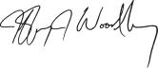
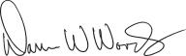

Jeffrey J. Woodbury

Secretary

Darren W. Woods

Chairman of the Board

Table of Contents

 |  |  |  |  |  |  |  |  |  |  |  |  |  | TABLE OF CONTENTS
 |  |  |  |  |  |  |  |  |  |  |  |  |  |  |  |  |  |  | Page
GENERAL INFORMATION |  |  |  |  |  |  |  |  |  |  |  |  |  |  |  |  |  |  | 1
BOARD OF DIRECTORS |  |  |  |  |  |  |  |  |  |  |  |  |  |  |  |  |  |  | 4
Corporate Governance |  |  |  |  |  |  |  |  |  |  |  |  |  |  |  |  |  |  | 4
 | Item 1 – Election of Directors |  |  |  |  |  |  |  |  |  |  |  |  |  |  |  |  |  | 15
Director Compensation |  |  |  |  |  |  |  |  |  |  |  |  |  |  |  |  |  |  | 21
Certain Beneficial Owners |  |  |  |  |  |  |  |  |  |  |  |  |  |  |  |  |  |  | 23
Director and Executive Officer Stock Ownership |  |  |  |  |  |  |  |  |  |  |  |  |  |  |  |  |  |  | 23
Audit Committee Report |  |  |  |  |  |  |  |  |  |  |  |  |  |  |  |  |  |  | 24
 | Item 2 – Ratification of Independent Auditors |  |  |  |  |  |  |  |  |  |  |  |  |  |  |  |  |  | 25
Compensation Committee Report |  |  |  |  |  |  |  |  |  |  |  |  |  |  |  |  |  |  | 26
 | Item 3 – Advisory Vote to Approve Executive Compensation |  |  |  |  |  |  |  |  |  |  |  |  |  |  |  |  |  | 26
COMPENSATION DISCUSSION AND ANALYSIS |  |  |  |  |  |  |  |  |  |  |  |  |  |  |  |  |  |  | 27
EXECUTIVE COMPENSATION TABLES |  |  |  |  |  |  |  |  |  |  |  |  |  |  |  |  |  |  | 45
SHAREHOLDER PROPOSALS |  |  |  |  |  |  |  |  |  |  |  |  |  |  |  |  |  |  | 54
 | Item 4 – Independent Chairman |  |  |  |  |  |  |  |  |  |  |  |  |  |  |  |  |  | 54
 | Item 5 – Special Shareholder Meetings |  |  |  |  |  |  |  |  |  |  |  |  |  |  |  |  |  | 55
 | Item 6 – Board Diversity Matrix |  |  |  |  |  |  |  |  |  |  |  |  |  |  |  |  |  | 56
 | Item 7 – Report on Lobbying |  |  |  |  |  |  |  |  |  |  |  |  |  |  |  |  |  | 58
PAY RATIO |  |  |  |  |  |  |  |  |  |  |  |  |  |  |  |  |  |  | 60
ADDITIONAL INFORMATION |  |  |  |  |  |  |  |  |  |  |  |  |  |  |  |  |  |  | 61
DIRECTIONS TO 2018 ANNUAL MEETING |  |  |  |  |  |  |  |  |  |  |  |  |  |  |  |  |  |  | 63

Table of Contents

GENERAL INFORMATION

Who May Vote

Shareholders of ExxonMobil, as recorded in our stock register on April 4, 2018, may vote at the meeting.

How to Vote

You may vote in person at the meeting or by proxy. We recommend you vote by proxy even if you plan to attend the meeting. You can always change your vote at the meeting.

Important Notice Regarding the Availability of Proxy Materials for the Shareholder Meeting to be held on May 30, 2018:


The 2018 Proxy Statement, 2017 Summary Annual Report, and 2017 Financial Statements are available at www.edocumentview.com/xom.

Notice and Access

We distribute proxy materials to many shareholders via the Internet under the Securities and Exchange Commission’s (SEC’s) “Notice and Access” rules, thereby capturing cost and environmental benefits. On or about April 12, 2018, we mailed a Notice Regarding the Availability of Proxy Materials (“Notice”) that contains information about our 2018 Annual Shareholders Meeting and instructions on how to view all proxy materials on the Internet. Also included are instructions on how to vote and how to request a paper or e-mail copy of the proxy materials.

Electronic Delivery of Proxy Statement and Annual Report Documents

For shareholders receiving proxy materials by mail, you can elect to receive an e-mail in the future that will provide electronic links to these documents. Opting to receive your proxy materials online will save the Company the cost of producing and mailing documents to your home or business, and will also give you an electronic link to the proxy voting site.

- Shareholders of Record: If you vote on the Internet at www.investorvote.com/exxonmobil, simply follow the prompts for enrolling in the electronic proxy delivery service. You may enroll in the electronic proxy delivery service at any time in the future by going directly to www.computershare.com/exxonmobil. You may also revoke an electronic delivery election at this site at any time.

- Beneficial Shareholders: If you hold your shares in a brokerage account, you may also have the opportunity to receive copies of the proxy materials electronically. Please check the information provided in the proxy materials mailed to you by your bank or broker regarding the availability of this service.

How Proxies Work

ExxonMobil’s Board of Directors is asking for your proxy. Giving us your proxy means you authorize us to vote your shares at the meeting in the manner you direct.

2018 Proxy Statement | 1

Table of Contents

If your shares are held in your name, you can vote by proxy in one of three convenient ways:

Via Internet | By telephone | In writing
Follow the instructions at | Call toll-free 1-800-652-8683 or | Complete, sign, date, and return your
www.investorvote.com/exxonmobil. | 1-781-575-2300 (outside the United | proxy card in the enclosed envelope. If
You will need to have your proxy card or | States, Canada, and Puerto Rico), and | you receive a Notice and would like to
Notice in hand. At this website, you can | follow the instructions. You will need to | vote in writing, please follow the
elect to access future proxy statements | have your proxy card or Notice in hand. | instructions in the Notice to obtain
and annual reports via the Internet. |  | paper proxy materials.




Your proxy card covers all shares registered in your name and shares held in your Computershare Investment Plan account. If you own shares in the ExxonMobil Savings Plan for employees and retirees, your proxy card also covers those shares.

If you give us your signed proxy but do not specify how to vote, we will vote your shares as follows:

- For the election of our director candidates;

- For ratification of the appointment of independent auditors;

- For approval of the compensation of the Named Executive Officers; and

- As recommended by the Board with respect to shareholder proposals.

If you hold shares through someone else, such as a stockbroker, you will receive material from that firm asking how you want to vote. Check the voting form used by that firm to see if it offers Internet or telephone voting.

Voting Shares in the ExxonMobil Savings Plan

The Trustee of the ExxonMobil Savings Plan will vote Plan shares as participants direct. To the extent participants do not give instructions, the Trustee will vote shares as it thinks best. The proxy card serves to give voting instructions to the Trustee.

Revoking a Proxy

You may revoke your proxy before it is voted at the meeting by:

- Submitting a new proxy with a later date via a proxy card, the Internet, or by telephone;

- Notifying ExxonMobil’s Secretary in writing before the meeting; or

- Voting in person at the meeting.

Confidential Voting

Independent inspectors count the votes. Your individual vote is kept confidential from us unless special circumstances exist. For example, a copy of your proxy card will be sent to us if you write comments on the card.

Quorum

In order to carry on the business of the meeting, we must have a quorum. This means at least a majority of the outstanding shares eligible to vote must be represented at the meeting, either by proxy or in person. Treasury shares, which are shares owned by ExxonMobil itself, are not voted and do not count for this purpose.

2 2018 Proxy Statement

Table of Contents

Votes Required

- Election of Directors Proposal: Under ExxonMobil’s bylaws, a director nominee must receive a majority of votes cast in order to be elected to the Board of Directors in a non-contested election. In a contested election (in which the number of nominees exceeds the number of directors to be elected), the plurality vote standard under New Jersey law would apply. Under plurality voting, the director nominee with the most votes for a particular seat is elected for that seat. Abstentions and broker non-votes are not counted for purposes of the election of directors. A broker non-vote occurs when a bank, broker, or other holder of record that is holding shares for a beneficial owner does not vote on a particular proposal because the record holder does not have discretionary voting power for that particular item and has not received instructions from the beneficial owner. If you own shares through a broker, you must give the broker instructions to vote your shares in the election of directors. Otherwise, your shares will not be voted.

Our Corporate Governance Guidelines, which can be found in the Corporate Governance section of our website at exxonmobil.com/guidelines, state that all directors will stand for election at the annual meeting of shareholders. In any non-contested election of directors, any director nominee who receives a greater number of votes AGAINST his or her election than votes FOR such election shall tender his or her resignation. Within 90 days after certification of the election results, the Board of Directors will decide, through a process managed by the Board Affairs Committee and excluding the nominee in question, whether to accept the resignation. Absent a compelling reason for the director to remain on the Board, the Board shall accept the resignation. The Board will promptly disclose its decision and, if applicable, the reasons for rejecting the tendered resignation on Form 8-K filed with the Securities and Exchange Commission (SEC).

- Other Proposals: Approval of the ratification of the appointment of independent auditors, the advisory vote to approve executive compensation, and the shareholder proposals requires the favorable vote of a majority of votes cast. Only votes FOR or AGAINST these proposals count.

Abstentions count for quorum purposes, but not for voting. Broker non-votes count as votes FOR the ratification of the appointment of independent auditors but do not count for voting on any of the other proposals.

Annual Meeting Admission

Only shareholders or their proxy holders and ExxonMobil guests may attend the meeting.

For safety and security reasons, cameras, smartphones, recording equipment, electronic devices, computers, large bags, briefcases, packages, and firearms or other weapons will not be permitted in the building. In addition, each shareholder and ExxonMobil guest will be asked to present valid government-issued picture identification, such as a driver’s license, before being admitted to the meeting.

For registered shareholders, an admission ticket is the upper part of your proxy card or the full Notice. Please bring the admission ticket with you to the meeting.

If your shares are held in the name of your broker, bank, or other nominee, you must bring to the meeting an account statement or letter from the nominee indicating that you beneficially owned the shares on April 4, 2018, the record date for voting. You may receive an admission ticket in advance by sending a written request with proof of ownership to the address listed below under Contact Information.

Shareholders who do not present admission tickets at the meeting will be admitted only upon verification of ownership at the admission counter.


Audio Webcast of the Annual Meeting

You are invited to visit our website at exxonmobil.com to hear the audio webcast with slide presentation at 9:30 a.m. Central Time, on Wednesday, May 30, 2018. An archived copy of this audio webcast will be available on our website for one year.

2018 Proxy Statement | 3

Table of Contents

Conduct of the Meeting

The Chairman has broad responsibility and legal authority to conduct the annual meeting in an orderly and timely manner. This authority includes establishing rules for shareholders who wish to address the meeting. Only shareholders or their valid proxy holders may address the meeting. Copies of these rules will be available at the meeting. The Chairman may also exercise broad discretion in recognizing shareholders who wish to speak and in determining the extent of discussion on each item of business. In light of the number of business items on this year’s agenda and the need to conclude the meeting within a reasonable period of time, we cannot ensure that every shareholder who wishes to speak on an item of business will be able to do so.

Dialogue can usually be better accomplished with interested parties outside the meeting and, for this purpose, we have provided a method on our website at exxonmobil.com/directors for raising issues and contacting the non-employee directors either in writing or electronically. The Chairman may also rely on applicable law regarding disruptions or disorderly conduct to ensure that the meeting is conducted in a manner that is fair to all shareholders. Shareholders making comments during the meeting must do so in English so that the majority of shareholders present can understand what is being said.


Contact Information

If you have questions or need more information about the annual meeting, write to Mr. Jeffrey J. Woodbury, Secretary, Exxon Mobil Corporation, 5959 Las Colinas Boulevard, Irving, TX 75039-2298. Alternatively, call us at 1-972-940-6715 or send a fax to 1-972-940-6748.

For information about shares registered in your name or your Computershare Investment Plan account, call ExxonMobil Shareholder Services at 1-800-252-1800 or 1-781-575-2058 (outside the United States, Canada, and Puerto Rico), or access your account via the website at www.computershare.com/exxonmobil. We also invite you to visit ExxonMobil’s website, where investor information can be found at exxonmobil.com/investor. Website materials are not part of this proxy solicitation.

BOARD OF DIRECTORS

Corporate Governance

Overview

The Board of Directors and its committees perform a number of functions for ExxonMobil and its shareholders, including:

- Overseeing the management of the Company on your behalf, including oversight of risk management;

- Reviewing ExxonMobil’s long-term strategic plans;

- Exercising direct decision-making authority in key areas, such as declaring dividends;

- Selecting the CEO and evaluating the CEO’s performance; and

- Reviewing development and succession plans for ExxonMobil’s top executives.

The Board has adopted Corporate Governance Guidelines that govern the structure and functioning of the Board and set out the Board’s position on a number of governance issues. A copy of our current Corporate Governance Guidelines is posted on our website at exxonmobil.com/guidelines.

4 2018 Proxy Statement

Table of Contents

Risk Oversight

Risk oversight is the responsibility of the full Board of Directors. The Board throughout the year participates in reviews with management on the Company’s business, including identified risk factors. As a whole, the Board reviews include litigation and other legal matters; political contributions, budget, and policy; lobbying costs; developments in climate science and policy; the Energy Outlook, which projects world supply and demand to 2040; stewardship of business performance; and long-term strategic plans.

The Board and/or the Public Issues and Contributions Committee visit an ExxonMobil operation each year. These visits allow the directors to better understand local issues and to discuss safety, environmental performance, technology, products, industry and corporate standards, and community involvement associated with the Company’s business.

In addition, existing committees help the Board carry out its responsibility for risk oversight by focusing on specific key areas of risk:

- The Audit Committee oversees risks associated with financial and accounting matters, including compliance with legal and regulatory requirements, and the Company’s financial reporting and internal control systems;

- The Board Affairs Committee oversees risks associated with corporate governance, including board structure and succession planning;

- The Compensation Committee helps ensure that the Company’s compensation policies and practices encourage long-term focus, support the retention and development of executive talent, and discourage excessive risk taking;

- The Public Issues and Contributions Committee oversees operational risks such as those relating to employee and community safety, health, environmental, and security matters; and

- The Finance Committee oversees risk associated with financial instruments, financial policies and strategies, and capital structure.

The Board receives regular updates from the committees, and believes this structure is best for overseeing risk.

Board Leadership Structure

The Board believes that the decision as to who should serve as Chairman and/or CEO is the proper responsibility of the Board. The Board retains authority to amend the bylaws to separate the positions of Chairman and CEO at any time and will carefully consider the pros and cons of such separation or combination. At the present time, the Board believes the interests of all shareholders are best served through a leadership model with a combined Chairman/CEO position and an independent Presiding Director.

The current CEO possesses an in-depth knowledge of the Company; its integrated, multinational operations; the evolving energy industry supply and demand; and the array of challenges to be faced. This knowledge was gained through more than 25 years of successful experience in progressively more senior positions, including domestic and international responsibilities.

The Board believes that these experiences and other insights put the CEO in the best position to provide broad leadership for the Board as it considers strategy and as it exercises its fiduciary responsibilities to shareholders. Further, the Board has demonstrated its commitment and ability to provide independent oversight of management.

The Board is comprised entirely of independent directors except the CEO, and 100 percent of the Audit, Compensation, Board Affairs, and Public Issues and Contributions Committee members are independent. Each independent director has access to the CEO and other Company executives on request, may call meetings of the independent directors, and may request agenda topics to be added or dealt with in more detail at meetings of the full Board or an appropriate Board committee.

2018 Proxy Statement | 5

Table of Contents

In addition, after considering evolving governance practices and shareholder input regarding Board independence, the Board established the role of Presiding Director. The Board believes the Presiding Director can provide effective independent Board leadership. Steven S Reinemund serves as Presiding Director and is expected to remain in the position at least through the annual meeting of shareholders. In accordance with the specific duties prescribed in the Corporate Governance Guidelines, the Presiding Director chairs and approves the agenda for executive sessions of the independent directors, which are held several times per year, normally coincident with meetings of the Board and without the CEO or other management present; chairs meetings of the Board in the absence of the Chairman; and works closely with the Chairman in developing Board agendas, topics, schedules, and in reviewing materials provided to the directors.

Director Qualifications

The Board has adopted guidelines outlining the qualifications sought when considering non-employee director candidates. These Guidelines for the Selection of Non-Employee Directors (“Selection Guidelines”), which are published on our website at exxonmobil.com/directorguidelines, are reviewed annually and state in part:

“ExxonMobil recognizes the strength and effectiveness of the Board reflect the balance, experience, and diversity of the individual directors; their commitment; and importantly, the ability of directors to work effectively as a group in carrying out their responsibilities. ExxonMobil seeks candidates with diverse backgrounds who possess knowledge and skills in areas of importance to the Corporation.”

The experience, qualifications, and attributes we consider for director candidates include:

- Individuals who have achieved prominence in their fields

- Diversity of life experiences and backgrounds, as well as gender and ethnic diversity

- Experience and demonstrated expertise in managing large, relatively complex organizations, such as that of CEOs or next-level executives of a significant company or organization with global responsibilities

- Financial and other risk management expertise

- Experience on one or more boards of significant public or nonprofit organizations

- Expertise resulting from significant academic, scientific, or research activities

- Experience with cyclical businesses, such as commodities

Other considerations:

- A substantial majority of the Board must meet independence standards as described in the Corporate Governance Guidelines

- All candidates must be free from any relationship with management or the Corporation that would interfere with the exercise of independent judgment

- Candidates should be committed to representing the interests of all shareholders and not any particular constituency

- The Board must include members who satisfy legal and stock exchange requirements for certain Board committees

6 2018 Proxy Statement

Table of Contents

The Board is comprised of an effective mix of backgrounds, knowledge, and skills. The graph below provides a summary of the collective competencies and diversity of the Board nominees:
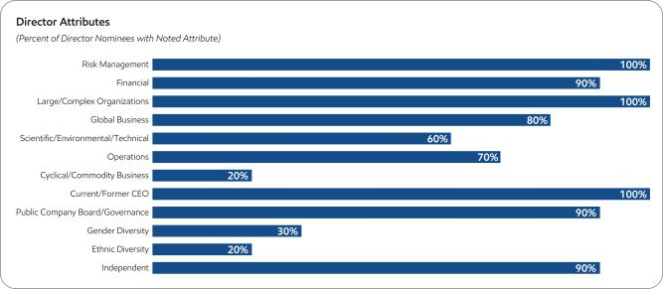

Board Succession

As noted in the committee information on pages 11 and 12, the Board Affairs Committee is responsible for identifying director candidates. The Committee seeks new candidates in several ways:

- Recommendations made by the non-employee directors. These recommendations are developed based on the directors’ own knowledge and experience in a variety of fields and on the research conducted by ExxonMobil staff at the Committee’s direction.

- Engagement of an executive search firm. The firm brings forward potential director candidates for the Committee to consider and helps research candidates identified by the Committee.

- Recommendations made by employee directors, shareholders, and others.

All recommendations, regardless of the source, are evaluated on the same basis against the criteria contained in the Selection Guidelines. The Committee has also instructed its executive search firm to include diversity as part of the candidate search criteria.

Shareholders may send recommendations for director candidates to the Secretary at the address given under Contact Information on page 4. A submission recommending a candidate should include:

- Sufficient biographical information to allow the Committee to evaluate the candidate in light of the Selection Guidelines;

- Information concerning any relationship between the candidate and the shareholder recommending the candidate; and

- Material indicating the willingness of the candidate to serve if nominated and elected.

The procedures by which shareholders may recommend nominees have not changed materially since last year’s proxy statement.

The Company seeks to have a diverse Board representing a range of backgrounds, knowledge, and skills relevant to the Company’s business and the needs of the Board, and as part of the search process, considers highly qualified candidates, including women and minorities. The Committee does not use quotas but considers diversity along with the other requirements of the Selection Guidelines when evaluating potential new directors.

2018 Proxy Statement | 7

Table of Contents

The recommendation of Mr. Kandarian was made by incumbent directors and the executive search firm.

Board Tenure

The Board does not impose tenure limits on its directors, other than a mandatory retirement age of 72 and the requirement to stand for election annually. Given the complexity and breadth of our business and its long investment horizons, the Board considers longevity of service and experience of great value. The Board also believes that its director compensation approach, which limits the vesting of restricted shares until retirement, closely aligns directors with the interests of long-term shareholders. The Board seeks to achieve a balance of diversity and experience in the composition of the Board.

All ExxonMobil directors stand for election at the annual meeting. Non-employee directors cannot stand for election after they have reached age 72, unless the Board makes an exception on a case-by-case basis. Employee directors resign from the Board when they are no longer employed by ExxonMobil.

As of April 1, 2018, the average tenure of non-employee directors standing for election is 5.3 years, well below the average of S&P 500 companies of 8.2 years (per 2017 Spencer Stuart Board Index).

Director Independence

Our Corporate Governance Guidelines require that a substantial majority of the Board consist of independent directors. In general, the Guidelines require that an independent director must have no material relationship with ExxonMobil, directly or indirectly, except as a director. The Board determines independence on the basis of the standards specified by the New York Stock Exchange (NYSE), the additional standards referenced in our Corporate Governance Guidelines, and other facts and circumstances the Board considers relevant.

Under ExxonMobil’s Corporate Governance Guidelines, a director will not be independent if a reportable “related person transaction” exists with respect to that director or a member of the director’s family for the current or most recently completed fiscal year. See the Guidelines for Review of Related Person Transactions posted on the Corporate Governance section of our website and described in more detail under Related Person Transactions and Procedures on pages 8 to 10.

The Board has reviewed relevant relationships between ExxonMobil and each non-employee director and director nominee to determine compliance with the NYSE standards and ExxonMobil’s additional standards. The Board has also evaluated whether there are any other facts or circumstances that might impair a director’s independence. Based on that review, the Board has determined that all ExxonMobil non-employee directors and nominees are independent. The Board has also determined that each member of the Audit, Board Affairs, Compensation, and Public Issues and Contributions Committees (see membership table on page 11) is independent based on both applicable NYSE standards and the Company’s independence standards for each of these committees. The Company’s standards for each committee are included in their respective charters and are posted on our website at exxonmobil.com/governance. Website materials are not part of this proxy statement or the accompanying solicitation.

In recommending that each director and nominee be found independent, the Board Affairs Committee reviewed the following transactions, relationships, or arrangements. All matters described below fall within the NYSE and ExxonMobil independence standards.

Name | Matters Considered
K.C. Frazier | Ordinary course business with Merck (purchases of pharmaceuticals; sales of chemicals and oils)
S.A. Kandarian | Ordinary course business with MetLife (purchases of employee life insurance, other benefits)

Related Person Transactions and Procedures

In accordance with SEC rules, ExxonMobil maintains Guidelines for Review of Related Person Transactions. These Guidelines are available on the Corporate Governance section of our website.

8 2018 Proxy Statement

Table of Contents

In accordance with the Related Person Transaction Guidelines, all executive officers, directors, and director nominees are required to identify, to the best of their knowledge after reasonable inquiry, business and financial affiliations involving themselves or their immediate family members that could reasonably be expected to give rise to a reportable related person transaction. Covered persons must also advise the Secretary of the Corporation promptly of any change in the information provided, and will be asked periodically to review and reaffirm their information.

For the above purposes, “immediate family member” includes a person’s spouse, parents, siblings, children, in-laws, and step-relatives.

Based on this information, we review the Company’s own records and make follow-up inquiries as may be necessary to identify potentially reportable transactions. A report summarizing such transactions and including a reasonable level of detail is then provided to the Board Affairs Committee. The Committee oversees the Related Person Transaction Guidelines generally and reviews specific items to assess materiality.

In assessing materiality for this purpose, information will be considered material if, in light of all circumstances, there is a substantial likelihood a reasonable investor would consider the information important in deciding whether to buy or sell ExxonMobil stock or in deciding how to vote shares of ExxonMobil stock. A director will abstain from the decision on any transactions involving that director or his or her immediate family members.

Under SEC rules, certain transactions are deemed not to involve a material interest (including transactions in which the amount involved in any 12-month period is less than $120,000 and transactions with entities where a related person’s interest is limited to service as a non-employee director). In addition, based on a consideration of ExxonMobil’s facts and circumstances, the Committee will presume that the following transactions do not involve a material interest for purposes of reporting under SEC rules:

- Transactions in the ordinary course of business with an entity for which a related person serves as an executive officer, provided: (1) the affected director or executive officer did not participate in the decision on the part of ExxonMobil to enter into such transactions; and (2) the amount involved in any related category of transactions in a 12-month period is less than 1 percent of the entity’s gross revenues.

- Grants or membership payments in the ordinary course of business to nonprofit organizations, provided: (1) the affected director or executive officer did not participate in the decision on the part of ExxonMobil to make such payments; and (2) the amount of general purpose grants in a 12-month period is less than 1 percent of the recipient’s gross revenues.

- Payments under ExxonMobil plans and arrangements that are available generally to U.S. salaried employees (including contributions under the ExxonMobil Foundation’s Educational and Cultural Matching Gift Programs and payments to providers under ExxonMobil health care plans).

- Employment by ExxonMobil of a family member of an executive officer, provided the executive officer does not participate in decisions regarding the hiring, performance evaluation, or compensation of the family member.

Transactions or relationships not covered by the above standards will be assessed by the Committee on the basis of the specific facts and circumstances.

The following disclosures are made as of February 28, 2018, the date of the most recent Board Affairs Committee review of potential related person transactions.

ExxonMobil and its affiliates have more than 70,000 employees around the world and employees related by birth or marriage may be found at all levels of the organization. ExxonMobil employees do not receive preferential treatment by reason of being related to an executive officer, and executive officers do not participate in hiring, performance evaluation, or compensation decisions for family members. ExxonMobil’s employment guidelines state, “Relatives of Company employees may be employed on a non-preferential basis. However, an employee should not be employed by or assigned to work under the direct supervision of a relative, or to report to a supervisor who in turn reports to a relative of the employee.”

2018 Proxy Statement | 9

Table of Contents

Several current ExxonMobil executive officers have family members who are employed by the Corporation or its affiliates and whose current annualized compensation (including benefits) exceeds the SEC disclosure threshold: M.W. Albers (Senior Vice President) has a daughter employed by ExxonMobil Global Services Company; R.N. Schleckser (Vice President and Treasurer) has a brother employed by ExxonMobil Research and Engineering Company; S.M. Greenlee (Vice President) has a son-in-law employed by ExxonMobil Chemical Company; L.M. Mallon (President, ExxonMobil Development Company) has a son employed by ExxonMobil Research and Engineering Company; J.M. Spellings (Vice President and General Tax Counsel) has a son employed by ExxonMobil Pipeline Company; and J.J. Woodbury (Vice President – Investor Relations and Secretary) has a son employed by XTO Energy Inc. Consistent with ExxonMobil’s Related Person Transaction Guidelines as described above, we do not consider any of these relationships to be material within the meaning of the related person transaction disclosure rules.

S.N. Ortwein (President, XTO Energy Inc.) has a brother-in-law currently serving as Chief Executive Officer of Oracle Corporation. In the ordinary course of our business, ExxonMobil purchases a variety of computer technology and services from Oracle. Ms. Ortwein has no involvement in decisions regarding ExxonMobil’s business with Oracle and the annual volume of such business is well below the categorical threshold established in ExxonMobil’s Related Person Transaction Guidelines. R.M. Ebner (Vice President and General Counsel) has a brother-in-law who is a partner of a law firm that performs limited work for ExxonMobil. Mr. Ebner’s brother-in-law does not work on ExxonMobil’s account and Mr. Ebner is recused from any involvement in decisions to retain the firm. Therefore, we do not consider these relationships to be material within the meaning of the related person transaction disclosure rules.

The Board Affairs Committee also reviewed ExxonMobil’s ordinary course business with companies for which non-employee directors or their immediate family members serve as executive officers. The Committee determined that, in accordance with the categorical standards described above, none of those matters represent reportable related person transactions. See Director Independence on page 8.

The Committee also determined that no related person transactions occurred during the year involving any of the investors who have reported ownership of 5 percent or more of ExxonMobil’s outstanding common stock. See “Certain Beneficial Owners” on page 23.

We are not aware of any related person transactions required to be reported under applicable SEC rules since the beginning of the last fiscal year where our policies and procedures did not require review, or where such policies and procedures were not followed.

The Corporation’s Related Person Transaction Guidelines are intended to assist the Corporation in complying with its disclosure obligations under SEC rules. These procedures are in addition to, not in lieu of, the Corporation’s Code of Ethics and Business Conduct.

Code of Ethics and Business Conduct

The Board maintains policies and procedures (which we refer to in this proxy statement as the “Code”) that represent both the code of ethics for the principal executive officer, principal financial officer, and principal accounting officer under SEC rules, and the code of business conduct and ethics for directors, officers, and employees under NYSE listing standards. The Code applies to all directors, officers, and employees. The Code includes a Conflicts of Interest Policy under which directors, officers, and employees are expected to avoid any actual or apparent conflict between their own personal interests and the interests of the Corporation.

The Code is posted on the ExxonMobil website at exxonmobil.com/code. The Code is also included as an exhibit to our Annual Report on Form 10-K. Any amendment of the Code will be posted promptly on our website.

The Corporation maintains procedures for administering and reviewing potential issues under the Code, including procedures that allow employees to make complaints without identifying themselves. The Corporation also conducts periodic mandatory business practice training sessions, and requires regular employees and non-employee directors to complete annual compliance certifications.

10 2018 Proxy Statement

Table of Contents

The Board Affairs Committee will initially review any suspected violation of the Code involving an executive officer or director and will report its findings to the Board. The Board does not envision that any waiver of the Code will be granted. Should such a waiver occur, it will be promptly disclosed on our website.

Board Meetings and Annual Meeting Attendance

The Board met 11 times in 2017. ExxonMobil’s incumbent directors, on average, attended approximately 98 percent of Board and committee meetings during 2017. No director attended less than 75 percent of such meetings. ExxonMobil’s non-employee directors held six executive sessions in 2017.

As specified in our Corporate Governance Guidelines, it is ExxonMobil’s policy that directors should make every effort to attend the annual meeting of shareholders. All incumbent directors attended last year’s meeting except Mr. Kandarian, who was first elected to the Board effective February 1, 2018.

Board Committees

The Board appoints committees to help carry out its duties. Board committees work on key issues in greater detail than would be possible at full Board meetings. Only non-employee directors may serve on the Audit, Compensation, Board Affairs, and Public Issues and Contributions Committees. Each committee has a written charter. The charters are posted on the Corporate Governance section of our website at exxonmobil.com/governance.

The table below shows the current membership of each Board committee and the number of meetings each committee held in 2017.

 |  |  | Board |  | Public Issues | Executive⁽¹⁾
Director | Audit | Compensation | Affairs | Finance | and Contributions | Executive⁽¹⁾
S.K. Avery |  |  | ✓ |  | ✓
M.J. Boskin |  | ✓ |  |  | C | ✓
A.F. Braly |  | ✓ |  |  | ✓
U.M. Burns | C |  |  | ✓
K.C. Frazier |  | ✓ | C |  |  | ✓
S.A. Kandarian |  | ✓ |  |  | ✓
D.R. Oberhelman | ✓ |  |  | ✓
S.J. Palmisano |  | C | ✓ |  |  | ✓
S.S Reinemund |  |  | ✓ |  | ✓ | ✓
W.C. Weldon | ✓ |  |  | ✓
D.W. Woods |  |  |  | C |  | C
2017 Meetings | 11 | 7 | 7 | 2 | 4 | 0
C = Chair ✓ = Member | (1) Other directors serve as alternate members on a rotational basis

Below is additional information about each Board committee.

Board Affairs Committee

The Board Affairs Committee serves as ExxonMobil’s nominating and corporate governance committee. Its responsibilities include:

- Recommendation of director candidates;

- Review of non-employee director compensation;

- Review of other corporate governance practices, including the Corporate Governance Guidelines;

2018 Proxy Statement | 11

Table of Contents

- Reviews any issue involving an executive officer or director under ExxonMobil’s Code of Ethics and Business Conduct; and

- Administers ExxonMobil’s Related Person Transaction Guidelines.

The Committee also administers provisions of the Corporate Governance Guidelines that require a director to tender a resignation when there is a substantial change in the director’s circumstances. The Committee reviews the relevant facts to determine whether the director’s continued service would be appropriate and makes a recommendation to the Board.

Another responsibility of the Committee is to review and make recommendations to the Board regarding the compensation of the non-employee directors. The Committee uses an independent consultant, Pearl Meyer & Partners, LLC (Pearl Meyer), to provide information on current developments and practices in director compensation. Pearl Meyer is the same consultant retained by the Compensation Committee to advise on executive compensation, but performs no other work for ExxonMobil.

The Guidelines for the Selection of Non-Employee Directors describe the qualifications the Committee looks for in director candidates. These Selection Guidelines, as well as the Committee’s charter, are posted on the Corporate Governance section of our website, and are described in more detail below and in the section titled Director Qualifications on pages 6 and 7.

Audit Committee

The Audit Committee oversees accounting and internal control matters. Its responsibilities include oversight of:

- Management’s conduct of the Corporation’s financial reporting process;

- The integrity of the financial statements and other financial information provided by the Corporation to the SEC and the public;

- The Corporation’s system of internal accounting and financial controls;

- The Corporation’s compliance with legal and regulatory requirements;

- The performance of the Corporation’s internal audit function;

- The independent auditors’ qualifications, performance, and independence; and

- The annual independent audit of the Corporation’s financial statements.

The Committee has direct authority and responsibility to appoint (subject to shareholder ratification), compensate, retain, and oversee the independent auditors.

The Committee also prepares the report that SEC rules require be included in the Corporation’s annual proxy statement.

This report is on pages 24 to 25.

The Audit Committee has adopted specific policies and procedures for pre-approving fees paid to the independent auditors. Under the Audit Committee’s approach, an annual program of work is approved each October for the following categories of services: Audit, Audit-Related, and Tax. Additional engagements may be brought forward from time to time for pre-approval by the Audit Committee. Pre-approvals apply to engagements within a category of service, and cannot be transferred between categories. If fees might otherwise exceed pre-approved amounts for any category of permissible services, the incremental amounts must be reviewed and pre-approved prior to commitment. The complete text of the Audit Committee’s pre-approval policies and procedures is posted on the Corporate Governance section of ExxonMobil’s website.

The Board has determined that all members of the Committee are financially literate within the meaning of the NYSE standards, and that Ms. Burns, Mr. Oberhelman, and Mr. Weldon are “audit committee financial experts” as defined in the SEC rules.

12 2018 Proxy Statement

Table of Contents

Compensation Committee

The Compensation Committee is comprised exclusively of non-employee, independent directors and oversees compensation for ExxonMobil’s senior executives (including salary, bonus, and performance share awards) as well as succession planning for key executive positions. The Committee’s charter is available on the Corporate Governance section of our website.

During 2017, the Committee took the following actions:

- Reviewed and approved the corporate goals and objectives relevant to the compensation of the CEO;

- Reviewed the Corporation’s business results and progress on strategic plans during the year with ExxonMobil’s CEO and other senior executives;

- Carefully considered the results of the 2017 advisory vote on executive compensation;

- Assessed each element of the Company’s compensation program and practices, and confirmed that they do not create any material adverse risks for the Company. The key design features of the compensation program that discourage executives from taking inappropriate risk are described in detail in this proxy statement (see pages 36 and 40 to 43);

- Discussed the Company’s executive compensation program with its independent consultant;

- Established the aggregate annual ceilings for the 2017 short-term and long-term incentive award programs taking into account input received from the CEO and other senior executives;

- Approved the salary program for 2018;

- Reviewed the performance and contributions of, and granted incentive awards and salary for the CEO. The CEO does not participate in or provide input on decisions regarding his own compensation;

- Reviewed the individual performance and contributions of, and granted individual incentive awards and set salaries for other senior executives based on recommendations to the Committee by the CEO; and

- Reviewed progress on executive development and succession planning for senior-level positions with input from the CEO.

The Committee does not delegate its responsibilities with respect to ExxonMobil’s executive officers and other senior executives (currently 25 positions). For other employees, the Committee delegates authority to determine individual salaries and incentive awards to a committee currently consisting of the Chairman and the Senior Vice Presidents of the Corporation. That committee’s actions are subject to a salary budget and aggregate annual ceilings on short-term and long-term incentive awards established by the Compensation Committee.

For more information on the compensation decisions made by the Committee for 2017, refer to the Compensation Discussion and Analysis (CD&A) beginning on page 27.

The Compensation Committee’s report is available on page 26.

The Compensation Committee utilizes the expertise of an external independent consultant, Pearl Meyer. At the direction of the Committee, Pearl Meyer:

- Attends Committee meetings;

- Informs the Committee regarding general trends in executive compensation across industries;

- Prepares the analysis of comparator company compensation used by the Committee; and

- Participates in the Committee’s deliberations regarding compensation for Named Executive Officers.

In addition, at the direction of the Chair of the Board Affairs Committee, Pearl Meyer provides an annual survey of non-employee director compensation for use by that Committee.

2018 Proxy Statement | 13

Table of Contents

The Compensation Committee is solely and directly responsible for the appointment, compensation, and oversight of the consultant. The Committee considers factors that could affect Pearl Meyer’s independence, including that the consultant provides no other services for ExxonMobil other than its engagement by the Committee and the Board Affairs Committee as described above. Based on this review, the Committee has determined the consultant’s work for the Committee to be free from conflicts of interest.

Finance Committee

The Finance Committee reviews ExxonMobil’s financial policies and strategies, including our capital structure, dividends, and share purchase program. The Committee authorizes the issuance of corporate debt subject to limits set by the Board. The Committee’s charter is available on the Corporate Governance section of our website.

Public Issues and Contributions Committee

The Public Issues and Contributions Committee reviews the effectiveness of the Corporation’s policies, programs, and practices with respect to safety, security, health, the environment, and social issues. The Committee hears reports from operating units on safety and environmental activities, and also visits operating sites to observe and comment on current operating practices. In addition, the Committee reviews the level of ExxonMobil’s support for education and other public service programs, including the Company’s contributions to the ExxonMobil Foundation. The Foundation works to improve the quality of education in the United States at all levels, with special emphasis on math and science. The Foundation also supports the Company’s other cultural and public service giving. The Committee’s charter is available on the Corporate Governance section of our website.

Executive Committee

The Executive Committee has broad power to act on behalf of the Board. In practice, the Committee meets only when it is impractical to call a meeting of the full Board.


Shareholder Engagement

We believe ongoing engagement with our shareholders is vitally important. ExxonMobil understands the importance of keeping shareholders informed about our business and to address areas of interest. In 2017, the Company held shareholder engagements on environmental, social, and governance matters with institutional investors, pension funds, and labor, religious, and nongovernmental organizations representing over 1.2 billion shares, or about

30 percent of total shares outstanding and nearly 50 percent of institutional shareholdings. The number of engagements with shareholders on environmental, social, and governance issues is up 75 percent since 2014.

The Company communicates with shareholders through a variety of means, including publications we issue throughout the year; our website (including the Perspectives blog); the annual shareholders meeting; webcasts, including our annual executive compensation and governance webcast during which any shareholder can submit comments or questions; and through direct interface. We welcome and value input from all shareholders, and such input is taken seriously by the Company.

The Board Affairs Committee has approved and implemented procedures for shareholders and other interested persons to send written or electronic communications to individual directors, including the Presiding Director, Board committees, or the non-employee directors as a group.

- Written Communications: Written correspondence should be addressed to the director or directors in care of the Secretary at the address given under Contact Information on page 4.

- Electronic Communications: You may send e-mail to individual non-employee directors, Board committees, or the non-employee directors as a group by using the form provided for that purpose on our website at exxonmobil.com/directors.

Additional instructions and procedures for communicating with the directors are posted on the Corporate Governance section of our website at exxonmobil.com/proceduresdircom.

14 2018 Proxy Statement

Table of Contents

Item 1 – Election of Directors

The Board of Directors has nominated the director candidates named on the following pages. Personal information on each of our nominees, including public company directorships during the past five years, is provided. Also included are the particular experiences, qualifications, attributes, and skills of each director nominee that led the Board to conclude that such person should serve as a director of the Company. All of our nominees currently serve as ExxonMobil directors.

All director nominees have stated they are willing to serve if elected. If a nominee becomes unavailable before the election, your proxy authorizes the people named as proxies to vote for a replacement nominee if the Board names one. Alternatively, the Board may reduce its size to equal the number of remaining nominees.

The Board recommends you vote FOR each of the following candidates:
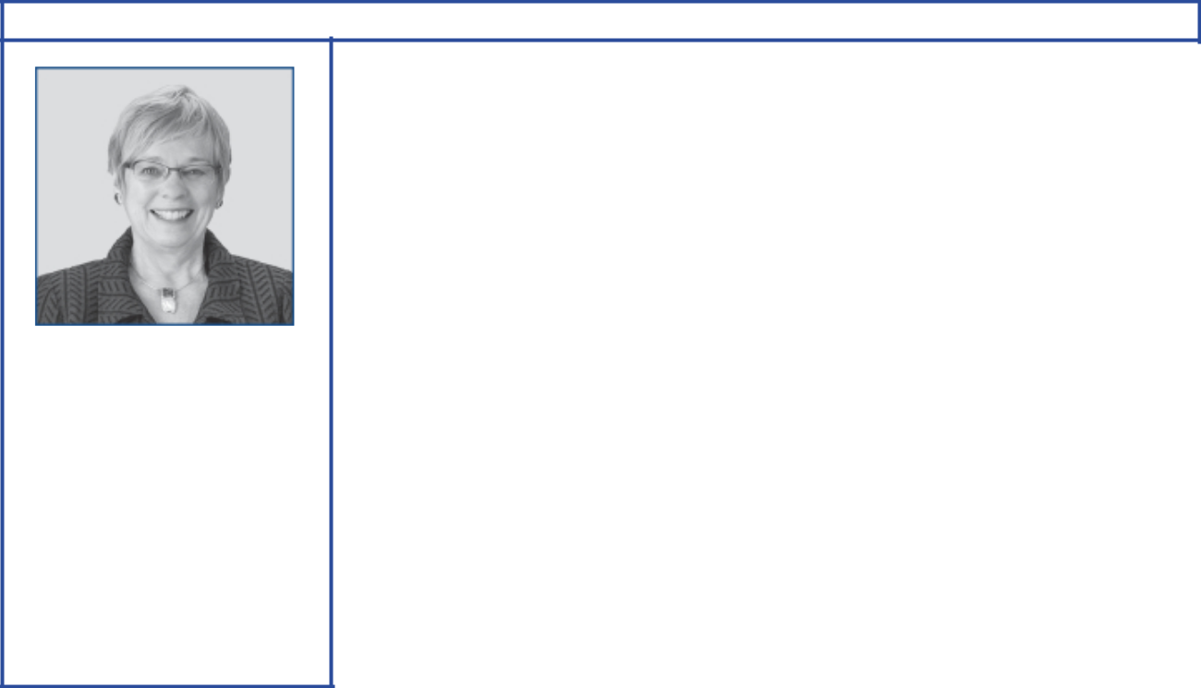

Susan K. Avery

Principal occupation: President Emerita of the Woods Hole Oceanographic Institution

Age 68

Director since 2017
Independent director

Committees:

Board Affairs, Public Issues and Contributions

Experience, qualifications, and attributes:

- Global leadership at the Woods Hole Oceanographic Institution, a global research organization, as President and Director from 2008 to 2015

- Academic leadership at the University of Colorado Boulder as interim dean of the graduate school and vice chancellor for research, interim provost, and executive vice chancellor for academic affairs from 2004 to 2008

- Government/scientific research experience as member of the Scientific Advisory Board of the United Nations Secretary-General and member of the National Research Council Global Change Research Program Advisory Committee

- Scientific and research advisory committee memberships at NASA, NOAA, National Science Foundation, National Park System, Climate Change Science Program, Center for Southern Hemisphere Ocean Research, Qingdao National Laboratory for Marine Science and Technology, and Japan Agency for Marine-Earth Science and Technology

- Scientific and environmental affiliations: Consortium for Ocean Leadership (senior fellow), American Geophysical Union, American Meteorological Society (fellow), American Association for the Advancement of Science (fellow), and Institute of Electrical and Electronics Engineers

Current public company directorships: None

Previous public company directorships in last five years: None

2018 Proxy Statement | 15

Table of Contents
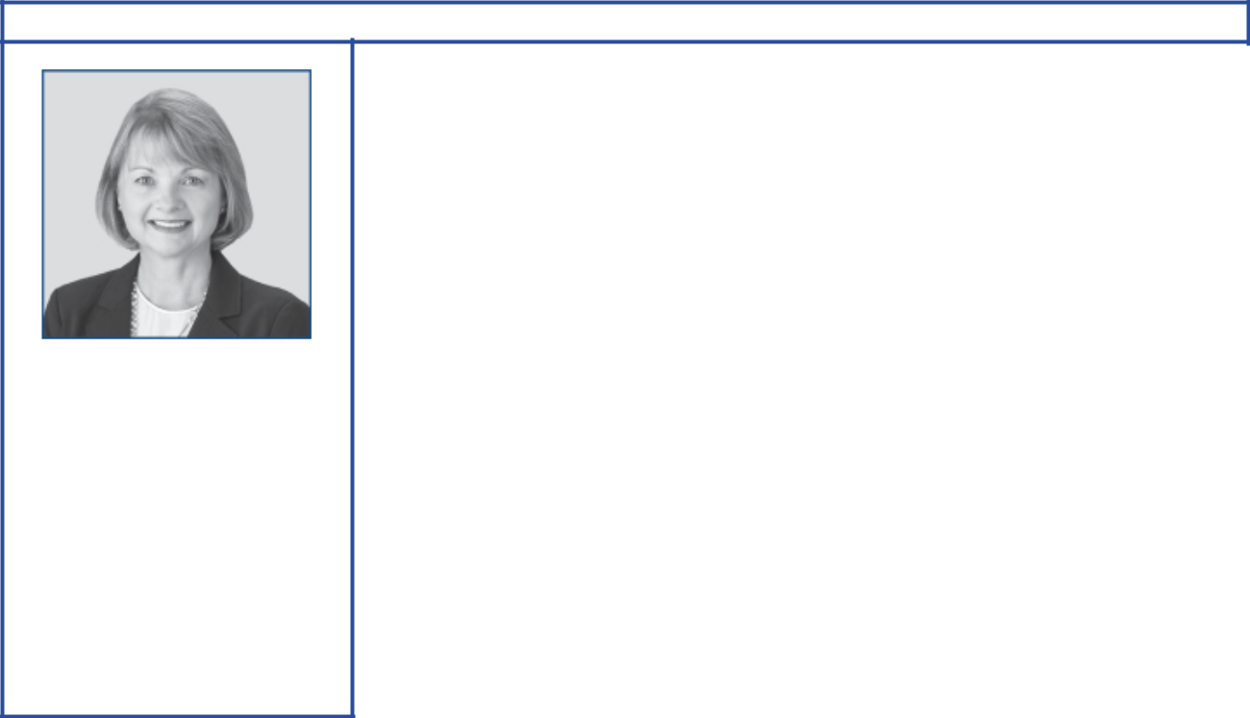

Angela F. Braly

Principal occupation: Former Chairman of the Board, President, and Chief Executive Officer of WellPoint (now Anthem), a health insurance company

Age 56

Director since 2016
Independent director

Committees:

Compensation, Public Issues
and Contributions

Experience, qualifications, and attributes:

- Business leadership at WellPoint as Chairman from 2010 to 2012; as President and Chief Executive Officer from 2007 to 2012; and as Executive Vice President, General Counsel, and Chief Public Affairs Officer from 2005 to 2007. She also served as President and Chief Executive Officer of Blue Cross Blue Shield of Missouri from 2003 to 2005.

- Business and public policy affiliations: Policy Circle (Co-Founder and Director), Indiana Economic Development Corporation (Director), Business Council (former member), Business Roundtable (former member), Harvard Advisory Council on Health Care Policy, and Blue Cross Blue Shield Association (former Director)

Current public company directorships: Brookfield Asset Management (May 2015– Present); Lowe’s (November 2013–Present); Procter & Gamble (December 2009– Present)

Previous public company directorships in last five years: None

Other board experience: former Director of WellPoint (prior to 2013)
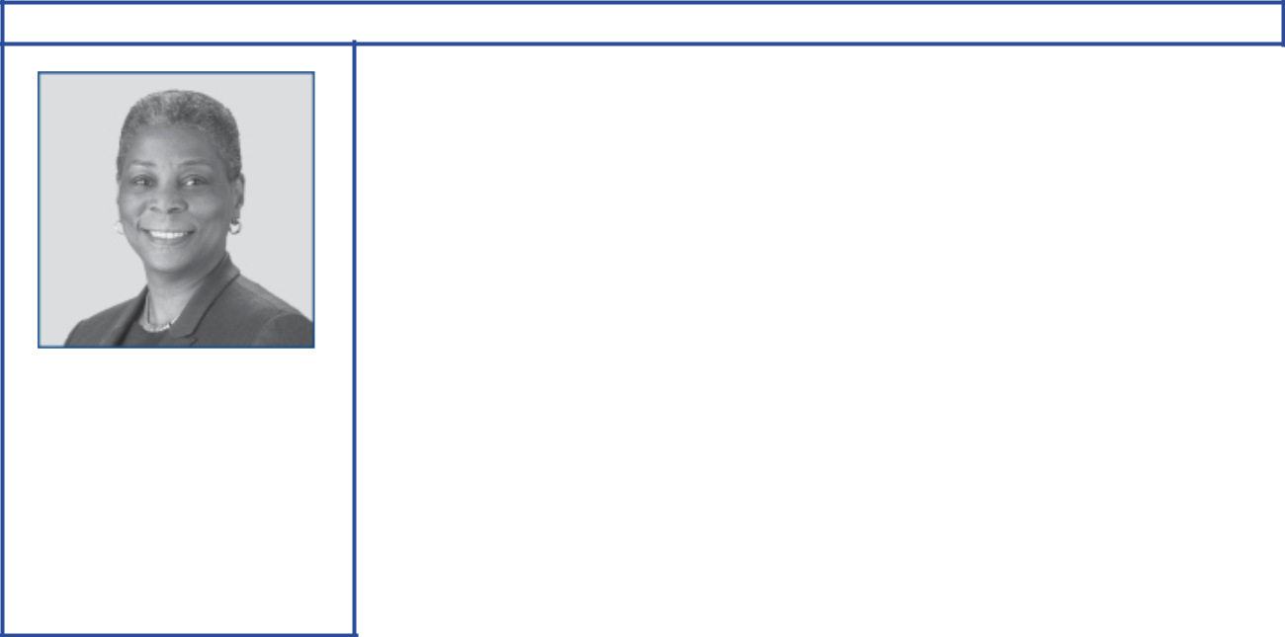

Ursula M. Burns

Principal occupation: Former Chairman of the Board, Xerox Corporation

Age 59

Director since 2012
Independent director

Committees:

Audit, Finance

Experience, qualifications, and attributes:

- Global business leadership at Xerox as Chairman from 2010 to 2017; as Chief Executive Officer from 2009 to 2016; and as President from 2007 to 2016. She also served as Senior Vice President, Corporate Strategic Services; and Senior Vice President and President, Document Systems and Solutions Group, and Business Group Operations, at Xerox.

- Government/public policy experience as Chair of the President’s Export Council

- Scientific, educational, and nonprofit affiliations: Change the Equation, an organization created to improve STEM education (founding Director), FIRST (For Inspiration and Recognition of Science and Technology), Ford Foundation, National Academy Foundation, Mayo Clinic, MIT, National Academy of Engineering, and American Academy of Arts and Sciences

Current public company directorships: American Express (January 2004–Present); Nestlé (April 2017–Present); VEON (July 2017–Present)

Previous public company directorships in last five years: Xerox (April 2007–May 2017)

Other board experience: former Director of Boston Scientific (prior to 2013)

16 2018 Proxy Statement

Table of Contents
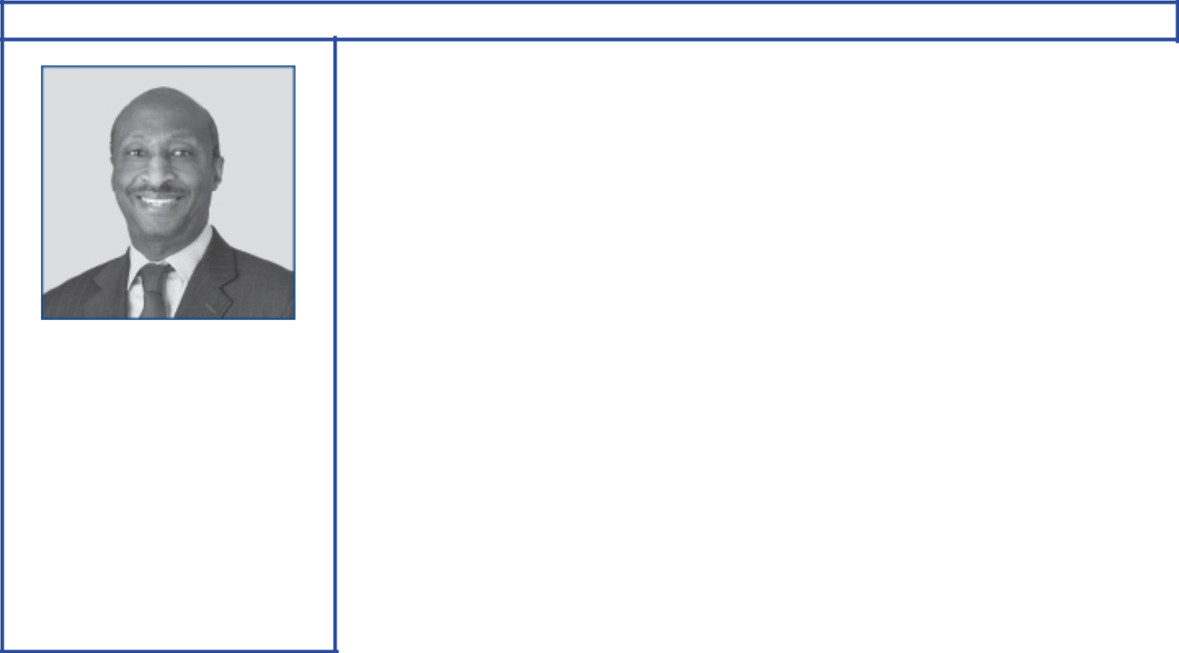

Kenneth C. Frazier

Principal occupation: Chairman of the Board, President, and Chief Executive Officer, Merck & Co.

Age 63

Director since 2009
Independent director

Committees:

Board Affairs, Compensation, Executive

Experience, qualifications, and attributes:

- Global business leadership at Merck as Chairman and Chief Executive Officer from 2011 to present; as President from 2010 to present; and as Executive Vice President and President, Global Human Health, from 2007 to 2010. He also served as Executive Vice President and General Counsel and as Senior Vice President and General Counsel.

- Legal, business, and research affiliations: American Law Institute, Business Council, and Pharmaceutical Research and Manufacturers of America

Current public company directorships: Merck (January 2011–Present)

Previous public company directorships in last five years: None
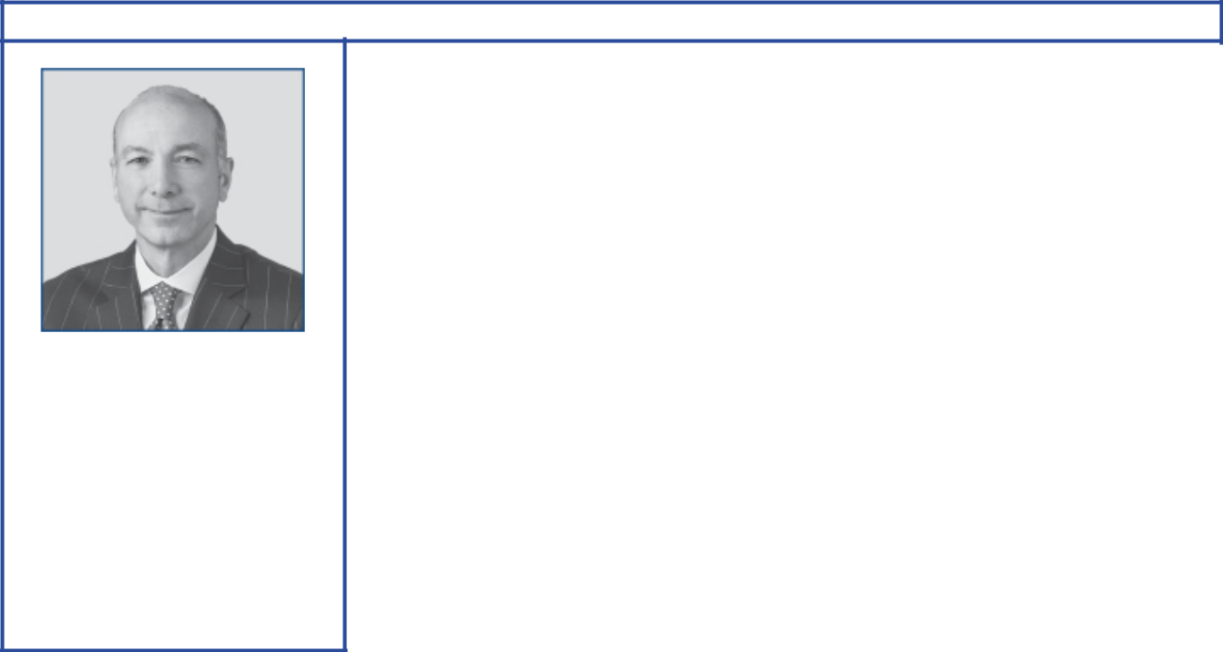

Steven A. Kandarian

Principal occupation: Chairman of the Board, President, and Chief Executive Officer, MetLife

Age 66

Director since 2018
Independent director

Committees:

Compensation, Public Issues
and Contributions

Experience, qualifications, and attributes:

- Global business leadership at MetLife as Chairman since 2012; as President and Chief Executive Office since 2011; and as Executive Vice President and Chief Investment Officer from 2005 to 2011. He also served as Executive Director of the Pension Benefit Guaranty Corporation from 2001 to 2004.

- Business, research, and cultural affiliations: Business Roundtable, Business Council, Institute of International Finance (Chair, Insurance Regulatory Committee), Partnership for New York City, Damon Runyon Cancer Research Foundation, and Lincoln Center for the Performing Arts

Current public company directorships: MetLife (May 2011–Present)

Previous public company directorships in last five years: None

2018 Proxy Statement | 17

Table of Contents
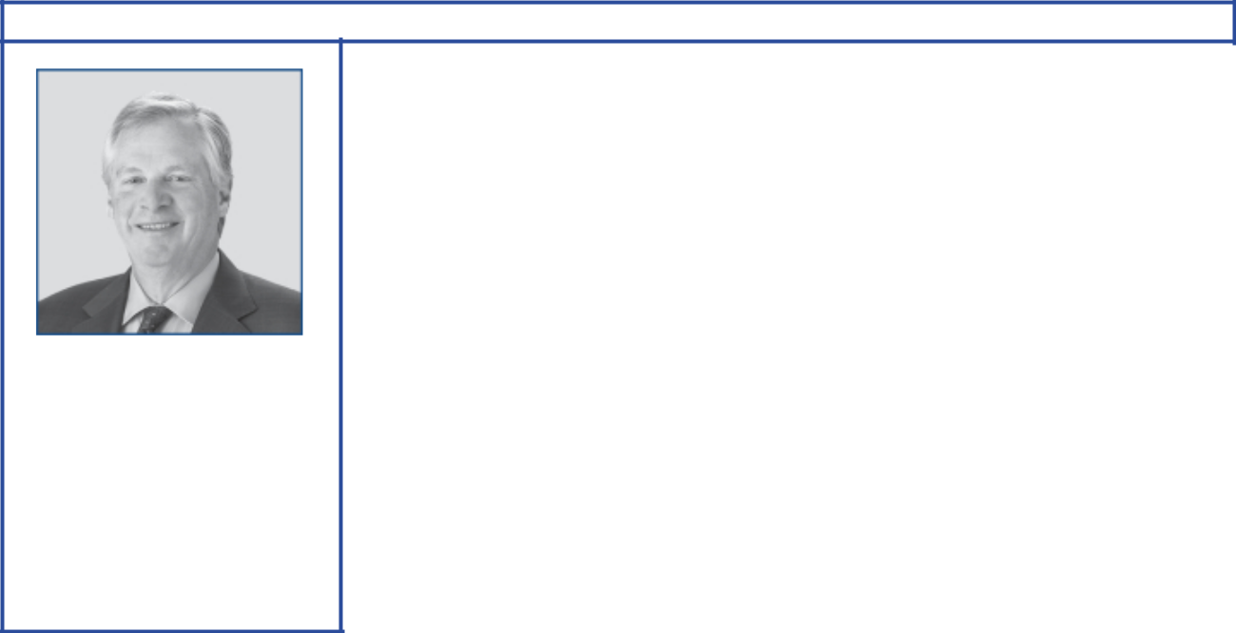

Douglas R. Oberhelman

Principal occupation: Former Chairman of the Board and Chief Executive Officer, Caterpillar Inc.

Age 65

Director since 2015
Independent director

Committees:

Audit, Finance

Experience, qualifications, and attributes:

- Global business leadership at Caterpillar as Chairman from 2010 to 2017; as Chief Executive Officer from 2010 to 2016; as Group President of Caterpillar from 2002 to 2010; and as Vice President, Engine Products Division from 1998 to 2002. He also served as Vice President and Chief Financial Officer from 1995 to 1998.

- Business, conservation, and charitable affiliations: Business Roundtable (former Chairman), National Association of Manufacturers (former Chairman), Business Council (graduate member), Wetlands America Trust (Vice President), Easter Seals Foundation of Central Illinois (Chairman), Gilmore Foundation (Vice President and Director), Intersect Illinois, and Max McGraw Wildlife Foundation

Current public company directorships: Bombardier (November 2017–Present)

Previous public company directorships in last five years: Eli Lilly and Company (December 2008–February 2015); Caterpillar (July 2010–March 2017)

Other board experience: former Director of Ameren Corporation (prior to 2013)
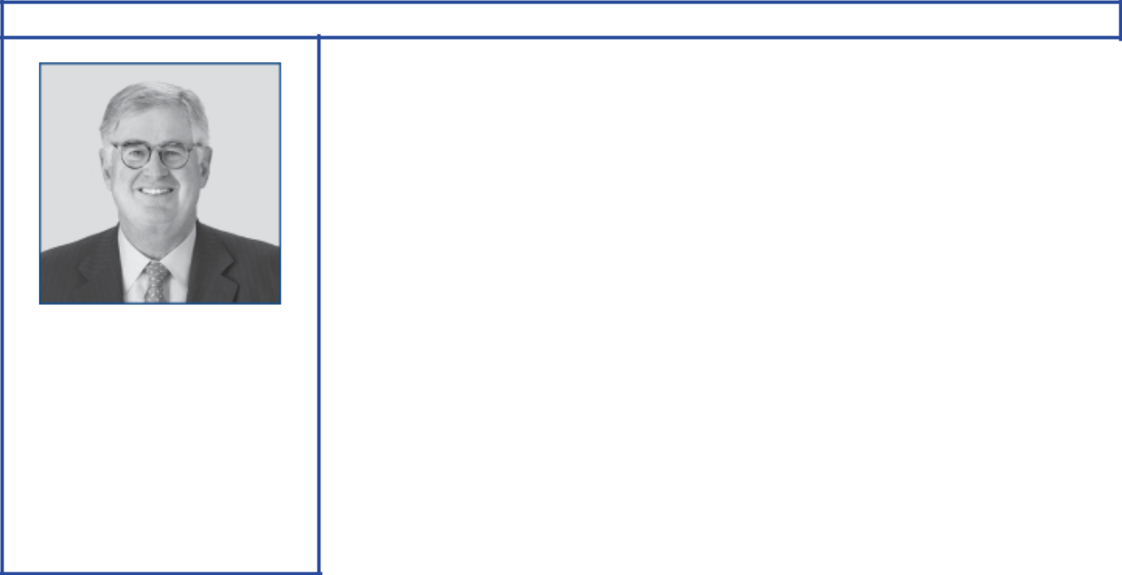

Samuel J. Palmisano

Principal occupation: Former Chairman of the Board, IBM

Age 66

Director since 2006
Independent director

Committees:

Board Affairs, Compensation, Executive

Experience, qualifications, and attributes:

- Global business leadership at IBM as Chairman, President, and Chief Executive Officer from 2003 to 2012. He also served as President, Senior Vice President, and Group Executive for IBM’s Enterprise Systems Group, IBM Global Services, and IBM’s Personal Systems Group.

- Business, public policy, and research affiliations: Center for Global Enterprise (Chairman), Business Roundtable, Executive Committee of the Council on Competitiveness, and Commission on Enhancing National Cybersecurity (former Vice Chair)

Current public company directorships: American Express (March 2013–Present)

Previous public company directorships in last five years: None

Other board experience: former Director of Gannett Co. and IBM (both prior to 2013)

18 2018 Proxy Statement

Table of Contents
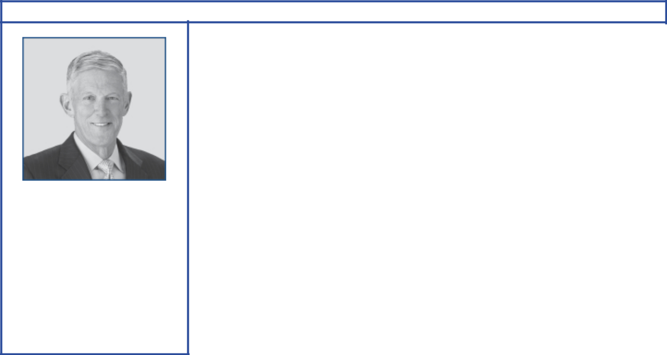

Steven S Reinemund

Principal occupation: Executive in Residence, Wake Forest University

Age 70

Director since 2007
Presiding director since 2016

Independent director

Committees:

Board Affairs, Public Issues and Contributions, Executive

Experience, qualifications, and attributes:

- Global business leadership at PepsiCo as Executive Chairman of the Board from 2006 to 2007; as Chairman and Chief Executive Officer from 2001 to 2006; and as President and Chief Operating Officer from 1999 to 2001. He also served as President and CEO of Frito-Lay and Pizza Hut.

- Academic leadership at Wake Forest University as Dean of Business from 2008 to 2014; and as Professor of Leadership and Strategy

- Business, research, and educational affiliations: U.S. Naval Academy Foundation, Cooper Institute, Newman’s Own Foundation, Wake Forest University, and Center for Creative Leadership

Current public company directorships: Marriott (April 2007–Present); Walmart (June 2010–Present)

Previous public company directorships in last five years: American Express (April 2007–May 2015)

Other board experience: former Director of Johnson & Johnson and PepsiCo (both prior to 2013)
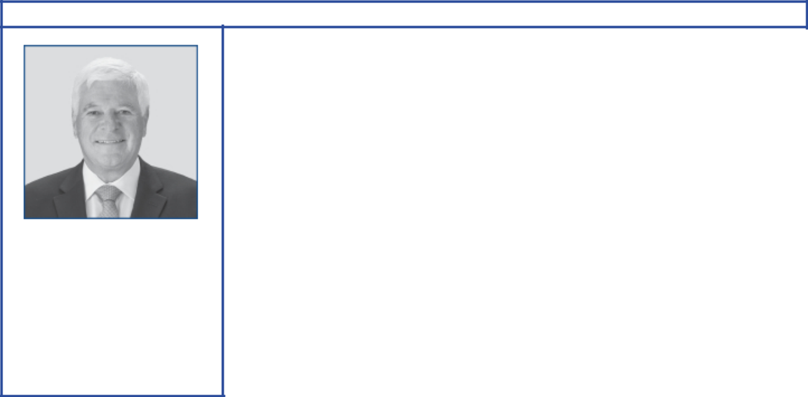

William C. Weldon

Principal occupation: Former Chairman of the Board, Johnson & Johnson

Age 69

Director since 2013
Independent director

Committees:

Audit, Finance

Experience, qualifications, and attributes:

- Global business leadership at Johnson & Johnson as Chairman and Chief Executive Officer from 2002 to 2012; as Vice Chairman from 2001 to 2002; and as Worldwide Chairman, Pharmaceuticals Group from 1998 to 2001

- Business, research, and educational affiliations: Quinnipiac University Board of Trustees (Chairman), Business Council (former Vice Chairman), Business Roundtable, CEO Roundtable on Cancer (past Chairman), Healthcare Leadership Council, Pharmaceutical Research and Manufacturers of America (past Chairman)

Current public company directorships: CVS Caremark (March 2013–Present); JPMorgan Chase (March 2005–Present)

Previous public company directorships in last five years: Chubb (May 2013– January 2016)

Other board experience: former Director of Johnson & Johnson (prior to 2013)

2018 Proxy Statement | 19

Table of Contents
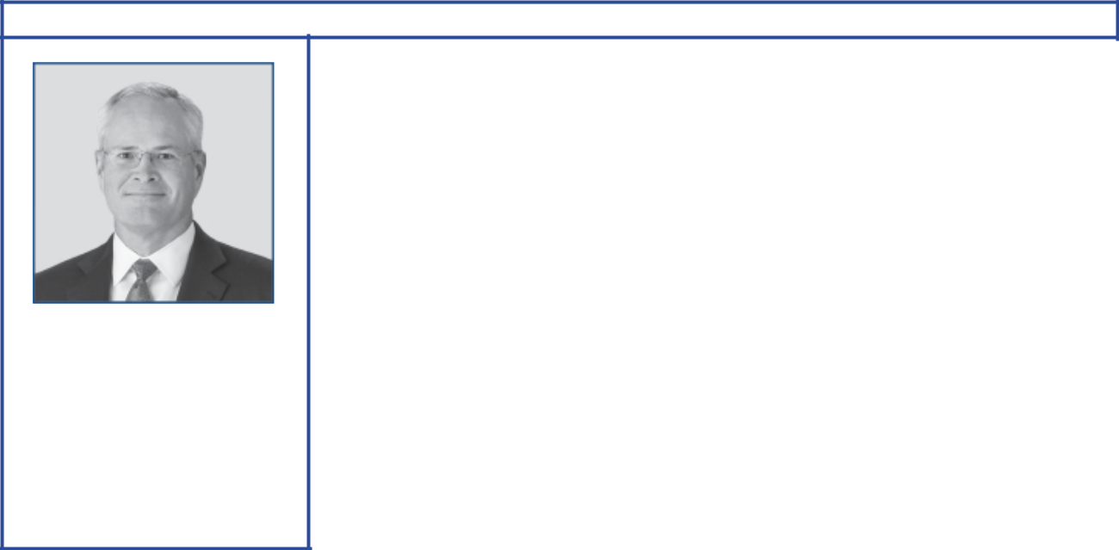

Darren W. Woods

Principal occupation: Chairman of the Board and Chief Executive Officer, Exxon Mobil Corporation

Age 53

Director since 2016

Committees:

Finance, Executive

Experience, qualifications, and attributes:

- Global business leadership at Exxon Mobil Corporation as Chairman and Chief Executive Officer since 2017; as President in 2016; and as Senior Vice President from 2014 to 2016. He also served as Vice President, and President, ExxonMobil Refining & Supply Company from 2012 to 2014.

- Global business operations experience with positions of increasing responsibility in domestic and international business operations at ExxonMobil Refining & Supply Company, ExxonMobil Chemical Company, and Exxon Company International

- Business affiliations: Business Roundtable, American Petroleum Institute (Chair)

Current public company directorships: None

Previous public company directorships in last five years: Imperial Oil Ltd. (April 2013–July 2014)

20 2018 Proxy Statement

Table of Contents

Director Compensation

Director compensation elements are designed to:

- Ensure alignment with long-term shareholder interests;

- Ensure the Company can attract and retain outstanding director candidates who meet the selection criteria outlined in the Guidelines for Selection of Non-Employee Directors, which can be found on the Corporate Governance section of our website;

- Recognize the substantial time commitments necessary to oversee the affairs of the Corporation; and

- Support the independence of thought and action expected of directors.

Non-employee director compensation levels are reviewed by the Board Affairs Committee each year, and resulting recommendations are presented to the full Board for approval. The Committee uses an independent consultant, Pearl Meyer, to provide information on current developments and practices in director compensation. Pearl Meyer is the same consultant retained by the Compensation Committee to advise on executive compensation, but performs no other work for ExxonMobil.

ExxonMobil employees receive no additional pay for serving as directors.

Non-employee directors receive compensation consisting of cash and equity in the form of restricted stock. Non-employee directors are also reimbursed for reasonable expenses incurred to attend Board meetings or other functions relating to their responsibilities as a director of Exxon Mobil Corporation.

The annual cash retainer for non-employee directors in 2017 was $110,000 per year. Chairs of the Audit and Compensation Committees and the Presiding Director receive an additional $10,000 per year.

A significant portion of director compensation is granted in the form of restricted stock to align director interests with the interests of our long-term shareholders. The annual restricted stock award grant for incumbent non-employee directors is 2,500 shares. A new non-employee director receives a one-time grant of 8,000 shares of restricted stock upon first being elected to the Board.

While on the Board, the non-employee director receives the same cash dividends on restricted shares as a holder of regular common stock, but the shares remain unvested and thus cannot be sold. The restricted shares are subject to forfeiture if the non-employee director leaves the Board early, i.e., before the retirement age of 72, as specified for non-employee directors.

Current and former non-employee directors of Exxon Mobil Corporation are eligible to participate in the ExxonMobil Foundation’s Educational and Cultural Matching Gift Programs under the same terms as the Corporation’s U.S. employees.

Mr. Kandarian was first elected to the Board effective February 1, 2018, and therefore is not included in the tables below in this section.

2018 Proxy Statement | 21

Table of Contents

Director Compensation for 2017

 |  |  |  |  | Change in
 |  |  |  |  | Pension Value
 |  |  |  |  | and
 | Fees |  |  |  | Nonqualified
 | Earned |  |  | Non-Equity | Deferred | Other
 | or Paid | Stock | Option | Incentive Plan | Compensation | Other
 | in Cash | Awards | Awards | Compensation | Earnings | Compensation | Total
Name | ($) | ($)(a) | ($) | ($) | ($) | ($)(b) | ($)
S.K. Avery | 100,528 | 666,480 | 0 | 0 | 0 | 238 | 767,246
M.J. Boskin | 110,000 | 226,650 | 0 | 0 | 0 | 268 | 336,918
P. Brabeck-Letmathe(c) | 45,934 | 226,650 | 0 | 0 | 0 | 112 | 272,696
A.F. Braly | 110,000 | 226,650 | 0 | 0 | 0 | 268 | 336,918
U.M. Burns | 115,824 | 226,650 | 0 | 0 | 0 | 268 | 342,742
L.R. Faulkner(c) | 50,110 | 226,650 | 0 | 0 | 0 | 112 | 276,872
H.H. Fore(d) | 110,000 | 226,650 | 0 | 0 | 0 | 268 | 336,918
K.C. Frazier | 110,000 | 226,650 | 0 | 0 | 0 | 268 | 336,918
D.R. Oberhelman | 110,000 | 226,650 | 0 | 0 | 0 | 268 | 336,918
S.J. Palmisano | 120,000 | 226,650 | 0 | 0 | 0 | 268 | 346,918
S.S Reinemund | 120,000 | 226,650 | 0 | 0 | 0 | 268 | 346,918
W.C. Weldon | 110,000 | 226,650 | 0 | 0 | 0 | 268 | 336,918

- In accordance with SEC rules, the valuation of stock awards in this table represents fair value on the date of grant. Dividends on stock awards are not shown in the table because those amounts are factored into the grant date fair value.

Each director (other than Dr. Avery, who joined the Board in February 2017) received an annual grant of 2,500 restricted shares in January 2017. The valuation of these awards is based on a market price of $90.66 on the date of grant.

Dr. Avery received a one-time grant of 8,000 restricted shares upon first being elected to the Board in February 2017. The valuation of this award is based on the market price of $83.31 on the date of the grant.

At year-end 2017, the aggregate number of restricted shares held by each director was as follows:

Name | Restricted Shares (#)
S.K. Avery | 8,000
M.J. Boskin | 69,300
A.F. Braly | 10,500
U.M. Burns | 20,500
H.H. Fore | 20,500
K.C. Frazier | 28,000
D.R. Oberhelman | 13,000
S.J. Palmisano | 37,000
S.S Reinemund | 33,000
W.C. Weldon | 18,000

- The amount shown for each director is the cost of travel accident insurance covering death, dismemberment, or loss of sight, speech, or hearing under a policy purchased by the Corporation with a maximum benefit of $500,000 per individual.

- Retired effective May 31, 2017.

- Resigned effective December 31, 2017.

The non-employee directors are not entitled to any additional payments or benefits as a result of leaving the Board or death except as described above. The non-employee directors are not entitled to any payments or benefits resulting from a change in control of the Corporation.

22 2018 Proxy Statement

Table of Contents

Certain Beneficial Owners

Based on our review of ownership reports filed with the SEC, the firms listed below are the only beneficial owners of more than 5 percent of ExxonMobil’s outstanding common stock as of December 31, 2017.

Name and Address | Shares | Percent of
of Beneficial Owner | Owned | Class
The Vanguard Group | 317,711,413 | 7.5%
100 Vanguard Blvd.
Malvern, PA 19355
BlackRock, Inc. | 259,208,368 | 6.1%
55 East 52nd Street
New York, NY 10055
State Street Corporation | 213,671,449 | 5.0%
One Lincoln Street
Boston, MA 02111

Director and Executive Officer Stock Ownership

These tables show the number of ExxonMobil common shares each executive named in the Summary Compensation Table on page 45 and each non-employee director or director nominee owned on February 28, 2018. In these tables, ownership means the right to direct the voting or the sale of shares, even if those rights are shared with someone else. None of these individuals owns more than 0.02 percent of the outstanding shares.

 |  | Shares Covered by
Named Executive Officer | Shares Owned⁽¹⁾ | Exercisable Options
D.W. Woods | 72,686 | 0
M.W. Albers | 408,610 | 0
M.J. Dolan | 509,105⁽²⁾ | 0
N.W. Duffin | 250,606⁽³⁾ | 0
A.P. Swiger | 469,631 | 0

- Does not include unvested restricted stock units, which do not carry voting rights prior to the issuance of shares on settlement of the awards.

- Includes 184,003 shares jointly owned with spouse.

- Co-trustee and co-beneficiary with spouse in family trust for 93,529 shares.

Non-Employee Director | Shares Owned
S.K. Avery | 10,500
M.J. Boskin | 71,800
A.F. Braly | 15,075
U.M. Burns | 23,206
K.C. Frazier | 30,500
S.A. Kandarian | 8,000
D.R. Oberhelman | 15,500
S.J. Palmisano | 39,500
S.S Reinemund | 45,625
W.C. Weldon | 21,660

On February 28, 2018, ExxonMobil’s incumbent directors and executive officers (30 people) together owned 3,214,905 shares of ExxonMobil stock and zero shares covered by exercisable options, representing about 0.08 percent of the outstanding shares.

2018 Proxy Statement | 23

Table of Contents

Section 16(a) Beneficial Ownership Reporting Compliance

Section 16(a) of the Securities and Exchange Act of 1934 requires our executive officers and directors to file reports of their ownership and changes in ownership of ExxonMobil stock on Forms 3, 4, and 5 with the SEC. We are not aware of any unfiled or late reports for 2017.

Audit Committee Report

The primary function of our Committee is oversight of the Corporation’s financial reporting process, public financial reports, internal accounting and financial controls, and the independent audit of the annual consolidated financial statements. Our Committee acts under a charter, which can be found on the ExxonMobil website at exxonmobil.com/auditcharter. We review the adequacy of the charter at least annually. All of our members are independent directors. We held 11 meetings in 2017 at which, as discussed in more detail below, we had extensive reports and discussions with the independent auditors, internal auditors, and members of management.

In performing our oversight function, we reviewed and discussed the consolidated financial statements with management and PricewaterhouseCoopers LLP (PwC), the independent auditors. Management and PwC indicated that the Corporation’s consolidated financial statements were fairly stated in accordance with generally accepted accounting principles. We discussed significant accounting policies applied by the Corporation in its financial statements, as well as alternative treatments. We discussed with PwC matters covered by Public Company Accounting Oversight Board (PCAOB) standards, including PCAOB AS 1301 Communication with Audit Committees. In addition, we reviewed and discussed management’s report on internal control over financial reporting and the related audits performed by PwC, which confirmed the effectiveness of the Corporation’s internal control over financial reporting.

We also discussed with PwC its independence from the Corporation and management, including the communications PwC is required to provide us under applicable PCAOB rules. We considered the non-audit services provided by PwC to the Corporation, and concluded that the auditors’ independence has been maintained.

We discussed with the Corporation’s internal auditors and PwC the overall scope and plans for their respective audits. We met with the internal auditors and PwC at each meeting, both with and without management present. Discussions included the results of their examinations, their evaluations of the Corporation’s internal controls, and the overall quality of the Corporation’s financial reporting.

We discussed with the Corporation’s management the comprehensive, long-standing risk management and compliance processes of the Corporation, and reviewed several topics of interest.

Based on the reviews and discussions referred to above, in reliance on management and PwC, and subject to the limitations of our role described below, we recommended to the Board, and the Board approved, the inclusion of the audited financial statements in the Corporation’s Annual Report on Form 10-K for the year ended December 31, 2017, for filing with the SEC.

We have also appointed PwC to audit the Corporation’s financial statements for 2018, subject to shareholder ratification of that appointment.

In carrying out our responsibilities, we look to management and the independent auditors. Management is responsible for the preparation and fair presentation of the Corporation’s financial statements and for maintaining effective internal control. Management is also responsible for assessing and maintaining the effectiveness of internal control over the financial reporting process in compliance with Sarbanes-Oxley Section 404 requirements. The independent auditors are responsible for auditing the Corporation’s annual financial statements, and expressing an opinion as to whether the statements are fairly stated in conformity with generally accepted accounting principles. In addition, the independent auditors are responsible for auditing the Corporation’s internal control over financial reporting and for expressing an opinion on the effectiveness of internal control over financial reporting. The independent auditors perform their responsibilities in accordance with the standards of the PCAOB. Our members

24 2018 Proxy Statement

Table of Contents

are not professionally engaged in the practice of accounting or auditing, and are not experts under the Securities Act of 1933 in either of those fields or in auditor independence.

Ursula M. Burns, Chair

William C. Weldon

Douglas R. Oberhelman

Item 2 – Ratification of Independent Auditors

The Audit Committee has appointed PricewaterhouseCoopers LLP (PwC) to audit ExxonMobil’s financial statements for 2018. We are asking you to ratify that appointment.

Total Fees

The total fees for PwC professional services rendered to ExxonMobil for the year ended December 31, 2017, were $45.1 million, an increase of $8.8 million from 2016. The Audit Committee reviewed and pre-approved all services in accordance with the service pre-approval policies and procedures, which can be found on the ExxonMobil website at exxonmobil.com/pre-approval. The Audit Committee did not use the “de minimis” exception to pre-approval that is available under SEC rules. The following table summarizes the fees, which are described in more detail below.

 | 2017 |  |  | 2016
 |  | (millions of dollars)
Audit Fees | 32.2 |  |  | 28.0
Audit-Related
Fees | 11.4 |  |  | 7.5
Tax Fees | 1.5 |  |  | 0.8
All Other Fees |  | — |  |  | —
Total |  | 45.1 |  |  | 36.3

Audit Fees

The aggregate fees for PwC professional services rendered for the annual audits of ExxonMobil’s financial statements for the year ended December 31, 2017, and for the reviews of the financial statements included in our quarterly reports on Form 10-Q for that year were $32.2 million (versus $28.0 million for 2016), with the increase primarily due to acquisition-related work.

Audit-Related Fees

The aggregate fees for PwC Audit-Related services rendered to ExxonMobil for the year ended December 31, 2017, were $11.4 million (versus $7.5 million in 2016), with the increase primarily due to support work regarding regulatory matters. Audit-related services were mainly related to benefit plans audits and other attestation procedures.

Tax Fees

The aggregate fees for PwC Tax services rendered to ExxonMobil for the year ended December 31, 2017, were

$1.5 million (versus $0.8 million for 2016), with the increase primarily due to acquisition-related work. These services were mainly related to assisting various ExxonMobil affiliates with the preparation of local tax filings and related services.

All Other Fees

The aggregate fees for PwC services rendered to ExxonMobil, other than the services described above under “Audit Fees,” “Audit-Related Fees,” and “Tax Fees,” for the year ended December 31, 2017, were zero (also zero in 2016).

We believe PwC is well qualified to perform this work. A PwC representative will be at the annual meeting to answer appropriate questions and to make a statement if desired.

The Audit Committee recommends you vote FOR this proposal.

2018 Proxy Statement | 25

Table of Contents

Compensation Committee Report

The Compensation Committee of the Board of Directors has reviewed and discussed the Compensation Discussion and Analysis with management of the Corporation. Based on that review and discussion, we recommended to the Board that the Compensation Discussion and Analysis be included in the Corporation’s proxy statement for the 2018 annual meeting of shareholders, and also incorporated by reference in the Corporation’s Annual Report on Form 10-K for the year ended December 31, 2017.

Samuel J. Palmisano, Chair

Angela F. Braly
Steven A. Kandarian

Michael J. Boskin

Kenneth C. Frazier

Item 3 – Advisory Vote to Approve Executive Compensation

At the meeting, shareholders will be asked to vote on a non-binding resolution to approve the compensation of the Named Executive Officers (NEOs), listed in the Summary Compensation Table.

When casting your vote, we encourage you to consider the content of our Executive Compensation Overview and detailed information included in the Compensation Discussion and Analysis beginning on page 27.

The Board continues to support the overall design of the compensation program, which is characterized by three key features:

- Ties compensation to the experience of long-term shareholders – The majority of compensation is delivered in the form of performance shares, linking the ultimate value of pay to the performance of ExxonMobil stock.

- Recognizes the long-term nature of ExxonMobil’s business model – Performance shares are subject to the longest restriction periods in industry, including through the commodity price cycle and into retirement. Therefore, executives are encouraged to take a long-term view in their business decision-making.

- Links executives’ compensation to Company performance – The number of shares at grant is determined by relative Company performance versus industry peers and market orientation of total compensation. We set the highest standards, requiring industry-leading results over the investment lead times of the business (10 years) in pre-established performance metrics.

For 2017, Company performance remains industry-leading in all but one of these performance metrics. As a result, the Compensation Committee has reduced 2017 CEO and NEO performance share awards.

We continue to listen and respond to the feedback we receive from shareholders during our shareholder engagement process regarding the design of our compensation program. This year, shareholder feedback resulted in specific changes to the compensation program and improvements in our disclosure.

The Board recommends an advisory vote FOR the following resolution:

RESOLVED: That shareholders approve the compensation of the Named Executive Officers as disclosed pursuant to Item 402 of SEC Regulation S-K, including the Compensation Discussion and Analysis, compensation tables, and narrative discussion on pages 27 to 53 of this proxy statement.

26 2018 Proxy Statement

Table of Contents

COMPENSATION DISCUSSION AND ANALYSIS

Executive Compensation | • | Letter to Shareholders
Overview | • | Shareholder Engagement
 | • | Say-On-Pay Results
 | • | Executive Summary
 | • | Performance Share Program
 | • | Bonus Program
 | • | Benchmarking and Scale/Complexity
 | • | Compensation for CEO Position
 | • | Company Performance
Key Elements of the | • | Sound Governance Practices
Key Elements of the | • | Salary
Compensation Program and
Compensation Program and | • | Annual Bonus Program
Compensation Committee | • | Performance Share Program
2017 Decisions | • | Retirement Plans
Other Key Elements of the | • | Benchmarking Principles
Compensation Program | • | Performance Measurements
 | • | Share Utilization
 | • | Granting Practices
 | • | Stock Ownership
 | • | Hedging Policy
 | • | Clawback Policy and Forfeiture Provisions
 | • | Employment Arrangements
 | • | Tax Matters
Executive Compensation | • | Changes to Company Performance Metrics
Executive Compensation | • | Summary Compensation Table
Tables and Narratives | • | Grants of Plan-Based Awards
 | • | Outstanding Equity Awards
 | • | Option Exercises and Stock Vested
 | • | Pension Benefits
 | • | Nonqualified Deferred Compensation
 | • | Administrative Services for Retired Employee Directors
 | • | Health Care Benefits
 | • | Unused Vacation
 | • | Termination and Change in Control
 | • | Payments in the Event of Death
 |  |  |  |  |  |  |  |  |  |  |  |  |  |  |  |  |  |  |  |  |  |  |  |  |  |  |  |  | 2018 Proxy Statement

Page

28

28

28

29

30

32

32

33

34

36

38

38

39

39

40

41

42

42

42

43

43

43

43

44

45

48

49

50

50

52

52

53

53

53

53

27

Table of Contents
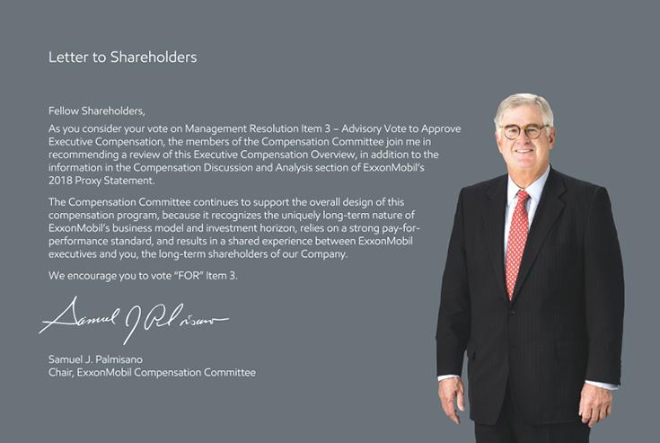

Shareholder Engagement Highlights

- Held 28 meetings with our largest shareholders throughout the calendar year – before, during, and after the proxy season

- Conducted shareholder webinar on May 11, 2017; next webinar scheduled for May 10, 2018

– Webinars allow the Company to gather input from all shareholders

- Shareholder feedback resulted in specific changes to the compensation program and improvements in the disclosure

Say-On-Pay Results (“FOR”)

2013 | 2014 | 2015 | 2016 | 2017
71% | 90% | 90% | 89% | 69%

28 2018 Proxy Statement

Table of Contents

Executive Summary

Key Messages – Why Vote “FOR” Say-On-Pay?
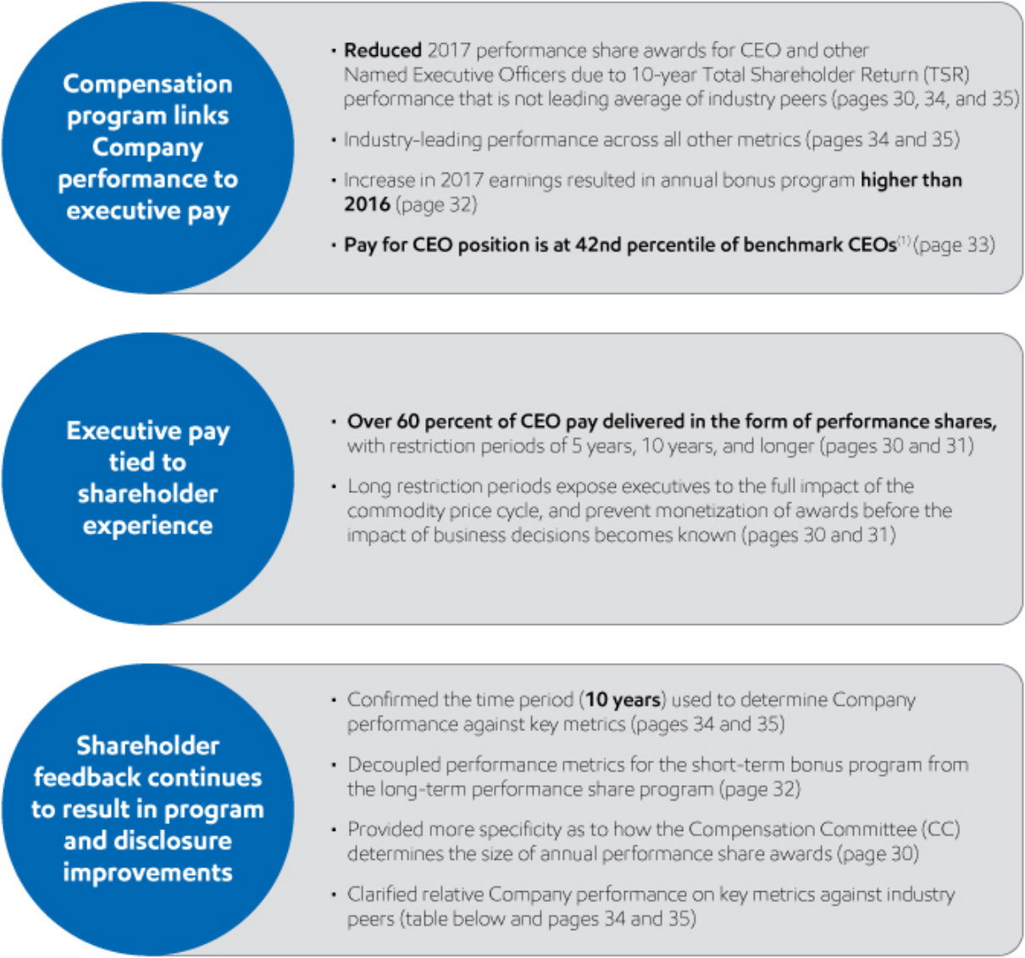

Performance Share Program – Key Metrics and Results


Performance | Safety & | Return on Average | Cash Flow from | Total Shareholder | Strategic Objectives,
Performance | Operations | Capital Employed | Operations and | Total Shareholder | Business Results &
Metrics (10-year) | Operations | Capital Employed | Operations and | Return (TSR) | Business Results &
Metrics (10-year) | Integrity* | (ROCE)* | Asset Sales | Return (TSR) | Project Execution
Assessment Criteria | vs. U.S. Petroleum | Rank Position | Rank Position | vs. Average of | CC Assessment
Assessment Criteria | Industry Benchmark | vs. Industry Peers | vs. Industry Peers | Industry Peers | CC Assessment
Status | Leading | Leading | Leading | Not Leading | Strong Results
 |  |  |  |  | (see page 35)
* Highest priority metrics considered by CC
 |  |  | 2018 Proxy Statement |  | 29

Table of Contents

Performance Share Program

Design Principles

Shareholder alignment By design, the majority of executive compensation is delivered in performance shares, aligning executive pay with the experience of long-term shareholders

Performance-based program using highest standards Level of performance share grant is determined by relative Company performance versus industry peers in five pre-established performance metrics

Performance metrics applied at grant Enables performance and restriction periods of 5 years, 10 years, and longer. This is important because the alternative of applying performance metrics at vest would require line of sight to credibly and practically set targets, thus requiring shorter performance and restriction periods. Shorter performance and restriction periods would be misaligned with our business model and the experience of long-term shareholders

Promotes retention and long-term view Majority of compensation delayed due to restriction periods up to three times longer than industry peers, with a significant portion restricted beyond retirement and at risk of forfeiture. This convention strengthens retention and achieves alignment with the experience of long-term shareholders
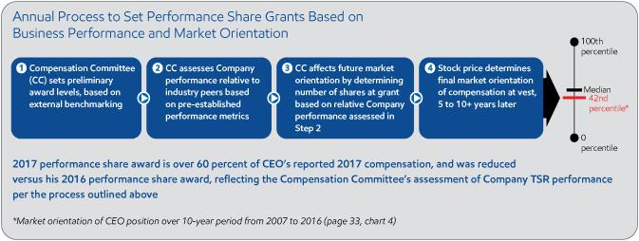

Long Restriction Periods

Longest restrictions in industry Restriction periods for senior executives far exceed typical three-year vesting that is common across most industries

Restrictions aligned with investment lead times of business Performance shares vest 50 percent in 5 years from grant date and 50 percent in 10 years or retirement, whichever is later; vesting is not accelerated upon retirement

Illustration of long-term orientation of performance share program

Illustration shows retirement at year-end 2029; last grant vests in 2039

30 2018 Proxy Statement

Table of Contents

Examples of Why Long Restriction Periods Align with ExxonMobil’s Business Model
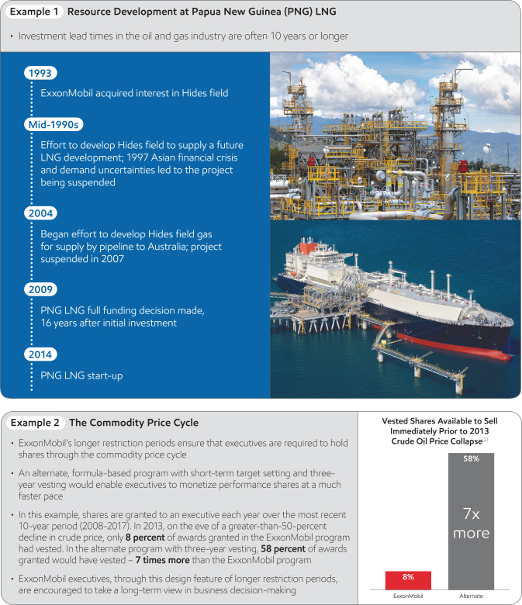

2018 Proxy Statement | 31

Table of Contents

Bonus Program
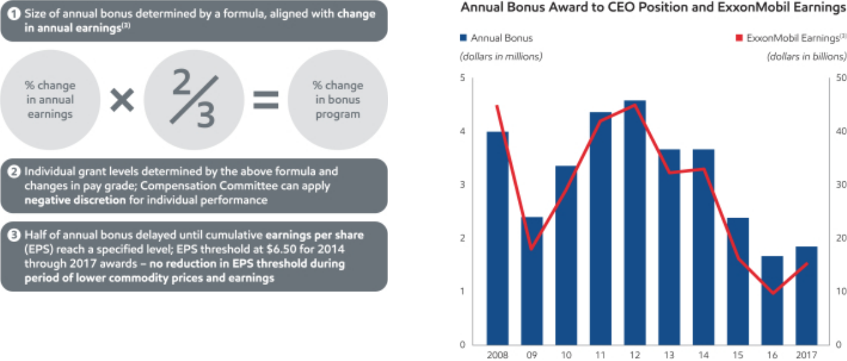

The bonus program formula has been consistently applied in each of the last 16 years, including years in which earnings declined

In 2017, the overall bonus program was increased by 40 percent versus 2016 due to stronger Company earnings performance, but is 42-percent lower than the 2008 program and 49-percent lower than the 2012 program. Mr. Woods’ bonus increased more than the overall 2017 program to recognize his appointment as CEO (higher pay grade), and represented 11 percent of his 2017 reported pay

Benchmarking and Scale/Complexity

- Annual benchmarking conducted to assess market orientation of executive compensation and program design features

- All three of ExxonMobil’s major business segments, on a stand-alone basis, would rank among other large companies based on revenue

- The Compensation Committee considers scale and complexity as relevant factors in assessing the appropriateness of pay levels

- Assessment of relative Company performance requires comparison against companies of similar scale and complexity in the same industry (pages 34 and 35)

– Industry peers: Chevron, Royal Dutch Shell, Total, and

BP
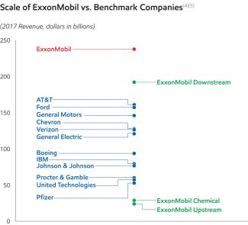

32 2018 Proxy Statement

Table of Contents

Compensation for CEO Position
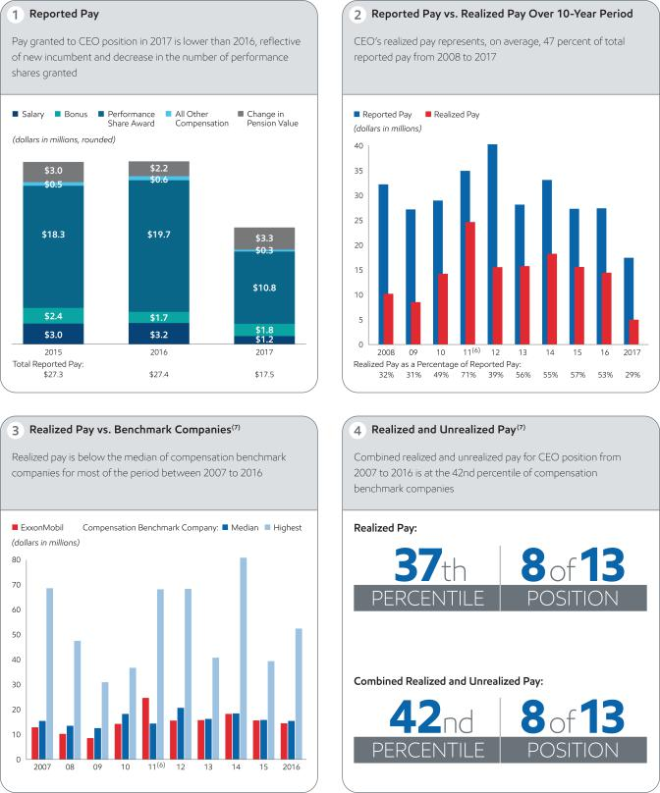

2018 Proxy Statement | 33

Table of Contents

Company Performance
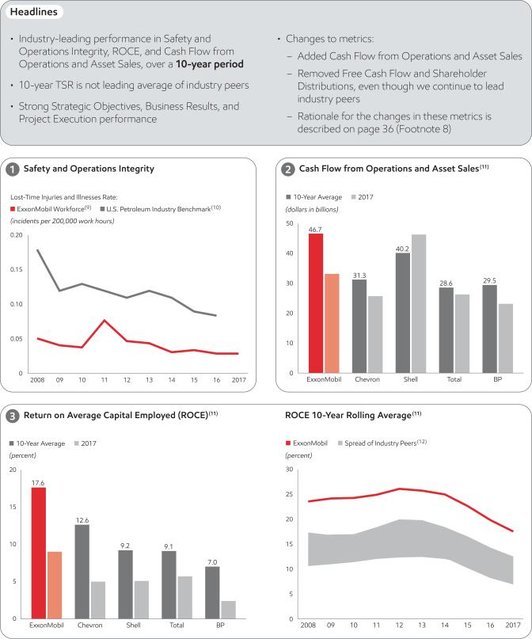

34 2018 Proxy Statement

Table of Contents
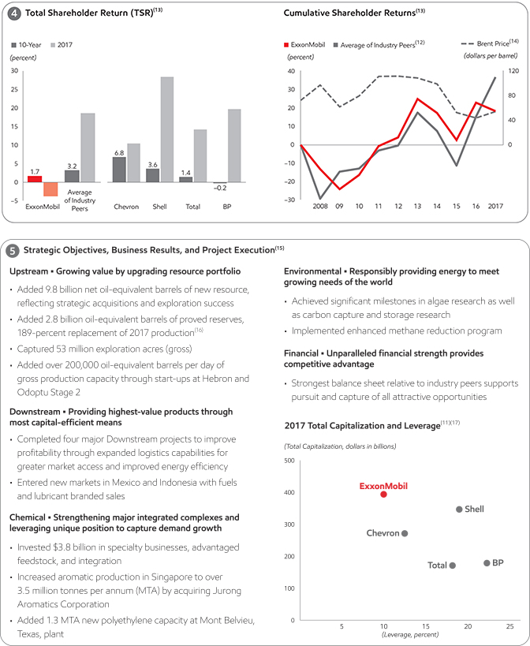

2018 Proxy Statement | 35

Table of Contents

Sound Governance Practices

- Long restriction periods on performance shares result in required ownership that far exceeds typical stock ownership guidelines among compensation benchmark companies

– Executives see a one-for-one change in compensation through share price, aligned with the experience of long-term shareholders
– At retirement, ExxonMobil senior executives continue to have performance shares unvested and at risk of forfeiture for 10 years
– Unvested performance shares and the delayed payout of half of the annual bonus are subject to forfeiture for resignation or detrimental activity, with no accelerated payout at retirement

- Bonus clawback policy

- No employment contracts, severance agreements, or change-in-control arrangements for the CEO and other Named Executive Officers

- No guaranteed bonuses or additional grants to balance changes in value of prior grants
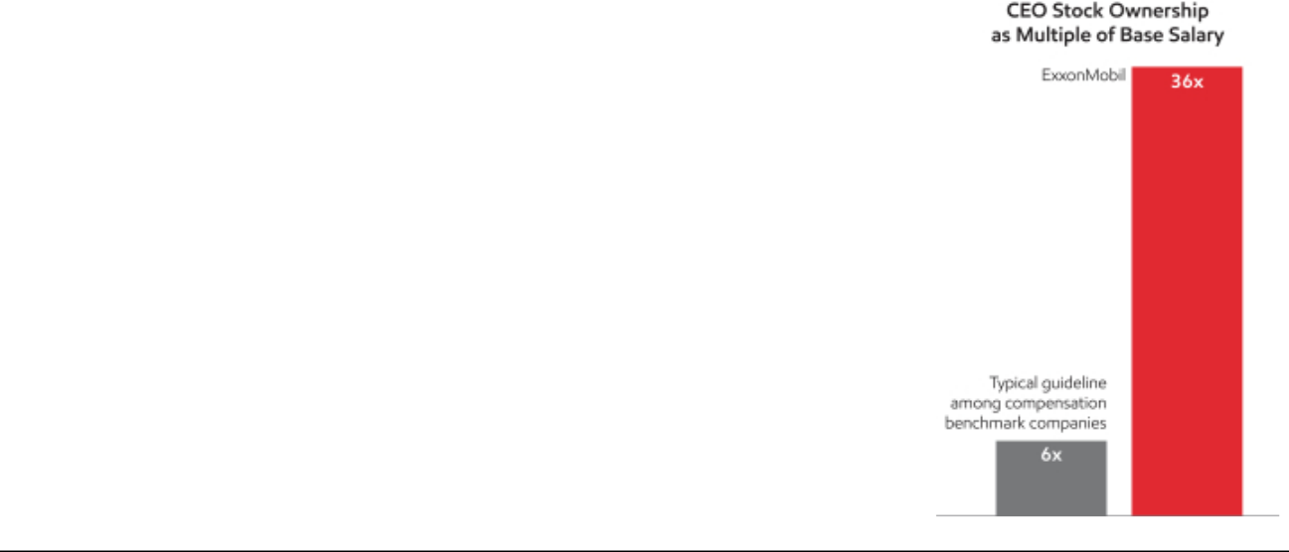

Footnotes

- Pay means the sum of Realized Pay and Unrealized Pay as described in more detail on page 33 and in the related Frequently Used Terms on page 37.

- In Example 2, for both the ExxonMobil and Alternate programs, 100 shares are granted each year from 2008 to 2017. For ExxonMobil performance share program, 50 percent of an annual grant of performance shares vests in 5 years and the other 50 percent vests in 10 years or retirement, whichever is later. For the hypothetical alternate formula-based program, shares would vest after 3 years based on TSR performance. Values shown represent percent of target shares that would pay out based on ExxonMobil’s actual relative three-year TSR rank versus our industry peers (see footnote 12). Payout schedule as follows: 200% of target if ranked 1; 150% of target if ranked 2; 100% of target if ranked 3; 50% of target if ranked 4; and, 0% of target if ranked 5.

- Bonus program is based on estimates of year-end earnings made in November of each year, such that payment can occur in that calendar year. The purpose of the two-thirds adjustment in the formula is to mitigate the impact of commodity price swings on short-term earnings performance.

- Benchmark companies are the same companies noted in the 2017 Proxy Statement, except that General Motors replaced Caterpillar. See Frequently Used Terms on page 37 for a full list of benchmark companies.

- Benchmark company data based on public information. Data represents the fiscal year ending in 2017. Excludes sales-based taxes and intersegment revenues.

- Exercised last stock options granted in 2001 that would have expired in 2011. No stock options granted since 2001.

- 2017 benchmark company data not available at time of publication.

- Replaced Free Cash Flow (FCF) with Cash Flow from Operations and Asset Sales (CFOAS). CFOAS is more likely to drive desired behavior, as it focuses on cash generation and is neutral to uses of cash; FCF maximization could discourage investment. Removed Shareholder Distributions, as the Total Shareholder Return (TSR) metric reflects the value of dividend growth and share buybacks over time; distribution yield could inappropriately benefit from stock price decreases and vice versa.

- Employees and contractors, includes XTO Energy Inc. data beginning in 2011.

- Workforce safety data from participating American Petroleum Institute (API) companies; 2017 industry data not available at time of publication.

- Competitor data estimated on a consistent basis with ExxonMobil and based on public information. ROCE data for Total available from 1999. For definitions and more information, see Frequently Used Terms on page 37.

- Industry peers include Chevron, Royal Dutch Shell, Total, and BP.

- Growth rate of an investor’s holdings with reinvestment of dividends. Chevron, Royal Dutch Shell, Total, and BP weighted by market capitalization.

- Annual data calculated as average of daily prices from Platts.

- For more information, see the Summary Annual Report included with the Corporation’s 2018 Proxy Statement and available on our website at exxonmobil.com/annualreport.

- Proved reserves exclude asset sales.

- Total Capitalization defined as “Net Debt + Market Capitalization”; Leverage defined as “Net Debt / Total Capitalization.”

36 2018 Proxy Statement

Table of Contents

Frequently Used Terms

Please also read the footnotes on page 36 for additional definitions of terms we use and other important information.

Performance Share Program is the terminology used to describe our equity program to better reflect the strong connection between performance and pay.

Compensation Benchmark Companies consist of AT&T, Boeing, Chevron, Ford, General Electric, General Motors, IBM, Johnson & Johnson, Pfizer, Procter & Gamble, United Technologies, and Verizon. For consistency, CEO compensation on page 33, in charts 3 and 4, is based on compensation as disclosed in the Summary Compensation Table of the proxy statements as of July 31, 2017.

Reported Pay is Total Compensation reported in the Summary Compensation Table, except for 2008, where the grant date value of restricted stock as provided under current SEC rules is used to put all years of compensation on the same basis.

Realized Pay is compensation actually received by the CEO during the year, including salary, current bonus, payouts of previously granted earnings bonus units (EBUs), net spread on stock option exercises, market value at vesting of previously granted stock-based awards, and All Other Compensation amounts realized during the year. It excludes unvested grants, change in pension value, and other amounts that will not actually be received until a future date. Amounts for compensation benchmark companies include salary, bonus, payouts of non-equity incentive plan compensation, and All Other Compensation as reported in the Summary Compensation Table, plus value realized on option exercise or stock vesting as reported in the Option Exercises and Stock Vested table. It excludes unvested grants, change in pension value, and other amounts that will not actually be received until a future date, as well as any retirement-related payouts from pension or nonqualified compensation plans.

Unrealized Pay is calculated on a different basis than the grant date fair value of awards used in the Summary Compensation Table. Unrealized Pay includes the value based on each compensation benchmark company’s closing stock price at fiscal year-end 2016 of unvested restricted stock awards; unvested long-term share- and cash performance awards, valued at target levels; and the “in the money” value of unexercised stock options (both vested and unvested). If a CEO retired during the period, outstanding equity is included assuming that unvested awards, as of the retirement date, continued to vest pursuant to the original terms of the award.

Cash Flow from Operations and Asset Sales is the sum of the net cash provided by operating activities and proceeds associated with sales of subsidiaries, property, plant and equipment, and sales and returns of investments from the Summary Statement of Cash Flows. For additional information, see page 37 of the Summary Annual Report included with the Corporation’s 2018 Proxy Statement.

Return on Average Capital Employed (ROCE) for the Corporation is net income attributable to ExxonMobil excluding the after-tax cost of financing, divided by total corporate average capital employed. For this purpose, capital employed means the Corporation’s net share of property, plant and equipment, and other assets less liabilities, excluding both short-term and long-term debt. For additional information, see pages 36 and 37 of the Summary Annual Report included with the Corporation’s 2018 Proxy Statement.

Total Shareholder Return (TSR) measures the change in value of an investment in stock over a specified period of time, assuming dividend reinvestment. TSR is subject to many different variables, including factors beyond the control of management. For additional information, see page 36 of the Summary Annual Report included with the Corporation’s 2018 Proxy Statement.

Statements regarding future events or conditions are forward-looking statements. Actual future results, including project plans, schedules, and results, as well as the impact of compensation incentives, could differ materially due to changes in oil and gas prices and other factors affecting our industry, technical or operating conditions, and other factors described in Item 1A Risk Factors in our most recent Form 10-K. References to oil-equivalent barrels and other quantities of oil and gas herein include amounts not yet classified as proved reserves under SEC rules, but which are expected to be ultimately moved into the proved category and produced in the future.

The term “project” can refer to a variety of different activities and does not necessarily have the same meaning as in any government payment transparency reports.

2018 Proxy Statement | 37

Table of Contents

Key Elements of the Compensation Program and Compensation Committee 2017 Decisions

- The Company’s executive compensation program consists of base salary, annual bonus, and long-term equity in the form of performance shares. The Company also provides retirement plans in the form of pension and savings plans.

- The Compensation Committee determined that the following allocation of annual pay granted best supports the business model and the interests of long-term shareholders, by rewarding performance, promoting retention, and encouraging a long-term view in making business decisions. The actual allocation of these compensation elements can vary year-to-year based on the performance of the business.

 | Target Percent of Annual Pay Granted* | Objective
Salary | 10 percent or less | Provide a base level of income
Annual Bonus | 10 to 20 percent | Tie compensation to annual business performance
Performance Shares | Over 50 percent | Achieve alignment with the interests of long-term shareholders

  - Annual Pay Granted for this purpose means total compensation shown in the Summary Compensation Table, minus Change in Pension Value and Nonqualified Deferred Compensation Earnings and All Other Compensation.

- In 2017, the Compensation Committee determined and approved the individual elements of compensation, as well as total compensation for each Named Executive Officer. Within the context of the compensation program structure and performance assessment process (see “Performance Measurements” on page 41), the Committee aligned the value of 2017 compensation for the Named Executive Officers with the performance of the Company, individual performance, and compensation of benchmark companies, as described in the Executive Compensation Overview.

Salary

- Annual benchmarking determines the overall size of the salary program.

- The level of annual salary for an individual is based on their performance, experience, and pay grade.

- Salary decisions directly affect the level of retirement benefits since salary is included in retirement benefit formulas.

- Changes in salary for the Named Executive Officers are consistent with the base salary program for all U.S. executives, taking into account desired market orientation, individual performance, increased individual experience, and level of responsibility.

Annual Bonus Program

- The Compensation Committee establishes the overall size of the annual bonus pool (“ceiling”) based on the annual percent change in projected Corporate earnings, using the bonus program formula described on page 32. The program has been applied consistently for the last 16 years, including years in which earnings declined.

- Individual bonus awards are determined by the bonus program formula and changes in pay grade. The Compensation Committee can apply negative discretion for individual performance.

- The annual bonus is generally delivered as shown below.

– Half of the annual bonus is delayed and paid out when a specified level of cumulative earnings per share (EPS) is achieved or in three years at a reduced level.

38 2018 Proxy Statement

Table of Contents

– If the cumulative EPS threshold required for payout is not reached within three years, the EBU is reduced to an amount equal to the number of units times the actual cumulative EPS over the three-year period. This threshold ties the timing of the bonus payment to the rate of the Corporation’s future earnings and is therefore intentionally set at a level that is expected to be achieved within the three-year period. The threshold is reviewed each year and may be adjusted up or down to achieve payout within three years.

– The delayed portion of the bonus is at risk of forfeiture, see page 43.

– The bonus award in its entirety is also subject to clawback, see page 43.

- In 2017, the overall bonus program increased by 40 percent. Mr. Woods’ bonus increased by more than the overall bonus program to recognize his appointment as CEO (higher pay grade). Messrs. Swiger and Albers’ awards increased by more than the overall program to reflect their transition to higher pay grades. Bonus awards increased by 40 percent for Messrs. Dolan and Duffin.

Performance Share Program

- This program accounts for the majority of annual pay granted, and is intended to align the personal financial interests of executives with the interests of long-term shareholders and to encourage a long-term view through the commodity price cycle.

- The Compensation Committee sets the size of the performance share program. The Committee does not support a practice of offsetting the loss or gain of prior performance share grants by the value of current year grants, which would minimize the risk/reward profile of stock-based awards and undermine the long-term view that executives are expected to adopt.

- The annual process to set performance share grants is based on external benchmarking, relative Company performance, and strategic positioning against other integrated oil and gas companies over investment lead times of the business (10 years), see page 30.

– In 2017, the number of performance shares granted to all Named Executive Officers was reduced to reflect the Company’s relative TSR performance against industry peers.

- Performance shares granted under this program are currently in the form of stock units.

- Stock options have not been granted since 2001 and there are no plans to make such grants in the future.

Vesting and Restriction Periods

- Performance share awards vest 50 percent in 5 years from grant date and 50 percent in 10 years or retirement, whichever is later.

- Performance share awards are not subject to acceleration, even at retirement, except in the case of death.

- These restriction periods far exceed those applied by most companies across all industries and better align with the long investment lead times of our business and the decisions that affect long-term shareholder value in our industry. For additional information on the benefits of long-term restriction periods, see pages 30 and 31.

- Unvested performance share awards cannot be used as collateral for any purpose and are subject to forfeiture, even beyond retirement, see page 43.

Retirement Plans

Retirement plans include defined contribution plans, such as the Company’s savings plans, that are attractive to new hires who can begin building an account balance immediately, and defined benefit plans, such as the Company’s pension plans (qualified and nonqualified), that help retain mid- and late-career employees until retirement age. This objective of promoting a long-term career is consistent with the long-term nature of the Company’s business.

The Named Executive Officers participate in the same savings and pension plans as other U.S. executives.

Change in control is not a triggering event under any ExxonMobil benefit plan.

2018 Proxy Statement | 39

Table of Contents

Savings Plans

- The qualified Savings Plan permits employees to make pre- or post-tax contributions and receive a Company-matching contribution of 7 percent of eligible salary, when they contribute a minimum of 6 percent of salary. These contributions are subject to Internal Revenue Code limits on the amount of pay taken into account and the total amount of contributions.

- The nonqualified Supplemental Savings Plan does not permit employee contributions but provides 7 percent of eligible pay to continue the Company contributions that could not be made to the qualified plan due to Internal Revenue Code limits.

Pension Plans

- Pay for the purpose of pension calculations includes base salary and bonus, but does not include stock-based awards. Inclusion of the annual bonus in the pension formula further strengthens the performance basis of the total compensation and benefits program.

- Because pension benefits use final average pay applied to all years of service, the increase in pension values is greatest late in an employee’s career when compensation tends to be highest. This also enhances the retention of high-performing employees whose compensation typically increases as their job responsibilities expand.

- The nonqualified Supplemental Pension Plan provides pension benefits to the extent annual salary exceeds the amount that can be considered in determining qualified pension benefits and to the extent other limits may apply to qualified benefits. Without the Supplemental Pension Plan, the retention power of the overall pension plan would be greatly reduced for employees earning more than that amount, since pension values would not reflect the higher level of pay in mid- to late-career.

- The nonqualified Additional Payments Plan provides pension benefits tied to the annual bonus, which further supports retention and performance objectives, and reinforces the Compensation Committee’s practice of linking a greater proportion of compensation to business results for more-senior-level executives. Including annual bonus in the pension formula gives the retirement program a greater performance orientation.

- For more information on the pension plans, including the benefits formula, see pages 50 to 52.

- In 2017, the pension accrual shown in the Summary Compensation Table for Mr. Woods increased. For a description of the breakdown of the underlying factors that resulted in the increase, see page 46. For the other Named Executive Officers, the higher lump sum interest rate (2.75 percent) versus 2016 (2.25 percent) and a decrease in the average annual bonus are the contributing factors to the negative pension accruals reported in the narrative to the Summary Compensation Table. These values are estimates; the actual values will be determined at the time each individual retires.

Other Key Elements of the Compensation Program

Benchmarking Principles

- Consistent with the Compensation Committee’s practice of using well-informed judgment to determine overall executive compensation, the Committee focuses on a broad orientation, generally a range around the median compensation of our benchmark companies, which provides the ability to:

– Differentiate compensation based on experience and performance levels among executives;

– Minimize the potential for automatic ratcheting-up of compensation that could occur with a narrow target among benchmarked companies;

– Ensure that a change in share price is a significant factor in determining market orientation;

– Manage salaries based on a long-term career orientation; and

– Respond to changing business conditions.

- These benchmarking principles apply to salary, annual bonus, and performance share awards.

- Evaluation of level of compensation requires comparison against other U.S. companies that generally have large scale and complexity, capital intensity, international operations, and proven sustainability over time. For a list of companies used to benchmark compensation, see page 37.

40 2018 Proxy Statement

Table of Contents

- The Compensation Committee also uses tally sheets that provide detailed information, by pay element, and allow for assessment against publicly available data for similar positions at compensation benchmark companies.

- Whether an executive’s total compensation is near, substantially below, or above the median is a factor the Compensation Committee considers along with relative Company performance against industry peers, individual performance, experience, and level of responsibility when determining individual compensation levels, see below.

- The Compensation Committee uses an independent consultant to assist in this analysis as discussed in the Corporate Governance section, see page 13.

Performance Measurements

- The Compensation Committee assesses the CEO’s performance and documents the basis on which compensation decisions are made.

- Similarly, the CEO reviews the performance of all other senior executives with the Board of Directors during the annual executive development review in October of each year. In addition to this formal annual assessment, the Board also assesses the performance of all senior executives throughout the year during specific business reviews and Board Committee meetings.

- Industry-leading performance across companies within the oil and gas industry of comparable scale and complexity and over investment lead times of the business (10 years) is required in pre-established performance metrics to achieve a top category performance share award, see pages 29, 30, 34, and 35. While the performance metrics are not assigned a specific weight, safety performance and return on average capital employed (ROCE) are given the highest priority.

- Outstanding performance in one area will not cancel out poor performance in another.

- ExxonMobil encourages safety and safety reporting throughout the Company. Applying a measure of safety success at the senior executive level is intended to hold senior leaders accountable for the overall results of the Company’s safety program.

- Executive Officers are expected to perform at the highest level or they are replaced. If it is determined that another executive would make a stronger contribution than the current officer, a succession plan is implemented and the incumbent is reassigned or separated.

- The Committee also takes into account leadership in sustaining sound business controls and a strong ethical and corporate governance environment.

– A violation of the Company’s code of business conduct could result in elimination of an officer’s incentive award for the year, as well as termination of employment and/or cancellation of all previously granted awards that have not yet vested.

- Experience and level of responsibility are also considered in assessing the contributions of individual executives. Career service for Named Executive Officers ranges from 25 to more than 39 years. Their most recent responsibilities are outlined below.

Name | Principal Position
D.W. Woods | – Chairman of the Board and CEO since January 1, 2017
 | – President and member of the Board since January 1, 2016
 | – Senior Vice President in 2014 and 2015
 | – More information regarding his career history is on page 20
A.P. Swiger | – Principal Financial Officer (PFO) since 2013
 | – Senior Vice President since 2009
M.W. Albers | – Senior Vice President since 2007
M.J. Dolan | – Senior Vice President since 2008
N.W. Duffin | – President of ExxonMobil Production Company and Vice President of Exxon Mobil
 | Corporation since January 1, 2017
 | – President of ExxonMobil Development Company from 2007 through 2016
 | 2018 Proxy Statement | 41

Table of Contents

Share Utilization

- Each year, the Compensation Committee establishes a ceiling for performance share awards. The overall number of shares underlying awards granted in 2017 represents dilution of 0.2 percent. This dilution is about 70 percent below the average of the companies benchmarked for compensation based on historical grant patterns. The effect is a lower relative impact on earnings per share at time of grant versus the compensation benchmark companies.

- The Company has a long-established practice of purchasing shares in the open market and through negotiated transactions to offset the dilutive effect of shares or units settled in shares issued under the performance share program.

Granting Practices

- The Compensation Committee grants incentive awards to the Company’s senior executives at its regular November meeting and does not do so by written consent.

- A committee currently comprised of ExxonMobil’s Chairman and Senior Vice Presidents grants incentive awards to other eligible employees within the parameters of the bonus and performance share award ceilings approved by the Compensation Committee. The schedule of the Compensation Committee determines when this committee meets to make such grants.

- The Compensation Committee does not award additional grants to offset any decline in value of prior grants. This ensures that the interests of executives are aligned with those of long-term shareholders, see page 39.

Stock Ownership

- In order to further align the interests of our senior executives with the interests of long-term shareholders and to ensure they have a significant stake in the sustainable long-term success of the Corporation, it is ExxonMobil’s policy that executives hold significant amounts of performance shares during employment and for many years after retirement.

- Performance shares cannot be used as collateral for any reason during the period of restriction, even during retirement.

- With over 50 percent of total compensation awarded in long-term equity with long vesting periods under the performance share program, stock ownership of ExxonMobil executives far exceeds the ownership guidelines of most companies.

- The table below shows stock ownership, including shares underlying performance shares, as a multiple of salary and the percentage of shares that are still subject to restrictions for the Named Executive Officers as well as the average for all current U.S.-dollar-paid executive officers as of year-end 2017.

 |  | Dollar Value of | Percent of
 |  | Stock Ownership | Performance Shares
 | Name | as a Multiple of Salary | Restricted
 | D.W. Woods | 36 | 91
 | A.P. Swiger | 60 | 73
 | M.W. Albers | 56 | 86
 | M.J. Dolan | 63 | 81
 | N.W. Duffin | 46 | 84
 | All Other U.S.-Dollar-Paid Executive Officers (Average) | 30 | 80
42 | 2018 Proxy Statement

Table of Contents

Hedging Policy

- Company policy prohibits all active executives, management, professional, or technical employees from purchasing or selling puts, calls, other options, or futures contracts on ExxonMobil common stock or trading in the oil or gas futures markets.

Clawback Policy and Forfeiture Provisions

- In the event of a material negative restatement of ExxonMobil’s reported financial or operating results, the Board is authorized to take actions as it deems necessary and appropriate, including the recoupment (clawback) of any bonus (cash or earnings bonus units) paid to an executive officer. This recoupment policy reflects the Company’s high ethical standards and strict compliance with accounting and other regulations applicable to public companies.

- The delayed portion of the annual bonus and unvested long-term performance share awards are at risk of forfeiture in case of early retirement and/or detrimental activity if an executive:

– Leaves the Company before standard retirement time (defined as age 65 for U.S. employees). In the event of retirement prior to the age of 65 but after eligibility for early retirement (i.e., age 55 to 64), the Compensation Committee, in the case of an executive officer, must approve the retention of awards.

– Engages in activity that is detrimental to the Company, even if such activity occurs or is discovered after retirement.

- The uniquely long vesting periods of performance shares substantially increase the percentage of career compensation at risk of forfeiture due to detrimental activity.

Employment Arrangements

- The CEO and other Named Executive Officers are “at-will” employees and as such do not have employment contracts, severance agreements, or change-in-control arrangements with the Company.

- This eliminates any real or perceived “safety net” with respect to job security and increases the risk and consequences to the individual of performance that does not meet the highest standards.

Tax Matters

- The Company does not provide tax assistance for either bonus or performance share awards.

- Starting in 2018, the U.S. Internal Revenue Code (Code) was amended so that annual compensation, including performance-based compensation, in excess of $1 million paid to the CEO, the Principal Financial Officer (PFO), and the other three most highly paid executives is not tax deductible by the Corporation. This amendment applies to bonuses and performance shares granted beginning in November 2017 and later. It also applies to non-qualified pensions and other compensation paid to covered executives following retirement.

- A transition rule preserves the tax deductibility of bonuses and performance shares awarded prior to 2017 under pre-amendment Code provisions.

- Executives may not elect to defer any element of compensation prior to retirement.

- Nonqualified pension and other benefits have been designed in a manner intended to avoid additional taxes that could potentially be imposed on the recipients of such amounts by Section 409A of the Internal Revenue Code. This is achieved by setting the form and timing of distributions to eliminate executive and Company discretion.

The above Tax Matters discussion is based on the Company’s interpretation of current U.S. tax laws.

2018 Proxy Statement | 43

Table of Contents

Changes to Company Performance Metrics

- As described in the Executive Compensation Overview on page 34, the Compensation Committee made changes to the Company performance metrics used in compensation decisions in 2017.

- Free Cash Flow and Shareholder Distributions yield metrics were removed but the charts are provided to show that the Company continues to lead our industry peers on these metrics over the investment lead times of the business (10 years). The rationale for removing these as performance metrics is provided on page 36, Footnote 8.
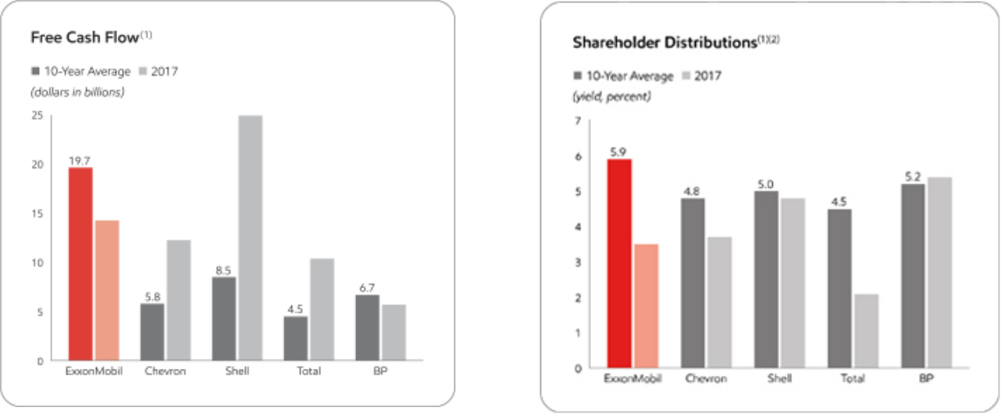

- Competitor data estimated on a consistent basis with ExxonMobil and based on public information. For definitions and more information, see the Summary Annual Report on page 37.
- Total shareholder distributions divided by market capitalization. Shareholder distributions consist of cash dividends and share buybacks to reduce shares outstanding.

44 2018 Proxy Statement

Table of Contents

EXECUTIVE COMPENSATION TABLES

Summary Compensation Table for 2017

 |  |  |  |  |  |  | Change in
 |  |  |  |  |  | Non- | Pension
 |  |  |  |  |  | Non- | Value and
 |  |  |  |  |  | Equity | Nonqualified | All
 |  |  |  |  |  | Incentive | Deferred | All
 |  |  |  | Stock | Option | Plan | Compen- | Other
Name and |  | Salary | Bonus | Stock | Option | Compen- | sation | Compen- | Total
Name and | Year | Salary | Bonus | Awards | Awards | sation | Earnings | sation | Total
Principal Position | Year | ($) | ($) | ($) | ($) | ($) | ($) | ($) | ($)
D.W. Woods | 2017 | 1,200,000 | 1,848,000 | 10,809,810 | 0 | 0 | 3,325,779 | 282,544 | 17,466,133
Chairman and CEO (1) | 2016 | 1,000,000 | 1,232,000 | 12,014,215 | 0 | 0 | 2,179,208 | 421,505 | 16,846,928
 | 2015 | 736,667 | 1,219,000 | 7,241,492 | 0 | 0 | 954,492 | 143,221 | 10,294,872
A.P. Swiger | 2017 | 1,337,500 | 1,603,000 | 8,123,736 | 0 | 0 | 0 | 151,738 | 11,215,974
Senior Vice President; PFO | 2016 | 1,287,500 | 986,000 | 9,330,748 | 0 | 0 | 3,805,931 | 146,568 | 15,556,747
 | 2015 | 1,228,750 | 1,409,000 | 8,648,192 | 0 | 0 | 3,489,861 | 126,559 | 14,902,362
M.W. Albers | 2017 | 1,337,500 | 1,603,000 | 8,123,736 | 0 | 0 | 0 | 166,875 | 11,231,111
Senior Vice President | 2016 | 1,287,500 | 986,000 | 9,330,748 | 0 | 0 | 4,056,601 | 171,658 | 15,832,507
 | 2015 | 1,232,500 | 1,409,000 | 8,648,192 | 0 | 0 | 3,277,380 | 129,265 | 14,696,337
M.J. Dolan | 2017 | 1,430,000 | 1,603,000 | 8,123,736 | 0 | 0 | 0 | 158,215 | 11,314,951
Senior Vice President | 2016 | 1,385,000 | 1,145,000 | 10,874,180 | 0 | 0 | 2,088,167 | 153,388 | 15,645,735
 | 2015 | 1,322,500 | 1,635,000 | 10,078,720 | 0 | 0 | 1,565,725 | 147,587 | 14,749,532
N.W. Duffin | 2017 | 1,063,250 | 1,021,000 | 5,675,150 | 0 | 0 | 0 | 120,349 | 7,879,749
Vice President; President,
ExxonMobil Production
Company

- Mr. Woods was elected Chairman of the Board and CEO of ExxonMobil effective January 1, 2017. Mr. Woods was Senior Vice President in 2015 and elected President of ExxonMobil and member of the Board of Directors effective January 1, 2016.

Compensation Adjusted for Negative Change in Pension

- In 2017, the annual change in pension value was negative for Messrs. Swiger, Albers, Dolan, and Duffin. However, SEC regulations do not allow for inclusion of negative pension amounts in the Summary Compensation Table. The following pro forma table reflects the impact of the negative pension value on 2017 compensation:

 | Reported Pay from Table Above ($) |  | 2017 Negative Pension | 2017 Total | 2017 Total Adjusted Pay vs.
Name | 2016 | 2017 | Adjustment ($) | Adjusted Pay ($) | 2016 Reported Pay ($)
A.P. Swiger | 15,556,747 | 11,215,974 | -3,169,691 | 8,046,283 | -7,510,464
M.W. Albers | 15,832,507 | 11,231,111 | -3,610,483 | 7,620,628 | -8,211,879
M.J. Dolan | 15,645,735 | 11,314,951 | -3,871,569 | 7,443,382 | -8,202,353
N.W. Duffin | — | 7,879,749 | -3,225,966 | 4,653,783 | —

Salary

- Effective January 1, 2018, the annual salary was increased for Mr. Woods to $1,400,000. Effective April 1, 2018, the annual salary was increased for Mr. Swiger to $1,411,000; Mr. Dolan to $1,505,000; and Mr. Duffin to $1,119,000.

- For more details on the design of the salary program and decisions made by the Compensation Committee in 2017, see page 38.

Bonus

- The 2017 bonus was paid one-half in cash at the time of grant. The Company delays payment of the balance until cumulative earnings reach $6.50 per share. Delayed bonus amounts do not earn interest.

2018 Proxy Statement | 45

Table of Contents

- For more details on the design of the bonus program and decisions made by the Compensation Committee in 2017, see page 38.

Stock Awards

- In accordance with disclosure regulations, the valuation of stock awards in this table represents the grant date fair value, which is equal to the number of performance shares awarded times the grant price. Grant price is deemed to be the average of the high and low sale prices on the NYSE on the grant date: $81.89 on November 29, 2017; $87.70 on November 30, 2016; $81.28 on November 24, 2015; and $76.03 on December 9, 2015 (with respect to a supplemental award made to Mr. Woods in connection with his election as President).

- Dividend equivalents paid on performance share awards are reflected in the grant date fair value and, therefore, are not shown in the table.

- For more details on the design of the performance share program and decisions made by the Compensation Committee in 2017, see pages 30 and 39.

Change in Pension Value and Nonqualified Deferred Compensation Earnings

- The amounts shown in this column in the Summary Compensation Table solely represent the positive change in pension value. The Corporation’s nonqualified deferred compensation plan (Supplemental Savings Plan) does not permit accrual of above-market or preferential earnings.

- The change in pension value shown in the table for 2017 is the increase between year-end 2016 and year-end 2017 in the present value of each executive’s pension benefits under the plans. For a description of the pension plans and the present value calculation, see pages 50 to 52.

- For Mr. Woods, the change in pension value for 2017 represents a 38.4 percent increase in the present value of his pension benefits as shown in the Pension Benefits table on page 50. The following table provides a breakdown of the underlying factors.

 | Change in Pension Value | Change in
Factors | (Percent, Rounded) | Present Value ($)
Lump Sum Interest Rate and Change in Mortality Tables | 0.5 | 45,278
Change in Final Average Bonus | 15.8 | 1,370,371
Change in Final Average Salary | 10.2 | 885,589
Age and Service | 11.8 | 1,024,541
Total | 38.4 | 3,325,779

All Other Compensation

The following table breaks down the amounts included in the All Other Compensation column of the Summary Compensation Table for 2017.

 |  | Life | Savings | Personal | Personal Use of Company |  | Financial
Name |  | Insurance ($) | Plan ($) | Security ($) | Aircraft ($) | Properties/Car ($) | Planning ($) | Total ($)
D.W. Woods |  | 0 | 84,000 | 107,763 | 80,691 | 453 | 9,637 | 282,544
A.P. Swiger |  | 42,240 | 93,625 | 3,931 | 0 | 805 | 11,137 | 151,738
M.W. Albers |  | 42,240 | 93,625 | 763 | 0 | 19,110 | 11,137 | 166,875
M.J. Dolan |  | 45,197 | 100,100 | 1,781 | 0 | 0 | 11,137 | 158,215
N.W. Duffin |  | 33,602 | 74,428 | 1,118 | 0 | 64 | 11,137 | 120,349
46 | 2018 Proxy Statement

Table of Contents

Life Insurance

- Mr. Woods participates in the Company’s broad-based employee life insurance program that provides coverage that equals 2 times base salary as an active employee.

- The other Named Executive Officers participate in the Company’s senior executive term life insurance program that provides coverage of 4 times base salary until age 65 and a declining multiple thereafter until age 75, at which point the multiple remains at 2.5 times salary. The Company eliminated this program for all newly eligible senior executives as of October 2007.

- For executives with senior executive term life insurance coverage, the premium cost in any year depends on overall financial and mortality experience under the group policy. The amounts shown are based on Internal Revenue Code tables used to value the term cost of such coverage. This valuation is applied since the actual life insurance premium is a single payment for a large group of executives that does not represent the cost of insuring one specific individual.

Savings Plan

- The amount shown is the value of Company-matching contributions under ExxonMobil’s tax-qualified savings plan and Company credits under the related nonqualified supplemental plan. For a description of the savings plan, see page 40.

- The value of the credits to the nonqualified supplemental plan is also disclosed in the Nonqualified Deferred Compensation table on page 52.

Personal Security

- The Company provides security for its employees as appropriate based on an assessment of risk, which includes consideration of the employee’s position and work location.

- The Company does not consider any such security costs to be personal benefits since these costs arise from the nature of the employee’s employment by the Company. However, the disclosure regulations require certain security costs to be reported as personal benefits.

- The amounts shown in the table include the following types of security-related costs: security systems at executive residences; security services and personnel (at residences and/or during personal travel); car and personal security driver; and Company communications equipment. Costs of security related to travel for business purposes are not included.

- The car provided for security reasons and used primarily for commuting is valued based on the annualized cost of the car plus maintenance and fuel. Reported costs for rental cars utilized for security concerns during personal travel are the actual incremental costs.

- For security personnel employed by the Company, the cost is the actual incremental cost of expenses incurred by the security personnel. Total salary, wages, and benefits are not allocated because the Company already incurs these costs for business purposes.

- For security contractors, the cost is the actual incremental cost of such contractors associated with the executive’s personal time.

- For Mr. Woods, the amount shown includes $50,467 for residential security and $40,774 for the cost of his car provided for security reasons as described above; the remainder is for other communications equipment to conduct business in a secure manner.

Aircraft

- For security reasons, the Board requires the Chairman and CEO to use Company aircraft for both business and personal travel. The Compensation Committee considers these costs to be necessary security-related business expenses rather than perquisites, but per the disclosure regulations, the incremental cost of aircraft usage for personal travel is reported.

2018 Proxy Statement | 47

Table of Contents

- Incremental cost for personal use of the aircraft is based on direct operating costs (fuel, airport fees, incremental pilot costs, etc.) and does not include capital costs of the aircraft since the Company already incurs these costs for business purposes.

Properties/Car

- The Company owns or leases various venues for the purpose of business entertainment, including boxes and season tickets to sporting events, and recreation and conference retreat properties. When these venues are not in use for business entertainment, they may be available to executives and other personnel.

- The table shows the incremental cost incurred for any personal use of these venues by the Named Executive Officers. Cost for this purpose is based solely on incremental operating costs (catering, transportation, incremental employee or contractor costs, etc.) and does not include annual or capital costs of these venues since the Company already incurs these costs for business purposes.

- The amount shown also includes the incremental cost for personal use of a Company car, which is based on an assumed cost of $0.535 per mile. Driver personnel costs are not allocated because the Company already incurs these costs for business purposes.

Financial Planning

- The Company provides financial planning services to senior executives, which includes tax preparation. This benefit is valued based on the actual charge for the services.

Grants of Plan-Based Awards for 2017

 |  |  |  |  |  |  |  |  |  | All | All Other
 |  |  |  |  |  |  |  |  |  | Other | All Other
 |  |  |  |  |  |  |  |  |  | Stock | Option
 |  | Estimated Future Payouts |  |  |  | Estimated Future Payouts |  |  |  | Awards: | Awards: | Exercise
 |  | Under Non-Equity Incentive |  |  |  | Under Equity Incentive |  |  |  | Number | Number | or | Grant Date
 |  |  | Plan Awards |  |  |  | Plan Awards |  |  | of | of | Base | Grant Date
 |  |  |  |  |  |  |  |  |  | Shares | Securities | Price | Fair Value
 |  |  |  |  |  |  |  |  |  | of | Under- | of | of Stock
 |  | Threshold |  | Target | Maximum | Threshold |  | Target | Maximum | Stock | lying | Option | and
Name | Grant Date | Threshold |  | Target | Maximum | Threshold |  | Target | Maximum | or Units | Options | Awards | Option
Name | Grant Date | ($) |  | ($) | ($) | (#) |  | (#) | (#) | (#) | (#) | ($/Sh) | Awards ($)
D.W. Woods | 11/29/2017 | 0 |  | 0 | 0 | 0 |  | 0 | 0 | 132,000 | 0 | 0 | 10,809,810
A.P. Swiger | 11/29/2017 | 0 |  | 0 | 0 | 0 |  | 0 | 0 | 99,200 | 0 | 0 | 8,123,736
M.W. Albers | 11/29/2017 | 0 |  | 0 | 0 | 0 |  | 0 | 0 | 99,200 | 0 | 0 | 8,123,736
M.J. Dolan | 11/29/2017 | 0 |  | 0 | 0 | 0 |  | 0 | 0 | 99,200 | 0 | 0 | 8,123,736
N.W. Duffin | 11/29/2017 | 0 |  | 0 | 0 | 0 |  | 0 | 0 | 69,300 | 0 | 0 | 5,675,150

In 2017, performance share grants were made in the form of stock units. Each stock unit represents one share of ExxonMobil common stock. Performance shares granted to the Named Executive Officers may be settled only in stock. During the restricted period, the executive receives a cash payment on each performance share corresponding to the cash dividends paid on an outstanding share of ExxonMobil stock. Unlike common stock, performance shares granted in stock units do not carry voting rights prior to settlement.

Restrictions and Forfeiture Risk

- For details regarding ExxonMobil’s restrictions and forfeiture provisions, see pages 39 and 43.

Grant Date

- The grant date is the same as the date on which the Compensation Committee of the Board met to approve the awards. For details of grant date fair value, see page 46.

48 2018 Proxy Statement

Table of Contents

Outstanding Equity Awards at Fiscal Year-End for 2017

 |  | Option Awards |  |  |  |  | Stock Awards
 |  |  |  |  |  |  |  |  | Equity
 |  |  |  |  |  |  |  | Equity | Incentive
 |  |  |  |  |  |  |  | Equity | Plan
 |  |  | Equity |  |  |  |  | Incentive | Awards:
 |  |  | Equity |  |  |  |  | Plan | Market or
 |  |  | Incentive |  |  |  |  | Awards: | Payout
 |  |  | Plan |  |  |  | Market | Number of | Value of
 | Number of | Number of | Awards: |  |  | Number of | Market | Unearned | Unearned
 | Number of | Number of | Number of |  |  | Number of | Value of | Shares, | Shares,
 | Securities | Securities | Securities | Option |  | Shares or | Shares or | Units or | Units or
 | Underlying | Underlying | Underlying | Option | Option | Units of | Units of | Other | Other
 | Unexercised | Unexercised | Unexercised | Exercise | Option | Stock That | Stock That | Rights That | Rights That
Name | Options (#) | Options (#) | Unearned | Price | Expiration | Have Not | Have Not | Have Not | Have Not
Name | Exercisable | Unexercisable | Options (#) | ($) | Date | Vested (#) | Vested ($) | Vested (#) | Vested ($)
D.W. Woods | 0 | 0 | 0 | 0 | — | 473,800 | 39,628,632 | 0 | 0
A.P. Swiger | 0 | 0 | 0 | 0 | — | 700,850 | 58,619,094 | 0 | 0
M.W. Albers | 0 | 0 | 0 | 0 | — | 779,350 | 65,184,834 | 0 | 0
M.J. Dolan | 0 | 0 | 0 | 0 | — | 872,900 | 73,009,356 | 0 | 0
N.W. Duffin | 0 | 0 | 0 | 0 | — | 493,050 | 41,238,702 | 0 | 0

Stock Awards (Performance Shares)

- Performance shares shown in the table above include both stock and stock units. The market value is based on the 2017 year-end closing stock price of $83.64 and this value has not been risk adjusted. These performance shares have the same terms, except that stock units do not include voting rights. For more information regarding the performance share program, see page 39.

- For Mr. Woods, the table above includes 12,400 performance shares that were granted before he became a senior executive. They are subject to a different vesting schedule than his current and more recent awards, but otherwise have the same terms as awards granted to other senior executives. These remaining outstanding performance shares vest in seven years from grant date.

- The table below shows the dates on which the respective restricted periods for the performance shares shown in the previous table expire, assuming the awards are not forfeited and the executive is living when the restrictions lapse.

 |  |  | Date Restrictions Lapse and Number of Performance Shares
Name | 2018 | 2019 |  | 2020 | 2021 | 2022 | 10 Years or Retirement,
Name | 2018 | 2019 |  | 2020 | 2021 | 2022 | Whichever Occurs Later
D.W. Woods | 31,950 | 23,400 |  | 45,400 | 68,500 | 66,000 | 238,550
A.P. Swiger | 45,400 | 45,400 |  | 53,200 | 53,200 | 49,600 | 454,050
M.W. Albers | 45,400 | 45,400 |  | 53,200 | 53,200 | 49,600 | 532,550
M.J. Dolan | 53,200 | 53,200 |  | 62,000 | 62,000 | 49,600 | 592,900
N.W. Duffin | 32,200 | 32,200 |  | 32,200 | 38,500 | 34,650 | 323,300
 |  |  |  |  | 2018 Proxy Statement |  | 49

Table of Contents

Option Exercises and Stock Vested for 2017

 | Option Awards |  |  | Stock Awards
 | Number of Shares |  | Value Realized | Number of Shares |  | Value Realized
Name | Acquired on Exercise |  | on Exercise | Acquired on Vesting |  | on Vesting
Name | (#) |  | ($) | (#) |  | ($)
D.W. Woods | 0 |  | 0 | 25,350 |  | 2,066,010
A.P. Swiger | 0 |  | 0 | 42,000 |  | 3,429,930
M.W. Albers | 0 |  | 0 | 45,400 |  | 3,707,591
M.J. Dolan | 0 |  | 0 | 49,300 |  | 4,026,085
N.W. Duffin | 0 |  | 0 | 32,200 |  | 2,629,613

Stock Awards/Restriction Lapse in 2017

- In 2017, restrictions lapsed on 50 percent of performance share awards that were granted in 2012. For Mr. Woods, restrictions also lapsed on 50 percent of performance share awards that were granted in 2010. See notes to Outstanding Equity Awards at Fiscal Year-End for 2017 table for more information (page 49).

- The number of shares acquired on vesting is the gross number of shares to which the award relates. The value realized is the gross number of shares times the market price, which is the average of the high and low sale prices on the NYSE on the date that the restrictions lapse.

- The net number of shares acquired (gross number of shares less shares withheld for taxes) are 14,714 for Mr. Woods; 24,380 for Mr. Swiger; 26,354 for Mr. Albers; 28,618 for Mr. Dolan; and 18,692 for Mr. Duffin.

- Refer to the Performance Share Program section on page 39 for additional information.

Pension Benefits for 2017

 |  | Number of | Present Value of | Payments
 |  | Years Credited | Accumulated | During Last
 |  | Service | Benefit | Fiscal Year
Name | Plan Name | (#) | ($) | ($)
D.W. Woods | ExxonMobil Pension Plan | 25.34 | 1,231,816(a) | 0
 | ExxonMobil Supplemental Pension Plan | 25.34 | 3,567,004(b) | 0
 | ExxonMobil Additional Payments Plan | 25.34 | 7,176,735(b) | 0
A.P. Swiger | ExxonMobil Pension Plan | 39.33 | 2,524,801 | 0
 | ExxonMobil Supplemental Pension Plan | 39.33 | 10,389,154 | 0
 | ExxonMobil Additional Payments Plan | 39.33 | 18,218,088 | 0
M.W. Albers | ExxonMobil Pension Plan | 38.42 | 2,500,150 | 0
 | ExxonMobil Supplemental Pension Plan | 38.42 | 10,294,696 | 0
 | ExxonMobil Additional Payments Plan | 38.42 | 18,030,308 | 0
M.J. Dolan | ExxonMobil Pension Plan | 37.42 | 2,155,530 | 0
 | ExxonMobil Supplemental Pension Plan | 37.42 | 9,904,271 | 0
 | ExxonMobil Additional Payments Plan | 37.42 | 17,719,245 | 0
N.W. Duffin | ExxonMobil Pension Plan | 38.25 | 2,482,052 | 0
 | ExxonMobil Supplemental Pension Plan | 38.25 | 7,608,445 | 0
 | ExxonMobil Additional Payments Plan | 38.25 | 12,473,801 | 0

- The Present Value of Accumulated Benefit figure for the ExxonMobil Pension Plan for Mr. Woods is calculated as if he were eligible for early retirement (i.e., at least 55 years of age with at least 15 years of service). Because Mr. Woods is not yet 55 years of age, he would not be eligible to receive a single lump sum payment of his pension benefit if he were to terminate employment at year-end 2017; and, in such circumstance, any annuity benefit he elected to receive would be actuarially reduced.

- In the event of termination prior to early retirement eligibility, there is no benefit payable under the Supplemental Pension Plan or Additional Payments Plan. The Present Value of Accumulated Benefit figure for these plans for Mr. Woods is calculated as if he were eligible for early retirement, even though he is not eligible as of year-end 2017.

50 2018 Proxy Statement

Table of Contents

Pension Plans

- Retirement benefit plans (qualified and nonqualified) provide an annual benefit of 1.6 percent of final average pay per year of service, with the qualified plan having an offset for Social Security benefits. For a description, see page 40. Below are the calculations and forms of payments for each plan:

Plan Name | Calculation |  | Forms of Payment
Pension Plan | 1.6% x final average salary⁽¹⁾ | x years credited service, less a | Benefit available as a lump sum or in
(qualified) | Social Security offset |  | various annuity forms
Supplemental Pension Plan | 1.6% x final average salary⁽¹⁾ | x years credited service | Paid in the form of an equivalent lump
(nonqualified) |  |  | sum six months after retirement
Additional Payments Plan | 1.6% x average annual bonus⁽²⁾ x years credited service |  | Paid in the form of an equivalent lump
(nonqualified) |  |  | sum six months after retirement

- Final average salary is the average of the highest 36 consecutive months in the 10 years of service prior to retirement. For the Pension Plan, final average salary included and benefits paid are subject to the limits on compensation ($270,000 for 2017, adjusted each year for inflation) and benefits prescribed by the Internal Revenue Code. For the Supplemental Pension Plan, final average salary is the amount that exceeds the Internal Revenue Code limit. Additionally, the Supplemental Pension Plan benefit includes any benefit amount in excess of the benefit limit prescribed by the Internal Revenue Code.

- Average annual bonus is the average of the annual bonus for the three highest grants of the last five awarded prior to retirement (including the portion of the annual bonus that is paid at time of grant and the portion that is paid on a delayed basis as described beginning on page 38).

Present Value Pension Calculations

- The present value of accumulated benefits is determined by converting the annuity values earned as of year end to lump sum values payable at age 60 (or at the employee’s actual age, if older) using the applicable mortality tables and interest rates.

- The value shown in the Pension Benefits table is the accumulated benefit as of year-end 2017 and the value shown in the Summary Compensation Table on page 45 represents the annual increase in the value of the pension between year-end 2016 and 2017.

- The lump sum interest rates used to calculate the accumulated benefits in the Pension Benefits table and Summary Compensation Table were:
– For plan participants who had attained age 50 with at least 10 years of service before January 1, 2008 (including all Named Executive Officers except Mr. Woods), the lump sum interest rates for an employee who worked through the end of 2016 was 2.25 percent and through the end of 2017 was 2.75 percent.

– For other participants (including Mr. Woods), the plan specifies short-, medium-, and long-term interest rate assumptions for this purpose. The lump sum interest rates for an employee who worked through the end of 2016 were 1.43 percent, 3.31 percent, and 4.24 percent, respectively, and through the end of 2017 were 1.95 percent, 3.58 percent, and 4.36 percent, respectively.

– The actual lump sum conversion factors that will apply when each executive retires may be different.

- For employees not age 60, these age 60 lump sum values are discounted to present values based on the time difference between the individual’s age at year-end 2017 and age 60 (and at year-end 2016 and age 60 for the annual increase in pension calculation in the Summary Compensation Table) using the interest rates for valuing financial reporting of pension obligations as of each year end. The discount rate for determining the present value of benefits was 4.25 percent as of year-end 2016 and 3.8 percent as of year-end 2017.

Effect of Early Retirement or Death

- The Named Executive Officers have not received any additional service credit. Actual service is reflected in the table on page 50.

- All three pension plans require completion of 15 years of service and attainment of age 55 to be eligible for early retirement. All Named Executive Officers have satisfied this requirement except for Mr. Woods who does not currently meet the age requirement.

2018 Proxy Statement | 51

Table of Contents

- The early retirement benefit under the pension plans consists of an annuity benefit that is undiscounted for retirement ages of 60 years or over, with a discount of 5 percent for each year under age 60. In addition, the Social Security offset is waived for annuity payments scheduled to be paid prior to age 62. The benefit is eligible to be paid in the form of a lump sum.

- In the event of termination prior to early retirement eligibility, there is no benefit payable under the Supplemental Pension Plan or Additional Payments Plan, and the pension benefit payable from the ExxonMobil Pension Plan is actuarially discounted.

- In the event of death after early retirement eligibility, the retirement benefit is payable to the participant’s beneficiary. Prior to early retirement eligibility, if a participant has at least 15 years of service, the actuarially determined present value of the benefit accrued prior to death is payable to the participant’s beneficiary. Under the qualified Pension Plan, if a participant has less than 15 years of service at the time of death, the survivor benefit, payable to the participant’s surviving spouse, is 50 percent of the actuarially discounted vested termination benefit payable under the qualified joint and survivor annuity option.

Nonqualified Deferred Compensation for 2017

 | Executive | Registrant | Aggregate | Aggregate | Aggregate
 | Contributions in | Contributions in | Earnings in | Withdrawals/ | Balance at
 | Last FY | Last FY | Last FY | Distributions | Last FYE
Name | ($) | ($) | ($) | ($) | ($)
D.W. Woods | 0 | 65,100 | 9,844 | 0 | 359,389
A.P. Swiger | 0 | 74,725 | 27,206 | 0 | 923,327
M.W. Albers | 0 | 74,725 | 22,257 | 0 | 764,203
M.J. Dolan | 0 | 81,200 | 30,185 | 0 | 1,022,723
N.W. Duffin | 0 | 55,528 | 15,107 | 0 | 523,267

- The table above shows the value of the Company credits under ExxonMobil’s nonqualified Supplemental Savings Plan. For a description of the nonqualified Supplemental Savings Plan, see page 40.

- The nonqualified savings plan provides employees with the 7-percent, Company-matching contribution to which they would otherwise be entitled under the qualified plan if not for limitations on covered compensation and total contributions under the Internal Revenue Code.

- The rate at which the nonqualified savings plan account bears interest during the term of a participant’s employment is 120 percent of the long-term Applicable Federal Rate.

- The Company credits for 2017 are also included in the Summary Compensation Table under the column labeled All Other Compensation. The aggregate balance at the last fiscal year end shown above includes amounts reported as Company contributions in the Summary Compensation Table of the current proxy statement and proxy statements from prior years as follows: $149,567 for Mr. Woods; $381,238 for Mr. Swiger; $438,550 for Mr. Albers; $566,913 for Mr. Dolan; and $55,528 for Mr. Duffin.

Administrative Services for Retired Employee Directors

- The Company provides certain administrative support to retired employee directors, generally involving, but not limited to, assistance with correspondence and travel arrangements relating to activities the retired directors are involved with that continue from their employment, such as board positions with nonprofit organizations. Given the nature of the support provided, a retired director’s spouse may also benefit from the support provided. Retired employee directors are also allowed to use vacant office space at headquarters.

- The aggregate incremental cost of providing these services to all current beneficiaries is approximately $65,000 per year. This amount represents the cost of compensation and benefits for support personnel allocated based on their estimated time dedicated to providing this service, as well as other miscellaneous office support costs.

- It is not possible to estimate the future cost that may be incurred by the Company for providing these services to Mr. Woods, who is currently the only employee director.

52 2018 Proxy Statement

Table of Contents

Health Care Benefits

- Executives and their families are eligible to participate in the Company’s health care programs, including medical, dental, prescription drug, and vision care, on the same basis as all other U.S. employees. No special provisions apply.

Unused Vacation

- U.S. salaried employees are entitled to payment of salary for any accumulated but unused vacation days at retirement or other termination of employment. Payment for unused vacation is included in final payments of earned salary, if applicable.

Termination and Change in Control

- The Named Executive Officers are not entitled to any additional payments or benefits relating to termination of employment other than the retirement benefits previously described.

- The Named Executive Officers do not have employment contracts, a severance program, or any benefits or payments triggered by a change in control.

- For more details on ExxonMobil’s clawback policy and forfeiture provisions, see page 43.

Payments in the Event of Death

- The only event that results in the acceleration of the vesting period for outstanding performance share awards is death.

- Also in the event of death, an executive’s estate or beneficiaries would be entitled to receive the applicable pension death benefits as described beginning on page 51, a distribution of the executive’s savings plan balances, and payment of Company-provided life insurance or death benefits as described beginning on page 47. At year-end 2017, the amount of Company-provided life insurance for each Named Executive Officer is as follows:

Name | Life Insurance Benefit ($)
D.W. Woods | 2,400,000
A.P. Swiger | 5,400,000
M.W. Albers | 5,400,000
M.J. Dolan | 5,760,000
N.W. Duffin | 4,284,000

2018 Proxy Statement | 53

Table of Contents

SHAREHOLDER PROPOSALS

We expect Items 4 through 7 to be presented by shareholders at the annual meeting. Following SEC rules, other than minor formatting changes, we are reprinting the proposals and supporting statements as they were submitted to us. We take no responsibility for them. Upon oral or written request to the Secretary at the address listed under Contact Information on page 4, we will provide information about the sponsors’ shareholdings, as well as the names, addresses, and shareholdings of any co-sponsors.

The Board recommends you vote AGAINST Items 4 through 7 for the reasons we give after each one.

Item 4 – Independent Chairman

This proposal was submitted by The Kestrel Foundation, 111 Commercial Street, Suite 302, Portland, ME 04101, the beneficial owner of 320 shares and lead proponent of a filing group.

“RESOLVED: The shareholders request the Board of Directors to adopt as policy, and amend the bylaws as necessary, to require the Chair of the Board of Directors, whenever possible, to be an independent member of the Board. This policy would be phased in for the next CEO transition.

If the Board determines that a Chair who was independent when selected is no longer independent, the Board shall select a new Chair who satisfies the requirements of the policy within a reasonable amount of time. Compliance with this policy is waived if no independent director is available and willing to serve as Chair.

Supporting Statement:

We believe:

- The role of the CEO and management is to run the company.

- The role of the Board of Directors is to provide independent oversight of management and the CEO.

- There is a potential conflict of interest for a CEO to be her/his own overseer as Chair while managing the business.

ExxonMobil’s CEO Darren Woods serves both as CEO and Chair of the Company’s Board of Directors. We believe the combination of these two roles in a single person weakens a corporation’s governance structure.

Chairing and overseeing the Board is a time intensive responsibility. A separate Chair also frees the CEO to manage the company and build effective business strategies.

As Andrew Grove, Intel’s former chair, stated, ‘The separation of the two jobs goes to the heart of the conception of a corporation. Is a company a sandbox for the CEO, or is the CEO an employee? If he’s an employee, he needs a boss, and that boss is the Board. The Chairman runs the Board. How can the CEO be his own boss?’

In our view, shareholders are best served by an independent Board Chair who can provide a balance of power between the CEO and the Board. The primary duty of a Board of Directors is to oversee the management of a company on behalf of shareholders. A combined CEO / Chair creates a potential conflict of interest, resulting in excessive management influence on the Board and weaker oversight of management.

Numerous institutional investors recommend separation of these two roles. For example, California’s Public Employee Retirement System’s Principles & Guidelines encourage separation, even with a lead director in place.

According to ISS ‘2015 Board Practices’, (April 2015), 53% of S&P 1,500 firms separate these two positions and the number of companies separating these roles is growing.

54 2018 Proxy Statement

Table of Contents

With the appointment of a new CEO, and with the unprecedented rate of change facing companies regarding climate change and the role of energy companies, it is an important time to ensure our company’s governance is the best it can be.

The shareholder resolution urging separation of CEO and Chair to ExxonMobil received 38.3% vote in 2017.

To simplify the transition, this new policy, if enacted, would be phased in when a next CEO is chosen.”

The Board recommends you vote AGAINST this proposal for the following reasons:

The Board agrees with the importance of a strong, independent Board to represent the interests of shareholders. The Board also agrees that it is responsible for effective oversight of Management, including the CEO. However, the Board does not agree that the combined Chairman/CEO position weakens corporate governance, impedes its ability to provide effective oversight, or that it constitutes a conflict.

The Board believes it is important to preserve flexibility in choosing the best leadership structure for the Company to best serve the long-term interests of shareholders. The Board carefully considers the merits of separating or combining the Chairman and CEO positions and whether the Chairmanship should be held by an independent director, whenever a CEO change occurs.

The Board is comprised entirely of independent directors, except the CEO. Each independent director has access to the CEO and other Company executives on request, may call meetings of the independent directors, and may request agenda topics to be added or dealt with in more detail at meetings of the full Board or an appropriate committee.

At the present time, the Board believes that independent Board leadership is effectively provided by the Presiding Director, who:

- Has the authority to call, chair, and determine the agenda for executive sessions of the independent directors and provide feedback to the Chairman;

- Chairs Board meetings in the absence of the Chairman; and

- Works with the Chairman on schedules and agendas for Board meetings.

The Compensation Committee, comprised of independent directors, reviews the CEO performance and establishes his compensation, the result of which is reviewed with the full Board, absent the Chairman.

The 2017 Spencer Stuart Board Index notes that only 28 percent of S&P 500 companies have a truly independent chairman, i.e., one that meets the NYSE rules for independence. It also notes that the number of independent chairs has remained steady over the past several years. Separately, no prevailing empirical evidence supports the merits of independent chairs.

Item 5 – Special Shareholder Meetings

This proposal was submitted by Kenneth Steiner, 14 Stoner Ave., 2M, Great Neck, NY 11021, the beneficial owner of 500 shares.

“Proposal [5] – Special Shareholder Meeting

Resolved, Shareowners ask our board to take the steps necessary (unilaterally if possible) to amend our bylaws and each appropriate governing document to give holders in the aggregate of 10% of our outstanding common stock the power to call a special shareowner meeting (or the closest percentage to 10% according to state law). This proposal does not impact our board’s current power to call a special meeting.

Special meetings allow shareowners to vote on important matters, such as electing new directors that can arise between annual meetings. This proposal topic won more than 70%-support at Edwards Lifesciences and SunEdison in 2013.

2018 Proxy Statement | 55

Table of Contents

A shareholder right to call a special meeting and to act by written consent and are 2 complimentary ways to bring an important matter to the attention of both management and shareholders outside the annual meeting cycle such as the election of directors. More than 100 Fortune 500 companies provide for shareholders to call special meetings and to act by written consent.

This proposal topic won 40%-support at the 2017 Exxon annual meeting. This 40%-support could have been higher (for instance 45%) if small shareholders had the same access to independent corporate governance recommendations as large shareholders.

A shareholder ability to call a special meeting would put shareholders in a better position to ask for improvement in our board of directors after the 2018 annual meeting. For instance, directors could be given more appropriate assignments on our Board of Directors. Company performance and the stock price can benefit from such an improvement.

For instance Steven Reinemund and Kenneth Frazier each received 12-times as many negative votes as some of our directors. Mr. Reinemund and Mr. Frazier were both on an important board committee. Perhaps serious consideration should be given to keep directors off such board committees when they receive such shareholder dissatisfaction.

Please vote to increase management accountability to shareholders:

Special Shareholder Meeting – Proposal [5]”

The Board recommends you vote AGAINST this proposal for the following reasons:

The Board believes it is important that shareholders have a meaningful right to call special shareholder meetings, a right that ExxonMobil currently provides. A special meeting of ExxonMobil shareholders may be called by holders of not less than 10 percent of outstanding shares, in accordance with New Jersey law, upon a showing of good cause.

By requiring a showing of good cause to call a special meeting, New Jersey law balances the interests of all parties by allowing shareholders to call a meeting for a legitimate purpose while protecting against the potential for abuse. The Board believes this proposal is therefore unnecessary.

Item 6 – Board Diversity Matrix

This proposal was submitted by the City of New York Retirement Systems, 1 Centre Street, New York, NY 10007, the beneficial owner of 7,837,594 shares.

“RESOLVED: Shareholders of Exxon Mobil Corporation (‘Exxon’) request that its Board of Directors (the ‘Board’) disclose to shareholders each director’s/nominee’s gender and race/ethnicity, as well as skills, experience, and attributes that are most relevant in light of Exxon’s overall business, long-term strategy and risks, presented in a matrix form. The requested matrix shall not include any attributes the Board identifies as minimum qualifications for all Board candidates in compliance with SEC Regulation S-K.

The requested matrix shall be presented to shareholders in Exxon’s annual proxy statement and on its website within six months of the date of the annual meeting, and updated annually.

SUPPORTING STATEMENT

We believe a diverse board – in terms of relevant skills and experience AND gender and race/ethnicity – is a good indicator of a well-functioning board. Among other benefits, diverse boards can better manage risk by avoiding ‘groupthink’ – a cognitive bias whereby ‘homogeneous, cohesive groups’ tend toward standard agreement with known business associates and not challenge ‘basic premises’ (http://www.ieo-imf.org/ieo/files/ completedevaluations/01102011Crisis_IV._Why_Did_the_IMF_Fail_to_Give_Clear_Warning.pdf).

56 2018 Proxy Statement

Table of Contents

Research by McKinsey suggests that companies with greater gender and ethnic board diversity have stronger financial performance (https://www.mckinsey.com/business-functions/organization/our-insights/why-diversity-matters). MSCI research suggests that gender diverse boards have fewer instances of bribery, corruption, and fraud (https://www.msci.com/documents/10199/04b6f646-d638-4878-9c61-4eb91748a82b).

Many boards recognize the importance of, and disclose information on, their boards’ gender and racial/ethnic diversity:

- According to a 2017 PwC survey of 886 directors, 68% believe gender diversity is very important and 42% believe racial diversity is very important. Among those who responded that diversity is important, 82% said it improved board performance and 59% said it improved company performance. (https://www.pwc.com/us/en/governance-insights-center/annual-corporate-directors-survey/assets/pwc-2017-annual-corporate--directors--survey.pdf)

- According to a 2017 Equilar study of 500 large companies, 45.1% disclosed board composition by gender and 39.8% disclosed composition in terms of race/ethnicity. (http://semlerbrossy.com/wp-content/uploads/Equilar-Board-Composition-and-Director-Recruiting-Trends-SEP-2017.pdf)

In its 2017 proxy statement, Exxon provides no overview of how its directors’ different qualifications fit together to effectively fulfill their oversight responsibilities, nor did it explicitly disclose their gender and race.

Providing a Board matrix will give Exxon shareholders a ‘big-picture’ view of Exxon directors’ attributes and how they fit together, thereby enabling shareholders to (a) assess how well-suited individual director nominees are for the company in light of (i) the company’s evolving business strategy and risks and (ii) the overall mix of director skills and experiences; (b) identify any gaps in skills, experience or other characteristics; and (c) make better informed proxy voting decisions.

Use of a matrix to present director qualifications is recommended by the National Association of Corporate Directors (https://www.nacdonline.org/Resources/Article.cfm?ItemNumber=35337), among other business and investor groups. The EY Center for Board Matters recently reported that 16% of S&P 500 companies disclosed a director skills matrix in 2017 (http://www.ey.com/Publication/vwLUAssets/EY-board-matters-quarterly-june-2017/$FILE/EY-board-matters-quarterly-june-2017.pdf).

The specific matrix approach that we are requesting, with gender and race/ethnicity as essential dimensions, is consistent with the request in a March 31, 2015 rulemaking petition to the U.S. Securities and Exchange Commission seeking mandatory matrix disclosure by all U.S. public companies (https://www.sec.gov/rules/petitions/2015/petn4-682.pdf).

We urge shareholders to vote FOR this proposal.”

The Board recommends you vote AGAINST this proposal for the following reasons:

The Board agrees that diversity, including gender and ethnicity, is a key attribute of the composition and competency of a board, and believes that this is relevant information for shareholders. This is why we have traditionally provided detailed information regarding our Board members in our proxy statement and on our website. Our proxy statement also: a) provides the description of the qualifications that the Board seeks in its directors; b) emphasizes the importance of diversity in our candidate search process; and c) provides a summary of the Board’s collective competencies and diversity. We believe the breadth of our disclosures meaningfully addresses the proposal.

Diversity of life experiences and backgrounds, as well as gender and ethnic diversity, is an important consideration in identifying and assessing board candidates, as is a thorough assessment of a candidate’s experiences, qualifications, and attributes. The success of our Board refreshment process, from the standpoint of diversity, is seen in the results. Female members comprise 27 percent of our current Board, above the S&P average of 22 percent. The Board’s ethnic minority representation of 18 percent also exceeds the average S&P performance of 17 percent. Additionally, five of the last ten most recently elected independent directors were women or ethnic minorities (S&P data sourced from 2017 Spencer Stuart Board Index).

2018 Proxy Statement | 57

Table of Contents

ExxonMobil’s Board selection process has been successful in identifying and attracting a diverse slate of very experienced and qualified individuals. The quality of ExxonMobil’s Board has been recognized by third-party experts (JamesDruryPartners – The Weight of America’s Boards – 2016). Our Board also enjoys significant support in the mid 90-percentile from shareholders over the past five years.

Item 7 – Report on Lobbying

This proposal was submitted by the United Steelworkers, 60 Boulevard of the Allies, Pittsburgh, PA 15222, the beneficial owner of 116 shares and lead proponent of a filing group.

“Whereas, we believe in full disclosure of ExxonMobil’s direct and indirect lobbying activities and expenditures to assess whether ExxonMobil’s lobbying is consistent with its expressed goals and in the best interests of shareholders.

Resolved, the shareholders of ExxonMobil request the preparation of a report, updated annually, disclosing:

- Company policy and procedures governing lobbying, both direct and indirect, and grassroots lobbying communications.

- Payments by ExxonMobil used for (a) direct or indirect lobbying or (b) grassroots lobbying communications, in each case including the amount of the payment and the recipient.

- ExxonMobil’s membership in and payments to any tax-exempt organization that writes and endorses model legislation.

- Description of management’s and the Board’s decision making process and oversight for making payments described in sections 2 and 3 above.

For purposes of this proposal, a ‘grassroots lobbying communication’ is a communication directed to the general public that (a) refers to specific legislation or regulation, (b) reflects a view on the legislation or regulation and (c) encourages the recipient of the communication to take action with respect to the legislation or regulation. ‘Indirect lobbying’ is lobbying engaged in by a trade association or other organization of which ExxonMobil is a member.

Both ‘direct and indirect lobbying’ and ‘grassroots lobbying communications’ include efforts at the local, state and federal levels.

The report shall be presented to the Audit Committee or other relevant oversight committees and posted on ExxonMobil’s website.

Supporting Statement

We encourage transparency and accountability in ExxonMobil’s use of corporate funds to influence legislation and regulation. Since 2010, ExxonMobil has spent over $ 94 million on federal lobbying. These figures do not include lobbying expenditures to influence legislation in states, where ExxonMobil also lobbies in 33 states (‘Amid Federal Gridlock, Lobbying Rises in the States,’ Center for Public Integrity, February 11, 2016), but disclosure is uneven or absent. For example, ExxonMobil has spent over $ 3.6 million lobbying in California since 2010, and its lobbying on California’s cap and trade bill attracted media attention (‘Businesses Spent Millions Lobbying Before Cap-and-Trade Vote,’ E&E News, July 26, 2017).

ExxonMobil is a member of the American Petroleum Institute (API), Business Roundtable and National Association of Manufacturers, which together spent over $74 million on lobbying for 2015 and 2016. ExxonMobil does not disclose its memberships in, or payments to, trade associations, or the amounts used for lobbying. We are concerned that ExxonMobil’s lack of trade association lobbying disclosure presents reputational risks. For example, API and ExxonMobil have drawn scrutiny for lobbying against stricter benzene regulation (‘Oil Companies Leaking Benzene Lobbied against Pollution Rules,’ International Business Times, September 6, 2017).

58 2018 Proxy Statement

Table of Contents

And ExxonMobil is a member of the American Legislative Exchange Council (ALEC), and its ALEC membership has drawn media focus (‘Exxon Continued Paying Millions to Climate-Change Deniers under Rex Tillerson,’ Huffington Post, January 9, 2017). Over 100 companies have publicly left ALEC, including BP, ConocoPhillips and Shell.”

The Board recommends you vote AGAINST this proposal for the following reasons:

The Board fully supports accountability and appropriate transparency and disclosure of lobbying activities and expenditures. As a result, the Company currently makes its positions on key issues available to the public. In addition, lobbying expenses and the specific issues lobbied are also publicly available.

These efforts comply fully with the spirit and letter of all federal and state lobby disclosure requirements. We believe these existing disclosure laws are appropriately broad and provide the necessary transparency. As such, ExxonMobil believes that the Congress, Executive Branch, and state and local governments are the appropriate recipients of the proponent’s specific positions on lobbying disclosure laws, and any reforms they seek.

Under our Political Activities Policy and Guidelines, certain employees are authorized to act on behalf of the Company to execute the political activities of the Company, including lobbying. Lobbying is viewed by the Corporation as a political activity in support of business interests. The policy and guidelines are viewable and lobbying activities are described in the Political Contributions and Lobbying section on exxonmobil.com.

ExxonMobil has an established process to determine public policy issues that are important to the Company, which includes reviews by both the Management Committee and the Board. We calibrate our lobbying and advocacy efforts accordingly. The Company’s positions on key issues are available in the Current Issues section of our website.

ExxonMobil publicly reports on a quarterly basis to Congress our federal lobbying expenses and the specific issues lobbied. The total figure reported in ExxonMobil’s public Lobbying Disclosure Act filings includes expenses associated with the costs of employee federal lobbying, as well as those portions of payments to trade associations and other groups that are spent on federal lobbying. All reports are accessible to the general public on the U.S. Senate’s website at www.senate.gov. More recently filed reports are also listed on exxonmobil.com. The Company promotes transparency of our grassroots lobbying communications sent to members of the ExxonMobil Citizen Action Team by publishing live action alerts on exxonmobilcat.com. Any interested party may join our Citizen Action Team by enrolling on exxonmobilcat.com.

Our contributions to more than 100 U.S.-based organizations, including the American Legislative Exchange Council (ALEC), are detailed in the Worldwide Contributions and Community Investments: Public Policy report available at exxonmobil.com. Our contributions do not constitute an endorsement of every policy position or point of view expressed by a recipient organization. ExxonMobil participates in ALEC policy discussions on a range of issues including taxes, regulatory reform, education, and energy policy. At several recent ALEC annual meetings, ExxonMobil speakers discussed our support for a revenue-neutral carbon tax as an option for policy makers to address climate change. At the most recent ALEC annual meeting, ExxonMobil successfully opposed resolution language that the Company believed was in opposition to climate science. As is true of all nonprofit groups we support, an annual evaluation of the merits of each organization is conducted, and we reserve the right to initiate, sustain, or withdraw support at any time.

2018 Proxy Statement | 59

Table of Contents

PAY RATIO

The annual total compensation of the CEO of the Corporation for 2017 was $17,495,119. The median of the annual total compensation of all employees of the Corporation except the CEO for 2017 was $161,562. The ratio of the annual total compensation of the CEO for 2017 to the median of the annual total compensation of all employees was 108:1.

The median employee was identified as of October 1, 2017, based on total taxable wages for the most recently completed prior fiscal year as shown in the Corporation’s records. No estimates or sampling methodologies were used for this purpose. No cost-of-living adjustments were made and the taxable wages of employees employed for less than the full fiscal year were not annualized. “Employees” were defined based on applicable employment and tax laws.

For purposes of this disclosure, as permitted by SEC rules, the value of nondiscriminatory benefits is included in annual total compensation of both the median employee and the CEO. These nondiscriminatory benefits are long-term disability, basic life insurance, accidental death and dismemberment insurance, medical, and dental.

We believe including these benefits provides a more accurate compensation ratio. Since SEC rules do not require inclusion of these generally available benefits in the Summary Compensation Table, the annual total compensation of the CEO shown above is slightly higher than the Total Compensation shown for the CEO in that table.

ExxonMobil is a global company with employees in many countries around the world. As permitted by the de minimis exemption under the SEC rules, for purposes of identifying the median employee we have excluded employees from 36 countries, which represent in aggregate less than 5 percent of the Corporation’s total employees. As required, where any employees from a jurisdiction were excluded, all employees from that jurisdiction were excluded. In total, as detailed in the table below 2,295 employees were excluded under the de minimis exemption out of a total number of worldwide employees of 72,557.


Countries Excluded / Number of Employees

1. | Colombia | 416 | 10. | Sweden | 74 | 19. | New Caledonia | 28 | 28. | Greece | 7
2. | Egypt | 346 | 11. | Taiwan | 62 | 20. | South Korea | 21 | 29. | Ukraine | 5
3. | Mexico | 256 | 12. | Japan | 57 | 21. | Romania | 20 | 30. | Vietnam | 4
4. | Peru | 152 | 13. | Guyana | 53 | 22. | N. Mariana Islands | 17 | 31. | Tanzania | 4
5. | Qatar | 142 | 14. | Guam | 40 | 23. | Ecuador | 14 | 32. | Micronesia | 4
6. | Turkey | 123 | 15. | Poland | 38 | 24. | Spain | 13 | 33. | Azerbaijan | 3
7. | Finland | 101 | 16. | Cyprus | 38 | 25. | Saudi Arabia | 13 | 34. | Luxembourg | 3
8. | New Zealand | 83 | 17. | Fiji | 33 | 26. | South Africa | 10 | 35. | Cameroon | 2
9. | United Arab Emirates | 76 | 18. | Kazakhstan | 29 | 27. | Denmark | 7 | 36. | Iraq | 1
 |  |  |  |  |  |  |  | Total Number of Employees Excluded |  |  | 2,295
60 |  | 2018 Proxy Statement

Table of Contents

ADDITIONAL INFORMATION

Other Business

We are not currently aware of any other business to be acted on at the meeting. Under the laws of New Jersey, where ExxonMobil is incorporated, no business other than procedural matters may be raised at the meeting unless proper notice has been given to the shareholders. If other business is properly raised, your proxies have authority to vote as they think best, including to adjourn the meeting.

People With Disabilities

We can provide reasonable assistance to help you participate in the meeting if you tell us about your disability and your plans to attend. Please call or write the Secretary at least two weeks before the meeting at the telephone number, address, or fax number listed under Contact Information on page 4.

Outstanding Shares

On February 28, 2018, there were 4,235,790,953 shares of common stock outstanding. Each common share has one vote.

How We Solicit Proxies

In addition to this mailing, ExxonMobil officers and employees may solicit proxies personally, electronically, by telephone,

or with additional mailings. ExxonMobil pays the costs of soliciting this proxy. We are paying D.F. King & Co. a fee of
$30,000 plus expenses to help with the solicitation. We also reimburse brokers and other nominees for their expenses in

sending these materials to you and getting your voting instructions.

Shareholder Proposals and Director Nominations for Next Year

Any shareholder proposal for the annual meeting in 2019 must be sent to the Secretary at the address or fax number of ExxonMobil’s principal executive office listed under Contact Information on page 4. The deadline for receipt of a proposal to be considered for inclusion in the 2019 proxy statement is 5 p.m. Central Time, on December 13, 2018. The deadline for notice of a proposal for which a shareholder will conduct his or her own solicitation is February 26, 2019. Upon request, the Secretary will provide instructions for submitting proposals.

Submissions of nominees for director under the proxy access provisions of our bylaws for the 2019 Annual Meeting must be submitted in compliance with those bylaws no later than December 13, 2018, and no earlier than November 13,

2018. Notice of a director nomination other than under proxy access must be submitted in compliance with the advance notice provisions of our bylaws no later than January 30, 2019, and no earlier than December 31, 2018.

Duplicate Annual Reports

Registered shareholders with multiple accounts may authorize ExxonMobil to discontinue mailing annual reports on an account by calling ExxonMobil Shareholder Services at the toll-free telephone number listed on page 4 at any time during the year. Beneficial holders should contact their banks, brokers, or other holders of record to discontinue duplicate mailings. At least one account must continue to receive an annual report. Eliminating these duplicate mailings will not affect receipt of future proxy statements and proxy cards.

Shareholders With the Same Address

If you share an address with one or more ExxonMobil shareholders, you may elect to “household” your proxy mailing. This means you will receive only one set of proxy materials at that address unless one or more shareholders at that address specifically elect to receive separate mailings. Shareholders who participate in householding will continue to receive separate proxy cards. Householding will not affect dividend check mailings. We will promptly send separate proxy materials to a shareholder at a shared address on request. Shareholders with a shared address may also request us to send separate proxy materials in the future, or to send a single copy in the future, if we are currently sending multiple copies to the same address.

2018 Proxy Statement | 61

Table of Contents

Requests related to householding should be made by calling ExxonMobil Shareholder Services at the telephone number listed on page 4. Beneficial shareholders should request information about householding from their banks, brokers, or other holders of record.

SEC Form 10-K

Shareholders may obtain a copy of the Corporation’s Annual Report on Form 10-K to the Securities and Exchange Commission without charge by writing to the Secretary at the address listed under Contact Information on page 4, or by visiting ExxonMobil’s website at exxonmobil.com/secfilings.

62 2018 Proxy Statement

Table of Contents

DIRECTIONS

ExxonMobil 2018 Annual Meeting

Wednesday, May 30, 2018
9:30 a.m. Central Time
Morton H. Meyerson Symphony Center
2301 Flora Street

Dallas, Texas 75201
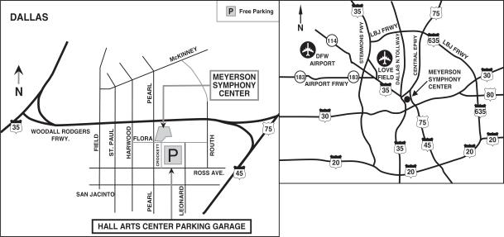

- Free parking is available at the Hall Arts Center Parking Garage. Traffic and construction in the area may cause a delay; please allow extra time for parking.

- From I-45/Hwy. 75 – Take I-35E exit (Woodall Rodgers Frwy.) to Pearl Street exit or St. Paul exit (follow frontage road east to Pearl Street); turn south and continue to Ross Avenue; turn left to the Hall Arts Center Parking Garage.

- From I-35 – Take I-45/Hwy. 75 exit (Woodall Rodgers Frwy.) to Pearl Street exit; continue to Ross Avenue; turn left to the Hall Arts Center Parking Garage.

- From DFW Airport – Take South exit to Hwy. 183 East (merges with I-35E); follow directions from I-35E (above).

- From Love Field – Exit airport on Mockingbird Lane west to I-35E South; follow directions from I-35E (above).

2018 Proxy Statement | 63

Table of Contents

Printed entirely on recycled paper 002CSN8BFF

Table of Contents


Here’s how to vote:

Online

• Go to www.investorvote.com/exxonmobil or

scan the QR code

Telephone

• Call toll free at 1-800-652-VOTE (8683)

• Outside the U.S., Canada, and Puerto Rico, call

1-781-575-2300 through an operator and we will

accept the charge

Vote online or by telephone 24 hours a day, 7

days a week. Login details are located in the

shaded bar below.
Using a black ink pen, mark your votes with an X as shown in this |  |  | ☒
example.
example. | Please do not write outside the designated areas.

q IF VOTING BY MAIL, SIGN THE REVERSE SIDE, DETACH AND RETURN THE BOTTOM PORTION IN THE ENCLOSED ENVELOPE. q

VOTING ITEMS — The Directors recommend a vote FOR all the nominees listed. (page 15)
1. Election of |  |  |  | +
Directors: | For Against Abstain | For Against Abstain | For Against Abstain

01 - Susan K. Avery

02 - Angela F. Braly

03 - Ursula M. Burns

04 - Kenneth C. Frazier

☐ ☐ ☐

☐ ☐ ☐

☐ ☐ ☐

☐ ☐ ☐

05 - Steven A. Kandarian

06 - Douglas R. Oberhelman

07 - Samuel J. Palmisano

☐ ☐ ☐

☐ ☐ ☐

☐ ☐ ☐

08 - Steven S Reinemund

09 - William C. Weldon

10 - Darren W. Woods

☐ ☐ ☐

☐ ☐ ☐

☐ ☐ ☐

The Directors recommend a vote FOR proposal items 2 and 3.

For Against Abstain

2. | Ratification of Independent Auditors (page 25) |  |  |  | ☐ | ☐ | ☐ | 3. Advisory Vote to Approve Executive
 |  |  |  |  | ☐ | ☐ | ☐ |  | Compensation (page 26)
The Directors recommend a vote AGAINST shareholder proposal items 4 through 7.
 |  |  |  |  | For | Against | Abstain
4. | Independent Chairman (page 54) |  |  |  | ☐ | ☐ | ☐ | 6. | Board Diversity Matrix (page 56)
5. | Special Shareholder Meetings (page 55) |  |  |  | ☐ | ☐ | ☐ | 7. | Report on Lobbying (page 58)
 |  |  |  |  |  |  |  | 1 P C F
002CSP0083 |  | 02R2KK

For Against Abstain

☐ ☐ ☐

For Against Abstain

☐ ☐ ☐

☐ ☐ ☐

+

Table of Contents

c/o Computershare Investor Services

P.O. Box 43105
Providence, RI 02940-5076

2018 Annual Meeting of Shareholders

Admission Ticket

TIME

PLACE

AUDIO WEBCAST

Wednesday, May 30, 2018

9:30 a.m. Central Time

Morton H. Meyerson Symphony Center

2301 Flora Street

Dallas, Texas 75201

A slide presentation with audio will be available on the Internet at exxonmobil.com. Instructions will appear on the website prior to the event.

ADMISSION This ticket will admit shareholder. Ticket for one guest can be requested at Admissions desk at the annual

meeting. Valid admission ticket and government-issued picture identification are required for shareholder and guest.

For safety and security reasons, cameras, smartphones, recording equipment, electronic devices, computers, large bags, briefcases, packages, and firearms or other weapons will not be permitted in the building.

Small steps make an impact.

Help the environment by consenting to receive electronic delivery of materials.

q IF VOTING BY MAIL, SIGN BELOW, DETACH AND RETURN THE BOTTOM PORTION IN THE ENCLOSED ENVELOPE. q

PROXY/VOTING INSTRUCTIONS | +
Solicited by the Board of Directors | +

The undersigned hereby appoints, and instructs the appropriate account trustee(s), if any, to appoint, U.M. Burns, K.C. Frazier, S.J. Palmisano, S.S Reinemund, and D.W. Woods, or each or any of them, with power of substitution, proxies to act and vote shares of common stock of the undersigned at the 2018 annual meeting of shareholders of Exxon Mobil Corporation and at any adjournments thereof, as indicated, upon all matters referred to on the reverse side and described in the proxy statement for the meeting and, at their discretion, upon any other matters that may properly come before the meeting.

This proxy covers shares of ExxonMobil common stock registered in the name of the undersigned (whether certificated or book entry) and shares held in the name of the undersigned in the Computershare Investment Plan. This card also provides voting instructions to the applicable trustees for any shares held in the name of the undersigned in the ExxonMobil Savings Plan and/or a Computershare Investment Plan IRA.

If no other indication is made on the reverse side of this form, the proxies/trustees shall vote: (a) for the election of the director nominees; and (b) in accordance with the recommendations of the Board of Directors on the other matters referred to on the reverse side.

NON-VOTING ITEMS

Change of Address — Please print new address below.
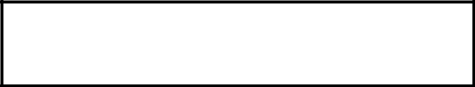

Comments — Please print your comments below.
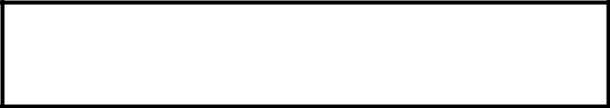

AUTHORIZED SIGNATURES — This section must be completed for your vote to be counted. Date and sign below.

Please sign exactly as name(s) appears hereon. Joint owners should each sign. When signing as attorney, executor, administrator, corporate officer, trustee, guardian, or custodian, please give full title.

Date (mm/dd/yyyy) — Please print date below. Signature 1 — Please keep signature within the box. Signature 2 — Please keep signature within the box.
/ /

+

