Table of Contents

UNITED STATES

SECURITIES AND EXCHANGE COMMISSION
Washington, D.C. 20549

SCHEDULE 14A

Proxy Statement Pursuant to Section 14(a)

of the Securities Exchange Act of 1934
(Amendment No. )

Filed by the Registrant ☒ |  | ☐
Filed by a Party other than the Registrant |  | ☐
Check the appropriate box:
☐ | Preliminary Proxy Statement | ☐ Confidential, for Use of the Commission Only(as permitted by Rule 14a-
☒ | Definitive Proxy Statement | 6(e)(2))

- Definitive Additional Materials

- Soliciting Material Pursuant to §240.14a-12

EXXON MOBIL CORPORATION

(Name of Registrant as Specified In Its Charter)

(Name of Person(s) Filing Proxy Statement, if other than the Registrant)

Payment of Filing Fee (Check the appropriate box):

- No fee required.

- Fee computed on table below per Exchange Act Rules 14a-6(i)(4) and 0-11.

  - Title of each class of securities to which transaction applies:

  - Aggregate number of securities to which transaction applies:

  - Per unit price or other underlying value of transaction computed pursuant to Exchange Act Rule 0-11 (set forth the amount on which the filing fee is calculated and state how it was determined):

  - Proposed maximum aggregate value of transaction:

  - Total fee paid:

- Fee paid previously with preliminary materials.

- Check box if any part of the fee is offset as provided by Exchange Act Rule 0-11(a)(2) and identify the filing for which the offsetting fee was paid previously. Identify the previous filing by registration statement number, or the Form or Schedule and the date of its filing.

  - Amount Previously Paid:

  - Form, Schedule or Registration Statement No.:

  - Filing Party:

  - Date Filed:

Table of Contents

Notice of 2021 Annual Meeting


and Proxy Statement

March 16, 2021

Dear Shareholder:

We invite you to attend the annual meeting of shareholders on Wednesday, May 26, 2021, beginning promptly at 9:30 a.m. Central Time. For the health and safety of shareholders, employees and our communities, the annual meeting of shareholders will be a virtual meeting. Shareholders will be able to listen, vote, and submit questions during the annual meeting from any remote location that has Internet connectivity by connecting 15-minutes prior to the annual meeting start time at www.virtualshareholdermeeting.com/XOM2021. Please see page 5 for detailed instructions for attending and participating at the annual meeting.

At the meeting, you will hear a report on our business and the following items:

- Election of directors;

- Ratification of PricewaterhouseCoopers LLP as independent auditors;

- Advisory vote to approve executive compensation;

- Seven shareholder proposals contained in this proxy statement; and

- Other matters if properly raised.

As you may have heard, an activist investment firm and shareholder, Engine No. 1 (Engine), has proposed four director nominees for election at the annual meeting in opposition to the nominees recommended by our Board of Directors. As a result, you may receive solicitation materials, including a white proxy card, from Engine seeking your proxy to vote for Engine’s nominees. ExxonMobil is not responsible for the accuracy of any information provided by or relating to Engine or its nominees contained in solicitation materials filed or disseminated by or on behalf of Engine or any other statements Engine may make.

The Board of Directors does not endorse any Engine nominees and unanimously recommends that you vote FOR the election of nominees proposed by the Board of Directors on the BLUE proxy card. The Board urges you to discard any white proxy card sent to you by Engine. If you have already submitted a white proxy card, you can revoke that proxy by signing and dating the enclosed BLUE proxy card and returning it in the enclosed postage-paid envelope or by voting via Internet or telephone by following the instructions on your BLUE proxy card, BLUE voting instruction form or notice.

Your last submitted proxy card counts as your vote; we encourage you to vote only on the BLUE proxy card.

Only shareholders of record on March 29, 2021, or their valid proxy holders may vote at the meeting. We are first mailing these proxy materials to our shareholders of record on or about March 16, 2021.

This booklet includes the formal notice of the meeting and proxy statement. The proxy statement tells you about the agenda, procedures, and rules of conduct for the meeting. It also describes how the Board operates, gives information about our director candidates, and provides information about the other items of business to be conducted at the meeting.

Financial information is provided separately in the 2020 Annual Report that accompanies or precedes the proxy materials or made available online to all shareholders.

Your vote is extremely important. We request that you vote your shares by voting your BLUE proxy card. Even if you own only a few shares, we want your voice to be represented at the meeting. You can vote your shares by Internet, toll-free telephone call, or proxy card. A preliminary summary of 2021 Proxy Voting Results may be available at exxonmobil.com after the annual shareholders meeting and will be filed on a Form 8-K within four business days of the meeting.

Sincerely,



Stephen A. Littleton
Secretary

Darren W. Woods
Chairman of the Board

Table of Contents


Board of Directors

Darren W. Woods

Chief Executive Officer, Kenneth C. Frazier

Chairman of the Board Lead Director

Exxon Mobil Corporation Exxon Mobil Corporation

Dear Fellow Shareholders: Dear Fellow Shareholders:

It is my pleasure to invite you to the 2021 Exxon Mobil Corporation virtual Annual Shareholder Meeting on Wednesday, May 26, 2021, beginning at 9:30 a.m. Central Time.

This past year was unprecedented. The pandemic had a severe impact on society and our industry. Despite these challenges, our employees delivered exceptional operational and safety results while looking after themselves and helping out in communities where we work and live.

In response to the resulting reduction in demand for our products, we took decisive actions to reduce costs, focus our investments on our highest-returning assets, preserve the strength of the balance sheet, and maintain a reliable dividend. We are confident the actions we’ve taken to pace development and preserve long-term value have positioned ExxonMobil and its shareholders for future success.

The future is underpinned by an ongoing need for affordable and reliable energy as the global population increases and people everywhere strive for better living conditions, greater mobility, and healthier communities. For more than 135 years, ExxonMobil has provided the energy and products that meet society’s growing and evolving needs, and that continues to be our focus.

At this year’s meeting, we’ll share with you the progress we’ve made in ensuring continued supplies of energy and related products while positioning the Company for a lower-carbon energy future. This includes investments in Guyana and the Permian Basin, as well as our efforts to reduce emissions and advance lower-emission technologies, including our new ExxonMobil Low Carbon Solutions business, which are critical in meeting the goals of the Paris Agreement and society’s net-zero ambitions. We have and continue to be a strong supporter of the Paris Agreement and its objectives of mitigating global emissions.

We look forward to sharing more with you at our Annual Meeting.

Thank you for your investment in ExxonMobil.

As Lead Director for the ExxonMobil Board, I wanted to tell you how proud we are of the way our employees, partners and management rose to the extreme challenges resulting from the COVID-19 pandemic and its impact on the global economy.

In my role as independent Lead Director, I worked with other independent directors and the Company’s management to guide its response and strategic priorities as it made significant business improvements to weather near-term challenges while maintaining focus on long-term shareholder value.

This oversight demonstrates the importance of sound, proactive corporate governance. ExxonMobil’s Board has worked hard to fulfill its role as stewards of shareholders’ interests. An important part of that role is oversight of the Company’s strategy and key risks, including risks related to climate change.

Also important is your Board’s well-defined, rigorous refreshment process, which selects nominees with a range of backgrounds, knowledge, and complementary skills relevant to the Company’s business and future direction. In recent years, the Company has pursued additional board expertise in the areas of climate science, asset and risk management, and relevant industry experience. This year, a shareholder, Engine No. 1, nominated four directors to oppose the highly qualified directors recommended by your Board. After a thorough review, your Board unanimously determined not to recommend the Engine No. 1 candidates and urges you to support the Board’s candidates.

I am confident in our disciplined approach. During the year, we consistently leveraged diverse perspectives and experiences to test assumptions, challenge conventional thinking, offer solutions, and assess management’s beliefs and actions – all in the context of building long-term shareholder value.

We appreciate the trust you’ve placed in ExxonMobil as we continue to create sustainable shareholder value.
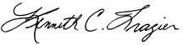

Table of Contents

TABLE OF CONTENTS
 | Page
PROXY SUMMARY AND VOTING MAP | 1
GENERAL INFORMATION | 4
BOARD OF DIRECTORS | 9
Item 1 – Election of Directors | 9
Background to the Solicitation | 16
Corporate Governance | 21
Director Compensation | 33
Certain Beneficial Owners | 35
Director and Executive Officer Stock Ownership | 35
Audit Committee Report | 38
Item 2 – Ratification of Independent Auditors | 39
Compensation Committee Report | 40
Item 3 – Advisory Vote to Approve Executive Compensation | 40
EXECUTIVE COMPENSATION | 41
Compensation Discussion and Analysis | 41
Executive Compensation Tables | 60
SHAREHOLDER PROPOSALS | 69
Item 4 – Independent Chair | 69
Item 5 – Special Shareholder Meetings | 71
Item 6 – Report on Scenario Analysis | 73
Item 7 – Report on Environmental Expenditures | 75
Item 8 – Report on Political Contributions | 77
Item 9 – Report on Lobbying | 78
Item 10 – Report on Climate Lobbying | 80
PAY RATIO | 82
ADDITIONAL INFORMATION | 83
EXHIBIT A | 85
EXHIBIT B | 95

Table of Contents

PROXY SUMMARY AND VOTING MAP


ITEM 1: Election of Directors

The Board recommends you vote FOR each of the following candidates using the BLUE proxy card.

YOUR VOTE IS EXTREMELY IMPORTANT. THE BOARD OF DIRECTORS UNANIMOUSLY RECOMMENDS A VOTE FOR THE ELECTION OF THESE 12 DIRECTOR NOMINEES ON THE BLUE PROXY CARD. THE BOARD OF DIRECTORS DOES NOT ENDORSE ANY ENGINE NOMINEES AND URGES YOU NOT TO SIGN OR RETURN ANY WHITE PROXY CARD SENT TO YOU BY ENGINE.

ExxonMobil Board of Directors
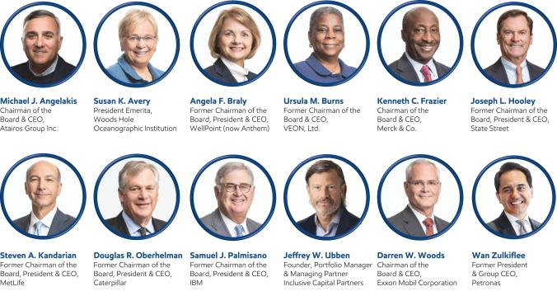

ExxonMobil has a strong, diverse, engaged, and highly experienced Board comprised of eleven independent directors and the CEO. Our independent directors have experience leading some of the world’s largest, most complex, and successful companies. The Company’s shareholders benefit from this unique and diverse resource of knowledge, backgrounds and experience – which was especially evident during the COVID pandemic. In response to COVID-19, ExxonMobil quickly implemented its detailed crisis plan, efficiently executed on that plan, and adapted it to incorporate the learnings of our Board members from their relevant experience at other large global companies. The Board’s capabilities create a collective skillset that is well qualified to provide sound governance and risk management oversight with a focus on building long-term shareholder value.

ExxonMobil continually looks for highly qualified Board candidates who can add new experience and insights to help the Company generate long-term sustainable value for shareholders. The Board’s refreshment process has been successful in identifying diverse, experienced and qualified Board candidates. ExxonMobil has added eight new independent directors in six years with specific experience in the areas of climate science, asset and risk management, capital allocation across industries, energy and business transition, and additional energy industry experience. Five of the last eleven independent directors to join the Board are female and/or racial/ethnic minorities, reflecting the ExxonMobil Board’s belief in the value a diverse Board brings to shareholders.

The Board unanimously recommends you vote FOR each of the

ExxonMobil director candidates on the BLUE proxy card.

2021 Proxy Statement | 1

Table of Contents

Board Tenure

ExxonMobil has added eight new non-employee directors in six years — 67% of the total Board. Average tenure for non-employee director nominees is 4.9 years which is three years lower than the applicable Standard & Poor’s 500 average.

67%

Non-employee director nominees who
joined the Board since 2015

Director Diversity

The Board believes diversity of thought, experience and background adds value for shareholders. Our nominees are a diverse group of highly qualified individuals. Their unique perspectives and experiences bring value as we work together as a collective body to represent the interests of all shareholders.
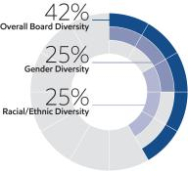

Worldwide Perspectives

ExxonMobil operates in many countries around the world. Board nominees who have lived and worked around the world bring broad perspectives to ExxonMobil’s global businesses.

83%

Director nominees with
global business leadership experience

Oversight of Emissions Reduction

The Board leads the Company as it strives to deliver superior results while providing energy and products that are essential to the health and welfare of billions of people around the world. ExxonMobil achieved its 2020 emission-reduction goals and set new plans for further reductions through 2025 and industry-leading greenhouse gas performance by 2030. The 2025 plans, which include a reduction in Upstream greenhouse gas intensity by

15-20%, supported by a 40-50% reduction in methane emissions intensity and a 35-45% reduction in flaring intensity relative to 2016 levels, are projected to be consistent with the goals of the Paris Agreement. These measures are expected to result in:

~30% | ~40-50%
Reduction in absolute | Reduction in absolute
Upstream greenhouse | methane & flaring
gas emissions | emissions

Broad Range of Business Experience

Directors bring a wide range of business experience, including climate expertise, operational experience, investor perspectives, and experience in the oil and gas industry.

Director Nominee Competencies

Risk Management 12 of 12 Directors

Financial Experience 12 of 12 Directors

25%

Director nominees with experience in commodities/cyclical businesses

Additional information:

Director leadership & oversight...Page 22

Director qualifications & competencies...Page 23

Director tenure...Page 27

2 2021 Proxy Statement

Scientific / Technical / Research | 6 of 12 | Directors
Current / Former CEO / Field Prominence | 12 of 12 | Directors

Table of Contents

ITEM 2: Ratification of Independent Auditors

The Board recommends you vote FOR this proposal on the BLUE proxy card.

The ExxonMobil Audit Committee has appointed PricewaterhouseCoopers LLP (PwC) to audit ExxonMobil’s financial statements for 2021.

You are asked to ratify that appointment.

Page 38

Additional information about the Audit Committee’s appointment of PwC and PwC’s fees for 2019 and 2020

ITEM 3: Advisory Vote to Approve Executive Compensation

The Board recommends you vote FOR this proposal on the BLUE proxy card.

ExxonMobil asks you to vote on a non-binding resolution to approve the Page 40

compensation of the Named Executive Officers. Additional information
about ExxonMobil’s
compensation

program

ITEMS 4 through 10: Shareholder Proposals

The Board recommends you vote AGAINST each of these proposals on the BLUE proxy card.

You will have the opportunity to vote on shareholder proposals submitted to Page 69

ExxonMobil. The text of these
resolutions, the
proponents’ statements
in support and
ExxonMobil’s responses


NOTE: Withholding your vote on Engine nominees on a white proxy card is NOT the same as voting FOR our Board’s nominees. Submitting a white proxy card will revoke any vote you previously made via the Board’s BLUE proxy card. If you wish to vote pursuant to the recommendation of the Board, you should disregard any proxy card that you receive that is not a BLUE proxy card, and do not return any white proxy card that you may receive. If you have already submitted a white proxy card, you can revoke that proxy and vote for our Board’s nominees and on the other matters to be voted on at the meeting using the BLUE proxy card, or by voting via Internet or telephone by following the instructions on your BLUE proxy card.

2021 Proxy Statement | 3

Table of Contents

GENERAL INFORMATION

Who May Vote

Shareholders of ExxonMobil, as recorded in our stock register on March 29, 2021, may vote at the meeting according to the instructions directly below.

Different Color Proxy Cards

ExxonMobil has received Engine’s nomination of four director candidates for election at the annual meeting in opposition to the nominees recommended by our Board of Directors. ExxonMobil has provided you with the enclosed BLUE proxy card. You may receive a white proxy card from Engine. The white proxy card does not reflect the views of the ExxonMobil Board.

How to Vote

Your vote is extremely important. We recommend you vote by proxy using the BLUE proxy card even if you plan to participate in the virtual meeting. The Board recommends that you DISREGARD the white proxy card. You may vote at the annual meeting according to the instructions below or by proxy.

If your shares are held in your name, you can vote by proxy in one of three convenient ways:


Online

Follow the instructions at
www.proxyvote.com.

You will need to have your

BLUE proxy card or Notice in hand.

Telephone

Call toll-free
1-800-690-6903, and follow the instructions. You will need to

have your BLUE proxy card

or Notice in hand.

Mail

Complete, sign, date, and return your BLUE proxy card in the enclosed envelope. If you receive a Notice and would like to vote by mail, please follow the instructions in the Notice to obtain paper proxy materials.

How Proxies Work

ExxonMobil’s Board of Directors is asking for your proxy. Giving us your proxy means you authorize us to vote your shares at the meeting in the manner you direct on the BLUE proxy card from the Board of Directors.

If you give us your signed BLUE proxy but do not specify how to vote, we will vote your shares as follows:

- For the election of all director candidates nominated by the ExxonMobil Board;

- For ratification of the appointment of independent auditors;

- For approval of the compensation of the Named Executive Officers; and

- As recommended by the Board with respect to shareholder proposals.

If you hold shares through someone else, such as a brokerage firm, bank or intermediary, you will receive materials from that firm asking how you want to vote. Check the voting form used by that firm as most offer online or telephone voting in addition to mail.

4 2021 Proxy Statement

Table of Contents

Attendance at the Annual Meeting

You have received this proxy statement because you are a shareholder as of the record date. Attendance at the
annual meeting through the website www.virtualshareholdermeeting.com/XOM2021 or any adjournment or postponement thereof will be limited to shareholders of the Company as of the close of business on the record date and guests. You will not be able to attend the annual meeting in person at a physical location. To attend the annual meeting as a shareholder and have the ability to vote and/or submit a comment or question during the annual meeting, registered shareholders will need to pre-register by 4:00 p.m. Central Time on May 21, 2021. To pre-register for the annual meeting, please follow the instructions described below.

Pre-registration for Registered Shareholders

For Registered Shareholders, the control number can be found on the Notice of Internet Availability (Notice), BLUE proxy card, email, or other communication you received. To pre-register to participate in the annual meeting remotely, visit the website www.virtualshareholdermeeting.com/XOM2021 prior to 4:00 p.m. Central Time on May 21, 2021. Please have your BLUE proxy card, Notice, email, or other communication containing your control number available and follow the instructions to complete your registration request. After registering, you will receive a confirmation email with a link and instructions for accessing the virtual annual meeting. Please verify that you have received the confirmation email in advance of the meeting, including the possibility that it may be in your spam or junk folder. Requests to register to participate in the annual meeting remotely must be received no later than 4:00 p.m. Central Time on May 21, 2021. You must pre-register to vote and/or submit a comment or question during the annual meeting.

Beneficial Shareholders

For Beneficial Shareholders who hold their shares through an intermediary, such as a brokerage firm or bank, the control number can be found on the Notice of Internet Availability (Notice), BLUE voting instruction form, or other instructions you receive from your bank, brokerage firm, or other intermediary. Beneficial shareholders can use their 16-digit control numbers to log in to attend the meeting, submit questions and vote during the meeting.

Beneficial shareholders who did not receive a 16-digit control number from their bank or brokerage firm, who wish to attend the meeting should follow the instructions from their bank or brokerage firm, including any requirement to obtain a legal proxy. Most brokerage firms or banks allow a shareholder to obtain a legal proxy either online or by mail.

Attending as a Guest

Shareholders who do not pre-register for the virtual Annual Meeting (as specified above) or who do not have their 16-digit control number may still attend the meeting virtually as a guest by accessing the annual meeting website, www.virtualshareholdermeeting.com/XOM2021, beginning 15-minutes prior to the annual meeting’s scheduled start time and following the instructions provided to attend as a Guest.

Guests at the virtual annual meeting will be able to listen to the meeting but will not be able to vote nor submit a comment or question during the annual meeting.

Submitting Questions and Voting at the Annual Meeting

Other than shareholders who attend as guests, all shareholders may submit questions and vote at the meeting.

Submitting a Question Prior to the Annual Meeting

Shareholders may submit a comment or question prior to the annual meeting, beginning on May 3, 2021, by visiting exxonmobil.com/investor and following the instructions on the website.

Questions received prior to or during the annual meeting will be answered as the allotted annual meeting time permits. In light of the number of business items on this year’s agenda and the need to conclude the annual meeting

2021 Proxy Statement | 5

Table of Contents

within a reasonable period of time, we cannot ensure that every shareholder who wishes to have a question or comment addressed during the annual meeting will be able to do so.

Virtual Meeting Technical Assistance

If you encounter any technical difficulties accessing the virtual annual meeting, the virtual annual meeting login page will include technical support contact information, including a telephone number and email address. Technical support will be available beginning at 9:15 a.m. Central Time on May 26, 2021 and will remain available until the annual meeting has ended.

Important Notice Regarding the Availability of Proxy Materials for the Shareholders Meeting to be held on

May 26, 2021:

The 2021 Proxy Statement and 2020 Annual Report are available at www.proxyvote.com.

Notice and Access

We distribute proxy materials to many shareholders via the Internet under the Securities and Exchange Commission’s (SEC) “Notice and Access” rules, thereby capturing cost and environmental benefits. On or about March 16, 2021, we mailed a Notice Regarding the Availability of Proxy Materials (Notice) that contains information about our 2021 annual shareholders meeting and instructions on how to view all proxy materials on the Internet. Also included are instructions on how to vote and how to request a paper or e-mail copy of the proxy materials.

Electronic Delivery of Proxy Statement and Annual Report Documents

For shareholders receiving proxy materials by mail, you can elect to receive an e-mail in the future that will provide electronic links to these documents. Opting to receive your proxy materials online will save the Company the cost of producing and mailing documents to your home or business, and will also give you an electronic link to the proxy voting site.

- Shareholders of Record: You may enroll in the electronic proxy delivery service at any time in the future by going directly to computershare.com/exxonmobil. You may also revoke an electronic delivery election at this site at any time.

- Beneficial Shareholders: If you hold your shares in a brokerage firm or bank account, you may also have the opportunity to receive copies of the proxy materials electronically. Please check the information provided in the proxy materials mailed to you by your bank, brokerage firm or intermediary regarding the availability of this service.

6 2021 Proxy Statement

Table of Contents

Voting Shares in the ExxonMobil Savings Plan

The Trustee of the ExxonMobil Savings Plan will vote Plan shares as participants direct. To the extent participants do not give instructions, the Trustee will vote shares as it thinks best. The proxy card serves to give voting instructions to the Trustee.

Revoking a Proxy for Registered Shareholders

You may revoke your proxy before it is voted at the meeting by:

- Submitting a new proxy with a later date via a proxy card, online, by telephone or by mail;

- Notifying ExxonMobil’s Secretary in writing before the meeting; or

- Voting during the meeting.


NOTE: Withholding your vote on Engine nominees on a white proxy card is NOT the same as voting FOR our Board’s nominees. Submitting a white proxy card will revoke any vote you previously made via the Board’s BLUE proxy card. If you wish to vote pursuant to the recommendation of the Board, you should disregard any proxy card that you receive that is not a BLUE proxy card. Do not return any white proxy card that you may receive. If you have already submitted a white proxy card, you can revoke that proxy and vote for our Board’s nominees and on the other matters to be voted on at the meeting using the BLUE proxy card or by voting via Internet or telephone by following the instructions on your BLUE proxy card.

Your last submitted proxy card counts as your vote; we encourage you to vote only on the BLUE proxy card.

Confidential Voting

Independent inspectors count the votes. Your individual vote is kept confidential from us unless otherwise required by law or special circumstances exist. For example, a copy of your proxy card will be sent to us if you write comments on the card.

Quorum

In order to carry on the business of the meeting, we must have a quorum. This means at least a majority of the outstanding shares eligible to vote must be represented at the meeting, either by proxy or in person. Treasury shares, which are shares owned by ExxonMobil itself, are not voted and do not count for this purpose.

Votes Required

- Election of Directors Proposal: Under ExxonMobil’s by-laws, in a non-contested election a director nominee must receive a majority of votes cast in order to be elected to the Board of Directors. However, the 2021 election is contested by Engine, which nominated four directors. As a result, there are 16 director nominees which exceed the number of directors to be elected, which is 12. In such a case, our by-laws provide for a plurality voting standard, which determines that the 12 persons who receive the greatest number of votes are elected to the Board for the following year. If you own shares through a brokerage firm, bank or intermediary, you must give the brokerage firm, bank or intermediary instructions to vote your shares in the election of directors. You provide those instructions to your brokerage firm, bank or intermediary by voting according to the directions on your proxy card or notice by mail, online or telephone. If you do not give your brokerage firm, bank or intermediary instructions by voting your shares, then your shares will not be voted for this proposal.

- Other Proposals: Approval of the ratification of the appointment of independent auditors, the advisory vote to approve executive compensation, and the shareholder proposals require the favorable vote of a majority of votes cast. Only votes FOR or AGAINST these proposals count.

Abstentions count for quorum purposes, but not for voting.

2021 Proxy Statement | 7

Table of Contents

Conduct of the Meeting

The Chairman has broad responsibility and legal authority to conduct the annual meeting in an orderly and timely manner. This authority includes establishing rules for shareholders who wish to address the virtual meeting. Only shareholders or their valid proxy holders may address the meeting. Copies of these rules will be available at the virtual meeting. The Chairman may also exercise discretion in recognizing shareholders’ comments or questions and in determining the extent of discussion on each item of business. In light of the number of business items on this year’s agenda and the need to conclude the meeting within a reasonable period of time, we cannot ensure that every shareholder who wishes to have a question or comment addressed during the meeting will be able to do so.

Dialogue can also be facilitated with interested parties outside the meeting and, for this purpose, we have provided a method on our website at exxonmobil.com/directors for raising issues and contacting the non-employee directors either in writing or electronically. The Chairman may also rely on applicable law regarding disruptions or disorderly conduct to ensure that the meeting is conducted in a manner that is fair to all shareholders. Shareholders who wish to make comments during the meeting should do so in writing. Shareholders may send their questions or comments prior to the meeting in writing to the Secretary as set forth below.


Contact Information

If you have questions or need more information about the annual meeting, write to Mr. Stephen A. Littleton, Secretary, Exxon Mobil Corporation, 5959 Las Colinas Boulevard, Irving, TX 75039-2298. Alternatively, call us at 1-972-940-6715 or send a fax to 1-972-940-6748.

For information about shares registered in your name or your Computershare Investment Plan account, call ExxonMobil Shareholder Services at 1-800-252-1800 or 1-781-575-2058 (outside the United States, Canada, and Puerto Rico), or access your account via the website at computershare.com/exxonmobil. We also invite you to visit ExxonMobil’s website, where investor information can be found at exxonmobil.com/investor. Shareholders may submit a comment or question in advance of the annual meeting beginning on May 3, 2021, by following the instructions on the website. Website materials are not part of this proxy solicitation.

8 2021 Proxy Statement

Table of Contents

BOARD OF DIRECTORS

Item 1 – Election of Directors

The Board recommends you vote by proxy using the BLUE proxy card even if you plan to attend the virtual meeting. The Board recommends that you DISREGARD AND DO NOT USE the white proxy card. Voting AGAINST Engine’s nominees on its proxy card is NOT the same as voting FOR our Board’s director nominees. If you have already submitted a white proxy card, you can revoke that proxy and vote for our Board of Directors’ nominees and on the other matters to be voted on at the meeting using the BLUE proxy card or by voting via Internet or telephone by following the instructions on your BLUE proxy card. Your last submitted proxy card counts as your vote; we encourage you to vote only on the BLUE proxy card.


Our Board of Directors has general oversight responsibility for ExxonMobil’s affairs pursuant to New Jersey’s General Corporation Law and ExxonMobil’s Restated Certificate of Incorporation and by-laws. In exercising its fiduciary duties, the Board represents and acts on behalf of ExxonMobil’s shareholders and is committed to strong corporate governance, as reflected through its policies and practices. The Board of Directors has nominated the director candidates named on the following pages. All of our nominees currently serve as ExxonMobil directors.

All director nominees have stated they are willing to serve if elected and have consented to be named in this proxy statement. If a nominee becomes unavailable before the election, your proxy authorizes the people named as proxies to vote for a replacement nominee if the Board names one. In any event, the Board size at the time of the meeting will equal the number of nominees nominated by the Board, and there will be no vacancy at the time of the meeting.

The Board unanimously recommends you vote FOR each of the following candidates on the BLUE proxy card:
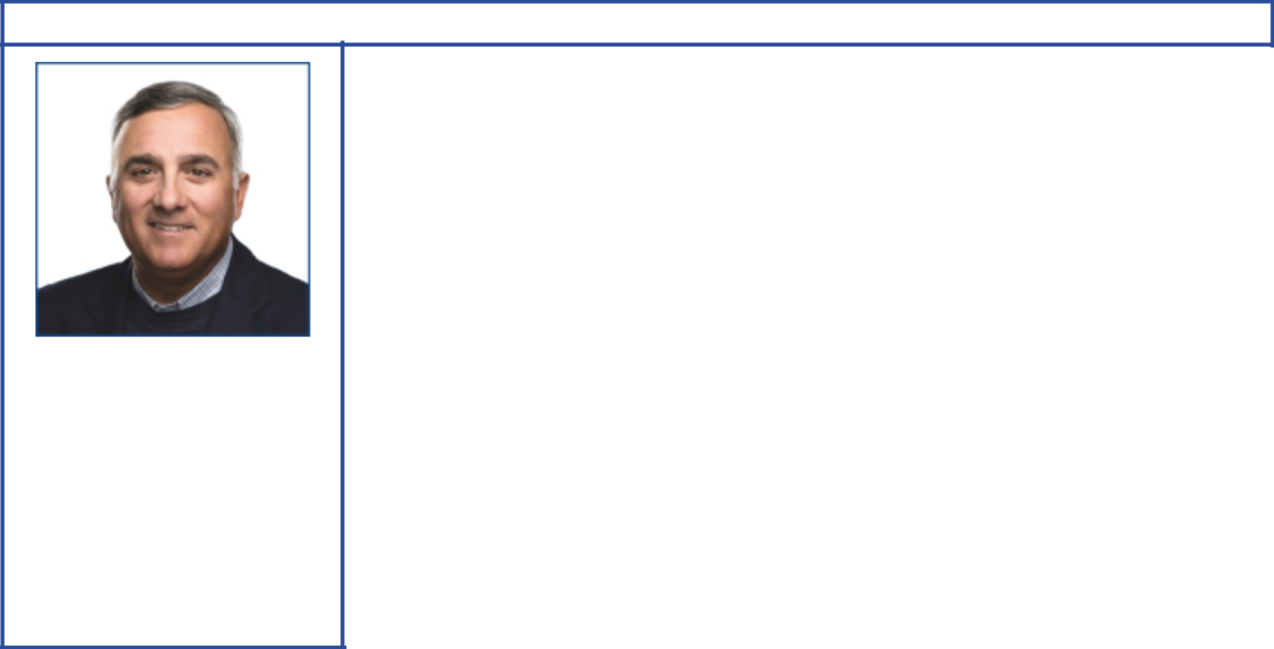

Michael J. Angelakis

Principal occupation: Chairman of the Board and Chief Executive Officer, Atairos Group Inc.

Age 56
Director since 2021

Independent director

Committees:

Audit, Finance

Background:

- Business leadership at Atairos Group as Chairman and Chief Executive Officer since 2015. He also serves as Senior Advisor to the Management Committee of Comcast Corportation since 2015. At Comcast, he served as Vice Chairman and Chief Financial Officer from 2011 to 2015, and as Executive Vice President and Chief Financial Officer from 2007 to 2011. He also served as a Managing Director of Providence Equity Partners from 1999 to 2007.

- Academic affiliations: Babson College (former Trustee)

Current public company directorships: Groupon, Inc. (April 2016 to Present); TriNet Group, Inc. (February 2017 to Present)

Previous public company directorships in last five years: Duke Energy Corporation (October 2015 to August 2017); Hewlett Packard Enterprise Company (November 2015 to April 2020)

Other board experience: former Chairman of The Federal Reserve Bank of Philadelphia (January 2016 to January 2018) and Deputy Chairman and Board Member (January 2012 to January 2016)

2021 Proxy Statement | 9

Table of Contents


Susan K. Avery

Principal occupation:

President Emerita,
Woods Hole Oceanographic

Institution

Age 71
Director since 2017

Independent director

Committees:

Board Affairs, Public Issues and Contributions

Background:

- Achieved prominence in her field at the Woods Hole Oceanographic Institution, a global research organization, as President and Director from 2008 to 2015. In the course of her lengthy and varied experience with matters of climate science,

Dr. Avery has been involved with areas of policy, carbon pricing, renewable energy, and adaptation.

- Academic leadership at the University of Colorado Boulder as interim dean of the graduate school and vice chancellor for research, interim provost, and executive vice chancellor for academic affairs from 2004 to 2008

- Government / scientific research experience as past member of the United Nations Scientific Advisory Board and the National Research Council Global Change Research Program Advisory Committee

- Scientific and research advisory committee memberships held or recently held at American Institute of Physics Board (Vice Chair), NASA, NOAA, National Science Foundation, Lawrence Berkeley National Laboratory, National Park System, Independent Advisory Committee on Applied Climate Risk, Center for Southern Hemisphere Ocean Research, Qingdao National Laboratory for Marine Science and Technology, and Japan Agency for Marine-Earth Science and Technology

- Scientific and environmental affiliations: University Corporation for Atmospheric Research (Chair of Board), Consortium for Ocean Leadership (senior fellow), American Geophysical Union, American Meteorological Society (fellow), American Association for the Advancement of Science (fellow), and Institute of Electrical and Electronics Engineers (fellow)

Current public company directorships: None

Previous public company directorships in last five years: None
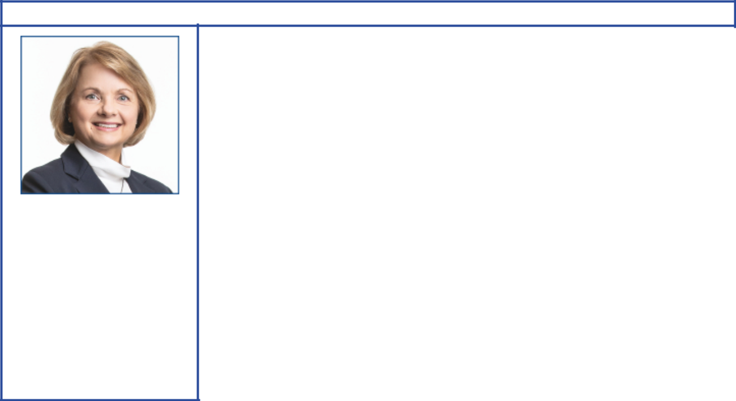

Angela F. Braly

Principal occupation: Former Chairman of the Board, President and Chief Executive Officer, WellPoint (now Anthem)

Age 59
Director since 2016

Independent director

Committees:

Compensation, Public Issues

and Contributions

Background:

- Business leadership with operational experience at WellPoint as Chairman from 2010 to 2012; as President, Chief Executive Officer, and board member from 2007 to 2012; and as Executive Vice President, General Counsel, and Chief Public Affairs Officer from 2005 to 2007. She also served as President and Chief Executive Officer of Blue Cross Blue Shield of Missouri from 2003 to 2005.

- Business and public policy affiliations: The Policy Circle (Co-Founder, Director, and Secretary), Indiana Economic Development Corporation (former Director), Business Council (former member), Business Roundtable (former member), Harvard Advisory Council on Health Care Policy (former member), and Blue Cross Blue Shield Association (former Director)

Current public company directorships: Brookfield Asset Management Inc. (May 2015 to Present); Lowe’s Companies, Inc. (November 2013 to Present); The Procter & Gamble Company (December 2009 to Present)

Previous public company directorships in last five years: None

Other board experience: former Director of WellPoint, Inc. (prior to 2016)

10 2021 Proxy Statement

Table of Contents
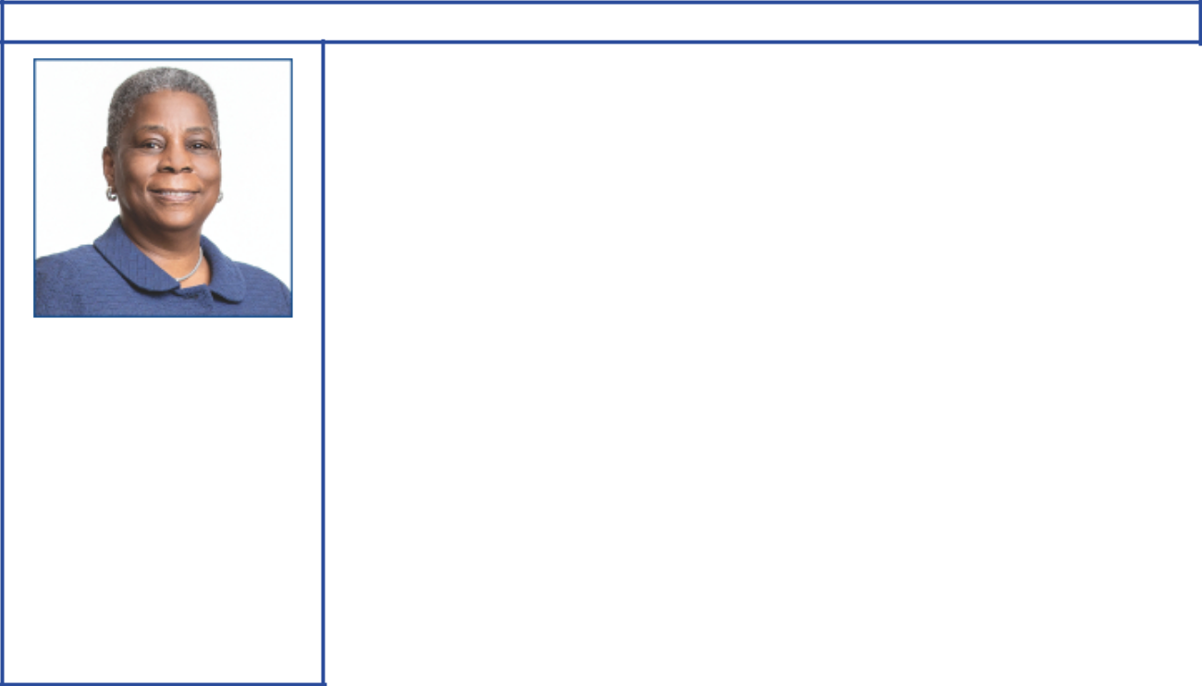

Ursula M. Burns

Principal occupation: Former Chairman of the Board and Chief Executive Officer, VEON Ltd.

Age 62
Director since 2012

Independent director

Committees:

Audit, Executive, Finance

Background:

- Global business leadership with operational experience at Xerox as Chairman from 2010 to 2017; as Chief Executive Officer from 2009 to 2016; and as President from 2007 to 2016. She also served as Senior Vice President, Corporate Strategic Services, and Senior Vice President and President, Document Systems and Solutions Group, and Business Group Operations, at Xerox. At VEON Ltd., she was Chairman of the Board until May 2020, and served as Chief Executive Officer from 2018 through February 2020.

- Government and public policy experience as Vice Chair and Chair of the President’s Export Council (2010 to 2016)

- Scientific, academic, and non-profit affiliations: Ford Foundation (Trustee), National Academy Foundation, Mayo Clinic (counsel/advisor), MIT Corporation (Trustee), National Academy of Engineers (member), American Academy of Arts and Sciences (member), Cornell Technology Board of Overseers (counsel/advisor), and New York City Ballet Inc. (Director)

Current public company directorships: Nestlé S.A. (April 2017 to Present); Uber (May 2019 to Present)

Previous public company directorships in last five years: American Express (January 2004 to May 2018); VEON Ltd. (July 2017 to May 2020); Xerox (April 2007 to June 2017)

Other board experience: former Director of Boston Scientific (prior to 2016)
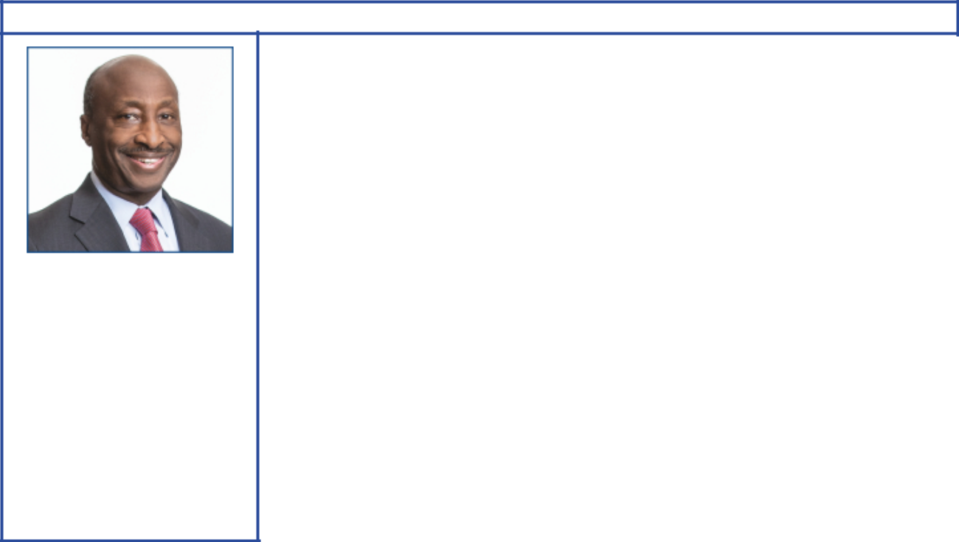

Kenneth C. Frazier

Principal occupation:

Chairman of the Board
and Chief Executive Officer,

Merck & Co., Inc.

Age 66
Director since 2009
Independent director
Lead Director since
March 2020

Committees:

Board Affairs, Compensation, Executive

Background:

- Global business leadership with operational experience at Merck & Co., Inc. as Chairman and Chief Executive Officer from 2011 to present; and as Executive Vice President and President, Global Human Health, from 2007 to 2010. He also served as Executive Vice President and General Counsel.

- Legal and business affiliations: American Law Institute, Business Council and American Bar Association

- Scientific and research affiliations: Pharmaceutical Research and Manufacturers of America, Weill Cornell Medicine, and American Academy of Arts and Sciences

Current public company directorships: Merck & Co., Inc. (January 2011 to Present)

Previous public company directorships in last five years: None

2021 Proxy Statement | 11

Table of Contents
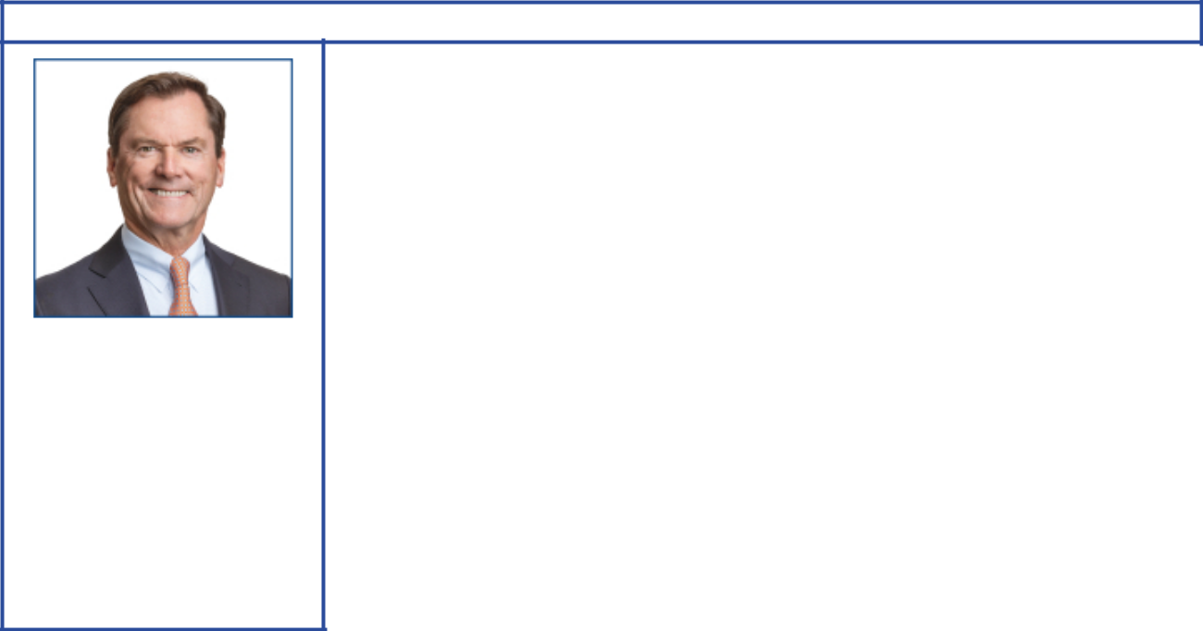

Joseph L. Hooley

Principal occupation: Former Chairman of the Board, President and Chief Executive Officer,

State Street Corporation Age 64
Director since 2020
Independent director

Committees:

Audit, Finance

Background:

- Global business leadership with operational experience at State Street Corporation as Chairman from 2011 to 2019; as Chief Executive Officer from 2010 to 2018; as President and Chief Operating Officer from 2008 to 2014; as Executive Vice President and head of Investor Services Division from 2002 to 2008; and, in 2006, as Vice Chairman and Global Head of Investment Servicing and Investment Research and Trading. He also served as President and Chief Executive Officer of Boston Financial Data Services from 1990 to 2000, and as President and Chief Executive Officer of National Financial Data Services from 1988 to 1990.

- Charitable affiliations: Boys & Girls Clubs of Boston (Trustee of Youth Services)

Current public company directorships: Aptiv PLC (January 2020 to Present)

Previous public company directorships in last five years: State Street Corporation (2010 to December 2019)

Other board experience: Liberty Mutual Insurance (April 2019 to Present)
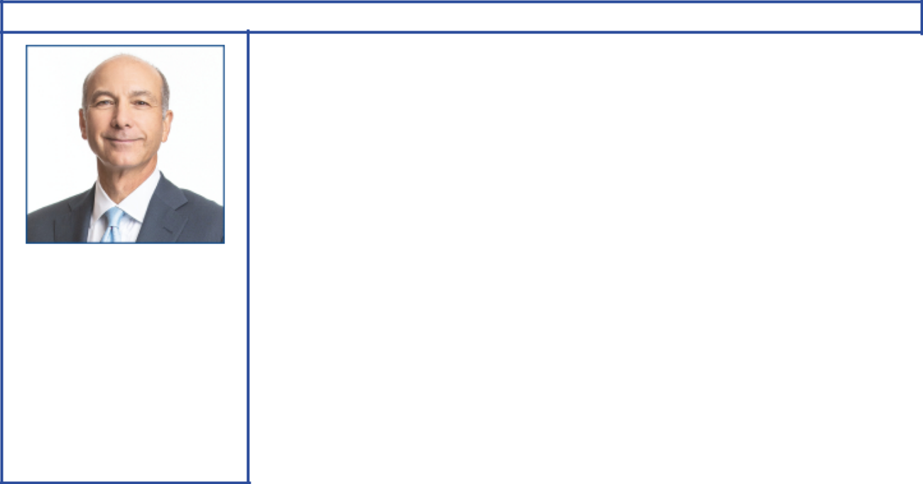

Steven A. Kandarian

Principal occupation: Former Chairman of the Board, President and Chief Executive Officer, MetLife

Age 69
Director since 2018

Independent director

Committees:

Compensation, Public Issues

and Contributions

Background:

- Global business leadership with operational experience at MetLife, Inc. as Chairman from 2012 to 2019; as President and Chief Executive Officer from 2011 to 2019; and as Executive Vice President and Chief Investment Officer from 2005 to 2011. He also served as Executive Director of the Pension Benefit Guaranty Corporation from 2001 to 2004.

- Business and cultural affiliations: Business Council, Business Roundtable (former member), Partnership for New York City (former Director), Institute of International Finance (former Director and Chair, Insurance Regulatory Committee), and the Lincoln Center for the Performing Arts (former Director)

- Scientific and research affiliations: Damon Runyon Cancer Research Foundation (Director)

Current public company directorships: None

Previous public company directorships in last five years: AECOM (March 2019 to February 2021); MetLife (May 2011 to April 2019)

Other board experience: Non-Executive Chairman of Jackson National (February 2021 to Present); Director of Neuberger Berman (March 2015 to Present)

12 2021 Proxy Statement

Table of Contents
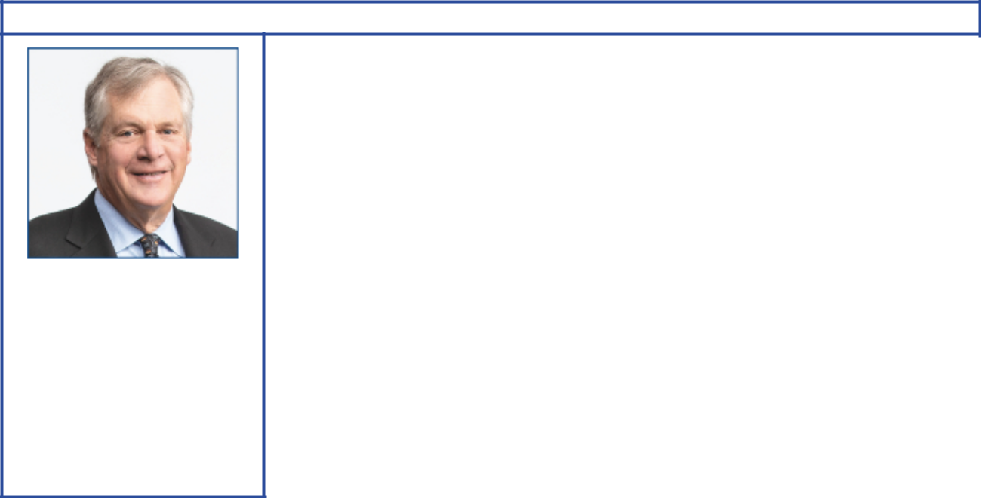

Douglas R. Oberhelman

Principal occupation: Former Chairman of the Board and Chief Executive Officer, Caterpillar Inc.

Age 68
Director since 2015

Independent director

Committees:

Audit, Finance

Background:

- Global business leadership with operational and commodity business experience at Caterpillar Inc. as Chairman from 2010 to 2017; as Chief Executive Officer from 2010 to 2016; as Group President of Caterpillar from 2002 to 2010; and as Vice President, Engine Products Division from 1998 to 2002. He also served as Vice President and Chief Financial Officer from 1995 to 1998.

- Business and charitable affiliations: Business Roundtable (former Chairman), National Association of Manufacturers (former Chairman), Easter Seals Foundation of Central Illinois (Chairman), Gilmore Foundation (Chairman), and Intersect Illinois (Director)

- Environmental conservation: Wetlands America Trust (Vice President), Max McGraw Wildlife Foundation (Director)

Current public company directorships: Bombardier (November 2017 to Present)

Previous public company directorships in last five years: Caterpillar Inc. (July 2010 to March 2017)

Other board experience: Director of Peter Kiewit Sons’, Inc. (August 2017 to Present); Chairman and Director of Switch Rail Safety Systems, LLC (June 2018 to Present); former Director of Eli Lilly and Company and Ameren Corporation (both prior to 2016)
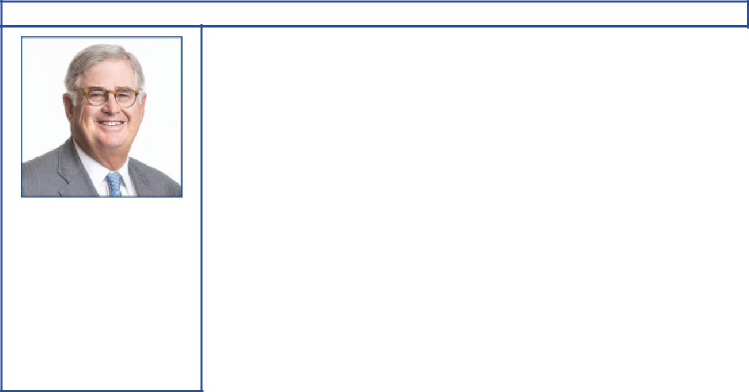

Samuel J. Palmisano

Principal occupation: Former Chairman of the Board, President and Chief Executive Officer, IBM

Age 69
Director since 2006

Independent director

Committees:

Board Affairs, Compensation, Executive

Background:

- Global business leadership with operational experience at IBM as Chairman, President, and Chief Executive Officer from 2003 to 2012. He also served as President, Senior Vice President, and Group Executive for IBM’s Enterprise Systems Group, IBM Global Services, and IBM’s Personal Systems Group.

- Business and public policy affiliations: The Center for Global Enterprise (Chairman), Business Roundtable (former member), Executive Committee of the Council on Competitiveness, Commission on Enhancing National Cybersecurity (former Vice Chair), and co-chair of an independent task force of the Council on Foreign Relations on cybersecurity

Current public company directorships: None

Previous public company directorships in last five years: American Express (March 2013 to May 2019)

Other board experience: former Director of Gannett Co. and IBM (both prior to 2016)

2021 Proxy Statement | 13

Table of Contents
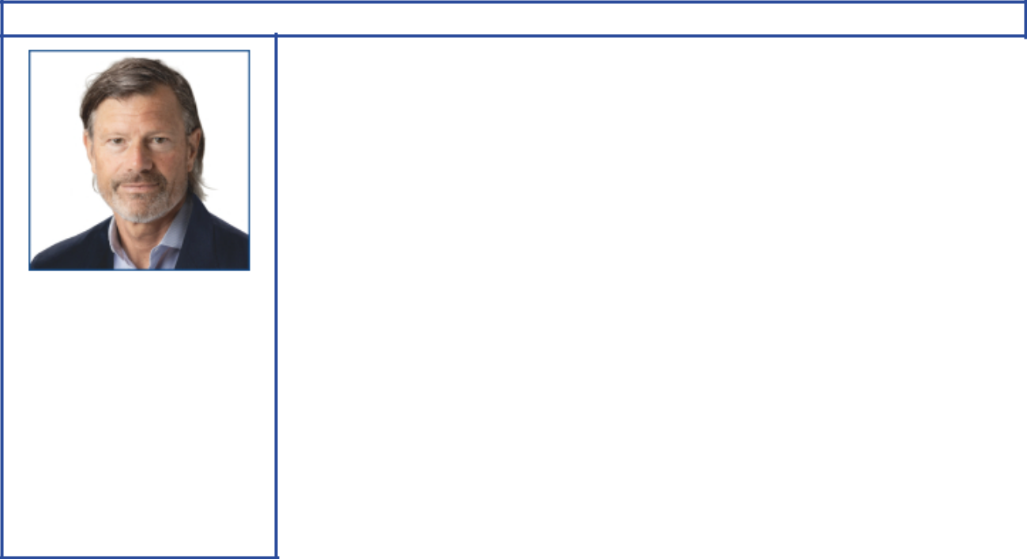

Jeffrey W. Ubben

Principal occupation: Founder, Portfolio Manager and Managing Partner, Inclusive Capital Partners, L.P.

Age 59
Director since 2021

Independent director

Committees: Finance, Public Issues and Contributions

Background:

- Business leadership at Inclusive Capital Partners, L.P. as Founder, Portfolio Manager and Managing Partner since 2020. He also founded and served as Chief Executive Officer of ValueAct Capital Management, L.P. from 2000 to 2020 and as Chief Investment Officer from 2000 to 2017. He was a Managing Partner of Blum Capital Partners L.P. from 1995 to 2000. He also served in various positions including Portfolio Manager and Research Analyst at Fidelity Investments from 1987 to 1995.

- Academic and Environmental affiliations: Duke University (Trustee), E.O. Wilson Biodiversity Foundation (Director), The Nature Conservancy’s NatureVest (Advisory Board), World Wildlife Fund (Director)

Current public company directorships: AppHarvest, Inc. (May 2019 to Present); Enviva Partners, LP (June 2020 to Present); Nikola Corporation (September 2019 to Present)

Previous public company directorships in last five years: The AES Corporation (January 2018 to March 2021); Twenty-First Century Fox, Inc. (November 2015 to April 2018); Willis Towers Watson plc (January 2016 to November 2017)

Other board experience: former Chairman and Director of Martha Stewart Living Omnimedia, Inc., Director of Misys Plc, Bausch Health Companies Inc., Sara Lee Corp. (all prior to 2016)
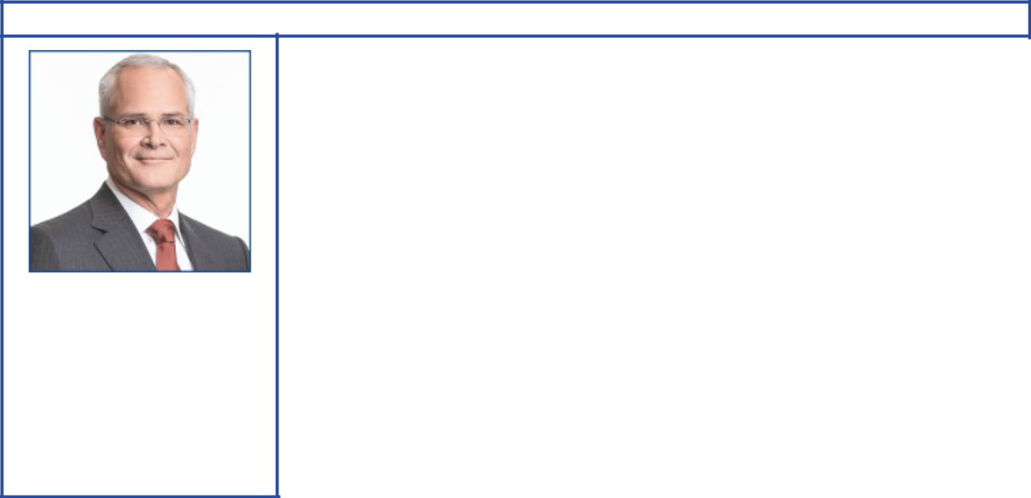

Darren W. Woods

Principal occupation: Chairman of the Board and Chief Executive Officer, Exxon Mobil Corporation

Age 56
Director since 2016

Committees:

Finance, Executive

Background:

- Global business leadership at Exxon Mobil Corporation as Chairman and Chief Executive Officer since 2017; as President since 2016; and as Senior Vice President in 2014 and 2015. He also served as Vice President, and President, ExxonMobil Refining & Supply Company from 2012 to 2014.

- Operational and commodity business experience with positions of increasing responsibility in domestic and international business operations at ExxonMobil Refining & Supply Company, ExxonMobil Chemical Company, and Exxon Company International

- Business affiliations: Business Roundtable, American Petroleum Institute (former Chair), Business Council, Center for Strategic and International Studies (Trustee), Oil and Gas Climate Initiative, and National Petroleum Council (Vice Chair)

- Scientific and environmental experience: ExxonMobil Chemical Company and ExxonMobil Refining & Supply Company

Current public company directorships: None

Previous public company directorships: Imperial Oil Ltd. (April 2013 to July 2014)

14 2021 Proxy Statement

Table of Contents
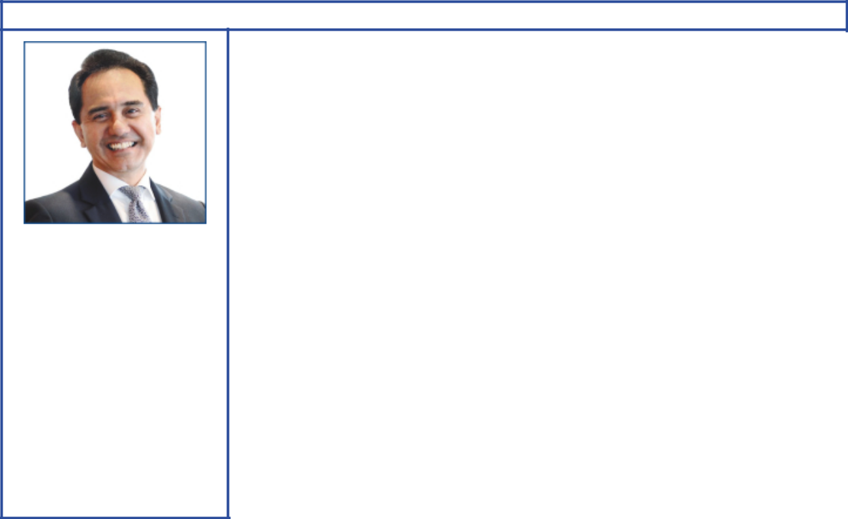

Wan Zulkiflee

Principal occupation: Former President and Group Chief Executive Officer, Petronas

Age 60
Director since 2021

Independent director

Committees:

Board Affairs, Public Issues and Contributions

Background:

- Global business leadership with operational and commodity business experience at Petronas as President and Group Chief Executive Officer from 2015 to June 2020. He also served as Chief Operating Officer and Downstream Executive Vice President. Additional senior management positions held include managing director and CEO of Petronas Gas Berhad, Vice President of Gas Business, Executive Vice President and CEO Downstream Business, as well as Chairman of Petronas Gas Berhad, Petronas Chemical Group and Petronas Dagangan Berhad.

- Scientific and environmental experience leading Petronas’s strategic growth and efficiency initiatives, including entry into specialty chemicals and furthering Petronas’s investments in lower-emission technologies

- Business, public policy, and academic affiliations: Razak School of Government (Trustee), International Islamic University Malaysia (Board of Governors), World Economic Forum, Stewardship Board of System Initiative on Shaping the Future of Energy, Oil & Gas Governors Forum, Oil & Gas Industry Group (former member), and Asia-Pacific Economic Cooperation Business Advisory Council (Malaysia’s former alternate member)

Current public company directorships: Non-Executive Chairman of DRB-HICOM Berhad (September 2020 to Present)

Previous public company directorships in last five years: None

Other board experience: Non-Executive Chairman of Malaysia Airlines Berhad (July 2020 to Present); former Director of Petronas (August 2007 to June 2020)


The Board recommends you vote by proxy using the BLUE proxy card even if you plan to attend the virtual meeting. The Board recommends that you DISREGARD AND DO NOT USE the white proxy card. Voting AGAINST Engine’s nominees on its proxy card is NOT the same as voting FOR our Board’s director nominees. If you have already submitted a white proxy card, you can revoke that proxy and vote for our Board of Directors’ nominees and on the other matters to be voted on at the meeting using the BLUE proxy card or by voting via Internet or telephone by following the instructions on your BLUE proxy card.

Your last submitted proxy card counts as your vote; we encourage you to vote only on the BLUE proxy card.

2021 Proxy Statement | 15

Table of Contents

Background to the Solicitation and Related Company Engagement

As part of its oversight role, the Company’s Board of Directors (the “Board”) evaluates, with management, the Company’s strategy, capital allocation framework, operating expenses and emissions reduction goals on an ongoing basis. This evaluation takes into account the varied perspectives of the Company’s shareholders, whose views are actively requested and received as a result of the Company’s engagement efforts.

Under the direction of the Board and senior management, the Company annually undertakes an expansive corporate planning process to drive alignment on the actions needed to implement the Company’s strategies, including its capital expenditures, operating expenses and emissions goals, across its businesses. Beginning each March and over the course of the year, the Board assesses the Company’s detailed analysis of future energy demand, the projected mix and changes of the energy supply, and the resulting price and margin assumptions. The process culminates each November in the Board’s approval of the planned capital and operating expenditures and capital budget for the following year. In 2020, the Board dedicated significant additional time to the plan process as it evaluated the impacts of the COVID-19 pandemic and the potential recovery pathways. After the Plan was approved by the Board and finalized, the Company published press releases on November 30, 2020 and December 14, 2020 outlining the updated Company plan and new Company emissions reduction goals as discussed with shareholders earlier in 2020.

Following this annual process, from December 2020 through the filing of this proxy statement, the Board and management also extensively reviewed and thoroughly considered the Engine Proposal, as described below. In addition to the Engine Proposal, the Company engaged with another hedge fund (“HF”), including reviewing its proposals. The Company also sought and received feedback from numerous shareholders during this period.

Through these processes, the Board has reaffirmed that the Company’s plans, developed over the past year, approved by the Board in November, and communicated externally on November 30 and December 14, are in the best interest of the Company and its shareholders to protect and fund current and future dividends, to reduce emissions while driving technologies that could support the Paris Agreement, to strengthen the Company’s balance sheet, and to grow shareholder value.

The summary below details the significant contacts between the Company and Engine No. 1 LLC (“Engine”), as well as associated entities supporting Engine’s efforts, either as a result of mutual shared perspectives or arrangements between the parties.

On November 19, 2020, Engine was incorporated in the state of Delaware.1 According to its newly launched website, Engine’s team includes Chris James and Charlie Penner. Just 18 days later, on December 7, 2020, Engine sent a letter to the Board that in summary covered four subjects: (1) Board composition, (2) the Company’s long-term capital allocation strategy, (3) the Company’s investment in clean energy and sustainability commitments and (4) the Company’s management compensation plans (collectively, the “Engine Proposal”). Engine had not previously reached out to the Company nor been involved in any of the Company’s engagement efforts prior to sending this letter. Engine released this letter to the press on the prior day before speaking with or sending it to the Company. Press articles reported that Engine had the support of the California State Teacher’s Retirement System (“CalSTRs”).

Also on December 7, Chris Ailman, Chief Investment Officer of CalSTRs, provided an interview on CNBC expressing its support for Engine’s letter, released hours earlier to the Company. Mr. Ailman stated that CalSTRs has become an “activist shareholder” and that the Company needed to “wake up” and “get out of the oil and gas focus”. Mr. Ailman acknowledged in the interview that the relatively small size of Engine’s and CalSTR’s investments constituted “the challenge that lies before us, and especially Engine 1.”

- On January 7, 2021, Engine was named a defendant in a lawsuit filed in the United States District Court for the Southern District of New York by the investment management and activist firm Engine Capital Management. The lawsuit seeks injunctive relief, money damages, and other relief in connection with Engine’s alleged unfair competition, cybersquatting, trademark infringement, and injury to Engine Capital Management’s business reputation. The complaint alleges, among other things, that Engine’s use of “Engine No. 1” and “Engine” in connection with its investment management services and activist efforts has caused confusion in the investment community and has harmed Engine Capital Management, which provides services similar to Engine’s. In light of this suit, the Company wishes to avoid any confusion and make clear that all references to “Engine” in this proxy refer only to Engine No. 1 LLC.

16 2021 Proxy Statement

Table of Contents

On December 8, 2020, HF sent a letter to the Board that in summary discussed the Company’s capital allocation policy, operating cost structure and emissions reduction opportunities, as well as the Company’s total shareholder return. HF requested a meeting with the Chairman of the Board and the Company’s Lead Director. HF ultimately did not submit a notice to nominate any candidates for election at the Company’s 2021 Annual Meeting.

On December 10, 2020, Company management updated the Board on the letters from Engine and HF and advised the Board generally on the situation and the Company’s response.

On December 14, 2020, the Company issued a press release announcing results on its ongoing emission reduction efforts for 2020 and setting out new emission reduction plans for 2021 through 2025 based on the comprehensive reviews beginning in the first half of 2020, all as discussed with shareholders during the Company’s 2020 shareholder engagements. The press release reaffirmed its continued support of the Paris Agreement and confirmed the Company’s success in meeting its 2018 goals to decrease methane emissions by 15% and reduce flaring by 25% by the end of 2020, compared to 2016 levels. The press release also announced its greenhouse gas emission reduction plans for the next five years that were developed as part of the 2020 Company plan process described above: a reduction in the intensity of operated upstream greenhouse gas emissions of 15-20% by 2025, compared to 2016 levels, supported by a 40-50% decrease in methane intensity and a 35-45% decrease in flaring intensity across its global operations. The emission plan covers Scope 1 and Scope 2 emissions from assets operated by the Company.

On December 17, 2020, a meeting of the Board was held, at which Company management updated the Board and advised the Board generally on the situation and the Company’s response. The Board determined that a working group of directors should be established to facilitate consultation on the situation as appropriate.

From mid-December 2020 through the month of January 2021, representatives of the Company and HF engaged in constructive conversations regarding the Company’s capital allocation, operating expenses, governance, Board composition, emission reduction plans and energy research efforts. HF made suggestions to the Company on potential director candidates, which the Company indicated it would consider along with other candidates consistent with its board refreshment and governance practices.

On December 18, 2020, Engine sent a letter to Stephen Littleton (the Company’s Head of Investor Relations) requesting the Company’s director and officer questionnaire and nominee representations agreement. These documents were provided to Engine on December 21, 2020.

On December 20, 2020, we understand that As You Sow, an activist that is not a shareholder to the Company’s knowledge but regularly submits shareholder proposals to the Company on behalf of actual shareholders, sent an email to all members of the Council of Institutional Investors, a group that includes the largest asset managers in the world, soliciting for members to formally join a new organization, the Coalition Urging Responsible Energy and Sustainability (“CURExxon”). The email stated that, once formed, As You Sow intended to have CURExxon send a letter to the Company supporting Engine, CalSTRs and HF, among other things.

On December 21, 2020, Mr. Littleton and Craig Morford (the Company’s General Counsel) met with Mr. Penner of Engine. The participants discussed the matters raised in Engine’s December 7 letter. In preparation for this meeting, the Company inquired whether CalSTRs should be invited to the call and were told that CalSTRs was not a party to Engine 1’s engagement. During the meeting, Mr. Littleton and Mr. Morford asked Mr. Penner if he had further information or perspectives to share beyond what is contained in the letter that Engine had submitted. Mr. Penner responded that Engine’s views are contained in the letter and that he did not have additional detail to provide.

On December 22, 2020, the Board working group met to discuss communications and developments with Engine and HF, the Company’s response plan and next steps.

On December 24, 2020, a representative of the Company had a follow-up call with a representative of Engine to discuss Engine’s key objectives and to continue to explore the possibility of constructive engagement.

On January 4, 2021, Engine sent a letter to Mr. Littleton making a request regarding shareholder records.

2021 Proxy Statement | 17

Table of Contents

On January 6, 2021, a representative of the Company had a follow-up call with a representative of Engine to continue to discuss Engine’s key objectives and to determine whether constructive engagement was feasible.

On January 7, 2021, the Board working group met to discuss communications and developments with Engine and HF, the Company’s response plan and next steps.

On January 11, 2021, Mr. Littleton sent a response letter to Engine’s January 4 request for shareholder records. For the next few weeks, the Company and Engine No. 1 continued to negotiate the appropriate terms and basis for furnishing and protecting such shareholder information under the relevant statute and a confidentiality agreement.

On January 14, 2021, a representative of the Company had a further follow-up call with a representative of Engine to continue to discuss the possibility of working constructively to address the matters raised by Engine, including Engine’s demand of having four representatives on the Board.

On January 19, 2021, the Board working group met to discuss communications and developments with Engine and HF, the Company’s response plan and next steps.

On January 20, 2021, a meeting of the Board was held, at which the Board working group and management updated the Board generally on and discussed the situations with Engine and HF.

On January 22, 2021, Darren Woods (Chairman and CEO) and Ken Frazier (Lead Director) met with representatives of
Engine. The respective representatives of Engine and the Company exchanged views on the matters that had been
raised by Engine, including the Company’s approach to energy transition matters, and governance. Mr. Frazier and
Mr. Woods advised the Engine representatives that the potential director candidates that had previously been informally
proposed by Engine would be considered in accordance with the Company’s governance practices.

On January, 27, 2021, the Board unanimously elected Tan Sri Wan Zulkiflee Wan Ariffin as a new director of the Company as part of the Board’s refreshment process, including the pending mandatory age limit retirement of William C. Weldon from the Board.

During the Board’s regularly scheduled January 27, 2021 meeting, the Board working group and Company management updated the Board generally on the discussions with and proposals of Engine and HF.

Also on January 27, 2021, Engine submitted its formal notice of its intent to nominate four nominees for election as directors at the Company’s 2021 Annual Meeting. On January 29, 2021, following the submission of the Engine slate of directors, Chris Ailman, Chief Investment Officer of CalSTRs, provided an interview on CNBC reaffirming that CalSTRs intended to be “a more activist shareholder” before stating that “[he was] actually optimistic that our slate is going to win and take over their board and change that company from the top.” (Emphasis added).

On February 1, 2021, the Company issued a press release announcing the creation of a new business to commercialize its extensive low -carbon technology portfolio. The new business, ExxonMobil Low Carbon Solutions, will initially focus on commercializing the Company’s significant experience with carbon capture and storage, one of the critical technologies that could support net zero emissions and the climate goals outlined in the Paris Agreement. ExxonMobil Low Carbon Solutions will also leverage the Company’s significant experience in the production of hydrogen which, when coupled with carbon capture and storage, is likely to play a critical role in a lower-carbon energy system. The business builds on the carbon capture venture established by the Company in 2018.

On February 2, 2021, the Company issued press releases announcing, among other things:

- the election of a new director, Tan Sri Wan Zulkiflee Wan Ariffin, and updated information on its capital plan and annual cost reductions.

- the Company released Fourth Quarter Earnings and discussed further details on the Company’s plans which provided insight into the operating expense reduction, capital expenditure flexibility, and perspectives on the Company’s efforts to reduce emissions.

18 2021 Proxy Statement

Table of Contents

On February 2, 2021, CURExxon issued a press release and sent a letter to the Company, consistent with their email to the Council of Institutional Investors on December 20, 2020, outlining their support for Engine and CalSTRs in their engagement with the Company. The letter misleadingly referred to the $2.27 trillion USD of assets under management by signatories of CURExxon, but omitted the number of Company shares actually owned by the signatories. The list of signatories includes activists such as As You Sow and Arjuna Capital, who, to the Company’s knowledge, neither invest in nor recommend ExxonMobil stock. CURExxon’s press release also referred to certain lawsuits against the Company as well. Notably, representatives of As You Sow and Arjuna Capital recently participated as witnesses for the New York Attorney General in its unsuccessful four year campaign against the Company that was decided in favor of the Company on all counts after a two week trial in late 2019. One of Arjuna Capital’s three managing partners, Natasha Lamb, testified at trial and was found by the Honorable Barry Ostrager of the New York Supreme Court, Commercial Division, to be “manifestly biased” against ExxonMobil. After hearing the evidence, including Ms. Lamb’s testimony, Justice Ostrager ruled in favor of the Company on all counts, including those brought under what is widely considered the most prosecutor-friendly state securities law in the country. In addition to ruling for ExxonMobil on the merits on all counts, Justice Ostrager concluded that the “evidence at trial revealed that ExxonMobil executives and employees were uniformly committed to rigorously discharging their duties in the most comprehensive and meticulous manner possible.”

On February 8, 2021, the Board working group met to discuss the status of communications and developments with Engine, the Company’s response plan and next steps.

On February 9, the Company and Engine entered into a confidentiality agreement related to the furnishing of shareholder ownership information.

On February 15, 2021, the Company provided its record holder list to Engine in digital format.

On February 17, 2021, the Company’s Board Affairs Committee met to consider and discuss the credentials, qualifications, skill sets and past experience of director candidates, as part of its continuing succession planning duties. As part of this work, the Committee reviewed the backgrounds and qualifications of two candidates whom the Board had previously discussed, as well as each of the four candidates that had been nominated by Engine. Taking into account information provided by the Company’s advisors, shareholders and directors relating to the credentials, qualifications, skill sets, past experience and diligence background information as to each of the candidates, including each of the four Engine candidates, the Committee compared each candidate to the Board’s director qualification standards (set forth separately in this proxy statement) and determined to recommend that the Board elect Michael Angelakis and Jeffrey Ubben to serve as directors. As part of its review, the Committee found that none of the Engine director candidates meet the standards or needs of the Company’s Board, and determined not to recommend any of the Engine candidates for election to the Board.

On February 18, 2021, a meeting of the Company’s Board was held to provide an update on the situation generally. The Board also received an update from the Board Affairs Committee on its February 17 meeting. The Committee discussed with the Board its determination that based on information provided by the Company’s advisors, shareholders and directors relating to the credentials, qualifications, skill sets, past experience and diligence background information as to each of the candidates, it had determined that none of the Engine candidates meet the standards or needs of the Company’s Board, that Mr. Angelakis and Mr. Ubben, each of whom the Board had previously discussed, meet the Board’s standards and would bring skill sets and qualifications consistent with the Board’s ongoing refreshment and succession planning needs. The Committee recommended that the Board review Mr. Angelakis and Mr. Ubben as proposed director candidates at its February 24 meeting. The Board then discussed the Committee’s determinations and recommendations.

On February 19, 2021, Mr. Woods and Mr. Littleton met with Jack Ehnes, Chief Executive Officer of CalSTRs, and Chris Ailman, Chief Investment Officer of CalSTRs, and discussed their perspectives on the Company’s progress and plans regarding energy transition matters.

On February 22, 2021, Engine provided Bloomberg.com with a letter outlining its position on the Company’s efforts regarding energy transition. Engine sent this letter to the Board later that day and subsequently filed the letter with the SEC after close of business on February 22, 2021.

2021 Proxy Statement | 19

Table of Contents

The Board took unanimous action on February 27, 2021 to elect Mr. Angelakis and Mr. Ubben to the Board, effective March 1, 2021. As part of the Board refreshment process and in line with shareholder feedback, the Board has added new directors with scientific climate science expertise (Dr. Susan K. Avery in 2017), with an investor perspective (Joseph L. Hooley in 2020), and three directors in 2021 with oil and gas experience, international experience, and transition experience. With the addition of the new Board members, the average independent director tenure for the Board nominees is approximately five years, compared to an average of eight years for companies in the S&P 500.

On March 1, 2021, the Company issued a press release announcing the election of Mr. Angelakis and Mr. Ubben to the Board. Mr. Angelakis is the chairman and CEO of Atairos, an independent strategic investment company focused on supporting growth-oriented businesses across a range of industries. Prior to founding Atairos, he served as Comcast Corporation’s Vice Chairman and Chief Financial Officer. In those roles, Mr. Angelakis led strategic planning, capital allocation and corporate development, including overseeing Comcast’s successful transition into media and other technologies. Mr. Ubben is the Founder of Inclusive Capital Partners, an investment firm focused on increasing shareholder value and promoting sound environmental, social and governance practices. The Board believes Mr. Angelakis’ and Mr. Ubben’s experience in capital allocation across different industries and strategy development will be valuable to the Company as the Company advances plans to increase shareholder value by responsibly providing needed energy while playing a leadership role in the energy transition. The election of Mr. Angelakis and Mr. Ubben brings the Board to 13 directors, 12 of whom are independent.

Following the March 1, 2021 announcement, the Company has continued to engage with shareholders regarding the new members of the Board and the Company’s continuing focus on the energy transition and capital allocation matters.

20 2021 Proxy Statement

Table of Contents

CORPORATE GOVERNANCE

Overview

The Board of Directors and its committees perform a number of functions for ExxonMobil and its shareholders, including:

- Overseeing the management of the Company on your behalf, including oversight of risk management;

- Reviewing ExxonMobil’s long-term strategic plans;

- Exercising direct decision-making authority in key areas, such as declaring dividends;

- Selecting the Chief Executive Officer (CEO) and reviewing the CEO’s performance;

- Reviewing development and succession plans for ExxonMobil’s top executives; and

- Gathering insights and sharing perspectives from shareholders during engagements and other communications.

The Board has adopted Corporate Governance Guidelines that govern the structure and functioning of the Board and set out the Board’s position on a number of governance issues. A copy of our current Corporate Governance Guidelines is posted on our website at exxonmobil.com/guidelines.

At least annually, the Board and each of the Board committees conduct an evaluation of their performance and effectiveness. Any potential changes to the committees’ charters are also considered at least once a year.

Risk Oversight

The full Board of Directors provides oversight of key risks to ExxonMobil’s business. The Board throughout the year participates in reviews with management on the Company’s business, including identified risk factors. As a whole, the Board reviews litigation and other legal matters; political contributions, budget, and policy; lobbying costs; developments in climate science and policy; the Outlook for Energy, which projects world energy supply and demand to 2040; the Energy & Carbon Summary; stewardship of business performance; and long-term strategic plans. The Board receives updates and reviews from both internal ExxonMobil and external experts on issues of importance to the Company.

The Board, including the Public Issues and Contributions Committee, visits an ExxonMobil operations site each year. These visits enable the directors to observe and provide input on safety, operating practices, environmental performance, technology, products, industry and corporate standards, and community engagement.

The Board oversees a broad spectrum of interrelated risks with assistance from its committees. This integrated risk management approach facilitates recognition and oversight of important risk interdependencies.
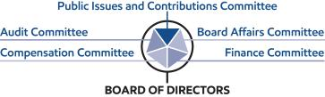

2021 Proxy Statement | 21

Table of Contents

Audit Committee oversees risks associated with financial and accounting matters, including compliance with legal and regulatory requirements, and the Company’s financial reporting and internal control systems. The Audit Committee also periodically reviews cybersecurity risks and preparedness and ExxonMobil’s overall risk management approach and structure.

Board Affairs Committee oversees Board structure and matters of corporate governance, including Board evaluation and director refreshment. It also coordinates identification of external experts to address the Board and sets the criteria for shareholder engagement with directors.

Compensation Committee reviews executive compensation, which is designed to promote accountability to maximize shareholder value over the long term while effectively managing longer term risks, including those related to climate change. The Committee also assesses each element of the compensation program to ensure that these do not create any material adverse risks to the Company and do not encourage executives to take risks that may not be aligned with shareholders’ long-term interests.

Public Issues and Contributions Committee oversees operational risks such as those relating to employee and community safety, health, environmental performance, including actions taken to address climate-related risks, security matters, and reviews and provides advice on objectives, policies and programs related to lobbying activities and political and other contributions.

Finance Committee oversees risks associated with financial instruments, financial policies and strategies, and capital structure.

The Board receives regular updates from the committees, and believes this structure is best suited for overseeing risk.

Board Leadership Structure

The Board believes that the decision as to who should serve as Chairman and/or CEO is the proper responsibility of the Board. The Board retains authority to amend the by-laws to separate the positions of Chairman and CEO at any time and regularly considers the pros and cons of such separation or combination. At the present time, the Board believes the interests of all shareholders are best served through a leadership model with a combined Chairman/CEO position and an independent Lead Director elected by and from among the independent directors.

The current CEO possesses an in-depth knowledge of the Company; its integrated, multinational operations; the evolving energy industry supply and demand fundamentals; and the array of challenges to be faced. This knowledge was gained through more than 28 years of successful experience in progressively more senior positions, including domestic and international responsibilities.

The Board believes that these experiences and other insights put the CEO in the best position to provide broad leadership for the Board as it considers strategy and as it exercises its fiduciary responsibilities to shareholders. Further, the Board has demonstrated its commitment and ability to provide independent oversight of management.

The Board is comprised solely of independent directors other than the CEO, and 100 percent of the Audit, Compensation, Board Affairs, and Public Issues and Contributions Committee members are independent. Each independent director has access to the CEO and other Company executives and employees, and is empowered to call meetings of the independent directors and request agenda topics to be added or addressed in more detail at meetings of the full Board or an appropriate Board committee.

22 2021 Proxy Statement

Table of Contents

The Board believes the Lead Director provides effective independent Board leadership. Kenneth C. Frazier serves as Lead Director and is expected to remain in the position at least through the annual meeting of shareholders.

The Lead Director’s authority, under the

Corporate Governance Guidelines, includes:

- Calling, chairing, and setting the agenda for executive sessions of the non-employee directors
- Providing feedback to the Chairman

- Chairing meetings of the Board in the absence of the Chairman

- Reviewing and approving the schedule and agenda for all Board meetings and reviewing associated materials distributed to the directors, in consultation with the Chairman

- Advising the Chairman on the quality, quantity, and timeliness of information flow

- Reviewing committee meeting schedules

- Engaging with shareholders, as appropriate

- Leading the annual performance evaluation of the Board

The Lead Director also serves as Chair of the Board Affairs Committee with authority that includes:

- Establishing the criteria for director engagement with shareholders

- Providing comments and suggestions to the Board on Board committee structure, operations, member qualification, and member appointment
- Overseeing independent director succession planning, remuneration, requests for additions to board memberships, and resignations
- Establishing and maintaining procedures for interested parties to communicate with non-employee directors

- Considering Board governance practices and procedures including any changes to governance guidelines

- Providing oversight of the performance and effectiveness of the evaluation process for the Board and its committees

In addition, the Lead Director, working together with the Compensation Committee, oversees the annual evaluation of the CEO, the communication of resulting feedback to the CEO, and the review of CEO succession plans.

Director Qualifications

The Board has adopted guidelines outlining the qualifications sought when considering non-employee director candidates. These Guidelines for the Selection of Non-Employee Directors (Selection Guidelines), which are published on our website at exxonmobil.com/directorguidelines, are reviewed annually and state in part:

“ExxonMobil recognizes the strength and effectiveness of the Board reflects the balance, experience, and diversity of the individual directors; their commitment; and importantly, the ability of directors to work effectively as a group in carrying out their responsibilities. ExxonMobil seeks candidates with diverse backgrounds who possess knowledge and skills in areas of importance to the Corporation.”

The qualifications we consider for director candidates include: individuals who have achieved prominence in their fields; diversity of experiences and backgrounds, including gender and race/ethnic diversity; experience and demonstrated expertise in managing large, relatively complex organizations, such as that of CEOs of a significant company or organization with global responsibilities; financial and other risk management expertise; experience on one or more boards of significant public or non-profit organizations; expertise resulting from significant academic, scientific, or research activities; and experience with cyclical businesses, such as commodities.

Other considerations for director candidates include: a substantial majority of the Board must meet independence standards as described in the Corporate Governance Guidelines; all candidates must be free from any relationship with management or the Corporation that would interfere with the exercise of independent judgment; candidates should be committed to representing the interests of all shareholders and not any particular constituency; and the Board must include members who satisfy legal and stock exchange requirements for certain Board committees.

All directors are expected adhere to the Company’s policies and procedures, including the Conflict of Interest Policy and Ethics Policy. See the Code of Ethics and Business Conduct section below for additional information.

2021 Proxy Statement | 23

Table of Contents

The Board is comprised of directors with an effective mix of backgrounds, knowledge, and skills that the Board considers relevant and beneficial in fulfilling its oversight role. The chart below provides a summary of the collective competencies of the ExxonMobil Board nominees and explains why these are important:

Director | Competencies and | Board
Qualifications | Relevance to ExxonMobil | Composition
Individuals who | Current CEO / Former CEO / Field Prominence
have achieved | Experience serving as a CEO or other prominent leader provides unique
prominence in their | perspectives to help the Board independently oversee ExxonMobil’s CEO
fields | and management. Having this experience also increases the Board’s
 | understanding and appreciation of the many facets of modern international
 | organizations, including strategic planning, financial reporting and
 | compliance, and risk oversight.

Experience and demonstrated expertise in managing large, relatively complex organizations, such as CEOs of a significant company or organization with global responsibilities

Large / Complex Organizations

ExxonMobil is among the largest corporations in the world. Experience leading a large organization provides practical insights on the challenges and opportunities complex businesses encounter.

Global Business Leadership

ExxonMobil conducts business around the world. Having a global business perspective aids the Board in understanding diverse business environments, economic conditions, and cultures associated with our global workforce and activities.

Operational Experience

Our Company operates in many different places and under varied conditions. Having experience with operational matters and requirements assists the Board in understanding the issues that may face ExxonMobil in its worldwide activities, including maintenance needs, labor relations, and regulatory requirements.

Financial or other | Financial Experience
risk management | ExxonMobil’s business involves complex financial management, capital
expertise | allocation, and reporting issues. An understanding of finance and financial
 | reporting is valuable in order to promote effective capital allocation, robust
 | controls, and oversight.

Risk Management

The scale, scope, and complexity of ExxonMobil’s business raises a multitude of interdependent risks, which can vary over time. Experience in effectively identifying, prioritizing, and managing a broad spectrum of risks can help the Board appreciate, anticipate, and oversee the Company in managing the risks that face its varied businesses.

Experience on one | Public Company Board
or more boards of | An understanding of public company reporting responsibilities and the
significant public | issues commonly faced by public companies is important to navigating
or non-profit | governance issues as applied to ExxonMobil.
organizations

Expertise resulting | Scientific / Technical / Research Experience
from significant | ExxonMobil is a leader in research and technology, from finding and
academic, scientific, | producing oil and natural gas to developing new products, mitigating
or research activities | emissions, and protecting the environment. It is helpful for Board members
 | to have these competencies, as science and technology are cornerstones
 | to ExxonMobil’s businesses.

Experience with | Commodity / Cyclical Business Experience
cyclical businesses, | Understanding the unique challenges of a cyclical or commodity business
such as | provides helpful insights for assessing Company strategies, challenges,
commodities | and opportunities.

24 2021 Proxy Statement

Table of Contents

Diversity of experiences and backgrounds, including gender and race/ethnicity, is also an important consideration for Board members. The charts below reflect the diversity of the Board nominees.

Strong Board Gender and Race/Ethnic Diversity
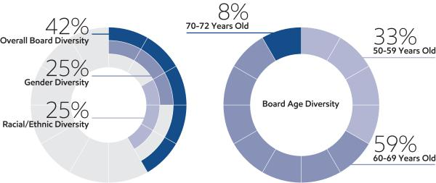

Director Independence

The Corporation’s Corporate Governance Guidelines require that a
substantial majority of the Board consists of independent directors. In general, the Guidelines require that an independent director must have no material relationship with ExxonMobil, directly or indirectly, except as a director. The Board determines independence on the basis of the standards specified by the New York Stock Exchange (NYSE), the additional standards referenced in our
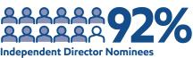
Corporate Governance Guidelines, and other facts and circumstances the Board considers relevant.

Under ExxonMobil’s Corporate Governance Guidelines, a director will not be independent if a reportable “related person transaction” exists with respect to that director or a member of the director’s family for the current or most recently completed fiscal year. See the Guidelines for Review of Related Person Transactions posted on the Corporate Governance section of our website and described in more detail under Related Person Transactions and Procedures below.

The Board has reviewed relevant relationships between ExxonMobil and each non-employee director and director nominee to determine compliance with the NYSE standards and ExxonMobil’s additional standards. The Board has evaluated whether there are any other facts or circumstances that might impair a director’s independence. Based on that review, the Board has determined that all ExxonMobil non-employee directors are independent. The Board has also determined that each member of the Audit, Board Affairs, Compensation, and Public Issues and Contributions Committees (see table on page 30) is independent based on both applicable NYSE standards and the Company’s independence standards for each of these committees. The Company’s standards for each committee are included in their respective charters and are posted on our website at exxonmobil.com/guidelines.

In recommending that each director and nominee be found independent, the Board Affairs Committee reviewed the following transactions, relationships, or arrangements. All matters described below fall within the NYSE and ExxonMobil independence standards.

Name | Matters Considered
U.M. Burns | Ordinary course business with VEON (purchases of telecommunication services)
K.C. Frazier | Ordinary course business with Merck (purchases of pharmaceuticals; sales of chemicals and oils)
 | 2021 Proxy Statement | 25

Table of Contents

Shareholder Engagement in 2020

The Board and management believe ongoing engagement with our shareholders is vitally important and understand the importance of keeping shareholders informed about the business, understanding shareholders’ perspectives, and addressing areas of interest. The Board and management welcome and value input from all shareholders.

Engaged with: |  |  | Engaged through: |  |  |  |  | Engagements include:
✓ | Institutional Investors |  | ✓ | Individual Investor Meetings |  |  |  | ✓ | Non-employee Directors
✓ | Retail Shareholders |  | ✓ | Investor Day |  |  |  | ✓ Chairman / CEO /
✓ | Pension Funds |  | ✓ | Quarterly Earnings Calls |  |  |  | ✓ | Management Committee
✓ | Religious Organizations |  | ✓ | Investor Conferences |  |  |  | ✓ | Senior Management
✓ | Nongovernmental |  | ✓ | Spotlight Events |  |  |  | ✓ | Subject Matter Experts
✓ | Organizations |  | ✓ | Annual Shareholder Meeting |  |  |  | ✓ | Other Employees
✓ | Proxy Advisory Firms |  | ✓ | Shareholder Webcast
✓ | ESG Rating Firms |  | ✓ | Stakeholder Outreach |  |  |  | ESG Engagements:
✓ | Industry Thought Leaders |  |  |  |  |  |  |  | ~ 200%
 |  |  |  |  |  |  |  | of 2015 ESG engagements
Engaged with shareholders representing: |  |  |  |  | Information shared through:
 | ~ 1.6 billion shares |  |  |  | • | SEC Filings |  | • | Energy & Carbon
~ 38% of total outstanding shares |  |  |  |  | • | Press Releases |  | • | Summary
 |  |  |  |  | • | Annual Report |  | • | Sustainability Report
 | and |  |  |  | • | Company Website |  | • | Perspectives Blog
~ 70% of institutional shareholdings |  |  |  |  | • | Energy Factor

Director Nomination Process and Board Succession

As noted in the committee information that follows, the Board Affairs Committee is responsible for identifying and evaluating director candidates. The below sets forth the process through which the Committee identifies potential nominees to the Board and evaluates their qualifications.

Candidate Recommendations

The Board Affairs Committee seeks new candidates in several ways:

- Recommendations made by the non-employee directors. These recommendations are developed based on the directors’ own knowledge and experience in a variety of fields and on the research conducted by ExxonMobil staff at the Committee’s direction.

- Engagement of an executive search firm. The firm brings forward potential director candidates for the Committee to consider and helps research candidates identified by the Committee.

- Recommendations made by employee directors, shareholders, and others.

All recommendations, regardless of the source, are evaluated on the same basis against the criteria contained in the Selection Guidelines. The Committee has also instructed its executive search firm to include diversity as part of the candidate search criteria.

Shareholders may send recommendations for director candidates to the Corporate Secretary at the address given under
Contact Information on page 8. A submission recommending a candidate should include:

- Sufficient biographical information to enable the Committee to evaluate the candidate in light of the Selection Guidelines;

- Information concerning any relationship between the candidate and the recommending shareholder; and

- Material indicating the willingness of the candidate to serve if nominated and elected.

26 2021 Proxy Statement

Table of Contents

The procedures by which shareholders may recommend nominees have not changed materially since last year’s proxy statement.

Assessment and Nomination

Once potential nominees are identified, the Board Affairs Committee assesses the candidate’s overall qualifications for nomination to the Board relative to an assessment of the Company’s future direction. In evaluating prospective directors, the Committee considers various factors including:

- ExxonMobil’s Corporate Governance Guidelines;

- The candidate’s skills, expertise and background as compared to ExxonMobil’s Selection Guidelines;

- ExxonMobil’s strategy, risk profile and current Board composition;

- Independence, perspectives, objectivity, reasoning and judgement of the candidate; and

- Board diversity.

ExxonMobil seeks to have a diverse Board representing a range of backgrounds, knowledge, and skills relevant to the Company’s business and the needs of the Board, and as part of the search process, considers highly qualified candidates, including women and minorities. The Committee does not use quotas, but considers diversity along with the other requirements of the Selection Guidelines when evaluating potential new directors. The resulting diversity of experience, skills, gender and race/ethnicity on the ExxonMobil Board serves as a testament to this robust process.

If the Board Affairs Committee determines to advance a candidate in the nomination process, the Committee puts the candidate forward for consideration by the full Board.

Since our last annual shareholders meeting, the Committee continued its director succession planning, using the process described above and taking into account, among other factors, shareholders’ interest in board refreshment and specifically in adding directors with oil and natural gas industry, energy and business transition, capital allocation and finance expertise. Based on its review of the credentials, qualifications, skill sets and past experience of various candidates considered and the needs of the Board, the Committee recommended for election Mr. Angelakis, Mr. Ubben and Mr. Zulkiflee, who were identified by shareholders, members of our Board or our search firm. Based on the Committee’s recommendation and the information considered on each of Mr. Angelakis, Mr. Ubben and Mr. Zulkiflee, the Board elected each of them as director. For information on Mr. Angelakis’, Mr. Ubben’s and Mr. Zulkiflee’s qualifications, see pages 9 and following.

Director Re-Nomination

The Board Affairs Committee also oversees the re-nomination process. In considering whether to re-nominate a director for re-election at our annual meeting, the Committee reviews each director, considering such factors as:

- Attendance and participation at Board and committee meetings;

- Skills, experience and personal attributes;

- Continued contribution to the Board’s effectiveness;

- Results from the annual Board and committee self-assessments;

- Shareholder feedback, including the support received at our annual meeting of shareholders; and

- Independence.

Board Tenure

The Board does not impose tenure limits on its directors, other than a mandatory retirement age of 72 and the requirement to stand for election annually. Given the complexity and breadth of our business and its long-term investment horizons, the Board considers longevity of service and experience of great value. The Board also believes that its director compensation approach, which limits the vesting of restricted shares until retirement, closely aligns directors with the interests of long-term shareholders.

2021 Proxy Statement | 27

Table of Contents

All ExxonMobil directors stand for election at the annual meeting. Non-employee directors cannot stand for election after they have reached age 72, unless the Board makes an exception on a case-by-case basis. Restricted shares received by non-employee directors are subject to forfeiture if the non-employee director leaves the Board early, i.e., before the retirement age of 72. Employee directors resign from the Board when they are no longer employed by ExxonMobil.

As of March 1, 2021, the average tenure of ExxonMobil’s non-employee directors standing for election is 4.9 years, well below the average of S&P 500 companies of 7.9 years (per 2020 Spencer Stuart Board Index). Seventy-five percent of ExxonMobil director nominees joined the Board since 2015.
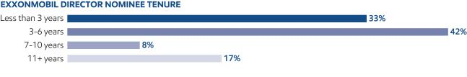

Insights into the Boardroom

The Board provides oversight for ExxonMobil’s key risks, including strategic, reputational, financial, operational, SSHE (safety, security, health and environment) and legal compliance matters. The Board regularly reviews environmental stewardship and discusses issues related to the Company’s business, including the risks related to climate change, in a process that involves briefings with internal and external subject-matter experts.

ExxonMobil’s independent Lead Director holds broad oversight responsibilities that were further strengthened in 2020 and include leading the annual performance evaluation of the Board and its committees. The Lead Director also works with the Compensation Committee to oversee the annual evaluation of the CEO and communicate feedback to the CEO. The Lead Director further provides vital oversight and guidance. During 2020, the Lead Director oversaw special Board and committee meetings called to discuss the COVID-19 global pandemic and ExxonMobil’s rapid modifications to operations and personnel work environments. The Lead Director also oversaw a variety of reviews and discussions to keep directors informed of ExxonMobil’s adaptations throughout the pandemic.

Refreshment is a priority for the ExxonMobil Board. The Board added eight new independent directors in the last six years, including Mr. Hooley in 2020 and Mr. Angelakis, Mr. Ubben and Mr. Zulkiflee in 2021. Director qualifications are enhanced by an understanding of diverse business environments, economic conditions, and cultures associated with ExxonMobil’s global workforce and operations. ExxonMobil aims to have a diverse Board representing a range of backgrounds, knowledge, and skills relevant to the Company’s business and the needs of the Board, and reflective of ExxonMobil’s stakeholder population. As part of the refreshment process, highly qualified candidates, including women and minorities, are considered. Five of the last eleven directors added to the Board have been female and/or racially/ethnically diverse. An established onboarding process for new directors includes detailed information about ExxonMobil’s history, culture, practices, risk framework, legal and regulatory requirements, ethics and other policies applicable to directors and approach to other important issues, including the management of workforce diversity and the risks related to climate change, among other topics.

In its oversight role, the Board reviews a variety of issues important to ExxonMobil. For example, the Board considers climate change risk regularly as it assesses management’s reports on ExxonMobil’s research and development efforts, operating strategies, business and corporate planning, technology, current events, shareholder engagements, and Company performance. These frequent and detailed reviews, supplemented by briefings with internal and external experts, increase the full Board’s knowledge regarding issues of climate risk and the transition to lower-carbon energy sources. This past year, the Board provided oversight as ExxonMobil set new plans for greenhouse gas reductions through 2025 and industry-leading greenhouse gas performance by 2030. The 2025 plans, which include a reduction in Upstream greenhouse gas intensity by 15-20%, supported by a 40-50% reduction in methane emissions intensity and a 35-45% reduction in flaring intensity relative to 2016 levels, are projected to be consistent with the goals of the Paris Agreement. These 2025 plans are expected to result in an estimated 30% reduction in absolute Upstream greenhouse gas emissions, and a 40-50% reduction in absolute methane and flaring emissions. The Board also provided guidance as the Company created its new ExxonMobil Low Carbon Solutions business to advance lower-emission technologies which are critical to achieving the Paris Agreement goals.

28 2021 Proxy Statement

Table of Contents

In addition, the Board regularly reviews ExxonMobil’s talent strategy, which encompasses all elements of human capital management including attracting, retaining and developing a productive, capable, and diverse workforce that is reflective of the global community in which ExxonMobil operates, and the Company’s efforts to support the health and safety of its workforce. Diversity and inclusion are critical to the success of ExxonMobil’s talent strategy, and the Board stewards the Company’s performance against this objective.

The directors make annual site visits to operating locations to observe and provide input on operating practices and external engagement. In 2020, the Public Issues and Contributions Committee visited ExxonMobil’s petrochemical manufacturing complex in Beaumont, Texas. During the visit, directors had the opportunity to meet with employees and external guests, including elected officials and local community leaders, to hear how ExxonMobil is making a positive impact on local communities.

Throughout the year, directors participate in engagements with shareholders, in addition to receiving shareholder and stakeholder feedback through other avenues of communication including letters and emails. The Board values these communications and takes such perspectives into consideration in its deliberations, as appropriate.


The Board Affairs Committee has established and oversees procedures for shareholders and other interested persons to send written or electronic communications to individual directors, including the Lead Director, Board committees, or the non-employee directors as a group.

- Written Communications: Written correspondence should be addressed to the director or directors at the address given under Contact Information on page 8.

- Electronic Communications: You may send a message to individual non-employee directors, Board committees, or the non-employee directors as a group by using the form provided for that purpose on our website at exxonmobil.com/directors.

All communications are recorded by an ExxonMobil Assistant Secretary or designated staff member and forwarded to the appropriate director or directors or otherwise handled as the Committee has directed.

Code of Ethics and Business Conduct

The Board maintains policies and procedures (referred to in this proxy statement as the Code) that represent both the code of ethics for the principal executive officer, principal financial officer, and principal accounting officer under SEC rules, and the code of business conduct and ethics for directors, officers, and employees under NYSE listing standards. The Code applies to all directors, officers, and employees and is at the core of the Company’s foundational policies. The Code includes a Conflicts of Interest Policy under which directors, officers and employees are expected to avoid any actual or apparent conflict between their own personal interests and the interests of the Corporation. The Code also includes an Ethics Policy under which directors, officers and employees are expected to observe the highest ethical standards of integrity in the conduct of the Company’s business. Each year, directors, officers and employees are required to certify that they have read the Code and remain in compliance with its requirements. The Code is posted on the ExxonMobil website at exxonmobil.com/code. The Code is also included as an exhibit to our Annual Report on Form 10-K. Any amendment of the Code will be posted promptly on ExxonMobil’s website.

The Corporation maintains procedures for administering and reviewing potential issues under the Code, including procedures that allow employees to make complaints without identifying themselves unless otherwise required by law. The Corporation also conducts periodic mandatory business practice training sessions.

The Board Affairs Committee will initially review any suspected violation of the Code involving an executive officer or director and will report its findings to the Board. The Board does not envision that any waiver of the Code will be granted. Should such a waiver occur, it will be promptly disclosed on ExxonMobil’s website.

2021 Proxy Statement | 29

Table of Contents

Board Meetings and Annual Meeting Attendance

The Board met 10 times in 2020. ExxonMobil’s incumbent directors, on average, attended approximately 98 percent of Board and committee meetings during 2020. No director attended fewer than 75 percent of such meetings. ExxonMobil’s non-employee directors held eight executive sessions in 2020, chaired by the independent Lead Director. As specified in our Corporate Governance Guidelines, it is ExxonMobil’s policy that directors should make every effort to attend the annual meeting of shareholders. All directors attended the 2020 annual meeting of shareholders.

Board Committees

The Board appoints committees to help carry out its duties. Board committees work on key issues in greater detail than would be possible at full Board meetings. Only non-employee directors may serve on the Audit, Compensation, Board Affairs, and Public Issues and Contributions Committees. Each committee has a written charter. The charters are posted on the Corporate Governance section of our website at exxonmobil.com/governance.

The tables below show the current membership of each Board committee and the number of meetings each committee held in 2020.

 |  |  | Board |  |  | Public Issues
Director | Audit | Compensation | Affairs | Finance |  | and Contributions | Executive⁽¹⁾
M.J. Angelakis | ✓ |  |  | ✓
S.K. Avery |  |  | ✓ |  |  | ✓
A.F. Braly |  | ✓ |  |  |  | C
U.M. Burns | C |  |  | ✓ |  |  | ✓
K.C. Frazier |  | ✓ | C |  |  |  | ✓
J.L. Hooley | ✓ |  |  | ✓
S.A. Kandarian |  | ✓ |  |  |  | ✓
D.R. Oberhelman | ✓ |  |  | ✓
S.J. Palmisano |  | C | ✓ |  |  |  | ✓
J.W. Ubben |  |  |  | ✓ |  | ✓
W.C. Weldon | ✓ |  |  | ✓ |  |  | ✓
D.W. Woods |  |  |  | C |  |  | C
W. Zulkiflee |  |  | ✓ |  |  | ✓
C = Chair ✓ = Member | (1) Other directors serve as alternate members on a rotational basis

Meetings in 2020:
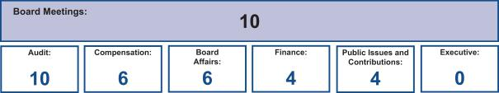

Board Affairs Committee

The Board Affairs Committee, chaired by the independent Lead Director, serves as ExxonMobil’s nominating and corporate governance committee. Its responsibilities include:

- Recommendations on director candidates and reviewing requests for participation on other boards;

- Maintaining procedures for director engagement with shareholders;

- Providing comments and suggestions to the Board on committee structure and committee assignments;

- Reviewing corporate governance practices, including the Corporate Governance Guidelines;

- Reviewing any issue involving an executive officer or director under the Code; and

- Administering ExxonMobil’s Related Person Transaction Guidelines.

30 2021 Proxy Statement

Table of Contents

The Committee also administers provisions of the Corporate Governance Guidelines that require a director to tender a resignation when there is a substantial change in the director’s circumstances. The Committee reviews the relevant facts to determine whether the director’s continued service would be appropriate and makes a recommendation to the Board.

Another responsibility of the Committee is to review and make recommendations to the Board regarding the compensation of the non-employee directors. The Committee uses an independent consultant, Pearl Meyer & Partners, LLC (Pearl Meyer), to provide information on current developments and practices in director compensation. Pearl Meyer is the same consultant retained by the Compensation Committee to advise on executive compensation, but performs no other work for ExxonMobil.

The Guidelines for the Selection of Non-Employee Directors describe the qualifications the Committee looks for in director candidates. These Selection Guidelines, as well as the Committee’s charter, are posted on the Corporate Governance section of our website.

Audit Committee

The Audit Committee oversees accounting and internal control matters. Its responsibilities include oversight of:

- Management’s conduct of the Corporation’s financial reporting process;

- The integrity of the financial statements and other financial information provided by the Corporation to the SEC and the public;

- The Corporation’s system of internal accounting and financial controls;

- The Corporation’s compliance with legal and regulatory requirements;

- The performance of the Corporation’s internal audit function;

- The independent auditors’ qualifications, performance, and independence; and

- The annual independent audit of the Corporation’s financial statements.

The Committee has direct authority and responsibility to appoint (subject to shareholder ratification), compensate, retain, and oversee the independent auditors.

The Committee also prepares the report that SEC rules require be included in the Corporation’s annual proxy statement.
The report begins on page 38.

The Audit Committee has adopted specific policies and procedures for pre-approving fees paid to the independent auditors. Under the Audit Committee’s approach, an annual program of work is approved each October for the following categories of services: Audit, Audit-Related, and Tax. Additional engagements may be brought forward from time to time for pre-approval by the Audit Committee. Pre-approvals apply to engagements within a category of service, and cannot be transferred between categories. If fees might otherwise exceed pre-approved amounts for any category of permissible services, the incremental amounts must be reviewed and pre-approved prior to commitment. The complete text of the Audit Committee’s pre-approval policies and procedures, as well as the Committee’s charter, is posted on the Corporate Governance section of ExxonMobil’s website.

The Board has determined that all members of the Committee are financially literate within the meaning of the NYSE standards, and that Ms. Burns, Mr. Hooley, Mr. Oberhelman, and Mr. Weldon are “audit committee financial experts” as defined in the SEC rules.

Compensation Committee

The Compensation Committee is comprised exclusively of non-employee, independent directors, and oversees compensation for ExxonMobil’s senior executives (including salary, bonus, and performance share awards), as well as succession planning for key executive positions. The Committee’s charter is available on the Corporate Governance section of our website.

2021 Proxy Statement | 31

Table of Contents

During 2020, the Committee took the following actions:

- Reviewed and approved the corporate goals and objectives;

- Reviewed the Corporation’s business results and progress toward strategic objectives during the year with ExxonMobil’s CEO and other senior executives;

- Reviewed the individual performance and contributions of the CEO and other senior executives;

- Discussed the Company’s executive compensation program design with its independent consultant;

- Considered the results of the 2020 advisory vote on executive compensation;

- Deliberated pay decisions based on an assessment of progress toward strategic objectives, business results, individual performance, and the results of annual benchmarking, taking into account experience in position;

- Established the aggregate annual ceiling for the 2020 long-term incentive award program and suspended the 2020 bonus program;

- Assessed each element of the Company’s compensation program and practices, and confirmed that they do not create any material adverse risks for the Company. The key design features of the compensation program that discourage executives from taking inappropriate risk are described in detail in this proxy statement (see pages 43, 56, and 57); and

- Reviewed progress on executive development and succession planning for senior-level positions with input from the CEO.

The Committee does not delegate its responsibilities with respect to ExxonMobil’s executive officers and other senior executives (currently 19 positions). For other employees, the Committee delegates authority to determine individual salaries and incentive awards to a committee consisting of the Chairman and the Senior Vice Presidents of the Corporation. That committee’s actions are subject to a salary budget and aggregate annual ceilings on incentive awards established by the Compensation Committee.

For more information on the compensation decisions made by the Committee for 2020, refer to the Compensation Discussion and Analysis beginning on page 41.

The Compensation Committee’s report is available on page 40.

The Compensation Committee utilizes the expertise of an external independent consultant, Pearl Meyer. At the direction of the Committee, Pearl Meyer:

- Attends Committee meetings;

- Informs the Committee regarding general trends in executive compensation across industries;

- Prepares the analysis of comparator company compensation used by the Committee; and

- Participates in the Committee’s deliberations regarding compensation for Named Executive Officers.

In addition, at the direction of the Chair of the Board Affairs Committee, Pearl Meyer provides an annual survey of non-employee director compensation for use by that Committee.

The Compensation Committee is solely and directly responsible for the appointment, compensation, and oversight of the consultant. The Committee considers factors that could affect Pearl Meyer’s independence, including that the consultant provides no other services for ExxonMobil other than its engagement by the Committee and the Board Affairs Committee as described above. Based on this review, the Committee has determined the consultant’s work for the Committee to be free from conflicts of interest.

Finance Committee

The Finance Committee reviews ExxonMobil’s financial policies and strategies, including our capital structure, dividends, and share purchase program. The Committee authorizes the issuance of corporate debt subject to limits set by the Board. The Committee’s charter is available on the Corporate Governance section of our website.

32 2021 Proxy Statement

Table of Contents

Public Issues and Contributions Committee

The Public Issues and Contributions Committee reviews the effectiveness of the Corporation’s policies, programs, and practices with respect to safety, security, health, the environment, including climate-related matters, and social issues. The Committee hears reports from operating units on safety and environmental activities, and also visits operating sites to observe and comment on current operating practices. In addition, the Committee reviews the level of ExxonMobil’s support for education and other public service programs, including the Company’s contributions to the ExxonMobil Foundation. The Foundation and Corporation engage in a range of philanthropic activities that advance education, with a focus on math and science in the United States, promote women as catalysts for economic development, combat malaria, and support other cultural and public service initiatives. The Committee’s charter is available on the Corporate Governance section of our website.

Executive Committee

The Executive Committee has broad power to act on behalf of the Board. In practice, the Committee meets only when it is impractical to call a meeting of the full Board.

DIRECTOR COMPENSATION

Director compensation elements are designed to:

- Ensure alignment with long-term shareholder interests;

- Ensure the Company can attract and retain outstanding director candidates who meet the selection criteria outlined in the Guidelines for the Selection of Non-Employee Directors, which can be found on the Corporate Governance section of our website;

- Recognize the substantial time commitment necessary to oversee the affairs of the Corporation; and

- Support the independence of thought and action expected of directors.

Non-employee director compensation levels are reviewed by the Board Affairs Committee each year, and resulting recommendations are presented to the full Board for approval. The Committee uses an independent consultant, Pearl Meyer, to provide information on current developments and practices in director compensation. Pearl Meyer is the same consultant retained by the Compensation Committee to advise on executive compensation, but performs no other work for ExxonMobil.

ExxonMobil employees receive no additional pay for serving as directors.

Non-employee directors receive compensation consisting of cash and equity in the form of restricted stock. Non-employee directors are also reimbursed for reasonable expenses incurred to attend Board meetings or other functions relating to their responsibilities as a director of Exxon Mobil Corporation.

The annual cash retainer for non-employee directors is $ 110,000 per year. The Chairs of the Audit and Compensation Committees receive an additional $10,000 per year. The Lead Director receives an additional $50,000 per year.

A significant portion of director compensation is granted in the form of restricted stock to align director interests with the interests of our long-term shareholders. The annual restricted stock award grant for incumbent non-employee directors is 2,500 shares. A new non-employee director receives a one-time grant of 8,000 shares of restricted stock upon first being elected to the Board.

While on the Board, the non-employee director receives the same cash dividends on restricted shares as a holder of regular common stock, but the shares remain unvested and, thus, cannot be sold or pledged. The restricted shares are subject to forfeiture if the non-employee director leaves the Board early, i.e., before the retirement age of 72, as specified for non-employee directors.

Current and former non-employee directors of Exxon Mobil Corporation are eligible to participate in the ExxonMobil Foundation’s Educational and Cultural Matching Gift Programs under the same terms as the Corporation’s U.S. employees.

2021 Proxy Statement | 33

Table of Contents

Non-Employee Director Compensation for 2020

 |  |  |  |  | Change in
 |  |  |  |  | Pension Value
 | Fees |  |  |  | and Nonqualified
 | Earned |  |  | Non-Equity | Deferred
 | or Paid | Stock | Option | Incentive Plan | Compensation | Other
 | in Cash | Awards | Awards | Compensation | Earnings | Compensation | Total
Name | ($) | ($)(c) | ($) | ($) | ($) | ($)(d) | ($)
S.K. Avery | 110,000 | 176,575 | 0 | 0 | 0 | 271 | 286,846
A.F. Braly | 110,000 | 176,575 | 0 | 0 | 0 | 271 | 286,846
U.M. Burns | 120,000 | 176,575 | 0 | 0 | 0 | 271 | 296,846
K.C. Frazier^{(a)} | 151,758 | 176,575 | 0 | 0 | 0 | 271 | 328,604
J.L. Hooley | 110,000 | 565,040 | 0 | 0 | 0 | 271 | 675,311
S.A. Kandarian | 110,000 | 176,575 | 0 | 0 | 0 | 271 | 286,846
D.R. Oberhelman | 110,000 | 176,575 | 0 | 0 | 0 | 271 | 286,846
S.J. Palmisano | 120,000 | 176,575 | 0 | 0 | 0 | 271 | 296,846
S.S Reinemund^{(b)} | 46,374 | 176,575 | 0 | 0 | 0 | 113 | 223,062
W.C. Weldon | 110,000 | 176,575 | 0 | 0 | 0 | 271 | 286,846

- Mr. Frazier served as Lead Director and received an additional annual cash retainer of $50,000 beginning March 1, 2020.

- Mr. Reinemund served as Presiding Director and received an additional annual cash retainer of $10,000 until February 29, 2020; he retired from the Board on May 27, 2020.

- In accordance with SEC rules, the valuation of stock awards in this table represents fair value on the date of grant. Dividends on stock awards are not shown in the table because those amounts are factored into the grant date fair value.

Each director received an annual grant of 2,500 restricted shares in January 2020. The valuation of these awards is based on a market price of $70.63 on the date of grant. Mr. Hooley received a one-time grant of 8,000 restricted shares in January 2020 upon joining the Board. The valuation of this grant is based on a market price of $70.63 on the date of grant.

At year-end 2020, the aggregate number of restricted shares held by each director was as follows:

Name | Restricted Shares (#)
S.K. Avery | 15,500
A.F. Braly | 18,000
U.M. Burns | 28,000
K.C. Frazier | 35,500
J.L. Hooley | 8,000
S.A. Kandarian | 13,000
D.R. Oberhelman | 20,500
S.J. Palmisano | 44,500
W.C. Weldon | 25,500

- The amount shown for each director is the cost of travel accident insurance covering death, dismemberment, or loss of sight, speech, or hearing under a policy purchased by the Corporation with a maximum benefit of $500,000 per individual.

The non-employee directors do not receive any additional payments or benefits as a result of leaving the Board or death except as described above. The non-employee directors are not entitled to any payments or benefits resulting from a change in control of the Corporation.

34 2021 Proxy Statement

Table of Contents

CERTAIN BENEFICIAL OWNERS

Based on our review of ownership reports filed with the SEC, the firms listed below are the only beneficial owners of more than 5 percent of ExxonMobil’s outstanding common stock as of December 31, 2020.

 | Aggregate
Name and Address | Beneficial
Name and Address | Ownership in | Percent of
of Beneficial Owner | Shares⁽¹⁾ | Outstanding Shares⁽¹⁾
The Vanguard Group(2) | 344,393,240 | 8.2%
100 Vanguard Blvd.
Malvern, PA 19355
BlackRock, Inc.(3) | 283,311,239 | 6.7%
55 East 52nd Street
New York, NY 10055
State Street Corporation(4) | 241,604,130 | 5.7%
One Lincoln Street
Boston, MA 02111

- The Company is permitted to rely on the information set forth in these filings and has no reason to believe that the information is incomplete or inaccurate or that the beneficial owner should have filed an amended report and did not.
- Based solely on a Schedule 13G/A filed with the Securities and Exchange Commission on February 10, 2021, The Vanguard Group reported it has shared voting power with respect to 6,708,316 shares, sole dispositive power with respect to 326,726,347 shares, and shared dispositive power with respect to 17,666,893 shares as of December 31, 2020.

- Based solely on a Schedule 13G/A filed with the Securities and Exchange Commission on February 5, 2021, Blackrock, Inc. reported that it has sole voting power with respect to 253,019,946 shares and sole dispositive power with respect to 283,311,239 shares as of December 31, 2020.

- Based solely on a Schedule 13G filed with the Securities and Exchange Commission on February 10, 2021, State Street Corporation reported that it has shared voting power with respect to 228,735,714 shares and shared dispositive power with respect to 241,539,137 shares as of December 31, 2020.

DIRECTOR AND EXECUTIVE OFFICER STOCK OWNERSHIP

These tables show the number of ExxonMobil common shares each executive named in the Summary Compensation Table on page 60 and each non-employee director or director nominee owned on January 31, 2021. In these tables, ownership means the right to direct the voting or the sale of shares, even if those rights are shared with someone else. None of these individuals owns more than 0.04 percent of the outstanding shares.

 | Shares Owned⁽¹⁾ | Shares Covered by
Named Executive Officer | Shares Owned⁽¹⁾ | Exercisable Options
D.W. Woods | 126,498 | 0
A.P. Swiger | 590,362 | 0
N.A. Chapman | 122,684⁽²⁾ | 0
J.P. Williams, Jr. | 117,105 | 0
N.W. Duffin | 340,157⁽³⁾ | 0

- Does not include unvested restricted stock units, which do not carry voting rights prior to the issuance of shares on settlement of the awards.
- Includes 37,674 shares jointly owned with spouse.

- Co-trustee and co-beneficiary with spouse in family trust for 181,626 shares.

2021 Proxy Statement | 35

Table of Contents

Non-Employee Director | Shares Owned
M.J. Angelakis | 5,792⁽¹⁾
S.K. Avery | 18,000
A.F. Braly | 22,575⁽²⁾
U.M. Burns | 30,706
K.C. Frazier | 38,000
J.L. Hooley | 10,500
S.A. Kandarian | 15,500
D.R. Oberhelman | 23,000
S.J. Palmisano | 47,000
J.W. Ubben | 1,500,000⁽³⁾
W.C. Weldon | 38,114⁽⁴⁾
W. Zulkiflee | ₀(5)

- Mr. Angelakis joined the Board on March 1, 2021 and received a one-time grant of 8,000 restricted shares on that date.

- Includes 1,175 shares owned by spouse and 900 shares held in trusts for family members for which Ms. Braly serves as co-trustee.
- Shares held by Inclusive Capital Partners Spring Master Fund, L.P., which may be deemed to be indirectly beneficially owned by Inclusive Capital Partners, L.P. Mr. Ubben is Founder, Portfolio Manager, and Managing Partner of Inclusive Capital Partners, L.P. Mr. Ubben and each of Inclusive Capital Partners, L.P. and Inclusive Capital Partners Spring Master Fund, L.P. disclaim beneficial ownership of the reported securities except to the extent of his or its pecuniary interest therein. Mr. Ubben joined the Board on March 1, 2021 and received a one-time grant of 8,000 restricted shares on that date.

- Includes 10,000 shares held by GRAT.

- Mr. Zulkiflee joined the Board on January 27, 2021 and received a one-time grant of 8,000 restricted shares on February 1, 2021.

On January 31, 2021, ExxonMobil’s incumbent directors and executive officers (26 people) together owned 3,509,595 shares of ExxonMobil stock and zero shares covered by exercisable options, representing less than 0.09 percent of the outstanding shares.

Delinquent Section 16(a) Reports

Section 16(a) of the Securities and Exchange Act of 1934 requires our executive officers and directors to file reports of their ownership and changes in ownership of ExxonMobil stock on Forms 3, 4, and 5 with the SEC. In 2020, due to a delay in internal communication, Mr. Weldon filed a Form 4 reporting two purchases. One purchase was reported three days and the other purchase was reported two days after the respective reporting due dates.

Related Person Transactions and Procedures

In accordance with SEC rules, ExxonMobil maintains Guidelines for Review of Related Person Transactions (Related Person Transaction Guidelines). These guidelines are available on the Corporate Governance section of our website.

All executive officers, directors, and director nominees are required to identify, to the best of their knowledge after reasonable inquiry, business and financial affiliations involving themselves or their immediate family members that could reasonably be expected to give rise to a reportable related person transaction. Covered persons must also advise the Secretary of the Corporation promptly of any change in the information provided, and will be asked periodically to review and reaffirm their information.

Based on this information, the Company’s own records are reviewed and follow-up inquiries are made as may be necessary to identify potentially reportable transactions. A report summarizing such transactions is then provided to the Board Affairs Committee. The Committee oversees the Related Person Transaction Guidelines generally and reviews specific items to assess materiality. A director will abstain from the decision on any transactions involving that director or his or her immediate family members.

36 2021 Proxy Statement

Table of Contents

Under SEC rules, certain transactions are deemed not to involve a material interest (including interests solely as a non-employee director). In addition, based on a consideration of ExxonMobil’s facts and circumstances, the Committee will presume that the following transactions do not involve a material interest:

- Transactions in the ordinary course of business with an entity for which a related person serves as an executive officer, provided: (1) the affected person did not participate in the decision on the part of ExxonMobil to enter into such transactions; and (2) the amount involved in any related transactions in a year is less than 1 percent of the entity’s gross revenues;

- Grants or membership payments in the ordinary course of business to nonprofit organizations, provided: (1) the affected person did not participate in the decision on the part of ExxonMobil to make such payments; and (2) the amount of grants in a year is less than 1 percent of the recipient’s gross revenues;

- Payments under ExxonMobil plans and arrangements that are available generally to U.S. salaried employees; and

- Employment by ExxonMobil of a family member of an executive officer, provided the executive officer does not participate in decisions regarding the hiring, performance evaluation, or compensation of the family member.

Transactions or relationships not covered by the above standards will be assessed by the Board Affairs Committee on the basis of the specific facts and circumstances.

Unless otherwise noted, the following disclosures are made as of February 24, 2021, which is the date of the most recent Board Affairs Committee review of potential related person transactions.

ExxonMobil and its affiliates have more than 70,000 employees around the world, and employees related by birth or marriage may be found at all levels of the organization. ExxonMobil employees do not receive preferential treatment by reason of being related to an executive officer, and executive officers do not participate in hiring, performance evaluation, or compensation decisions for family members.

Several current ExxonMobil executive officers and retirees who served as executive officers in 2020 have family members who are employed by the Corporation or its affiliates and whose current annualized compensation (including benefits) exceeds the SEC disclosure threshold of $120,000: L.D. DuCharme (President – Upstream Integrated Solutions Company) has a spouse employed by ExxonMobil Upstream Oil & Gas Company; N.A. Hansen (Vice President – Investor Relations and Secretary to March 15, 2020) has a brother-in-law employed by ExxonMobil Upstream Integrated Solutions Company; L.M. Mallon (President – ExxonMobil Upstream Oil & Gas Company) has a son employed by ExxonMobil Upstream Integrated Solutions Company; K.T. McKee (President – ExxonMobil Chemical Company) has a spouse employed by ExxonMobil Fuels & Lubricants Company; J.M. Spellings, Jr. (Vice President, Treasurer and General Tax Counsel) has a son employed by ExxonMobil Pipeline Company; A.P. Swiger (Senior Vice President – Exxon Mobil Corporation) has a daughter-in-law employed by Exxon Mobil Corporation; and T.J. Wojnar, Jr. (Vice President – Corporate Strategic Planning) has a son-in-law employed by ExxonMobil Fuels & Lubricants Company. Each employee mentioned above received total cash compensation in 2020 between $138,625 and $445,500. Pay earned was comparable to that of employees in similar positions. All are eligible to participate in employee benefit programs on the same basis as other eligible employees. Consistent with ExxonMobil’s guidelines described above, these relationships are not considered to be material within the related person transaction rules.

R.M. Ebner (retired former Vice President and General Counsel) has a brother-in-law who is a partner of a law firm that performs limited work for ExxonMobil. Mr. Ebner’s brother-in-law does not work on ExxonMobil’s account and, during his tenure, Mr. Ebner recused himself from any involvement in decisions to retain the firm. Therefore, this relationship is not considered to be material within the meaning of the related person transaction disclosure rules.

The Board Affairs Committee also reviewed ExxonMobil’s ordinary course business with companies for which non-employee directors or their immediate family members serve as executive officers. The Committee determined that, in accordance with the categorical standards described above, none of those matters represent reportable related person transactions. See Director Independence on page 25.

2021 Proxy Statement | 37

Table of Contents

The Committee also determined that no related person transactions occurred during the year involving any of the investors who have reported ownership of more than 5 percent of ExxonMobil’s outstanding common stock. See Certain Beneficial Owners on page 35.

ExxonMobil is not aware of any related person transactions required to be reported under applicable SEC rules since the beginning of the last fiscal year where our policies and procedures did not require review, or where such policies and procedures were not followed.

AUDIT COMMITTEE REPORT

The primary function of the Audit Committee is oversight of the Corporation’s financial reporting process, public financial reports, internal accounting and financial controls, and the independent audit of the annual consolidated financial statements. The Committee acts under a charter which can be found on the ExxonMobil website at exxonmobil.com/auditcommitteecharter. The adequacy of the charter is reviewed at least annually. All members of the Audit Committee are independent directors, and the Committee met 10 times in 2020. In these meetings, as discussed in more detail below, it had extensive reports and discussions with the independent auditors, internal auditors, and members of management.

In performing its oversight function, the Committee reviewed and discussed the consolidated financial statements with management and PricewaterhouseCoopers LLP (PwC), the independent auditors. Management and PwC indicated that the Corporation’s consolidated financial statements were fairly stated in accordance with generally accepted accounting principles. The Committee discussed significant accounting policies applied by the Corporation in its financial statements, as well as alternative treatments. It also discussed with PwC matters covered by Public Company Accounting Oversight Board (PCAOB) standards and the Commission, including PCAOB AS 1301 Communication with Audit Committees. In addition, the Committee reviewed and discussed management’s report on internal control over financial reporting and the related audits performed by PwC, which confirmed the effectiveness of the Corporation’s internal control over financial reporting.

The Audit Committee also reviewed the written disclosure and the letter from PwC required by the PCAOB rules regarding PwC’s communications with the Audit Committee concerning independence, and has discussed with PwC its independence from the Corporation and management. The Committee considered the non-audit services provided by PwC to the Corporation, and concluded that the auditors’ independence has been maintained.

The Committee discussed with the Corporation’s internal auditors and PwC the overall scope and plans for their respective audits; furthermore, it met with the internal auditors and PwC at each meeting, both with and without management present. Discussions included the results of their examinations, their evaluations of the Corporation’s internal controls, and the overall quality of the Corporation’s financial reporting.

The Audit Committee met with the Corporation’s management to discuss the comprehensive, long-standing risk management and compliance processes of the Corporation, and reviewed several topics of interest.

Based on the reviews and discussions referred to above, in reliance on management and PwC, and subject to the limitations of its role described below, the Audit Committee recommended to the Board, and the Board approved, the inclusion of the audited financial statements in the Corporation’s Annual Report on Form 10-K for the year ended December 31, 2020, for filing with the SEC.

In carrying out its responsibilities, the Audit Committee looks to management and the independent auditors. Management is responsible for the preparation and fair presentation of the Corporation’s financial statements and for maintaining effective internal control. Management is also responsible for assessing and maintaining the effectiveness of internal control over the financial reporting process in compliance with Sarbanes-Oxley Section 404 requirements. The independent auditors are responsible for auditing the Corporation’s annual financial statements, and expressing an opinion as to whether the statements are fairly stated in conformity with generally accepted accounting principles. In addition, the independent auditors are responsible for auditing the Corporation’s internal control over financial reporting and for expressing an opinion on the effectiveness of internal control over financial reporting. The independent auditors perform their responsibilities in accordance with the standards of the PCAOB. Audit Committee members are not professionally engaged in the practice of accounting or auditing, and are not experts under the Securities Act of 1933 in either of those fields or in auditor independence.

The Audit Committee has also appointed PwC to audit the Corporation’s financial statements for 2020, subject to shareholder ratification of that appointment. The Committee, along with the other members of the Board,

38 2021 Proxy Statement

Table of Contents

management, the Controller, and the General Auditor, annually evaluates PwC’s qualifications, performance and independence, including the performance of the lead audit partner, in deciding whether or not to retain PwC. That evaluation includes consideration of:

- PwC’s quality control, including any material issues identified by that quality control or a governmental/professional authority along with PwC’s plan to deal with any such issues;

- All relationships between PwC and ExxonMobil covered by the PCAOB;

- PwC’s expertise in the global oil and gas industry; and

- The quality of PwC’s audit plans.

The Committee believes that PwC’s tenure as ExxonMobil’s independent registered public accounting firm is a benefit to audit quality given PwC’s experience with ExxonMobil and knowledge of the business, as well as the effectiveness of their audit plans, which build on that established knowledge.

Based on its annual evaluation of PwC’s qualifications, performance, and independence, as well as frequent private meetings with the lead partner, the Audit Committee believes that the continued retention of PwC as ExxonMobil’s independent registered public accounting firm is in the best interest of the Corporation and its stockholders.

Ursula M. Burns, Chair

Joseph L. Hooley

Douglas R. Oberhelman
William C. Weldon

Item 2 – Ratification of Independent Auditors

The Audit Committee has appointed PricewaterhouseCoopers LLP to audit ExxonMobil’s financial statements for 2021.
We are asking you to ratify that appointment.

Total Fees

The total fees for PwC professional services rendered to ExxonMobil for the year ended December 31, 2020, were $41.8 million, a decrease of $0.7 million from 2019. The Audit Committee reviewed and pre-approved all services in accordance with the service pre-approval policies and procedures, which can be found on the ExxonMobil website at exxonmobil.com/pre-approval. The Audit Committee did not use the “de minimis” exception to pre-approval that is available under SEC rules. The following table summarizes the fees, which are described in more detail below.

 | 2020 |  |  | 2019
 |  |  | (millions of dollars)
Audit Fees | 35.9 |  |  | 34.6
Audit-Related Fees | 4.7 |  |  | 6.9
Tax Fees | 1.2 |  |  | 1.0
All Other Fees |  |  | — |  | —
Total | 41.8 |  |  | 42.5

Audit Fees

The aggregate fees for PwC professional services rendered for the annual audits of ExxonMobil’s financial statements for the year ended December 31, 2020, and for the reviews of the financial statements included in our quarterly reports on Form 10-Q for that year were $35.9 million (versus $34.6 million for 2019).

Audit-Related Fees

The aggregate fees for PwC Audit-Related services rendered to ExxonMobil for the year ended December 31, 2020, were $4.7 million (versus $6.9 million for 2019). Audit-related services were mainly related to benefit plan audits and other attestation procedures.

2021 Proxy Statement | 39

Table of Contents

Tax Fees

The aggregate fees for PwC Tax services rendered to ExxonMobil for the year ended December 31, 2020, were
$1.2 million (versus $1.0 million for 2019). These services were mainly related to assisting various ExxonMobil affiliates with the preparation of local tax filings and related services.

All Other Fees

The aggregate fees for PwC services rendered to ExxonMobil, other than the services described above under “Audit Fees,” “Audit-Related Fees,” and “Tax Fees,” for the year ended December 31, 2020, were zero (also zero for 2019).

We believe PwC is well qualified to perform this work. A PwC representative will be at the annual meeting to answer appropriate questions and to make a statement if desired.

The Audit Committee recommends you vote FOR this proposal.

COMPENSATION COMMITTEE REPORT

The Compensation Committee of the Board of Directors has reviewed and discussed the Compensation Discussion and Analysis with management of the Corporation. Based on that review and discussion, we recommended to the Board that the Compensation Discussion and Analysis be included in the Corporation’s proxy statement for the 2021 annual meeting of shareholders, and also incorporated by reference in the Corporation’s Annual Report on Form 10-K for the year ended December 31, 2020.

Samuel J. Palmisano, Chair

Kenneth C. Frazier

Angela F. Braly
Steven A. Kandarian

Item 3 – Advisory Vote to Approve Executive Compensation

At the meeting, shareholders will be asked to vote on a non-binding resolution to approve the compensation of the Named Executive Officers (NEOs), listed in the Summary Compensation Table.

When casting your vote, we encourage you to consider the detailed information in the Compensation Discussion and Analysis beginning on page 41.

The Board continues to support the overall design of the compensation program, on the basis that the program:

- Is aligned with the Company’s business model and shareholder returns over the long term;

- Delivers pay that is highly performance based and tied to company and individual performance; and

- Enables the Compensation Committee to leverage its experience and judgment to deliver market competitive pay.

We continue to listen and respond to the feedback we receive from shareholders during our shareholder engagement process. As in previous years, we enhanced disclosures in response to shareholder feedback.

The Board recommends an advisory vote FOR the following resolution:

RESOLVED: That shareholders approve the compensation of the Named Executive Officers as disclosed pursuant to Item 402 of SEC Regulation S-K, including the Compensation Discussion and Analysis, compensation tables, and narrative discussion on pages 41 to 68 of this proxy statement.

40 2021 Proxy Statement

Table of Contents
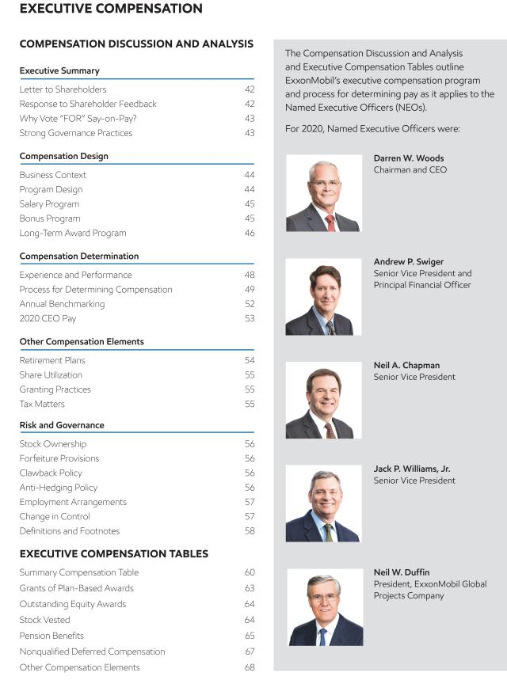

2021 Proxy Statement | 41

Table of Contents
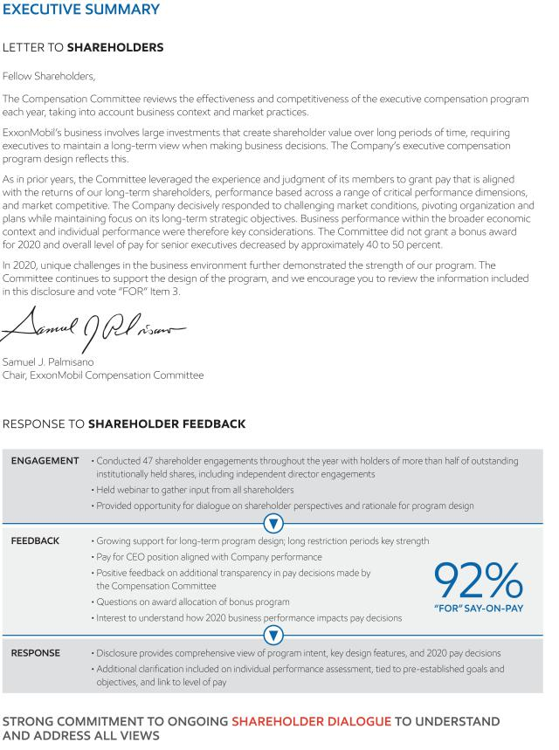

42 2021 Proxy Statement

Table of Contents
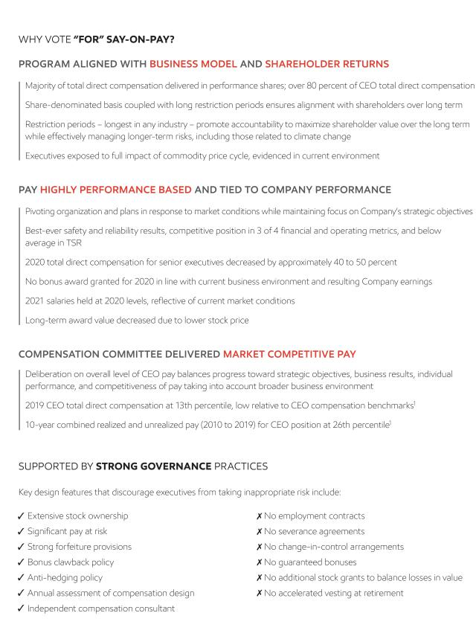

2021 Proxy Statement | 43

Table of Contents
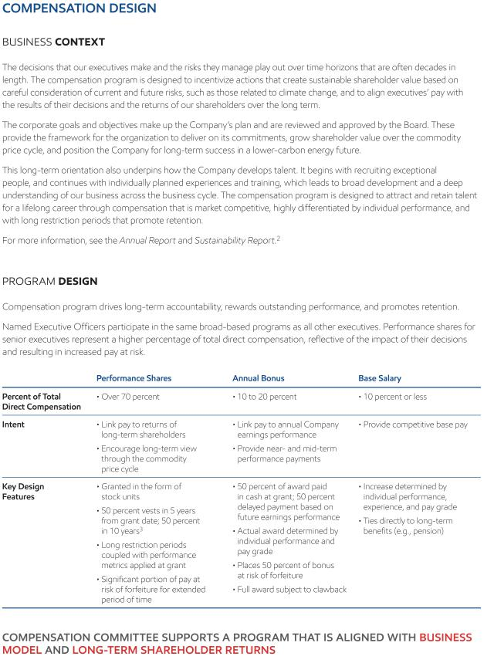

44 2021 Proxy Statement

Table of Contents
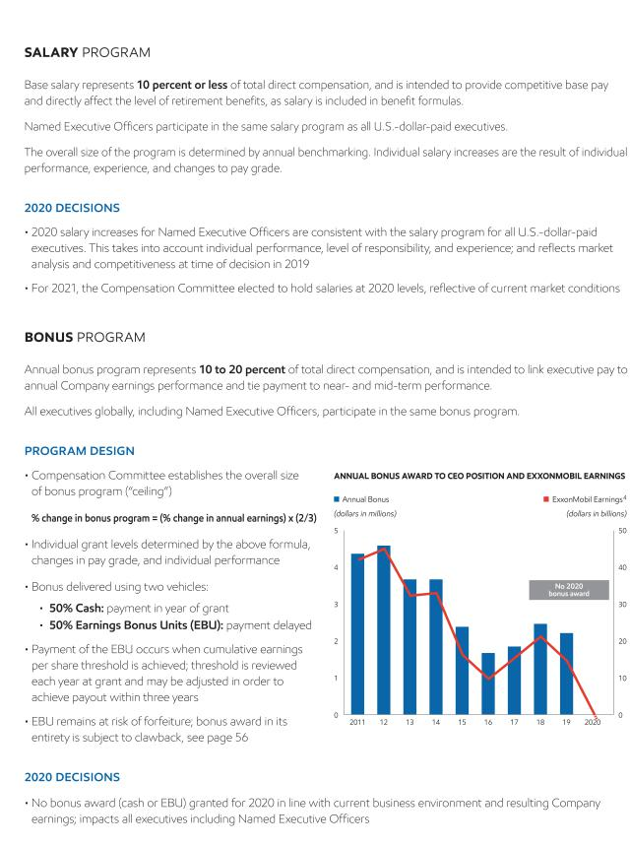

2021 Proxy Statement | 45

Table of Contents
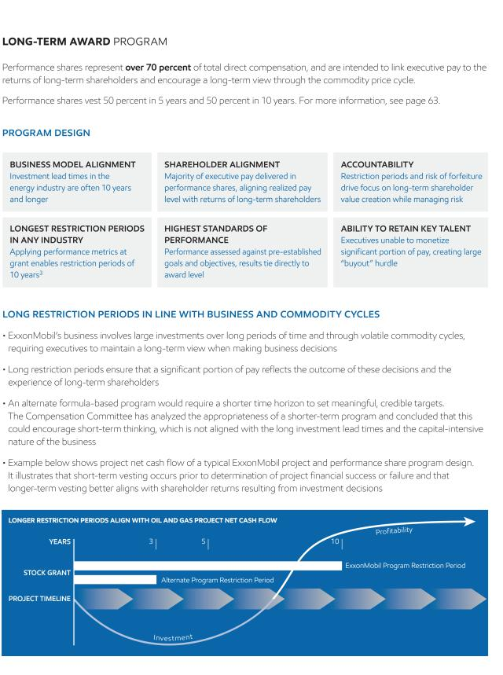

46 2021 Proxy Statement

Table of Contents
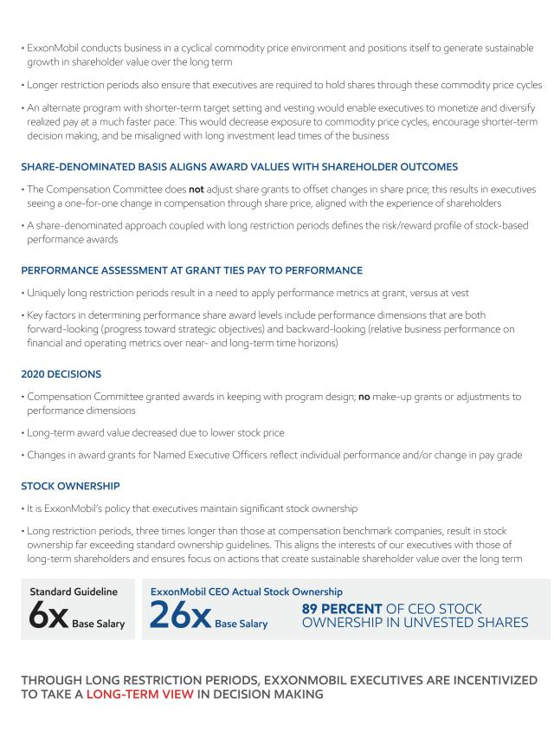

2021 Proxy Statement | 47

Table of Contents
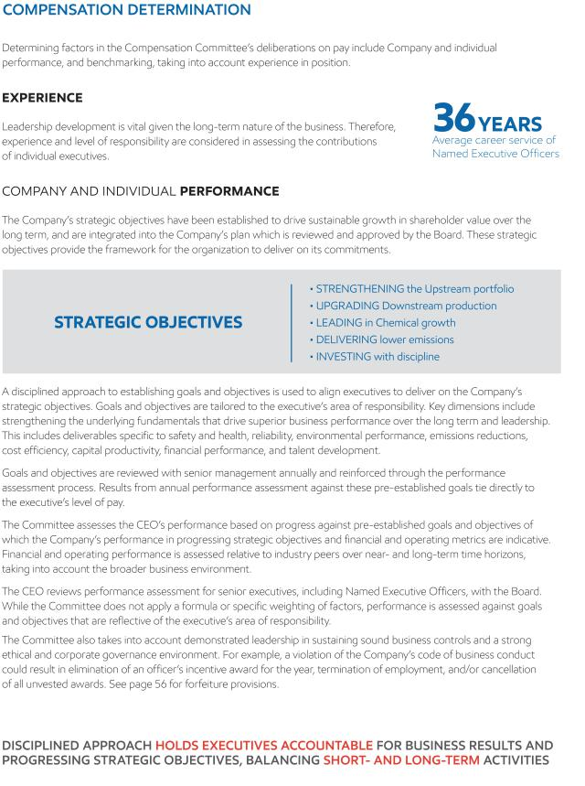

48 2021 Proxy Statement

Table of Contents
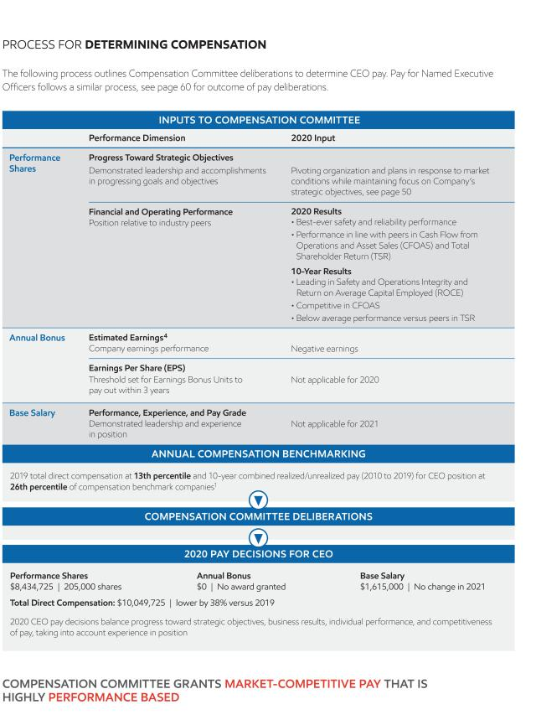

2021 Proxy Statement | 49

Table of Contents
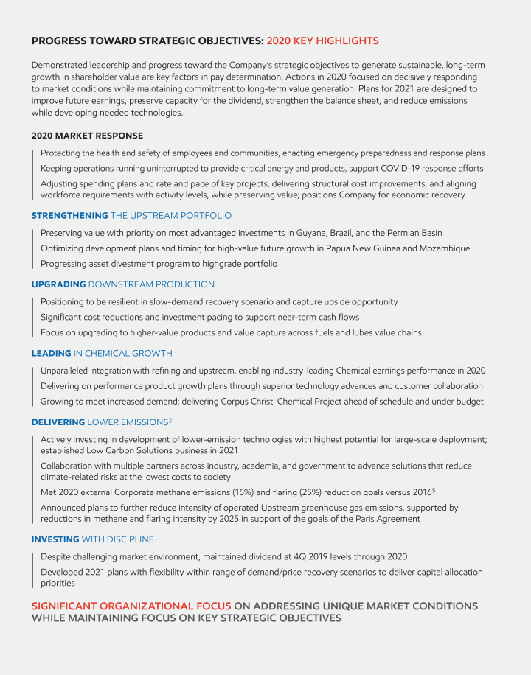

50 2021 Proxy Statement

Table of Contents
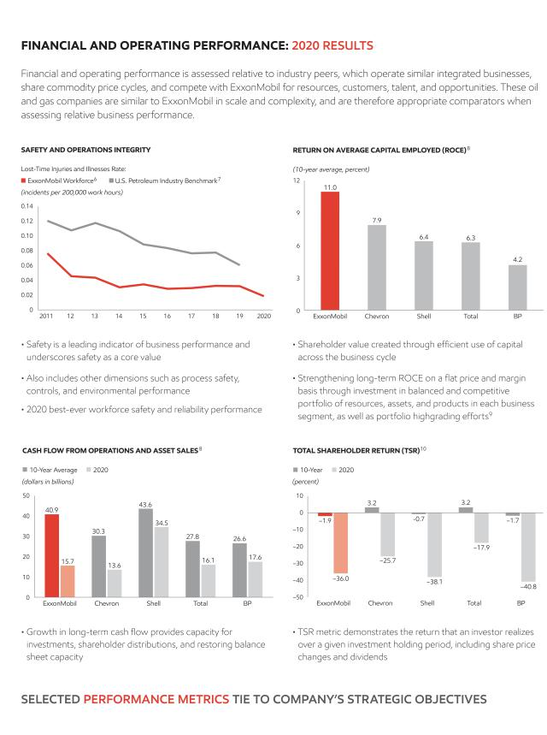

2021 Proxy Statement | 51

Table of Contents
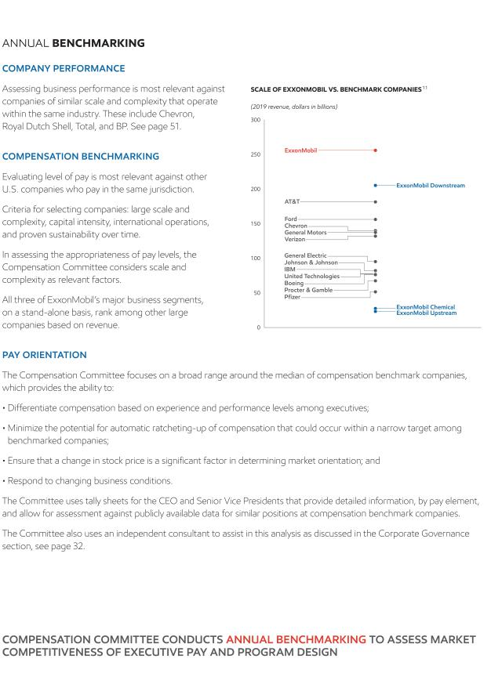

52 2021 Proxy Statement

Table of Contents
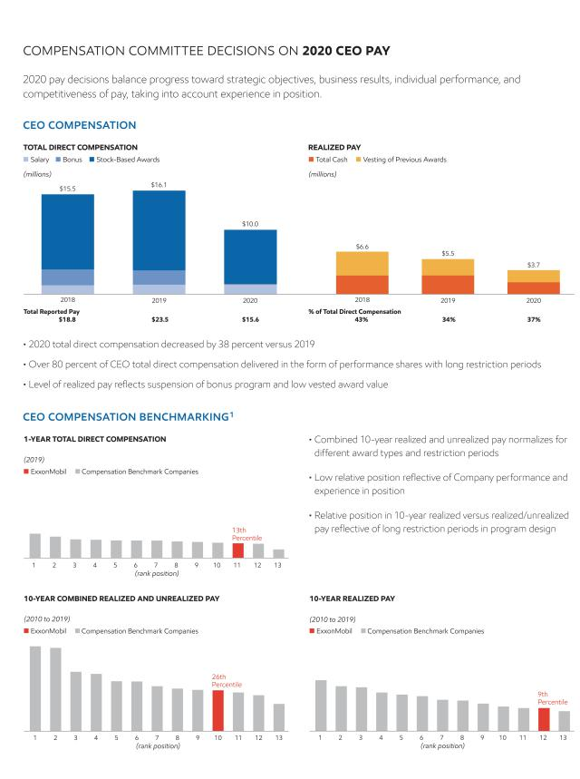

2021 Proxy Statement | 53

Table of Contents
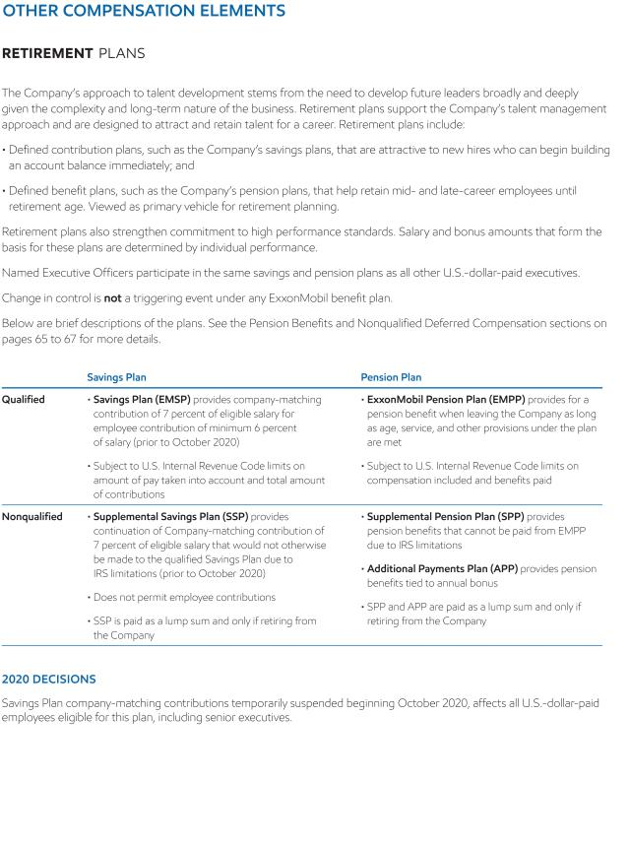

54 2021 Proxy Statement

Table of Contents
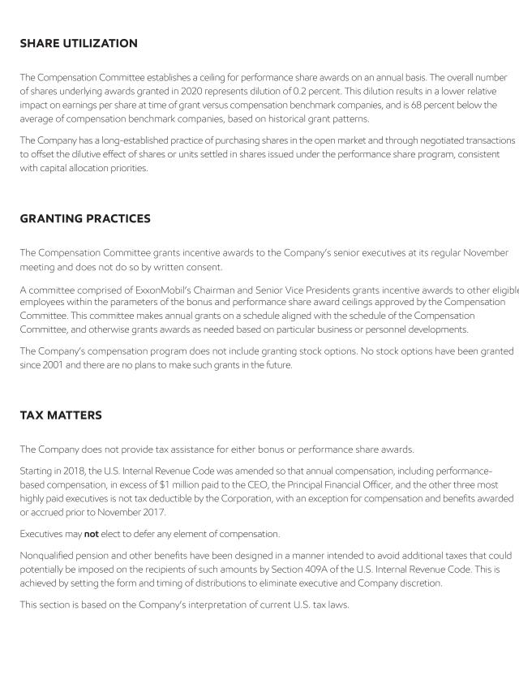

2021 Proxy Statement | 55

Table of Contents
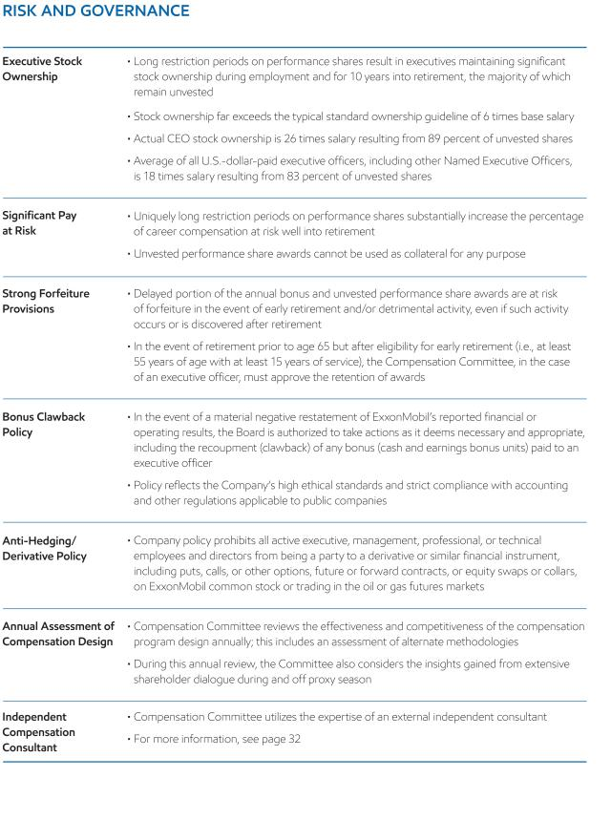

56 2021 Proxy Statement

Table of Contents
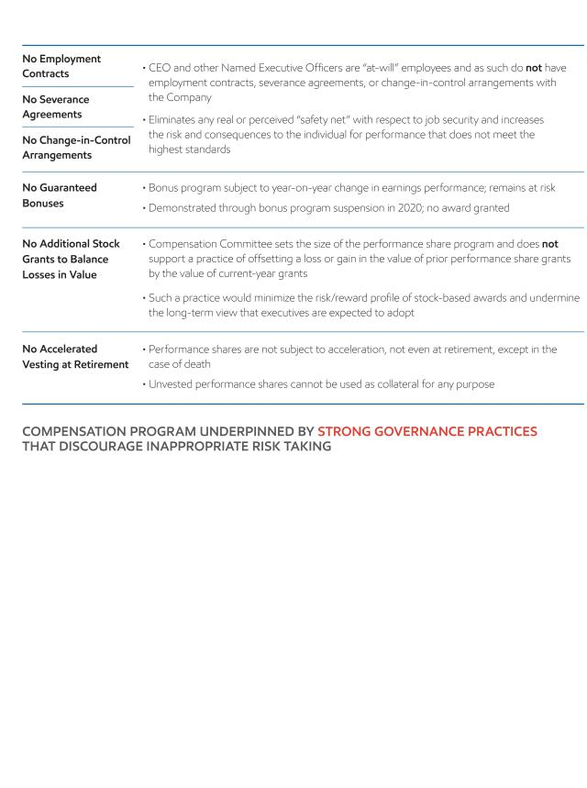

2021 Proxy Statement | 57

Table of Contents
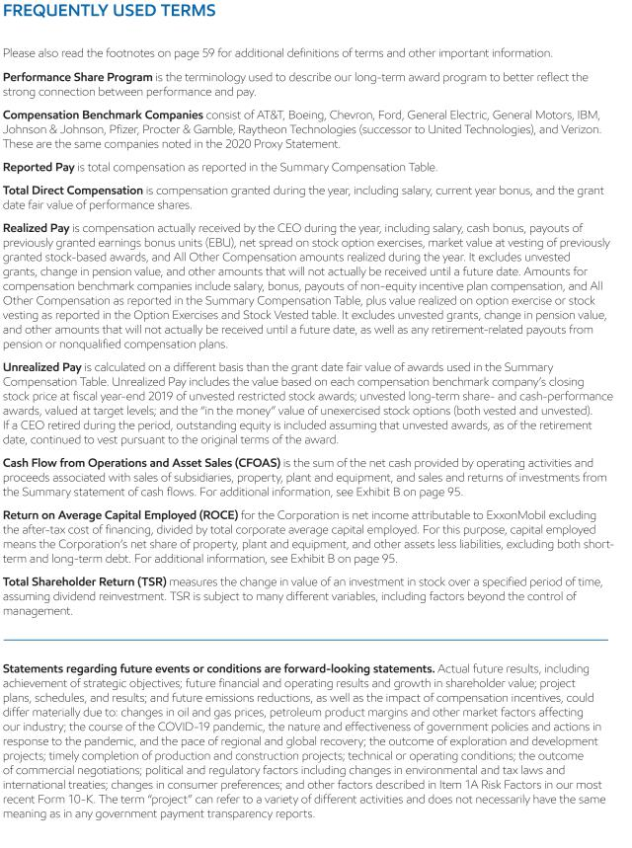

58 2021 Proxy Statement

Table of Contents
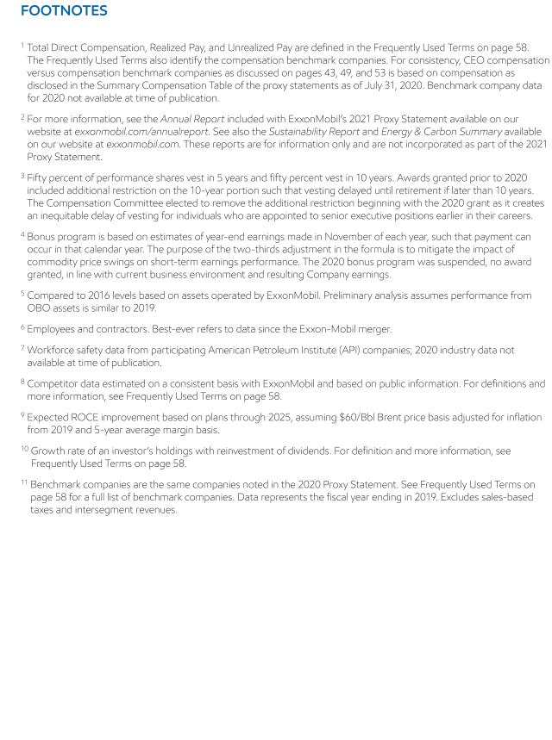

2021 Proxy Statement | 59

Table of Contents
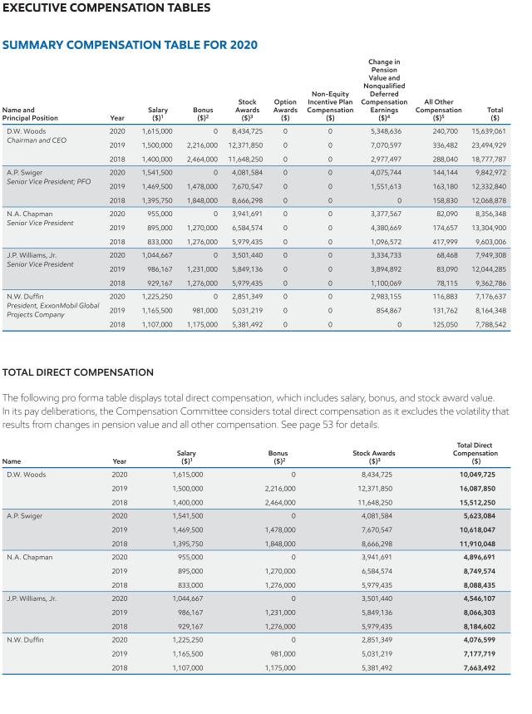

60 2021 Proxy Statement

Table of Contents
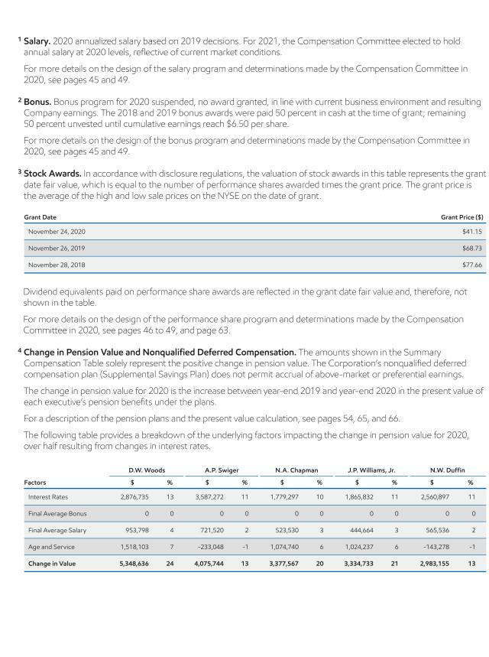

2021 Proxy Statement | 61

Table of Contents
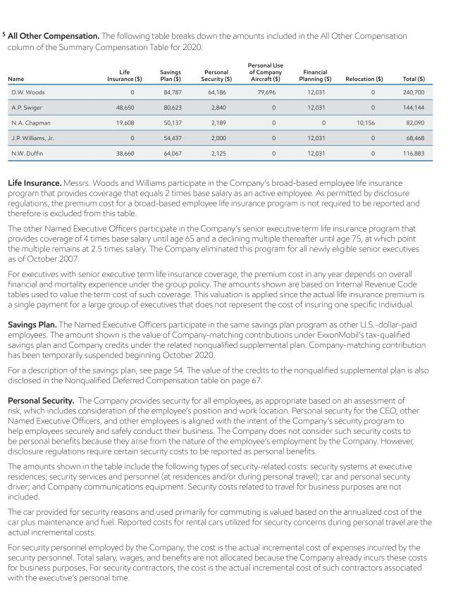

62 2021 Proxy Statement

Table of Contents
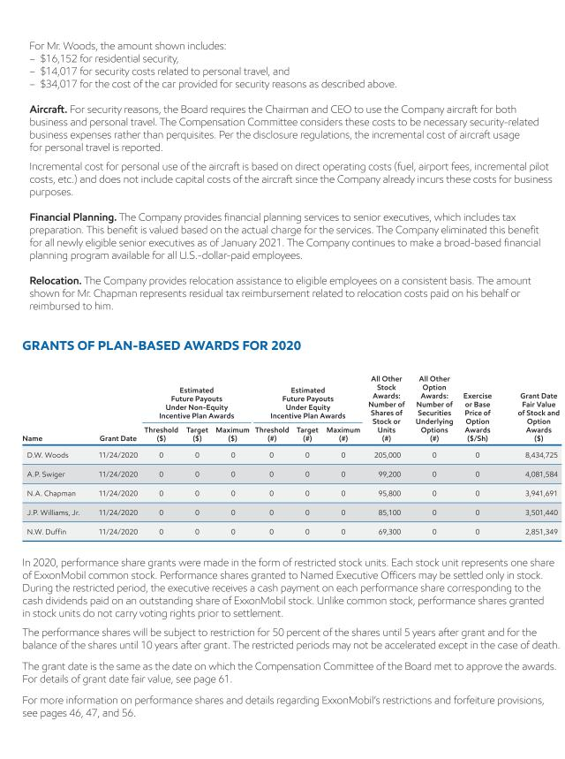

2021 Proxy Statement | 63

Table of Contents
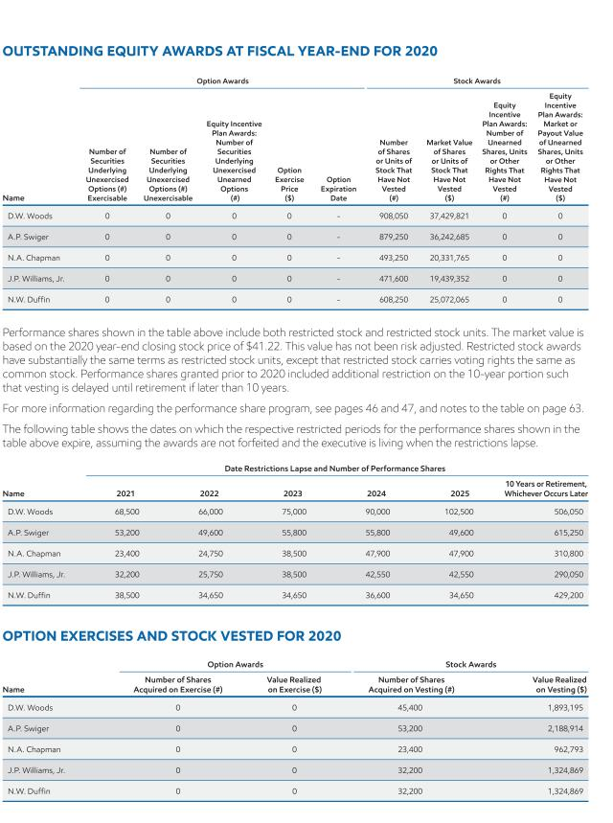

64 2021 Proxy Statement

Table of Contents
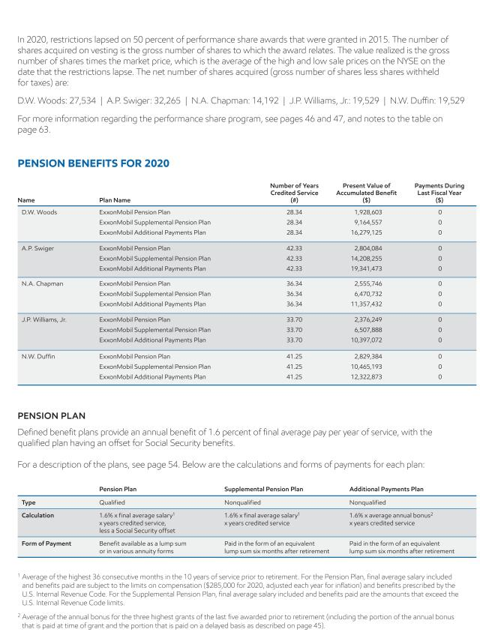

2021 Proxy Statement | 65

Table of Contents

66 2021 Proxy Statement

Table of Contents
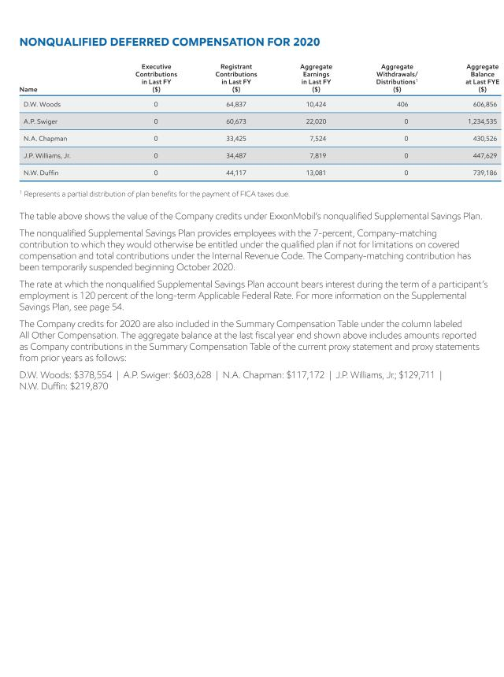

2021 Proxy Statement | 67

Table of Contents
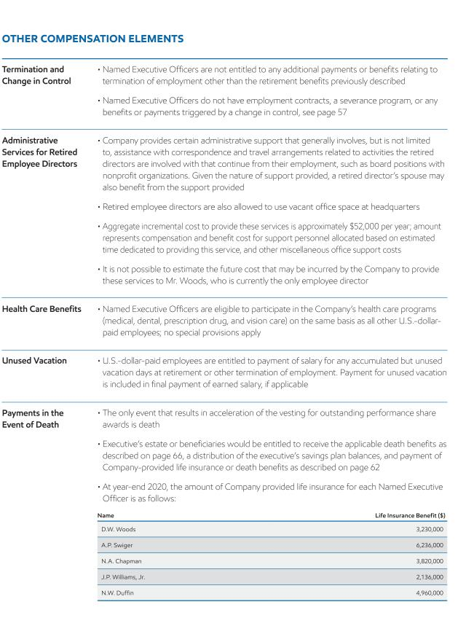

68 2021 Proxy Statement

Table of Contents

SHAREHOLDER PROPOSALS

We expect Items 4 through 10 to be presented by shareholders at the annual meeting. Following SEC rules, other than minor formatting changes, we are reprinting the proposals and supporting statements as they were submitted to us. We take no responsibility for them. Upon oral or written request to the Secretary at the address listed under Contact Information on page 8, we will provide information about the sponsors’ shareholdings, as well as the names, addresses, and shareholdings of any co-sponsors.

The Board recommends you vote AGAINST Items 4 through 10 on the BLUE proxy card for the reasons we give after each one.

Item 4 – Independent Chairman

This proposal was submitted by Olga Monks Pertzoff Trust 1945, 111 Commercial Street, Suite 302, Portland, ME 04101, the beneficial owner of 400 shares and lead proponent of a filing group.

“RESOLVED: The shareholders request the Board of Directors to adopt as policy, and amend the bylaws as necessary, to require the Chair of the Board of Directors, whenever possible, to be an independent member of the Board. This policy would be phased in for the next CEO transition.

If the Board determines that a Chair who was independent when selected is no longer independent, the
Board shall select a new Chair who satisfies the requirements of the policy within a reasonable amount of time.

Compliance with this policy is waived if no independent director is available and willing to serve as Chair.

Supporting Statement:

We believe:

- The role of the CEO and management is to run the company.

- The role of the Board of Directors is to provide independent oversight of management and the CEO.

- There is a potential conflict of interest for a CEO to be her/his own overseer as Chair while managing the business.

Exxon Mobil’s CEO Darren Woods serves both as CEO and Chair of the Company’s Board of Directors.
We believe the combination of these two roles in a single person weakens a corporation’s governance structure.

Chairing and overseeing the Board is a time intensive responsibility. A separate independent Chair also frees the CEO to manage the company and build effective business strategies.

As Andrew Grove, Intel’s former chair, stated, ‘The separation of the two jobs goes to the heart of the conception of a corporation. Is a company a sandbox for the CEO, or is the CEO an employee? If he’s an employee, he needs a boss, and that boss is the Board. The Chairman runs the Board. How can the CEO be his own boss?’

In our view, shareholders are best served by a separate independent Board Chair who provides a balance of power between the CEO and the Board. The primary duty of a Board of Directors is to oversee the management of a company on behalf of shareholders. A combined CEO / Chair creates a potential conflict of interest, resulting in excessive management influence on the Board and weaker oversight of management.

Numerous institutional investors recommend separation of these two roles and the number of companies separating these roles is growing.

With the unprecedented climate change challenges facing global energy companies as they face important transitions to a low carbon economy, it is important to ensure our company’s governance is the best it can be, and the board is

2021 Proxy Statement | 69

Table of Contents

empowered to provide strong direction and leadership. Exxon Mobil and the industry faces numerous and significant climate related challenges from decisions about developing new oil and gas fields for the market to revising its climate related lobbying.

This resolution to Exxon Mobil received a vote in support of approximately 41% in 2019 and 33% in 2020, a significant showing. To simplify the transition, this new policy would be phased in when a next CEO is chosen.”

The Board recommends you vote AGAINST this proposal for the following reasons:

A strong, independent Board responsible for oversight of management, including the CEO, is important to effectively represent the interests of shareholders. The Board, however, does not agree that separating the Chairman and CEO positions in all cases, and relinquishing the Board’s authority and flexibility to choose the best leadership structure, would be in the best interest of shareholders or improve its ability to provide effective oversight.

The Board regularly and carefully considers the merits of separating or combining the Chair and CEO positions, including whether an independent director should hold the Chairmanship, especially when a CEO change occurs. The Board believes it is important to preserve the flexibility to implement the leadership structure that will best serve the long-term interests of shareholders. Adoption of a singular approach without the flexibility to adapt to company-specific circumstances would compromise the Board’s ability to assess and implement the optimal oversight framework.

The Board believes having the current Chairman and CEO roles combined results in significant benefits for shareholders. At present, the combined Chairman and CEO role ensures items of greatest importance for the business are brought to the attention of, and reviewed by, the Board on a timely basis. As new issues arise, market dynamics change or risk exposures evolve, the Chairman/CEO is best positioned, with deep Company knowledge and industry experience, to highlight those issues with the Board, ensuring appropriate oversight and discussion.

To ensure independent oversight of management, the Board is comprised entirely of independent directors, with the exception of the CEO. Each independent director has access to the CEO and other Company executives and employees. Independent directors are empowered to call meetings of the independent directors, and request additional agenda topics at meetings of the full Board or committees.

To further strengthen oversight, the independent members of the Board elect a director to serve as Lead Director. The Lead Director must be independent and has specific authority and broad oversight responsibilities that were further strengthened in 2020 to include:

- Calling, chairing and setting the agenda for executive sessions of the non-employee directors;

- Providing feedback to the Chairman;

- Chairing meetings of the Board in the absence of the Chairman;

- Reviewing and approving the schedule and agenda for all Board meetings and reviewing associated materials distributed to the directors, in consultation with the Chairman;

- Advising the Chairman on the quality, quantity, and timeliness of information flow;

- Reviewing committee meeting schedules;

- Engaging with shareholders, as appropriate; and

- Leading the annual performance evaluation of the Board.

The Lead Director also concurrently serves as Chair of the Board Affairs Committee, which is comprised entirely of independent directors, to direct other key activities including:

- Establishing the criteria for director engagement with shareholders;

- Providing comments and suggestions to the Board on Board committee structure, committee operations, committee member qualifications, and committee member appointment;

70 2021 Proxy Statement

Table of Contents

- Overseeing independent director succession planning and remuneration;

- Reviewing the service of independent directors on boards of other companies, including requests to accept a seat on any additional company board;

- Establishing and maintaining procedures for interested parties to communicate with independent directors;

- Considering Board governance practices and procedures including any changes to governance guidelines; and

- Providing oversight of the performance and effectiveness of the annual evaluation process for the Board and its committees.

The Board’s Compensation Committee independently reviews CEO performance and compensation and conducts a review with the full Board, absent the Chairman.

Working with the Compensation Committee, the Lead Director oversees the annual evaluation of the CEO, communicates feedback to the CEO, and reviews CEO succession plans.

Our independent Lead Director also leads the Board in its oversight of the Company’s response to critical issues. For example: in 2020, the Lead Director provided oversight of management responses to the COVID-19 pandemic. This included a series of actions that helped protect employees and communities in which ExxonMobil works, and reconfigured operations and processes to provide critical products, supplies and fuel, to frontline workers and first responders around the world.

Importantly, only a minority of S&P 500 companies have adopted an independent chairman. This was evidenced in the 2020 Spencer Stuart Board Index report, which examines the latest data and trends among the S&P 500 for board composition, governance practices, and director compensation. This report noted that only a third of S&P 500 boards have a chairman that meets the New York Stock Exchange rules for independence.

To ensure continuation of the significant benefits of a combined Chairman/CEO role and preserve the Board’s authority and flexibility to determine the appropriate leadership and oversight structure, shareholders should reject this proposal.

Item 5 – Special Shareholder Meetings

This proposal was submitted by Kenneth Steiner, 14 Stoner Ave., 2M, Great Neck, NY 11021, the beneficial owner of 500 shares.

“Proposal 5 – Special Shareholder Meeting Improvement

Shareholders ask our board to take the steps necessary to amend the appropriate company governing documents to give the owners of a combined 10% of our outstanding common stock the power to call a special shareholder meeting without the need to get court approval.

A special shareholder meeting is a means shareholders can use to raise important matters outside the normal annual meeting cycle like the election of a new director.

For instance Mr. Kenneth Frazier, Merck Chair-CEO and Exxon Lead Director, was rejected by our 438 million votes in 2020. Having a Chair-CEO of another company as a Lead Director at XOM is like having a union boss set the pay of hourly workers. And Ms. Angela Braly was rejected by our 409 million votes. It has been almost a decade since Ms. Braly 59 last worked at Anthem.

And since the 2020 Exxon annual meeting there has been a dramatic development that makes shareholder meetings so much easier for management with a substantial cost reduction – the avalanche of bare bones online shareholder meetings.

2021 Proxy Statement | 71

Table of Contents

Management entrenchment is so well defended at an online shareholder meeting that shareholders should have a corresponding greater flexibility in calling for a special shareholder meeting.

It is astounding what management can get away with at a non-transparent online shareholder meeting. At a bare bones online shareholder meeting almost everything is optional. For instance a few words from management on the state of the company is optional. Also management answers to shareholder questions are optional even if management asks for questions.

Management hardly needs to prepare for an online shareholder meeting. Thus shareholders should rightfully have more flexibility in requesting a special shareholder meeting. The core purpose of such a meeting can simply be the announcement of the vote.

For instance the Goodyear online shareholder meeting was spoiled by a trigger-happy management mute button for shareholders that was used to quash constructive criticism. AT&T, with 3000 institutional shareholders, would not even allow shareholders to speak at its online shareholder meeting. Shareholders are so restricted in online meetings that management will never want a return to a much more transparent in-person shareholder meeting format.

Please see:

Goodyear’s virtual meeting creates issues with shareholder https://www.crainscleveland.com/manufacturing/goodyears-virtual-meeting-creates-issues-shareholder

Please see:

AT&T investors denied a dial-in as annual meeting goes online https://whbl.com/2020/04/17/att-investors-denied-a-dial-in-as-annual-meeting-goes-online/1007928/

Shareholders thus need greater flexibility in calling for a special shareholder meeting without the need to get court approval.

Please vote yes:

Special Shareholder Meeting Improvement – Proposal 5”

The Board recommends you vote AGAINST this proposal for the following reasons:

The Board believes it is important for shareholders to have the right to call a special shareholder meeting, a right that ExxonMobil recently expanded in response to shareholder requests. With the enhancements, ExxonMobil shareholders are able to call a special meeting in two ways. Shareholders holding at least 15 percent of shares outstanding can call a special meeting. Alternatively, under New Jersey law, shareholders holding at least 10 percent of outstanding stock may call a special meeting upon a court order showing good cause.

In addition to this right, shareholder interests are protected by a strong, independent Board responsible for the oversight of management, including the CEO. Effective leadership is also provided by an independent Lead Director with expansive oversight authorities and responsibilities. In each of the last six years, shareholders recognized the strong leadership and independence of the Board with an average vote in favor of all directors of more than 93 percent.

ExxonMobil’s by-laws enable shareholders of at least 15 percent of common stock outstanding to call a special meeting, which provides a meaningful and more advantageous shareholder right than most large publicly traded companies. The most common threshold among S&P 500 companies is 25 percent.

Therefore, the Board believes this proposal is unnecessary.

72 2021 Proxy Statement

Table of Contents

Item 6 – Report on Scenario Analysis

This proposal was submitted by Christian Brothers Investment Services, Inc., 125 S. Wacker Drive, Suite 2400, Chicago, IL 60606, the beneficial owner of shares with a market value greater than $2,000 and lead proponent of a filing group.

“WHEREAS:

- As evidence of the severe impacts from climate change mounts, policy makers, companies, and financial bodies are increasingly focused on the economic impacts1 from driving greenhouse gas (GHG) emissions to well-below 2 degrees Celsius below pre-industrial levels (including 1.5° C ambitions), as outlined in the Paris Agreement;

- This focus has led many ExxonMobil peers (including BP, Eni, Equinor, Repsol, Royal Dutch Shell, and Total) to commit to major GHG reductions, including setting ‘net zero emission’ goals by 2050;2 3

- Investors are also calling for high-emitting companies to test their financial assumptions and resiliency against substantial reduced-demand climate scenarios,4 and to provide investors insights about the potential impact on their financial statements;5 6 7

- As of November 2020, ExxonMobil had neither committed to net-zero emissions by 2050 across its value chain, nor disclosed how its financial assumptions would change from doing so;

- In contrast, the audit reports for other high GHG-emitting companies clearly discussed this connection:

- BP: how climate change and a global energy transition impacted the capitalization of exploration and appraisal costs and risks that oil and gas price assumptions could lead to financial misstatements;

- Shell: how long-term price assumptions impacted by climate change could affect asset values and impairment estimates;

- National Grid: noted estimates inconsistent with 2050 ‘net zero’ commitments;

- Additionally, in 2020, BP, Shell and Total reviewed their 2019 financial accounting practices in light of the accelerating low-carbon energy transition. All three subsequently adjusted critical accounting assumptions, resulting in material impairments, and disclosed how climate change affected the adjustments;

- In October 2020, the International Energy Agency (IEA) issued a new ‘Net Zero 2050’ scenario which describes what it would mean for the energy sector globally to reach net-zero GHG emissions by 2050. This more aggressive global action to curtail climate change is consistent with a 1.5°C temperature increase globally.8

RESOLVED: Shareholders request that ExxonMobil’s Board of Directors issue an audited report to shareholders on whether and how a significant reduction in fossil fuel demand, envisioned in the IEA Net Zero 2050 scenario, would affect its financial position and underlying assumptions. The Board should summarize its findings to shareholders by January 31, 2022, and the report should be completed at reasonable cost and omitting proprietary information.

SUPPORTING STATEMENT: Proponents recommend that in issuing the report, the company take account of information on:

- Assumptions, costs, estimates, and valuations that may be materially impacted; and

- The potential for widespread adoption of net-zero goals by governments and peers.9

Proponents recommend that the report be supported by reasonable assurance from an independent auditor.”

- https://www.cftc.gov/sites/default/files/2020-09/9-9-20%20Report%20of%20the%20Subcommittee%20on%20Climate-Related%20Market%20Risk%20-%20Managing%20Climate%20Risk%20in%20the%20U.S.%20Financial%20

- https://www.reuters.com/article/climate-change-carbon-targets/factbox-big-oils-climate-targets-idUSL8N2HO1B4

2021 Proxy Statement | 73

Table of Contents

- https://carbontracker.org/reports/fault-lines/
- https://www.iigcc.org/news/investor-groups-call-on-companies-to-reflect-climate-related-risks-in-financial-reporting/
- https://www.unpri.org/sustainability-issues/accounting-for-climate-change
- https://www.iigcc.org/download/investor-expectations-for-paris-aligned-accounts/?wpdmdl=4001& masterkey=5fabc4d15595d 7 https://cdn.ifrs.org /-/media/feature/news/2019/november/in-brief-climate-change-nick-anderson.pdf?la=en
- https://www.iea.org/reports/world-energy-outlook-2020/achieving-net-zero-emissions-by-2050
9https://www.climatechangenews.com/2019/06/14/countries-net-zero-climate-goal/

The Board recommends you vote AGAINST this proposal for the following reasons:

The Board believes transparency and accurate disclosure are important for shareholders to adequately assess potential risks and benefits of investments, which is why the Company works to ensure the information it provides is timely, vetted by subject-matter experts, grounded in third-party data, rigorously analyzed and compliant with regulations. Its existing disclosures already cover a range of third-party scenarios and potential outcomes that make this proposal duplicative and unnecessary.

One example is the Company’s 2021 Energy & Carbon Summary, which includes analyses through 2040 on Intergovernmental Panel on Climate Change (IPCC) 74 “Lower 2°C” and International Energy Agency (IEA) scenarios consistent with the Task Force on Climate-related Financial Disclosures (TCFD) guidance on scenario analysis. The TCFD is clear that scenario analyses should “evaluate a range of hypothetical outcomes by considering a variety of alternative plausible future states (scenarios) under a given set of assumptions and constraints.” TCFD emphasizes that “a critical aspect of scenario analysis is the selection of a set of scenarios that cover a reasonable variety of future outcomes, both favorable and unfavorable.” The Board believes that a separate report based on a single scenario would be inferior to existing disclosures, inconsistent with TCFD guidance, and potentially misleading to stakeholders.

Furthermore, the IEA Net Zero 2050 scenario sought by the proponent only goes through 2030, not 2050, and the IEA Net Zero 2050 scenario estimated 2030 oil and gas consumption that is equal to, and in some cases greater than, some of the scenarios already analyzed in the Energy & Carbon Summary. Because of this, the Energy & Carbon Summary already analyzes scenarios with lower oil and gas demand by 2030 than the IEA Net Zero 2050 scenario.

The details of the IEA Net Zero 2050 scenario are also important context to understand the proposal. The IEA Net Zero 2050 scenario was created to stress-test what would be required in the next 10 years to be on track for net zero by 2050. The scenario assumes drastic behavior changes occur now, including (1) a 5.4°F change in preferred indoor heating and cooling temperatures (for example, moving the thermostat from 80° to 85.4° in August); (2) reintroduction of clothing lines in place of electric dryers throughout the world; (3) all car trips in urban areas being shared; (4) and replacement worldwide of all flights less than one hour and 75 percent of all long-haul flights. In addition, it requires many technologies be deployed that have not yet been commercialized or built. Understanding that these assumptions are required in the near-term, we believe decreases the value of this scenario to shareholders in understanding potential future demand for ExxonMobil’s products.

As the Company has communicated in the Energy & Carbon Summary, its business strategies and investment plans are aligned with the aggregate of the Paris Agreement Nationally Determined Contributions. And, under most third-party scenarios that meet the objectives of the Paris Agreement, oil and natural gas continue to play a significant role for decades in meeting increasing energy demand of a growing and more prosperous global population.

ExxonMobil is well positioned for a lower-carbon energy future as it works to provide the reliable energy that supports economic growth and improves the quality of life for people around the world, while at the same time pursuing further emission reductions and technologies that support of the goals of the Paris Agreement. This includes ExxonMobil’s new ExxonMobil Low Carbon Solutions to commercialize its extensive low-carbon technology portfolio, with an initial focus on carbon capture and storage.

74 2021 Proxy Statement

Table of Contents

ExxonMobil has announced near-term plans to further reduce methane intensity, flaring intensity, and Upstream greenhouse gas intensity by 2025 as its current goals for methane and flaring were achieved by the end of 2020. Longer term, ExxonMobil continues to focus on development of technologies including reducing the cost of these technologies critical to achieve the Paris Agreement goals.

Technology innovation is critical because the current solution set is insufficient to reduce emissions to targeted levels at an acceptable cost to society. The International Energy Agency recognizes that meeting these goals will require large-scale deployment of key technologies for power generation, commercial transportation, and industrial processes, where global carbon emissions are most significant and forecast to increase. IEA tracks such deployment and has reported that only six of 46 key technologies and sectors are on track to help society reach the Paris Agreement goals. ExxonMobil’s sustained investment in research and development plays an important role in positioning the Company to develop next-generation solutions and progress breakthroughs in areas such as carbon capture, biofuels and energy-efficient process technology. These solutions are critical to addressing the risks of climate change, and have the potential to be used across these highest-emitting sectors recognized by the IEA.

ExxonMobil will continue to apply new technologies and approaches to successfully meet future energy and environmental challenges, and will consider additional reduction plans as appropriate.

Since the Company already publishes its annual Energy & Carbon Summary, which includes analyses on a range of third-party scenarios regarding energy supply and demand, the Board believes the requested audited report is unnecessary.

Item 7 – Report on Environmental Expenditures

This proposal was submitted by Steven Milloy, 12309 Briarbush Lane, Potomac, MD 20854, the beneficial owner of 250 shares.

“Greenwashing Audit

Resolved:

Shareholders request that, beginning in 2021, ExxonMobil publish an annual report of the incurred costs and associated significant and actual benefits that have accrued to shareholders, the public health and the environment, including the global climate, from the company’s environment-related activities that are voluntary and that exceed U.S. and foreign compliance and regulatory requirements. The report should be prepared at reasonable cost and omit proprietary information.

Supporting Statement:

The resolution is intended to help shareholders monitor and evaluate whether the company’s voluntary activities and expenditures touted as protecting the public health and environment are producing actual and meaningful benefits to shareholders, the public health and the environment, including global climate.

Corporate managements sometimes engage in the practice of ‘greenwashing,’ which is defined as the expenditure of shareholder assets on ostensibly environment-related activities but possibly undertaken merely for the purpose of improving the company’s or management’s public image. Such insincere ‘green’ posturing and associated touting of hypothetical or imaginary benefits to public health and the environment may harm shareholders by wasting corporate assets, and deceiving shareholders and the public by accomplishing nothing real and significant for the public health and environment.

For example, amid global warming hysteria in 2002, ExxonMobil publicly announced it would provide Stanford University with $100 million over 10 years for the purpose of ‘researching new options for commercially viable, technological systems for energy supply and use which have the capability to substantially reduce greenhouse emissions,’ according to a November 19, 2002 media release. On what was the money actually spent? What actual progress was made? What were the meaningful benefits produced?

2021 Proxy Statement | 75

Table of Contents

ExxonMobil spends $1 billion per year and has spent $8 billion since 2000 researching, developing, and deploying allegedly low-carbon technologies (including algae biofuels, biodiesel from agricultural waste and carbonate fuel cells) according to a November 3, 2017 Bloomberg News report. ExxonMobil touts its algae activities in paid television advertisements. But what are the actual benefits to shareholders, the public health and the environment of the money spent? By how much, for example, has any of these activities reduced, or can be expected to reduce, climate change?

‘We are still 10-plus years away’ from deploying algae biofuels and carbonate fuel at scale, a company official told Bloomberg. With many years already invested in algae biofuels and 10-plus years to go, shareholders should be concerned about the viability and sincerity of these touted-as-green and feel-good corporate endeavors.

The information requested by this proposal is not already contained in any ExxonMobil report, including its annual corporate citizenship report which, since it contains none of the actual and significant cost-benefits detail requested here, may itself be reasonably suspected of being an example of don’t-look-behind-the-curtain corporate green propaganda.

ExxonMobil should report to shareholders what are the actual benefits being produced by its voluntary and highly touted environmental activities. Are they real and worthwhile, or just greenwashing?”

The Board recommends you vote AGAINST this proposal for the following reasons:

The Board believes transparently providing information to shareholders is important to enable assessment of potential risks and benefits of investments. The Company works to ensure the information it provides is timely, vetted by subject-matter experts, grounded in third-party data, rigorously analyzed and compliant with regulations.

All opportunities, including those undertaken to address the risks of climate change, are rigorously evaluated to support the objective of generating long-term shareholder value.

Part of the Company’s objective is to contribute to society’s growing need for energy while mitigating the potential impacts of climate change. ExxonMobil aims to research and develop technologies to provide lower-carbon products that are scalable and affordable. Toward this end, ExxonMobil has been at the forefront of many technologies that have enabled energy to be produced and delivered in a safe, affordable and sustainable manner. The Company aims for industry-leading greenhouse gas performance across its businesses by 2030, and recently announced new emission reduction plans for 2025, which are projected to be consistent with the goals of the Paris Agreement. The Company’s investment plans provide growth of high-performance, lower-carbon products to meet growing demand and to help customers reduce their emissions. As the world demands more energy and fewer emissions, ExxonMobil is well positioned to contribute through development of scalable, high-impact solutions to help reduce emissions in power generation, industry and transportation. The Company is working to develop breakthrough solutions in areas such as carbon capture, biofuels, hydrogen and energy-efficient process technology.

Safe, reliable, and responsible operations, including steps to reduce emissions, are correlated with strong financial and operating performance. Investments that result in an increase in sales of higher value and more sustainable products generally yield higher margins and expand the earnings and cash flow potential of the Company. Developing and deploying proprietary technologies, such as biofuel and carbon capture, will position the Company for a lower-carbon energy system consistent with the goals of the Paris Agreement. Engaging with governments to implement effective climate-related policies leads to a more efficient regulatory environment and a level playing field for market participants, including ExxonMobil.

ExxonMobil has invested approximately $10.4 billion since 2000 to research, develop and deploy lower-emission energy solutions, resulting in highly efficient operations. Of this amount, approximately $4.6 billion is related to oil and gas operations, including energy efficiency, carbon capture and storage, and flaring and methane mitigation, which help to reduce emissions. The Company also invested $2.7 billion in cogeneration facilities to more efficiently produce electricity and further reduce greenhouse gas emissions across its operations. Additional investments in refining and chemical facilities, and research to identify additional emission-reduction opportunities, accounted for the remaining $3.1 billion. These investments were key in eliminating or reducing CO2 emissions by more than 480 million tonnes from 2000 through year end 2019, which is equivalent to the average annual energy demand of more than 55 million U.S. homes.

76 2021 Proxy Statement

Table of Contents

The Company also announced that it achieved its 2020 goals to further reduce emissions from its operations versus 2016 levels. These goals include a 15-percent decrease in methane emissions and a 25-percent reduction in flaring by year-end 2020.

Building upon the success of its 2020 emission-reduction goals, the Company recently announced plans to further reduce greenhouse gas emissions in its operations by 2025, compared to 2016 levels, while aiming for industry-leading greenhouse gas performance across its businesses by 2030. The 2025 plans, which are consistent with the goals of the Paris Agreement, include a 15- to 20-percent reduction in greenhouse gas intensity of Upstream operations. The reductions will be supported by a 40- to 50-percent reduction in methane intensity and a 35- to 45-percent reduction in flaring intensity. The emission reduction plans cover Scope 1 and Scope 2 emissions from assets operated by the Company. The Company also plans to eliminate all routine flaring by 2030 in its Upstream operations, in line with the World Bank’s initiative.

The 2025 emission reduction plans includes actions that are expected to reduce absolute greenhouse gas emissions by an estimated 30 percent for the Upstream business. Similarly, absolute flaring and methane emissions are expected to decrease by 40 to 50 percent. These actions will include deploying industry-leading best practices such as increased leak detection and repair, the application of advanced technologies to improve inspections, and improved facility designs including the continued phase out of high-bleed pneumatic devices.

ExxonMobil’s sustained investment in research and development plays an important role in positioning the Company to develop next-generation solutions and progress breakthroughs in areas such as carbon capture, biofuels and energy-efficient process technology. These solutions are critical to addressing the risks of climate change, and have the potential to be used across the highest-emitting sectors of the global economy including power generation, industrial, and commercial transportation.

Details related to these major investments are available in reports published by the Company including the 2021 Energy & Carbon Summary and other publications and regulatory filings. The Board believes the proposal, therefore, is unnecessary.

Item 8 – Report on Political Contributions

This proposal was submitted by the Unitarian Universalist Association, 24 Farnsworth Street, Boston, MA 02210, the beneficial owner of 87 shares and lead proponent of a filing group.

“Resolved, that the shareholders of Exxon Mobil Corp. (‘Exxon’ or ‘Company’) hereby request the Company to prepare and semiannually update a report, which shall be presented to the pertinent board of directors committee and posted on the Company’s website, disclosing the Company’s:

- Policies and procedures for making electoral contributions and expenditures (direct and indirect) with corporate funds, including the board’s role (if any) in that process; and

- Monetary and non-monetary contributions or expenditures that could not be deducted as an ‘ordinary and necessary’ business expense under section 162(e)(1)(B) of the Internal Revenue Code, including (but not limited to) contributions or expenditures on behalf of candidates, parties, and committees and entities organized and operating under section 501(c)(4) of the Internal Revenue Code, as well as the portion of any dues or payments made to any tax-exempt organization (such as a trade association) used for an expenditure or contribution that, if made directly by the Company, would not be deductible under section 162(e)(1)(B) of the Internal Revenue Code.

The report shall be made available within 12 months of the annual meeting and identify all recipients and the amount paid to each recipient from Company funds. This proposal does not encompass lobbying spending.

Supporting Statement

As long-term Exxon shareholders, we support transparency and accountability in corporate electoral spending. Disclosure is in the best interest of the Company and its shareholders. The Supreme Court recognized this in its 2010

2021 Proxy Statement | 77

Table of Contents

Citizens United decision, which said, ‘[D]isclosure permits citizens and shareholders to react to the speech of corporate entities in a proper way. This transparency enables the electorate to make informed decisions and give proper weight to different speakers and messages.’

Publicly available records show Exxon has contributed at least $19.2 million in corporate funds since the 2010 election cycle, including over $6.5 million so far in 2020 alone.

Exxon publicly discloses a policy on corporate political spending and its direct contributions to candidates, parties, and committees but this is deficient because Exxon does not disclose the following:

- Direct independent expenditures;

- Payments to trade associations that the recipient organization may use for election-related purposes;

- Payments to any other tax-exempt organizations such as 501(c)(4)s that could be used for election-related purposes; and,

- Payments to influence the outcome of ballot measures.

Information on indirect electoral spending through trade associations and 501(c)(4) groups cannot be obtained by shareholders unless the Company discloses it. This proposal asks the Company to disclose all of its electoral spending, direct and indirect. This would bring our company in line with a growing number of leading companies, including AT&T, Union Pacific Corp., and ConocoPhillips, which present this information on their websites. The Company’s Board and shareholders need comprehensive disclosure to be able to fully evaluate the use of corporate assets in elections. We urge your support for this critical governance reform.”

The Board recommends you vote AGAINST this proposal for the following reasons:

ExxonMobil is committed to full compliance with relevant laws and regulations, and publicly shares its policy on corporate political spending and its direct contributions to candidates, parties, and committees. The Company believes disclosure requirements outlined by federal and state laws are both adequate and equitable, in that they require the same level of disclosure from all participants in the political process.

In addition to federal and state regulations, ExxonMobil’s political contributions are subject to a strict internal review process that requires approval by the Chairman as directed by the Company’s Political Activities Guidelines, available at exxonmobil.com/company/policy/political-contributions-and-lobbying. The political contributions of the Corporation, as well as the contributions of the political action committees established by the Corporation, are reviewed with the Board of Directors annually. Procedures are subject to controls and verified during internal audits of the Company’s political activities.

With respect to contributions to third-party organizations, the Company publishes on its website a list of all U.S. trade associations in which the Corporation or its affiliates are members and to which it made payments of $100,000 or more and a portion of which was reported as used for lobbying. These organizations represent approximately 95 percent of the Company’s annual trade association expenditures. This list is available at exxonmobil.com/company/policy/political-contributions-and-lobbying.

Therefore, for the reasons stated above, the Board believes current federal and state oversight is sufficient to ensure disclosure and transparency, and to provide a consistent standard for all reporting entities. The Congress, Executive Branch, and state and local governments may appropriately respond to the proponent’s positions on the matter. In the Board’s view, this proposal is unnecessary.

Item 9 – Report on Lobbying

This proposal was submitted by the United Steelworkers, 60 Boulevard of the Allies, Pittsburgh, PA 15222, the beneficial owner of 116 shares and lead proponent of a filing group.

“Whereas, we believe in full disclosure of ExxonMobil’s direct and indirect lobbying activities and expenditures to assess whether ExxonMobil’s lobbying is consistent with its expressed goals and in shareholder interests.

78 2021 Proxy Statement

Table of Contents

Resolved, the shareholders of ExxonMobil request the preparation of a report, updated annually, disclosing:

- Company policy and procedures governing lobbying, both direct and indirect, and grassroots lobbying communications.

- Payments by ExxonMobil used for (a) direct or indirect lobbying or (b) grassroots lobbying communications, including in each case the amount of the payment and the recipient.

- Description of management’s and the Board’s decision-making process and oversight for making payments described above.

For purposes of this proposal, a ‘grassroots lobbying communication’ is a communication directed to the general public that (a) refers to specific legislation or regulation, (b) reflects a view on the legislation or regulation and (c) encourages the recipient of the communication to take action with respect to the legislation or regulation. ‘Indirect lobbying’ is lobbying engaged in by a trade association or other organization of which ExxonMobil is a member.

Both ‘direct and indirect lobbying’ and ‘grassroots lobbying communications’ include efforts at the local, state and federal levels. A lobbying activities alignment assessment is not encompassed by this proposal.

The report shall be presented to the Audit Committee or other relevant oversight committees and posted on ExxonMobil’s website.

Supporting Statement

ExxonMobil spent $120,450,000 from 2010 – 2019 on federal lobbying. This does not include state lobbying expenditures, where ExxonMobil also lobbies but disclosure is uneven or absent. For example, ExxonMobil spent $ 4,226,747 on lobbying in California from 2010 – 2019. Exxon also lobbies abroad, spending between €3,250,000 – 3,499,999 on lobbying in Europe for 2019.

ExxonMobil belongs to the American Fuel & Petrochem Manufacturers, American Petroleum Institute, Business Roundtable, Chamber of Commerce, Consumer Energy Alliance, and National Association of Manufacturers, which altogether spent $122,009,109 on lobbying for 2019. CEA has drawn attention for its involvement in a grassroots campaign that sent emails based on the same template and using ‘the names and addresses of people without their knowledge.’ ExxonMobil does not disclose its memberships in, or payments to, trade associations, or the amounts used for lobbying.

We believe ExxonMobil’s lack of trade association lobbying disclosure presents reputational risks that could harm long-term value creation. For example, ExxonMobil supports the Paris climate agreement, yet a 2019 report found Exxon was one of five companies spending $1 billion as part of a ‘carefully-managed trend of campaigns designed to portray positive messaging combined with negative policy lobbying on climate change in an effort to maintain public-facing support while simultaneously blocking the creation of binding policies.’1 Highlighting these risks, Norway’s largest private asset manager Storebrand divested from ExxonMobil citing its lobbying practices ‘amid growing concern about trade groups lobbying to soften green finance rules in Europe.’2

As long-term shareholders, we support transparency, disclosure and accountability in corporate lobbying, and we therefore urge ExxonMobil to expand its disclosure”

- https://cleantechnica.com/2019/04/01/claims-big-oil-invested-over-1-billion-on-misleading-climate-lobbying-
since-paris-labelled-fanciful/
- https://www.reuters.com/article/climatechange-funds-storebrand/storebrand-divests-out-of-exxon-others-over-climate-lobbying-idUSL8N2FM46M

The Board recommends you vote AGAINST this proposal for the following reasons:

ExxonMobil, like many U.S. companies, labor unions, and other entities, engages in lobbying at both the federal and state levels to explain or advocate the Company’s positions on key issues related to its business. These issues cover a

2021 Proxy Statement | 79

Table of Contents

range of topics, including climate change, environment, fiscal policy, international trade and public health. The Board has long believed that sound public policy benefits, and results from, the participation of a broad range of voices in the political process.

The Board fully supports accountability, transparency, and disclosure of lobbying activities, lobbying expenditures and trade association memberships. The Board exercises its oversight of these matters through its stewardship of the Company’s enterprise-risk framework, which includes considerations of potential or perceived financial, legal and reputational risk associated with direct and indirect lobbying. The Company follows a strict internal review and oversight process to ensure its public policy positions are aligned with lobbying activities. Relevant business units and the Public & Government Affairs and Law departments provide regular reviews of public policy issues of significance to both the Management Committee and to the Board.

The Company’s positions on many key issues are available through a variety of sources, including the Company’s website, 2021 Energy & Carbon Summary, Sustainability Report, press releases, and Exxchange, ExxonMobil’s advocacy community portal. Lobbying and political contributions are aligned with these publically available positions.

ExxonMobil’s participation in trade associations enables the Company to effectively advocate for positions it supports, share its views with other companies, and influence trade association policy debates. The Company publishes on its website details on its trade association approach and participation, including a list of key recipient organizations and the primary policy topics relevant to ExxonMobil in which those organizations are involved. The list accounts for more than 95 percent of the Company’s annual trade association expenditures.

The Company’s contributions to trade associations and other organizations do not constitute an endorsement of every public policy position or point of view expressed by a recipient organization. While it would be impractical to expect perfect alignment among ExxonMobil’s policy positions and those of every trade association, and unreasonable to expect any single member of a given association to ensure that was the case, the Company encourages trade associations to support initiatives that it believes in, including the goals of the Paris Agreement and the United Nation’s Sustainable Development Goals. As is true of all nonprofit groups it supports, the Company conducts an annual evaluation of the merits of each organization and reserves the right to initiate, sustain, or withdraw support at any time.

ExxonMobil publicly reports, on a quarterly basis, to the U.S. Congress its federal lobbying expenses and the specific issues lobbied. The total figure reported in ExxonMobil’s public Lobbying Disclosure Act filings includes expenses associated with the costs of employee federal lobbying, as well as those portions of payments to trade associations, coalitions and think tanks that are spent on federal lobbying. All reports are accessible to the general public on the U.S. Senate website at www.senate.gov. More recently filed reports are also posted on the Company website at exxonmobil.com/company/policy/political-contributions-and-lobbying.

Furthermore, ExxonMobil, and its employees involved in lobbying, file lobby disclosure reports at the federal, state and local levels, in accordance with all applicable disclosure laws. The Company’s Political Activities Policy and Guidelines, which are available on its website, at exxonmobil.com/company/policy/political-contributions-and-lobbying, provide clear guidance that only certain employees may act on behalf of the Company to execute the political activities of the corporation, including lobbying. Therefore, a well-established process is in place to authorize individual employee engagement in lobbying activities.

Importantly, existing disclosure laws provide a consistent, equitable and common standard for transparency for all individuals and organizations that participate in the political process.

The Board believes the proponent’s specific positions on lobbying disclosure included in this proposal are most appropriately addressed to the U.S. Congress, the Executive Branch, and state and local governments. For this reason, and others stated above, the Board recommends voting against this proposal.

Item 10 – Report on Climate Lobbying

This proposal was submitted by BNP Paribas Asset Management, 200 Park Avenue, 11th Floor, New York, NY 10166, the beneficial owners of shares with a market value greater than $2,000 and lead proponent of a filing group.

80 2021 Proxy Statement

Table of Contents

“Climate Lobbying Report

Shareholders request that the Board of Directors conduct an evaluation and issue a report within the next year (at reasonable cost, omitting proprietary information) describing if, and how, ExxonMobil’s lobbying activities (direct and through trade associations) align with the goal of limiting average global warming to well below 2 degrees Celsius (the Paris Climate Agreement’s goal). The report should also address the risks presented by any misaligned lobbying and the company’s plans, if any, to mitigate these risks.

Supporting Statement

According to the United Nations Environment Programme’s most recent annual ‘Emissions Gap Report’ (November 26, 2019), critical gaps remain between the commitments of national governments and the actions required to prevent the worst effects of climate change. Companies have an important and constructive role to play in enabling policy-makers to close these gaps.

Corporate lobbying that is inconsistent with the goals of the Paris Agreement presents regulatory, reputational and legal risks to investors. These efforts also present systemic risks to our economies, as delays in implementation of the Paris Agreement increase the physical risks of climate change, pose a systemic risk to economic stability and introduce uncertainty and volatility into our portfolios. We believe that Paris-aligned climate lobbying helps to mitigate these risks, and contributes positively to the long-term value of our investment portfolios.

Of particular concern are trade associations and other politically active organizations that speak for business but too often present forceful obstacles to progress in addressing the climate crisis.

As investors, we view fulfillment of the Paris Agreement’s agreed goal–to hold the increase in the global average temperature to ‘well below’ 2°C above preindustrial levels, and to pursue efforts to limit the temperature increase to 1.5°C

– as an imperative. We believe that unabated climate change will have a devastating impact on our clients, plan beneficiaries, and the value of their portfolios. We see future ‘business as usual’ scenarios of 3–4°C or greater as both unacceptable and uninvestable.

In 2019, two hundred institutional investors managing $6.5 trillion wrote to ExxonMobil, seeking to understand how the company is managing this critical governance issue. Insufficient information is available to evaluate how ExxonMobil ensures that its lobbying activities, directly, in the company’s name, and indirectly, through trade associations, align with the Paris Agreement’s goals, and how misalignments are addressed. The investors received no response. By contrast, more than a dozen large European companies have reached agreement with investors. Shell, BP and Total have published reports evaluating the positions their trade associations are taking on climate change.

We commend the company for its public support for strong methane regulations and its decision to withdraw from at least one membership organization due to its positions on climate change. However, publicly available information on ExxonMobil’s ongoing lobbying efforts through trade associations still presents serious concerns.

We urge the Board and management to assess the company’s climate related lobbying and report to shareholders.”

The Board recommends you vote AGAINST this proposal for the following reasons:

ExxonMobil has supported the goals of the Paris Agreement since its inception, and has consistently voiced support for U.S. participation in the agreement, including actively engaging with U.S. government officials to encourage remaining in the Paris Agreement. The Company has published on its website a report on its policies and processes with respect to lobbying that explains its policy positions and risk mitigation strategies. This information can be found at exxonmobil.com/company/policy/political-contributions-and-lobbying. Without exception, the Company’s lobbying efforts are aligned with its publicly stated positions, which can be found in a wide range of sources, including the corporate website, 2021 Energy & Carbon Summary, Sustainability Report, press releases, and Exxchange, ExxonMobil’s advocacy community portal.

2021 Proxy Statement | 81

Table of Contents

The Board agrees that companies play an important and constructive role in addressing risks related to climate change. The Paris Agreement is an accord among sovereign countries that allows them to develop their own Nationally Determined Contributions and set policies to pursue them. The private sector works within policy and regulatory frameworks set by governments. Companies can demonstrate support for the goals of the Paris Agreement by taking meaningful steps to reduce their emissions in the most efficient ways possible and seeking opportunities to research, develop and deploy lower-emission energy solutions.

ExxonMobil recently announced its aim for industry-leading greenhouse gas performance across its businesses by 2030, and its plans to further reduce emissions from its operations by 2025, which are projected to be consistent with the goals of the Paris Agreement. The Company respects and support society’s ambition to achieve net zero emissions by 2050, and continues to advocate for policies that promote cost-effective, market-based solutions to address the risks of climate change. ExxonMobil is a member of the Oil & Gas Climate Initiative, which brings together 12 of the largest oil and natural gas producers to work collaboratively to develop practical solutions to address greenhouse gas emissions, as well as the Climate Leadership Council, which advocates for a carbon tax in the U.S. Both of these groups are specifically focused on engaging in efforts to address the risks of climate change and help meet the goals of the Paris Agreement.

ExxonMobil’s participation in trade associations enables the Company to effectively advocate positions it supports, share its views with others companies, and influence trade association policy debates. With respect to membership fees to third-party organizations, the Company publishes on its website a list of all U.S. trade associations in which the Corporation or its affiliates are members and to which it made payments of $100,000 or more and a portion of which was reported as used for lobbying. These organizations represent approximately 95 percent of the Company’s annual trade association expenditures. The publication includes details on the Company’s policy principles on addressing climate risks, including support for the goals of the Paris Agreement, and the consistent communication of those principles to trade associations to which the Company is a member.

The Board exercises its oversight of these matters through its stewardship of the Company’s enterprise-risk framework, which includes considerations of potential or perceived financial, legal and reputational risk. The Company follows a strict internal review and oversight process to ensure its public policy positions are aligned with lobbying activities. Relevant business units and the Public & Government Affairs and Law departments provide regular reviews of public policy issues of significance, which are then provided to both the Management Committee and to the Board.

Given the diversity of ExxonMobil’s global business and the unique environments where it operates, the Company participates in numerous types of organizations. Some are general business associations and others are more specific to the energy industry. While it would be impractical to expect perfect alignment among ExxonMobil’s policy positions and those of every trade association, and not possible for any single member of a given association to ensure that was the case, the Company encourages trade associations to support initiatives that it believes in, including the goals of the Paris Agreement. The Board believes the trade associations in which ExxonMobil participates are well aware of the Company’s support for the Paris Agreement.

Considering the above, the Board believes the elements of this proposal have already been met or surpassed, and it is therefore unnecessary.

PAY RATIO

Annual total CEO compensation for 2020 was $15,679,016. The median of annual total compensation of all employees of the Corporation, except the CEO, for 2020 was $183,234. The ratio of annual total CEO compensation to the median of annual total compensation of all employees was 86:1.

As permitted by SEC rules, the pay ratio disclosure for 2020 is based on the same median employee used for the Corporation’s pay ratio disclosure for the 2019 fiscal year. There has been no change in the Corporation’s employee population or employee compensation arrangements that the Corporation reasonably believes would significantly

82 2021 Proxy Statement

Table of Contents

impact the pay ratio disclosure for 2020. The median employee was identified as of October 1, 2019, based on total taxable wages for the most recently completed prior fiscal year as shown in the Corporation’s records. No estimates or sampling methodologies were used for this purpose. No cost-of-living adjustments were made and the taxable wages of employees employed for less than the full fiscal year were not annualized. “Employees” were defined based on applicable employment and tax laws.

For purposes of this disclosure, as permitted by SEC rules, the value of non-discriminatory benefits is included in annual total compensation of both the median employee and the CEO. These non-discriminatory benefits are long-term disability plan; basic life insurance and accidental death and dismemberment; medical plan; and dental plan.

Including these benefits provides a more accurate pay ratio. Since SEC rules do not require inclusion of these generally available benefits in the Summary Compensation Table, annual total CEO compensation shown above is slightly higher than the Total CEO Compensation shown in that table.

ExxonMobil is a global company with employees in many countries around the world. As permitted by the de minimis exemption under the SEC rules, for purposes of identifying the median employee in 2019, we excluded employees from 44 countries which represent in aggregate less than 5 percent of the Corporation’s total employees. As required, where any employees from a jurisdiction were excluded, all employees from that jurisdiction were excluded. In total, as detailed in the table below, 3,569 employees out of a total number of 75,927 worldwide employees (as of October 1, 2019) were excluded under the de minimis exemption.


Countries Excluded / Number of Employees

1. | Angola | 529 | 12. | New Zealand | 93 | 23. | South Korea | 28 | 34. | Mauritania | 4
2. | Norway | 391 | 13. | Sweden | 68 | 24. | Colombia | 22 | 35. | Ukraine | 4
3. | Egypt | 358 | 14. | Taiwan | 65 | 25. | Vietnam | 21 | 36. | Azerbaijan | 3
4. | Chad | 327 | 15. | United Arab Emirates | 64 | 26. | N. Mariana Island | 21 | 37. | Cameroon | 3
5. | Mexico | 292 | 16. | Mozambique | 61 | 27. | Romania | 18 | 38. | Ghana | 3
6. | Equatorial Guinea | 272 | 17. | Cyprus | 43 | 28. | Saudi Arabia | 13 | 39. | Luxembourg | 3
7. | Guyana | 169 | 18. | Guam | 41 | 29. | Spain | 11 | 40. | Peru | 2
8. | Qatar | 150 | 19. | Poland | 34 | 30. | South Africa | 11 | 41. | Namibia | 2
9. | Turkey | 116 | 20. | Kazakhstan | 31 | 31. | Micronesia | 9 | 42. | Switzerland | 2
10. | Japan | 114 | 21. | New Caledonia | 29 | 32. | Greece | 7 | 43. | Pakistan | 1
11. | Finland | 97 | 22. | Fiji | 29 | 33. | Denmark | 7 | 44. | Tanzania | 1
 |  |  |  |  |  |  |  | Total number of employees excluded: |  |  | 3,569

ADDITIONAL INFORMATION

Other Business

Engine has nominated a slate of four candidates for election to the Board, in opposition to the nominees recommended by your Board. If any other business is properly raised under the Company’s by-laws and New Jersey law, your proxies have authority to vote as they think best with respect to such business to the extent permitted by Rule 14(a)-4(c) under the SEC rules.

Outstanding Shares

Holders of record of our common stock at the close of business on March 29, 2021 are entitled to vote at the 2021 Annual Meeting of Shareholder. On February 28, 2021, there were 4,233,522,767 shares of common stock outstanding and entitled to vote. Each common share entitles the holder to one vote.

How We Solicit Proxies

We will bear the cost of solicitation of proxies by the Company. In addition to this mailing, ExxonMobil directors, officers and employees in the ordinary course of their employment, without special compensation other than

2021 Proxy Statement | 83

Table of Contents

reimbursement of expenses, may solicit proxies personally, electronically, by telephone, or with additional mailings. We also reimburse brokerage firms, banks and other intermediaries for their expenses in sending these materials to you and getting your voting instructions.

ExxonMobil pays the costs of soliciting this proxy. As a result of the proxy solicitation by Engine, we will incur additional costs in connection with the solicitation of proxies. We have retained Mackenzie Partners, Inc. and D.F. King & Co., Inc., proxy solicitation firms, to assist us in soliciting proxies for an aggregate fee of $2,500,000 plus expenses for assistance in connection with the solicitation, and they expect that approximately 350 of their employees will assist in the solicitation. The total amount to be spent for the company’s solicitation of proxies in excess of that normally spent is estimated to be approximately $35,000,000, approximately $1,500,000 of which has been accrued to date.

Shareholder Proposals and Director Nominations for Next Year

Any shareholder proposal for the annual meeting in 2022 must be sent to the Secretary at the address or fax number of ExxonMobil’s principal executive office listed under Contact Information on page 8. The deadline for receipt of a proposal to be considered for inclusion in the 2022 proxy statement is 5:00 p.m. Central Time, on November 16, 2021. The deadline for notice of a proposal for which a shareholder will conduct his or her own solicitation is January 30, 2022. Upon request, the Secretary will provide instructions for submitting proposals.

Submissions of nominees for director under the proxy access provisions of our by-laws for the 2022 annual meeting must be submitted in compliance with those by-laws no later than November 16, 2021, and no earlier than October 17,

2021. Notice of a director nomination other than under proxy access must be submitted in compliance with the advance notice provisions of our by-laws no later than January 26, 2022, and no earlier than December 27, 2021.

For the 2021 Annual Meeting of Shareholders, the ExxonMobil proxy card will be Blue. ExxonMobil intends to use the white proxy card for its annual meeting next year and for all future shareholder meetings.

Duplicate Annual Reports

Registered shareholders with multiple accounts may authorize ExxonMobil to discontinue mailing annual reports on an account by calling ExxonMobil Shareholder Services at the toll-free telephone number listed on page 8 at any time during the year. Beneficial holders should contact their banks, brokerage firms, or other holders of record to discontinue duplicate mailings. At least one account must continue to receive an annual report. Eliminating these duplicate mailings will not affect receipt of future proxy statements and proxy cards.

Shareholders With the Same Address

If you share an address with one or more ExxonMobil shareholders, you may elect to “household” your proxy mailing. This means you will receive only one set of proxy materials at that address unless one or more shareholders at that address specifically elect to receive separate mailings. Shareholders who participate in householding will continue to receive separate proxy cards. Householding will not affect dividend check mailings. We will promptly send separate proxy materials to a shareholder at a shared address on request. Shareholders with a shared address may also request us to send separate proxy materials in the future, or to send a single copy in the future, if we are currently sending multiple copies to the same address.

Requests related to householding should be made by calling ExxonMobil Shareholder Services at the telephone number listed on page 8. Beneficial shareholders should request information about householding from their banks, brokers, or other holders of record.

SEC Form 10-K

Shareholders may obtain a copy of the Corporation’s Annual Report on Form 10-K to the Securities and Exchange Commission without charge by writing to the Secretary at the address listed under Contact Information on page 8, or by visiting ExxonMobil’s website at exxonmobil.com/secfilings.

84 2021 Proxy Statement

Table of Contents

EXHIBIT A: Supplemental Information Regarding Participants in the Solicitation

Under applicable SEC rules and regulations, members of the Board of Directors, the Board’s nominees, and certain officers and other employees of the Company are “participants” with respect to the Company’s solicitation of proxies in connection with the annual meeting. The following sets forth certain information about the persons who are “participants.”

Directors and Nominees

The names of our Directors and nominees are set forth below, and the principal occupations of our Directors and nominees are set forth under Item 1 of this proxy statement, titled “Election of Directors”

Name | Role | Business Address
M.J. Angelakis | Director Nominee
S.K. Avery | Director Nominee
A.F. Braly | Director Nominee
U.M. Burns | Director Nominee
K.C. Frazier | Director Nominee
J.L. Hooley | Director Nominee | Exxon Mobil Corporation
S.A. Kandarian | Director Nominee | 5959 Las Colinas Blvd.
D.R. Oberhelman | Director Nominee | Irving, TX 75039
S.J. Palmisano | Director Nominee
J.W. Ubben | Director Nominee
W.C. Weldon | Director
D.W. Woods | Director Nominee
W. Zulkiflee | Director Nominee

Certain Officers and Other Employees

The following table sets forth the name and principal occupation of the Company’s officers and employees who are “participants.” The principal occupation refers to such person’s position with the Company.

Participant^{(a)} | Role | Business Address
D.W. Woods | CEO, President, Chairman
A.P. Swiger | Senior Vice President and Principal Financial Officer
N.A. Chapman | Senior Vice President
J.P. Williams, Jr. | Senior Vice President | Exxon Mobil Corporation
 |  | 5959 Las Colinas Blvd.
S.A. Littleton | Vice President of Investor Relations and Secretary | 5959 Las Colinas Blvd.
S.A. Littleton | Vice President of Investor Relations and Secretary | Irving, TX 75039
L.K. Bork | Manager, Office of the Secretary
S.E. Brown | Manager, ESG Engagement
S.E. Horne | Manager, Investor Relations

(a)“Participant” is defined to include (i) any director and any nominee for whose election proxies are solicited; (ii) any committee or group which solicits proxies, any of their respective members, and any person whether or not named as a member who, acting alone or with one or more other persons, directly or indirectly, takes the initiative, or engages, in organizing, directing, or arranging for the financing of any such committee or group; (iii) any person who finances or joins with another to finance the solicitation of proxies, except persons who contribute not more than $500 and who are not otherwise participants; (iv) any person who lends money or furnishes credit or enters into any other arrangements, pursuant to any contract or understanding with a participant, for the purpose of financing or otherwise inducing the purchase, sale, holding or voting of the Company’s securities by any participant or other persons, in support of or in opposition to a participant; except that such terms do not include a bank, broker or dealer who, in the ordinary course of business, lends money or executes orders for the purchase or sale of securities and who is not otherwise a participant; and (v) any person who solicits proxies.

2021 Proxy Statement | 85

Table of Contents

Information Regarding Ownership of Company’s Securities by Participants

The number of Company securities beneficially owned by directors and named executive officers as of January 31, 2021 is set forth under the “Director and Executive Officer Stock Ownership” section of this proxy statement. The number of ExxonMobil common shares beneficially owned as of January 31, 2021 by the Company’s other officers and employees who are “participants” is set forth below. Indirect ownership includes shares owned by a spouse, dependent child, family trust, or through a Company Savings Plan. Except as otherwise noted in the footnotes below, each person or entity identified in the table below, to our knowledge, has sole voting and investment power with respect to the securities they hold, other than property rights of spouses.

Participant | Shares Owned^{(a)}
S.A. Littleton | 20,009
L.K. Bork | 12,782
S.E. Brown | 6,110
S.E. Horne | 11,302

- Does not include unvested restricted stock units which do not carry voting rights prior to the issuance of shares on settlement of the awards.

Information Regarding Transactions of the Company’s Securities by Participants

The following tables set forth purchases and sales of the Company’s common stock during the period from January 1, 2019 to January 31, 2021 by the persons listed above under “Directors and Nominees” and “Certain Officers and Other Employees.” None of the purchase price or market value of the securities listed below is represented by funds borrowed or otherwise obtained for the purpose of acquiring or holding such securities.

 |  |  |  |  | Transaction
Name | Transaction Date |  | Number of Direct Shares | Number of Indirect Shares | Description
M.J. Angelakis | 9/15/2020 |  | (4,900) | 4,900 | 9
 |  |  |  |  | Transaction
Name | Transaction Date |  | Number of Direct Shares | Number of Indirect Shares | Description
S.K. Avery | 1/2/2019 |  | 2,500 |  | 1
 | 1/2/2020 |  | 2,500 |  | 1
 | 1/2/2021 |  | 2,500 |  | 1
 |  |  |  |  | Transaction
Name | Transaction Date |  | Number of Direct Shares | Number of Indirect Shares | Description
A.F. Braly | 1/2/2019 |  | 2,500 |  | 1
 | 1/2/2020 |  | 2,500 |  | 1
 | 1/2/2021 |  | 2,500 |  | 1
 |  |  |  |  | Transaction
Name | Transaction Date |  | Number of Direct Shares | Number of Indirect Shares | Description
U.M. Burns | 1/2/2019 |  | 2,500 |  | 1
 | 1/2/2020 |  | 2,500 |  | 1
 | 1/2/2021 |  | 2,500 |  | 1
86 | 2021 Proxy Statement

Table of Contents

 |  |  |  | Transaction
Name | Transaction Date | Number of Direct Shares | Number of Indirect Shares | Description
K.C. Frazier | 1/2/2019 | 2,500 |  | 1
 | 1/2/2020 | 2,500 |  | 1
 | 1/2/2021 | 2,500 |  | 1
 |  |  |  | Transaction
Name | Transaction Date | Number of Direct Shares | Number of Indirect Shares | Description
J.L. Hooley | 1/2/2020 | 8,000 |  | 2
 | 1/2/2021 | 2,500 |  | 1
 |  |  |  | Transaction
Name | Transaction Date | Number of Direct Shares | Number of Indirect Shares | Description
S.A. Kandarian | 1/2/2019 | 2,500 |  | 1
 | 1/2/2020 | 2,500 |  | 1
 | 1/2/2021 | 2,500 |  | 1
 |  |  |  | Transaction
Name | Transaction Date | Number of Direct Shares | Number of Indirect Shares | Description
D.R. Oberhelman | 1/2/2019 | 2,500 |  | 1
 | 1/2/2020 | 2,500 |  | 1
 | 1/2/2021 | 2,500 |  | 1
 |  |  |  | Transaction
Name | Transaction Date | Number of Direct Shares | Number of Indirect Shares | Description
S.J. Palmisano | 1/2/2019 | 2,500 |  | 1
 | 1/2/2020 | 2,500 |  | 1
 | 1/2/2021 | 2,500 |  | 1
 |  |  |  | Transaction
Name | Transaction Date | Number of Direct Shares | Number of Indirect Shares | Description
J.W. Ubben | 1/25/2021 |  | 400,000 | 10
 | 1/25/2021 |  | 200,000 | 10
 | 1/26/2021 |  | 400,000 | 10
 | 1/26/2021 |  | 200,000 | 10
 | 1/27/2021 |  | 200,000 | 10
 | 1/27/2021 |  | 100,000 | 10
 |  |  |  | Transaction
Name | Transaction Date | Number of Direct Shares | Number of Indirect Shares | Description
W.C. Weldon | 1/2/2019 | 2,500 |  | 1
 | 3/11/2019 | 12 |  | 5
 | 6/10/2019 | 14 |  | 5
 | 9/10/2019 | 15 |  | 5
 | 12/10/2019 | 16 |  | 5
 | 1/2/2020 | 2,500 |  | 1
 | 3/6/2020 | 4,180 |  | 10
 | 3/9/2020 | 4,591 |  | 10
 |  |  | 2021 Proxy Statement | 87

Table of Contents
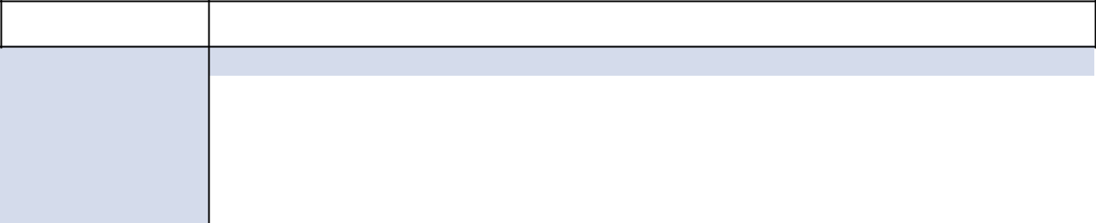

Name

 |  |  | Transaction
Transaction Date | Number of Direct Shares | Number of Indirect Shares | Description
3/10/2020 | 23 |  | 5
6/10/2020 | 21 |  | 5
9/10/2020 | 30 |  | 5
10/31/2020 | (10,000) | 10,000 | 11
12/10/2020 | 2 |  | 5
1/2/2021 | 2,500 |  | 1

 |  |  |  |  | Transaction
Name | Transaction Date |  | Number of Direct Shares | Number of Indirect Shares | Description
D.W. Woods | 1/31/2019 |  |  | 122 | 3
 | 2/28/2019 |  |  | 111 | 3
 | 3/11/2019 |  |  | 94 | 5
 | 3/29/2019 |  |  | 26 | 3
 | 6/10/2019 |  |  | 109 | 5
 | 9/10/2019 |  |  | 115 | 5
 | 11/26/2019 |  | (9,208) |  | 7
 | 11/26/2019 |  | 180,000 |  | 8
 | 12/10/2019 |  |  | 119 | 5
 | 1/31/2020 |  |  | 147 | 3
 | 2/10/2020 |  |  | 2,858 | 10
 | 2/28/2020 |  |  | 176 | 3
 | 3/10/2020 |  |  | 188 | 5
 | 3/31/2020 |  |  | 30 | 3
 | 6/10/2020 |  |  | 165 | 5
 | 9/10/2020 |  |  | 237 | 5
 | 11/24/2020 |  | (12,671) |  | 7
 | 11/24/2020 |  | 205,000 |  | 8
 | 12/9/2020 |  | (5,195) |  | 7
 | 12/10/2020 |  |  | 217 | 5
 | 12/23/2020 |  | (2,820) | 2,820 | 11
 |  |  |  |  | Transaction
Name | Transaction Date |  | Number of Direct Shares | Number of Indirect Shares | Description
W. Zulkiflee | None
 |  |  |  |  | Transaction
Name | Transaction Date |  | Number of Direct Shares | Number of Indirect Shares | Description
N.A. Chapman | 1/31/2019 |  |  | 132 | 3
 | 2/15/2019 |  | 629 | (629) | 4
 | 2/28/2019 |  |  | 120 | 3
 | 3/11/2019 |  |  | 108 | 5
88 | 2021 Proxy Statement

Table of Contents


Name

 |  |  | Transaction
Transaction Date | Number of Direct Shares | Number of Indirect Shares | Description
3/29/2020 |  | 117 | 3
4/30/2019 |  | 21 | 3
5/7/2019 | (1,321) |  | 6
5/31/2019 |  | 7 | 3
6/10/2019 |  | 128 | 5
6/28/2019 |  | 7 | 3
9/10/2019 |  | 133 | 5
11/26/2019 | (7,693) |  | 7
11/26/2019 | 95,800 |  | 8
12/10/2019 |  | 140 | 5
12/11/2019 | (1,299) | 1,299 | 9
1/31/2020 |  | 157 | 3
2/28/2020 |  | 188 | 3
3/10/2019 |  | 248 | 5
3/31/2020 |  | 267 | 3
4/30/2020 |  | 11 | 3
5/29/2020 |  | 11 | 3
6/10/2020 |  | 208 | 5
6/30/2020 |  | 11 | 3
7/31/2020 |  | 6 | 3
9/10/2020 |  | 287 | 5
11/24/2020 | (9,208) |  | 7
11/24/2020 | 95,800 |  | 8
12/10/2020 |  | 154 | 5
1/29/2021 |  | 160 | 3

 |  |  |  | Transaction
Name | Transaction Date | Number of Direct Shares | Number of Indirect Shares | Description
A.P. Swiger | 3/11/2019 |  | 204 | 5
 | 6/10/2019 |  | 233 | 5
 | 9/10/2019 |  | 247 | 5
 | 11/26/2019 | (17,865) |  | 7
 | 11/26/2019 | 111,600 |  | 8
 | 12/10/2019 |  | 255 | 5
 | 3/10/2020 |  | 396 | 5
 | 3/19/2020 | 30,000 |  | 10
 | 6/10/2020 |  | 340 | 5
 | 9/10/2020 |  | 488 | 5
 | 11/24/2020 | (20,935) |  | 7
 | 11/24/2020 | 99,200 |  | 8
 | 12/10/2020 |  | 447 | 5
 |  |  | 2021 Proxy Statement | 89

Table of Contents

 |  |  |  |  | Transaction
Name | Transaction Date |  | Number of Direct Shares | Number of Indirect Shares | Description
J.P. Williams, Jr. | 3/11/2019 |  |  | 93 | 5
 | 6/10/2019 |  |  | 106 | 5
 | 9/10/2019 |  |  | 112 | 5
 | 11/26/2019 |  | (9,208) |  | 7
 | 11/26/2019 |  | 85,100 |  | 8
 | 12/10/2019 |  |  | 116 | 5
 | 3/10/2020 |  |  | 181 | 5
 | 6/10/2020 |  |  | 155 | 5
 | 9/10/2020 |  |  | 223 | 5
 | 11/24/2020 |  | (12,671) |  | 7
 | 11/24/2020 |  | 85,100 |  | 8
 | 12/10/2020 |  |  | 204 | 5
 |  |  |  |  | Transaction
Name | Transaction Date |  | Number of Direct Shares | Number of Indirect Shares | Description
S.A. Littleton | 1/31/2019 |  |  | 41 | 3
 | 2/1/2019 |  | (1,000) |  | 12
 | 2/28/2019 |  |  | 22 | 3
 | 3/11/2019 |  |  | 58 | 5
 | 3/25/2019 |  | (2,187) |  | 12
 | 3/29/2019 |  |  | 22 | 3
 | 4/30/2019 |  |  | 24 | 3
 | 5/31/2019 |  |  | 26 | 3
 | 6/10/2019 |  |  | 67 | 5
 | 6/28/2019 |  |  | 21 | 3
 | 7/10/2019 |  | (5,560) |  | 12
 | 9/10/2019 |  |  | 72 | 5
 | 11/26/2019 |  | 24,800 |  | 8
 | 12/3/2019 |  | (987) |  | 7
 | 12/5/2019 |  | (2,097) |  | 7
 | 12/10/2019 |  |  | 74 | 5
 | 12/10/2019 |  | (8,416) |  | 12
 | 1/31/2020 |  |  | 48 | 3
 | 2/28/2020 |  |  | 37 | 3
 | 3/10/2020 |  |  | 116 | 5
 | 3/31/2020 |  |  | 51 | 3
 | 4/30/2020 |  |  | 44 | 3
 | 5/29/2020 |  |  | 43 | 3
 | 6/10/2020 |  |  | 102 | 5
90 | 2021 Proxy Statement

Table of Contents


Name

 |  |  | Transaction
Transaction Date | Number of Direct Shares | Number of Indirect Shares | Description
6/30/2020 |  | 27 | 3
9/10/2020 |  | 148 | 5
11/24/2020 | 24,800 |  | 8
12/1/2020 | (1,169) |  | 7
12/2/2020 | (2,350) |  | 7
12/10/2020 |  | 135 | 5
1/29/2021 |  | 54 | 3

 |  |  |  | Transaction
Name | Transaction Date | Number of Direct Shares | Number of Indirect Shares | Description
L.K. Bork | 1/31/2019 |  | 33 | 3
 | 2/28/2019 |  | 30 | 3
 | 3/11/2019 |  | 61 | 5
 | 3/29/2019 |  | 29 | 3
 | 6/10/2019 |  | 71 | 5
 | 6/19/2019 | (14,590) |  | 12
 | 9/10/2019 |  | 75 | 5
 | 9/26/2019 | (420) |  | 6
 | 11/26/2019 | 6,600 |  | 8
 | 12/3/2019 | (634) |  | 7
 | 12/5/2019 | (804) |  | 7
 | 12/10/2019 |  | 77 | 5
 | 12/24/2019 | (143) |  | 6
 | 12/24/2019 | (50) |  | 6
 | 3/10/2020 |  | 120 | 5
 | 6/10/2020 |  | 103 | 5
 | 9/10/2020 |  | 148 | 5
 | 11/24/2020 | 7,400 |  | 8
 | 12/1/2020 | (634) |  | 7
 | 12/2/2020 | (719) |  | 7
 | 12/10/2020 |  | 136 | 5
 | 12/18/2020 | (5,600) |  | 12
 |  |  |  | Transaction
Name | Transaction Date | Number of Direct Shares | Number of Indirect Shares | Description
S.E. Brown | 1/7/2019 | 21 |  | 10
 | 1/7/2019 | (21) | 21 | 11
 | 1/22/2019 | 100 |  | 10
 | 1/31/2019 |  | 20 | 3
 | 2/28/2019 |  | 18 | 3
 | 3/11/2019 | 7 | 40 | 5
 |  |  | 2021 Proxy Statement | 91

Table of Contents


Name

 |  |  | Transaction
Transaction Date | Number of Direct Shares | Number of Indirect Shares | Description
3/22/2019 | 200 |  | 10
3/29/2019 |  | 18 | 3
4/30/2019 |  | 18 | 3
5/31/2019 |  | 20 | 3
6/10/2019 | 7 | 48 | 5
6/28/2019 |  | 19 | 3
7/31/2019 |  | 19 | 3
8/30/2019 |  | 21 | 3
9/10/2019 | 7 | 51 | 5
9/30/2019 |  | 20 | 3
10/31/2019 |  | 21 | 3
11/26/2019 | 600 |  | 8
11/29/2019 |  | 21 | 3
12/10/2019 | 7 | 54 | 5
12/30/2019 |  | 10 | 10
12/31/2019 |  | 21 | 3
1/31/2020 |  | 23 | 3
2/28/2020 |  | 27 | 3
3/10/2020 | 11 | 84 | 5
3/23/2020 | 300 |  | 10
3/31/2020 |  | 39 | 3
4/30/2020 |  | 32 | 3
5/29/2020 |  | 33 | 3
6/10/2020 | 15 | 74 | 5
6/30/2020 |  | 34 | 3
7/31/2020 |  | 35 | 3
8/31/2020 |  | 38 | 3
9/10/2020 | 21 | 108 | 5
9/30/2020 |  | 43 | 3
11/24/2020 | 1,200 |  | 8
12/2/2020 | (37) |  | 7
12/10/2020 | 19 | 101 | 5

 |  |  |  |  | Transaction
Name | Transaction Date |  | Number of Direct Shares | Number of Indirect Shares | Description
S.E. Horne | 1/31/2019 |  |  | 13 | 3
 | 2/28/2019 |  |  | 12 | 3
 | 3/11/2019 |  |  | 3 | 5
 | 3/29/2019 |  |  | 11 | 3
 | 4/30/2019 |  |  | 11 | 3
 | 5/31/2019 |  |  | 13 | 3
92 | 2021 Proxy Statement

Table of Contents

Name

 |  |  | Transaction
Transaction Date | Number of Direct Shares | Number of Indirect Shares | Description
6/10/2019 |  | 4 | 5
6/28/2019 |  | 12 | 3
7/31/2019 |  | 8 | 3
8/30/2019 |  | 13 | 3
9/10/2019 |  | 5 | 5
9/30/2019 |  | 7 | 3
11/26/2019 | 6,600 |  | 8
12/3/2019 | (217) |  | 7
12/5/2019 | (748) |  | 7
12/10/2019 |  | 5 | 5
1/31/2020 |  | 16 | 3
2/28/2020 |  | 19 | 3
3/10/2020 |  | 8 | 5
3/31/2020 |  | 27 | 3
4/30/2020 |  | 22 | 3
5/29/2020 |  | 22 | 3
6/10/2020 |  | 8 | 5
6/30/2020 |  | 21 | 3
7/31/2020 |  | 16 | 3
8/31/2020 |  | 17 | 3
9/10/2020 |  | 13 | 5
9/14/2020 | 134 |  | 5
9/30/2020 |  | 11 | 3
11/24/2020 | 6,600 |  | 8
12/1/2020 | (207) |  | 7
12/2/2020 | (463) |  | 7
12/10/2020 |  | 13 | 5
12/14/2020 | 127 |  | 5
1/29/2021 |  | 15 | 3
 |  | 2021 Proxy Statement | 93
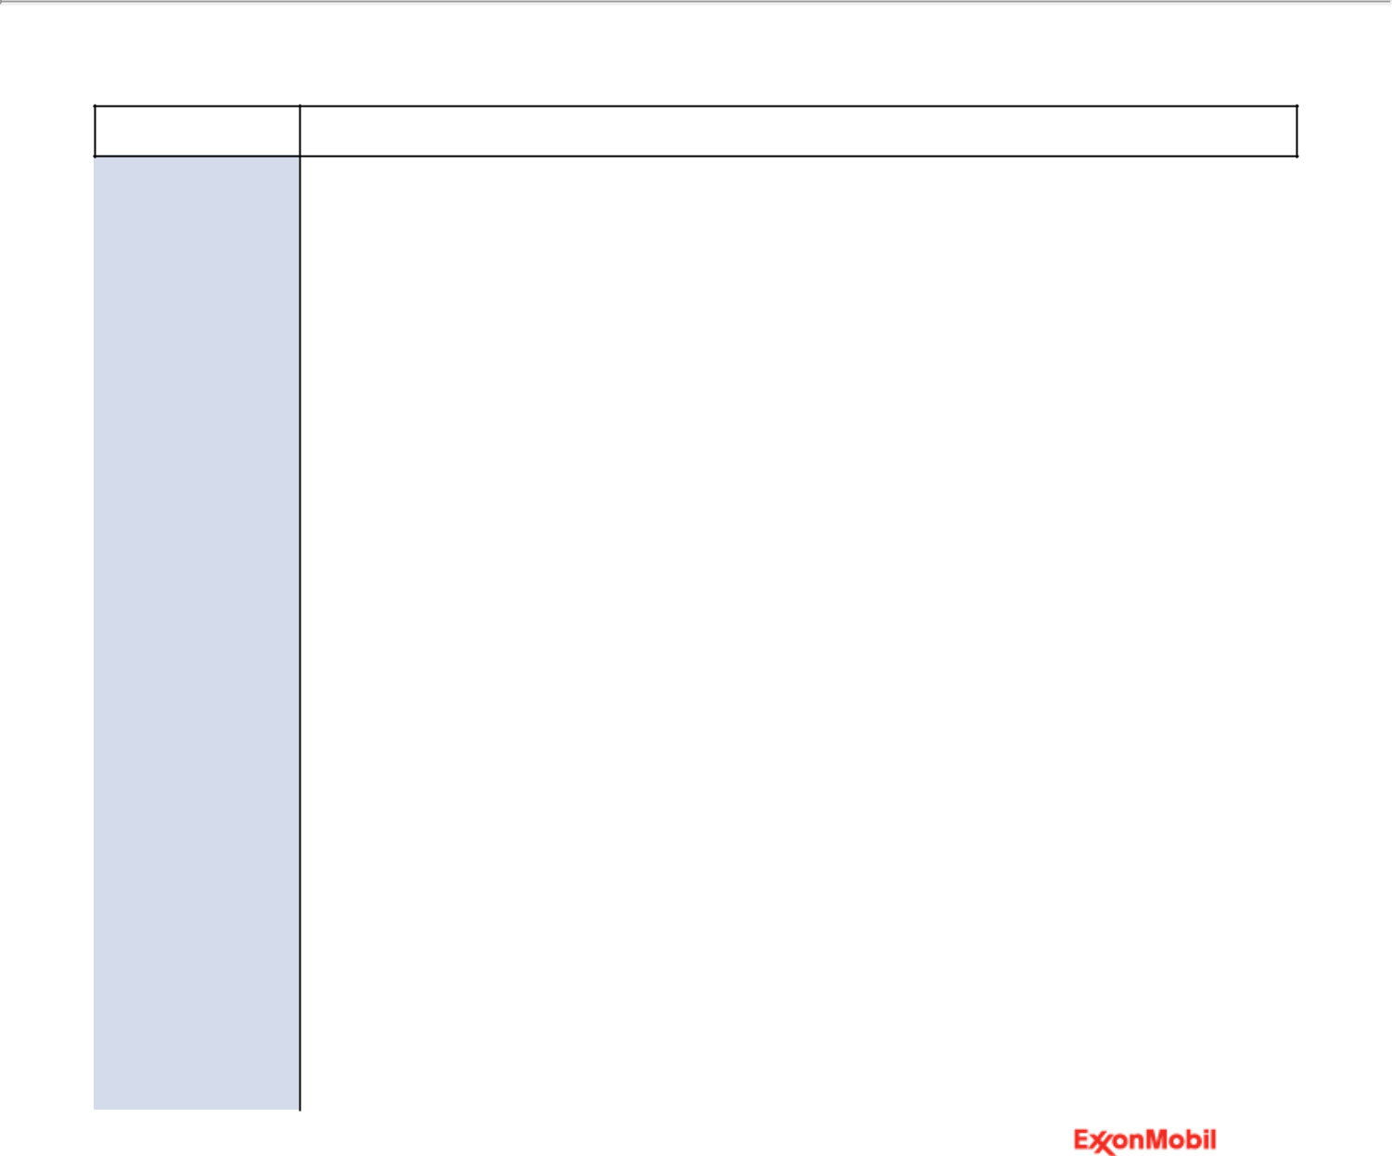

Table of Contents

Transaction Descriptions
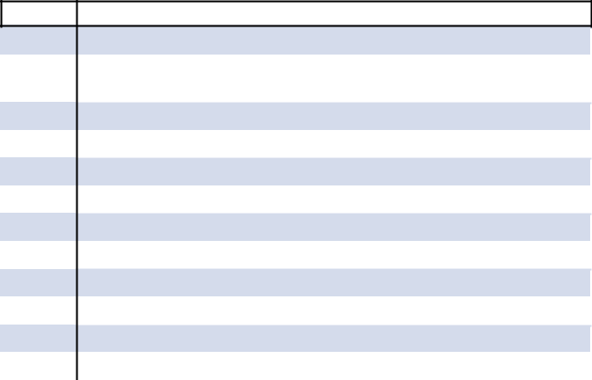

Item | Description

- Grant of restricted shares for director grant

- Grant of annual restricted shares for first year director grant

- Regular scheduled purchase

- Transfer to direct

- Dividend reinvestment

- Gift

- Shares withheld for tax

- Officer grant (including unvested restricted stock units)

- Transfer to indirect by gift

- Purchase

- Transfer to indirect

- Sale

Miscellaneous Information Regarding Participants

Except as described in this Exhibit A or in this proxy statement, neither any participant nor any of their respective associates or affiliates (together, the “Participant Affiliates”) is either a party to any transaction or series of transactions since February 1, 2021 or has knowledge of any current proposed transaction (i) to which the Company or any of its subsidiaries was or is to be a participant, (ii) in which the amount involved exceeds $120,000 and (iii) in which any participant or Participant Affiliate had, or will have, a direct or indirect material interest. Furthermore, except as described in this Exhibit A or in this proxy statement, (a) no participant or Participant Affiliate, directly or indirectly, beneficially owns any securities of the Company or any securities of any subsidiary of the Company, and (b) no participant owns any securities of the Company of record but not beneficially.

Except as described in this Exhibit A or in this proxy statement, no participant or Participant Affiliate has entered into any agreement or understanding with any person with respect to any future employment by the Company or any of its affiliates or any future transactions to which the Company or any of its affiliates will or may be a party.

Except as described in this Exhibit A or in this proxy statement, there are no contracts, arrangements or understandings by any participant or Participant Affiliate since February 1, 2021 with any person with respect to any securities of the Company, including, but not limited to, joint ventures, loan or option arrangements, puts or calls, guarantees against loss or guarantees of profit, division of losses or profits, or the giving or withholding of proxies.

Except as described in this Exhibit A or in this proxy statement, and excluding any Director or executive officer of the Company acting solely in that capacity, no person who is a party to an arrangement or understanding pursuant to which a nominee for election as director is proposed to be elected has any substantial interest, direct or indirect, by security holdings or otherwise, in any matter to be acted upon at the annual meeting.

Except as described in this Exhibit A or in this proxy statement, there are no material legal proceedings to which any participant or Participant Affiliate or any of their associates is a party adverse to, or has a material interest adverse to, the Company or any of its subsidiaries.

94 2021 Proxy Statement

Table of Contents

EXHIBIT B: Frequently Used Terms

Listed below are definitions of several of ExxonMobil’s key business and financial performance measures. These definitions are provided to facilitate understanding of the terms and their calculation.

Cash Flow From Operations and Asset Sales

Cash flow from operations and asset sales is the sum of the net cash provided by operating activities and proceeds associated with sales of subsidiaries, property, plant and equipment, and sales and returns of investments from the Consolidated Statement of Cash Flows. This cash flow reflects the total sources of cash from both operating the Corporation’s assets and from the divesting of assets. The Corporation employs a long-standing and regular disciplined review process to ensure that assets are contributing to the Corporation’s strategic objectives. Assets are divested when they are no longer meeting these objectives or are worth considerably more to others. Because of the regular nature of this activity, we believe it is useful for investors to consider proceeds associated with asset sales together with cash provided by operating activities when evaluating cash available for investment in the business and financing activities, including shareholder distributions.

Cash flow from operations and asset sales | 2020 | 2019 | 2018
 |  | (millions of dollars)
Net cash provided by operating activities | 14,668 | 29,716 | 36,014
Proceeds associated with sales of subsidiaries, property, plant and equipment, and sales and returns of
investments | 999 | 3,692 | 4,123
Cash flow from operations and asset sales | 15,667 | 33,408 | 40,137

Capital Employed

Capital employed is a measure of net investment. When viewed from the perspective of how the capital is used by the businesses, it includes ExxonMobil’s net share of property, plant and equipment and other assets less liabilities, excluding both short-term and long-term debt. When viewed from the perspective of the sources of capital employed in total for the Corporation, it includes ExxonMobil’s share of total debt and equity. Both of these views include ExxonMobil’s share of amounts applicable to equity companies, which the Corporation believes should be included to provide a more comprehensive measure of capital employed.

Capital employed | 2020 |  | 2019 | 2018
Business uses: asset and liability perspective |  |  | (millions of dollars)
Total assets | 332,750 |  | 362,597 | 346,196
Less liabilities and noncontrolling interests share of assets and liabilities
Total current liabilities excluding notes and loans payable | (35,905) |  | (43,411) | (39,880)
Total long-term liabilities excluding long-term debt | (65,075) |  | (73,328) | (69,992)
Noncontrolling interests share of assets and liabilities | (8,773) |  | (8,839) | (7,958)
Add ExxonMobil share of debt-financed equity company net assets |  | 4,140 | 3,906 | 3,914
Total capital employed |  | 227,137 | 240,925 | 232,280
Total corporate sources: debt and equity perspective
Notes and loans payable | 20,458 |  | 20,578 | 17,258
Long-term debt | 47,182 |  | 26,342 | 20,538
ExxonMobil share of equity | 157,150 |  | 191,650 | 191,794
Less noncontrolling interests share of total debt | (1,793) |  | (1,551) | (1,224)
Add ExxonMobil share of equity company debt |  | 4,140 | 3,906 | 3,914
Total capital employed |  | 227,137 | 240,925 | 232,280
 | 2021 Proxy Statement |  |  | 95

Table of Contents

Return on Average Capital Employed

Return on average capital employed (ROCE) is a performance measure ratio. From the perspective of the business segments, ROCE is annual business segment earnings divided by average business segment capital employed (average of beginning and end-of-year amounts). These segment earnings include ExxonMobil’s share of segment earnings of equity companies, consistent with our capital employed definition, and exclude the cost of financing. The Corporation’s total ROCE is net income attributable to ExxonMobil excluding the after-tax cost of financing, divided by total corporate average capital employed. The Corporation has consistently applied its ROCE definition for many years and views it as the best measure of historical capital productivity in our capital-intensive, long-term industry. Additional measures, which are more cash flow based, are used to make investment decisions.

Return on average capital employed |  | 2020 | 2019 | 2018
 |  |  | (millions of dollars)
Net income (loss) attributable to ExxonMobil |  | (22,440) | 14,340 | 20,840
Financing costs (after tax)
 | Gross third-party debt | (1,272) | (1,075) | (912)
 | ExxonMobil share of equity companies | (182) | (207) | (192)
 | All other financing costs – net | 666 | 141 | 498
 | Total financing costs | (788) | (1,141) | (606)
 | Earnings (Loss) excluding financing costs | (21,652) | 15,481 | 21,446
Average capital employed |  | 234,031 | 236,603 | 232,374
Return on average capital employed – corporate total |  | (9.3)% | 6.5% | 9.2%
96 | 2021 Proxy Statement

Table of Contents

Printed entirely on recycled paper 002CSNB836

Table of Contents
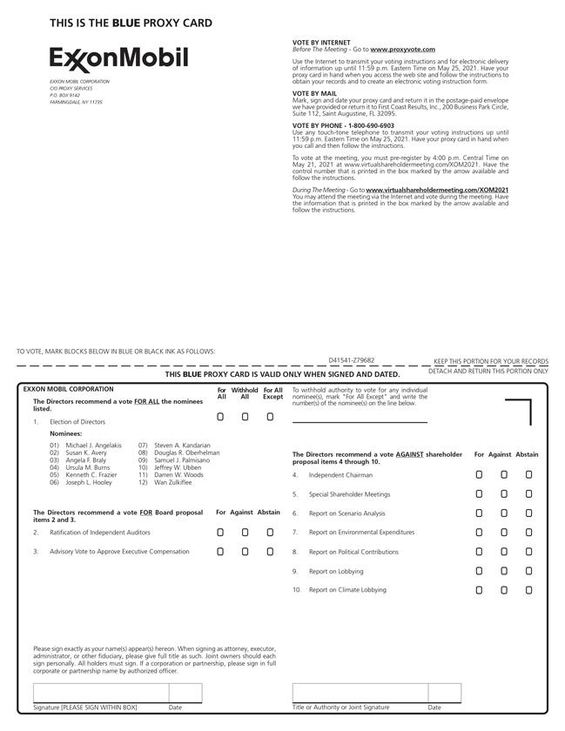

Table of Contents


