Table of Contents

UNITED STATES

SECURITIES AND EXCHANGE COMMISSION
Washington, D.C. 20549

SCHEDULE 14A

Proxy Statement Pursuant to Section 14(a)

of the Securities Exchange Act of 1934
(Amendment No. )

Filed by the Registrant ☒ |  | ☐
Filed by a Party other than the Registrant |  | ☐
Check the appropriate box:
☐ | Preliminary Proxy Statement | ☐ Confidential, for Use of the Commission Only(as permitted by Rule 14a-
☒ | Definitive Proxy Statement | 6(e)(2))

- Definitive Additional Materials

- Soliciting Material Pursuant to §240.14a-12

EXXON MOBIL CORPORATION

(Name of Registrant as Specified In Its Charter)

(Name of Person(s) Filing Proxy Statement, if other than the Registrant)

Payment of Filing Fee (Check the appropriate box):

- No fee required.

- Fee computed on table below per Exchange Act Rules 14a-6(i)(4) and 0-11.

  - Title of each class of securities to which transaction applies:

  - Aggregate number of securities to which transaction applies:

  - Per unit price or other underlying value of transaction computed pursuant to Exchange Act Rule 0-11 (set forth the amount on which the filing fee is calculated and state how it was determined):

  - Proposed maximum aggregate value of transaction:

  - Total fee paid:

- Fee paid previously with preliminary materials.

- Check box if any part of the fee is offset as provided by Exchange Act Rule 0-11(a)(2) and identify the filing for which the offsetting fee was paid previously. Identify the previous filing by registration statement number, or the Form or Schedule and the date of its filing.

  - Amount Previously Paid:

  - Form, Schedule or Registration Statement No.:

  - Filing Party:

  - Date Filed:

Table of Contents

Notice of 2020 Annual Meeting

and Proxy Statement


April 9, 2020

Dear Shareholder:

We invite you to attend the annual meeting of shareholders currently scheduled on Wednesday, May 27, 2020, at the Renaissance Dallas Hotel Conference Center, 2222 North Stemmons Freeway, Dallas, Texas 75207. The meeting will begin promptly at 9:30 a.m. Central Time. With the evolving concerns of COVID-19 and public health authority recommendations, these plans are subject to change and could evolve to a virtual meeting. We will notify you of any changes prior to the event and provide the latest status on the Investor Relations section of our website at exxonmobil.com/investor. As always, our first priority remains the health and safety of our shareholders, employees, and communities.

At the meeting, you will hear a report on our business and vote on the following items:

- Election of directors;

- Ratification of PricewaterhouseCoopers LLP as independent auditors;

- Advisory vote to approve executive compensation;

- Six shareholder proposals contained in this proxy statement; and

- Other matters if properly raised.

Only shareholders of record on April 2, 2020, or their valid proxy holders may vote at the meeting. Attendance at the meeting is limited to shareholders or their proxy holders and ExxonMobil guests. Only shareholders or their proxy holders may address the meeting.

This booklet includes the formal notice of the meeting and proxy statement. The proxy statement tells you about the agenda, procedures, and rules of conduct for the meeting. It also describes how the Board operates, gives information about our director candidates, and provides information about the other items of business to be conducted at the meeting.

Financial information is provided separately in the booklet, 2019 Financial Statements and Supplemental Information, enclosed with the proxy materials or made available online to all shareholders.

Your vote is important. Even if you own only a few shares, we want your shares to be represented at the meeting. You can vote your shares by Internet, toll-free telephone call, or proxy card. A Summary of 2020 Proxy Voting Results will be available at exxonmobil.com after the annual shareholders meeting.

To attend the meeting in person, please follow the instructions on page 6. An audio webcast and a report on the meeting will be available on our website at exxonmobil.com.

Sincerely,



Stephen A. Littleton Darren W. Woods
Secretary Chairman of the Board

Table of Contents

TABLE OF CONTENTS
 | Page
PROXY SUMMARY AND VOTING MAP | 1
GENERAL INFORMATION | 4
BOARD OF DIRECTORS | 7
Corporate Governance | 7
Item 1 – Election of Directors | 20
Director Compensation | 25
Certain Beneficial Owners | 27
Director and Executive Officer Stock Ownership | 27
Audit Committee Report | 28
Item 2 – Ratification of Independent Auditors | 29
Compensation Committee Report | 30
Item 3 – Advisory Vote to Approve Executive Compensation | 30
EXECUTIVE COMPENSATION | 31
Compensation Discussion and Analysis | 31
Executive Compensation Tables | 50
SHAREHOLDER PROPOSALS | 59
Item 4 – Independent Chairman | 59
Item 5 – Special Shareholder Meetings | 61
Item 6 – Report on Environmental Expenditures | 62
Item 7 – Report on Risks of Petrochemical Investments | 64
Item 8 – Report on Political Contributions | 66
Item 9 – Report on Lobbying | 67
PAY RATIO | 69
ADDITIONAL INFORMATION | 70
DIRECTIONS TO 2020 ANNUAL MEETING

Table of Contents

PROXY SUMMARY AND VOTING MAP

Shareholders are asked to consider the materials included in this proxy statement and to vote on the following:

ITEM 1: Election of Directors

The Board recommends you vote FOR each of the following candidates.

The Board of Directors has nominated the director candidates below. |  |  |  |  |  |  |  |  |  | Personal information about each
All of our nominees currently serve as ExxonMobil directors. |  |  |  |  |  |  |  |  |  | nominee is provided beginning on
All director nominees have stated that they are willing to serve if elected. |  |  |  |  |  |  |  |  |  | Page 20
 |  |  |  | Director |  | ExxonMobil Board Committees |  |  |  |  |  |  |  | Other Public
Name, Age, Principal Occupation |  |  |  | Since | AC |  | CC | BAC |  | FC | PICC |  | EC | Company Boards
Susan K. Avery, 70 |  |  | 2017 |  |  |  |  | ✓ |  |  | ✓ |  |  | None
President Emerita, Woods Hole |  |  |  |  |  |  |  |  |  |  | ✓
Oceanographic Institution
Angela F. Braly, 58 |  |  |  |  |  |  | ✓ |  |  |  | C |  |  | Brookfield Asset
Former Chairman of the Board, |  |  | 2016 |  |  |  | ✓ |  |  |  | C |  |  | Management; Lowe’s;
President, and CEO, WellPoint (now Anthem) |  |  |  |  |  |  |  |  |  |  |  |  |  | Procter & Gamble
Ursula M. Burns, 61 |  |  |  |  | C |  |  |  |  | ✓ |  |  | ✓ | Nestlé;
Chairman of the Board, |  |  | 2012 |  | C |  |  |  |  | ✓ |  |  | ✓ | VEON; Uber
VEON Ltd.
Kenneth C. Frazier, 65 LD |  |  | 2009 |  |  |  | ✓ | C |  |  |  |  | ✓ | Merck
Chairman of the Board |  |  |  |  |  |  | ✓ |  |  |  |  |  | ✓
and CEO, Merck & Co.
Joseph L. Hooley, 63 |  |  | 2020 |  | ✓ |  |  |  |  | ✓ |  |  |  | Aptiv
Former Chairman of the Board, |  |  |  |  | ✓ |  |  |  |  | ✓
President, and CEO, State Street
Steven A. Kandarian, 68 |  |  | 2018 |  |  |  | ✓ |  |  |  | ✓ |  |  | AECOM
Former Chairman of the Board, |  |  |  |  |  |  | ✓ |  |  |  | ✓
President, and CEO, MetLife
Douglas R. Oberhelman, 67 |  |  | 2015 |  | ✓ |  |  |  |  | ✓ |  |  |  | Bombardier
Former Chairman of the |  |  |  |  | ✓ |  |  |  |  | ✓
Board and CEO, Caterpillar
Samuel J. Palmisano, 68 |  |  | 2006 |  |  |  | C | ✓ |  |  |  |  | ✓ | None
Former Chairman of the Board, |  |  |  |  |  |  | C |  |  |  |  |  | ✓
President, and CEO, IBM
William C. Weldon, 71 |  |  | 2013 |  | ✓ |  |  |  |  | ✓ |  |  |  | CVS Caremark
Former Chairman of the Board and |  |  |  |  | ✓ |  |  |  |  | ✓
CEO, Johnson & Johnson
Darren W. Woods, 55 C |  |  | 2016 |  |  |  |  |  |  | C |  |  | C | None
Chairman of the Board and CEO, |  |  |  |  |  |  |  |  |  | C |  |  | C
Exxon Mobil Corporation
C | Chairman | AC | Audit Committee |  | FC |  | Finance Committee
LD | Lead Director | CC | Compensation Committee |  | PICC Public Issues and Contributions Committee
✓ | Member | BAC Board Affairs Committee |  |  | EC |  | Executive Committee
 |  |  |  |  |  |  |  | 2020 Proxy Statement |  |  |  |  |  | 1

Table of Contents

Director Attendance

During 2019, the ExxonMobil Board met ten times. Directors, on average, attended approximately 96 percent of Board and committee meetings. No director attended less than

75 percent of such meetings. ExxonMobil’s non-employee directors held seven executive sessions in 2019.

10 96%

Board meetings Director average
attendance

Board Tenure

The Board actively refreshes its membership; average tenure for non-employee director nominees is lower than the applicable Standard & Poor’s 500 average of 8.0 years.

6.1

Average tenure of non-
employee director nominees

Worldwide Perspectives

The Board nominees have lived and worked
around the world and bring broad perspectives to
ExxonMobil’s global
businesses.

Additional information:

Director leadership & oversight...Page 8

Director qualifications & competencies...Page 9
Director tenure...Page 12

Board Highlights

The ExxonMobil Board is comprised of directors with a diverse mix of backgrounds, knowledge, and skills.

“ExxonMobil recognizes the strength and effectiveness of the Board reflects the balance, experience, and diversity of the individual directors; their commitment; and importantly, the ability of directors to work effectively as a group in carrying out their responsibilities. ExxonMobil seeks candidates with diverse backgrounds who possess knowledge and skills in areas of importance to the Corporation.”

– ExxonMobil Director Selection Guidelines
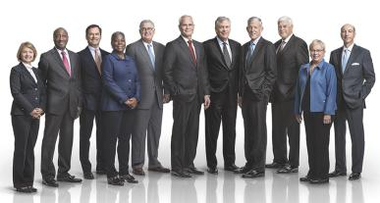

ExxonMobil’s director nominee competencies/ profiles include:

Risk Management 10 of 10 Directors

Independence 9 of 10 Directors

Large / Complex Organizations 10 of 10 Directors

Gender and / or Race / Ethnic Diversity 4 of 10 Directors

Scientific / Technical / Research 6 of 10 Directors

Current / Former CEO / Field Prominence 10 of 10 Directors

2 2020 Proxy Statement

Table of Contents

ITEM 2: Ratification of Independent Auditors

The Board recommends you vote FOR this proposal.

The ExxonMobil Audit Committee has appointed PricewaterhouseCoopers LLP (“PwC”) to audit ExxonMobil’s financial statements for 2020.

You are asked to ratify that appointment.

Page 29

Additional information about the Audit Committee’s appointment of PwC

and PwC’s fees for
2018 and 2019

ITEM 3: Advisory Vote to Approve Executive Compensation

The Board recommends you vote FOR this proposal.

ExxonMobil asks you to vote on a non-binding resolution to approve the Page 30

compensation of the Named Executive Officers. Additional information
about ExxonMobil’s
compensation
program

ITEMS 4 through 9: Shareholder Proposals

The Board recommends you vote AGAINST each of these proposals.

You will have the opportunity to vote on shareholder proposals submitted to Page 59

ExxonMobil. The text of these
proposals, the
proponents’
statements in support,
and ExxonMobil’s
responses

2020 Proxy Statement | 3

Table of Contents

GENERAL INFORMATION

The annual meeting of shareholders is currently scheduled to take place on Wednesday, May 27, 2020 at 9:30 a.m. Central Time at the Renaissance Dallas Hotel Conference Center. However the Corporation continues to monitor closely the coronavirus pandemic (COVID-19) and public health authority recommendations. It is possible the time, date, location or logistics of the meeting may be changed, including by holding a virtual meeting. In that case, the Corporation will issue additional public disclosure regarding any changes, including on the Investor Relations section of our website at exxonmobil.com/investor. As always, our first priority remains the health and safety of our shareholders, employees, and communities.

Who May Vote

Shareholders of ExxonMobil, as recorded in our stock register on April 2, 2020, may vote at the meeting.

How to Vote

You may vote in person at the meeting or by proxy. We recommend you vote by proxy even if you plan to attend the meeting. You can always change your vote at the meeting.

Important Notice Regarding the Availability of Proxy Materials for the Shareholders Meeting to be held on

May 27, 2020:


The 2020 Proxy Statement, 2019 Summary Annual Report, and 2019 Financial Statements are available at www.edocumentview.com/xom.

Notice and Access

We distribute proxy materials to many shareholders via the Internet under the Securities and Exchange Commission’s (“SEC’s”) “Notice and Access” rules, thereby capturing cost and environmental benefits. On or about April 9, 2020, we mailed a Notice Regarding the Availability of Proxy Materials (“Notice”) that contains information about our 2020 annual shareholders meeting and instructions on how to view all proxy materials on the Internet. Also included are instructions on how to vote and how to request a paper or e-mail copy of the proxy materials.

Electronic Delivery of Proxy Statement and Annual Report Documents

For shareholders receiving proxy materials by mail, you can elect to receive an e-mail in the future that will provide electronic links to these documents. Opting to receive your proxy materials online will save the Company the cost of producing and mailing documents to your home or business, and will also give you an electronic link to the proxy voting site.

- Shareholders of Record: If you vote on the Internet at www.investorvote.com/exxonmobil, follow the prompts for enrolling in the electronic proxy delivery service. You may enroll in the electronic proxy delivery service at any time in the future by going directly to www.computershare.com/exxonmobil. You may also revoke an electronic delivery election at this site at any time.

- Beneficial Shareholders: If you hold your shares in a brokerage account, you may also have the opportunity to receive copies of the proxy materials electronically. Please check the information provided in the proxy materials mailed to you by your bank or broker regarding the availability of this service.

How Proxies Work

ExxonMobil’s Board of Directors is asking for your proxy. Giving us your proxy means you authorize us to vote your shares at the meeting in the manner you direct.

4 2020 Proxy Statement

Table of Contents

If your shares are held in your name, you can vote by proxy in one of three convenient ways:


Online

Follow the instructions at

www.investorvote.com/exxonmobil.

You will need to have your proxy card or Notice in hand. At this website, you can elect to access future proxy statements and annual reports via the Internet.

Telephone

Call toll-free 1-800-652-8683 or

1-781-575-2300 (outside the United States, Canada, and Puerto Rico), and follow the instructions. You will need to have your proxy card or Notice in hand.

Mail

Complete, sign, date, and return your proxy card in the enclosed envelope. If you receive a Notice and would like to vote in writing, please follow the instructions in the Notice to obtain paper proxy materials.

Your proxy card covers all shares registered in your name and shares held in your Computershare Investment Plan account. If you own shares in the ExxonMobil Savings Plan for employees and retirees, your proxy card also covers those shares.

If you give us your signed proxy but do not specify how to vote, we will vote your shares as follows:

- For the election of our director candidates;

- For ratification of the appointment of independent auditors;

- For approval of the compensation of the Named Executive Officers; and

- As recommended by the Board with respect to shareholder proposals.

If you hold shares through someone else, such as a stockbroker, you will receive materials from that firm asking how you want to vote. Check the voting form used by that firm to see if it offers online or telephone voting.

Voting Shares in the ExxonMobil Savings Plan

The Trustee of the ExxonMobil Savings Plan will vote Plan shares as participants direct. To the extent participants do not give instructions, the Trustee will vote shares as it thinks best. The proxy card serves to give voting instructions to the Trustee.

Revoking a Proxy

You may revoke your proxy before it is voted at the meeting by:

- Submitting a new proxy with a later date via a proxy card, online, or by telephone;

- Notifying ExxonMobil’s Secretary in writing before the meeting; or

- Voting in person at the meeting.

Confidential Voting

Independent inspectors count the votes. Your individual vote is kept confidential from us unless special circumstances exist. For example, a copy of your proxy card will be sent to us if you write comments on the card.

Quorum

In order to carry on the business of the meeting, we must have a quorum. This means at least a majority of the outstanding shares eligible to vote must be represented at the meeting, either by proxy or in person. Treasury shares, which are shares owned by ExxonMobil itself, are not voted and do not count for this purpose.

2020 Proxy Statement | 5

Table of Contents

Votes Required

- Election of Directors Proposal: Under ExxonMobil’s by-laws, a director nominee must receive a majority of votes cast in order to be elected to the Board of Directors in a non-contested election. In a contested election (in which the number of nominees exceeds the number of directors to be elected), the plurality vote standard under New Jersey law applies. Under plurality voting, the director nominee with the most votes for a particular seat is elected for that seat. Abstentions and broker non-votes are not counted for purposes of the election of directors. A broker non-vote occurs when a bank, broker, or other holder of record that is holding shares for a beneficial owner does not vote on a particular proposal because the record holder does not have discretionary voting power and has not received instructions from the beneficial owner. If you own shares through a broker, you must give the broker instructions to vote your shares in the election of directors. Otherwise, your shares will not be voted.

Our Corporate Governance Guidelines, which can be found in the Corporate Governance section of our website at exxonmobil.com/governance, state that all directors will stand for election at the annual meeting of shareholders. In any non-contested election of directors, any director nominee who receives a greater number of votes AGAINST his or her election than votes FOR such election shall tender his or her resignation. Within 90 days after certification of the election results, the Board of Directors will decide, through a process managed by the Board Affairs Committee and excluding the nominee in question, whether to accept the resignation. Absent a compelling reason for the director to remain on the Board, the Board shall accept the resignation. The Board will promptly disclose its decision and, if applicable, the reasons for rejecting the tendered resignation on Form 8-K filed with the Securities and Exchange Commission.

- Other Proposals: Approval of the ratification of the appointment of independent auditors, the advisory vote to approve executive compensation, and the shareholder proposals require the favorable vote of a majority of votes cast. Only votes FOR or AGAINST these proposals count.

Abstentions count for quorum purposes, but not for voting. Broker non-votes count as votes FOR the ratification of the appointment of independent auditors but do not count for voting on any of the other proposals.

Annual Meeting Admission

Only shareholders or their proxy holders and ExxonMobil guests may attend the meeting.

For safety and security reasons, cameras, smartphones, recording equipment, electronic devices, computers, large bags, briefcases, packages, and firearms or other weapons will not be permitted in the building. In addition, each shareholder and ExxonMobil guest will be asked to present valid government-issued picture identification, such as a driver’s license, before being admitted to the meeting.

For registered shareholders, an admission ticket is the upper part of your proxy card or the full Notice. Please bring the admission ticket with you to the meeting.

If your shares are held in the name of your broker, bank, or other nominee, you must bring to the meeting an account statement or letter from the nominee indicating that you beneficially owned the shares on April 2, 2020, the record date for voting. You may receive an admission ticket in advance by sending a written request with proof of ownership to the address listed below under Contact Information.

Shareholders who do not present admission tickets at the meeting will be admitted only upon verification of ownership at the admission counter.


Audio Webcast of the Annual Meeting

You are invited to visit our website at exxonmobil.com to hear the audio webcast at 9:30 a.m. Central Time, on Wednesday, May 27, 2020. An archived copy of this webcast will be available for one year.

6 2020 Proxy Statement

Table of Contents

Conduct of the Meeting

The Chairman has broad responsibility and legal authority to conduct the annual meeting in an orderly and timely manner. This authority includes establishing rules for shareholders who wish to address the meeting. Only shareholders or their valid proxy holders may address the meeting. Copies of these rules will be available at the meeting. The Chairman may also exercise broad discretion in recognizing shareholders who wish to speak and in determining the extent of discussion on each item of business. In light of the number of business items on this year’s agenda and the need to conclude the meeting within a reasonable period of time, we cannot ensure that every shareholder who wishes to speak on an item of business will be able to do so.

Dialogue can usually be better accomplished with interested parties outside the meeting and, for this purpose, we have provided a method on our website at exxonmobil.com/directors for raising issues and contacting the non-employee directors either in writing or electronically. The Chairman may also rely on applicable law regarding disruptions or disorderly conduct to ensure that the meeting is conducted in a manner that is fair to all shareholders. Shareholders making comments during the meeting must do so in English so that the majority of shareholders present can understand what is being said.


Contact Information

If you have questions or need more information about the annual meeting, write to Mr. Stephen A. Littleton, Secretary, Exxon Mobil Corporation, 5959 Las Colinas Boulevard, Irving, TX 75039-2298. Alternatively, call us at 1-972-940-6715 or send a fax to 1-972-940-6748.

For information about shares registered in your name or your Computershare Investment Plan account, call ExxonMobil Shareholder Services at 1-800-252-1800 or 1-781-575-2058 (outside the United States, Canada, and Puerto Rico), or access your account via the website at www.computershare.com/exxonmobil. We also invite you to visit ExxonMobil’s website, where investor information can be found at exxonmobil.com/investor. Website materials are not part of this proxy solicitation.

BOARD OF DIRECTORS

CORPORATE GOVERNANCE

Overview

The Board of Directors and its committees perform a number of functions for ExxonMobil and its shareholders, including:

- Overseeing the management of the Company on your behalf, including oversight of risk management;

- Reviewing ExxonMobil’s long-term strategic plans;

- Exercising direct decision-making authority in key areas, such as declaring dividends;

- Selecting the Chief Executive Officer (“CEO”) and evaluating the CEO’s performance;

- Reviewing development and succession plans for ExxonMobil’s top executives; and

- Gathering insights and sharing perspectives from shareholders during periodic engagements and other communications.

The Board has adopted Corporate Governance Guidelines that govern the structure and functioning of the Board and set out the Board’s position on a number of governance issues. A copy of our current Corporate Governance Guidelines is posted on our website at exxonmobil.com/guidelines.

At least annually, the Board and each of the Board committees conduct an evaluation of their performance and effectiveness. Any potential changes to the committees’ charters are also considered at least once a year.

2020 Proxy Statement | 7

Table of Contents

Risk Oversight

The full Board of Directors provides oversight of key risks to ExxonMobil’s business. The Board throughout the year participates in reviews with management on the Company’s business, including identified risk factors. As a whole, the Board reviews litigation and other legal matters; political contributions, budget, and policy; lobbying costs; developments in climate science and policy; the Outlook for Energy, which projects world energy supply and demand to 2040; the Energy & Carbon Summary; stewardship of business performance; and long-term strategic plans. The Board receives updates and reviews from both internal ExxonMobil and external experts on issues of importance to the Company.

The Board, including the Public Issues and Contributions Committee, visits an ExxonMobil operations site each year. These visits enable the directors to observe and provide input on safety, operating practices, environmental performance, technology, products, industry and corporate standards, and community engagement.

The Board oversees a broad spectrum of interrelated risks with assistance from its committees. This integrated risk management approach facilitates recognition and oversight of important risk interdependencies.

Audit Committee oversees risks associated with financial and accounting matters, including compliance with legal and regulatory requirements, and the Company’s financial reporting and internal control systems. The Committee also periodically reviews cybersecurity risks and preparedness and ExxonMobil’s overall risk management approach and structure.

Board Affairs Committee oversees Board structure and matters of corporate governance, including Board evaluation and director refreshment. It also coordinates identification of external experts to address the Board and sets the criteria for shareholder engagement with directors.

Compensation Committee reviews executive compensation, which is designed to incentivize executives to maximize long-term shareholder value, requiring a long-term view in decision-making that includes careful consideration of current and future risks.

Public Issues and Contributions Committee oversees operational risks such as those relating to employee and community safety, health, environmental performance, including actions taken to address climate-related risks, security matters, and reviews and provides advice on objectives, policies and programs related to political and other contributions.

Finance Committee oversees risks associated with financial instruments, financial policies and strategies, and capital structure.

The Board receives regular updates from the committees, and believes this structure is best suited for overseeing risk.

Board Leadership Structure

The Board believes that the decision as to who should serve as Chairman and/or CEO is the proper responsibility of the Board. The Board retains authority to amend the by-laws to separate the positions of Chairman and CEO at any time and will carefully consider the pros and cons of such separation or combination. At the present time, the Board believes the interests of all shareholders are best served through a leadership model with a combined Chairman/CEO position and an independent Lead Director.

The current CEO possesses an in-depth knowledge of the Company; its integrated, multinational operations; the evolving energy industry supply and demand fundamentals; and the array of challenges to be faced. This knowledge was gained through more than 27 years of successful experience in progressively more senior positions, including domestic and international responsibilities.

The Board believes that these experiences and other insights put the CEO in the best position to provide broad leadership for the Board as it considers strategy and as it exercises its fiduciary responsibilities to shareholders. Further, the Board has demonstrated its commitment and ability to provide independent oversight of management.

8 2020 Proxy Statement

Table of Contents

The Board is comprised solely of independent directors and the CEO, and 100 percent of the Audit, Compensation, Board Affairs, and Public Issues and Contributions Committee members are independent. Each independent director has access to the CEO and other Company executives upon request, may call meetings of the independent directors, and may request agenda topics to be added or addressed in more detail at meetings of the full Board or an appropriate Board committee.

The Board believes the Lead Director provides effective independent Board leadership. Kenneth C. Frazier serves as Lead Director, as of March 2020, and is expected to remain in the position at least through the annual meeting of shareholders.

The Lead Director’s authorities, under the

Corporate Governance Guidelines, include:

- Calling, chairing, and setting the agenda for executive sessions of the non-employee directors

- Providing feedback to the Chairman

- Chairing meetings of the Board in the absence of the Chairman
- Reviewing and approving the schedule and agenda for all Board meetings and reviewing associated materials distributed to the directors, in consultation with the Chairman

- Advising the Chairman on the quality, quantity, and timeliness of information flow
- Reviewing committee meeting schedules

- Engaging with shareholders, as appropriate

- Leading the annual performance evaluation of the Board

The Lead Director also serves as Chair of the Board Affairs Committee with authorities that include:

- Establishing the criteria for director engagement with shareholders
- Providing comments and suggestions to the Board on Board committee structure, operations, member qualification, and member appointment

- Overseeing independent director succession planning, remuneration, requests for additions to board memberships, and resignations

- Establishing and maintaining procedures for interested parties to communicate with non-employee directors
- Considering Board governance practices and procedures including any changes to governance guidelines
- Providing oversight of the performance and effectiveness of the evaluation process for the Board and its committees

In addition, the Lead Director, working together with the Compensation Committee, oversees the annual evaluation of the CEO, the communication of resulting feedback to the CEO, and the review of CEO succession plans.

Director Qualifications

The Board has adopted guidelines outlining the qualifications sought when considering non-employee director candidates. These Guidelines for the Selection of Non-Employee Directors (“Selection Guidelines”), which are published on our website at exxonmobil.com/directorguidelines, are reviewed annually and state in part:

“ExxonMobil recognizes the strength and effectiveness of the Board reflects the balance, experience, and diversity of the individual directors; their commitment; and importantly, the ability of directors to work effectively as a group in carrying out their responsibilities. ExxonMobil seeks candidates with diverse backgrounds who possess knowledge and skills in areas of importance to the Corporation.”

The qualifications we consider for director candidates include: individuals who have achieved prominence in their fields; diversity of experiences and backgrounds, including gender and race/ethnic diversity; experience and demonstrated expertise in managing large, relatively complex organizations, such as that of CEOs or next-level executives of a significant company or organization with global responsibilities; financial and other risk management expertise; experience on one or more boards of significant public or non-profit organizations; expertise resulting from significant academic, scientific, or research activities; and experience with cyclical businesses, such as commodities.

Other considerations for director candidates include: a substantial majority of the Board must meet independence standards as described in the Corporate Governance Guidelines; all candidates must be free from any relationship with management or the Corporation that would interfere with the exercise of independent judgment; candidates should be committed to representing the interests of all shareholders and not any particular constituency; and the Board must include members who satisfy legal and stock exchange requirements for certain Board committees.

2020 Proxy Statement | 9

Table of Contents

The Board is comprised of directors with an effective mix of backgrounds, knowledge, and skills that the Board considers relevant and beneficial in fulfilling its oversight role. The chart below provides a summary of the collective competencies of the Board nominees and explains why these are important:

Director | Competencies and | Board
Qualifications | Relevance to ExxonMobil | Composition
Individuals who | Current CEO / Former CEO / Field Prominence
have achieved | Experience serving as a CEO or other prominent leader provides unique
prominence in their | perspectives to help the Board independently oversee ExxonMobil’s CEO
fields | and management. Having this experience also increases the Board’s
 | understanding and appreciation of the many facets of modern international
 | organizations, including strategic planning, financial reporting and
 | compliance, and risk oversight.

Experience and demonstrated expertise in managing large, relatively complex organizations, such as CEOs or next-level executives of a significant company or organization with global responsibilities

Large / Complex Organizations

ExxonMobil is among the largest corporations in the world. Experience leading a large organization provides practical insights on the challenges and opportunities complex businesses encounter.

Global Business Leadership
ExxonMobil conducts business around the world. Having a global business perspective aids the Board in understanding diverse business environments, economic conditions, and cultures associated with our global workforce and activities.

Operational Experience

Our Company operates in many different places and under varied conditions. Having experience with operational matters and requirements assists the Board in understanding the issues that may face ExxonMobil in its worldwide activities, including maintenance needs, labor relations, and regulatory requirements.

Financial or other | Financial Experience
risk management | ExxonMobil’s business involves complex financial management, capital
expertise | allocation, and reporting issues. An understanding of finance and financial
 | reporting is valuable in order to promote effective capital allocation, robust
 | controls, and oversight.

Risk Management

The scale, scope, and complexity of ExxonMobil’s business raises a multitude of interdependent risks, which can vary over time. Experience in effectively identifying, prioritizing, and managing a broad spectrum of risks can help the Board appreciate, anticipate, and oversee the Company managing the risks that face its varied businesses.

Experience on one | Public Company Board
or more boards of | An understanding of public company reporting responsibilities and the issues
significant public | commonly faced by public companies is important to navigating governance
or non-profit | issues as applied to ExxonMobil.
organizations

Expertise resulting | Scientific / Technical / Research Experience
from significant | ExxonMobil is a leader in research and technology, from finding and
academic, scientific, | producing oil and natural gas, to developing new products, mitigating
or research activities | emissions, and protecting the environment. It is helpful for Board members
 | to have these competencies, as science and technology are cornerstones to
 | ExxonMobil’s businesses.

Experience with | Commodity / Cyclical Business Experience
cyclical businesses, | Understanding the unique challenges of a cyclical or commodity business
such as | provides helpful insights for assessing Company strategies, challenges, and
commodities | opportunities.

10 2020 Proxy Statement

Table of Contents

Diversity of experiences and backgrounds, including gender and race/ethnicity, is also an important consideration for Board members. The charts below reflect the gender, race/ethnicity, and age diversity of the Board nominees.

Strong Board Gender and Race/Ethnic Diversity
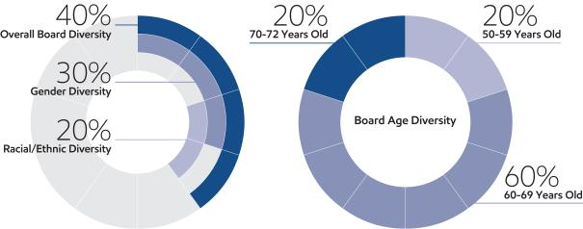

Director Independence

The Corporation’s Corporate Governance Guidelines require that a
substantial majority of the Board consists of independent directors. In general, the Guidelines require that an independent director must have no material relationship with ExxonMobil, directly or indirectly, except as a director. The Board determines independence on the basis of the standards specified by the New York Stock Exchange (“NYSE”), the additional standards referenced in our
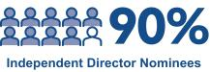
Corporate Governance Guidelines, and other facts and circumstances the Board considers relevant.

Under ExxonMobil’s Corporate Governance Guidelines, a director will not be independent if a reportable “related person transaction” exists with respect to that director or a member of the director’s family for the current or most recently completed fiscal year. See the Guidelines for Review of Related Person Transactions posted on the Corporate Governance section of our website and described in more detail under Related Person Transactions and Procedures on pages 13 and 14.

The Board has reviewed relevant relationships between ExxonMobil and each non-employee director and director nominee to determine compliance with the NYSE standards and ExxonMobil’s additional standards. The Board has evaluated whether there are any other facts or circumstances that might impair a director’s independence. Based on that review, the Board has determined that all ExxonMobil non-employee directors and nominees are independent. The Board has also determined that each member of the Audit, Board Affairs, Compensation, and Public Issues and Contributions Committees (see table on page 15) is independent based on both applicable NYSE standards and the Company’s independence standards for each of these committees. The Company’s standards for each committee are included in their respective charters and are posted on our website at exxonmobil.com/guidelines.

In recommending that each director and nominee be found independent, the Board Affairs Committee reviewed the following transactions, relationships, or arrangements. All matters described below fall within the NYSE and ExxonMobil independence standards.

Name | Matters Considered
U.M. Burns | Ordinary course business with VEON (purchases of telecommunication services)
K.C. Frazier | Ordinary course business with Merck (purchases of pharmaceuticals; sales of chemicals and oils)
S.A. Kandarian | Ordinary course business with MetLife (purchases of employee life insurance and other benefits)
 | 2020 Proxy Statement | 11

Table of Contents

Board Succession

As noted in the committee information that follows, the Board Affairs Committee is responsible for identifying director candidates. The Committee seeks new candidates in several ways:

- Recommendations made by the non-employee directors. These recommendations are developed based on the directors’ own knowledge and experience in a variety of fields and on the research conducted by ExxonMobil staff at the Committee’s direction.

- Engagement of an executive search firm. The firm brings forward potential director candidates for the Committee to consider and helps research candidates identified by the Committee.

- Recommendations made by employee directors, shareholders, and others.

All recommendations, regardless of the source, are evaluated on the same basis against the criteria contained in the Selection Guidelines. The Committee has also instructed its executive search firm to include diversity as part of the candidate search criteria.

Shareholders may send recommendations for director candidates to the Secretary at the address given under Contact Information on page 7. A submission recommending a candidate should include:

- Sufficient biographical information to enable the Committee to evaluate the candidate in light of the Selection Guidelines;

- Information concerning any relationship between the candidate and the recommending shareholder; and

- Material indicating the willingness of the candidate to serve if nominated and elected.

The procedures by which shareholders may recommend nominees have not changed materially since last year’s proxy statement.

The Company seeks to have a diverse Board representing a range of backgrounds, knowledge, and skills relevant to the Company’s business and the needs of the Board, and as part of the search process, considers highly qualified candidates, including women and minorities. The Committee does not use quotas, but considers diversity along with the other requirements of the Selection Guidelines when evaluating potential new directors.

The recommendation to elect Mr. Hooley was made by the incumbent directors.

Board Tenure

The Board does not impose tenure limits on its directors, other than a mandatory retirement age of 72 and the requirement to stand for election annually. Given the complexity and breadth of our business and its long-term investment horizons, the Board considers longevity of service and experience of great value. The Board also believes that its director compensation approach, which limits the vesting of restricted shares until retirement, closely aligns directors with the interests of long-term shareholders.

All ExxonMobil directors stand for election at the annual meeting. Non-employee directors cannot stand for election after they have reached age 72, unless the Board makes an exception on a case-by-case basis. Employee directors resign from the Board when they are no longer employed by ExxonMobil.

As of April 1, 2020, the average tenure of non-employee directors standing for election is 6.1 years, well below the average of S&P 500 companies of 8.0 years (per 2019 Spencer Stuart Board Index).
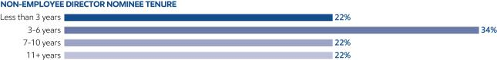

12 2020 Proxy Statement

Table of Contents

Related Person Transactions and Procedures

In accordance with SEC rules, ExxonMobil maintains Guidelines for Review of Related Person Transactions (“Related Person Transaction Guidelines”). These guidelines are available on the Corporate Governance section of our website.

In accordance with the Related Person Transaction Guidelines, all executive officers, directors, and director nominees are required to identify, to the best of their knowledge after reasonable inquiry, business and financial affiliations involving themselves or their immediate family members that could reasonably be expected to give rise to a reportable related person transaction. Covered persons must also advise the Secretary of the Corporation promptly of any change in the information provided, and will be asked periodically to review and reaffirm their information.

For the above purposes, “immediate family member” includes a person’s spouse, parents, siblings, children, in-laws, and step-relatives.

Based on this information, the Company’s own records are reviewed and follow-up inquiries are made as may be necessary to identify potentially reportable transactions. A report summarizing such transactions and including a reasonable level of detail is then provided to the Board Affairs Committee. The Committee oversees the Related Person Transaction Guidelines generally and reviews specific items to assess materiality.

In assessing materiality for this purpose, information will be considered material if, in light of all circumstances, there is a substantial likelihood that a reasonable investor would consider the information important in deciding whether to buy or sell ExxonMobil stock or in deciding how to vote shares of ExxonMobil stock. A director will abstain from the decision on any transactions involving that director or his or her immediate family members.

Under SEC rules, certain transactions are deemed not to involve a material interest (including transactions in which the amount involved in any 12-month period is less than $120,000 and transactions with entities where a related person’s interest is limited to service as a non-employee director). In addition, based on a consideration of ExxonMobil’s facts and circumstances, the Committee will presume that the following transactions do not involve a material interest for purposes of reporting under SEC rules:

- Transactions in the ordinary course of business with an entity for which a related person serves as an executive officer, provided: (1) the affected director or executive officer did not participate in the decision on the part of ExxonMobil to enter into such transactions; and (2) the amount involved in any related category of transactions in a 12-month period is less than 1 percent of the entity’s gross revenues;

- Grants or membership payments in the ordinary course of business to nonprofit organizations, provided: (1) the affected director or executive officer did not participate in the decision on the part of ExxonMobil to make such payments; and (2) the amount of general purpose grants in a 12-month period is less than 1 percent of the recipient’s gross revenues;

- Payments under ExxonMobil plans and arrangements that are available generally to U.S. salaried employees (including contributions under the ExxonMobil Foundation’s Educational and Cultural Matching Gift Programs and payments to providers under ExxonMobil health care plans); and

- Employment by ExxonMobil of a family member of an executive officer, provided the executive officer does not participate in decisions regarding the hiring, performance evaluation, or compensation of the family member.

Transactions or relationships not covered by the above standards will be assessed by the Board Affairs Committee on the basis of the specific facts and circumstances.

Unless otherwise noted, the following disclosures are made as of February 26, 2020, which is the date of the most recent Board Affairs Committee review of potential related person transactions.

ExxonMobil and its affiliates have more than 70,000 employees around the world and employees related by birth or marriage may be found at all levels of the organization. ExxonMobil employees do not receive preferential treatment by reason of being related to an executive officer, and executive officers do not participate in hiring, performance

2020 Proxy Statement | 13

Table of Contents

evaluation, or compensation decisions for family members. ExxonMobil’s employment guidelines state, “Relatives of Company employees may be employed on a non-preferential basis. However, an employee should not be employed by or assigned to work under the direct supervision of a relative, or to report to a supervisor who in turn reports to a relative of the employee.”

Several current ExxonMobil executive officers and retirees who served as executive officers in 2019 have family members who are employed by the Corporation or its affiliates and whose current annualized compensation (including benefits) exceeds the SEC disclosure threshold: L.D. DuCharme (President – Upstream Integrated Solutions Company) has a spouse employed by ExxonMobil Upstream Oil & Gas Company; N.A. Hansen (Vice President – Investor Relations and Secretary to March 15, 2020) has a brother-in-law employed by ExxonMobil Upstream Integrated Solutions Company; L.M. Mallon (President – ExxonMobil Upstream Oil & Gas Company) has a son employed by ExxonMobil Upstream Integrated Solutions Company; K.T. McKee (President – ExxonMobil Chemical Company) has a spouse employed by ExxonMobil Chemical Company; R.N. Schleckser (retired former Vice President and Treasurer) has a brother formerly employed by (now retired from) ExxonMobil Research and Engineering Company; J.M. Spellings, Jr. (Vice President, Treasurer and General Tax Counsel) has a son employed by ExxonMobil Pipeline Company; A.P. Swiger (Senior Vice President – Exxon Mobil Corporation) has a daughter-in-law employed by Exxon Mobil Corporation; and T.J. Wojnar, Jr. (Vice President – Corporate Strategic Planning) has a son-in-law employed by ExxonMobil Fuels & Lubricants Company. Consistent with ExxonMobil’s Related Person Transaction Guidelines as described above, these relationships are not considered to be material within the meaning of the related person transaction disclosure rules.

S.N. Ortwein (retired former President, XTO Energy Inc.) had a brother-in-law who served as Chief Executive Officer of Oracle Corporation. In the ordinary course of our business, ExxonMobil purchases a variety of computer technology and services from Oracle. Ms. Ortwein had no involvement in decisions regarding ExxonMobil’s business with Oracle and the annual volume of such business is well below the categorical threshold established in ExxonMobil’s Related Person Transaction Guidelines. R.M. Ebner (Vice President and General Counsel) has a brother-in-law who is a partner of a law firm that performs limited work for ExxonMobil. Mr. Ebner’s brother-in-law does not work on ExxonMobil’s account and Mr. Ebner is recused from any involvement in decisions to retain the firm. Therefore, these relationships are not considered to be material within the meaning of the related person transaction disclosure rules.

The Board Affairs Committee also reviewed ExxonMobil’s ordinary course business with companies for which non-employee directors or their immediate family members serve as executive officers. The Committee determined that, in accordance with the categorical standards described above, none of those matters represent reportable related person transactions. See Director Independence on page 11.

The Committee also determined that no related person transactions occurred during the year involving any of the investors who have reported ownership of more than 5 percent of ExxonMobil’s outstanding common stock. See Certain Beneficial Owners on page 27.

ExxonMobil is not aware of any related person transactions required to be reported under applicable SEC rules since the beginning of the last fiscal year where our policies and procedures did not require review, or where such policies and procedures were not followed.

The Corporation’s Related Person Transaction Guidelines are intended to assist the Corporation in complying with its disclosure obligations under SEC rules. These procedures are in addition to, not in lieu of, the Corporation’s Code of Ethics and Business Conduct.

Code of Ethics and Business Conduct

The Board maintains policies and procedures (referred to in this proxy statement as the “Code”) that represent both the code of ethics for the principal executive officer, principal financial officer, and principal accounting officer under SEC rules, and the code of business conduct and ethics for directors, officers, and employees under NYSE listing standards. The Code applies to all directors, officers, and employees. The Code includes a Conflicts of Interest Policy under which directors, officers, and employees are expected to avoid any actual or apparent conflict between their own personal interests and the interests of the Corporation.

The Code is posted on the ExxonMobil website at exxonmobil.com/code. The Code is also included as an exhibit to our Annual Report on Form 10-K. Any amendment of the Code will be posted promptly on ExxonMobil’s website.

14 2020 Proxy Statement

Table of Contents

The Corporation maintains procedures for administering and reviewing potential issues under the Code, including procedures that allow employees to make complaints without identifying themselves. The Corporation also conducts periodic mandatory business practice training sessions, and requires regular employees and non-employee directors to complete annual compliance certifications.

The Board Affairs Committee will initially review any suspected violation of the Code involving an executive officer or director and will report its findings to the Board. The Board does not envision that any waiver of the Code will be granted. Should such a waiver occur, it will be promptly disclosed on ExxonMobil’s website.

Board Meetings and Annual Meeting Attendance

The Board met ten times in 2019. ExxonMobil’s incumbent directors, on average, attended approximately 96 percent of Board and committee meetings during 2019. No director attended less than 75 percent of such meetings. ExxonMobil’s non-employee directors held seven executive sessions in 2019.

As specified in our Corporate Governance Guidelines, it is ExxonMobil’s policy that directors should make every effort to attend the annual meeting of shareholders. All directors in 2019 attended last year’s meeting.

Board Committees

The Board appoints committees to help carry out its duties. Board committees work on key issues in greater detail than would be possible at full Board meetings. Only non-employee directors may serve on the Audit, Compensation, Board Affairs, and Public Issues and Contributions Committees. Each committee has a written charter. The charters are posted on the Corporate Governance section of our website at exxonmobil.com/governance.

The tables below show the current membership of each Board committee and the number of meetings each committee held in 2019.

 |  |  |  | Board |  | Public Issues
Director |  | Audit | Compensation | Affairs | Finance | and Contributions | Executive⁽¹⁾
S.K. Avery |  |  |  | ✓ |  | ✓
A.F. Braly |  |  | ✓ |  |  | C
U.M. Burns |  | C |  |  | ✓ |  | ✓
K.C. Frazier |  |  | ✓ | C |  |  | ✓
J.L. Hooley |  | ✓ |  |  | ✓
S.A. Kandarian |  |  | ✓ |  |  | ✓
D.R. Oberhelman |  | ✓ |  |  | ✓
S.J. Palmisano |  |  | C | ✓ |  |  | ✓
S.S Reinemund |  |  |  | ✓ |  | ✓ | ✓
W.C. Weldon |  | ✓ |  |  | ✓
D.W. Woods |  |  |  |  | C |  | C
C = Chair ✓ = Member | (1) Other directors serve as alternate members on a rotational basis

Meetings in 2019:
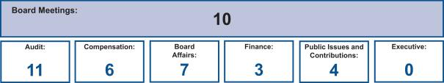

2020 Proxy Statement | 15

Table of Contents

Following is additional information about each Board committee.

Board Affairs Committee

The Board Affairs Committee, chaired by the independent Lead Director, serves as ExxonMobil’s nominating and corporate governance committee. Its responsibilities include:

- Recommendation on director candidates and requests for participation on other boards;

- Maintain procedures for director engagement with shareholders;

- Provide comments and suggestions to the Board on committee structure and committee assignments;

- Review of corporate governance practices, including the Corporate Governance Guidelines;

- Review of any issue involving an executive officer or director under the Code; and

- Administration of ExxonMobil’s Related Person Transaction Guidelines.

The Committee also administers provisions of the Corporate Governance Guidelines that require a director to tender a resignation when there is a substantial change in the director’s circumstances. The Committee reviews the relevant facts to determine whether the director’s continued service would be appropriate and makes a recommendation to the Board.

Another responsibility of the Committee is to review and make recommendations to the Board regarding the compensation of the non-employee directors. The Committee uses an independent consultant, Pearl Meyer & Partners, LLC (“Pearl Meyer”), to provide information on current developments and practices in director compensation. Pearl Meyer is the same consultant retained by the Compensation Committee to advise on executive compensation, but performs no other work for ExxonMobil.

The Guidelines for the Selection of Non-Employee Directors describe the qualifications the Committee looks for in director candidates. These Selection Guidelines, as well as the Committee’s charter, are posted on the Corporate Governance section of our website.

Audit Committee

The Audit Committee oversees accounting and internal control matters. Its responsibilities include oversight of:

- Management’s conduct of the Corporation’s financial reporting process;

- The integrity of the financial statements and other financial information provided by the Corporation to the SEC and the public;

- The Corporation’s system of internal accounting and financial controls;

- The Corporation’s compliance with legal and regulatory requirements;

- The performance of the Corporation’s internal audit function;

- The independent auditors’ qualifications, performance, and independence; and

- The annual independent audit of the Corporation’s financial statements.

The Committee has direct authority and responsibility to appoint (subject to shareholder ratification), compensate, retain, and oversee the independent auditors.

The Committee also prepares the report that SEC rules require be included in the Corporation’s annual proxy statement.
This report is on pages 28 and 29.

The Audit Committee has adopted specific policies and procedures for pre-approving fees paid to the independent auditors. Under the Audit Committee’s approach, an annual program of work is approved each October for the following categories of services: Audit, Audit-Related, and Tax. Additional engagements may be brought forward from time to time for pre-approval by the Audit Committee. Pre-approvals apply to engagements within a category of service, and cannot be transferred between categories. If fees might otherwise exceed pre-approved amounts for any category of permissible services, the incremental amounts must be reviewed and pre-approved prior to commitment. The complete text of the Audit Committee’s pre-approval policies and procedures, as well as the Committee’s charter, is posted on the Corporate Governance section of ExxonMobil’s website.

16 2020 Proxy Statement

Table of Contents

The Board has determined that all members of the Committee are financially literate within the meaning of the NYSE standards, and that Ms. Burns, Mr. Hooley, Mr. Oberhelman, and Mr. Weldon are “audit committee financial experts” as defined in the SEC rules.

Compensation Committee

The Compensation Committee is comprised exclusively of non-employee, independent directors, and oversees compensation for ExxonMobil’s senior executives (including salary, bonus, and performance share awards), as well as succession planning for key executive positions. The Committee’s charter is available on the Corporate Governance section of our website.

During 2019, the Committee took the following actions:

- Reviewed and approved the corporate goals and objectives relevant to the compensation of the CEO;

- Reviewed the Corporation’s business results and progress on strategic plans during the year with ExxonMobil’s CEO and other senior executives;

- Considered the results of the 2019 advisory vote on executive compensation;

- Assessed each element of the Company’s compensation program and practices, and confirmed that they do not create any material adverse risks for the Company. The key design features of the compensation program that discourage executives from taking inappropriate risk are described in detail in this proxy statement (see pages 33, 46, and 47);

- Discussed the Company’s executive compensation program with its independent consultant;

- Established the aggregate annual ceilings for the 2019 short-term and long-term incentive award programs taking into account input received from the CEO and other senior executives;

- Approved the salary program for 2020;

- Reviewed the performance and contributions of, and granted incentive awards and salary for, the CEO. The CEO does not participate in or provide input to decisions regarding his own compensation;

- Reviewed the individual performance and contributions of, and granted individual incentive awards and set salaries for, other senior executives based on recommendations to the Committee by the CEO; and

- Reviewed progress on executive development and succession planning for senior-level positions with input from the CEO.

The Committee does not delegate its responsibilities with respect to ExxonMobil’s executive officers and other senior executives (currently 20 positions). For other employees, the Committee delegates authority to determine individual salaries and incentive awards to a committee consisting of the Chairman and the Senior Vice Presidents of the Corporation. That committee’s actions are subject to a salary budget and aggregate annual ceilings on short-term and long-term incentive awards established by the Compensation Committee.

For more information on the compensation decisions made by the Committee for 2019, refer to the Compensation Discussion and Analysis beginning on page 31.

The Compensation Committee’s report is available on page 30.

The Compensation Committee utilizes the expertise of an external independent consultant, Pearl Meyer. At the direction of the Committee, Pearl Meyer:

- Attends Committee meetings;

- Informs the Committee regarding general trends in executive compensation across industries;

- Prepares the analysis of comparator company compensation used by the Committee; and

- Participates in the Committee’s deliberations regarding compensation for Named Executive Officers.

In addition, at the direction of the Chair of the Board Affairs Committee, Pearl Meyer provides an annual survey of non-employee director compensation for use by that Committee.

2020 Proxy Statement | 17

Table of Contents

The Compensation Committee is solely and directly responsible for the appointment, compensation, and oversight of the consultant. The Committee considers factors that could affect Pearl Meyer’s independence, including that the consultant provides no other services for ExxonMobil other than its engagement by the Committee and the Board Affairs Committee as described above. Based on this review, the Committee has determined the consultant’s work for the Committee to be free from conflicts of interest.

Finance Committee

The Finance Committee reviews ExxonMobil’s financial policies and strategies, including our capital structure, dividends, and share purchase program. The Committee authorizes the issuance of corporate debt subject to limits set by the Board. The Committee’s charter is available on the Corporate Governance section of our website.

Public Issues and Contributions Committee

The Public Issues and Contributions Committee reviews the effectiveness of the Corporation’s policies, programs, and practices with respect to safety, security, health, the environment, including climate-related matters, and social issues. The Committee hears reports from operating units on safety and environmental activities, and also visits operating sites to observe and comment on current operating practices. In addition, the Committee reviews the level of ExxonMobil’s support for education and other public service programs, including the Company’s contributions to the ExxonMobil Foundation. The Foundation works to improve the quality of education in the United States at all levels, with special emphasis on math and science. The Foundation also supports the Company’s other cultural and public service giving. The Committee’s charter is available on the Corporate Governance section of our website.

Executive Committee

The Executive Committee has broad power to act on behalf of the Board. In practice, the Committee meets only when it is impractical to call a meeting of the full Board.

Shareholder Engagement in 2019

The Board and management believe ongoing engagement with our shareholders is vitally important and understand the importance of keeping shareholders informed about the business, understanding shareholders’ perspectives, and addressing areas of interest. The Board and management welcome and value input from all shareholders.

Engaged with: |  | Engaged through: |  |  |  |  | Engagements include:
✓ | Institutional Investors | ✓ | Investor Day |  |  |  | ✓ | Non-employee Directors
✓ | Retail Shareholders | ✓ | Quarterly Earnings Calls |  |  |  | ✓ Chairman / CEO /
✓ | Pension Funds | ✓ | Investor Conferences |  |  |  | ✓ | Management Committee
✓ | Labor Unions | ✓ | Spotlight Events |  |  |  | ✓ | Senior Management
✓ | Religious Organizations | ✓ | Individual Investor Meetings |  |  |  | ✓ | Subject Matter Experts
✓ | Nongovernmental | ✓ | Annual Shareholder Meeting |  |  |  | ✓ | Other Employees
✓ | Organizations | ✓ | Shareholder Webcast
 |  |  |  |  |  |  | Engagements increased:
✓ | Proxy Advisory Firms | ✓ | Stakeholder Outreach
✓ | ESG Rating Firms |  |  |  |  |  |  | > 200%
✓ | Industry Thought Leaders |  |  |  |  |  |  | > 200%
 |  |  |  |  |  |  |  | since 2014
Engaged with shareholders representing: |  |  |  | Information shared through:
 | 1.4 billion shares |  |  | • | SEC Filings |  | • | Energy & Carbon
34% of total outstanding shares |  |  |  | • | Press Releases |  |  | Summary
 |  |  |  | • | Annual Report |  | • | Outlook for Energy
 | and |  |  | • | Company Website |  | • | Sustainability Report
58% of institutional shareholdings |  |  |  | • | Energy Factor |  | • | Perspectives Blog
18 | 2020 Proxy Statement

Table of Contents

Insights into the Boardroom

The Board provides oversight of key risks, including strategic, reputational, financial, operational, SSHE (safety, security, health and environment) and legal compliance matters. The Board routinely reviews environmental stewardship and discusses issues related to the Company’s business, including the risks related to climate change. The process includes briefings on scientific and technical research, public policy positions and analysis, and ongoing progress on Company initiatives and actions with internal and external subject-matter experts.

At least annually, the Board and each of the Board committees conduct an evaluation of their performance and effectiveness, as well as potential changes to the committees’ charters. The Board acts as a collective body, representing the interests of all shareholders. While individual directors leverage their experience and knowledge in Board and committee deliberations, Board decisions and perspectives reflect the collective wisdom of the group. As new directors join the ExxonMobil Board, there is an established process for onboarding and education. This orientation process includes detailed information about ExxonMobil’s history, culture, practices, risk framework and approach to important issues, including the risks related to climate change, among other topics.

The Board has a well-established and rigorous enterprise risk framework in place to oversee risks faced by the Company, including those related to climate change. This integrated risk management approach facilitates recognition and oversight of important risk interdependencies.

The Board considers climate change throughout the year as it assesses research and development efforts, operating strategies, business and corporate planning, technology, current events, shareholder engagements, and Company performance. The Board evaluates climate risks in the context of other operational, market, and financial risks and considers the interactions with these additional factors. It also includes at least one session each year when the full Board engages on the latest developments in climate science and policy.

The Board of Directors, including the Public Issues and Contributions Committee, makes annual site visits to operating locations to observe and provide input on operating practices and external engagement. In 2019, the Board visited ExxonMobil’s largest manufacturing complex, the integrated refining and petrochemical facilities on Jurong Island, Singapore. The visit included an overview of operations, including the fuels, lubricants and chemicals value chains, and the gas and power marketing business. The directors also met with employees responsible for operations and other commercial and business support activities. Additionally, directors met with senior government officials to discuss issues important to the Company and the country of Singapore, including the risks related to climate change. In April, the Board of Directors traveled to the Company’s Spring, Texas, campus to review advances in subsurface technology and gain perspectives from employees. Through these site visits, the directors reviewed the effectiveness of the risk management process and received additional insight into how the Operations Integrity Management System protects ExxonMobil’s employees and physical assets, as well as the community and the environment.

Directors participate in engagements with shareholders periodically throughout the year, in addition to receiving shareholder and stakeholder feedback through other avenues of communication including letters and emails. The Board values these communications and takes such perspectives into consideration in its deliberations, as appropriate.


The Board Affairs Committee has approved and implemented procedures for shareholders and other interested persons to send written or electronic communications to individual directors, including the Lead Director, Board committees, or the non-employee directors as a group.

- Written Communications: Written correspondence should be addressed to the director or directors in care of the Secretary at the address given under Contact Information on page 7.

- Electronic Communications: You may send email to individual non-employee directors, Board committees, or the non-employee directors as a group by using the form provided for that purpose on our website at exxonmobil.com/directors.

2020 Proxy Statement | 19

Table of Contents

Item 1 – Election of Directors

The Board of Directors has nominated the director candidates named on the following pages. Personal information about each of our nominees, including public company directorships during the past five years, is provided. Also included are the particular qualifications and competencies of each director nominee that led the Board to conclude that such person should serve as a director of the Company. All of our nominees currently serve as ExxonMobil directors.

All director nominees have stated they are willing to serve if elected. If a nominee becomes unavailable before the election, your proxy authorizes the people named as proxies to vote for a replacement nominee if the Board names one. Alternatively, the Board may reduce its size to equal the number of remaining nominees.

The Board recommends you vote FOR each of the following candidates:


Susan K. Avery

 |  | Background:
 |  | • Achieved prominence in her field at the Woods Hole Oceanographic Institution, a
 |  |  | global research organization, as President and Director from 2008 to 2015. In the
 |  |  | course of her lengthy and varied experience with matters of climate science,
 |  |  | Dr. Avery has been involved with areas of policy, carbon pricing, renewable energy,
 |  |  | and adaptation.
 |  | • Academic leadership at the University of Colorado Boulder as interim dean of the
 |  |  | graduate school and vice chancellor for research, interim provost, and executive
 |  |  | vice chancellor for academic affairs from 2004 to 2008
Principal occupation: |  | • | Government / scientific research experience as past member of the United
President Emerita, |  |  | Nations Scientific Advisory Board and the National Research Council Global
Woods Hole Oceanographic |  |  | Change Research Program Advisory Committee
Institution |  | • | Scientific and research advisory committee memberships held or recently held at
Age 70 |  | •
Age 70 |  |  | NASA, NOAA, National Science Foundation, Lawrence Berkeley National
Director since 2017 |  |  | Laboratory, National Park System, Independent Advisory Committee on Applied
Independent director |  |  | Climate Risk, Center for Southern Hemisphere Ocean Research, Qingdao National
Committees: |  |  | Laboratory for Marine Science and Technology, and Japan Agency for Marine-Earth
Committees: |  |  | Science and Technology
Board Affairs, Public Issues |  |  | Science and Technology
 |  |  | Scientific and environmental affiliations: University Corporation for Atmospheric
and Contributions |  | •
 |  |  | Research (Chair of Board), Consortium for Ocean Leadership (senior fellow),
 |  |  | American Geophysical Union, American Meteorological Society (fellow), American
 |  |  | Association for the Advancement of Science (fellow), and Institute of Electrical and
 |  |  | Electronics Engineers (fellow)
 |  | Current public company directorships: None
 |  | Previous public company directorships in last five years: None
20 | 2020 Proxy Statement

Table of Contents
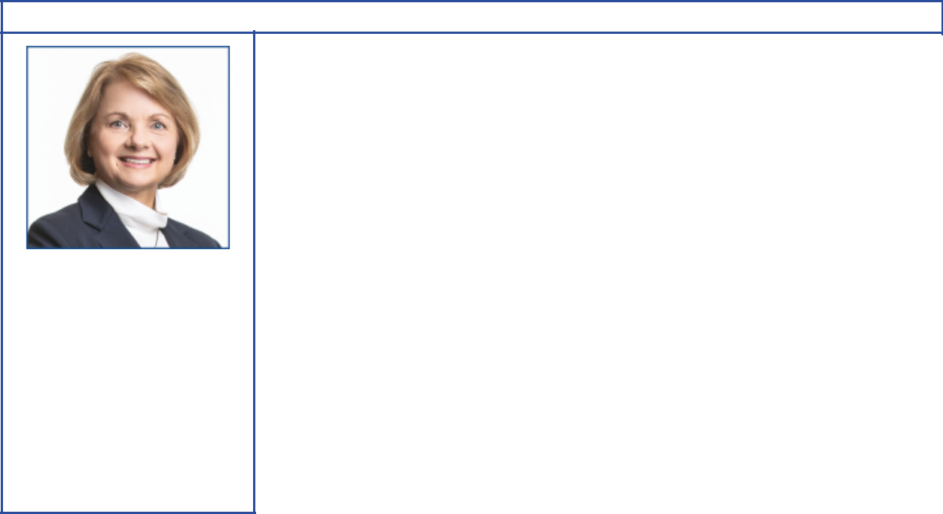

Angela F. Braly

Principal occupation: Former Chairman of the Board, President, and Chief Executive Officer, WellPoint (now Anthem)

Age 58
Director since 2016
Independent director

Committees:

Compensation, Public Issues
and Contributions

Background:

- Business leadership with operational experience at WellPoint as Chairman from 2010 to 2012; as President, Chief Executive Officer, and board member from 2007 to 2012; and as Executive Vice President, General Counsel, and Chief Public Affairs Officer from 2005 to 2007. She also served as President and Chief Executive Officer of Blue Cross Blue Shield of Missouri from 2003 to 2005.

- Business and public policy affiliations: The Policy Circle (Co-Founder, Director, and Secretary), Indiana Economic Development Corporation (former Director), Business Council (former member), Business Roundtable (former member), Harvard Advisory Council on Health Care Policy (former member), and Blue Cross Blue Shield Association (former Director)

Current public company directorships: Brookfield Asset Management Inc. (May 2015 to Present); Lowe’s Companies, Inc. (November 2013 to Present); The Procter & Gamble Company (December 2009 to Present)

Previous public company directorships in last five years: None

Other board experience: former Director of WellPoint, Inc. (prior to 2015)
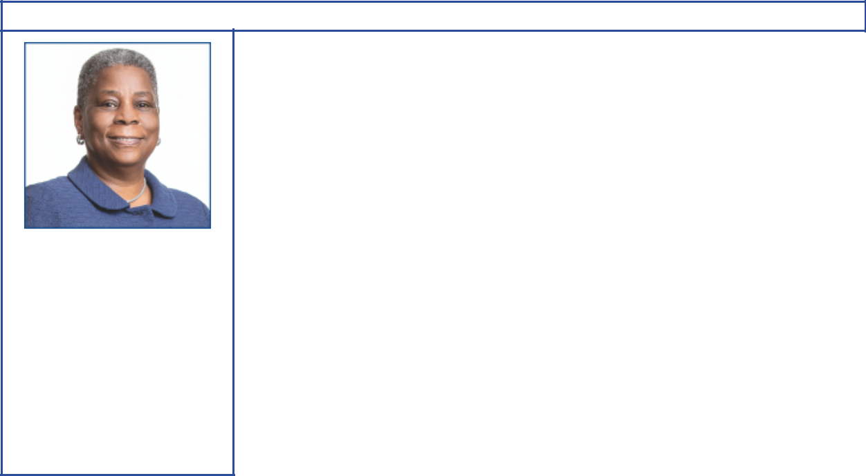

Ursula M. Burns

Principal occupation: Chairman of the Board, VEON Ltd.

Age 61
Director since 2012
Independent director

Committees:

Audit, Executive, Finance

Background:

- Global business leadership with operational experience at Xerox as Chairman from 2010 to 2017; as Chief Executive Officer from 2009 to 2016; and as President from 2007 to 2016. She also served as Senior Vice President, Corporate Strategic Services, and Senior Vice President and President, Document Systems and Solutions Group, and Business Group Operations, at Xerox. She is currently Chairman of the Board of VEON Ltd., and served as Chief Executive Officer from 2018 through February 2020.

- Government and public policy experience as Vice Chair and Chair of the President’s Export Council (2010 to 2016)

- Scientific, academic, and non-profit affiliations: Ford Foundation (Trustee), National Academy Foundation, Mayo Clinic (counsel/advisor), MIT Corporation (Trustee), National Academy of Engineers (member), American Academy of Arts and Sciences (member), Cornell Technology Board of Overseers (counsel/advisor), and New York City Ballet Inc. (Director)

Current public company directorships: Nestlé S.A. (April 2017 to Present); Uber (May 2019 to Present); VEON Ltd. (July 2017 to Present)

Previous public company directorships in last five years: American Express (January 2004 to May 2018); Xerox (April 2007 to June 2017)

Other board experience: former Director of Boston Scientific (prior to 2015)

2020 Proxy Statement | 21

Table of Contents


Kenneth C. Frazier

Principal occupation:

Chairman of the Board
and Chief Executive Officer,
Merck & Co., Inc.

Age 65
Director since 2009
Independent director
Lead Director since 2020

Committees:

Board Affairs, Compensation, Executive

Background:

- Global business leadership with operational experience at Merck & Co., Inc. as Chairman and Chief Executive Officer from 2011 to present; and as Executive Vice President and President, Global Human Health, from 2007 to 2010. He also served as Executive Vice President and General Counsel.

- Legal and business affiliations: American Law Institute, Business Council and American Bar Association

- Scientific and research affiliations: Pharmaceutical Research and Manufacturers of America, Weill Cornell Medicine, and American Academy of Arts and Sciences

Current public company directorships: Merck & Co., Inc. (January 2011 to Present)

Previous public company directorships in last five years: None


Joseph L. Hooley

 |  | Background:
 |  | • Global business leadership with operational experience at State Street
 |  | Corporation as Chairman from 2011 to 2019; as Chief Executive Officer from 2010
 |  | to 2018; as President and Chief Operating Officer from 2008 to 2014; as Executive
 |  | Vice President and head of Investor Services Division from 2002 to 2008; and, in
 |  | 2006, as Vice Chairman and Global Head of Investment Servicing and Investment
 |  | Research and Trading. He also served as President and Chief Executive Officer of
 |  | Boston Financial Data Services from 1990 to 2000, and as President and Chief
 |  | Executive Officer of National Financial Data Services from 1988 to 1990.
Principal occupation: |  | • Charitable affiliations: Boys & Girls Clubs of Boston (Trustee of Youth Services)
Principal occupation: |  | Current public company directorships: Aptiv PLC (January 2020 to Present)
Former Chairman of the
Board, President, and Chief |  | Previous public company directorships in last five years: State Street Corporation
Executive Officer,
Executive Officer, |  | (2009 to December 2019)
State Street Corporation |  | (2009 to December 2019)
 |  | Other board experience: Liberty Mutual Insurance (April 2019 to Present)
Age 63
Director since 2020
Independent director
Committees:
Audit, Finance
22 | 2020 Proxy Statement

Table of Contents
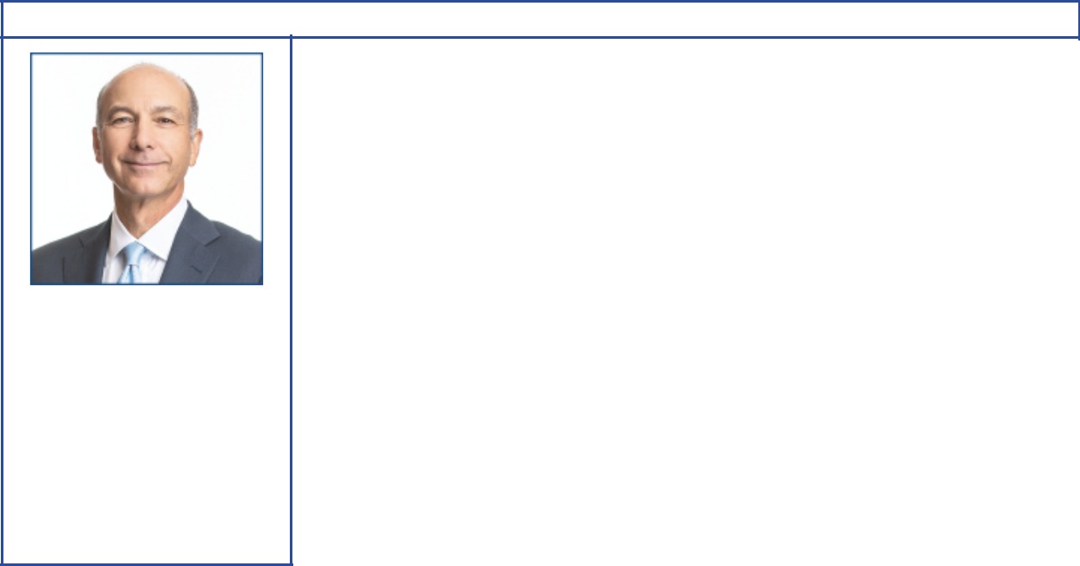

Steven A. Kandarian

Principal occupation: Former Chairman of the Board, President, and Chief Executive Officer, MetLife

Age 68
Director since 2018
Independent director

Committees:

Compensation, Public Issues
and Contributions

Background:

- Global business leadership with operational experience at MetLife, Inc. as Chairman from 2012 to 2019; as President and Chief Executive Office from 2011 to 2019; and as Executive Vice President and Chief Investment Officer from 2005 to 2011. He also served as Executive Director of the Pension Benefit Guaranty Corporation from 2001 to 2004.

- Business and cultural affiliations: Business Council, Business Roundtable (former member), Partnership for New York City (former Director), Institute of International Finance (former Director and Chair, Insurance Regulatory Committee), and the Lincoln Center for the Performing Arts (former Director)

- Scientific and research affiliations: Damon Runyon Cancer Research Foundation (Director)

Current public company directorships: AECOM (March 2019 to Present)

Previous public company directorships in last five years: MetLife (May 2011 to April 2019)

Other board experience: Director of Neuberger Berman (March 2015 to Present)
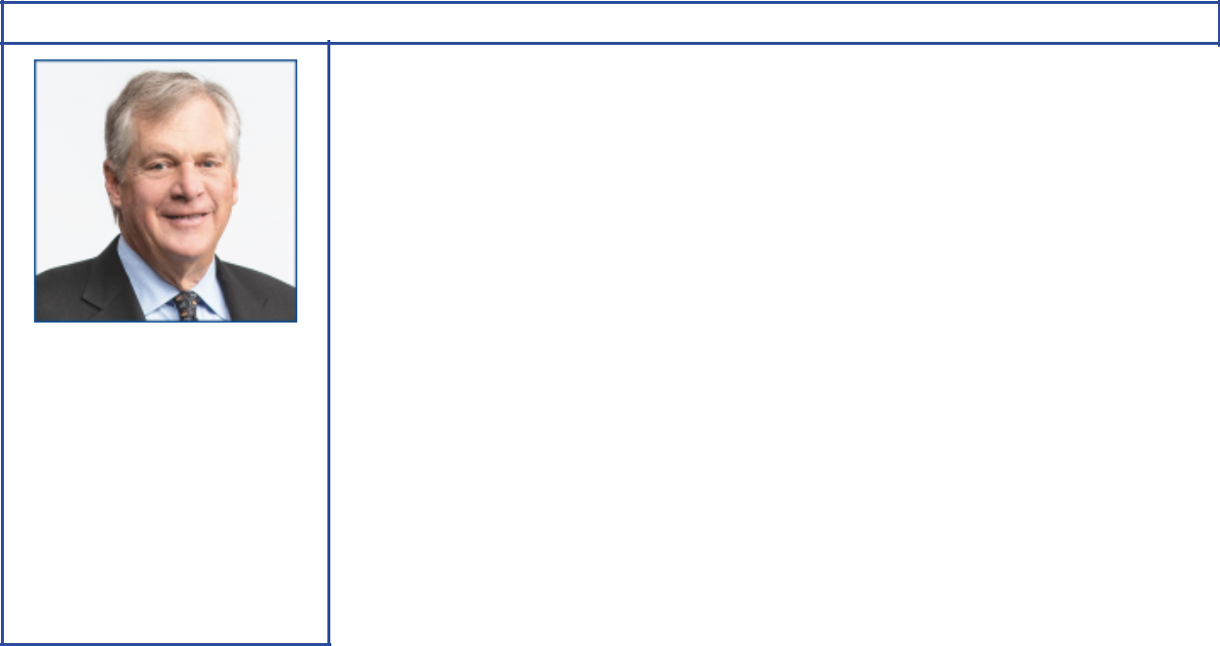

Douglas R. Oberhelman

Principal occupation: Former Chairman of the Board and Chief Executive Officer, Caterpillar Inc.

Age 67
Director since 2015
Independent director

Committees:

Audit, Finance

Background:

- Global business leadership with operational and commodity business experience at Caterpillar Inc. as Chairman from 2010 to 2017; as Chief Executive Officer from 2010 to 2016; as Group President of Caterpillar from 2002 to 2010; and as Vice President, Engine Products Division from 1998 to 2002. He also served as Vice President and Chief Financial Officer from 1995 to 1998.

- Business and charitable affiliations: Business Roundtable (former Chairman), National Association of Manufacturers (former Chairman), Easter Seals Foundation of Central Illinois (Chairman), Gilmore Foundation (Chairman), and Intersect Illinois (Director)

- Environmental conservation: Wetlands America Trust (Vice President), Max McGraw Wildlife Foundation (Director)

Current public company directorships: Bombardier (November 2017 to Present)

Previous public company directorships in last five years: Caterpillar Inc. (July 2010 to March 2017)

Other board experience: Director of Peter Kiewit Sons’, Inc. (August 2017 to Present); Chairman and Director of Switch Rail Safety Systems, LLC (June 2018 to Present); former Director of Eli Lilly and Company (December 2008 to February 2015); former Director of Ameren Corporation (prior to 2015)

2020 Proxy Statement | 23

Table of Contents
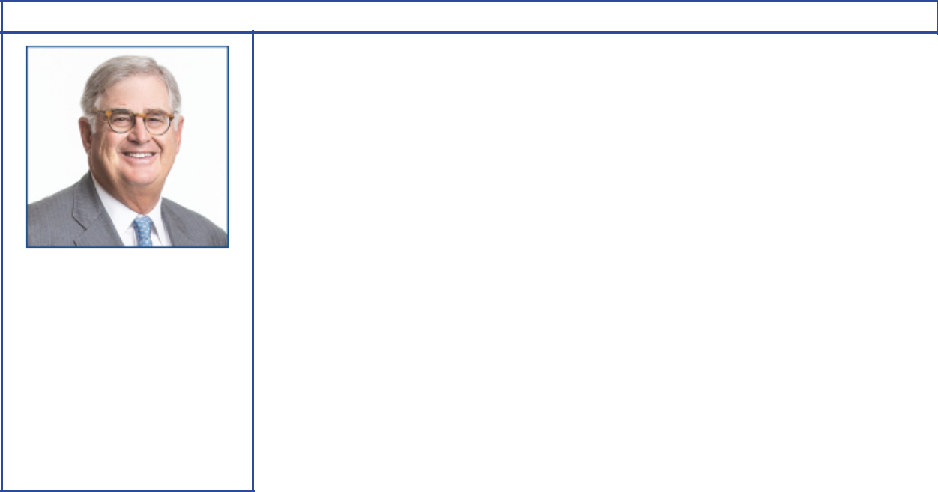

Samuel J. Palmisano

Principal occupation: Former Chairman of the Board, President, and Chief Executive Officer, IBM

Age 68
Director since 2006
Independent director

Committees:

Board Affairs, Compensation, Executive

Background:

- Global business leadership with operational experience at IBM as Chairman, President, and Chief Executive Officer from 2003 to 2012. He also served as President, Senior Vice President, and Group Executive for IBM’s Enterprise Systems Group, IBM Global Services, and IBM’s Personal Systems Group.

- Business and public policy affiliations: The Center for Global Enterprise (Chairman), Business Roundtable (former member), Executive Committee of the Council on Competitiveness, Commission on Enhancing National Cybersecurity (former Vice Chair), and co-chair of an independent task force of the Council on Foreign Relations on cybersecurity

Current public company directorships: None

Previous public company directorships in last five years: American Express (March 2013 to May 2019)

Other board experience: former Director of Gannett Co. and IBM (both prior to 2015)
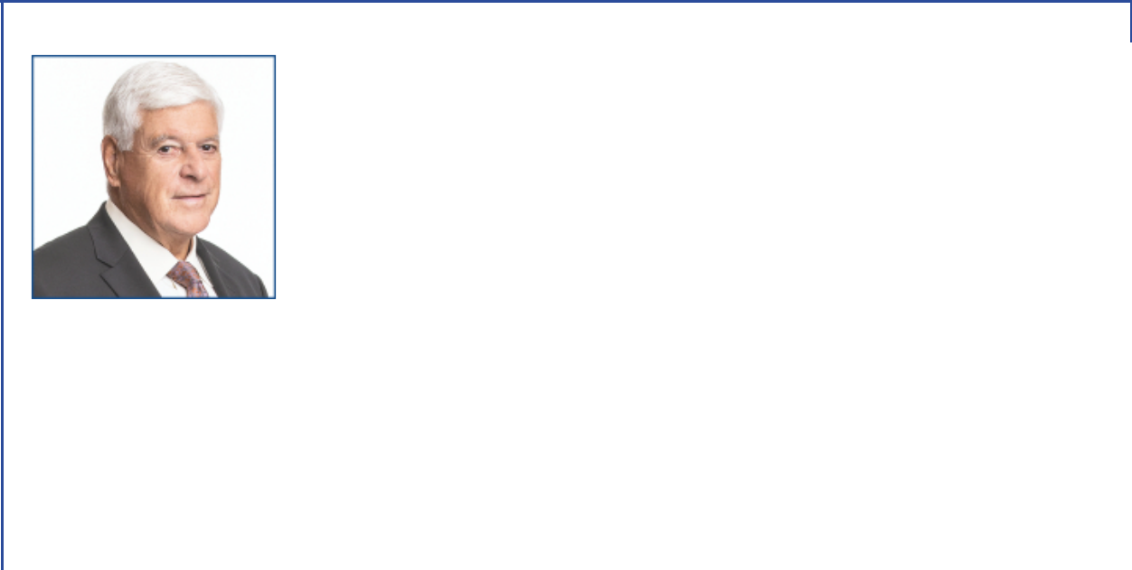

William C. Weldon

 |  | Background:
 |  | • Global business leadership with operational experience at Johnson & Johnson
 |  | as Chairman and Chief Executive Officer from 2002 to 2012; as Vice Chairman from
 |  | 2001 to 2002; and as Worldwide Chairman, Pharmaceuticals Group from 1998 to
 |  | 2001.
 |  | • Business affiliations: Business Council (former Vice Chairman), Business
 |  | Roundtable (former member), and Healthcare Leadership Council
 |  | • Scientific, research and academic affiliations: Pharmaceutical Research and
Principal occupation: |  | Manufacturers of America (former Chairman), Quinnipiac University Board of
Principal occupation: |  | Trustees (Chairman), and CEO Roundtable on Cancer (former Chairman)
Former Chairman of the |  | Current public company directorships: CVS Caremark (March 2013 to Present)
Board and Chief Executive
Officer, Johnson & Johnson |  | Previous public company directorships in last five years: JPMorgan Chase (March
Age 71 |  | 2005 to April 2019); The Chubb Corporation (May 2013 to January 2016)
Director since 2013 |  | Other board experience: former Director of Johnson & Johnson (prior to 2015)
Independent director
Committees:
Audit, Finance
24 | 2020 Proxy Statement

Table of Contents
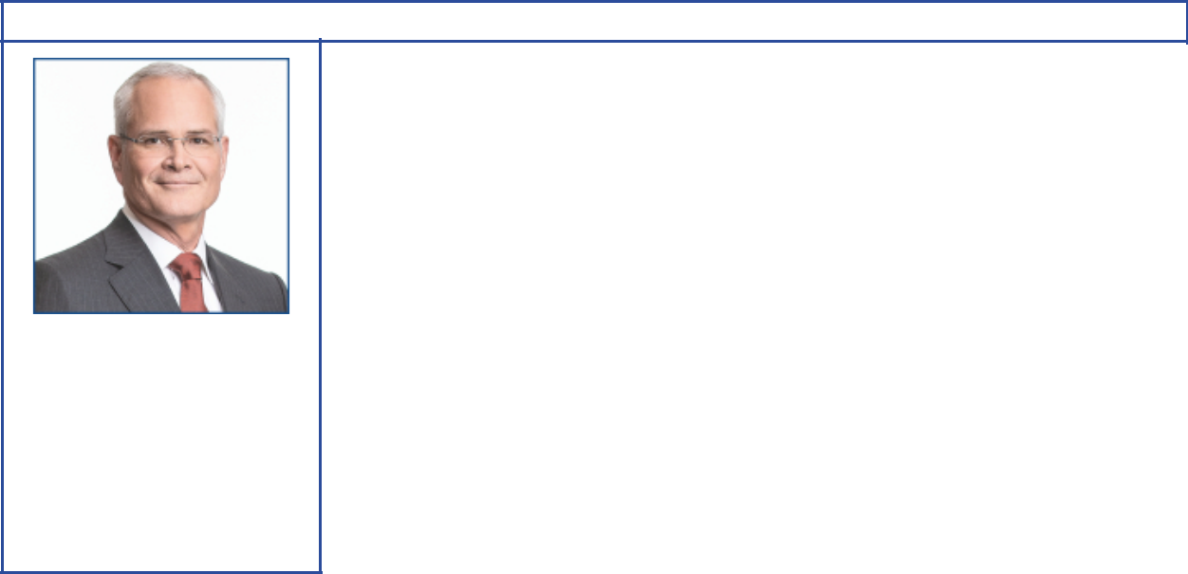

Darren W. Woods

Principal occupation: Chairman of the Board and Chief Executive Officer, Exxon Mobil Corporation

Age 55
Director since 2016

Committees:

Finance, Executive

Background:

- Global business leadership at Exxon Mobil Corporation as Chairman and Chief Executive Officer since 2017; as President in 2016; and as Senior Vice President in 2014 and 2015. He also served as Vice President, and President, ExxonMobil Refining & Supply Company from 2012 to 2014.

- Operational and commodity business experience with positions of increasing responsibility in domestic and international business operations at ExxonMobil Refining & Supply Company, ExxonMobil Chemical Company, and Exxon Company International

- Business affiliations: Business Roundtable, American Petroleum Institute (former Chair), Business Council, Center for Strategic and International Studies (Trustee), Oil and Gas Climate Initiative, and National Petroleum Council (Vice Chair)

- Scientific and environmental experience: ExxonMobil Chemical Company and ExxonMobil Refining & Supply Company

Current public company directorships: None

Previous public company directorships: Imperial Oil Ltd. (April 2013 to July 2014)

DIRECTOR COMPENSATION

Director compensation elements are designed to:

- Ensure alignment with long-term shareholder interests;

- Ensure the Company can attract and retain outstanding director candidates who meet the selection criteria outlined in the Guidelines for Selection of Non-Employee Directors, which can be found on the Corporate Governance section of our website;

- Recognize the substantial time commitment necessary to oversee the affairs of the Corporation; and

- Support the independence of thought and action expected of directors.

Non-employee director compensation levels are reviewed by the Board Affairs Committee each year, and resulting recommendations are presented to the full Board for approval. The Committee uses an independent consultant, Pearl Meyer, to provide information on current developments and practices in director compensation. Pearl Meyer is the same consultant retained by the Compensation Committee to advise on executive compensation, but performs no other work for ExxonMobil.

ExxonMobil employees receive no additional pay for serving as directors.

Non-employee directors receive compensation consisting of cash and equity in the form of restricted stock. Non-employee directors are also reimbursed for reasonable expenses incurred to attend Board meetings or other functions relating to their responsibilities as a director of Exxon Mobil Corporation.

The annual cash retainer for non-employee directors is $ 110,000 per year. The Chairs of the Audit and Compensation Committees receive an additional $10,000 per year. The Lead Director receives an additional $50,000 per year.

A significant portion of director compensation is granted in the form of restricted stock to align director interests with the interests of our long-term shareholders. The annual restricted stock award grant for incumbent non-employee directors is 2,500 shares. A new non-employee director receives a one-time grant of 8,000 shares of restricted stock upon first being elected to the Board.

2020 Proxy Statement | 25

Table of Contents

While on the Board, the non-employee director receives the same cash dividends on restricted shares as a holder of regular common stock, but the shares remain unvested and, thus, cannot be sold or pledged. The restricted shares are subject to forfeiture if the non-employee director leaves the Board early, i.e., before the retirement age of 72, as specified for non-employee directors.

Current and former non-employee directors of Exxon Mobil Corporation are eligible to participate in the ExxonMobil Foundation’s Educational and Cultural Matching Gift Programs under the same terms as the Corporation’s U.S. employees.

Non-employee Director Compensation for 2019

 |  |  |  |  | Change in
 |  |  |  |  | Pension Value
 |  |  |  |  | and
 | Fees |  |  |  | Nonqualified
 | Earned |  |  | Non-Equity | Deferred
 | or Paid | Stock | Option | Incentive Plan | Compensation | Other
 | in Cash | Awards | Awards | Compensation | Earnings | Compensation | Total
Name | ($) | ($)(b) | ($) | ($) | ($) | ($)(c) | ($)
S.K. Avery | 110,000 | 171,413 | 0 | 0 | 0 | 283 | 281,696
A.F. Braly | 110,000 | 171,413 | 0 | 0 | 0 | 283 | 281,696
U.M. Burns | 120,000 | 171,413 | 0 | 0 | 0 | 283 | 291,696
K.C. Frazier | 110,000 | 171,413 | 0 | 0 | 0 | 283 | 281,696
S.A. Kandarian | 110,000 | 171,413 | 0 | 0 | 0 | 283 | 281,696
D.R. Oberhelman | 110,000 | 171,413 | 0 | 0 | 0 | 283 | 281,696
S.J. Palmisano | 120,000 | 171,413 | 0 | 0 | 0 | 283 | 291,696
S.S Reinemund | 120,000^{(a)} | 171,413 | 0 | 0 | 0 | 283 | 291,696
W.C. Weldon | 110,000 | 171,413 | 0 | 0 | 0 | 283 | 281,696

- During 2019, S.S Reinemund served as Presiding Director, entitled to an additional cash retainer of $10,000.

- In accordance with SEC rules, the valuation of stock awards in this table represents fair value on the date of grant. Dividends on stock awards are not shown in the table because those amounts are factored into the grant date fair value.

Each director received an annual grant of 2,500 restricted shares in January 2019. The valuation of these awards is based on a market price of $68.565 on the date of grant.

At year-end 2019, the aggregate number of restricted shares held by each director was as follows:

Name | Restricted Shares (#)
S.K. Avery | 13,000
A.F. Braly | 15,500
U.M. Burns | 25,500
K.C. Frazier | 33,000
S.A. Kandarian | 10,500
D.R. Oberhelman | 18,000
S.J. Palmisano | 42,000
S.S Reinemund | 38,000
W.C. Weldon | 23,000

- The amount shown for each director is the cost of travel accident insurance covering death, dismemberment, or loss of sight, speech, or hearing under a policy purchased by the Corporation with a maximum benefit of $500,000 per individual.

The non-employee directors are not entitled to any additional payments or benefits as a result of leaving the Board or death except as described above. The non-employee directors are not entitled to any payments or benefits resulting from a change in control of the Corporation.

26 2020 Proxy Statement

Table of Contents

CERTAIN BENEFICIAL OWNERS

Based on our review of ownership reports filed with the SEC, the firms listed below are the only beneficial owners of more than 5 percent of ExxonMobil’s outstanding common stock as of December 31, 2019.

Name and Address | Shares | Percent of
of Beneficial Owner | Owned | Class
The Vanguard Group | 353,531,191 | 8.4%
100 Vanguard Blvd.
Malvern, PA 19355
BlackRock, Inc. | 282,620,834 | 6.7%
55 East 52nd Street
New York, NY 10055

DIRECTOR AND EXECUTIVE OFFICER STOCK OWNERSHIP

These tables show the number of ExxonMobil common shares each executive named in the Summary Compensation Table on page 50 and each non-employee director or director nominee owned on February 29, 2020. In these tables, ownership means the right to direct the voting or the sale of shares, even if those rights are shared with someone else. None of these individuals owns more than 0.02 percent of the outstanding shares.

 |  | Shares Covered by
Named Executive Officer | Shares Owned⁽¹⁾ | Exercisable Options
D.W. Woods | 98,128 | 0
A.P. Swiger | 526,425 | 0
N.A. Chapman | 107,129⁽²⁾ | 0
J.P. Williams, Jr. | 96,813 | 0
N.W. Duffin | 290,095⁽³⁾ | 0

- Does not include unvested restricted stock units, which do not carry voting rights prior to the issuance of shares on settlement of the awards.
- Includes 23,482 shares jointly owned with spouse.
- Co-trustee and co-beneficiary with spouse in family trust for 132,097 shares.

Non-Employee Director | Shares Owned
S.K. Avery | 15,500
A.F. Braly | 20,075⁽¹⁾
U.M. Burns | 28,206
K.C. Frazier | 35,500
J.L. Hooley | 8,000⁽²⁾
S.A. Kandarian | 13,000
D.R. Oberhelman | 20,500
S.J. Palmisano | 44,500
S.S Reinemund | 50,625
W.C. Weldon | 26,767

- Includes 1,175 shares owned by spouse and 900 shares held in trusts for family members for which Ms. Braly serves as co-trustee.
- Mr. Hooley joined the Board in January 2020 and received a one-time grant of 8,000 restricted shares.

On February 29, 2020, ExxonMobil’s incumbent directors and executive officers (26 people) together owned 2,164,631 shares of ExxonMobil stock and zero shares covered by exercisable options, representing about 0.05 percent of the outstanding shares.

2020 Proxy Statement | 27

Table of Contents

Section 16(a) Beneficial Ownership Reporting Compliance

Section 16(a) of the Securities and Exchange Act of 1934 requires our executive officers and directors to file reports of their ownership and changes in ownership of ExxonMobil stock on Forms 3, 4, and 5 with the SEC. We are not aware of any unfiled or late reports for 2019.

AUDIT COMMITTEE REPORT

The primary function of the Audit Committee is oversight of the Corporation’s financial reporting process, public financial reports, internal accounting and financial controls, and the independent audit of the annual consolidated financial statements. The Committee acts under a charter, which can be found on the ExxonMobil website at exxonmobil.com/auditcommitteecharter. The adequacy of the charter is reviewed at least annually. All members of the Audit Committee are independent directors and the Committee met 11 times in 2019. In these meetings, as discussed in more detail below, it had extensive reports and discussions with the independent auditors, internal auditors, and members of management.

In performing its oversight function, the Committee reviewed and discussed the consolidated financial statements with management and PricewaterhouseCoopers LLP (“PwC”), the independent auditors. Management and PwC indicated that the Corporation’s consolidated financial statements were fairly stated in accordance with generally accepted accounting principles. The Committee discussed significant accounting policies applied by the Corporation in its financial statements, as well as alternative treatments. It also discussed with PwC matters covered by Public Company Accounting Oversight Board (“PCAOB”) standards, including PCAOB AS 1301 Communication with Audit Committees. In addition, the Committee reviewed and discussed management’s report on internal control over financial reporting and the related audits performed by PwC, which confirmed the effectiveness of the Corporation’s internal control over financial reporting.

The Audit Committee also discussed with PwC its independence from the Corporation and management, including the communications PwC is required to provide under applicable PCAOB rules. The Committee considered the non-audit services provided by PwC to the Corporation, and concluded that the auditors’ independence has been maintained.

The Committee discussed with the Corporation’s internal auditors and PwC the overall scope and plans for their respective audits; furthermore, it met with the internal auditors and PwC at each meeting, both with and without management present. Discussions included the results of their examinations, their evaluations of the Corporation’s internal controls, and the overall quality of the Corporation’s financial reporting.

The Audit Committee met with the Corporation’s management to discuss the comprehensive, long-standing risk management and compliance processes of the Corporation, and reviewed several topics of interest.

Based on the reviews and discussions referred to above, in reliance on management and PwC, and subject to the limitations of its role described below, the Audit Committee recommended to the Board, and the Board approved, the inclusion of the audited financial statements in the Corporation’s Annual Report on Form 10-K for the year ended December 31, 2019, for filing with the SEC.

In carrying out its responsibilities, the Audit Committee looks to management and the independent auditors. Management is responsible for the preparation and fair presentation of the Corporation’s financial statements and for maintaining effective internal control. Management is also responsible for assessing and maintaining the effectiveness of internal control over the financial reporting process in compliance with Sarbanes-Oxley Section 404 requirements. The independent auditors are responsible for auditing the Corporation’s annual financial statements, and expressing an opinion as to whether the statements are fairly stated in conformity with generally accepted accounting principles. In addition, the independent auditors are responsible for auditing the Corporation’s internal control over financial reporting and for expressing an opinion on the effectiveness of internal control over financial reporting. The independent auditors perform their responsibilities in accordance with the standards of the PCAOB. Audit Committee members are not professionally engaged in the practice of accounting or auditing, and are not experts under the Securities Act of 1933 in either of those fields or in auditor independence.

28 2020 Proxy Statement

Table of Contents

The Audit Committee has also appointed PwC to audit the Corporation’s financial statements for 2020, subject to shareholder ratification of that appointment. The Committee, along with the other members of the Board, management, the Controller, and the General Auditor, annually evaluates PwC’s qualifications, performance, and independence, including the performance of the lead audit partner, in deciding whether or not to retain PwC. That evaluation includes consideration of:

- PwC’s quality control, including any material issues identified by that quality control or a governmental/professional authority along with PwC’s plan to deal with any such issues;

- All relationships between PwC and ExxonMobil covered by the PCAOB;

- PwC’s expertise in the global oil and gas industry; and

- The quality of PwC’s audit plans.

The Committee believes that PwC’s tenure as ExxonMobil’s independent registered public accounting firm is a benefit to audit quality given PwC’s experience with ExxonMobil and knowledge of the business, as well as the effectiveness of their audit plans, which build on that established knowledge.

Based on its annual evaluation of PwC’s qualifications, performance, and independence, as well as frequent private meetings with the lead partner, the Audit Committee believes that the continued retention of PwC as ExxonMobil’s independent registered public accounting firm is in the best interest of the Corporation and its stockholders.

Ursula M. Burns, Chair
Joseph L. Hooley

Douglas R. Oberhelman
William C. Weldon

Item 2 – Ratification of Independent Auditors

The Audit Committee has appointed PricewaterhouseCoopers LLP to audit ExxonMobil’s financial statements for 2020.
We are asking you to ratify that appointment.

Total Fees

The total fees for PwC professional services rendered to ExxonMobil for the year ended December 31, 2019, were $42.5 million, an increase of $1.3 million from 2018. The Audit Committee reviewed and pre-approved all services in accordance with the service pre-approval policies and procedures, which can be found on the ExxonMobil website at exxonmobil.com/pre-approval. The Audit Committee did not use the “de minimis” exception to pre-approval that is available under SEC rules. The following table summarizes the fees, which are described in more detail below.

 | 2019 |  |  | 2018
 |  |  | (millions of dollars)
Audit Fees | 34.6 |  |  | 31.4
Audit-Related Fees | 6.9 |  |  | 8.8
Tax Fees | 1.0 |  |  | 1.0
All Other Fees |  |  | — |  | —
Total | 42.5 |  |  | 41.2

Audit Fees

The aggregate fees for PwC professional services rendered for the annual audits of ExxonMobil’s financial statements for the year ended December 31, 2019, and for the reviews of the financial statements included in our quarterly reports on Form 10-Q for that year were $34.6 million (versus $31.4 million for 2018).

Audit-Related Fees

The aggregate fees for PwC Audit-Related services rendered to ExxonMobil for the year ended December 31, 2019, were $6.9 million (versus $8.8 million for 2018). Audit-related services were mainly related to benefit plan audits and other attestation procedures.

2020 Proxy Statement | 29

Table of Contents

Tax Fees

The aggregate fees for PwC Tax services rendered to ExxonMobil for the year ended December 31, 2019, were
$1.0 million (versus $1.0 million for 2018). These services were mainly related to assisting various ExxonMobil affiliates with the preparation of local tax filings and related services.

All Other Fees

The aggregate fees for PwC services rendered to ExxonMobil, other than the services described above under “Audit Fees,” “Audit-Related Fees,” and “Tax Fees,” for the year ended December 31, 2019, were zero (also zero for 2018).

We believe PwC is well qualified to perform this work. A PwC representative will be at the annual meeting to answer appropriate questions and to make a statement if desired.

The Audit Committee recommends you vote FOR this proposal.

COMPENSATION COMMITTEE REPORT

The Compensation Committee of the Board of Directors has reviewed and discussed the Compensation Discussion and Analysis with management of the Corporation. Based on that review and discussion, we recommended to the Board that the Compensation Discussion and Analysis be included in the Corporation’s proxy statement for the 2020 annual meeting of shareholders, and also incorporated by reference in the Corporation’s Annual Report on Form 10-K for the year ended December 31, 2019.

Samuel J. Palmisano, Chair
Kenneth C. Frazier

Angela F. Braly
Steven A. Kandarian

Item 3 – Advisory Vote to Approve Executive Compensation

At the meeting, shareholders will be asked to vote on a non-binding resolution to approve the compensation of the Named Executive Officers (NEOs), listed in the Summary Compensation Table.

When casting your vote, we encourage you to consider the detailed information in the Compensation Discussion and Analysis beginning on page 31.

The Board continues to support the overall design of the compensation program, on the basis that the program:

- Is aligned with the Company’s business model and shareholder returns over the long term;

- Delivers pay that is highly performance based and tied to company performance; and

- Enables the Compensation Committee to leverage its experience and judgment to deliver market competitive pay.

We continue to listen and respond to the feedback we receive from shareholders during our shareholder engagement process. As in previous years, we enhanced disclosures in response to shareholder feedback.

The Board recommends an advisory vote FOR the following resolution:

RESOLVED: That shareholders approve the compensation of the Named Executive Officers as disclosed pursuant to Item 402 of SEC Regulation S-K, including the Compensation Discussion and Analysis, compensation tables, and narrative discussion on pages 31 to 58 of this proxy statement.

30 2020 Proxy Statement

Table of Contents
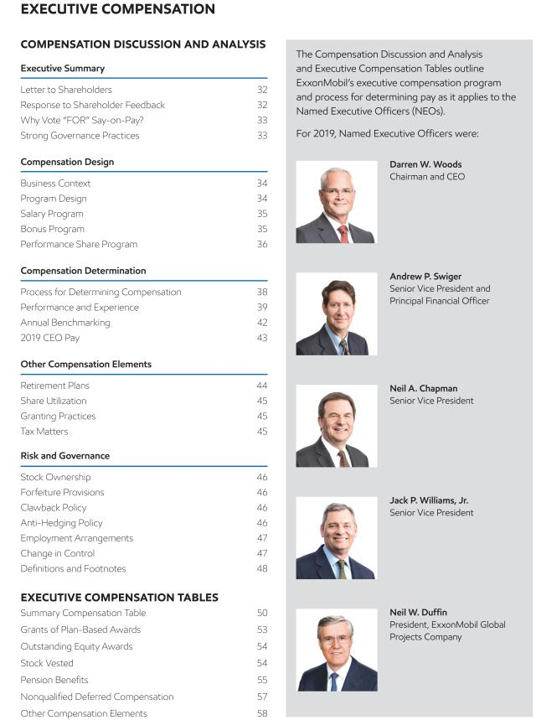

2020 Proxy Statement | 31

Table of Contents
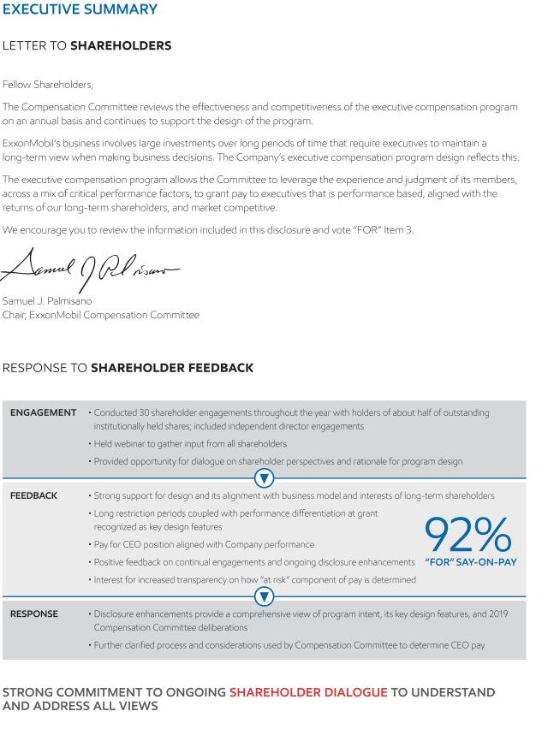

32 2020 Proxy Statement

Table of Contents
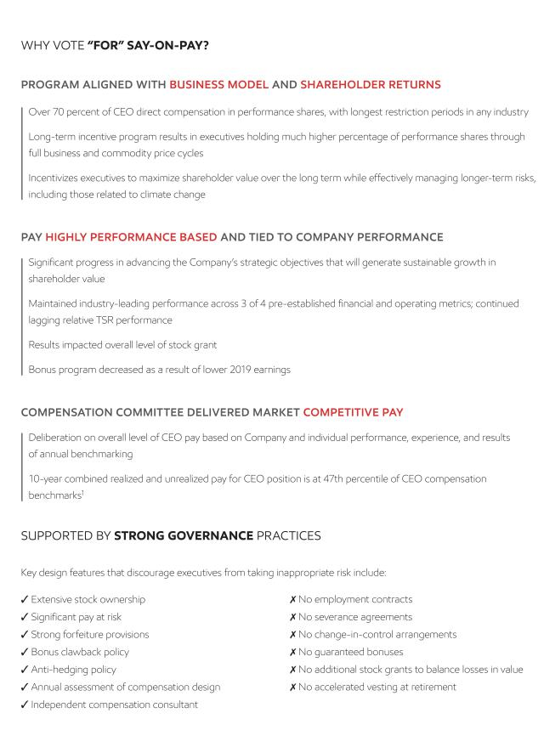

2020 Proxy Statement | 33

Table of Contents
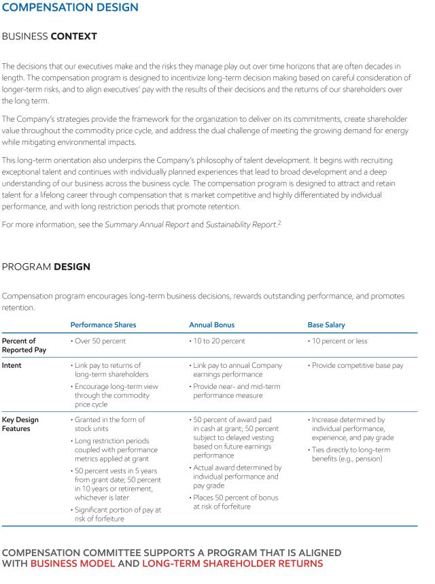

34 2020 Proxy Statement

Table of Contents
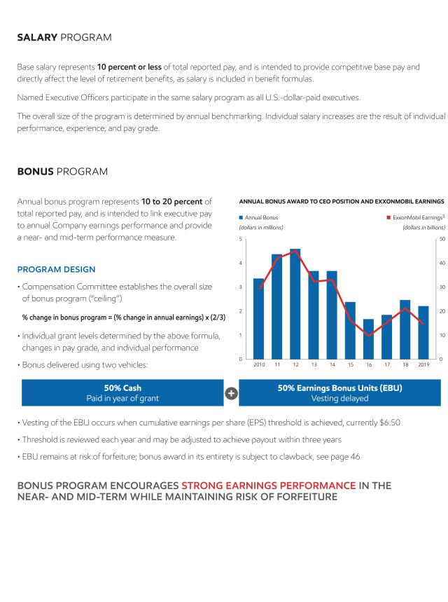

2020 Proxy Statement | 35

Table of Contents
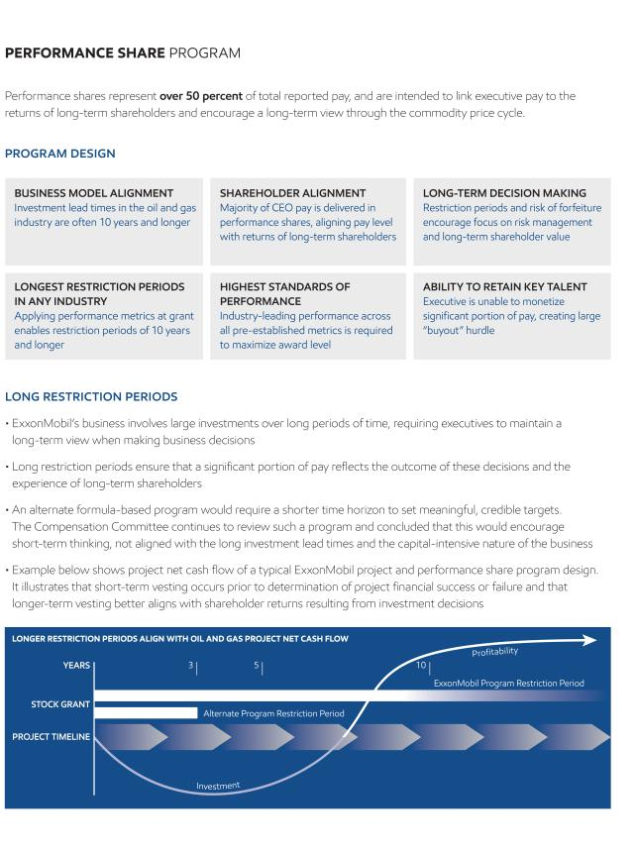

36 2020 Proxy Statement

Table of Contents
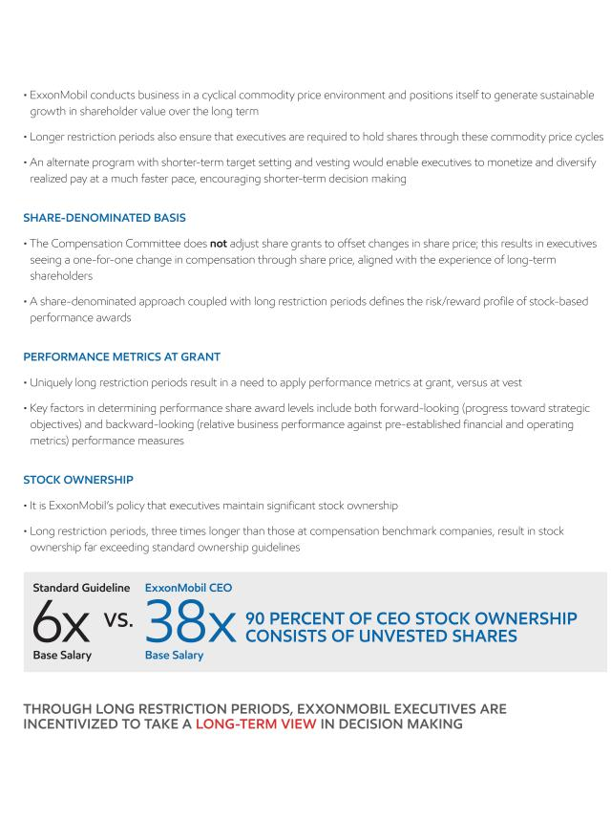

2020 Proxy Statement | 37

Table of Contents
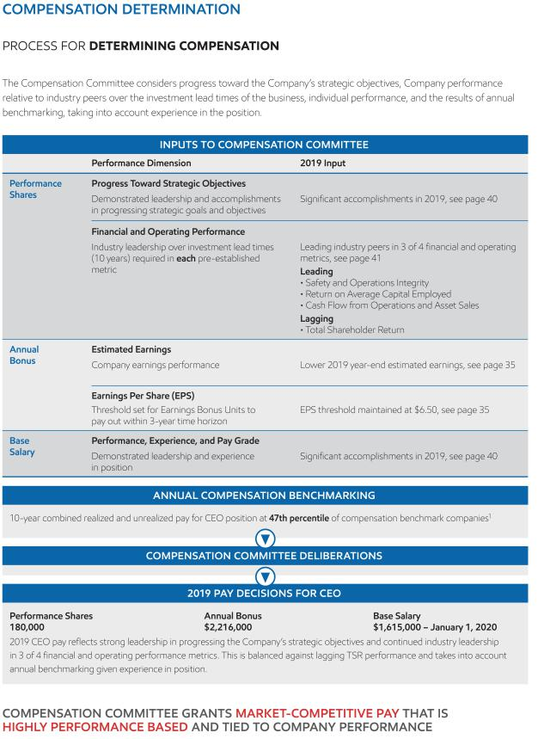

38 2020 Proxy Statement

Table of Contents
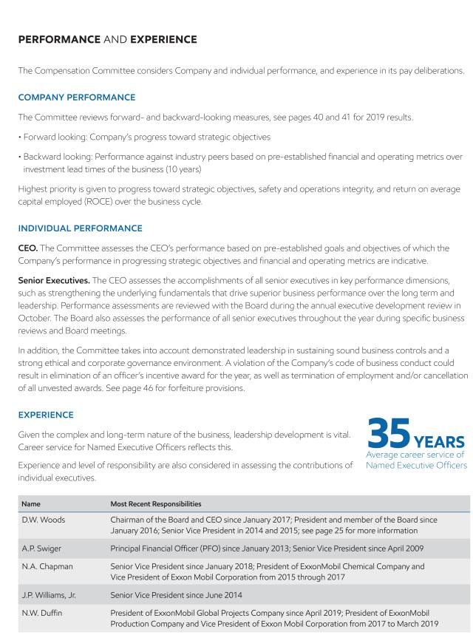

2020 Proxy Statement | 39

Table of Contents
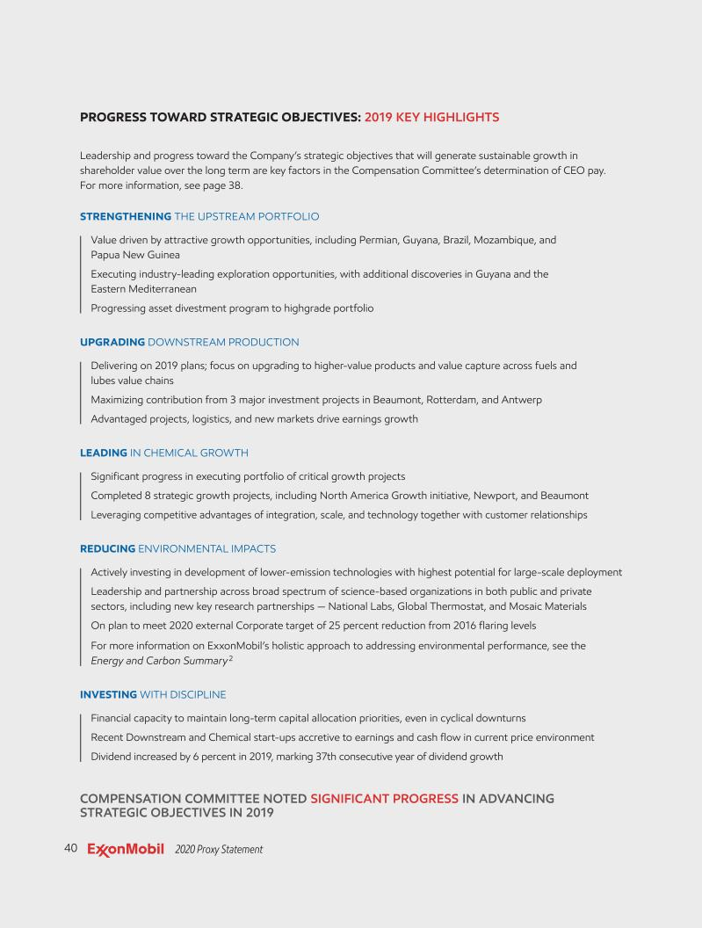

Table of Contents
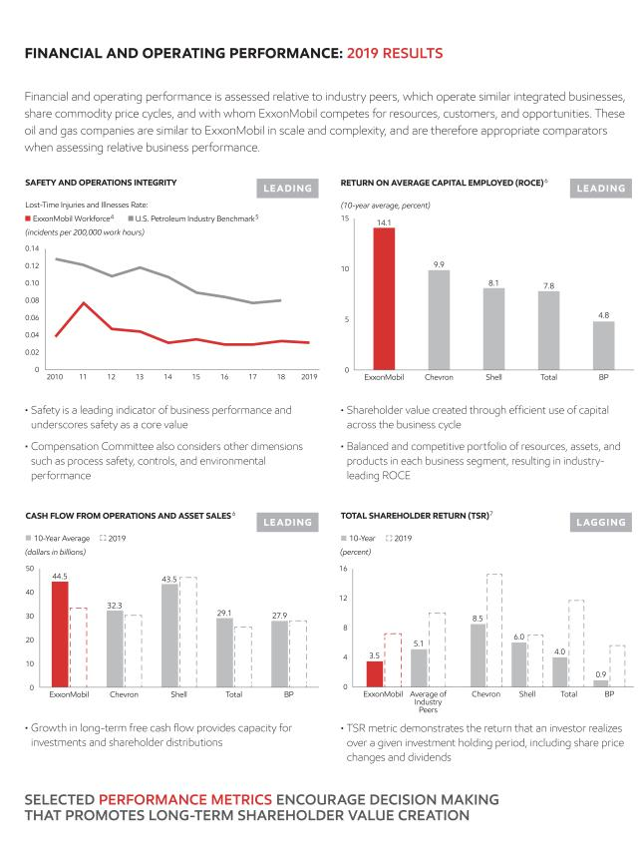

2020 Proxy Statement | 41

Table of Contents
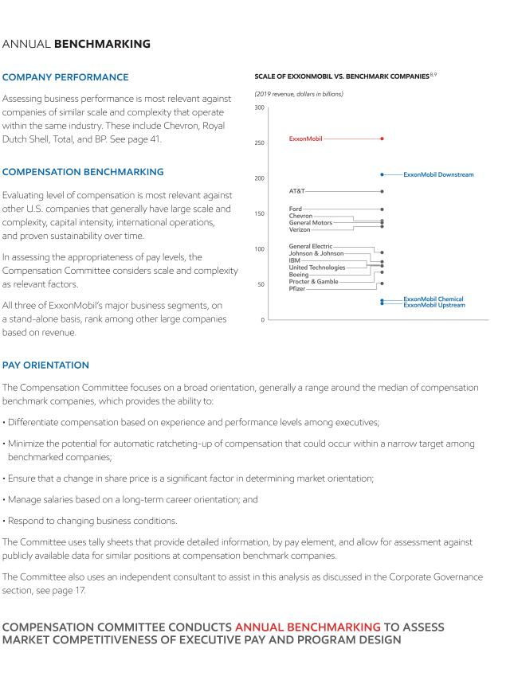

42 2020 Proxy Statement

Table of Contents
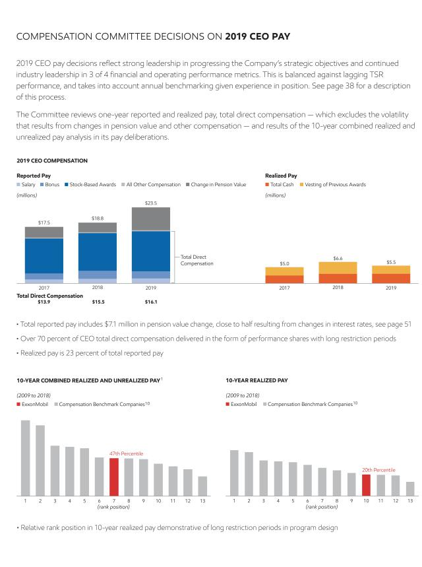

2020 Proxy Statement | 43

Table of Contents
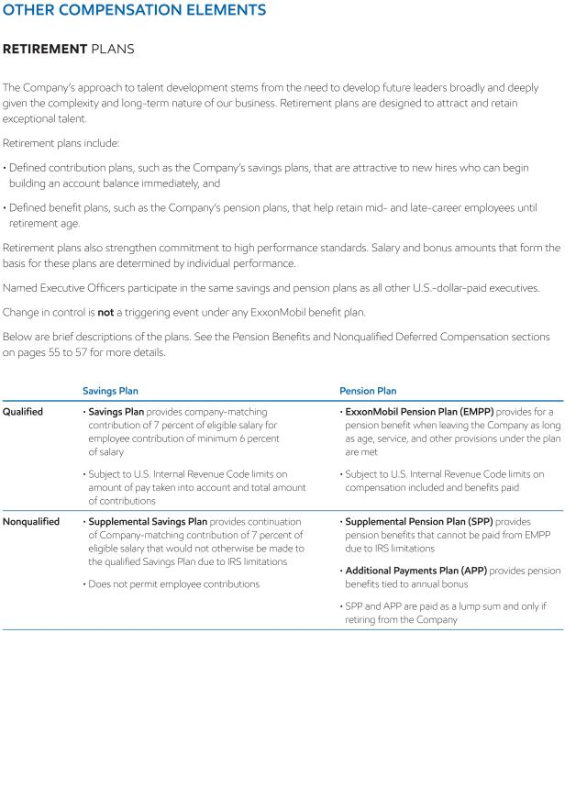

44 2020 Proxy Statement

Table of Contents
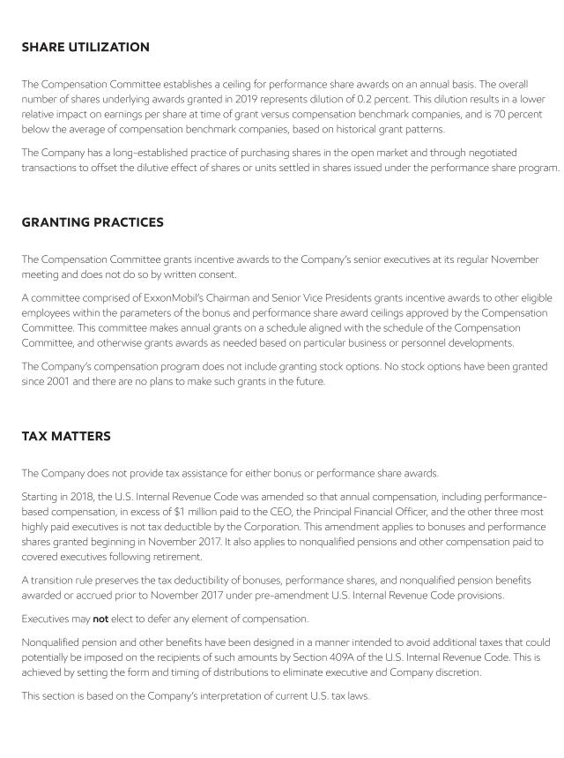

2020 Proxy Statement | 45

Table of Contents
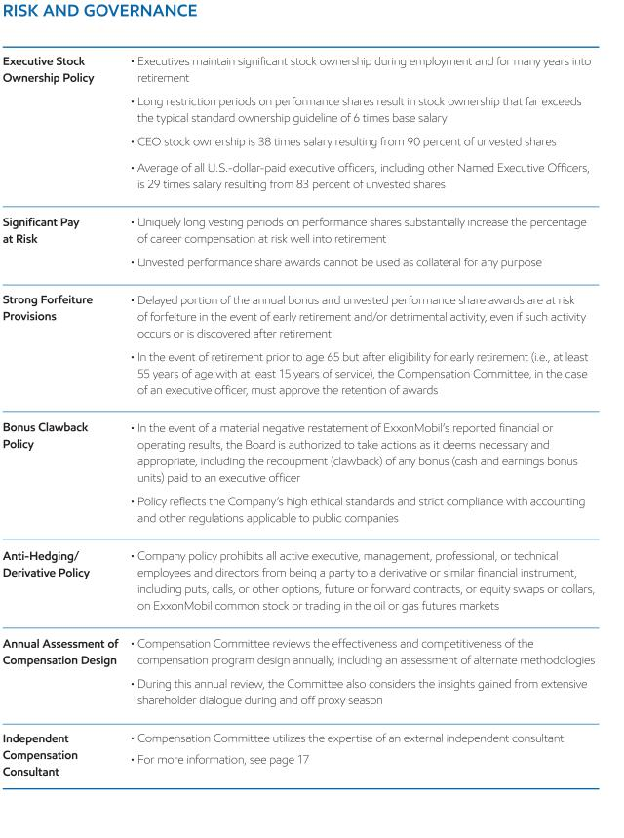

46 2020 Proxy Statement

Table of Contents
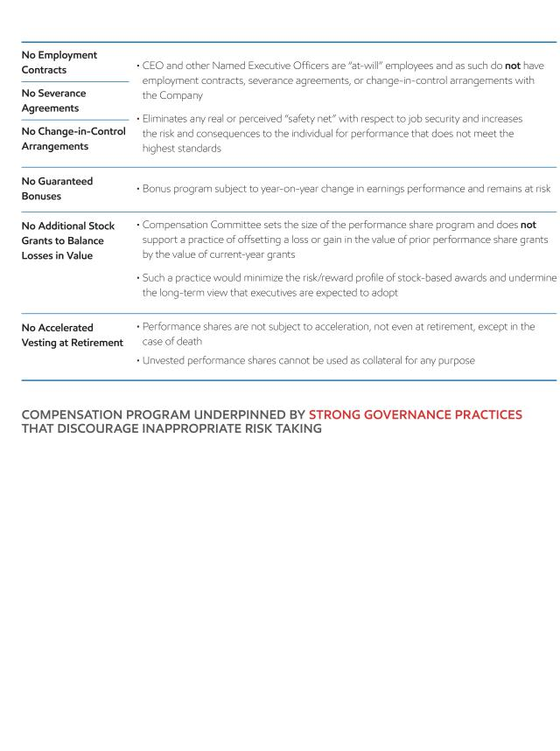

2020 Proxy Statement | 47

Table of Contents
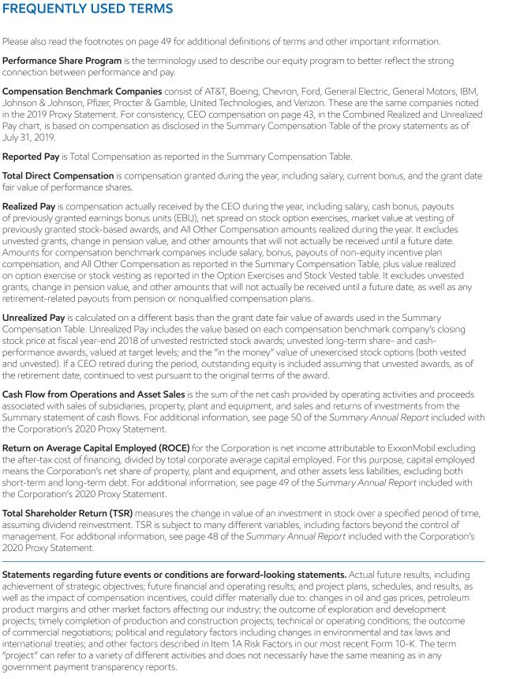

48 2020 Proxy Statement

Table of Contents
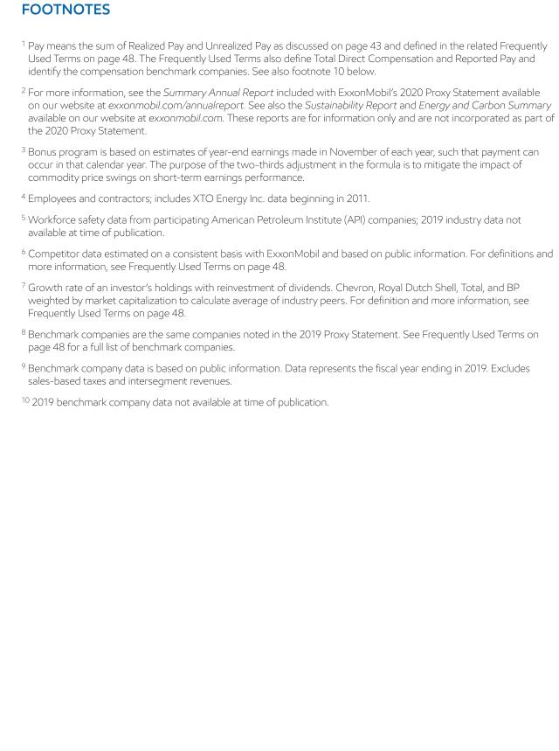

2020 Proxy Statement | 49

Table of Contents
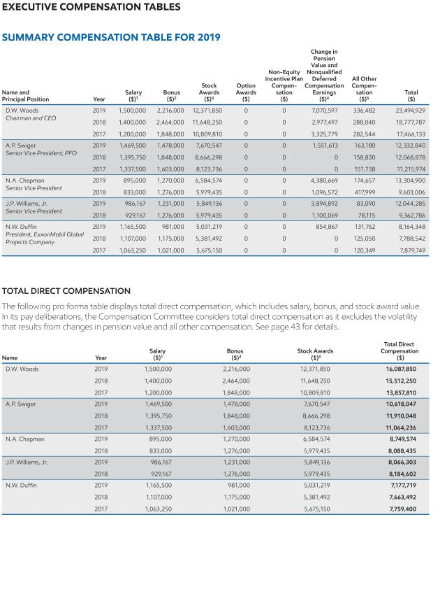

50 2020 Proxy Statement

Table of Contents
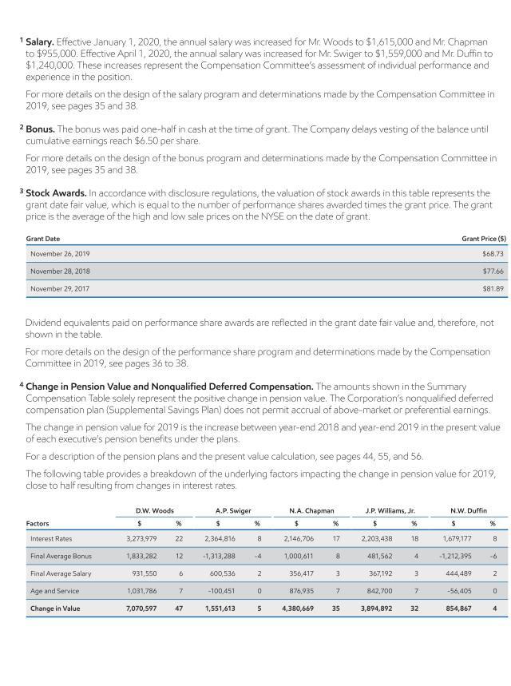

2020 Proxy Statement | 51

Table of Contents
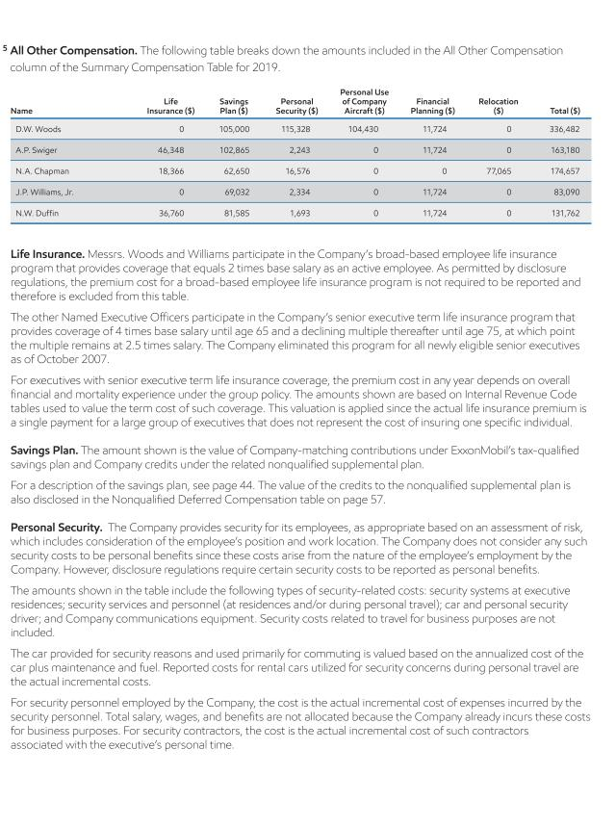

52 2020 Proxy Statement

Table of Contents
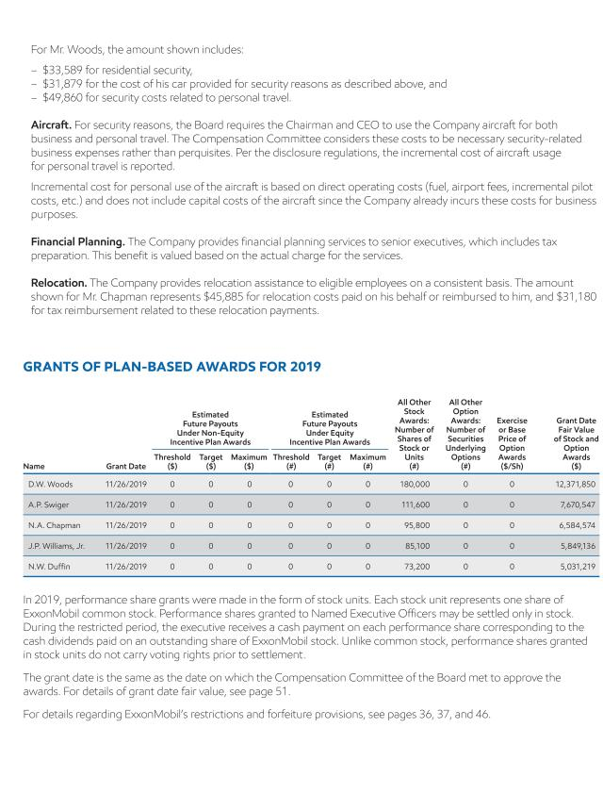

2020 Proxy Statement | 53

Table of Contents
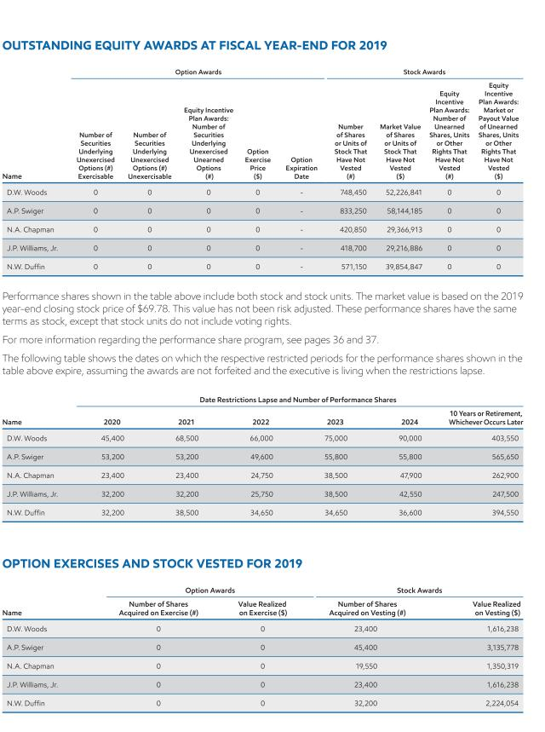

54 2020 Proxy Statement

Table of Contents
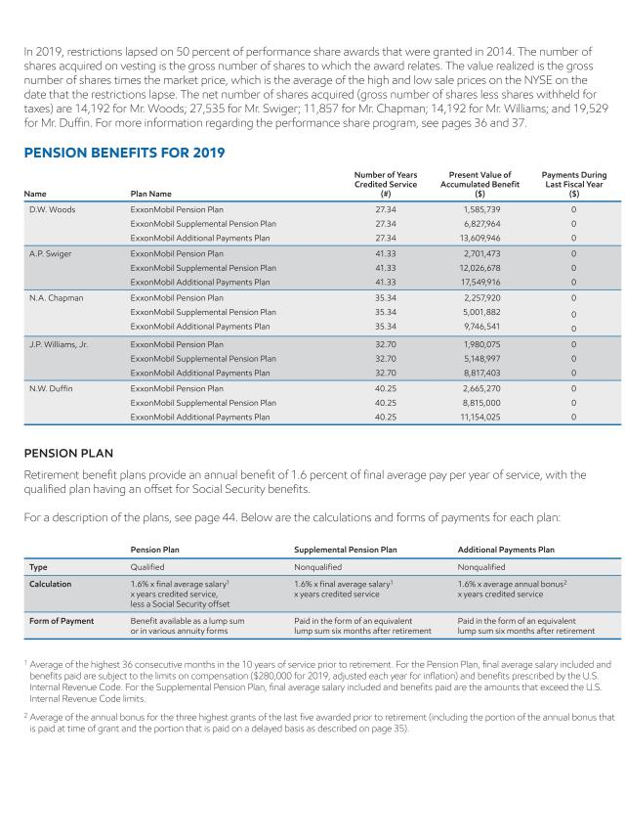

2020 Proxy Statement | 55

Table of Contents
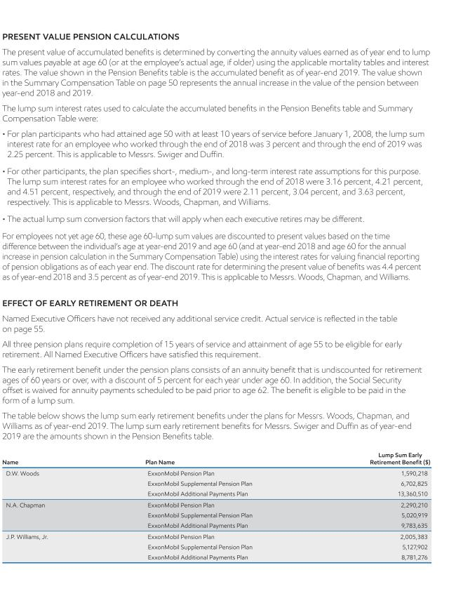

56 2020 Proxy Statement

Table of Contents
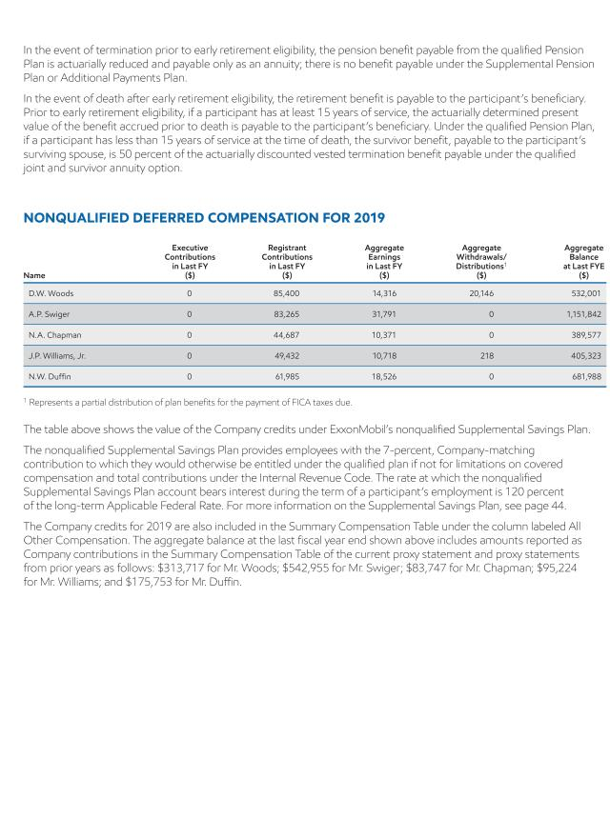

2020 Proxy Statement | 57

Table of Contents
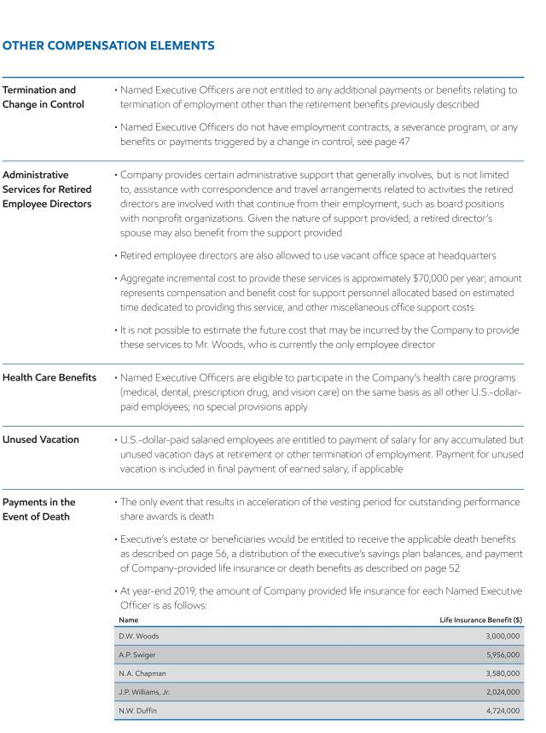

58 2020 Proxy Statement

Table of Contents

SHAREHOLDER PROPOSALS

We expect Items 4 through 9 to be presented by shareholders at the annual meeting. Following SEC rules, other than minor formatting changes, we are reprinting the proposals and supporting statements as they were submitted to us. We take no responsibility for them. Upon oral or written request to the Secretary at the address listed under Contact Information on page 7, we will provide information about the sponsors’ shareholdings, as well as the names, addresses, and shareholdings of any co-sponsors.

The Board recommends you vote AGAINST Items 4 through 9 for the reasons we give after each one.

Item 4 – Independent Chairman

This proposal was submitted by the Olga Monks Pertzoff Trust 1945, 111 Commercial Street, Suite 302, Portland, ME 04101, the beneficial holder of 400 shares and lead proponent of a filing group.

“RESOLVED: The shareholders request the Board of Directors to adopt as policy, and amend the bylaws as necessary, to require the Chair of the Board of Directors, whenever possible, to be an independent member of the Board. This policy would be phased in for the next CEO transition.

If the Board determines that a Chair who was independent when selected is no longer independent, the Board shall select a new Chair who satisfies the requirements of the policy within a reasonable amount of time. Compliance with this policy is waived if no independent director is available and willing to serve as Chair.

Supporting Statement:

We believe:

- The role of the CEO and management is to run the company.

- The role of the Board of Directors is to provide independent oversight of management and the CEO.

- There is a potential conflict of interest for a CEO to be her/his own overseer as Chair while managing the business.

Exxon Mobil’s CEO Darren Woods serves both as CEO and Chair of the Company’s Board of Directors. We believe the combination of these two roles in a single person weakens a corporation’s governance structure.

Chairing and overseeing the Board is a time intensive responsibility. A separate independent Chair also frees the CEO to manage the company and build effective business strategies.

As Andrew Grove, Intel’s former chair, stated, “The separation of the two jobs goes to the heart of the conception of a corporation. Is a company a sandbox for the CEO, or is the CEO an employee? If he’s an employee, he needs a boss, and that boss is the Board. The Chairman runs the Board. How can the CEO be his own boss?”

In our view, shareholders are best served by a separate independent Board Chair who provides a balance of power between the CEO and the Board. The primary duty of a Board of Directors is to oversee the management of a company on behalf of shareholders. A combined CEO / Chair creates a potential conflict of interest, resulting in excessive management influence on the Board and weaker oversight of management.

Numerous institutional investors recommend separation of these two roles and the number of companies separating these roles is growing.

With the unprecedented climate change challenges facing global energy companies as they face important transitions to a low carbon economy, it is important to ensure our company’s governance is the best it can be, and the board is

2020 Proxy Statement | 59

Table of Contents

empowered to provide strong direction and leadership. Exxon Mobil and the industry faces numerous and significant climate related challenges from decisions about developing new oil and gas fields for the market to revising its climate related lobbying.

This resolution to Exxon Mobil received a vote in support of approximately 41% in 2019, a significant showing. To simplify the transition, this new policy would be phased in when a next CEO is chosen.”

The Board recommends you vote AGAINST this proposal for the following reasons:

The Board agrees effectively representing the interests of shareholders requires a strong, independent Board responsible for oversight of management, including the CEO. The Board, however, disagrees that separating the Chairman and CEO positions would be in the best interest of shareholders or improve its ability to provide effective oversight.

The Board carefully considers the merits of separating or combining the Chairman and CEO positions, including whether an independent director should hold the Chairmanship, whenever a CEO change occurs. The Board believes it is important to preserve the flexibility to implement the leadership structure that will best serve the long-term interests of shareholders. Adoption of a singular approach without the flexibility to adapt to company-specific circumstances would compromise the Board’s ability to assess and implement the optimal oversight framework.

The Board currently believes having the Chairman and CEO roles combined results in significant benefits for shareholders. A combined Chairman and CEO role ensures items of greatest importance for the business are brought to the attention of, and reviewed by, the Board on a timely basis. As new issues arise, market dynamics change, or risk exposures evolve, the Chairman/CEO is best positioned, with deep Company knowledge and industry experience, to highlight those issues with the Board, ensuring appropriate oversight and discussion.

The Board is also comprised entirely of independent directors, with the exception of the CEO. Each independent director has access to the CEO and other Company executives. Independent directors also have the authority to call meetings of the independent directors, and may request agenda topics at meetings of the full Board or committees.

Further independent oversight is provided by the Company’s appointing of an independent Lead Director whose broad oversight responsibilities include:

- Calling, chairing, and setting the agenda for executive sessions of the non-employee directors;

- Providing feedback to the Chairman;

- Chairing meetings of the Board in the absence of the Chairman;

- Reviewing and approving the schedule and agenda for all Board meetings and reviewing associated materials distributed to the directors, in consultation with the Chairman;

- Advising the Chairman on the quality, quantity, and timeliness of information flow;

- Reviewing committee meeting schedules;

- Engaging with shareholders, as appropriate; and

- Leading the annual performance evaluation of the Board.

The Lead Director also concurrently serves as Chair of the Board Affairs Committee, which is comprised entirely of independent directors, to direct other key activities including:

- Establishing the criteria for director engagement with shareholders;

- Providing comments and suggestions to the Board on Board committee structure, committee operations, committee member qualifications, and committee member appointment;

- Overseeing independent director succession planning and remuneration;

60 2020 Proxy Statement

Table of Contents

- Reviewing the service of independent directors on boards of other companies, including requests to accept a seat on any additional company board;

- Establishing and maintaining procedures for interested parties to communicate with independent directors;

- Considering Board governance practices and procedures including any changes to governance guidelines; and

- Providing oversight of the performance and effectiveness of the annual evaluation process for the Board and its committees.

The Board’s Compensation Committee also independently reviews CEO performance and compensation and conducts a review with the full Board, absent the Chairman.

In addition, the Lead Director, working together with the Compensation Committee, oversees the annual evaluation of the CEO, the communication of resulting feedback to the CEO, and the review of CEO succession plans.

Importantly, only a minority of S&P 500 companies have adopted an independent chairman. This was evidenced in the 2019 Spencer Stuart Board Index, which examines the latest data and trends among the S&P 500 for board composition, governance practices, and director compensation. The Index noted that only 34 percent of S&P 500 boards have a chairman that meets the New York Stock Exchange rules for independence.

To maintain alignment with the substantial majority of S&P 500 boards, ensure continuation of the significant shareholder benefits of a combined Chairman/CEO role, and preserve the Board’s flexibility to determine the appropriate leadership and oversight structure, shareholders should reject this proposal.

Item 5 – Special Shareholder Meetings

This proposal was submitted by Kenneth Steiner, 14 Stoner Ave., 2M, Great Neck, NY 11021, the beneficial owner of 500 shares.

“Proposal 5 – Enable Special Shareholder Meeting without the Need to go to Court

Shareholders ask our board to take the steps necessary to amend our bylaws and appropriate governing documents to give the owners of a total of 10% of our outstanding common stock the power to call a special shareholder meeting (or the closest percentage to 10% according to state law) without the current requirement to petition a court in order to do so. The Board of Directors would continue to have its existing power to call a special meeting.

Exxon Mobil is in a small minority of companies that require shareholders to go to court in order to call for a special shareholder meeting. Plus Exxon Mobil has an unlimited budget to oppose such a request in court and shareholders do not have any such a budget.

This proposal topic won 42%-support at our 2019 annual meeting. This was a significant increase from 36%-support in 2018.

A more accessible shareholder ability to call a special meeting would put shareholders in a better position to give continuing input on improving the makeup of our board of directors. Calling a special meeting is also a means shareholders can use to raise important matters outside the normal annual meeting cycle like the election of a new director.

This topic is more important since we have no oversight of our CEO by an independent Board Chairman. Our combined Chairman/CEO, Darren Woods was rejected by the 3rd highest number of shares in 2019. Meanwhile Mr. Woods’ total pay was $15 million. Ursula Burns, who chaired the Exxon audit committee, was rejected by 27% of shares in 2019 and Steven Reinemund was rejected by 14% of shares.

Mark Zuckerberg, Jeff Immelt, Elon Musk and Dennis Muilenburg are examples of problems with concentrating too much power in one person. Plus we apparently do not have a Lead Director as this title does not even appear in our 2019 proxy. Our stock price is down from $100 in 2013.

2020 Proxy Statement | 61

Table of Contents

A more accessible shareholder ability to call a special meeting is more important because our right to shareholder proxy access may be out of reach since it can only be used by 20 shareholders who have owned a total of $30 billion of Exxon Mobil stock continuously for 3-years. If a group of 20 shareholders is $1 short of meeting this enormous $30 billion requirement – the group is totally out of luck.

Please vote yes:

Enable Special Shareholder Meeting without the Need to go to Court – Proposal 5”

The Board recommends you vote AGAINST this proposal for the following reasons:

The Board believes it is important for shareholders to have the right to call a special shareholder meeting, a right ExxonMobil currently provides. ExxonMobil shareholders holding at least 15 percent of shares outstanding may call a special meeting in accordance with recently amended Corporate Governance Guidelines. No court petition is required.

Shareholder interests are further protected by a strong, independent Board responsible for the oversight of management, including the CEO. Effective leadership is also provided by an independent Lead Director with expansive oversight responsibilities. In each of the last two years, shareholders recognized the strong leadership and independence of the Board with an average vote in favor of all directors of more than 93 percent.

ExxonMobil’s current Corporate Governance Guidelines allow for shareholders of at least 15 percent of common stock outstanding to call a special meeting without the need for a court petition, which provides a meaningful and more advantageous shareholder right than most large-cap companies. Many companies that provide shareholders the right to call a special shareholder meeting do so at a much higher threshold. The most common threshold among S&P 500 companies is 25 percent.

Therefore, the Board believes this proposal is unnecessary.

Item 6 – Report on Environmental Expenditures

This proposal was submitted by Steven Milloy, 12309 Briarbush Lane, Potomac, MD 20854, the beneficial owner of 250 shares.

“Greenwashing Audit

Resolved:

Shareholders request that, beginning in 2020, ExxonMobil publish an annual report of the incurred costs and associated significant and actual benefits that have accrued to shareholders, the public health and the environment, including the global climate, from the company’s environment-related activities that are voluntary and that exceed U.S. and foreign compliance and regulatory requirements. The report should be prepared at reasonable cost and omit proprietary information.

Supporting Statement:

The resolution is intended to help shareholders monitor and evaluate whether the company’s voluntary activities and expenditures touted as protecting the public health and environment are producing actual and meaningful benefits to shareholders, the public health and the environment, including global climate.

Corporate managements sometimes engage in the practice of ‘greenwashing,’ which is defined as the expenditure of shareholder assets on ostensibly environment-related activities but actually undertaken merely for the purpose of improving the company’s or management’s public image.

62 2020 Proxy Statement

Table of Contents

Such insincere ‘green’ posturing and associated touting of hypothetical or imaginary benefits to public health and the environment may harm shareholders by wasting corporate assets, and deceiving shareholders and the public by accomplishing nothing real and significant for the public health and environment.

For example, ExxonMobil claimed in its 2019 ‘Energy and Carbon Summary’ report that it:

- Plays ‘an essential role in protecting the environment and addressing the risks of climate change’;

- Reduced its operational emissions by an average of about 20 MILLION tons annually since 2000.

- Spent $9 billion since 2000 on efforts to reduce emissions.

None of these emissions reduction activities are required by law or regulation.

But in 2018 alone:

- Exxon produced about 1.4 BILLION barrels of oil which, when burned, produced about 588 MILLION tons of carbon dioxide (CO2).

- Global emissions of CO2-equivalents in 2018 were about 55.3 BILLION tons.

So:

- While ExxonMobil touts its operational reductions in CO2, it sells products that, when burned by consumers, emit almost 30 times more CO2.

- ExxonMobil’s products when burned produce CO2 emissions that amount to a mere one percent (1%) of global manmade emissions.

Although ExxonMobil’s operational emissions cuts and the emissions from its products are both meaningless in larger context ExxonMobil bizarrely, if not falsely claims that it plays ‘an essential role in... addressing the risks of climate change.’

So, what are the actual benefits to shareholders and the climate of ExxonMobil’s multibillion-dollar bid to reduce its CO2 emissions. By how much, in what way, and when will any of these activities reduce, alter or improve climate change, for example?

The information and honesty requested by this proposal is not already contained in any ExxonMobil report. As none of them present the actual and significant cost-benefit details requested here, they may all be reasonably suspected of being examples of don’t-look-behind-the-curtain corporate greenwashing propaganda.

ExxonMobil should report to shareholders what are the actual benefits being produced by its voluntary and highly touted environmental activities. Are they real and worthwhile, or just greenwashing?”

The Board recommends you vote AGAINST this proposal for the following reasons:

The Board believes transparency and accurate disclosure are important for shareholders to adequately assess potential risks and benefits of investments. The Company works to ensure the information it provides is timely, factual, vetted by subject matter experts, and compliant with regulations.

All opportunities inclusive of those undertaken to address the risks of climate change are rigorously evaluated to support the objective of generating long-term shareholder value.

For example, safe, reliable, and responsible operations, including steps to reduce emissions, are correlated with strong financial and operating performance. Investments that result in an increase in sales of higher value and more sustainable products, which generally yield higher margins, expand the earnings and cash flow potential of the Company. Developing and deploying proprietary technologies, such as biofuel and carbon capture, will position the Company to participate in the transition to a lower-carbon energy system consistent with the goals of the Paris Agreement. Engaging with governments to implement effective climate-related policies leads to a more efficient regulatory environment and a level playing field for market participants, including ExxonMobil.

2020 Proxy Statement | 63

Table of Contents

ExxonMobil has invested nearly $ 10 billion in technology and programs to reduce emissions since 2000. Of this amount, approximately $4 billion is related to oil and gas operations, including energy efficiency and flare mitigation efforts, which help to reduce emissions and minimize costly waste. The Company also invested $3 billion in cogeneration facilities to more efficiently produce electricity and further reduce greenhouse gas (“GHG”) emissions across its operations. Additional investments in refining and chemical facilities around the world, and research to identify additional emission reduction opportunities, accounted for the remaining $3 billion. These investments were key in eliminating or reducing CO2 emissions by more than 400 million tonnes, which is equivalent to the average annual energy demand of more than

46 million U.S. homes.

The Company also announced, and is on track to meet, goals to further reduce emissions from its operations, including a 15-percent decrease in methane emissions and a 25-percent reduction in flaring by year-end 2020, as well as a

10-percent reduction in GHG intensity for the Imperial Oil-operated oil sands operations by 2023. These measures build upon established programs to deliver sustainable GHG reductions that help meet society’s ambition for a lower-carbon future.

Details related to these major investments are available in existing reports published by the Company including the Outlook for Energy, Energy & Carbon Summary and other publications and regulatory filings. The Board believes the proposal, therefore, is unnecessary.

Item 7 – Report on Risks of Petrochemical Investments

This proposal was submitted by the Park Foundation, a client of As You Sow, 2150 Kittredge St., Suite 450, Berkeley, CA 94704, the beneficial owner of 117 shares and lead proponent of a filing group.

“Resolved: Shareholders request that ExxonMobil, with board oversight, publish a report, omitting proprietary information and prepared at reasonable cost, assessing the public health risks of expanding petrochemical operations and investments in areas increasingly prone to climate change-induced storms, flooding, and sea level rise.

Supporting Statement: Investors request the company assess, among other related issues at management and Board

discretion: The adequacy of measures the company is employing to prevent public health impacts from associated chemical releases.

Whereas: Investors are concerned about the financial, health, environmental, and reputational risks associated with operating and building-out new chemical plants and related infrastructure in Gulf Coast locations increasingly prone to catastrophic storms and flooding associated with climate change. Civil society groups have mobilized to oppose the expansion of petrochemical facilities in their communities due to concerns regarding direct health and livelihood impacts from air and water pollutant releases. Such opposition threatens to jeopardize ExxonMobil’s social license to operate in the region.

Petrochemical facilities like ethane crackers and polyethylene processing plants produce dangerous pollutants including benzene (a known carcinogen), Volatile Organic Compounds, and sulfur dioxide. These operations can become inundated and pose significant chemical release risks during extreme weather events. Flooding from Hurricane Harvey in 2017 resulted in ExxonMobil plant shut downs and the release of unpermitted, unsafe levels of pollutants. Nearby Houston residents reported respiratory and other health problems following ExxonMobil’s releases during Hurricane Harvey.

Growing storms and the costs they bring our company are predicted to increase in frequency and intensity as global warming escalates. Recent reports show that greenhouse gas emissions throughout the petrochemical and plastic supply chain contribute significantly to climate change, exacerbating the threat of physical risks like storms. Flood-related damage is projected to be highest in Texas, where many ExxonMobil petrochemical plants are concentrated. Houston alone has seen three 500-year floods in a three-year span. Hurricane Harvey contributed to decreased earnings of approximately $40 million for ExxonMobil in 2017 and decreasing social license from surrounding communities.

64 2020 Proxy Statement

Table of Contents

Historically, releases from ExxonMobil’s petrochemical operations have exceeded legal limits, exposing the company to liability and millions in payment for violations of environmental laws including the Clean Air and Clean Water Acts. As climate change intensifies flooding and storm strength, the potential for unplanned chemical releases grows.

In spite of these risks, ExxonMobil continues to accelerate its petrochemical activity in the Gulf Coast, investing heavily to expand in flood-prone areas of Texas and Louisiana. The company has generally disclosed that risks from storms may impact its business and that climate risks like extreme storms are among the factors it considers in construction and operation of assets. The impacts to ExxonMobil’s operations from Hurricane Harvey, however, indicate the company’s level of preparedness is insufficient. As the Company rapidly expands its petrochemical assets in climate-impacted areas, investors seek improved disclosure to understand whether ExxonMobil is adequately evaluating and mitigating public health risks associated with climate-related impacts and the dangerous chemicals it uses.”

The Board recommends you vote AGAINST this proposal for the following reasons:

ExxonMobil works in remote and challenging environments around the world, including flood-prone areas, and as a result has extensive experience operating facilities in a wide range of challenging physical environments. The Company’s history of design, construction, and operations provides a solid foundation to address the risks associated with different environments. The Company designs and operates its facilities in consideration of those risks.

ExxonMobil uses a rigorous and comprehensive assessment process, which includes the collection of extensive data from measurements and advanced computer modeling to consider the full range of potential environmental, socioeconomic, and health risks associated with its operations, prior to pursuing a new development. Importantly, ExxonMobil works closely with governments and regulatory agencies, for permitting and other requirements, to ensure appropriate operating procedures and response measures are in place to minimize potential impacts. These external professionals, working on behalf of governments, regulatory bodies, and residents, are trained to identify risk factors that may affect projects, facilities, and local communities. This collaborative approach enables the Company to gain a holistic view of issues that may affect a specific project, and implement measures to eliminate, avoid, or remedy potential concerns.

As the Company undertakes its risk assessments, it carefully considers the unique factors faced by its facilities. For example, offshore facilities are potentially impacted by changes in wave and wind intensity, loop currents, and ice floe patterns. Onshore facilities, including petrochemical operations, are exposed to potential sea-level changes, storm surge, flooding, wind, seismicity, or geotechnical considerations. In each case, environmental assessments, as described above, are conducted in advance to ensure protective measures and response procedures are in place prior to building and commissioning facilities.

ExxonMobil’s Operations Integrity Management System is the backbone of this process and has proven effective at ensuring readiness for and resiliency to extreme weather conditions.

ExxonMobil’s participation in Gulf Coast Growth Ventures, a world-scale ethane steam cracker and derivative units in San Patricio County, Texas, is an excellent example of the Company’s risk management processes in practice. ExxonMobil, through the joint venture, worked with government regulators and local communities to address four key priorities expressed by local residents: health and safety, education and workforce development, quality of life, and environmental stewardship. The Company held approximately 150 meetings with local residents, community groups, and other organizations to gather stakeholder perspectives and ensure that identified risks and concerns were appropriately addressed. Through this process, the Company received comments related to wastewater disposal and air quality and, following review by the Texas Commission on Environmental Quality, modified facility design to mitigate community concerns.

Once facilities are in operation, the Company maintains disaster preparedness, response and business continuity plans. Detailed, well-practiced, and frequently updated emergency response plans tailored to each facility help prepare for unplanned events, including extreme weather. Regular emergency response drills are practiced in coordination with appropriate government agencies and community coalitions to help ensure readiness and minimize the impacts of such events. ExxonMobil has also established strategic emergency support groups around the world to develop and practice response strategies and assist field responders. Each facility and business unit has access to readily available trained responders, including regional response teams, to provide rapid tactical support.

2020 Proxy Statement | 65

Table of Contents

We also monitor and manage ongoing integrity through periodic checks on key aspects of facility structures, including adopting learnings from recent extreme weather events as part of ongoing engineering evaluations. These evaluations include the use of engineering assessments to identify potential impacts on critical systems, such as facilities for storm water handling and upgrades of electrical systems. Enhancements could involve procedural revisions and / or changes in equipment design to help ensure resiliency.

The Company publicly shares its guidelines, measures, and practices to assess and mitigate risk factors, and includes the information requested by the proponent in its Energy & Carbon Summary publication.

Based on the Company’s extensive experience and well-established processes, procedures, and disclosures, the Board believes this proposal is unnecessary.

Item 8 – Report on Political Contributions

This proposal was submitted by the Unitarian Universalist Association, 24 Farnsworth Street, Boston, MA 02210, the beneficial owners of 87 shares and lead proponent of a filing group.

“Resolved, that the shareholders of Exxon Mobil Corp. (‘Exxon’ or ‘Company’) hereby request that the Company prepare and semiannually update a report, which shall be presented to the pertinent board of directors committee and posted on the Company’s website, disclosing the Company’s:

- Policies and procedures for making electoral contributions and expenditures (direct and indirect) with corporate funds, including the board’s role (if any) in that process; and

- Monetary and non-monetary contributions or expenditures that could not be deducted as an ‘ordinary and necessary’ business expense under section 162(e)(1)(B) of the Internal Revenue Code, including (but not limited to) contributions or expenditures on behalf of candidates, parties, and committees and entities organized and operating under section 501(c)(4) of the Internal Revenue Code, as well as the portion of any dues or payments made to any tax-exempt organization (such as a trade association) used for an expenditure or contribution that, if made directly by the Company, would not be deductible under section 162(e)(1)(B) of the Internal Revenue Code.

The report shall be made available within 12 months of the annual meeting and identify all recipients and the amount paid to each recipient from Company funds. This proposal does not encompass lobbying spending.

Supporting Statement

As long-term Exxon shareholders, we support transparency and accountability in corporate electoral spending. Disclosure is in the best interest of the Company and its shareholders. The Supreme Court recognized this in its 2010 Citizens United decision, which said, ‘[D]isclosure permits citizens and shareholders to react to the speech of corporate entities in a proper way. This transparency enables the electorate to make informed decisions and give proper weight to different speakers and messages.’

Publicly available records show Exxon has contributed at least $12,900,000 in corporate funds since the 2010 election cycle. (CQMoneyLine: http://moneyline.cq.com; National Institute on Money in State Politics: http://www.followthemoney.org).

We acknowledge that Exxon publicly discloses a policy on corporate political spending and its direct contributions to candidates, parties, and committees. We believe this is deficient because Exxon does not disclose the following:

- A full list of trade associations to which it belongs and the non-deductible portion under section 162(e)(1)(B) of the dues paid to each; and

- Payments to other third-party organizations, including those organized under section 501(c)(4) of the Internal Revenue Code, that could be used for election-related purposes.

66 2020 Proxy Statement

Table of Contents

Information on indirect electoral spending through trade associations and 501(c)(4) groups cannot be obtained by shareholders unless the Company discloses it. This proposal asks the Company to disclose all of its electoral spending, both direct and indirect. This would bring our company in line with a growing number of leading companies, including AT&T, United Technologies, and ConocoPhillips, which present this information on their websites. The Company’s Board and shareholders need comprehensive disclosure to be able to fully evaluate the use of corporate assets in elections. We urge your support for this critical governance reform.”

The Board recommends you vote AGAINST this proposal for the following reasons:

ExxonMobil is committed to full compliance with applicable regulations, and publicly shares its policy on corporate political spending and its direct contributions to candidates, parties, and committees. The Company believes disclosure requirements outlined by federal and state laws are both adequate and equitable, in that they require the same level of disclosure from all participants in the political process.

In addition to federal and state regulations, ExxonMobil’s political contributions are subject to a strict internal review process that requires approval by the Chairman as directed by the Company’s Political Activities Guidelines, available on exxonmobil.com/company/policy/political-contributions-and-lobbying. The political contributions of the Corporation, as well as the contributions of the political action committees established by the Corporation, are reviewed with the Board of Directors of the Corporation annually, and procedures are routinely verified during internal audits of the Company’s political activities.

With respect to contributions to third-party organizations, the Company publishes its Worldwide Contributions and Community Investment: Public Policy report on its website, at exxonmobil.com/community-engagement/worldwide-giving. The most recent listing includes contributions to more than 100 U.S.-based, non-profit organizations that in many cases contribute to informed policy discussions.

Therefore, for the reasons stated above, the Board believes current federal and state oversight are sufficient to ensure disclosure and transparency, and to provide a consistent standard for all reporting entities. Any desire for additional disclosure would be more appropriately addressed to Congress, the Executive Branch, and/or relevant state and local governments. In the Board’s view, this proposal is unnecessary.

Item 9 – Report on Lobbying

This proposal was submitted by the United Steelworkers, 60 Boulevard of the Allies, Pittsburgh, PA 15222, the beneficial owner of 116 shares and lead proponent of a filing group.

“Whereas, we believe in full disclosure of ExxonMobil’s direct and indirect lobbying activities and expenditures to assess whether ExxonMobil’s lobbying is consistent with its expressed goals and in shareholder interests.

Resolved, the shareholders of ExxonMobil request the preparation of a report, updated annually, disclosing:

- Company policy and procedures governing lobbying, both direct and indirect, and grassroots lobbying communications.

- Payments by ExxonMobil used for (a) direct or indirect lobbying or (b) grassroots lobbying communications, including in each case the amount of the payment and the recipient.

- Description of management’s and the Board’s decision-making process and oversight for making payments described above.

For purposes of this proposal, a ‘grassroots lobbying communication’ is a communication directed to the general public that (a) refers to specific legislation or regulation, (b) reflects a view on the legislation or regulation and (c) encourages the recipient of the communication to take action with respect to the legislation or regulation. ‘Indirect lobbying’ is lobbying engaged in by a trade association or other organization of which ExxonMobil is a member.

2020 Proxy Statement | 67

Table of Contents

Both ‘direct and indirect lobbying’ and ‘grassroots lobbying communications’ include efforts at the local, state and federal levels.

The report shall be presented to the Audit Committee or other relevant oversight committees and posted on ExxonMobil’s website.

Supporting Statement

ExxonMobil spent $110,700,000 from 2010 – 2018 on federal lobbying. This does not include state lobbying expenditures, where ExxonMobil also lobbies but disclosure is uneven or absent. For example, ExxonMobil spent $ 4,055,093 on lobbying in California from 2010 – 2018. Exxon also lobbies abroad, spending between €3,250,000 – €3,499,999 on lobbying in Europe for 2018.

ExxonMobil belongs to the American Petroleum Institute, Business Roundtable (BRT), Chamber of Commerce and National Association of Manufacturers (NAM), which altogether spent $260,638,048 on lobbying for 2017 and 2018. Both the BRT and NAM are lobbying against shareholder rights to file resolutions. ExxonMobil does not disclose its memberships in, or payments to, trade associations, or the amounts used for lobbying.

We are concerned that ExxonMobil’s lack of disclosure presents reputational risks when its lobbying contradicts company public positions. For example, ExxonMobil supports the Paris climate agreement, yet a 2019 InfluenceMap report found Exxon has spent millions lobbying to undermine it.1

Investors participating in the Climate Action 100+ representing more than $34 trillion in assets are asking companies to align their lobbying, including through their trade associations, with the goals of the Paris agreement. Peer Shell produced an ‘Industry Associations Climate Review’ report to ensure its trade association participation aligned with its views.2 ExxonMobil uses the Global Reporting Initiative (GRI) for sustainability reporting, yet fails to report ‘any differences between its lobbying positions and any stated policies, goals, or other public positions’ under GRI Standard 415.

We believe the reputational damage stemming from this misalignment between general policy positions and actual direct and indirect lobbying efforts harms long-term value creation by ExxonMobil. Thus, we urge ExxonMobil to expand its lobbying disclosure.”

- https://thehill.com/policy/energy-environment/436117-top-oil-firms-spend-millions-on-lobbying-to-block-climate-
change

- https://www.reuters.com/article/us-shell-afpm-idUSKCN1RE0VB

The Board recommends you vote AGAINST this proposal for the following reasons:

The Board fully supports accountability, appropriate transparency, and disclosure of lobbying activities and expenditures. Lobbying and political engagements are addressed as part of the Board’s oversight of the Company’s enterprise-risk framework, including potential reputational risk. The Company follows a strict internal review and oversight process to ensure its public policy positions are aligned with lobbying activities. Regular reviews of public-policy issues of significance are provided to the Management Committee and to the Board. Positions on key issues and grassroots lobbying communications are made publicly available on ExxonMobil’s corporate website, at exxonmobil.com/company/policy/political-contributions-and-lobbying, and exxchange.com, the Company’s advocacy community portal. Without exception, the Company’s lobbying efforts are aligned with its publicly available positions.

The Company’s Political Activities Policy and Guidelines, which is available to the public on its website, at exxonmobil.com/company/policy/political-contributions-and-lobbying, provide clear guidance that only certain employees may act on behalf of the Company to execute the political activities of the corporation, including lobbying. Therefore, a well-established process is in place to authorize individual employee engagement in lobbying activities.

68 2020 Proxy Statement

Table of Contents

ExxonMobil publicly reports, on a quarterly basis, to the U.S. Congress its federal lobbying expenses and the specific issues lobbied. The total figure reported in ExxonMobil’s public Lobbying Disclosure Act filings includes expenses associated with the costs of employee federal lobbying, as well as those portions of payments to trade associations, coalitions and think tanks that are spent on federal lobbying. All reports are accessible to the general public on the U.S. Senate website at www.senate.gov. More recently filed reports are also posted on the Company website at exxonmobil.com/company/policy/political-contributions-and-lobbying. Furthermore, ExxonMobil, and its employees involved in lobbying, file lobby disclosure reports at the federal, state and local level, in accordance with all applicable disclosure laws. Requiring additional disclosure would hold ExxonMobil to a different standard than other groups engaging in similar lobbying activities.

The Company’s contributions to trade associations and other organizations do not constitute an endorsement of every public policy position or point of view expressed by a recipient organization. As is true of all nonprofit groups the Company supports, an annual evaluation of the merits of each organization is conducted, and the Company reserves the right to initiate, sustain, or withdraw support at any time.

Existing disclosure laws provide consistent transparency for all parties involved in the political process. As such, the Board believes the proponent’s specific positions on lobbying disclosure included in this proposal are more appropriately addressed to the U.S. Congress, the Executive Branch, and state and local governments. For this reason, and others stated above, the Board recommends voting against this proposal.

PAY RATIO

Annual total CEO compensation for 2019 was $23,529,292. The median of annual total compensation of all employees of the Corporation, except the CEO, for 2019 was $173,712. The ratio of annual total CEO compensation to the median of annual total compensation of all employees was 135:1.

The median employee was identified as of October 1, 2019, based on total taxable wages for the most recently completed prior fiscal year as shown in the Corporation’s records. No estimates or sampling methodologies were used for this purpose. No cost-of-living adjustments were made and the taxable wages of employees employed for less than the full fiscal year were not annualized. “Employees” were defined based on applicable employment and tax laws.

For purposes of this disclosure, as permitted by SEC rules, the value of non-discriminatory benefits is included in annual total compensation of both the median employee and the CEO. These non-discriminatory benefits are long-term disability plan; basic life insurance and accidental death and dismemberment; medical plan; and dental plan.

Including these benefits provides a more accurate compensation ratio. Since SEC rules do not require inclusion of these generally available benefits in the Summary Compensation Table, annual total CEO compensation shown above is slightly higher than the Total CEO Compensation shown in that table.

2020 Proxy Statement | 69

Table of Contents

ExxonMobil is a global company with employees in many countries around the world. As permitted by the de minimis exemption under the SEC rules, for purposes of identifying the median employee, we have excluded employees from 44 countries which represent in aggregate less than 5 percent of the Corporation’s total employees. As required, where any employees from a jurisdiction were excluded, all employees from that jurisdiction were excluded. In total, as detailed in the table below, 3,569 employees out of a total number of 75,927 worldwide employees were excluded under the de minimis exemption.


Countries Excluded / Number of Employees

1. | Angola | 529 | 12. | New Zealand | 93 | 23. | South Korea | 28 | 34. | Mauretania | 4
2. | Norway | 391 | 13. | Sweden | 68 | 24. | Colombia | 22 | 35. | Ukraine | 4
3. | Egypt | 358 | 14. | Taiwan | 65 | 25. | Vietnam | 21 | 36. | Azerbaijan | 3
4. | Chad | 327 | 15. | United Arab Emirates | 64 | 26. | N. Mariana Island | 21 | 37 | Cameroon | 3
5. | Mexico | 292 | 16. | Mozambique | 61 | 27. | Romania | 18 | 38. | Ghana | 3
6. | Equatorial Guinea | 272 | 17. | Cyprus | 43 | 28. | Saudi Arabia | 13 | 39. | Luxembourg | 3
7. | Guyana | 169 | 18. | Guam | 41 | 29. | Spain | 11 | 40. | Peru | 2
8. | Qatar | 150 | 19. | Poland | 34 | 30. | South Africa | 11 | 41. | Namibia | 2
9. | Turkey | 116 | 20. | Kazakhstan | 31 | 31. | Micronesia | 9 | 42. | Switzerland | 2
10. | Japan | 114 | 21. | New Caledonia | 29 | 32. | Greece | 7 | 43. | Pakistan | 1
11. | Finland | 97 | 22. | Fiji | 29 | 33. | Denmark | 7 | 44. | Tanzania | 1
 |  |  |  |  |  |  |  | Total number of employees excluded: |  |  | 3,569

ADDITIONAL INFORMATION

Other Business

We are not currently aware of any other business to be acted on at the annual meeting. Under the laws of New Jersey, where ExxonMobil is incorporated, no business other than procedural matters may be raised at the meeting unless proper notice has been given to the shareholders. If other business is properly raised, your proxies have authority to vote as they think best, including to adjourn the meeting.

People With Disabilities

We can provide reasonable assistance to help you participate in the meeting if you tell us about your disability and your plans to attend. Please call or write the Secretary at least two weeks before the meeting at the telephone number, address, or fax number listed under Contact Information on page 7.

Outstanding Shares

On February 29, 2020, there were 4,230,430,398 shares of common stock outstanding. Each common share has one vote.

How We Solicit Proxies

In addition to this mailing, ExxonMobil officers and employees may solicit proxies personally, electronically, by telephone, or with additional mailings. ExxonMobil pays the costs of soliciting this proxy. We are paying D.F. King & Co. a fee of $30,000 plus expenses to help with the solicitation. We also reimburse brokers and other nominees for their expenses in sending these materials to you and getting your voting instructions.

Shareholder Proposals and Director Nominations for Next Year

Any shareholder proposal for the annual meeting in 2021 must be sent to the Secretary at the address or fax number of ExxonMobil’s principal executive office listed under Contact Information on page 7. The deadline for receipt of a proposal to be considered for inclusion in the 2021 proxy statement is 5 p.m. Central Time, on December 10, 2020. The deadline for notice of a proposal for which a shareholder will conduct his or her own solicitation is February 23, 2021. Upon request, the Secretary will provide instructions for submitting proposals.

70 2020 Proxy Statement

Table of Contents

Submissions of nominees for director under the proxy access provisions of our by-laws for the 2021 annual meeting must be submitted in compliance with those by-laws no later than December 10, 2020, and no earlier than November 10,

2020. Notice of a director nomination other than under proxy access must be submitted in compliance with the advance notice provisions of our by-laws no later than January 27, 2021, and no earlier than December 28, 2020.

Duplicate Annual Reports

Registered shareholders with multiple accounts may authorize ExxonMobil to discontinue mailing annual reports on an account by calling ExxonMobil Shareholder Services at the toll-free telephone number listed on page 7 at any time during the year. Beneficial holders should contact their banks, brokers, or other holders of record to discontinue duplicate mailings. At least one account must continue to receive an annual report. Eliminating these duplicate mailings will not affect receipt of future proxy statements and proxy cards.

Shareholders With the Same Address

If you share an address with one or more ExxonMobil shareholders, you may elect to “household” your proxy mailing. This means you will receive only one set of proxy materials at that address unless one or more shareholders at that address specifically elect to receive separate mailings. Shareholders who participate in householding will continue to receive separate proxy cards. Householding will not affect dividend check mailings. We will promptly send separate proxy materials to a shareholder at a shared address on request. Shareholders with a shared address may also request us to send separate proxy materials in the future, or to send a single copy in the future, if we are currently sending multiple copies to the same address.

Requests related to householding should be made by calling ExxonMobil Shareholder Services at the telephone number listed on page 7. Beneficial shareholders should request information about householding from their banks, brokers, or other holders of record.

SEC Form 10-K

Shareholders may obtain a copy of the Corporation’s Annual Report on Form 10-K to the Securities and Exchange Commission without charge by writing to the Secretary at the address listed under Contact Information on page 7, or by visiting ExxonMobil’s website at exxonmobil.com/secfilings.

2020 Proxy Statement | 71

Table of Contents

DIRECTIONS

ExxonMobil 2020 Annual Meeting

Wednesday, May 27, 2020
9:30 a.m. Central Time
Renaissance Dallas Hotel Conference Center
2222 North Stemmons Freeway
Dallas, Texas 75207
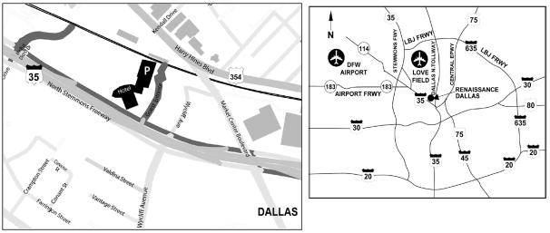

- Free self-parking is provided at the Renaissance Hotel in the parking garage and in the hotel’s uncovered ground-level parking lot.

- From I-45/Hwy. 75 – Take I-345, Exit 286A, TX-366 Spur West (Woodall Rodgers Freeway) and I-35E North to North Stemmons Freeway. Take exit 430B-430C from I-35E North toward Market Center Boulevard/Wycliff Avenue. Merge onto North Stemmons Freeway. Hotel is located at North Stemmons Freeway and Wycliff Avenue.

- From I-35 – Take exit 430B-430C toward Market Center Boulevard/Wycliff Avenue. Merge onto North Stemmons Freeway. Hotel is located at North Stemmons Freeway and Wycliff Avenue.

- From DFW Airport – Take South exit to Hwy. 183 East. Follow 183 East to Interstate 35/Stemmons Freeway South. Continue on the freeway to exit 430C for Wycliff Avenue. Turn left off exit. Travel under the bridge then turn left onto North Stemmons Freeway. The hotel entrance is on the right.

- From Love Field – Take first right turn onto West Mockingbird Lane. Merge onto southbound Harry Hines Boulevard then make a slight right onto Market Center Boulevard. Take the second right turn onto North Stemmons Freeway. The hotel entrance is on the right.

Printed entirely on recycled paper 002CSNA8D5

Table of Contents
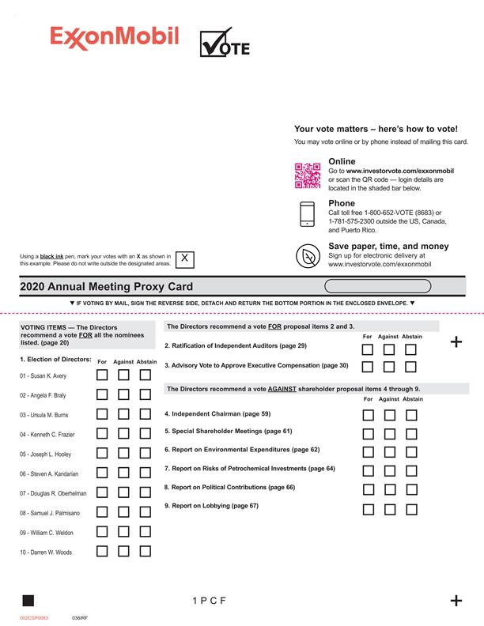

Table of Contents


