UNITED STATES

SECURITIES AND EXCHANGE COMMISSION
Washington, D.C. 20549

SCHEDULE 14A

Proxy Statement Pursuant to Section 14(a) of the

Securities Exchange Act of 1934

Filed by the Registrant ☒ Filed by a Party other than the Registrant ☐

Check the appropriate box:

- Preliminary Proxy Statement

- Confidential, for Use of the Commission Only (as permitted by Rule 14a-6(e)(2))

- Definitive Proxy Statement

- Definitive Additional Materials

- Soliciting Material under § 240.14a-12

EXXON MOBIL CORPORATION

(Name of Registrant as Specified In Its Charter)

NOT APPLICABLE

(Name of Person(s) Filing Proxy Statement, if other than the Registrant)

Payment of Filing Fee (Check all boxes that apply):

- No fee required

- Fee paid previously with preliminary materials

- Fee computed on table in exhibit required by Item 25(b) per Exchange Act Rules 14a-6(i)(1) and 0-11.

LinkedIn Post Example:

Are you a shareholder in ExxonMobil? Your vote matters.

ExxonMobil is proposing to redomicile our company to our home state of Texas – aligning our legal structure with our physical headquarters in Spring, Texas.

The proposal maintains strong shareholder rights and supports efficient governance and long-term decision-making.

Learn how you can vote here: Vote+and+ASM+Dial+In+Instructions+2026.pdf

You can also join ExxonMobil’s virtual Annual Shareholder Meeting on May 27 to learn more: Annual Shareholder Meeting :: Exxon Mobil Corporation (XOM)
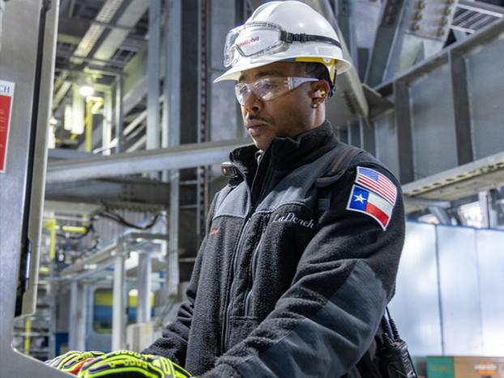

Voting Instructions:
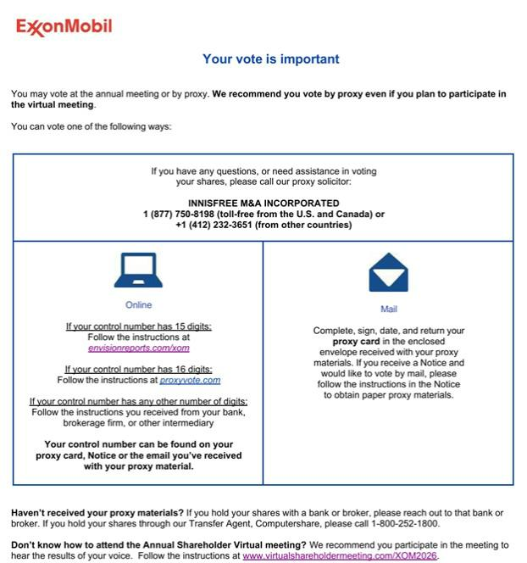

Annual Shareholder Meeting Website:


