UNITED STATES

SECURITIES AND EXCHANGE COMMISSION
Washington, D.C. 20549

SCHEDULE 14A

Proxy Statement Pursuant to Section 14(a) of the
Securities Exchange Act of 1934

Filed by the Registrant ☒

Filed by a Party other than the Registrant ☐

Check the appropriate box:

- Preliminary Proxy Statement

- Confidential, for Use of the Commission Only (as permitted by Rule 14a-6(e)(2))

- Definitive Proxy Statement

- Definitive Additional Materials

- Soliciting Material under § 240.14a-12

EXXON MOBIL CORPORATION

(Name of Registrant as Specified In Its Charter)

NOT APPLICABLE

(Name of Person(s) Filing Proxy Statement, if other than the Registrant)

Payment of Filing Fee (Check all boxes that apply):

- No fee required

- Fee paid previously with preliminary materials

- Fee computed on table in exhibit required by Item 25(b) per Exchange Act Rules 14a-6(i)(1) and 0-11.

Explanatory Note: The following contains the various correspondence related to solicitation and communication for the annual proxy season. It contains advertisements of additional digital ads and videos for shareholders awareness.

Digital Ads
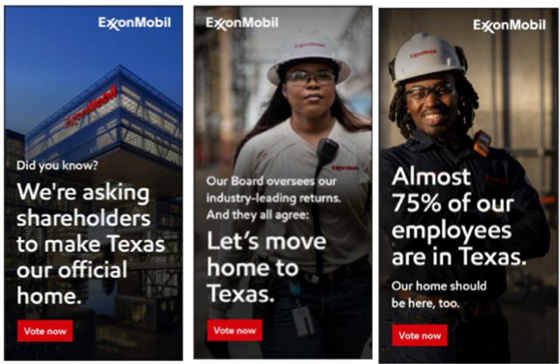

Video Storyboard:
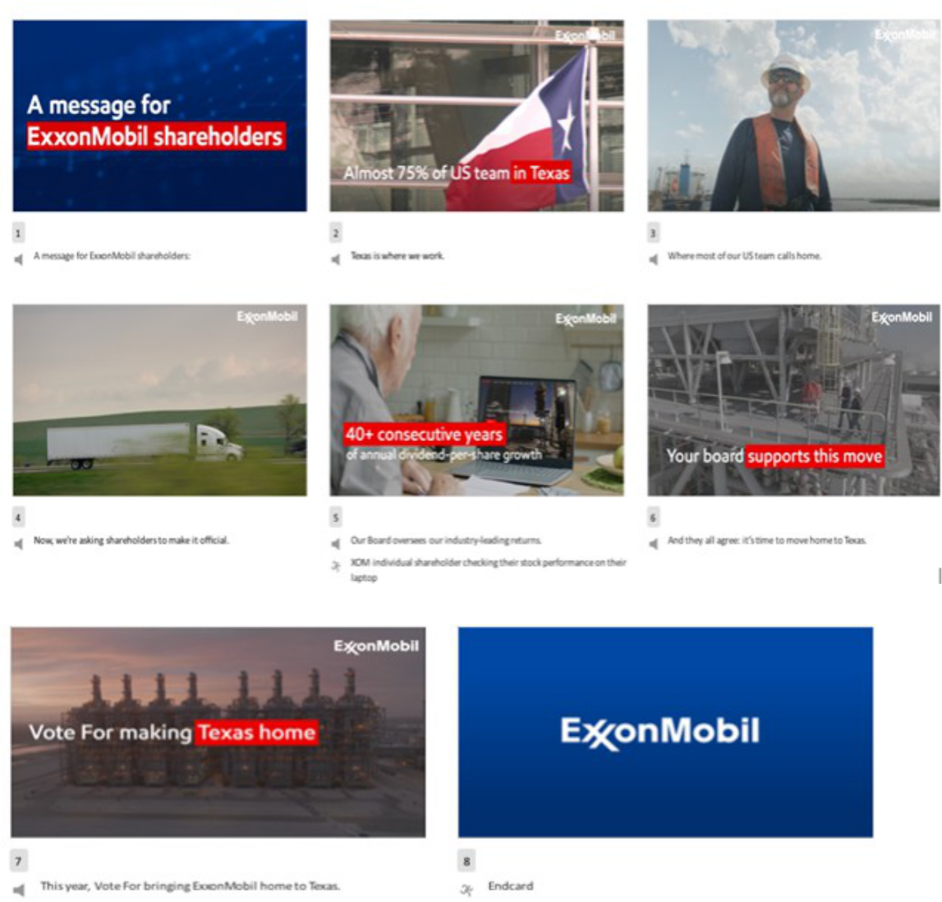

The company’s 2026 Proxy Statement and 2025 Annual Report are available at https://investor.exxonmobil.com/news-events/annual-shareholder-meeting.

Forward-Looking Statements

Statements related to the benefits and effects of the proposed redomiciliation of ExxonMobil from New Jersey to Texas (the “Texas Redomiciliation”) and other statements of future events or conditions following the Texas Redomiciliation also are forward-looking statements. Actual future results or events, including future litigation; expectations related to the Texas business environment and Texas courts; potential benefits, implications, risks, costs, tax effects, costs savings or other related implications associated with the Texas Redomiciliation, the Company’s future financial position, growth opportunities and trends in the markets in which we operate; and prospects, plans and objectives of management and the Board, could differ materially due to a number of factors. These include, without limitation, legislative, regulatory, or judicial developments; unexpected costs, fees and expenses related to the Redomiciliation; the nature, cost and outcome of any litigation and other legal proceedings, including any such proceedings related to the Redomiciliation; unanticipated responses to the Redomiciliation from customers, suppliers and others with whom the Company does business; any inability to consummate the Redomiciliation within the anticipated time period, or at all, due to any reason, including the failure to obtain the necessary shareholder or regulatory approvals; and other risks identified in the Company’s annual report on Form 10-K for the year ended December 31, 2025, filed with the SEC on February 18, 2026, the Company’s proxy statement filed with the SEC on April 8, 2026, and as otherwise described or updated from time to time in ExxonMobil’s other filings with the SEC.

