UNITED STATES
SECURITIES AND EXCHANGE COMMISSION
Washington, D.C. 20549

SCHEDULE 14A
Proxy Statement Pursuant to Section 14(a) of the
Securities Exchange Act of 1934

Filed by the Registrant ☒ Filed by a Party other than the Registrant ☐
Check the appropriate box:

☐ | Preliminary Proxy Statement

☐ | Confidential, for Use of the Commission Only (as permitted by Rule 14a-6(e)(2))

☐ | Definitive Proxy Statement

☒ | Definitive Additional Materials

☐ | Soliciting Material under § 240.14a-12
EXXON MOBIL CORPORATION
(Name of Registrant as Specified In Its Charter)
NOT APPLICABLE
(Name of Person(s) Filing Proxy Statement, if other than the Registrant)
Payment of Filing Fee (Check all boxes that apply):

☒ | No fee required

☐ | Fee paid previously with preliminary materials

☐ | Fee computed on table in exhibit required by Item 25(b) per Exchange Act Rules 14a-6(i)(1) and 0-11.

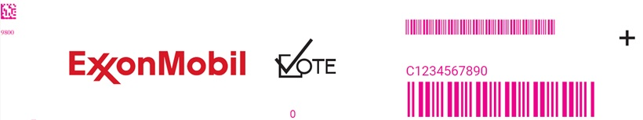
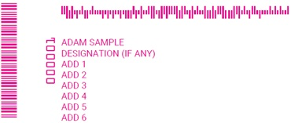
SHAREHOLDER ANNUAL MEETING NOTICE

Important Notice Regarding the Availability of Proxy Materials for the Exxon Mobil Corporation Annual Meeting of Shareholders to Be Held on May 27, 2026

This communication presents only an overview of the more complete proxy materials that are available to you on the internet. We encourage you to access and review all of the important information contained in the proxy materials before voting.
The 2025 Annual Report and 2026 Proxy Statement are available at envisionreports.com/XOM.
Under Securities and Exchange Commission rules, you are receiving this notice that the proxy materials for the Annual Meeting are available on the internet. The items to be voted on and location of the meeting are on the reverse side.
If you want to receive a copy of the proxy materials, you must request one. There is no charge to you for requesting a copy. Please make your request by using one of the methods listed on the reverse side 10 days prior to the meeting to facilitate timely delivery.

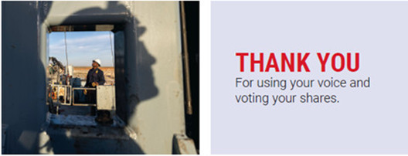

YOUR VOTE IS IMPORTANT

Meeting details are listed on the reverse side. All votes must be received by the closing of the polls at the meeting.

TO VOTE ONLINE AND ACCESS
THE MEETING
MATERIALS

Scan the QR code or go to envisionreports.com/XOM
to vote your shares





ATTEND
the meeting on
May 27, 2026, at 9:30 a.m.
(Central Time).

Go to
envisionreports.com/XOM
for instructions.

MEETING DETAILS
The Annual Meeting of Shareholders of Exxon Mobil Corporation will be held on May 27, 2026, at 9:30 a.m. (Central Time). Attend virtually at https://www.virtualshareholdermeeting.com/XOM2026. To attend as a guest, simply access the meeting 15 minutes prior to the meeting start time. To be able to vote or ask questions as a shareholder at the meeting, see the attendance instructions at envisionreports.com/XOM which describe how to obtain a virtual meeting access control number.
Proposals to be voted on at the meeting are listed below along with the Board of Directors’ recommendations.
THE BOARD OF DIRECTORS RECOMMENDS A VOTE FOR ALL THE NOMINEES LISTED:
1. | Election of Directors:
01 - Michael J. Angelakis |  | 02 - Angela F. Braly |  | 03 - Maria S. Dreyfus |  | 04 - Gregory C. Garland
05 - John D. Harris II |  | 06 - Kaisa H. Hietala |  | 07 - Joseph L. Hooley |  | 08 - Steven A. Kandarian
09 - Alexander A. Karsner |  | 10 - Lawrence W. Kellner |  | 11 - Dina Powell McCormick |  | 12 - Darren W. Woods
THE BOARD OF DIRECTORS RECOMMENDS A VOTE FOR PROPOSALS 2 THROUGH 4:

2. | Ratification of Independent Auditors

3. | Advisory Vote to Approve Executive Compensation

4. | Texas Redomiciliation
THE BOARD OF DIRECTORS RECOMMENDS A VOTE AGAINST PROPOSALS 5 AND 6:

5. | Independent Chair, a proposal overwhelmingly defeated on 16 separate occasions since 2000

6. | Proposal requesting Company to modify its Voluntary Retail Voting Program to provide multiple options not aligned with the Board’s recommendations

PLEASE NOTE: YOU CANNOT VOTE BY RETURNING THIS NOTICE

To vote your shares, you must go online or request a paper copy of the proxy materials to receive a proxy card. If you wish to attend and vote at the meeting, please see the instructions at envisionreports.com/XOM.

ORDER MATERIALS
Please make your materials request by using one of the methods listed below. You will need the number located in the box on the reverse side.
REQUEST VIA:

Internet | Visit envisionreports.com/XOM
Phone | Call 1-866-641-4276
Email | Send an email to investorvote@computershare.com and include:
 “Proxy Materials Exxon Mobil Corporation” in the subject line
 Your full name and address
 The number located in the box on the reverse side
 Statement that you want a paper copy of the meeting materials

PLEASE REVIEW THE MEETING MATERIALS  We encourage you to read the meeting documents found at envisionreports.com/XOM. |  |  | 

