Table of Contents

UNITED STATES

SECURITIES AND EXCHANGE COMMISSION
Washington, D.C. 20549

SCHEDULE 14A

Proxy Statement Pursuant to Section 14(a) of the

Securities Exchange Act of 1934

Filed by the Registrant ☒ Filed by a Party other than the Registrant ☐

Check the appropriate box:

- Preliminary Proxy Statement

- Confidential, for Use of the Commission Only (as permitted by Rule 14a-6(e)(2))

- Definitive Proxy Statement

- Definitive Additional Materials

- Soliciting Material under § 240.14a-12

EXXON MOBIL CORPORATION

(Name of Registrant as Specified In Its Charter)

NOT APPLICABLE

(Name of Person(s) Filing Proxy Statement, if other than the Registrant)

Payment of Filing Fee (Check all boxes that apply):

- No fee required

- Fee paid previously with preliminary materials

- Fee computed on table in exhibit required by Item 25(b) per Exchange Act Rules 14a-6(i)(1) and 0-11.

Table of Contents

Notice of 2022 Annual Meeting


and Proxy Statement

April 7, 2022

Dear Shareholder:

We invite you to attend the annual meeting of shareholders on Wednesday, May 25, 2022, beginning promptly at

9:30 a.m. Central Time. The annual meeting of shareholders will be a virtual meeting. This will help provide for a safe experience for our shareholders, employees, and other members of the community, and provide broader access and participation in the meeting versus an in-person meeting. Shareholders will be able to attend, vote, and submit questions during the annual meeting from any remote location that has Internet connectivity. We believe this approach provides for equitable participation and enhances accessibility to the meeting. Online access will be available approximately

15-minutes prior to the annual meeting start time at www.virtualshareholdermeeting.com/XOM2022. Please see page 5 for detailed instructions for attending and participating in the annual meeting.

At the meeting, you will hear a report on our business and the following items:

- Election of directors;

- Ratification of PricewaterhouseCoopers LLP as independent auditors;

- Advisory vote to approve executive compensation;

- Seven shareholder proposals contained in this proxy statement; and

- Other matters if properly raised.

Only shareholders of record on April 1, 2022, or their valid proxy holders may vote at the meeting. We are first mailing these proxy materials to shareholders of record on or about April 7, 2022.

This booklet includes the formal notice of the meeting and proxy statement. The proxy statement tells you about the agenda, procedures, and rules of conduct for the meeting. It also describes how the Board operates, gives information about our director candidates, and provides information about the other items of business to be conducted at the meeting.

Financial information is provided separately in the 2021 Annual Report that accompanies or precedes the proxy materials or is made available online to all shareholders.

Your vote is important. Even if you own only a few shares, we want your voice to be represented at the meeting. You can vote your shares by Internet, toll-free telephone call, or proxy card. A preliminary summary of 2022 Proxy Voting Results will be available at exxonmobil.com after the annual meeting of shareholders and will be filed on a Form 8-K within four business days of the meeting.

Sincerely,



Craig S. Morford

Secretary

Darren W. Woods

Chairman of the Board

Table of Contents


Board of Directors

Darren W. Woods

Chairman of the Board, Kenneth C. Frazier

Chief Executive Officer, Lead Director,

Exxon Mobil Corporation Exxon Mobil Corporation

Dear Fellow Shareholders: Dear Fellow Shareholders:

I am pleased to invite you to the 2022 Exxon Mobil Corporation virtual Annual Shareholder Meeting on May 25, 2022, beginning at 9:30 a.m. Central Time.

ExxonMobil delivered exceptional financial and operating performance in 2021 that supported a dividend increase, restored our balance sheet, and achieved our 2025 emission-reduction goals four years early.

These results were driven by a focused and disciplined strategy that leverages our competitive advantages to build globally competitive businesses with industry-leading earnings and cash flow growth across a broad range of future scenarios.

At this year’s meeting, we’ll highlight the progress we’ve made to structurally reduce costs, enhance capital efficiency, and drive improvements across our businesses to maximize shareholder returns. We’ll also share how our businesses and strategy are resilient across a broad range of future energy transition scenarios. We’re significantly increasing investments in high-value lower-emission business opportunities and taking a comprehensive approach to reaching our ambition of net-zero operated Scope 1 and 2 greenhouse gas emissions by 2050.

We plan to play a significant leadership role in global efforts to reduce emissions in support of a net-zero future. The same capabilities, technical strengths, and market experience that have positioned us to meet society’s essential needs, will also enable us to develop and deploy lower-emission solutions to address climate change.

We look forward to sharing more with you at our Annual Shareholder Meeting. Thank you for investing in ExxonMobil.

As ExxonMobil’s Lead Director, I am proud of the progress the Company has made to build shareholder value and further its leadership in the energy transition.

In 2021, five new directors joined the Board, adding to its existing diverse skillsets and leadership with additional expertise in energy, business transition, and capital allocation.

The Board is highly engaged in future business planning and focused on ensuring the Company tests its assumptions, consistently challenges conventional thinking, and pursues high-value solutions. The perspectives of all our members are helping inform the Company’s strategy, strengthen our competitive position, and maximize shareholder returns.

As a Board, we support the Company’s pursuit of industry leadership across a variety of key metrics, including in the advancement of lower-emission opportunities. The progress to date has been impressive. The Company delivered industry-leading results in 2021 while competitively positioning itself for the future. It announced a Scope 1 and 2 net-zero ambition by 2050 and is building asset-level emission-reduction roadmaps to achieve this goal. It is significantly increasing investments in lower-emission initiatives, which will help accelerate opportunities in its Low Carbon Solutions business and drive accelerated greenhouse gas emission reductions.

The Board’s goal is to ensure ExxonMobil is successful across a wide range of scenarios, at the forefront of industry innovation, and positioned to deliver leading shareholder value into the future. The Company’s results demonstrate alignment with this goal and help position ExxonMobil to succeed in an evolving energy landscape.

Thank you for the trust you’ve placed in the Board and in ExxonMobil.
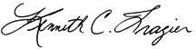

Table of Contents

 |  |  |  |  |  |  |  |  |  |  |  |  |  |  | TABLE OF CONTENTS
 |  |  |  |  |  |  |  |  |  |  |  |  |  |  |  |  |  |  |  |  |  | Page
PROXY SUMMARY |  |  |  |  |  |  |  |  |  |  |  |  |  |  |  |  |  |  |  |  |  | 1
GENERAL INFORMATION |  |  |  |  |  |  |  |  |  |  |  |  |  |  |  |  |  |  |  |  |  | 4
BOARD OF DIRECTORS |  |  |  |  |  |  |  |  |  |  |  |  |  |  |  |  |  |  |  |  |  | 9
 | Item 1 – Election of Directors |  |  |  |  |  |  |  |  |  |  |  |  |  |  |  |  |  |  |  |  | 9
CORPORATE GOVERNANCE |  |  |  |  |  |  |  |  |  |  |  |  |  |  |  |  |  |  |  |  |  | 15
DIRECTOR COMPENSATION |  |  |  |  |  |  |  |  |  |  |  |  |  |  |  |  |  |  |  |  |  | 28
CERTAIN BENEFICIAL OWNERS |  |  |  |  |  |  |  |  |  |  |  |  |  |  |  |  |  |  |  |  |  | 30
DIRECTOR AND EXECUTIVE OFFICER STOCK OWNERSHIP |  |  |  |  |  |  |  |  |  |  |  |  |  |  |  |  |  |  |  |  |  | 31
AUDIT COMMITTEE REPORT |  |  |  |  |  |  |  |  |  |  |  |  |  |  |  |  |  |  |  |  |  | 33
 | Item 2 – Ratification of Independent Auditors |  |  |  |  |  |  |  |  |  |  |  |  |  |  |  |  |  |  |  |  | 35
COMPENSATION COMMITTEE REPORT |  |  |  |  |  |  |  |  |  |  |  |  |  |  |  |  |  |  |  |  |  | 36
 | Item 3 – Advisory Vote to Approve Executive Compensation |  |  |  |  |  |  |  |  |  |  |  |  |  |  |  |  |  |  |  |  | 36
EXECUTIVE COMPENSATION |  |  |  |  |  |  |  |  |  |  |  |  |  |  |  |  |  |  |  |  |  | 37
 | Compensation Discussion and Analysis |  |  |  |  |  |  |  |  |  |  |  |  |  |  |  |  |  |  |  |  | 37
 | Executive Compensation Tables |  |  |  |  |  |  |  |  |  |  |  |  |  |  |  |  |  |  |  |  | 60
SHAREHOLDER PROPOSALS |  |  |  |  |  |  |  |  |  |  |  |  |  |  |  |  |  |  |  |  |  | 69
 | Item 4 – Remove Executive Perquisites |  |  |  |  |  |  |  |  |  |  |  |  |  |  |  |  |  |  |  |  | 69
 | Item 5 – Limit Shareholder Rights for Proposal Submission |  |  |  |  |  |  |  |  |  |  |  |  |  |  |  |  |  |  |  |  | 70
 | Item 6 – Reduce Company Emissions and Hydrocarbon Sales |  |  |  |  |  |  |  |  |  |  |  |  |  |  |  |  |  |  |  |  | 71
 | Item 7 – Report on Low Carbon Business Planning |  |  |  |  |  |  |  |  |  |  |  |  |  |  |  |  |  |  |  |  | 73
 | Item 8 – Report on Scenario Analysis |  |  |  |  |  |  |  |  |  |  |  |  |  |  |  |  |  |  |  |  | 75
 | Item 9 – Report on Plastic Production |  |  |  |  |  |  |  |  |  |  |  |  |  |  |  |  |  |  |  |  | 78
 | Item 10 – Report on Political Contributions |  |  |  |  |  |  |  |  |  |  |  |  |  |  |  |  |  |  |  |  | 80
PAY RATIO |  |  |  |  |  |  |  |  |  |  |  |  |  |  |  |  |  |  |  |  |  | 81
ADDITIONAL INFORMATION |  |  |  |  |  |  |  |  |  |  |  |  |  |  |  |  |  |  |  |  |  | 82
EXHIBIT A |  |  |  |  |  |  |  |  |  |  |  |  |  |  |  |  |  |  |  |  |  | 84

Table of Contents

PROXY SUMMARY


ITEM 1: Election of Directors

The Board recommends you vote FOR each of the following nominees.

The Board of Directors has nominated the director candidates below. All of our nominees currently serve as ExxonMobil directors. All director nominees have stated that they are willing to serve if elected.

Personal information about each nominee begins on Page 9.

ExxonMobil Board of Directors
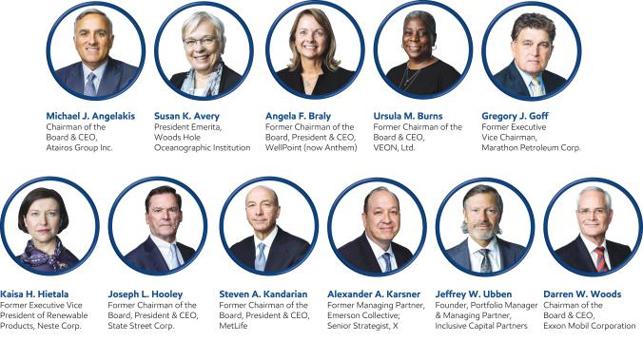

ExxonMobil leverages its core capabilities to meet society’s needs for products essential to modern life, while addressing the challenge of climate change. The Company’s strategy uses its advantages in scale, integration, technology, functional excellence, and talent to build globally competitive businesses that lead the industry in earnings and cash flow growth across a broad range of future scenarios. ExxonMobil is committed to playing a leading role in the energy transition, while retaining investment flexibility across a portfolio of evolving opportunities to maximize shareholder returns.

The Board of Directors oversees the Company’s strategy and planning process, which includes assessing opportunities and risks related to climate change and the energy transition. The Board considers multiple potential scenarios as it deliberates strategy and capital allocation to ensure the Company is well positioned to deliver shareholder value across a wide range of future pathways. In addition, the Board reviews assumptions and sensitivities in testing projects and investments for resiliency. As an example, the Board oversaw the development of the Company’s plans through 2027 that included significantly increasing investments in lower-emission initiatives to $15 billion. The Board is also actively involved in discussions on technology development and deployment to further emission reductions and grow the Low Carbon Solutions business.

The Board refreshment process is led by the Board Affairs Committee, which incorporates the perspectives of external experts and shareholders. The Committee seeks a diverse slate of experienced and highly qualified Board members who bring unique perspectives to deliberations and discussions. Important director competencies include experience in risk management, global business leadership, finance, energy, industrial operations, science, technology, and research.

The Board unanimously recommends you vote FOR

each of the ExxonMobil director candidates.

2022 Proxy Statement | 1

Table of Contents

Board Tenure

ExxonMobil added six new non-employee directors in less than three years — 50% of the total current Board. Average tenure for current non-employee directors is 4 years, which is almost half the applicable Standard & Poor’s 500 average.

50%

Business Strategy Delivering Results

Earnings |  | Dividend |  | Cash flow from
 |  |  |  | operations
increased to |  | annual growth for |  | increased to
$23 billion |  | 39 consecutive |  | $48 billion
 |  | years

of current directors have

joined the Board since 2020

Director Diversity

The Board believes diversity of thought, experience, and background is critical to good governance. Their unique perspectives and experiences add value as they work together as a collective body to represent the interests of all shareholders.
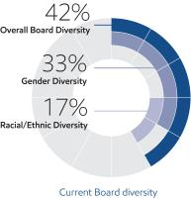

Broad Range of Business & Industry Experience

2050 Net-Zero Ambition for Operated Assets

ExxonMobil achieved its 2025 greenhouse gas emission reduction plans four years ahead of schedule and the Board approved the Company’s new 2030 emission reduction plans for Company operated assets relative to 2016 levels. The Company further announced a corporate-wide net-zero ambition by 2050.

20-30% | 40-50%
Reduction in | Reduction in Upstream
corporate-wide greenhouse | greenhouse gas emissions
gas emissions intensity by 2030 | intensity by 2030

70-80% | 60-70%
Reduction in | Reduction in
corporate-wide methane | corporate-wide flaring
intensity by 2030 | intensity by 2030
Net-Zero GHG Emissions
Permian Basin by 2030 Plan | Corporate-wide by 2050 Ambition
for Scope 1 and Scope 2 | for Scope 1 and Scope 2

Investing in Lower-Emission Opportunities

Directors bring a wide range of business experience, including climate expertise, industrial operations experience, investor perspectives, and experience in the oil and gas industry.

25%

of current directors have experience in the energy industry / commodities / cyclical businesses

Additional information:

Director leadership & oversight...Page 15

Director qualifications & competencies...Page 18

Director tenure...Page 22

ExxonMobil plans to invest $15 billion in lower-emission initiatives over the next six years, including scaling up carbon capture and storage, hydrogen, and lower-emission fuels. Stronger government policy could accelerate development and deployment of newer technologies and would provide ExxonMobil additional investment opportunities to reduce greenhouse gas emissions. The Company’s robust research and development process, continued evaluation of emerging technologies, and global collaborations will be key to identifying lower-emission opportunities and growing the Low Carbon Solutions business.

$15 Billion

Allocated toward lower-emissions

investments through 2027

2 2022 Proxy Statement

Table of Contents

ITEM 2: Ratification of Independent Auditors

The Board recommends you vote FOR this proposal.

The ExxonMobil Audit Committee has appointed PricewaterhouseCoopers LLP (PwC) to audit ExxonMobil’s financial statements for 2022.

You are asked to ratify that appointment.

Page 33

Additional information about the Audit Committee’s appointment of PwC and PwC’s fees for 2020 and 2021

ITEM 3: Advisory Vote to Approve Executive Compensation

The Board recommends you vote FOR this proposal.

ExxonMobil asks you to vote on a non-binding resolution to approve the Page 36

compensation of the Named Executive Officers. Additional information
about ExxonMobil’s
compensation

program

ITEMS 4 through 10: Shareholder Proposals

The Board recommends you vote AGAINST each of these proposals.

You will have the opportunity to vote on shareholder proposals submitted to Page 69

ExxonMobil. The text of these
proposals, the
proponents’ statements
in support, and
ExxonMobil’s responses

2022 Proxy Statement | 3

Table of Contents

GENERAL INFORMATION

Who May Vote

Shareholders of ExxonMobil, as recorded in our stock register on April 1, 2022, may vote at the meeting according to the instructions below.

How to Vote

Your vote is important. We recommend you vote by proxy even if you plan to participate in the virtual meeting.

You may vote at the annual meeting according to the instructions below or by proxy.

If your shares are held in your name, you can vote by proxy in one of three convenient ways:

Online | Telephone | Mail
Follow the instructions at | Call toll-free | Complete, sign, date, and return your
investorvote.com/exxonmobil. | 1-800-652-8683 or | proxy card in the enclosed
You will need to have your | 1-781-575-2300 (outside the | envelope. If you receive a Notice and
proxy card or Notice of Internet | United States, Canada, and | would like to vote by mail, please
Availability (Notice) in hand. | Puerto Rico), | follow the instructions in the Notice
 | and follow the instructions. | to obtain paper proxy materials.
 | You will need to have your
 | proxy card or Notice in hand.




How Proxies Work

ExxonMobil’s Board of Directors is asking for your proxy. Giving us your proxy means you authorize us to vote your shares at the meeting in the manner you direct on the proxy card from the Board of Directors.

If you give us your signed proxy but do not specify how to vote, we will vote your shares as follows:

- For the election of all director candidates nominated by the ExxonMobil Board;

- For ratification of the appointment of independent auditors;

- For approval of the compensation of the Named Executive Officers; and

- As recommended by the Board with respect to shareholder proposals.

If you hold shares through someone else, such as a brokerage firm, bank, or intermediary, you will receive materials from that firm asking how you want to vote. Check the voting form used by that firm as most offer online or telephone voting in addition to mail.

4 2022 Proxy Statement

Table of Contents

Attendance at the Annual Meeting

You have received this proxy statement because you are a shareholder as of the record date. Attendance at the

annual meeting through the website www.virtualshareholdermeeting.com/XOM2022 or any adjournment or postponement thereof will be limited to shareholders of the Company as of the close of business on the record date and to guests. You will not be able to attend the annual meeting in person at a physical location. Separate instructions for how to attend the annual meeting as a shareholder and have the ability to vote and/or submit a comment or question during the annual meeting are provided below for Registered Shareholders (those who hold shares through our transfer agent, Computershare, or participate in the Savings Plan) and Beneficial Shareholders (generally, those who hold shares through a bank or brokerage account).

Registered Shareholders must pre-register by 4:00 p.m. Central Time on May 18, 2022

For Registered Shareholders who hold shares through our transfer agent, Computershare, or participate in the Savings Plan, you must request a 16-digit virtual meeting access (VMA) control number no later than 4:00 p.m. Central Time on Wednesday, May 18, 2022.

To request a VMA control number, please email Computershare at legalproxy@computershare.com. Include your full name exactly as it appears on your account and include a copy of your proxy card or Notice. Alternatively, if you received your voting instructions via email, you may forward or attach that email. The 15-digit voter control number on your proxy card, Notice, or email allows you to vote your shares prior to and during the meeting but does not provide access to the virtual meeting.

You will receive an email response from Computershare within 7 days of your request. The email response will include your VMA control number and instructions to attend the virtual meeting. Please check that you have received a response in advance of the meeting, as it may be possible that the email may be in your spam or junk folder.

As a reminder, requests for VMA control numbers must be received at legalproxy@computershare.com no later than 4:00 p.m. Central Time on May 18, 2022.

Beneficial Shareholders

For Beneficial Shareholders who hold their shares through an intermediary, such as a bank or brokerage firm, the 16-digit control number can be found on the Notice of Internet Availability (Notice), voting instruction form, or other instructions you receive from your bank, brokerage firm, or other intermediary. Beneficial Shareholders can use their 16-digit control number to log in to attend the meeting, submit questions, and vote during the meeting.

Beneficial Shareholders who did not receive a 16-digit control number from their bank or brokerage firm who wish to attend the meeting should follow the instructions from their bank or brokerage firm, including any requirement to obtain a legal proxy. Most brokerage firms or banks allow a shareholder to obtain a legal proxy either online or by mail.

Attending as a Guest

Shareholders who do not pre-register for the virtual annual meeting (as specified above) or who do not have their 16-digit control number may still attend the meeting virtually as a guest by accessing the annual meeting website, www.virtualshareholdermeeting.com/XOM2022, beginning 15-minutes prior to the annual meeting’s scheduled start time and following the instructions provided to attend as a Guest.

Guests at the virtual annual meeting will be able to listen to the meeting but will not be able to vote nor submit a comment or question during the annual meeting.

Submitting Questions and Voting at the Annual Meeting

Other than shareholders who attend as guests, all shareholders may submit questions and vote at the annual meeting by following the instructions that will be available on the annual meeting website. Even if you plan to attend the annual meeting,

2022 Proxy Statement | 5

Table of Contents

the Company recommends that you vote your shares in advance, so that your vote will be counted if you later decide not to attend the annual meeting. Please note the additional information below for Registered Shareholders on voting during the annual meeting.

Registered Shareholders can continue to vote their shares during the annual meeting by following the instructions that will be available on the annual meeting website and using the 15-digit voter control number displayed on your proxy card, Notice, or meeting materials email for the annual meeting. The 15-digit voter control number will not provide you access to the virtual annual meeting. For instructions on attending the annual meeting, please reference the section above titled “Attendance at the Annual Meeting”.

Submitting a Question Prior to the Annual Meeting

Shareholders may submit a comment or question prior to the annual meeting, beginning on May 2, 2022, by visiting exxonmobil.com/investor and following the instructions on the website.

Questions received prior to or during the annual meeting will be answered as allotted time permits. In light of the number of business items on this year’s agenda and the need to conclude the annual meeting within a reasonable period of time, we cannot ensure that every shareholder who wishes to have a question or comment addressed during the annual meeting will be able to do so.

Virtual Meeting Technical Assistance

If you encounter technical difficulties accessing the virtual annual meeting, the meeting login page will include technical support line contact information. Technical support will be available beginning at 9:15 a.m. Central Time on May 25, 2022, and will remain available until the annual meeting has ended.

Important Notice Regarding the Availability of Proxy Materials for the Shareholders Meeting to be held on

May 25, 2022:

The 2022 Proxy Statement and 2021 Annual Report are available at www.edocumentview.com/xom.

Notice and Access

We distribute proxy materials to many shareholders via the Internet under the Securities and Exchange Commission’s (SEC) “Notice and Access” rules, thereby capturing cost and environmental benefits. On or about April 7, 2022, we mailed a Notice Regarding the Availability of Proxy Materials (Notice) that contains information about our 2022 annual meeting of shareholders and instructions on how to view all proxy materials on the Internet. Also included are instructions on how to vote and how to request a paper or e-mail copy of the proxy materials.

Electronic Delivery of Proxy Statement and Annual Report Documents

For shareholders receiving proxy materials by mail, you can elect to receive an e-mail in the future that will provide electronic links to these documents. Opting to receive your proxy materials online will save the Company the cost of producing and mailing documents to you, and will also give you an electronic link to vote your proxy.

- Registered Shareholders: You may enroll in the electronic proxy delivery service at any time by going to computershare.com/exxonmobil. You may also revoke an electronic delivery election at this site at any time.

- Beneficial Shareholders: If you hold your shares in a brokerage firm or bank account, you may also have the opportunity to receive copies of the proxy materials electronically. Please check the information provided in the proxy materials mailed to you by your bank, brokerage firm, or intermediary regarding the availability of this service.

6 2022 Proxy Statement

Table of Contents

Voting Shares in the ExxonMobil Savings Plan

The Trustee of the ExxonMobil Savings Plan will vote Plan shares as participants direct. If participants do not give instructions, the Trustee will vote shares as it thinks best. The proxy card serves to give voting instructions to the Trustee.

Revoking a Proxy for Registered Shareholders

You may revoke your proxy before it is voted at the meeting by:

- Submitting a new proxy with a later date via a proxy card, online, by telephone, or by mail;

- Notifying ExxonMobil’s Secretary in writing before the meeting; or

- Voting during the meeting.

Confidential Voting

Independent inspectors count the votes. Your individual vote is kept confidential from us unless otherwise required by law or special circumstances exist. For example, a copy of your proxy card will be sent to us if you write comments on the card.

Quorum

In order to carry on the business of the meeting, we must have a quorum. This means at least a majority of the outstanding shares eligible to vote must be represented at the meeting, either by proxy or in person. Treasury shares, which are shares owned by ExxonMobil itself, are not voted and do not count for this purpose.

Votes Required

- Election of Directors Proposal: Under ExxonMobil’s by-laws, in a non-contested election, a director nominee must receive a majority of votes cast in order to be elected to the Board of Directors. In a contested election (in which the number of nominees exceeds the number of directors to be elected), the plurality vote standard under New Jersey law applies. Under plurality voting, the director nominee with the most votes for a particular seat is elected for that seat. Abstentions and broker non-votes are not counted for purposes of the election of directors. A broker non-vote occurs when a bank, broker, or other holder of record that is holding shares for a beneficial owner does not vote on a particular proposal because the record holder does not have discretionary voting power and has not received instructions from the beneficial owner. If you own shares through a brokerage firm, bank, or intermediary, you must give the brokerage firm, bank, or intermediary instructions to vote your shares in the election of directors. You provide those instructions to your brokerage firm, bank, or intermediary by voting according to the directions on your proxy card or Notice by mail, online or telephone. If you do not give your brokerage firm, bank, or intermediary instructions by voting your shares, then your shares will not be voted for this proposal.

Our Corporate Governance Guidelines, which can be found in the Corporate Governance section of our website at exxonmobil.com/governance, state that all directors will stand for election at the annual meeting of shareholders. In a non-contested election of directors, any director nominee who receives a greater number of votes AGAINST his or her election than votes FOR such election shall tender his or her resignation. Within 90 days after certification of the election results, the Board of Directors will decide, through a process managed by the Board Affairs Committee and excluding the nominee in question, whether to accept the resignation. Absent a compelling reason for the director to remain on the Board, the Board shall accept the resignation. The Board will promptly disclose its decision and, if applicable, the reasons for rejecting the tendered resignation on Form 8-K filed with the Securities and Exchange Commission.

2022 Proxy Statement | 7

Table of Contents

- Other Proposals: Approval of the ratification of the appointment of independent auditors, the advisory vote to approve executive compensation, and the shareholder proposals require the favorable vote of a majority of votes cast. Only votes FOR or AGAINST these proposals count.

Abstentions count for quorum purposes, but not for voting. Broker non-votes count as votes FOR the ratification of the appointment of independent auditors but do not count for voting on any of the other proposals.

Conduct of the Meeting

The Chairman has broad responsibility and legal authority to conduct the annual meeting in an orderly and timely manner. This authority includes establishing rules for shareholders who wish to address the virtual meeting. Only shareholders or their valid proxy holders may address the meeting. A copy of these rules will be available at the virtual meeting. The Chairman may also exercise discretion in recognizing shareholders’ comments or questions and in determining the extent of discussion on each item of business. In light of the number of business items on this year’s agenda and the need to conclude the meeting within a reasonable period of time, we cannot ensure that every shareholder who wishes to have a question or comment addressed during the meeting will be able to do so.

Dialogue can also be facilitated with interested parties outside the meeting and, for this purpose, we have provided a method on our website at exxonmobil.com/directors for raising issues and contacting the non-employee directors either in writing or electronically. The Chairman may also rely on applicable law regarding disruptions or disorderly conduct to ensure that the meeting is conducted in a manner that is fair to all shareholders. Shareholders who wish to make comments during the meeting should do so in writing. Shareholders may send their comments prior to the meeting in writing to the Secretary as set forth below.


Contact Information

If you have questions or need more information about the annual meeting, write to Mr. Craig S. Morford, Secretary, Exxon Mobil Corporation, 5959 Las Colinas Boulevard, Irving, TX 75039-2298. Alternatively, call us at 1-972-940-6715 or send a fax to 1-972-940-6748.

For information about shares registered in your name or your Computershare Investment Plan account, call ExxonMobil Shareholder Services at 1-800-252-1800 or 1-781-575-2058 (outside the United States, Canada, and Puerto Rico), or access your account via the website at computershare.com/exxonmobil. We also invite you to visit ExxonMobil’s website, where investor information can be found at exxonmobil.com/investor. Shareholders may submit a comment or question in advance of the annual meeting beginning on May 2, 2022, by following the instructions on the website. Website materials are not part of this proxy solicitation.

8 2022 Proxy Statement

Table of Contents

BOARD OF DIRECTORS

Item 1 – Election of Directors

Our Board of Directors has general oversight responsibility for ExxonMobil’s affairs pursuant to New Jersey’s General Corporation Law and ExxonMobil’s Restated Certificate of Incorporation and by-laws. In exercising its fiduciary duties, the Board represents and acts on behalf of ExxonMobil’s shareholders and is committed to strong corporate governance, as reflected through its policies and practices. The Board of Directors has nominated the director candidates named on the following pages. All of our nominees currently serve as ExxonMobil directors.

All director nominees have stated they are willing to serve if elected and have consented to be named in this proxy statement. If a nominee becomes unavailable before the election, your proxy authorizes the people named as proxies to vote for a replacement nominee if the Board names one. In any event, the Board size at the time of the meeting will equal the number of nominees nominated by the Board, and there will be no vacancy at the time of the meeting.

The Board unanimously recommends you vote FOR each of the following candidates:
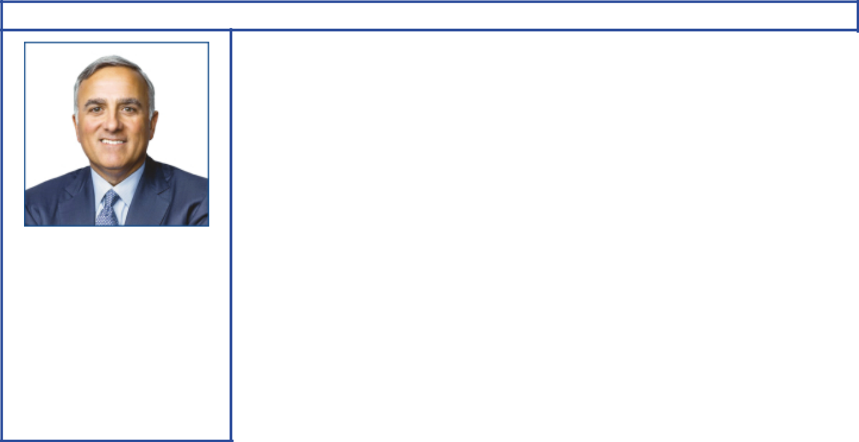

Michael J. Angelakis

Principal occupation: Chairman of the Board and Chief Executive Officer, Atairos Group Inc.

Age 57

Director since 2021
Independent director

Committees:

Audit, Finance, Executive

Background:

- Business leadership at Atairos Group as Chairman and Chief Executive Officer since 2015. He also serves as Senior Advisor to the Management Committee of Comcast Corporation since 2015. At Comcast, he served as Vice Chairman and Chief Financial Officer from 2011 to 2015, and as Executive Vice President and Chief Financial Officer from 2007 to 2011. He also served as a Managing Director and a member of the Management and Investment Committees of Providence Equity Partners from 1999 to 2007.

- Academic affiliations: Babson College (former Trustee), and Harvard Business School Management Program (Owner and President)

Current public company directorships: Bowlero Corporation (December 2021 to present); Clarivate Plc (December 2021 to present); TriNet Group, Inc. (February 2017 to present)

Previous public company directorships in last five years: Duke Energy Corporation (October 2015 to August 2017); Groupon, Inc. (April 2016 to May 2021); Hewlett Packard Enterprise Company (November 2015 to April 2020)

Other board experience: Chairman of The Federal Reserve Bank of Philadelphia (January 2016 to January 2018) and Deputy Chairman and board member (January 2012 to January 2016)

2022 Proxy Statement | 9

Table of Contents


Susan K. Avery

 | Background:
 | • Achieved prominence in her field at the Woods Hole Oceanographic Institution, a
 |  | global research organization, as President and Director from 2008 to 2015. In the
 |  | course of her lengthy and varied experience with matters of climate science,
 |  | Dr. Avery has been involved with areas of policy, carbon pricing, renewable energy,
 |  | and adaptation.
 | • Academic leadership at the University of Colorado Boulder as interim dean of the
 |  | graduate school and vice chancellor for research, interim provost, and executive
 |  | vice chancellor for academic affairs from 2004 to 2008
Principal occupation: | • | Government / scientific research experience as past member of the United
President Emerita, |  | Nations Scientific Advisory Board and the National Research Council Global
Woods Hole Oceanographic |  | Change Research Program Advisory Committee
Institution | • | Scientific and research advisory committee memberships held or recently held
Age 72 | •
Age 72 |  | include the American Institute of Physics Board (Treasurer), NASA, NOAA, National
Director since 2017 |  | Science Foundation, Lawrence Berkeley National Laboratory, National Park
Independent director |  | System, Independent Advisory Committee on Applied Climate Risk, Center for
Committees: |  | Southern Hemisphere Ocean Research, and Japan Agency for Marine-Earth
Committees: |  | Science and Technology
Board Affairs, Public Issues |  | Science and Technology
and Contributions | • | Scientific and environmental affiliations: University Corporation for Atmospheric
 |  | Research (Chair of Board), Consortium for Ocean Leadership (senior fellow),
 |  | American Geophysical Union, American Meteorological Society (fellow), American
 |  | Association for the Advancement of Science (fellow), and IEEE (fellow)
 | Current public company directorships: None
 | Previous public company directorships in last five years: None
Angela F. Braly


Principal occupation: Former Chairman of the Board, President and Chief Executive Officer, WellPoint (now Anthem)

Age 60

Director since 2016
Independent director

Committees:

Compensation, Public Issues

and Contributions

Background:

- Business leadership with operational experience at WellPoint as Chairman from 2010 to 2012; as President, Chief Executive Officer, and board member from 2007 to 2012; and as Executive Vice President, General Counsel, and Chief Public Affairs Officer from 2005 to 2007. She also served as President and Chief Executive Officer of Blue Cross Blue Shield of Missouri from 2003 to 2005.

- Business and public policy affiliations: Blue Cross Blue Shield Association (former Director), Business Council (former member), Business Roundtable (former member), Harvard Advisory Council on Health Care Policy (former member), Indiana Economic Development Corporation (former Director), and The Policy Circle (Co-Founder, Director, and Secretary)

Current public company directorships: Brookfield Asset Management Inc.

(May 2015 to present); The Procter & Gamble Company (December 2009 to present)

Previous public company directorships in last five years: Lowe’s Companies, Inc. (November 2013 to July 2021)

Other board experience: Director of WellPoint, Inc. (prior to 2017)

10 2022 Proxy Statement

Table of Contents


Ursula M. Burns

Principal occupation: Former Chairman of the Board and Chief Executive Officer, VEON Ltd.

Age 63

Director since 2012
Independent director

Committees:

Audit, Executive, Finance

Background:

- Global business leadership with operational experience at Xerox as Chairman from 2010 to 2017; as Chief Executive Officer from 2009 to 2016; and as President from 2007 to 2016. She also served as Senior Vice President, Corporate Strategic Services, and Senior Vice President and President, Document Systems and Solutions Group, and Business Group Operations, at Xerox. At VEON Ltd., she was Chairman of the Board until May 2020, and served as Chief Executive Officer from 2018 through February 2020.

- Government and public policy experience: Vice Chair and Chair of the President’s Export Council (2010 to 2016), and U.S. Department of Commerce Advisory Committee on Supply Chain Competitiveness (February 2022 to present)

- Scientific, academic, and non-profit affiliations: American Academy of Arts and Sciences (member), Columbia Engineering (member, Board of Visitors), Cornell Technology (member, Board of Overseers), FIRST (board member), Ford Foundation (Trustee), Friends of the High Line (board member), Mayo Clinic (Trustee), Massachusetts Institute of Technology Corporation (Trustee), National Academy Foundation (board member), National Academy of Engineering (member), New York City Ballet Inc. (Trustee), Metropolitan Museum of Art (Trustee), and Scratch Foundation (board member)

Current public company directorships: Endeavor Group Holdings (July 2021 to present); IHS Holding Ltd. (July 2020 to present); Plum Acquisition Corp I (March 2021 to present); Uber Technologies Inc. (May 2019 to present)

Previous public company directorships in last five years: American Express (January 2004 to May 2018); Nestlé S.A. (April 2017 to April 2021); VEON Ltd. (July 2017 to May 2020); Xerox (April 2007 to June 2017)

Other board experience: Director of Boston Scientific (prior to 2017)


Gregory J. Goff

Principal occupation: Former Executive Vice Chairman, Marathon Petroleum Corporation

Age 65

Director since 2021
Independent director

Committees:

Board Affairs, Compensation, Executive

Background:

- Global business leadership with operational and commodity business experience at Marathon Petroleum Corporation as Executive Vice Chairman from 2018 to 2019. At Andeavor, he was President and Chief Executive Officer from
2010 to 2018; and as Chairman from 2014 to 2018. He also held a number of senior leadership positions during his 30-year career at ConocoPhillips in the areas of Exploration and Production, Downstream, and as Senior Vice President of Commercial from 2008 to 2010.

- Academic affiliations: National Advisory Board of the University of Utah Business School (board member), and The Goff Strategic Leadership Center at the University of Utah (Founder)

Current public company directorships: Avient Corporation (October 2011 to present)

Previous public company directorships in last five years: Andeavor (May 2010 to October 2018); Andeavor Logistics LP (April 2011 to October 2018); Enbridge Inc. (February 2020 to June 2021); Marathon Petroleum Corporation (October 2018 to December 2019)

Other board experience: Chairman of the American Fuel & Petrochemical Manufacturers (April 2015 to April 2017)

2022 Proxy Statement | 11

Table of Contents
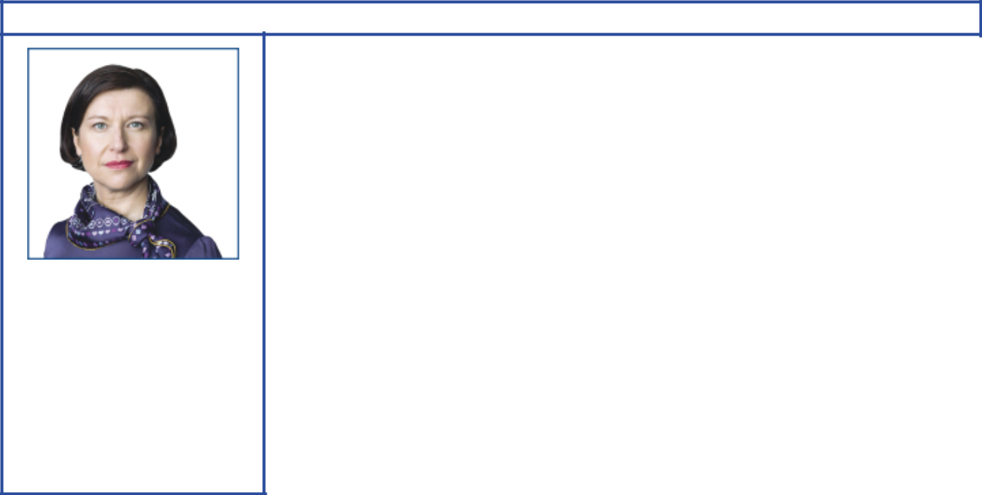

Kaisa H. Hietala

Principal occupation:

Former Executive Vice President of Renewable Products, Neste Corporation

Age 51

Director since 2021
Independent director

Committees:

Audit, Finance

Background:

- Global business leadership with operational and commodity business experience as Executive Vice President of Renewable Products and member of the Executive Committee at Neste Corporation from 2014 to 2019. She also held a number of senior positions during her 20-year career at Neste Corporation including VP, Renewable Fuels.

- Sustainability and academic affiliations: New Sustainability Oy (partner), Supervisory Board of Oulu University (member), Susformation Oy (Founder), and Sustainability Hub Advisory Board of Aalto University (former member)

Current public company directorships: Smurfit Kappa Group Plc (October 2020 to present)

Previous public company directorships in last five years: Kemira Oyj (March 2016 to March 2021)

Other board experience: Chairman of Tracegrow Oy (May 2019 to present)


Joseph L. Hooley

 |  | Background:
 |  | • Global business leadership with operational experience at State Street
 |  | Corporation as Chairman from 2011 to 2019; as Chief Executive Officer from 2010
 |  | to 2018; as President and Chief Operating Officer from 2008 to 2014; as Executive
 |  | Vice President and head of Investor Services Division from 2002 to 2008; and, in
 |  | 2006, as Vice Chairman and Global Head of Investment Servicing and Investment
 |  | Research and Trading. He also served as President and Chief Executive Officer of
 |  | Boston Financial Data Services from 1990 to 2000, and as President and Chief
 |  | Executive Officer of National Financial Data Services from 1988 to 1990.
Principal occupation: |  | • Charitable affiliations: Boys & Girls Clubs of Boston (Director)
Principal occupation: |  | Current public company directorships: Aptiv PLC (January 2020 to present)
Former Chairman of the
Board, President and Chief |  | Previous public company directorships in last five years: State Street Corporation
Executive Officer,
Executive Officer, |  | (October 2009 to December 2019)
State Street Corporation |  | (October 2009 to December 2019)
 |  | Other board experience: Liberty Mutual Insurance (April 2019 to present)
Age 65
Director since 2020
Independent director
Committees:
Audit, Finance
12 | 2022 Proxy Statement

Table of Contents
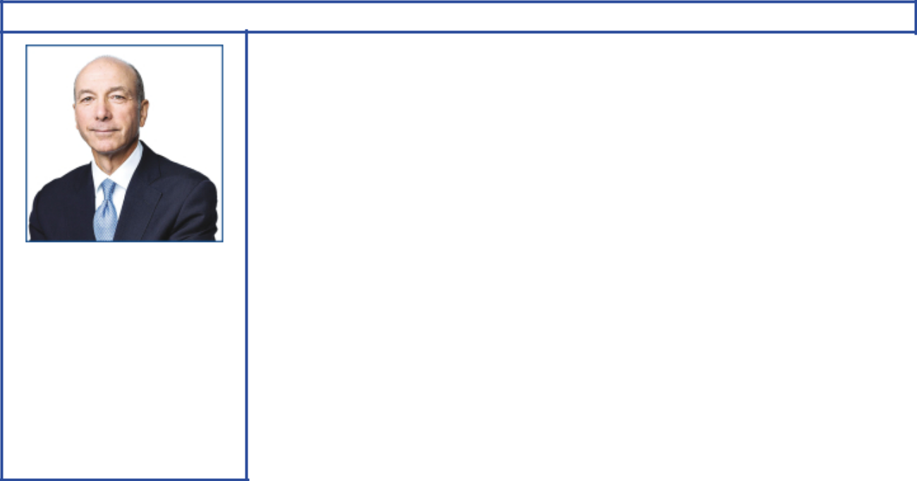

Steven A. Kandarian

Principal occupation: Former Chairman of the Board, President and Chief Executive Officer, MetLife

Age 70

Director since 2018
Independent director

Committees:

Compensation, Public Issues

and Contributions

Background:

- Global business leadership with operational experience at MetLife, Inc. as Chairman from 2012 to 2019; as President and Chief Executive Officer from 2011 to 2019; and as Executive Vice President and Chief Investment Officer from 2005 to 2011. He also served as Executive Director of the Pension Benefit Guaranty Corporation from 2001 to 2004.

- Business and cultural affiliations: Business Council (member), Business Roundtable (former member), Partnership for New York City (former Director), Institute of International Finance (former Director and Chair, Insurance Regulatory Committee), and the Lincoln Center for the Performing Arts (former Director)

- Scientific and research affiliations: Damon Runyon Cancer Research Foundation (Director)

Current public company directorships: Jackson Financial Inc. (February 2021 to present)

Previous public company directorships in last five years: AECOM (March 2019 to February 2021); MetLife (May 2011 to April 2019)

Other board experience: Non-Executive Chairman of Jackson National (February 2021 to present); Director of Neuberger Berman (March 2015 to present)
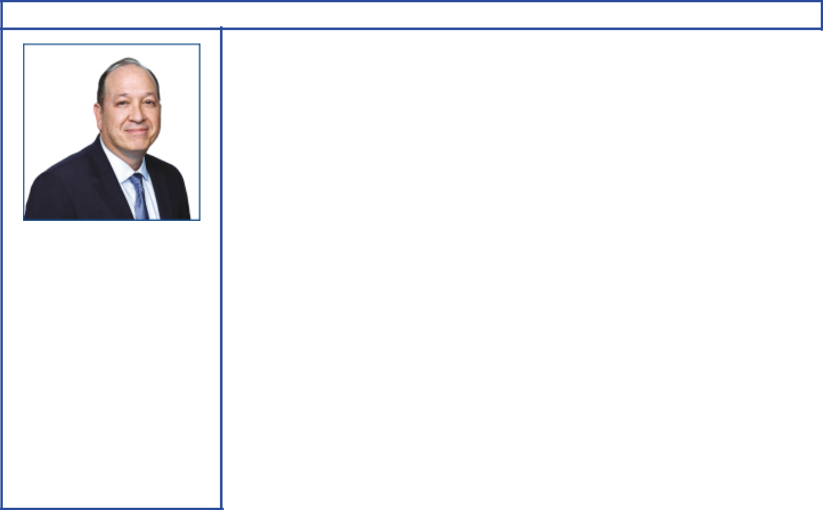

Alexander A. Karsner

Principal occupation: Former Managing Partner, Emerson Collective; Senior Strategist, X

Age 55

Director since 2021
Independent director

Committees:

Board Affairs, Public Issues and Contributions

Background:

- Achieved prominence in his field as Senior Strategist at X: the moonshot factory (formerly Google X). Managing Partner of Emerson Collective from 2016 to 2019. From 2009 to 2014, he was Senior Advisor to Hudson Private Equity and Vantage Point Venture Capital, and Venture Partner. Founder and Chief Executive Officer of Manifest Energy, Inc. since 2009; and Executive Chairman since 2013. U.S. Assistant Secretary for the Department of Energy from 2006 to 2008.

- Business, government and public policy experience: National Petroleum Council (former member), Energy Futures Initiative (member), Trilateral Commission (member), Council on Foreign Relations Working Group (co-chair), and U.S.-India and U.S.-China Track II diplomatic climate bilaterals (delegate)

- Sustainability, scientific and academic affiliations: Conservation International (Director), Elemental Labs (Founder; Executive Chairman), National Marine Sanctuary Foundation (Trustee Emeritus), Aspen Institute Clean Energy Forum (Founder), American Academy of Arts & Sciences Accelerating Climate Action Commission (member), Stanford University Precourt Institute for Energy (member, Board of Advisors), Hoover Institution Shultz-Stephenson Energy Task Force (member), Stanford Natural Capital Project (member), Argonne National Laboratory (former Director), Sandia National Laboratory (former advisor), National Renewable Energy Laboratory (former advisor), UCLA Institute of Environment and Sustainability (advisor), and Gas Technology Institute (former Director)

Current public company directorships: Applied Materials, Inc. (September 2008 to present); Broadscale Acquisition Corp. (February 2021 to present)

Other board experience: Codexis, Inc. (prior to 2017)

2022 Proxy Statement | 13

Table of Contents
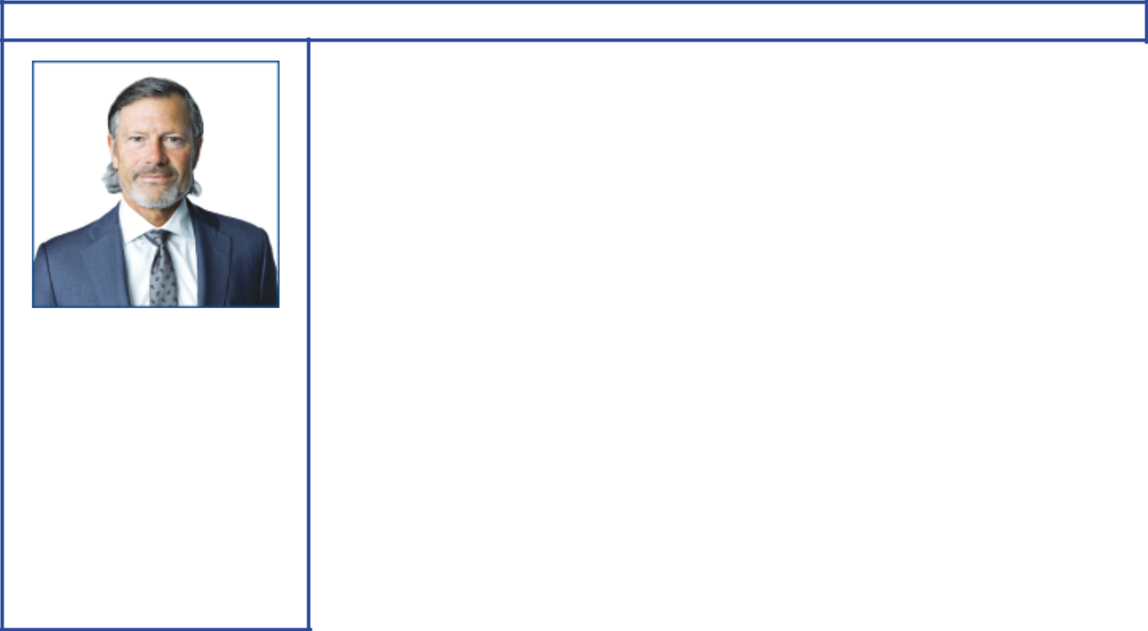

Jeffrey W. Ubben

Principal occupation: Founder, Portfolio Manager and Managing Partner, Inclusive Capital Partners, L.P.

Age 60

Director since 2021
Independent director

Committees:

Finance, Public Issues and Contributions

Background:

- Business leadership at Inclusive Capital Partners, L.P. as Founder, Portfolio Manager and Managing Partner since 2020. He also founded and served as Chief Executive Officer of ValueAct Capital Management, L.P. from 2000 to 2020 and as Chief Investment Officer from 2000 to 2017. He was a Managing Partner of Blum Capital Partners L.P. from 1995 to 2000. He also served in various positions including Portfolio Manager and Research Analyst at Fidelity Investments from 1987 to 1995.

- Academic and environmental affiliations: Duke University (Trustee), E.O. Wilson Biodiversity Foundation (Director), and World Wildlife Fund (Director)

Current public company directorships: Enviva Inc. (June 2020 to present); Fertiglobe Plc (November 2021 to present)

Previous public company directorships in last five years: The AES Corporation (January 2018 to March 2021); AppHarvest, Inc. (May 2019 to March 2022); Nikola Corporation (September 2019 to February 2022); Twenty-First Century Fox, Inc.

(November 2015 to April 2018); Willis Towers Watson plc (January 2016 to November 2017)

Other board experience: Chairman and Director of Martha Stewart Living Omnimedia, Inc.; Director of Misys Plc; Bausch Health Companies Inc.; Sara Lee Corp. (all prior to 2017)
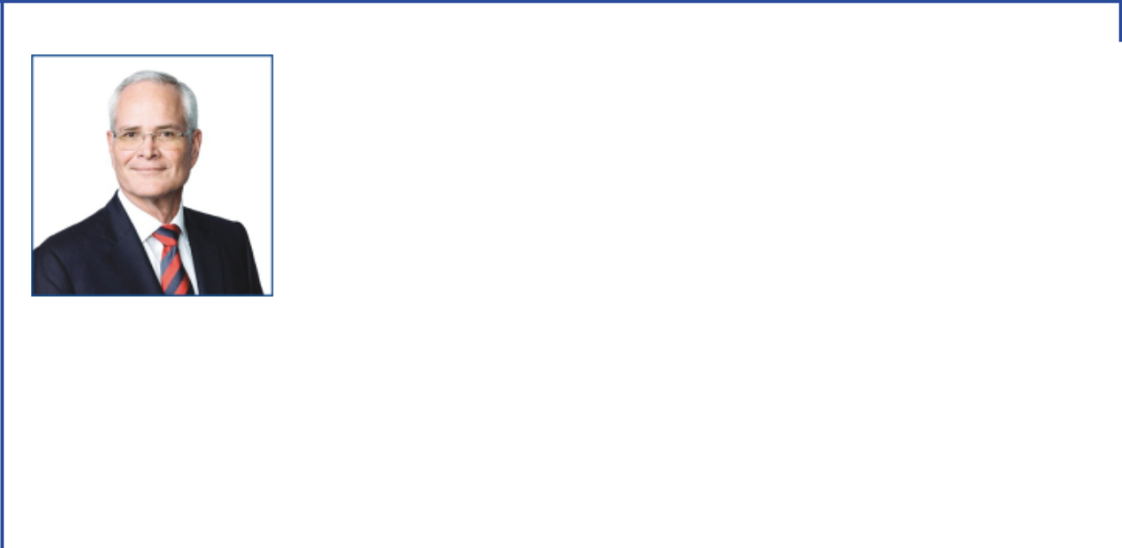

Darren W. Woods

 |  | Background:
 |  | • Global business leadership at Exxon Mobil Corporation as Chairman and Chief
 |  | Executive Officer since 2017; as President since 2016; and as Senior Vice
 |  | President in 2014 and 2015. He also served as Vice President, and President,
 |  | ExxonMobil Refining & Supply Company from 2012 to 2014.
 |  | • Operational and commodity business experience with positions of increasing
 |  | responsibility in domestic and international business operations at ExxonMobil
 |  | Refining & Supply Company, ExxonMobil Chemical Company, and Exxon Company
 |  | International
Principal occupation: |  | • Business affiliations: Business Roundtable (member), American Petroleum
Chairman of the Board and |  | Institute (former Chair), Business Council (member), Center for Strategic and
Chief Executive Officer, |  | International Studies (Trustee), Oil and Gas Climate Initiative, and National
Exxon Mobil Corporation |  | Petroleum Council (Chair)
Age 57 |  | • Scientific and environmental experience: ExxonMobil Chemical Company and
Director since 2016 |  | ExxonMobil Refining & Supply Company
Committees: |  | Current public company directorships: None
Finance, Executive |  | Previous public company directorships: Imperial Oil Ltd. (April 2013 to July 2014)
14 | 2022 Proxy Statement

Table of Contents

CORPORATE GOVERNANCE

Overview

The Board of Directors and its committees perform a number of functions for ExxonMobil and its shareholders, including:

- Overseeing the management of the Company on your behalf, including oversight of risk management;

- Reviewing ExxonMobil’s long-term strategic plans;

- Exercising direct decision-making authority in key areas, such as declaring dividends;

- Selecting the Chief Executive Officer (CEO) and reviewing the CEO’s performance;

- Reviewing development and succession plans for ExxonMobil’s top executives; and

- Gathering insights and sharing perspectives from shareholders during engagements and other communications.

The Board has adopted Corporate Governance Guidelines that govern the structure and functioning of the Board and set out the Board’s position on a number of governance issues. A copy of our current Corporate Governance Guidelines is posted on our website at exxonmobil.com/guidelines.

At least annually, the Board and each of the Board committees conduct an evaluation of their performance and effectiveness. Any potential changes to the committees’ charters are also considered at least once a year.

Risk Oversight

The full Board of Directors provides oversight of key risks to ExxonMobil’s business. The Board throughout the year participates in reviews with management on the Company’s business, including identified risk factors. As a whole, the Board reviews litigation and other legal matters; political contributions, budget, and policy; lobbying costs; developments in climate science and policy; the Outlook for Energy, which projects world energy supply and demand to 2050; the Advancing Climate Solutions report; stewardship of business performance; and long-term strategic plans. The Board receives updates and reviews from both internal ExxonMobil and external experts on issues of importance to the Company.

The Board, including the Public Issues and Contributions Committee, visits an ExxonMobil operations site each year. These visits enable the directors to observe and provide input on safety, operating practices, environmental performance, technology, products, industry and corporate standards, and community engagement.

2022 Proxy Statement | 15

Table of Contents

The Board oversees a broad spectrum of interrelated risks with assistance from its committees. This integrated risk management approach facilitates recognition and oversight of important risk interdependencies.
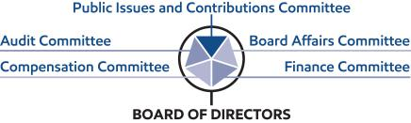

Audit Committee oversees risks associated with financial and accounting matters, including compliance with legal and regulatory requirements and the Company’s financial reporting and internal control systems. The Audit Committee also periodically reviews cybersecurity risks and preparedness and ExxonMobil’s overall risk management approach and structure.

Board Affairs Committee oversees Board structure and matters of corporate governance, including Board evaluation and director refreshment. It also coordinates identification of external experts to address the Board and sets the criteria for shareholder engagement with directors.

Compensation Committee reviews executive compensation, which is designed to promote accountability to maximize shareholder value over the long term while effectively managing longer term risks, including those related to climate change. The Committee also assesses each element of the compensation program to ensure that these do not create any material adverse risks to the Company and do not encourage executives to take risks that may not be aligned with shareholders’ long-term interests.

Public Issues and Contributions Committee oversees operational risks such as those relating to employee and community safety, health, environmental performance, including actions taken to address climate-related risks, and security matters. The Committee also reviews and provides advice on objectives, policies, and programs related to lobbying activities and political and other contributions.

Finance Committee oversees risks associated with financial instruments, financial policies, practices and strategies, capital structure, and capital allocation.

Each Board committee has the authority to retain outside advisors as it deems appropriate and approve the fees and expenses of such advisors. The Board receives regular updates from the committees and believes this structure is best suited for overseeing risk.

16 2022 Proxy Statement

Table of Contents

Board Leadership Structure

The Board believes that the decision as to who should serve as Chairman and/or CEO is the proper responsibility of the Board. The Board retains authority to amend the by-laws to separate the positions of Chairman and CEO at any time and regularly considers the pros and cons of such separation or combination. At the present time, the Board believes the interests of all shareholders are best served through a leadership model with a combined Chairman/CEO position and an independent Lead Director selected by and from the independent directors.

The current CEO possesses an in-depth knowledge of the Company; its integrated, multinational operations; the evolving energy industry supply and demand fundamentals; and the array of challenges and opportunities presented by the energy transition. This knowledge was gained through 30 years of successful experience in progressively more senior positions, including domestic and international responsibilities.

The Board believes that these experiences and other insights put the CEO in the best position to provide broad leadership for the Board as it considers strategy and exercises its fiduciary responsibilities to shareholders. Further, the Board has demonstrated its commitment and ability to provide independent oversight of management.

The Board is comprised solely of independent directors other than the CEO, and 100 percent of the Audit, Compensation, Board Affairs, and Public Issues and Contributions Committee members are independent. Each independent director has access to the CEO and other Company executives and employees, and is empowered to call meetings of the independent directors and request agenda topics to be added or addressed in more detail at meetings of the full Board or an appropriate Board committee.

The Board believes the Lead Director provides effective independent Board leadership. Kenneth C. Frazier serves as Lead Director and is expected to remain in the position through the annual meeting of shareholders. The Board has selected Joseph L. Hooley to serve as Lead Director after the annual meeting of shareholders.

The Lead Director’s authority, under the

Corporate Governance Guidelines, includes:

- Calling, chairing, and setting the agenda for executive sessions of the non-employee directors;

- Providing feedback to the Chairman;

- Chairing meetings of the Board in the absence of the Chairman;

- Reviewing and approving the schedule and agenda for all Board meetings and reviewing associated materials distributed to the directors, in consultation with the Chairman;

- Advising the Chairman on the quality, quantity, and timeliness of information flow;

- Reviewing committee meeting schedules;

- Engaging with shareholders, as appropriate; and

- Leading the annual performance evaluation of the Board.

The Lead Director also serves as Chair of the Board Affairs Committee with authority that includes:

- Establishing the criteria for director engagement with shareholders;
- Providing comments and suggestions to the Board on Board committee structure, operations, member qualification, and member appointment;
- Overseeing independent director succession planning, remuneration, requests for additions to board memberships, and resignations;
- Establishing and maintaining procedures for interested parties to communicate with non-employee directors;

- Considering Board governance practices and procedures, including any changes to governance guidelines; and

- Providing oversight of the performance and effectiveness of the evaluation process for the Board and its committees.

In addition, the Lead Director, working together with the Compensation Committee, oversees the annual evaluation of the CEO, the communication of resulting feedback to the CEO, and the review of CEO succession plans.

2022 Proxy Statement | 17

Table of Contents

Director Qualifications

The Board has adopted guidelines outlining the qualifications sought when considering non-employee director candidates. These Guidelines for the Selection of Non-Employee Directors (Selection Guidelines), which are published on our website at exxonmobil.com/directorguidelines, are reviewed annually and state in part:

“ExxonMobil recognizes the strength and effectiveness of the Board reflects the balance, experience, and diversity of the individual directors; their commitment; and importantly, the ability of directors to work effectively as a group in carrying out their responsibilities. ExxonMobil seeks candidates with diverse backgrounds who possess knowledge and skills in areas of importance to the Corporation.”

The qualifications we consider for director candidates include: individuals who have achieved prominence in their fields; diversity of experiences and backgrounds, including gender and race/ethnic diversity; experience and demonstrated expertise in managing large, relatively complex organizations, such as that of CEOs of a significant company or organization with global responsibilities; financial and other risk management expertise; government, regulatory, or public policy experience; experience on one or more boards of significant public or non-profit organizations; expertise resulting from significant academic, scientific, or research activities; and experience in the energy industry or with cyclical businesses, such as commodities.

Other considerations for director candidates include: a substantial majority of the Board must meet independence standards as described in the Corporate Governance Guidelines; all candidates must be free from any relationship with management or the Corporation that would interfere with the exercise of independent judgment; candidates should be committed to representing the interests of all shareholders and not any particular constituency; and the Board must include members who satisfy legal and stock exchange requirements for certain Board committees.

All directors are expected to adhere to the Company’s policies and procedures, including the Conflict of Interest Policy and Ethics Policy. See the Code of Ethics and Business Conduct section below for additional information.

18 2022 Proxy Statement

Table of Contents

The Board is comprised of directors with an effective mix of backgrounds, knowledge, and skills that the Board considers relevant and beneficial in fulfilling its oversight role. The chart below provides a summary of the competencies of the current ExxonMobil Board and explains why these are important:
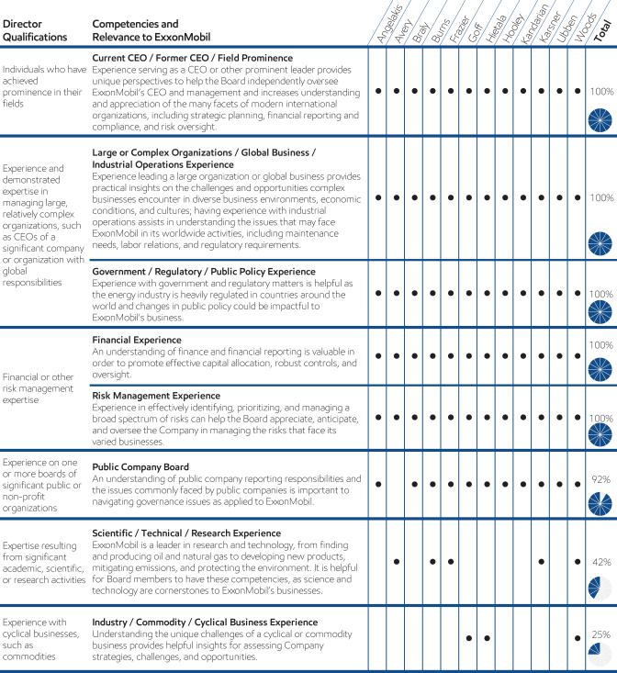

2022 Proxy Statement | 19

Table of Contents

Diversity of experiences and backgrounds, including gender and race/ethnicity, is also an important consideration for Board members. The charts below reflect the diversity of the current Board.

Strong Board Gender and Race/Ethnic Diversity
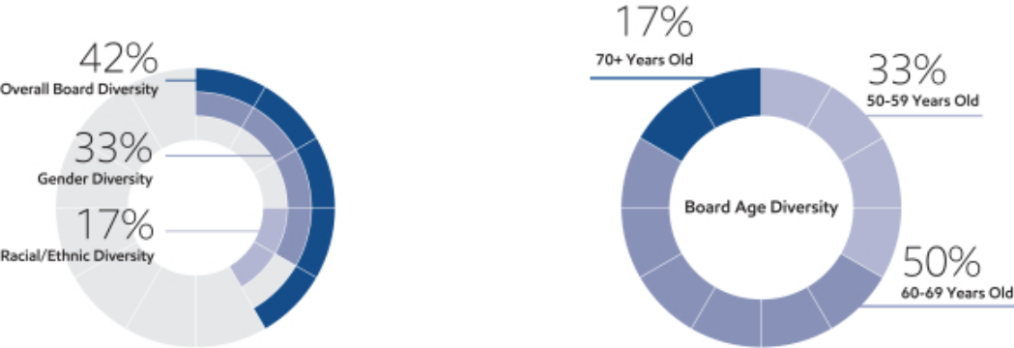

Director Independence

The Corporation’s Corporate Governance Guidelines require that a substantial majority of the Board consists of independent directors. In general, the Guidelines require that an independent director must have no material relationship with ExxonMobil, directly or indirectly, except as a director. The Board determines independence on the basis of the standards specified by the New York Stock Exchange (NYSE), the additional standards referenced in our

Corporate Governance Guidelines, and other facts and circumstances the Board considers relevant.

Under ExxonMobil’s Corporate Governance Guidelines, a director will not be independent if a reportable “related person transaction” exists with respect to that director or a member of the director’s family for the current or most recently completed fiscal year. See the Guidelines for Review of Related Person Transactions posted on the Corporate Governance section of our website and described in more detail under Related Person Transactions and Procedures below.

The Board has reviewed relevant relationships between ExxonMobil and each non-employee director and director nominee to determine compliance with the NYSE standards and ExxonMobil’s additional standards. The Board has evaluated whether there are any other facts or circumstances that might impair a director’s independence. Based on that review, the Board has determined that all ExxonMobil non-employee directors are independent. The Board has also determined that each member of the Audit, Board Affairs, Compensation, and Public Issues and Contributions Committees (see table on page 25) is independent based on both applicable NYSE standards and the Company’s independence standards for each of these committees. The Company’s standards for each committee are included in their respective charters and posted on our website at exxonmobil.com/guidelines.

In recommending that each director and nominee be found independent, the Board Affairs Committee reviewed the following transactions, relationships, or arrangements. All matters described below fall within the NYSE and ExxonMobil independence standards.

Name | Matters Considered
K.C. Frazier | Ordinary course business with Merck (purchases of pharmaceuticals; sales of chemicals and oils)
20 | 2022 Proxy Statement

Table of Contents

Shareholder Engagement in 2021

The Board and management believe ongoing engagement with our shareholders is vitally important and understand the importance of keeping shareholders informed about the business, understanding shareholders’ perspectives, and addressing shareholders’ areas of interest. The Board and management welcome and value input from all shareholders.

Engaged with: |  |  | Engaged through: |  |  |  |  | Engagements include:
✓ | Institutional Investors |  | ✓ | Individual and Group Investor |  |  |  | ✓ | Non-employee Directors
✓ | Retail Shareholders |  | ✓ | Meetings |  |  |  | ✓ Chairman / CEO /
✓ | Pension Funds |  | ✓ | Investor Day |  |  |  | ✓ | Management Committee
✓ | Religious Organizations |  | ✓ | Quarterly Earnings Calls |  |  |  | ✓ | Senior Management
✓ | Nongovernmental |  | ✓ | Investor Conferences |  |  |  | ✓ | Subject Matter Experts
 | Organizations |  | ✓ | Spotlight Events |  |  |  | ✓ | Other Employees
✓ | Proxy Advisory Firms |  | ✓ | Annual Shareholder Meeting
✓ | ESG Rating Firms |  | ✓ | Shareholder Webcasts |  |  |  | ESG Engagements:
✓ | Industry Thought Leaders |  | ✓ | Stakeholder Outreach |  |  |  | More than doubled
 |  |  |  |  |  |  |  |  | since 2016
Engaged with shareholders representing: |  |  |  |  | Information shared through:
 | ~ 1.7 billion shares |  |  |  | • | SEC Filings |  | • | Advancing Climate Solutions
~ 41% of total outstanding shares |  |  |  |  | • | Press Releases |  |  | report
 |  |  |  |  | • | Annual Report |  | • | Sustainability Report
 | and |  |  |  | • | Company Website |  | • | Perspectives Blog
~ 77% of institutional shareholdings |  |  |  |  | • | Energy Factor Website

Director Nomination Process and Board Succession

As noted in the committee information that follows, the Board Affairs Committee is responsible for identifying and evaluating director candidates. The description below sets forth the process through which the Committee identifies potential nominees to the Board and evaluates their qualifications.

Candidate Recommendations

The Board Affairs Committee seeks new candidates in several ways:

- Recommendations made by the non-employee directors. These recommendations are developed based on the directors’ own knowledge and experience in a variety of fields and on the research conducted by ExxonMobil staff at the Committee’s direction.

- Engagement of an executive search firm. The firm brings forward potential director candidates for the Committee to consider and helps research candidates identified by the Committee.

- Recommendations made by employee directors, shareholders, and others.

All recommendations, regardless of the source, are evaluated on the same basis against the criteria contained in the Selection Guidelines. The Committee has also instructed its executive search firm to include diversity as part of the candidate search criteria.

Shareholders may send recommendations for director candidates to the Corporate Secretary at the address given under

Contact Information on page 8. A submission recommending a candidate should include:

- Sufficient biographical information to enable the Committee to evaluate the candidate in light of the Selection Guidelines;

- Information concerning any relationship between the candidate and the recommending shareholder; and

- Material indicating the willingness of the candidate to serve if nominated and elected.

2022 Proxy Statement | 21

Table of Contents

The procedures by which shareholders may recommend nominees have not changed materially since last year’s proxy statement.

Assessment and Nomination

Once potential nominees are identified, the Board Affairs Committee assesses each candidate’s overall qualifications for nomination to the Board relative to an assessment of the Company’s future direction. In evaluating prospective directors, the Committee considers various factors including:

- ExxonMobil’s Corporate Governance Guidelines;

- The candidate’s skills, expertise, and background as compared to ExxonMobil’s Selection Guidelines;

- ExxonMobil’s strategy, risk profile, and current Board composition;

- Independence, perspectives, objectivity, reasoning, and judgment of the candidate; and

- Board diversity.

ExxonMobil seeks to have a diverse Board representing a range of backgrounds, knowledge, and skills relevant to the Company’s business and the needs of the Board, and as part of the search process, considers highly qualified candidates, including women and minorities. The Committee does not use quotas, but considers diversity along with the other requirements of the Selection Guidelines when evaluating potential new directors. The resulting diversity of experience, skills, gender, and race/ethnicity on the ExxonMobil Board serves as a testament to this robust process.

If the Board Affairs Committee determines to advance a candidate in the nomination process, the Committee puts the candidate forward for consideration by the full Board.

Since our last annual meeting of shareholders, the Committee continued its director succession planning, using the process described above and taking into account, among other factors, shareholders’ interest in board refreshment and specifically in adding directors with oil and natural gas industry, energy and business transition, capital allocation, and finance expertise. Mr. Goff, Ms. Hietala, and Mr. Karsner were recommended by a shareholder and joined the Board during 2021 with the support of shareholders.

Director Re-Nomination

The Board Affairs Committee also oversees the re-nomination process. In considering whether to re-nominate a director for re-election at our annual meeting, the Committee reviews each director, considering such factors as:

- Attendance and participation at Board and committee meetings;

- Skills, experience, and personal attributes;

- Continued contribution to the Board’s effectiveness;

- Results from the annual Board and committee self-assessments;

- Shareholder feedback, including the support received at our annual meeting of shareholders; and

- Independence.

Board Tenure

The Board does not impose tenure limits on its directors, other than a mandatory retirement age of 72 and the requirement to stand for election annually. Given the complexity and breadth of our business and its long-term investment horizons, the Board considers longevity of service and experience of great value. The Board also believes that its director compensation approach, which limits the vesting of restricted shares until retirement, closely aligns directors with the interests of long-term shareholders.

All ExxonMobil directors stand for election at the annual meeting. Non-employee directors cannot stand for election after they have reached age 72, unless the Board makes an exception on a case-by-case basis.

22 2022 Proxy Statement

Table of Contents

During 2021 and 2022, the Board assisted by the Board Affairs Committee evaluated an exception to the mandatory retirement age for Dr. Avery. The Committee and Board considered Dr. Avery’s climate change related experience as an atmospheric scientist with significant scientific and research qualifications and skills, her continued leadership as the Chair of the Public Issues and Contributions Committee, her relatively short tenure on the Board of only five years, and the views and perspectives of our shareholders. The Board and Committee evaluated these skills and experiences as valuable in supporting the strategic direction of the Company and its efforts to play a leading role in the energy transition. The Committee and Board also evaluated the importance of continuity of leadership during the significant Board refreshment in 2021. In light of these considerations, in 2022 the Board Affairs Committee recommended, and the Board concurred that the Company would benefit from Dr. Avery’s continued contributions and service as a director and the Board approved Dr. Avery’s re-nomination. Dr. Avery recused herself from all Committee and Board discussions of the exception and abstained from the Board vote on the matter.

Restricted shares received by non-employee directors are subject to forfeiture if the non-employee director leaves the Board early, i.e., before the retirement age of 72. Employee directors resign from the Board when they are no longer employed by ExxonMobil.

As of April 1, 2022, the average tenure of ExxonMobil’s non-employee directors is 4.0 years, well below the average of Standard & Poor’s (S&P) 500 companies of 7.7 years (per 2021 Spencer Stuart Board Index). Fifty percent of current ExxonMobil directors joined the Board since 2020.
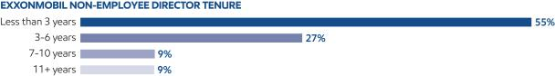

Insights into the Boardroom

The Board added five new independent directors in 2021. These new directors add to the Board’s existing skillsets and expertise by providing additional experience in energy, business transition, and capital allocation. Each new director participated in comprehensive onboarding sessions designed to accelerate the learning curve and cover a wide range of topics, including the Company’s history, culture, practices, risk framework, legal and regulatory requirements, and ethics and other policies.

ExxonMobil aims to have a diverse Board representing a range of backgrounds, knowledge, and skills relevant to the Company’s business and the Board’s needs. As part of the refreshment process, highly qualified candidates, including women and minorities, are considered. Four of the last ten directors added to the Board have been female and/or racially/ethnically diverse.

The ExxonMobil Board is actively engaged and committed to overseeing the Company’s efforts to grow long-term shareholder value while playing a leading role in the energy transition. The Board provides oversight for the Company’s key risks and opportunities and regularly reviews a variety of issues important to ExxonMobil through a process that involves briefings with subject matter experts from inside and outside the Company. Topics include climate change, research and development efforts, operating strategies, business and corporate planning, technology, current events, shareholder engagements, and Company performance.

This past year, the Board met on nearly a monthly basis. The Board provided oversight and guidance on strategy development and key activities, including the 2022 to 2027 corporate plan and associated capital plan. This plan supports investments in competitively advantaged, low-cost-of-supply opportunities; growing high value products and fuels, lubricants, and chemicals; and a significant increase in investments in lower-emission initiatives to $15 billion through 2027. Among these initiatives are ongoing efforts to reduce Scope 1 and Scope 2 greenhouse gas emissions from the Company’s operations and growing the Company’s Low Carbon Solutions business.

2022 Proxy Statement | 23

Table of Contents

The Low Carbon Solutions business is focused on carbon capture and storage, hydrogen, and lower-emission fuels, which will be critical to reducing emissions in hard-to-abate sectors such as heavy industry and commercial transportation. ExxonMobil has extensive experience and competitive advantages in these technologies that will enable the Company to spur consideration of supportive government policy and play a leadership role in the markets that develop to meet demand for these solutions. Under the Board’s oversight, the Company also announced new Scope 1 and Scope 2 emission reduction plans through 2030 for Company operated assets relative to 2016 levels, including plans to achieve net-zero emissions in the Permian Basin by 2030. Further, the Company announced its ambition to achieve net-zero emissions for Scope 1 and Scope 2 emissions by 2050 for Company operated assets. More details on these actions can be found in the Advancing Climate Solutions report, which is available on the Company’s website.

20-30% | 40-50% | 70-80% | 60-70%
Reduction in | Reduction in | Reduction in | Reduction in
corporate-wide GHG | Upstream GHG | corporate-wide | corporate-wide flaring
intensity by 2030 | intensity | methane intensity | intensity by 2030
 | by 2030 | by 2030

To enhance Board governance, ExxonMobil’s independent Lead Director’s broad authorities were enhanced in 2020 and include leading the annual performance evaluation of the Board and its committees. The Lead Director also works with the Compensation Committee to oversee the annual evaluation of the CEO.

Beyond evaluation of the CEO, the Board regularly reviews ExxonMobil’s talent strategy, succession planning and training, and other development programs. This talent strategy encompasses all elements of human capital management, including attracting, retaining, and developing a productive, capable, and diverse workforce that is reflective of the global community where ExxonMobil operates. Diversity and inclusion are critical to the success of ExxonMobil’s talent strategy, and the Board stewards the Company’s performance against this objective.


The Board Affairs Committee has established and oversees procedures for shareholders and other interested persons to send written or electronic communications to individual directors, including the Lead Director, Board committees, or the non-employee directors as a group.

- Written Communications: Written correspondence should be addressed to the director or directors at the address given under Contact Information on page 8.

- Electronic Communications: You may send a message to individual non-employee directors, Board committees, or the non-employee directors as a group by using the form provided for that purpose on our website at exxonmobil.com/directors.

All communications are recorded by an ExxonMobil Assistant Secretary or designated staff member and forwarded to the appropriate director or directors or otherwise handled as the Committee has directed.

Code of Ethics and Business Conduct

The Board maintains policies and procedures (referred to in this proxy statement as the Code) that represent both the code of ethics for the principal executive officer, principal financial officer, and principal accounting officer under SEC rules, and the code of business conduct and ethics for directors, officers, and employees under NYSE listing standards. The Code applies to all directors, officers, and employees and is at the core of the Company’s foundational policies. The Code includes a Conflicts of Interest Policy under which directors, officers, and employees are expected to avoid any actual or apparent conflict between their own personal interests and the interests of the Corporation. The Code also includes an Ethics Policy under which directors, officers, and employees are expected to observe the highest ethical standards of integrity in the conduct of the Company’s business. Each year, directors, officers, and employees are required to certify that they have read the Code and remain in compliance with its requirements. The

24 2022 Proxy Statement

Table of Contents

Code is posted on the ExxonMobil website at exxonmobil.com/code. The Code is also included as an exhibit to our Annual Report on Form 10-K. Any amendment of the Code will be posted promptly on ExxonMobil’s website.

The Corporation maintains procedures for administering and reviewing potential issues under the Code, including procedures that allow employees to make complaints without identifying themselves unless otherwise required by law. The Corporation also conducts periodic mandatory business practice training sessions.

The Board Affairs Committee will initially review any suspected violation of the Code involving an executive officer or director and will report its findings to the Board. The Board does not envision that any waiver of the Code will be granted. Should such a waiver occur, it will be promptly disclosed on ExxonMobil’s website.

Board Meetings and Annual Meeting Attendance

The Board met 13 times in 2021. ExxonMobil’s incumbent directors, on average, attended approximately 97 percent of Board and committee meetings during 2021. No director attended fewer than 75 percent of such meetings. ExxonMobil’s non-employee directors held 10 executive sessions in 2021, chaired by the independent Lead Director. As specified in our Corporate Governance Guidelines, it is ExxonMobil’s policy that directors should make every effort to attend the annual meeting of shareholders. All directors on May 26, 2021 attended the 2021 annual meeting of shareholders.

Board Committees

The Board appoints committees to help carry out its duties. Board committees work on key issues in greater detail than would be possible at full Board meetings. Only non-employee directors may serve on the Audit, Compensation, Board Affairs, and Public Issues and Contributions Committees. Each committee has a written charter. The charters are posted on the Corporate Governance section of our website at exxonmobil.com/governance.

The tables below show the current membership of each Board committee and the number of meetings each committee held in 2021.

 |  |  | Board |  |  | Public Issues
Director | Audit | Compensation | Affairs | Finance |  | and Contributions | Executive⁽¹⁾
M.J. Angelakis | ✓ |  |  | ✓ |  |  | ✓
S.K. Avery |  |  | ✓ |  |  | C
A.F. Braly |  | C |  |  |  | ✓
U.M. Burns | C |  |  | ✓ |  |  | ✓
K.C. Frazier |  | ✓ | C |  |  |  | ✓
G.J. Goff |  | ✓ | ✓ |  |  |  | ✓
K.H. Hietala | ✓ |  |  | ✓
J.L. Hooley | ✓ |  |  | C
S.A. Kandarian |  | ✓ |  |  |  | ✓
A.A. Karsner |  |  | ✓ |  |  | ✓
J.W. Ubben |  |  |  | ✓ |  | ✓
D.W. Woods |  |  |  | ✓ |  |  | C
C = Chair ✓ = Member | (1) Other directors serve as alternate members on a rotational basis
 |  |  |  | 2022 Proxy Statement |  |  | 25

Table of Contents

Meetings in 2021:
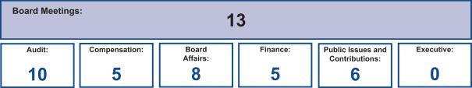

Board Affairs Committee

The Board Affairs Committee, chaired by the independent Lead Director, serves as ExxonMobil’s nominating and corporate governance committee. Its responsibilities include:

- Recommendations on director candidates and reviewing requests for participation on other boards;

- Maintaining procedures for director engagement with shareholders;

- Providing comments and suggestions to the Board on committee structure and committee assignments;

- Reviewing corporate governance practices, including the Corporate Governance Guidelines;

- Reviewing any issue involving an executive officer or director under the Code; and

- Administering ExxonMobil’s Related Person Transaction Guidelines.

The Committee also administers provisions of the Corporate Governance Guidelines that require a director to tender a resignation when there is a substantial change in the director’s circumstances. The Committee reviews the relevant facts to determine whether the director’s continued service would be appropriate and makes a recommendation to the Board.

Another responsibility of the Committee is to review and make recommendations to the Board regarding the compensation of the non-employee directors. The Committee uses an independent consultant, Pearl Meyer & Partners, LLC (Pearl Meyer), to provide information on current developments and practices in director compensation. Pearl Meyer is the same consultant retained by the Compensation Committee to advise on executive compensation, but performs no other work for ExxonMobil.

The Guidelines for the Selection of Non-Employee Directors describe the qualifications the Committee looks for in director candidates. These Selection Guidelines, as well as the Committee’s charter, are posted on the Corporate Governance section of our website.

Audit Committee

The Audit Committee oversees accounting and internal control matters. Its responsibilities include oversight of:

- Management’s conduct of the Corporation’s financial reporting process;

- The integrity of the financial statements and other financial information provided by the Corporation to the SEC and the public;

- The Corporation’s system of internal accounting and financial controls;

- The Corporation’s compliance with legal and regulatory requirements;

- The performance of the Corporation’s internal audit function;

- The independent auditors’ qualifications, performance, and independence; and

- The annual independent audit of the Corporation’s financial statements.

26 2022 Proxy Statement

Table of Contents

The Committee has direct authority and responsibility to appoint (subject to shareholder ratification), compensate, retain, and oversee the independent auditors.

The Committee also prepares the report that SEC rules require be included in the Corporation’s annual proxy statement.

The report begins on page 33.

The Audit Committee has adopted specific policies and procedures for pre-approving fees paid to the independent auditors. Under the Audit Committee’s approach, an annual program of work is approved each October for the following categories of services: Audit, Audit-Related, and Tax. Additional engagements may be brought forward from time to time for pre-approval by the Audit Committee. Pre-approvals apply to engagements within a category of service, and cannot be transferred between categories. If fees might otherwise exceed pre-approved amounts for any category of permissible services, the incremental amounts must be reviewed and pre-approved prior to commitment. The complete text of the Audit Committee’s pre-approval policies and procedures, as well as the Committee’s charter, is posted on the Corporate Governance section of ExxonMobil’s website.

The Board has determined that all members of the Committee are financially literate within the meaning of the NYSE standards, and a majority are “audit committee financial experts” as defined in the SEC rules, including Ms. Burns as the Audit Committee Chair.

Compensation Committee

The Compensation Committee is comprised exclusively of non-employee, independent directors, and oversees compensation for ExxonMobil’s senior executives (including salary, bonus, and performance share awards), as well as succession planning for key executive positions. The Committee’s charter is available on the Corporate Governance section of our website.

The Committee took the following actions:

- Reviewed and approved the corporate goals and objectives;

- Reviewed the Corporation’s business results and progress toward strategic objectives during the year with ExxonMobil’s CEO and other senior executives;

- Reviewed the individual performance and contributions of the CEO and other senior executives;

- Discussed the Company’s executive compensation program design with its independent consultant;

- Considered the results of the 2021 advisory vote on executive compensation;

- Deliberated pay decisions based on an assessment of progress toward strategic objectives, business results, individual performance, and the results of annual benchmarking, taking into account experience in position;

- Established the aggregate annual ceiling for the 2021 long-term incentive award program and bonus program;

- Assessed each element of the Company’s compensation program and practices, and confirmed that they do not create any material adverse risks for the Company. The key design features of the compensation program that discourage executives from taking inappropriate risk are described in detail in this proxy statement (see pages 39, 56, and 57); and

- Reviewed progress on executive development and succession planning for senior-level positions with input from the CEO.

The Committee does not delegate its responsibilities with respect to ExxonMobil’s executive officers and other senior executives. For other employees, the Committee delegates authority to determine individual salaries and incentive awards to a committee consisting of the Chairman and Management Committee. That committee’s actions are subject to a salary budget and aggregate annual ceilings on incentive awards established by the Compensation Committee.

For more information on the compensation decisions made by the Committee for 2021, refer to the Compensation Discussion and Analysis beginning on page 37.

2022 Proxy Statement | 27

Table of Contents

The Compensation Committee’s report is available on page 36.

The Compensation Committee utilizes the expertise of an external independent consultant, Pearl Meyer. At the direction of the Committee, Pearl Meyer:

- Attends Committee meetings;

- Informs the Committee regarding general trends in executive compensation across industries;

- Prepares the analysis of comparator company compensation used by the Committee; and

- Participates in the Committee’s deliberations regarding compensation for Named Executive Officers.

In addition, at the direction of the Chair of the Board Affairs Committee, Pearl Meyer provides an annual survey of non-employee director compensation for use by that Committee.

The Compensation Committee is solely and directly responsible for the appointment, compensation, and oversight of the consultant. The Committee considers factors that could affect Pearl Meyer’s independence, including that the consultant provides no services for ExxonMobil other than its engagement by the Committee and the Board Affairs Committee as described above. Based on this review, the Committee has determined the consultant’s work for the Committee to be free from conflicts of interest.

Finance Committee

The Finance Committee reviews ExxonMobil’s financial policies, practices, and strategies, including our capital structure / capital allocation, and share purchase program. The Committee authorizes the issuance of corporate debt subject to limits set by the Board. The Committee’s charter is available on the Corporate Governance section of our website.

Public Issues and Contributions Committee

The Public Issues and Contributions Committee reviews the effectiveness of the Corporation’s policies, programs, and practices with respect to safety, security, health, the environment, including climate-related matters, and social issues. The Committee hears reports from operating units on safety and environmental activities, and also visits operating sites to observe and comment on current operating practices. In addition, the Committee reviews the level of ExxonMobil’s support for education and other public service programs, including the Company’s contributions to the ExxonMobil Foundation. The Foundation and Corporation engage in a range of philanthropic activities that advance education, with a focus on math and science in the United States; promote women as catalysts for economic development; combat malaria; and support other cultural and public service initiatives. The Committee’s charter is available on the Corporate Governance section of our website.

Executive Committee

The Executive Committee has broad power to act on behalf of the Board. In practice, the Committee meets only when it is impractical to call a meeting of the full Board.

DIRECTOR COMPENSATION

Director compensation elements are designed to:

- Ensure alignment with long-term shareholder interests;

- Ensure the Company can attract and retain outstanding director candidates who meet the selection criteria outlined in the Guidelines for the Selection of Non-Employee Directors, which can be found on the Corporate Governance section of our website;

- Recognize the substantial time commitment necessary to oversee the affairs of the Corporation; and

- Support the independence of thought and action expected of directors.

28 2022 Proxy Statement

Table of Contents

Non-employee director compensation levels are reviewed by the Board Affairs Committee each year, and resulting recommendations are presented to the full Board for approval. The Committee uses an independent consultant, Pearl Meyer, to provide information on current developments and practices in director compensation. Pearl Meyer is the same consultant retained by the Compensation Committee to advise on executive compensation, but performs no other work for ExxonMobil.

ExxonMobil employees receive no additional pay for serving as directors.

Non-employee directors receive compensation consisting of cash and equity in the form of restricted stock. Non-employee directors are also reimbursed for reasonable expenses incurred to attend Board meetings or other functions relating to their responsibilities as a director of Exxon Mobil Corporation.

The annual cash retainer for non-employee directors is $ 110,000 per year. The Chairs of the Audit and Compensation Committees receive an additional $10,000 per year. The Lead Director receives an additional $50,000 per year.

A significant portion of director compensation is granted in the form of restricted stock to align director interests with the interests of our long-term shareholders. The annual restricted stock award grant for incumbent non-employee directors is 2,500 shares. A new non-employee director receives a one-time grant of 8,000 shares of restricted stock upon first being elected to the Board.

While on the Board, the non-employee director receives the same cash dividends on restricted shares as a holder of regular common stock but the shares remain unvested and, thus, cannot be sold or pledged. The restricted shares are subject to forfeiture if the non-employee director leaves the Board early, i.e., before the retirement age of 72, as specified for non-employee directors.

Current and former non-employee directors of Exxon Mobil Corporation are eligible to participate in the ExxonMobil Foundation’s Educational and Cultural Matching Gift Programs under the same terms as the Corporation’s U.S. employees.

Non-Employee Director Compensation for 2021

 |  |  |  |  | Change in
 |  |  |  |  | Pension Value
 | Fees |  |  |  | and Nonqualified
 | Earned |  |  | Non-Equity | Deferred
 | or Paid | Stock | Option | Incentive Plan | Compensation | Other
 | in Cash | Awards | Awards | Compensation | Earnings | Compensation | Total
Name | ($) | ($)(c) | ($) | ($) | ($) | ($)(d) | ($)
M.J. Angelakis | 91,972 | 455,020 | 0 | 0 | 0 | 193 | 547,185
S.K. Avery | 110,000 | 104,063 | 0 | 0 | 0 | 232 | 214,295
A.F. Braly | 114,725 | 104,063 | 0 | 0 | 0 | 232 | 219,020
U.M. Burns | 120,000 | 104,063 | 0 | 0 | 0 | 232 | 224,295
K.C. Frazier | 160,000 | 104,063 | 0 | 0 | 0 | 232 | 264,295
G.J. Goff | 58,022 | 494,400 | 0 | 0 | 0 | 116 | 552,538
K.H. Hietala | 58,022 | 494,400 | 0 | 0 | 0 | 116 | 552,538
J.L. Hooley | 110,000 | 104,063 | 0 | 0 | 0 | 232 | 214,295
S.A. Kandarian | 110,000 | 104,063 | 0 | 0 | 0 | 232 | 214,295
A.A. Karsner | 58,022 | 494,400 | 0 | 0 | 0 | 116 | 552,538
D.R. Oberhelman^{(a)} | 52,280 | 104,063 | 0 | 0 | 0 | 116 | 156,459
S.J. Palmisano^{(a)} | 57,033 | 104,063 | 0 | 0 | 0 | 116 | 161,212
J.W. Ubben | 91,972 | 455,020 | 0 | 0 | 0 | 193 | 547,185
W.C. Weldon^{(b)} | 44,423 | 104,063 | 0 | 0 | 0 | 97 | 148,582
W. Zulkiflee^{(a)} | 44,336 | 358,880 | 0 | 0 | 0 | 97 | 403,313

- Mr. Oberhelman, Mr. Palmisano, and Mr. Zulkiflee left the Board on June 21, 2021.

2022 Proxy Statement | 29

Table of Contents

- Mr. Weldon retired from the Board on May 26, 2021.

- In accordance with SEC rules, the valuation of stock awards in this table represents fair value on the date of grant. Dividends on stock awards are not shown in the table because those amounts are factored into the grant date fair value.

Each director in office at that time received an annual grant of 2,500 restricted shares in January 2021. The valuation of these awards is based on a market price of $41.63 on the date of grant. Mr. Zulkiflee received a one-time grant of 8,000 restricted shares in February 2021 upon joining the Board. The valuation of this grant is based on a market price of $44.86 on the date of grant. Mr. Angelakis and Mr. Ubben each received a one-time grant of 8,000 restricted shares in March 2021 upon joining the Board. The valuation of this grant is based on a market price of $56.88 on the date of grant. Mr. Goff, Ms. Hietala, and Mr. Karsner each received a one-time grant of 8,000 restricted shares in June 2021 upon joining the Board. The valuation of this grant is based on a market price of $61.80 on the date of grant.

At year-end 2021, the aggregate number of restricted shares held by each director was as follows:

Name | Restricted Shares (#)
M.J. Angelakis | 8,000
S.K. Avery | 18,000
A.F. Braly | 20,500
U.M. Burns | 30,500
K.C. Frazier | 38,000
G.J. Goff | 8,000
K.H. Hietala | 8,000
J.L. Hooley | 10,500
S.A. Kandarian | 15,500
A.A. Karsner | 8,000
J.W. Ubben | 8,000

- The amount shown for each director is the cost of travel accident insurance covering death, dismemberment, or loss of sight, speech, or hearing under a policy purchased by the Corporation with a maximum benefit of $500,000 per individual.

The non-employee directors do not receive any additional payments or benefits as a result of leaving the Board or death except as described above. The non-employee directors are not entitled to any payments or benefits resulting from a change in control of the Corporation.

CERTAIN BENEFICIAL OWNERS

Based on our review of ownership reports filed with the SEC, the firms listed below are the only beneficial owners of more than 5 percent of ExxonMobil’s outstanding common stock as of December 31, 2021.

Name and Address | Aggregate Beneficial | Percent of
of Beneficial Owner | Ownership in Shares⁽¹⁾ | Outstanding Shares⁽¹⁾
The Vanguard Group(2) | 355,607,673 | 8.4%
100 Vanguard Blvd.
Malvern, PA 19355
BlackRock, Inc.(3) | 262,837,867 | 6.2%
55 East 52nd Street
New York, NY 10055
State Street Corporation(4) | 253,266,613 | 6.0%
One Lincoln Street
Boston, MA 02111

- The Company is permitted to rely on the information set forth in these filings and has no reason to believe that the information is incomplete or inaccurate or that the beneficial owner should have filed an amended report and did not.

30 2022 Proxy Statement

Table of Contents

- Based solely on a Schedule 13G/A filed with the Securities and Exchange Commission on February 9, 2022, The Vanguard Group reported it has shared voting power with respect to 6,513,893 shares, sole dispositive power with respect to 338,672,876 shares, and shared dispositive power with respect to 16,934,797 shares as of December 31, 2021.

- Based solely on a Schedule 13G/A filed with the Securities and Exchange Commission on March 11, 2022, BlackRock, Inc. reported that it has sole voting power with respect to 239,245,954 shares, and sole dispositive power with respect to 262,837,867 shares as of December 31, 2021.

- Based solely on a Schedule 13G/A filed with the Securities and Exchange Commission on February 11, 2022, State Street Corporation reported that it has shared voting power with respect to 241,191,841 shares and shared dispositive power with respect to 253,211,345 shares as of December 31, 2021.

DIRECTOR AND EXECUTIVE OFFICER STOCK OWNERSHIP

These tables show the number of ExxonMobil common shares each executive named in the Summary Compensation Table on page 60 and each non-employee director or director nominee owned on February 28, 2022. In these tables, ownership means the right to direct the voting or the sale of shares, even if those rights are shared with someone else. None of these individuals owns more than 0.02 percent of the outstanding shares.

 | Shares Owned⁽¹⁾ | Shares Covered by
Named Executive Officer | Shares Owned⁽¹⁾ | Exercisable Options
D.W. Woods | 169,496⁽²⁾ | 0
K.A. Mikells | 10,050⁽³⁾ | 0
A.P. Swiger | 590,998⁽⁴⁾ | 0
N.A. Chapman | 136,842⁽⁵⁾ | 0
J.P. Williams, Jr. | 137,241 | 0
L.M. Mallon

- Does not include unvested restricted stock units, which do not carry voting rights prior to the issuance of shares on settlement of the awards.

- Includes 757 shares held by spouse.

- Includes 8,350 shares owned together with spouse through family trusts and related entities.

- Ownership shown as of retirement on August 31, 2021.

- Includes 48,830 shares jointly owned with spouse.

- Includes 7,472 shares jointly owned with spouse.

Non-Employee Director | Shares Owned
M.J. Angelakis | 51,292⁽¹⁾
S.K. Avery | 20,500
A.F. Braly | 25,075⁽²⁾
U.M. Burns | 33,206
K.C. Frazier | 40,500
G.J. Goff | 20,962(3),(4)
K.H. Hietala | 10,500⁽³⁾
J.L. Hooley | 13,000
S.A. Kandarian | 18,000
A.A. Karsner | 27,500⁽³⁾
J.W. Ubben | 187,500⁽⁵⁾

- Includes 30,000 shares jointly owned with spouse. Also includes 10,792 shares in a charitable family trust for which Mr. Angelakis serves as co-trustee.

- Includes 1,175 shares owned by spouse and 900 shares held in trusts for family members for which Ms. Braly serves as co-trustee.
- Mr. Goff, Ms. Hietala, and Mr. Karsner joined the Board on June 21, 2021, and each received a one-time grant of 8,000 shares on that date.
- Includes 10,041 shares jointly owned with spouse. Also includes 421 shares held in trusts for family members for which Mr. Goff serves as co-trustee.

2022 Proxy Statement | 31

Table of Contents

- Includes shares held by certain funds managed by Inclusive Capital Partners, L.P. Mr. Ubben is Founder, Portfolio Manager, and Managing Partner of Inclusive Capital Partners, L.P. Mr. Ubben disclaims beneficial ownership of the reported securities except to the extent of his pecuniary interest therein.

On February 28, 2022, ExxonMobil’s incumbent directors and executive officers (25 people) together owned 1,386,602 shares of ExxonMobil stock and zero shares covered by exercisable options, representing less than 0.04 percent of the outstanding shares.

Related Person Transactions and Procedures

In accordance with SEC rules, ExxonMobil maintains Guidelines for Review of Related Person Transactions (Related Person Transaction Guidelines). These guidelines are available on the Corporate Governance section of our website.

All executive officers, directors, and director nominees are required to identify, to the best of their knowledge after reasonable inquiry, business and financial affiliations involving themselves or their immediate family members that could reasonably be expected to give rise to a reportable related person transaction. Covered persons must also advise the Secretary of the Corporation promptly of any change in the information provided, and will be asked periodically to review and reaffirm their information.

Based on this information, the Company’s own records are reviewed and follow-up inquiries are made as may be necessary to identify potentially reportable transactions. A report summarizing such transactions is then provided to the Board Affairs Committee. The Committee oversees the Related Person Transaction Guidelines generally and reviews specific items to assess materiality. A director will abstain from the decision on any transactions involving that director or his or her immediate family members.

Under SEC rules, certain transactions are deemed not to involve a material interest (including interests solely as a non-employee director). In addition, based on a consideration of ExxonMobil’s facts and circumstances, the Committee will presume that the following transactions do not involve a material interest:

- Transactions in the ordinary course of business with an entity for which a related person serves as an executive officer, provided: (1) the affected person did not participate in the decision on the part of ExxonMobil to enter into such transactions; and (2) the amount involved in any related transactions in a year is less than 1 percent of the entity’s gross revenues;

- Grants or membership payments in the ordinary course of business to nonprofit organizations, provided: (1) the affected person did not participate in the decision on the part of ExxonMobil to make such payments; and (2) the amount of grants in a year is less than 1 percent of the recipient’s gross revenues;

- Payments under ExxonMobil plans and arrangements that are available generally to U.S. salaried employees; and

- Employment by ExxonMobil of a family member of an executive officer, provided the executive officer does not participate in decisions regarding the hiring, performance evaluation, or compensation of the family member.

Transactions or relationships not covered by the above standards will be assessed by the Board Affairs Committee on the basis of the specific facts and circumstances.

Unless otherwise noted, the following disclosures are made as of February 22, 2022, which is the date of the most recent Board Affairs Committee review of potential related person transactions, except that the affiliate names used below reflect subsequent changes that took effect April 1, 2022.

ExxonMobil and its affiliates have more than 63,000 employees around the world, and employees related by birth or marriage may be found at all levels of the organization. ExxonMobil employees do not receive preferential treatment by reason of being related to an executive officer, and executive officers do not participate in hiring, performance evaluation, or compensation decisions for family members.

Several current ExxonMobil executive officers and retirees who served as executive officers in 2021 have family members who are employed by the Corporation or its affiliates and whose current annualized compensation (including benefits) exceeds the SEC disclosure threshold of $120,000: L.D. DuCharme (President – ExxonMobil Technology and Engineering Company) has a spouse employed by ExxonMobil Upstream Company; L.M. Mallon (President – ExxonMobil Upstream Company) has a son employed by ExxonMobil Upstream Company; K.T. McKee

32 2022 Proxy Statement

Table of Contents

(President – ExxonMobil Product Solutions Company) has a spouse employed by ExxonMobil Product Solutions Company; and T.J. Wojnar, Jr. (retired former Vice President – Corporate Strategic Planning) has a son-in-law formerly employed by ExxonMobil Product Solutions Company. Each employee mentioned above received total cash compensation in 2021 between $ 120,000 and $605,000. Pay earned was comparable to that of employees in similar positions. Employees are eligible to participate in benefit programs on the same basis as other eligible employees. Consistent with ExxonMobil’s guidelines described above, these relationships are not considered to be material within the related person transaction rules.

The Board Affairs Committee also reviewed ExxonMobil’s ordinary course business with companies for which non-employee directors or their immediate family members serve as executive officers. The Committee determined that, in accordance with the categorical standards described above, none of those matters represent reportable related person transactions. See Director Independence on page 20.

The Committee also determined that no related person transactions occurred during the year involving any of the investors who have reported ownership of more than 5 percent of ExxonMobil’s outstanding common stock. See Certain Beneficial Owners on page 30.

ExxonMobil is not aware of any related person transactions required to be reported under applicable SEC rules since the beginning of the last fiscal year where our policies and procedures did not require review, or where such policies and procedures were not followed.

AUDIT COMMITTEE REPORT

The primary function of the Audit Committee is oversight of the Corporation’s financial reporting process, public financial reports, internal accounting and financial controls, and the independent audit of the annual consolidated financial statements. The Committee acts under a charter which can be found on the ExxonMobil website at exxonmobil.com/auditcommitteecharter. The adequacy of the charter is reviewed at least annually. All members of the Audit Committee are independent directors, and the Committee met 10 times in 2021. In these meetings, as discussed in more detail below, it had extensive reports and discussions with the independent auditors, internal auditors, and members of management.

In performing its oversight function, the Committee reviewed and discussed the consolidated financial statements with management and PricewaterhouseCoopers LLP (PwC), the independent auditors. Management and PwC indicated that the Corporation’s consolidated financial statements were fairly stated in accordance with generally accepted accounting principles. The Committee discussed significant accounting policies applied by the Corporation in its financial statements, as well as alternative treatments. It also discussed with PwC matters covered by Public Company Accounting Oversight Board (PCAOB) standards and the Commission, including PCAOB AS 1301 Communication with Audit Committees. In addition, the Committee reviewed and discussed management’s report on internal control over financial reporting and the related audits performed by PwC, which confirmed the effectiveness of the Corporation’s internal control over financial reporting.

The Audit Committee also reviewed the written disclosure and the letter from PwC required by the PCAOB rules regarding PwC’s communications with the Audit Committee concerning independence, and has discussed with PwC its independence from the Corporation and management. The Committee considered the non-audit services provided by PwC to the Corporation, and concluded that the auditors’ independence has been maintained.

The Committee discussed with the Corporation’s internal auditors and PwC the overall scope and plans for their respective audits; furthermore, it met with the internal auditors and PwC at each meeting, both with and without management present. Discussions included the results of their examinations, their evaluations of the Corporation’s internal controls, and the overall quality of the Corporation’s financial reporting.

The Audit Committee met with the Corporation’s management to discuss the comprehensive, long-standing risk management and compliance processes of the Corporation, and reviewed several topics of interest.

2022 Proxy Statement | 33

Table of Contents

Based on the reviews and discussions referred to above, in reliance on management and PwC, and subject to the limitations of its role described below, the Audit Committee recommended to the Board, and the Board approved, the inclusion of the audited financial statements in the Corporation’s Annual Report on Form 10-K for the year ended December 31, 2021, for filing with the SEC.

In carrying out its responsibilities, the Audit Committee looks to management and the independent auditors. Management is responsible for the preparation and fair presentation of the Corporation’s financial statements and for maintaining effective internal control. Management is also responsible for assessing and maintaining the effectiveness of internal control over the financial reporting process in compliance with Sarbanes-Oxley Section 404 requirements. The independent auditors are responsible for auditing the Corporation’s annual financial statements, and expressing an opinion as to whether the statements are fairly stated in conformity with generally accepted accounting principles. In addition, the independent auditors are responsible for auditing the Corporation’s internal control over financial reporting and for expressing an opinion on the effectiveness of internal control over financial reporting. The independent auditors perform their responsibilities in accordance with the standards of the PCAOB. Audit Committee members are not professionally engaged in the practice of accounting or auditing, and are not experts under the Securities Act of 1933 in either of those fields or in auditor independence.

The Audit Committee has also appointed PwC to audit the Corporation’s financial statements for 2022, subject to shareholder ratification of that appointment. The Committee, along with the other members of the Board, management, the Controller, and the General Auditor, annually evaluates PwC’s qualifications, performance and independence, including the performance of the lead audit partner, in deciding whether or not to retain PwC. That evaluation includes consideration of:

- PwC’s quality control, including any material issues identified by that quality control or a governmental/professional authority along with PwC’s plan to deal with any such issues;

- All relationships between PwC and ExxonMobil covered by the PCAOB;

- PwC’s expertise in the global oil and gas industry; and

- The quality of PwC’s audit plans.

The Committee believes that PwC’s tenure as ExxonMobil’s independent registered public accounting firm is a benefit to audit quality given PwC’s experience with ExxonMobil and knowledge of the business, as well as the effectiveness of their audit plans, which build on that established knowledge.

Based on its annual evaluation of PwC’s qualifications, performance, and independence, as well as frequent private meetings with the lead partner, the Audit Committee believes that the continued retention of PwC as ExxonMobil’s independent registered public accounting firm is in the best interest of the Corporation and its stockholders.

Ursula M. Burns, Chair

Michael J. Angelakis

Kaisa H. Hietala

Joseph L. Hooley

34

2022 Proxy Statement

Table of Contents

Item 2 – Ratification of Independent Auditors

The Audit Committee has appointed PricewaterhouseCoopers LLP to audit ExxonMobil’s financial statements for 2022.

We are asking you to ratify that appointment.

Total Fees

The total fees for PwC professional services rendered to ExxonMobil for the year ended December 31, 2021, were $40.9 million, a decrease of $0.9 million from 2020. The Audit Committee reviewed and pre-approved all services in accordance with the service pre-approval policies and procedures, which can be found on the ExxonMobil website at exxonmobil.com/pre-approval. The Audit Committee did not use the “de minimis” exception to pre-approval that is available under SEC rules. The following table summarizes the fees, which are described in more detail below.

 | 2021 |  |  | 2020
 |  |  | (millions of dollars)
Audit Fees | 34.1 |  |  | 35.9
Audit-Related Fees | 5.8 |  |  | 4.7
Tax Fees | 1.0 |  |  | 1.2
All Other Fees |  |  | — |  | —
Total | 40.9 |  |  | 41.8

Audit Fees

The aggregate fees for PwC professional services rendered for the annual audits of ExxonMobil’s financial statements for the year ended December 31, 2021, and for the reviews of the financial statements included in our quarterly reports on Form 10-Q for that year were $34.1 million (versus $35.9 million for 2020).

Audit-Related Fees

The aggregate fees for PwC Audit-Related services rendered to ExxonMobil for the year ended December 31, 2021, were $5.8 million (versus $4.7 million for 2020). Audit-related services were mainly related to benefit plan audits and other attestation procedures.

Tax Fees

The aggregate fees for PwC Tax services rendered to ExxonMobil for the year ended December 31, 2021, were

$1.0 million (versus $1.2 million for 2020). These services were mainly related to assisting various ExxonMobil affiliates with the preparation of local tax filings and related services.

All Other Fees

The aggregate fees for PwC services rendered to ExxonMobil, other than the services described above under “Audit Fees,” “Audit-Related Fees,” and “Tax Fees,” for the year ended December 31, 2021, were zero (also zero for 2020).

We believe PwC is well qualified to perform this work. A PwC representative will be at the annual meeting to answer appropriate questions and to make a statement if desired.

The Audit Committee recommends you vote FOR this proposal.

2022 Proxy Statement | 35

Table of Contents

COMPENSATION COMMITTEE REPORT

The Compensation Committee of the Board of Directors has reviewed and discussed the Compensation Discussion and Analysis with management of the Corporation. Based on that review and discussion, we recommended to the Board that the Compensation Discussion and Analysis be included in the Corporation’s proxy statement for the 2022 annual meeting of shareholders, and also incorporated by reference in the Corporation’s Annual Report on Form 10-K for the year ended December 31, 2021.

Angela F. Braly, Chair

Kenneth C. Frazier

Gregory J. Goff

Steven A. Kandarian

Item 3 – Advisory Vote to Approve Executive Compensation

At the meeting, shareholders will be asked to vote on a non-binding resolution to approve the compensation of the Named Executive Officers (NEOs), listed in the Summary Compensation Table.

When casting your vote, we encourage you to consider the detailed information in the Compensation Discussion and Analysis beginning on page 37.

The Board continues to support the overall design of the compensation program, on the basis that the program:

- Is aligned with the Company’s business model and shareholder returns over the long term;

- Delivers pay that is highly performance based and tied to company and individual performance; and

- Enables the Compensation Committee to leverage its experience and judgment to deliver market competitive pay.

We continue to listen and respond to the feedback we receive from shareholders during our shareholder engagement process. In response, this disclosure has been enhanced to better articulate the tie between business performance and pay decisions. This includes the Company’s ambition to lead industry in hard-to-decarbonize emissions reductions. Furthermore, financial and operating metrics have been expanded to include a greater emphasis on environmental performance.

The Board recommends an advisory vote FOR the following resolution:

RESOLVED: That shareholders approve the compensation of the Named Executive Officers as disclosed pursuant to Item 402 of SEC Regulation S-K, including the Compensation Discussion and Analysis, compensation tables, and narrative discussion on pages 37 to 68 of this proxy statement.

36 2022 Proxy Statement

Table of Contents
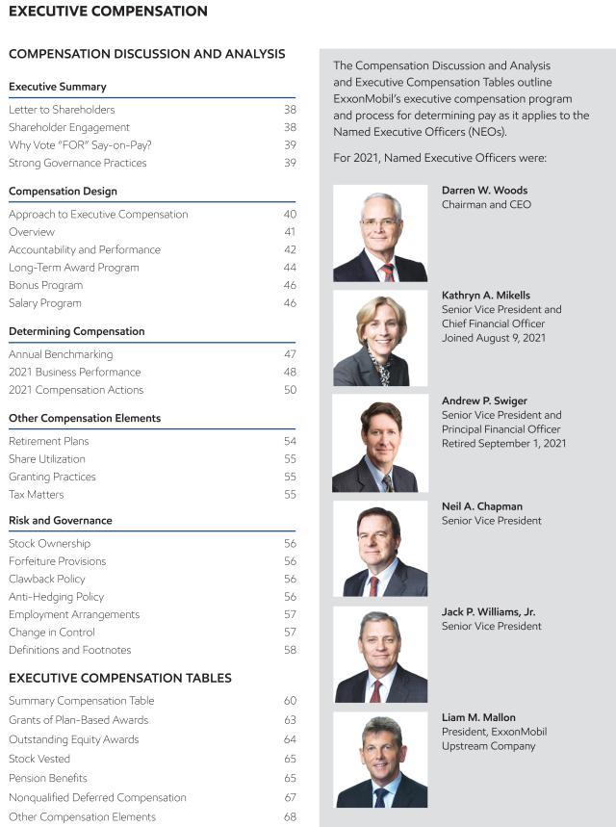

2022 Proxy Statement | 37

Table of Contents
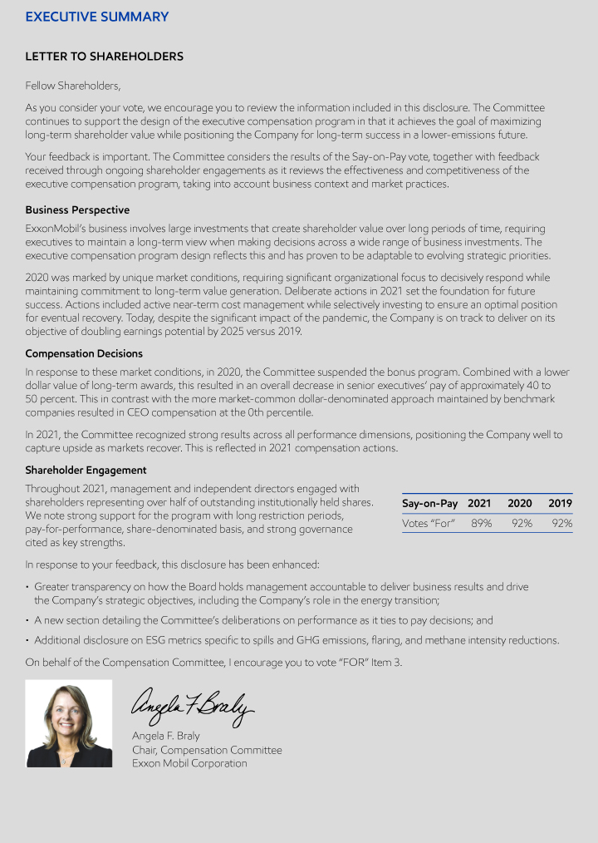

38 2022 Proxy Statement

Table of Contents
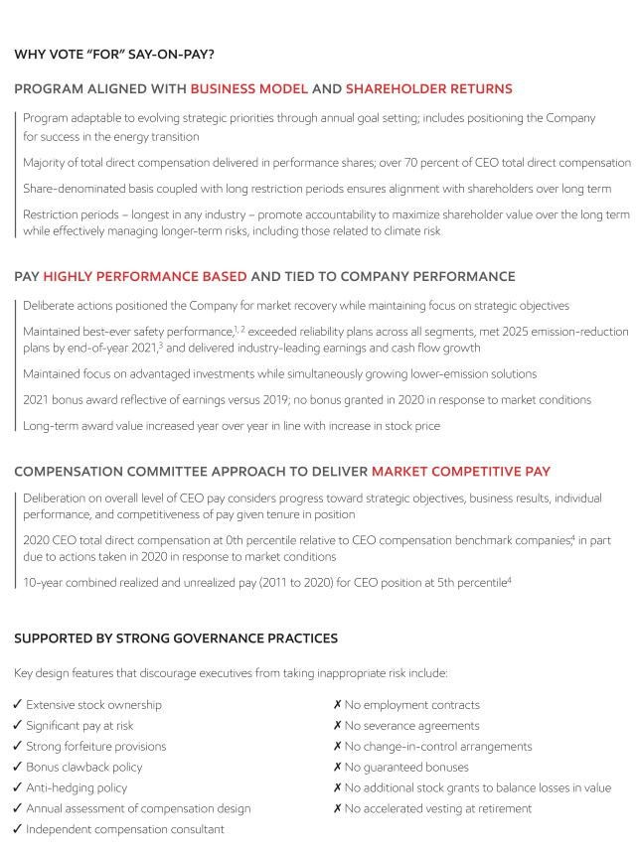

2022 Proxy Statement | 39

Table of Contents
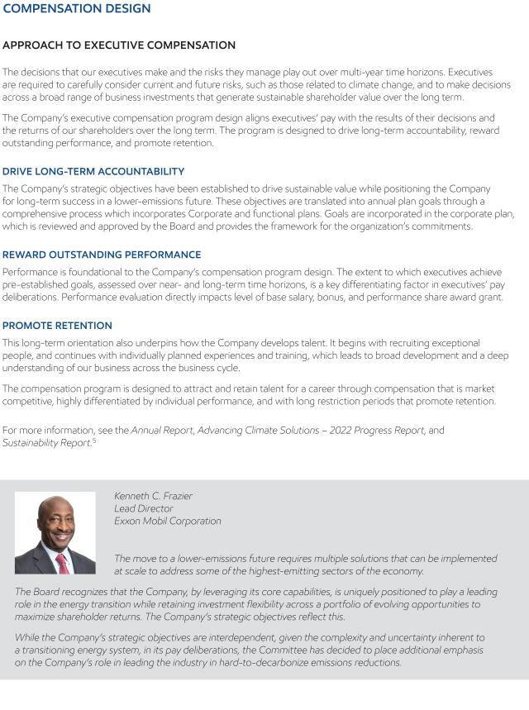

40 2022 Proxy Statement

Table of Contents
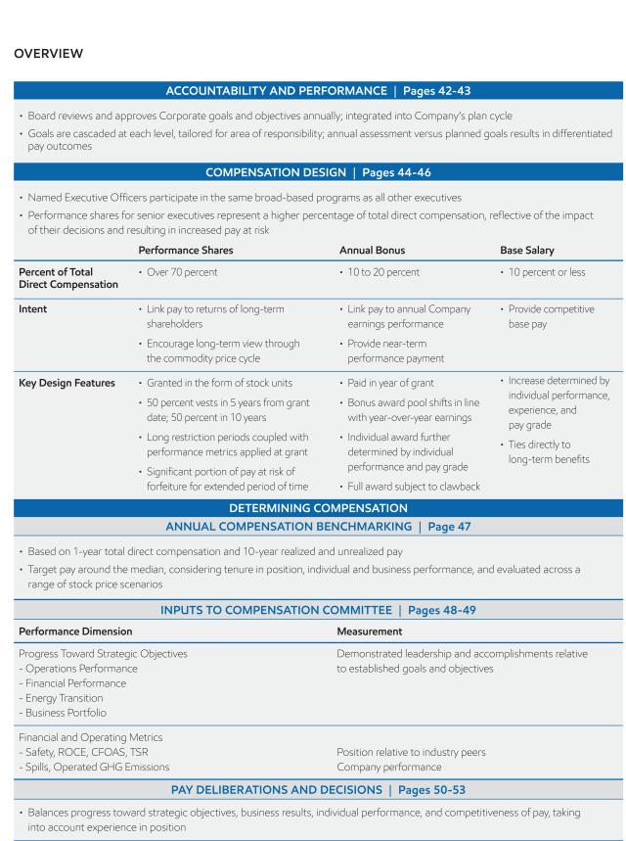

2022 Proxy Statement | 41

Table of Contents
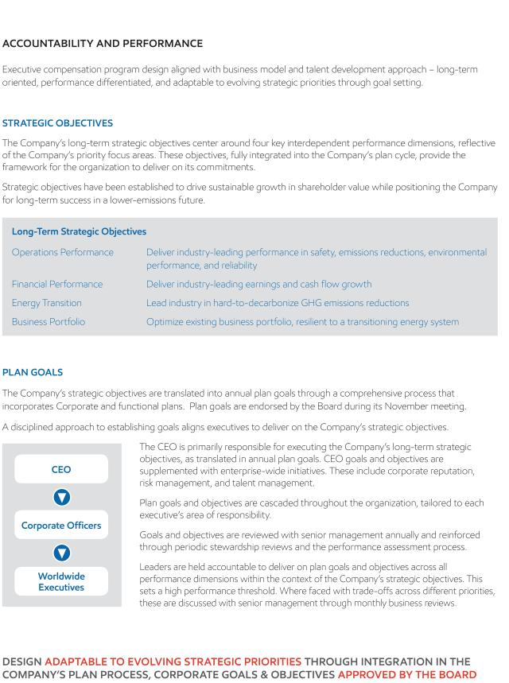

42 2022 Proxy Statement

Table of Contents
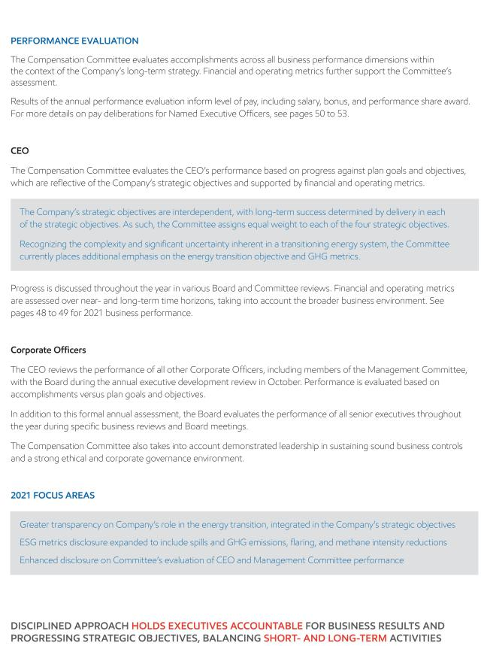

2022 Proxy Statement | 43

Table of Contents
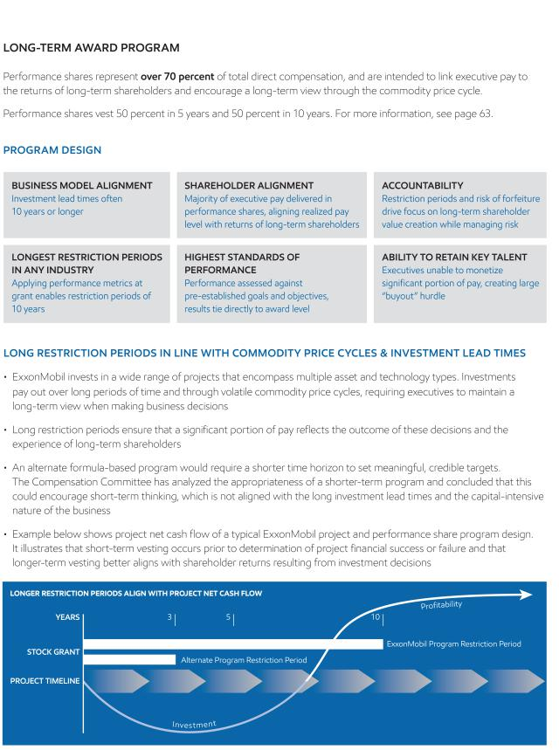

44 2022 Proxy Statement

Table of Contents
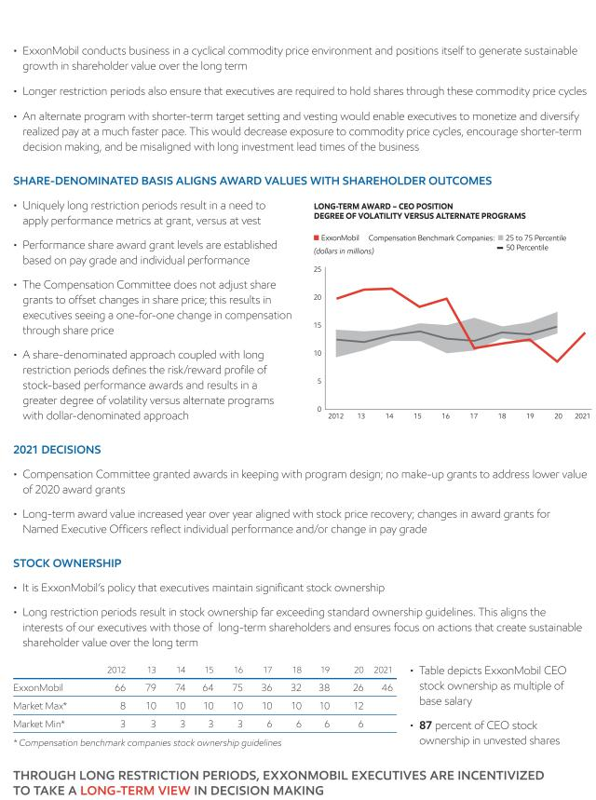

2022 Proxy Statement | 45

Table of Contents

46 2022 Proxy Statement

Table of Contents
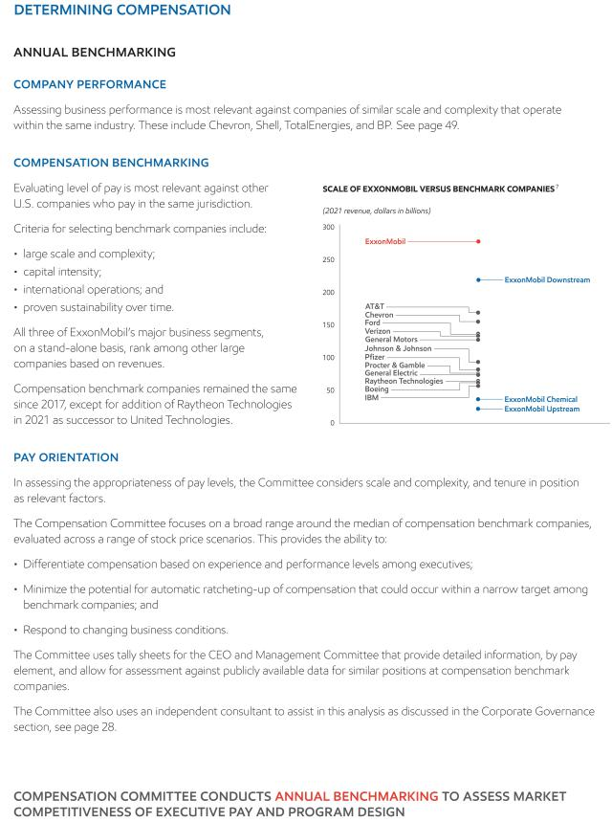

2022 Proxy Statement | 47

Table of Contents
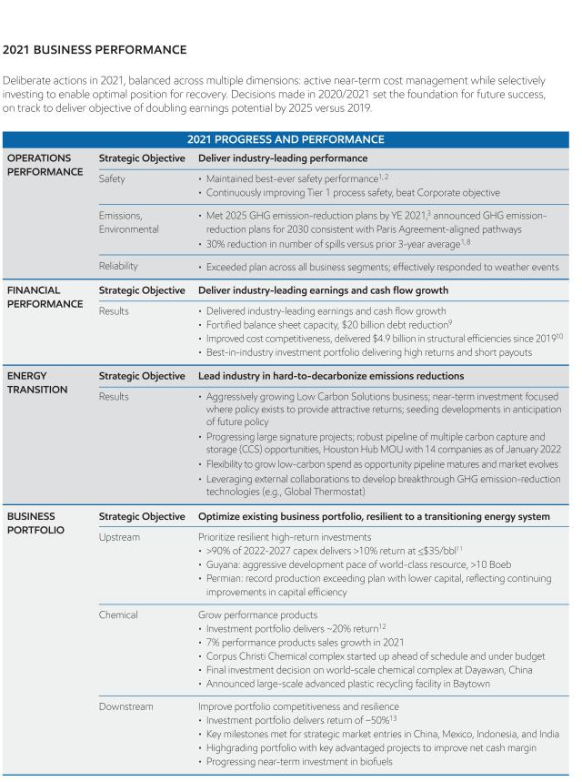

48 2022 Proxy Statement

Table of Contents
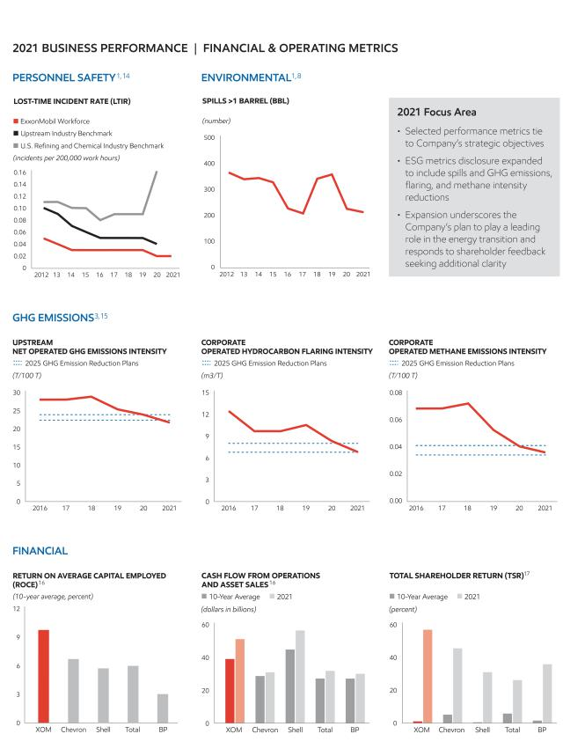

2022 Proxy Statement | 49

Table of Contents
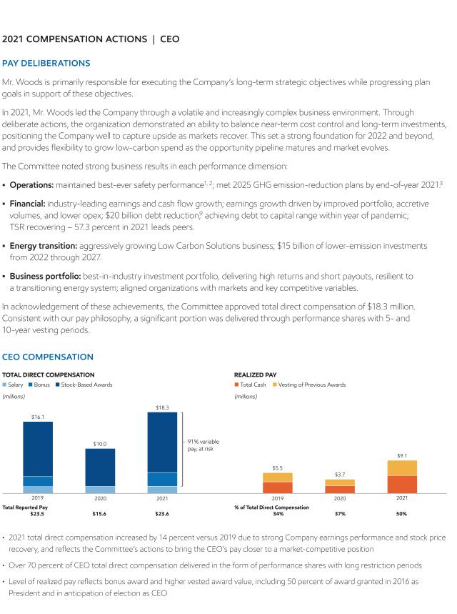

50 2022 Proxy Statement

Table of Contents
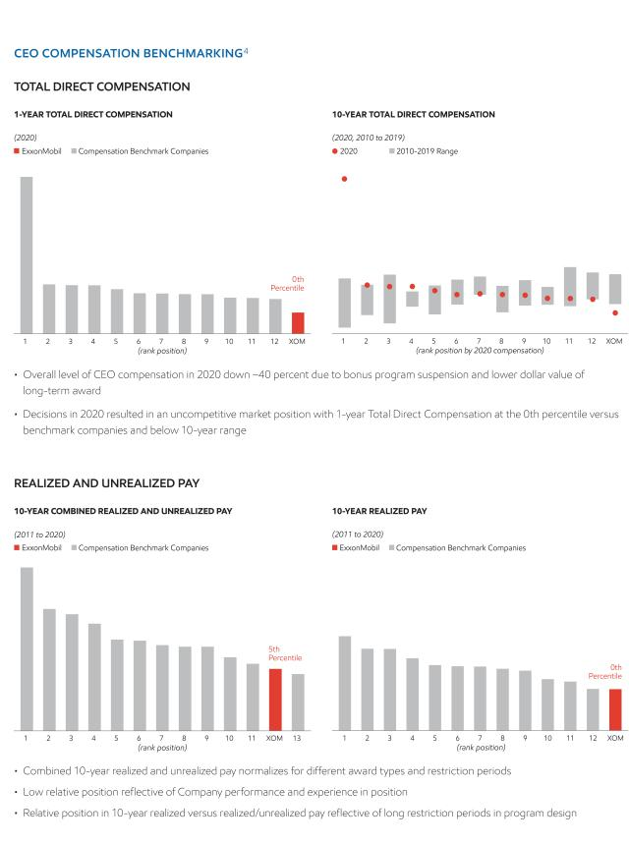

2022 Proxy Statement | 51

Table of Contents
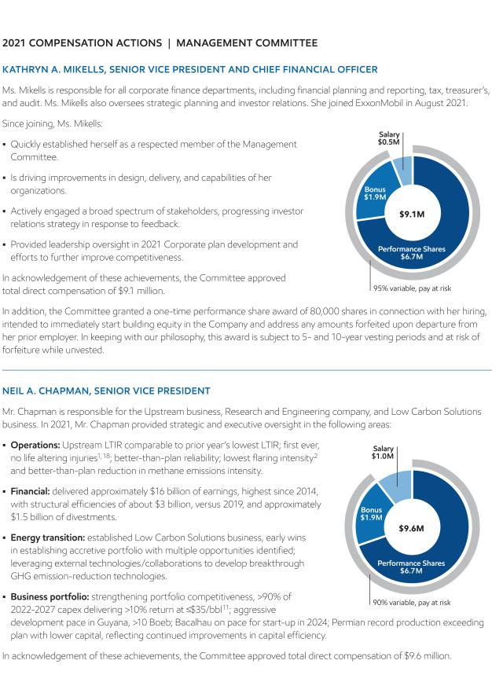

52 2022 Proxy Statement

Table of Contents
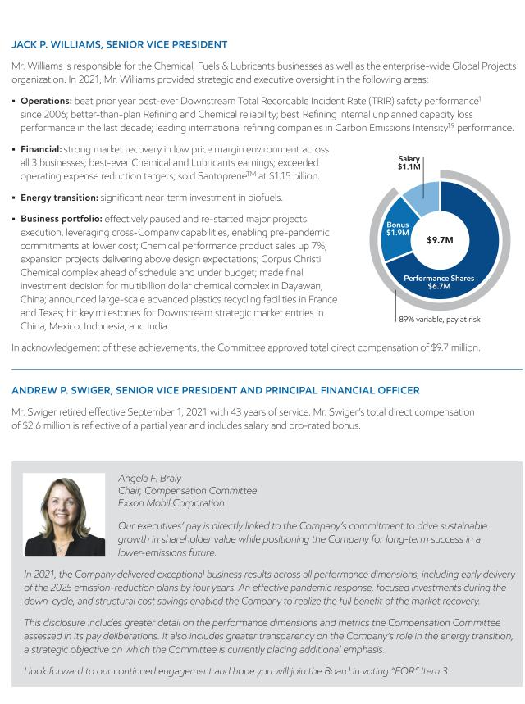

2022 Proxy Statement | 53

Table of Contents
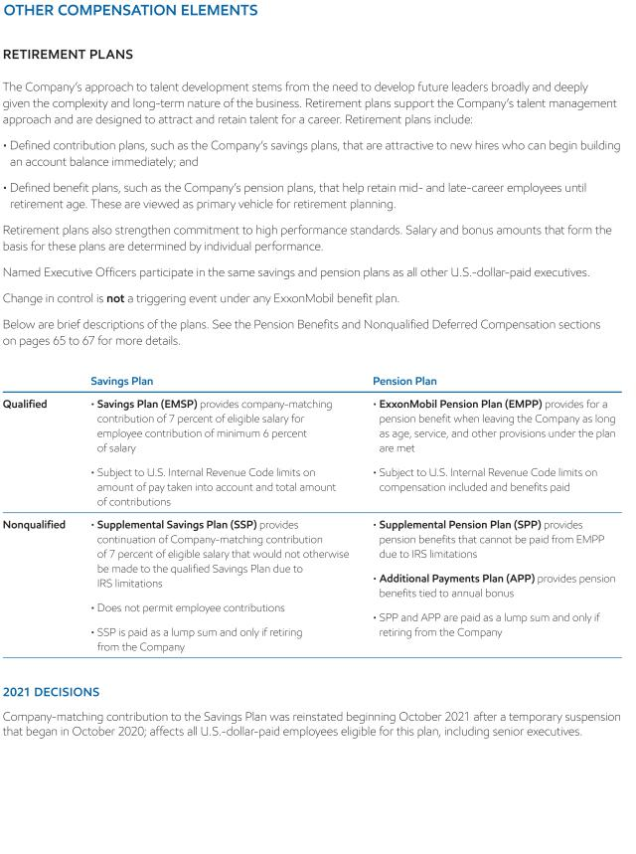

54 2022 Proxy Statement

Table of Contents
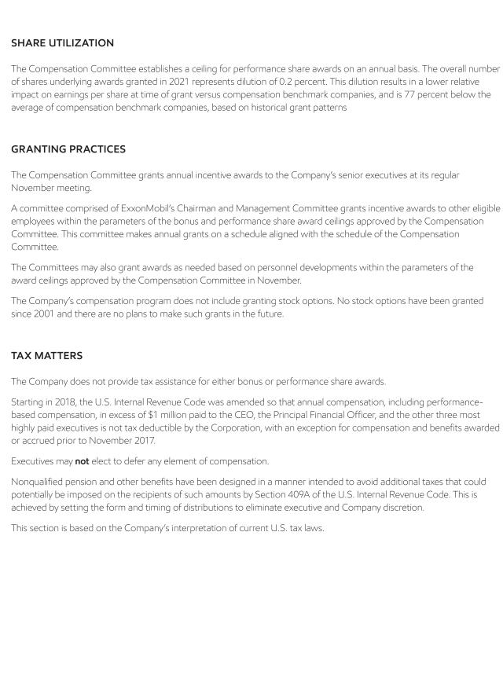

2022 Proxy Statement | 55

Table of Contents
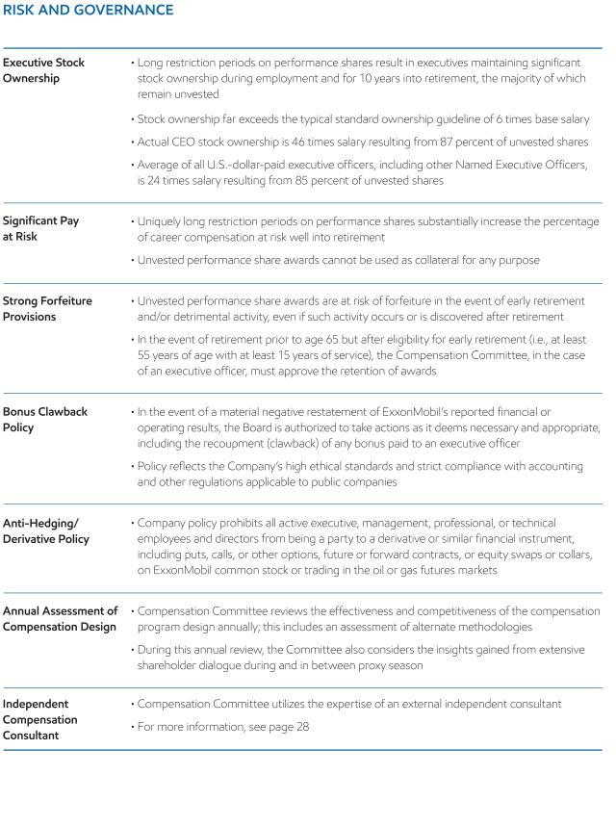

56 2022 Proxy Statement

Table of Contents
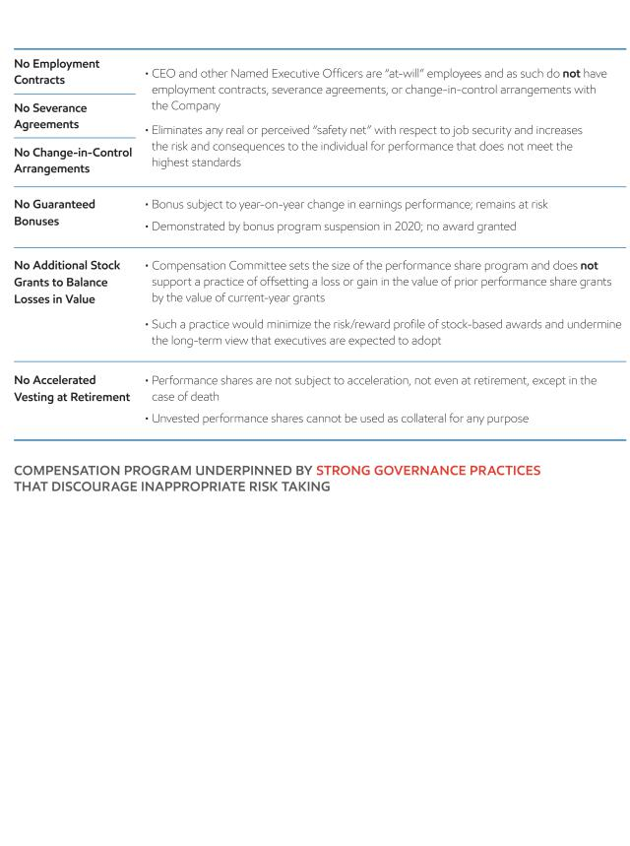

2022 Proxy Statement | 57

Table of Contents
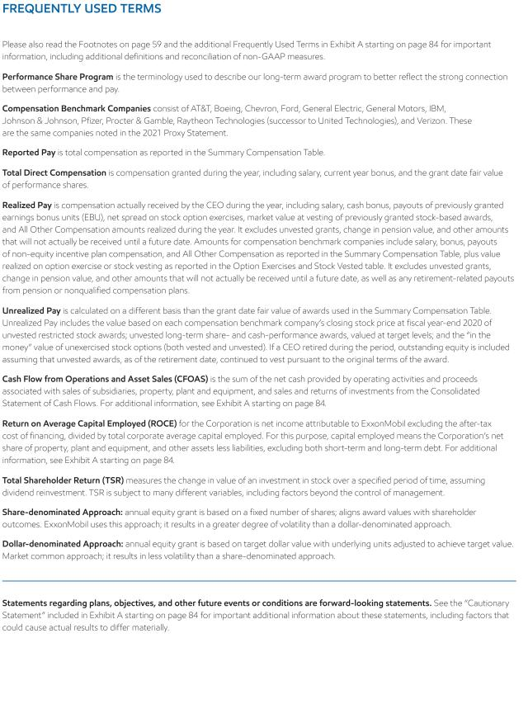

58 2022 Proxy Statement

Table of Contents
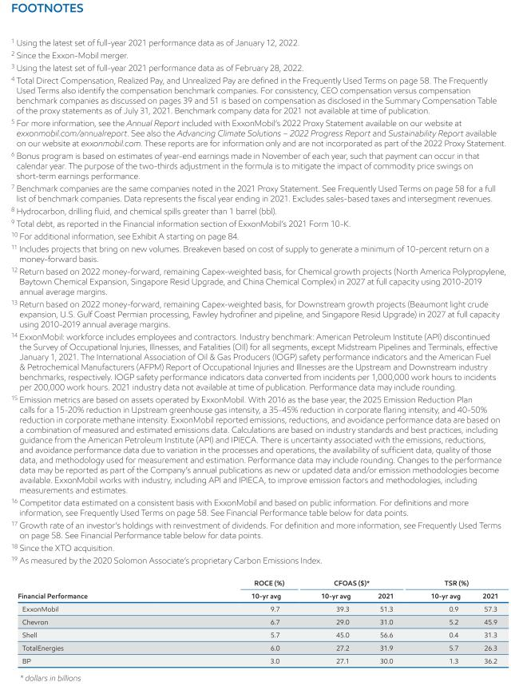

2022 Proxy Statement | 59

Table of Contents
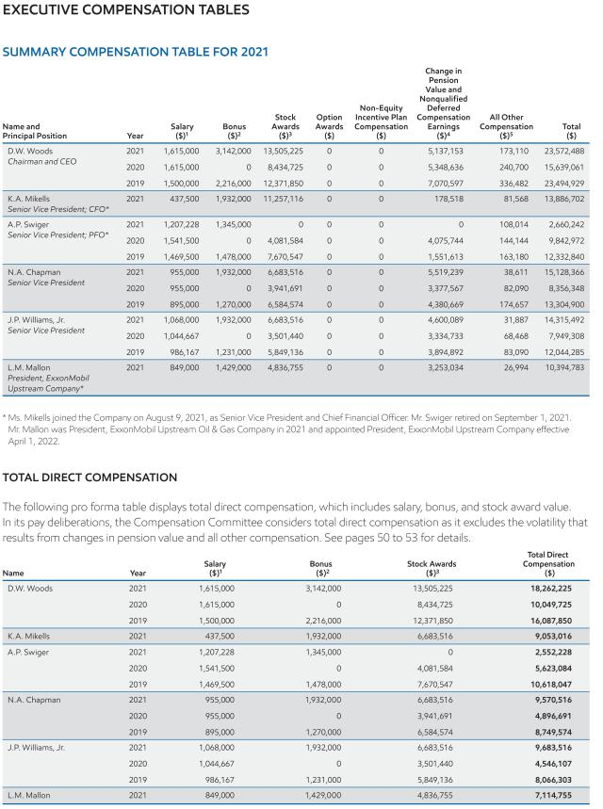

60 2022 Proxy Statement

Table of Contents
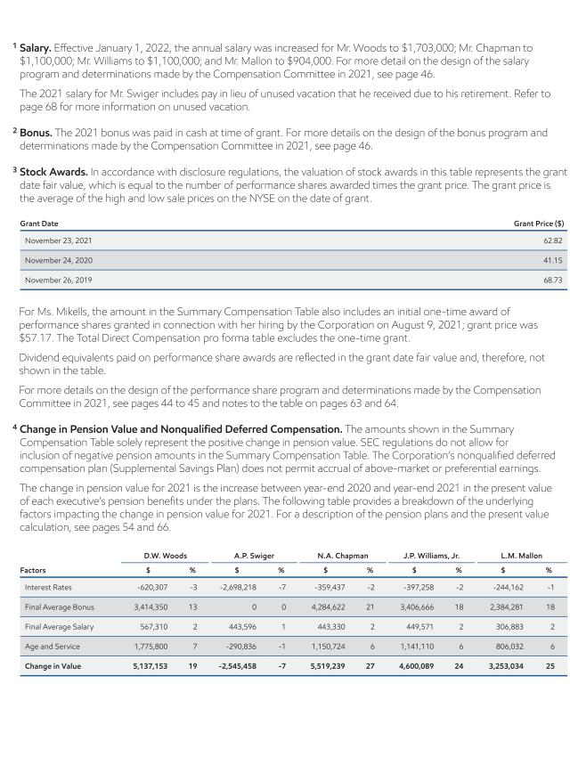

2022 Proxy Statement | 61

Table of Contents
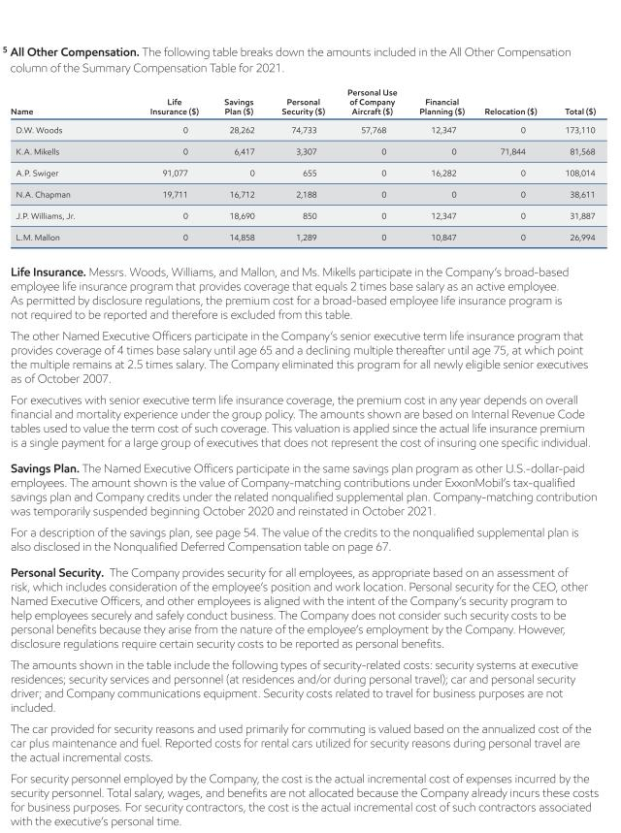

62 2022 Proxy Statement

Table of Contents
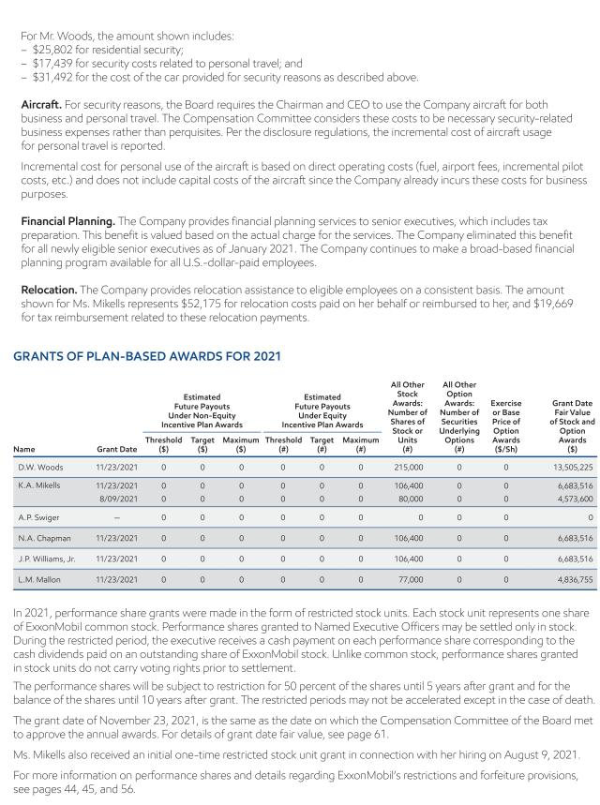

2022 Proxy Statement | 63

Table of Contents
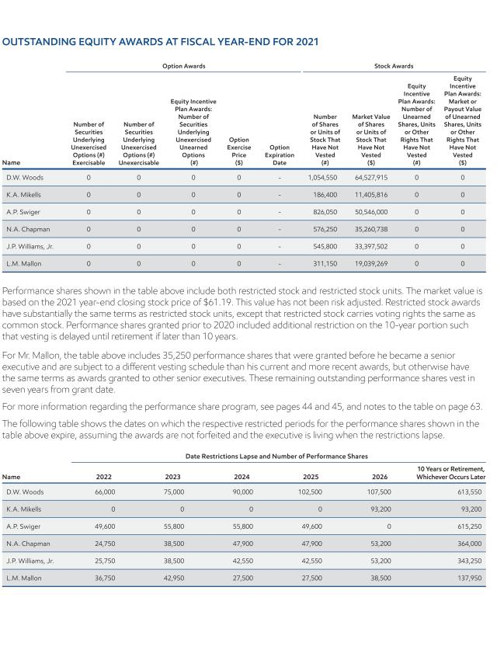

64 2022 Proxy Statement

Table of Contents
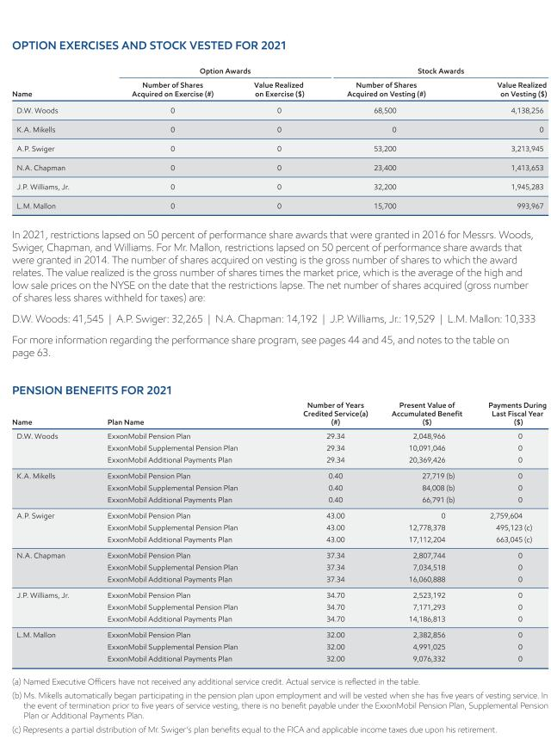

2022 Proxy Statement | 65

Table of Contents
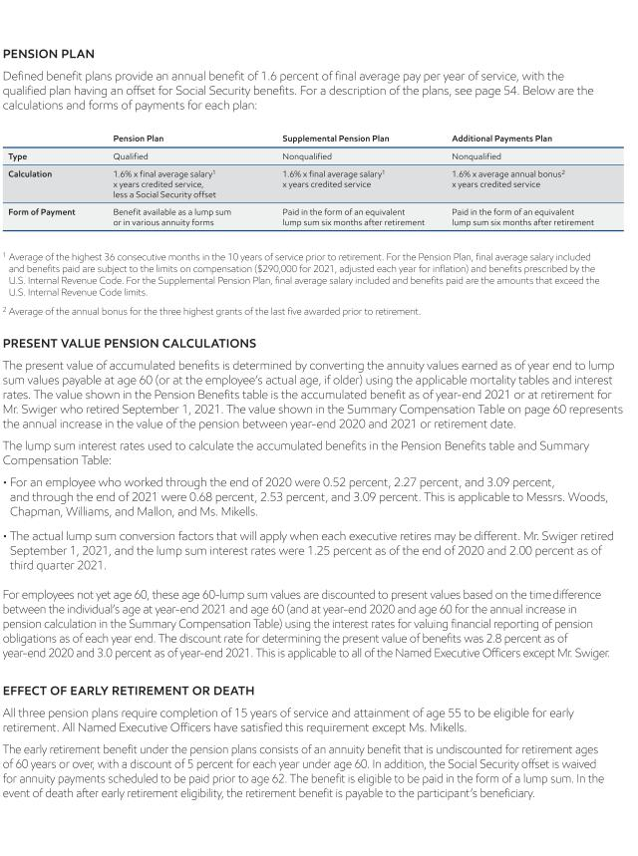

66 2022 Proxy Statement

Table of Contents
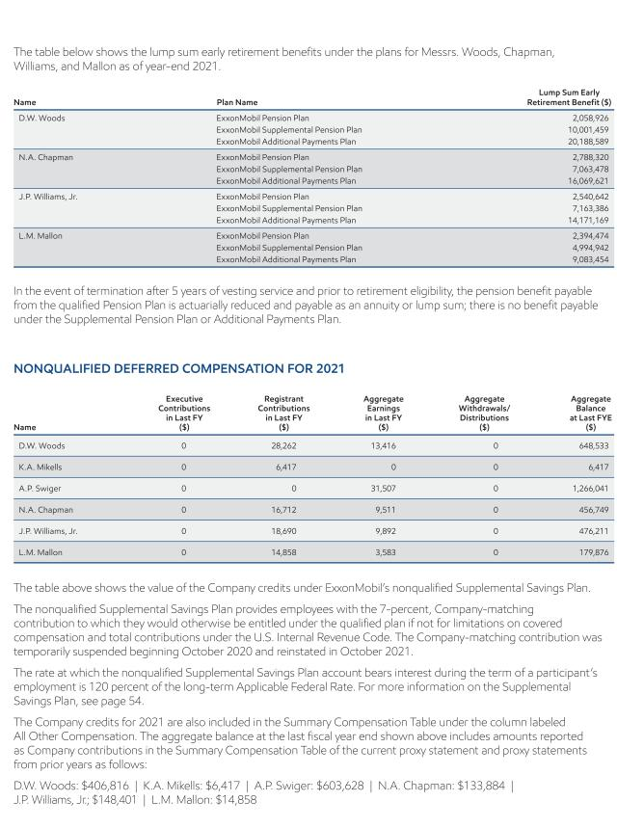

2022 Proxy Statement | 67

Table of Contents
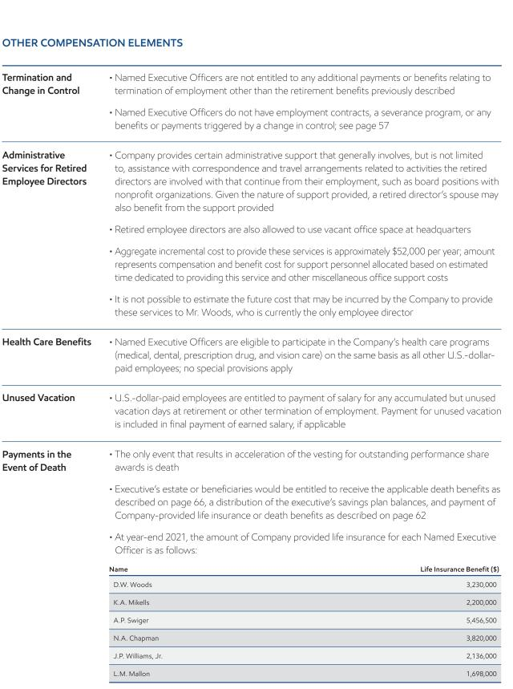

68 2022 Proxy Statement

Table of Contents

SHAREHOLDER PROPOSALS

We expect Items 4 through 10 to be presented by shareholders at the annual meeting. Following SEC rules, other than minor formatting changes, we are reprinting the proposals and supporting statements as they were submitted to us. We take no responsibility for them. Upon oral or written request to the Secretary at the address listed under Contact Information on page 8, we will provide information about the sponsors’ shareholdings, as well as the names, addresses, and shareholdings of any co-sponsors.

The Board recommends you vote AGAINST Items 4 through 10 for the reasons we give after each one.

Item 4 – Remove Executive Perquisites

This proposal was submitted by Bernie J. Pafford, 600 Studemont Street, Apt. 3333, Houston, Texas 77007, the owner of 858 shares.

“Resolved – Shareholders request that payments and/or reimbursements to current and former Named Executive Officers (NEOs) for personal expenses which are not allowed to US dollar paid salaried employees under the Company’s policies and procedures be discontinued.

Supporting Statement:

Although the total dollars involved are small, exceptions made for NEOs send the wrong message (‘don’t do as I do, do as I say’) to other employees when Corporate policies are not consistently applied. For current NEOs, these exceptions include, but are not limited to, tax preparation, financial planning services, residential security systems, and personal travel (fuel, airport fees, and incremental pilot costs associated with the CEO’s use of Company aircraft) as detailed in the ’All Other Compensation’ Section of page 62 on the Notice of 2021 Annual Meeting and Proxy Statement.

In all cases, NEOs are well compensated beyond these payments and/or reimbursements for personal expenses through base salary, bonuses, and stock awards. To be sure, their salaries and remuneration are more than sufficient to pay these expenses and it is time for them to live by the same Corporate policies that apply to others. Any other employee that places personal charges on an expense statement must reimburse the Company. If they do not, they are subject to disciplinary measures up to and including termination.

In 2020, the Compensation Committee saw fit to discontinue offering free tax preparation and financial advice for future NEOs. However, it is not clear why that service continues for current NEOs. There is a third-party service that is available to provide financial advice to regular employees. NEOs should use that same service if they need advice versus having a special arrangement set up specifically for them.

Furthermore, NEOs may use headquarter office space and receive administrative support (e.g., preparation of correspondence and making travel arrangements) after retirement. The support (1) is not necessarily limited to activities that retired NEOs were involved in during their employment and (2) may also benefit the NEO’s spouse (see page 68 of the Notice of 2021 Annual Meeting and Proxy Statement). Other retirees, even those who are active in charities, such as the United Way, are not offered this benefit.

The Corporation faces an increasing number of challenges that call for leadership, not just management, by the NEOs. Leaders motivate by acting as examples for the organization. By accepting different behavioral standards that run counter to Corporate policy, the NEOs fall short of that call.”

The Board recommends you vote AGAINST this proposal for the following reasons:

ExxonMobil’s compensation and benefits programs are designed to support the Company’s core principles and business strategies and are market competitive for all employees. The Chief Executive Officer, Named Executive

2022 Proxy Statement | 69

Table of Contents

Officers, executives, and other U.S. employees participate in the same broad-based programs. In cases where program application is different, this is generally due to legacy participation in a previously offered and since-terminated program, or based on position-specific requirements.

For example, all U.S.-dollar-paid employees can access a broad-based financial planning program. The financial planning program specific to senior executives was closed to new entrants effective January 2021. Participants prior to January 2021 may continue to access the program.

The Company also provides security for its employees, as appropriate, based on a risk assessment that includes consideration of the employee’s position and work location. The Company does not consider security costs to be personal benefits since these costs arise from the nature of the employee’s occupation with the Company. The personal protection provided to the CEO and/or other employees is aligned with the intent of the Company’s security program. In addition, the Board requires the CEO to use company aircraft for both business and personal travel for security reasons.

The Board believes this proposal is unnecessary, as ExxonMobil’s approach is consistent with market practices, and security services are informed by a thorough security risk assessment.

Item 5 – Limit Shareholder Rights for Proposal Submission

This proposal was submitted by Steven Milloy, 12309 Briarbush Lane, Potomac, Maryland 20854, the beneficial owner of 1,016 shares.

“Nuisance Shareholders

Resolved:

That the Company amend its bylaws to no longer permit shareholders to submit precatory (non-binding or advisory) proposals for consideration at annual shareholder meetings, unless the board of directors takes specific action to approve submission of such proposals.

Supporting Statement:

Stock ownership has unfortunately become politicized. Many shareholders own stock in publicly-owned corporations for the sole purpose of advancing the shareholders’ own social or political agendas, while simultaneously assailing the corporations’ legitimate business operations. To put it politely, these activist shareholders are ‘nuisance shareholders.’

Climate activists are nuisance shareholders who have leveraged proposals over the years to the point where they now have a significant presence on the ExxonMobil board of directors. These anti-fossil fuel nuisance shareholders may soon control the ExxonMobil board of directors. What could go wrong?

A primary tool of nuisance shareholders is the submission of non-binding precatory (advisory) proposals for discussion and vote at annual meetings of shareholders. Proposals from nuisance shareholders can coerce management into making decisions not in the best interests of ExxonMobil and its bona fide shareholders, and turn the annual meeting into a media-activist circus.

The overarching purpose of these proposals is to harass, intimidate and otherwise force ExxonMobil management into actions that it would not normally undertake and that, in fact, may be harmful to the company and its bona fide shareholders.

As Nobel laureate Milton Friedman wrote, ‘The social responsibility of business is to increase its profits.’ Businesses accomplish this vital role by providing the goods and services that society needs and wants in compliance with the law.

70 2022 Proxy Statement

Table of Contents

Businesses are society’s wealth generators. This wealth fuels the rest of society via salaries, taxes, dividends, and stock price appreciation. Businesses should not be distracted and hijacked by social and political activists seeking to change perceived shortcomings of society, which are issues better and more appropriately addressed by governments and charities.

Nuisance shareholders and their proposals distract management and coerce it into taking harmful actions based on junk science, political correctness and other non-business agendas rather than rational business practice. This can only reduce profits and, thereby, prevent ExxonMobil from achieving its actual social responsibility.”

The Board recommends you vote AGAINST this proposal for the following reasons:

The Board values input from shareholders and considers this input as it fulfills its commitment to thorough oversight of the Company’s plans to grow long-term shareholder value.

The Board respects the rights of shareholders to have their perspectives heard and provides several alternatives, including written correspondence and a portal for electronic communication at exxonmobil.com/directors, through which shareholders can communicate with the directors. The Board encourages shareholders to make use of those communication channels, and also recognizes that shareholder proposals can be a constructive element of corporate governance. As a result, the Board believes the current proposal is unnecessary.

Item 6 – Reduce Company Emissions and Hydrocarbon Sales

This proposal was submitted by Follow This, Hillegomstraat 15, Amsterdam, 1059 BW, Netherlands, the beneficial owner of 37 shares and lead proponent of a filing group.

“WHEREAS: We, the shareholders, must protect our assets against devastating climate change, and we therefore support companies to substantially reduce greenhouse gas (GHG) emissions.

RESOLVED: Shareholders request the Company to set and publish medium- and long-term targets to reduce the greenhouse gas (GHG) of the Company’s operations and energy products (Scope 1, 2, and 3) consistent with the goal of the Paris Climate Agreement: to limit global warming to well below 2°C above pre-industrial levels and to pursue efforts to limit the temperature increase to 1.5°C.

You have our support.

SUPPORTING STATEMENT:

The policies of energy companies – the largest greenhouse gas (GHG) emitters – are crucial to confronting the climate crisis. Therefore shareholders support oil and gas companies to substantially reduce their emissions.

We, the shareholders, understand this support to be essential in protecting all our assets in the global economy from devastating climate change.

We therefore support the Company to set emission reduction targets for all emissions: the emissions of the company’s operations and the emissions of its energy products (Scope 1, 2, and 3). Reducing Scope 3 emissions, the vast majority, is essential to limiting global heating.

Scientific consensus

The world’s leading international scientific bodies recently released reports which clearly state the need for deep cuts in emissions in order to limit global warming to safe levels.

Financial momentum

A growing international consensus has emerged among financial institutions that climate-related risks are a source of financial risk, and therefore limiting global warming is essential to risk management and responsible stewardship of the economy.

2022 Proxy Statement | 71

Table of Contents

Backing from investors that insist on targets for all emissions continues to gain momentum: 2021 saw unprecedented investor support for climate resolutions. In the US, three of these climate resolutions passed with a historic majority. In Europe, support for these climate resolutions continued to build.

Legal risk

In 2021, a Dutch court ordered Shell to severely reduce their worldwide emissions (Scope 1, 2, and 3) by 2030. This indicates that oil majors and large investors have an individual legal responsibility to combat dangerous climate change by reducing emissions and confirms the risk of liability.

We believe that the Company could lead and thrive in the energy transition. We therefore encourage you to set targets that are inspirational for society, employees, shareholders, and the energy sector, allowing the company to meet an increasing demand for energy while reducing GHG emissions to levels consistent with curbing climate change.

You have our support.”

The Board recommends you vote AGAINST this proposal for the following reasons:

The Board takes an active role in overseeing ExxonMobil’s approach to climate change and agrees with the proponent that the Company can be a leader in the energy transition. As described in the recently published Advancing Climate Solutions report, the Company is undertaking a number of initiatives to reduce greenhouse gas emissions. These include ExxonMobil’s ambition to achieve Scope 1 and Scope 2 net-zero greenhouse gas emissions from operated assets by 2050, and ongoing efforts to help customers reduce their emissions.

To achieve the Company’s net-zero ambition, ExxonMobil is taking a comprehensive approach that develops detailed emission-reduction roadmaps for major operated assets. The roadmaps account for facility configuration and maintenance schedules, and will be updated as technologies and government policies evolve. Net-zero roadmaps for major assets, covering about 90% of the Company’s greenhouse gas emissions, are scheduled to be completed by year-end 2022, and the remainder in 2023.

The Company has also set aggressive medium-term plans to reduce Scope 1 and Scope 2 greenhouse gas emissions through 2030 compared to 2016 levels that are consistent with Paris-aligned pathways and support the Company’s net-zero ambition. The plans are expected to result in a 20-30% reduction in corporate-wide greenhouse gas intensity, including reductions of 40-50% in upstream intensity, 70-80% in methane intensity, and 60-70% in flaring intensity. These plans include actions that are expected to reduce absolute company-wide greenhouse gas emissions by approximately 20%, including an estimated 70% reduction in methane emissions, 60% reduction in flaring emissions, and 30% reduction in upstream emissions. For non-operated assets, the Company works with its equity partners to advance greenhouse gas reductions to achieve comparable results.

ExxonMobil plans to invest more than $ 15 billion by 2027 to advance emission-reduction initiatives using its technology expertise, particularly in carbon capture and storage, hydrogen, and biofuels. Additional policy support would accelerate and broaden deployment of critical technology and provide ExxonMobil additional investment opportunities to reduce greenhouse gas emissions. As outlined in the Advancing Climate Solutions report, ExxonMobil is working on the key technologies that many reputable third-parties, including the International Energy Agency and the Intergovernmental Panel on Climate Change, indicate are required to achieve net-zero ambitions but are not currently deployed at scale to significantly reduce overall emissions or achieve this goal.

The proposal by the proponent does not acknowledge the significant work and commitment by ExxonMobil to reduce its own emissions as well as the emissions of its customers. The proponent has confirmed in an interview available on its website that their proposal is designed with the explicit intent to constrain ExxonMobil’s future investments in oil and gas.1

But advocating for ExxonMobil to decrease production and supply at present, without any commensurate reductions in corresponding demand, would result in customers simply choosing other suppliers, which could have unintended

72 2022 Proxy Statement

Table of Contents

consequences. A proposal to constrain leading companies from producing products that currently have insufficient practical alternatives, simply transfers that production and associated emissions to other producers. If the other producers are less efficient and have higher emissions intensity, society’s overall emissions would likely increase.

The efficiency and relative emissions performance of ExxonMobil refineries provides an example. For more than two decades, ExxonMobil refineries have focused on improving energy efficiency and lowering emissions. As a result, their emissions intensity (Scope 1 and Scope 2) is already more than 15% lower than the global industry average.2 This is the equivalent of about 5 million metric tons per year CO2e, based on ExxonMobil refining throughput in 2020.

In addition, many of the products produced by ExxonMobil may enable reductions of overall emissions, while concurrently contributing to a greater Scope 3 emissions count for the Company under the present duplicative and flawed accounting methods for Scope 3 reporting. For example, natural gas or LNG produced by ExxonMobil reduces global emissions when it displaces coal for power generation. In the same way, plastics produced by ExxonMobil reduce the weight and increase the efficiency of vehicles, both electric and traditional, reducing their emissions. Renewable diesel produced by ExxonMobil increases the Company’s Scope 3 emissions, but reduces overall emissions when it replaces conventional diesel.

In lieu of a universal standard of transparent, objective, high-integrity accounting measures for calculating and reporting global emissions, multiple methodologies are presently employed using questionable, often double counted (or more), estimates with widely acknowledged deficiencies and inconsistencies when calculating and reporting Scope 3 emissions. The present methodology does not provide the value, and meet the ultimate necessity, of an objective and accurate determination of benefits and emissions across the full product life cycle. Trusted comparable emissions reporting requires the development and adoption of a credible and consistent global accounting system to measure the global emissions impact across the entire value chain. ExxonMobil pursues life cycle analysis methodology to provide greater consistency and mathematical clarity when comparing products and industrial processes. The Company discusses the advantages of life cycle analyses in its Advancing Climate Solutions report and welcomes continued work and dialogue on evolving objectivity and accuracy of measuring, monitoring, and management of global emissions.

The Board supports the Company’s approach towards net-zero: 1) measuring, monitoring, and managing reductions of the Company’s emissions; 2) providing lower emissions-intensive products as the energy transition progresses that help our customers increasingly reduce their own emissions, and 3) importantly, advancing commercialization of emissions-reduction, and emissions-sequestration technologies. Taken together, this is a more effective response to credibly addressing the risks of climate change than excess reliance on unreliable methodologies and inadequate assumptions intended to characterize a single company’s “Scope 3” emissions.

Therefore, the Board recommends a vote against this proposal.

- Available at the time of publication of this proxy statement at: https://www.follow-this.org/big-oil-can-make-or-break-the-paris-
climate-accords-follow-this-founder-says/
- Calculated by Solomon Associates’ proprietary Carbon Emission Index in a 2020 industry survey.

Item 7 – Report on Low Carbon Business Planning

This proposal was submitted by Kimberly Indresano and Brian Robert Romer JT Ten, clients of Arjuna Capital, 1 Elm Street, Manchester, Massachusetts, 01944, the beneficial owner of 286 shares.

“Whereas: Exxon, in 2019, signed a ‘Statement on the Purpose of a Corporation,’ committing the Company to all stakeholders, including ‘protect[ing] the environment by embracing sustainability practices across our businesses.’

Inconsistent with this ‘embrace’ of sustainability, Exxon lacks a business strategy consistent with limiting global temperature rise to 1.5 degrees Celsius, with no commitment to Net Zero by 2050 or a roadmap to get there. Importantly, current 2025 emission targets ignore the Scope 3 emissions of their products, which account for 83 percent of total emissions.

2022 Proxy Statement | 73

Table of Contents

A global transition towards a low carbon economy places unprecedented risk on oil companies and the economy. The Intergovernmental Panel on Climate Change warns oil industry emissions need to drop 50 to 90 percent by 2050 to avoid catastrophic consequences. The United States’ Commodity Futures Trading Commission stresses ‘climate change poses a major risk to the stability of the U.S. financial system and to its ability to sustain the American economy’. The United Nations Environment Programme Finance Initiative reports in ‘Universal Ownership’ that 50 percent of companies’ earnings are at risk from climate costs, creating systemic risk for Exxon, and diversified investors alike.

A failure to plan for this transition may place investor capital at substantial risk. The CEOs of Shell, Equinor, and BP predict peak oil demand may occur by 2025. Carbon Tracker reports Exxon could lose 80 percent of its petroleum investments if the world takes action to limit global temperature rise.

Peers have begun investing in clean energy, including wind, solar, and renewables storage, while Exxon has invested in less effective carbon mitigation solutions like carbon capture and sequestration. The World Benchmarking Alliance reports companies need to dedicate 77 percent of capital expenditure to low carbon projects to meet a 1.5 degree scenario. Yet, Exxon plans to invest a fraction of that amount–only 3.3 percent–in ‘lower emission energy solutions’ through 2025.

Exxon’s current strategy has not benefited its stock price for a decade, with the stock price falling approximately negative 20 percent, compared to a near tripling of the S&P 500. Exxon’s returns remain at risk in the absence of a comprehensive climate strategy.

Resolved: With board oversight, shareholders request ExxonMobil issue a report (at reasonable cost, omitting proprietary information) describing how the company could alter its business model to yield profits within the limits of a 1.5 degree Celsius global temperature rise by substantially reducing its dependence on fossil fuels.

Supporting Statement: The proponent suggests such a report could include a roadmap (with timelines, short and long term goals, capital expenditure planning) to alter its energy mix to reduce fossil fuel dependence, including options such as buying, or merging with, companies with renewable energy assets or technologies, and/or internally expanding its renewable energy portfolio, and/or exercising stricter capital discipline by focusing on high return, low cost, and low carbon capital expenditures to boost return on capital, reduce societal greenhouse gas emissions, and protect shareholder value.”

The Board recommends you vote AGAINST this proposal for the following reasons:

The information requested by the proposal is included in reports already prepared and published by the Company. This includes the Advancing Climate Solutions report, Energy Outlook, Sustainability Report, and other publications and filings that are available on the Company’s website.

The move to a lower-emission future requires multiple solutions that can be implemented at scale to address some of the highest-emitting sectors of the economy. For example, the power, industrial, and transportation sectors account for roughly 80% of global emissions. This is where ExxonMobil is focused, leveraging its experience and long history of meeting vast complex challenges.

The Company leverages its core capabilities to meet society’s needs for products essential for modern life, while addressing the challenge of climate change. ExxonMobil’s strategy uses its advantages in scale, integration, technology, and talent to build globally competitive businesses that lead industry in earnings and cash flow growth across a broad range of scenarios. ExxonMobil plans to play a leading role in the energy transition, while retaining investment flexibility across a portfolio of evolving opportunities to maximize shareholder returns.

The Company has publicly announced its ambition to achieve net-zero emissions from its operated assets by 2050 and is taking a comprehensive approach centered on developing detailed emission-reduction roadmaps for major operated assets to support this goal. This ambition applies to Scope 1 and Scope 2 greenhouse gas emissions. It builds on the Company’s recently announced 2030 emission reduction plans, which are consistent with Paris-aligned

74 2022 Proxy Statement

Table of Contents

pathways, and includes plans to reach net-zero emissions in the Company’s Permian Basin operations by 2030. Further, the Company has increased planned investments to $15 billion from 2022 through 2027 to help accelerate emission reductions in the Company’s operations and grow lower-emission business opportunities in carbon capture and storage, hydrogen, and biofuels that help customers reduce their emissions.

The Company’s Advancing Climate Solutions report includes a detailed analysis of ExxonMobil’s business and investment portfolio under the International Energy Agency’s (IEA) Net Zero Emissions by 2050 (NZE) scenario, which is a deep decarbonization scenario aligned with a 1.5°C pathway. Using the IEA’s assumptions, the Company’s analysis further tested the resiliency of its businesses and strategy.

The assessment, which was reviewed by a respected third party, showed significant growth potential exists in chemicals, lower-emission fuels, carbon capture and storage, and hydrogen. ExxonMobil is positioned to successfully compete in these businesses by leveraging existing differentiated capabilities and repurposing assets toward these growth opportunities.

Under the IEA NZE scenario, production of traditional refined products would decline as sites are closed, converted to terminals, or reconfigured to shift production to chemicals, lubricants, basestocks, and lower-emission fuels. Investments in carbon capture and storage, hydrogen, and biofuels increase significantly, supported by higher carbon pricing assumed by the IEA in its NZE scenario. The Company would continue to make accretive investments in its chemicals business as demand for these products grows in the IEA NZE scenario, with many of these products generating lower life-cycle emissions relative to available alternatives. For example, by 2030, ExxonMobil’s products used in plastic packaging solutions could avoid approximately 40 million metric tons of greenhouse gas emissions per year by displacing alternative options.

Existing oil and natural gas production and fuels manufacturing assets would be optimized and operated as long as economically justified, consistent with the IEA NZE demand assumptions, which project daily production of 24 million barrels of oil and 169 billion cubic feet of natural gas will still be needed to meet demand in 2050.

Throughout the modeled period, IEA NZE’s hypothetical carbon price supports attractive investments in key growth areas, including carbon capture and storage, hydrogen, and biofuels, that drive long-term increases in cash flow. For example, in Paris-aligned scenarios, over the next decade, three to four times the existing carbon capture and storage capacity would need to be added annually, and in the IEA NZE scenario, biofuels would need to grow 3.5 times the average of the last five years for the next decade, with commensurate growth in logistics, to meet expected demand.

The Company’s core capabilities, experience, and advantages in scale, integration, technology, project execution, and talent would remain critical success factors in succeeding in these new market opportunities under this hypothetical transition path. For example, ExxonMobil is the world leader in carbon capture and storage, having captured more anthropogenic CO2 than any other company over the past 30 years. The Company has announced progress on 10 carbon capture and storage opportunities since establishing its Low Carbon Solutions business in the first quarter of 2021. ExxonMobil is also evaluating strategic investments in hydrogen to increase the use of this important lower-emissions energy technology and studying large-scale production of hydrogen for the Rotterdam industrial complex. Further, ExxonMobil is focused on growing its lower-emission fuels business by continuing research in advanced biofuels. The Company plans to provide more than 40,000 barrels per day of lower-emissions fuels by 2025 and has a further goal of 200,000 barrels per day by 2030.

These disclosures and the comprehensive materials that are publicly available demonstrate the Company’s responsiveness to shareholder feedback. Creating an additional report as requested by this proposal is unnecessary.

Item 8 – Report on Scenario Analysis

This proposal was submitted by Christian Brothers Investment Services, Inc., 733 Third Avenue, Ste. 2020, New York, New York 10017, the beneficial owner of shares with a market value greater than $2,000 and lead proponent of a filing group.

2022 Proxy Statement | 75

Table of Contents

“FINANCIAL STATEMENT ASSUMPTIONS AND CLIMATE CHANGE

WHEREAS:

Many policymakers, investors and companies have converged on goals including the need to limit global temperature increase to 1.5° C and to reach net zero global greenhouse gas (GHG) emissions by 2050, if not sooner.1

The International Energy Agency’s Net Zero 2050 Roadmap (NZE) describes an energy sector path for net-zero GHG emissions. According to the IEA, no investment in new fossil supply projects is needed in a net zero scenario and the IEA anticipates oil prices dropping as low as $36/barrel in 2030 and $24/barrel in 2050, projecting a negative trend for a fundamental input in developing ExxonMobil’s cash flow projections for oil and gas production assets.2

Yet ExxonMobil continues development of new fossil fuel resources, even while acknowledging3 that climate change scenarios pose uncertainties that may lead to impairments. Investors are concerned that the continued development of new fossil fuel resources increases the risk of such future impairments. ExxonMobil’s existing, audited annual disclosures do not provide investors with sufficient insight into stranded asset risk related to the energy transition. ’If climate change impacts the entity, the auditor needs to consider whether the financial statements appropriately reflect this,’ according to the International Auditing and Assurance Standards Board.

An independent September 2021 analysis4 concluded that the financial statements of ExxonMobil lack the requisite transparency about climate-related assumptions and estimates, and company disclosures do not appear to use Paris-aligned assumptions and estimates. In contrast, peers (Royal Dutch Shell, bp, TotalEnergies) released more transparent disclosures in their audited financial statements, articulating the extent of consideration of climate change contingencies and risks.5

RESOLVED: Shareholders request that ExxonMobil’s Board of Directors seek an audited report assessing how applying the assumptions of the International Energy Agency’s Net Zero by 2050 pathway would affect the assumptions, costs, estimates, and valuations underlying its financial statements, including those related to long-term commodity and carbon prices, remaining asset lives, future asset retirement obligations, capital expenditures and impairments. The Board should obtain and ensure publication of the report by February 2023, at reasonable cost and omitting proprietary information.

Supporting Statement

The proponent recommends the requested report be supported with reasonable assurance from an independent auditor.

Investors with $103 trillion in assets under management have already called for companies and their auditors to rigorously disclose climate risks in financial reporting, or risk overstatement by failing to integrate impacts on profits and financial positions.6

Last year, this topic received 49.4% support of ExxonMobil investors. In light of ExxonMobil’s disclosures regarding potential impairments from uncertain climate scenarios depressing product demand, it is urgent for investors to vote in favor.

- See, for instance, Glasgow Financial Alliance for Net Zero, with over $130 trillion in assets under management. https://www.gfanzero.com/press/amount-of-finance-committed-to-achieving-1-5c-now-at-scale-needed-to-deliver-the-transition/
- IEA, World Energy Outlook, October 2021, p. 101.
- E.g., MD&A: https://www.sec.gov/ix?doc=/Archives/edgar/data/34088/000003408821000064/xom-20210930.htm
- Carbon Tracker with Climate Accounting Project, Flying Blind: the glaring absence of climate risks in financial reporting, Table 2, p.
24.
- https://www.sec.gov/Archives/edgar/data/34088/000121465921004380/cg421210px14a6g.htm

- https://www.unpri.org/accounting-for-climate-change/investor-groups-call-on-companies-to-reflect-climate-related-risks-in-financial-reporting/6432.article”

76 2022 Proxy Statement

Table of Contents

The Board recommends you vote AGAINST this proposal for the following reasons:

The information requested by the proposal has recently been published by ExxonMobil and is available on the Company’s website. ExxonMobil’s Advancing Climate Solutions report includes an analysis of the Company’s business and investment portfolio under the International Energy Agency’s Net Zero Emissions by 2050 (IEA NZE) scenario.

The analysis, which has been reviewed in a quality assurance audit by a credible third party, used the IEA NZE’s scenario assumptions and included existing operations and future opportunities across ExxonMobil’s businesses in oil, natural gas, fuels, lubricants, chemicals, lower-emission fuels, hydrogen, and carbon capture and storage.

It demonstrated that under the IEA NZE assumptions, the Company could continue to grow cash flows over time through reduced investments in oil and natural gas and increased investments in accretive projects in chemicals, carbon capture and storage, lower-emission fuels, and hydrogen.

Under the IEA NZE scenario, production of traditional refined products would decline as sites closed, converted to terminals, or reconfigured to shift production to chemicals, lubricants, basestocks, and lower-emission fuels. Investments in carbon capture and storage, hydrogen, and biofuels increase significantly, supported by higher carbon pricing assumed by the IEA in its NZE scenario. The Company would continue to make accretive investments in its chemicals business as demand for these products grows in the IEA NZE scenario, with many of these products generating lower life-cycle emissions relative to available alternatives. For example, by 2030, ExxonMobil’s products used in plastic packaging solutions could avoid approximately 40 million metric tons of greenhouse gas emissions per year by displacing alternative options.

Existing oil and natural gas production and fuels manufacturing assets would be optimized and operated as long as economically justified, consistent with the IEA NZE demand assumptions, which project daily production of 24 million barrels of oil and 169 billion cubic feet of natural gas will still be needed to meet demand in 2050.

Overall, under IEA NZE scenario, significant growth potential exists in chemicals, lower-emission fuels, carbon capture and storage, and hydrogen. ExxonMobil is positioned to effectively compete in these businesses by leveraging existing differentiated capabilities and repurposing assets. Throughout the modeled period, IEA NZE scenario’s assumed carbon price supports attractive investments in key growth areas, including carbon capture and storage, hydrogen, and biofuels that drive increases in long-term cash flow. For example, in Paris-aligned scenarios, over the next decade, three to four times the existing carbon capture and storage capacity would need to be added annually, and in the IEA NZE scenario, biofuels would need to grow 3.5 times the average of the last five years for the next decade, with commensurate growth in logistics, to meet expected demand.

The Company’s core capabilities, experience, and advantages in scale, integration, technology, project execution, and talent would be critical success factors in these new market opportunities under this hypothetical transition path. For example, ExxonMobil is the world leader in carbon capture and storage, and has captured more anthropogenic CO2 than any other company over the past 30 years. The Company has announced progress on 10 carbon capture and storage opportunities since establishing its Low Carbon Solutions business early in 2021. ExxonMobil is also evaluating strategic investments in hydrogen to increase the use of this important lower-emissions energy technology and studying large-scale production of hydrogen for the Rotterdam industrial complex. Further, ExxonMobil is focused on growing its lower-emission fuels business by continuing research in advanced biofuels. The Company plans to provide more than 40,000 barrels per day of lower-emissions fuels by 2025 and has a further goal of 200,000 barrels per day by 2030.

The analysis highlighted in the Advancing Climate Solutions report demonstrates the resiliency of the Company’s businesses and strategy under the IEA NZE scenario and includes analysis of the Company’s plans for capital spending and modeling of potential future cash flow.

The Company received a similar shareholder proposal last year and although that proposal did not reach majority support, ExxonMobil has been responsive to shareholder feedback by expanding disclosures, including in the Advancing Climate Solutions report, Sustainability Report and Energy Outlook. An additional report, as requested by this proposal, would result in duplication and incremental costs. The proposal, therefore, is unnecessary.

2022 Proxy Statement | 77

Table of Contents

Item 9 – Report on Plastic Production

This proposal was submitted by Andrew Behar, 2020 Milvia Street, Suite 500, Berkeley, California 94704, the beneficial owner of 42 shares.

“Whereas: Plastics, with a lifecycle social cost at least ten times higher than its market price, actively threaten the world’s oceans, wildlife, and public health.1 Concern about the growing scale and impact of global plastic pollution has elevated the issue to crisis levels.2 Of particular concern are single-use plastics (SUPs)3 which make up the largest component of the 11 million metric tons of plastic ending up in waterways annually.4 Without drastic action, this amount could triple by 2040.5

In response to the plastic pollution crisis, countries and major packaging brands are beginning to drive reductions in virgin plastic use.6,7

Several studies demonstrate that a significant absolute reduction in virgin plastic demand is critical to curbing the flow of plastic into oceans.8 One of the most robust reduction pathways is presented in the widely-respected report, Breaking the Plastic Wave, which found that plastic leakage into the ocean can be feasibly reduced by 80% under its System Change Scenario (SCS), which is based on a significant absolute reduction of virgin SUPs.9,10

BP has recognized the potential disruption that global SUP reductions could have on the oil industry in its 2019 Outlook, where it found a global SUP ban by 2040 would reduce oil demand growth by 60%.11

The future under the SCS – one built on recycled plastics and circular business models – looks drastically different than today’s linear take-make-waste production model. Several implications of the SCS, including a one-third absolute demand reduction (mostly of virgin SUPs) and immediate reduction of new investment in virgin production, are at odds with Exxon’s planned investments.12

Exxon was recently identified as the largest global producer of SUP-bound polymers (5.9 million metric tons in 2019, an estimated 50% of its total polymer production) and exposed for lobbying against plastic pollution laws.13,14 While Exxon states it is acting to ‘address plastic waste,’ it fails to meaningfully address the potential for regulatory restrictions and/or significant disruption in demand for virgin plastic, both of which could result in stranded assets.15,16

Resolved: Shareholders request that Exxon’s Board issue an audited report addressing whether and how a significant reduction in virgin plastic demand, as set forth in Breaking the Plastic Wave’s System Change Scenario to reduce ocean plastic pollution, would affect the Company’s financial position and assumptions underlying its financial statements. The report should be at reasonable cost and omit proprietary information.

Supporting Statement: Proponents recommend that, in the Board’s discretion, the report include:

- Quantification (in tons and/or as a percentage of total) of the company’s polymer production for SUP markets;

- A summary or list of the company’s existing and planned investments that may be materially impacted by the SCS;

- Any future plans or goals to shift its business model from virgin to recycled plastics.

- https://wwfint.awsassets.panda.org/ downloads/wwf_pctse e_report_e nglsh.pdf
- https:/www.unep.org/resources/pollution-solution-global-assessment-marine-litter-and-plastic-pollution
- As defined by the European Union, a global pioneer in SUP reduction, at

https://eur-lex.europa.eu/legal-content/EN/TXT/PDF/?uri=CELEX:32019L0904&from=EN#page=8
- https://www.minderoo.org/plastic-waste-makers-index/findings/executive-summary/
- https://www.nationalgeographic.com/science/article/plastic-trash-in-seas-will-nearly-triple-by-2040-if-nothing-done
- https://www.pbs.org/newshour/science/bold-single-use-plastic-ban-kicks-europes-plastic-purge-into-high-gear
- https://www.unilever.com/news/press-releases/2019/unilever-announces-ambitious-new-commitments-for-a-waste-free-world.html

⁸ https://www.theguardian.com/environment/2021/jul/01/call-for-global-treaty-to-end-production-of-virgin-plastic-by-2040
78 2022 Proxy Statement

Table of Contents

- https://www.pewtrusts.org/-/media/assets/2020/07/breakingtheplasticwave_report.pdf
¹⁰ https://www.science.org/doi/full/10.1126/science.aba9475
¹¹ https://www.bp.com/content/dam/bp/business-sites/en/global/corporate/pdfs/energy-economics/energy-outlook/bp-energy-outlook-2019.pdf#page=18
¹² https://www.bloomberg.com/news/articles/2019-06-13/exxon-sabic-greenlight-new-texas-plant-to-process-shale-output? sref=TtrRgti9
¹³ https://www.minderoo.org/plastic-waste-makers-index/data/flows/#/sankey/global/10
¹⁴ https://gizmodo.com/we-now-know-how-exxon-secretly-fights-crackdowns-on-pla-1847220288
¹⁵ https://corporate.exxonmobil.com/Sustainability/Sustainability-Report/Environment/Plastic-waste-management#Addressingplasticwaste
¹⁶ https://www.forbes.com/sites/scottcarpenter/2020/09/05/why-the-oil-industrys-400-billion-bet-on-plastics-could-backfire/? sh=6e099bd843fe”

The Board recommends you vote AGAINST this proposal for the following reasons:

ExxonMobil shares the concerns about plastic waste in the environment and is taking action by enabling products that society can more easily recycle, advancing recycling technology for use in a broader array of products, and also supporting improvements in plastic waste recovery. We work with a number of partners and are a founding member of the Alliance to End Plastic Waste. Elimination of plastic waste pollution requires the support, innovation, and global collaboration of the entire plastics value chain: resin producers, converters, consumer brands, retailers, consumers, NGOs, governments, waste management companies, and recyclers.

The Company is working on advanced recycling solutions that create and capture value from plastic waste by converting it into raw materials that can be used to re-make plastic and other valuable products. For example, ExxonMobil has announced advanced recycling projects in Baytown, Texas, and in Notre Dame de Gravenchon, France, and is assessing additional opportunities in the Netherlands, the U.S. Gulf Coast, Canada, and Singapore. By year-end 2026, ExxonMobil is planning to build advanced recycling capacity to process approximately 500,000 metric tons of plastic waste per year.

The Company also employs a comprehensive approach and established systems to manage the manufacture of plastics in an environmentally responsible way. One example is a global standard in place across all resin-handling operations with the objective of zero pellet loss to the environment. Beyond these examples, the Company publicly shares its guidelines, measures, and practices to assess and mitigate risk factors, and includes information about plastic waste solutions in its Sustainability Report.

While plastic waste in the environment is an issue that must be addressed, plastics are a material of choice in part due to their superior performance and life cycle sustainability benefits versus alternatives. In addition, plastics play an important role in helping society achieve many of the United Nations’ (UN) Sustainable Development Goals, including good health, food preservation, and clean drinking water.

Plastics also play a valuable role in enabling new lower-emission technologies, such as electric vehicles, solar panels, wind turbine blades, and high-performance building insulation. On a life-cycle basis, plastic packaging has a 54% lower greenhouse gas emission impact compared to alternative materials as a group, including aluminum, glass, and paper.1 Even in the International Energy Agency’s Net Zero Emissions by 2050 scenario, demand for chemicals grows to more than 30% versus 2020, and plastics make up approximately half of that total volume.

The benefits of plastics are compelling and help make modern life possible. In any emergency room, kitchen, daycare center, shopping center, data center, or mode of transportation, there are abundant examples of life-enhancing plastic products. Medical equipment, hygienic products, building materials, mobile phones, computers, monitors, appliances, packaging, clothes, protective sporting gear, and many other applications provide countless benefits. Plastics even played a vital role in the pandemic response. For example, vaccines are delivered in disposable plastic syringes and ventilators and other medical equipment are made of plastic. Health care workers also depend on personal protective equipment made from hygienic, durable, and reliable plastics.

At the same time, the Company believes that all waste products need to be properly managed to minimize environmental impact, which requires significant investment in waste management infrastructure, including in rapidly growing economies.

2022 Proxy Statement | 79

Table of Contents

To help address the need for increased collection and sorting of plastic waste, ExxonMobil formed a joint venture with Agilyx Corporation, Cyclyx International, focused on developing innovative solutions for aggregating and pre-processing large volumes of plastic waste that can be converted into feedstocks for valuable products.

Based on the importance of plastics in helping society achieve its net-zero ambitions, and the UN’s Sustainable Development goals, as well as the Company’s commitment to responsible operations, support of expanding recycling efforts, and well-established risk management processes, procedures, and disclosures, the Board believes this proposal is unnecessary.

- Per April 2018 report of Franklin Associates; US; Max Decomp.; Figure 4-1; Impacts as defined in Chapter 4.7: Global Warming Potential (GWP) results, and Indexed to the alternatives as a group (including steel; aluminum; glass; paper-based packaging; fiber-based textiles; and wood). Source: https:// www.americanchemistry.com /content/download/7885/file/Life-Cycle-Impacts-of-Plastic-Packaging-Compared-to-Substitutes-in-the-United-States-and-Canada.pdf.

Item 10 – Report on Political Contributions

This proposal was submitted by the Unitarian Universalist Association, 24 Farnsworth Street, Boston, Massachusetts, 02210, the beneficial owner of shares with a market value greater than $2,000 and lead proponent of a filing group.

“Resolved, that the shareholders of Exxon Mobil Corp. (‘Exxon’ or ‘Company’) hereby request the Company to prepare and semiannually update a report, which shall be presented to the pertinent board of directors committee and posted on the Company’s website, disclosing the Company’s:

- Policies and procedures for making electoral contributions and expenditures (direct and indirect) with corporate funds, including the board’s role (if any) in that process; and

- Monetary and non-monetary contributions or expenditures that could not be deducted as an ‘ordinary and necessary’ business expense under section 162(e)(1)(B) of the Internal Revenue Code, including (but not limited to) contributions or expenditures on behalf of candidates, parties, and committees and entities organized and operating under section 501(c)(4) of the Internal Revenue Code, as well as the portion of any dues or payments made to any tax-exempt organization (such as a trade association) used for an expenditure or contribution that, if made directly by the Company, would not be deductible under section 162(e)(1)(B) of the Internal Revenue Code.

The report shall be made available within 12 months of the annual meeting and identify all recipients and the amount paid to each recipient from Company funds. This proposal does not encompass lobbying spending.

Supporting Statement

As long-term Exxon shareholders, we support transparency and accountability in corporate electoral spending. A company’s reputation, value, and bottom line can be adversely impacted by election spending that is conducted blindly.

The Conference Board’s 2021 ‘Under a Microscope’ report details these risks, recommends the process suggested in this proposal, and warns ‘a new era of stakeholder scrutiny, social media, and political polarization has propelled corporate political activity – and the risks that come with it – into the spotlight. Political activity can pose increasingly significant risks for companies, including the perception that political contributions – and other forms of activity – are at odds with core company values.’

Exxon discloses some election related spending, but it does not disclose direct independent expenditures, payments to influence the outcome of ballot measures, or payments to trade associations or 501(c)(4) organizations that could be used for election-related purposes.

Publicly available records show Exxon has contributed nearly $20 million in corporate funds since the 2010 election cycle.

80 2022 Proxy Statement

Table of Contents

But information on indirect electoral spending through trade associations and 501(c)(4) groups cannot be obtained by shareholders unless the Company discloses it. This proposal asks the Company to disclose all of its electoral spending, direct and indirect. This would bring our company in line with leading companies, including AT&T, Phillips 66, and ConocoPhillips.

We believe Exxon’s lack of disclosure presents reputational risk when the candidates supported by its election spending contradict company public positions or take controversial positions. For example, Exxon supports federal tax policies to address climate change, yet many of the candidates supported by its trade associations speak out against climate action and even question the scientific consensus on climate change. We urge your support for this critical governance reform.”

The Board recommends you vote AGAINST this proposal for the following reasons:

ExxonMobil is committed to full compliance with relevant laws and regulations, and publicly shares its policy on corporate political spending and its direct contributions to candidates, parties, and committees. The Company believes disclosure requirements outlined by federal and state laws are both adequate and equitable, in that they require the same level of disclosure from all participants in the political process.

In addition to federal and state regulations, ExxonMobil’s political contributions are subject to a strict internal review process that requires approval by the Chairman as directed by the Company’s Political Activities Guidelines, available at exxonmobil.com/company/policy/political-contributions-and-lobbying. The political contributions of the Corporation, and the contributions of the political action committees established by the Corporation, are reviewed with the Public Issues and Contributions Committee, and the Board, on multiple occasions annually. Procedures to ensure adherence to the guidelines are routinely verified during internal audits of the Company’s political activities.

The Company publishes on its website a list of all third-party U.S. organizations in which the Corporation or its affiliates are members, and a portion of its membership fees was reported as used for lobbying. This list, along with an accounting of the Company’s direct lobbying and grassroots lobbying, is available as part of its newly published Lobbying Report, which has been developed after discussion with investors and can be found at exxonmobil.com/company/policy/political-contributions-and-lobbying.

The Board believes this proposal is unnecessary as current federal and state oversight are sufficient to ensure transparency and provide a consistent standard for all reporting entities. Any request for further disclosure requirements would be most appropriately addressed to the U.S. Congress, the Executive Branch, and state and local governments.

PAY RATIO

Annual total CEO compensation for 2021 was $23,613,478. The median annual total compensation of all employees of the Corporation, except the CEO, for 2021 was $189,082. The ratio of annual total CEO compensation to the median annual total compensation of all employees was 125:1.

The median employee was identified as of October 15, 2021, based on total taxable wages for the most recently completed prior fiscal year as shown in the Corporation’s records. No estimates or sampling methodologies were used for this purpose. No cost-of-living adjustments were made and the taxable wages of employees employed for less than the full fiscal year were not annualized. “Employees” were defined based on applicable employment and tax laws.

For purposes of this disclosure, as permitted by SEC rules, the value of non-discriminatory benefits is included in annual total compensation of both the median employee and the CEO. These non-discriminatory benefits are long-term disability plan; basic life insurance and accidental death and dismemberment; medical plan; and dental plan.

Including these benefits provides a more accurate pay ratio. Since SEC rules do not require inclusion of these generally available benefits in the Summary Compensation Table, annual total CEO compensation shown above is slightly higher than the Total CEO Compensation shown in that table.

2022 Proxy Statement | 81

Table of Contents

ExxonMobil is a global company with employees in many countries around the world. As permitted by the de minimis exemption under the SEC rules, for purposes of identifying the median employee in 2021, we excluded employees from 42 countries which represent in aggregate less than 5 percent of the Corporation’s total employees. As required, where any employees from a jurisdiction were excluded, all employees from that jurisdiction were excluded. In total, as detailed in the table below, 3,126 employees out of a total number of 65,237 worldwide employees (as of October 15, 2021) were excluded under the de minimis exemption.


Countries Excluded / Number of Employees

1. | Angola | 477 | 12. | Sweden | 65 | 23. | New Caledonia | 24 | 34. | Luxembourg | 4
2. | Guyana | 316 | 13. | Japan | 63 | 24. | South Korea | 22 | 35. | Micronesia | 3
3. | Chad | 298 | 14. | Taiwan | 54 | 25. | N.Mariana Islnd | 16 | 36. | Azerbaijan | 3
4. | Egypt | 287 | 15. | Utd Arab Emir. | 52 | 26. | Romania | 13 | 37. | Cameroon | 3
5. | Mexico | 281 | 16. | Cyprus | 39 | 27. | Saudi Arabia | 13 | 38. | Peru | 2
6. | Norway | 232 | 17. | Guam | 37 | 28. | Vietnam | 12 | 39. | Namibia | 2
7. | Equatorial Guinea | 228 | 18. | Kazakhstan | 34 | 29. | Greece | 9 | 40. | Mauritania | 2
8. | Qatar | 138 | 19. | Mozambique | 27 | 30. | Spain | 8 | 41. | Pakistan | 1
9. | Turkey | 104 | 20. | Poland | 25 | 31. | South Africa | 6 | 42. | Bahamas | 1
10. | New Zealand | 83 | 21. | Colombia | 25 | 32. | Denmark | 6
11. | Finland | 83 | 22. | Fiji | 24 | 33. | Ukraine | 4
 |  |  |  |  |  |  |  | Total number of employees excluded: |  |  | 3,126

ADDITIONAL INFORMATION

Other Business

We are not currently aware of any other business to be acted on at the annual meeting. Under the laws of New Jersey, where ExxonMobil is incorporated, no business other than procedural matters may be raised at the meeting unless proper notice has been given to the shareholders. If other business is properly raised, your proxies have authority to vote as they think best, including to adjourn the meeting.

Outstanding Shares

Holders of record of our common stock at the close of business on April 1, 2022 are entitled to vote at the 2022 annual meeting of shareholders. On February 28, 2022, there were 4,225,673,726 shares of common stock outstanding and entitled to vote. Each common share entitles the holder to one vote.

How We Solicit Proxies

We will bear the cost of solicitation of proxies by the Company. In addition to this mailing, ExxonMobil directors, officers, and employees in the ordinary course of their employment, without special compensation other than reimbursement of expenses, may solicit proxies personally, electronically, by telephone, or with additional mailings. We are paying D.F. King & Co. a fee of $30,000 plus expenses to help with the solicitation. We also reimburse brokerage firms, banks, and other intermediaries for their expenses in sending these materials to you and getting your voting instructions.

Shareholder Proposals and Director Nominations for Next Year

Any shareholder proposal for the annual meeting in 2023 must be sent to the Secretary at the address or fax number of ExxonMobil’s principal executive office listed under Contact Information on page 8. The deadline for receipt of a proposal to be considered for inclusion in the 2023 proxy statement is 5:00 p.m. Central Time, on December 8, 2022. The deadline for notice of a proposal for which a shareholder will conduct his or her own solicitation is February 21, 2023. Upon request, the Secretary will provide instructions for submitting proposals.

Submissions of nominees for director under the proxy access provisions of our by-laws for the 2023 annual meeting must be submitted in compliance with those by-laws no later than December 8, 2022, and no earlier than

82 2022 Proxy Statement

Table of Contents

November 8, 2022. Notice of a director nomination other than under proxy access must be submitted in compliance with the advance notice provisions of our by-laws no later than January 25, 2023, and no earlier than December 26, 2022.

For the 2022 annual meeting of shareholders, the ExxonMobil proxy card will be White. ExxonMobil intends to use the White proxy card for its annual meeting next year and for all future shareholder meetings.

Duplicate Annual Reports

Registered Shareholders with multiple accounts may authorize ExxonMobil to discontinue mailing annual reports on an account by calling ExxonMobil Shareholder Services at the toll-free telephone number listed on page 8 at any time during the year. Beneficial holders should contact their banks, brokerage firms, or other holders of record to discontinue duplicate mailings. At least one account must continue to receive an annual report. Eliminating these duplicate mailings will not affect receipt of future proxy statements and proxy cards.

Shareholders With the Same Address

If you share an address with one or more ExxonMobil shareholders, you may elect to “household” your proxy mailing. This means you will receive only one set of proxy materials at that address unless one or more shareholders at that address specifically elect to receive separate mailings. Shareholders who participate in householding will continue to receive separate proxy cards. Householding will not affect dividend check mailings. We will promptly send separate proxy materials to a shareholder at a shared address on request. Shareholders with a shared address may also request us to send separate proxy materials in the future, or to send a single copy in the future, if we are currently sending multiple copies to the same address.

Requests related to householding should be made by calling ExxonMobil Shareholder Services at the telephone number listed on page 8. Beneficial Shareholders should request information about householding from their banks, brokers, or other holders of record.

SEC Form 10-K

Shareholders may obtain a copy of the Corporation’s Annual Report on Form 10-K to the Securities and Exchange Commission without charge by writing to the Secretary at the address listed under Contact Information on page 8, or by visiting ExxonMobil’s website at exxonmobil.com/secfilings.

2022 Proxy Statement | 83

Table of Contents

EXHIBIT A: Forward-Looking Statements and Frequently Used Terms

Set forth below is important information concerning forward-looking statements, as well as definitions and additional information for certain key business and financial performance measures, made or referenced in this proxy statement.

Cautionary Statement

Statements of plans, outlooks, targets, ambitions, and other future events or conditions in this report are forward-looking statements. Actual future results, including financial and operating performance; demand growth and mix, including the timing and nature of future markets for low emission energy products and technologies, and our related product sales levels and mix; capital expenditures; cost reductions; debt levels and allocation of capital; earnings and cash flow growth and shareholder returns; the ability to meet or exceed announced emission reduction plans and ambitions; resource recoveries; production rates; and project plans, timing, costs, and capacities could differ materially due to a number of factors including global or regional changes in supply or demand for oil, gas, or petrochemicals and other conditions affecting oil, gas, and petrochemical prices; the pace of recovery from, and the occurrence and severity of future outbreaks, of COVID-19 and the nature of responsive actions; the ability to realize efficiencies within and across our business lines and to maintain cost reductions while protecting our competitive positioning; our ability to recognize and adapt to changes in the global energy system, including the transition to low emission technologies, and to invest on a timely basis in successful future businesses; the outcome and timing of exploration and development projects; timely completion of construction projects; war and other security disturbances; political factors including changes in local, national, or international policies affecting our business and development of appropriate policies to support the energy transition; changes in law or government regulations, including trade sanctions, taxes, and environmental regulations relating to the risks of climate change; the granting of necessary licenses and permits; the outcome of commercial negotiations; actions of competitors and commercial counterparties; actions of consumers including changes in demand preferences; the outcome of research efforts, including the success of collaborative efforts to develop new energy technologies, and the ability to bring new technologies to commercial scale on a cost-competitive basis; the development and competitiveness of alternative energy and emission reduction technologies; unforeseen technical or operating difficulties; and other factors discussed here and in Item 1A. Risk Factors of our most recent Form 10-K. All forward-looking statements are based on management’s knowledge and reasonable expectations at the time of this report and we assume no duty to update these statements as of any future date.

As used in this publication, references to “recoverable resource” and similar terms include quantities of oil and gas that are not yet classified as proved reserves under SEC definitions but that are expected to be ultimately recoverable. “Industry” refers to publicly traded international energy companies. The term “project” can refer to a variety of different activities and does not necessarily have the same meaning as in any government payment transparency reports. Unless otherwise specified, data shown is for 2021. Prior years’ data have been reclassified in certain cases to conform to the 2021 presentation basis. Unless otherwise stated, resources, production rates, and project capacities are gross. References to “emissions” refer to energy-related emissions.

84 2022 Proxy Statement

Table of Contents

Cash Flow From Operations and Asset Sales

Cash flow from operations and asset sales is the sum of the net cash provided by operating activities and proceeds associated with sales of subsidiaries, property, plant and equipment, and sales and returns of investments from the Consolidated Statement of Cash Flows. This cash flow reflects the total sources of cash both from operating the Corporation’s assets and from the divesting of assets. The Corporation employs a long-standing and regular disciplined review process to ensure that assets are contributing to the Corporation’s strategic objectives. Assets are divested when they are no longer meeting these objectives or are worth considerably more to others. Because of the regular nature of this activity, we believe it is useful for investors to consider proceeds associated with asset sales together with cash provided by operating activities when evaluating cash available for investment in the business and financing activities, including shareholder distributions.

Cash Flow From Operations and Asset Sales | 2021 | 2020 | 2019
 |  | (millions of dollars)
Net cash provided by operating activities | 48,129 | 14,668 | 29,716
Proceeds associated with sales of subsidiaries, property, plant and equipment, and sales and returns of
investments | 3,176 | 999 | 3,692
Cash flow from operations and asset sales | 51,305 | 15,667 | 33,408

Capital Employed

Capital employed is a measure of net investment. When viewed from the perspective of how the capital is used by the businesses, it includes ExxonMobil’s net share of property, plant and equipment and other assets less liabilities, excluding both short-term and long-term debt. When viewed from the perspective of the sources of capital employed in total for the Corporation, it includes ExxonMobil’s share of total debt and equity. Both of these views include ExxonMobil’s share of amounts applicable to equity companies, which the Corporation believes should be included to provide a more comprehensive measure of capital employed.

Capital Employed | 2021 |  | 2020 | 2019
Business uses: asset and liability perspective |  |  | (millions of dollars)
Total assets | 338,741 |  | 332,750 | 362,597
Less liabilities and noncontrolling interests share of assets and liabilities
Total current liabilities excluding notes and loans payable | (52,367) |  | (35,905) | (43,411)
Total long-term liabilities excluding long-term debt | (62,987) |  | (65,075) | (73,328)
Noncontrolling interests share of assets and liabilities | (8,746) |  | (8,773) | (8,839)
Add ExxonMobil share of debt-financed equity company net assets |  | 4,001 | 4,140 | 3,906
Total capital employed | 218,642 |  | 227,137 | 240,925
Total corporate sources: debt and equity perspective
Notes and loans payable | 4,276 |  | 20,458 | 20,578
Long-term debt | 43,428 |  | 47,182 | 26,342
ExxonMobil share of equity | 168,577 |  | 157,150 | 191,650
Less noncontrolling interests share of total debt | (1,640) |  | (1,793) | (1,551)
Add ExxonMobil share of equity company debt |  | 4,001 | 4,140 | 3,906
Total capital employed |  | 218,642 | 227,137 | 240,925
 | 2022 Proxy Statement |  |  | 85

Table of Contents

Return on Average Capital Employed

Return on average capital employed (ROCE) is a performance measure ratio. From the perspective of the business segments, ROCE is annual business segment earnings divided by average business segment capital employed (average of beginning and end-of-year amounts). These segment earnings include ExxonMobil’s share of segment earnings of equity companies, consistent with our capital employed definition, and exclude the cost of financing. The Corporation’s total ROCE is net income attributable to ExxonMobil excluding the after-tax cost of financing, divided by total corporate average capital employed. The Corporation has consistently applied its ROCE definition for many years and views it as a meaningful measure of historical capital productivity in our capital-intensive, long-term industry. Additional measures, which are more cash flow based, are used to make investment decisions.

Return on Average Capital Employed | 2021 | 2020 | 2019
 |  | (millions of dollars)
Net income (loss) attributable to ExxonMobil | 23,040 | (22,440) | 14,340
Financing costs (after tax)
Gross third-party debt | (1,196) | (1,272) | (1,075)
ExxonMobil share of equity companies | (170) | (182) | (207)
All other financing costs – net | 11 | 666 | 141
Total financing costs | (1,355) | (788) | (1,141)
Earnings (loss) excluding financing costs | 24,395 | (21,652) | 15,481
Average capital employed | 222,890 | 234,031 | 236,603
Return on average capital employed – corporate total | 10.9% | (9.3)% | 6.5%

Structural Cost Savings

Structural cost savings describe decreases in the below expenses as a result of operational efficiencies, workforce reductions and other cost saving measures that are expected to be sustainable compared to 2019 levels. Relative to 2019, estimated cumulative annual structural cost savings totaled $4.9 billion, of which $1.9 billion was achieved in 2021. The total change between periods in expenses below will reflect both structural cost savings and other changes in spend, including market factors, such as energy costs, inflation, and foreign exchange impacts, as well as changes in activity levels and costs associated with new operations. Structural cost savings are stewarded internally to support management’s oversight of spending over time. This measure is useful for investors to understand the Corporation’s efforts to optimize spending through disciplined expense management.

Structural Cost Savings |  | 2021 | 2020 | 2019
Subset of total costs and other deductions |  |  | (millions of dollars)
 | Production and manufacturing expenses | 36,035 | 30,431 | 36,826
 | Selling, general and administrative expenses | 9,574 | 10,168 | 11,398
 | Exploration expenses, including dry holes | 1,054 | 1,285 | 1,269
 | Total | 46,663 | 41,884 | 49,493
86 | 2022 Proxy Statement

Table of Contents

Printed entirely on recycled paper 002CSNCA53

Table of Contents
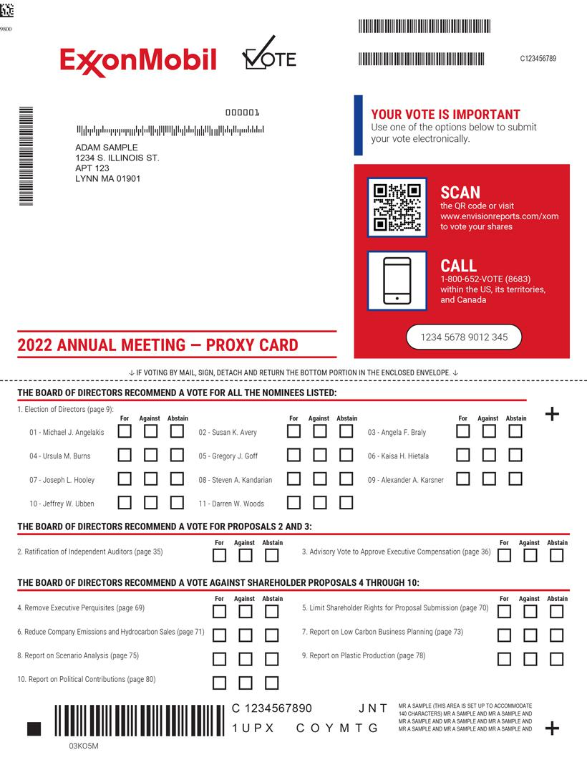

Table of Contents


