SCHEDULE 14A
Proxy Statement Pursuant to Section 14(a)
of the Securities Exchange Act of 1934

Filed by the Registrant ☐

Filed by a Party other than the Registrant ☑

Check the appropriate box:

- Preliminary Proxy Statement
- Confidential, for Use of the Commission Only (as permitted by Rule 14a-6(e)(2))
- Definitive Proxy Statement
- Definitive Additional Materials Soliciting Material Under Rule 14a-12
- Soliciting Material Under Rule 14a-12

Exxon Mobil Corporation

(Name of Registrant as Specified in Its Charter)

Engine No. 1 LLC

Engine No. 1 LP
Christopher James
Charles Penner
Gregory J. Goff
Kaisa Hietala
Alexander Karsner

Anders Runevad

(Name of Person(s) Filing Proxy Statement, if other than the Registrant)

Payment of Filing Fee (check the appropriate box):

- No fee required.

- Fee computed on table below per Exchange Act Rule 14a-6(i)(4) and 0-11.

  - Title of each class of securities to which transaction applies:

  - Aggregate number of securities to which transaction applies:

  - Per unit price or other underlying value of transaction computed pursuant to Exchange Act Rule 0-11 (set forth the amount on which the filing fee is calculated and state how it was determined):

  - Proposed maximum aggregate value of transaction:

  - Total fee paid:

- Fee paid previously with preliminary materials.

- Check box if any part of the fee is offset as provided by Exchange Act Rule 0-11(a)(2) and identify the filing for which the offsetting fee was paid previously. Identify the previous filing by registration statement number, or the Form or Schedule and the date of its filing.

  - Amount Previously Paid:

  - Form, Schedule or Registration Statement No.:

  - Filing Party:

  - Date Filed:

On December 7, 2020, Engine No. 1 LLC (“Engine No. 1”) issued a press release (the “Press Release”) announcing that Engine No. 1 had identified a proposed path forward for ExxonMobil Corporation (the “Company”) that it believes will increase value for all shareholders of the Company, including by imposing greater long-term capital allocation discipline, implementing a strategic plan for sustainable value creation, realigning management incentives, and refreshing the Company’s board of directors with four highly-qualified, independent individuals. A copy of the Press Release is filed herewith as Exhibit 1. The Press Release contains a link to a letter to the Board of the Directors of the Company that provides further details on Engine No. 1's proposal (the “Board Letter”). A copy of the Board Letter is filed herewith as Exhibit 2.

In addition, on December 7, 2020, Engine No. 1 launched a website related to its proposal located at www.ReenergizeXOM.com (the “Website”), and copies of the materials posted to the Website are filed herewith as Exhibit 3. Further, Exhibit 4 contains statements that, beginning on December 7, 2020, will be advertised on search engines and social media platforms that will direct viewers to the Website, with such statements referring to the Company as “Exxon,” “ExxonMobil” or “XOM.” Exhibit 5 contains copies of materials posted to certain social media platforms on December 7, 2020, directing users to the Website. Information regarding the Participants (as defined in Exhibit 6) in any future solicitation of proxies regarding the Company is filed herewith as Exhibit 6.

Exhibit 1

ENGINE NO. 1 TO NOMINATE FOUR HIGHLY QUALIFIED, INDEPENDENT
DIRECTOR CANDIDATES TO EXXONMOBIL BOARD

Sends Letter to ExxonMobil Board Outlining Need for Directors with Diversified Energy Experience, Greater Capital Allocation Discipline, Strategic Plan for Sustainable Value Creation, and

Better Shareholder-Aligned Management Incentives

Believes Oil & Gas Industry is in Transition and ExxonMobil Must Evolve
to Protect and Enhance Long-Term Value for Shareholders

SAN FRANCISCO – December 7, 2020 – Engine No. 1, a new investment firm that seeks to enhance long-term value through active ownership, today announced its intention to nominate four highly qualified, independent director candidates to the Exxon Mobil Corporation (NYSE: XOM) (“ExxonMobil” or the “Company”) Board of Directors (the “Board”) in connection with the 2021 Annual Meeting of Shareholders.

The California State Teachers’ Retirement System (“CalSTRS”), the nation’s second largest pension fund and owner of over $300 million in value of the Company’s stock, today is announcing its support for Engine No. 1’s director candidates.

In a letter sent today to the Board, Engine No. 1 outlined the case for much-needed change at ExxonMobil and a proposed path forward to protect and enhance long-term value for the Company’s shareholders.

Engine No. 1’s plan to reenergize ExxonMobil includes:

- Refresh the Board with highly qualified, independent directors who have diverse track records of success in the energy sector and can help the Board, which has no independent directors with any outside energy experience, position ExxonMobil to successfully evolve with changing industry dynamics;

- Impose greater long-term capital allocation discipline by applying more stringent approval criteria for new capital expenditures, including lower required break-even oil and gas prices;
- Implement a strategic plan for sustainable value creation by fully exploring growth areas, including more significant investment in clean energy, to help the Company profitably diversify and ensure it can commit to emission reduction targets, all with the benefit of a Board better qualified to consider such opportunities; and
- Overhaul management compensation to better align incentives with shareholder value creation.

In its letter, Engine No. 1 stated, “We believe that for ExxonMobil to avoid the fate of other once-iconic American companies, it must better position itself for long-term, sustainable value creation. Doing so will not be easy and will require a board with a diversified level of insight into the evolving trends, technologies, markets, and policies shaping the future of the industry, yet none of ExxonMobil’s independent directors have any other energy industry experience. This is not a criticism of any director, each of whom is highly accomplished and respected, including by us. It is instead an acknowledgement of the unique challenges facing ExxonMobil and the industry.”

Christopher Ailman, Chief Investment Officer of CalSTRS, stated, “It is time to demand change at ExxonMobil. CalSTRS’ stewardship activities date back over 30 years and reflect our focus on influencing long-term value creation. We intend to use our vote as an active shareholder to support Engine No. 1’s slate of directors because a change at the top is necessary to reposition this Company to be successful for the long-term.”

Engine No. 1’s Director Candidates include:

- Gregory J. Goff – Mr. Goff has a long track record of success in the energy industry. Mr. Goff served as the CEO of Andeavor, a leading petroleum refining and marketing company formerly known as Tesoro, for eight years ending in 2018. During his tenure, Andeavor generated total returns of 1,224%, versus 55% for the U.S. energy sector. He was named one of the “Best-Performing CEOs in the World” by Harvard Business Review in 2018. Prior to Andeavor, he spent almost 30 years with ConocoPhillips in various leadership positions in Exploration and Production, Downstream, and Commercial operations.

- Kaisa Hietala – Ms. Hietala is an experienced leader in strategic transformation in the energy sector who began her career in upstream oil and gas exploration and crude oil trading. Ms. Hietala served as the EVP of Renewable Products at Neste, a petroleum refining and marketing company, for five years ending in 2019. During her tenure, the Renewable Products segment’s revenues grew by 1.6x and operating profits grew by 4x. She played a central role in the strategic transformation of Neste into the world’s largest and most profitable producer of renewable diesel and jet fuel, which was named by Harvard Business Review as one of the “Top 20 Business Transformations of the Last Decade” in 2019.

- Alexander Karsner – Mr. Karsner is a leading corporate innovation strategist and accomplished energy entrepreneur and policymaker with more than three decades of global conventional and renewable energy experience. He is Senior Strategist at X (formerly Google X), the innovation lab of Alphabet Inc. He began his career developing and financing large scale energy infrastructure. As a private equity investor, venture partner, and advisor, his portfolios have included some of the most successful cleantech startups of the past decade. He previously served as U.S. Assistant Secretary of Energy, responsible for multi-billion dollar federal R&D programs. He is a Precourt Energy Scholar at Stanford University’s School of Civil and Environmental Engineering.

- Anders Runevad – Mr. Runevad is a successful business leader with global energy experience. He served as the CEO of Vestas Wind Systems, a wind turbine manufacturing, installation, and servicing company with more installed wind power worldwide than any other manufacturer, for six years ending in 2019, and is credited with turning around the company. During his tenure, Vestas stock returned a total of 480%, significantly outperforming the global energy and industrials sectors. He was included in Fortune’s “Businessperson of the Year” list in 2016.

The full text of the letter is available here.

Additional information regarding Engine No. 1’s plan to reenergize ExxonMobil may be found at www.ReenergizeXOM.com.

About Engine No. 1
Engine No. 1 is an investment firm purpose-built to create long-term value by driving positive impact through active ownership. For more information, please visit: www.Engine1.com

Media Contacts
Gasthalter & Co.
Jonathan Gasthalter/Amanda Klein
212-257-4170

Engine1@gasthalter.com

Investor Contacts:

Innisfree M&A Incorporated
Scott Winter/Gabrielle Wolf
212-750-5833

Important Information

Engine No. 1 LLC, Engine No. 1 LP, Christopher James, Charles Penner (collectively, “Engine”), Gregory J. Goff, Kaisa Hietala, Alexander Karsner, and Anders Runevad (collectively and together with Engine, the “Participants”) intend to file with the Securities and Exchange Commission (the “SEC”) a definitive proxy statement and accompanying form of WHITE proxy to be used in connection with the solicitation of proxies from the shareholders of Exxon Mobil Corporation (the “Company”). All shareholders of the Company are advised to read the definitive proxy statement and other documents related to the solicitation of proxies by the Participants when they become available, as they will contain important information, including additional information related to the Participants. The definitive proxy statement and an accompanying WHITE proxy card will be furnished to some or all of the Company’s shareholders and will be, along with other relevant documents, available at no charge on the SEC website at http://www.sec.gov/.

Information about the Participants and a description of their direct or indirect interests by security holdings will be contained in a Schedule 14A filed by the Participants with the SEC. This document will be available free of charge from the source indicated above. For information about CalSTRS and its interests in the Company, the Participants refer stockholders to CalSTRS and its public filings on the SEC website at http://www.sec.gov.

Disclaimer

This material does not constitute an offer to sell or a solicitation of an offer to buy any of the securities described herein in any state to any person. In addition, the discussions and opinions in this press release and the material contained herein are for general information only, and are not intended to provide investment advice. All statements contained in this press release that are not clearly historical in nature or that necessarily depend on future events are “forward-looking statements,” which are not guarantees of future performance or results, and the words “anticipate,” “believe,” “expect,” “potential,” “could,” “opportunity,” “estimate,” and similar expressions are generally intended to identify forward-looking statements. The projected results and statements contained in this press release and the material contained herein that are not historical facts are based on current expectations, speak only as of the date of this press release and involve risks that may cause the actual results to be materially different. Certain information included in this material is based on data obtained from sources considered to be reliable. No representation is made with respect to the accuracy or completeness of such data, and any analyses provided to assist the recipient of this material in evaluating the matters described herein may be based on subjective assessments and assumptions and may use one among alternative methodologies that produce different results. Accordingly, any analyses should also not be viewed as factual and also should not be relied upon as an accurate prediction of future results. All figures are unaudited estimates and subject to revision without notice. Engine disclaims any obligation to update the information herein and reserves the right to change any of its opinions expressed herein at any time as it deems appropriate. Past performance is not indicative of future results. Engine has neither sought nor obtained the consent from any third party to use any statements or information contained herein that have been obtained or derived from statements made or published by such third parties. Except as otherwise expressly stated herein, any such statements or information should not be viewed as indicating the support of such third parties for the views expressed herein.

Exhibit 2


December 7, 2020

Board of Directors

Exxon Mobil Corporation
5959 Las Colinas Boulevard
Irving, Texas 75039
Attention: Darren Woods, Chairman & CEO

Ladies & Gentlemen,

No company in the history of oil and gas has been more influential than Exxon Mobil Corporation (“ExxonMobil” or the “Company”), which is home to many of the industry’s most talented managers, operators, scientists, engineers, safety professionals, and other employees. It is clear, however, that the industry and the world it operates in are changing and that ExxonMobil must change as well. While the entire industry has faced steep declines, ExxonMobil stands apart.

- The Company’s total shareholder return, including dividends, over the last 10 years has been -20%, versus +277% for the S&P 500. Its total shareholder return for the prior 3-, 5- and 10-year periods trails each of its self-selected proxy peers and the S&P 500, both before and after the COVID-19 pandemic.^{[i]}

- Return on Capital Employed (ROCE) for Upstream projects (which have historically accounted for over 75% of total capital expenditures (“capex”)) has fallen from an average of ~35% from 2001-10 to ~6% from 2015-2019, even during periods of higher oil and gas prices.^{[ii]} As Bloomberg Opinion noted last week, “Exxon’s reputation for discipline has eroded alongside its return on capital …”^{[iii]}

- While ExxonMobil once had no net debt, today it has the highest debt level in its history, the highest net debt to cash from operations ratio among the Oil Majors at over 3.0x, and its debt has been downgraded twice by S&P since 2016 (and is on negative watch), all of which has contributed to market skepticism that it can maintain its current dividend.^{[iv]}
- Despite the Company’s dramatic decline in value, as of last week only 14% of sell-side analysts covering the Company rated it as a “Buy,” versus an average of 66% for its proxy peers, and of the top 50 institutional shareholders of ExxonMobil and Chevron, 66% were underweight ExxonMobil versus its closest peer, Chevron.^{[v]}

We are a new investment firm that seeks to enhance long-term value through active ownership. We have conducted an in-depth analysis over many months including talking to industry operators, analysts, and investors, and engaged a leading industry consultant to help analyze the Company’s assets and operations. We believe that for ExxonMobil to avoid the fate of other once-iconic American companies, it must better position itself for long-term, sustainable value creation.

Doing so will not be easy and will require a board with a diversified level of insight into the evolving trends, technologies, markets, and policies shaping the future of the industry, yet none of ExxonMobil’s independent directors have any other energy industry experience. This is not a criticism of any director, each of whom is highly accomplished and respected, including by us. It is instead an acknowledgement of the unique challenges facing ExxonMobil and the industry.

We have therefore identified four highly qualified, independent individuals who have agreed to be nominated, if necessary, for election to the Company’s Board of Directors (the “Board”).

We have reviewed the qualifications of these individuals with the second largest pension fund in the U.S., the California State Teachers’ Retirement System (“CalSTRS”), which owns over $300 million in value of the Company’s stock. CalSTRS has informed us that, based upon the qualifications of such individuals, it intends to support them if nominated for election to the Board, and we believe that other long-term oriented investors will share this view.

- Gregory J. Goff. Mr. Goff has a long track record of success in the energy industry. Mr. Goff served as the CEO of Andeavor, a leading petroleum refining and marketing company formerly known as Tesoro, for eight years ending in 2018. During his tenure, Andeavor generated total returns of 1,224%, versus 55% for the U.S. energy sector. He was named one of the “Best-Performing CEOs in the World” by Harvard Business Review in 2018. Prior to Andeavor, he spent almost 30 years with ConocoPhillips in various leadership positions in Exploration and Production, Downstream, and Commercial operations.

- Kaisa Hietala. Ms. Hietala is an experienced leader in strategic transformation in the energy sector who began her career in upstream oil and gas exploration and crude oil trading. She served as the EVP of Renewable Products at Neste, a petroleum refining and marketing company, for five years ending in 2019. During her tenure, the Renewable Products segment’s revenues grew by 1.6x and operating profits grew by 4x. She played a central role in the strategic transformation of Neste into the world’s largest and most profitable producer of renewable diesel and jet fuel, which was named by Harvard Business Review as one of the “Top 20 Business Transformations of the Last Decade” in 2019.

- Alexander Karsner. Mr. Karsner is a leading corporate innovation strategist and accomplished energy entrepreneur and policymaker with more than three decades of global conventional and renewable energy experience. He is Senior Strategist at X (formerly Google X), the innovation lab of Alphabet Inc. He began his career developing and financing large scale energy infrastructure. As a private equity investor, venture partner, and advisor, his portfolios have included some of the most successful cleantech startups of the past decade. He previously served as U.S. Assistant Secretary of Energy, responsible for multi-billion dollar federal R&D programs. He is a Precourt Energy Scholar at Stanford University’s School of Civil and Environmental Engineering.

- Anders Runevad. Mr. Runevad is a successful business leader with global energy experience. Mr. Runevad served as the CEO of Vestas Wind Systems, a wind turbine manufacturing, installation, and servicing company with more installed wind power worldwide than any other manufacturer, for six years ending in 2019, and is credited with turning around the company. During his tenure, Vestas stock returned a total of 480%, significantly outperforming the global energy and industrials sectors. He was included in Fortune’s “Businessperson of the Year” list in 2016.

Together this group has a diverse set of experiences in successful, global energy operations and decades of leading value-creating transformations in the industry. We are open to engaging in a constructive dialogue to discuss these individuals before the need arises to nominate them for election to the Board. We believe that collectively they can help the Board unlock sustainable, long-term shareholder value by addressing the fundamental issues facing the Company.

Fundamental Issues at ExxonMobil

Poor Long-Term Capital Allocation Strategy. We believe ExxonMobil’s underperformance can be largely attributed to its pursuit of production growth at the expense of returns and a lack of adaptability to changing industry dynamics, including higher production costs and growing long-term demand uncertainty. While ExxonMobil once led the industry in returns on capital, its returns have declined significantly and earlier this year Goldman Sachs estimated that from 2020 on its returns on capital would be the lowest among its proxy peers.^{[vi]} In

addition, ExxonMobil as of this summer owned 60% of the Oil Majors’ 30 lowest margin assets by production.^{[vii]} The primary driver of this underperformance has been upstream capital productivity (which is independent of oil and gas prices) at the Company, which has declined ~80%, from 39 barrels of oil equivalent produced per $1,000 of capital employed in 2001 to 8 barrels by 2019.^{[viii]}

While the entire industry faces similar headwinds, ExxonMobil stands apart in its adherence to a long-term strategy of aggressive spending despite such declining returns. In 2018, ExxonMobil announced plans to spend ~$30 billion annually on capex from 2020-25. While oil and gas companies must spend to offset natural decline rates in producing assets, this spending plan went far beyond that needed to maintain the Company’s current production and targeted growing production by ~25% to ~5.0 mboe/d by 2025, highest among the Oil Majors. Despite a largely negative reception from the market, the Company repeatedly reaffirmed this strategy, including guiding to $180-$210 billion in capex from 2020-25 in March of this year. Subsequently, in response to COVID-19, the Company announced short-term capex delays and cuts for 2020-21, but made clear that it viewed these as temporary, referring to them as “a short-term reduction in capital expenditure to manage the current situation.”^{[ix]}

- While ExxonMobil has noted that trillions in new oil and gas industry spending will be required to meet forecasted growth in energy demand (although the amount will vary widely based upon various demand scenarios), this argument misses the key point:

Whatever the level of future demand growth may be, ExxonMobil has no obligation to spend aggressively if doing so is likely to deliver suboptimal returns. As analysts at Evercore ISI have noted, “the historical investment model which assumed that higher oil prices would always lead to higher share prices in Energy has been disrupted.”^{[x]}
- While there will be periods during which oil and gas prices rise and offer at least temporary support for aggressive spending, the Company’s history shows that a failure to be adequately discerning in chasing growth is still likely to generate suboptimal returns, which we believe will not satisfy investors focused on share price performance, the security of the dividend, or ExxonMobil’s long-term future.

While presented with significant fanfare, ExxonMobil’s announcement last week that it would reduce its planned capex for 2022-25 to $20-$25 billion had been widely anticipated given its current financial position.^{[xi]} Likewise, analysts at Goldman Sachs estimated after this announcement that the Company’s break-even oil price through 2025 was ~$60 (versus the current Brent forward curve of ~$50), and analysts at J.P. Morgan noted that, “we think that a dividend cut is still possible in early 2021.” In short, we believe this overdue acknowledgment of reality does not constitute a long-term strategy, and that there is little reason to hope that this change marks a new era of more disciplined capital allocation. The Company appeared to confirm as much just a few days later, with a senior executive telling Barron’s that its “aggressive organic investment program” had not “changed dramatically,” and had rather been “just delayed a little bit.”^{[xii]}

Lack of a Long-Term Plan to Enhance and Protect Value. ExxonMobil has set methane emission reduction goals, participated in industry efforts to reduce carbon intensity, and invested in carbon capture and algae biofuel research (more detailed information on these and other efforts can be found on the Company’s website). Still, the Company has little material exposure to newer growth areas and has shown little inclination to materially alter this position.^{[xiii]} ExxonMobil has argued that there is little value in materially pursuing growth areas like renewables, as such investments are likely to deliver lower returns to shareholders than oil and gas projects. While any decision to diversify must be carefully considered, the question of how best to position ExxonMobil for the long-term merits a more comprehensive approach.

- The Company’s average return on upstream capex has been nowhere near its target, falling to mid-single digits, while the cost of capital for oil and gas spending is likely to continue rising given long-term uncertainty, which will significantly impact relative returns. In fact, this summer analysts at Goldman Sachs predicted that, “even on our above consensus oil price forecast, we believe [ExxonMobil] will generate returns below [its] cost of capital.”^{[xiv]}

- As the Company can attest, returns for any energy project can vary widely based upon strategy and execution. Lower returns appear more likely when a company simply invests in a pre-existing project, such as BP’s recent purchase of a stake in a developed wind farm for over a billion dollars. While BP’s early efforts to diversify have been received poorly by the market to date, companies like Equinor and NextEra have demonstrated that by carefully planning, taking on prudent project development risk, and fully utilizing a company’s assets and knowledge, it is possible to create compelling sustainable growth plans that drive positive investor sentiment. We believe that to have any chance of correctly answering the complicated question of whether ExxonMobil can pursue such a long-term path, the Company needs a board with relevant industry experience.

ExxonMobil has a long history of industry-leading innovation, and we believe it should not so easily cede this ground, particularly as its iconic status is threatened. We are not suggesting that ExxonMobil can or should diversify overnight. However, given the Company’s size, global influence, expertise in complex energy projects, and world-renowned engineers and scientists, the possibility of long-term repositioning demands full consideration by directors with the relevant experience to do so. As Goldman Sachs has noted, “Big Oils have shown tremendous ability to adapt to technological change in their 100+ years of history,” and “their long-standing experience in the energy sector could provide them with a technological advantage in areas that remain currently underinvested and underdeveloped but will be

critical for net zero…”^{[xv]} While the Company has publicly and regrettably dismissed carbon emission reduction targets as a “beauty competition,” such targets have more than cosmetic value to investors. Decreasing price/book multiples, increasing dividend yields, and increasing costs of capital all show that the market ascribes a declining terminal value to ExxonMobil and its peers because the market believes these companies are poorly positioned for an energy transition.

ExxonMobil and others have argued that such assessments are premature given the amount of change that would be required for a material energy transition to occur in the decades to come. Disruptive innovation continues to occur rapidly, however, and it would be entirely economically rational for the world to act more quickly than many expect to avoid the worst outcomes of climate change. Thus, companies that have few cards to play in the event of a material long-term energy demand shift – and who indicate they have no intention of changing this outlying position – are unlikely to be highly valued by the market, even during brief periods of higher performance. It is thus prudent for ExxonMobil, as a means of shareholder capital preservation, to seriously explore opportunities to profitably diversify and signal to long-term investors that its terminal value could be more than zero in a decarbonizing world, with the assistance of new directors with notable track records of agile and adaptative innovation in energy.

Failure to Align Management Compensation with Value Creation for Shareholders. Despite ExxonMobil’s negative cumulative total shareholder return (-12%) from 2017 to 2019, total CEO compensation at the Company rose almost 35% during this period.^{[xvi]} While the Company’s incentive plans focus largely on long-term results, this disjuncture between returns for shareholders and management compensation indicates that such plans require better investor alignment. Unlike many of its peers, ExxonMobil does not disclose the weightings it assigns to various performance metrics or specific targets that management must meet to achieve them, and has not disclosed cost or balance sheet-focused metrics used to measure management performance, creating a lack of accountability for project cost overruns, higher production costs, or balance sheet deterioration.

In addition, return-focused metrics like total shareholder return and ROCE are compared only to industry averages without reference to the overall market (unlike Chevron) or cost of capital (unlike BP). As a result, management may be incentivized to deploy capital to generate “leading” industry returns even where shareholders would be better served by increased returns of capital or other investments to strengthen the business for the long-term. As analysts at Evercore ISI have noted, “Unfortunately, when the industry is in value-destruction mode as it was during the past decade, CEO pay can remain high as long as management teams destroy less value than peers.”^{[xvii]}

Reenergizing ExxonMobil

For these reasons, we are proposing a new path forward to reenergize ExxonMobil, including:

Refresh the Board. The highly qualified, independent individuals named above will bring to the Board track records of success in building, developing, operating, and/or investing in successful, large-scale, global energy operations, and can help oversee implementation of the strategic changes we believe are required. We are confident that these individuals can work collaboratively as members of the Board to maximize long-term value for all shareholders.

Impose Greater Long-Term Capital Allocation Discipline. We believe ExxonMobil needs a more disciplined and forward-thinking approach to capital allocation strategy, including a long-term commitment to only funding projects that can break-even at much more conservative oil and gas prices. Upstream projects that do not easily exceed the Company’s target returns when factoring in all costs (including SG&A) under probabilistically-weighted demand scenarios should be cancelled or rejected and this capital should be returned to investors or put to work strengthening ExxonMobil for the long-term. We believe that a long-term commitment to cutting unproductive capex and tightening project return requirements for approval would likely increase free cash flow, strengthen the Company’s balance sheet, and help secure its ability to cover its dividend, which are crucial considerations particularly for the Company’s smaller shareholders.

Implement a Strategic Plan for Sustainable Value Creation in a Changing World. Change will not come overnight, but ExxonMobil should fully explore ways to leverage its scale and expertise in delivering energy by exploring growth areas, including more significant investment in net-zero emissions energy sources and clean energy infrastructure, under the guidance of a special committee of the Board with relevant experience created for this purpose. Improved long-term capital allocation discipline, combined with this effort to diversify, should help create a more favorable long-term risk/reward scenario for shareholders and ensure the Company can not only set Scope 1, 2, and 3 carbon emission reduction targets, but also make them part of a sustainable, transparent, and profitable long-term plan focused on accelerating rather than deferring the energy transition.

Realign Management Incentives. We believe that the Company’s management compensation plans should be overhauled for the long-term to better align compensation with value creation for shareholders. Such changes would include utilizing preset weightings and targets, employing more cost management and balance sheet-focused metrics, and measuring value creation not just by reference to the oil and gas industry but to the overall market, to ensure that management is not rewarded for outperforming the industry but eroding shareholder value.

Conclusion

There is an ongoing debate about whether public companies should focus on their impact versus their value creation potential. We believe that, when viewed from a long-term perspective, these considerations almost always go hand-in-hand, and ExxonMobil is no exception. Rising costs for non-state oil and gas companies and near-term price volatility combined with long-term demand uncertainty have caused the market to favor companies with more disciplined capital allocation strategies and more ways to win for investors under a variety of long-term demand scenarios. ExxonMobil has focused for years on growth based on its belief that oil and gas prices will rise and remain elevated. However, this is of little benefit to long-term investors if the market increasingly discounts the Company’s cash flows and terminal growth rate because earnings remain volatile and long-term demand remains uncertain, and if the Company’s dividend-paying ability remains questionable and its iconic status continues to gradually fade.

We understand ExxonMobil is aware of many of the points we have raised and has fundamental differences of opinion on many of them. We also acknowledge that there are good faith debates to be had about these topics, as is the case in every industry facing change. We believe, however, that given the Company’s long-running underperformance and the challenges it faces, it is time for shareholders to weigh in. While the idea of ExxonMobil prioritizing returns over growth, diversifying its strategic options, and reevaluating its role in the energy transition may have seemed farfetched in years past, our conversations with energy industry executives, analysts, and public and private investors have given us confidence that the time for change at the Company has come.

We look forward to a constructive dialogue, and we are open to beginning at your convenience.

Sincerely,

Engine No. 1 LLC

- Bloomberg. Current returns are for the 3-, 5- and 10-year periods ending November 30, 2020. Pre-COVID-19 returns are calculated for the periods ending February 19, 2020. ExxonMobil’s proxy peers named in its 2020 Proxy Statement dated April 9, 2020 are BP, Chevron, Shell, and Total.

- ExxonMobil public filings.

- Liam Denning. Exxon Is Now the Thing It Wasn’t Supposed to Be: Shrinking discipline and rising leverage make what was once the smartest oil major a risky play on crude prices. Bloomberg Opinion. December 1, 2020. Retrieved from Bloomberg.com.

- JP Morgan estimates; ExxonMobil public filings. “Oil Majors” as used herein refers to BP, Chevron, Eni, Equinor, ExxonMobil, Shell, and Total.

- Bloomberg compiled data as of November 30, 2020.

- Neil Mehta, Emily Chieng, CFA, and Carly Davenport. Exxon Mobil Corp.: Downgrade to Sell on Challenged FCF, returns and valuation. Goldman Sachs Equity Research. February 3, 2020. (“On average since 1995, XOM has generated a 5% ROCE premium relative to its peers (CVX, COP, RDS, BP, and Total). That said, following a number of dilutive investments, particularly in the Upstream business, the company’s ROCE has deteriorated and has been below its peer average since 2018, a trend we expect to continue through 2024.”) and (“Relative to global majors, XOM generates the lowest ROCE from 2019 onwards, in our view.”)

- Simon Flowers, Chairman and Chief Analyst, Wood Mackenzie. Building upstream portfolio resilience: the search for robust cash margins. Wood Mackenzie. June 11, 2020.

- ExxonMobil public filings. Upstream capital productivity calculated by dividing annual oil equivalent production by average Upstream capital employed.

- ExxonMobil Q2 2020 Earnings Call Transcript. July 31, 2020.

- Doug Terreson, Chai Zhao, and Sioban Hickie. Crude Oil, Energy Strategy: Pledger World. Evercore ISI. December 16, 2019.

- See, e.g., Phil Gresh, CFA, John M Royall, CFA, and Nicholas J. Lampman. Exxon Mobil Corp.: Thoughts on Guidance Update. J.P. Morgan Equity Research. November 30, 2020. (Noting that the Company’s new 2022-25 capex guidance was “consistent with our expectations.”)

- Avi Salzman. Exxon is Retrenching. A Top Executive Defends the Strategy. Barron’s. December 1, 2020.

- See, e.g., Robert Perkins. ExxonMobil focused on core oil and gas as renewable returns too weak: official. S&P Global Platts. September 30, 2020.

(“ExxonMobil remains focused on growing its core oil and gas business as alternative renewable energies are mostly unable to offer attractive rates of return compared to hydrocarbons, a top official at the US oil giant said Sept. 30. Asked why ExxonMobil is still planning to grow its future oil production while European oil majors are pivoting towards renewable and low-carbon energy, ExxonMobil's head in Brazil Carla Lacerda said the company is prioritizing its ‘core competencies’ of oil and gas.”). See, also, e.g., Derek Brower. Why ExxonMobil is sticking with oil as rivals look to a greener future. The Financial Times. October 28, 2020.

- Neil Mehta, Emily Chieng, CFA, and Carly Davenport. Exxon Mobil Corp.: Now trading below book value, but de-rate is fundamentally justified; still Sell. Goldman Sachs Equity Research. July 10, 2020.
- Michele Della Vigna, et al. Carbonomics: Re-Imagining Big Oils – The Age of Transformation. Goldman Sachs Equity Research. September 1, 2020.

- ExxonMobil 2020 proxy statement summary compensation table for 2019.

- Doug Terreson, Chai Zhao, and Sioban Hickie. Crude Oil, Energy Strategy: Pledger World. Evercore ISI. December 16, 2019.

Exhibit 3
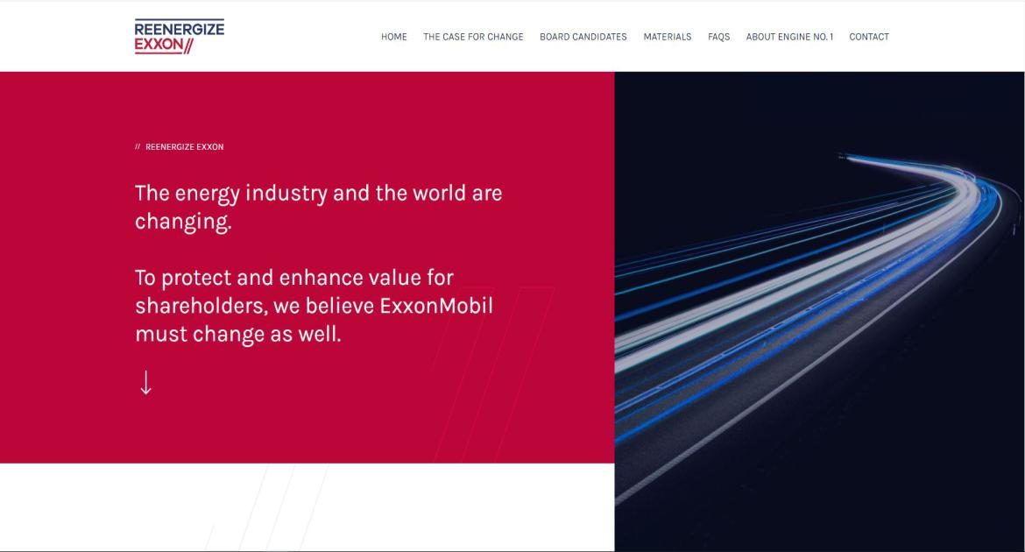

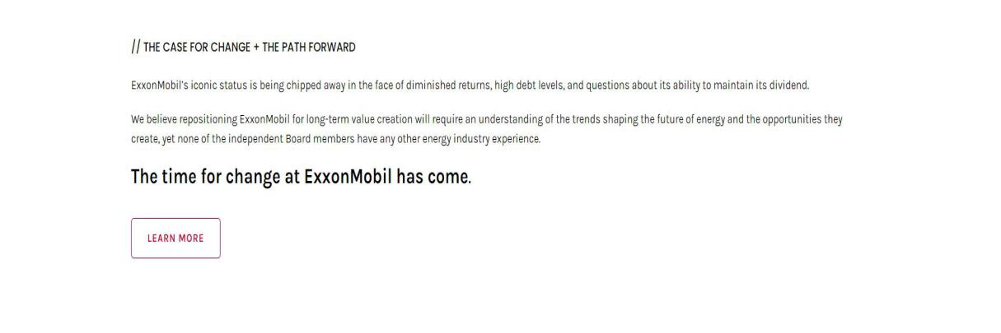

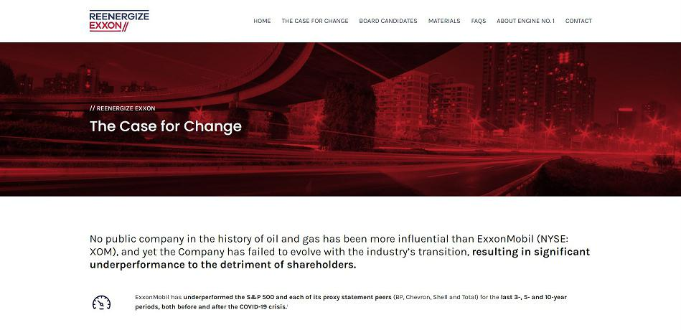

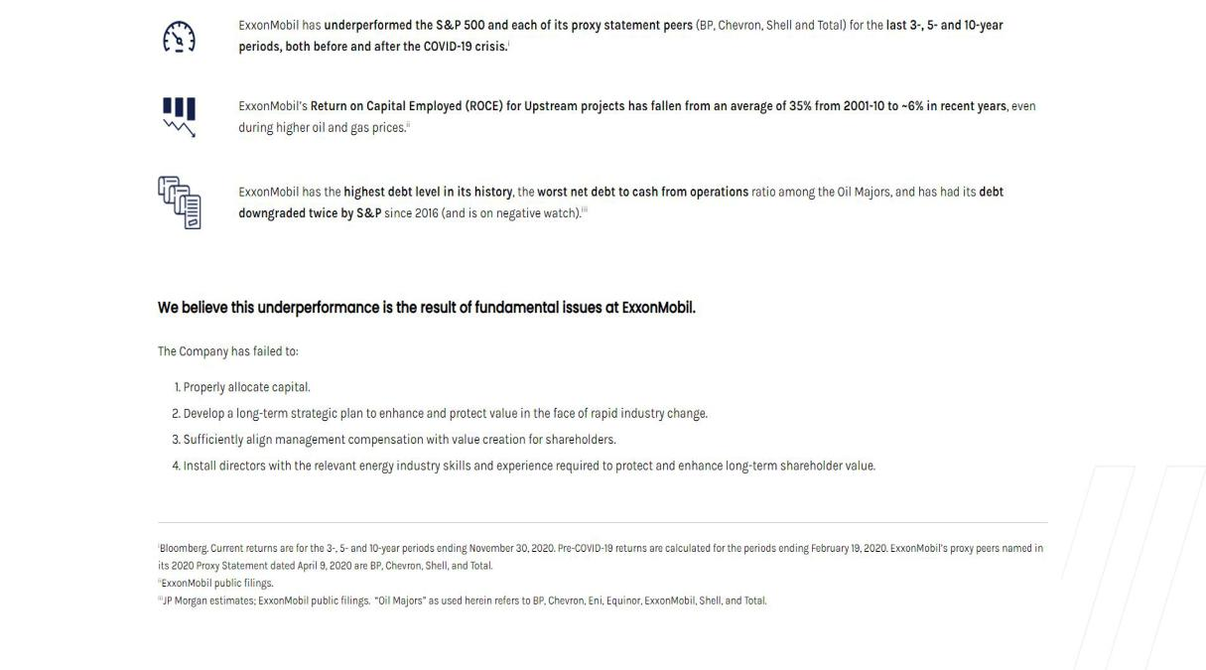

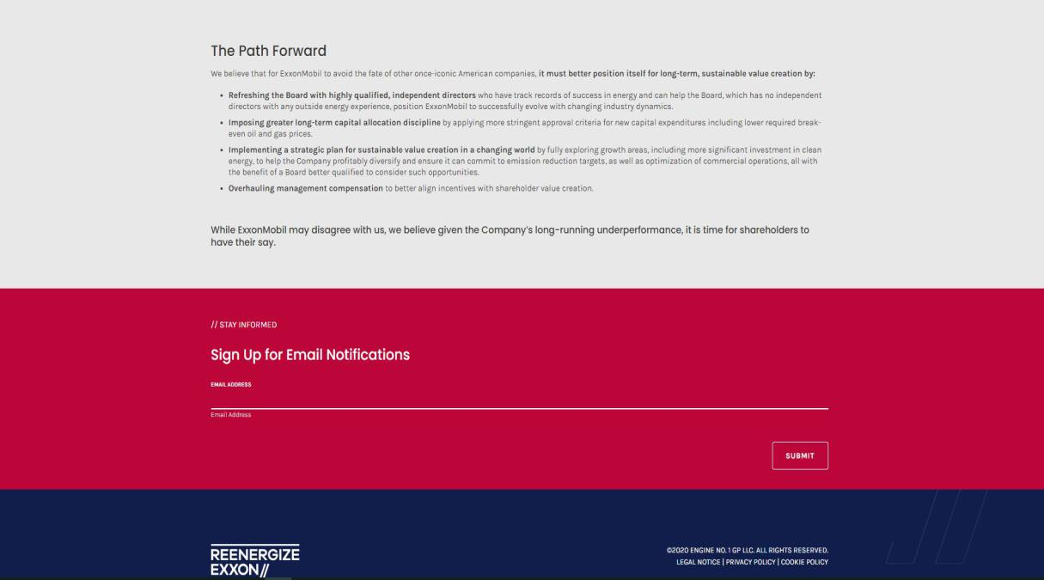

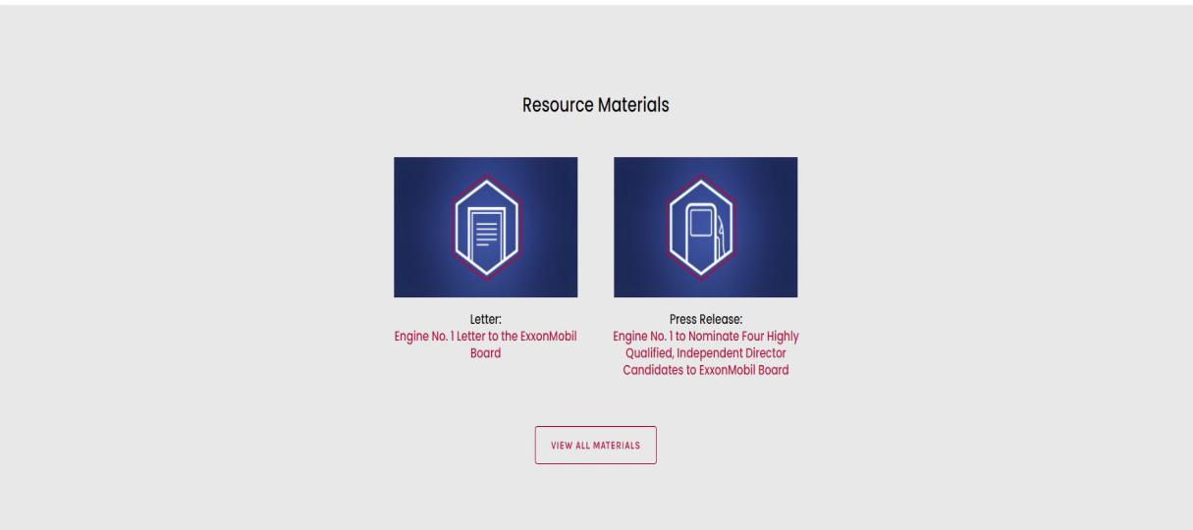

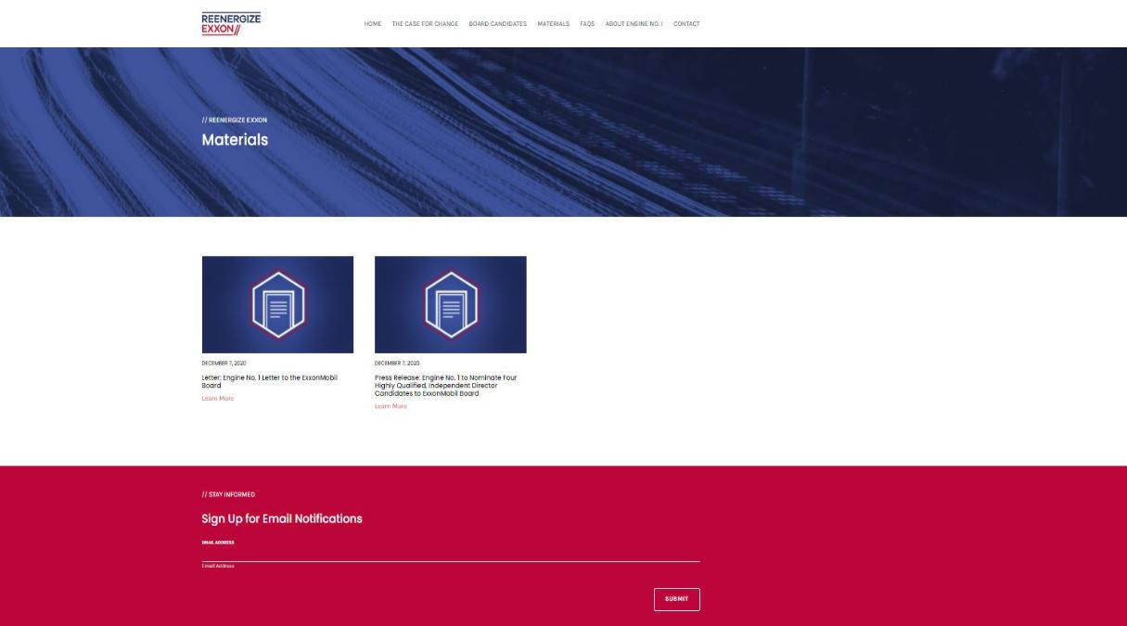

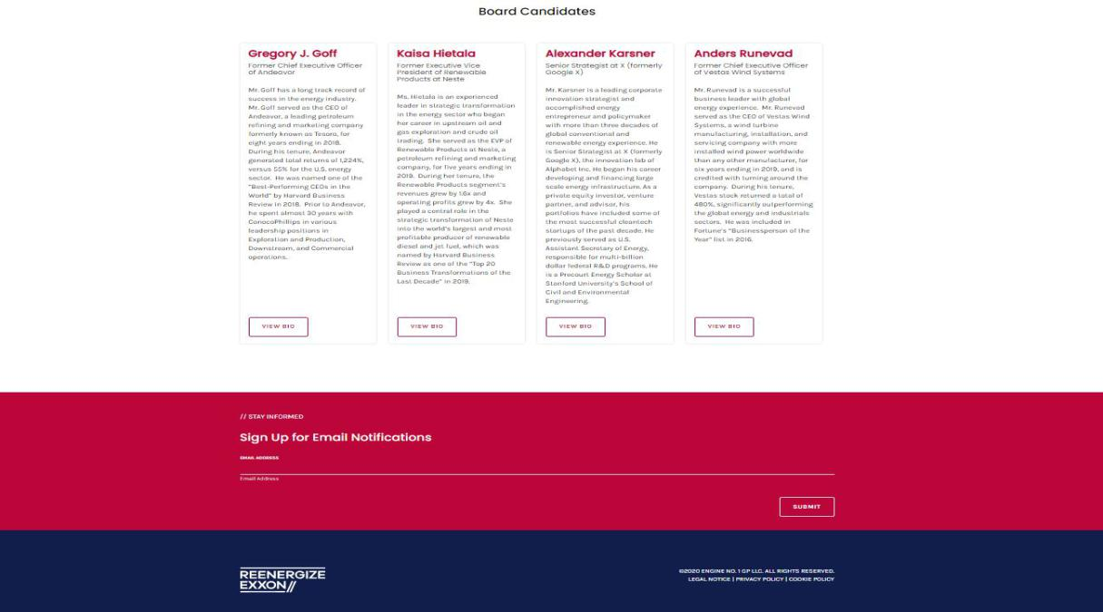

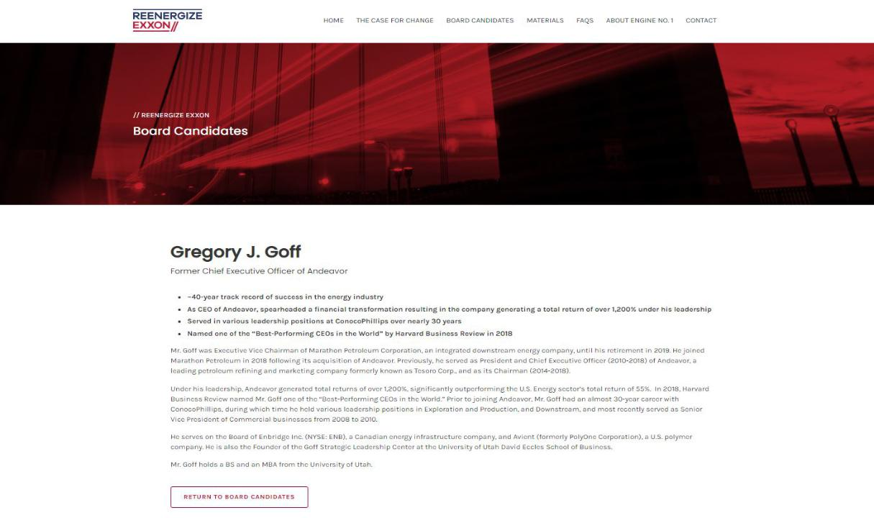

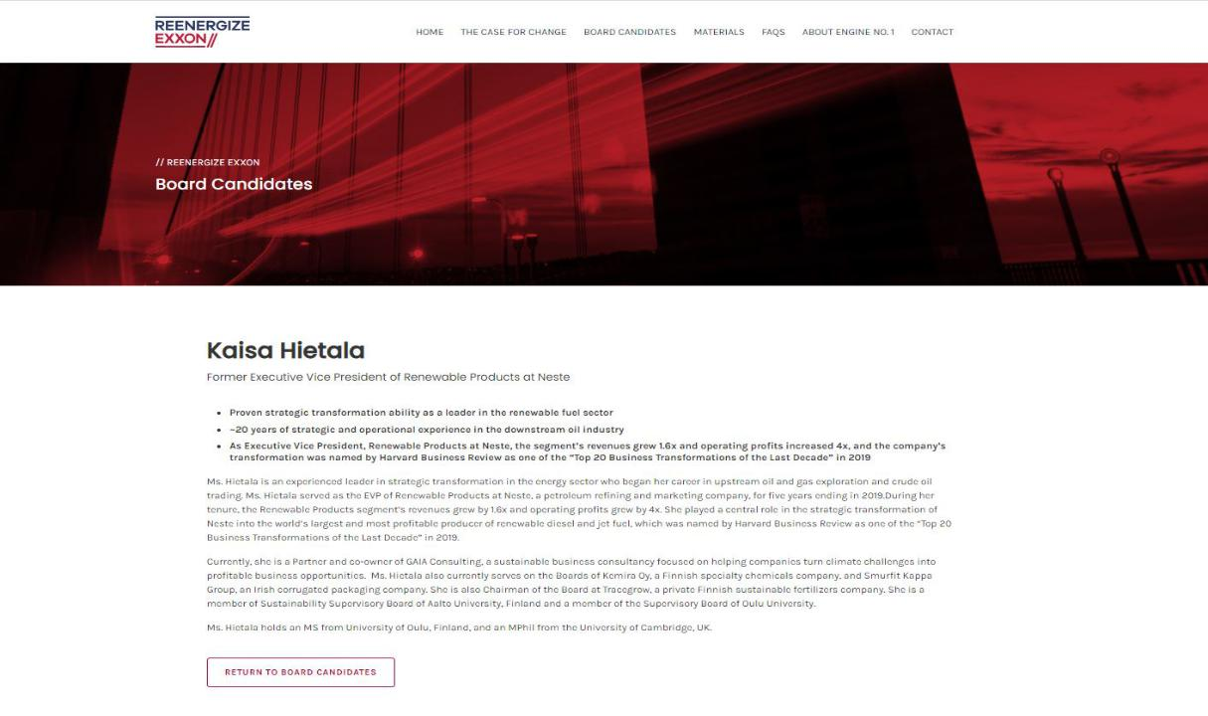

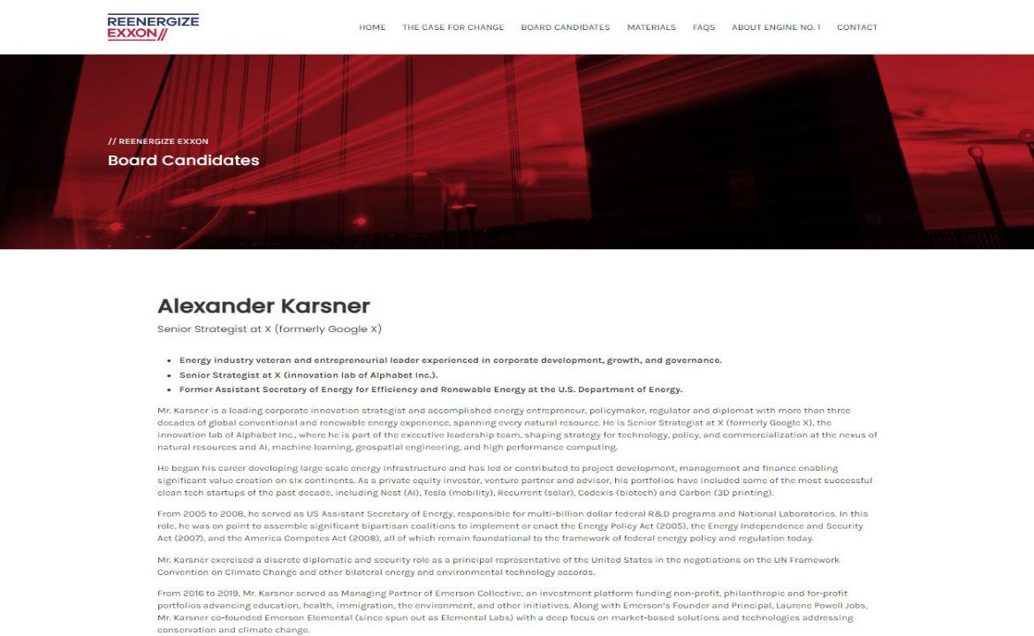

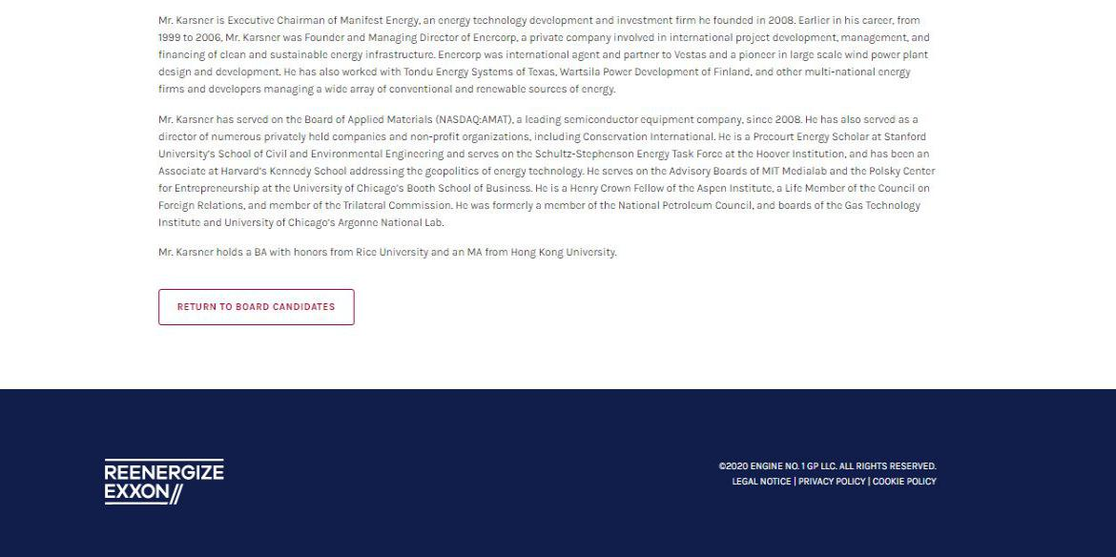

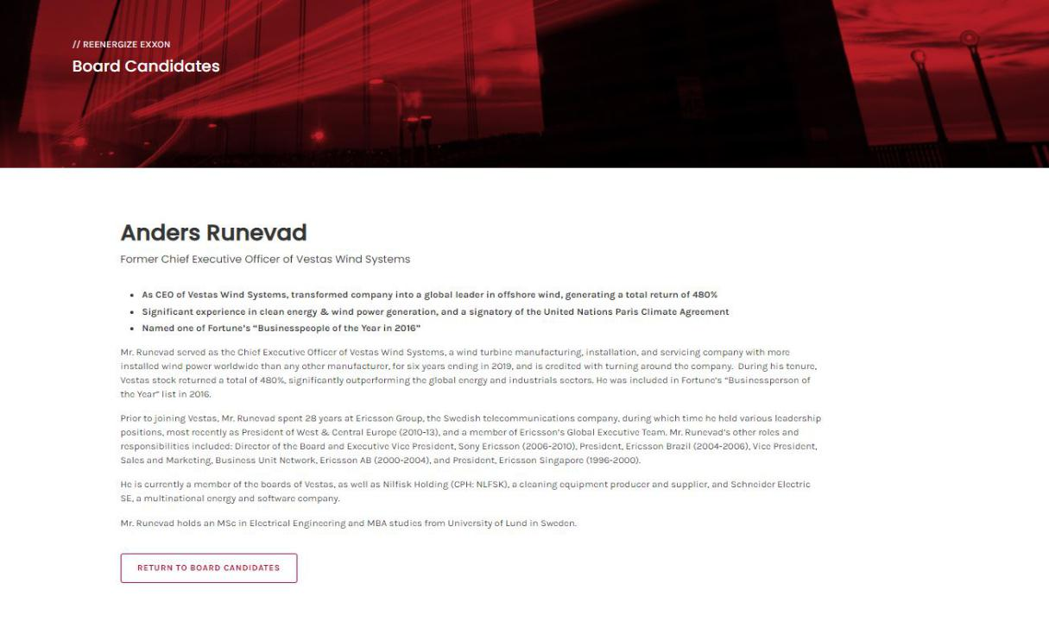

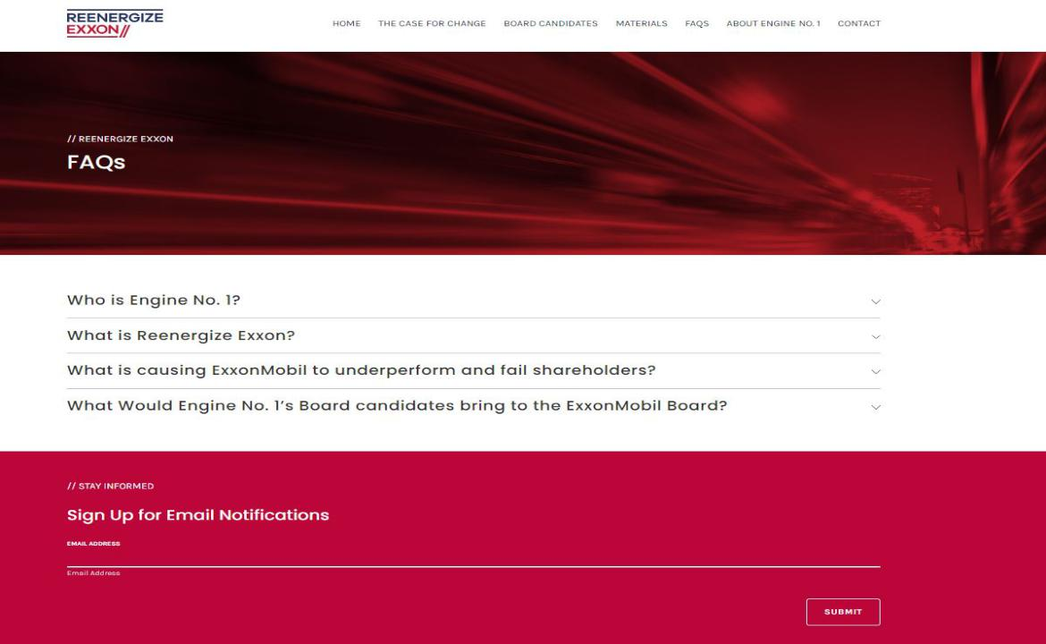

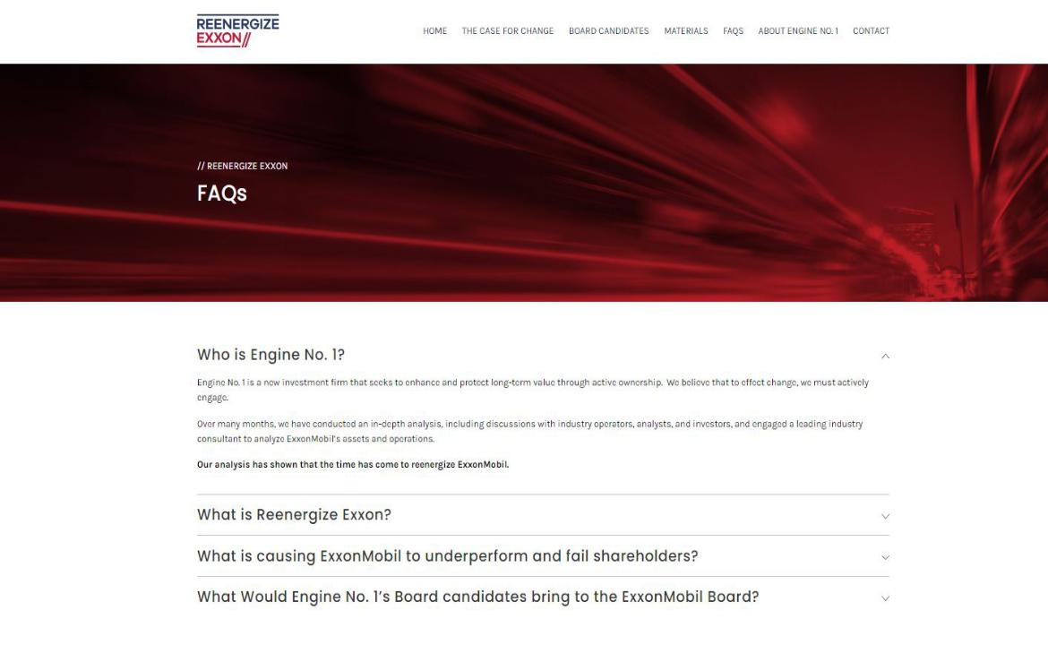

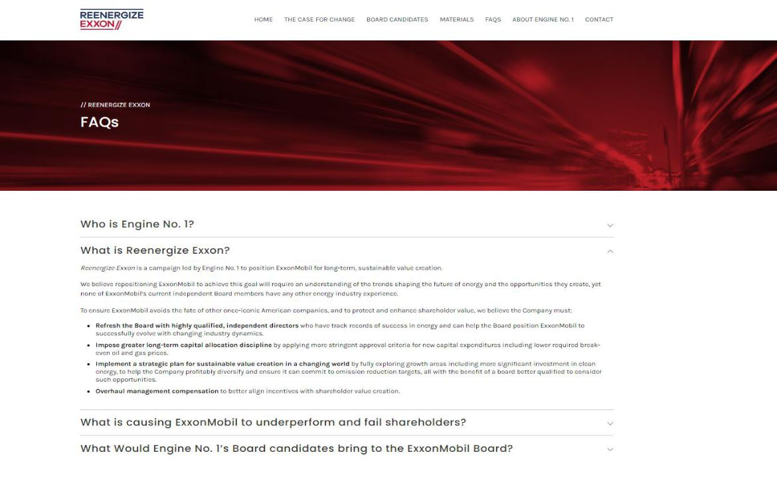

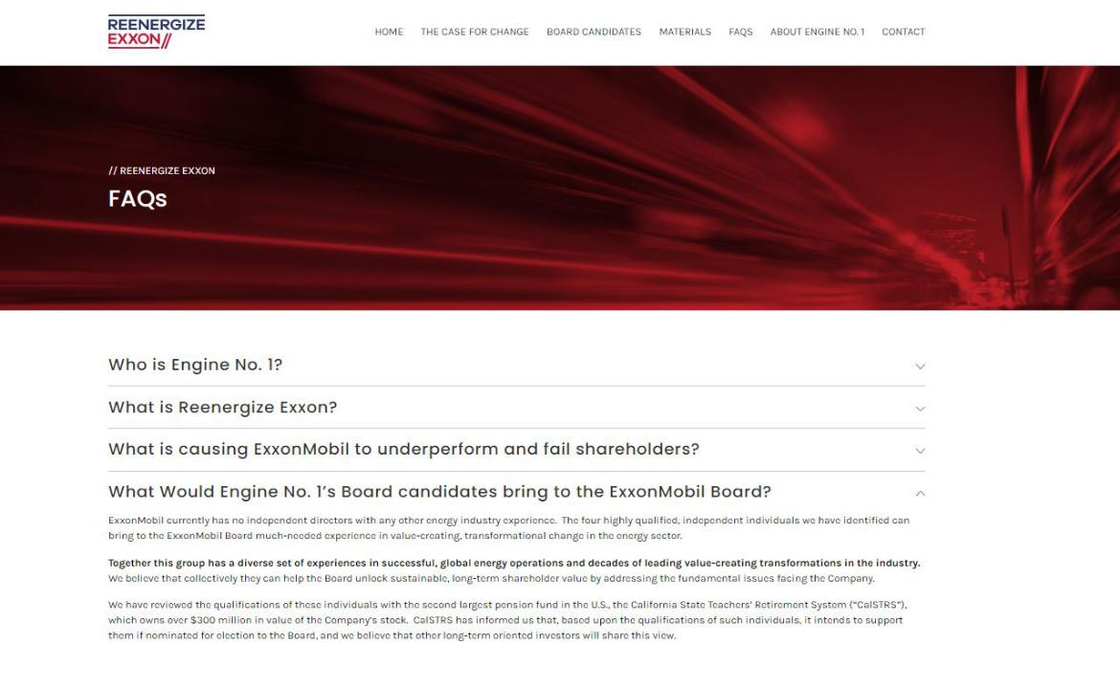

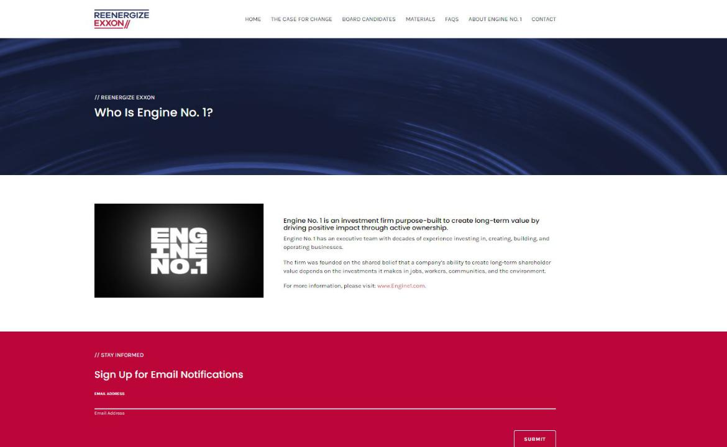

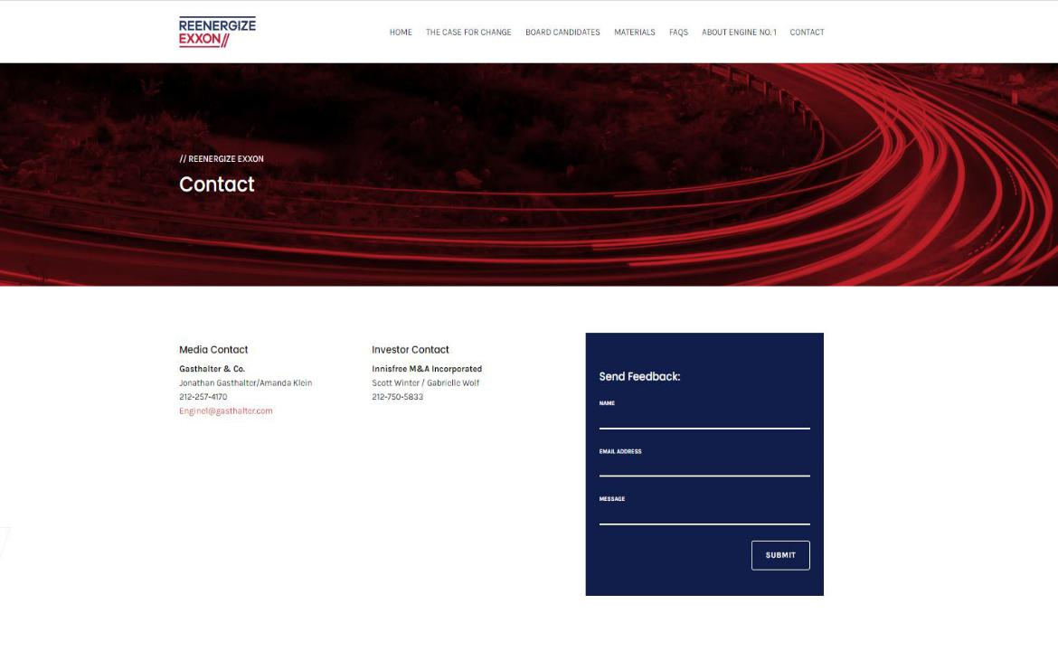

Exhibit 4

The industry is changing. ExxonMobil must change as well to protect & enhance its value. ExxonMobil’s iconic status is being chipped away in the face of diminished returns. The time for change at ExxonMobil has come.

It's time to Reenergize Exxon to enhance shareholder value and evolve with the industry. ExxonMobil’s iconic status is being chipped away in the face of high debt levels. The time for change at ExxonMobil has come.

Exxon's Board requires change to enhance shareholder value and better position Exxon. ExxonMobil's independent directors have no other relevant industry skills. Given Exxon's long-running underperformance, it's time for shareholders to have their say.

The world is changing. Yet Exxon has failed to evolve. It's time to Reenergize Exxon. ExxonMobil must better position itself for long-term, sustainable value creation. Given its long-running underperformance, it is time for shareholders to have their say.

Exhibit 5
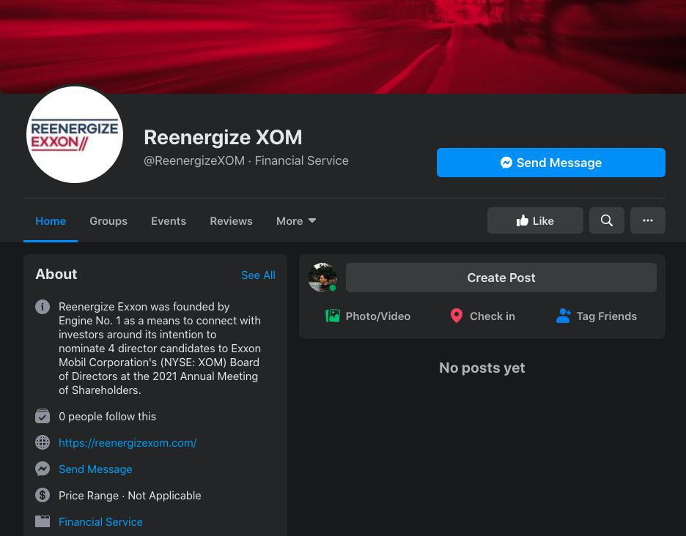

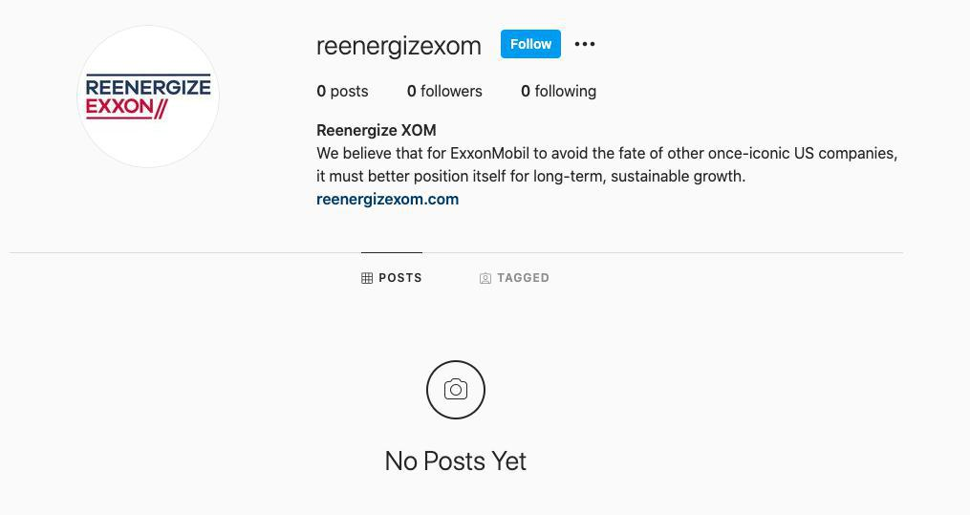

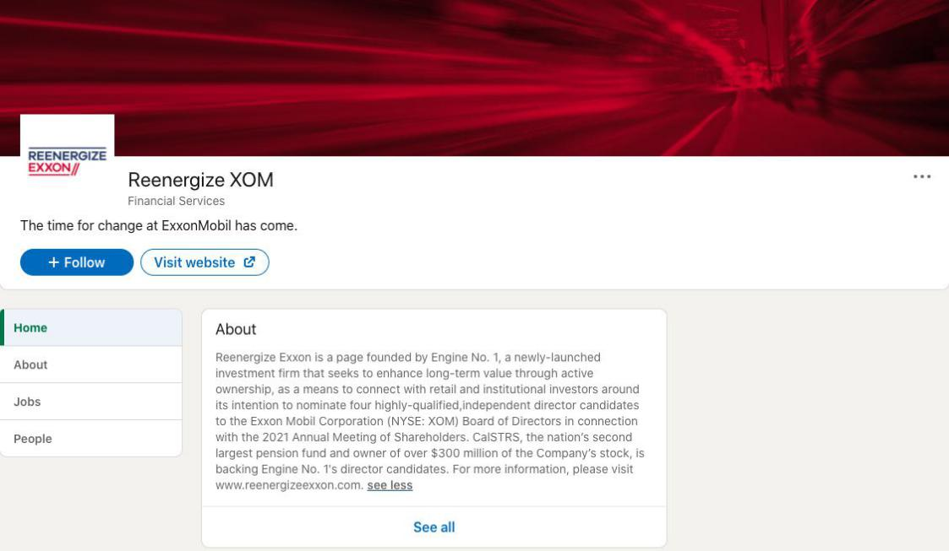

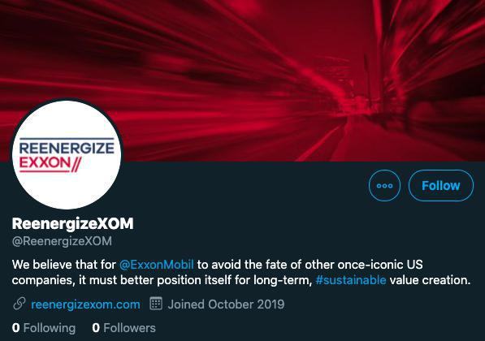

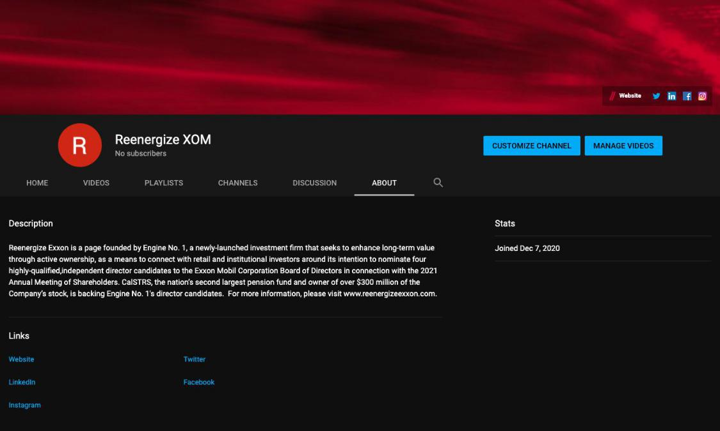

Exhibit 6

CERTAIN INFORMATION CONCERNING THE PARTICIPANTS

The Engine No. 1 Parties (as defined below), together with the other Participants (as defined below), intend to file a preliminary proxy statement and accompanying proxy card with the SEC to be used to solicit proxies for votes (a “Proxy Solicitation”) regarding the election of its slate of director nominees and other proposals that may come before the 2021 annual meeting of shareholders of Exxon Mobil Corporation (the “Company”).

THE PARTICIPANTS STRONGLY ADVISE ALL SHAREHOLDERS OF THE COMPANY TO READ THE PROXY STATEMENT AND OTHER PROXY MATERIALS AS THEY BECOME AVAILABLE BECAUSE THEY WILL CONTAIN IMPORTANT INFORMATION. SUCH PROXY MATERIALS WILL BE AVAILABLE AT NO CHARGE ON THE SEC’S WEB SITE AT HTTP://WWW.SEC.GOV. IN ADDITION, THE PARTICIPANTS IN THIS PROXY SOLICITATION WILL PROVIDE COPIES OF THE PROXY STATEMENT WITHOUT CHARGE, WHEN AVAILABLE, UPON REQUEST. REQUESTS FOR COPIES SHOULD BE DIRECTED TO THE PARTICIPANTS’ PROXY SOLICITOR, INNISFREE M&A INCORPORATED AT (877) 750-8310 (TOLL-FREE FROM THE U.S. AND CANADA) OR +1 (412) 232-3651 (FROM OTHER LOCATIONS).

The Participants in any future Proxy Solicitation are anticipated to be: (i) Engine No. 1 LLC, a Delaware limited liability company (“Engine No. 1 LLC”), (ii) Engine No. 1 LP, a Delaware statutory public benefit limited partnership and the sole owner of Engine No. 1 LLC (“Engine No. 1 LP”); (iii) Christopher James, a United States citizen (“Mr. James”) and Managing Member of Engine No. 1 GP LLC, a Delaware limited liability company and the general partner of Engine No. 1 LP (“Engine No. 1 GP” and together with Engine No. 1 LLC and Engine No. 1 LP, “Engine No. 1”), (iv) Charles Penner, a principal and authorized person of Engine No. 1 LLC and certain funds or affiliates controlled by Engine No. 1 and a United States citizen (“Mr. Penner,” and together with Engine No. 1 and Mr. James, the “Engine No. 1 Parties”); (v) Gregory J. Goff (“Mr. Goff”), (vi) Kaisa Hietala (“Ms. Hietala”), (vii) Alexander Karsner (“Mr. Karsner”) and (viii) Anders Runevad (“Mr. Runevad”, together with Mr. Goff, Ms. Hietala and Mr. Karsner, the “Nominees”, and the Nominees together the Engine No. 1 Parties, the “Participants”).

As of the date hereof, the Participants may be deemed to beneficially own (within the meaning of Rule 13d-3 under the Securities Exchange Act of 1934), in the aggregate, 944,064 shares of common stock, without par value, of the Company (the “Common Stock”). Of the 917,400 shares of Common Stock beneficially owned in the aggregate by the Engine No. 1 Parties, such shares of Common Stock may be deemed to be beneficially owned as follows: (a) 917,400 Common Shares may be deemed to be beneficially owned by Engine No. 1 LLC by virtue of it being the investment advisor, directly or indirectly, to certain investment funds, (b) 917,400 Common Shares may be deemed to be beneficially owned by Engine No. 1 LP by virtue of it being the sole owner and the managing member of Engine No. 1 LLC and (c) 917,400 shares of Common Stock may be deemed to be beneficially owned by Mr. James by virtue of him being the managing member of Engine No. 1 GP. In addition, Mr. Karsner may be deemed to beneficially own 17,000 shares of Common Stock and Mr. Goff may be deemed to beneficially own 9,664 shares of Common Stock.

Mr. Karsner expressly disclaims beneficial ownership of the shares of Common Stock beneficially owned by the Engine No. 1 Parties and Mr. Goff. Mr. Goff expressly disclaims beneficial ownership of the shares of Common Stock beneficially owned by the Engine No. 1 Parties and Mr. Karsner. Each of the Engine No. 1 Parties expressly disclaims beneficial ownership of the shares of Common Stock beneficially owned by Mr. Karsner and by Mr. Goff. Each Participant disclaims beneficial ownership of the Common Shares reported above except to the extent of his, her or its actual pecuniary interest therein.

