UNITED STATES

SECURITIES AND EXCHANGE COMMISSION
Washington, D.C. 20549

SCHEDULE 14A

Proxy Statement Pursuant to Section 14(a) of the

Securities Exchange Act of 1934

Filed by the Registrant ☒ Filed by a Party other than the Registrant ☐

Check the appropriate box:

- Preliminary Proxy Statement

- Confidential, for Use of the Commission Only (as permitted by Rule 14a-6(e)(2))

- Definitive Proxy Statement

- Definitive Additional Materials

- Soliciting Material under § 240.14a-12

EXXON MOBIL CORPORATION

(Name of Registrant as Specified In Its Charter)

NOT APPLICABLE

(Name of Person(s) Filing Proxy Statement, if other than the Registrant)

Payment of Filing Fee (Check all boxes that apply):

- No fee required

- Fee paid previously with preliminary materials

- Fee computed on table in exhibit required by Item 25(b) per Exchange Act Rules 14a-6(i)(1) and 0-11.

Exxon Mobil Corporation

22777 Springwoods Village Pkwy

Spring, TX 77389

May 8, 2026

Supplemental Information Related to Item 3 – Advisory Vote to Approve Executive Compensation

The 2026 Proxy Statement outlines ExxonMobil’s executive compensation program and 2025 pay decisions. In 2025, the Company achieved industry-leading results across all performance dimensions, demonstrating our ability to deliver on our commitments.

The compensation program remains strong and aligns executives’ pay with the results of their decisions and returns of our shareholders over the long-term. The program is highly performance based; all pay outcomes are a direct result of Company and individual performance.

CEO Total Direct Compensation (TDC) is lower in 2025 versus 2024, reflective of lower earnings and lower share price at grant. The majority of CEO TDC is delivered in performance shares (81%), which have uniquely long restriction periods, 50% vesting in 5 years and 50% in 10 years. Share grants are not adjusted to offset changes in share price, resulting in executives seeing a one-for-one change in compensation through share price, ensuring alignment with the experience of our shareholders over the long term.

At time of filing the 2026 Proxy Statement, 2025 data for compensation benchmark companies was not yet available. The charts below, included on page 64 of the Compensation Discussion & Analysis (CD&A), have been updated for the most recent 1- and 10-year time periods. This also updates all other references to ExxonMobil’s position versus compensation benchmark companies in the CD&A.

When considering scale and complexity of operations, ExxonMobil remains the largest across compensation benchmark companies, as illustrated on page 55 of the CD&A. That said, 10-year realized and unrealized pay is at the 40th percentile, down from the 41st percentile in 2024. Combined 10-year realized and unrealized pay normalizes for different award types and restriction periods. The relative position on 10-year realized pay further underscores the impact of long restriction periods, the longest across all industries.

Please read this supplemental information together with the more detailed information included in the CD&A, compensation tables, and narrative on pages 45 through 75 of ExxonMobil’s 2026 Proxy Statement before you cast your vote on Management Resolution Item 3 – Advisory Vote to Approve Executive Compensation.

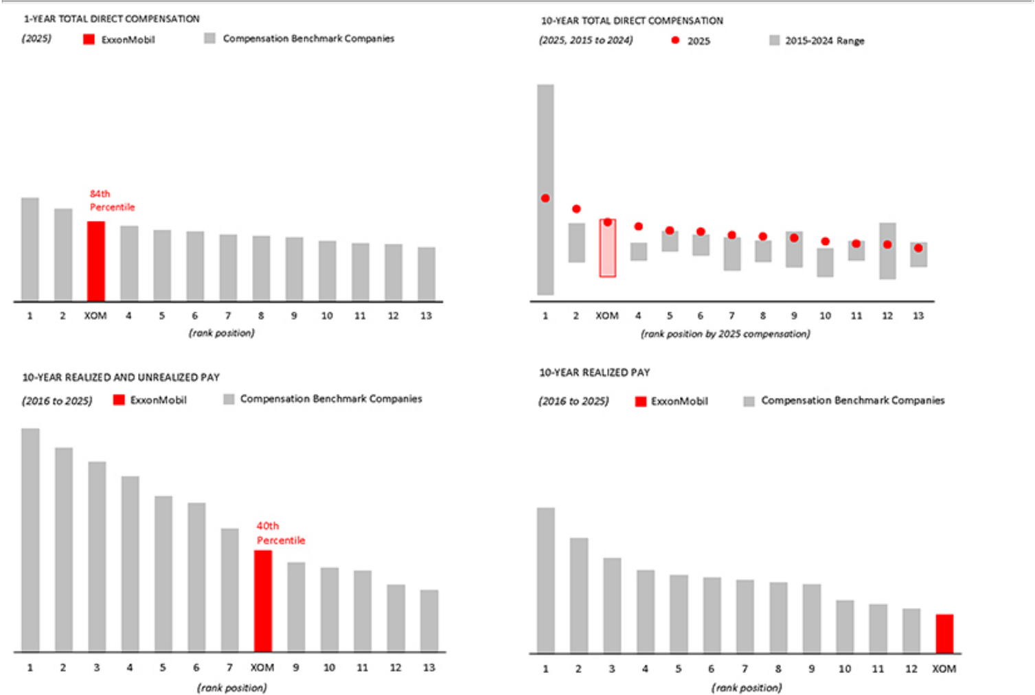

Total Direct Compensation is compensation granted during the year, including salary, current year bonus, and the grant date fair value of equity awards. Realized pay is compensation actually received by the CEO during the year, excluding any retirement distributions. Unrealized pay represents the current value – not the grant date value used for reporting in the Summary Compensation Table – of outstanding unvested cash and stock-based incentive awards as well as the current market value of unexercised “in the money” stock options granted during the years 2016 through 2025. Award values are based on target levels of formula-based awards and fiscal year-end 2025 stock prices. See page 62 of the CD&A for more detailed definitions of realized and unrealized pay.

